WATER DISTRIBUTION NETWORKS AND ANALYSIS OF PIPE MATERIAL USING WATER GEMS
Jay Kishore Mhatre¹, Om Hitendra Pandya¹, Pravin Shankar Pawar¹, Ulkesh Ulhas Shama^{1*},
Hemant Kumar Thakur², Yash Suresh Shet²
¹ B.E. Student, Department of Civil Engineering, GM Vedak Institute of Technology, Tala Raigad.
² Assistant Professor, Department of Civil Engineering, GM Vedak Institute of Technology, Tala Raigad.
Gmail Id: - jaykmhatre91@gmail.com¹, ompandya2124@gmail.com², pawarpravin5727@gmail.com^{3,} ulkeshshama2911@gmail.com^{4,*} hemantkumarthakur2021@gmail.com.², yashsheth@gmvit.com. ²
Abstract
Efficient design and management of water distribution networks are essential for ensuring reliable and sustainable water supply in rural areas. This study presents the hydraulic modeling and analysis of a water distribution system for Mhasoli village in Maharashtra, using WaterGEMS simulation software. Population forecasting was performed using arithmetic increase, geometric increase, and incremental increase methods to estimate the future demand for a selected design period. Based on the projected population of 2431 persons, the total daily water demand was calculated as 328,185 liters per day considering the standard per capita water requirement. A hydraulic network model was developed using field survey data, including pipeline layout, junction elevations, and nodal demand. The model was simulated to evaluate important hydraulic parameters such as pipe diameter, flow velocity, hydraulic gradient, and pressure distribution throughout the network. The results show that pipe velocities vary between 0.02 m/s and 1.69 m/s, which are within acceptable design limits for water distribution systems. The analysis also confirms that adequate pressure is maintained at all junction nodes. The study demonstrates that WaterGEMS provides an effective tool for hydraulic analysis, design optimization, and performance evaluation of rural water distribution networks, supporting efficient planning and sustainable water supply management.

Key words: Water Distribution, Water Gems, Population forecasting, pipe, Liters Per Capita Per Day (LPCD)
INTRODUCTION
Water distribution systems (WDSs) are one of the major infrastructure assets of the society, with new systems being continually developed reflecting the population growth, and existing systems being upgraded and extended due to raising water demands. Designing economically effective WDSs is a complex task, which involves solving a large number of simultaneous nonlinear network equations, and at the same time, optimizing sizes, locations, and operational statuses of network components such as pipes, pumps, tanks and valves. This task becomes even more complex when the optimization problem involves a larger number of requirements for the designed system to comply with (e.g., water quality), includes additional objectives beside a least-cost economic measure (e.g., potential fire damage) and incorporates more real-life aspects (e.g., uncertainty, staging of construction) (Todini & Pilati, 1988; Lansey & Mays, 1989; Alperovits & Shamir, 1977). WATERGEMS is such a computer-based program that plays out an all-encompassing period re-enactment of water powered and water quality conduct inside pressurized pipe systems (Bentley Systems, 2014; Rossman, 1993). Open Flows Water GEMS provides you with a comprehensive yet easy-to-use decision-support tool for water distribution networks. The software helps improve your knowledge of how infrastructure behaves as a system, how it reacts to operational strategies, and how it should grow as population and demands increase (Rai & Dohare, 2019; Ormsbee, 2006).

Need of Water Supply
Water quality may be assessed upon several occasions: to determine if the available water is suitable for a particular purpose, to determine if there has been a significant change in water quality or to determine if adverse health effects that are occurring may be attributable to water contamination (World Health Organization, 2017). Numerous commercial, governmental and academic laboratories offer water quality analytical services. The assessment of the analytical results from such laboratories requires some sort of standards against which to compare the results. National, state or provincial, or local governments may regulate water quality and water quality standards may be established by any or all of those governmental bodies (BIS, 2012; WHO, 2017). The quality of drinking water intended for consumption by humans is almost always more extensively regulated than for any other water use (Garg, 2010).
Reports of results of water quality analyses often include water quality standard ranges against which to assess the reported results. They may include graphical comparisons of the results to the water quality standards, making identification of parameters that fall outside of the standard limits easily identifiable. Such reports often use water quality standards intended for human drinking water. Assessment of the results of water quality analyses must be done using standards that are applicable for the intended use of the water and which are in force for the venue at which the water is to be used (Maharashtra Jeevan Pradhikaram, 2012). The suitability of water intended for use as drinking water by animals is better assessed using drinking water standards for
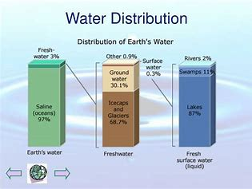
animals instead of standards for humans. Otherwise, animal owners may take unnecessary and costly actions to mitigate what are erroneously believed to be unacceptably high risk of some sort of adverse health effect.
- water distribution
Pipe Materials:
HDPE (high-density polyethylene) pipes are flexible, durable, and corrosion resistant pipes widely used in various industries for fluid and gas transfer (Pillai, 2020).
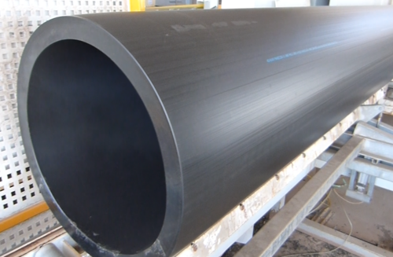
- HDPE Pipe
HDPE pipe is made from thermoplastic highdensity polyethylene, known for its strong molecular structure, which allows it to withstand high pressures and resist environmental factors (Pillai,2020). It is commonly used for applications such as:
Water and sewer systems: HDPE pipes are ideal for municipal water supply and wastewater management due to their leak-free joints and resistance to corrosion.
Gas distribution: They are also used in natural gas pipelines, providing a safe and reliable option for gas transport.
Irrigation and drainage: HDPE pipes are effective for agricultural irrigation systems and stormwater drainage due to their flexibility and durability.
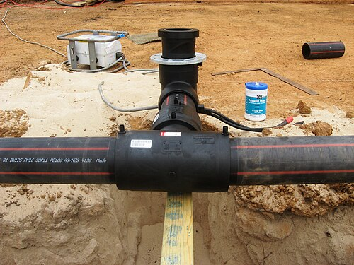
- HDPE Pipe Joints
Some investigators have attempted to analyzed the pipeline distribution of this city but not any detailed investigation is considering analysis and design method with respect to Indian Standards. A brief review of these investigations, analysis and design parameters, theories have been reported in these chapter and also the objectives of this investigation.
LITERATURE SUMMARY:
Related to the project topic, A brief review of investigations, design parameters and theories by many people has been reported in this chapter and summarized as follows:
Vicki L. Van Blaricum and Vincent F. Hock (2007)
This paper describes the demonstration and validation of multi-parameter water quality sensors and corrosion rate sensors that were permanently installed at a U. S. Army installation to detect corrosion problems and fine-tune the chemical treatment program. The use of water quality and corrosion rate sensors has been demonstrated and validated in the field. Ekisha Sharma , Nawa Raj Khatiwada, “Design Of Micro Water Supply System Using Solar Energy”, 2019
Dr. R.K. Bansal, “Fluid Mechanics and Hydraulics (Book)”, 2018
Standard formulae for population forecasting, water demand and concept of siphon.
Chunping Yang, ZhiqiangShen, Hong Chen, Guangming-Zeng, YuanyuanZhong (2006)
A lot of technological problems including advanced treatment processes, pH regulation, sterilization, and pipe selection have been solved cost-effectively. Arjun Kumar Et Al., “Design of Water Distribution System Using Epanet”, International Journal of Advanced Research,2015,
The examination discusses the water request of the constantly developing populace, it is basic to give the adequate and uniform amount of water through the structured system of funnels. This work features the procedure completed on the structure of the water supply framework for a territory named KATHGARH with the assistance of this data the plan of the water supply conspires for the region with the assistance of programming "EPANET".
Dr. G. Venkata Ramana, Ch. V.S.S. Sudheer, B. Rajashekhar, “Network Analysis of Water Distribution System in Rural Areas Using EPANET”2015,
This paper discusses the accessibility of adequate amount of good nature of water to the different segment of the network as per the interest. Numerous PC apparatuses were created, out of the considerable number of instruments accessible EPANET become most prevalent and advantageous for the viable plan of complex pipe systems. The lingering head at every single hub was discovered by having the height as info and along these lines, the relating stream amounts were gotten from the residual head, speed, and nodal request and so forth.
“Designing of Water Distribution System in A Site Development Project Using Water Gems”, (General Information of Micro-Station Integration)”, 2014
This guidelines emphasis theoretical a few analysts have grown entirely unexpected methodologies for the best plan of establishment pipe systems. Yet, none of them offer a close composition for style strategy concerned. Understudies and youthful scientists World Wellbeing Association region unit working in the field of water conveyance organizes generally pay their significant time paying special mind to the methodology to sign
up hereditary algorithmic program and EPANET and Water distribution planning and designing through water gems.
Maharashtra Jeevan Pradhikaram (MJP), “basic of water supply system”, 2012
This research discusses the paper exhibits a multi-objective hereditary calculation way to deal with the structure of a water conveyance network (WDN). The goals considered are the minimization of the system cost and augmentation of an unwavering quality measure. The proposed technique delivers a lot of pareto-ideal Arrangements in the inquiry space of expense and system strength basics on work measurement and specifications in water supply system.
METHODOLOGY & MATERIALS
In this chapter, methods used to achieve the desired results are explained. After a thorough study of literature, the appropriate methodology is fragmented and observations use in software and calculations were done (Kumar et al., 2015; Ramana et al., 2015).
Work process:
- First data preparation for study area including information like Google and Satellite Image,
- Road network map and Land use or cover area then data collection for field survey includes population, source and water tank, Pipe and nodal these all data collected to department of rural water supply and construction, the next step is setting up the network based on the observation.
- This network can be drawn using AUTOCAD software.
- After finalizing the network diagram, it is then materialized in this software.
- The other important details are necessarily provided for such a network in hydraulic software (WATERGEMS).
- This important detail is categorized into link/pipe input and node/junction input. Link/pipe details include length, roughness and diameter of pipe and Node/junction detail include elevation of ground and demand of water at that node.
- This is fair enough to run water gems software with the provided details. After running the network with given detail, the output is analyzed.
- This analyzed report would then tend to give the answer to a simple but effective question that whether it is satisfactory or not.
- If the analyzed result tends to unsatisfactory result, then the details provided are returned and again the output is analyzed. If the analyzed result is satisfactory then the output is extracted in the form of graphs and tables. Figure 3.1 shows the flowchart of the methodology used.

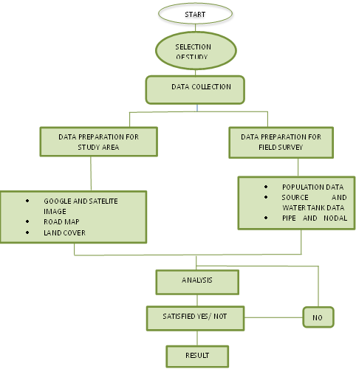
- flowchart of the methodology
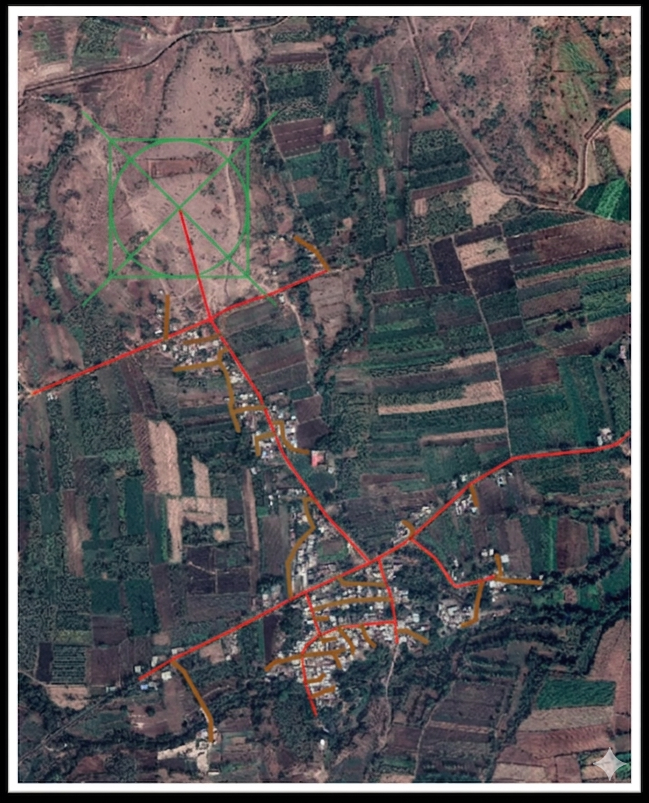
- Pipeline distribution through A-CAD
Analysia And Result for Population Determination in Mhasoli Village
In this section emphasis on discussion of date collection out of field survey and following points has been given:
Population Determination Method:
To find out the population is a standout amongst the most significant factors in arranging, if the undertaking needs to serve the network for a specific plan period. Regularly, a design period of 20 to 40 years is chosen. What will be the population toward the finish of the plan period is the fundamental inquiry? This can be accomplished by utilizing different strategies for the population determination shown in the following Equation 5.1, 5.2 and 5.3 (Arjun Kumar 2015).
1.Arithmetical Increase Method
- Population increases at constant rate (dp/dt = const.)

$P_{n}= (P_{0} + n * X)$ … (Equation5.1)
2.Geometrical Increase Method
- Rate of growth is progressively increasing or decreasing

$P_{n}=p_{0 }{[1+\frac{r}{100}]}^{n}$ … (Equation 5.2)
3. Incremental Increase Method
- Percentage growth rate (r) is assumed to be constant
- The increase is compounded for the existing population, every decade
$p_{n}=p_{0}+n*x+\{n\left(\frac{n+1}{2}\right)\}$ ... (Equation 5.3)

Where,
$p_{n}$ = Forecasted Population after n decades
$p_{0}$ = Population at present
n = No. of decades between now & future
r = Growth rate
X = Arithmetic Mean
Y = Av, of incremental increase

The following table shows previous year population and increasing decades of Mhasoli village
- Population and decades of Mhasoli village
YEAR | POPULATION | INCREASE DECADE | r%
1999 | 1577 | - | -
2001 | 1774 | 197 | 12.49
2011 | 1892 | 118 | 6.651
2021 | 1985 | 93 | 4.91

Population forecasting for Mhasoli:
2051=?
Here, p₀₌1985,
n= $\frac{2051-2021}{10}$,
n=3
- Geometric Increase Method:
$r=\frac{12.49+6.651+4.91}{3}$
r= 8.017
where, r= per decade%,
$$P_{2051}=p_{0 }{[1+\frac{r}{100}]}^{n}$$
$$P_{2051}=1985{[1+\frac{8.017}{100}]}^{3}$$
$$P_{2051}=2501$$

- Arithmetical Increase Method:
$X=\frac{197+118+93}{3}$,
X=136
$$P_{n}= (P_{0} + n * X)$$
$$P_{2051}= (1985 + 3* 136)$$
$$P_{2051}=2393$$

- Incremental Increase Method:
$$p_{n}=p_{0}+n*x+\{n\left(\frac{n+1}{2}\right)\}$$
$$p_{2051}=1985+3*136+\{3\left(\frac{3+1}{2}\right)\}$$
$$p_{2051}=2399$$
Average Population=$\frac{2501+2393+2393}{3}$
Average Population=2431
Water Demand for Mhasoli:
We know that the water requirement for domestic use per person per day varies according to the location, so
Total Demand = Average Population*135lpcd (benchmark standard for water supply in urban Indian areas for domestic use)
Total Demand= Average Population *180 (typically used in water supply planning for high-density, developed areas or to calculate maximum daily demand)
As we know this village is located in a urban area
Total Demand = Average Population *135
Total Demand = 2431*135 lpcd daily demand
Total Demand=3,28,185lpcd

RESULT & DISCUSSION
- The average population of Mhasoli village is 2431,
- The total demand of water is 3,28,185lpcd.
- Results of Pipe Data:
Below table we discussed about velocity, diameter of pipes, the material of pipe and hydraulic gradient.
- Result for pipe data
ID | LABEL | L | S-N1 | S-N2 | DIA. | M | C | V | H
30 | P1 | 15.14 | J-1 | J-2 | 63 | HDPE | 145 | 0.83 | 12.218
33 | P2 | 17.46 | J-3 | J-4 | 140 | HDPE | 145 | 0.77 | 4.143
36 | P3 | 18.75 | J-5 | J-6 | 63 | HDPE | 145 | 0.2 | 0.881
39 | P4 | 18.75 | J-6 | J-7 | 63 | HDPE | 145 | 0.07 | 0.115
41 | P5 | 19.40 | J-8 | J-9 | 63 | HDPE | 145 | 0.02 | 0.012
44 | P6 | 20.84 | J-10 | J-11 | 63 | HDPE | 145 | 1.69 | 45.16
47 | P7 | 23.90 | J-2 | J-12 | 63 | HDPE | 145 | 0.04 | 0.04
49 | P8 | 25.73 | J-8 | J-13 | 63 | HDPE | 145 | 0.04 | 0.04
51 | P9 | 26.73 | J-14 | J-15 | 63 | HDPE | 145 | 0.91 | 14.307
54 | P10 | 33.81 | J-16 | J-17 | 63 | HDPE | 145 | 0.05 | 0.064
57 | P11 | 28.91 | J-18 | J-19 | 63 | HDPE | 145 | 0.3 | 1.814
60 | P12 | 29.21 | J-20 | J-21 | 110 | HDPE | 145 | 1.45 | 17.774
63 | P13 | 31.32 | J-22 | J-23 | 63 | HDPE | 145 | 0.4 | 3.186
66 | P14 | 31.71 | J-24 | J-25 | 63 | HDPE | 145 | 0.11 | 0.268
69 | P15 | 31.71 | J-26 | J-24 | 63 | HDPE | 145 | 0.26 | 1.406
71 | P16 | 31.88 | J-27 | J-3 | 110 | HDPE | 145 | 1.3 | 14.429
73 | P17 | 36.51 | J-21 | J-28 | 110 | HDPE | 145 | 0.44 | 1.91
75 | P18 | 32.59 | J-2 | J-16 | 63 | HDPE | 145 | 0.77 | 10.425
76 | P19 | 32.66 | J-29 | J-20 | 110 | HDPE | 145 | 1.49 | 18.57
78 | P20 | 32.34 | J-30 | J-31 | 63 | HDPE | 145 | 0.11 | 0.268
81 | P21 | 33.78 | J-32 | J-33 | 63 | HDPE | 145 | 0.09 | 0.185
84 | P22 | 37.53 | J-26 | J-34 | 63 | HDPE | 145 | 0.07 | 0.116
86 | P23 | 44.03 | J-19 | J-35 | 63 | HDPE | 145 | 0.1 | 0.225
88 | P24 | 37.21 | J-22 | J-1 | 63 | HDPE | 145 | 0.83 | 12.158
89 | P25 | 38.92 | J-36 | J-16 | 63 | HDPE | 145 | 0.05 | 0.069
91 | P26 | 39.91 | J-37 | J-38 | 63 | HDPE | 145 | 0.13 | 0.362
94 | P27 | 40.84 | J-39 | J-36 | 63 | HDPE | 145 | 0.22 | 1.075
96 | P28 | 43.04 | J-15 | J-5 | 63 | HDPE | 145 | 0.65 | 7.644
97 | P29 | 45.83 | J-39 | J-40 | 63 | HDPE | 145 | 0.06 | 0.088
99 | P30 | 51.28 | J-24 | J-41 | 63 | HDPE | 145 | 0.09 | 0.184
101 | P31 | 49.20 | J-42 | J-26 | 63 | HDPE | 145 | 0.38 | 2.913
103 | P32 | 64.91 | J-4 | J-43 | 63 | HDPE | 145 | 0.08 | 0.148
105 | P33 | 52.57 | J-16 | J-42 | 63 | HDPE | 145 | 0.71 | 9.101
106 | P34 | 54.10 | J-36 | J-44 | 63 | HDPE | 145 | 0.05 | 0.062
108 | P35 | 53.27 | J-11 | J-14 | 63 | HDPE | 145 | 0.62 | 7.104
109 | P36 | 61.79 | J-6 | J-45 | 63 | HDPE | 145 | 0.1 | 0.224
111 | P37 | 60.80 | J-32 | J-27 | 63 | HDPE | 145 | 0.96 | 15.884
112 | P38 | 60.30 | J-42 | J-8 | 63 | HDPE | 145 | 0.1 | 0.223
113 | P39 | 62.54 | J-5 | J-39 | 63 | HDPE | 145 | 0.4 | 3.096
114 | P40 | 64.07 | J-10 | J-46 | 63 | HDPE | 145 | 0.96 | 15.707
116 | P41 | 64.07 | J-22 | J-46 | 63 | HDPE | 145 | 0.49 | 4.491
117 | P42 | 66.85 | J-20 | J-47 | 63 | HDPE | 145 | 0.07 | 0.116
119 | P43 | 66.91 | J-48 | J-49 | 63 | HDPE | 145 | 0.07 | 0.116
122 | P44 | 68.37 | J-11 | J-30 | 63 | HDPE | 145 | 0.97 | 16.189
123 | P45 | 71.07 | J-42 | J-50 | 63 | HDPE | 145 | 0.05 | 0.062
125 | P46 | 76.26 | J-51 | J-52 | 63 | HDPE | 145 | 0.04 | 0.041
128 | P47 | 88.94 | J-19 | J-53 | 63 | HDPE | 145 | 0.13 | 0.364
130 | P48 | 82.74 | J-28 | J-54 | 63 | HDPE | 145 | 0.12 | 0.313
132 | P49 | 85.16 | J-55 | J-56 | 63 | HDPE | 145 | 0.09 | 0.184
135 | P50 | 104.19 | J-3 | J-57 | 63 | HDPE | 145 | 0.05 | 0.062
137 | P51 | 89.44 | J-29 | J-51 | 63 | HDPE | 145 | 0.17 | 0.664
138 | P52 | 95.67 | J-14 | J-46 | 63 | HDPE | 145 | 0.41 | 3.274
139 | P53 | 101.08 | J-18 | J-58 | 63 | HDPE | 145 | 0.11 | 0.266
141 | P54 | 99.21 | J-28 | J-32 | 110 | HDPE | 145 | 0.37 | 1.406
142 | P55 | 130.94 | J-21 | J-27 | 110 | HDPE | 145 | 1 | 8.974
143 | P56 | 142.04 | J-4 | J-59 | 110 | HDPE | 145 | 1.2 | 12.539
145 | P57 | 146.33 | J-30 | J-37 | 63 | HDPE | 145 | 0.32 | 2.04
146 | P58 | 149.41 | J-1 | J-15 | 63 | HDPE | 145 | 0.12 | 0.298
147 | P59 | 173.06 | J-30 | J-18 | 63 | HDPE | 145 | 0.45 | 3.926
148 | P60 | 156.07 | J-59 | J-10 | 110 | HDPE | 145 | 0.89 | 7.184
149 | P61 | 170.98 | J-48 | J-60 | 63 | HDPE | 145 | 0.08 | 0.148
151 | P62 | 220.35 | J-59 | J-23 | 63 | HDPE | 145 | 0.77 | 10.508
152 | P63 | 210.56 | J-15 | J-29 | 110 | HDPE | 145 | 1.61 | 21.438
154 | P64 | 236.25 | J-29 | J-55 | 63 | HDPE | 145 | 0.14 | 0.474
155 | P65 | 248.62 | J-23 | J-48 | 63 | HDPE | 145 | 0.22 | 1.045
156 | P66 | 268.31 | J-51 | J-62 | 63 | HDPE | 145 | 0.08 | 0.148
158 | P67 | 318.05 | J-37 | J-63 | 63 | HDPE | 145 | 0.12 | 0.313

- The minimum diameter is used for water distribution system is 63mm and the maximum diameter is 140mm.
- The minimum velocity is 0.02m/s, and the maximum velocity is 1.69m/s, for water distribution system. And the average velocity is used for the network is 0.45m/s.
- The mean hydraulic gradient is 5.16m.
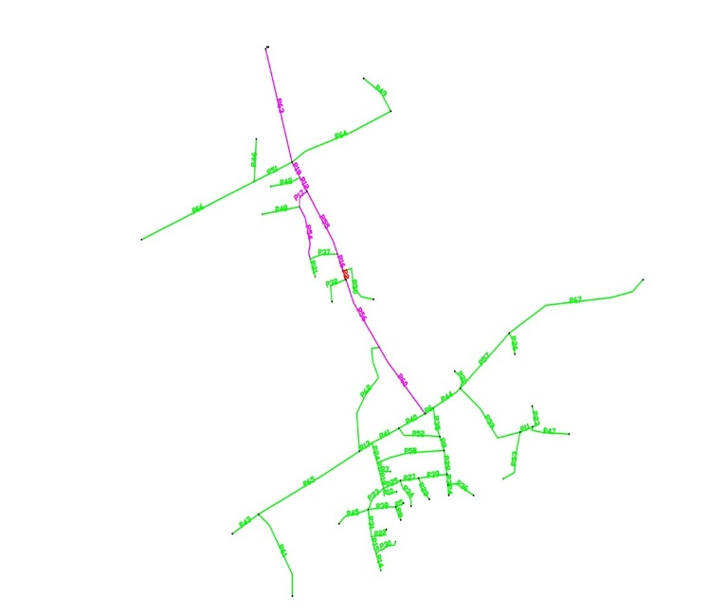
- Network modelling through water-gems

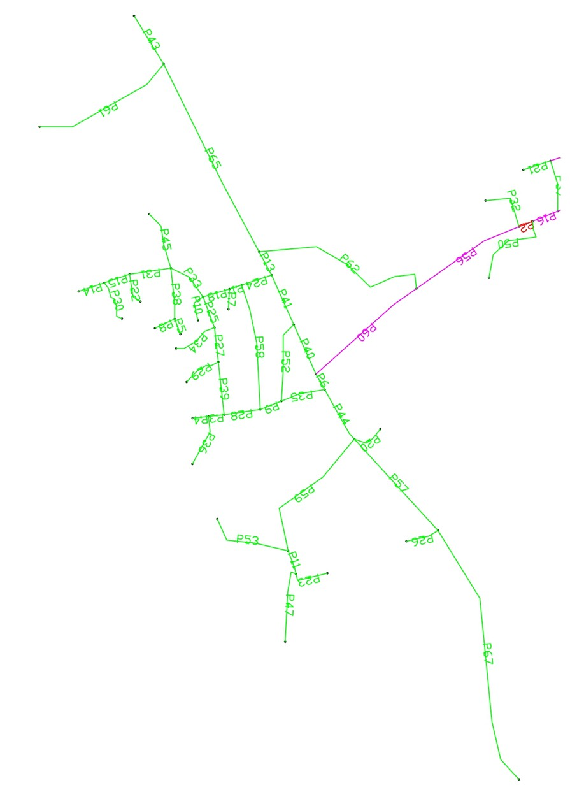
- Network modelling through water gems zone-1
- Result of Junction points:
- Elevation, demand and pressure at each junction point
ID | LABEL | ELEVATION | DEMAND | HYDRAULIC GRADE | PRESSURE
31 | J-1 | 660 | 0.36 | 673 | 0.127
32 | J-2 | 660 | 0.09 | 672.82 | 0.125
34 | J-3 | 663 | 0.33 | 677.73 | 0.144
35 | J-4 | 662 | 0.18 | 677.65 | 0.153
37 | J-5 | 653 | 0.15 | 672.72 | 0.193
38 | J-6 | 651 | 0.12 | 672.7 | 0.212
40 | J-7 | 650 | 0.21 | 672.7 | 0.222
42 | J-8 | 655 | 0.12 | 671.99 | 0.166
43 | J-9 | 655 | 0.06 | 671.99 | 0.166
45 | J-10 | 657 | 0.21 | 674.75 | 0.174
46 | J-11 | 657 | 0.3 | 673.81 | 0.165
48 | J-12 | 660 | 0.12 | 672.82 | 0.125
50 | J-13 | 653 | 0.12 | 671.99 | 0.186
52 | J-14 | 656 | 0.39 | 673.43 | 0.171
53 | J-15 | 656 | 0.45 | 673.05 | 0.167
55 | J-16 | 660 | 0.18 | 672.48 | 0.122
56 | J-17 | 657 | 0.15 | 672.48 | 0.151
58 | J-18 | 655 | 0.15 | 672.02 | 0.167
59 | J-19 | 657 | 0.24 | 671.97 | 0.147
61 | J-20 | 670 | 0.12 | 679.88 | 0.097
62 | J-21 | 669 | 0.12 | 679.36 | 0.101
64 | J-22 | 659 | 0.18 | 673.46 | 0.141
65 | J-23 | 660 | 0.45 | 673.56 | 0.133
67 | J-24 | 654 | 0.21 | 671.81 | 0.174
68 | J-25 | 652 | 0.33 | 671.8 | 0.194
70 | J-26 | 656 | 0.18 | 671.86 | 0.155
72 | J-27 | 665 | 0.21 | 678.19 | 0.129
74 | J-28 | 669 | 0.27 | 679.29 | 0.101
77 | J-29 | 672 | 0.15 | 680.49 | 0.083
79 | J-30 | 656 | 0.3 | 672.7 | 0.163
80 | J-31 | 656 | 0.33 | 672.69 | 0.163
82 | J-32 | 663 | 0.24 | 679.15 | 0.158
83 | J-33 | 661 | 0.27 | 679.14 | 0.178
85 | J-34 | 655 | 0.21 | 671.85 | 0.165
87 | J-35 | 659 | 0.3 | 671.96 | 0.127
90 | J-36 | 658 | 0.39 | 672.48 | 0.142
92 | J-37 | 660 | 0.24 | 672.4 | 0.121
93 | J-38 | 660 | 0.39 | 672.39 | 0.121
95 | J-39 | 655 | 0.36 | 672.53 | 0.172
98 | J-40 | 652 | 0.18 | 672.52 | 0.201
100 | J-41 | 652 | 0.27 | 671.8 | 0.194
102 | J-42 | 660 | 0.57 | 672 | 0.117
104 | J-43 | 662 | 0.24 | 677.64 | 0.153
107 | J-44 | 653 | 0.15 | 672.48 | 0.191
110 | J-45 | 647 | 0.3 | 672.69 | 0.251
115 | J-46 | 658 | 0.18 | 673.74 | 0.154
118 | J-47 | 670 | 0.21 | 679.87 | 0.097
120 | J-48 | 662 | 0.24 | 673.3 | 0.111
121 | J-49 | 665 | 0.21 | 673.29 | 0.081
124 | J-50 | 659 | 0.15 | 672 | 0.127
126 | J-51 | 671 | 0.18 | 680.43 | 0.092
127 | J-52 | 679 | 0.12 | 680.42 | 0.014
129 | J-53 | 655 | 0.39 | 671.94 | 0.166
131 | J-54 | 668 | 0.36 | 679.26 | 0.11
133 | J-55 | 671 | 0.18 | 680.37 | 0.092
134 | J-56 | 672 | 0.27 | 680.36 | 0.082
136 | J-57 | 666 | 0.15 | 677.72 | 0.115
140 | J-58 | 647 | 0.33 | 672 | 0.245
144 | J-59 | 659 | 0.57 | 675.87 | 0.165
150 | J-60 | 659 | 0.24 | 673.27 | 0.14
157 | J-62 | 673 | 0.24 | 680.39 | 0.072
159 | J-63 | 659 | 0.36 | 672.3 | 0.13
187 | J-71 | 0 | (N/A) | (N/A) | (N/A)

The minimum demand is 0.06 m³/s and the maximum demand is for the water distribution network is 0.57 m³/s.

CONCLUSION
This study presented the hydraulic modeling and analysis of a rural water distribution network for Mhasoli village using WaterGEMS software. Population forecasting methods were applied to estimate future demand, and the projected population of 2431 was used to determine the total daily water demand of approximately 328,185 liters. A hydraulic model of the distribution network was developed to evaluate critical parameters including pipe diameter, velocity, pressure distribution, and hydraulic gradient. The simulation results indicate that the designed network satisfies standard hydraulic design criteria, with pipe velocities ranging from 0.02 m/s to 1.69 m/s and adequate pressure maintained at all junction nodes. The use of HDPE pipes provides advantages such as corrosion resistance, durability, and reduced leakage, making them suitable for rural water supply systems. Overall, the results demonstrate that WaterGEMS is an effective decision-support tool for hydraulic modeling and optimization of water distribution networks. The proposed approach can support efficient planning, design, and sustainable management of rural water supply infrastructure in similar developing regions.

REFERENCES
Alperovits, E., & Shamir, U. (1977). Design of optimal water distribution systems. Water Resources Research, 13(6), 885–900.
Bansal, R. K. (2018). Fluid mechanics and hydraulic machines. Laxmi Publications.
Bentley Systems. (2014). WaterGEMS user guide.
Bureau of Indian Standards. (2012). Drinking water specifications (IS 10500:2012).
Garg, S. K. (2010). Water supply engineering. Khanna Publishers.
Kumar, A., et al. (2015). Design of water distribution system using EPANET. International Journal of Advanced Research.
Lansey, K. E., & Mays, L. W. (1989). Optimization model for water distribution system design. Journal of Hydraulic Engineering, 115(10), 1401–1418.
Maharashtra Jeevan Pradhikaram. (2012). Basic of water supply system.
Ormsbee, L. E. (2006). History of water distribution system analysis.
Pillai, L. (2020). Design of pipeline distribution network. Maharashtra Water Resources Department.
Rai, R., & Dohare, D. (2019). Application of WaterGEMS in hydraulic modeling. Global Journal of Engineering Science.
Ramana, G. V., et al. (2015). Network analysis of water distribution systems using EPANET.
Rossman, L. A. (1993). EPANET user manual. U.S. Environmental Protection Agency.
Todini, E., & Pilati, S. (1988). A gradient algorithm for pipe network analysis. Computer Applications in Water Supply.
Van Blaricum, V. L., & Hock, V. F. (2007). Water quality sensor validation study.
World Health Organization. (2017). Guidelines for drinking-water quality.
Yang, C., et al. (2006). Water treatment and pipe system optimization. Journal of Environmental Engineering.

