Enhancing Knowledge of Neurological Examination Among Nursing Students and Staff Nurses Through Structured Teaching Programme: An Experimental Study.

¹Muskan Thakur, ²Maga Pira, ³Passang Droima Bapu, ⁴Nemmey Tangha, ⁵Nabam Ania
PG MSN (Neuroscience Nursing)
PG MSN (Cardiothoracic and Vascular Nursing)
PG MSN (Cardiothoracic and Vascular Nursing)
PG MSN (Cardiothoracic and Vascular Nursing)
PG Community Health Nursing
Akal College of Nursing

INTRODUCTION
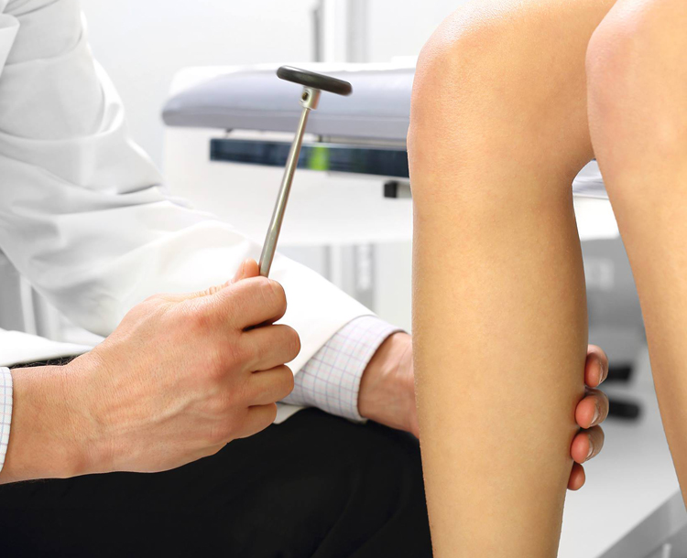
Neurological examination is a systematic and comprehensive assessment used to evaluate the functioning of the nervous system. It plays a vital role in identifying abnormalities related to the brain, spinal cord, and peripheral nerves. This examination helps healthcare professionals in diagnosing neurological disorders, localizing lesions, and planning appropriate treatment.
The neurological examination consists of seven major categories, including Mental Status Examination, Cranial Nerve Examination, Motor System, Reflexes, Sensory System, Coordination, and Gait. Each component provides essential information about different aspects of nervous system functioning.
Among these, the Mental Status Examination assesses cognitive and behavioral functions such as memory, attention, language, and orientation. Cranial nerve examination evaluates sensory and motor functions of the head and neck, while motor and sensory assessments help in identifying muscle strength, tone, and sensory deficits.
Reflex testing and coordination assessment are important for understanding the integrity of neural pathways, whereas gait analysis provides insight into balance and movement disorders.
Overall, neurological examination is a fundamental clinical skill that enables early detection, accurate diagnosis, and effective management of neurological conditions. It is especially important for nursing students and healthcare professionals to develop competency in performing and interpreting neurological assessments.
Methodology:
Research Title: Enhancing Knowledge of Neurological Examination Among Nursing Students and Staff Nurses Through Structured Teaching Programme: An Experimental Study.

OBJECTIVES OF THE STUDY:
• To assess the pre-test knowledge of nursing students and staff nurses regarding neurological examination.
• To implement a structured teaching programme on neurological examination.
• To evaluate the post-test knowledge of participants after the intervention.
• To compare the pre-test and post-test knowledge scores to determine the effectiveness of the teaching programme.

AIM:
To evaluate the effectiveness of a structured teaching programme in enhancing the knowledge of nursing students and staff nurses regarding neurological examination of patients in Himachal Pradesh.
Research Design: Pre-Experimental Research (One Group pre-test post-test only design)
Sample Size: 15
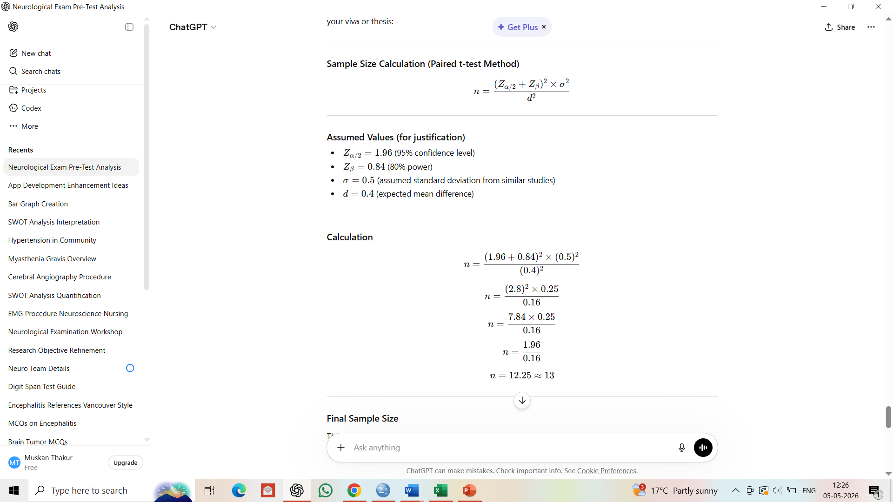
Sampling Technique: Simple Random Sampling
Research Setting: IGMC, Shimla
Intervention: Structured Teaching using Power point Presentation and Demonstrations
Abstract
Neurological examination is a fundamental component of patient assessment, requiring adequate knowledge and clinical competence among nursing professionals. This experimental study was conducted to evaluate the effectiveness of a structured teaching programme in enhancing the knowledge of nursing students and staff nurses regarding neurological examination of patients in Himachal Pradesh. A pre-experimental one-group pre-test and post-test design was adopted, and a total of 15 participants were selected using a convenient sampling technique. Baseline knowledge was assessed using a structured questionnaire covering key domains such as mental status examination, cranial nerves, motor system, reflexes, coordination, and gait.
The pre-test results revealed inadequate knowledge among participants, with low mean scores and a higher proportion of incorrect responses, particularly in areas related to reflexes and specific neurological tests. Following this, a structured teaching programme was administered. Post-test findings demonstrated a significant improvement in knowledge, with most participants achieving near-perfect scores and minimal variability. The paired t-test analysis showed a highly significant difference between pre-test and post-test scores (t = -13.229, p < 0.001), indicating the effectiveness of the intervention.
The study concludes that structured teaching programmes are highly effective in improving knowledge of neurological examination among nursing personnel. It is recommended that such educational interventions be regularly incorporated into nursing education and in-service training to enhance clinical competency and improve patient care outcomes.
Keywords:
Neurological Examination, Structured Teaching Programme, Nursing Students, Staff Nurses, Knowledge Enhancement, Pre-test and Post-test, Experimental Study, Clinical Competency, Nursing Education, Himachal Pradesh.

ANALYSIS AND INTERPRETATION

Section I- Frequency, Mean and SD of Pre-test

Pre-test Questions | f |  | Mean | SD
- How many categories are included in neurological examination?  5  6  7  8 | Wrong Answers  9 | Right  Answers  6 | 0.40 | 0.507
- Mental Status Examination (MSE) is used to assess:  Only motor function  Behavioral and cognitive functioning  Reflexes only  Sensory system only | 10 | 5 | 0.33 | 0.488
- Which of the following is NOT a component of MSE?  Memory  Mood and affect  Blood pressure  Language | 10 | 5 | 0.33 | 0.488
- The Digit Span Test assesses:  Motor strength  Memory and attention  Reflexes  Gait | 12 | 3 | 0.20 | 0.414
- Cranial nerves are  10 pairs  11 pairs  12 pairs  14 pairs | 10 | 5 | 0.33 | 0.488
- Which of the following is assessed in motor examination?  Muscle tone  Muscle strength  Coordination  All of the above | 10 | 5 | 0.33 | 0.488
- Flaccidity means  Increased muscle tone  Decreased muscle tone  Normal tone  Painful muscle | 10 | 5 | 0.33 | 0.488
- The Patellar reflex tests which spinal level?  C5–C6  L2–L4  S1–S2  C6–C7 | 13 | 2 | 0.13 | 0.352
- Achilles reflex is also called  Knee jerk  Ankle jerk  Biceps reflex  Triceps reflex | 13 | 2 | 0.13 | 0.352
- Babinski sign is considered abnormal in:  Infants  Adults  Children only  All ages | 13 | 2 | 0.13 | 0.352
- Normal reflex grading is:  0  1  2  4 | 12 | 3 | 0.20 | 0.414
- Graphesthesia refers to:  Recognizing objects by touch  Recognizing writing on skin  Pain sensation  Vibration sense | 11 | 4 | 0.27 | 0.458
- Romberg test assesses:  Muscle strength  Coordination  Balance and proprioception  Reflexes | 9 | 6 | 0.40 | 0.507
- Finger-to-nose test evaluates:  Sensory system  Coordination  Reflexes  Gait | 10 | 5 | 0.33 | 0.488
- Parkinsonian gait is characterized by:  Wide base walking  Shuffling steps  High stepping  Limping | 7 | 8 | 0.53 | 0.516

This table represents : The pre-test data indicate that participants had generally low baseline knowledge regarding neurological examination, as reflected by a higher number of wrong answers compared to correct ones in most questions. Only a few areas, such as Parkinsonian gait (8 correct responses) and Romberg test (6 correct responses), showed relatively better understanding. Several critical topics—including patellar reflex, Achilles reflex, and Babinski sign—had very low correct responses (only 2), highlighting major knowledge gaps in reflex assessment. The mean scores further support this trend, with most values ranging between 0.13 and 0.40, indicating poor performance overall. The standard deviation values suggest moderate variability in responses, meaning participants differed somewhat in their knowledge levels. Questions related to MSE, motor examination, and cranial nerves also showed limited correct responses, emphasizing insufficient conceptual clarity. Overall, the findings reveal inadequate pre-existing knowledge and a clear need for structured educational intervention to improve competency in neurological assessment.

Section II- Frequency, Mean and SD of Post-test

Post-test Questions | f |  | Mean | SD
- How many categories are included in neurological examination?  5  6  7  8 | Wrong answers  0 | Right  Answers  15 | 1 | 0
- Mental Status Examination (MSE) is used to assess:  Only motor function  Behavioral and cognitive functioning  Reflexes only  Sensory system only | 0 | 15 | 1 | 0
- Which of the following is NOT a component of MSE?  Memory  Mood and affect  Blood pressure  Language | 0 | 15 | 1 | 0
- 0 The Digit Span Test assesses:  Motor strength  Memory and attention  Reflexes  Gait | 0 | 15 | 1 | 0
- Cranial nerves are  10 pairs  11 pairs  12 pairs  14 pairs | 0 | 15 | 1 | 0
- Which of the following is assessed in motor examination?  Muscle tone  Muscle strength  Coordination  All of the above | 0 | 15 | 1 | 0
- Flaccidity means  Increased muscle tone  Decreased muscle tone  Normal tone  Painful muscle | 0 | 15 | 1 | 0
- The Patellar reflex tests which spinal level?  C5–C6  L2–L4  S1–S2  C6–C7 | 0 | 15 | 1 | 0
- Achilles reflex is also called  Knee jerk  Ankle jerk  Biceps reflex  Triceps reflex | 1 | 14 | 0.933 | 0.258
- Babinski sign is considered abnormal in:  Infants  Adults  Children only  All ages | 0 | 15 | 1 | 0
- Normal reflex grading is:  0  1  2  4 | 0 | 15 | 1 | 0
- Graphesthesia refers to:  Recognizing objects by touch  Recognizing writing on skin  Pain sensation  Vibration sense | 1 | 14 | 0.933 | 0.258
- Romberg test assesses:  Muscle strength  Coordination  Balance and proprioception  Reflexes | 0 | 15 | 1 | 0
- Finger-to-nose test evaluates:  Sensory system  Coordination  Reflexes  Gait | 3 | 12 | 0.80 | 0.414
- Parkinsonian gait is characterized by:  Wide base walking  Shuffling steps  High stepping  Limping | 1 | 14 | 0.933 | 0.258

This table represents : The post-test findings show a dramatic improvement in participants’ knowledge of neurological examination, with almost all questions having 15 correct responses and zero wrong answers. Most items achieved a perfect mean score of 1.00 with a standard deviation of 0, indicating complete accuracy and uniformity among participants. This reflects excellent understanding of key areas such as Mental Status Examination, cranial nerves, motor system, and reflex assessment after the intervention. A few questions—such as Achilles reflex, graphesthesia, finger-to-nose test, and Parkinsonian gait—had slightly lower correct responses, but still demonstrated high performance with mean scores ranging from 0.80 to 0.933. The minimal standard deviation in these items suggests only slight variation in responses. Compared to the pre-test, there is a clear and substantial gain in knowledge across all domains. Overall, the results confirm that the educational intervention was highly effective in improving participants’ competency in neurological assessment.

Section-III Paired t-Test Value:

Knowledge  Level | Mean | SD | Paired t-test value | df | Sig.(2-tailed)
Pre-test knowledge | -1.66667 | .48795 | -13.229 | 14 | .000
Post-test knowledge

This table represents : The paired t-test results indicate a statistically significant improvement in knowledge after the intervention. The mean difference of -1.66667 shows a substantial increase in post-test scores compared to pre-test scores. The calculated t-value (-13.229) is very high, suggesting a strong effect of the educational program. With a degree of freedom (df) of 14, the significance value (p = .000) is far below the standard level of 0.05, confirming that the difference is highly significant and not due to chance. The standard deviation (0.48795) indicates moderate variability in the difference scores among participants. Overall, these findings clearly demonstrate that the teaching intervention was highly effective in improving participants’ knowledge of neurological examination.
Overall Result:
The overall findings of the study reveal that participants had inadequate baseline knowledge regarding neurological examination, as indicated by low pre-test mean scores and a higher frequency of incorrect responses. After the educational intervention, there was a remarkable improvement in knowledge, with post-test scores showing near-perfect mean values and minimal variability. Most participants answered all questions correctly in the post-test, reflecting a high level of understanding across all domains, including mental status examination, cranial nerves, motor system, reflexes, and coordination. The paired t-test result (t = -13.229, p < 0.001) confirms that the improvement in knowledge was statistically highly significant. This demonstrates that the intervention had a strong positive impact on participants’ learning outcomes.
Conclusion:
The study concludes that the educational intervention was highly effective in enhancing knowledge of neurological examination among participants. There was a clear and significant difference between pre-test and post-test scores, indicating successful knowledge acquisition. Initially, participants lacked adequate understanding in key areas, especially reflexes and specific neurological tests. However, post-intervention results showed excellent comprehension and retention of concepts. The statistical analysis further supports that the improvement was not due to chance. Therefore, structured teaching programs play a crucial role in strengthening clinical knowledge. Such interventions should be regularly implemented in nursing education. Continuous training can improve competency and patient care quality. Overall, the study highlights the importance of targeted educational strategies in improving neurological assessment skills.

