A Quantitative Analysis of Channelizing Island as a Traffic Calming Device: A Comprehensive Analysis of Post-Construction Traffic Congestion of Vehicular Flow

Abstract
This study evaluates the effectiveness of the latest traffic calming measures in Intramuros, Manila, by examining traffic flow after the construction of a newly created channelizing island in Victoria Street. The study employed a non-experimental, quantitative method to measure traffic volumes during peak periods and applied Passenger Car Equivalent Factors (PCEF) to standardize the results. These measures were then used to determine the Peak Hour Factor (PHF), Design Hourly Volume (DHV), Volume-to-Capacity Ratio (VCR), and Level of Service (LOS). A one-way ANOVA was also performed to assess differences across time points. The absolute peak hour occurred between 6:00 and 7:00 PM, recording 1,209 vehicles, yielding a PHF of 0.87 and a DHV of 188.9 veh/hr. These values indicate the roadway is at Level of Service B (relatively free-flowing), given the maximum computed VCR of 0.48. The difference in traffic demand between the morning and afternoon/evening peaks was statistically significant (p = 0.035). Combined, these findings suggest that this channelizing island provides sufficient roadway capacity while promoting stable traffic flow without excessive congestion.

Keywords: Channelizing Island, Traffic Calming Device, Traffic Flow, Pedestrian Safety, Urban Mobility, Volume-to-Capacity Ratio (VCR), Level of Service (LOS), Peak Hour Factor (PHF), Design Hourly Volume (DHV), Passenger Car Equivalent Factor (PCEF)

Introduction
Traffic congestion and pedestrian safety have become major challenges in urban areas, particularly in the Philippines, where rapid urbanization has worsened these issues. Given concerns about pedestrian safety and traffic flow, channelizing islands have been suggested to reduce vehicle-pedestrian conflicts and improve traffic flow organization. According to research, these infrastructures can reduce vehicle-pedestrian conflicts and contribute to a safer crossing experience by providing designated pedestrian waiting zones (Mendoza and Santos, 2019).

Consequently, this research uses the level of service (LOS) as the main reference to determine the standardized ranking of the condition of operating transport facilities in the area. Level of service (LOS) is a qualitative measure of roadway operating conditions, and VCR is a measure of how much traffic is carried relative to the roadway's capacity (DPWH, 2012; Transportation Research Board, 2016). The following figures are used:
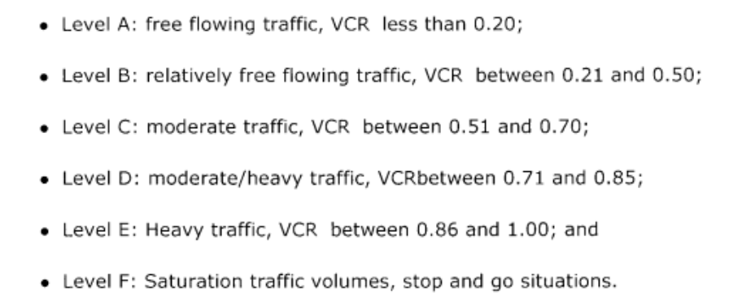
Figure 1. Level of Service Criteria (LOS)
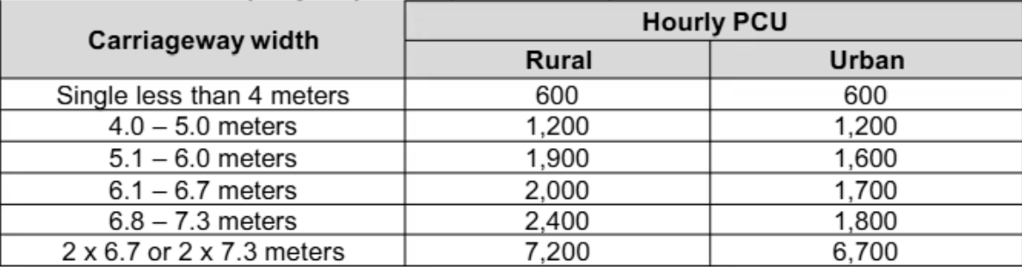
Figure 2. Passenger Car Equivalent Factor (PCEF)

The traffic analysis also incorporated Passenger Car Equivalent Factor (PCEF) and Average Annual Daily Traffic (AADT) data to calculate key performance indicators, including the Peak Hour Factor (PHF), Design Hourly Volume (DHV), and Volume Capacity Ratio (VCR). The following are the formulas used:

Design Hour Volume [DHV] = K * Average Annual Daily Traffic [AADT]
Eq 1. Design Hour Volume

Peak Hour Factor [PHF] = Total Hourly Volume / 4 * Traffic volume during the highest 15-minute interval
Eq 2. Peak Hour Factor

Volume Capacity Ratio [VCR] = Vehicles or passenger cars per hour / Maximum capacity of the road
Eq 3. Volume Capacity Ratio

The Intramuros Administration's Average Annual Daily Traffic (AADT) of 1,800 vehicles per day was used for the calculation of the Design Hour Volume (DHV). The Volume-to-Capacity Ratio (VCR) was calculated using the actual traffic count data collected during the study and was compared to the roadway's capacity to help determine the traffic flow condition. The given and computed data were used in a one-way ANOVA to determine whether significant differences exist between observed traffic conditions during peak periods. Through this approach, the study provides a quantitative basis for understanding current roadway performance and recommending improvements that may further enhance traffic flow efficiency and road safety.

Moreover, by conducting a traffic impact analysis in the specific area, this paper identifies the major factors affecting congestion and pedestrian safety, including channelizing islands, vehicle-pedestrian interaction, geometric intersection planning, and road hazard reduction. Through a detailed evaluation of traffic volume characteristics, flow performance, and statistical road conditions, the study examines how strategic design influences user behavior to maximize pedestrian safety and traffic flow dynamics.

Furthermore, the purpose of this study is to assess the effects of the newly constructed channelizing island along Victoria Street, Intramuros, Manila, with a particular emphasis on its ability to improve traffic flow and contribute to organized vehicle-pedestrian movement . By conducting a comprehensive analysis of post-construction data, this research provides valuable insights into the infrastructure's real-world utility for traffic management. Ultimately, these empirical findings help evaluate how effectively the intervention optimizes vehicle dynamics while safeguarding pedestrians.

Results and Discussion

Traffic Volume Characteristics

Some of the traffic data gathered around the channelizing island along Victoria Street in the City of Manila in the Intramuros area, was analyzed to establish the post-construction traffic condition. Vehicle classification was performed using Passenger Car Equivalent Factors (PCEFs) to convert different vehicle types into a common format for comparing traffic demand with roadway capacity. The analysis was carried out using the observed peak periods to assess the roadway's operating condition.

The peak traffic period was the afternoon/evening, from 6:00 PM to 7:00 PM, with an observed traffic volume of 1,209 vehicles. This suggests that peak traffic occurs in the evening, likely due to higher commuter and urban activity at that time.

Peak Period | Observed Vehicle Volume
Morning Peak | 1,086 vehicles
Afternoon-Evening Peak | 1,209 vehicles
Highest Traffic Period | 6:00 PM – 7:00 PM

Table 1. Observed Traffic Volume per Peak Period

The observed traffic analyses have shown that the area is subject to higher demand at peak times, but the roadway remains in acceptable condition for operation as determined by traffic performance indicators.

Traffic Flow Performance Analysis

Peak Hour Factor (PHF), Design Hour Volume (DHV), Volume-to-Capacity Ratio (VCR), and Level of Service (LOS) were used to assess the performance of the roadway. The following indicators were used to identify post-construction congestion on the channelizing island area.

The Peak Hour Factor (PHF) is calculated and found to be 0.87, which means the traffic is relatively even during the peak hour. A higher PHF value is indicative of a more balanced traffic demand in time than a concentrated demand in short time, which in turn decreases the likelihood of congestion.

Design Hour Volume (DHV) computed was 188.9 vehicles per hour which is the peak traffic volume during the critical operating period.

Parameter | Result | Interpretation
Peak Hour Factor (PHF) | 0.87 | Stable traffic distribution
Design Hour Volume (DHV) | 188.9 veh/hr | Estimated peak demand
Volume-to-Capacity Ratio (VCR) | 0.48 | Roadway operates below capacity
Level of Service (LOS) | B | Good operating condition
Table 2. Traffic Performance Indicators

The VCR value of 0.48 means that the roadway is operating at less than 50% capacity. This shows that the channelizing island does not obstruct the traffic significantly within the studied area.

The roadway has met Level of Service B. This means that vehicles can travel efficiently and that the existing roadway capacity is adequate for the traffic demand that is observed.

Statistical Analysis of Traffic Conditions

A one-way Analysis of Variance (ANOVA) was conducted to determine whether significant differences existed between the observed traffic conditions during the different peak periods.

The F value obtained was 5.036 and the significance value was 0.035. As the significance value is less than the level of significance (0.05), the null hypothesis was rejected.

Source of Variation | SS | df | MS | F | p-value
Between Groups | 0.0145 | 1 | 0.0145 | 5.036 | 0.035
Within Groups | 0.0634 | 22 | 0.0029
Total | 0.0779 | 23

Table 3. One-way ANOVA (Statistical Treatment)

The result indicates that traffic conditions vary significantly between peak periods. The difference is a result of variations in the traffic demand during the day, especially during the morning compared to the evening.

The statistical analysis is only able to show that differences do exist between traffic conditions, however, it cannot be used independently to prove that the changes are attributable to the channelizing island only. The effectiveness evaluation was thus conducted on the basis of the joint evaluation of statistical results and roadway performance indicators like LOS and VCR.

Discussion of Channelizing Island Performance

The results suggest the channelizing island is an effective traffic control device as used. The roadway continued to run at LOS B and had a VCR of 0.48, indicating that the infrastructure does not have a negative impact on the capacity of the roadway.

The results confirm the conclusions of earlier transportation studies that channelization of islands can enhance traffic organization by controlling traffic flow, minimizing conflict points, and providing predictable vehicle movements. The island physically separates traffic flow and helps to achieve efficient roadway operations while maintaining acceptable traffic flow.

While the study has shown satisfactory performance, it should be noted that a before and after comparison was not made. So, the results are indicative of the current operational status of the roadway and not necessarily the same level of improvement as a result of the installation.

Future studies could enhance the evaluation by incorporating pre-construction traffic data, pedestrian behavior analysis, vehicle speed measurements, and accident data to better quantify the overall safety benefits of the channelizing island.

Conclusion

This study analyzed the traffic performance of the channelizing island after its construction through quantitative traffic engineering measures along Victoria Street, Intramuros, Manila. The data used was traffic volume data, Passenger Car Equivalent Factors (PCEF), Peak Hour Factor (PHF), Design Hour Volume (DHV), Volume-to-Capacity Ratio (VCR), Level of Service (LOS) and statistical analysis using one way ANOVA.

It was found that the highest traffic demand took place during the afternoon / evening peak period, where 1,209 vehicles were counted during the period 6.00 PM to 7.00 PM. In spite of the high traffic demand, the roadway remained in fairly good operating conditions with a PHF value of 0.87, DHV of 188.9 vehicles/hour, and a maximum VCR of 0.48.

The roadway was rated at LOS B, which represents a stable traffic flow and adequate roadway capacity. The ANOVA results also revealed a statistically significant difference between peak-period traffic conditions, which suggests that there were variations in the traffic demand during the day.

The results indicate that the channelizing island is effective at providing organized traffic flow and satisfactory roadway performance in its current configuration. However, the study only examined post-construction conditions, hence additional studies with before/after comparisons are recommended to quantify the direct effect of the channelizing island on traffic improvement.

Reference/s:
Abaya, E., Fabian, B., Gota, S., & Mejia, A. (2011). Assessment of Pedestrian Facilities in Major Cities of the Philippines. Proceedings of the Eastern Asia Society for Transportation Studies, 8. https://www.jstage.jst.go.jp/article/eastpro/2011/0/2011_0_243/_pdf
Abayari, R. M., Dematera, K. A., Ilas, G., Paeste, R. M., Taveso, D., Valenzuela, I., & Tolentino, L. K. S. (2015). Analysis of Accidents in San Marcelino St. and Ayala Boulevard Intersection: Pedestrian or Motorist. International Conference on Higher Education (IRCHE). https://papers.ssrn.com/sol3/papers.cfm?abstract_id=3592295
Adiong, R. A., & Ramos, M. J. (2020). Pedestrian safety in Metro Manila: An analysis of road user behavior. Philippine Journal of Transportation Studies, 14(2), 45-60.
Alfonso, M., Delos Santos, Z., Hipolito, F., Manaloto, J., Pareña, H., Velasco, G., Guiao, B., & Tongol, J. (2023). Analysis of Factors Associated with Pedestrians’ Crossing Behavior along MacArthur Highway, San Matias, Santo Tomas, Pampanga. IRE Journals. https://www.irejournals.com/formatedpaper/1704719.pdf
Alvarez, L. (2022, May 31). What is Peak Hour Factor (PHF)? UrbanLogiq. https://urbanlogiq.com/what-is-peak-hour-factor-phf/
Aquitania, R. L., Roxas, D. C., & Soriano, J. (2023). Enabling pedestrian-related traffic studies through a realistic pedestrian simulation module in LocalSim. Proceedings of the 29th Annual Conference of the TSSP and Philippine Transportation Journal.
Asian Institute of Management - Policy Center. (2020). "Economic and Social Impact Assessment of Traffic Islands in Metro Manila." AIM Policy Brief, 14(2), 30-45.
Cao, Y., Ni, Y., & Li, K. (2017). Effects of Refuge Island Settings on Pedestrian Safety Perception and Signal Violation at Signalized Intersections. ResearchGate. https://www.researchgate.net/publication/317411298_Effects_of_Refuge_Island_Settings_on_Pedestrian_Safety_Perception_and_Signal_Violation_at_Signalized_Intersections
Cruz, J. (2018). "Design Considerations for Traffic Islands in Urban Areas." Journal of Philippine Infrastructure and Development, 12(3), 45-59.
Dey, D., & Terken, J. (2017). Pedestrian Interaction with Vehicles: Roles of Explicit and Implicit Communication. ResearchGate. https://www.researchgate.net/publication/320073542_Pedestrian_Interaction_with_Vehicles_Roles_of_Explicit_and_Implicit_Communication
Department of Public Works and Highways. (2012). Highway safety design standards manual. DPWH.
Engineers), I.(.O. T., Wolshon, B., & Pande, A. (2016). Traffic Engineering Handbook, 7th Edition (7th ed.). Wiley Professional, Reference & Trade (Wiley K&L). https://bookshelf.vitalsource.com/books/9781118762264
Era, M., Fillone, A., Yu, K. D., Paringit, M. C., & Lucero, P. I. (2023). Social and Gender Issues Related to the Implementation of the Traffic Discipline Zone (TDZ) in Malate, Manila. Asia-Pacific Social Science Review, 23. https://doi.org/10.59588/2350-8329.1506
Estrada, A. C., & Bautista, M. L. (2020). Traffic congestion and its impact on pedestrian safety in Cebu City. Cebu Journal of Environmental Studies, 16(2), 55-72.
Federal Highway Administration. (2018). Guide for improving pedestrian safety at uncontrolled crossing locations (Report No. FHWA-SA-17-072). U.S. Department of Transportation.
Federal Highway Administration. (2022). Improving Intersections for Pedestrians and Bicyclists: Informational Guide. U.S. Department of Transportation.
Garber, N. J., & Hoel, L. A. (2019). Traffic and Highway Engineering, Enhanced Edition (5th ed.). Cengage Learning US. https://bookshelf.vitalsource.com/books/9780357111772
Hydén, C. (2021). Refuge islands. In ScienceDirect. https://www.sciencedirect.com/science/article/abs/pii/B9780081026717101721
Japan International Cooperation Agency (JICA). (2022). The project for comprehensive traffic management plan for Metro Manila: Technical report no. 9: Guidebook on traffic management. https://openjicareport.jica.go.jp/pdf/12374856_05.pdf
Kim, J., Lee, J., Koh, H., & Kum, K. J. (2023). A Study on the Severity Factors of Traffic Accidents at Intersections with Traffic Island : A Case Study of Seongnam City. Daehan Gyotong Hakoeji/Daehan Gyotong Haghoeji, 41(3), 340–352. https://doi.org/10.7470/jkst.2023.41.3.340
Mannering, F. L., & Washburn, S. S. (2019). Principles of Highway Engineering and Traffic Analysis (7th ed.). Wiley Global Education US. https://bookshelf.vitalsource.com/books/9781119493969
Mendoza, R., & Santos, P. (2019). "Impact of Traffic Islands on Traffic Flow and Safety in Metro Manila." Transport Research Journal of the Philippines, 14(2), 67-82.
National Academies of Sciences, Engineering, and Medicine. (2022). Highway capacity manual 7th edition: A guide for multimodal mobility analysis. The National Academies Press.
Neil Andrew Menjares. (2015, February 22). Summary Report on Road Safety in the Philippines. Academia.edu. https://www.academia.edu/10991631/Summary_Report_on_Road_Safety_in_the_Philippines?auto=download
Pedestrian Refuge Island – Road Safety Toolkit. (2022). https://toolkit.irap.org/safer-road-treatments/pedestrian-refuge-island/
Philippine Institute for Development Studies (PIDS) (2018). Road Infrastructure and Traffic Islands in Urban Development. Makati City: PIDS.
Reyes, L., Tan, S., & Villanueva, M. (2020). "Pedestrian Safety and Accessibility in Traffic Islands: A Case Study in Quezon City." Urban Planning and Transportation Review, 8(1), 101-115.
Sadrayi, A., & Boroujerdian, A. (2016). Assessment of Pedestrian Refuge Islands on Vehicle Speed Changes and Pedestrian Safety: Case Study in Tehran. Journal of Traffic and Logistics Engineering, 4(1). http://www.jtle.net/uploadfile/2016/0531/20160531041637565.pdf
Singh, R., & Gupta, A. (2021). Improving urban traffic flow through design innovations. International Journal of Civil Engineering, 29(4), 333-345.
Sustainable development goals. (2024). UNDP. https://www.undp.org/sustainable-development-goals/industry-innovation-and-infrastructure
Texas A&M Transportation Institute. (2016). A Report on the Development of Guidelines for Applying Right-Turn Slip Lanes. TxDOT Research Library.
Thakur, S., & Biswas, S. (2019). Assessment of pedestrian-vehicle interaction on urban roads: a critical review. Archives of Transport. 51. 49-63. https://doi.org/10.5604/01.3001.0013.6162
Torres, G. P. (2017). Urban Spaces and Traffic Islands: Planning and Design for Metro Manila. Manila: University of the Philippines Press.
Transportation Research Board. (2016). Highway capacity manual (6th ed.). National Academies Press. https://doi.org/10.17226/24798
University of the Philippines National Center for Transportation Studies (UP-NCTS). (2021). "Public Perception of Traffic Islands in Metro Manila." UP-NCTS Survey Report.
Zamora, H. D., & Lim, F. J. (2019). Pedestrian-related accidents in the Philippines: A statistical overview. Journal of Philippine Statistics, 23(1), 1-15.
Zheng, L., Fan, S., & Jiao, H. (2023). Study on the effects of refuge islands on pedestrian crossing behavior and safety. ASCE. https://doi.org/10.1061/9780784484869.124

