Exploring the Multi-Theoretical Pathways between Work Life Balance (WLB) and Organizational Commitment (OC): An IMRAD-Based Framework

ABSTRACT

Purpose: Despite the many studies focusing on work life balance (WLB) and organizational commitment (OC), the literature on human resource development (HRD) is lacking in integrative, theory-forming explanations of how gendered, socio-cultural, and contextual factors all interact to shape commitment in high-intensity professions. This shortage is particularly severe among female doctors who practice at the private health-care facilities.

Design/methodology/approach: The current study uses a conceptual and theory-building methodology that is consistent with the scholarly literature of HRD, which builds an integrated framework based on five existing perspectives, i.e., Spillover Theory, Social Exchange Theory, Conservation of Resources Theory, the Job Demands-resources model, and Self-Determination Theory. In this context, the work-life balance is theorized as the major mediating developmental process and the marital status is hypothesized as a demarcating condition that remedies the linkage between work-life balance and organizational-commitment.

Findings: The research progresses six theoretically based propositions that outline the influence of personal-professional demands, socio-cultural expectations, external stressors and gender discrimination on work-life balance, which in turn impacts affective, continuance and normative types of organizational commitment.

Originality/value: This article will contribute to HRD and management research by providing a multi-theoretical and gender-sensitive approach that goes beyond single-theory explanations that are fragmented. The theorization of work-life balance as a development process and marital status as a moderating condition explicitly gives a sensitive insight into employee development, retention and sustainable workforce management in the health-care arena.

Keywords: Work-Life Balance, Organizational Commitment, Female Doctors, Multi-theoretical Framework, Marital Status, Gender Discrimination

INTRODUCTION

The research on human resource development (HRD) continues to predict the sustainability of employees, their well-being and long-term attachment with the organization as the strategic consequences of effective people management. Work-life balance (WLB) has become a developmental issue of particular concern in quality of work in high-demand jobs that are marked with emotional labour, long hours, and continued role overload, as part of this discourse. The healthcare environment is one of such settings, where the current labor scarcity, the growing demands of services, and the swift feminization of the workforce increase the importance of WLB in terms of organizational performance and human capital formation.

Women doctors are placed in a very special status in modern healthcare systems. They often have to negotiate deeply rooted socio-cultural norms of caregiving, gender roles and gender-appropriate behavior along with their intensive clinical responsibilities. Previous studies have always shown that these two pressures of roles increase work-family conflict, psychological strain and turnover intentions, and thus hinder organizational commitment (OC). HRD-wise, reduced commitment is not only the increase in the risk of retention but also the waste of investments in professional capability development and knowledge of the organization.

Whereas the research has long been studied as a precursor of OC, the current body of research is theoretically disjointed. A large part of the literature is either based on single-theory explanations or is narrow in its concentration on organizational determinants, and does not provide much information about the interaction of socio-cultural norms, gender discrimination, and exogenous stress factors in influencing the experiences of workers. Furthermore, contextual boundary conditions especially marital status has been largely theorized without being given much consideration despite its significance to women professionals working in collectivist and family-oriented societies.

Overcoming these shortcomings, this paper draws a multi-theoretical framework that lies at the crossroad of HRD and management literature. The paper uses a conceptualization based on the combination of five major organizational behavior theories that WLB can be conceptualized as a mediating developmental process between various antecedents and organizational commitment outcomes, with marital status moderating the quality of this interaction. By so doing, the paper addresses HRD research calls to be more integrative of theory, more sensitive to context, and more gender-sensitive models that can explain the intersection of development, well-being, and commitment in modern organizations.

Research gap

The existing academic literature lacks unifying models of how personal-professional demands, socio-cultural requirements, gender discrimination, and external stressors can be integrated simultaneously to explain the balance between workplace and family and occupational commitment. Multi-theoretical theories are also quite uncommon, and the moderating role of marital status in healthcare settings is not theorized in a sufficient manner (Kossek and Ozeki, 1998; Allen et al., 2000; Haar et al., 2014).

Research objectives
- The proposed study will explore the impact of personal-professional issues, socio-cultural demands, external stress, and gender discrimination on work-life balance (WLB) in female physicians.

- It attempts to theorize the concept of WLB as an intermediating process, which connects antecedents to both affective, continuance, and normative commitment.

- The research also determines the moderating effect of marital status on the relationship between WLB and occupational commitment (OC).

- Lastly, the research comes up with testable propositions which can be empirically tested in future research.

Research question

How are Work-Life Balance and Organizational Commitment among female physicians affected by contextual, personal-professional, and gender-based antecedents, and how is marital status a moderator of this relationship?

CONCEPTUAL FRAMEWORK

The conceptual framework is indicated in Figure 1. There are four antecedent variables, namely, (i) Personal and Professional Factors, (ii) Socio-Cultural Elements, (iii) External Stressors, and (iv) Gender Discrimination, which are abstracted as direct predictors of Work-Life Balance (WLB). WLB is hypothesized to serve as a mediating variable that impacts the three levels of Organizational Commitment (OC). The moderating variable that is theorized to mute or enhance the WLB-OC relationship is marital status.

This structure provides the ground for a multi-theoretical investigation based on tested theories of organizational behavior. The next sections expound on how five theoretical perspectives shape each of these concepts: Spillover Theory, Social Exchange Theory, Conservation of Resources Theory, the Job Demands–Resources Model, and Self-Determination Theory.

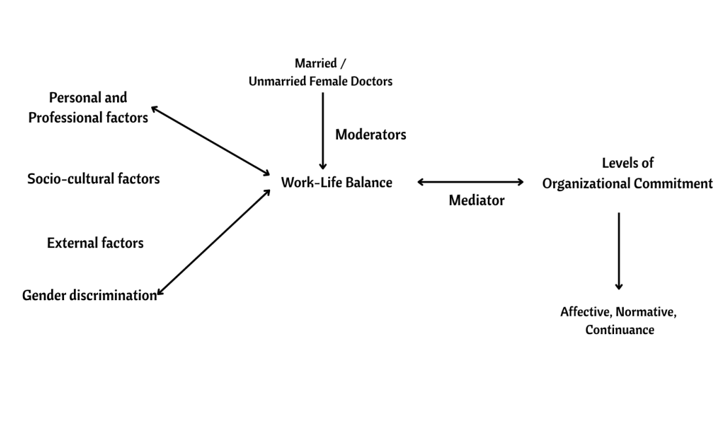 Figure 1. Conceptual Framework Linking Antecedents, Work–Life Balance, and Organizational Commitment (Source: Author’s compilation)

THEORETICAL BACKGROUND AND PATH ANALYSIS

This subsection clarifies how each one of the five root theories underpins various elements of the conceptual framework. Combined, they shed light on how various antecedents contribute to Work-Life Balance (WLB) and, in turn, Organizational Commitment (OC). Multi-theoretical alignment is imperative in resolving the addressed research gap, meeting stated goals, and responding to the guiding research question.

Spillover theory

Spillover Theory argues that experiences, moods, and needs in one area of life—e.g., work or family—have the potential to affect performance in another (Edwards & Rothbard, 2000). The crossover can be both beneficial and detrimental, affecting mood, behavior, and levels of energy. In female physicians, long working hours, high emotional labor demands, and clinical workload tend to create adverse spillover into home life, interfering with Work-Life Balance (WLB) and lowering Organizational Commitment (OC). Current views on spillover also emphasize the possibility of positive interactions between domains, for example, increased self-efficacy in the home environment as a result of professional achievement (Wayne et al., 2007). Spillover theory is, therefore, a rich framework for appreciating how work experiences—particularly in high-demand occupations—spill over into the broader life satisfaction and level of commitment.

Social exchange theory (set)

Social Exchange Theory (SET) offers a starting-point perspective to explore the mutual dynamics of employees and organizations. It suggests that the quality of the employee–organization relationship is established by perceived fairness, mutual obligations, and resource exchange (Blau, 1986; Cropanzano & Mitchell, 2005). SET posits the support of personal and professional variables to WLB by implying that while organizations show support—through policies, flexibility, or affective resources—employees respond with higher affective commitment and loyalty. On the other hand, the lack of the same in organizations that have environments of gender discrimination can contribute to the breakdown of psychological contracts and reduce WLB and OC. In the case of female doctors, SET assists in understanding how socio-cultural forces and workplace routines cross-interact to establish impressions of support or injustice, eventually determining their work-life integration and organizational devotion.

Conservation of Resources (COR) Theory

Conservation of Resources (COR) Theory proposes that people are driven to attain, maintain, and defend precious resources like time, energy, and psychological strength (Hobfoll, 1989) As these resources are diminished—because of overload roles, discrimination, or hostile work environments—stress is caused, resulting in compromised WLB and lowered OC. In the case of women physicians, COR Theory accounts for why constant demands and gendered expectations drain critical psychological and physical resources. (Hobfoll et al., 2018) also highlight that whenever resource loss is greater than resource gain, the strain intensifies—particularly in organizational cultures without support structures. COR Theory thereby confirms the mediating function of WLB between resource-consuming antecedents and organizational outcomes.

Job demands–resources (jd-r) model

The JD-R Model offers a dynamic approach to explaining employee well-being by contrasting job requirements as demands and resources (Demerouti et al., 2001). Job demands, for example, long working hours, night shifts, and emotional exhaustion, may drain personal resources, while job resources, such as autonomy, managerial support, and flexibility in terms of work schedules, act as buffer factors. In women healthcare workers, the mismatch between excessive job demands and few resources tends to enhance WLB issues and lower OC. (Bakker & Demerouti, 2017) generalized the JD-R model by adding personal resources (e.g., resilience, self-efficacy) and examining how the interaction between demands and resources predicts burnout and engagement. WLB features as a major mechanism by which organizational antecedents influence employee commitment and retention, especially in high-stakes, gendered careers such as medicine.

Self-determination theory (sdt)

Self-Determination Theory (SDT) asserts that humans perform best when their intrinsic psychological needs for autonomy, competence, and relatedness are fulfilled (Deci & Ryan, 2000). In health care environments, structural barriers like inflexible scheduling, hierarchical control, or gender exclusion can undermine these needs, leading to lower motivation, burnout, and decreased organizational attachment. (Van den Broeck et al., 2016) note the way that fulfilling these needs in the workplace increases intrinsic motivation and organizational commitment, and their frustration as resulting in disengagement and work-life imbalance. For female physicians balancing professional and family roles, SDT accounts for the way in which the fulfillment—or suppression—of these needs directly affects their well-being, WLB, and long-term organizational commitment.
Multi-theoretical Integration
Rather than treating theories in isolation, this study consolidates their explanatory logic to avoid redundancy and enhance coherence.
- Spillover Theory explains how emotional and behavioral experiences transfer between work and family domains, intensifying role conflict among female doctors.
- Social Exchange Theory (SET) accounts for reciprocal dynamics between organizational support and employee commitment, highlighting the role of fairness and inclusion.
- Conservation of Resources (COR) Theory frames stress as a consequence of resource depletion arising from excessive demands, discrimination, and external shocks.
- Job Demands–Resources (JD–R) Model provides a structural lens to examine how high demands and insufficient resources undermine WLB and engagement.
- Self-Determination Theory (SDT) adds a motivational dimension, emphasizing autonomy, competence, and relatedness as prerequisites for sustainable commitment.
Together, these theories justify WLB as a central psychological and structural mechanism translating antecedents into organizational outcomes. Table 1 summarizes how each theory aligns with specific constructs in the model.

Theory | Key Conceptual Focus | Related Constructs | Role in the Model
Spillover Theory (Edwards & Rothbard, 2000;Grzywacz & Marks, 2000) | Emotional and behavioral transfer between work and family domains | Personal & Professional Factors → WLB | Explains how work-related demands and emotions spill over into the personal domain, influencing WLB, particularly in dual-role situations
Social Exchange Theory (SET)  (Blau, 1986;Cropanzano & Mitchell, 2005) | Reciprocity in employer–employee relationships | Socio-Cultural Elements → WLB → OC | Demonstrates how perceived organizational support or discrimination affects employee loyalty and commitment through WLB
Conservation of Resources (COR)  (Hobfoll, 1989;Hobfoll et al., 2018) | Resource preservation and stress response | External Stressors, Gender Discrimination → WLB | Provides a stress-based explanation of how resource loss leads to poor WLB and ultimately reduced OC
Job Demands–Resources (JD-R)  (Demerouti et al., 2001;  Bakker & Demerouti, 2017) | Balance between job demands and available resources | All antecedents → WLB → OC | Offers a flexible model to analyze how work demands and resources jointly affect WLB and commitment
Self-Determination Theory (SDT)  (Deci & Ryan, 2000;  Van den Broeck et al., 2016) | Psychological needs of autonomy, competence, and relatedness | Socio-Cultural Elements, Gender Discrimination → WLB → OC | Explains how unmet needs erode intrinsic motivation, WLB, and OC
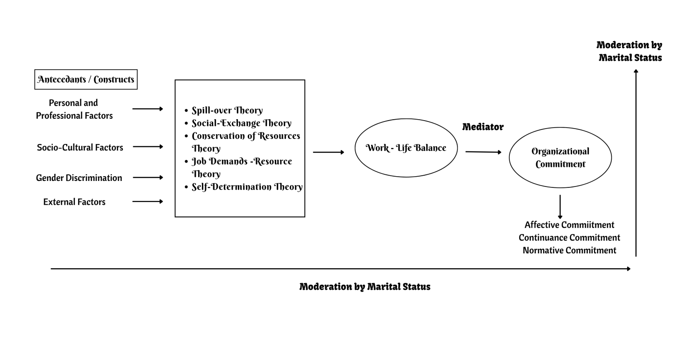
Table 1: Theoretical Foundations and Construct Mapping (Source: Author’s compilation)
Figure 2. Integrated Theoretical Path Model (Source: Author’s compilation)

Marital status as moderator

Marital status intensifies non-work demands and role expectations, particularly for women in collectivist cultures. Across theories, marital status shapes spillover intensity, resource depletion, and the effectiveness of job resources, thereby moderating the WLB–OC relationship.

PROPOSITION DEVELOPMENT
Consistent with IMRAD conventions for conceptual papers, theoretical outputs are presented as propositions.
P1: Personal and professional factors negatively influence Work–Life Balance among female doctors.
P2: Socio-cultural expectations and gender role norms negatively influence Work–Life Balance.
P3: External stressors (e.g., crises, emergencies) negatively influence Work–Life Balance.
P4: Gender discrimination negatively influences Work–Life Balance.
P5: Work–Life Balance positively influences affective, continuance, and normative commitment.
P6: Marital status moderates the relationship between Work–Life Balance and Organizational Commitment, such that the relationship is stronger for married female doctors.

DISCUSSION AND IMPLICATIONS

This section places the suggested multi-theory framework and related propositions within the context of current literature and sets out its theory development, managerial practice, and public policy contribution.

Contribution to theory (human resource development perspective)
This research offers some unique theoretical contributions to scholarly literature on HRD and management.

- Theoretical progress of WLB as a process of development, instead of work-life balance as an effect or personal coping challenge, this framework views WLB as a mediating variable where structural, socio-cultural and organizational factors determine employee commitment. This re-thinking brings WLB closer to the HRD issues of sustainable capability building and workforce sustainability.

- Synthesizing disaggregated theoretical traditions: The synthesis of Spillover Theory, Social Exchange Theory, Conservation of Resources Theory, the JD -R model and Self-Determination Theory allows the study to surpass single-theory explanations, which prevail in previous WLB-OC studies. The integrated framework explains how the dynamics of stress, reciprocity, motivation and resources work together to provide a more detailed explanatory model to the HRD scholars.

- Gendering organizational commitment theory: The theory clearly connects WLB to the affective, continuance and normative commitment showing how gendered and socio-cultural demands selectively influence the form of commitment. This applies the commitment theory to under-theorised healthcare and female professional settings.

- Bringing in marital status as a boundary condition: Theorising marital status as a moderator, the study addresses the call to have context-sensitive models of HRD. It illuminates how family-role set ups mediate the developmental and commitment effects, thus contributing to the COR and JD-R approaches into the HRD studies.

Managerial and practical implications

The results of this study provide practical recommendations for hospital administrators, human resource managers, and policy makers in healthcare institutions:
- Institutions must implement family-friendly policies, including flexible work schedules, telecommuting possibilities, and on-site childcare centers, to mitigate work-family conflict and enable WLB.
- Sensitization programs and anti-discrimination training for managers are necessary to encourage inclusive workplace environments and ensure equal career opportunities for female physicians.
- Tailored interventions that address the marital and family situation of women doctors will contribute to the reduction of stress and increased long-term attachment to the organization.
- Ladies' specific dual-role burdens must be identified as central to the development of supportive and retention-oriented HR practices.

Policy implications
This study identifies a number of key policy-level priorities:
- Regulatory bodies and healthcare institutions must actively implement gender equity frameworks and enforce anti-discrimination legislation in both recruitment and career advancement processes.
- National and regional healthcare regulators should mandate structured work-life balance and well-being programs in all healthcare settings, especially where gender disparities persist.
- Policy tools need to acknowledge the double burdens of work and family imposed on women medical practitioners and institutionalize specific support systems to lower attrition and enhance professional satisfaction.
These are aligned with (Boniol et al., 2019) WHO guidance on maximizing gender equity in the health workforce and the role of institutional accountability to lead change. (Gupta, 2019) supports the importance of evidence-based policies that facilitate gender-balanced planning and organizational culture supporting worker well-being and inclusive participation.

LIMITATIONS AND FUTURE RESEARCH DIRECTIONS

Though this conceptual paper provides a new multi-theoretical model, it too has various limitations that indicate directions for future research.

Scope and conceptual boundaries
This paper offers a conceptual, theory-based model that has yet to be empirically tested. Thus, the hypothesized relationships and propositions rested on grounded theoretical foundations and current literature but need to be tested through quantitative or qualitative research in the future. The strength of the model is its multi-theory integration; however, the same complexity comes with limitations in scope.

The study's context-specific nature—specifically, female doctors practicing in private hospitals in India—could restrict the framework's generalizability across other professional groups, the public healthcare sector, or other cultural contexts. Furthermore, the model focuses on four of the most important antecedents and one moderation variable (marital status), but does not include possibly influential factors such as organizational culture, leadership style, job satisfaction, and psychological well-being. These untested variables provide future directions for extending the framework and sharpening its predictive power

Future research directions

Subsequent studies should test the multi-theoretical model empirically using quantitative, qualitative, or mixed-methods methods. Quantitative research utilizing structural equation modeling (SEM) can confirm the predicted paths of the antecedents to mediators to outcomes, while qualitative methods like interviews or case studies might yield rich contextual insights into the lived experiences of female doctors. Longitudinal designs are particularly indicated to ascertain how work-life balance and organizational commitment change with time as a reaction to shifts in professional requirements, personal life situations, or organizational support systems. Longitudinal studies would also enable observation of causal relations and temporal processes which might be missed in cross-sectional studies.

Moreover, broadening the theoretical basis by bringing in complementary theories like Role Theory, Boundary Theory, or Equity Theory could further increase the model's explanatory capability. Further research could also include more moderators (e.g., organizational culture, leadership styles) and mediators (e.g., job satisfaction, psychological resilience) to provide a more in-depth understanding of the determinants affecting WLB and OC.

CONCLUSION

This research develops an integrated multi-theoretical framework for explaining the antecedents and outcomes of Work-Life Balance (WLB) and its impact on Organizational Commitment (OC) among female doctors in private hospitals. By synthesizing five dominant organizational behavior theories—Spillover Theory, Social Exchange Theory, Conservation of Resources (COR) Theory, Job Demands–Resources (JD-R) Theory, and Self-Determination Theory (SDT)—this framework fills a major void in the prior literature, which mostly used disconnected or single-theory approaches.

The research places WLB as a mediating variable within the center of influence by personal and career factors, socio-cultural norms, external pressures, and gender discrimination. Marital status is also placed as a moderating factor that determines the intensity of the WLB-OC relationship. Notably, this research presents a new, multi-theoretical framework specific to the intersectional contexts of women physicians in private hospitals—a space primarily neglected in prevailing literature. The theoretical combination provides useful insights for academics, practitioners, and policymakers aiming to mitigate the distinct challenges encountered by women professionals in medicine.

The hypotheses developed throughout this paper lay strong groundwork for future empirical confirmation and theoretical expansion. Through the presentation of a comprehensive and context-sensitive model, this research helps to further develop theory as well as inform the creation of more just, inclusive, and sustainable healthcare work environments.

REFERENCES
Allen, T. D., Herst, D. E. L., Bruck, C. S., & Sutton, M. (2000). Consequences associated with work-to-family conflict: A review and agenda for future research. Journal of Occupational Health Psychology, 5(2), 278–308. https://doi.org/10.1037/1076-8998.5.2.278
Bakker, A. B., & Demerouti, E. (2017). Job demands–resources theory: Taking stock and looking forward. Journal of Occupational Health Psychology, 22(3), 273–285. https://doi.org/10.1037/ocp0000056
Blau, P. M. (1986). Exchange and power in social life (2nd ed.). Transaction Publishers.
Boniol, M., McIsaac, M., Xu, L., Wuliji, T., Diallo, K., & Campbell, J. (2019). Gender equity in the health workforce: Analysis of 104 countries. World Health Organization. https://apps.who.int/iris/handle/10665/311314
Cropanzano, R., & Mitchell, M. S. (2005). Social exchange theory: An interdisciplinary review. Journal of Management, 31(6), 874–900. https://doi.org/10.1177/0149206305279602
Deci, E. L., & Ryan, R. M. (2000). The “what” and “why” of goal pursuits: Human needs and the self-determination of behavior. Psychological Inquiry, 11(4), 227–268. https://doi.org/10.1207/S15327965PLI1104_01
Demerouti, E., Nachreiner, F., Bakker, A. B., & Schaufeli, W. B. (2001). The job demands–resources model of burnout. Journal of Applied Psychology, 86(3), 499–512. https://doi.org/10.1037/0021-9010.86.3.499
Edwards, J. R., & Rothbard, N. P. (2000). Mechanisms linking work and family: Clarifying the relationship between work and family constructs. Academy of Management Review, 25(1), 178–199. https://doi.org/10.5465/amr.2000.2791609
Greenhaus, J. H., & Allen, T. D. (2011). Work–family balance: A review and extension of the literature. In J. C. Quick & L. E. Tetrick (Eds.), Handbook of occupational health psychology (2nd ed., pp. 165–183). American Psychological Association. https://doi.org/10.1037/12116-007
Grzywacz, J. G., & Marks, N. F. (2000). Reconceptualizing the work–family interface: An ecological perspective on the correlates of positive and negative spillover between work and family. Journal of Occupational Health Psychology, 5(1), 111–126. https://doi.org/10.1037/1076-8998.5.1.111
Gupta, N. (2019). Research to support evidence-informed decisions on optimizing gender equity in health workforce policy and planning. Human Resources for Health, 17(1), Article 38. https://doi.org/10.1186/s12960-019-0380-6
Haar, J. M., Russo, M., Suñe, A., & Ollier-Malaterre, A. (2014). Outcomes of work–life balance on job satisfaction, life satisfaction and mental health: A study across seven cultures. Journal of Vocational Behavior, 85(3), 361–373. https://doi.org/10.1016/j.jvb.2014.08.006
Hobfoll, S. E. (1989). Conservation of resources: A new attempt at conceptualizing stress. American Psychologist, 44(3), 513–524. https://doi.org/10.1037/0003-066X.44.3.513
Hobfoll, S. E., Halbesleben, J., Neveu, J.-P., & Westman, M. (2018). Conservation of resources in the organizational context: The reality of resources and their consequences. Annual Review of Organizational Psychology and Organizational Behavior, 5, 103–128. https://doi.org/10.1146/annurev-orgpsych-032117-104640
Kossek, E. E., & Ozeki, C. (1998). Work–family conflict, policies, and the job–life satisfaction relationship: A review and directions for organizational behavior–human resources research. Journal of Applied Psychology, 83(2), 139–149. https://doi.org/10.1037/0021-9010.83.2.139
McMillan, H. S., Morris, M. L., & Atchley, E. K. (2011). Constructs of the work/life interface: A synthesis of the literature and introduction of the concept of work/life harmony. Human Resource Development Review, 10(1), 6–25. https://doi.org/10.1177/1534484310384958
Meyer, J. P., & Allen, N. J. (1991). A three-component conceptualization of organizational commitment. Human Resource Management Review, 1(1), 61–89. https://doi.org/10.1016/1053-4822(91)90011-Z
Mowday, R. T., Steers, R. M., & Porter, L. W. (1979). The measurement of organizational commitment. Journal of Vocational Behavior, 14(2), 224–247. https://doi.org/10.1016/0001-8791(79)90072-1
Rhoades, L., & Eisenberger, R. (2002). Perceived organizational support: A review of the literature. Journal of Applied Psychology, 87(4), 698–714. https://doi.org/10.1037/0021-9010.87.4.698
Van den Broeck, A., Ferris, D. L., Chang, C. H., & Rosen, C. C. (2016). A review of self-determination theory’s basic psychological needs at work. Journal of Management, 42(5), 1195–1229. https://doi.org/10.1177/0149206316632058
Wayne, J. H., Grzywacz, J. G., Carlson, D. S., & Kacmar, K. M. (2007). Work–family facilitation: A theoretical explanation and model of primary antecedents and consequences. Human Resource Management Review, 17(1), 63–76. https://doi.org/10.1016/j.hrmr.2007.01.002

