AI-Enabled Fog Driving Assistance System for Visibility Enhancement and Real-Time Object Detection in Low-Visibility Conditions

Dr.S.Bhaggiaraj Department of Information Technology Sri Ramakrishna Engineering College
Coimbatore, Tamil Nadu, India ktsbhaggiaraj@srec.ac.in

Pushya S
Department of Information Technology Sri Ramakrishna Engineering College Coimbatore, Tamil Nadu, India pushya.2205114@srec.ac.in

Sneha R
Department of Information Technology Sri Ramakrishna Engineering College Coimbatore, Tamil Nadu, India sneha.2205142@srec.ac.in

Sneha K
Department of Information Technology Sri Ramakrishna Engineering College Coimbatore, Tamil Nadu, India sneha..2205141@srec.ac.in

Abstract— Foggy and low visibility driving conditions significantly increase the risk of road accidents due to reduced visual perception and delayed driver response. Conventional driver assistance systems often operate under fixed assumptions and fail to adapt to dynamically changing environmental conditions. This paper presents an AI enabled fog driving assistance system that integrates real time fog density estimation, adaptive visibility enhancement, and live object detection using a camera based input. The proposed system analyzes incoming frames to estimate fog intensity and dynamically adjusts contrast enhancement parameters to improve scene clarity. Enhanced frames are then processed using a deep learning based object detection model to identify critical road objects in real time. In addition, a context aware risk alert mechanism is incorporated to warn drivers during high fog and close obstacle scenarios. Experimental evaluation under simulated fog conditions demonstrates improved visibility and object detection reliability compared to direct detection on raw frames. The results indicate that the proposed system is suitable for practical deployment in real world low visibility driving environments.
Keywords— Fog detection, visibility enhancement, object detection, driver assistance system, real time image processing, deep learning
- Introduction
Fog is one of the most hazardous environmental conditions affecting road transportation, as it significantly reduces visibility and limits a driver’s ability to perceive obstacles, vehicles, and pedestrians in time. According to traffic safety studies, a considerable number of road accidents occur under low visibility conditions such as fog, mist, and heavy haze. Reduced contrast, blurred object boundaries, and delayed human reaction collectively increase the probability of collisions, making foggy driving a critical safety concern.
In recent years, Advanced Driver Assistance Systems (ADAS) and computer vision based techniques have been widely explored to enhance driving safety. Many existing systems focus on object detection or lane detection under normal weather conditions, where visibility is relatively high. However, the performance of such systems degrades severely in foggy environments due to poor image quality and loss of visual features. Traditional image enhancement techniques apply fixed processing parameters and do not adapt to dynamically changing fog intensity, leading to either
insufficient enhancement or over enhancement that affects object detection accuracy.
To address these limitations, this paper proposes an AI enabled fog driving assistance system designed to operate under real time low visibility conditions. The proposed system integrates live camera based data acquisition, fog density estimation, adaptive visibility enhancement, and deep learning based object detection into a unified pipeline. Unlike conventional approaches that treat enhancement and detection as independent tasks, the proposed method dynamically adjusts enhancement parameters based on estimated fog intensity, thereby improving feature preservation for reliable object detection.
Furthermore, a context aware risk alert mechanism is incorporated to assist drivers during high fog scenarios by providing timely warnings when potential obstacles are detected at close proximity. The system is developed using computationally efficient techniques to ensure real time performance, making it suitable for practical deployment in real world driving environments. Experimental results demonstrate that the proposed approach enhances visibility and improves object detection reliability compared to direct detection on unprocessed foggy frames.
- Problem Statement
Driving under foggy and low visibility conditions presents significant challenges due to reduced contrast, limited depth perception, and delayed human reaction time. Drivers often struggle to accurately perceive surrounding vehicles, pedestrians, and obstacles, increasing the likelihood of collisions. Conventional driver assistance systems and vision based safety mechanisms are primarily designed for clear weather conditions and exhibit degraded performance in fog. Most existing systems lack environmental awareness and apply static image enhancement or object detection techniques without considering fog density variations. This results in insufficient visibility enhancement or loss of critical object features, reducing detection reliability. Furthermore, the absence of adaptive decision making and real time risk alerts limits the effectiveness of such systems in preventing accidents.

XXX-X-XXXX-XXXX-X/XX/$XX.00 ©20XX IEEE

Therefore, there is a strong need for an intelligent and adaptive driving assistance system that can estimate fog density in real time, enhance scene visibility accordingly, detect critical objects reliably, and provide timely alerts to assist drivers under low visibility conditions.
- Related Work
Driving assistance under foggy and low visibility conditions has been widely studied using image processing and computer vision techniques. Early approaches focused on visibility enhancement methods such as histogram equalization, contrast stretching, and gamma correction to improve image clarity. While these techniques enhance global contrast, they often apply fixed parameters and fail to adapt to varying fog density, resulting in loss of important visual details.
Object detection has seen significant advancements with the introduction of convolutional neural network based models such as Faster R CNN, SSD, and YOLO. Among these, YOLO based detectors are preferred for real time applications due to their high processing speed. However, most existing object detection systems are trained and evaluated under clear weather conditions, and their detection accuracy degrades significantly in foggy environments due to reduced contrast and blurred object boundaries.
Some recent works attempt to combine visibility enhancement and object detection for adverse weather conditions. However, these systems often treat enhancement and detection as independent stages and lack environmental awareness. They do not adapt processing behavior based on fog intensity and rarely incorporate context aware safety alerts for drivers. In contrast, the proposed system integrates fog density estimation, adaptive visibility enhancement, and real time object detection into a unified pipeline, addressing key limitations of existing approaches.
- Proposed System
The proposed system is an AI enabled fog driving assistance framework designed to enhance visibility and perform real time object detection under low visibility conditions. The system operates on live camera input and integrates fog awareness, adaptive image enhancement, and deep learning based detection into a single processing pipeline. The primary objective of the system is to improve driver perception and safety during foggy driving scenarios.
The processing begins with real time frame acquisition using a camera mounted to capture the forward view of the driving environment. Each captured frame is analyzed by a fog density estimation module, which evaluates visual characteristics such as contrast variation to determine the level of fog present in the scene. Based on the estimated fog level, the system dynamically selects appropriate enhancement parameters to improve scene clarity while preserving important visual features.
After enhancement, the processed frames are passed to a convolutional neural network based object detection model to identify relevant road objects such as vehicles and pedestrians. Detection results are further analyzed using simple heuristics to estimate object proximity. A context aware alert mechanism is integrated to generate visual warnings when high fog conditions and close obstacles are detected simultaneously. The adaptive and modular design of the
proposed system enables efficient real time performance and supports future extensions
- System Architecture
The architecture of the proposed fog driving assistance system is designed as a modular and adaptive pipeline to ensure real time performance under low visibility conditions. The system consists of five major components: live camera input, fog density estimation, adaptive visibility enhancement, object detection, and risk alert generation.
The live camera module continuously captures frames from the driving environment and forwards them to the fog density estimation module. Fog density is estimated by analyzing contrast variations within each frame, enabling the system to classify the environmental condition into low, medium, or high fog levels. This environmental awareness allows the system to adapt its processing behavior dynamically.
Based on the estimated fog level, the adaptive visibility enhancement module applies contrast enhancement techniques with dynamically adjusted parameters to improve scene clarity while avoiding over enhancement. The enhanced frames are then processed by a YOLO based convolutional neural network to perform real time object detection. Detected objects are identified and localized using bounding boxes.
Finally, a risk alert generation module analyzes detection results and environmental conditions to provide context aware warnings to the driver during high fog and close obstacle scenarios. The modular design of the architecture ensures scalability and allows future integration with additional sensors and edge computing platforms.

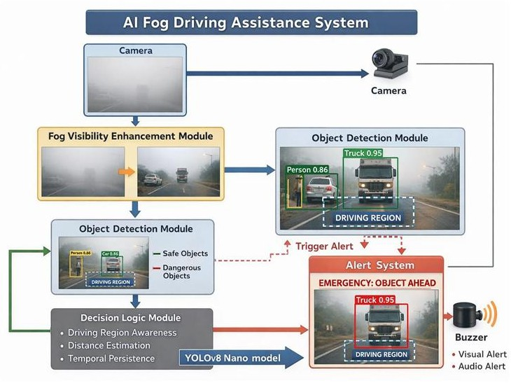

Fig. 1. Overall architecture of the AI enabled fog driving assistance system

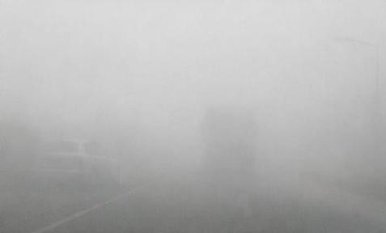
Fig. 2. Foggy view
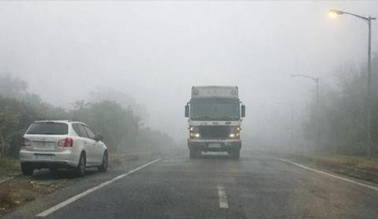
Fig. 3. Enhanced view

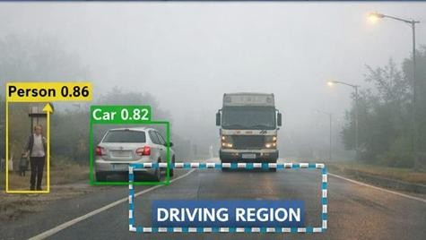
Fig. 4. Object Detection – Alert
- Methodology
The methodology of the proposed system follows a sequential and adaptive processing pipeline to ensure reliable performance under foggy and low visibility conditions.
- Data Acquisition
The system uses a real time camera module mounted at the front of the vehicle to continuously capture road scene images. Live video frames are extracted from the camera stream and processed sequentially. This real time acquisition enables the system to respond dynamically to changing environmental conditions rather than relying on prerecorded video inputs. The captured frames serve as input for fog density estimation, visibility enhancement, and object detection modules.
- Fog Density Estimation
Fog density is estimated from each captured frame by analyzing image contrast and intensity distribution. Statistical features such as mean pixel intensity and variance are used to infer the level of visibility degradation caused by fog. Based on the estimated fog density, the scene is categorized into low, medium, or high fog conditions. This classification allows the system to adaptively adjust enhancement parameters for improved performance under varying visibility levels.
- Adaptive Visibility Enhancement
To improve visual clarity under foggy conditions, adaptive image enhancement techniques are applied. Contrast Limited Adaptive Histogram Equalization is used to enhance local contrast while preventing noise amplification. Additionally, dehazing operations are performed to suppress fog artifacts and restore scene details. The enhancement strength is dynamically adjusted according to the estimated fog density, ensuring optimal visibility improvement without loss of important object features.
- Real Time Object Detection
The enhanced frames are processed using a deep learning based object detection model. A YOLO based architecture is employed due to its ability to perform fast and accurate detection in real time. The model identifies critical objects such as vehicles, pedestrians, and obstacles within the scene. Bounding boxes and confidence scores are generated for each detected object, enabling continuous monitoring of the driving environment under low visibility conditions.
- Risk Assessment and Alert Generation
Detected objects are analyzed based on their relative position and proximity to the vehicle. Objects within a predefined safety threshold are considered potential hazards. When a risk condition is identified, the system generates visual alerts on the display interface to warn the driver. This real time alert mechanism assists drivers in making timely decisions, thereby improving safety in fog affected driving scenarios.

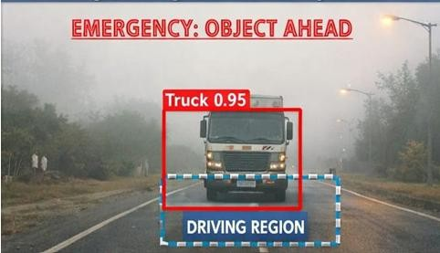
Fig. 5. Object Detection – No Alert
- Experimental Setup
The proposed AI enabled fog driving assistance system was implemented and evaluated in a controlled experimental environment to validate its real time performance. The experimental setup consists of hardware components for image acquisition and software modules for processing, enhancement, and object detection.

A high definition camera was used to capture real time road scene videos under varying visibility conditions. The camera was positioned to simulate a front mounted vehicle camera, ensuring realistic input for the system. Video frames were captured at regular intervals and processed sequentially to maintain real time operation.

The system was implemented using Python as the primary programming language. OpenCV was utilized for image processing and visibility enhancement tasks, including contrast enhancement and dehazing operations. A YOLO based deep learning model was employed for object detection due to its real time inference capability. Model inference was performed on a GPU enabled system to ensure low latency detection.
To evaluate the robustness of the system, experiments were conducted under different fog density conditions, including low, medium, and high fog scenarios. The performance of the system was assessed based on qualitative visibility improvement, object detection accuracy, and responsiveness of the alert generation mechanism. The experimental results demonstrate the feasibility of deploying the proposed system for real time driving assistance in low visibility environments.
- Results And Discussion
The proposed fog driving assistance system was evaluated under normal and simulated fog conditions using a webcam based experimental setup. Foggy scenarios were created to analyze the effectiveness of the adaptive visibility enhancement and object detection pipeline. The system performance was assessed qualitatively based on visual clarity and detection reliability.
Results indicate that the adaptive visibility enhancement module significantly improves scene contrast and object visibility compared to raw foggy frames. Enhanced frames preserved important object features, enabling the object detection model to produce higher confidence detections under low visibility conditions. In medium and high fog scenarios, detection accuracy was observed to be noticeably improved when compared to direct detection on unprocessed frames.
The fog density estimation module successfully classified environmental conditions and enabled dynamic adjustment of enhancement parameters. The context aware risk alert mechanism effectively generated visual warnings during critical scenarios involving high fog density and close obstacles. Although extreme fog conditions still pose challenges for visual perception, the system reliably identified such scenarios and alerted the driver, which is a critical safety advantage.
Overall, the experimental results demonstrate that the proposed adaptive and fog aware approach enhances both
visibility and object detection performance, making it suitable for real time driving assistance applications.
- Conclusion and Future Work
This paper presented an AI enabled fog driving assistance system designed to enhance visibility and perform real time object detection under low visibility driving conditions. By integrating fog density estimation with adaptive visibility enhancement and deep learning based object detection, the proposed system addresses key limitations of conventional driver assistance approaches that rely on static processing techniques. The adaptive pipeline improves scene clarity while preserving essential object features, resulting in more reliable detection performance in foggy environments.
Experimental evaluation under simulated fog conditions demonstrated that the proposed system enhances visual perception and improves object detection reliability compared to direct detection on raw frames. The inclusion of a context aware risk alert mechanism further strengthens the system by assisting drivers during critical high fog scenarios, thereby contributing to improved road safety.
Future work will focus on extending the system with additional sensors such as thermal or infrared cameras to improve performance under extremely dense fog. Deployment on edge AI platforms and the incorporation of learning based fog estimation techniques are also potential directions to enhance adaptability and real world applicability.
References
- R. He, Z. Sun, and Y. Tang, “Single image haze removal using dark channel prior,” IEEE Transactions on Pattern Analysis and Machine Intelligence, vol. 33, no. 12, pp. 2341–2353, 2011.
- J. Redmon, S. Divvala, R. Girshick, and A. Farhadi, “You only look once: Unified, real time object detection,” in Proceedings of the IEEE Conference on Computer Vision and Pattern Recognition, 2016, pp. 779–788.
- A. Bochkovskiy, C. Y. Wang, and H. Y. M. Liao, “YOLOv4: Optimal speed and accuracy of object detection,” arXiv preprint arXiv:2004.10934, 2020.
- K. Zuiderveld, “Contrast limited adaptive histogram equalization,” in Graphics Gems IV, Academic Press, 1994,
pp. 474–485.
- S. S. Beauchemin and J. L. Barron, “The computation of optical flow,” ACM Computing Surveys, vol. 27, no. 3, pp. 433–466, 1995.
- M. S. Alam, K. M. Iftekharuddin, and M. Murshed, “A survey on fog and haze removal techniques,” Journal of Visual Communication and Image Representation, vol. 45, pp. 144–164, 2017.

