A REVIEW ON TECHNOLOGICAL ADVANCEMENT IN CHARGE STORAGE TECHNOLOGIES FOR RENEWABLE ENERGY APPLICATIONS.
O. Nwandieze ¹, V.A. Francis¹, T.E. Amakoromo¹, P.O Nwabuzor¹
Department of Physics with Electronics Technology, School of Science Laboratory Technology University of Port Harcourt

Abstract
The growing worldwide need for dependable and sustainable energy has raised the demand for improved energy storage technologies that can facilitate the integration of renewable energy sources. This review analyzes the progress in charge storage technologies, specifically looking at electrochemical, electrostatic, mechanical, chemical, and thermal energy storage methods. Electrochemical energy storage, especially lithium-ion batteries, continues to be the leading option because of its high energy density and efficiency. Nevertheless, issues like limited resources, safety risks, and costs have prompted the investigation of other technologies. New technologies such as sodium-ion batteries, solid-state batteries, redox flow batteries, and hybrid energy storage systems provide potential solutions for large-scale and long-term energy storage needs. Additionally, improvements in nanostructured and carbon-based materials, like graphene and MXenes, have greatly improved the performance of supercapacitors and batteries by enhancing conductivity, surface area, and electrochemical stability. The combination of batteries and supercapacitors in hybrid systems has enhanced the balance of energy and power density for renewable applications. Traditional storage systems like pumped hydro, compressed air, and hydrogen storage remain important for managing energy on a large scale but the study stresses on the important of developing new materials, optimizing systems, and combining different technologies to address existing challenges and facilitate effective, scalable, and sustainable energy storage solutions for future energy systems.

Keywords: Energy Storage Systems, Electrochemical Batteries, Redox Flow Batteries, Sodium-ion and Solid-state Batteries, Supercapacitors, Renewable Energy Integration.

Correspondence: victor.francis@uniport.edu.ng 08034255200

1.0 Introduction
To maintain a stable and reliable electrical grid, power supply must be stabilized through reliable storage systems. These systems act as a critical buffer, absorbing excess energy when generation outpaces demand, such as during a sunny midday when solar panels are at peak output and discharging that stored energy back into the grid during periods of high demand or low generation, like the evening when people return home and turn on appliances and lights. Without such storage, grid operators would be forced to rely on quick-start "peaker" plants, which often run on natural gas and are less efficient and more polluting, to fill the gaps. Therefore, the advancement and deployment of efficient, large-scale energy storage, whether in the form of advanced batteries, pumped hydro, or other innovative technologies, is not just an enhancement but a fundamental prerequisite for a future powered predominantly by renewable energy, ensuring that clean power is available whenever it is needed, not just whenever the sun shines or the wind blows.
Electrochemical energy storage has become a cornerstone of modern energy infrastructure due to its high efficiency and scalability. This category of storage, which converts chemical energy into electrical energy through reversible reactions, offers distinct advantages over mechanical methods like pumped hydro, faster response times, modularity, and the ability to be deployed in a wide range of environments, from residential buildings to large-scale grid substations. (Ferreira-Martínez et.al, 2024). Among the available electrochemical technologies, lithium-ion batteries dominate current energy storage applications due to their high energy density and long life cycle (Goodenough & Park, 2013). Their superior performance has made them the technology of choice for the portable electronics revolution, the electrification of transportation in electric vehicles (EVs), and the majority of new grid-scale battery projects, driving down costs through massive manufacturing scale.
However, the very success of lithium-ion technology has brought its limitations into sharp focus. Concerns about lithium resource availability and safety have encouraged the development of alternative storage technologies. The geographical concentration of lithium reserves and the environmental impact of extraction raise questions about long-term supply chain sustainability and geopolitical stability. Furthermore, the use of flammable organic electrolytes in conventional lithium-ion cells presents safety risks, particularly as the industry pushes for higher energy densities. These factors, combined with the need for even lower costs for long duration grid storage, have spurred intense research and development into "post-lithium" technologies. Promising alternatives include sodium-ion batteries, which leverage far more abundant and cheaper materials; solid-state batteries, which aim to replace the flammable liquid electrolyte with a solid one for enhanced safety and energy density; and flow batteries, which offer the potential for independently scalable power and energy capacity, making them ideally suited for long-duration stationary storage applications (Shi et al., 2024).
In recent years, sodium-ion batteries have emerged as promising alternatives to lithium-ion systems, primarily driven by the natural abundance and consequent low cost of sodium resources. Unlike lithium, which is geographically concentrated and faces supply chain vulnerabilities, sodium is ubiquitously available, from common places like seawater and soda ash, offering a path toward more geopolitically stable and sustainable material sourcing for large scale energy storage. Researchers have demonstrated that sodium-ion batteries operate through mechanisms highly similar to lithium-ion batteries, a "rocking-chair" mechanism where ions move between the cathode and anode during charge and discharge. This fundamental similarity allows researchers and manufacturers to leverage existing lithium-ion battery production infrastructure, potentially accelerating commercialization. This technical parallelism, combined with the use of materials like aluminum rather than copper, which is relatively expensive to aluminum, for the anode current collector, making sodium-ion technology a compelling alternative for grid scale storage where energy density is less critical than cost and longevity. (Shi et al., 2024)
Technological advances in materials science and nanotechnology have also enabled the development of high-performance supercapacitors and hybrid storage systems capable of delivering both high energy and power densities. This progress addresses the fundamental trade-off that has long existed between batteries, which store large amounts of energy (high energy density) but release it slowly, and traditional capacitors, which release energy very quickly (high power density) but store very little. By engineering materials at the nanoscale, such as using graphene which was first isolated in 2004 by Andre Geim and Konstantin Novoselov at the University of Manchester, is a single, extremely thin layer of carbon atoms arranged in a two-dimensional honeycomb lattice that is considered the thinnest yet one of the strongest and most conductive materials known, carbon nanotubes, or metal oxide frameworks to create electrodes with immense surface areas and extremely short ion diffusion paths. Scientists have dramatically increased the energy storage capacity of supercapacitors without sacrificing their rapid charge-discharge capability.
These innovations are particularly important for grid scale storage and renewable energy integration. The electrical grid requires a diverse set of tools to remain stable. While lithium-ion batteries are excellent for smoothing power over hours, supercapacitors and hybrid systems are uniquely suited for handling transient fluctuations and power quality events. They can react in fractions of a second to absorb or release surges of power, effectively protecting the grid from the momentary dips and spikes caused by a cloud passing over a solar farm or a sudden change in wind speed. In a hybrid energy storage system, supercapacitors can act as a shock absorber, handling the rapid, high-power pulses and thereby reducing stress on the main battery banks, prolonging their operational life and improving the overall efficiency and resilience of the renewable energy infrastructure. In addition, mechanical energy storage systems store electrical energy by converting it into potential or kinetic mechanical energy. Chemical energy storage systems utilize chemical reactions to store and release energy through molecular bond transformations. Thermal energy storage systems capture and store heat energy that can later be converted into electricity or used directly for heating applications (Koohi Fayegh & Rosen, 2020).
These conventional technologies form the foundation of modern energy storage infrastructure and continue to support numerous applications including grid stabilization, transportation, renewable energy integration, portable electronics, and industrial power systems.
2.0 Fundamentals of Charge Storage Technology
Charge storage technology refers to the methods and materials used to store electrical energy for later use, enabling electricity generated at one time to be utilized at another in applications such as renewable energy systems, electric vehicles, grid storage, and portable electronics (Aneke & Wang, 2016; Koohi Fayegh & Rosen, 2020; Mitali et al., 2022). The fundamental principle involves the movement and separation of electrons and ions within a storage medium. For instance, in electrostatic systems like capacitors, stored charge follows the relationship (Q = CV), where (Q) is charge, (C) is capacitance, and (V) is voltage, while stored energy is expressed as (E $=1/2{CV}^{2}$). Electrostatic storage involves the accumulation of charges on conductive plates separated by a dielectric material, allowing rapid charging and discharging, whereas electrochemical storage in batteries involves reversible chemical reactions, including oxidation at the anode, reduction at the cathode, and ion transport through an electrolyte (Goodenough & Park, 2017; Liu et al., 2022). Based on these mechanisms, energy storage technologies are broadly classified into batteries, capacitors, and supercapacitors, with supercapacitors combining both electrostatic and electrochemical charge storage processes (Chen, 2017; Simon & Gogotsi, 2020). The performance of these systems is evaluated using parameters such as energy density, power density, cycle life, and charge–discharge efficiency (Nadeem et al., 2019; Zhao & Burke, 2021). Advanced materials including activated carbon, carbon nanotubes, graphene, metal oxides, and conducting polymers significantly enhance conductivity, surface area, and stability (Liu et al., 2019; Wang et al., 2019).
Despite their importance, challenges such as limited energy density, high material costs, environmental concerns related to battery disposal, and safety risks like thermal runaway remain (Dunn et al., 2016; Krishan & Suhag, 2019). These issues have driven research into next-generation technologies such as solid-state batteries, graphene-based supercapacitors, flow batteries, and hybrid energy storage systems (Deysher et al., 2022; Singh et al., 2023; Wang et al., 2025).
2.1 Electrochemical Energy Storage (EES)
Electrochemical energy storage (EES) relies on Faradaic electron-transfer reactions that convert electrical energy into chemical changes in electrode or electrolyte species and back during discharge. Key manifestations are redox at surfaces, ion insertion (intercalation) into host lattices, and multi-electron conversion reactions that define battery chemistries and their voltage and capacities (Goodenough & Park, 2017; Liu et al., 2022).
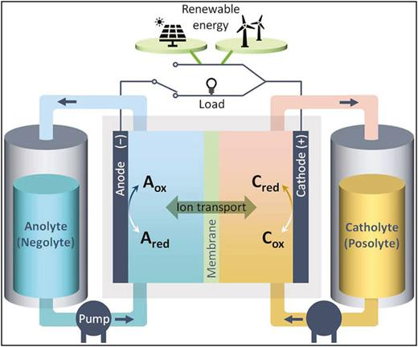
Figure 1: Electrochemical Energy Storage system (adapted from Okazawa et al., 2023).
2.1.1 Faradaic redox reactions occur when electrons are transferred between electrode and redox-active species, producing chemical state changes that store charge as chemical energy (Srividhya & Ponpandian, 2023).
2.1.2 Ion Intercalation involves reversible insertion/removal of ions into solid host structures (for example layered or tunneled electrodes); charge storage is coupled to lattice occupation rather than simple surface adsorption (Rudra et al., 2024)
2.1.3 Battery Chemistry types include intercalation-type electrodes (high reversibility and cycle life) and conversion-type electrodes (often higher capacity but larger structural change); these chemistries determine thermodynamic cell voltage, specific capacity, and rate behavior. (Srividhya & Ponpandian, 2023).
Faradaic EES performance is commonly limited by ion diffusion in solids and by phase-change kinetics, which typically make high-rate operation harder than purely electrostatic storage (Rudra et al., 2024).
Rudra et al. (2024) noted that Faradaic EES performance is commonly limited by ion diffusion in solids and by phase-change kinetics, which typically make high-rate operation more difficult than purely electrostatic storage.
2.2 Electrostatic mechanisms
Electrostatic storage places charge without net chemical transformation, either by forming an electrochemical double layer at electrode electrolyte interfaces or through dielectric polarization in insulating materials. These processes are inherently non-Faradaic because charge is stored through field-driven separation rather than redox reactions (Volfkovich, 2024; Rahmawati et al., 2025)
Electrical double layer capacitors store charge through the adsorption of ions at the interface between high surface area electrodes and the electrolyte, and the capacitance is largely determined by the accessible electrode surface area and the structure of the electrical double layer described in classical electrochemistry (Wei et al., 2026; Oladele et al., 2025)
Dielectric capacitors store energy by polarizing an insulating dielectric between electrodes; energy is stored in the electric field and does not involve ionic motion or chemical change (Chan, 2017)
Fleischmann et al. (2022) postulated that Non-Faradaic process means no net electron transfer chemical reactions occur at the electrode during charge/discharge. This yields very fast response and excellent cycle life compared with Faradaic devices.
In representative performance commercial electrochemical capacitors (EDLCs and related devices) can reach gravimetric energy on the order of a few Wh·kg-1 and usable power densities in the kW·kg−1 range, reflecting the high-rate, non-Faradaic character of EDLCs (Chan, 2017).
Performance comparison
The dominant differences between EES and electrostatic storage appear in energy density, power density, and the governing charge/discharge mechanisms; the table summarizes these contrasts.

Table 1 Comparison between EES and electrostatic storage
Device class | Energy Density | Power Density | Charge and Discharge mechanisms
Batteries  Intercalation/conversion | Generally higher energy per mass due to storage in chemical bonds and bulk insertion; exact values vary by chemistry and are not provided in the supplied sources (insufficient evidence) | Typically lower peak power than EDLCs because rates are limited by solid-state diffusion and phase transformations (Rudra et, al., 2024). | Charge/discharge via Faradaic electron-transfer reactions and ion transport into/out of host phases; kinetics often diffusion-limited (Srividhya & Ponpandian, 2023).
EDLCs Electrostatic double layer | Lower energy than batteries, often a few Wh·kg−1 in commercial electrochemical capacitors (Chen, 2017). | Very high power, up to kW·kg−1 levels in practice due to rapid ion rearrangement and non-Faradaic charge storage (Chen, 2017). | Non-Faradaic ion adsorption/desorption at the electrode/electrolyte interface; very fast charge transfer and minimal chemical change (Fleischmann et al., 2022)
Dielectric capacitors | Very low energy density compared with electrochemical devices (insufficient evidence for quantitative numbers in supplied sources) | Extremely high power and very fast response because energy is stored electrostatically in a dielectric medium (Chen, 2017). | Polarization and depolarization of a dielectric under applied field; no ionic motion or redox chemistry (Chen, 2017).

Electrostatic devices (EDLCs, dielectric capacitors) excel at high-power, high-cycle-life applications because they avoid bulk chemical transformation, while Faradaic EES (batteries) deliver higher stored energy but require slower, diffusion-limited ion transport and undergo chemical state changes during cycling (Srividhya & Ponpandian, 2023).
2.3 Hybrid Mechanism
Pseudocapacitance and hybrid energy storage devices connect electrostatic capacitive storage with Faradaic battery behavior by combining rapid surface or near surface redox reactions with capacitive responses. This results in devices with mixed characteristics whose performance may resemble either capacitors or batteries depending on electrode materials and structural confinement. Wang et al. (2025) noted that hybrid supercapacitors integrate electric double layer capacitance with Faradaic redox processes, thereby bridging the gap between conventional capacitors and batteries. Surface pseudocapacitance involves fast, reversible Faradaic reactions at electrode surfaces, producing a near-linear voltage–charge relationship unlike battery plateaus (Dunn et al., 2022; Brousse et al., 2017). Intercalation pseudocapacitance enables rapid ion insertion without phase change, supporting continuous potential variation and high-rate charge storage (Dunn et al., 2022; Fleischmann et al., 2022).
Hybrid supercapacitors and supercapatteries intentionally combine EDLC-type electrodes with Faradaic battery-type or pseudocapacitive electrodes to improve energy density while preserving much of the power and cycle-life advantages of capacitive components. According to Brousse et al. (2017), recent work emphasizes that charge storage can span a continuum from purely non-Faradaic to strongly Faradaic behavior (e.g., nanoconfined electrolytes or surface redox can blur categories), so device behavior depends on materials, confinement, and electrode architectures. Materials design such as nanoscale electrodes, conductive scaffolds, and ion-confining architectures can tune the balance between Faradaic and non-Faradaic contributions and enable fast, high-capacitance behavior (Choudhary et al., 2023).

3.0 Conventional Energy Storage Systems
The continuous growth in global energy demand has intensified the need for reliable and efficient energy storage technologies capable of supporting modern power systems. Rapid industrialization, increasing population, and expanding digital infrastructure have significantly increased electricity consumption worldwide. At the same time, concerns regarding the environmental consequences of fossil fuel dependence have accelerated the transition toward renewable energy resources such as solar and wind power. Despite their environmental advantages, renewable energy systems suffer from inherent intermittency and variability in power generation. Solar energy production depends on sunlight availability, while wind energy output fluctuates according to atmospheric conditions. Consequently, effective energy storage systems are required to balance power supply and demand, stabilize electrical grids, and ensure continuous energy availability (Koohi Fayegh & Rosen, 2020; Mitali et al., 2022).
Energy storage systems function by capturing excess energy produced during periods of low demand and storing it for later use during periods of higher demand or insufficient generation. These systems enable the integration of renewable energy resources into the power grid while improving power quality, grid stability, and reliability. Moreover, energy storage technologies enhance energy efficiency by minimizing losses associated with energy transmission and distribution. Since electrical energy cannot be stored directly in alternating current form for long periods, it is typically converted into other energy forms such as mechanical, chemical, thermal, electrostatic, or electromagnetic energy for storage purposes (Guney & Tepe, 2017).
Conventional energy storage technologies have therefore been developed to store energy in various physical and chemical forms. These technologies differ in their operating principles, energy densities, efficiencies, response times, and suitability for specific applications (Aneke & Wang, 2016; Koohi Fayegh & Rosen, 2020).
3.1 Classification of Conventional Energy Storage Systems
Energy storage technologies can be categorized based on the form of energy stored, the technology employed, and the scale of application. In general, conventional energy storage systems are grouped into five main categories: mechanical energy storage, chemical energy storage, electrochemical energy storage, electrostatic and electromagnetic energy storage, and thermal energy storage. These classifications provide a systematic framework for understanding the different mechanisms used to store energy and facilitate the evaluation of their performance characteristics such as energy density, power density, efficiency, response time, lifespan, and cost effectiveness (Krishan & Suhag, 2019).
Mechanical energy storage systems store electrical energy by converting it into potential or kinetic mechanical energy. Chemical energy storage systems utilize chemical reactions to store and release energy through molecular bond transformations. Electrochemical storage systems rely on reversible redox reactions occurring within electrochemical cells. Electrostatic and electromagnetic systems store energy directly as electric or magnetic fields without conversion into other forms. Thermal energy storage systems capture and store heat energy that can later be converted into electricity or used directly for heating applications (Koohi Fayegh & Rosen, 2020).
These conventional technologies form the foundation of modern energy storage infrastructure and continue to support numerous applications including grid stabilization, transportation, renewable energy integration, portable electronics, and industrial power systems.
3..1.1 Mechanical Energy Storage Systems
Mechanical energy storage systems represent some of the most widely implemented energy storage technologies due to their reliability, scalability, and relatively long operational lifetimes. These systems store energy by converting electrical energy into mechanical energy in the form of potential or kinetic energy and subsequently reconvert it into electricity when required. Mechanical storage technologies are particularly valuable for large scale grid applications where rapid energy delivery and long cycle lifetimes are essential (Mahmoud et al., 2020).
The primary forms of mechanical energy storage include pumped hydroelectric energy storage, compressed air energy storage, flywheel energy storage, and gravity energy storage.
Pumped Hydroelectric Energy Storage
Pumped hydroelectric energy storage is the most mature and widely deployed large scale energy storage technology worldwide. The system operates by transferring water between two reservoirs located at different elevations. During periods of low electricity demand or surplus energy generation from renewable sources, electrical energy is used to pump water from the lower reservoir to the upper reservoir. This process converts electrical energy into gravitational potential energy stored in the elevated water body.
When electricity demand increases, the stored water is released from the upper reservoir and allowed to flow downward through hydraulic turbines. The kinetic energy of the moving water rotates the turbine blades, which drive generators that produce electricity. This electricity is then supplied back to the power grid to meet demand requirements. Pumped hydroelectric systems typically exhibit high efficiency, long lifespans exceeding several decades, and large storage capacities, making them suitable for grid scale energy management (Aneke & Wang, 2016).
Compressed Air Energy Storage
Compressed air energy storage stores electrical energy by compressing air and storing it in underground caverns or specially designed containers. During periods of excess electricity generation, electric compressors are used to compress air and store it at high pressure. The stored compressed air represents potential energy.
When electricity is needed, the compressed air is released and expanded through turbines that drive electrical generators. This expansion process converts the stored mechanical energy back into electrical energy. Compressed air energy storage systems are capable of providing large scale storage capacities reaching hundreds of megawatts. Variants of this technology include diabatic, adiabatic, and isothermal compressed air systems depending on how heat generated during compression is managed (Rabi et al., 2023).
Flywheel Energy Storage
Flywheel energy storage systems store energy in the form of rotational kinetic energy. The system consists of a rotating mass typically in the form of a disc or cylinder connected to a motor generator assembly. During the charging phase, electrical energy is converted into mechanical energy by accelerating the flywheel to high rotational speeds using an electric motor.
When energy is required, the rotating flywheel drives the generator, converting the stored kinetic energy back into electrical energy. Flywheel systems are characterized by high power density, rapid response times, and long operational lifetimes. They are particularly useful for short duration energy storage applications such as frequency regulation, power quality improvement, and backup power supply systems (Amiryar & Pullen, 2017).
Gravity Energy Storage
Gravity energy storage systems operate on principles similar to pumped hydroelectric storage but use solid masses instead of water. Excess electricity is used to lift heavy masses to higher elevations using mechanical lifting systems such as cranes or motors. The stored gravitational potential energy is later converted into electricity when the mass is allowed to descend and drive electrical generators.
Although gravity energy storage technology is still under development, it has gained interest due to its potential scalability, long lifespan, and minimal environmental impact (Tong et al., 2022).
3.1.2 Chemical Energy Storage Systems
Chemical energy storage involves storing energy in the chemical bonds of molecules. Energy is released when chemical reactions occur that transform these molecules into new compounds. Chemical fuels such as coal, natural gas, gasoline, and hydrogen are traditional examples of chemical energy carriers used for electricity generation and transportation.
Modern chemical energy storage technologies aim to utilize renewable energy sources to produce clean fuels such as hydrogen and synthetic natural gas. These fuels can store energy for extended periods and can be transported and utilized in various sectors including transportation and industrial processes (Revankar, 2019).
Hydrogen Energy Storage
Hydrogen energy storage is considered one of the most promising solutions for long term renewable energy storage. Excess electricity generated from renewable sources can be used to split water molecules into hydrogen and oxygen through electrolysis. The produced hydrogen is then stored in compressed tanks, liquefied form, or underground reservoirs.
When electricity is needed, hydrogen can be converted back into electricity through fuel cells. Fuel cells generate electricity through electrochemical reactions between hydrogen and oxygen, producing water and heat as byproducts. Various fuel cell technologies exist including proton exchange membrane fuel cells, alkaline fuel cells, phosphoric acid fuel cells, molten carbonate fuel cells, and solid oxide fuel cells (Aminudin et al., 2023).
Synthetic Natural Gas Energy Storage
Synthetic natural gas storage converts electrical energy into methane through chemical reactions involving hydrogen and carbon dioxide. The resulting methane can be stored using existing natural gas infrastructure and later utilized as a fuel for power generation or heating applications (Bolt et al., 2020).
Solar Fuel Storage
Solar fuel technologies aim to convert solar energy into chemical fuels through processes such as artificial photosynthesis and thermochemical reactions. Artificial photosynthesis mimics natural photosynthesis by using sunlight to split water molecules and reduce carbon dioxide to produce fuels such as methane or methanol. Thermochemical processes use high temperature reactions to generate hydrogen or synthetic hydrocarbons from solar heat energy (Dogutan & Nocera, 2019).
3.1.3 Electrochemical Energy Storage Systems
Electrochemical energy storage systems store electrical energy through reversible electrochemical reactions occurring within batteries. Batteries consist of three primary components including an anode, a cathode, and an electrolyte that facilitates ionic transport between the electrodes.
Electrochemical storage technologies are classified into primary and secondary batteries. Primary batteries are non-rechargeable and operate through irreversible chemical reactions. Secondary batteries are rechargeable and capable of undergoing multiple charge and discharge cycles (Liu et al., 2022).
Common electrochemical storage technologies include lead acid batteries, nickel cadmium batteries, sodium sulfur batteries, lithium ion batteries, and redox flow batteries.
Lithium Ion Batteries
Lithium ion batteries are currently the most widely used electrochemical energy storage systems due to their high energy density, high efficiency, and lightweight design. These batteries operate by reversible intercalation of lithium ions between the cathode and anode materials during charging and discharging processes. Lithium ion batteries typically deliver energy densities between 100 and 200 Wh kg⁻¹ and power densities up to 2000 W kg⁻¹, making them suitable for applications ranging from portable electronics to electric vehicles (Liu et al., 2022).
Flow Batteries
Flow batteries store energy in liquid electrolytes containing dissolved electroactive species. The electrolytes are stored in external tanks and pumped through electrochemical cells during operation. This configuration allows independent scaling of power and energy capacity, making flow batteries suitable for large scale grid storage applications (Soloveichik, 2015).
Vanadium redox flow batteries represent one of the most developed flow battery technologies due to their long cycle life and high reliability.
Redox flow batteries
Redox flow batteries (RFBs) are electrochemical energy storage systems in which energy is stored in liquid electrolytes containing dissolved redox-active species that circulate through an electrochemical cell during operation. Unlike conventional batteries, RFBs separate energy storage from power generation: energy capacity is determined by the volume of electrolyte stored in external tanks, while power output depends on the size of the cell stack (Soloveichik, 2015; Dunn et al., 2016). During operation, oxidation and reduction reactions occur at the electrodes, enabling reversible energy conversion with high efficiency and long cycle life.
A major advantage of RFBs is their scalability and flexibility, making them suitable for large-scale and grid-level energy storage applications, particularly for integrating intermittent renewable energy sources such as solar and wind (Nadeem et al., 2019; Koohi-Fayegh & Rosen, 2020). Additionally, their design allows deep discharge, improved safety due to aqueous electrolytes, and reduced degradation compared to solid-state batteries (Aneke & Wang, 2016).
However, RFBs are limited by relatively low energy density, high system complexity, and material costs, especially for vanadium-based systems (Soloveichik, 2015). Despite these challenges, ongoing research focuses on improving electrolyte chemistry and system efficiency, positioning RFBs as a promising solution for long-duration energy storage in modern power systems (Mitali et al., 2022).

3.1.4 Electrostatic and Electromagnetic Energy Storage
Electrostatic and electromagnetic storage systems store electrical energy directly in electric or magnetic fields without converting it into chemical or mechanical forms. Examples include capacitors, supercapacitors, and superconducting magnetic energy storage systems.
Supercapacitors store energy through electrostatic charge accumulation at the electrode electrolyte interface. Their energy density can be expressed as
E = ½ C V²
where C represents capacitance and V represents applied voltage. Supercapacitors exhibit extremely high power density and long cycle lifetimes exceeding one million cycles, making them suitable for applications requiring rapid energy delivery (Zhao & Burke, 2021).
Superconducting magnetic energy storage systems store energy in magnetic fields generated by superconducting coils maintained at cryogenic temperatures. These systems offer extremely fast response times and high efficiency but are limited by high installation and cooling costs (Mukherjee & Rao, 2019).
3.1.5 Thermal Energy Storage Systems
Thermal energy storage systems store heat energy that can later be converted into electricity or used directly for heating applications. Thermal storage technologies are categorized into sensible heat storage, latent heat storage, and thermochemical storage systems (Alva et al., 2018).
Sensible heat storage involves raising the temperature of a material such as water, rock, or molten salts to store thermal energy. Latent heat storage utilizes phase change materials that absorb or release heat during phase transitions such as melting or solidification. Thermochemical storage systems store energy through reversible chemical reactions that break and reform molecular bonds.
These systems play an important role in solar thermal power plants, district heating networks, and industrial heat recovery applications.
Conventional energy storage systems form the backbone of modern energy infrastructure and are essential for ensuring reliable electricity supply in the evolving global energy landscape. These systems encompass a wide range of technologies including mechanical, chemical, electrochemical, electrostatic, electromagnetic, and thermal storage solutions. Each technology offers distinct advantages and limitations in terms of energy density, response time, efficiency, lifespan, and cost.
Mechanical energy storage technologies such as pumped hydroelectric and compressed air storage provide large scale grid support, while electrochemical batteries dominate portable and transportation applications. Chemical energy storage systems such as hydrogen offer promising solutions for long duration energy storage, whereas electrostatic and electromagnetic systems provide rapid response capabilities for power quality management. Thermal energy storage technologies contribute to efficient heat management and renewable energy integration.
Despite significant advancements, ongoing research is required to improve the efficiency, safety, sustainability, and economic feasibility of these technologies. The continued development and integration of advanced energy storage systems will play a critical role in enabling the widespread adoption of renewable energy sources and achieving global energy sustainability goals.

4.0 Emerging Charge Storage Technologies
All-Solid-State Batteries are considered a next-generation energy storage solution particularly for applications requiring compact size, high safety, and high energy density, such as electric vehicles, portable electronics, and stationary storage. Their development demands multidisciplinary engineering skills (materials science, mechanical design, electrochemistry, thermal management, and manufacturing engineering (Deysher et al., 2022)
Advantages of All-Solid-State Lithium-Ion Batteries
All-solid-state lithium-ion batteries are considered as one of the most promising battery systems and higher volumetric energy density than the currently available lithium-ion batteries are expected. Deysher et al., (2022) Further explained that All-solid-state batteries can highly enhance the capability of cell design by allowing in-series stacking and bipolar structures, greatly improving the packaging efficiency of the battery. Therefore, high energy density can be achieved by the reduction of the dead space between single cells of the conventional lithium-ion batteries, as shown in Figure 4.1.
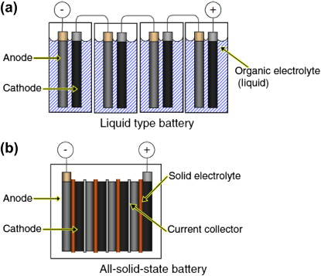
Figure 2 All-Solid-State Batteries (Deysher et al., 2022)
4.1 Solid-State Batteries
Solid-state electrolytes have advanced across oxide, sulfide, polymer and composite classes but electrode electrolyte interfaces remain the dominant barrier to practical SSBs. Sodium-ion cathode chemistry and scalable electrode fabrication show strong cost-performance promise, while silicon anodes, high-nickel cathodes, and recycling are leading next-generation LIB trends.
Hou et al. (2024) stated that Oxide electrolytes offers high chemical and electrochemical stability but are mechanically brittle and suffer from poor interfacial resistance with electrodes, while Sulfide Electrolytes can reach high ionic conductivities at room temperature but pose challenges in electrochemical stability windows and sensitivity to moisture, complicating electrode compatibility (Li et al., 2024). Similarly Polymer electrolytes provide good conformal contact and flexibility, yet intrinsic ionic conductivity at room temperature is often lower; recent in-situ polymerization approaches have demonstrated markedly improved interface formation and long cycle life in high-voltage Li metal cell (Siddique et al., 2025).
Researchers are developing different types of solid electrolytes which includes inorganic-inorganic, two solid inorganic materials are combined to enhance ionic transport. Polymer-polymer, two polymers are blended to improve flexibility and ion conduction and inorganic-polymer composites, which is a hybrid of inorganic and polymer materials combines the high conductivity of inorganics with the mechanical flexibility of polymers to achieve a combination of high ionic conductivity, mechanical flexibility, and better compatibility with electrodes. Vedhanarayanan and Seetha Lakshmi (2024) discussed emerging next-generation battery technologies, including solid-state, lithium-sulfur, sodium, and multivalent metal batteries, highlighting their potential to overcome the limitations of conventional lithium-ion systems.
Interfacial stability remains a critical challenge for solid state batteries, as reactions between electrodes and solid state electrolytes can form resistive interphases or consume active species, limiting cycle life and the usable voltage window (Li et al., 2024). Mechanical contact loss at solid interfaces further increases impedance during cycling, which can be mitigated using soft polymer components or compliant interlayers (Vedhanarayanan et al., 2024). Engineering solutions such as interface coatings, tailored interlayer chemistries, and in situ polymerization to form conformal SEI or CEI films have demonstrated improved performance for instance, in situ polymerized solid polymer electrolyte cells achieved over 1000 hours of Li cycling and approximately 86.8% capacity retention in NCM SPE Li cells after 1000 cycles (Siddique et al., 2025). Emerging electrolyte chemistries, including hydridoborate based sodium solid electrolytes, provide favorable ionic conductivity and electrode compatibility, representing promising alternatives for sodium metal solid state batteries (Yu, 2024). Overall, solid state batteries offer intrinsic safety and the potential for high energy density with metal anodes, but practical success depends on durable, low impedance electrode electrolyte interfaces achieved through integrated materials and interface engineering rather than single component improvements (Hou et al. 2024; Li et al., 2024).

4.2. Sodium-ion Batteries
Sodium-ion batteries (SIBs) are advancing rapidly in cathode chemistry and electrode fabrication, targeting grid and large-scale applications where raw-material cost and resource abundance are decisive. Recent reviews and experimental work report improved layered oxides, Prussian blue analogues, and polyanionic cathodes alongside scalable electrode manufacturing that narrows the performance gap with LIBs.
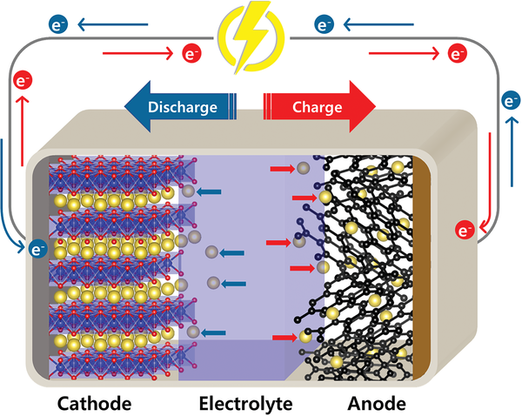
Figure 3 Schematic of the working principle of a sodium‐ion (Singh et al., 2023).

4.2.1 Cathode Materials Progress and Tradeoff.
Layered oxides provide relatively high specific capacity and voltage but require composition and surface control to improve cycling and rate performance (Lv et al., 2024), while Prussian Blue Analogues offer open framework structures with fast Na+ diffusion and low cost, making them attractive for large-scale applications, though structural water content and vacancies must be controlled for long life (Lv et al., 2024). Also Polyanionic compounds like Na2V3(PO4)3 and related phosphates) deliver good structural stability, safety, and thermal robustness; recent fabrication advances have dramatically increased areal loading while preserving energy and power performance (Ouyang et al., 2024).

4.2.2 Manufacturing and Scale Indicators
High areal loading electrodes were produced using a combined electrospinning and electrospraying technique for Na₂V₃(PO₄)₃ cathodes, achieving 296 mg cm² areal loading and pouch cell validated energy and power densities of approximately 231.6 Wh kg1 and 7152.6 W kg1, indicating practical pathways toward industry relevant electrode architectures (Ouyang et al., 2024).

Figure 4. Energy density (Wh/kg) and power density (W/kg) of high areal loading Na₂V₃(PO₄)₃ cathodes (Ouyang et al., 2024)
In terms of cost versus performance, sodium ion batteries benefit from abundant sodium resources and lower raw material costs compared with lithium systems, which supports competitiveness in grid and stationary storage; however, energy density remains lower than lithium ion batteries, so sodium ion batteries are most compelling where cost and raw material supply dominate system requirements (Lv et al., 2024).
4.2.3 Deployment Considerations
Deployment considerations include the benefit of reduced material cost and resource availability aligned with large scale storage needs (Lv et al., 2024). Challenges include closing the energy density gap while ensuring long calendar life and developing compatible, scalable electrolytes and electrode fabrication methods. Integration with solid state electrolyte advances could further enhance safety but requires parallel progress in SSE conductivity and interfaces (Hou et al., 2024).

4.3 Next Generation Lithium-ion
Next-generation lithium-ion development focuses on electrode materials that raise energy and/or reduce cost, plus lifecycle considerations such as recycling. Research trajectories emphasize silicon-based anodes, high-nickel cathodes, and system-level circularity. Materials-level innovations and nanostructuring are central to mitigating degradation mechanisms while enabling greater specific capacity.

Figure 5 Next-generation lithium-ion (Crawford, 2018)
4.3.1 Silicon Anodes and Related Engineering
Lee et al. (2025) discussed silicon anodes and related engineering focus on high capacity, as silicon offers very large specific capacity compared with graphite, motivating numerous nanoscale and composite strategies to accommodate drastic volume changes Primary challenges include mechanical pulverization, unstable SEI formation, and first cycle irreversible loss. Nanoscaling, binder and architectural design, and protective coatings remain the leading mitigation routes reported in recent nanomaterials focused reviews (Lee et al., 2025)
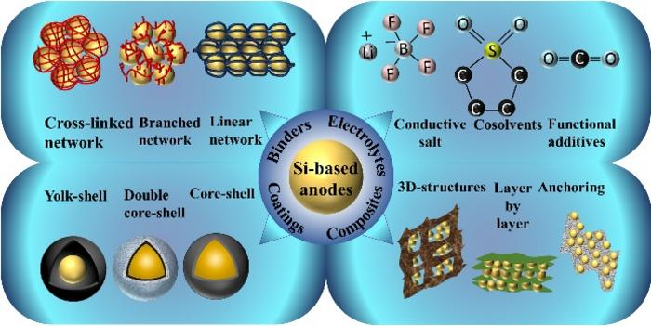
Figure 6 Silicon-Based Anode Materials. (Adapted from AZoM, 2024)
4.3.2 High-nickel Cathodes and Limits
Energy gain comes from increasing nickel content, which raises the specific energy of layered cathodes but exacerbates thermal instability, oxygen release, and surface reactivity toward the electrolyte, requiring advanced surface coatings and electrolyte stabilization strategies (Lee et al., 2025). Interface control is critical, as achieving long life with high nickel compositions depends on coupled cathode and electrolyte interface engineering, an area highlighted across next generation materials reviews (Vedhanarayanan et al., 2024).
4.3.3 Recycling and Lifecycle Perspective
Strategic importance arises from the environmental and economic implications of expanding battery deployment, motivating stronger emphasis on reuse and recycling in recent perspectives on post LIB futures (Lü et al., 2024). Evidence limitations include that the supplied literature highlights recycling as a priority and discusses environmental and economic contexts, but detailed, standardized process metrics and large scale recycling performance data are not provided in the available corpus, indicating insufficient evidence.

4.3.4 Net assessment
Benefits include that silicon anodes and high nickel cathodes promise step changes in specific energy and range for electric vehicles and portable systems when coupled with compatible electrolytes and interface solutions (Lee et al., 2025). Challenges involve material degradation mechanisms, both mechanical and interfacial, cell safety at higher energy, and the need for economically viable recycling, which remain the central hurdles to commercialization (Lee et al., 2025; Siddique et al., 2025; Lü et al., 2024).

5.0 Advanced Materials for Energy Storage
The rapid growth of renewable energy systems and modern electronic technologies has intensified the demand for efficient and high-performance energy storage solutions. Central to this advancement is the development of advanced materials, which significantly influence the capacity, efficiency, lifespan, and safety of energy storage devices. These materials have transformed conventional storage technologies by enabling higher energy densities, faster charge–discharge rates, and improved durability.
5.1 Role of Advanced Materials in Energy Storage
Advanced materials serve as the backbone of modern energy storage technologies, particularly in batteries and supercapacitors. Their unique structural, electrical, and electrochemical properties determine the overall performance of storage systems. Traditional materials are increasingly being replaced by nanostructured and multifunctional materials, which offer enhanced surface area, improved conductivity, and better electrochemical stability (Arico, A. S. et al., 2020; Liu et al., 2019).
Nanostructured materials, in particular, have revolutionized energy storage by enabling efficient ion transport and electron mobility. These materials reduce diffusion distances and increase electrode-electrolyte interaction, thereby improving charge storage capacity and cycling stability (Arico et al., 2020). As a result, they are widely applied in next-generation batteries and electrochemical capacitors.
5.2 Nanostructured Materials and Their Applications
Nanostructured materials, including nanoparticles, nanowires, and nanosheets, are widely used in energy storage devices due to their superior physical and chemical properties. Their high surface-to-volume ratio enhances electrochemical reactions, leading to improved energy and power densities.
For instance, nanostructured electrode materials have been successfully applied in lithium-ion batteries, where they improve charge transport and reduce degradation over time (Goodenough & Park, 2017). Similarly, in supercapacitors, nanostructured carbon materials provide high capacitance and rapid charge–discharge capabilities (Wang et al., 2019).
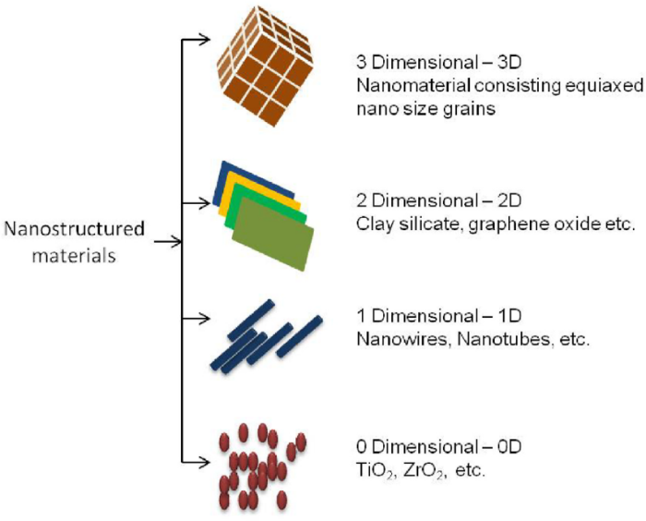
Figure 7: Nanostructured Materials (Saeed et al., 2023)
The integration of nanotechnology into energy storage systems has also enabled the development of hybrid devices, combining the advantages of batteries and capacitors. These hybrid systems offer both high energy density and high power density, making them suitable for applications such as electric vehicles and grid stabilization (Lukatskaya et al., 2018).
5.3 Carbon-Based Materials
Carbon-based materials remain one of the most widely studied and utilized classes of advanced materials in energy storage. These include graphene, carbon nanotubes, activated carbon, and porous carbon structures. Their popularity stems from their excellent electrical conductivity, chemical stability, and large surface area.
Graphene, in particular, has attracted significant attention due to its exceptional electrical and mechanical properties. It enables the development of high-performance supercapacitors with improved energy density and flexibility (Zhang et al., 2021). Carbon nanotubes and porous carbon materials also enhance charge storage by providing efficient pathways for electron transport and ion diffusion (Zhang et al., 2020).
Furthermore, carbon-based materials are widely used in commercial supercapacitors, where they contribute to long cycle life and high power output. Their versatility allows them to be tailored for various applications, including portable electronics and renewable energy systems (Simon & Gogotsi, 2020).
5.4 MXenes and Two-Dimensional Materials
The discovery of MXenes, a family of two-dimensional transition metal carbides and nitrides, has opened new possibilities in energy storage research. These materials exhibit excellent electrical conductivity and high capacitance, making them suitable for use in supercapacitors and batteries (Naguib et al., 2017).
MXenes also offer tunable surface chemistry, which enhances their interaction with electrolytes and improves charge storage performance. Their layered structure facilitates rapid ion transport, making them ideal for high-power applications (Lukatskaya et al., 2018).
In addition to MXenes, other two-dimensional materials such as transition metal dichalcogenides are being explored for their potential in energy storage systems. These materials contribute to the development of flexible and wearable energy storage devices.
5.5 Advanced Materials for Supercapacitors
Supercapacitors have benefited significantly from advancements in material science. The development of novel electrode materials has led to improved energy density, bridging the gap between conventional capacitors and batteries.
Recent studies highlight the use of nanostructured metal oxides, conductive polymers, and carbon composites in supercapacitor design. These materials enhance capacitance, energy density, and cycling stability (Wang et al., 2019; Zhang et al., 2021). Additionally, asymmetric supercapacitors, which use different materials for positive and negative electrodes, have shown improved performance compared to symmetric designs (Wang et al., 2021).
The continuous innovation in material design has also enabled the development of flexible and miniaturized supercapacitors for use in wearable electronics and portable devices.
5.6 Materials for Advanced Battery Technologies
Battery technology has evolved significantly with the introduction of advanced materials. Lithium-ion batteries, for example, rely on high-performance electrode materials to achieve high energy density and long cycle life. Research efforts are focused on developing alternative materials such as silicon anodes, solid electrolytes, and lithium-sulfur systems (Armand & Tarascon, 2018).
These materials address key limitations of conventional batteries, including capacity fading, safety concerns, and limited energy density. For instance, silicon-based anodes offer significantly higher capacity than traditional graphite anodes, although challenges related to volume expansion remain (Goodenough & Park, 2017).
Advanced materials also enable the development of solid-state batteries, which offer improved safety and energy density compared to liquid electrolyte systems. These batteries are expected to play a crucial role in future energy storage applications, particularly in electric vehicles and grid systems.
5.7 Challenges and Future Directions
Despite significant progress, the development of advanced materials for energy storage faces several challenges. These include high production costs, scalability issues, and material degradation over time. Additionally, environmental concerns related to material extraction and disposal must be addressed.
Future research is focused on:
- Developing low-cost and sustainable materials
- Improving material stability and lifespan
- Enhancing energy and power density simultaneously
- Integrating advanced materials into hybrid energy storage systems.
Advanced materials have become a cornerstone of modern energy storage technologies, significantly enhancing the performance of batteries, supercapacitors, and hybrid systems. From nanostructured materials to emerging two-dimensional materials such as MXenes, these innovations have expanded the capabilities of energy storage devices. As research continues to address existing challenges, advanced materials will play a pivotal role in supporting the global transition toward sustainable and renewable energy systems.
6.0 Application of Charge Storage Technologies in Renewable Energy Systems
Renewable energy systems, particularly solar and wind, are inherently intermittent due to their dependence on environmental conditions. This variability introduces challenges in ensuring a stable and reliable electricity supply. Charge storage technologies play a crucial role in mitigating these challenges by storing excess energy during peak generation periods and releasing it when demand exceeds supply. As a result, they enhance energy reliability, improve grid stability, and enable deeper penetration of renewable energy into modern power systems (Adeyemo et al., 2024; Sahu et al., 2021).
6.1 Battery Energy Storage Systems (BESS)
Battery energy storage systems represent the most widely deployed charge storage technology in renewable energy applications. These systems store electrical energy in electrochemical form and discharge it when required.
6.1.1 Application in Solar Photovoltaic Systems
In solar photovoltaic (PV) systems, batteries are used to store surplus energy generated during periods of high solar irradiance for use during nighttime or low sunlight conditions. This application is common in both residential and utility-scale solar installations, where batteries facilitate load shifting and ensure uninterrupted power supply (Electricity Magnetism, 2023; Adeyemo et al., 2024).
6.1.2 Application in Wind Energy Systems
Wind energy systems experience fluctuations due to variable wind speeds. Batteries help smooth these fluctuations by storing excess energy during high wind periods and releasing it during low wind conditions. This improves system reliability and contributes to voltage and frequency regulation within the grid (Sahu et al., 2021).
6.1.3 Application in Hybrid Renewable Systems
In hybrid systems combining solar, wind, and conventional generators, batteries act as a central energy buffer. They optimize energy utilization, reduce fuel consumption, and improve overall system efficiency, particularly in remote and off-grid applications (Adeyemo et al., 2024).
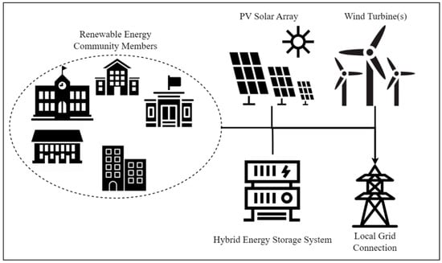
Figure 8: Schematic illustration of hybrid energy storage system (adapted from Oudejans et al., 2023).
6.1.4 Application in Electric Vehicles Integrated with Renewables
Battery technologies are also central to electric vehicles powered by renewable energy. In vehicle-to-grid configurations, electric vehicle batteries can store renewable energy and feed it back into the grid, enhancing energy flexibility and resilience (Danzi et al., 2021).
6.2 Supercapacitors in Renewable Energy Systems
Supercapacitors, also known as ultracapacitors, store energy through electrostatic charge accumulation and are characterized by high power density and rapid charge-discharge cycles.
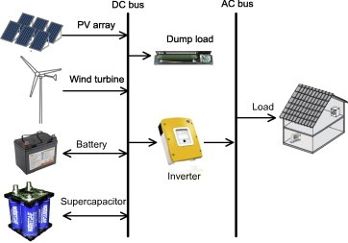
Figure 9: Supercapacitors and their use in Hybrid Energy Storage System (Junaid,T. 2020
6.2.1 Power Smoothing Applications
Supercapacitors are widely used alongside batteries to manage short-term fluctuations in renewable energy output. Their rapid response capability allows them to handle transient variations, while batteries manage long-term energy storage (Skeleton Technologies, 2025; Electricity Magnetism, 2023).
6.2.2 Grid Stabilization and Power Quality
In renewable-integrated grids, supercapacitors contribute to voltage stabilization and power quality improvement by compensating for sudden disturbances and maintaining system stability (Adeyemo et al., 2024).
6.2.3 Applications in Renewable-Powered Transport Systems
Supercapacitors are used in electric buses, cranes, and rail systems powered by renewable energy. They enable regenerative braking and rapid energy delivery, improving overall system efficiency (Skeleton Technologies, 2025).
6.3 Flywheel Energy Storage Systems
Flywheel energy storage systems store energy in the form of rotational kinetic energy and are suitable for high-power, short-duration applications.
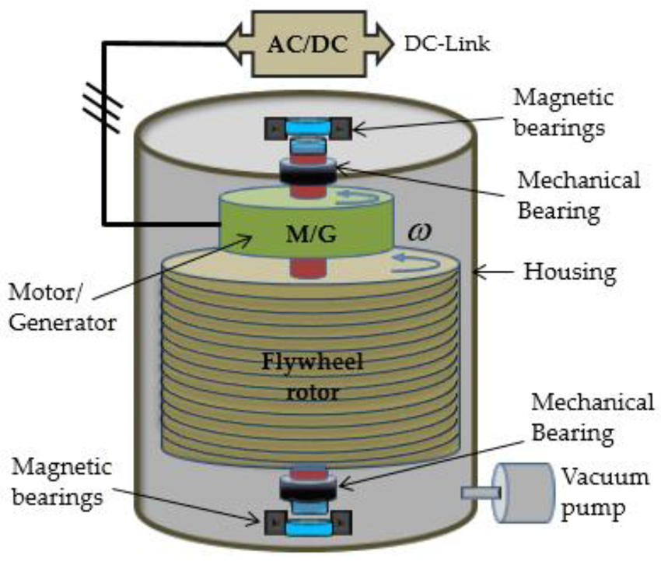
Figure 9: Flywheel Energy Storage System (Amiryar & Pullen, 2020)
6.3.1 Frequency Regulation in Renewable Grids
Flywheels provide rapid frequency response in grids with high renewable penetration. They stabilize frequency deviations caused by sudden changes in generation or load (Adeyemo et al., 2024).
6.3.2 Applications in Wind Power Systems
In wind energy systems, flywheels smooth output variations caused by fluctuating wind speeds, ensuring a more consistent power supply (Sahu et al., 2021).
6.3.3 Transportation Applications
Flywheel systems have been applied in electric transport systems such as buses, where they store and release energy efficiently during operation cycles (Wikipedia, 2024).
6.4 Superconducting Magnetic Energy Storage (SMES)
SMES systems store energy in the magnetic field generated by a superconducting coil, offering near-instantaneous response and high efficiency.
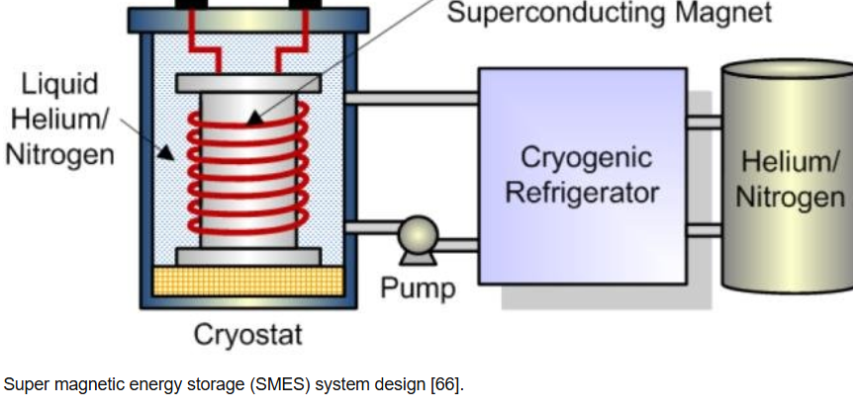
Figure 10: Superconducting Magnetic Energy Storage (SMES) (Nadeem et al., 2019)
6.4.1 Power Quality Enhancement
SMES systems are used to mitigate power disturbances such as voltage sags and interruptions in renewable energy systems, thereby improving power quality (Adeyemo et al., 2024).
6.4.2 Grid Stability Applications
Due to their rapid response, SMES systems are suitable for stabilizing grids with high levels of renewable energy integration (Adeyemo et al., 2024).
6.4.3 Hydrogen Energy Storage Systems
Hydrogen energy storage involves converting electrical energy into hydrogen through electrolysis and storing it for later use.
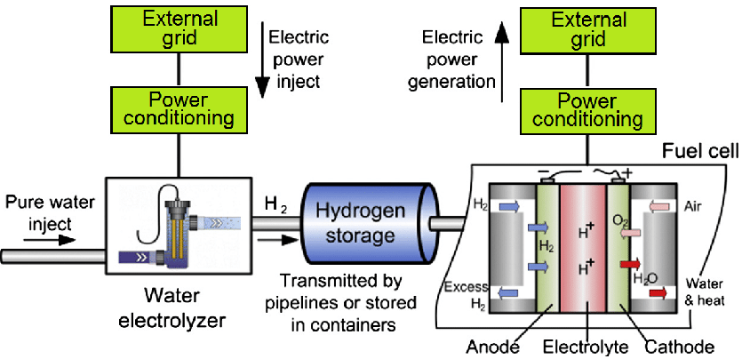
Figure 11: Hydro Energy Storage System (Kleperis et al., 2016)
6.5 Long-Term Energy Storage
Hydrogen storage systems are particularly suitable for long-term and seasonal energy storage, addressing limitations associated with battery storage duration (World Economic Forum, 2025).

6.5.1 Power-to-Gas Applications
Excess renewable energy can be converted into hydrogen and integrated into gas networks or used in fuel cells to generate electricity when needed (World Economic Forum, 2025).
6.5.2 Industrial and Transportation Applications
Hydrogen produced from renewable energy is increasingly used in fuel cell vehicles and industrial processes, contributing to decarbonization efforts (World Economic Forum, 2025).
6.5.3 Thermal Energy Storage Systems
Thermal energy storage systems store energy in the form of heat and are commonly used in solar thermal applications.
6.5.4 Concentrated Solar Power (CSP) Plants
In CSP plants, thermal storage enables electricity generation even in the absence of sunlight, thereby improving system reliability and dispatchability (Sahu et al., 2021).
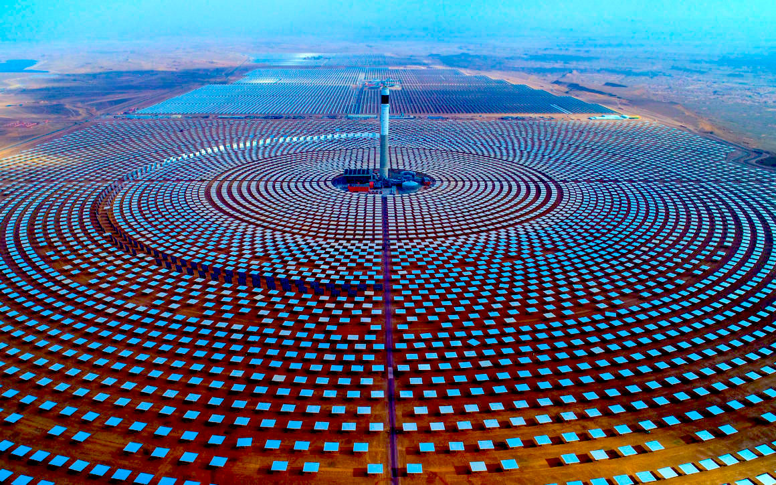
Figure 12: Tower and parabolic trough concentrated solar power systems at the Noor Ouarzazate Solar Complex, illustrating hybrid CSP technologies used for large-scale solar energy generation completed in 2018 (SolarPACES, n.d.).
6.5.5 Building Energy Systems
Thermal storage systems are also applied in renewable-powered buildings to regulate temperature and reduce overall energy consumption (Electricity Magnetism, 2023).
7.0 Pumped Hydro Energy Storage (PHES)
Pumped hydro energy storage is one of the most established large-scale energy storage technologies.
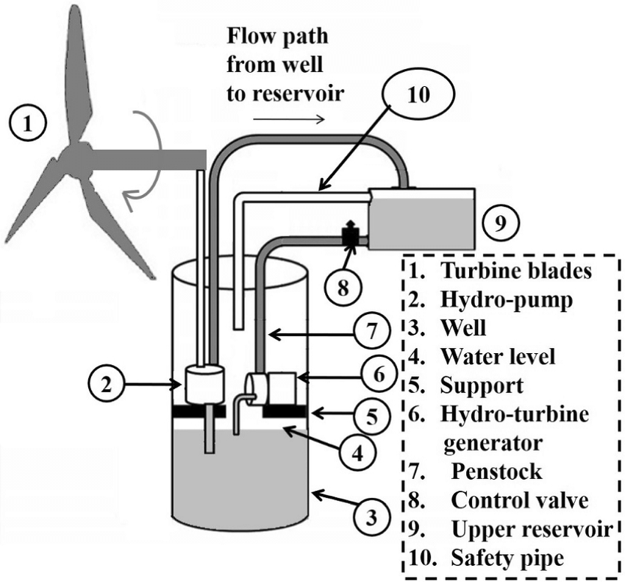
Figure 13: Schematic representation of power transmission strategies in wind turbines, showing gearbox-based and direct-drive configurations. Adapted from Mahato and Ghoshal (2019).
7.1 Grid-Scale Renewable Integration
PHES systems store excess renewable energy by pumping water to elevated reservoirs and releasing it to generate electricity during peak demand periods (Adeyemo et al., 2024).
7.2 Load Balancing Applications
They play a significant role in balancing supply and demand in power systems with high renewable penetration (Adeyemo et al., 2024).
8.0 Emerging Applications of Advanced Storage Technologies
Recent advancements in materials science have led to the development of innovative storage technologies.
Graphene-based supercapacitors are being used in flexible electronics and wearable devices (Bellani et al., 2019; Live Science, 2025).
3D-printed energy storage devices enable customized applications in electronics and biomedical systems (Gulzar et al., 2019; Egorov et al., 2019).
Structural batteries are integrated into electric vehicles and aerospace systems, serving both structural and energy storage functions (Danzi et al., 2021).
These emerging technologies expand the scope of charge storage applications beyond traditional power systems. Charge storage technologies are indispensable in renewable energy systems, providing solutions to intermittency, enhancing grid stability, and enabling efficient energy utilization. Their applications span residential, industrial, transportation, and grid-scale systems. As technological advancements continue, these storage systems will play an increasingly vital role in achieving sustainable and resilient energy systems globally.
Conclusion
Charge storage technologies are an essential part of contemporary energy systems, especially for facilitating the widespread use of renewable energy sources. This review shows that traditional technologies like lithium-ion batteries, pumped hydro storage, and thermal systems are still commonly used, but they are increasingly being supplemented by new technologies aimed at overcoming their limitations. Electrochemical storage systems remain the leading choice because of their effectiveness and flexibility. However, issues concerning energy density, safety, cost, and environmental effects require ongoing improvements. New technologies like sodium-ion batteries, solid-state batteries, and redox flow batteries offer practical options, especially for large-scale and long-term energy storage. Furthermore, electrostatic systems like supercapacitors provide high power density and quick response times, which makes them effective for managing transient energy. Advanced materials, particularly nanostructured and carbon-based materials, are seen as essential for improving the performance of future storage devices. Hybrid energy storage systems enhance the connection between energy and power density, which increases the efficiency and longevity of the overall system. In summary, the future of energy storage depends on combining various technologies, along with advancements in materials and overall system improvements, to create a dependable, efficient, and sustainable energy infrastructure.
Future focus
There should be more focus on developing nanostructured, carbon-based, and composite materials to improve the energy density, conductivity, and lifespan of storage devices. Research and commercialization of alternatives like sodium-ion, solid-state, and redox flow batteries should be expedited to decrease reliance on lithium resources and enhance sustainability. Encouraging the combination of batteries with supercapacitors or other storage technologies can enhance both energy and power performance in renewable energy systems. Efforts should concentrate on lowering manufacturing costs, optimizing system design, and increasing efficiency to make energy storage technologies more financially feasible. Improving safety and environmental sustainability should focus on the development of non-flammable electrolytes, recyclable materials, and eco-friendly disposal methods. Governments and relevant parties should encourage policies that facilitate the widespread use of energy storage systems to integrate renewable energy and maintain grid stability. Emphasis should be placed on advancing long-duration energy storage technologies, including hydrogen storage, redox flow batteries, and thermal storage systems, to meet the requirements for extended and seasonal energy storage.

References
Adeyemo, I. A., Adelani, S. A., & Adebiyi, O. W. (2024). Energy storage systems: Technologies and high-power applications. Batteries, 10(4), 141. https://doi.org/10.3390/batteries10040141
Alva, G., Lin, Y., & Fang, G. (2018). An overview of thermal energy storage systems. Energy, 144, 341–378.
Aminudin, M. A., Kamarudin, S. K., Lim, B. H., Majilan, E. H., Masdar, M. S., & Shaari, N. (2023). Current progress on hydrogen fuel cell vehicles. International Journal of Hydrogen Energy, 48, 4371–4388.
Amiryar, M. E., & Pullen, K. R. (2017). A review of flywheel energy storage system technologies and their applications. Applied Sciences, 7, 286.
Amiryar, M. E., & Pullen, K. R. (2020). Analysis of standby losses and charging cycles in flywheel energy storage systems. Energies, 13(17), 4441. https://doi.org/10.3390/en13174441
Aneke, M., & Wang, M. (2016). Energy storage technologies and real life applications. Applied Energy, 179, 350–377.
Arico, A. S., Bruce, P., Scrosati, B., Tarascon, J. M., & Van Schalkwijk, W. (2020). Nanostructured materials for advanced energy conversion and storage devices. Nature Materials, 19(8), 813–820.
Armand, M., & Tarascon, J. M. (2018). Building better batteries. Nature, 451(7179), 652–657. https://doi.org/10.1038/451652a
AZoM. (2024, February 1). Advancements and challenges in silicon-based anode materials. AZoM – The A-Z of Materials. https://www.azom.com/news.aspx?newsID=62491
Bellani, S., Najafi, L., Martín-García, B., Ansaldo, A., Del Rio Castillo, A. E., Bonaccorso, F., & Pellegrini, V. (2019). Scalable production of graphene inks via wet-jet milling exfoliation for screen-printed micro-supercapacitors. Nature Communications, 10, 1–10. https://doi.org/10.1038/s41467-019-09335-6
Bolt, A., Dincer, I., & Agelin Chaab, M. (2020). A critical review of synthetic natural gas production techniques. Journal of Natural Gas Science and Engineering, 84, 103670.
Brousse, T., Long, J. W., & Bélanger, D. (2017). Pseudocapacitive vs battery type electrodes: Two distinctive aspects of fast electrochemical processes and devices. ECS Transactions, 75(14), 605–611. https://doi.org/10.1149/ma2017-02/7/605
Chen, G. (2017). Supercapacitor and supercapattery as emerging electrochemical energy stores. International Materials Reviews, 62(4), 173–202. https://doi.org/10.1080/09506608.2016.1240914
Choudhary, G., Dhariwal, J., Saha, M., Trivedi, S., Banjare, M. K., Kanaoujiya, R., & Behera, K. (2023). Ionic liquids: Environmentally sustainable materials for energy conversion and storage applications. Environmental Science and Pollution Research. https://doi.org/10.1007/s11356-023-25468-w
Crawford, M. (2018, October 24). Making the next-generation lithium-ion batteries safer, longer- lasting. ASME. https://www.asme.org/topics-resources/content/making-nextgeneration- lithiumion-batteries-safer
Danzi, F., Salgado, R. M., Oliveira, J. E., Arteiro, A., & Camanho, P. P. (2021). Structural batteries: A review. Molecules, 26(23), 7208. https://doi.org/10.3390/molecules26237208
Deysher, G., Ridley, P., Ham, S.-Y., Doux, J.-M., Chen, Y.-T., Wu, E. A., Tan, D. H. S., Cronk, A., Jang, J., & Meng, Y. S. (2022). Transport and mechanical aspects of all-solid-state lithium batteries. Materials Today Physics, 24, 100679. https://doi.org/10.1016/j.mtphys.2022.100679
Dogutan, D. K., & Nocera, D. G. (2019). Artificial photosynthesis at efficiencies exceeding natural photosynthesis. Accounts of Chemical Research, 52, 3143–3148.
Dunn, B., Kamath, H., & Tarascon, J. M. (2016). Electrical energy storage for the grid: A battery of choices. Science, 334(6058), 928–935. https://doi.org/10.1126/science.1212741
Dunn, B., Zheng, H., & Gogotsi, Y. (2022). Electrochemical energy storage for the future: Redefining pseudocapacitance. Nature Reviews Materials, 7(6), 433–452. https://doi.org/10.1038/s41578-022-00421-6
Egorov, V., Gulzar, U., Zhang, Y., O’Dwyer, C., & Nikolayev, V. (2019). Evolution of 3D printing methods and materials for electrochemical energy storage. Advanced Materials Technologies, 5(1), 1900441. https://doi.org/10.1002/admt.201900441
Electricity Magnetism. (2023). What are the different types of energy storage technologies and their applications? Retrieved from https://www.electricity-magnetism.org
Ferreira-Martínez, D., & López-Agüera, A. (2024, October 4). Effects of including resource intermittency of wind and solar technologies in OSeMOSYS modelling tool. Preprints.org. https://doi.org/10.20944/preprints202410.0346.v1
Fleischmann, S., Zhang, Y., Wang, X., Cummings, P. T., Wu, J., Simon, P., Gogotsi, Y., Presser, V., & Augustyn, V. (2022). Continuous transition from double layer to Faradaic charge storage in confined electrolytes. Nature Energy, 7, 222–228. https://doi.org/10.1038/s41560-022-00962-8
Goodenough, J. B., & Park, K. S. (2017). The Li ion rechargeable battery: A perspective. Journal of the American Chemical Society, 135(4), 1167–1176. https://doi.org/10.1021/ja3091438
Gulzar, U., Glynn, C., & O’Dwyer, C. (2019). Additive manufacturing for energy storage devices: A review. Advanced Energy Materials, 9(23), 1900483. https://doi.org/10.1002/aenm.201900483
Guney, M. S., & Tepe, Y. (2017). Classification and assessment of energy storage systems. Renewable and Sustainable Energy Reviews, 75, 1187–1197.
Hou, J., Zhang, X., Li, Y., Chen, J., Wang, H., Liu, Q., Zhao, S., & Ma, Z. (2024). Composite electrolytes and interface designs for progressive solid‐state sodium batteries. Carbon Energy. https://doi.org/10.1002/cey2.628
Junaid, T. (2020, March 7). Hybrid energy storage system (HESS): Super capacitor and their use in hybrid energy storage system. LinkedIn.
Kleperis, J., Fylenko, V. V., Vanags, M., Volkovs, A., et al. (2016). Energy storage solutions for small and medium-sized self-sufficient alternative energy objects. Bulgarian Chemical Communications, 48(Special Issue E), 290–296.
Koohi Fayegh, S., & Rosen, M. A. (2020). A review of energy storage types, applications and recent developments. Journal of Energy Storage, 27, 101047.
Krishan, O., & Suhag, S. (2019). An updated review of energy storage systems. International Journal of Energy Research, 43, 6171–6210.
Lee, D., Kakarla, A. K., Sun, S., Kim, P. J., & Choi, J. (2025). Inorganic solid-state electrolytes for solid-state sodium batteries: Electrolyte design and interfacial challenges. ChemElectroChem, 12(1), e202400612. https://doi.org/10.1002/celc.202400612
Li, F., Hou, M., Zhao, L., Zhang, D., Yang, B., & Liang, F. (2024). Electrolyte and interface engineering for solid-state sodium batteries. Energy Storage Materials, 48, 103181. https://doi.org/10.1016/j.ensm.2024.103181
Liu, C., Li, F., Ma, L. P., & Cheng, H. M. (2019). Advanced materials for energy storage. Advanced Materials, 22(8), E28–E62. https://doi.org/10.1002/adma.200903328
Liu, W., Placke, T., & Chau, K. T. (2022). Overview of batteries and battery management for electric vehicles. Energy Reports, 8, 4058–4084.
Live Science. (2025). Graphene supercapacitor breakthrough could boost energy storage in future EVs and devices. Retrieved from https://www.livescience.com
Lü, Z., Kang, J., Qiu, P., & Chen, X. (2024). Hydridoborate-based solid-state electrolytes for sodium metal batteries. Batteries & Supercaps, 7(11), e202400636. https://doi.org/10.1002/batt.202400636
Lukatskaya, M. R., Dunn, B., & Gogotsi, Y. (2018). Multidimensional materials and device architectures for future hybrid energy storage. Nature Communications, 7, 12647. https://doi.org/10.1038/ncomms12647
Lv, Q., Li, C., Liu, Y., Jing, Y., Sun, J., Wang, H., Wang, L., Ren, H., Wu, B., Cheng, T., Wang, D., Liu, H., Dou, S. X., Wang, B., & Wang, J. (2024). In-situ polymerized high-voltage solid-state lithium metal batteries with dual-reinforced stable interfaces. ACS Nano, 18(8), 8234–8247. https://doi.org/10.1021/acsnano.4c06057
Mahato, A. C., & Ghoshal, S. K. (2019). Various power transmission strategies in wind turbine: An overview. International Journal of Dynamics and Control, 7(4), 1285–1304. https://doi.org/10.1007/s40435-019-00543-8
Mahmoud, M., Ramadan, M., Olabi, A. G., Pullen, K., & Naher, S. (2020). A review of mechanical energy storage systems combined with renewable applications. Energy Conversion and Management, 210, 112670.
Mitali, J., Dhinakaran, S., & Mohamad, A. A. (2022). Energy storage systems: A review. Energy Storage and Saving, 1, 166–216.
Mukherjee, P., & Rao, V. V. (2019). Development of superconducting magnetic energy storage systems. Physica C Superconductivity and Applications, 563, 67–73.
Naguib, M., Mochalin, V., Barsoum, M. W., & Gogotsi, Y. (2017). 25th anniversary article: MXenes: A new family of two dimensional materials. Advanced Materials, 26(7), 992– 1005. https://doi.org/10.1002/adma.201304138
Nadeem, F., Hussain, S. M. S., Tiwari, P. K., Goswami, A. K., & Ustun, T. S. (2019). Comparative review of energy storage systems, their roles and impacts on future power systems. IEEE Access, 7, 4555–4585. https://doi.org/10.1109/ACCESS.2018.2888497
Oladele, I. O., Adelani, S. O., Taiwo, A. S., Akinbamiyorin, I. M., Olanrewaju, O. F., & Orisawayi, A. O. (2025). Polymer based nanocomposites for supercapacitor applications: A review on principles, production and products. RSC Advances. https://doi.org/10.1039/D5RA
Okazawa, A., Kakuchi, T., Kawai, K., & Okubo, M. (2023). Iron-based catholytes for aqueous redox-flow batteries. APL Materials, 11(11), 110901. https://doi.org/10.1063/5.0160078
Oudejans, D., Offidani, M., Constantinou, A., Albonetti, S., Dimitratos, N., & Bansode, A. (2023). Optimal design and analysis of a hybrid hydrogen energy storage system for an island- based renewable energy community [Figure]. Energies, 16(21), 7363. https://doi.org/10.3390/en16217363
Ouyang, M., Guo, Z., Salinas-Farran, L., Zhao, Y., Zhao, S., Zheng, K., Zhang, H., Wang, M., Li, G., Li, F., Liu, X., Yang, S., Xie, F., Shearing, P. R., Titirici, M.-M., & Brandon, N. P. (2024). High-areal-capacity Na-ion battery electrode with uncompromised energy and power densities by simultaneous electrospinning-spraying fabrication. arXiv. https://doi.org/10.48550/arxiv.2408.11655
Rabi, A., Radulovic, J., & Buick, J. (2023). Comprehensive review of compressed air energy storage technologies. Thermo, 3, 104–126.
Rahmawati, F., Rustamaji, E., Prakoso, A., Devianto, H., Widiatmoko, P., & Kurnia, R. (2025). Electrochemical double-layer capacitor energy storage mechanisms and performance analysis. International Journal of Renewable Energy Development, 14(3), 392–403.
Revankar, S. T. (2019). Chemical energy storage. Elsevier.
Rudra, S., Seo, H. W., Sarker, S., Kim, D. M. (2024). Supercapatteries as Hybrid Electrochemical Energy Storage Devices: Current Status and Future Prospects. Molecules. 29 doi: 10.3390/molecules29010243.
Sahu, P. K., Jena, S., & Sahoo, U. (2021). Efficient energy storage systems for wind power applications. In U. Sahoo (Ed.), Energy storage technologies and applications (pp. 123– 156). Wiley. https://doi.org/10.1002/9781119555599
Saeed, M., et al. (2023). A comprehensive review of nanomaterials: Types, synthesis, characterization, and applications [Figure]. ResearchGate. https://www.researchgate.net/publication/368807997
Shi, K., Guan, B., Zhuang, Z., Chen, J., Chen, Y., Ma, Z., Zhu, C., Hu, X., Zhao, S., Dang, H., Guo, J., Chen, L., Shu, K., Li, Y., Guo, Z., Yi, C., Hu, J., & Huang, Z. (2024). Recent progress and prospects on sodium-ion battery and all-solid-state sodium battery: A promising choice of future batteries for energy storage. Energy & Fuels, 38(11), 9280– 9319. https://doi.org/10.1021/acs.energyfuels.4c00980
Siddique, M. T., Nisar, A., Wafad, A. A., Anjum, S., Zahid, U., Syed Akbar, W. A., Mateen, A., Deebaj, M., & Abbas, N. (2025). Advances in nanomaterials for next-generation lithium- ion and solid-state batteries: A physics-driven review. Scholars Journal of Engineering and Technology, 13(8), 664–672. https://doi.org/10.36347/sjet.2025.v13i08.006
Simon, P., & Gogotsi, Y. (2020). Perspectives for electrochemical capacitors and related devices. Nature Materials, 19(11), 1151–1163.
Singh, A. N., Islam, M., Meena, A., Faizan, M., Han, D., Bathula, C., Hajibabaei, A., Anand, R., & Nam, K.-W. (2023). Unleashing the potential of sodium-ion batteries: Current state and future directions for sustainable energy storage. Advanced Functional Materials, 33(46), Article 2304617. https://doi.org/10.1002/adfm.202304617
Skeleton Technologies. (2025). Supercapacitor applications in transport and industry. Retrieved from https://www.skeletontech.com
SolarPACES. (n.d.). How concentrated solar power works. How concentrated solar power works
Soloveichik, G. L. (2015). Flow batteries: Current status and trends. Chemical Reviews, 115, 11533–11558.
Srividhya, G., & Ponpandian, N. (2023). Pseudocapacitance: Mechanism and characteristics. In Engineering materials (pp. 39–56). Springer. https://doi.org/10.1007/978-3-031-45430- 1_3
Vedhanarayanan, B., & Seetha Lakshmi, K. C. (2024). Beyond lithium-ion: Emerging frontiers in next-generation battery technologies. Frontiers in Battery and Energy Storage, 5, 1377192. https://doi.org/10.3389/fbael.2024.1377192
Volfkovich, Y. M. (2024). Electric double layer capacitors (review). Russian Journal of Electrochemistry, 60(10), 654–691. https://doi.org/10.31857/S0424857024100022
Wang, F., Wu, X., Yuan, X., Liu, Z., Zhang, Y., Fu, L., Zhu, Y., Zhou, Q., Wu, Y., & Huang, W. (2019). Latest advances in supercapacitors from new electrode materials to novel device designs. Chemical Society Reviews, 46(22), 6816–6854.
Wang, H., Yi, H., Chen, X., & Wang, X. (2021). Asymmetric supercapacitors based on nanostructured materials. Nano Energy, 39, 83–90. https://doi.org/10.1016/j.nanoen.2017.04.009
Wang, Y., Chen, Q., Zhao, P., Wu, C., Wu, X., & Chou, S. L. (2025). Recent advances in hybrid supercapacitors: A review of high performance materials and scalable fabrication techniques. Journal of Materials Chemistry A. https://doi.org/10.1039/D5TA02887F
Wei, Q., et al. (2026). Unlocking limited electric double layer capacity via electrochemically driven continuous partial desolvations in carbon nanopores. Nature Communications, 17, 363. https://doi.org/10.1038/s41467-025-66433-0
Wikipedia. (2024). Capacitor. Retrieved March 26, 2026, from https://en.wikipedia.org/wiki/Capacitor
Wikipedia. (2024). Gyrobus. Retrieved March 26, 2026, from https://en.wikipedia.org/wiki/Gyrobus
Wikipedia. (2024). Potential applications of graphene. Retrieved March 26, 2026, from https://en.wikipedia.org/wiki/Potential_applications_of_graphene
World Economic Forum. (2025). Top emerging technologies of 2025. Retrieved from https://www.weforum.org
Yu, M. (2024). Battery components derived from silica-depleted rice hull ash (SDRHA) (Master’s thesis, University of Michigan). University of Michigan Deep Blue Repository. https://doi.org/10.7302/24934
Zhang, L. L., Zhao, X. S., & Ji, H. (2020). Carbon based materials as supercapacitor electrodes. Chemical Society Reviews, 38(9), 2520–2531. https://doi.org/10.1039/b813846j
Zhang, L., Zhao, X., Ji, H., & Li, Y. (2021). Emerging materials for high performance supercapacitors. Energy Storage Materials, 34, 545–576.
Zhao, J., & Burke, A. F. (2021). Review on supercapacitors technologies and performance evaluation. Journal of Energy Chemistry, 59, 276–291.

