Child Malnutrition and Minimum Dietary Diversity Across Indian States: A Comparative Analysis

Anil¹ and Ruby Nehra²
^{1,2} Research Scholars, Department of Economics, Guru Jambheshwar University of Science and Technology, Hisar (125001), Haryana
Email: 18anil.ma@gmail.com; rubynehra9@gmail.com

Child Malnutrition and Minimum Dietary Diversity Across Indian States: A Comparative Analysis

Abstract

India, the most populous country in the world, faces a significant burden of child malnutrition. Despite economic progress, India continues to host one of the largest numbers of undernourished individuals globally. Approximately 12 per cent of the Indian population was undernourished in 2024. In the same year, 37.4 million children under five were stunted in India, and 18.7 per cent suffered from wasting, which is among the highest rates in the world. India faced the burden of child malnutrition, the highest in the world and is significantly higher than that of many sub-Saharan African countries. Malnutrition contributes significantly to the disease burden among children, with more than fifty per cent of deaths among children under five in the world related to undernutrition, specifically in the low and middle-income countries, including India. Significant regional disparities in Minimum Dietary Diversity (MDD) were observed across India. MDD was associated with lower odds of wasting but showed a positive association with stunting, whereas its relationship with underweight was not statistically significant. Female children, higher household wealth, and maternal education significantly reduced the likelihood of child malnutrition, highlighting the importance of socioeconomic and educational factors in improving nutritional outcomes.
Keywords: child malnutrition, stunting, wasting, underweight, minimum dietary diversity

Child Malnutrition and Minimum Dietary Diversity Across Indian States: A Comparative Analysis

Introduction

Good nutrition involves taking in and utilising enough energy and nutrients for good health and nutritional status. Nutrition is essential during childhood for proper growth, brain development, and a healthier, longer life. India, which is the most populous country on Earth, has a great deal of malnourished children. Despite economic progress, India continues to host one of the largest numbers of undernourished individuals globally. Approximately 12 per cent of the Indian population was undernourished in 2024. In the same year, 37.4 million children under five were stunted in India, and 18.7 per cent suffered from wasting, which is among the highest rates in the world (The State of Food Security and Nutrition in the World, 2025). Economic implications of malnutrition are also substantial. It is estimated that every one-dollar investment in nutrition interventions can generate up to sixteen dollars in economic returns (Micha et al., 2020). Malnutrition imposes high economic costs. India is estimated to lose around 2.6 per cent of its GDP due to malnutrition (Nugent, Levine and Hale).
The key elements of children's good nutrition are adequate meals and the availability of foods of the right quality and quantity. Encouraging moms to breastfeed exclusively for the first six months and to start age-appropriate, safe, responsive, and nutritionally enough supplemental feeding at six months is an easy way to achieve optimal baby and young child feeding. A low-nutrient diet is the root cause of malnourishment. Malnutrition has many varied and complex causes, many of which are linked to poverty, limited access to essential services, and mothers' lack of understanding. Malnutrition during a child's first two years of life causes physical and cognitive deficits that are mostly irreversible. If a child survives, they may experience a lifetime of terrible side effects, such as heightened susceptibility to illnesses, delayed development, reduced growth, and even blindness that keeps kids from succeeding in school and from going for meaningful jobs as adults, which eventually results in decreased production and income. According to the World Health Organisation, “malnutrition is divided into four comprehensive categories, viz. stunting, wasting, underweight and overweight, measured by standardised anthropometric measures viz. height for age, weight for height, and weight for age, and weight for height indexes, respectively”. A lack of calories and protein available to the body's tissues is known as stunting or chronic protein-energy malnutrition. It is brought on by either chronic and recurrent illness or insufficient food consumption over an extended period of time. Acute protein energy malnutrition, often known as wasting, is the inadequate nutrition brought on by recent disease episodes, diarrhoea in particular, or severe food scarcity. Stunting, or low height for age, is a result of illnesses and undernutrition that have slowed a child's growth from birth. Children who are underweight or underweight for their age may exhibit wasting, or low weight-height, which might be a sign of stunting, acute weight loss, or both.

A stunted child has a low height for age, which is a result of illnesses and malnutrition that have stunted the child's growth since birth. Youngsters who are underweight for their age (underweight) can be a sign of stunting, acute weight loss, or both. Malnutrition is determined by several cultural, social, economic, biological and morbidity factors, such as age, birth weight, duration of breastfeeding, family head gender, place of residence (rural/urban), type of house, sanitation facilities, education level of the father and mother, caregiver, frequency of cough and diarrhoea, and consumption of milk and dairy products (Tharakan & Suchindran, 1999). Children from families with higher and middle-class incomes were less likely to be wasted, underweight, or stunted, and children of working mothers were less likely to be wasted than children of mothers who did not work (Siddiqa et al., 2023). Mother's education has a significant, favourable impact on children's health (Lakshmanasamy, 2022). The majority of the changes in child nutrition can be attributed to maternal body mass index, education, and household economic status; the prevalence of stunting and underweight has decreased by 7 and 6 percentage points, respectively (Nie et al., 2019). Significant risk factors for childhood undernutrition include the kid's age, whether the child has a fever or diarrhoea, the kind of birth, the education level of the mother and BMI, the wealth of the household, and the number of children under five in the home (Khanam et al., 2019). The nutritional status of children and the level of maternal awareness are significantly improved by nutrition education (Prasetyo et al., 2023).
Improvements in women's dietary diversity, self-esteem, and the pace of a child's dietary diversity all have a major impact on the child's nutritional health (Banu et al., 2023). The likelihood of malnutrition rises sharply with the number of one's siblings, the mother's poor level of education, inappropriate food consumption, etc. (Chakraborty & Ghosh, 2020). Poverty, lack of child-feeding practices, a lack of nutrition knowledge among brestfeeding mothers or other caregivers, and inadequate healthcare facilities have been identified as the most important risk factors for malnutrition (Ijarotimi, 2013). The issue of minimum dietary diversity (MDD) and minimum acceptable diet (MAD) among children has been widely examined in the Indian context using large-scale survey data and localised studies. The prevalence of MDD and MAD in India remains critically low at 25% and 10.5%, respectively, with maternal education, maternal BMI, and household wealth emerging as significant determinants(Jaleel et al., 2025). Similarly, (Jain et al., 2022), using NFHS-4 data, highlighted substantial regional disparities, reporting that only 19.8% of children met the MDD criteria, with pronounced clustering of poor dietary diversity in states like Rajasthan and Uttar Pradesh. (Rai et al., 2022) Further examined temporal trends and observed persistently high levels of minimum dietary diversity failure (MDDF), particularly in rural areas and among socially advantaged groups, indicating structural and socio-cultural influences on child feeding practices. In addition, Saha et al., 2022), established a strong link between dietary diversity and child growth outcomes, demonstrating that consumption of animal-source foods significantly reduces the risk of stunting, although less than one-fourth of children in India receive a diversified diet. (Vashist et al., 2024) Based on primary data from rural Gurugram, reported that only 14% of children achieved minimum dietary diversity and less than 10% met MAD standards, with maternal awareness and healthcare counselling playing a crucial role in improving feeding practices. Furthermore,(Sihag et al., 2026), emphasised the importance of nutritional knowledge and household food expenditure patterns in shaping intra-household dietary outcomes, particularly among farming communities in Haryana.

Purpose of the study

- To study the status of child Malnutrition in the Indian States.
- To study the acceptable minimum diet diversity in different states.

Research Methodology
To study the status of child Malnutrition in India, the methodology given by WHO has been used. This methodology consists of two steps. In the first step, the study identifies the undernutrition or overnutrition level of children. As per the WHO, “Undernutrition is measured by stunting, wasting, and being underweight, while overnutrition is measured by being overweight. Stunted (Length/height-for-age ≤−2 SD and ≥−3 SD of the median), Wasted (Weight-for-length/height ≤−2 SD and ≥−3 SD of the median), Underweight (Weight-for-age <−2 SD and ≥−3 SD of the median)” (WHO).
For the second objective, adopt the WHO’s infant and young child feeding (IYCF) guidelines as internationally recognised supplementary feeding guidelines tools (WHO 2021). The eight food categories, which are given by WHO, are as follows:
- mother breast milk (2) roots, grains, plantains and tubers (3) seeds, nuts and pulses (peas, lentils and beans) (4) dairy products like yogurt, cheese, milk and infant formula (5) flesh foods, fish, meat, poultry (6) fruits & vegetables containing vitamin A (7) eggs (8) other vegetable & fruits. The data on these food categories was gathered by NFHS, consumed by a child in the last 24 hours, from the child's mother, by using a structured questionnaire. If a child eats one food item from all categories in the last 24 hours, then one value is assigned to that category for that child and otherwise zero if they do not eat. After this, the scores are summed up to get the diet diversity score (DDS), which ranges from 0 to 8. If a child consumed five or more foods, then he was assigned minimum dietary diversity (MDD)
Results and Findings

Figure:1 Percentage of children under 5 affected by stunting, wasting, and underweight in India

Source: based on the author’s calculation using NFHS (2015 -16) and NFHS (2019 -21)

Figure 1: The percentage of Indian children under five who suffer from stunting, wasting, and underweight. From NFHS-4 to NFHS-5, wasting shows a significant decrease of (2), although stunting and underweight show very slight improvements (4 and 2).

Figure 2: Percentage of Children under 5 affected by Stunting in India, NFHS-5
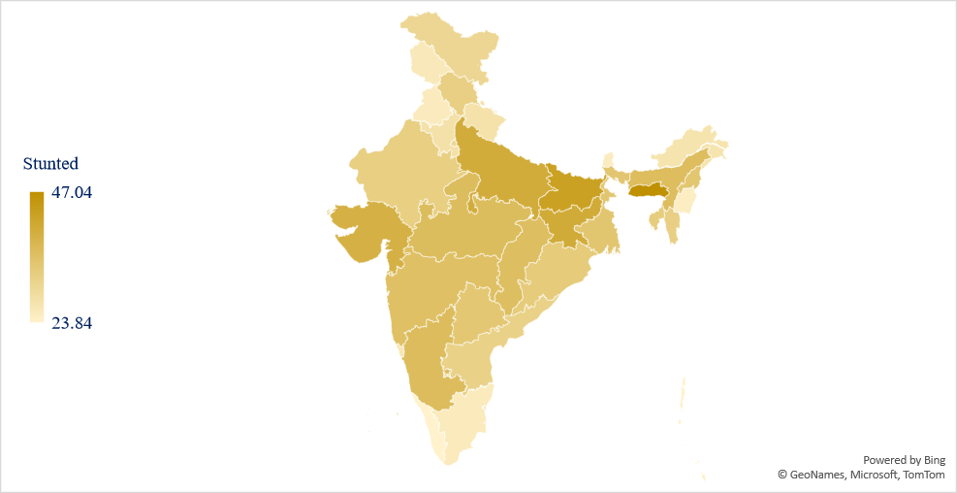
Source: based on the author’s calculation using NFHS (2015 -16) and NFHS (2019 -21)

Figure 3: Trends of Stunting in Children Under Five Years old in India, NFHS-4 to NFHS-5

based on the author’s calculation using NFHS (2015 -16) and NFHS (2019 -21)

Figure 3 illustrates the patterns of stunting in children under five in India during NFHS-4 and NFHS-5. Meghalaya and Bihar had the highest number of stunted children, while Kerala had the lowest number of stunted children in NFHS-5 in India, while Andaman & Nicobar Island had the lowest and Dadra & Nagar Haveli had the highest number of stunted children. In all states, the government tried to reduce stunting in children under age 5 children but in some states, i.e. Goa, Tripura, Himachal Pradesh, Kerala, Nagaland, Lakshadweep, Telangana, Puducherry, Meghalaya, Mizoram, Delhi, West Bengal, Punjab, the number of stunted children increased from NFHS-4 to NFHS-5 in India.

Figure 5 Percentage Change in Stunted Children Under 5 Years between NFHS-4 and NFHS-5

Source: based on the author’s calculation using NFHS (2015 -16) and NFHS (2019 -21)

Table 1: The percentage change in stunting among children under five years old between NFHS-4 and NFHS – 5
State | NFHS 5 | NFHS 4 | CHANGE | NFHS 5 | NFHS 4
Andaman & Nicobar | 24.15 | 25.81 | -6.43 | H | H
Andhra Pradesh | 31.67 | 31.97 | -0.94 | VH | VH
Arunachal Pradesh | 27.2 | 29.91 | -9.06 | H | H
Assam | 36.33 | 36.12 | 0.58 | H | H
Bihar | 43.04 | 48.33 | -10.95 | VH | VH
Chandigarh | 24.52 | 29.21 | -16.06 | H | H
Chhattisgarh | 36.15 | 38.42 | -5.91 | VH | VH
Dadra and Nagar Haveli | 36.15 | 38.42 | -5.91 | VH | VH
Delhi | 30.62 | 29.74 | 2.96 | VH | H
Goa | 26.47 | 20.21 | 30.97 | H | H
Gujarat | 39.23 | 39.87 | -1.61 | VH | VH
Haryana | 27.77 | 34.09 | -18.54 | H | VH
Himachal Pradesh | 32.11 | 25.41 | 26.37 | VH | H
Jammu and Kashmir | 25.87 | 28.27 | -8.49 | H | H
Jharkhand | 40.64 | 44.66 | -9.0 | VH | VH
Karnataka | 36.52 | 37.61 | -2.90 | VH | VH
Kerala | 23.84 | 19.42 | 22.76 | H | M
Lakshadweep | 31.08 | 26.83 | 15.84 | VH | H
Madhya Pradesh | 36.42 | 42.22 | -13.74 | VH | VH
Maharashtra | 35.62 | 36.15 | -1.47 | VH | VH
Manipur | 24.94 | 30.10 | -17.14 | H | VH
Meghalaya | 47.04 | 43.64 | 7.79 | VH | VH
Mizoram | 32.07 | 29.81 | 7.58 | VH | H
Nagaland | 34.34 | 28.95 | 18.62 | VH | H
Odisha | 33.14 | 34.92 | -5.10 | VH | VH
Puducherry | 28.53 | 26.21 | 8.85 | H | H
Punjab | 25.6 | 25.25 | 1.39 | H | H
Rajasthan | 32.22 | 38.86 | -17.09 | VH | VH
Sikkim | 25.14 | 29.62 | -15.12 | H | H
Tamil Nadu | 25.71 | 27 | -4.78 | H | H
Telangana | 33.91 | 29.8 | 13.79 | VH | H
Tripura | 32.81 | 25.43 | 29.02 | VH | H
Uttar Pradesh | 40.31 | 45.92 | -12.22 | VH | VH
Uttarakhand | 27.65 | 32.88 | -15.91 | H | VH
West Bengal | 34.41 | 33.58 | 2.47 | VH | VH
Source: based on the author’s calculation using NFHS (2015 -16) and NFHS (2019 -21)

Figure 7: Percentage of Indian Children Under Five Affected by Wasting, NFHS-5

Source: based on the author’s calculation using NFHS (2015 -16) and NFHS (2019 -21)

Figure 8: Percentage of Children under 5 affected by Wasting in India, NFHS-4 & NFHS-5

Source: based on the author’s calculation using NFHS (2015 -16) and NFHS (2019 -21)

Figure 8 shows that I state and UTs of India, Gujarat and Maharashtra had the most wasted children, Mizoram had the fewest, Chandigarh had the fewest, and Dadra & Nagar Haveli had the most. The highest progress was made by Haryana in reducing the number of children affected by wasting from NFHS-4 to NFHS-5, i.e., 47.52 per cent. Mizoram, Assam, Lakshadweep, Manipur, Nagaland, and Jammu & Kashmir were the states with the lowest performance, where childhood wasting in NFHS-5 grew rather than decreased.

Figure 9: Percentage Change in Wasted Children Under 5 Years between NFHS-4 and NFHS-5

Source: based on the author’s calculation using NFHS (2015 -16) and NFHS (2019 -21)

Table 2: The percentage change in wasted among children under five years old between NFHS-4 and NFHS - 5

State | NFHS – 5 | NFHS - 4 | Change | NFHS- 5 | NFHS - 4
Andaman & Nicobar Island | 17.84 | 15.67 | 13.84 | VH | VH
Andhra Pradesh | 15.94 | 16.86 | -5.45 | VH | VH
Arunachal Pradesh | 13.12 | 17.16 | -23.54 | H | VH
Assam | 21.3 | 16.04 | 32.79 | VH | VH
Bihar | 24.04 | 21.38 | 12.44 | VH | VH
Chandigarh | 9.09 | 11.8 | -22.96 | M | H
Chhattisgarh | 19.18 | 24.16 | -20.61 | VH | VH
Dadra & Nagar Haveli | 21.19 | 27.34 | -22.49 | VH | VH
Delhi | 11.3 | 18.18 | -37.84 | H | VH
Goa | 18.75 | 20.47 | -8.40 | VH | VH
Gujarat | 26.58 | 27.92 | -4.79 | VH | VH
Haryana | 11.35 | 21.63 | -47.52 | H | VH
Himachal Pradesh | 15.9 | 14.35 | 10.80 | VH | H
Jammu & Kashmir | 18.7 | 11.4 | 64.03 | VH | H
Jharkhand | 22.46 | 29.66 | -24.27 | VH | VH
Karnataka | 19.52 | 25.03 | -22.01 | VH | VH
Kerala | 15.38 | 16.15 | -4.76 | VH | VH
Lakshadweep | 19.31 | 13.24 | 45.84 | VH | H
Madhya Pradesh | 18.75 | 26.21 | -28.46 | VH | VH
Maharashtra | 25.77 | 25.18 | 2.34 | VH | VH
Manipur | 10.24 | 6.94 | 47.55 | H | M
Meghalaya | 12 | 15.82 | -24.14 | H | VH
Mizoram | 9.89 | 8.01 | 23.47 | M | M
Nagaland | 17.63 | 11.44 | 54.10 | VH | H
Odisha | 18.87 | 21.71 | -13.08 | VH | VH
Puducherry | 11.66 | 17.06 | -31.65 | H | VH
Punjab | 10.79 | 15.41 | -29.98 | H | VH
Rajasthan | 17.84 | 23.81 | -25.07 | VH | VH
Sikkim | 10.93 | 15.24 | -28.28 | H | VH
Tamil Nadu | 14.44 | 20.26 | -28.72 | H | VH
Telangana | 21.83 | 19.26 | 13.34 | VH | VH
Tripura | 19.16 | 17.81 | 7.58 | VH | VH
Uttar Pradesh | 17.64 | 17.77 | -0.73 | VH | VH
Uttarakhand | 12.14 | 19.81 | -38.71 | H | VH
West Bengal | 20.92 | 20.91 | 0.04 | VH | VH
Source: based on the author’s calculation using NFHS (2015 -16) and NFHS (2019 -21)

Figure 11: Percentage of Indian Children Under Five Affected by Underweight, NFHS-5

Source: based on the author’s calculation using NFHS (2015 -16) and NFHS (2019 -21)

Figure 12: Children under 5 affected by Underweight in India, NFHS-4 & NFHS-5

Source: based on the author’s calculation using NFHS (2015 -16) and NFHS (2019 -21)

Figure 12 shows that Bihar and Gujrat had the highest percentage of underweight children and Manipur and Arunachal Pradesh had the lowest percentage of underweight children in NFHS-5 in India while Puducherry had the lowest and Dadra & Nagar Haveli had the highest percentage of underweight children in UT’s. Haryana made the most improvement, reducing underweight children by 28.16 points, while Nagaland performed the worst, increasing underweight children by 60 points between NFHS-4 and NFHS-5 in India.

Figure 13: Percentage Change in Underweight Children Under 5 Years between NFHS-4 and NFHS-5

Source: based on the author’s calculation using NFHS (2015 -16) and NFHS (2019 -21)

Table 3: The percentage change in Underweight among children under five years old between NFHS-4 and NFHS - 5

State | NFHS - 5 | NFHS - 4 | Change | NFHS - 5 | NFHS - 4
Andaman & Nicobar Island | 27.7 | 20.28 | 36.59 | VH | VH
Andhra Pradesh | 29.85 | 31.74 | -5.95 | VH | VH
Arunachal Pradesh | 14.11 | 18.44 | -23.48 | H | VH
Assam | 32.55 | 28.43 | 14.49 | VH | VH
Bihar | 42.01 | 44.54 | -5.68 | VH | VH
Chandigarh | 20.65 | 25.28 | -18.31 | VH | VH
Chhattisgarh | 33.72 | 39.15 | -13.87 | VH | VH
Dadra & Nagar Haveli | 34.87 | 38.41 | -9.22 | VH | VH
Delhi | 21.89 | 26.17 | -16.35 | VH | VH
Goa | 22.97 | 23.36 | -1.67 | VH | VH
Gujarat | 41.17 | 41.28 | -0.27 | VH | VH
Haryana | 21.63 | 30.11 | -28.16 | VH | VH
Himachal Pradesh | 24.42 | 20.6 | 18.54 | VH | VH
Jammu & Kashmir | 20.74 | 16.66 | 24.49 | VH | VH
Jharkhand | 40.23 | 48.01 | -16.20 | VH | VH
Karnataka | 33.26 | 35.95 | -7.48 | VH | VH
Kerala | 19.8 | 16.5 | 20.00 | VH | VH
Lakshadweep | 27.56 | 22.65 | 21.68 | VH | VH
Madhya Pradesh | 33.45 | 43.44 | -23.00 | VH | VH
Maharashtra | 37.19 | 37.17 | 0.05 | VH | VH
Manipur | 13.63 | 14.04 | -2.92 | H | H
Meghalaya | 26.63 | 29.2 | -8.80 | VH | VH
Mizoram | 14.2 | 13.86 | 2.45 | H | H
Nagaland | 26.88 | 16.8 | 60.00 | VH | VH
Odisha | 31.84 | 35.9 | -11.31 | VH | VH
Puducherry | 20 | 21.17 | -5.53 | VH | VH
Punjab | 17.78 | 21.23 | -16.25 | VH | VH
Rajasthan | 28.66 | 37.3 | -23.16 | VH | VH
Sikkim | 12.43 | 15.03 | -17.30 | H | VH
Tamil Nadu | 21.64 | 24.59 | -12.00 | VH | VH
Telangana | 33.44 | 30.19 | 10.77 | VH | VH
Tripura | 27.03 | 25.35 | 6.63 | VH | VH
Uttar Pradesh | 32.67 | 38.86 | -15.93 | VH | VH
Uttarakhand | 19.01 | 26.31 | -27.75 | VH | VH
West Bengal | 33.09 | 33.29 | -0.60 | VH | VH
Source: based on the author’s calculation using NFHS (2015 -16) and NFHS (2019 -21)

Minimum diet diversity
Figure 14: Percentage of children under 6 to 23 months who received a minimum diet diversity
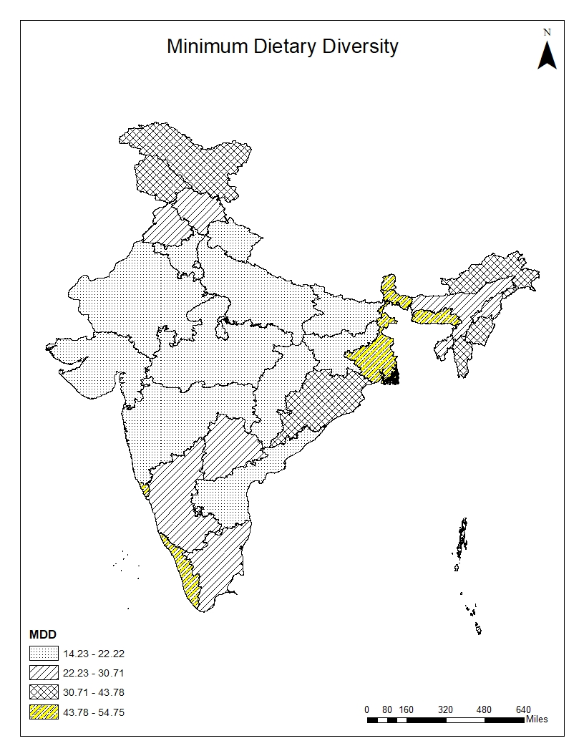
Source: based on the author’s calculation using NFHS (2015 -16) and NFHS (2019 -21)

This map highlights substantial regional disparities in Minimum Dietary Diversity (MDD) among children aged 6–23 months in India. The Northeastern region reported the highest prevalence of MDD, with states such as Sikkim, Meghalaya, Manipur, and Ladakh performing considerably better than the national average, reflecting the role of diversified traditional diets and greater consumption of nutrient-rich foods. The Southern region also showed relatively higher dietary diversity, particularly in Kerala, Goa, and Karnataka, which may be associated with better maternal education, healthcare utilisation, and public health infrastructure. In contrast, the Northern and Central regions recorded comparatively low levels of MDD, especially in Uttar Pradesh, Rajasthan, Haryana, Bihar, and Madhya Pradesh, indicating poor complementary feeding practices and continued dependence on cereal-based diets. The Western region displayed mixed performance, as Goa reported high MDD prevalence, whereas Gujarat and Maharashtra showed relatively lower levels despite stronger economic development. The Eastern region exhibited moderate variation, with West Bengal and Odisha performing better than Bihar and Jharkhand. In the adjusted model, Minimum Dietary Diversity (MDD) showed mixed associations with child malnutrition indicators. Children receiving adequate dietary diversity had higher odds of stunting (OR = 1.116, p < 0.01), while they were less likely to experience wasting (OR = 0.925, p < 0.05). However, the association between MDD and underweight was not statistically significant (OR = 1.013, p > 0.05). Female children were consistently less likely to suffer from stunting, wasting, and underweight compared to male children. Household wealth status emerged as a strong protective factor, as the likelihood of malnutrition declined significantly with improvement in economic status. Similarly, maternal education showed a significant negative association with all forms of malnutrition, particularly among children of highly educated mothers. Rural residence was associated with lower odds of underweight, whereas its effect on stunting was marginal and on wasting was statistically insignificant. Overall, the findings highlight the important role of socioeconomic status and maternal education in shaping child nutritional outcomes.

Conclusion
Although there have been some improvements in economic development and other areas, malnutrition continues to be one of the major public health problems in India. It can be noted from the analysis that minimal dietary diversity (MDD) has an impact on the results of children’s nutrition, since it reduces the chances of wasting; its link with stunting is more complex and requires additional research. There has not been any correlation found between MDD and being underweight, as it demonstrates that MDD may not reflect the essence of malnutrition fully. Thus, it is necessary to develop regionally specific policies of nutrition in order to reduce child malnutrition in India through improving dietary diversity. The government needs to focus on raising the level of mothers’ education, decreasing socio-economic inequality, and improving access to healthcare and nutrition among high-burden states. It is important for achieving the SDGs 2030 related to child nutrition and health.

References

Banu, b., haque, s., shammi, s. A., & hossain, m. A. (2023). Maternal nutritional knowledge and determinants of the child nutritional status in the northern region of bangladesh. Bangladesh Journal of Multidisciplinary Scientific Research, 7(1), 11–21. https://doi.org/10.46281/bjmsr.v7i1.2018

Chakraborty, M., & Ghosh, S. (2020). Factors Influencing the Nutritional Status Among Children of 6–11 Years of Age: A Case Study from an Indian Megacity. Journal of Health Management, 22(1), 78–95. https://doi.org/10.1177/0972063420908394

Jain, A., Wang, W., James, K. S., Sarwal, R., Kim, R., & Subramanian, S. V. (2022). Small area variations in dietary diversity among children in India: a multilevel analysis of 6–23-Month-Old children. Frontiers in Nutrition, 8, 791509. https://doi.org/10.3389/fnut.2021.791509

Jaleel, A., Goud, C. S. S., Shankar, S., & Venkatesh, K. (2023). Nourishing the future: exploring the factors influencing minimum diet diversity and minimum acceptable diet among Indian children aged 6–23 months. Journal of Public Health, 33(5), 1057–1069. https://doi.org/10.1007/s10389-023-02085-y

Lakshmanasamy, T. (2022). MOTHER’S EDUCATION AND CHILD HEALTH IN INDIA: MULTINOMIAL LOGIT ESTIMATION OF MALNUTRITION. INDIAN JOURNAL OF APPLIED ECONOMICS AND BUSINESS, 5(1), 19–36. https://doi.org/10.47509/ijaeb.2023.v05i01.02

Nie, P., Rammohan, A., Gwozdz, W., & Sousa-Poza, A. (2019). Changes in child Nutrition in India: A decomposition approach. International Journal of Environmental Research and Public Health, 16(10), 1815. https://doi.org/10.3390/ijerph16101815

Prasetyo, Y. B., Permatasari, P., & Susanti, H. D. (2023). The effect of mothers’ nutritional education and knowledge on children’s nutritional status: a systematic review. International Journal of Child Care and Education Policy/International Journal of Child Care and Education, 17(1). https://doi.org/10.1186/s40723-023-00114-7

Rai, R. K., Kumar, S. S., & Kumar, C. (2022). Factors associated with minimum dietary diversity failure among Indian children. Journal of Nutritional Science, 11, e4. https://doi.org/10.1017/jns.2022.2

Saha, J., Chouhan, P., Malik, N. I., Ghosh, T., Das, P., Shahid, M., Ahmed, F., & Tang, K. (2022). Effects of Dietary Diversity on Growth Outcomes of Children Aged 6 to 23 Months in India: Evidence from National Family and Health Survey. Nutrients, 15(1), 159. https://doi.org/10.3390/nu15010159

Siddiqa, M., Shah, G. H., Mayo-Gamble, T. L., & Zubair, A. (2023). Determinants of Child Stunting, Wasting, and Underweight: Evidence from 2017 to 2018 Pakistan Demographic and Health Survey. Journal of Nutrition and Metabolism, 2023, 1–12. https://doi.org/10.1155/2023/2845133

Sihag, R., Pawar, N., Chahal, S., & Kathpalia, J. (2026). Dietary Diversity, Nutritional Knowledge, and Food Expenditure Patterns among Farmer Households in Haryana. European Journal of Nutrition & Food Safety, 18(2), 59–66. https://doi.org/10.9734/ejnfs/2026/v18i21955
Tharakan, C. T., & Suchindran, C. M. (1999). Determinants of child malnutrition—An intervention model for Botswana. Nutrition Research, 19(6), 843–860. https://doi.org/10.1016/s0271-5317(99)00045-7

Vashist, S., Gupta, N., Singh, N., Bhawna, & Chamola, S. K. (2024). Study of prevalence of minimum acceptable diet and associated factors among children aged 6-24 months in rural Gurugram, Haryana, India. International Journal of Community Medicine and Public Health, 11(8), 3041–3046. https://doi.org/10.18203/2394-6040.ijcmph20241976

The State of Food Security and Nutrition in the World. (2025). UN agencies IFAD, UNICEF, WFP and WHO. https://www.fao.org/publications/fao-flagship publications/the-state-of-food-security-and-nutrition-in-the-world/en

Thorat, S., Sadana, N., & Institute of Development Studies. (2009). Discrimination and Children’s Nutritional Status in India. IDS Bulletin, 40(4), https://onlinelibrary.wiley.com/doi/10.1111/j.1759-5436.2009.00055.x

United nation, Day of 8 billion 2022. Available 25–27. online: https://www.un.org/en/dayof8billion

WHO, available online:https://www.who.int/data/gho/data/major-themes/health-and well-being

World Health Organization. Global nutrition targets 2025: low birth weight policy brief. World Health Organization; 2014.

Levels and trends in child malnutrition. (2025). UNICEF / WHO / World Bank Group Joint Child Malnutrition https://iris.who.int/server/api/core/bitstreams/a0aad785-4ff8-43d7-bdf9 be6c9a221e8e/content

