How Tamarix grows and reproduces in the Iranian desert
Hamid kheyrodin
Assistant professor , Semnan university-Iran
Mail:hamid.kheyrodin@semnan.ac.ir

Halophytes and halophilic plants are plants that can naturally grow, develop, and reproduce in saline-sodic soil due to the presence of salt tolerance genes that have evolved throughout history. For this reason, halophytes are proposed as the main plants for exploitation and cultivation in saline lands all over the world. Considering that Gaz, from the family of woody halophytes, is very resistant to salt and saline soil and has high economic value. Understanding the mechanisms of salt tolerance in Gaz and identifying the key genes involved is important for improving saline lands and increasing salt tolerance of agricultural products. In this study, 8 field-grown Tamarix plants were irrigated with 3% (180 mM) salt for one month. Measurements of electrical conductivity (EC), physiological parameters such as stomatal conductance, stem length, leaf cover volume, chlorophyll content, and plant growth were performed on salt-treated and control plants. In the species Tamarix, the results showed that the physiological parameters of the plant showed that the plant species grown under sandy soil texture were more affected by salt exposure than the plant grown in loamy texture. Therefore, considering the greater tolerance of Tamarix to salt and/or water stress and the strict environmental regulations, the planting of native Tamarix species remains a preferred plant over non-native Tamarix around the deserts of Semnan province. The sycamore tree secretes salt during hot days, a process that causes water to evaporate. During the night, the salt absorbs moisture from the air on the underside of the leaves. In the morning, the accumulated moisture evaporates, creating a kind of natural air conditioning. This cooling effect is another reason for its popularity as an ornamental tree. Since the sycamore tree is an evergreen species, it is often used to beautify paths and parks. Also Our results have shown that in general the number of trees planted per hectare varies from 1000 to 2500, but their number will vary greatly depending on the tree species and the type of planting.

Keywords: Halophyte, Tamarix, Tolerance, Salin soil

Introduction
The genus Tamarix (tamarisk, salt cedar, taray) is composed of about 50–60 species of flowering plants in the family Tamaricaceae, native to drier areas of Eurasia and Africa. The generic name originated in Latin and may refer to the Tamaris River in Hispania Tarraconensis (Spain).
The tolerance of plants to salinity is not only highly variable among different species, but also varies within each plant and under environmental conditions. Many factors related to the plant, soil, water, and atmosphere combine to affect a plant's tolerance to salinity. Therefore, the response of a plant to a given concentration of salt cannot be predicted absolutely. However, plants can be compared relatively to each other.
The tolerance of a plant to salinity is assessed by one of the following criteria:
The ability of the plant to survive in saline soil
The absolute growth or yield of the plant
The relative growth or yield of the plant in a saline soil compared to the growth of the same plant in a non-saline soil
Plant survival may be important to botanists or ecologists, but for farmers, the ability of a plant to survive in saline soil conditions and not produce a crop is not important. In fact, the farmer is looking for the yield of the plant in saline soil. Although absolute yield allows a direct estimate of economic returns under specific salinity conditions, the farmer's decision to choose a crop type to plant in a given soil is based on a comparison of their performance to salinity. Therefore, absolute yield cannot be used to compare plants. Therefore, the third criterion, the relative yield of a plant in saline soil compared to the yield of the same plant in non-saline soil, is used as a practical guide in selecting a plant type to plant and predicting the effects of salinity stress (Alizadeh 2006).

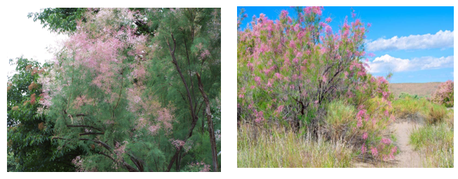

Figure 1: Show Tamarix ramosissima (Tamarisk)و Growing agave trees in salty soil

Salinity stress affects plants at all stages of growth, but the sensitivity of the plant may differ at one stage of growth compared to another. At the germination stage, plant tolerance is measured only by the survival of the buds or the so-called percentage of seed germination, because no other criterion can be imagined for it, but at later stages, reduced yield is a comparable criterion for plant tolerance to salinity. Table 1 presents the relative tolerance of some crops at the germination stage and during the growth period based on the above two criteria. For example, in the case of eared corn, if the electrical conductivity of the saturated soil extract is 13 millimoos/cm, 50% of the seeds will not germinate, or if the electrical conductivity of the saturated soil extract reaches 50 millimoos/cm during the growth period, there will be a 50% reduction in yield.

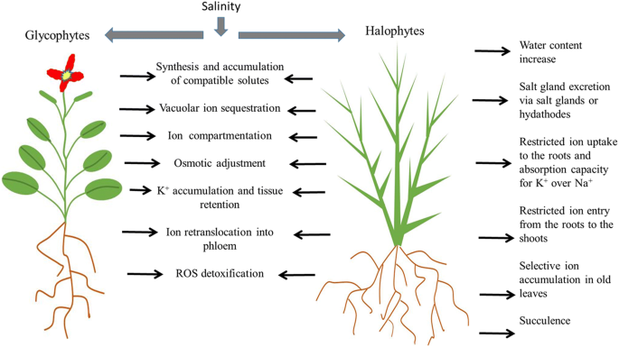

Figure 2 shows a comparison of root growth of the salt-loving Tamarix plant and other plants.

Various factors related to water, soil and environment combine with the problem of salinity and affect plant resistance to salinity. In some cases, they increase plant tolerance and in some cases, they reduce plant resistance to salinity. Temperature, humidity and air pollution are among these factors. For example, most plants are more sensitive to salinity in hot and dry conditions than in cold and humid areas (Bai Bordi, Mohammad 208).

It seems that plants that grow and develop in infertile soils are more resistant to salinity, and if their yield is low in these conditions, the problem may be related to soil fertility. However, regardless of whether the soil is saline or non-saline, the application of appropriate fertilizer increases yield, but this increase in yield is more significant in saline soils.

Another factor is water volume. As the plant extracts water from the soil, the remaining water in the soil becomes more concentrated and, as a result, with a decrease in soil moisture, the plant faces increased salinity stress as well as water stress. Plant growth is closely related to the salinity of the soil water in the root zone where maximum water absorption occurs. Therefore, the yield value should be related to the trend of salt increase over time in the root development zone where maximum water is absorbed by the root (Smidma, Lambert et al. Translated by Amin Alizadeh. New Drainage, 2005).

Tolerance of herbaceous plants to salinity
Herbaceous plants are divided into four groups in terms of their resistance to salinity, which are:
- Sensitive 2- Relatively sensitive 3- Relatively resistant 4- Resistant

Material and methods:
Plan experimental show in figure 2. All soil microbial activity measurement by kheyrodin , methods 2014 . Soil microbial biomass and soil sampling measurement concluded by kheyrodin method 2005) In order to investigate the biological properties of the soil, sampling of the surface soil (0-5 cm depth) under the azalea shrub canopy and the open space was carried out using a systematic random method. The total number of soil samples was 62, of which 31 samples were from under the canopy and 31 samples were outside the azalea shrub canopy. After collecting the soil samples and transferring them to the laboratory, soil biological analyses including microbial biomass carbon and nitrogen,(Nelson 1986). basal respiration, substrate-induced respiration, microbial yield, metabolic yield, and soil organic carbon were performed on the samples. Statistical analyses such as one-way analysis of variance and correlation coefficient were performed with SAS 9.1 software. The t-test was used to compare the average of the biological properties of the soil. Soil microbial respiration and biomass analysis bt Anderson et al. method 1982 and 1990.all soil enzymes activity concluded by kheyrodin hamid methodes 2014.

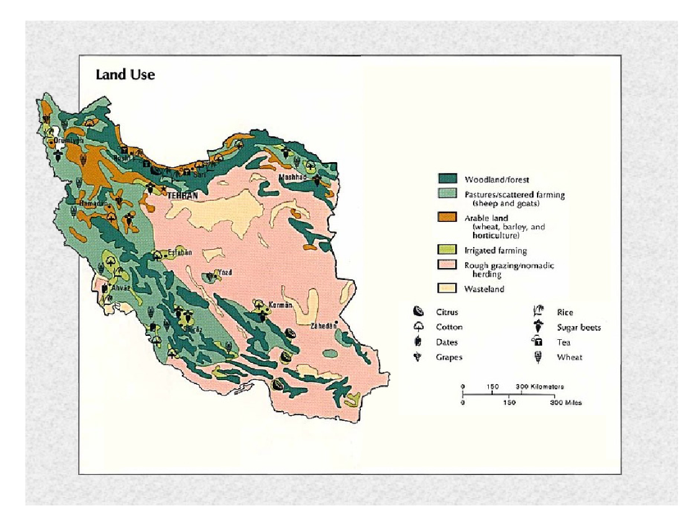
Figure 3: A map of the various agricultural and desert Tamarix cultivation areas of Iran

Difference between c3, c4 and cam plants
The main difference between C3 and C4 plants is that C3 plants form a three-carbon compound as the first stable product of the dark reaction, while C4 plants form a four-carbon compound as the first stable product of the dark reaction
In C3 plants, which include most common plants such as wheat and rice, carbon dioxide enters the Calvin cycle directly, producing the initial three-carbon product. This pathway is efficient at moderate temperatures and light, but its efficiency decreases in hot and dry conditions due to photorespiration. In contrast, C4 plants such as corn and sugarcane have an additional mechanism for concentrating carbon dioxide; CO₂ is first fixed to four-carbon compounds in mesophyll cells and then transported to bundle sheath cells to perform the Calvin cycle more efficiently. This feature allows C4 plants to perform better in hot and dry conditions and to show greater resistance to environmental stress (kheyrodin 2021).

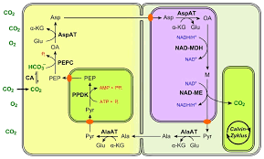

Figure 4: C3, C4 and CAM Plants -

Result and Discussion
The Role of Artificial Intelligence in the Evolution of Tamarix Tree Cultivation.
Artificial intelligence in smart agriculture acts as the driving force behind the evolution. By analyzing huge amounts of data collected from fields, this technology identifies patterns that are undetectable to the human eye. With recent developments, more than 50% of large farms are expected to adopt AI-based soil monitoring systems. Figure 5 shows how irrigation affects the lateral branches of Tamarix.

Table 1: Consequently, a higher root/ shoot ratio was recorded in T. jordanis, while non-significant changes of root/shoot ratio were detected in T. aphylla (Victoria Dawalibi et al. 2015)
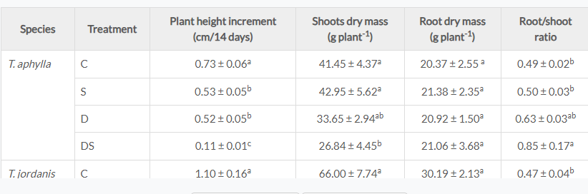

Plant Water Stress Detection
The Internet of Things technology plays a vital role in precision agriculture. By connecting various sensors across the fields to continuously monitor moisture, pH levels, temperature, and crop health, this robust sensor network continuously collects data and sends it to centralized systems for processing and analysis.

Figure 5 shows how irrigation affects the lateral branches of Tamarix

The ghazal is a desert tree and plant, shrubs or in fact evergreen ghazal trees with a height of about 10 to 12 meters with needle-shaped leaves are called desert cypress. The Tamarind tree is found in streams, waterways and rivers, where the ground is salty and the soil is moist. In the place where this desert tree grows, Nabka forests are usually created under special conditions. We have also talked a lot about Nabkas, these desert pots, on the Yardang site.

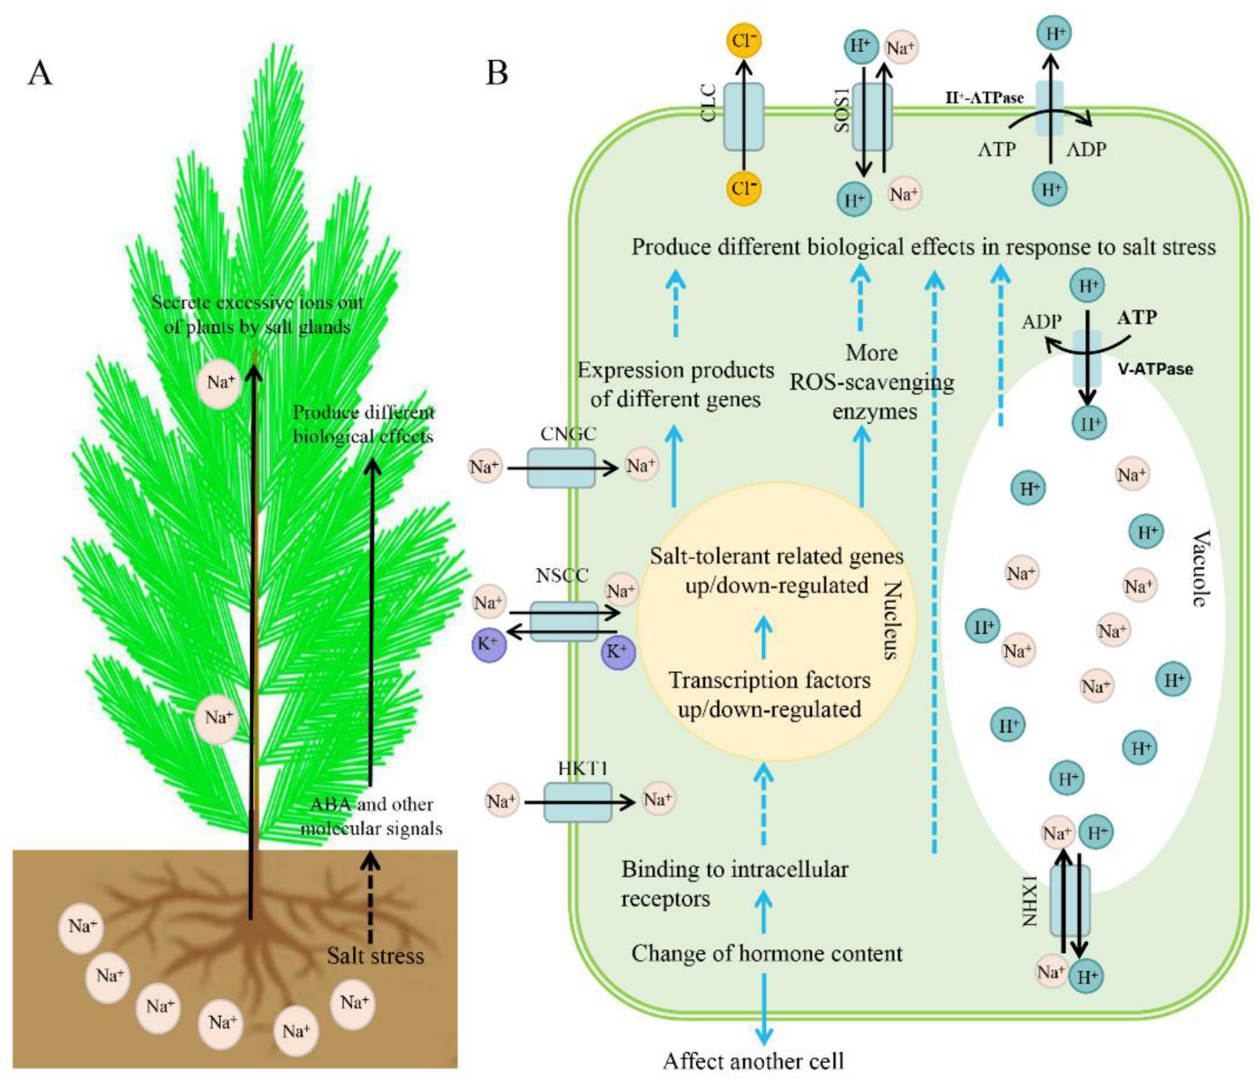

Figure 5: Recent Progress on the Salt Tolerance Mechanisms and Application of Tamarix

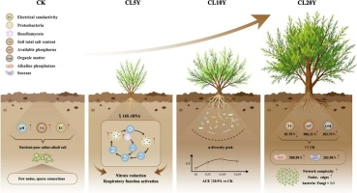

Figure 6: Tamarix chinensis Lour. cultivation drives microbial succession and network reconfiguration in salin. Zijian Zhang et al. 2026.
Tamarix propagates both vegetatively, by stems that produce adventitious roots, and sexually, by seeds. Each flower can produce thousands of tiny seeds, which are contained in a small capsule and adorned with a tuft of hairs that aid in wind dispersal. The seeds can also be dispersed by water. The seedlings require long periods of soil saturation to germinate. Tamarix trees are, however, often propagated by cuttings.
Table 2: The genes from tamarix were expressed in plant and enhanced salt tolerance of transformed plants by regulating Na homeostasis , osmotic and Ros

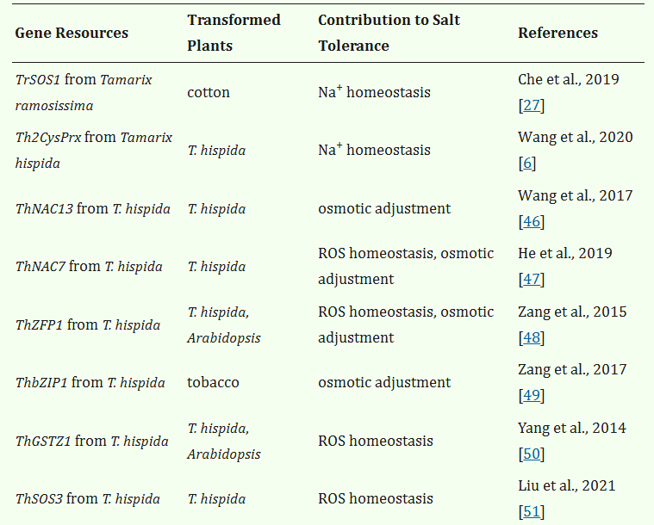

The Tamarix tree, with the scientific name Tamarix, is from the Tamaricaceae family, of which 27 species have been seen and recorded in Iran. Species with a height of 1 meter to even higher than 10 meters, which can be called by the names of Salty Tamarind (King's Tamarind), Fire Tamarind, Turkmeni Tamarind, Caspian Tamarind, Bushehr Tamarind, Isfahan Tamarind and Omani Tamarind.
The leaves of this plant are eaten by livestock, such as camels and sheep, in the deserts, and the branches and leaves of these beautiful and resistant trees are harvested by livestock breeders in the desert fringe area. On the other hand, some farmers also use its branches and leaves for windbreaks around their fields, and on the other hand, due to the high flammability of its trunk and branches, it is used as firewood by the uninitiated to start fires, and all these destructive human factors cause the drying and destruction of the gaz tree and the saplings produced from them.
Tamarix tree sap, a desert plant harvested in Iran, is used in confectionery in these regions due to its high sucrose content. In addition to the confectionery industry, its properties are also used in traditional medicine treatments to improve liver disorders.

Acknowledgments
We would like to thank Dr. M.Nasiri, the president of Semnan University, for approving the research project of Castor Oil in the Semnan University in research Council and for financial cooperation and personnel assistance.

References
1-Alizadeh, Amin. The relationship between soil, water and plants, 2006, Imam Reza University
2-Bai Bordi, Mohammad. Principles of Drainage and Soil Improvement Engineering, 2008, Tehran University Press
3-Chen R., Yang Y., Xu J., Pan Y., Zhang W., Xing Y., Ni H., Sun Y., Hou Y., Li N. Tamarix hohenackeri Bunge exerts anti-inflammatory effects on lipopolysaccharide-activated microglia in vitro. Phytomedicine. 2018;40:10–19. doi: 10.1016/j.phymed.2017.12.035
4-Ehteshami, Majid; Hossein Ashk Torab, Mohammad Kazem Siyahi. Concepts of Drainage and Soil Salinity, 2000, National Irrigation and Drainage Committee of Iran Press
5-He Z., Li Z., Lu H., Huo L., Wang Z., Wang Y., Ji X. The NAC Protein from Tamarix hispida, ThNAC7, Confers Salt and Osmotic Stress Tolerance by Increasing Reactive Oxygen Species Scavenging Capability. Plants. 2019;8:221. doi: 10.3390/plants8070221
6-Kheyrodin, H. 2014. Methodology for measurement of enzyme activity in soil. World J Biol Med Sci. Vol. 1. Pages: 18-25.
7-Kheyrodin hamid. Soil science 2005 . Semnan university publication
8-Kheyrodin hamid. 2021. Study of salinity tolerance in oryza sativa. Journal of applied chemical science international. 12(1) page. 1-5
9-Kheyrodin., H. 2026. Response and Factors Affecting Tamarix Tolerance to Salinity and the growth of Tamarix in Iran desert INTERNATIONAL JOURNAL OF MULTIDISCIPLINARY RESEARCH AND STUDIES. Volume 9. Issue 5. Page 20-26
10-Liu Z., Xie Q., Tang F., Wu J., Dong W., Wang C., Gao C. The ThSOS3 Gene Improves the Salt Tolerance of Transgenic Tamarix hispida and Arabidopsis thaliana. Front. Plant Sci. 2021;11:597480. doi: 10.3389/fpls.2020.597480.
11-Smidma, Lambert et al. Translated by Amin Alizadeh. New Drainage, 2005, Imam Reza University
12-Victoria Dawalibi , Maria Cristina Monteverdi Stefano Moscatello 2015. Effect of salt and drought on growth, physiological and biochemical responses of two Tamarix species. iForest - Biogeosciences and Forestry, Volume 8, Issue 6, Pages 772-779
13-Wang Y., Shen W., Chan Z., Wu Y. Endogenous Cytokinin Overproduction Modulates ROS Homeostasis and Decreases Salt Stress Resistance in Arabidopsis thaliana. Front. Plant Sci. 2015;6:1004. doi: 10.3389/fpls.2015.01004
14-Wang R., Zhang Y., Wang C., Wang Y.C., Wang L.Q. ThNAC12 from Tamarix hispida directly regulates ThPIP2;5 to enhance salt tolerance by modulating reactive oxygen species. Plant Physiol. Biochem. 2021;163:27–35. doi: 10.1016/j.plaphy.2021.03.042.
15-Yang G.Y., Wang Y.C., Xia D.A., Gao C.Q., Wang C., Yang C.P. Overexpression of a GST gene (ThGSTZ1) from Tamarix hispida, improves drought and salinity tolerance by enhancing the ability to scavenge reactive oxygen species. Plant Cell Tissue Organ Cult. 2014;117:99–112. doi: 10.1007/s11240-014-0424-5. [DOI] [Google Scholar
16-Zang D., Wang C., Ji X., Wang Y. Tamarix hispida zinc finger protein ThZFP1 participates in salt and osmotic stress tolerance by increasing proline content and SOD and POD activities. Plant Sci. 2015;235:111–121. doi: 10.1016/j.plantsci.2015.02.016. [DOI] [PubMed] [Google Scholar]
17-Zang D., Wang L., Zhang Y., Zhao H., Wang Y. ThDof1.4 and ThZFP1 constitute a transcriptional regulatory cascade involved in salt or osmotic stress in Tamarix hispida. Plant Mol. Biol. 2017;94:495–507. doi: 10.1007/s11103-017-0620-x. [DOI] [PubMed] [Google Scholar
18-Zijian Zhang, Weishuai Wang, Ruinan Hou, Changxiong Zhu , Yali Huang. 2026. Tamarix chinensis Lour. cultivation drives microbial succession and network reconfiguration in saline-alkali soil restorationEnvironmental Technology & Innovation.

