ENHANCING FRAUD DETECTION ACCURACY USING SUPERVISED MACHINE LEARNING ALGORITHMS
BRINDHA S¹ , GNANA SOWNDARI M² , RAJESHWARI J³

¹UG Student , Department of Computer Science and Data Science, Nehru Arts and Science College, Coimbatore, Tamil Nadu, India.
²UG Student , Department of Computer Science and Data Science, Nehru Arts and Science College, Coimbatore, Tamil Nadu, India.
³Assistant Professor, Department of Computer Science and Data Science, Nehru Arts and Science College, Coimbatore, Tamil Nadu, India.

ABSTRACT
More people are using digital financial services and online transaction platforms. This has made it harder to spot fraud in real time. Traditional fraud detection systems rely on fixed rules, struggle to keep up with changing fraud patterns, and produce many false positives. This paper looks at how effective supervised machine learning algorithms are in improving fraud detection accuracy in financial transaction data. The study reviews four popular classification models: Logistic Regression, Random Forest, Support Vector Machine (SVM), and Gradient Boosting Machine (GBM). It aims to see how suitable these models are for large-scale fraud detection.
A detailed data preprocessing framework is used. This includes feature scaling, handling class imbalances with the Synthetic Minority Oversampling Technique (SMOTE), and creating behavioral features based on time and transaction patterns. The models are trained and assessed using metrics like Accuracy, Precision, Recall, F1-score, and Area Under the ROC Curve (AUC-ROC) to ensure a reliable evaluation under imbalanced conditions. Results show that models based on ensembles perform better than traditional linear classifiers. The Gradient Boosting Machine achieves the highest accuracy at 96.5% and an F1-score of 0.94.
These findings indicate that supervised learning techniques significantly improve fraud detection by reducing false positives and better identifying minority classes. The suggested framework offers a scalable and efficient solution for real-time monitoring of financial transactions. This research contributes to the growth of smart, data-driven fraud detection systems and provides ideas for future studies that combine hybrid and adaptive learning models.

KEYWORDS :
Fraud Detection, Supervised Machine Learning, Gradient Boosting, Random Forest, Support Vector Machine, Logistic Regression, Class Imbalance, SMOTE, Financial Transactions, AUC-ROC.

1.INTRODUCTION
The rapid growth of digital financial ecosystems has changed how economic transactions happen around the world. Online banking, electronic payment gateways, mobile wallets, and e-commerce platforms are now essential parts of today’s financial systems. While these technologies have increased transaction speed, access, and scalability, they have also introduced new risks that fraudsters are quick to exploit. Financial fraud has shifted from simple tricks to complex, tech-driven schemes that use automation, artificial intelligence, identity theft, and international digital networks. As transaction volumes surge, spotting fraudulent activity in real time has become a major challenge for financial institutions and regulators.
Traditional fraud detection methods mainly relied on rule-based systems that were built using expert knowledge and set logical conditions. These systems depended on fixed thresholds, such as unusually large transaction amounts, quick changes in user location, or frequent transactions in a short period. Although these early models offered some protection, they had serious drawbacks. They are static, need constant manual updates, and often fail to catch new fraud patterns that were not included in the rules. Additionally, rule-based systems tend to produce many false positives, leading to customer frustration, operational inefficiencies, and increased investigation costs. In a fast-changing fraud landscape, it is crucial to have adaptive and smart detection systems for maintaining reliability and effectiveness.
Supervised machine learning has become a strong alternative that can address many limitations of traditional methods. Unlike rule-based systems, supervised learning algorithms examine historical labeled transaction data to find hidden statistical relationships and behavioral patterns related to fraud. These models can pick up on complex interactions between various factors and can apply knowledge from past data to identify new fraudulent behavior. By continuously retraining on updated datasets, supervised models can adjust to new fraud tactics. This research explores how effective several supervised machine learning algorithms are in improving fraud detection accuracy, focusing on lowering false positives, enhancing recall for rare fraud cases, and ensuring they can scale for real-world use in financial systems.
2.BACKGROUND AND THEORETICAL FOUNDATIONS

Fraud detection is fundamentally a binary classification problem where each transaction must be identified as either legitimate or fraudulent. However, unlike typical classification tasks, fraud detection has several unique challenges. One major issue is extreme class imbalance, where fraudulent transactions make up only a small portion of the total dataset. In many real-world financial datasets, fraud cases account for less than one percent of all transactions. This imbalance complicates model training because machine learning algorithms often favor the majority class. This results in high overall accuracy but poor fraud detection performance. Thus, evaluation metrics beyond simple accuracy, such as precision, recall, and F1-score, become vital in judging model effectiveness.

Another important aspect of fraud detection is concept drift. This term describes how fraudulent behavior evolves over time. Fraudsters continuously change their tactics to evade detection systems, making static models ineffective unless they are frequently updated. This shifting environment demands learning algorithms that can adjust to new data distributions. Moreover, fraud detection systems need to work under strict real-time conditions. Financial institutions often need transaction decisions made within milliseconds to stop fraudulent payments from being approved. Thus, computational efficiency, scalability, and model optimization are key factors when choosing suitable algorithms.

From a mathematical standpoint, supervised learning aims to estimate a predictive function that connects input feature vectors with corresponding class labels. During training, model parameters are improved by minimizing a loss function that reflects the difference between predicted and actual results. In classification tasks like fraud detection, cross-entropy loss is often used due to its probabilistic nature and strong gradient characteristics. The optimization process usually involves iterative methods like gradient descent, which modify model parameters to decrease prediction errors. Understanding these foundational concepts is crucial for analyzing how different algorithms perform with imbalanced and high-dimensional financial datasets.

3.DATA PREPROCESSING AND FEATURE ENGINEERING

The performance of any machine learning model relies heavily on the quality of input data. Raw financial transaction logs often have inconsistencies, missing values, extra records, and noise that need
to be fixed before training the model. Data preprocessing starts with careful cleaning. This includes removing duplicate transactions, correcting corrupted entries, and checking that timestamps are consistent. Keeping data accurate helps avoid bias and improves model reliability.
Feature scaling is another important preprocessing step, especially for algorithms that react strongly to changes in feature size. Techniques like standardization adjust variables to have a zero mean and unit variance. This prevents features with large numerical ranges from having too much influence on the model. This normalization speeds up training and helps maintain numerical stability.

Feature engineering is particularly important in fraud detection. Rather than just using raw transaction details like amount and time, engineered features look for behavioral patterns and unusual contexts. For instance, tracking how often transactions happen within a certain time frame can show suspicious rapid activity. Additionally, calculating the average transaction amount for each customer can reveal sudden changes in spending habits. Features that indicate late-night transactions or unusual weekend activity can also suggest potential fraud. By using knowledge from the field in these engineered features, models build a deeper understanding of user behavior, which helps classify complex fraudulent patterns more accurately.

4.HANDLING CLASS IMBALANCE

Class imbalance is a major challenge in fraud detection systems. When fraudulent transactions make up only a small part of the dataset, machine learning models can reach high overall accuracy by predicting the majority, which is the legitimate class. However, these models fail because they ignore fraudulent cases. To tackle this imbalance, we need specific data-level and algorithm-level strategies.
One common method is undersampling, which lowers the number of majority class samples to balance the dataset. While this technique makes training easier, it might throw away important information from legitimate transactions, possibly harming the model's ability to generalize. Oversampling, in contrast, boosts minority class representation by duplicating existing fraud samples. Though oversampling helps balance the classes, it can cause overfitting because the model sees the same minority examples too often.
A more advanced approach is the Synthetic Minority Oversampling Technique (SMOTE). This method generates new fraud samples by blending existing minority instances. Instead of just copying data points, SMOTE creates new examples along the line segments that connect the nearest neighbors within the minority class. This technique increases diversity among fraud samples and lowers the risk of overfitting. By improving the balance of class distribution, SMOTE helps supervised learning algorithms better identify subtle fraud characteristics without losing information about the majority class.

5.LOGISTIC REGRESSION
Logistic Regression is a commonly used supervised learning method for binary classification problems. It is a basic model in fraud detection research. Despite being simple, Logistic Regression offers a solid statistical foundation and clear outcomes, making it especially useful in finance where compliance and transparency are important. Unlike linear regression, which predicts continuous values, Logistic Regression estimates the likelihood that a transaction is fraudulent by using the logistic (sigmoid) function on a linear combination of input features.

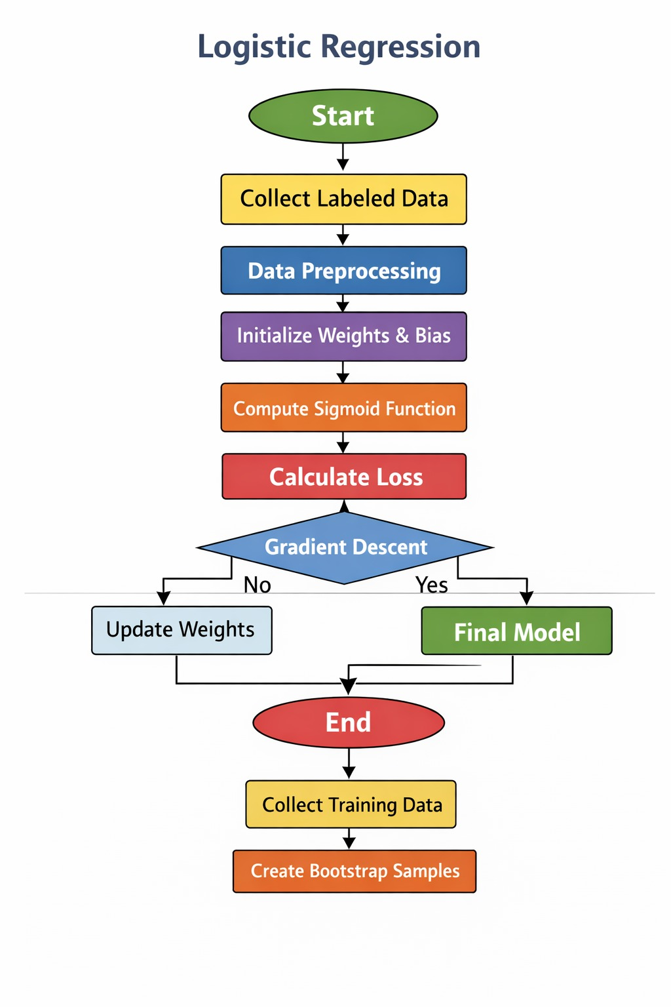
Fig 1 : Logistic Regression
Mathematically, the model calculates a weighted sum of input variables and then transforms the result with the sigmoid function. This function converts real-valued inputs into a probability range from zero to one. This probabilistic approach allows for adjusting decision thresholds based on business needs. For instance, a lower threshold may boost sensitivity to fraud detection, while a higher threshold could lessen false alarms. Model parameters are improved by minimizing cross-entropy loss. This loss function penalizes incorrect probability estimations more when confidence is high. This process ensures the model not only classifies transactions correctly but also provides reliable probability scores. In fraud detection, Logistic Regression works well when the relationships between variables and the likelihood of fraud are roughly linear. It is efficient and suitable for large transaction systems that need real-time predictions. Moreover, the interpretability of regression coefficients helps analysts understand how specific features—like transaction amount, frequency, or geographic deviation—affect fraud risk. However, Logistic Regression struggles to capture complex nonlinear interactions between features. Fraudulent behavior often shows intricate patterns that a simple linear boundary cannot represent. This limitation can lessen the model’s ability to detect highly sophisticated fraud situations. Therefore, while Logistic Regression is valuable as a benchmark and understandable model, more advanced ensemble methods usually provide better predictive accuracy.

6.RANDOM FOREST

Random Forest is an ensemble learning method that builds multiple decision trees during training and combines their predictions to enhance overall classification performance. It is part of the bagging methods, which aim to lower variance and prevent overfitting by training models on randomly sampled subsets of data. In fraud detection, where datasets are large and complex, Random Forest shows strong reliability.

The algorithm starts by generating several bootstrap samples from the original training dataset. A decision tree is built for each bootstrap sample using a randomly selected subset of features at every split. This random feature selection adds diversity among the trees, making sure that individual models do not depend too much on the same dominant attributes. After all trees are trained, predictions are combined using majority voting for classification tasks. This method helps minimize the chance that noise or outliers in the training data will significantly affect the final prediction.

Random Forest is especially useful in fraud detection because it can model nonlinear relationships and feature interactions without needing much preprocessing. Financial transaction data often includes complex dependencies between variables, such as correlations among spending patterns, merchant types, and geographic behavior. Random Forest captures these interactions automatically through hierarchical tree structures. Additionally, the algorithm shows feature importance measures, which help identify the most influential predictors in fraud detection. These insights can inform further feature engineering and risk assessment strategies.

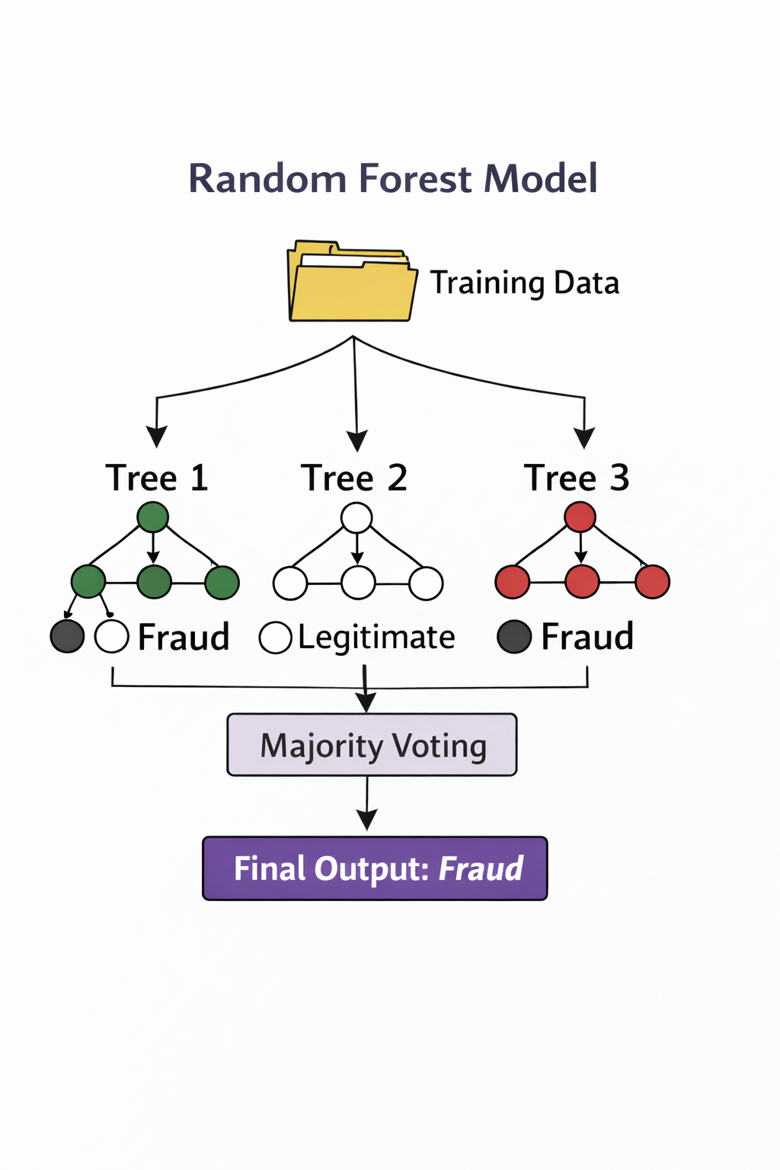
Fig 2 : Random Forest
However, Random Forest can become computationally heavy when the number of trees is large. While it offers better generalization than single decision trees, it may still face challenges with extreme class imbalance unless it is combined with resampling techniques or cost-sensitive learning. Still, in many real-world fraud detection systems, Random Forest provides a good balance between interpretability, performance, and computational efficiency.

7. SUPPORT VECTOR MACHINE
Support Vector Machine (SVM) is a strong supervised learning method that finds the best separating hyperplane. This hyperplane maximizes the distance between two classes. Unlike probabilistic classifiers, SVM focuses on minimizing structural risk to improve generalization by managing model complexity. The core idea of SVM is to identify support vectors, which are key data points near the decision boundary. It then constructs a hyperplane that maximizes the distance between these points and the boundary. In fraud detection, SVM works well with high-dimensional feature spaces. Transaction datasets often include many behavioral, temporal, and engineered features, which can complicate the model. SVM handles these high-dimensional spaces effectively by using kernel functions. Kernels change input data into higher-dimensional forms, allowing the model to separate nonlinear patterns that would be hard to distinguish in the original feature space. The Radial Basis Function (RBF) kernel is often used in fraud detection because it captures local variations and subtle nonlinear connections. One major benefit of SVM is its strong theoretical base in convex optimization, which ensures a global optimum solution under specific conditions. This feature provides stability during training and lowers the risk of getting stuck in local minima. However, SVM can be computationally demanding when used with very large datasets, especially in real-time fraud detection systems that handle millions of transactions each day. Additionally, picking the right kernel parameters requires careful adjustment since poor choices can significantly hurt performance. While SVM often achieves high classification accuracy in moderately sized datasets, its scalability issues restrict its use in large financial environments. Still, when optimized correctly, SVM remains a competitive method for fraud detection tasks that involve complex features.
Consider a training dataset
$$\{(x_{i},y_{i})\}_{i=1}^{n}$$
where $x_{i}∈R^{d}$represents feature vectors and $y_{i}∈\{-1,+1\}$denotes class labels (fraud or legitimate). The objective of SVM is to find a hyperplane defined by:
$$w⋅x+b=0$$
where
- $w$is the weight vector,
- $b$is the bias term.
For linearly separable data, SVM seeks to maximize the margin, which is defined as:
$$\text{Margin}=\frac{2}{∥w∥}$$
Maximizing the margin is equivalent to minimizing:
$$\frac{1}{2}∥w∥^{2}$$
subject to the constraint:
$$y_{i}(w⋅x_{i}+b)≥1∀i$$
However, financial fraud data are rarely perfectly separable. Therefore, slack variables $ξ_{i}$are introduced to allow misclassification:
$$y_{i}(w⋅x_{i}+b)≥1-ξ_{i}$$
The optimization problem becomes:
$$\underset{w,b,ξ}{min⁡}\frac{1}{2}∥w∥^{2}+C\sum_{i=1}^{n}{}ξ_{i}$$
where $C$is a regularization parameter controlling the trade-off between margin maximization and classification error.
For nonlinear fraud patterns, SVM employs kernel functions that map data into higher-dimensional space. A commonly used kernel in fraud detection is the Radial Basis Function (RBF):
$$K(x_{i},x_{j})=exp⁡(-γ∥x_{i}-x_{j}∥^{2})$$
where $γ$controls the influence radius of each training point.
In the fraud detection algorithms, SVM is highly effective in modeling the complex nonlinear transaction patterns. However, the computational complexity of SVM is dependent on the size of the dataset, which may pose scalability challenges in large-scale banking applications. However, SVM has excellent theoretical foundations and classification performance.
8.GRADIENT BOOSTING MACHINE (GBM)

Gradient Boosting Machine (GBM) is an advanced form of ensemble learning. GBM creates predictive models by trying to optimize a differentiable loss function. Unlike the Random Forest algorithm, which creates decision trees independently using bagging, GBM creates decision trees one by one, where the next decision tree tries to compensate for the errors made by the previous decision tree. This makes GBM a very efficient algorithm for fraud detection.
The model begins with an initial prediction:
$$F_{0}(x)=arg⁡\underset{γ}{min⁡}\sum_{i=1}^{n}{}L(y_{i},γ)$$
where $L(y,F(x))$is a differentiable loss function, commonly the logistic loss for binary classification:
$$L(y,F(x))=log⁡(1+e^{-yF(x)})$$
At each iteration $m$, GBM computes the negative gradient of the loss function with respect to the current model predictions. These residuals represent the direction of steepest descent:
$$r_{im}=-[\frac{∂L(y_{i},F(x_{i}))}{∂F(x_{i})}]$$
A new weak learner $h_{m}(x)$, typically a shallow decision tree, is trained to approximate these residuals. The model is then updated as:
$$F_{m}(x)=F_{m-1}(x)+ηh_{m}(x)$$
where
- $η$is the learning rate controlling the contribution of each tree.
The final prediction is obtained after $M$iterations:
$$F(x)=\sum_{m=1}^{M}{}ηh_{m}(x)$$GBM is very effective in fraud detection because it has the ability to learn complex nonlinear relationships between the features of a transaction. The ability of GBM to iteratively minimize the residual error enables it to focus on the most difficult to classify fraud transactions, which are normally in the minority class. Moreover, regularization techniques such as shrinkage (small learning rate), tree depth, and subsampling can be used to prevent overfitting.

The empirical evidence has shown that GBM outperforms single classifiers in fraud detection due to its robust optimization environment and flexibility.

9.MODEL EVALUATION METRICS
Accuracy is not a sufficient measure for evaluating fraud detection models because of the class imbalance problem. Let:

True Positives (TP): Correctly identified fraud cases

True Negatives (TN): Correctly identified legitimate cases

False Positives (FP): Legitimate transactions incorrectly flagged

False Negatives (FN): Fraud cases missed
Accuracy is defined as:
$$\text{Accuracy}=\frac{TP+TN}{TP+TN+FP+FN}$$
However, in highly imbalanced datasets, accuracy may be misleading. Therefore, precision and recall are more informative.
Precision measures how many predicted fraud cases were actually fraud:
$$\text{Precision}=\frac{TP}{TP+FP}$$Recall (Sensitivity) measures how many actual fraud cases were detected:
$$\text{Recall}=\frac{TP}{TP+FN}$$
The F1-score balances precision and recall:
$$F1=2×\frac{\text{Precision}×\text{Recall}}{\text{Precision}+\text{Recall}}$$
Another critical metric is the Area Under the ROC Curve (AUC). The True Positive Rate (TPR) and False Positive Rate (FPR) are defined as:
$$TPR=\frac{TP}{TP+FN} \\ FPR=\frac{FP}{FP+TN}$$The ROC curve is a graph of the TPR versus the FPR for different values of the threshold, and the AUC is a measure of the overall discriminative ability. An AUC of 1.0 is a very strong indication of having better fraud detection capability.

10.OPERATIONAL EFFICIENCY & PRODUCTIVITY

Operational efficiency is one of the important factors that determine the effectiveness of a warehouse and has a direct impact on order fulfillment, customer satisfaction, and supply chain productivity. Automation solutions such as Automated Storage and Retrieval Systems (AS/RS), robotic picking systems, barcode scanners, conveyor systems, and Warehouse Management Systems (WMS) have been designed to automate repetitive tasks and reduce processing time. The automation solution operates at a fixed speed with minimal variability and enables high-volume processing with minimal human interaction. The automation solution is most appropriate in a setting where continuous operation is necessary, such as 24/7 e-commerce fulfillment operations, where downtime can significantly affect revenue and customer satisfaction.
On the other hand, the human workforce offers flexibility and cognitive intelligence in the warehouse setting. The human workforce has the capability of making decisions in real time, responding to unexpected changes, processing customized orders, and overcoming operational bottlenecks without the need for reprogramming. Human involvement is especially required in handling sensitive products, complex packaging requirements, or handling unusual product types that may not be processed efficiently by automated systems. However, the productivity of the human workforce may be affected by fatigue, working hours, or variations in human workforce skills. Therefore, this issue evaluates the factors of order processing time, picking accuracy, rate of throughput, and overall operational efficiency to determine which method is more productive in the warehouse setting.

11.COST IMPLICATIONS AND INVESTMENT ANALYSIS
Cost implications are a fundamental criterion for deciding whether a warehouse should go for automation or adopt the human resource approach. Automation is a costly affair, as it requires significant investment in the form of purchasing robots, automated conveyors, software infrastructure, and cybersecurity. Furthermore, maintenance, upgradation, and technical support services further increase the financial burden. Although the initial investment is high, automation can help reduce labor costs in the long run, reduce human error that results in financial losses, and increase efficiency, ultimately leading to long-term return on investment (ROI).

On the other hand, the human resource approach requires low initial investment in infrastructure but incurs operational expenses in terms of salaries, overtime, benefits, insurance, recruitment, and training. Human resource-based warehouses also incur additional expenses in terms of absenteeism, employee turnover, and work-related injuries. Although automation helps reduce costs in the long run, small warehouses or small businesses may find it economically unfeasible to invest in advanced technology. This section discusses the short-term and long-term financial implications, scalability, cost-benefit analysis, and economic viability of both systems in different warehousing configurations.

12.COMPARISON OF RISK, ACCURACY, AND SAFETY

Risk management and safety at the workplace are major issues in warehousing. Automation helps to reduce manual handling, which in turn reduces the risk of musculoskeletal disorders, fatigue, and repetitive strain injuries. Automation helps to improve accuracy and reduces the risk of errors in inventory management, scanning, and picking. Automation is less prone to errors and can perform at optimal levels even during peak times. However, automation is not risk-free, and the risk of mechanical failure, software malfunction, or hacking can cause temporary closure.
Human employees, although able to exercise critical thinking and make complex decisions, are more prone to errors due to stress, fatigue, or heavy workload conditions. Labor-intensive environments may also put employees at risk of safety-related hazards such as heavy lifting, slipping, or accidents involving equipment. However, human oversight is crucial for risk detection, monitoring compliance with safety regulations, and dealing with emergency situations that cannot be independently managed by automated systems. The comparison below highlights the differences:

Factor | Automation in Warehousing | Human Workforce in Warehousing
Initial investment | High capital investment | Loe initial investment
Accuracy | High precision with minimal variation | May vary depending on skill
Speed | Consistent and fast for repetitive tasks | Variable speed depending on work load
Error rate | Low once properly programmed | Higher due to manual handling
Safety | Reduces physical train and injury risk | Higher exposure to physical hazards
Operational cost | Lower long term operating cost | Continuous salary and benefit expenses
Maintenance cost | Requires technical maintenance and upgrades | Minimal technical maintenance
Flexibility | Limited adaptability without pre programming | Highly adaptable to unexpected tasks
Decision making | Rule based or AI driven decisions | Experience based and situation decisions
Scalability | Easily scalable by adding systems | Requires hiring and training new workers
Productivity | High output consistency | Productivity varies by individual
Risk of failure | System or technical breakdowns | Human errors and ups and absenteesism

13.CONCLUSION

In conclusion, this paper has provided a comparative study of automation and the human workforce in warehousing operations, including efficiency, cost, flexibility, risk management, and workplace safety. The results indicate that automation has greatly improved speed, accuracy, and consistency in repetitive and high-volume tasks, with lower rates of errors and improved productivity. While automation is highly expensive in terms of initial investment and technical maintenance costs, it has long-term advantages in terms of reduced labor dependency and improved reliability. However, automation technology is also prone to mechanical breakdowns and requires highly skilled personnel to ensure continuous operation.

On the other hand, the human workforce has the advantage of flexibility, critical thinking, and adaptability, which are highly desirable in dynamic and unpredictable warehousing operations. The human workforce can efficiently undertake complex, customized, and non-standard tasks, as well as adapt to sudden changes in warehousing operations. While the human workforce may have limitations in terms of errors due to fatigue and recurring labor costs, it is still indispensable for oversight, decision-making, and quality control. Thus, the conclusion of this study is that an integrated approach that combines automation with human expertise is the most effective and sustainable strategy for modern warehousing operations.

REFERENCES

- Alonge, Enoch Oluwabusayo, Nsisong Louis Eyo-Udo, Bright Chibunna Ubanadu, Andrew Ifesinachi Daraojimba, Emmanuel Damilare Balogun, and Kolade Olusola Ogunsola. "Enhancing data security with machine learning: A study on fraud detection algorithms." Journal of Data Security and Fraud Prevention 7, no. 2 (2021): 105-118.

- Afriyie, Jonathan Kwaku, Kassim Tawiah, Wilhemina Adoma Pels, Sandra Addai-Henne, Harriet Achiaa Dwamena, Emmanuel Odame Owiredu, Samuel Amening Ayeh, and John Eshun. "A supervised machine learning algorithm for detecting and predicting fraud in credit card transactions." Decision Analytics Journal 6 (2023): 100163.

- Bello, O. A., Folorunso, A., Ejiofor, O. E., Budale, F. Z., Adebayo, K., & Babatunde, O. A. (2023). Machine learning approaches for enhancing fraud prevention in financial transactions. International Journal of Management Technology, 10(1), 85-108.

- Bello, Oluwabusayo Adijat, et al. "Analysing the impact of advanced analytics on fraud detection: a machine learning perspective." European Journal of Computer Science and Information Technology 11.6 (2023): 103-126.

- Khatri, S., Arora, A., & Agrawal, A. P. (2020, January). Supervised machine learning algorithms for credit card fraud detection: a comparison. In 2020 10th international conference on cloud computing, data science & engineering (confluence) (pp. 680-683). IEEE.

- Ismail, Mustafa Mohamed, and Mohd Anul Haq. "Enhancing enterprise financial fraud detection using machine learning." Engineering, Technology & Applied Science Research 14, no. 4 (2024): 14854-14861.

- Eswar Prasad, G., G. Hemanth Kumar, B. Venkata Nagesh, S. Manikanth, and P. Kiran. "Enhancing Performance of Financial Fraud Detection Through Machine Learning Model." J Contemp Edu Theo Artific Intel: JCETAI-101 (2023).

