DEVELOPMENT AND EXPERIMENTAL PERFORMANCE ANALYSIS OF A LOW-COST, ECO-FRIENDLY HYBRID SOLAR DRYER

Candidates Supervisor

Abid Al Hossain Arif Md. Shahed Iqubal
ID: 22107067 Associate Professor
Department of Mechanical Engineering

Mohammad Naimur Rahman
ID: 22107055

ABSTRACT

The design and development of a dry storage system is presented in this project with the goal of maintaining regulated humidity and temperature levels for the secure storage of materials that are sensitive to moisture. To reduce heat loss and stop external heat exchange, the system is built with adequate insulation and an aluminum outer layer. To enable efficient and well-organized storage, the chamber has three storage trays. To maintain the necessary internal temperature range of 40 °C to 65 °C, a 200 W bulb is used as a heating element. A sensor is used to continuously monitor the temperature, and the system functions automatically according to predetermined limits: the bulb heater turns on when the temperature drops below 40 °C and off when it rises above 65 °C. Exhaust fans installed in a front ventilation chamber and at the back are used to control humidity. The fan is turned on to remove extra moisture when the internal humidity rises above 35%, and it turns off when the humidity falls below 20%. Temperature and humidity levels can be monitored in real time using an LCD display. The system is energy-efficient and appropriate for low-power applications because it is powered by a 20 W solar panel with SMPS. All things considered, this dry storage system provides an economical, automated, and environmentally responsible way to preserve ideal storage conditions.

Table of CONTENTS

CHAPTER-1 INTRODUCTION | 01-05
1.1 Introduction | 01
1.2 Background of Drying Concept | 02
1.3 Problem Statement | 02
1.4 Work Flow Diagram | 03
1.5 Objectives | 04
1.6 Organization of Report | 05
CHAPTER-2 LITERATURE REVIEW | 06-09
2.1 Introduction | 06
2.2 Literature Review | 06
2.3 Summary | 09
CHAPTER-3 SYSTEM ARCHITECTURE | 10-16
3.1 Introduction | 10
3.2 Methodology | 10
3.3 System Design | 10
3.4 Block Diagram | 12
3.5 Circuit Diagram | 12
3.6 Working Principle | 13
3.7 Cost Analysis | 13
3.8 Hardware Implementation | 14
CHAPTER-4 HARDWARE AND SOFTWARE ANALYSIS | 17-38
4.1 Introduction | 17
4.2 Hardware and Software | 17
4.3 Arduino Nano | 17
4.4 LCD Display | 21
4.5 Temperature Sensor | 22
4.6 Relay | 23
4.7 Switch Mode Power Supply (SMPS) | 26
4.8 Solar panel | 31
4.9 Exhaust fan | 33
4.10 Arduino software | 34
4.11 Easy EDA | 37
CHAPTER-5 DRYING CALCULATIONS | 39-45
5.1 Drying & Moisture Calculation | 39
5.2 Drying System Calculation | 41
5.3 Power consumption calculation | 43
5.4 Calculation of Required Components | 45
CHAPTER-6 RESULT'S AND DISCUSSION | 46-49
6.1 Project outcome | 46
6.2 Final project | 47
6.3 Advantages | 47
6.4 Limitation | 48
6.5 Applications | 48
6.6 Discussion | 48
CHAPTER-7 CONCLUSION | 49
7.1 Conclusion | 49
7.2 Future Scope of Work | 49
REFERENCES | 50-51
APPENDIX | 52-53

List of FIGURES

Figure no | Figure name | Page no
1.1 | Work Flow Diagram | 04
3.1 | Tray | 10
3.2 | Back Side View | 11
3.3 | Front Side View | 11
3.4 | Block Diagram of our Project | 12
3.5 | Schematic Diagram of our Project | 12
3.6 | Tray | 14
3.7 | Structure Frame | 14
3.8 | Tray Setup | 15
3.9 | Body Structure | 15
3.10 | Component Implementation | 16
3.11 | Wiring | 16
4.1 | Arduino Nano | 18
4.2 | Arduino Nano Schematic Diagram | 18
4.3 | How Arduino Nano Looks Like | 19
4.4 | Micro-controller IC AT mega 328p | 20
4.5 | 16*2 LCD Display | 21
4.6 | Pin Out of 16*2 LCD display | 21
4.7 | 16*2 LCD Display Interfacing with Arduino | 22
4.8 | DHT 11 Temperature Sensor | 23
4.9 | Relay | 24
4.10 | Relay Module | 24
4.11 | Mains Voltage Connections | 25
4.12 | Voltage Connections | 25
4.13 | SMPS | 26
4.14 | SMPS Circuit | 28
4.15 | SMPS Circuit Connections | 30
4.16 | DC Power Supply way | 30
4.17 | Solar panel | 31
4.18 | Solar panel Schematic Diagram | 32
4.19 | Solar Cell System | 32
4.20 | Solar Charge Controller circuit | 33
4.21 | Exhaust fan | 34
4.22 | Arduino Software Interface IDE | 36
4.23 | Easy EDA Software Interface | 37
6.1  6.2 | Fruits and Vegetables inside the dryer.  Complete Project prototype | 46  47

CHAPTER 1
INTRODUCTION

1.1 Introduction
The sun is the most important source of heat and light in the universe. In ancient times, when there was no electricity, people relied solely on the sun’s heat and light for all daily activities. However, with the increased use of fossil fuels and thermal electricity, there is now a risk of global warming. It is feared that if the Earth continues to progress at its current rate, there will be insufficient natural resources left for future generations. This has led the world to gradually turn towards alternative energy sources. While wind and hydro power are also advancing, solar energy has become the most popular among people due to its affordability.

Another important application of solar energy is the solar Powered dryer, which is widely used in the food and agricultural industries. In some parts of the world, food crops and clothes are still dried directly under sunlight. However, solar energy can also be used indirectly for drying through the use of a solar dryer. The main disadvantage of direct sun drying is contamination—dust, animals, insects, etc. Moreover, sudden changes in weather, such as rain or storms, pose a risk. Drying is an excellent method of food preservation and is believed to be the first-ever technique used by humans. This process removes moisture from agricultural products, making them safe for long-term storage.

In solar drying, solar dryers are specially designed devices that control the drying process and protect agricultural products from insects, dust, and rain. Additionally, they require less space, take less time, and are relatively inexpensive compared to artificial mechanical drying methods. Therefore, solar drying is a superior alternative to both natural sun drying and artificial mechanical drying. Solar dryers can be considered an effective solution to the world’s food and energy challenges. Through drying, most agricultural products can be preserved, and this can be achieved more efficiently using solar dryers.

- Solar dryers are highly useful for:
- Drying agricultural crops
- Dehydrating fruits and vegetables in food processing industries
- Drying fish and meat
- Producing milk powder in dairy industries
- Seasoning wood and timber
- Drying textiles in the textile industry

Thus, the solar dryer is an important way of efficiently using solar energy to meet human demands for energy and food supply. When designing a solar dryer for agricultural purposes, the total system cost is a key consideration. No matter how efficiently a solar system operates, it will not gain widespread adoption unless it presents an economically viable alternative to other available energy sources.

1.2 Background of Drying Concept
The idea of using solar energy to produce high temperature dates back to ancient times. The solar radiation has been used by man since the beginning of time for heating his domicile, for agricultural purposes and for personal comfort. Reports abounding literature on the 18th century works of Archimedes on concentrating the sun’s rays with flat mirrors; Modern research on the use of solar energy started during the 20th century. Developments include the invention of a solar boiler, small powered steam engines and solar battery, but it is difficult to market them in competition with engines running on inexpensive gasoline. During the mid-1970’s shortages of oil and natural gas, increase in the cost of fossil fuels and the depletion of other resources stimulated efforts in the United States to develop solar energy into a practical power source.

1.3 Problem Statement
According to research by food scientists, bacteria, yeast, mold, and enzymes cannot contaminate food if the moisture content is kept between 10% and 20%. [1] The majority of the nutritious value is kept, and the flavor is concentrated. One of the first solar energy uses was for drying and preserving agricultural produce. The age-old technique, which is still commonly practiced today, is open sun drying, in which a variety of crops, including fruits, vegetables, cereals, grains, tobacco, etc., are spread out on the ground and periodically turned until they are sufficiently dried to be safely stored. Open-air sun drying, however, is not without its issues.

The following disadvantages have been seen with open sun drying. Both a lot of room and a lot of drying time is required. The drawbacks of open-air drying call for the development of technology that will enhance product quality while lowering waste. This resulted in the use of many kinds of drying equipment, including solar dryers, electric dryers, wood fuel dryers, and oil-burning dryers. Unfortunately, some of these driers are very unappealing due to the high cost of oil and power as well as their scarcity in the rural areas of most third-world nations. As a result, attention has mostly been paid to the development of solar dryers.

Thus, the development of solar dryers has received the majority of attention. Dryers using solar energy are typically divided into two categories: forced convection dryers and natural convection dryers, depending on how air flows through them. A fan is indeed not required to circulate air through a natural convection drier. However, the low air flow rate and the prolonged drying period led to a low drying capacity. The fact that forced convection dryers need electricity to run the fan is a fundamental drawback. These dryers are only used in electrified urban areas because rural or isolated locations in many developing nations are not electrified [2]

1.4 Work Flow Diagram
This Diagram represents the systematic development flow of the Dry Storage System project. The process begins with the Study phase, where background research is conducted to understand moisture control, solar energy utilization, and storage requirements. Next, the Design stage focuses on planning the structure, insulation, airflow, temperature range, and control logic of the system. In the Components Collection phase, required hardware such as the solar panel, heater bulb, exhaust fan, sensors, SMPS, and LCD are selected and gathered. The Assembling stage involves integrating all components into a functional unit with proper wiring and placement. Finally, the Complete Project stage ensures successful operation, testing, and validation of temperature and humidity control.
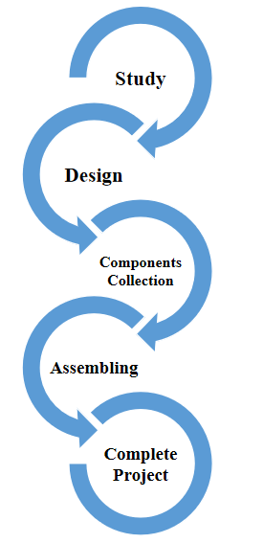
Figure 1.1: Work Flow Diagram

1.5 Objectives
The objectives of this project are:
- To study design and construct about Dry Storage System.
- To design and develop a solar-assisted dry storage system for safe storage of moisture-sensitive products.
- To maintain controlled temperature (40–65°C) using an automatic heating mechanism.
- To monitor and control humidity levels to prevent spoilage and microbial growth.
- To utilize renewable solar energy for energy-efficient and eco-friendly operation.
- To provide real-time temperature and humidity display using an LCD.
- To ensure hygienic and contamination-free storage compared to open sun drying.

1.6 Organization of the Report
- Chapter 1: Introduction. This chapter is all about introduction, background of dry concept, Problem Statement, Work flow Diagram, Objectives and thesis book organization.

- Chapter 2: Literature Review- Here briefly describe about previous book review and Summary of this chapter.

- Chapter 3: System Architecture - This chapter is discussed about our project Methodology, Block Diagram, Circuit Diagram, Working Principle and Cost analysis.

- Chapter 4: Hardware and Software Analysis- This chapter is discussed about our project hardware and Software. Here we describe our hole instrument details.

- Chapter 5: Result and Discussion– Here briefly discuss about this project, project Outcome, Advantages, Application, Limitation and Discussion.

- Chapter 6: Conclusion– In the final chapter, we have discussed the, Future Scope, conclusion of the project.

CHAPTER 2
Literature review

2.1 Introduction
In this chapter we discuss our system overview. In this paper we are also work about Dry Storage System. In below section we will describe some previous literature review. From previous literature we gather more knowledge to build this project and we successfully made it.

2.2 Literature Survey
It has showed designed and developed an indirect solar dryer to investigate the drying kinetics of ginger in terms of convective heat transfer coefficients, moisture removing rates and collector efficiency under natural and forced convection drying modes.[1] The convective heat transfer coefficients obtained under natural and forced convection drying modes were reported to vary from 0.59 to 5.42 W/m² and 2.52 to 6.33 W/m² respectively. Further, the average collector efficiency under natural convection drying mode was calculated to be varied from 14.97 to 16.14%. However, it was obtained to be higher in forced convection drying mode and found to lie in between 27.90 to 33.92%, respectively. Therefore, the forced convection drying method was recommended for the drying of products having high moisture contents and requires either immediate consumption or quick preservation [1]. It has been studied designed of a solar air dryer with a collector area of 2m² dries agricultural products from 89.6% to 13% moisture content under ambient conditions during harvesting period from February to April. Experiments were performed on solar air heater; the maximum temperature rise is 20°C and the solar intensity was found to be in the range of 402-509 w/m². [2] Maximum collector efficiency of 55.15% was obtained for forced convection. Drying time was less in forced convection than the natural convection. So forced convection is preferred than natural convection for drying of agricultural products [2].

The studied concerned with performance analysis of solar drying system for Guntur red chili where Chili was dried to final moisture content of 9 % w.b from 80% w.b within 24 hrs. [3] Their Experimentation period was conducted from 9:30 AM to 5:30 PM daily basis, the daily mean values of the drying chamber air temperature, drying Chamber and solar radiation ranged from 30 °C to 57 °C, and 180W/m² to 950W/m². The drying temperature and relative humidity under solar drying continuously varied with increasing drying time. The efficiency of the solar collector is 71.4%, drying system is 42.18%, at the solar radiation of 950 w/m2 and a mass flow rate of 0.01 kg/sec [3].
The designed and Construction of an indirect forced convention solar crop dyer for the purpose of drying moringa samples using locally available materials. [4] A batch of moringa leaves 2 kg by mass, having an initial moisture content of 80% wet basis from which 1.556 kg of water is required to be removed to have it dried to a desired moisture content of 10% wet basis, is used as the drying load in designing the dryer. A drying time of 24-30 hrs was assumed for the anticipated test location (Kumasi; 6.7oN, 1.6oW) with an expected average solar irradiance of 320 W/m2 and ambient conditions of 25oC and 77% relative humidity. A minimum of 0.62 m2 of solar collection area, according to the design, is required for an expected drying efficiency of 25%. They recommended that a test under full loading conditions should be carried out in order to know if all the design parameters have been met and laboratory experiment should also be done to know the effects on the nutritional values of the moringa leaves when sun dried and solar dried [4].
The Research showed a comprehensive review of the various designs, details of construction, and operational principles of the wide variety of practical designs of solar energy drying systems has been described.[5] Two major groups of solar dryers can be identified, viz., passive or natural circulation solar dryers and active or forced convection solar dryers. Some easy-to-construct and user-friendly dryers that can be suitably employed at small-scale factories or at rural farming villages has been presented. These low-cost food drying technologies can be readily used in rural areas to reduce spoilage and improve product quality thus resulting in overall processing hygiene. Scientifically designed active solar dryers are generally found to be more effective and more controllable than the natural-circulation types. In most of the active solar dryers, the fan is driven by the solar photovoltaic cell. It makes the active dryer totally independent from the dependency over fossil fuel/electricity. Therefore, solar photovoltaic-thermal (PV/T) dryer is agreed to be suitable for remote rural village farm application in most developing countries [5].

This study presents a solar drying system that integrates thermal energy storage (TES) to serve as a backup heat source for sorghum drying. Flake salt is used within aluminum pipes as a medium to retain thermal energy. The system aims to address the shortcomings of traditional sun drying, particularly in sub-Saharan Africa, where grain is often left out in open conditions, making it vulnerable to pests, weather, and contamination. The paper highlights TES as an effective approach to improve energy utilization and maintain drying consistency [6].

This work introduces a dual-source dryer combining solar and biomass energy to enhance the drying of food items. The design, tailored for Pune’s climate, includes a solar chamber with multiple trays and a biomass chamber. It overcomes typical problems in open sun drying, such as direct exposure, pest infestation, and process inconsistency. Materials like mild steel, glass, and aluminum were employed to balance durability and efficiency [7].

A review focused on the evolution of solar drying systems for post-harvest produce. It classifies different types of dryers, discusses their principles, and compares them with conventional drying methods. The paper emphasizes the growing relevance of solar drying for small-scale farmers, particularly in regions with abundant sunlight, citing benefits such as energy efficiency, product quality preservation, and cost-effectiveness [8].

This research highlights how modern solar dryers aim to address the limitations of open-air drying. It evaluates the use of TES and biomass alternatives to extend drying periods beyond daylight hours. The study supports solar drying as a sustainable method to improve agricultural productivity and reduce spoilage [9].

The study examines the ongoing improvements in solar dryer systems designed to mitigate common drying issues like contamination and inconsistent results. It discusses how using clean energy from the sun, along with auxiliary systems like TES and biomass heating, can enhance the process's reliability, making solar dryers a viable option for reducing post- harvest waste and enhancing food security [10].

This report critically analyzes the working mechanisms of solar dryers, including airflow dynamics, energy conversion, and heat transfer models. It also assesses the impact of TES and microcontroller-based control systems on drying performance. The study underlines the need for adaptive designs to handle diverse climatic conditions and crop types [11].

2.3 Summary
The literature review highlights the importance of solar-assisted drying and controlled storage systems in reducing moisture-related spoilage of agricultural products. Previous studies emphasize temperature and humidity control, energy efficiency, and hygienic storage conditions. Solar-based systems are found to be cost-effective, sustainable, and suitable for rural and off-grid applications.

CHAPTER 3
SYSTEM ARCHITECTURE

3.1 Introduction
The project objectives, Background Study, Problem Identification literature evaluation, and other details were all clarified in the preceding chapter. The Methodology block diagram, circuit diagram, working principle and cost analysis will all be covered in this chapter.

3.2 Methodology
The methodologies we have used to build this project are given below:
- Creating an idea for Development and Experimental Performance Analysis of a Low - cost, Eco - Friendly Hybrid Solar Dryer. And designing a block diagram & circuit diagram to know which components need to construct it.
- Collecting the all components and programming for the micro controller to controlled the system.
- Setting all components in a PCB board & soldering. Then assembling the all block in a board and finally run the system & checking.

3.3 System Design


Figure 3.1: Tray
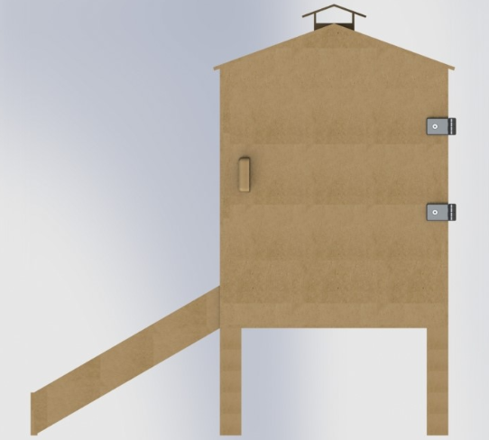
Figure 3.2: Back Side View

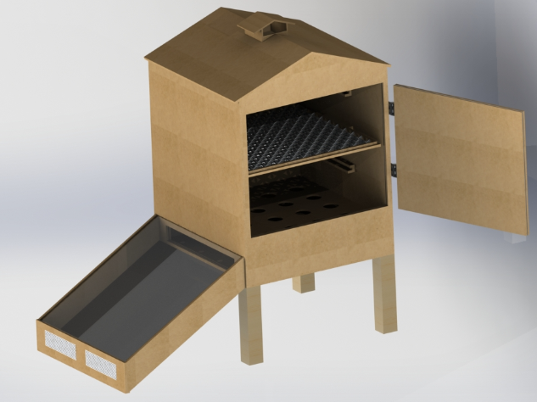
Figure 3.3: Front Side View
3.4 Block Diagram
Here is the block diagram of the Development and Experimental Performance Analysis of a Low - cost, Eco - Friendly Hybrid Solar Dryer with all the essential components. All of the components are shown in below as a block in this diagram. Here we use Arduino Nano for main brain of our project. Other equipment's are attached with this micro-controller and work together for perform as our desire outcome.
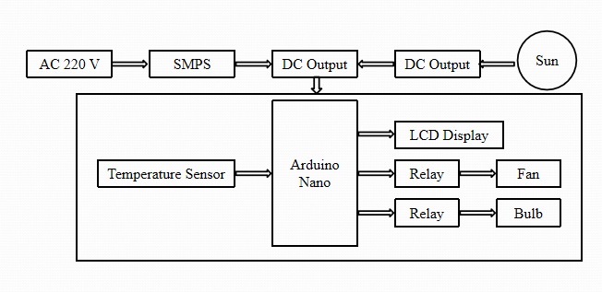
Figure 3.4: Block Diagram of our Project

3.5 Circuit Diagram

The schematic diagram here is representing the electrical circuit and the components of the Solar Dry Storage System. Here we connect equipment with the smart wire connection.
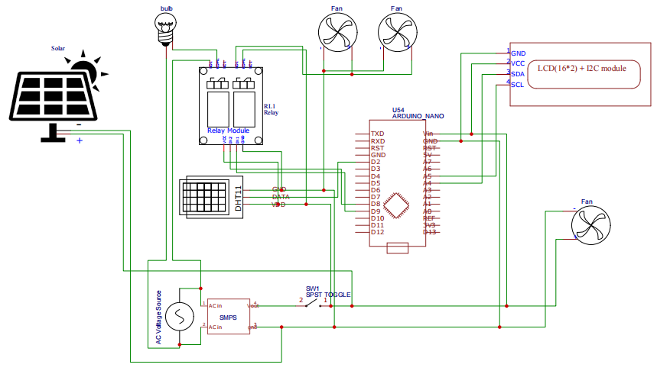
Figure 3.5: Schematic Diagram of our project
3.6 Working Principle
The Dry Storage System operates using solar energy and regulated electrical power to maintain proper temperature and humidity inside the storage chamber. Power is supplied from a solar panel and AC 220 V source, which is converted into stable DC voltage using an SMPS. This DC supply powers the Arduino Nano, sensors, LCD display, and relay modules. A temperature humidity sensor continuously monitors the internal conditions and sends real-time data to the Arduino Nano. The measured temperature and humidity values are displayed on the LCD display.

When the temperature falls below 30°C, the Arduino activates a relay to turn ON the bulb to increase the temperature. Once the temperature reaches 40°C, the relay switches OFF the bulb automatically. Similarly, humidity control is managed using an exhaust fan. When the humidity rises above 40%, the Arduino triggers the relay to turn ON the fan, and when the humidity reaches 45%, the fan is turned OFF. This relay-based automatic control ensures efficient drying, safe storage, and energy-efficient operation.

3.7 Cost Analysis

Table 1: List of Component with Price

Sl.  no | Particulars | Specification | Qty. | Unit Price (Taka) | Total Price (Taka)
1 | Arduino Nano | IC AT mega328P | 1 | 600 | 600
2 | SMPS | 5A | 1 | 500 | 500
3 | Temperature and Humidity Sensor | DHT 11 | 1 | 300 | 300
4 | LCD Display | 16*2 | 1 | 400 | 400
5 | Relay | 5V DC | 2 | 150 | 300
6 | Solar Panel | 12V 20 Watt | 1 | 2500 | 2500
7 | Exhaust Fan |  | 2 | 300 | 600
8 | Body Structure |  |  | 4500 | 4500
9 | Others |  |  |  | 1500
 |  |  |  | Total | 11,200/=
3.8 Hardware Implementation

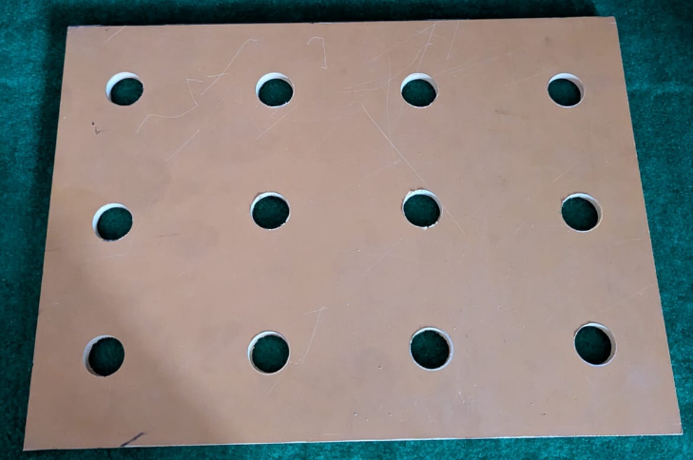

Figure 3.6: Tray

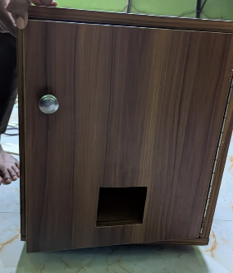

Figure 3.7: Structure frame

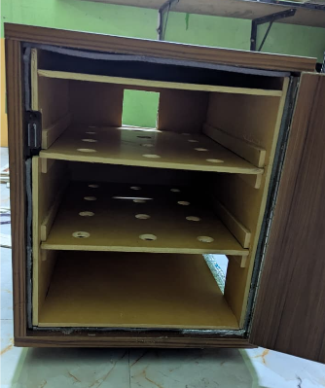

Figure 3.8: Tray Set up

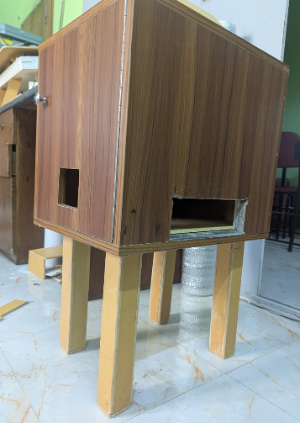
Figure 3.9: Body Structure

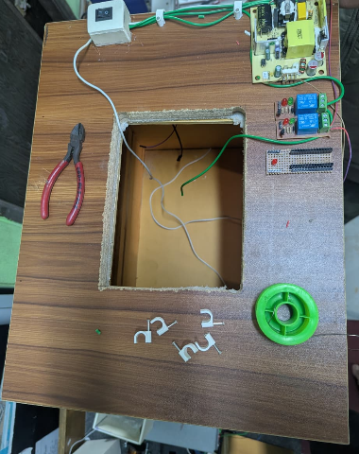

Figure 3.10: Component Implementation

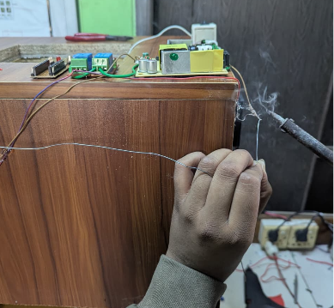

Figure 3.11: Wiring

CHAPTER 4
HARDWARE AND SOFTWARE ANALYSIS

4.1 Introduction
In this section, we will discuss elaborately about “Dry Storage System” and the component description, features, working procedure of our all equipment. The system hardware fabricates composed of micro-controller unit, power unit, source unit, power store unites, sensor unit and many more related components.

4.2 Hardware & Software
Hardware
- Arduino Nano
- LCD Display
- Relay
- Solar panel
- Humidity Temperature Sensor
- SMPS
- Exhaust Fan
Software
- Arduino IDE
- Easy EDA

4.3 Arduino Nano

Arduino is open-source electronics prototyping platform based on flexible, easy-to-use hardware and software. It's intended for artists, designers, hobbyists, and anyone interested in creating interactive objects or environments. Arduino can sense the environment by receiving input from a variety of sensors and can affect its surroundings by controlling Lights, motors, and other actuators.

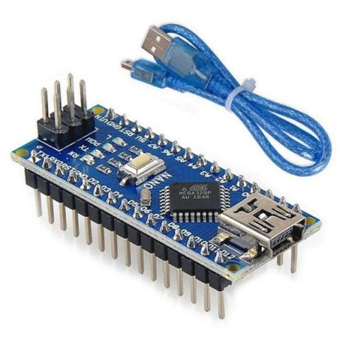

Figure 4.1: Arduino Nano

The micro-controller on the board is programmed using the Arduino programming language (based on Wiring) and the Arduino development environment (based on Processing). Arduino projects can be stand-alone or they can communicate with software on running on a computer (e.g. Flash, Processing, Maxims’). Arduino Nano is a surface mount breadboard embedded version with integrated USB. It is a small, complete, and breadboard friendly component. It has everything that Decimal has (electrically) with more analog input pins and onboard +5V AREF jumper. Physically, it is missing power jack. The Nano can automatically sense and switch to the higher potential source of power.

Figure 4.2: Arduino Nano Schematic Diagram

Nanos got the breadboard-ability of the Boarding and the Minibus with smaller footprint than either, so users have more breadboard space. It’s got a pin layout that works well with the Mini or the Basic Stamp (TX, RX, ATN, and GND on one top, power and ground on the other). This new version 3.0 comes with ATMEGA328 which offer more programming and data memory space. It has two layers. That make it easier to hack and more affordable. One of the best features of Arduino Nano is, it’s easy to use, compact and also small.

Figure 4.3: How Arduino Nano looks like

Specifications
- Micro-controller: Atmel ATmega328
- Operating Voltage (logic level): 5 V
- Input Voltage (recommended): 7-12 V
- Input Voltage (limits): 6-20 V
- Digital I/O Pins: 14 (of which 6 provide PWM output)
- Analog Input Pins: 8
- DC Current per I/O Pin: 40 mA
- Flash Memory: 32 KB (of which 2KB used by boot loader)
- SRAM: 2 KB
- EEPROM: 1 KB
- Clock Speed: 16 MHz
- Dimensions: 0.70” x 1.70”

Features
- Automatic reset during program download
- Power OK blue LED
- Green (TX), red (RX) and orange (L) LED
- Auto sensing/switching power input
- Small mini-B USB for programming and serial monitor
- ICSP header for direct program download
- Manual reset switch

Micro-controller IC ATmega328p
Figure 4.4: Micro-controller IC AT mega 328p

The high-performance Microchip Pico Power 8-bit AVR RISC-based micro-controller combines 32KB ISP flash memory with read-while-write capabilities, 1024B EEPROM, 2KB SRAM, 23 general purpose I/O lines, 32 general purpose working registers, three flexible timer/counters with compare modes, internal and external interrupts, serial programmable USART, a byte-oriented 2-wire serial interface, SPI serial port, a 6-channel 10-bit A/D converter (8-channels in TQFP and QFN/MLF packages), programmable watchdog timer with internal oscillator, and five software selectable power saving modes. The device operates between 1.8-5.5 volts. By executing powerful instructions in a single clock cycle, the device achieves throughput's approaching 1 MIPS per MHz, balancing power consumption and processing speed.

4.4 LCD Display
The LCD (liquid crystal display) screen is an electronic display module and looks for various applications. A 16x2 LCD display is a very basic module and it is very commonly used in various devices and circuits. These modules are preferred over seven sections and many other segments.

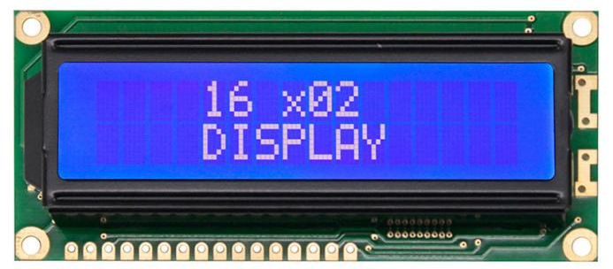

Figure 4.5: 16*2 LCD Display

The reasons for having LCD are economic; Easily programmable, special and even custom characters (different in seven sections), there are no restrictions on displaying animations. A 16x2 LCD means it can display 16 characters per line and contains 2 lines. Each character on this LCD is displayed in a 5x7 pixel matrix.

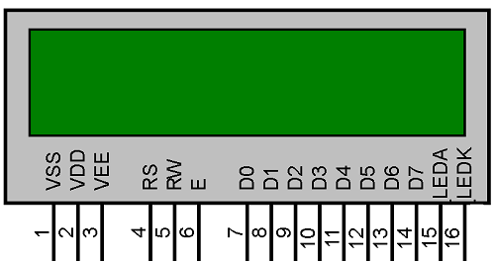

Figure 4.6: Pin out of 16*2 LCD Display

This LCD contains two articles called Command and Data. The command register stores the command instructions on the LCD. The command is a command given to the LCD to perform a predefined task such as starting it, clearing its screen, locating the cursor, controlling the display, etc.

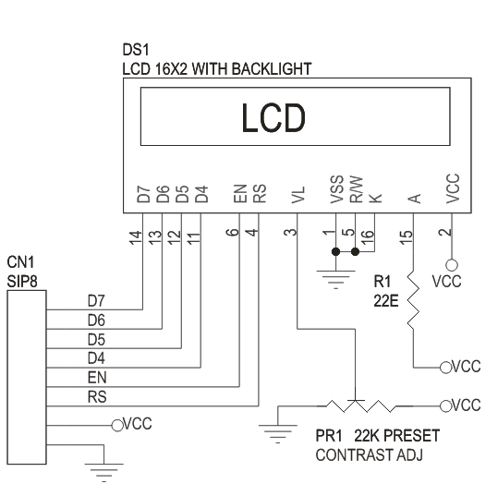
Figure 4.7: 16*2 LCD Display interfacing with Arduino
Feature
The features of this LCD mainly include the following.

- The operating voltage of this LCD is 4.7V-5.3V
- It includes two rows where each row can produce 16-characters.
- The utilization of current is 1mA with no backlight
- Every character can be built with a 5×8-pixel box
- The alphanumeric LCDs alphabets & numbers
- Is display can work on two modes like 4-bit & 8-bit
- These are obtainable in Blue & Green Backlight

4.5 Temperature Sensor
The DHT11 is a basic, ultra-low-cost digital temperature and humidity sensor. It uses a capacitive humidity sensor and a thermistor to measure the surrounding air, and spits out a digital signal on the data pin (no analog input pins needed). It’s fairly simple to use, but requires careful timing to grab data.

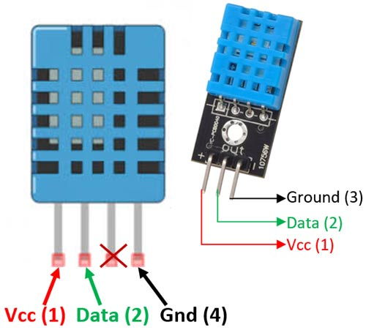
Figure 4.8: DHT11 Temperature Sensor

DHT11 Specifications
- Operating Voltage: 3.5V to 5.5V
- Operating current: 0.3mA (measuring) 60uA (standby)
- Output: Serial data
- Temperature Range: 0°C to 50°C
- Humidity Range: 20% to 90%
- Resolution: Temperature and Humidity both are 16-bit
- Accuracy: ±1°C and ±1%

4.6 Relay
A relay is an electrically operated switch. Many relays use an electromagnet to mechanically operate a switch, but other operating principles are also used, such as solid-state relays. Relays are used where it is necessary to control a circuit by a separate low-power signal, or where several circuits must be controlled by one signal. The first relays were used in long distance telegraph circuits as amplifiers: they repeated the signal coming in from one circuit and re-transmitted it on another circuit. Relays were used extensively in telephone exchanges and early computers to perform logical operations.
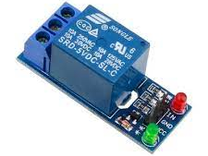

Figure 4.9: Relay

A type of relay that can handle the high power required to directly control an electric motor or other loads is called a contactor. Solid-state relays control power circuits with no moving parts, instead using a semiconductor device to perform switching. Relays with calibrated operating characteristics and sometimes multiple operating coils are used to protect electrical circuits from overload or faults; in modern electric power systems these functions are performed by digital instruments still called "protective relays". Magnetic latching relays require one pulse of coil power to move their contacts in one direction, and another, redirected pulse to move them back. Repeated pulses from the same input have no effect. Magnetic latching relays are useful in applications where interrupted power should not be able to transition the contacts. Magnetic latching relays can have either single or dual coils. On a single coil device, the relay will operate in one direction when power is applied with one polarity, and will reset when the polarity is reversed. On a dual coil device, when polarized voltage is applied to the reset coil the contacts will transition. AC controlled magnetic latch relays have single coils that employ steering diodes to differentiate between operate and reset commands. The relay module is the one in the figure below.

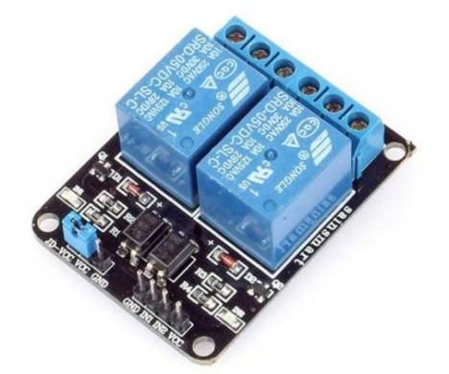
Figure 4.10: Relay Module.
This module has two channels (those blue cubes). There are other varieties with one, four and eight channels.

Main’s voltage connections.
In relation to mains voltage, relays have 3 possible connections:

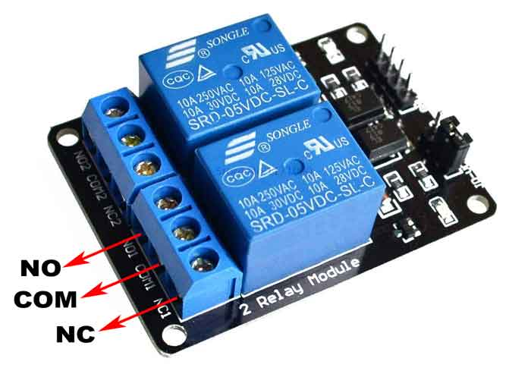

Figure 4.11: Main’s voltage connections.
COM: Common pin
NO (Normally Open): there is no contact between the common pin and the normally open pin. So, when you trigger the relay, it connects to the COM pin and supply is provided to a load
NC (Normally Closed): there is contact between the common pin and the normally closed pin. There is always connection between the COM and NC pins, even when the relay is turned off. When you trigger the relay, the circuit is opened and there is no supply provided to a load.

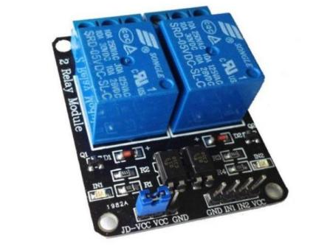

Figure 4.12: Voltage Connections

Pin wiring
The connections between the relay module and the Arduino are really simple:
GND: goes to ground
IN: controls the first relay (it will be connected to an Arduino digital pin)
IN2: controls the second relay (it should be connected to an Arduino digital pin if you
are using this second relay. Otherwise, you don’t need to connect it)
VCC: goes to 5V

4.7 Switch Mode Power Supply (SMPS)
A switched-mode power supply (switching-mode power supply, switch-mode power supply, switched power supply, SMPS, or switcher) is an electronic power supply that incorporates a switching regulator to convert electrical power efficiently. Like other power supplies, an SMPS transfers power from a DC or AC source (often mains power) to DC loads, such as a personal computer, while converting voltage and current characteristics. Unlike a linear power supply, the pass transistor of a switching-mode supply continually switches between low-dissipation, full-on and full-off states, and spends very little time in the high dissipation transitions, which minimizes wasted energy. A hypothetical ideal switched-mode power supply dissipates no power. Voltage regulation is achieved by varying the ratio of on-to-off time (also known as duty cycles). In contrast, a linear power supply regulates the output voltage by continually dissipating power in the pass transistor. This higher power conversion efficiency is an important advantage of a switched-mode power supply. Switched-mode power supplies may also be substantially smaller and lighter than a linear supply due to the smaller transformer size and weight.

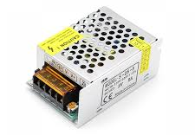
Figure 4.13: SMPS

Switching regulators are used as replacements for linear regulators when higher efficiency, smaller size or lighter weight are required. They are, however, more complicated; their switching currents can cause electrical noise problems if not carefully suppressed, and simple designs may have a poor power factor. Switched-mode power supplies are classified according to the type of input and output voltages. The four major categories are:

- AC to DC
- DC to DC
- DC to AC
- AC to AC

A basic isolated AC to DC switched-mode power supply consists of:

- Input rectifier and filter
- Inverter consisting of switching devices such as MOSFETs
- Transformer
- Output rectifier and filter
- Feedback and control circuit

The input DC supply from a rectifier or battery is fed to the inverter where it is turned on and off at high frequencies of between 20 KHz and 200 KHz by the switching MOSFET or power transistors. The high-frequency voltage pulses from the inverter are fed to the transformer primary winding, and the secondary AC output is rectified and smoothed to produce the required DC voltages. A feedback circuit monitors the output voltage and instructs the control circuit to adjust the duty cycle to maintain the output at the desired level.

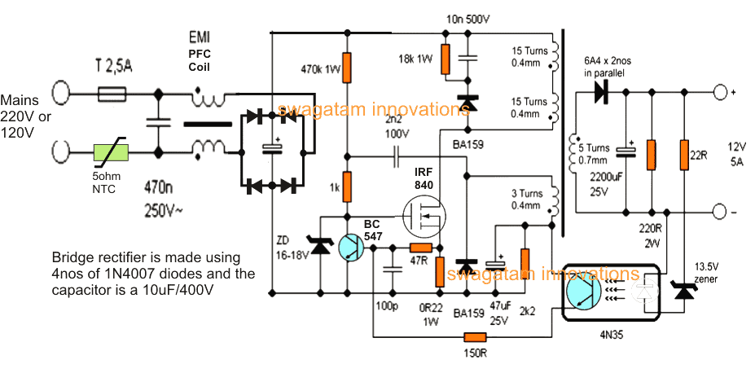
Figure 4.14: SMPS Circuit

Basic working concept of an SMPS
A switching regulator does the regulation in the SMPS. A series switching element turns the current supply to a smoothing capacitor on and off. The voltage on the capacitor controls the time the series element is turned. The continuous switching of the capacitor maintains the voltage at the required level.

Design basics

AC power first passes through fuses and a line filter. Then it is rectified by a full-wave bridge rectifier. The rectified voltage is next applied to the power factor correction (PFC) pre-regulator followed by the downstream DC-DC converter(s). Most computers and small appliances use the International Electrotechnical Commission (IEC) style input connector. As for output connectors and pin outs, except for some industries, such as PC and compact PCI, in general, they are not standardized and are left up to the manufacturer.

There are different circuit configurations known as topologies, each having unique characteristics, advantages and modes of operation, which determines how the input power is transferred to the output. Most of the commonly used topologies such as flyback, push-pull, half bridge and full bridge, consist of a transformer to provide isolation, voltage scaling, and multiple output voltages. The non-isolated configurations do not have a transformer and the power conversion is provided by the inductive energy transfer.

Advantages of switched-mode power supplies
- Higher efficiency of 68% to 90%
- Regulated and reliable outputs regardless of variations in input supply voltage
- Small size and lighter
- Flexible technology
- High power density
- Disadvantages:
- Generates electromagnetic interference
- Complex circuit design
- Expensive compared to linear supplies

Switched-mode power supplies are used to power a wide variety of equipment such as computers, sensitive electronics, battery-operated devices and other equipment requiring high efficiency. Linear voltage IC regulators have been the basis of power supply designs for many years as they are very good at supplying a continuous fixed voltage output. Linear voltage regulators are generally much more efficient and easier to use than equivalent voltage regulator circuits made from discrete components such a Zener diode and a resistor, or transistors and even op-amps. The most popular linear and fixed output voltage regulator types are by far the 78… positive output voltage series, and the 79… negative output voltage series.

These two types of complementary voltage regulators produce a precise and stable voltage output ranging from about 5 volts up to about 24 volts for use in many electronic circuits. There is a wide range of these three-terminal fixed voltage regulators available each with its own built-in voltage regulation and current limiting circuits. This allows us to create a whole host of different power supply rails and outputs, either single or dual supply, suitable for most electronic circuits and applications. There are even variable voltage linear regulators available as well providing an output voltage which is continually variable from just above zero to a few volts below its maximum voltage output

Switch Mode Power Supply

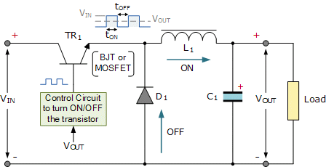
Figure 4.15: SMPS Circuit Connection

Most d.c. power supplies comprise of a large and heavy step-down mains transformer, diode rectification, either full-wave or half-wave, a filter circuit to remove any ripple content from the rectified d.c. producing a suitably smooth d.c. voltage, and some form of voltage regulator or stabilizer circuit, either linear or switching to ensure the correct regulation of the power supplies output voltage under varying load conditions. Then a typical d.c. power supply would look something like this:

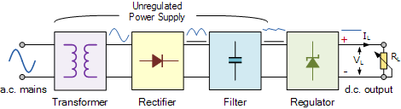
Figure 4.16: DC Power supply way

These typical power supply designs contain a large mains transformer (which also provides isolation between the input and output) and a dissipative series regulator circuit. The regulator circuit could consist of a single Zener diode or a three-terminal linear series regulator to produce the required output voltage. The advantage of a linear regulator is that the power supply circuit only needs an input capacitor, output capacitor and some feedback resistors to set the output voltage.

4.8 Solar Panel
A solar panel is a set of solar photovoltaic modules electrically connected and mounted on a supporting structure. A photovoltaic module is a packaged, connected assembly of solar cells. The solar panel can be used as a component of a larger photovoltaic system to generate and supply electricity in commercial and residential applications. Each module is rated by its DC output power under standard test conditions (STC), and typically ranges from 100 to 320 watts. The efficiency of a module determines the area of a module given the same rated output - an 8% efficient 230-watt module will have twice the area of a 16% efficient 230-watt module. A single solar module can produce only a limited amount of power; most installations contain multiple modules. A photovoltaic system typically includes a panel or an array of solar modules, an inverter, and sometimes a battery and/or solar tracker and interconnection wiring.

Solar cell modules produce electricity only when the sun is shining. They do not store energy, therefore to ensure flow of electricity when the sun is not shinning, it is necessary to store some of the energy produced. The most obvious solution is to use batteries, which chemically store electric energy. Batteries are groups of electro chemical cells (devices that convert chemical energy to electrical energy) connected in series.

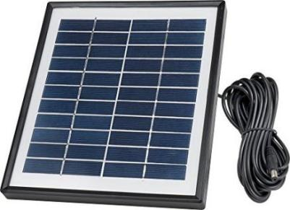
Figure 4.17: Solar Panel

Battery cells are composed of two electrodes immersed in electrolyte solution which produce an electric current when a circuit is formed between them. The current is caused by reversible chemical reactions between the electrodes and the electrolyte within the cell. Batteries that are re-chargeable are called secondary or accumulator batteries. As the battery is being charged, electric energy is stored as chemical energy in the cells. When being discharged, the stored chemical energy is being removed from the battery and converted to electrical energy. In East-Africa, the most common type of secondary battery is the Lead-acid battery.

Solar Charger Controller
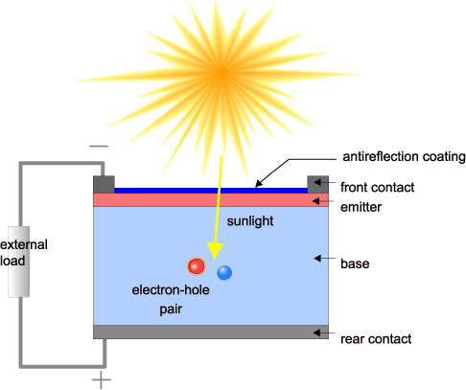
Figure 4.18: Solar Panel Schematic Diagram
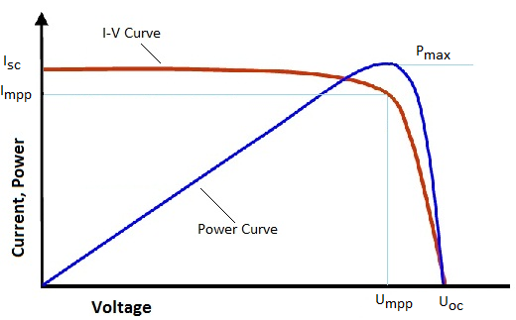
Figure 4.19: Solar Cell System Curve

Here is a solar charger circuit that is used to charge Lead Acid or Ni-Cd batteries using the solar energy power. The circuit harvests solar energy to charge a 6-volt 4.5 Ah rechargeable battery for various applications. The charger has voltage and current regulation and over voltage cut-off facilities.

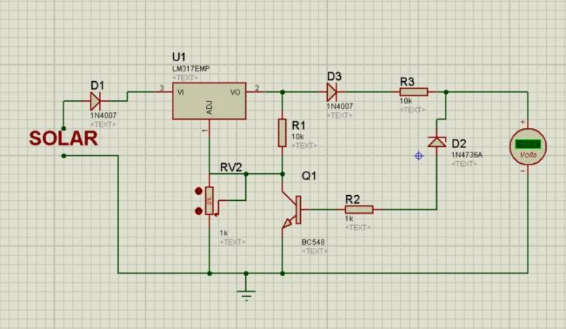
Figure 4.20: Solar Charger Controller Circuit

The circuit uses a 12-volt solar panel and a variable voltage regulator IC LM 317. The solar panel consists of solar cells each rated at 1.2 volts. 12-volt DC is available from the panel to charge the battery. Charging current passes through D1 to the voltage regulator IC LM 317. By adjusting its Adjust pin, output voltage and current can be regulated. VR is placed between the adjust pin and ground to provide an output voltage of 9 volts to the battery. Resistor R3 Restrict the charging current and diode D2 prevents discharge of current from the battery.

4.9 Exhaust Fan
An exhaust fan is a fan which is used to control the interior environment by venting out unwanted odors, particulates, smoke, moisture, and other contaminants which may be present in the air. Exhaust fans can also be integrated into a heating and cooling system. Common locations for exhaust fans include bathrooms and kitchens, and these fans are usually very easy to install, so they can be situated in many other locations as well. For installation, people do need a few tools, and they must be comfortable working with electricity to wire the fan in place.
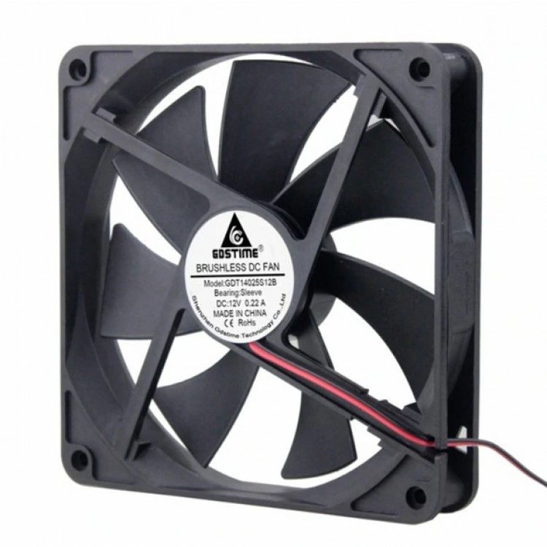
Figure 4.21: Exhaust Fan

Working Principle of Exhaust Fan
Exhaust fans work on the basic principle of sucking hot air, smell, moisture and dust from the room and pushing it outside. All fans work on this principle but the main purpose of an exhaust fan is to suck hot air from your house and blow it out from the other side. The exhaust fan blades are attached to a hub and the fans are angled in a way that when it rotates, it sucks air from one side and throw it from another side.

Industrial fans are bigger, consume a lot of power and are difficult to maintain. These fans are attached to warehouses and industries and commercial places. Industrial exhaust fans come in different shapes, sizes and forms but work on the same principle as a consumer exhaust fan. The main purpose of these fans is to maintain the temperature, moisture and humidity and remove foul smell.

SOFTWARE

4.10 Arduino IDE
The digital micro-controller unit named as Arduino Nano can be programmed with the Arduino software IDE. There is no any requirement for installing other software rather than Arduino. Firstly, Select "Arduino Nano from the Tools, Board menu (according to the micro controller on our board). The IC used to name as ATmega328 on the Arduino Nano comes pre burned with a boot loader that allows us to upload new code to it without the use of an external hardware programmer. Communication is using the original STK500 protocol (reference, C header files). We can also bypass the boot loader and programs the micro controller through the ICSP (In Circuit Serial Programming) header. The ATmega16U2 (or 8U2 in the rev1 and rev2 boards) firmware source code is available. The ATmega16U2/8U2 is loaded with a DFU boot loader, which can be activated by:

On Rev1 boards: connecting the solder jumper on the back of the board (near the map of Italy) and then resetting the 8U2. On Rev2 or later boards: there is a resistor that pulling the 8U2/16U2 HWB line to ground, making it easier to put into DFU mode. The Arduino Nano is one of the latest digital micro controller units and has a number of facilities for communicating with a computer, another Arduino, or other micro-controllers. The ATmega328 provides UART TTL at (5V) with serial communication, which is available on digital pins 0 -(RX) for receive the data and pin no.1 (TX) for transmit the data. An ATmega16U2 on the board channels this serial communication over USB and appears as a virtual com port to software on the computer. The '16U2 firmware uses the standard USB COM drivers, and no external driver is needed. However, on Windows, an .in file is required. The Arduino software includes a serial monitor which allows simple textual data to be sent to and from the Arduino board.

The RX and TX LEDs on the board will flash when data is being transmitted via the USB-to-serial chip and USB connection to the computer (but not for serial Communication on pins 0 and 1). A Software Serial library allows for serial communication on any of the Nano's digital pins. The ATmega328 also supports I2C (TWI) and SPI communication. The Arduino software includes a Wire library to simplify use of the I2C bus. Arduino programs are written in C or C++ and the program code written for Arduino is called sketch. The Arduino IDE uses the GNU tool chain and AVR Lab to compile programs.
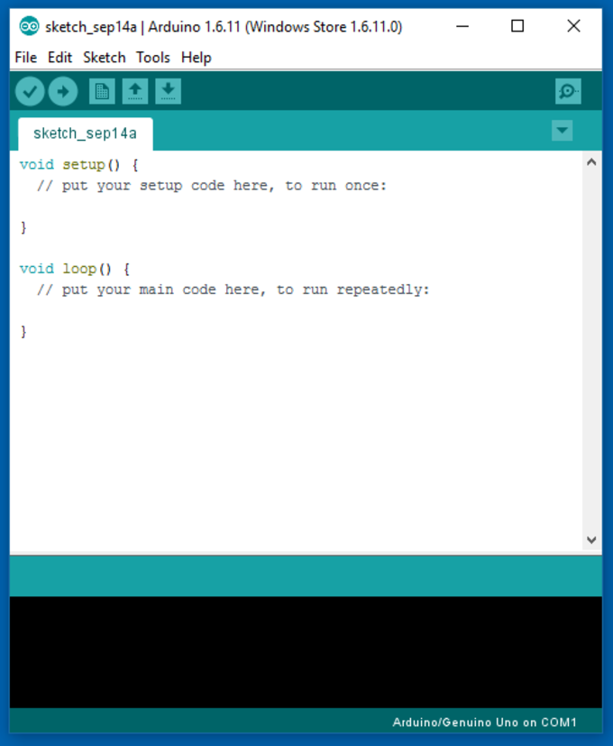
Figure 4.22: Arduino Software Interface IDE

Writing Sketches
Programs written using Arduino Software (IDE) are called sketches. These sketches are written in the text editor and are saved with the file extension. ino. The editor has features for cutting/pasting and for searching/replacing text. The message area gives feedback while saving and exporting and also displays errors. The console displays text output by the Arduino Software (IDE), including complete error messages and other information. The bottom righthand corner of the window displays the configured board and serial port. The toolbar buttons allow you to verify and upload programs, create, open, and save sketches, and open the serial monitor.

Libraries
Libraries provide extra functionality for use in sketches, e.g. working with hardware or manipulating data. To use a library in a sketch, select it from the Sketch > Import Library menu. This will insert one or more #include statements at the top of the sketch and compile the library with your sketch. Because libraries are uploaded to the board with your sketch, they increase the amount of space it takes up. If a sketch no longer needs a library, simply delete its #include statements from the top of your code.
There is a list of libraries in the reference. Some libraries are included with the Arduino software. Others can be downloaded from a variety of sources or through the Library Manager. Starting with version 1.0.5 of the IDE, you do can import a library from a zip file and use it in an open sketch. See these instructions for installing a third-party library.

Third-Party Hardware
Support for third-party hardware can be added to the hardware directory of your sketchbook directory. Platforms installed there may include board definitions (which appear in the board menu), core libraries, boot-loaders, and programmer definitions. To install, create the hardware directory, then unzip the third-party platform into its own sub-directory. (Don't use "Arduino" as the sub-directory name or you'll override the built-in Arduino platform.) To uninstall, simply delete its directory.

4.11 Easy EDA
Easy EDA is a web-based EDA tool suite that enables hardware engineers to design, simulate, share-publicly and privately-and discuss schematics, simulations and printed circuit boards. Other features include the creation of a bill of materials, Gerber files and pick and place files and documentary outputs in PDF, PNG and SVG formats. Easy EDA allows the creation and editing of schematic diagrams, SPICE simulation of mixed analogue and digital circuits and the creation and editing of printed circuit board layouts and, optionally, the manufacture of printed circuit boards.

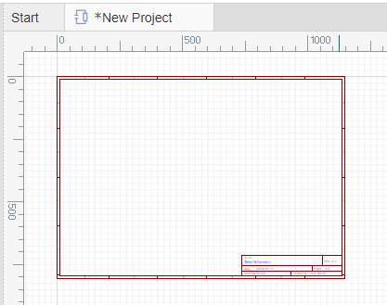

Figure 4.23: Easy EDA Software Interface

Subscription-free membership is offered for public plus a limited number of private projects. The number of private projects can be increased by contributing high quality public projects, schematic symbols, and PCB footprints and/or by paying a monthly subscription. Registered users can download Gerber files from the tool free of charge; but for a fee, Easy EDA offers a PCB fabrication service. This service is also able to accept Gerber file inputs from third party tools.

CHAPTER 5
DRYING CALCULATIONS

5.1 Drying & Moisture Calculation
Product: Pineapple
Number of slices: 11 pieces
Fresh weight: 50 g
Final dry weight: 17 g
Drying temperature: 35 °C
Relative humidity: 36 %
Drying time: 6 hours
- Average Weight Per Slice
Average fresh weight per slice = 50 / 11
= 4.545 g
Average dry weight per slice = 17 / 11
= 1.545 g

- Water Removed
Water removed = Fresh weight − Dry weight
= (50 – 17) g
= 33 g
- Moisture Content (Wet Basis)
Moisture content (wet basis) = (Water removed / Fresh weight) × 100
= (33 / 50) × 100
= 66 %
Initial moisture content = 66 %

- Moisture Content (Dry Basis)
Moisture content (dry basis) = (Water removed / Dry weight) × 100
= (33 / 17) × 100
= 194.12 %
Moisture content (dry basis) = 194.12 %

- Dry Matter Percentage
Dry matter % = (Dry weight / Fresh weight) × 100
= (17 / 50) × 100
= 34 %
Dry matter remaining = 34 %

- Weight Reduction Percentage
Weight reduction % = (Water removed / Fresh weight) × 100
= (33 / 50) × 100
= 66 %
Total weight reduction = 66 %

- Drying Rate
Drying rate = Water removed / Drying time
= 33 g / 6 hr
= 5.5 g/hr
Drying rate = 5.5 g/hr

- Moisture Ratio
Moisture ratio = Final moisture content (dry basis) / Initial moisture content (dry basis)
Initial moisture (dry basis) = 194.12 %
Final moisture after drying ≈ 10 %
Moisture ratio = 10 / 194.12
= 0.051
Moisture ratio = 0.051
Final results summary:
Initial moisture content (wet basis): 66 %
Moisture content (dry basis): 194.12 %
Dry matter: 34 %
Total water removed: 33 g
Drying rate: 5.5 g/hr
Moisture ratio: 0.051

5.2 Drying System Calculation
- Chamber Dimensions
Height = 400 mm = 0.40 m
Length = 450 mm = 0.45 m
Width = 350 mm = 0.35 m
Chamber Volume
Volume = Length × Width × Height
= 0.45 × 0.35 × 0.40
= 0.063 m³
Chamber Volume = 0.063 m³
- Mass of Air Inside Chamber
Density of air = 1.2 kg/m³
Mass of air = Density × Volume
= 1.2 × 0.063
= 0.0756 kg
Mass of air inside chamber = 0.0756 kg

- Heat Required to Raise Air Temperature
Specific heat of air = 1005 J/kg·K
Temperature rise = 5 °C
Heat required (Q) = m × c × ΔT
= 0.0756 × 1005 × 5
= 379.89 J
≈ 380 J
Heat required to raise chamber air temperature by 5 °C = 380 J

- Electrical Power Consumption
Heating bulb = 100 W
3 DC fans = 18 W
Sensors and control = 3 W
Total Power = 100 + 18 + 3
= 121 W
Total electrical power consumption = 121 W

- Energy Consumption for 6 Hours Operation
Energy (Wh) = Power × Time
= 121 × 6
= 726 Wh
Convert to kWh
= 0.726 kWh
Convert to kJ
1 Wh = 3.6 kJ
726 × 3.6
= 2613.6 kJ
Total energy consumed in 6 hours = 726 Wh
= 0.726 kWh
= 2613.6 kJ

- Air Circulation Rate (Single 12V DC Fan Approximation)
Typical small 12V fan airflow ≈ 70 CFM
Convert CFM to m³/min
1 CFM = 0.0283 m³/min
70 × 0.0283
= 1.981 m³/min
Air changes per minute
Air changes = Fan airflow / Chamber volume
= 1.981 / 0.063
= 31.44 times per minute
Air inside chamber is theoretically replaced about 31 times per minute.

Final calculated values:
Chamber Volume = 0.063 m³
Mass of Air = 0.0756 kg
Heat to Raise Air by 5 °C = 380 J
Total Power Consumption = 121 W
Energy for 6 Hours = 726 Wh (0.726 kWh)
Energy in kJ = 2613.6 kJ
Air Changes per Minute ≈ 31

5.3 Power consumption calculation

- Chamber Volume
$$V=L×W×H \\ V=0.45×0.35×0.4 \\ V=0.063m^{3}$$
chamber volume= 0.063m³
- Mass of Air Inside Chamber
Air density:
$$ρ=1.2kg/m^{3} \\ m=ρ×V \\ m=1.2×0.063 \\ m=0.0756kg$$ mass of air= 0.076kg
- Heat Required to Raise Temperature
Assumption:
Ambient temperature = 30°C
Dryer temperature = 35°C
ΔT = 5°C
Specific heat of air $c=1005J/kgK$
$$Q=mcΔT \\ Q=0.0756×1005×5 \\ Q=379.9J$$ Heat required=380 J
- Energy Per Day (6 Hours)
$$Energy=121×6 \\ Energy=726Wh=0.726kWh/day$$
- Solar Panel Requirement
Sunlight ≈ 4 hours
$$726÷4=181W$$
Including losses: $≈220W$
Need to use 250W solar panel
Energy= Power × Time
Energy: 220 $×6=$ 1320 Wh
- Battery Requirement
Ah=1320​/12
= 110Ah
Add safety factor (50% depth of discharge):110 $×2=220Ah$
Recommended battery: 12V 200Ah battery

SUMMARY
Chamber Volume = 0.063 m³
Mass of Air = 0.076 kg
Heat Required to Raise Temp (5°C) = 380 J
Total Electrical Load = 121 W
Daily Energy Consumption = 0.726 kWh
Solar Panel Required = 250 W
Battery Required = 12V 200A

5.4 Calculation of Required Components
Given:
- Fans = 3 × 12 V DC, 15 W (2 inlet, 1 outlet)
- Bulb = 100 W
- Required airflow = 450 CFM
- Chamber drying energy = 1.3 kWh (for 1.5 kg pineapple)

Fan Calculation
$$Total airflow=450 CFM \\ Inlet fan airflow=\frac{450}{2}=225 CFM each \\ Outlet fan airflow=450 CFM$$
Power consumption:
$$Total fan power=3×12=36 W \\ Energy_{fans}=36 W×13 h=0.468 kWh$$
- Reason for 12V fan:
Matches chamber size, widely available, low power, provides required airflow.

Bulb / Heater Calculation
- Bulb power = 100 W = 0.1 kW
- Required energy = 1.3 kWh
$$Drying time=\frac{1.3}{0.1}≈13 hours$$
- Reason for 100 W heater:
Small chamber, safe, maintains 30–40 °C, sufficient for demonstration batch.

CHAPTER 6
RESULTS AND DISCUSSION

6.1 Project outcome
After the successful completion of the project, the system was tested under real operating conditions to observe its performance. The results confirmed that the project functions efficiently and meets the expected objectives. All components were carefully monitored during operation, and each part performed according to the designed control logic. The system responded accurately to temperature and humidity changes, providing stable and reliable output. Multiple trials were conducted to evaluate consistency, and in each case, the project delivered satisfactory results. Overall, the performance of the Dry Storage System was found to be reliable, efficient, and well-suited for its intended application.

- The system successfully maintained the desired temperature range using automatic relay control.
- The bulb heater activated below 30°C and turned OFF at 40°C, ensuring stable thermal conditions.
- Humidity control was effective, with the exhaust fan activating above 40% and turning OFF at 45%.
- Real-time temperature and humidity values were accurately displayed on the LCD.
- The relay-based automation reduced manual intervention and improved reliability.
- The storage chamber remained dry and hygienic, reducing moisture-related spoilage.
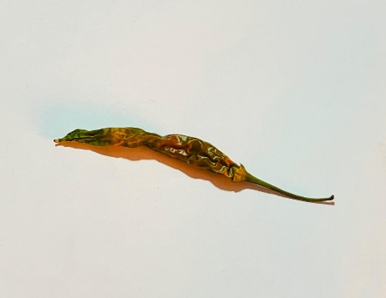
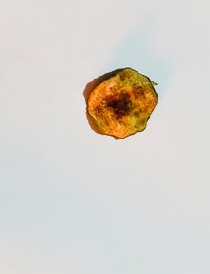
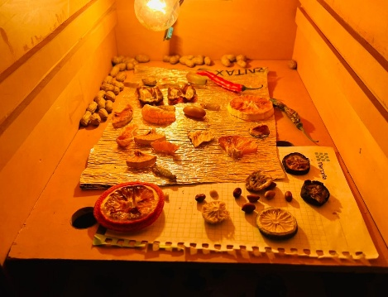
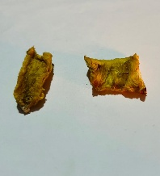

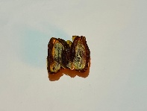

Figure 6.1: Fruits and Vegetables inside the dryer.

6.2 Final Project

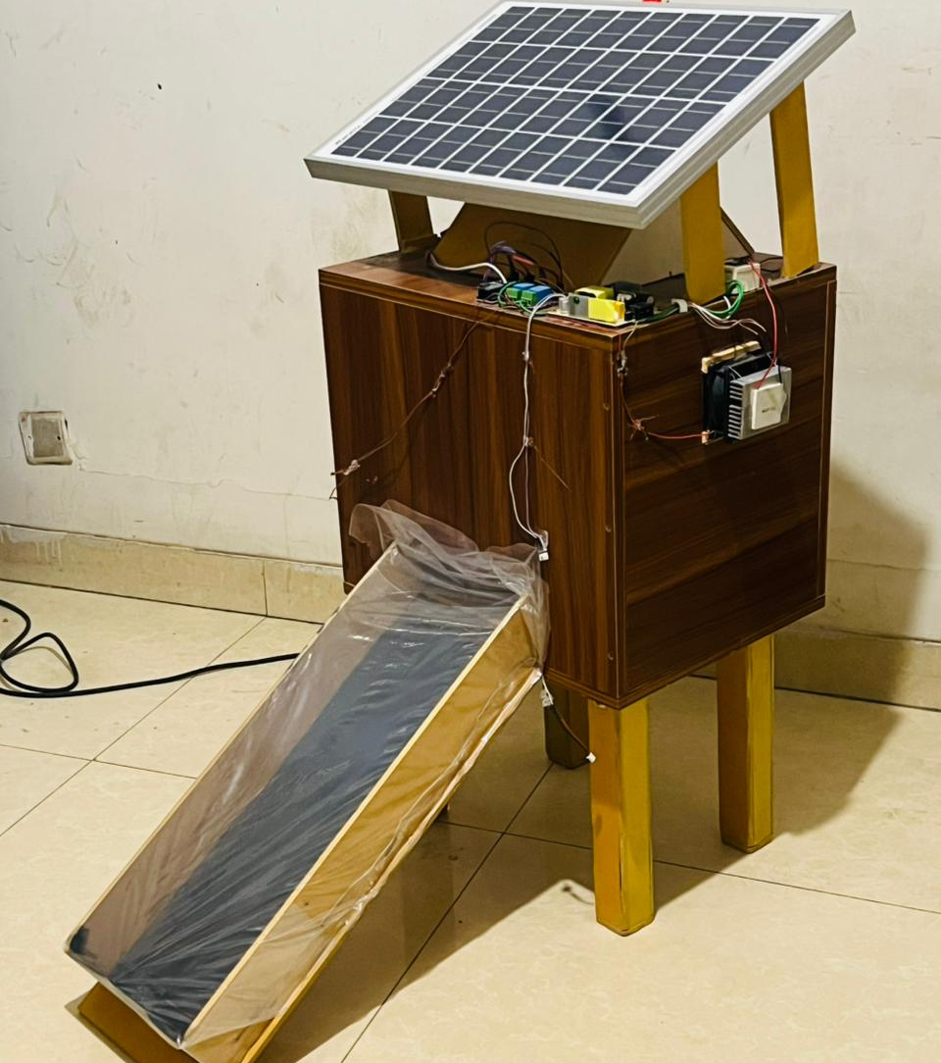

Figure 6.2: Complete Project prototype

6.3 Advantages
There are certainly many advantages of our project and some of the major ones have been given below:
- Maintains controlled temperature and humidity automatically
- Reduces moisture-related spoilage of stored products
- Uses solar energy, making it eco-friendly and cost-effective
- Minimizes manual effort through relay-based automation
- Provides real-time monitoring via LCD display
- Ensures hygienic and safe storage conditions
- Suitable for rural and off-grid applications

6.4 Limitation
It is a demo project so we found some limitation. In future we will work for reduce this kind of limitation. These limitations are -
- Limited storage capacity due to fixed chamber size
- Temperature and humidity range is predefined and not adaptive
- Performance may vary with ambient weather conditions
- Not suitable for large-scale industrial storage

6.5 Application
This project has applications in many fields due its necessity. We have selected a few of them and they are given below:
- Storage of agricultural products such as grains, seeds, and spices
- Preservation of fruits and vegetables after drying
- Seed storage to maintain viability and quality
- Suitable for rural and off-grid storage facilities
- Storage of herbal and medicinal products

6.6 Discussion
The Dry Storage System demonstrates an effective approach to controlling temperature and humidity for the safe storage of moisture-sensitive products. By integrating solar energy with an SMPS-powered control unit, the system ensures reliable operation while minimizing energy consumption. The use of an Arduino Nano enables automatic control of the heater and exhaust fan through relay modules, reducing manual intervention and improving consistency. Experimental results show that the system maintains the desired temperature range of 30–40°C and regulates humidity between 40% and 45%, which helps prevent microbial growth and product spoilage. The LCD display provides real-time monitoring, making the system user-friendly and easy to operate. Although the system is suitable for small-scale applications, its performance may depend on ambient weather conditions. Overall, the project proves to be a cost-effective, eco-friendly, and practical solution for controlled dry storage, especially in rural and off-grid environments.

CHAPTER 7
CONCLUSION

7.1 Conclusion
The Dry Storage System project successfully demonstrates a practical and efficient method for maintaining controlled temperature and humidity conditions for the safe storage of moisture-sensitive products. By integrating solar energy with an SMPS-based power supply, the system ensures energy-efficient and reliable operation. The Arduino Nano plays a key role in automating the control process by continuously monitoring temperature and humidity through sensors and operating the heater bulb and exhaust fan using relay modules. The system effectively maintains the temperature within the range of 30°C to 40°C and controls humidity between 40% and 45%, which significantly reduces the risk of microbial growth and spoilage.

The LCD display provides real-time feedback, making the system user-friendly and easy to monitor. Experimental testing confirmed that all components functioned as expected, and the system responded accurately to environmental changes. This project offers a low-cost, eco-friendly solution suitable for small-scale storage applications, particularly in rural and off-grid areas. Although the system has limitations in terms of storage capacity and weather dependency, it proves to be a reliable and sustainable approach for improving post-harvest storage conditions and reducing product losses.

7.2 Future Scope
In the future, we plan to enhance this project by incorporating additional features to achieve more efficient and desirable results. Some of the improvements we intend to implement are outlined below.
- Expansion to larger storage capacity for commercial use.
- Use of solar battery storage for uninterrupted operation.
- In future, I will try it to apply in real field.
- In future integration with IoT for remote monitoring and control via smartphone apps

REFERENCES

  - Sansaniwal, “Investigation of indirect solar drying of ginger rhizomes (zingiber officinale): a comparative study”, journal of engineering science and technology vol.12, (7), 2017.
  - Halewadimath, “Experimental analysis of solar air dryer for agricultural products.”India International Research Journal of Engineering and Technology (IRJET), Vol.2 (3) 2015.
  - Prakash, “Performance analysis of Solar Drying System for Guntur Chili”. International Journal of Latest Trends in Engineering and Technology. Vol.4 (2),2014.
  - Amedorme, “Design and construction of forced convection indirect solar dryer for drying moringa leaves”, Scholars journal of engineering and technology, vol. 1 (3) pp 91-97, 2013.
  - Om Prakash and Anil Kumar “Historical Review and Recent Trends in Solar Drying Systems”, International Journal of Green Energy, vol.(10), pp 690–738, 2013 Year: 2023, “Solar Crop Dryer with Thermal Energy Storage”, Journal of Renewable Energy Technologies.
  - M. Patil; S. Deshmukh, Year: 2023, “Hybrid SolarBiomass Dryers: A Case Study in Pune”, Energy for Agriculture. Year: 2023, “Overview of Solar Drying Technologies”, Agricultural Engineering Journal.
  - T. Khan, Year: 2022, “Progress in Solar Drying Technologies: A Review”, Sustainable Agriculture. Year: 2022, V. Gupta, “Innovationsin Solar Dryers”, International Journal of Green Energy.
  - B. Ramesh, Year: 2025, “Advanced Analysis of Solar Drying Mechanisms”, CleanTech Reports.
  - S. Janjai and P. Tung, “Performance of a solar dryer using hot air from roof-integrated solar collectors for drying herbs and spices,” Renewable Energy, vol. 30, no. 14, pp. 2085–2095, 2005.
  - M. P. Singh and S. S. Hada, “Design of temperature and humidity controlled storage system using microcontroller,” International Journal of Advanced Research in Electrical, Electronics and Instrumentation Engineering, vol. 3, no. 4, pp. 8732–8738, 2014.
  - S. Janjai and P. Tung, “Performance of a solar dryer using hot air from roof-integrated solar collectors for drying herbs and spices,” Renewable Energy, vol. 30, no. 14, pp. 2085–2095, 2005.
  - P. K. Jain and S. Kapoor, “Design, development and testing of solar dryer for agricultural products,” Energy Conversion and Management, vol. 45, no. 9–10, pp. 1477–1488, 2004.

APPENDIX

Programmed Code:
#include <DHT.h>
#include <LiquidCrystal_I2C.h>

// ================= DHT11 =================
#define DHTPIN 2
#define DHTTYPE DHT11
DHT dht(DHTPIN, DHTTYPE);

// ================= LCD ===================
LiquidCrystal_I2C lcd(0x27, 16, 2);

// ================= Relay Pins ============
const int bulbRelay = 8; // Heater / Bulb
const int fanRelay = 9; // Fan

// ================ Thresholds =============
// Temperature control
const float TEMP_LOW = 30.0;
const float TEMP_HIGH = 40.0;

// Humidity control
const float HUM_LOW = 43.0;
const float HUM_HIGH = 45.0;

// =========================================
void setup() {
pinMode(bulbRelay, OUTPUT);
pinMode(fanRelay, OUTPUT);

// HIGH-trigger relay → HIGH = OFF
digitalWrite(bulbRelay, LOW); // OFF
digitalWrite(fanRelay, LOW); // OFF

Serial.begin(9600);
dht.begin();

lcd.init();
lcd.backlight();

lcd.setCursor(0, 0);
lcd.print("Temp & Humid");
lcd.setCursor(0, 1);
lcd.print("System Ready");
delay(500);
lcd.clear();
}

// =========================================
void loop() {
float temperature = dht.readTemperature();
float humidity = dht.readHumidity();

// ---------- Sensor Error ----------
if (isnan(temperature) || isnan(humidity)) {
lcd.setCursor(0, 0);
lcd.print("Sensor Error ");
lcd.setCursor(0, 1);
lcd.print("Check DHT11 ");
delay(500);
return;
}

// ---------- Debug ----------
Serial.print("Temp: ");
Serial.print(temperature);
Serial.print(" C Hum: ");
Serial.print(humidity);
Serial.println(" %");

// ---------- Temperature Control (Bulb) ----------
if (temperature < TEMP_LOW) {
digitalWrite(bulbRelay, HIGH); // Bulb ON
}
else if (temperature > TEMP_HIGH) {
digitalWrite(bulbRelay, LOW); // Bulb OFF
}

// ---------- Humidity Control (Fan) ----------
if (humidity > HUM_HIGH) {
digitalWrite(fanRelay, HIGH); // Fan ON
}
else if (humidity < HUM_LOW) {
digitalWrite(fanRelay, LOW); // Fan OFF
}

// ---------- LCD Display ----------
lcd.setCursor(0, 0);
lcd.print("Tem:");
lcd.print(temperature, 1);
lcd.print((char)223);
lcd.print("C ");

lcd.setCursor(0, 1);
lcd.print("Hum:");
lcd.print(humidity, 1);
lcd.print("% ");

delay(500);
}

