SOLAR-POWERED AUTOMATED SPRINKLER IRRIGATION SYSTEM

ABSTRACT
Manual irrigation practices in agriculture often result in inconsistent watering, excessive water consumption, and increased labor, particularly in areas with limited access to reliable electricity. This study aimed to design, develop, and evaluate a Solar-Powered Automated Sprinkler Irrigation System with automated watering, remote monitoring, and web-based control features for agricultural applications. The study utilized the Software Development Life Cycle (SDLC) using the Waterfall Model as the research and development approach. The system was developed using a solar panel, ESP32 microcontroller, relay-controlled water pump, sprinkler mechanism, and a web-based interface for irrigation scheduling and system monitoring. The developed system was evaluated in terms of functionality, usability, and reliability through system testing and user assessment using a Five-Point Likert Scale. Results revealed that the system effectively automated irrigation processes, maintained consistent water distribution, reduced manual labor, and minimized water wastage. The web-based interface allowed users to conveniently monitor and control irrigation schedules remotely, improving accessibility and operational efficiency. Respondents also expressed satisfaction with the system’s performance, ease of use, and reliability in managing irrigation activities. The findings demonstrated that integrating solar energy and automation technologies into irrigation systems can improve water management, promote energy efficiency, and support sustainable agricultural practices. The developed Solar-Powered Automated Sprinkler Irrigation System proved to be a practical, cost-efficient, and environmentally sustainable solution for small- to medium-scale agricultural applications.

Keywords: Solar-Powered Irrigation, Automated Sprinkler System, Sustainable Agriculture, Web-based Control, Sustainable Farming

INTRODUCTION
Technology nowadays has become an essential part of everyday life. With the use of technology, most work is done quicker and easier, especially in agriculture. In recent years, farming practices have changed significantly because of modern innovations and the continuous increase in population. The growing need to increase food production while ensuring sustainable farming practices has led to technological innovations in agriculture. This transition from traditional farming techniques to more technology-based and automated systems has transformed approaches to crop management, resource use, and environmental protection (Montalvo-Romero et al., 2023).
In the Philippines, the population in 2024 was 112,727,776, a 3.39% increase from 2020 which was 109,033,245, and an 11.63% increase from 2015 which was 100,979,303. These data are based on official census data (Philippine Statistics Authority, 2025). Additionally, Teng (2024) highlighted how the growing urban population presents significant challenges to food production and how agricultural practices must be improved to fulfill the increasing demand for agricultural products. With the continuous increase in population and food demand, improving crop productivity and plant growth efficiency has become increasingly important to sustain agricultural production and ensure food security.
As technology advances quickly, it becomes more crucial to consider sustainable power sources and energy-efficient solutions to support the expanding use of technology. Technologies such as the Internet of Things (IoT) and artificial intelligence consume large amounts of energy, which may place pressure on existing power systems. At the same time, the rising cost of energy affects the profitability of agricultural production, encouraging farmers to search for affordable and renewable alternatives. Many studies today focus on applying solar energy in agriculture because it helps reduce operational costs and can either operate independently or connect to the electrical grid. Zhang et al. (2015) explained that solar energy can effectively provide power for greenhouse operations.
With the increasing demand for agricultural products due to population growth and the continuous advancement of technology worldwide, adopting advanced irrigation systems has become more important than ever. Efficient irrigation methods help conserve water, improve crop growth, increase productivity, and ensure better resource management.
In agricultural studies, particularly in agricultural schools like Mindanao State University Sultan Naga Dimaporo (MSU-SND), using water wisely is important and crucial, especially in areas where water resources are limited, specifically in the greenhouse area of the College of Agriculture. Traditional watering methods practiced in the school, such as manual watering, often result in water wastage and inconsistent irrigation due to water shortages, especially during drought seasons where water must be carefully managed.
To lessen the challenges in watering methods, this research focuses on developing a Solar-Powered Automated Sprinkler Irrigation System designed to help farmers and agriculture students at Mindanao State University Sultan Naga Dimaporo use water more efficiently while promoting environmental sustainability. The system uses solar panels to capture energy from the sun, which powers the entire irrigation process. This allows the system to operate without relying on conventional electricity, making it a practical solution for remote agricultural areas where access to power may be limited. In addition, the system integrates a web-based platform that enables users to remotely monitor and control watering schedules for continuous and convenient irrigation management. Furthermore, the developed Solar-Powered Automated Sprinkler Irrigation System supports the United Nations Sustainable Development Goals (SDGs), particularly SDG 2: Zero Hunger, by helping improve agricultural productivity and irrigation efficiency; SDG 7: Affordable and Clean Energy, through the utilization of solar energy as the system’s primary power source; and SDG 12: Responsible Consumption and Production, by promoting efficient water utilization and sustainable irrigation management practices.
The study was limited to the development, testing, and evaluation of the system for small- to medium-scale greenhouse applications. The system utilized a sprinkler-based irrigation setup supplied by a manually refilled water drum and covered plant watering activities from the germination stage up to the transplanting stage of seedlings. The developed system focused only on automated scheduling and remote web-based irrigation control through an internet connection provided by a dedicated router. However, the study did not include weather monitoring, sensor integration, long-term plant growth monitoring beyond transplanting, system security after deployment, long-term maintenance evaluation, or future economic impacts beyond the initial implementation of the system.

Statement of the Problem
Agricultural areas often experience challenges in maintaining proper and consistent irrigation due to limited water availability, unstable power supply, and the increasing demand for efficient farming practices. These conditions may result in irregular watering, water wastage, and poor plant growth, making irrigation management more difficult and less efficient. In addition, manual watering methods require continuous labor, monitoring, and time, which can become challenging in environments with limited manpower and busy schedules. The lack of a reliable and sustainable irrigation system further affects the ability to provide timely and efficient watering operations. Therefore, there is a need to develop an automated and sustainable irrigation system that can improve watering efficiency, reduce manual labor, conserve resources, and provide convenient irrigation management through modern technology.

Objectives of the Study
To address the existing challenges in greenhouse irrigation, a Solar-Powered Automated Sprinkler Irrigation System was designed and developed to provide efficient, sustainable, and reliable watering operations for agricultural applications. The system was created to automatically distribute water to plants through a sprinkler irrigation setup, minimizing manual labor and ensuring consistent irrigation management. A web-based platform was integrated into the system to enable users to remotely monitor, schedule, and manually control watering activities through internet-connected devices. Solar energy was utilized as the primary power source to support sustainable agricultural practices and reduce dependence on conventional electricity. Furthermore, the developed system was evaluated in terms of perceived usefulness, ease of use, web interface effectiveness, learning, and system capabilities to determine its functionality, reliability, usability, and overall operational performance

Conceptual Framework
The Input–Process–Output (IPO) model illustrates the overall operation of the Solar-Powered Automated Sprinkler Irrigation System. The input stage consists of the necessary resources, including solar energy components, hardware devices such as the ESP32 microcontroller, relay, water pump, sprinkler system, and the web-based platform, along with user-defined irrigation schedules, manual commands, and internet connectivity. These inputs serve as the foundation for system functionality and control.
The process stage involves the conversion of solar energy into usable power, followed by system initialization and integration with the web-based interface. The ESP32 microcontroller processes user inputs and automates irrigation by controlling the relay and water pump. The system executes scheduled watering, distributes water through the sprinkler system, and continuously monitors and records irrigation activities, providing real-time feedback to users.
The output stage represents the results of the system’s operation, which include automated and consistent irrigation, reduced manual labor, efficient water usage, and real-time monitoring and control. Additionally, the system promotes sustainable agricultural practices through the use of solar energy while improving irrigation management and overall plant growth. The system’s effectiveness is further validated through user evaluation based on usability, functionality, and performance.

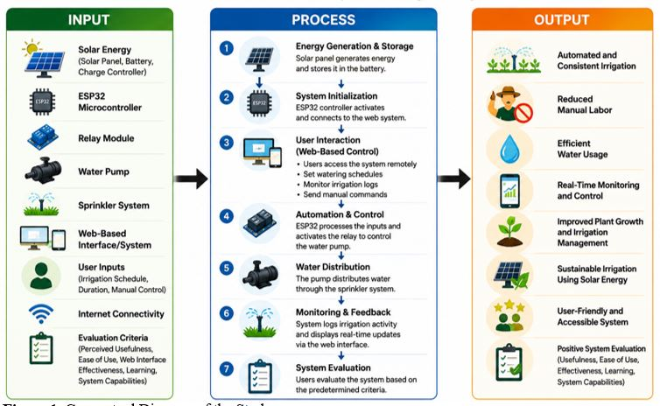

Figure 1. Conceptual Diagram of the Study

METHODOLOGY
The study employed the Software Development Life Cycle (SDLC) using the Waterfall Model in the development of the Solar-Powered Automated Sprinkler Irrigation System. The Waterfall Model provided a structured and sequential approach consisting of requirement analysis, system design, development, testing, implementation, and evaluation to ensure the proper integration and functionality of both hardware and software components.
The system utilized several hardware components, including the ESP32 microcontroller, 12V 50-Watt solar panel, 12V 5Ah battery, solar charge controller, 5V relay module, 12V DC water pump, and Wi-Fi router. The ESP32 functioned as the main controller responsible for processing commands, automating irrigation operations, and managing wireless communication. The solar panel supplied renewable energy to the system, while the battery stored electrical power for continuous operation. The solar charge controller regulated voltage and protected the battery from overcharging. Meanwhile, the relay module controlled the switching mechanism of the water pump, which distributed water through the sprinkler irrigation setup. The Wi-Fi router enabled remote monitoring and control through a web-based platform.
For software development, the study used the C++ programming language through the Arduino IDE to program the ESP32 microcontroller. The software enabled automated irrigation scheduling, pump activation and deactivation, Wi-Fi connectivity, and real-time data transmission. In addition, the system design was represented using the Data Flow Diagram (DFD), Use Case Diagram, Sequence Diagram, and System Architectural Diagram to illustrate data processing, user interactions, system workflow, and the overall structure of the proposed system. These tools served as the basis for developing an efficient, sustainable, and web-based automated irrigation system.

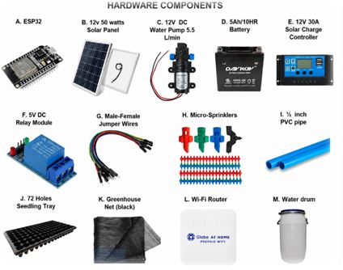

Figure 2. Hardware Components of Solar-Powered Automated Sprinkler Irrigation System
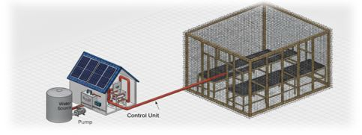

Figure 3. Conceptual System Design of the Solar-Powered Automated Irrigation System

System Design
The system design serves as the foundation of the proposed Solar-Powered Automated Irrigation System, presenting the overall structure and organization of the system components to ensure efficient, reliable, and automated irrigation operations.

Use Case Diagram
Figure 4 presents the Use Case Diagram of the Solar-Powered Automated Sprinkler Irrigation System, illustrating the interaction between the user and the system through a web-based interface. The main actor, the user, can perform key use cases such as secure login, manual pump control (ON/OFF), irrigation scheduling by setting the date, time, and duration, and viewing pump logs for monitoring watering activities. Overall, the diagram provides a clear overview of the system’s core functionalities and user interactions.

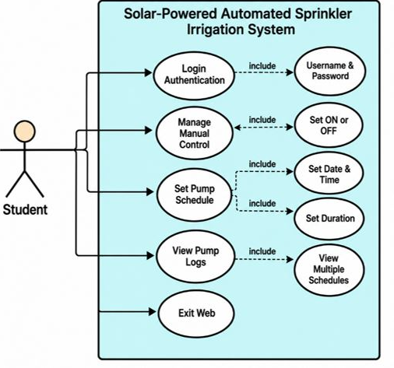

Figure 4. Use Case Diagram of Solar-Powered Automated Sprinkler Irrigation System

Sequence Diagram
This sequence diagram illustrates the interaction flow of the Water Pump Monitoring and Control System using an ESP32 microcontroller. The process begins when the user logs into the web interface using valid credentials. The web interface forwards the login request to the server for authentication. Once authenticated, the user sends a pump ON/OFF command through the interface. The server then transmits the command to the ESP32, which activates or deactivates the relay module responsible for controlling the water pump. After execution, the relay module and pump send status feedback to the ESP32, confirming the operation. The ESP32 forwards the completion status to the server, which records the system activity and pump status in the database. Finally, the updated pump status is displayed to the user through the web interface, ensuring real-time monitoring and control of the system.

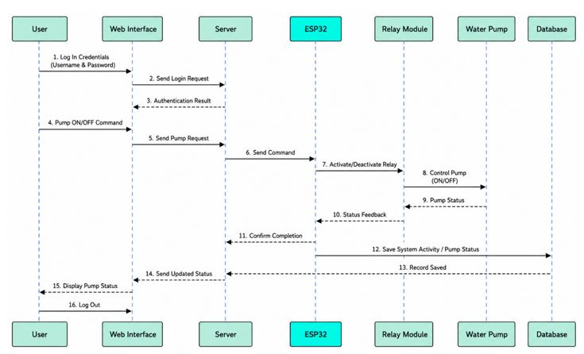

Figure 4. Sequence Diagram of Solar-Powered Automated Sprinkler Irrigation System

System Architectural Diagram
The System Architectural Diagram presents the overall structure and interaction of the hardware and software components within the Solar-Powered Automated Sprinkler Irrigation System. It illustrates how the solar panel, battery, charge controller, ESP32 module, relay module, water pump, web interface, and internet connectivity work together to support automated irrigation, remote monitoring, and efficient system operation.

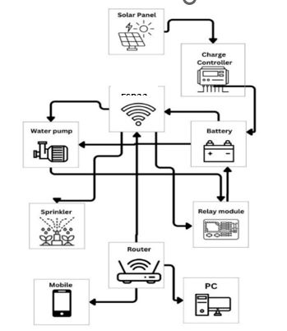

Figure 5. System Architectural Diagram of Solar-Powered Automated Sprinkler Irrigation System

Data Flow Diagram
The Data Flow Diagram (DFD) clearly illustrates the operation of the Solar-Powered Automated Sprinkler Irrigation System, showing how data, control signals, and feedback move throughout the system. It provides a structured view of the irrigation process, from user input to sprinkler activation and monitoring.
In the Level 0 Context Diagram, the system is represented as a single process interacting with the Student/User. The user sends irrigation schedules and pump control commands, while the system returns pump status updates and irrigation reports/logs. This highlights the system’s core function of automating irrigation while maintaining user control and monitoring.
The Level 1 DFD further breaks the system into three key processes: Manage User Inputs, Process and Control Irrigation, and Operate Sprinkler System. These processes validate user commands, generate irrigation control signals, activate or deactivate the pump, and store operational data in Pump Logs (D1) and Pump Status Records (D2). The inclusion of data stores strengthens monitoring, accountability, and maintenance by keeping accurate activity and status records.

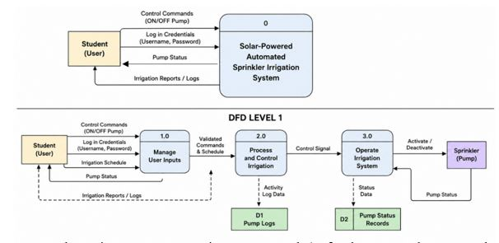

Figure 6. Data Flow Diagram (Context Diagram & Level 1) of Solar-Powered Automated Sprinkler Irrigation System

Testing Method
The testing methods included Blackbox Testing to verify system functionality and output accuracy, Stress Testing to determine the system’s stability and performance under varying conditions, and Usability Testing to evaluate user-friendliness and operational efficiency. These testing procedures ensured that the system was capable of performing effectively in actual field conditions.

Population and Sample of the Study
The study employed simple random sampling to select participants based on the following inclusion criteria: (1) currently enrolled in the Bachelor of Science in Agriculture program majoring in Agronomy, (2) officially registered during the conduct of the study, and (3) willing to participate in the research. The study population consisted of 121 Agronomy students.
To determine the appropriate sample size, the researchers applied Taro Yamane’s formula with a 5% margin of error, resulting in 93 respondents. From the qualified participants, respondents were selected using a technology-based number randomizer to ensure fairness in the selection process and to minimize selection bias. This procedure enhanced the representativeness of the sample and strengthened the validity and reliability of the study findings.
Instrument Use
The researchers utilized a structured questionnaire as the primary data-gathering instrument to obtain the information necessary to address the objectives of the study. The questionnaire consisted of a combination of Likert-scale items and checklist questions and was divided into two (2) major parts.
Part I assessed the perceived usefulness of the system using an adapted version of the Perceived Usefulness and Ease of Use (PUEU) Questionnaire developed by Davis (1989). Part II measured user interface satisfaction using the adapted Questionnaire for User Interface Satisfaction (QUIS) developed by Chin, Diehl, and Norman (1988).
The questionnaire was administered to respondents who directly interacted with the Solar-Powered Automated Sprinkler Irrigation System, enabling them to provide evaluations based on actual user experience. The data gathered were used to assess the system’s effectiveness, usability, functionality, and overall user satisfaction. For data analysis, the weighted mean was employed to compute and summarize the participants’ responses for each indicator. This facilitated the interpretation of the collected Likert-scale data in determining the overall assessment of the system.

RESULTS AND DISCUSSION
Figure 7 shows the log in form of the system where the system input login credentials before interacting with the main dashboard. Figure 8 shows the main web-based interface of the Solar-Powered Automated Sprinkler Irrigation System. The system serves as the main control panel where users can monitor, schedule, and manually operate the irrigation process in real time through a connected device such as a laptop or mobile phone.
At the top of the interface is the title “Water Pump Scheduler,” which identifies the system as an automated irrigation control platform. The dashboard is designed with a user-friendly layout to allow easy navigation and operation. On the left side of the dashboard is the Current Time section, which displays the real-time date and time of the system. This feature helps ensure that all scheduled irrigation activities are synchronized accurately. Below it is the Set Device Time section, where users can manually configure or update the system’s date and time settings whenever needed. At the center of the dashboard is the Manual Control section. This allows users to directly operate the water pump without waiting for the scheduled time. The system includes two buttons: Turn Pump On and Turn Pump Off. The displayed status indicator informs the user whether the pump is currently active or inactive. This feature is useful during emergency watering or maintenance operations. On the right side is the Create New Schedule section. In this area, users can set a specific date and time for irrigation and define the watering duration in seconds. Once the schedule is created, the system automatically activates the water pump at the assigned time. This automation reduces the need for constant manual monitoring and helps maintain consistent watering for plants. The lower part of the dashboard contains the Schedule History table. This section records all completed and manually activated irrigation schedules, including the schedule ID, date and time, watering duration, and system status. It also provides a delete option for removing unnecessary records. This feature helps users track previous irrigation activities and monitor system performance. Through the integration of web-based monitoring and manual control features, the system improves convenience, reduces labor, and supports effective plant watering management.
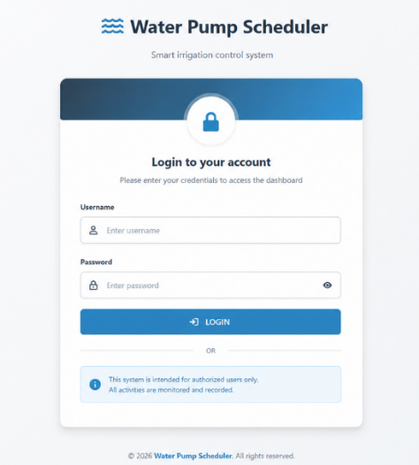

Figure 7. Login Form of Solar-Powered Automated Sprinkler Irrigation System
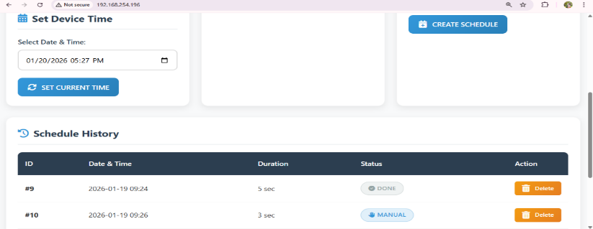
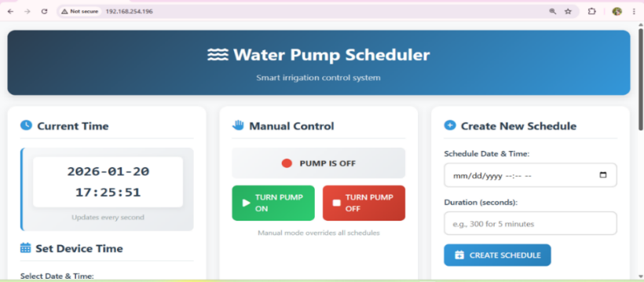

Figure 8. Main Web Page of Solar-Powered Automated Sprinkler Irrigation System

Figure 9 presents the overall evaluation results of the Solar-Powered Automated Sprinkler Irrigation System based on six evaluation criteria: Perceived Usefulness, Ease of Use, Web Interface, Terminology and System Information, Learning, and System Capabilities. The graph indicates that all criteria obtained high average weighted means ranging from 4.71 to 4.81, all verbally interpreted as “Strongly Agree.” These findings suggest that the respondents positively evaluated the system in terms of usability, functionality, efficiency, and overall user satisfaction. Among the evaluated criteria, “Learning” obtained the highest average weighted mean of 4.81. This result implies that respondents found the system easy to learn and operate, particularly in setting irrigation schedules and controlling the system through the web interface where respondents strongly agreed that the system’s features and controls were understandable and manageable even for first-time users. Both “Perceived Usefulness” and “System Capabilities” obtained an average weighted mean of 4.80 respondents strongly agreed that the system improved irrigation management, enhanced watering efficiency, minimized manual labor, and provided reliable watering operations according to the programmed schedule. These findings indicate that the developed system effectively supports irrigation activities while maintaining consistent operational performance. The “Web Interface” category obtained an average weighted mean of 4.78, indicating that respondents positively perceived the clarity, readability, and accessibility of the system interface where users strongly agreed that the interface was easy to understand and that the displayed information was readable and visually accessible. Meanwhile, the “Ease of Use” criterion recorded an average weighted mean of 4.76, suggesting that respondents experienced minimal difficulty in navigating and operating the system. On the other hand, “Terminology and System Information” obtained the lowest average weighted mean of 4.71. Despite being the lowest among the categories, it was still interpreted as “Strongly Agree,” indicating that respondents generally found the terminologies, instructions, and system messages clear, understandable, and appropriately presented.
Overall, the graph demonstrates that the Solar-Powered Automated Sprinkler Irrigation System achieved a high level of user acceptance across all evaluation criteria. The consistently high ratings confirm that the developed system is functional, user-friendly, reliable, and effective in supporting automated irrigation management for agricultural applications.

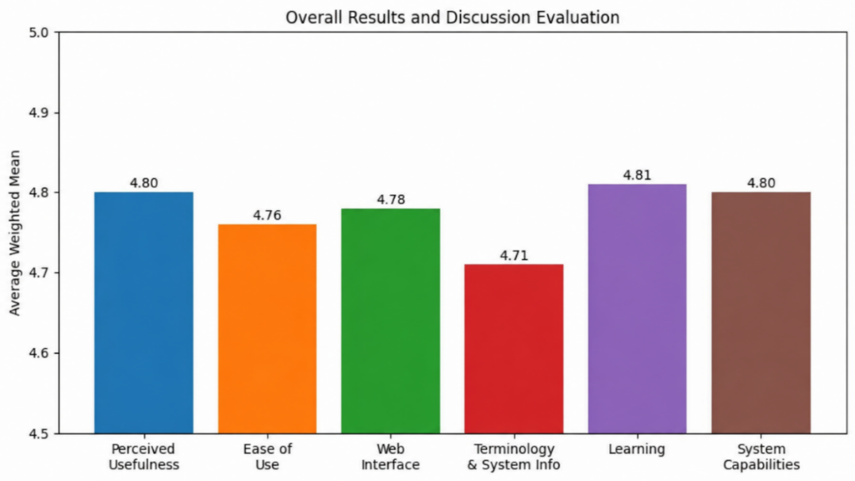

Figure 9. Overall Evaluation Result of the Solar-Powered Automated Sprinkler Irrigation System

Figure 10 shows the successful germination and early growth of cabbage seedlings cultivated using the Solar-Powered Automated Sprinkler Irrigation System. Based on visual observation of the seedling trays, the setup achieved a germination and survival rate of approximately 80%–90%, as most of the tray cells contain healthy and actively growing seedlings. The seedlings appear green, upright, and evenly distributed across the trays, indicating that the irrigation system consistently provided adequate moisture needed during the germination and early growth stages. The use of the protective plastic covering also helped maintain proper humidity and temperature conditions, which are essential factors for improving seed emergence and seedling survival.
The observed growth rate signifies that the developed irrigation system was effective in supporting healthy plant development and maintaining favorable growing conditions. The high percentage of germinated seedlings indicates that the automated sprinkler system successfully prevented water stress by delivering sufficient and timely irrigation. At the same time, the seedlings did not show visible signs of excessive watering, wilting, or severe nutrient deficiency, suggesting that the irrigation process was balanced and efficient. This demonstrates that the system can enhance seedling establishment while reducing the risks associated with manual watering practices.
Furthermore, the 80%–90% germination and survival rate reflects the reliability and efficiency of the Solar-Powered Automated Sprinkler Irrigation System in nursery crop production. Such a high survival percentage suggests that the integration of solar energy and automated irrigation technology can contribute to sustainable and resource-efficient agricultural practices. The vigorous and uniform growth of the cabbage seedlings also indicates the potential of the system to improve crop productivity, conserve water, minimize labor requirements, and support greenhouse or nursery operations, especially in areas with limited or unstable electricity supply.
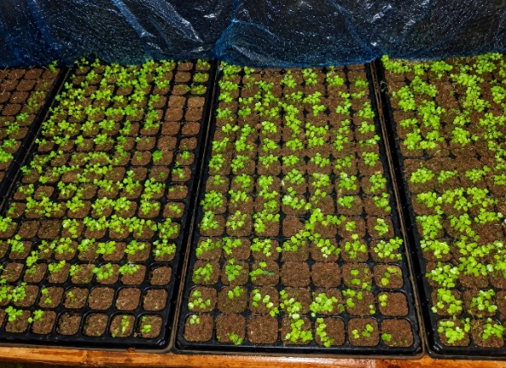
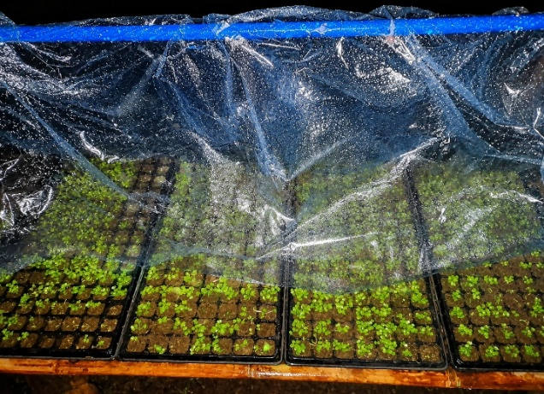

Figure 10. Cabbage Seedlings During Germination and Early Growth Stage Using the Solar-Powered Automated Sprinkler Irrigation System
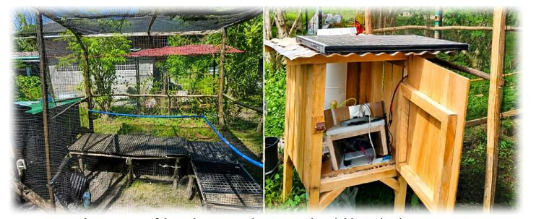

Figure 10. Hardware Setup of the Solar-Powered Automated Sprinkler Irrigation System

Comparative Analysis
Table 1 presents a comparative analysis of existing smart irrigation systems developed by Jariyayothin et al. (2018), Nor Adni et al. (2019), Kannan & Anandi (2020), and Lopez et al. (2024), alongside the developed SPASIS (Solar Powered Automated Sprinkler Irrigation System). It highlights differences in system type, power source, microcontroller, user interface, control type, automation method, sensors used, and system complexity, showing how SPASIS provides a more simplified and practical solution.
In terms of system type, earlier studies primarily utilize IoT-based or sensor-driven irrigation systems that depend on continuous monitoring and internet connectivity, while Lopez et al. (2024) introduces solar-based watering systems as an improvement. SPASIS further enhances this by using a solar automated sprinkler system that reduces dependence on complex IoT frameworks and constant connectivity, making it more practical for real-world agricultural use. For the power source, most earlier systems rely on electricity, which limits deployment in remote areas, whereas SPASIS, like Lopez et al. (2024), uses a solar and battery system, making it more sustainable and independent from the electrical grid. Regarding the microcontroller, previous studies commonly use Arduino-based platforms such as Arduino UNO and Arduino Mega. These boards do not have built-in Wi-Fi connectivity and therefore require additional modules (such as ESP8266 or other IoT components) to enable online monitoring and control. In contrast, SPASIS uses ESP32, which already has built-in Wi-Fi and Bluetooth capabilities, allowing direct internet connectivity without additional hardware. This makes the system more efficient, compact, and easier to deploy for web-based monitoring. For the user interface, earlier systems rely on mobile applications or LCD displays, while SPASIS uses a web dashboard, which is more flexible and accessible across different devices without requiring installation. In terms of control type and automation, most previous systems combine manual and automatic control or rely heavily on sensor-based automation. SPASIS, however, uses manual and scheduled time-based control, reducing dependency on sensors and minimizing possible errors caused by sensor malfunction or calibration issues.
Furthermore, earlier studies use multiple sensors such as soil moisture, temperature, and environmental sensors, while SPASIS eliminates sensor dependency entirely. This significantly reduces cost, maintenance requirements, and system complexity. Lastly, in terms of system complexity, previous systems range from medium to high complexity due to IoT integration and multiple sensors, while SPASIS is designed as a low-complexity system that is easier to install, operate, and maintain.
Overall, the table shows that SPASIS offers a more practical, cost-effective, energy-efficient, and user-friendly solution compared to existing systems, making it highly suitable for real-world agricultural applications, especially in areas with limited resources and technical infrastructure.

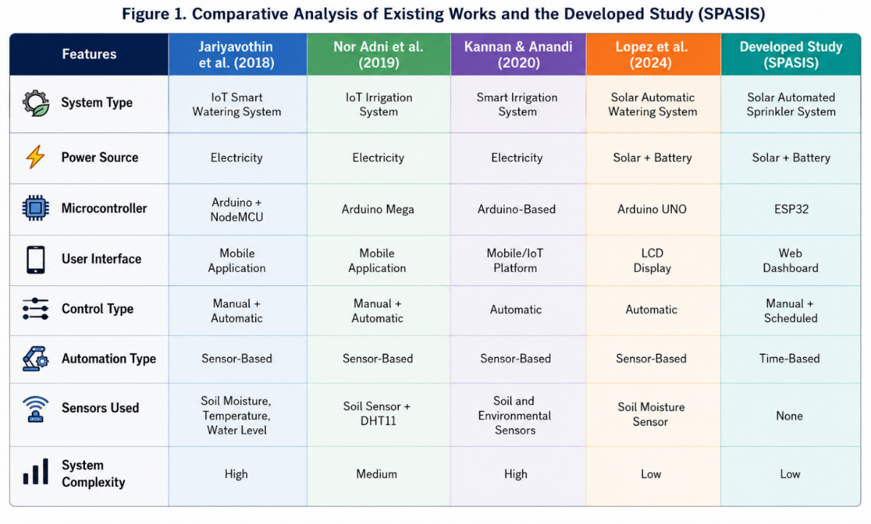
Table 1. Comparative Analysis

CONCLUSIONS AND RECOMMENDATIONS
The study successfully developed and implemented a Solar-Powered Automated Sprinkler Irrigation System that provides an efficient, sustainable, and technology-driven solution for modern irrigation management. By integrating solar energy, automated sprinkler irrigation, and web-based remote control, the system effectively addressed the common challenges associated with manual watering practices, including inconsistent irrigation, time-consuming labor, and dependence on conventional electricity. The developed system demonstrated reliable performance in automating watering operations, improving irrigation efficiency, minimizing water wastage, and providing convenient access through internet-based control and monitoring. Evaluation results further revealed that the system was highly accepted by the respondents in terms of perceived usefulness, ease of use, web interface effectiveness, learning, and system capabilities, indicating that the system is functional, reliable, and user-friendly. The findings of the study highlight the potential of integrating renewable energy and automation technologies in supporting sustainable agricultural practices and improving irrigation management.
Based on the findings of the study, future improvements may focus on integrating advanced monitoring and automation features to further enhance the efficiency and functionality of the system. Additional developments in system accessibility, scalability, and long-term operational performance may also strengthen its application in larger agricultural environments. Continuous testing, maintenance, and system enhancement are highly recommended to ensure reliability, sustainability, and adaptability to the evolving needs of modern agriculture.

REFERENCES

Aydogdu, M. H., Karli, B., & Aydogdu, M. (2015). Evaluation of attitudes of stakeholders for irrigation water management: A case study of Harran Plain, Turkey. Journal of Environmental and Agricultural Sciences47https://www.researchgate.net/publication/282655306_Evaluation_of_attitudes_of_stakeholders_for_irrigation_water_management_A_case_study_of_Harran_Plain_Turkey

Angel, Y., Sreekar, S., Prakash, A. M., Nagarajan, P., Karuppasamy, R. B., Akash, D., & Ajay, K. (2025). Smart solar-powered IoT-based automatic irrigation system with integrated rainwater harvesting. Annual

Research & Review in Biology, 40(6), 32–41. https://doi.org/10.9734/arrb/2025/v40i62251 (Annual Research & Review in Biology)

Arrang, H., Wee, S. Y., Bahaman, N. B., & Rusdi, J. F. (2025). Perceived usefulness and perceived ease of use as predictors of attitude toward IoT adoption among rice farmers. International Journal of Advanced Computer Science & Applications, 16(9), 362. https://doi.org/10.14569/ijacsa.2025.0160935

Armaroli, N., & Balzani, V. (2011). Energy for a sustainable world: From the oil age to a sun-powered future. Wiley-VCH. https://www.wiley-vch.de/en/areas-interest/natural-sciences/chemistry-11ch/general-introductory-chemistry-11ch0/energy-for-a-sustainable-world-978-3-527-32540-5 (Wiley-VCH)
Binayao, R. P., Mantua, P. V. L., Namocatcat, H. R. M. P., Seroy, J. K. K. B., Sudaria, P. R. A. B., Gumonan, K. M. V. C., & Orozco, S. M. M. (2024). Smart water irrigation for rice farming through the Internet of Things. International Journal of Computing Sciences Research, 8, 2550–2563. https://doi.org/10.25147/ijcsr.2017.001.1.172

Hebei Marshine New Material Technology Co., Ltd. (2024, June 25). Benefits of seedling trays. https://www.plantingtrays.com/resources/benefits-of-seedling-trays

Hopmann, C., Schmitz, T., & Weber, M. (2013). The impact of renewable energy on agricultural production. Renewable Energy, 57, 1–9. https://doi.org/10.1016/j.renene.2013.01.023

Jacoba, F. P. (2024). [Article on automatic garden sprinkler systems]. International Journal of Advanced and Applied Sciences, 11(8), 187–197. https://doi.org/10.1453/ijaas.v11i8

Jariyayothin, P., Jeravong-Aram, K., Ratanachaijaroen, N., Tantidham, T., & Intakot, P. (2018). IoT backyard: Smart watering control system. Internet of Things (IoT), 4, 1–6. https://doi.org/10.1109/ict-ispc.2018.8523856

Kannan, N., & Anandhi, A. (2020). Water management for sustainable food production. Water, 12(3), 778. https://doi.org/10.3390/w12030778

Leh, N. a. M., Kamaldin, M. S. a. M., Muhammad, Z., & Kamarzaman, N. A. (2019). Smart irrigation system using internet of things. IEEE Internet of Things Journal. https://doi.org/10.1109/icsengt.2019.8906497

Layek, U. (Ed.). (2024). Sustainable agriculture: Tools, technologies and transformations. https://www.researchgate.net/publication/399409139

Lopes Sobrinho, O. P., Silva dos Santos, L. N., Vitorino, L. C., Teixeira, M. B., Soares, F. A. L., Reis, M. N. O., … Matsura, E. E. (2024). Soil chemical characteristics, yield and technological quality of sugarcane under subsurface drip irrigation with treated sewage effluent. Archives of Agronomy and Soil Science, 70(1), 1–22. https://doi.org/10.1080/03650340.2024.2395556

Lopez, A. K. M. D., Balleza, E. R. A., Viaña, P. K. V., Gonzales, M. a. M., Diwa, S. M. C., & Limos-Galay, J. A. (2024). Solar-powered automatic plant watering system with moisture sensor using Arduino Uno. International Journal of Research Studies in Educational Technology, 8(3), 8027. https://doi.org/10.5861/ijrset.2024.8027

Montalvo-Romero, N., Montiel-Rosales, A., Purroy-Vásquez, R., & Quechulpa-Pérez, P. (2023). Agro-technological systems in traditional agriculture assistance: A systematic review. IEEE Access, 11, 123047–1230XX. https://doi.org/10.1109/ACCESS.2023.3329087

Nikolaou, G., Neocleous, D., Christou, A., Kitta, E., & Katsoulas, N. (2020). Implementing sustainable irrigation in water-scarce regions under the impact of climate change. Agronomy, 10(8), 1120. https://doi.org/10.3390/agronomy10081120

Nor Adni Mat Leh, M. S. A. Mohd Kamaldin, Zuraida Muhammad, & Nur Atharah Kamarzaman. (2019). Smart irrigation system using Internet of Things. In 2019 IEEE 9th International Conference on System Engineering and Technology (ICSET). IEEE. https://doi.org/10.1109/ICSEngT.2019.8906497

Pereira, L. S., Oweis, T., & Zairi, A. (2018). Irrigation management under water scarcity. Agricultural Water Management, 68(1), 99–115. https://doi.org/10.1016/j.agwat.2018.01.001.

Philippine Statistics Authority. (2025, July 17). 2024 Census of Population (POPCEN): Population counts declared official by the President. https://psa.gov.ph/statistics/population-and-housing

Raj, M., & Prahadeeswaran, M. (2025). Revolutionizing agriculture: A review of smart farming technologies for a sustainable future. Discover Applied Sciences, 7, 937. https://doi.org/10.1007/s42452-025-07561-6

Ritchie, D. M. (1972). The development of the C programming language. Bell Labs. https://www.bell-labs.com/usr/dmr/www/chist.html

Sakib, S. M. N. (2021). A research on stress testing approach towards evaluating credit risk of a financial institution. https://doi.org/10.20944/preprints202110.0119.v1

Shah, K., Pawar, S., Prajapati, G., Upadhyay, S., & Hegde, G. (2019, March). Proposed automated plant watering system using IoT. In Proceedings of the 2019 Conference on Technologies for Future Cities (CTFC). https://doi.org/10.1109/CTFC.2019.00013

Teng, P. (2024). Urban agriculture and food security in development planning. Asian Journal of Agriculture and Development, 21(AJAD 20th anniversary issue), 61–76. https://doi.org/10.22004/ag.econ.348351

Venkatesh, V., Morris, M. G., Davis, G. B., & Davis, F. D. (2003). User acceptance of information technology: Toward a unified view. MIS Quarterly, 27(3), 425–478. https://doi.org/10.2307/30036540

Yildirim, M., Yücel, M., & Kiliçarslan, Y. (2018). Automatic solar powered irrigation system in greenhouse. SDÜ Ziraat Fakültesi Dergisi, 259–264. https://avesis.comu.edu.tr/yayin/fd91cbc3-9420-451c-a4b3-388a079d28c4/automatic-solar-powered-irrigation-system-in-greenhouse

Zhang, Q., Li, H., & Wang, S. (2015). The use of solar energy in greenhouses: Current status and future trends. Renewable and Sustainable Energy Reviews, 50, 694–705. https://doi.org/10.1016/j.rser.2015.05.012

Zulfiqar, A. (2024). Hands-on ESP32 with Arduino IDE: Unleash the power of IoT with ESP32 and build exciting projects with this practical guide. Packt Publishing. https://www.packtpub.com/en-us/product/hands-on-esp32-with-arduino-ide-9781837638031

