DEEP LEARNING BASED CREDIT CARD FRAUD DETECTION IN ELECTRONIC PAYMENT PLATFORMS
¹Udeh Chukwuma Callistus, ²Chukwujekwu John Okafor, ³Ibeonu Ogochukwu C.
^{1,}Department of computer science, Faculty of Applied and Natural Science, Enugu State, University of Science and Technology, Agbani, Nigeria
² Department of Electrical Electronics Engineering, Enugu State University of Science and Technology, Enugu, Nigeria
³Department of Computer Science; Chukwuemeka Odumegwu Ojukwu University,
Uli, Anambara State, Nigeria
Email: ¹chukwuma.udeh@esut.edu.ng, ¹ogoodichik@gmail.com, c4okafor4@gmail.com
Abstract
The rapid transformation of payment system using digital platform has offered several advantages like seamless transactions, convenient, and easy to use, however it is also triggered massive digital fraud through credit card. This credit card fraud is an online crime where cyber criminals used unauthorized credit card to carryout financial transaction. To solve this problem, the aim of this paper is deep leaning based credit card fraud detection in electronic payment platforms. This was achieved with using the data of European credit card users with a sample size of 550000 records, including normal and fraudulent transaction cases. The dataset were processed and pre-processed before applying to train hybrid deep learning model of convolutional neural network (CNN) and Long Short Term Memory (LSTM) respectively. The model was validated through comparative analysis with other individual models like LSTM, CNN. Results achieved reported accuracy over 85% for all models, while the hybrid upon comparism reported 98% accuracy as the best. The model is recommended to companies managing financial transactions to facilitate real-time detection of credit card frauds. Future works can expands this study using dataset from other part of the works, as this work is limited to detect credit card fraud in the European continents only.
Keyword: Credit card, fraud, deep learning, financial transaction, accuracy, LSTN, CNN
- INTRODUCTION
The rapid expansion of digital banking, e-commerce platforms, mobile payment applications, and online financial services has fundamentally reshaped the modern financial ecosystem. Financial transactions that once required physical interaction can now be completed instantly from virtually any location in the world. While this transformation has improved convenience, accessibility, and transaction efficiency, it has also exposed financial systems to increasingly sophisticated cyber threats (Bhanusri et al., 2022). Among these threats, credit card fraud (CCF) remains one of the most persistent and financially damaging challenges confronting financial institutions, businesses, and consumers globally. Fraudulent activities such as unauthorized transactions, identity theft, account takeovers, and synthetic identity fraud continue to evolve in complexity, making the detection process far more difficult than in previous years (Nguyen et al., 2020). As a result, financial institutions are under growing pressure to process massive volumes of transactions in real time while maintaining high detection accuracy and minimizing false alarms that may inconvenience legitimate customers (Mehmet, 2023).
Traditional fraud detection approaches, including rule-based systems and conventional machine learning techniques (Azhan and Meraj, 2020), have struggled to cope with the rapidly changing nature of fraudulent behaviour. Most existing systems depend heavily on predefined rules and manually engineered features developed from historical fraud patterns. Although such approaches were effective to some extent in earlier financial systems, they are increasingly inadequate in modern environments where fraud patterns continuously evolve. Cybercriminals now employ dynamic attack strategies capable of bypassing static detection rules, thereby reducing the effectiveness of traditional systems (Qayoom et al., 2023). In addition, financial transaction data are highly nonlinear, sequential, and imbalanced in nature, making it difficult for shallow learning algorithms to effectively capture hidden behavioural patterns associated with fraudulent activities. These challenges have created the need for more intelligent and adaptive fraud detection frameworks capable of learning complex transaction behaviours automatically without relying excessively on manual intervention (Almuteer et al., 2021).
Recent developments in deep learning have introduced promising alternatives for improving fraud detection performance in financial systems. Unlike traditional machine learning models, deep learning architectures possess the ability to learn high-level representations directly from large and complex datasets. Models such as Convolutional Neural Networks (CNN), Long Short-Term Memory (LSTM), Recurrent Neural Networks (RNN), Autoencoders (AE), and reinforcement learning frameworks have demonstrated strong capabilities in detecting suspicious transaction activities (Taha, 2023; Chidi et al., 2023). CNN models are particularly effective in extracting meaningful hidden features from transaction data, while LSTM networks excel in learning sequential dependencies and behavioural patterns over time. Since fraudulent transactions often exhibit both hidden feature relationships and temporal behavioural irregularities, the integration of CNN and LSTM presents a strong opportunity for developing a more intelligent and efficient fraud detection system (Azhan and Meraj, 2020; Bawangade et al., 2022).
Several recent studies (Bhanusri et al., 2020; Taha, 2023; Voican, 2021) have reported encouraging results using deep learning techniques for credit card fraud detection. CNN-based models have shown impressive classification performance through automated feature extraction, while LSTM-based approaches have demonstrated effectiveness in analyzing sequential transaction behaviours and identifying abnormal financial activities over time. Despite these achievements, important limitations still exist in many of the proposed models. Some systems suffer from poor adaptability to emerging fraud patterns, while others experience high false positive rates, overfitting problems, and increased computational complexity. In many cases, existing approaches focus primarily on either feature extraction or sequential learning independently, without fully integrating both capabilities within a unified architecture. Consequently, the ability to simultaneously capture spatial transaction characteristics and temporal behavioural dependencies remains an open challenge in fraud detection research.
Another critical issue associated with credit card fraud detection is the highly imbalanced nature of financial transaction datasets (Nguyen et al., 2020). In most real-world scenarios, legitimate transactions significantly outnumber fraudulent ones, causing learning algorithms to become biased toward the majority class. This imbalance reduces the sensitivity of many detection systems to fraudulent activities and increases the likelihood of missed fraud cases. Furthermore, transaction behaviours continuously change due to evolving customer habits, emerging technologies, and new attack strategies introduced by fraudsters. These realities require fraud detection systems that are not only accurate, but also adaptive, scalable, and capable of learning continuously from changing transaction patterns.
To address these limitations, this paper proposes a hybrid CNN-LSTM model for enhanced credit card fraud detection. The proposed framework combines the feature extraction strength of CNN with the sequential learning capability of LSTM to improve the identification of fraudulent financial transactions. In the proposed architecture, the CNN component is responsible for extracting discriminative and meaningful features from transaction data, while the LSTM component learns temporal relationships and behavioural dependencies associated with transaction sequences. The integration of these two architectures enables the system to capture both contextual transaction information and long-term behavioural patterns simultaneously. This combined learning capability is expected to improve fraud detection accuracy, reduce false positive rates, and enhance the model’s ability to adapt to evolving fraudulent activities. The contributions of this study are as follows:
- Development of a hybrid CNN-LSTM deep learning framework for enhanced credit card fraud detection.
- Improvement of fraud detection performance through the integration of spatial and temporal transaction analysis for better classification accuracy and reduced false positive rates.
The study seeks to answer the following research questions:
- How can the integration of CNN and LSTM improve the accuracy and reliability of credit card fraud detection systems compared to existing standalone deep learning models?
- To what extent can the proposed CNN-LSTM framework effectively learn evolving transaction behaviors and reduce false positive rates in highly imbalanced financial datasets?
- RELATED WORKS
The work of El-Kafhali et al. (2024) introduced an adaptive credit card fraud detection framework that integrated Bayesian optimisation with multiple deep learning architectures. Their study evaluated the performance of RNN, ANN, and LSTM models, where the RNN model achieved the best accuracy of 95.93%, followed by ANN with 89.93%, while LSTM recorded the lowest performance of 75.62%. The study demonstrated that Bayesian optimisation significantly improved parameter tuning and model convergence. However, despite the strong classification capability achieved, the optimisation mechanism was still limited by the non-adaptive nature of Bayesian training during dynamic transaction changes, thereby restricting its flexibility in real-time fraud environments. Similarly, Alarfaj et al. (2022) explored the application of advanced machine learning and deep learning methods for fraud classification using CNN architecture. Their model achieved an impressive accuracy of 99.9%, an F1-score of 93%, precision of 85.71%, and an AUC value of 98%. These findings confirmed the effectiveness of convolutional feature extraction in detecting hidden fraud patterns within transaction records. Nevertheless, the study acknowledged that despite the excellent predictive performance, there remains room for improvement, especially in handling evolving fraudulent behaviours and reducing computational complexity during deployment. In another significant contribution, Nguyen et al. (2020) conducted an extensive comparative study involving deep learning algorithms and traditional machine learning approaches using three different financial datasets. Their investigation focused on CNN and LSTM architectures, with the 50-block LSTM model producing the best F1-score of 84.85%. The study highlighted the capability of deep sequential networks to capture temporal transaction dependencies more effectively than shallow learning methods. However, the reported performance also revealed the challenge of maintaining high detection consistency across multiple datasets with varying fraud distributions.
The study conducted by Mehmet et al. (2023) concentrated on the effect of hyperparameter configurations on deep learning performance for fraud detection. The researchers developed four separate deep learning networks using stacked autoencoders combined with SoftMax classifiers. Their experimental outcomes showed that the proposed system achieved an accuracy of 0.90 alongside an F1-score of 0.91. The integration of feature extraction through stacked autoencoders improved the representation of transaction data before classification. Despite the encouraging results, the work was still constrained by the complexity of hyperparameter selection and the high computational requirements associated with training deep stacked architectures. The findings reinforced the suitability of recurrent architectures for sequential transaction analysis. However, the study did not extensively address issues related to model scalability, online adaptation, and real-time deployment under high transaction volumes. Voican (2021) focused primarily on understanding and learning user behavioural patterns for identity fraud detection. Using ANN architecture, the study achieved an accuracy of 95.17%, indicating that neural-based behavioural analysis can effectively identify suspicious transaction activities. Although the system showed strong predictive capability, the study relied heavily on behavioural consistency assumptions, which may become ineffective when fraudsters successfully mimic legitimate user activities over time. Likewise, Qayoom et al. (2023) investigated the role of deep reinforcement learning in credit card fraud detection. Their framework integrated Deep Q-Network (DQN) reinforcement learning for real-time fraudulent transaction identification. The proposed deep learning component achieved 97% validation accuracy, while the reinforcement learning component recorded an 80% learning rate. The study introduced an important shift from static fraud detection towards adaptive learning environments capable of responding dynamically to transaction changes. However, the reinforcement learning mechanism still exhibited slower convergence during policy learning, which may affect real-time operational efficiency.
In another related study, Almuteer et al. (2021) proposed a CNN-based fraud detection framework while also comparing AE, LSTM, and hybrid AE-LSTM models. Their findings revealed that the AE model achieved the highest accuracy of 0.99, whereas CNN and LSTM recorded 0.85 accuracy each. The superior performance of the autoencoder model demonstrated the effectiveness of unsupervised feature learning in highly imbalanced fraud datasets. Nonetheless, the study did not sufficiently address the issue of model interpretability, which remains a critical concern in financial decision-making systems. The comparative work by Azhan and Meraj (2020) evaluated several machine learning and neural network techniques using the Universite Libre de Bruxelles (ULB) dataset. The models assessed included Multilayer Perceptron (MLP), Logistic Regression (LR), K-Nearest Neighbour (KNN), Gaussian Naïve Bayes, Random Forest (RF), and Neural Networks (NN). Their results showed that KNN and Neural Networks achieved the best precision values of 0.78, while Gaussian Naïve Bayes performed poorly with a precision of 0.05. The study clearly demonstrated the limitations of conventional statistical methods in highly complex fraud detection tasks. However, the overall performance metrics suggested the need for more advanced hybrid deep learning approaches capable of improving feature representation and detection reliability. Finally, Taha (2023) proposed a novel deep learning algorithm that combined Harris Hawks Optimisation with the Sine Cosine Algorithm for credit card fraud classification. The developed model achieved an impressive accuracy of 99.5%, indicating the effectiveness of metaheuristic optimisation in improving fraud detection performance. Despite the remarkable accuracy, the model still suffered from limited adaptability since the optimisation mechanism was not designed to continuously learn from newly emerging fraud patterns in real-time environments.
Overall, the reviewed literature confirms that deep learning has significantly transformed the field of credit card fraud detection through improved accuracy, feature extraction capability, and intelligent transaction analysis. Models such as LSTM, CNN, Autoencoders, RNN, and reinforcement learning frameworks have shown strong potential in handling large-scale financial data. However, several critical gaps remain unresolved across the studies, including limited studies which applied hybrid CNN+LSTM for detection of credit card fraud. These limitations suggest the need for this paper a deep learning based credit card fraud detection in electronic payment platforms.
- METHODOLOGY
The methodology adopted in this study focuses on the development of a hybrid Convolutional Neural Network–Long Short-Term Memory (CNN-LSTM) framework for improved credit card fraud detection through intelligent feature extraction and sequential behavioural learning. The process begins with the collection of credit card transaction datasets obtained from publicly available financial repository (European credit card fraud dataset from Kaggle) containing both legitimate and fraudulent transaction records. Since raw financial data often contain inconsistencies that can affect model performance, several preprocessing techniques are applied to improve data quality and reliability. These include handling missing values, removing duplicate records, data normalization, feature scaling, and class balancing to address the imbalance problem that is common in fraud detection datasets. After preprocessing, Exploratory Data Analysis (EDA) is carried out to gain deeper insight into the transaction data. At this stage, transaction distributions are examined, hidden behavioural patterns are identified, and relationships among features are analyzed to better understand the structure of the dataset. This step is important because it provides a clearer picture of how fraudulent and legitimate transactions differ before the learning process begins. Figure 1 presents the architecture of the proposed system.
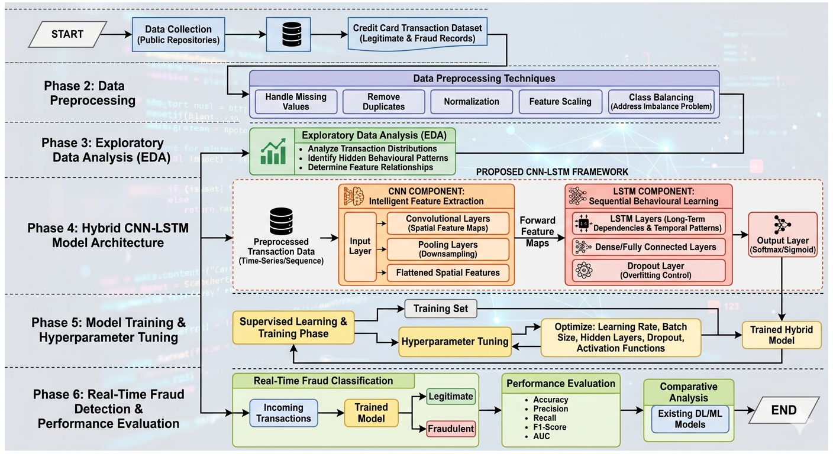
Figure 1: Architecture of the proposed system
The processed data are then passed into the CNN component of the proposed framework. Here, convolution and pooling operations are used to automatically extract important spatial and discriminative features from transaction records. Rather than relying heavily on manually engineered features, the CNN layer learns relevant patterns directly from the data, improving the model’s ability to identify suspicious transaction characteristics. The extracted feature maps are subsequently forwarded to the LSTM network, which is responsible for learning sequential dependencies and temporal behavioural patterns associated with transaction activities over time. This combination allows the framework to capture both local transaction features and long-term behavioural information simultaneously, thereby strengthening the overall fraud detection capability of the system. To train the proposed framework, supervised learning techniques are employed, where the dataset is divided into training and testing phases to evaluate the model’s generalization performance. Once training was completed, the developed CNN-LSTM model classifies transactions into legitimate or fraudulent categories in real-time. Finally, the performance of the proposed framework was evaluated considering metrics such as accuracy, precision, recall, F1-score, and Area under the Curve (AUC). Comparative analysis was applied to validate the study.
3.1 Data collection
The dataset used for this study is the European credit card dataset which was collected by a partnership project between Libre Brussels University and Worldline Company with the aim of fighting CCFs (Phakatkar A., 2022). The data contain over 550,000 records of credit card related transaction features which are either fraudulent or not fraudulent and span across 30 variables which include time, amount, transaction identification number, and other 28 anonymous features names v1 to v28 to protect customer’s transaction.
3.2 CNN+LSTM Modeling
This section presents the modeling of the deep learning algorithm which are the LSTM, CNN and hybrid model which combined the LSTM+CNN.
3.2.1 Long Short-Term Memory (LSTM)
The LSTM model is a specialized recurrent neural network designed for sequence modeling and capturing long-term temporal dependencies. It processes time-series or text input through an iterative state update within an LSTM cell, which utilizes forget, input, and output gates to manage information flow. This gating mechanism allows the model to maintain a cell memory ($C_{t}$) and a hidden state ($h_{t}$), resulting in a sequence-aware feature vector used for final classification (Taha, 2023).
3.2.2 Convolutional Neural Network (CNN)
The CNN model focuses on spatial pattern recognition by processing images or fixed-size input data through a series of specialized layers. It utilizes convolutional layers for automated feature extraction, followed by ReLU activation and pooling layers for downsampling and dimensionality reduction. These operations lead to a flatten layer that vectorizes the data into a spatial feature vector, which is then passed to a spatial classifier to identify local characteristics within the dataset (Chidi et al., 2024).
3.2.3 Hybrid CNN-LSTM Model
The hybrid approach integrates both architectures to create a unified framework capable of simultaneous spatial and temporal learning. In this combined model, sequential or multimodal input is processed through a feature extraction module where the CNN captures spatial patterns and the LSTM tracks temporal sequences. These findings are merged in a feature fusion layer to create a joint feature representation, which is then passed through fully connected and output layers to produce consolidated predictions. The flow chart of each model is presented in figure 2.
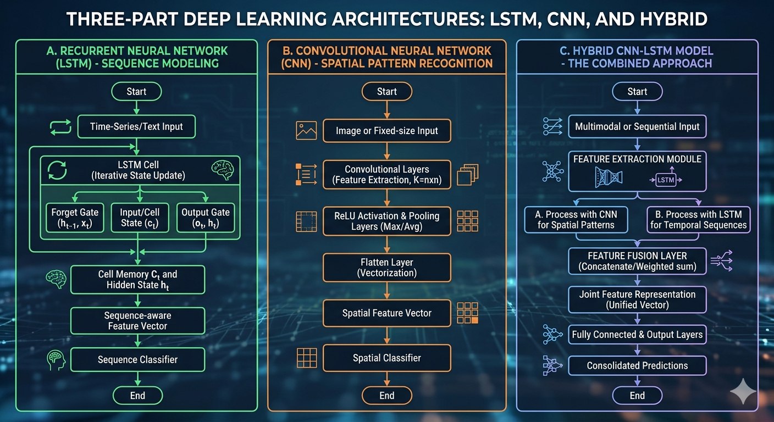
Figure 2: Modeling of the deep learning techniques for this work
3.4 Experimental Training of the Model
The experimental training of the proposed hybrid CNN-LSTM framework is conducted using a supervised learning approach, where the preprocessed and balanced dataset is partitioned into training and testing phases to evaluate generalization performance. The training process utilizes the Adam optimizer to minimize the binary cross-entropy loss function, facilitating efficient convergence during the feature extraction and sequential learning stages. To achieve optimal detection efficiency and mitigate the risk of overfitting, hyper-parameter tuning was applied to refine the model’s configuration. Key hyper-parameters optimized during this phase include a learning rate typically ranging from 0.001 to 0.0001, a batch size of 32 and the inclusion of dropout rates (0.2 to 0.5) within the LSTM and dense layers. Furthermore, the architecture is tuned for the number of hidden layers, the number of filters in the CNN component, and the specific activation functions utilizing ReLU for internal layers to maintain gradient flow and Sigmoid or Softmax for the final classification output. This experimental setup ensures that the model effectively captures both spatial transaction signatures and temporal behavioral patterns, resulting in a robust system capable of real-time fraud identification. We trained the CNN, LSTM and the hybrid respectively. Table 1 presents the training parameters.

Table 1: Training parameters
Parameter | Value
Optimizer | Adam
Learning Rate | 0.001
Batch Size | 64
Epochs | 100
Activation Function | ReLU and Sigmoid
Loss Function | Binary Cross-Entropy
Dropout Rate | 0.3
CNN Filters | 64 and 128
LSTM Units | 128
Dataset Split | 80% Training, 20% Testing
- RESULTS AND DISCUSSION
This section presents the result of the model trainings. The results were measured with accuracy as the main parameter. Figure 3 presents the accuracy of the LSTM model training and validation across different epochs. Figure 4 presents the training and validation of the CNN model. Figure 5 presents the training and validation of the hybrid model of CNN+LSTM.
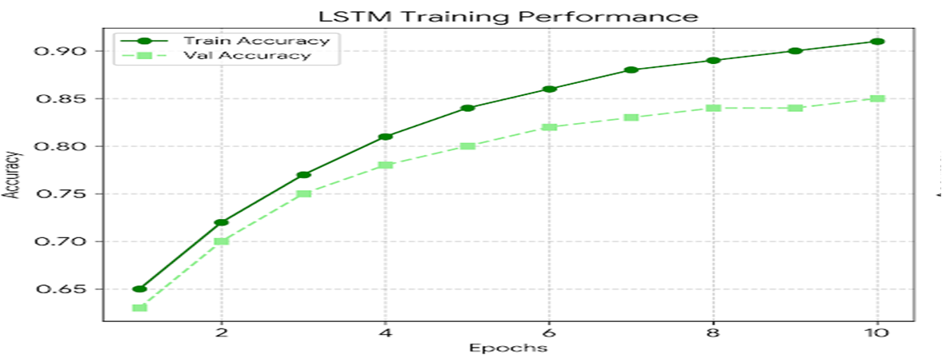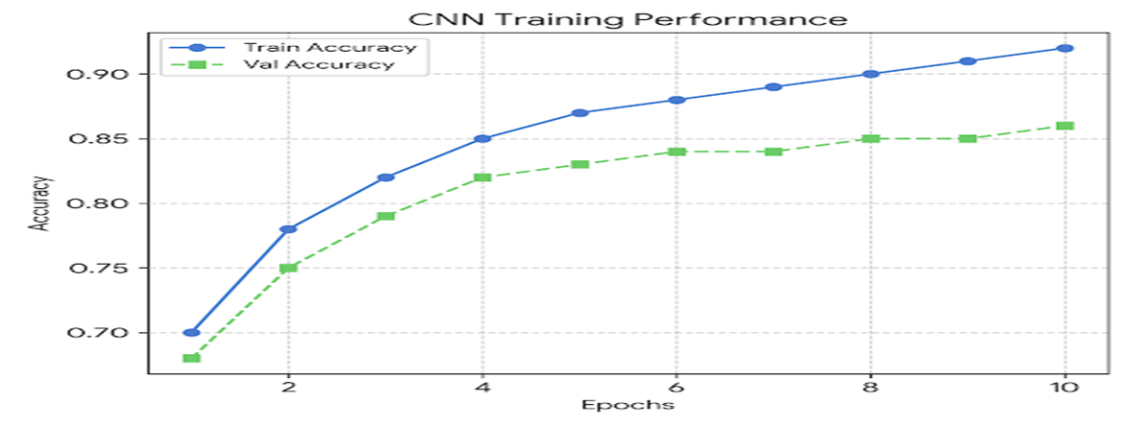
Figure 3: Result of the LSTM Figure 4: Result of the CNN model training
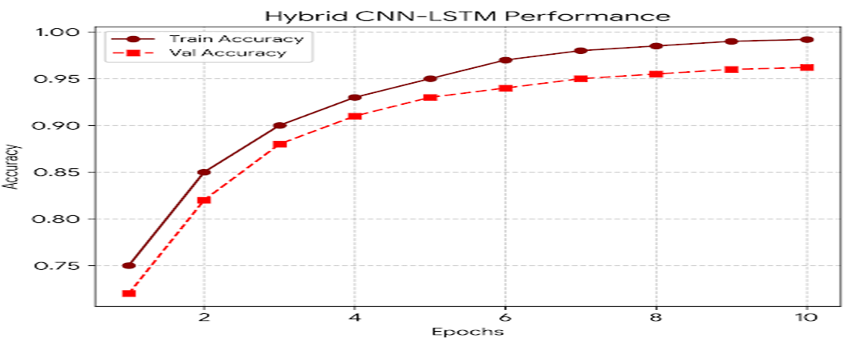
Figure 5: Training and validation result of the hybrid model
The CNN model in figure 3 demonstrates steady growth in spatial feature extraction, reaching a validation accuracy of approximately 86%. The gap between training and validation lines indicates a moderate level of generalization. The LSTM in figure 4 exhibits a similar trajectory, focusing on temporal dependencies with a validation accuracy peaking at 85%. This confirms its ability to learn sequential transaction patterns over time. The hybrid framework in figure 5 clearly outperforms the standalone models, achieving a superior validation accuracy of over 96%. The rapid convergence and high accuracy validate the effectiveness of integrating spatial feature extraction with sequential behavioral learning for fraud detection. The achieve results proved that the hybrid of CNN-LSTM framework offers several advantages over standalone deep learning models. The CNN layer improves feature representation and dimensionality reduction, thereby enhancing learning efficiency, while the LSTM layer strengthens the model’s ability to analyze sequential transaction behaviours over time. This integration is particularly important in modern financial environments where effective fraud detection depends not only on identifying suspicious transaction attributes, but also on understanding behavioural patterns associated with transaction sequences. In addition, the new framework reduces dependence on manual feature engineering by allowing the model to automatically learn relevant fraud characteristics directly from transaction data. Ultimately, this paper contributes to the growing field of intelligent financial cybersecurity systems by introducing a more comprehensive and adaptive fraud detection framework capable of handling large, complex, and highly imbalanced financial datasets. Beyond improving detection performance, the new model will assist financial institutions in minimizing financial losses, strengthening customer trust, and improving the overall security and reliability of digital payment systems.
- CONCLUSION
This study presents successfully a deep learning based solution for the detection of credit card fraud. The model training was done experimentally considering the individual version of the CNN+LSTM, and as hybrid. Each model reported accuracy above 85% which is good; however the results showed that a combination of LSTM and CNN reported better classification success. This solution provided in this work facilitates reliable detection of credit card fraud which has continued to threaten customer band relationship as a result of financial theft. The model developed is recommended for adoption by financial institutions to help combat credit card fraud. This when achieved will facilitate easy detection of credit card fraud.
- APPENDIX A (DATA SOURCE)
CCF Dataset. 2023. Available online: https://www.kaggle.com/mlg-ulb/creditcardfraud/data (accessed on 6th May, 2026).
- REFERENCE
Alarfaj, F., Malik, I., Khan H., Almussalam, N., Ramzan, M., & Ahmed, M., (2022) CCF Detection Using State-of-the-Art ML and DL Algorithms. IEEE Access Digital Object Identifier 10.1109/ACCESS.2022.3166891
Almuteer, A., Aloufi, A., Alrashidi, W., Alshobaili, J., & Ibrahim, D., (2021). Detecting CCF using ML. iJIM ‒ Vol. 15, No. 24,https://doi.org/10.3991/ijim.v15i24.27355
Almuteer, A., Aloufi, A., Alrashidi, W., Alshobaili, J., & Ibrahim, D., (2021). Detecting CCF using ML. iJIM ‒ Vol. 15, No. 24,https://doi.org/10.3991/ijim.v15i24.27355
Azhan, M., & Meraj, S., (2020) CCF Detection using ML and DL Techniques. Proceedings of the Third International Conference on Intelligent Sustainable Systems [ICISS 2020] DVD Part Number: CFP20M19-DVD; ISBN: 978-1-7281-7088-6
Azhan, M., & Meraj, S., (2020) CCF Detection using ML and DL Techniques. Proceedings of the Third International Conference on Intelligent Sustainable Systems [ICISS 2020] DVD Part Number: CFP20M19-DVD; ISBN: 978-1-7281-7088-6
Bawangade, P., Gedam, M., Khan, F., Sheikh, S., & Bhilawe, A., (2022) CCF Detection Using ML with Python. International Research Journal of Modernization in Engineering Technology and Science.
Bhanusri, A., Valli, K., Jyothi, P., Sai, G., & Subash, R., (2020) CCF detection using ML algorithms. Quest Journals Journal of Research in Humanities and Social Science Volume 8 ~ Issue 2 (2020) pp.: 04-11 ISSN(Online):2321-9467
Chidi, E.U., Udanor C.N. & Anoliefo E., “Exploring the Depths of Visual Understanding: A Comprehensive Review on Real-Time Object of Interest Detection Techniques.” Preprints 2024 2024020583
El Kafhali, S., Tayebi M., & Sulimani, H., (2024) An Optimized DL Approach for Detecting Fraudulent Transactions. Information 2024, 15, 227. https://doi.org/10.3390/info15040227
Mehmet, A., (2023) Hyperparameter Effect On The Performance Of A DL Network Established With Stacked Autocoder And SoftMax Classifier: CCF Detection. Conference Paper ·
Nguyen, T., Tahir, H., Abdelrazek, M., & Babar, A., (2020) DL Methods for CCF Detection. School of Information Technology, Deakin University, Victoria, Australia
Phakatkar, Anupama. (2022). Detection of Credit Card Fraud using a Hybrid Ensemble Model. International Journal of Advanced Computer Science and Applications. 13. 10.14569/IJACSA.2022.0130953.
Qayoom, A., Khuhro, M., Kumar, K., Waqas, M., Wu, Y., Wang, S., & Ur-Rehman, S., (2023) A Novel Approach for CCF Transaction Detection Using Deep Reinforcement Learning Scheme. Research Square https://doi.org/10.21203/rs.3.rs-3092096/v1
Taha, A., (2023). A novel DL-based hybrid Harris hawks with sine cosine approach for CCF detection. AIMS Mathematics, 8(10): 23200–23217. DOI: 10.3934/math.20231180
Voican, O., (2021) CCF Detection using DL Techniques. Informatica Economică vol. 25, no. 1/2021 DOI: 10.24818/issn14531305/25.1.2021.06

