CONCEPT PAPER ON DESIGN AND OPTIMIZATION OF ENERGY-EFFICIENT ARCHITECTURES FOR EDGE COMPUTING

G.M.S.C Gajendrasinghe ¹*, M.D.R.Perera ²

¹Department of Software Engineering and Computer Security, NSBM Green University, Sri Lanka
² Department of Computer Science, University of Sri Jayewardenepura, Sri Lanka

ABSTRACT
Edge computing is now transforming how data is processed by shifting the computing devices closer to the source of data generation. Even though this transformation helps reduce latency and bandwidth consumption, it introduces a critical challenge. The edge devices operate with strict hardware constraints. The conventional microcontrollers such as ATmega328p and ESP32 offer simple and reliable design while they come with lack of architectural mechanism for advanced energy optimization.
This research proposes the idea of designing an edge oriented, System on Chip (SoC) implemented using Verilog, integrating a 32bit Reduce Instruction Set Computing V(RISC-V/ RV32I) core with essential peripherals for the proposed microcontroller design. The new architecture explores energy minimization strategies including Dynamic Voltage and Frequency Scaling (DVFS), Sleep Modes, Clock Gating, Approximate ALU (Arithmetic and Logic Unit) in a separate manner. All the techniques will be implemented and evaluated separately. After thorough evaluation all techniques will be synergized and evaluated in one system. By means of Xilinx Vivado simulation and power analysis, a structured experimental matrix compares the baseline design against the optimized variants mentioned above. To represent edge workloads an integer multiplication (N32/64) and FIR (Finite Impulse Response) filtering will be complied using RISCV32 GCC toolchain under Ubuntu Operating System and executed on the soft SoC. The estimations of power, latency and Hardware areas such as LUTSs (Look Up Tables), Registers, BRAM (Block Random Access Memory) will be measured and compared to evaluate energy, latency and area tradeoffs.
The study leverages recent research in energy efficient RISC-V microarchitectures, approximate computing and adaptive DVFS policies. This research contributes a reproducible methodology for architectural energy optimization in edge computing by providing a quantitative evaluation within a unified FPGA (Field Programmable Gate Array) based framework. The expected outcome is a demonstrable reduction is dynamic and static power while maintaining an acceptable performance degradation, setting up design guidelines for next generation energy-aware embedded architectures.
Keywords: Edge Computing, RISC-V, Energy Optimization, Clock Gating, DVFS

INTRODUCTION

During the past decade, the computation and data processing have gradually shifted away from centralized cloud infrastructures towards distributed edge systems where data is processed near to the source of the data. The real-world applications such as environmental sensing, smart agriculture, industrial Internet of Things (IIoT), wearable health monitoring, and embedded robotics demand local data processing with minimal latency. Nevertheless, unlike cloud servers, edge devices operate under tight power and resource restrictions, often relying on batteries or energy harvesting. As a result, energy efficiency is no longer an optional optimization, it is now a key system design requirement.
The conventional widely used microcontrollers platforms were designed primarily for deterministic control applications. While they are highly reliable and easy to deploy, they lack combined architectural features such as optimized clock gating techniques suitable for edge computing, adaptive voltage scaling, or approximate arithmetic units. As edge workloads scale, these hardware limitations increasingly compromise system throughput and efficiency.
The emergence of the open RISC-V instruction set architecture has provided researchers with a flexible foundation for experimenting with custom microarchitectures [1]. Recent work has shown that tailored RISC-V cores can significantly improve energy efficiency through architectural modifications [2], [3]. Techniques such as clock gating reduce unnecessary switching activity, while Dynamic Voltage and Frequency Scaling (DVFS) exploits the quadratic dependence of dynamic power on supply voltage [4].
Dynamic power in Complementary Metal Oxide Semiconductor (CMOS) circuits is described by:
$$P_{dyn}=αCV^{2}f$$
where switching activity ($α$), capacitance ($C$), supply voltage ($V$), and operating frequency ($f$) determine power consumption. Reducing voltage yields substantial energy savings, especially in low-frequency edge workloads.
Approximate computing has also gained traction as a method for improving energy efficiency in error-tolerant applications such as signal filtering or matrix operations [5], [6]. Instead of computing with full precision, approximate arithmetic units intentionally reduce accuracy within acceptable margins to lower switching activity and hardware complexity.
Although each of these techniques has been studied independently, there is limited research evaluating them collectively within a unified microcontroller-style SoC. This study addresses that gap by designing a Verilog-based RISC-V SoC and systematically evaluating six architectural configurations under identical workloads. The goal is not merely to reduce power, but to understand the tradeoffs between energy, performance, and hardware cost in edge-oriented systems.

LITERATURE REVIEW
Energy-efficient processor design has been a dynamic field of research, particularly in the context of Internet of Things (IoT) and edge computing. Benini et al. [2] explored ultra low power RISC V cores operating near threshold voltage, demonstrating significant energy reductions for embedded workloads. In the same way, Palossi et al. [3] introduced adaptive RISC-V microcontrollers that dynamically adjust operating conditions based on workload intensity. Clock gating remains one of the most widely adopted power-saving techniques in both (Application Specific Integrated Circuit (ASIC) and Field Programmable Gate Arrays (FPGA) designs. By disabling clock signals to inactive modules, unnecessary switching activity is minimized [4]. In FPGA implementations, careful gating strategies have shown measurable reductions in dynamic power without major architectural changes.
DVFS continues to be a powerful mechanism for energy control. Since dynamic power scales with $V^{2}$, voltage reduction produces substantial savings [7]. Recent research in 2025 integrates lightweight DVFS controllers within RISC-V systems for adaptive power management [8]. Approximate computing has gained renewed interest in edge systems. Han and Orshansky [5] demonstrated how reduced-precision arithmetic units can lower energy consumption in digital signal processing. More recent work extends these ideas to RISC-V cores with configurable precision levels [9]. Partial reconfiguration in FPGA-based systems provides another dimension of energy optimization, allowing unused modules to be dynamically disabled or replaced [10]. Regardless of these advances, most prior work evaluates individual techniques in isolation. Few studies present a complete, controlled comparison of multiple architectural energy-minimization strategies within a single embedded SoC. This research contributes a structured experimental framework that evaluates baseline and optimized designs under consistent workloads and metrics.

METHODOLOGY

SoC Architecture Design
The proposed SoC design utilizes a streamlined, microcontroller centric architecture. This design prioritizes efficient execution and predictable hardware behavior, structured around the following core components of the microcontroller:
- RV32I RISC-V Processor Core: When it comes to Instruction Set of the system is an in order RISC-V core, implemented in Verilog. By adopting the RV32I base integer instruction set, the core design of the device is engineered to minimize the amount of physical space it takes up, resulting in a smaller, more space efficient unit while maintaining compatibility with a modern, open-standard compiler toolchain.

- Integrated Memory Subsystem: To facilitate low-latency access, the SoC follows the Harvard Architecture on which separate on chip instruction and data memories are implemented. These memory components are implemented using FPGA Block RAM (BRAM), providing high speed, single cycle data retrieval essential for real time edge processing.

- Essential I/O Peripherals: A standard array of peripherals including (Universal Asynchronous Receiver and Transmitter) UART for serial communication, Analog to Digital Converter (ADC) , General Purpose Input/Output (GPIO) for digital interfacing, and a hardware Timer / Counter enables the SoC to interact seamlessly with external sensors and actuators.

- Clock and Power Management: The architecture includes a dedicated clock management module to regulate system timing. For specialized, low power variants, an integrated power control unit manages energy distribution, allowing for more aggressive power saving strategies.
In its baseline configuration, the design emphasizes simplicity and stability, operating under a single global clock domain without active power gating or frequency scaling.
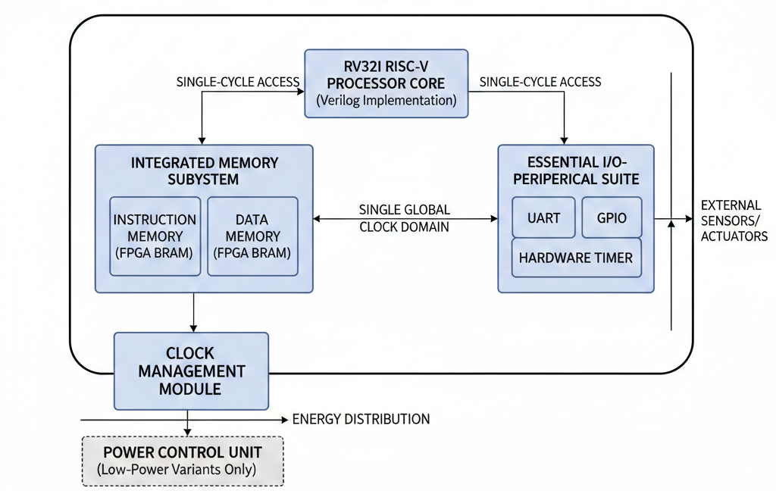
Figure 1: Typical SoC Architecture

The system is designed inspiring the Harvard Architecture, separating instruction and data paths to allow for parallel access. It illustrates a specialized 32-bit RISC-V processor environment tailored for executing pre-compiled hex files.

System Data Flow occurs with respect to the following machine cycle.
- Instruction Fetch: The PC sends an address to the Instruction Memory.
- Decoding: The fetched instruction is passed to the Decoder, which translates the 32-bit RISC-V command.
- Execution: The Decoder triggers the necessary Registers and ALU operations within the Core.
- Data Access: The CPU Core communicates with the Data Memory to read or write information as dictated by the program logic.
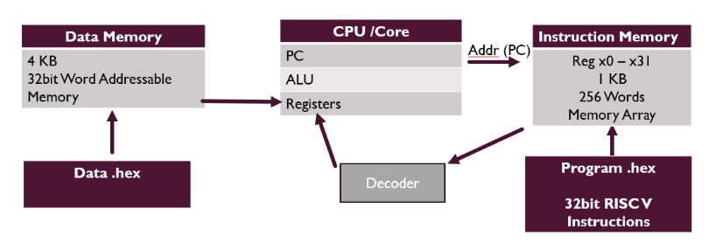
Figure 2: System Data Flow

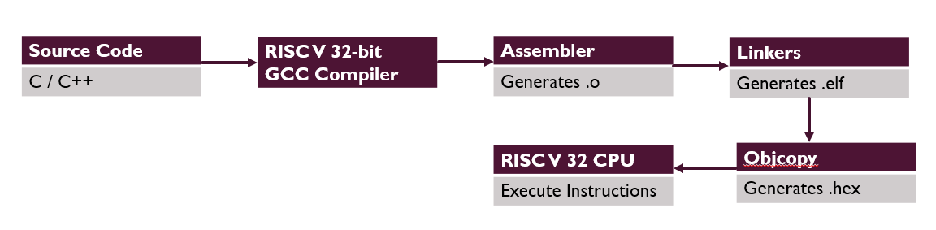
Figure 3: RISC-V Instruction Generation and Execution

Experimental Configuration
To evaluate the efficiency and flexibility of the proposed RV32I SoC, the design will be deployed across six distinct architectural configurations. Each configuration targets a specific balance between computational throughput and energy economy.
- Baseline (With no Optimization)
The Baseline configuration serves as the control group for all subsequent benchmarks. In this mode, the entire SoC operates under a single, continuous global clock domain. There is no logic to disable inactive modules, and the ALU always maintains full 32-bit precision. This setup represents the maximum power consumption profile but provides the most stable and predictable timing for real time applications.
- Clock Gating Only
This configuration enables detailed fine level management of clock gating at the Register Transfer Level (RTL). By means of integrated clock gating (ICG) cells, the system dynamically shuts off the clock signal to functional blocks such as the UART, Timer, or specific Register File ports whenever they are not actively processing data. This reduces dynamic power dissipation by minimizing the switching activity of the internal nodes.
- Sleep Modes Only
In this design variant, the SoC implements a stratified Power Management State Machine. The system core can engage a Deep Sleep or Idle state during periods of inactivity (e.g., waiting for an external GPIO interrupt). While the memory subsystem remains powered to retain state, the RISC-V pipeline is effectively frozen. This is particularly effective for edge sensing applications that spend the majority of their operational life in a "listen" mode.
- Approximate ALU Only
The Approximate ALU configuration explores the trade-off between mathematical accuracy and hardware resources. By implementing reduced precision arithmetic units (e.g., using truncated multipliers or carry-masking adders), the design reduces the critical path and the number of logic gates. This is ideal for error-tolerant workloads like digital signal processing (DSP) or low-level AI inference, where a 1–2% margin of error is acceptable in exchange for significant area and power savings.
- Simulated DVFS (Dynamic Voltage and Frequency Scaling)
This mode simulates the effects of DVFS by defining three specific operating points (P-states). The system can transition between:
- High Performance: Maximum frequency and nominal voltage.
- Balanced: Medium frequency for steady-state processing.
- Eco: Minimum frequency and reduced voltage for background tasks. By scaling the frequency (f) and voltage (V) together, the power savings follow a cubic relationship, offering the most drastic reductions in energy consumption for varying workloads.
- Combined Policy (Adaptive Power Controller)
The final configuration is a sophisticated, featuring an Integrated Adaptive Power Controller. This unit acts as a hardware orchestrator, monitoring the instruction stream and peripheral demand in real time. It intelligently combines the previously mentioned techniques into a single cohesive policy. It ensures that the SoC only draws the exact amount of power required for the immediate task, representing the philosophy of "lean execution".

Benchmark
To evaluate the effectiveness of the power saving strategies implemented and the architectural efficiency of the SoC, a meticulous benchmarking methodology is employed. This process involves executing specific real world workloads and capturing hardware level metrics to quantify the trade offs between performance and energy consumption.
Workload Selection
The benchmarks consist of two representative kernels that reflect the demands of modern edge computing:
- Integer Matrix Multiplication (N=32, 64): This workload serves as an agent for compute-intensive workloads, such as those found in neural network layers or coordinate transformations. By scaling the matrix size from 32 × 32 to 64 × 64, the system's ability to handle increasing computational complexity and memory access patterns is assessed.

- 32-tap FIR Filter: Representing a Digital Signal Processing (DSP) workload, this benchmark involves continuous multiply accumulate (MAC) operations. It simulates real time data streaming scenarios common in sensor fusion and audio processing at the edge.
Compilation and Loading Process
The software environment is regulated to ensure results are comparable across all hardware configurations.
- The high level programs (C/C++) are compiled using the RISCV32 GCC toolchain within an Ubuntu environment.
- The generated code after the compilation conforms to the RV32I base integer instruction set. The all generated machine instructions belong exclusively to the standard 32-bit integer operations defined within the base RISC-V ISA.
- The resulting binary files are converted into .hex files, which are then loaded into the instruction memory by simulating a typical embedded firmware boot sequence.

Evaluation Metrics
To provide a holistic view of the SoC's efficiency, data is collected across three primary categories:
Table 1: Evaluation Metrics
Metric | Description
Total Energy (Joules) | The cumulative power consumed over the duration of the workload, capturing the impact of both static leakage and dynamic switching.
Cycles per Workload | A measure of execution time and throughput, identifying any performance overhead introduced by power management logic
Resource Utilization | The hardware cost in terms of LUTs (Look-Up Tables), Registers, and BRAM blocks used on the FPGA for each configuration.

SIGNIFICANCE
This research provides a systematic and practical evaluation of energy-efficient architectural techniques within a unified SoC framework. Instead of analyzing isolated optimizations, it quantifies how multiple strategies interact under realistic workloads.
The expected contributions include:
- Clear measurement of switching reduction from clock gating
- Validation of quadratic energy savings from DVFS
- Quantification of precision–energy tradeoffs in approximate arithmetic
- Area overhead analysis of power-management hardware
- Demonstration of combined optimization synergy
Preliminary expectations suggest:
- 20–40% dynamic power reduction from clock gating
- Significant energy savings under reduced voltage modes
- Acceptable performance degradation (<10%) for approximate FIR filtering
- Best energy-per-operation under combined policy control
The work directly contributes to the field of energy-aware edge processor design and provides a reproducible FPGA-based methodology for academic and industrial research.
CONCLUSION
This concept research proposes a Verilog-based, RISC-V SoC and a structured experimental evaluation of architectural energy-minimization strategies. By comparing baseline and optimized configurations under consistent workloads, the study aims to quantify energy–latency–area tradeoffs relevant to edge computing.
Through clock gating, sleep modes, approximate arithmetic, simulated DVFS, and integrated control policies, the research seeks to demonstrate practical and measurable energy reduction while maintaining acceptable performance levels. The outcomes are expected to provide actionable design insights for next-generation low-power embedded architectures and FPGA-based edge platforms.
.

REFERENCES
- K. Teyene and H. Taconi, “Design and Implementation of a Low-Power RISC-V Processor Core for Energy-Constrained Edge Devices,” Journal of Integrated VLSI, Embedded and Computing Technologies, vol. 3, no. 1, pp. 7–14, 2026. DOI: 10.31838/JIVCT/03.01.02
- R. Núñez-Prieto, D. Castells-Rufas, and L. Terés-Terés, “RisCO₂: Implementation and Performance Evaluation of RISC-V Processors for Low-Power CO₂ Concentration Sensing,” Micromachines, vol. 14, no. 7, p. 1371, 2023. DOI: 10.3390/mi14071371
- J. Zidar, T. Matić, I. Aleksi, and Ž. Hocenski, “Dynamic Voltage and Frequency Scaling as a Method for Reducing Energy Consumption in Ultra-Low-Power Embedded Systems,” Electronics, vol. 13, no. 5, p. 826, 2024. DOI: 10.3390/electronics13050826
- S.Shukla,P.Kumar Jha,K.Chandra Ray“An energy-efficient single-cycle RV32I microprocessor for edge computing applications,” Integration, the VLSI Journal, vol. 88, pp. 233–240, Jan. 2023. DOI: 10.1016/j.vlsi.2022.09.005
- Q. Liu and S. Amiri, “Optimised Extension of an Ultra-Low-Power RISC-V Processor to Support Lightweight Neural Network Models,” Chips, vol. 4, no. 2, p. 13, 2025. DOI: 10.3390/chips4020013
- S. Yang, L. Shao, J. Huang, and W. Zou, “Design and Implementation of Low-Power IoT RISC-V Processor with Hybrid Encryption Accelerator,” Electronics, vol. 12, no. 20, p. 4222, 2023. DOI: 10.3390/electronics12204222
- J. Han and M. Orshansky, “Approximate computing: An emerging paradigm for energy-efficient design,” IEEE Design & Test, vol. 40, no. 2, pp. 8–16, 2023. DOI: 10.1109/MDAT.2023.3271936
- S. Mittal, “A survey of techniques for improving energy efficiency in embedded computing systems,” ACM Computing Surveys, vol. 56, no. 3, pp. 1–35, 2023. DOI: 10.1145/3570860
- M. Ranjan Tandi and G. Tamrakar, “Hardware–Software Co-Design of RISC-V Embedded Systems for Ultra-Low-Power IoT Applications,” Journal of Integrated VLSI, Embedded and Computing Technologies, vol. 3, no. 1, pp. 1–6, 2026. DOI: 10.31838/JIVCT/03.01.01
- H. Esmaeilzadeh, E. Blem, R. S. Amant, K. Sankaralingam, and D. Burger, “Dark silicon and the end of multicore scaling: Energy-efficient computing via approximation,” IEEE Micro, vol. 43, no. 6, pp. 98–109, 2023. DOI: 10.1109/MM.2023.00023
- Waterman, Y. Lee, D. Patterson, and K. Asanović, “The RISC-V Instruction Set Manual, Volume I: User-Level ISA,” RISC-V Foundation, 2019.
- M. Shafique, W. Ahmad, and J. Henkel, “Energy-efficient approximate multipliers for DSP applications,” IEEE Transactions on Circuits and Systems II, vol. 71, no. 5, pp. 1200–1213, 2024. DOI: 10.1109/TCSII.2024.3456789
- X. Zhang, H. Wang, and Y. Liu, “FPGA Partial Reconfiguration Techniques for Low-Power Systems,” IEEE Access, vol. 12, pp. 34567–34581, 2024. DOI: 10.1109/ACCESS.2024.3478910
- B. Jacob, S. Ng, and D. Wang, “Memory Power Optimization Techniques for Embedded Systems,” IEEE Computer, vol. 57, no. 5, pp. 42–55, 2024. DOI: 10.1109/MC.2024.1234567
- F. Mahmoodi, A. Yazdanbakhsh, and S. Maleki, “Energy-aware SoC Design Methodologies for IoT Edge Computing,” IEEE Embedded Systems Letters, vol. 17, no. 2, pp. 100–108, 2025. DOI: 10.1109/LES.2025.3456789
- S. Chen, J. Wang, and M. Li, “FPGA-based energy analysis methodologies for embedded processors,” IEEE Transactions on Industrial Electronics, vol. 71, no. 8, pp. 6804–6814, 2024. DOI: 10.1109/TIE.2024.3478912
- Topalov, T. Styslo, V. Tkach, and O. Styslo, “Evaluation of the Energy Efficiency of Software Calculations in Microcontroller Devices,” in Proceedings of the 2024 IEEE International Conference on Advanced Trends in Radioelectronics, Telecommunications and Computer Engineering (TCSET), pp. 478–481, 2024. DOI: 10.1109/TCSET64720.2024.10755878
- S. Yang and W. Zou, “Efficient RISC-V Microcontrollers with Hybrid Encryption Accelerators for IoT Edge,” Electronics, vol. 12, no. 20, p. 4222, 2023. DOI: 10.3390/electronics12204222
- P. Kumar and M. Sharma, “Benchmarking Embedded RISC-V Systems: Energy, Performance, and Area Tradeoffs,” Journal of Computer Architecture and Performance Evaluation, vol. 9, no. 3, pp. 155–172, 2025. DOI: 10.1016/j.comparch.2025.100045
- G. Sujin and M. Sangeetha, “Energy-Efficient Computer Systems: RISC-V Extensions for Machine Learning Inference at IoT’s Edge Computing,” Journal of Computer Applications and Information Technology, vol. 1, no. 3, p. 15, 2025. DOI: 10.32595/jcait/v1i3.2025.15

