A Modern Approach to Asset Management: Integrating SimCorp Dimensions with Cloud Data Platforms
Abstract
This paper will describe the way in which UNIFY has successfully integrated multiple technologies, including SimCorp Dimensions, Informatica PowerCenter ETL, Snowflake Cloud-based Data Warehouse, as well as IDL's Data Hub orchestration (or ETL), in order to convert a disparate and fragmented Asset Management platform into a truly cloud-native architecture. Through the use of Phased ETL Strategies and Agile/Scrum governance, UNIFY addresses many of the common challenges associated with legacy systems, including Fragile Integrations, Insufficient Data Sources, and High Maintenance Costs. Additionally, the UNIFY design has standardised data flows, provided for Very High Availability and enabled Seamless Migrations. Performance Studies conducted by the UNIFY development team indicate a marked improvement in overall efficiency, including Significant reductions in Query Costs and Increased Cache Hits; additionally, UNIFY has identified optimization opportunities using its Cost Dashboard. Future efforts will focus on the adoption of advanced technology, including GraphQL Federation, Real-Time Streaming, and AI-Driven Operations, as well as additional opportunities to improve scalability and reduce costs. Overall, the design created by UNIFY establishes a New Industry Standard for IT Transitioning of Asset Management platforms, while ensuring Compliance with Regulatory Requirements and Eliminating Legacy Silos.
Keywords: Informatica PowerCenter ETL, Snowflake Cloud-based Data Warehouse, Seamless Migrations, GraphQL Federation, Real-Time Streaming, AI-Driven Operations
Introduction
Asset management within the financial industry entails managing and growing an individual's or a corporation's financial assets in a methodical manner to achieve maximum value and return on investment and at the same time minimize the risks associated with those assets. The process of asset management consists of researching, acquiring, monitoring, evaluating, managing, and allocating resources, both physical and non-physical, related to the different asset classes, including IT assets, in the interest of maximizing operational efficiencies. Asset management offers several advantages, which include the ability to develop diversified portfolios that optimize returns while minimizing risks; the reduced variability of asset values resulting from professional-level risk management; and the ability to stimulate innovation by helping companies identify and invest in profitable projects/technologies with available capital. Nevertheless, there are some disadvantages to asset management, including higher fees attributable to the use of specialized services; the potential for poor performance due to poor management decisions or loss of traction due to an unexpected (and unmitigated) change in the market environment; and significant costs associated with meeting complex regulatory compliance requirements,, which result in increased operational costs.
The UNIFY (Universalized Framework for Improving Financial Services, Inc.) programme has been created to address some of the major challenges associated with asset management as a result of excessive redundancies that have been created within asset-management organizations by using unreliable and outdated databases. UNIFY has implemented streamlined oversight of each asset class, using shared databases and a unified portfolio accounting application solution. This eliminates cost, redundancy, and inefficiency, which enables the true essence of asset management's objectives to be achieved: risk-mitigating frameworks, standardization of financial products and services, and maximization of value within the context of the investor's individual needs. By creating this transformation, UNIFY has taken into account the fragmentation of the asset management industry in the past and its potential for further improvement and innovation by providing a scalable and low-risk financial asset management environment [1].
Finally, Asset management firms in the finance industry provide a high level of management over financial assets through the collaboration of professional resources to assist clients in building their portfolios. Asset managers provide clients with access to expert knowledge and investment expertise, which enables them to make practical decisions and create comprehensive investment strategies.Diversifying investments across asset classes allows firms to create large portfolios with much lower levels of risk than individual investors would have access to. In addition, firms can leverage economies of scale to negotiate lower fees and provide unique investment opportunities. To further promote increased transparency, firms must comply with regulatory requirements and report on their performance on a regular basis. Finally, firms save time by managing administrative responsibilities (e.g., portfolio rebalancing, etc.) from a centralized location rather than from each individual client. Firms use data-driven decision-making processes and adhere to fiduciary standards to help mitigate losses, identify trends, and protect against undue risks.

The UNIFY initiative is designed to support all of these benefits of professional management by standardizing data and establishing advanced systems that address prior inefficiencies and poor operational performance in the area of asset management. UNIFY also provides a comprehensive IT overhaul of your investment management systems and infrastructure (e.g., all client portfolios) to support the oversight of significant financial assets. The current state of the investment management industry (i.e., the fragmented IT environment of a large asset management firm with multiple clients worldwide) is characterized by a lack of integration between many different platforms for managing various aspects of the investment process. Platforms include trading, portfolio accounting, performance management, and reporting to clients—and therefore contribute to information duplication, producing mismatched and erroneous data that subsequently hinder reconciliation efforts.
Analysts experience extended periods of time and significant expenses in verifying their own clients’ reports because they have to access and navigate through several different platforms to retrieve the same trade execution data (and reports). Additionally, maintaining the multiple platforms is expensive because of the need for a high level of specialized technical support and multi-layer complexity in collaborating to maintain and update the Unify project is intended to provide one comprehensive integrated platform to improve the quality of the data, standardize the data usage, and reduce the operational risks by consolidating multiple fundamental data processing functions using the new platforms Simcorp Dimensions and AIM-GAIN. Through this process, we will be able to enhance client reporting and allow for real-time decisions, while at the same time providing stability to the company from a cost, time, and technology management perspective due to the ability to easily adjust to the ever-changing pace of the financial marketplace [3].
The duplication of functions from legacy systems creates the potential for the same tasks to be performed multiple times, thereby increasing the time and money spent on maintaining these applications by a substantial amount. Duplicate programs can require teams with specialized training to manage them, thereby increasing the number of resources required and therefore increasing the cost of ownership and management of these applications and the number of people in the organization with skills in these legacy programs is diminishing rapidly.
In addition to this issue of duplication of effort, inconsistent sources of client data can result in duplicate client records and transactions being stored, leading to significant issues with retrieving accurate data, generating reports, and complying with regulatory requirements. The limitations of the centralization of client records and transactions reduce the ease of updating client records and increase the security risks associated with outdated information. Point-to-point integration creates a fragmented architecture, which makes it difficult to modify and expand an integrated environment. Due to the nature of today's integrated IT environment, a lack of standardization will produce inconsistencies in the data and limit the potential for innovation while simultaneously increasing the costs to maintain compliance [4].
The integration of the IT platform relies on the use of both the GIM2 (Gensys Integrated Middleware) and the Integrated Distribution Layer (IDL) in order to facilitate a greater degree of consistency and throughput of data across all applications. The IDL helps resolve the long-standing problem of dispersed data storage by offering a single repository to store, convert and send data to all downstream systems.The integration layer aggregates data from several different sources while applying business rules for integrity and consistency before distributing the harmonized data to dependent applications. This centralization addresses issues associated with inconsistent or duplicate data, which is necessary to accurately account portfolios, comply with reporting requirements, and provide operational decision-making support.
The integration layer reduces the complexity of point-to-point integrations; therefore, simplifying the system architecture and increasing the maintainability of these integrations. By providing the means to reuse integration components and standardizing data formatting, the integration layer enables improved transition success as platforms evolve and systems are onboarded. The integrated solution also aligns with enterprise architectural practices for scalability, reliability, and agility of IT ecosystems. Ultimately, the goal of UNIFY is to develop an integrated, cost-effective, and reliable asset management platform utilizing GIM2 and the integration layer to provide a coordinated and consistent data transition to new portfolio accounting systems such as Simcorp Dimensions.
The UNIFY program's transition strategy will gradually move to modern portfolio accounting systems that consolidate old legacy systems into one integrated solution while maintaining continued data access during transition, and to achieve the maximum level of data continuity and minimize disruption to the business, integration solutions such as the integration layer will be utilized. A strategy of centralizing front-to-back functions through automation will enhance the speed of execution and accuracy of processing and reporting across asset classes.
As redundant systems are retired, organizations will be able to gain real-time insight during this transitional period; at the same time, these organizations' operational silos will be reduced and will continue to be in compliance with regulatory requirements. The initiative will consist of three main applications: 1) Simcorp Dimensions, a fully integrated multi-asset portfolio and compliance platform; 2) Simcorp IMW, a workflow tool to improve efficiency of operations through automation; 3) AIM-GAIN, a custom-built application to minimize human error in the management of corporate actions, thus providing high processing efficiency. Integrating strong integration components is critical for the success of the UNIFY program by eliminating historical fragmentation and developing a single-integrated data and information-sharing platform for the updated Asset Management IT platform, thereby minimizing data downtime and inconsistency and providing scalable capabilities for asset processing by using the integration layer as a data hub.
In addition, the UNIFY program must implement a carefully planned transition to the target architecture through a phased decommissioning of the current state, implementation of Simcorp Dimensions, Simcorp IMW, and AIM-GAIN will be essential to maintain the continuity of operations and data integrity. Proper transition planning will mitigate disruption to the business in this rapidly changing environment and accelerate the ability to obtain cost savings, increased performance monitoring and responsiveness, providing a foundational platform for future sustainable growth to address the challenges facing legacy business operations.
Related Work
Using UNIFY as a guideline, the UNIFY program focuses on providing asset management organizations some guidance on incorporating integration/consolidation practices to assist in resolving many of the difficulties associated with updating fragmented asset management systems. Numerous research papers and industry publications are in agreement with the premise of combining systems that have been previously disparate to create Unified Managed Accounts (UMA) to enable them to simplify their investment structure through taxation efficiency and risk alignment through the streamlining of their investment structures. Many case studies are available on family offices' platforms, and these demonstrate that in terms of standards like IDL for data harmonization, it is necessary to collect identical or uniform data for compliance and reporting. Additionally, academic resources that provide insight into challenges related to technology transformation and the legacy systems that continue to be used by a significant percentage of asset management organizations indicate that a unified or coordinated approach to managing these transitions can limit complexity and risks associated with using legacy systems.
Experts are also advocating for the development of standard application programming interfaces (APIs) and data centers as part of an organization's overall integration strategy, which would facilitate improved scalability, as well as an operationally agile solution to managing the assets of its clients and providing consistent data across the various asset managers in the asset management space. Current analytical tools and dashboards allow for quicker and easier adjustment to ultra-rapid response requirements for dynamic industries such as Banking, I.T., etc., through enhanced analytics and API driven solutions [8]. Studies conducted on legacy IT environments show many organizations struggling with issues caused by their outdated system, resulting in Functional Redundancies, high levels of Maintenance Costs (70% to 80% of operating budgets spent), and a web of disparate systems ("Patchwork System"). Consolidation of these legacy systems will allow for reduced overheads and the removal of information silos.
The use of a centralised hub, similar to the Statistics Canada industrial data library (IDL), is also encouraged to gather, store, transform, and distribute large amounts of data. Legacy applications often create problems in terms of compliance and data duplication when different employees perform their jobs with the same dataset but in different locations or from different sources. To assist clients during these transitions, the use of Data Hubs like Technology One Enterprise Asset Management (EAM) or Unify Software instead of point-to-point interfaces are recommended. Clients that have a coordinated approach to their technology transitions will be able to successfully phase out legacy applications through the use of staggered rollouts of systems such as those provided by Simcorp Dimensions, Incentive Management Works (IMW), and AIM-GAIN. Rewards achieved through these coordinated migrations include improved throughput and better dashboard reporting with the emphasis on “Integration” and “Rigor” in order to realize cost savings and increased flexibility [9].
The benefits of consolidating IT platforms include improved Architectural Management, quicker Deployment of Applications, and greater Cost Savings (i.e., in excess of 70%-80% of IT budgets). Progressive companies can realize much higher success from the Digital Transformation process because of enhanced levels of Security, increased Business Agility, and increased Data Visibility available to them. In addition to these advantages lie other positive outcomes, such as increased Employee Productivity, Innovativeness, the ability to develop Scalable systems, and thereby allowing companies in Asset Heavy Industries, such as Banking.
Consolidation can lead to many possibilities and risks such as vendor lock-in and migration complexities leading to downtime and performance issues like integration latency. The risk of failure is also greater when there is a loss of customization, when there are compatibility gaps between new and legacy systems, and with an increased reliance on single-source suppliers. After the merger, companies will face many challenges regarding scalability due to duplication of platforms, and careful planning will be required to avoid operational disruption during the transition. The goal of the UNIFY Programme is to mitigate risk related to migration through coordinated transitions, as well as reduce redundancy costs using IDL's data hubs and applications such as Simcorp Dimensions. It will also demonstrate that phased integration is essential to maintain agility and enable a seamless decommissioning process. Proactive strategies such as UNIFY, focusing on flexibility and standardization, can greatly mitigate risks related to vendor lock-in. Multi-cloud or multi-vendor solutions will allow organizations to distribute workloads across multiple vendors, increase service quality and improve negotiating power when negotiating contracts with vendors, creating a competitive advantage. Using open source software, open standards and APIs also improves interoperability and enables easier transitions between platforms without being locked into a proprietary platform.
Containerizing applications allows for reduced friction between platforms, ensuring that applications can be executed consistently across different infrastructures. It is critical to include provisions for short-term returns, portability of data, transition support and scalability without penalty in negotiated contracts and service level agreements. Regular data governance procedures, such as migration testing and testing of backups, are necessary to maintain control over data and continue to have access to data in a format that can be standardized. When selecting vendors, organizations should perform due diligence to evaluate vendors' solutions based on hardware agnosticism, interoperability, innovations, pricing, and exit support. The strategies outlined above are consistent with the UNIFY programme's strategy to replace legacy systems such as Simcorp Dimensions, IMW and AIM-GAIN through coordinated integration in order to eliminate vendor lock-in and facilitate a timely and affordable transition from legacy systems to modernized systems by leveraging IDL's standardized data hubs and open integration protocols. In addition to the above, the integration of AI, the migration of post-merger systems and the use of risk management in replacing traditional portfolio accounting systems and replacing the antiquated with the new is widely discussed in many academic and business publications.
The transition to AI enables the automation of data aggregation and reconciliation processes, thereby eliminating discrepancies in data. AI will also provide organizations the ability to use predictive analytics in real time and to enhance their reports on performance and NAV. The focus of post-merger integration is on restructuring to maintain historical integrity among securities and asset classes. However, post-merger integration can result in a loss of the former performance data associated with asset classes and securities prior to the merger. In addition, while in-house systems typically produce better results in terms of the security and reliability when utilizing vendor solutions; in-house systems also have a tendency to be error-prone due to the scarcity of talent needed to operate and manage these systems. These advantages of modernized systems through the integration of machine learning enable organizations to achieve greater efficiency and ultimately achieve folios that are better suited for the predicted growth of data, while preserving historical performance data during the transitional period. The above findings are consistent with the UNIFY programme's efforts to implement Simcorp Dimensions, IMW and AIM-GAIN, to effectively address the legacy systems and their challenges through coordinated integration [12].
System Architecture
An asset management platform designed for today is cloud-based and will allow for scalable integration of multiple data sources into one 'hub' by employing technology and process standards such as ETL, cloud data warehousing, and enterprise scheduling to enable comprehensive analytical capabilities, as illustrated below. This is accomplished by integrating multiple external Data Sources into one singular database, using ETL Pipelines built using industry-leading ETL Solution Providers, then consolidating that data into Snowflake and automating the Scheduling Process with Autosys for analytics & reporting using Simcorp Dimensions. The architecture will pull Data from multiple Database Providers such as Teradata or Oracle and allow for consistent, accurate Data through the use of industry-leading ETL Providers.
In addition, using Snowflake as the Central Data Warehouse in a Cloud-based environment and Autosys to automate scheduling processes allows for the timely processing of Data into Simcorp Dimensions, resulting in a greater ability to manage portfolios efficiently. The primary application in our architecture is Simcorp Dimensions, which is designed to manage portfolios and incorporate standard APIs that help improve the efficiency of Asset Management Processes in addition to other applications that support asset management operations. Furthermore, a Data Hub will enable users easy access to Data and enable easy Data Integration between Applications, while ongoing Collaboration with Business Teams ensures that ongoing updates will enable Business Teams to maintain a close relationship to the Technical Development of the Application. Maintaining Data Pipeline Integrity through Proactive Problem-Solving and Comprehensive Documentation will facilitate the onboarding process of Customers and with the Global Delivery Model that uses Agile/Scrum methodology for Efficient Delivery and Customer Engagement, we can assure that the delivery of Technology will be aligned with Corporate Goals, resulting in Industry Recognition for Innovative Portfolio Operations due to the advantages cloud technology and features deliver, such as Data Availability and Scalability.
The design of our architecture utilizes Snowflake as the Central Data Hub and comprises a combination of Informatica PowerCenter to perform Data Transformations and Autosys to automate Orchestration of data into the Data Hub. The resulting solution will be a Cloud-Native ETL and Data Warehousing Solution that is Integrated with Simcorp Dimensions to perform Portfolio Accounting, thus enabling Asset Management Operations to be performed efficiently as shown in the Following Figure 1.
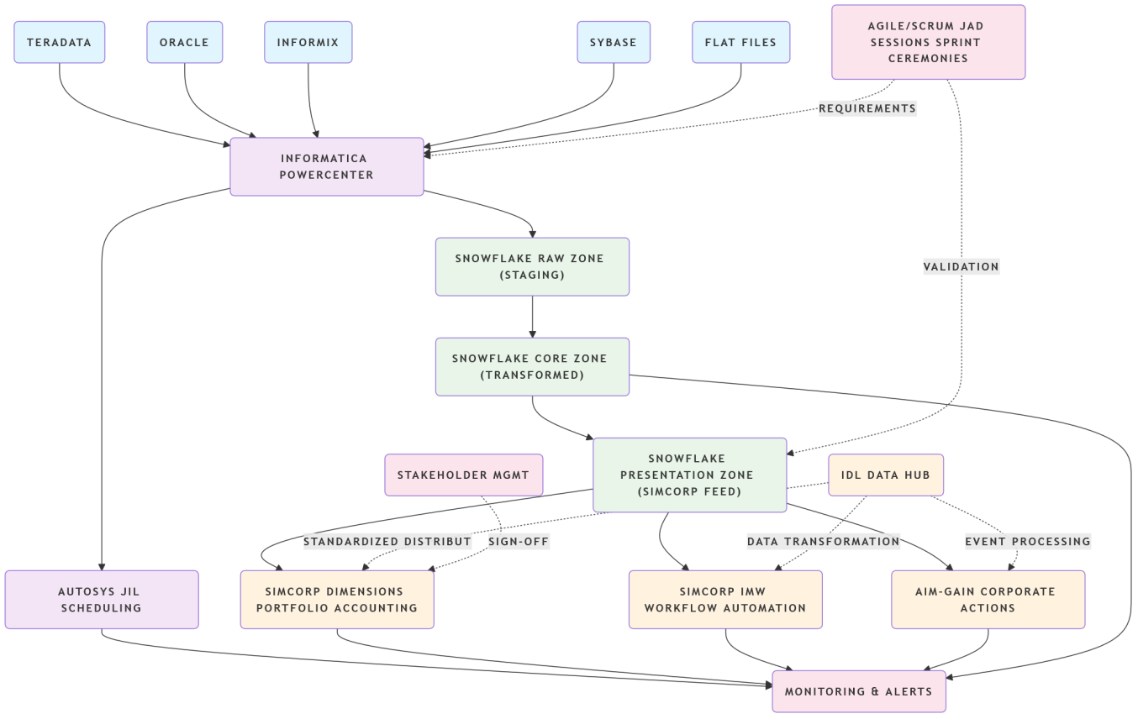
Figure 1: Architecture for Simcorp Dimensions Data Integration Platform
- ETL Layer & Data Ingestion:
  - ETL layer uses Informatica PowerCenter for cleaning and validating all source data from Teradata, Oracle, Informix, Sybase and Flat Files.
  - DIS Team will connect Unix (Operating System) to Databases by having the necessary Environment Setup to Connect to all databases as well as how PowerCenter transforms the data and handles errors in the ETL process.
  - WFE is an Automated Scheduled Process for a Workflow using Autosys JIL Scripts
- Data Management & Storage:
  - Snowflake Data Warehouse provides the capabilities of Scalable Storage, Multi-Currency Support and Optimized Queries for Simcorp Dimensions through the use of Data from Snowflake.
  - Custom Schema for the Different Classes of Assets within Snowflake have been developed, as well as maintenance of all Reconciliation Reference Data
- Application Layer / Integration Layer:
  - Simcorp Dimensions uses Snowflake Data for Accounting, Risk Analytic and Reporting Functions via a Batch Feed and an API Interface for the system.
  - The Simcorp IMW (Integrated Management Workbench) Module an Automated suite for processing; and their AIM-GAIN Module for monitoring Corporate Activities.
  - The IDL Data Hub reduces SimCorp’s dependency on Snowflake (i.e. the IDL Data Hub can replicate Snowflake's Data functions).
- Operations Layer / Governance Layer:
  - Monitoring involves Snowflake query tracking, as well as Informatica Workflow log analysis for Issue Resolution; Decision Support to help connect Business Requirements with Technology.
  - Agile Delivery Process will be managed via Scrum ceremonies that facilitate Collaboration between Teams.
  - Stakeholder Management will be aligned through working with Clients on aligning UBS Solutions.
In order to migrate SimCorp Dimensions with minimal downtime and Historical Data accuracy, implement a Phased Hybrid Migration Strategy consisting of a Big Bang Cutover of all Non-Critical Data followed by Incremental (Phased) Cutover(s) for all Critical Portfolio Related Data.There will be 4 phases during migration. For the first phase, there will be a 2-week period to load a basis reference file. For the second phase, over the next 4 weeks, there will be a delta load of historical transactions dating back 12-24 months. For the third phase, over another 4-week period, there will be a step-by-step reconciliation with previous system(s) in real-time. The Cutover will occur in one weekend. The architecture for the ETL Pipeline has several Source Systems (i.e. Oracle, Informix, Sybase, Teradata, etc.) and Flat Files that will be used as sources for the Informatica PowerCenter layer; these systems feed into the Informatica PowerCenter ETL Layer. The Snowflake Core Zone is where data transformation occurs; the Raw Zone is where the data is staged prior to being made available in the SimCorp Dimensions Feed. The primary mappings of the ETL Process will accommodate extraction from the Source backup, data cleansing, and the standardisation of currency and Instrument Codes.
Data Quality and Reconciliation are essential; there will be checks for Row Counts, NAV Reconciliation and, Referential Integrity. During migration, key considerations regarding SimCorp Dimensions include the following: Data Model Alignment, Multi-Currency Synchronisation of NAVs, and Batch/API integration. Risk reduction strategies will include rollback plans in the event of data loss, as well as data discrepancies, with specific triggers for a rollback action. Validation and Go-Live Checklists will verify that all Reference Data, Historical NAVs have been transferred successfully, and User Acceptance has taken place. The Migrations will follow overall Informatica - Snowflake Principles to ensure there will be 0% Data Loss, Minimal Downtime and Full Traceability throughout the Deployment of SimCorp Dimensions.
The Implementation of SimCorp Dimensions is broken into sequential steps. This process will include data migration, ETL design, implementation, testing, governance and post-go-live operational support. An important aspect during the entire project is to have clearly defined Data Management Governance surrounding a RACI matrix for data management definition, data quality, and auditor compliance through audit trails and data purification processes. To ensure a successful implementation, it is pivotal to have a strong testing strategy developed with multiple phases, where each phase entails; information mapping, integration testing, user acceptance with historical reference data, comparative analysis of the legacy NAV and stress testing for peak conditions.
The Execution Phase consists of having a very detailed go-live runbook with a checklist, having dual-write validation during cutover weekend, and supporting Hypercare for the next few weeks after the go-live of SimCorp Dimensions. Post-migration, there is a focus on optimizing the performance of Snowflake’s Queries and validating the batch settings and refining data loading options after migration. Also in the Operations phase, we continue to monitor Data Quality through Dashboard Monitoring, Breach Alerts within the capacity planning for Snowflake. The priority of Tasks should focus on immediate tasks including Testing Methodology, Go-live Preparations, and medium and low priority tasks relating to Cost Optimization, Performance Tuning, and Advanced Analytics after Hypercare.
The Testing Strategy is critical in ensuring a smooth transition from Legacy to SimCorp and relies heavily on the use of Actual Data Migration verified through User Acceptance Testing (UAT) prior to cutover. Additionally, The Document strongly supports the use of Agile/Scrum methodologies in managing complex data migration projects and specifically mentions using this approach during a SimCorp Migrations. The primary benefits of the agile/scrum methodologies are predictability of your delivery through direct stakeholder alignment and iterative validation throughout the project timeframe.It outlines a thorough approach to project planning with processes such as JAD sessions for converting legacy data into a new system, as well as a 12-week plan for the multiple phases of migration (Foundation, Historical Migration, Parallel Run/Cutover) on what and who needs to be done first (data modeling) with trained experts and how operational efficiencies can be achieved through daily standup meetings. In addition, it describes how sprint ceremonies (review/retrospective) are structured for the various multiple migration phases (Foundation, Historical Migration, Parallel Run/Cutover) with the goal of having all ETL jobs validated 100% as well as tracking the SLA (Service Level Agreement) for each ETL job.
The techniques used to identify the project’s requirements (workshops, prototypes, etc.) are key to improving the data model’s accuracy and enhancing the visibility of project stakeholders throughout the entire system implementation process. A proactive risk management strategy is supported by established project readiness (Definition of Ready) and Definition of Done) criteria, along with an impediment backlog to resolve any adversely impacting performance issues. The safety net rollback strategy allows for each sprint to create value; the parallel run serves as a final validation method prior to cutover.
The document also states that there are metrics to determine the impact of defects and budget variances due to using Agile leadership to convert data migrations from high-risk, big bang events into manageable, incremental steps, which have historically reduced timelines by 30-50% in past projects. By linking various Agile artifacts, ceremonies, roles, and technologies systematically to the various phases of the migration and the key deliverables, we will be able to better understand how the implementation of Agile/Scrum management will influence the success of the SimCorp Dimensions migration project.An extensive implementation plan utilizing Scrum and Agile methodologies for Migration.
The scopes of the prioritization of the product backlog are comprehensive Epic requirements of migration of Reference Data, Loading Historic Positions and Transactions, Consolidation and Parallel Runs, and the Execution of Go-Live and Cutover. The User Stories for each Epic contain specific Tasks and Acceptance Criteria to ensure successful delivery of results associated with those Epics. The Sprint capacity/team makes evaluation of its workload and provides Story Points with assigned Complexity to determine the Sprint capacity based on each task. The initial Sprints focus on Prototypes and Profiling Data. The final Sprints, focus on User Acceptance Testing and Performance Testing of the System.
Daily Standups allow for assessments of ETL Task updates, and Sprint Reviews present preliminary results and demonstrations to stakeholders. Retrospectives review the issues with Data, with the intent to develop further tools to improve the Data. Backlog Refinement Sessions allow for the modification of User Stories based upon newly found Data Anomalies or changes in the Business Processes. The key roles are identified as Product Owner, who is responsible for prioritizing Migration Requirements, Scrum Master, managing Agile Processes, and Development Team, who is responsible for technical aspects of Migration. Business Analysts assure the Data is accurate, and they provide oversight of the Cutover logistics.
Risk Management is included in Agile Artifacts, including Testing of Edge Scenarios and additional Research on API integrations. The Definition of Done includes Automation Testing Pass Rate, and Stakeholder Approval, and an Impediments Backlog provides a central location for documenting items that impede Data Availability. The Technical Integration Strategy will link Informatica Mapping Development to User Story Development, create Monitoring Dashboards for Autosys, and have Routine Validation of Snowflake Tables and Query Performance, as part of the Narrative Approval Process.
The Architectural Opportunities of SimCorp Dimensions include high availability (HA) of at or above 99.9% availability for the critical components, Snowflake, Informatica, Autosys, and SimCorp Dimensions' Feed. The HA design approach will have Redundancy and Failover Capability around the critical components, and thus reduce the amount of downtime across the various Systems. Snowflake uses Virtual Warehouses that support Replication and Auto-Scaling of Workload, while Informatica utilizes a Grid Configuration of Nodes and a Load Balancer approach to improve processing of Data. Autosys employs Dual Event Servers to improve Scheduling Reliability. Kafka/SQS provides Buffers and Retry Logic to maintain Data Integrity after Failures. The Architecture is designed around the two primary regions and DR Regions and provides detailed configurations on each component to allow for quick Failover and Recovery Times to keep Data available during Failures. Best Practices will include Multi-Cluster Setups of Snowflake, a Shared Repository of Informatica, and Robust Monitoring and Auto-Recovery.
Overall, the Design Focuses on High Resilience and Fast Recovery Times to help Businesses operate their respective Portfolios even if there is a failure. The Components are also discussed relative to the Recovery Time Objective (RTO) and Recovery Point Objective (RPO) associated with a Data Pipeline. A Snowflake ETL Process will be delivered to meet the target Pipeline Completion Time of Sixty (60) Seconds, as well as scheduled for Five (5) Minutes, to provide more flexibility to the Users about their Pipeline Scheduling Options: 5 Minutes, 15 Minutes, and 2 Minutes. Lastly, a SimCorp Feed can complete in One Minute. The importance of having at least Four Nines (99.99%) end-to-end availability is highlighted, to continue operations and processes of the Portfolio [13].
Component | RTO (Recovery Time) | RPO (Recovery Point)
Snowflake | 60 seconds | 5 minutes
ETL Pipeline | 5 minutes | 15 minutes
Scheduling | 2 minutes | None (resumable)
SimCorp Feed | 30 seconds | 1 minute
Table 1: RTO/RPO Targets
The SimCorp Dimension Architecture High Availability Metrics Dashboard highlights the most important metrics and thresholds associated with ensuring a high level of availability (HA), including a target Service Level Agreement (SLA) of 99.99% between SimCorp Dimension and the Snowflake Data Warehouse environments. The metrics also identify key HA measures including an expected warehouse availability of 99.99% with an alerting threshold of <99.9% for any 24-hour period, as well as an Informatica Job Success Rate of at least 99.9% with alerts for job failures and Autosys provides 100% schedule completion with all applicable job and workflow events logged. The Dashboard provides access to additional metrics for evaluating performance such as an average Snowflake Query Time of 2.1 seconds and a cache hit rate of 85% and a Job Success Rate of 99.9% (no Job Failures) for Informatica and no NAV Errors (acceptable NAV variance). Furthermore, there are established monitoring rules for alerts where critical alerts are given for any outages below 99.9% availability, and performance warnings for cache hit rate(s) below 70% and similar performance thresholds [14].
Monitoring of queries is performed in areas including Credit Usage, Cache Performance, and Warehouse Load. The success criteria proposed for the purpose of preparing for Go-Live include maintaining above 99.8% Snowflake availability; ETL Success Rate(s) of >98%; and NAV Accuracy approaching 100%(referenceable values) with acceptable variance. Data visualization tools such as Snowsight, Grafana, etc. are utilized for visualization of trend tracking and Performance Monitoring, along with Slack and Teams for alert and communication channels and to support proactive mitigations of HA interruptions, the below Figure 2 illustrates the proactive Monitoring Strategy to assure the continuous Availability of HA, Minimize Interruption and Maintain and Comply with Compliant Protocols.
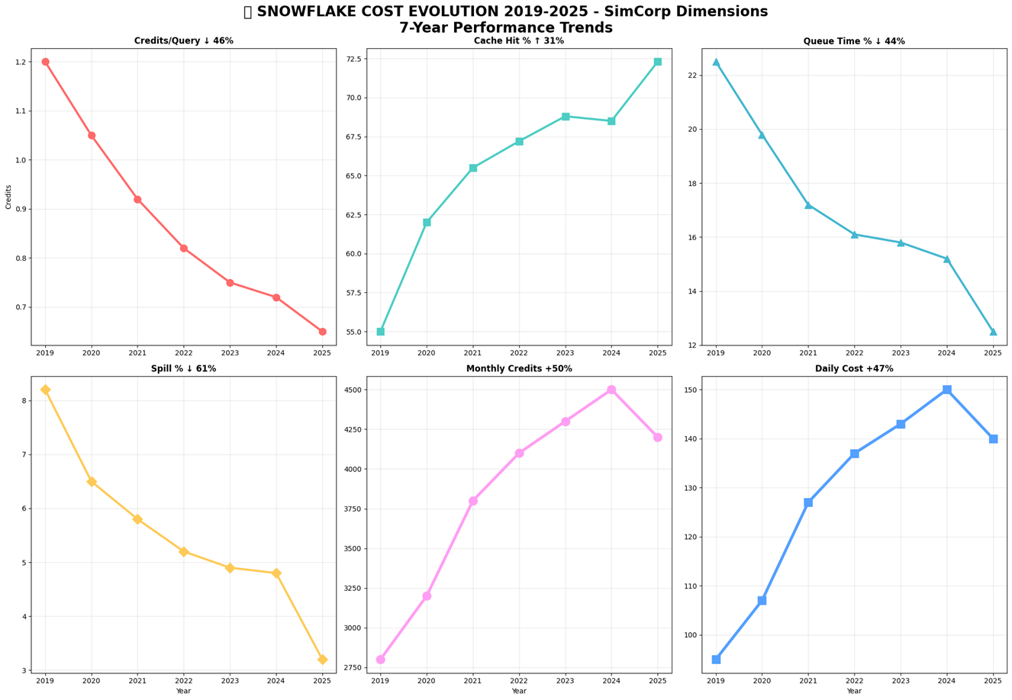
Figure 2: Snowflake Cost Evaluation

Conclusion
The Asset Management IT platform has evolved through the transformation of UNIFY into a cloud-native architecture using SimCorp Dimensions, Informatica ETL and Snowflake. Improvements include a 61% reduction of spill, a 31% increase in cache hits, and a 46% decrease in credits per query due to the increased level of data engineering experience. Data governance during the movement of assets to this new architecture was done using Agile, providing evidence of data integrity through dashboards allowing for process efficiencies of 30% to 70%. The architectural metrics convey the resiliency of the architecture by providing solid metrics indicating Critical Support with an RTO of less than 60 seconds. On the Technical Roadmap, the next stage will incorporate AI/ML capabilities to increase ETL performance with real-time updates using advanced APIs, along with continued development opportunities for an additional 25% cost savings. Additionally, the roadmap indicates a planned multi-region HA deployment along with emerging technologies (e.g., blockchain) to further enhance the position of the UNIFY program as an innovator of asset management technologies while moving toward the delivery of AI-driven operations that minimize NAV volatility, maximize efficiency, and optimize resources.

References
- “Asset Management Explained: Key Roles and Benefits”, Meeyeon Park, https://corporatefinanceinstitute.com/resources/career-map/sell-side/capital-markets/asset-management/.
- “5 Advantages of Hiring an Asset Management Company”, July 20, 2020, https://www.focusfinancial.com/5-advantages-of-hiring-an-asset-management-company/.
- "Asset Management Explained: Key Roles and Benefits", Meeyeon Park, 2015, https://corporatefinanceinstitute.com/resources/career-map/sell-side/capital-markets/asset-management/.
- "Redundant Software Functionality and Legacy Modernization : To Merge or Not to Merge", John Chang , 2019, https://www.castsoftware.com/pulse/merging-redundant-software-functionality-in-legacy-modernization .
- "Mawer selects SimCorp Dimension as its investment management platform", Pavithra R, September 10, 2020 , https://ibsintelligence.com/ibsi-news/mawer-selects-simcorp-dimension-as-its-investment-management-platform/..
- "Streamlining Laboratory Operations: Overcoming the Challenges of Point-to-Point Integrations", June 23, 2023, https://scitara.com/blog/streamlining-laboratory-operations-overcoming-the-challenges-of-point-to-point-integrations/.
- “Project, program and portfolio management as modes of organizing: Theorising at the intersection between mergers and acquisitions and project studies”, Joana Geraldi, Satu Teerikangas, Gustavo Birollo, May 2022, https://doi.org/10.1016/j.ijproman.2022.03.005.
- “Unified Asset Investment Portfolio Management”, 2023, https://riio3.cadentgas.com/ documents/aejp_05.pdf.
- “Transforming IT Asset Management”, 22 June 2023, greenbox, https://www.greenbox.com.au/ blog/2023/06/22/transforming-it-asset-management/.
- "Improve Business Agility Through Platform Consolidation", June 2018, https://www.servicenow.com/content/dam/servicenow-assets/public/en-us/doc-type/analyst-report/servicenow-forrester-platform-consolidation.pdf .
- “10 Best Practices to Avoid Cloud Vendor Lock-In”, Muhammad Raza, May 12, 2020, https://www.bmc.com/blogs/vendor-lock-in/.
- “4 Reasons Why Building Your Own Portfolio Accounting System Is Risky”, Stephen Van de Wetering, Feb 27, 2020, https://www.empaxis.com/blog/in-house-portfolio-accounting-system-risks.
- “Snowflake: Bar Chart in Native Streamlit”, Eric Heilman, 2023, https://ericheilman.com/2023/12/11/snowflake-bar-chart-in-native-streamlit/.
- “8 Snowflake Metrics to Help You Optimize Your Spend Now”, Skye Callan, June 4, 2024, https://keebo.ai/2024/06/04/8-snowflake-metrics-to-help-you-optimize-your-spend-now/.

