Energy Management System for Dynamic Power Balancing Between Photovoltaic and Fuel Cell Sources in a Standalone DC Microgrid
Ameze Big-Alabo
Department of Electrical/Electronic Engineering, Faculty of Engineering, University of Port Harcourt, PMB 5323, Port Harcourt, Rivers Nigeria.

ameze.odia@uniport.edu.ng
https://orcid.org/0000-0001-5384-888X

Abstract
This paper presents an energy management strategy for a standalone photovoltaic (PV) and proton exchange membrane fuel cell for a DC microgrid based on a sizing-oriented design philosophy. Unlike conventional hybrid architectures that rely on auxiliary energy storage devices or hierarchical voltage control structures, the proposed framework demonstrates that accurate source sizing combined with coordinated power balancing can inherently maintain DC bus voltage stability through real-time generation–load equilibrium. The PV array operates as the primary energy source under high irradiance conditions using a perturb and observe, P&O algorithm for maximum power point tracking. This is then combined with a PEMFC subsystem, interfaced through a two-phase interleaved boost converter that compensates for power deficits during low solar availability. The EMS continuously evaluates the instantaneous power mismatch and generates a reference current for the fuel cell to restore equilibrium without centralized voltage reference enforcement. Simulation results under step irradiance variation demonstrate smooth source transition, negligible overshoot of <5% and tight DC bus regulation within ±1.25%. The findings confirm that DC bus stability can be achieved as a direct consequence of power balance rather than aggressive hierarchical voltage control. The proposed architecture eliminates battery storage, thereby reducing system complexity, cost, and maintenance requirements. Moreover, the EMS improves hydrogen utilization efficiency by activating the fuel cell only during periods of insufficient solar generation. As a result, hydrogen fuel is conserved and used strictly when a solar power deficit occurs. This operating strategy makes the system particularly suitable for medium power standalone applications such as remote telecommunication stations and rural electrification systems.
Key words: Photovoltaic system; Proton exchange membrane fuel cell; Energy management system; Interleaved boost converter; DC Microgrid.
- Introduction
Direct current (DC) microgrids have gained significant attention due to their inherent compatibility with renewable energy sources, reduced conversion stages, higher efficiency, and simplified control structures compared to conventional AC systems. Photovoltaic (PV) arrays and proton exchange membrane fuel cells (PEMFCs) are particularly suitable for DC microgrid integration since both are native DC sources. Their hybridization offers complementary operational characteristics whereby PV systems provide clean and cost-effective daytime generation, while fuel cells ensure dispatchable and reliable supply during low irradiance periods or nighttime operation. Despite these advantages, hybrid PV fuel cell (FC) systems present several control challenges for example, the intermittency of solar irradiance introduces significant power fluctuations, whereas fuel cells exhibit slower electrochemical dynamics and hydrogen consumption constraints. These factors complicate DC bus voltage regulation, and power sharing coordination which has led to the investigation of advanced control and energy management strategies (EMS) to address these issues. These control and EMS strategies aid in voltage regulation which is a central objective in DC microgrids. Riad et al. [1] proposed an Artificial Rabbits Optimization (ARO) tuned fractional order PID controller for PEMFC voltage regulation, demonstrating improved transient response and reduced overshoot compared to conventional PID controllers. Similarly, Wan et al. [2] developed a hierarchical voltage control strategy for DC microgrids incorporating multiple FC, emphasizing efficiency optimization under both grid connected and islanded modes. Wen et al. [3] further proposed a hierarchical framework for PV storage hydrogen systems to enable smooth mode transitions while maintaining voltage stability. In addition to classical and fractional control techniques, intelligent controllers have gained prominence for example, Nureddin et al. [4] introduced a deep neural network power management controller for hybrid PV–FC systems which helped to improve maximum power point tracking (MPPT) accuracy and power quality. Devakirubakaran et al [5] applied ANFIS-based MPPT to PEMFC systems to enhance tracking performance under dynamic operating conditions. These intelligent methods can improve adaptability but often increase computational complexity.
Beyond voltage control, effective energy management strategies are essential to ensure power balance and hydrogen efficiency. Alharbi et al. [6] proposed a Beluga Whale Optimization-based EMS to minimize hydrogen consumption in PV–FC–battery systems. Fathy et al. [7] introduced an adaptive fuzzy EMS optimized using metaheuristic algorithms while Gugulothu et al [8] and Kamel et al [9] implemented centralized PI coordination schemes incorporating batteries for enhanced reliability. Other approaches include droop and multi-time scale coordination strategies for example Sharma et al. [10] presented a dynamic power management scheme for hybrid AC/DC microgrids, while Hossain et al. [11] proposed stepwise filtering integrated with droop controllers to stabilize hydrogen DC microgrids. Han et al. [12] introduced a two level EMS combining supervisory and local controllers. Advanced nonlinear control methods, such as flatness control [13], virtual impedance damping strategies [14] and Adaptive control [15] as well as optimal based EMS [16] have also been reported to enhance transient performance.
While these studies significantly advance DC microgrid control, most architectures include multiple storage devices such as batteries or supercapacitors to buffer power mismatches. Although effective, these additions increase system cost and maintenance complexity. For example, energy storage elements such as batteries, supercapacitors, or electrolyzers are incorporated to compensate for power imbalances and enhance dynamic performance. Although optimization energy management strategies (EMS) effectively improve hydrogen utilization and overall efficiency, they seldom investigate the possibility of achieving intrinsic voltage stabilization through proper source sizing. Consequently, limited attention has been devoted to simplified PV–FC architectures in which accurate generation sizing and coordinated EMS alone ensure stable DC bus operation without centralized voltage reference enforcement. In particular, the fundamental relationship between appropriate generation sizing, real-time power equilibrium, and inherent DC bus voltage stabilization remains largely underexplored in standalone PV–FC systems.
This study therefore proposes an effective energy management framework for a standalone PV–FC DC microgrid without auxiliary storage devices. The system comprises a PV array designed to supply a daytime load and fuel cell system with interleaved boost converter to provide support during nighttime particularly when there is low irradiance condition. The primary contribution of this work lies in a sizing design philosophy, demonstrating that accurate balance of PV and FC capacities to load demand enables inherent DC bus stabilization. An EMS is implemented such that the PV system dominates during high irradiance, while the FC compensates during reduced solar availability, without the need for centralized hierarchical voltage enforcement. By eliminating auxiliary battery storage, the proposed architecture reduces structural complexity, cost, and maintenance requirements. This PV–FC DC microgrid architecture is particularly well suited for medium power standalone applications where reliability, autonomy, and reduced maintenance are critical. Remote telecommunication stations, for example, require uninterrupted 24-hour power in isolated areas where grid access is unavailable and battery maintenance is costly. Rural electrification systems in off-grid communities can benefit from this architecture by providing stable power supply for lighting, communication, and small industrial loads without dependence on diesel generators. In general, these applications demand a reliable power supply without the lifecycle and thermal management challenges associated with battery storage, making properly sized PV–FC systems an attractive and sustainable long-term solution.

- Review of PV and PEM Fuel Cell.
This section presents the mathematical modelling equations that govern the PV and FC renewable energy sources.
  - Modelling of Photovoltaic System.
The PV cell is modeled using the single-diode model and the governing equation is stated in Eqn 1 which describes the current voltage I-V characteristics of the PV cell [17].

$$I=I_{l}-I_{S}\left(exp\left(\frac{V+IR_{s}}{mn_{se}V_{T}}\right)-1\right)-\frac{V+IR_{s}}{R_{sh}} (1)$$
Where $I_{l}$ is the light induced current, $I_{S}$ is the diode dark saturation current, $m$ is the diode quality factor, $R_{s}$is the series resistance, $R_{sh}$ is the shunt resistance, $n_{se}$ is the number of series-connected cells in the PV module, $V_{T}$ is the thermal voltage. The induced current in Eqn 1 is affected by changes in the irradiance and temperature [18]. The efficiency of the solar PV system depends on the panel’s output voltage and current such that the maximum power point MPP is the operating point at which the PV current and voltage is maximum. Hence, this study employs the conventional perturb and observe P&O technique for maintaining the MPP [19].
  - Modelling of PEM Fuel cell
The mathematical model of the nonlinear voltage–current characteristics of a typical PEMFC is expressed by Eqn 2 [20]:
$$V_{FC}=E_{Nernst}-V_{act}-V_{Ω}-V_{conc} (2)$$
Where $E_{Nernst}$ is reversible thermodynamic open circuit voltage per cell function of temperature and reactant partial pressures. $V_{act}$activation overpotential due to reaction kinetics at electrodes. $V_{Ω}$is ohmic drop due to ionic/electronic resistances resulting from the membrane, electrodes and contacts. $V_{conc}$concentration is the mass-transport at high current densities.
The $E_{Nernst}$ voltage is determined by Eqn (3):
$$E=E^{0}+ \frac{RT}{2F}ln\left(\frac{P_{H_{2}}\sqrt{P_{O_{2}}}}{P_{H_{2}O}}\right) (3)$$
where $E^{0}$ is the standard reversible cell potential, $R$ is the universal gas constant, $T$ is the absolute temperature, $F$is Faraday’s constant, $P_{H_{2}},P_{O_{2}}, P_{H_{2}O}$​ are the partial pressures of hydrogen, oxygen, and water, respectively.
- Methodology
This section presents the PV – FC system architecture and the EMS control strategy for balancing power sharing the standalone DC microgrid.
  - System Architecture
The system architecture implemented in this study is a standalone hybrid PV–FC DC microgrid designed to ensure reliable power supply and stable DC bus operation. As shown in Fig. 3.1., the PV array is interfaced to the DC bus through a conventional boost converter regulated by P&O MPPT algorithm. The MPPT controller dynamically adjusts the converter duty cycle to extract maximum available power from the PV array under changing irradiance levels. The fuel cell subsystem is connected to the same DC bus via a two-phase interleaved boost converter. The interleaved topology is adopted to reduce input current ripple, improve current sharing, enhance transient performance, and increase power handling capability. Unlike the PV subsystem, which operates in maximum power extraction mode, the FC operates in controlled current mode.
An EMS generates a reference current for the fuel cell based on the power deficit between the load demand and the PV output. This reference is tracked using the PI current controller, which regulates the duty cycles of the interleaved boost converter switches. Through this coordinated control strategy, the PV operates as the primary source while the fuel cell compensates for power mismatch, thereby maintaining DC bus voltage stability and ensuring power balance in the standalone system.
Fig 3.1. Standalone PV–FC DC microgrid architecture with EMS and PI current control
  - Design of the PV and PEM fuel cell
The PV array is sized to supply 4.4 kW under standard test conditions (STC), allowing it to operate as the primary power source during high irradiance conditions. The array configuration consists of 11series-connected modules per string and 2 parallel strings. This configuration raises the array voltage to approximately 290 V at MPP, making it suitable for stepping up to the regulated 400 V DC bus via the boost converter. The I – V and P – V characteristics design are given in Fig 3.2. while the specification design parameters are given in Table 1.

Fig 3.2. I – V and P -V characteristics of a typical PV system @ 1000 W/m² irradiance levels
Table 1: PV array data Specification
Parameter | Symbol | Value
Total Rated Power | P | 4.4 kW
Modules per String | N_{s} | 11
Parallel Strings | N_{p} | 2
Open Circuit Voltage | V_{oc} | 32.9
Short Circuit Current | I_{sc} | 8.21 A
Voltage at MPP | V_{mp} | 26.4 V
Current at MPP | I_{mp} | 7.58 A
Cells per Module | N | 60

Fig 3.3. V – I and P – I characteristics for a PEM Fuel Cell
The PEMFC subsystem is designed to contribute significantly to the DC load demand, particularly during periods of low solar irradiance. The PEM fuel cell stack is rated at 4.2 kW nominal power to ensure adequate load support and dynamic power balancing capability. The V–I curve demonstrates the typical decreasing voltage trend with increasing current due to polarization losses, while the P–I curve shows peak power near the rated current region as shown in Fig 3.3. The basic design parameters of the PEMFC are given in Table 2.
Table 2. PEMFC Design Parameters
Parameter | Symbol | Value
Nominal Power | P | 4.2 kW
Nominal Voltage | V | 210 V
Nominal Current | I | 20 A
Nerst voltage of one cell | V | 1.2102 V
Hydrogen Utilization | – | 99.5%
Air Utilization | – | 50%

The PV array and PEMFC stack are rated at 4.4 kW and 4.2 kW, respectively, to adequately support the 4 kW standalone DC load demand. The photovoltaic subsystem is configured as the primary energy source under standard irradiance conditions, ensuring maximum utilization of solar energy during daytime operation. The PEMFC serves as a complementary source, supplying power during periods of reduced solar availability, particularly at night or under low-irradiance conditions. The adoption of a two-phase interleaved boost converter for the fuel cell enhances current ripple suppression, improves transient response, and increases overall conversion efficiency. The selected power ratings ensure that, under nominal operating conditions, either the PV array or the PEMFC can independently meet the full load requirement. During irradiance degradation, the EMS dynamically generates a reference current for the fuel cell, activating its current control loop to compensate for the power deficit. This coordinated power sharing strategy ensures DC bus voltage regulation and uninterrupted power supply to the DC load.
  - Energy Management System of PV and PEMFC
The mathematical modelling of the EMS is given by Eqn. 4 and (5) and the corresponding flow chart is presented in Fig 3.4
$$P_{def}=P_{load}-P_{pv} (4)$$
$$\left\{\begin{matrix}0 { P}_{def}≤ϵ \\ \min\left(\frac{P_{def}}{V_{fc}},I_{fcf},max\right),P_{def}>ϵ\end{matrix}\right. \left(5\right)$$
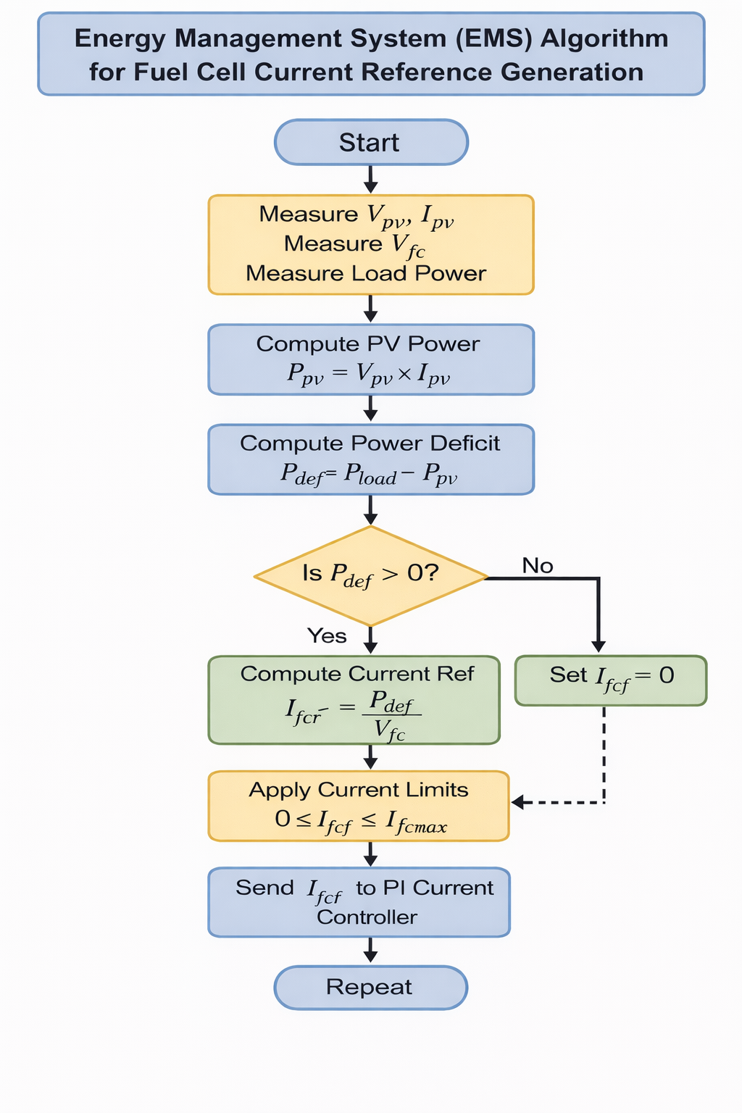
Fig. 3.4. Flowchart of the designed Energy Management System for PV – PEMFC
The EMS continuously measures the instantaneous PV voltage and current, fuel cell voltage, and load power. The instantaneous PV power is computed and compared with the load demand to determine the power deficit, $P_{def}$. If the PV power is lower than the load demand, the EMS computes the required PEMFC reference current based on $P_{def}$.. Otherwise, when the PV power is sufficient to meet the load demand, the reference current to the fuel cell, $I_{fcf}$. is set to zero so that there is no power supply coming from the PEMFC. The computed reference is then subjected to predefined current limits to ensure safe fuel cell operation before being transmitted to the PI current controller. This supervisory control strategy enables dynamic power balancing between the PV and PEMFC while maintaining DC bus stability.
- Results and Discussion
This section presents the results obtained from the PV – PEMFC EMS system considering the effect of the irradiance on the PV power response, the power balance between the PV and PEMFC and the corresponding effect on the DV bus voltage.
  - Irradiance Profile and corresponding PV Power Response
Figure 4.1 presents the irradiance profile and the corresponding PV power response. From $t= 0 to t=0.5 s$, the applied solar irradiance is maintained at 1000 W/m², representing standard test condition operation. At $t=0.5 s$, a step reduction is introduced, and the irradiance drops sharply to approximately 20 W/m², simulating night conditions or severe cloud cover. The corresponding PV power response follows the irradiance variation as expected. During the interval from 0 to 0.5 s, the PV system delivers up to 4 kW to the DC load, while about 0.4 kW accounts for system losses, resulting in a total generated power of roughly 4.4 kW. This value is consistent with the rated capacity of the PV array operating near its MPP.

Fig 4.1.: Irradiance Profile and corresponding PV Power Response

  - Power balance between PV, PEMFC and Load
Fig 4.2 presents the power balance between PV, PEMFC and the DC load.
Fig 4.2. Power balance between PV, PEMFC and DC Load
During the initial interval from 0 to 0.5 s, the PV array supplies about 4.4 kW, which includes the 4 kW delivered to the load and approximately 0.4 kW accounting for system losses, while the fuel cell output remains essentially at 0 W. This confirms that under high irradiance conditions, the PV system operates as the primary energy source, and the fuel cell remains inactive, thereby preventing unnecessary hydrogen consumption. The power balance condition is therefore satisfied by the PV subsystem alone.
Following the irradiance drop at 0.5 s, the PV output decreases sharply to approximately 0 – 20 W. In response, the fuel cell ramps up its output to approximately 4.0 kW, with an additional ~0.2 kW covering PEMFC system losses, while the load demand remains constant at about 4 kW. The transition is smooth, without significant oscillations or overshoot, indicating stable dynamic performance. This behavior confirms proper supervisory EMS logic coordination such that when PV power decreases, PEMFC compensates with a corresponding increase in output power to meet load demand.
  - DC Bus Voltage Response due to power balance between PV and PEMFC
The corresponding DC bus voltage response in Fig 4.3, demonstrates stable and regulated performance across all operating conditions. During the startup phase (0–0.1 s), the voltage rises smoothly from 0 V to approximately 400 V, settling rapidly within about 0.1 seconds with minimal overshoot of less than 5%. This indicates proper converter tuning and appropriate DC-link capacitor sizing. In steady operation between 0.1–0.5 s, the DC bus voltage remains tightly regulated at 400 V, with very small ripple estimated to be below 1–2%. When the source transition between PV and PEM takes place at t = 0.5 s, the voltage remains essentially constant at 400 V, with no noticeable oscillation, with a deviation of less than ±1.25%. This is a critical result, as it confirms that real-time power balance between generation and load is maintained. Since the load remains constant and total generation continuously matches demand, the DC bus capacitor does not experience net charging or discharging. Therefore, voltage stability is achieved through power equilibrium rather than aggressive voltage reference tracking.
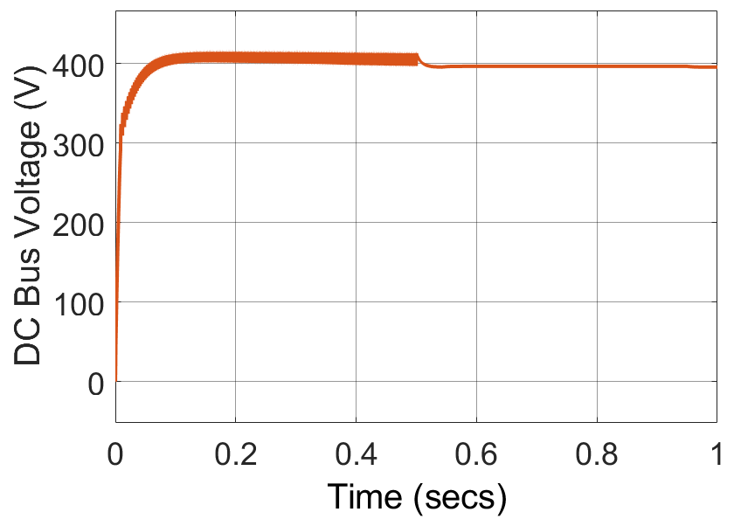
Fig 4.3: Voltage response due to power balance between PV, PEMFC and DC load
It is also observed that during operation from t = 0.5 s onward, the PEMFC produces a noticeably smoother DC bus voltage compared to the PV system. This improved voltage quality is attributed to the use of an interleaved boost converter in the PEMFC, which inherently reduces current ripple and distributes switching events across multiple phases. In contrast, the PV system employs a conventional single-phase boost converter, which results in larger voltage fluctuations. The interleaved topology not only enhances DC bus voltage stability but also reduces stress on the capacitor and other power electronics, demonstrating a clear advantage in dynamic and steady-state performance.
Limitation of study
Although the PV and PEMFC energy management strategy successfully maintains DC bus voltage stability through power equilibrium, certain practical limitations are acknowledged. The fuel cell inherently exhibits slow electrochemical dynamics and limited ramp-rate capability particularly under rapidly varying irradiance conditions. During abrupt solar transients, the delayed response of the fuel cell may result in short duration power mismatches before full compensation is achieved, potentially leading to minor DC bus voltage deviations. In this study, such effects are mitigated due to controlled irradiance step variations and appropriate source sizing. However, under highly intermittent solar profiles the intrinsic slow dynamics of the fuel cell could constrain dynamic performance. Furthermore, voltage stability is achieved primarily through generation–load equilibrium rather than high-bandwidth closed loop voltage reference enforcement, which may limit robustness under severe disturbances or sudden load steps.
As future work, the integration of a small auxiliary energy storage unit such as a battery or supercapacitor could be investigated to absorb excess PV energy during high irradiance periods and supply transient deficits during rapid irradiance drops. Such a hybrid extension would enable improved dynamic buffering, enhance fuel cell lifetime by reducing frequent ramping, and allow surplus daytime energy to be stored for nighttime use. This will help to improve overall system flexibility and energy utilization efficiency.
Conclusion
This paper presented a simplified EMS for a standalone PV–EMS DC microgrid based on a sizing oriented design philosophy. Unlike conventional approaches that rely on hierarchical voltage regulation structures or auxiliary storage devices, the proposed framework demonstrates that accurate generation sizing combined with coordinated energy management can inherently maintain DC bus voltage stability through real-time power equilibrium. Simulation results under step change in irradiance showed that the EMS successfully prioritized PV generation during high solar availability and smoothly transitioned to PEMFC dominance when PV output decreased due to low irradiance. Throughout the transition, the total generated power closely matched the load demand, satisfying the equilibrium condition thereby maintaining a stable DC bus. The results confirm that DC bus stability can be achieved as a direct consequence of power balance rather than aggressive hierarchical control.
Certain limitations were identified, which is the inherent slow dynamic response of the PEMFC under rapidly varying irradiance conditions may introduce transient power mismatches, potentially affecting short term voltage stability under extreme disturbances. While acceptable under moderate irradiance variations, practical large-scale implementations may require additional dynamic support mechanisms. Future work will therefore focus on integrating a small auxiliary energy storage element, such as a battery or supercapacitor, to absorb excess PV generation during high irradiance periods and provide fast transient compensation during rapid solar fluctuations
Overall, this work introduces an alternative design paradigm for standalone PV–PEMFC DC microgrids, emphasizing generation–load equilibrium and proper source sizing as fundamental mechanisms for intrinsic voltage stabilization. The findings provide a foundation for reduced complexity, cost-effective, and reliable hydrogen-based renewable power systems.
Acknowledgement
I wish to acknowledge the Alexander von Humboldt Foundation for the sponsorship of my research fellowship, Germany of which this work forms a part.
Declaration of conflicting interest
The author declares that they have no known competing financial interests or personal relationships that could have appeared to influence the work reported in this paper.
Data availability statement
All necessary data have been included in the manuscript.

Referencing
- A. J. Riad, H. M. Hasanien, Z. Ullah, A. Alkuhayli and A. H. Yakout, "Voltage Control of PEM Fuel Cell in a DC Microgrid Using Optimal Artificial Rabbits Algorithm-Based Fractional Order PID Controller," in IEEE Access, vol. 12, pp. 89191-89204, 2024, doi: 10.1109/ACCESS.2024.3419561.

- Z. Wan, H. Guo, F. Wang, Y. Zhu and S. Wu, "Voltage Hierarchical Control for a DC Microgrid Considering Multiple Fuel Cell Efficiency Optimization," 2024 CPSS & IEEE International Symposium on Energy Storage and Conversion (ISESC), Xi'an, China, 2024, pp. 670-675, doi: 10.1109/ISESC63657.2024.10785513.
- C. Wen, N. Sun, F. Xue, B. Sun, J. Wu, J. Chen, X. Xue. A hierarchical control framework for PV-storage-hydrogen DC microgrids under varying conditions. AIP Adv. 2025;15(10).
- A.A.M. Nureddin, J. Rahebi, and A. Ab-BelKhair. "Power management controller for microgrid integration of hybrid PV/fuel cell system based on artificial deep neural network." International Journal of Photoenergy 2020.1 (2020): 8896412. https://doi.org/10.1155/2020/8896412.

- S. Devakirubakaran, C. Bharatiraja, T. Narasimha Prasad, B. Praveen Kumar, and S. Shitharth, ‘Optimal power generation of proton exchange membrane fuel cell using ANFIS based MPPT algorithm. Scientific Reports, 14, (2024): 26455. doi: 10.1038/s41598-024-77696-w

- A. G., Alharbi, A. G. Olabi, H. Rezk, A. Fathy and M. A. Abdelkareem, ‘Optimized energy management and control strategy of photovoltaic/PEM fuel cell/batteries/supercapacitors DC microgrid system’. Energy, 290, (2024) 130121. https://doi.org/10.1016/j.energy.2023.130121

- A. Fathy, S. Ferahtia, H. Rezk, D. Yousri, M.A. Abdelkareem and A.G. Olabi, ‘Optimal adaptive fuzzy management strategy for fuel cell-based DC microgrid’. Energy, 247, (2022): p.123447. https://doi.org/10.1016/j.energy.2022.123447

- R. Gugulothu, B. Nagu, and D. Pullaguram. Energy management strategy for standalone DC microgrid system with photovoltaic/fuel cell/battery storage. Journal of Energy Storage, 57, (2023) 106274. https://doi.org/10.1016/j.est.2022.106274

- A. Kamel, H. Ahmed, H. Rezk, N. Shehata, and J. Thomas. "Energy management of a DC microgrid composed of photovoltaic/fuel cell/battery/supercapacitor systems." Batteries 5, no. 3 (2019): 63. https://doi.org/10.3390/batteries5030063

- R. K. Sharma and S. Mishra, "Dynamic Power Management and Control of a PV PEM Fuel-Cell-Based Standalone ac/dc Microgrid Using Hybrid Energy Storage," in IEEE Transactions on Industry Applications, vol. 54, no. 1, pp. 526-538, (2018), doi: 10.1109/TIA.2017.2756032

- M.A. Hossain, E. MacA. Gray, J. Lu, Enhancing stability in islanded DC hydrogen microgrids using step-wise filtering and autonomous control, Journal of Power Sources, Volume 663, 2026, 238829, https://doi.org/10.1016/j.jpowsour.2025.238829.
- Y. Han, W. Chen, Q. Li, H. Yang, F. Zare, and Y. Zheng, "Two-level energy management strategy for PV-Fuel cell-battery-based DC microgrid." International Journal of Hydrogen Energy 44, no. 35 (2019): 19395-19404. https://doi.org/10.1016/j.ijhydene.2018.04.013

- F. A. Abbas, A. A. Obed, A. Alhasiri and S. J. Yaqoob, A Hybrid Renewable Sources Implementation for a DC Microgrid with Flatness-Nonlinear Control to Achieve Efficient Energy Management Strategy. Journal of Techniques, 5(4), (2023): 16–27. https://doi.org/10.51173/jt.v5i4.1005

- M. Hamzeh, M. Ghafouri, H. Karimi, K. Sheshyekani and J. M. Guerrero, "Power Oscillations Damping in DC Microgrids," in IEEE Transactions on Energy Conversion, vol. 31, no. 3, pp. 970-980, Sept. 2016, doi: 10.1109/TEC.2016.2542266
- C. R. de Aguiar, G. H. F. Fuzato, R. Q. Machado and J. M. Guerrero, "An Adaptive Power Sharing Control for Management of DC Microgrids Powered by Fuel Cell and Storage System," in IEEE Transactions on Industrial Electronics, vol. 67, no. 5, pp. 3726-3735, May 2020, doi: 10.1109/TIE.2019.2916312.

- A. Kadri, H. Marzougui and F. Bacha, "Optimal Control based Energy Management Strategy of Photovoltaic/Fuel Cell/Supercapacitor Hybrid Power System," 2022 8th International Conference on Control, Decision and Information Technologies (CoDIT), Istanbul, Turkey, 2022, pp. 1356-1361, doi: 10.1109/CoDIT55151.2022.9804028.

- M.G. Villalva, J.R. Gazoli, E.R. Filho, Comprehensive approach to modeling and simulation of photovoltaic arrays, IEEE Trans. Power Electron. 24 (2009) 1198–1208

- P. Bharadwaj, K.N. Chaudhury and V. John, Sequential optimization for PV panel parameter estimation. IEEE J. Photovolt. 6 (5), 1261–1268 (2016).

- S. Thakran, J. Singh, R. Garg, and P. Mahajan, ‘‘Implementation of P&O algorithm for MPPT in SPV system,’’ in Proc. Int. Conf. Power Energy, Environ. Intell. Control (PEEIC), Apr. 2018, pp. 242–245, doi: 10.1109/peeic.2018.8665588

- B. Xia, P. Guo, X. Wei, and H. Zong. Reaction gas pressure, temperature, and membrane water content modulate electrochemical process of a PEMFC: A simulation study. Advances in Materials Science and Engineering, 2023, 1346872. https://doi.org/10.1155/2023/1346872

