Optimizing Circulation and Wayfinding Using Space-Syntax Principles in the Proposed International Conference Centre, Aluu, Rivers State.

1. Introduction
The increasing growth of international business, diplomacy, tourism, and academic collaboration has created greater demand for modern conference centres that support diverse activities within efficient, flexible, and sustainable environments. Contemporary conference centres function as multifunctional facilities comprising conference halls, exhibition spaces, banquet halls, administrative offices, commercial areas, and recreational facilities. Consequently, efficient spatial organisation has become essential for improving operational performance, accessibility, and user satisfaction (Mohamed & van der Laag-Yamu , 2024).
Circulation is a fundamental component of architectural planning because it determines how effectively users move between interconnected spaces. Efficient circulation reduces congestion, shortens travel distances, improves accessibility, supports emergency evacuation, and enhances overall building performance. In conference centres, where delegates, exhibitors, organisers, and visitors move simultaneously through multiple functional areas, poorly planned circulation often results in congestion, conflicting pedestrian flows, and reduced operational efficiency (Ereama, 2026). Effective circulation is therefore closely linked with successful wayfinding, which enables users to understand building layouts and navigate unfamiliar environments with minimal difficulty. Architectural features such as spatial hierarchy, visual connectivity, landmarks, and signage contribute significantly to users' orientation and movement (Akubue, 2022).
Space Syntax has emerged as one of the most effective evidence-based approaches for evaluating spatial configuration and predicting movement behaviour. Through measures such as integration, connectivity, intelligibility, visibility, and choice, it enables architects to assess circulation performance during the design stage rather than relying solely on intuition. Recent studies demonstrate its successful application in healthcare, educational, transportation, commercial, and public buildings, although its application to conference centres, particularly within Nigeria, remains limited (Mohamed & van der Laag-Yamu, 2024; Lee et al., 2023; Shang et al., 2026).
Many conference facilities in developing countries continue to experience inefficient circulation, fragmented spatial organisation, poor wayfinding, and inadequate functional zoning, resulting in reduced accessibility and user satisfaction. These challenges highlight the need for evidence-based design strategies capable of improving circulation efficiency and spatial legibility. The proposed International Conference Centre in Aluu, Rivers State, presents an opportunity to address these issues by integrating Space Syntax principles with sustainable environmental design.
This study has important implications for architectural design, planning practice, and future research on conference centre development. By demonstrating the applicability of Space Syntax principles to the planning of international conference centres, the study provides an evidence-based framework for improving circulation efficiency, wayfinding, and spatial performance in complex public buildings.
For architects and designers, the findings emphasise that circulation planning should extend beyond the provision of movement corridors to include spatial integration, visual connectivity, environmental legibility, and landscape design. Integrating these elements during the conceptual design stage can reduce congestion, improve accessibility, and enhance user experience.
For policymakers and institutional clients, the study provides practical guidance for planning conference facilities that meet international standards while responding to local environmental and functional requirements. Academically, the research contributes to the growing body of knowledge on evidence-based architectural design by extending the application of Space Syntax to conference centre planning in Nigeria. The study also establishes a framework that can be adapted for the planning of other complex public buildings, including convention centres, airports, hospitals, university campuses, and transportation terminals.
The study focuses on the proposed International Conference Centre located in Aluu, Ikwerre Local Government Area, Rivers State, Nigeria. The site was selected because of its strategic location, accessibility, proximity to major educational institutions, and potential to serve as a regional hub for conferences, exhibitions, and related international events. The insights derived from the comparative case studies were adapted to the environmental, cultural, and functional characteristics of the proposed development site.
Despite its contributions, this study has several limitations. The research relied primarily on documentary analysis and comparative evaluation of selected precedent projects. Consequently, the findings were not validated through post-occupancy evaluation or direct behavioural observation of users within completed conference centres.
Similarly, Space Syntax software simulations, such as DepthmapX and advanced Visibility Graph Analysis (VGA), were beyond the scope of the present study. While the research adopted Space Syntax principles conceptually, future investigations should integrate computational spatial analysis to quantify movement patterns and validate the proposed circulation framework.
Finally, the study focused specifically on international conference centres. Therefore, caution should be exercised when applying the findings directly to other building typologies without considering their unique functional and spatial requirements.
2. Literature Review
This review synthesises contemporary literature on circulation efficiency, wayfinding, and Space Syntax as they relate to the planning and design of international conference centres. Rather than presenting studies descriptively, the review critically examines existing knowledge, identifies areas of agreement and disagreement, and highlights research gaps that justify the present study. Recent architectural research increasingly adopts evidence-based design approaches that integrate spatial analysis with human behavioural studies to improve accessibility, movement efficiency, and user experience (Mohamed & van der Laag-Yamu, 2024; Meng & Zhang, 2025).
2.1 International Conference Centres
International conference centres are multifunctional public facilities designed to accommodate conferences, exhibitions, conventions, business meetings, and other large-scale events. Modern conference centres integrate plenary halls, exhibition spaces, seminar rooms, banquet halls, breakout rooms, restaurants, administrative offices, and support facilities within a unified spatial system. Their effectiveness depends not only on architectural aesthetics but also on functional efficiency, flexibility, accessibility, environmental sustainability, and well-planned circulation systems (Ereama, 2026; ICCA, 2024).
The diversity of users including delegates, exhibitors, organisers, media personnel, service staff, and VIP guests creates complex movement patterns that require carefully coordinated circulation networks. Contemporary research emphasises user-centred planning, environmental quality, and intuitive wayfinding as essential factors influencing operational performance. However, existing studies have focused largely on sustainability and functional planning, with comparatively little attention given to circulation efficiency through Space Syntax, particularly in developing countries (Mohamed & van der Laag-Yamu, 2024; Shang et al., 2026).
2.2 Circulation and Circulation Efficiency
Circulation comprises the interconnected system of entrances, corridors, lobbies, staircases, elevators, ramps, and transitional spaces that facilitate movement within buildings. Contemporary architectural research recognises circulation as a major determinant of accessibility, safety, operational efficiency, and user experience rather than merely a network of movement routes (Akubue, 2022).
Circulation efficiency refers to the ability of a building's spatial organisation to enable safe, direct, and uninterrupted movement while minimising congestion, travel distance, and user confusion. In conference centres, efficient circulation is achieved through logical functional zoning, central circulation spines, clear spatial hierarchy, and separation of public, service, and restricted movement routes. Studies consistently show that highly integrated circulation networks improve pedestrian flow, crowd management, accessibility, and overall building performance (Akubue, 2022; Ereama, 2026; Eze et al., 2023).
2.3 Wayfinding
Wayfinding is the process through which users orient themselves, interpret spatial information, select routes, and navigate unfamiliar environments. Effective wayfinding depends on architectural configuration, visual hierarchy, landmarks, spatial legibility, daylighting, visibility, and environmental cues rather than signage alone (Gath-Morad et al., 2024).
Research indicates that buildings with strong visual connectivity, logical circulation systems, and recognisable landmarks significantly improve users' cognitive mapping, reduce navigation errors, shorten travel time, and enhance visitor satisfaction. Consequently, contemporary conference centre design increasingly integrates architectural and environmental strategies to support intuitive navigation and improve operational efficiency (Passini, 2022; ICCA, 2024).
2.4 Space Syntax
Space Syntax provides a quantitative framework for analysing how spatial configuration influences accessibility, movement, visibility, social interaction, and wayfinding. Through analytical measures such as integration, connectivity, choice, depth, intelligibility, and Visibility Graph Analysis (VGA), architects can evaluate circulation performance and predict movement behaviour during the design stage (Mohamed & van der Laag-Yamu, 2024).
Recent studies demonstrate that Space Syntax has evolved into one of the most influential evidence-based tools in architecture and urban planning, with applications in healthcare, education, transport facilities, museums, commercial buildings, and tourism environments. Nevertheless, comparatively few studies have applied these analytical techniques to conference centre planning in Nigeria, creating an important research gap addressed by this study (Lee et al., 2023; Leite et al., 2024; Peponis, 2024).
2.5 Theoretical Framework
This theory is complemented by the Contemporary Wayfinding Framework, which explains users' navigation behaviour through environmental perception and cognitive processing (Lin et al., 2023), and the Contemporary Cognitive Mapping Framework, which explains how users develop mental representations of spatial environments that facilitate orientation and navigation (Farzanfar et al., 2023; Donato et al., 2023).
The integration of these complementary frameworks provides a comprehensive basis for evaluating circulation efficiency from configurational, behavioural, and cognitive perspectives. Together, they support the development of the proposed Ecological Conference Boulevard, which combines Space Syntax principles, landscape design, environmental quality, and intuitive wayfinding to improve accessibility and user experience within the proposed International Conference Centre.
2.6 Conceptual Framework
The conceptual framework assumes that circulation efficiency is influenced by spatial configuration, integration, connectivity, visibility, functional zoning, environmental legibility, landscape integration, daylighting, and wayfinding systems. These variables interact through the proposed Ecological Conference Boulevard, which serves as the principal circulation spine linking major functional spaces while strengthening environmental quality, spatial legibility, cognitive mapping, and intuitive navigation.
The expected outcomes include reduced travel distance, improved pedestrian flow, enhanced accessibility, reduced congestion, improved wayfinding performance, stronger emergency evacuation capability, higher user satisfaction, and better operational performance of the proposed conference centre.

2.7 Emperical Review
The reviewed literature demonstrates that efficient circulation and effective wayfinding are fundamental determinants of successful conference centre design. While contemporary studies have established the value of Space Syntax in analysing spatial configuration and predicting movement behaviour, its application to international conference centres within Nigeria remains limited. Furthermore, few studies integrate Space Syntax with environmental quality, landscape architecture, and cognitive mapping into a unified circulation strategy. This study addresses these gaps by proposing the Ecological Conference Boulevard as an evidence-based framework for optimising circulation efficiency, wayfinding, and user experience in the proposed International Conference Centre, Aluu, Rivers State.
3. Methodology
3.1 Research Design
This study adopted a mixed method approach combination of qualitative and comparative case study research design supported by documentary analysis to investigate how Space Syntax principles can optimise circulation efficiency and wayfinding in the proposed International Conference Centre, Aluu, Rivers State. The design was selected because it enables an in-depth evaluation of spatial organisation, circulation systems, accessibility, environmental legibility, and user movement within existing conference facilities. A comparative analysis of selected precedent projects provided empirical evidence for developing an appropriate architectural framework for the proposed conference centre. The study was further supported by an extensive review of scholarly literature on Space Syntax, circulation efficiency, wayfinding, and conference centre planning.
3.2 Research Strategy
A comparative architectural case study strategy was employed. This approach allowed the study to examine established conference centres that demonstrate effective circulation planning, spatial integration, environmental quality, and wayfinding systems. The findings from these precedent projects were synthesised to identify best practices applicable to the proposed International Conference Centre in Aluu. Comparative case study analysis is widely recognised as an appropriate strategy for architectural research because it facilitates the transfer of successful design principles to new contexts.

3.3 Selection of Case Studies
The case studies were selected purposively based on their international recognition, architectural quality, functional complexity, circulation performance, and relevance to the objectives of this research. The selected conference facilities are:
Calabar International Convention Centre
Abuja International Conference Centre
United Nations Conference Centre
Century City Conference Centre
International Conference Centre Geneva
These facilities were selected because they represent diverse approaches to conference centre planning while demonstrating effective solutions in circulation hierarchy, functional zoning, accessibility, wayfinding, environmental integration, and user experience. Their geographical diversity also enabled the study to compare regional and international best practices applicable to the Nigerian context.
3.4 Data Collection
Data were obtained through documentary review, architectural drawings, published journals, books, conference proceedings, technical reports, and official publications relating to the selected case studies. Information extracted from these sources included site planning, floor plans, circulation systems, functional zoning, spatial organisation, accessibility, vertical circulation, environmental features, and wayfinding strategies. The documentary sources were complemented by critical architectural observation of the selected projects to identify circulation characteristics influencing user movement and spatial cognition.
The adopted methodology provides a coherent framework for evaluating circulation efficiency and wayfinding through comparative analysis of the selected conference centres. By integrating documentary analysis with Space Syntax principles, the study identifies evidence-based architectural strategies that informed the design proposal for the International Conference Centre in Aluu, ensuring consistency between the literature review, methodology, findings, and conclusions.
4. Results and Discussion
4.1 Comparative Analysis of the Selected Case Studies
The comparative analysis of the five selected conference centres demonstrates that circulation efficiency and effective wayfinding depend primarily on spatial integration, functional zoning, accessibility, visibility, and environmental legibility. Although each facility reflects its own architectural context, they share common design strategies that facilitate intuitive movement and enhance user experience.
The analysis of Calabar International Convention Centre revealed a well-defined circulation hierarchy in which the principal entrance, central lobby, and major event spaces are logically connected. The separation of public, VIP, service, and emergency circulation routes minimises movement conflicts while improving operational efficiency. However, the study identified limitations in environmental wayfinding due to limited use of landscape features and architectural landmarks to reinforce spatial orientation. These findings suggest that functional circulation alone is insufficient without complementary environmental cues that support intuitive navigation.
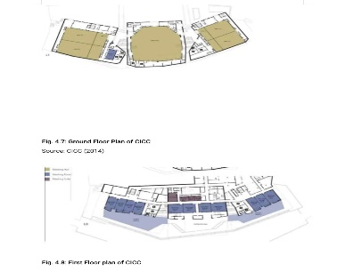
Fig 4.1: Picture of floor Floor Plan of Calabar International Convention Centre.
Source: (crspppprojects.org.ng 2026).

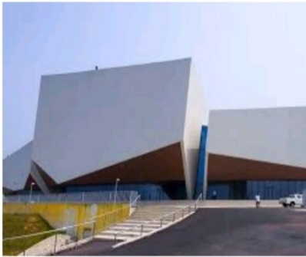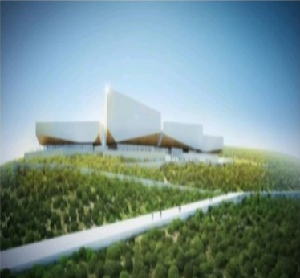
Fig 4.2: Picture of Exterior View of Calabar International Convention Centre.
Source: (crspppprojects.org.ng 2026).

Abuja International Conference Centre demonstrates effective spatial organisation through a centrally integrated circulation network that connects conference halls, administrative offices, banquet facilities, and support spaces. The building's symmetrical planning contributes to improved accessibility and simplified navigation. Nevertheless, increasing visitor numbers have exposed challenges associated with congestion during large-scale events, highlighting the need for more flexible circulation alternatives and improved pedestrian distribution.
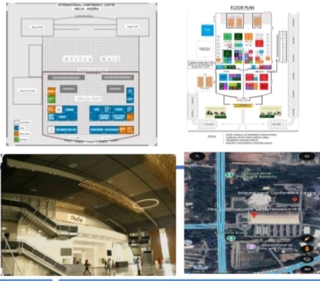
Fig 4.3: Picture of Floor Plan of Abuja International Conference Centre.
Source: (fcta.gov.ng 2026).

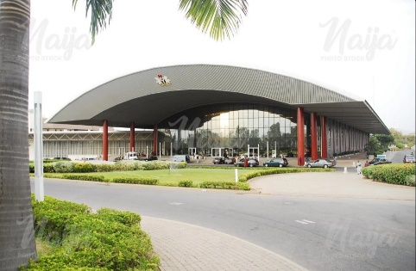
Fig 4.4: Picture of Approach view of Abuja International Conference Centre.
Source: (fcta.gov.ng 2026).

The evaluation of the United Nations Conference Centre Addis Ababa, Ethiopia, illustrates the importance of integrating architecture with landscape design to strengthen wayfinding. Open courtyards, landscaped pedestrian routes, visual transparency, and daylight penetration improve users' cognitive mapping while creating a more comfortable circulation environment. The relationship between indoor and outdoor spaces demonstrates how environmental design can complement Space Syntax principles in enhancing spatial legibility.
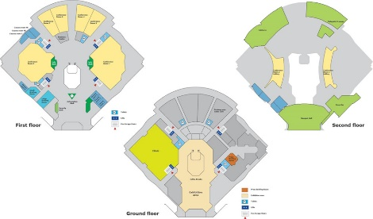
Fig 4.5: Picture of Floor Plans of The Unied Nation conference centre Addis Ababa, Ethiopia.
Source: (uneca.org 2026)
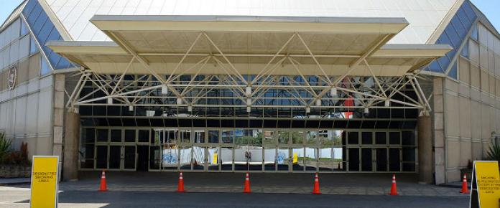
Fig 4.6: Picture of the Entrance of United Nation conference centre Addis Ababa, Ethiopia.
Source: (uneca.org 2026).

The Century City Conference Centre Cape Town, South Africa provides an example of highly flexible circulation planning. Multiple circulation loops, interconnected exhibition spaces, and adaptable event halls enable simultaneous activities without disrupting pedestrian movement. Clear visual connections between major functional spaces reduce navigation complexity while supporting efficient crowd management during conferences and exhibitions.
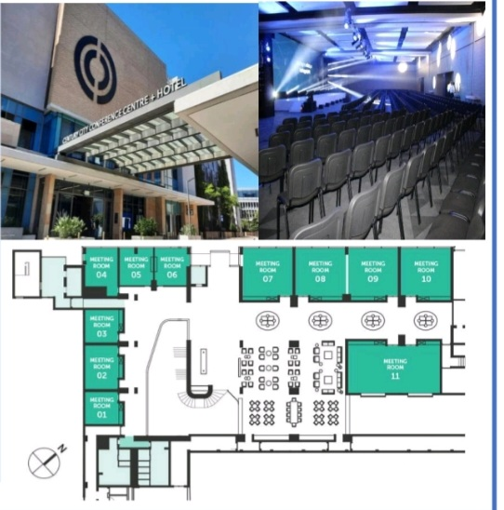
Fig 4.7: Picture of the Floor Plan of The Century Centre Cape Town, South Africa
Source: (ccconferencecentre.co.za 2026)

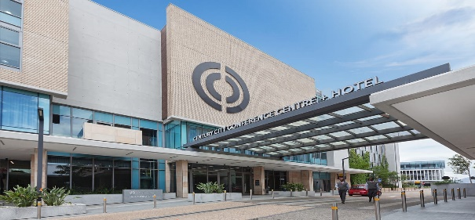
Fig 4.8: Picture of the Entrance of The Century Centre Cape Town, South Africa
Source: (ccconferencecentre.co.za 2026).

Among the selected case studies, International Conference Centre Geneva demonstrates the highest level of circulation efficiency through integrated planning, multiple access points, logical functional zoning, and comprehensive wayfinding systems. Architectural landmarks, transparent circulation corridors, carefully positioned vertical circulation cores, and strong visual connectivity collectively enhance movement efficiency and user orientation. The building illustrates how spatial configuration can significantly influence user behaviour and operational performance.
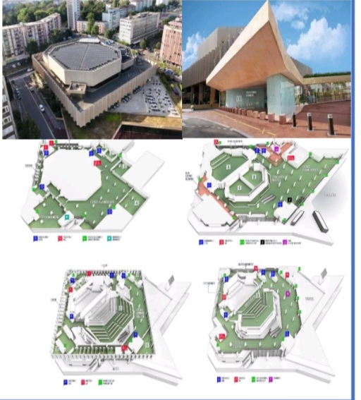
Fig 4.9: Picture of the Floor Plans of International Conference Centre Geneva
Source: (cicg.ch 2026)

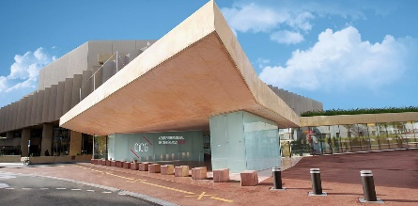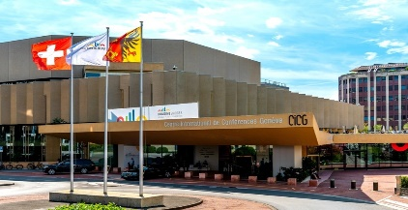
Fig 4.10: Picture of the Entrance of International Conference Centre Geneva
Source: (cicg.ch 2026)

4.2 Cross-Case Synthesis
Despite differences in architectural style and geographical location, all five case studies reveal several recurring principles that contribute to successful conference centre planning:
Highly integrated circulation networks reduce travel distance and improve accessibility.
Functional zoning minimises conflicts between delegates, VIPs, service personnel, and logistics operations.
Visual connectivity strengthens spatial legibility and facilitates intuitive wayfinding.
Landscape elements, courtyards, and daylight improve environmental orientation and user comfort.
Multiple circulation routes increase flexibility and reduce congestion during peak occupancy.
Architectural landmarks and open public spaces enhance cognitive mapping and visitor experience.
These findings confirm the relevance of Space Syntax principles in understanding movement behaviour and demonstrate that circulation efficiency extends beyond corridor design to include environmental quality, spatial hierarchy, and human perception.
4.3 Implications for the Proposed International Conference Centre, Aluu
The findings directly informed the design proposal for the International Conference Centre in Aluu. Lessons from the comparative analysis led to the development of the Ecological Conference Boulevard, which functions as the primary circulation spine connecting the major functional components of the conference centre. Unlike conventional circulation systems, the Ecological Conference Boulevard integrates pedestrian movement with landscaped open spaces, environmental landmarks, natural lighting, visual corridors, and sustainable landscape elements to improve both movement efficiency and user experience.
The proposed design incorporates clear circulation hierarchy, separated public and service routes, strategically positioned vertical circulation cores, interconnected public plazas, and environmentally responsive wayfinding features. These strategies collectively improve accessibility, reduce congestion, strengthen spatial legibility, and support intuitive navigation while enhancing the environmental quality of the conference centre.
The findings therefore demonstrate that integrating Space Syntax principles with ecological design strategies provides a comprehensive framework for improving circulation efficiency, wayfinding, operational performance, and user satisfaction in contemporary international conference centres. This integrated approach represents the principal contribution of the study and offers a practical design model for future conference centre developments in Nigeria and other emerging urban environments.

5. Conclusion and Recommendations
5.1 Conclusion
This study investigated the application of Space Syntax principles to optimise circulation efficiency and wayfinding in the proposed International Conference Centre, Aluu, Rivers State. The research was motivated by the increasing demand for conference facilities that provide efficient movement systems, intuitive navigation, and high-quality user experiences while accommodating diverse functions and large visitor populations.
The comparative analysis of the selected case studies demonstrated that circulation efficiency is strongly influenced by spatial integration, functional zoning, connectivity, visibility, accessibility, and environmental legibility. Conference centres that provide clearly defined circulation hierarchies, interconnected functional spaces, multiple movement routes, and strong visual relationships consistently achieve better pedestrian movement, improved wayfinding, reduced congestion, and greater operational efficiency. Furthermore, the study established that environmental features such as landscaped courtyards, daylighting, architectural landmarks, and visual corridors significantly strengthen users' cognitive mapping and spatial orientation, complementing the analytical principles of Space Syntax.
A major contribution of this research is the development of the Ecological Conference Boulevard, an innovative circulation framework that integrates Space Syntax principles with ecological landscape design, environmental sustainability, and user-centred planning. Unlike conventional circulation systems that primarily focus on movement, the proposed framework combines pedestrian circulation with environmental quality, landscape connectivity, natural lighting, and intuitive wayfinding to create a more accessible, sustainable, and user-friendly conference environment.
The study therefore demonstrates that integrating configurational analysis with ecological design strategies provides a comprehensive approach to improving circulation efficiency, spatial legibility, operational performance, and visitor experience in contemporary conference centres. The findings contribute to architectural knowledge by extending the application of Space Syntax to conference centre design within the Nigerian context and provide practical guidance for architects, planners, researchers, and policymakers involved in the planning of large public buildings.
5.2 Recommendations
Based on the findings of this study, the following recommendations are proposed:
Architects should integrate Space Syntax analysis during the early stages of conference centre design to evaluate spatial configuration, predict movement patterns, and optimise circulation efficiency before construction.
Conference centres should incorporate clear circulation hierarchies that separate public, VIP, service, and emergency movement routes to improve operational efficiency, accessibility, and safety.
Wayfinding should extend beyond conventional signage by integrating architectural landmarks, visual corridors, natural lighting, landscape features, and open public spaces that enhance cognitive mapping and intuitive navigation.
Sustainable landscape strategies should be integrated with circulation systems to improve environmental quality, thermal comfort, user experience, and the overall functionality of conference facilities.
Ecological Conference Boulevard should be introduced into public building designs to demonstrates how sustainable landscape design and Space Syntax principles can be integrated to improve operational efficiency and environmental quality.
Future conference centre developments in Nigeria should adopt the proposed Ecological Conference Boulevard as an integrated design framework for improving circulation efficiency, environmental performance, and spatial legibility.
Future research should evaluate the proposed framework using digital simulation tools such as DepthmapX, Visibility Graph Analysis (VGA), pedestrian movement simulation, and post-occupancy evaluation to validate its effectiveness in completed conference facilities.
Accordingly, this study investigates how Space Syntax principles can optimise circulation efficiency and wayfinding within the proposed International Conference Centre in Aluu. It further introduces the Ecological Conference Boulevard as an integrated circulation framework that combines spatial configuration, environmental quality, landscape design, and user-centred planning to improve accessibility, movement efficiency, and overall user experience. The study contributes to evidence-based architectural practice by providing practical design recommendations for conference centre development in Nigeria and similar emerging urban contexts.
Contribution to Knowledge
This study contributes to architectural scholarship by extending the application of Space Syntax to the planning and design of international conference centres in Nigeria. It introduces the Ecological Conference Boulevard as a novel design framework that integrates spatial configuration, ecological landscape design, environmental legibility, and user-centred wayfinding to improve circulation efficiency and overall building performance. The framework offers a practical and evidence-based model that can inform the design of future conference centres and other complex public buildings in Nigeria and comparable developing contexts.
Future studies should investigate the effectiveness of the proposed Ecological Conference Boulevard using digital spatial simulation tools, including Space Syntax software, pedestrian flow modelling, and post-occupancy evaluation. Comparative studies involving additional international conference centres across Africa, Europe, Asia, and North America would further strengthen understanding of global best practices.
Research should also explore the integration of artificial intelligence, smart wayfinding technologies, Building Information Modelling (BIM), Geographic Information Systems (GIS), and digital navigation systems in conference centre planning. These technologies have the potential to enhance movement efficiency, accessibility, emergency management, and user experience in large public buildings.
In addition, future researchers may examine how sustainable landscape strategies, environmental psychology, and biophilic design influence cognitive mapping, visitor satisfaction, and circulation performance within conference environments.

References
Bock, O., Huang, J.-Y., Onur, O. A., & Memmert, D. (2024). The structure of cognitive strategies for wayfinding decisions. Psychological Research, 88, 476–486. https://doi.org/10.1007/s00426-023-01863-3⁠
Braun, V., & Clarke, V. (2022). Thematic analysis: A practical guide. Sage Publications.
Creswell, J. W., & Plano Clark, V. L. (2023). Designing and conducting mixed methods research (4th ed.). Sage Publications.
Donato, F., Schwartzlose, A. X., & Mendes, R. A. V. (2023). How do you build a cognitive map? The development of circuits and computations for the representation of space in the brain. Annual Review of Neuroscience, 46, 281–299. https://doi.org/10.1146/annurev-neuro-090922-010618⁠
Ereama, G. C. (2026). Utilizing architectural design strategies to optimize spatial efficiency in a proposed convention and exhibition centre in Uyo, Akwa Ibom State, Nigeria. International Journal of Engineering and Modern Technology, 12(2), 286–297. https://doi.org/10.56201/ijemt.vol.12.no2.2026.pg286.297⁠
Farzanfar, D., Spiers, H. J., Moscovitch, M., & Rosenbaum, R. S. (2023). From cognitive maps to spatial schemas. Nature Reviews Neuroscience, 24(2), 63–79. https://doi.org/10.1038/s41583-022-00655-9⁠
Gath-Morad, M., Dalton, N. S., Hölscher, C., & Küpper, M. (2024). Visibility, spatial cognition and wayfinding in complex buildings: A systematic review. Frontiers in Psychology, 15, Article 1335300. https://doi.org/10.3389/fpsyg.2024.1335300⁠
Gath-Morad, M., Grübel, J., Steemers, K., Sailer, K., Ben-Alon, L., Hölscher, C., & Aguilar, L. E. (2024). The role of strategic visibility in shaping wayfinding behavior in multilevel buildings. Scientific Reports, 14, 3735. https://doi.org/10.1038/s41598-024-53420-6⁠
Guetterman, T. C., Fetters, M. D., & Creswell, J. W. (2023). Mixed methods research: Contemporary approaches and applications. Journal of Mixed Methods Research, 17(3), 243–261.
Ibifubara, H. I., & Bethels, U. P. (2026). Architectural strategies for wayfinding and circulation in multiplex and entertainment centres: Evidence from a Nigerian case and international precedents. International Journal of Engineering and Modern Technology, 12(1), 123–130. https://doi.org/10.56201/ijemt.vol.12.no1.2026.pg123.130⁠
Iftikhar, H., & Abbas, F. (2025). Conceptual models, influencing factors, and technological advancements in pedestrian wayfinding: A systematic literature review. Facilities. https://doi.org/10.1108/F-09-2025-0162⁠
International Congress and Convention Association. (2024). ICCA GlobeWatch: Business Analytics country and city rankings 2023. https://www.iccaworld.org⁠
Johansson, R. (2023). Case study methodology in architectural research: Contemporary perspectives. Architectural Research Quarterly, 27(2), 115–129.
Lee, J. H., Ostwald, M. J., & Zhou, L. (2023). Socio-spatial experience in space syntax research: A PRISMA-compliant review. Buildings, 13(3), 644. https://doi.org/10.3390/buildings13030644⁠
Leite, P. W. da L., Silva, C. C. O. A., Moro, L. D., Bodah, B. W., Mores, G. V., Piccinato Junior, D., Engel, A., Santosh, M., & Neckel, A. (2024). Space syntax as expression of science on user flows in open and closed spaces aimed at achieving the Sustainable Development Goal: A review. Architecture, 4(1), 170–187. https://doi.org/10.3390/architecture4010011⁠
Lin, J., Li, N., Rao, L.-L., & Lovreglio, R. (2023). Individual wayfinding decisions under stress in indoor emergency situations: A theoretical framework and meta-analysis. Safety Science, 160, 106063. https://doi.org/10.1016/j.ssci.2023.106063⁠
Meng, D., & Zhang, J. (2025). The evolution of space syntax over the past two decades: Evidence from China. Journal of Asian Architecture and Building Engineering, 24(5), 4606–4624. https://doi.org/10.1080/13467581.2024.2399739⁠
Mohamed, A. A. (2025). Using BERTopic modelling to map the evolution of space syntax research. Land Use Policy, 157. https://doi.org/10.1016/j.landusepol.2025.108438⁠
Mohamed, A. A., & van der Laag Yamu, C. (2024). Space syntax has come of age: A bibliometric review from 1976 to 2023. Journal of Planning Literature, 39(2), 203–217. https://doi.org/10.1177/08854122231208018⁠
Passini, R. (2022). Wayfinding in architecture: Contemporary perspectives on environmental legibility and user navigation. HERD: Health Environments Research & Design Journal.
Peponis, J. (2024). Space syntax and design. Environment and Planning B: Urban Analytics and City Science, 51(5), 1073–1078. https://doi.org/10.1177/23998083241246661⁠
Rayash, A. (2026). A comprehensive review of Space Syntax applications for sustainable urban development in commercial areas. Sustainability, 18(10), 5145. https://doi.org/10.3390/su18105145⁠
Shang, Z., Zhao, C., & Cai, A. (2026). Space syntax theory in tourism studies: A scoping review. SAGE Open. https://doi.org/10.1177/21582440251413384⁠
United Nations Human Settlements Programme. (2022). World Cities Report 2022: Envisaging the Future of Cities. UN-Habitat.
Wafoji, H. A., Orewere, E., & Olagunju, R. E. (2025). Wayfinding to enhance circulation in the design of a museum, Jalingo. International Journal of Engineering and Modern Technology, 11(8), 396–406. https://doi.org/10.56201/ijemt.vol.11.no8.2025.pg396.406⁠
Wolbers, T., & Ekstrom, A. D. (2023). Spatial navigation and memory: A review of the similarities and differences relevant to brain models and age. Neuron, 111(7), 1037–1049. https://doi.org/10.1016/j.neuron.2023.03.001⁠
Yin, R. K. (2024). Case study research and applications: Design and methods (7th ed.). Sage Publications.
Zhan, Z., Huang, H., Winter, S., & Van de Weghe, N. (2024). Cognitive mapping of indoor environments: Constructing an indoor navigation network from crowdsourced indoor route descriptions. Cartography and Geographic Information Science, 51(3), 385–403. https://doi.org/10.1080/15230406.2024.2305450⁠
Zhou, J., Ujang, N., Manan, M. S. A., & Aziz, F. A. (2026). Wayfinding signage and walking perception in urban environments: A Human Factors and Ergonomics framework based on a systematic review. Human Factors and Ergonomics in Manufacturing & Service Industries, 36(3), e70043. https://doi.org/10.1002/hfm.70043⁠

