Chapter 1

THE PROBLEM AND ITS SCOPE

Introduction
Academic faculty serve as the cornerstone of institutional success in higher education, particularly within healthcare institutions where the triad of teaching, research, and service creates uniquely demanding environments. Unlike other faculty groups, healthcare academic educators shoulder dual responsibilities— the academic duties such as teaching and research, and clinical supervision of students in real-world healthcare settings. This dual role exposes them to high levels of stress and makes them more vulnerable to burnout.
This study is undertaken in response to the recommendation of the International Organization for Standardization (ISO), acknowledging that the target institution has not yet conducted any formal assessment of job satisfaction among its faculty. Recognizing this gap, the research aims to determine how burnout, perceived organizational support (POS), and psychological safety predict job satisfaction among healthcare academic faculty. It seeks to understand whether these educators feel recognized, supported, and safe to express themselves within their academic environment, and how such perceptions affect their well-being and professional fulfillment. The significance of this inquiry extends beyond institutional boundaries. Healthcare faculty members are instrumental in shaping the competencies and values of future nurses, pharmacists, radiologic technologists, and other allied health professionals who will serve society. Their level of job satisfaction and psychological well-being thus has far-reaching implications—not only for the quality of education but also for the quality of care delivered by future health practitioners.
Balancing academic, clinical, research, and administrative duties poses a major challenge that may lead to chronic fatigue and emotional depletion. Nassar et al. (2019) found that clinician-educators are at heightened risk of burnout, which can diminish confidence in teaching skills and lifelong learning habits. Such outcomes threaten not only the personal health of faculty members but also the educational standards of their institutions. Hewitt et al. (2020) defined burnout as a multifaceted state characterized by exhaustion and detachment of professional efficacy due to prolonged workplace stress—conditions that often result in dissatisfaction, absenteeism, or turnover. Psychological safety, as highlighted by Edmondson et al. (2016), is crucial in helping individuals navigate interpersonally challenging work environments. When faculty members feel respected, heard, and accepted, they are more likely to engage in open communication and collaboration (Newman et al., 2017). A psychologically safe environment, therefore, becomes a vital component of job satisfaction and professional growth.
Similarly, perceived organizational support (POS)—the extent to which employees believe their organization values their contributions and cares for their well-being—has been shown to influence motivation, performance, and emotional resilience (Eisenberger et al., 2020; Claudia, 2016). In healthcare academia, strong organizational support can mitigate burnout, enhance motivation, and promote satisfaction, even amidst heavy workloads and complex responsibilities. Job satisfaction itself remains a crucial indicator of faculty well-being and institutional health. It encompasses contentment with workload, recognition, interpersonal relationships, and institutional support (Dwiyanti et al., 2022). In the context of healthcare education, understanding how burnout, psychological safety, and POS interact to influence job satisfaction is essential for crafting effective human resource and faculty development strategies.
While prior research has explored these variables individually, limited studies have examined their combined effects on job satisfaction among healthcare academic faculty in private higher education institutions in the Philippines. This study, therefore, seeks to fill that gap by providing empirical evidence on the predictors of job satisfaction within this critical yet underexplored sector. Ultimately, by examining burnout, psychological safety, and perceived organizational support as predictors of job satisfaction, this research aligns with the global call to promote mental health and well-being (SDG 3) and advance decent and productive work (SDG 8) in academic environments. By fostering a more supportive and psychologically safe institutional climate, the study aims to contribute to a sustainable and effective healthcare education system—one that values its educators as much as it prepares future health professionals to serve humanity.

Theoretical and Conceptual Framework
The theoretical and conceptual framework of this study serves as the foundation for understanding how burnout, psychological safety, and perceived organizational support (POS) collectively influence job satisfaction among healthcare academic faculty. It provides the lens through which the relationships among these variables are examined, guided by established theories .
In this study, one theory is anchored on the Job Demands–Resources (JD-R) Model, which explains how workplace conditions influence employee well-being and job satisfaction. According to Galebovic (2025), the JD-R model highlights that occupational burnout arises when continuous and excessive job demands are not balanced by sufficient resources to cope with those demands. Within the context of the Job Demands–Resources (JD-R) Model, this study conceptualizes burnout because of excessive job demands—such as workload and emotional strain—that deplete an individual’s physical and psychological energy. In contrast, psychological safety and perceived organizational support (POS) are viewed as vital job resources that can mitigate these negative effects. When faculty members feel supported by their institution and safe to express their ideas without fear of judgment, they are better able to cope with stress and maintain engagement in their work. These resources not only buffer against burnout but also enhance job satisfaction, which reflects the overall sense of fulfillment and well-being derived from one’s professional role.

Figure 1
Job-Demands Resources Model
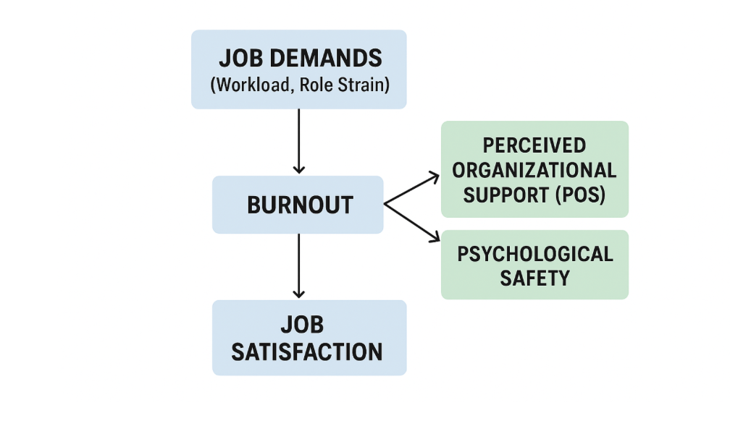
This framework therefore illustrates a dynamic interaction: high job demands increase the risk of burnout, while strong job resources (such as POS and psychological safety) reduce its impact and promote satisfaction. When job resources sufficiently balance or exceed job demands, faculty experience greater motivation, commitment, and satisfaction. Conversely, when demands outweigh resources, the likelihood of burnout and dissatisfaction rises.
Psychological Safety
Psychological safety describes people’s perceptions of the consequences of taking interpersonal risks in a particular context such as in the workplace. Edmondson and Lei (2014) noted that organizational research has identified psychological safety as a critical factor in understanding phenomena such as teamwork, team learning, and organizational learning. Additionally, psychological safety enables individuals to feel safe to engage in difficult conversations (Brown & McCormack, 2016). Edmondson and Bransby (2022) also stated that a growing body of conceptual and empirical work has focused on understanding the nature of psychological safety. When faculty perceive greater psychological safety, they are more likely to feel valued and creatively engaged, which enhances job satisfaction. Based on the model theory from the article the People Performance People (n.d.), they discovered that the higher the level of trust is between colleagues, the more psychologically safe they feel to share their ideas and opinions, show emotion, express concerns and disagree with others. This represents trust. While the other factor, feeling free to show vulnerability, discuss mistakes and have the opportunity to truly understand between colleagues all contribute towards feeling truly psychologically safe at work.
Figure 2
Two factors of Psychological Safety at Work
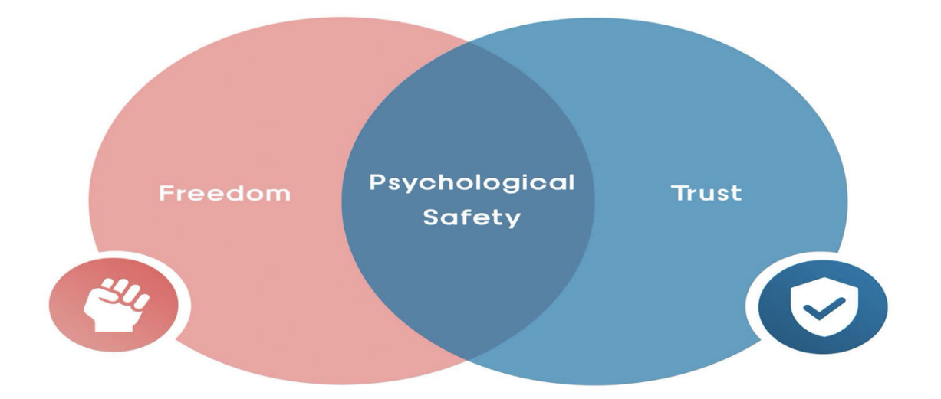

Perceived Organizational Support (POS)
Organizational support theory (OST) proposes that employees form a generalized perception concerning the extent to which the organization values their contributions and cares about their well-being (perceived organizational support, or POS) (Kurtessis et al., 2017). Research in organizational behavior draws some researchers’ attention on a narrow range of job-related attitudes, and POS is one of them. To establish proposed associations, the theoretical underpinning of POS is organizational support theory based on the study of Maan et al., (2020) model. Psychological empowerment fosters high-quality relationships by motivating an individual’s behavior.
Figure 3
Maan et al.’s OST Theory
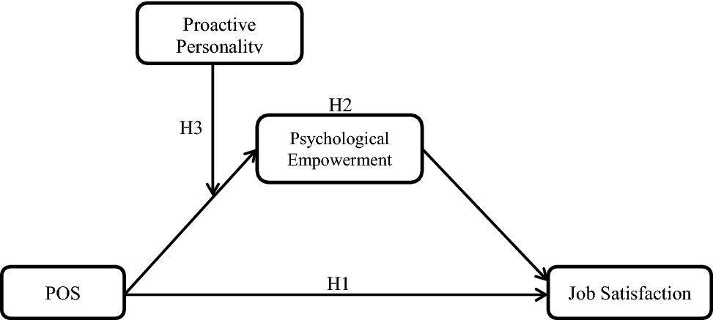
POS can improve individuals’ trust and beliefs in the organization, identifies their performance and reward them accordingly. As a consequence, individuals will reciprocate the organizational support received by them in several ways and possibly will experience more satisfaction with their job. Therefore, the result of their study was that POS is positively related to job satisfaction (Maan et al., 2020). Higher POS is linked to greater job satisfaction because employees feel supported, leading to better morale and motivation.
Figure 4
Schematic Diagram
INDEPENDENT VARIABLES DEPENDENT VARIABLE

Job Satisfaction

- Salary
- Benefits

Burnout

- Emotional Exhaustion
- Depersonalization

Perceived Organizational Support
(POS)

- Organizational Climate
- Organizational Transparency

Psychological Safety

- Mutual Respect

- Interpersonal risk taking

Statement of the Problem
This study seeks to understand how job satisfaction relate to the following variables: burnout, psychological safety and perceived organizational support, which are essential in helping institutions improve faculty support, reduce turnover, and strengthen healthcare academic quality.
1. What is the level of burnout among healthcare academic faculties in terms of;
1.1. Emotional Exhaustion; and
1.2. Depersonalization?
2. What is the level of perceived organizational support among healthcare academic faculties in terms of the following;
2.1. Organizational Climate; and
2.2. Organizational Transparency?
3. What is the level of Psychological Safety among healthcare academic faculties among the following;
3.1. Mutual Respect; and
3.2. Interpersonal Risk Taking?
4. What is the level of job satisfaction among healthcare academic faculties among the following;
4.1. Salary; and
4.2. Benefits?
5. Is there a significant relationship between job satisfaction and;
5.1 Burnout;
5.2. Psychological Safety; and
5.3. Perceived Organizational Support?
6. What factors affect job satisfaction among Healthcare academic faculties?
Hypothesis

This study aims to explore the relationship between burnout, psychological safety, and perceived organizational support (P.O.S.) as predictors of job satisfaction among healthcare academic faculty.

H₀1: There is no significant relationship between job satisfaction and the three independent variables namely; Burnout, Psychological Safety, Perceived Organizational Support.
Significance of the Study

This study is significant for several key stakeholders in higher education, particularly in the field of healthcare academics.
Commission on Higher Education (CHED), the findings of this study would provide a guide to the CHED in refining policies related to faculty development, workload standards, and institutional support systems to enhance academic performance in healthcare education.
Educational institutions, especially private colleges and universities offering health-related programs, this study would serve as a diagnostic tool for assessing faculty well-being and institutional climate. The result can help school administrators identify areas needing improvement and design targeted interventions to increase job satisfaction, which in turn can improve student outcomes and institutional reputation.
Teachers (Healthcare Academic Faculties) would give voice to the experiences and perceptions of healthcare academic faculty regarding their work satisfaction and organizational ties. By shedding light on the factors that contribute to or hinder their professional fulfillment, this study can support to improve faculty morale, recognition, and professional growth.
For Human Resources (HR) managers and academic affairs departments, the study would offer evidence-based guidance on how to design more effective faculty retention strategies. Understanding the burnout, psychological safety and perceived organizational support that most strongly relate to job satisfaction enables HR units to tailor their recruitment, seminars, and support systems to better align with faculty needs and motivations.
Future researchers, this study would be a valuable resource for those who are interested in organizational behavior, educational management, and healthcare education. It provides a localized framework and set of findings that can be built upon in future studies.
Scope and Delimitation of the Study
This study focuses on faculty members who are engaged in academic instruction within healthcare-related courses. These include educators teaching in programs such as Nursing, Pharmacy, Medical Laboratory Science, Radiologic Technology and Rehabilitation Science. The study is limited to those whose primary role is in healthcare-academic instruction, and it aims to explore how their levels of burnout, perceived organizational support and psychological safety relate to their job satisfaction. The research is concerned only with full-time faculty members currently employed with at least 1 year of service during the academic year in which the study is conducted.
The study will be conducted at Liceo de Cagayan University, Paseo del Rio Campus, where the majority of the university’s paramedical and healthcare academic programs are offered. This campus was selected as the study site because it houses the largest concentration of healthcare-related academic departments within the institution. The location provides a focused context in which the experiences and perspectives of healthcare academic faculty can be studied.
The variables examined in this study include job satisfaction as the dependent variable, and burnout, psychological safety and perceived organizational support—as the independent variables. This study seeks to determine the relationship between the following independent variables and the overall job satisfaction of healthcare academic faculty.

Definition of Terms

The following terms are defined based on the context of the research variables. These include burnout, psychological safety, perceived organizational support, and job satisfaction, along with their respective sub variables. The definitions are presented to ensure that the readers interpret the terms consistently as they are applied in the study.
Burnout a psychological syndrome experienced by healthcare educators as a response to prolonged occupational stress, reduced sense of personal accomplishments and emotional exhaustion.
Benefits pertain to the indirect or non-monetary rewards provided by the institution to support the welfare of faculty members. These may include health insurance, leave entitlements, retirement plans, tuition discounts, and other institutional incentives that contribute to employees’ overall well-being.
Depersonalization a psychological response where individuals develop a detached or impersonal attitude toward the people they work with, often as a coping mechanism in high-stress environments.
Emotional Exhaustion a state of feeling emotionally overextended and drained by one's work, often resulting from excessive demands and prolonged stress in the workplace.
Healthcare academic teaching professionals who are engaged in the instruction and academic service within healthcare-related programs in higher education institutions. These programs may include nursing, medical technology, pharmacy, physical therapy, radiologic technology and other allied health sciences.
Interpersonal Risk-Taking an engagement in behaviors such as admitting mistakes, asking questions, or offering dissenting views in team settings, reflecting a sense of psychological safety in the organization.
Job Satisfaction the level of contentment an individual feels toward their job. It is treated as the dependent variable and is measured by how positively healthcare academic faculty perceive their current roles and responsibilities within their institution.
Mutual Respect interactions characterized by mutual respect, dignity, and consideration among colleagues and leaders, contributing to a psychologically safe and inclusive workplace environment.
Organizational Climate the overall work conditions and available resources perceived by employees within their academic workplace. It encompasses the level of support, recognition, autonomy, and fairness experienced by faculty members in their daily work environment.
Organizational Transparency the degree to which an organization openly shares information regarding decisions, policies, and performance, fostering trust and alignment among healthcare faculties.
Perceived Organizational Support (POS) the degree to which healthcare academic employees believe that their institution values their contributions and cares about their well-being. High levels of POS are expected to enhance job satisfaction and reduce burnout.
Psychological Safety shared belief among healthcare faculty members that they can express ideas, raise concerns, and admit mistakes without fear of embarrassment, rejection, or punishment. A psychologically safe work environment fosters open communication, collaboration, and trust.
Salary the direct financial compensation received by faculty members in exchange for their professional services. It includes the regular monthly pay or wage provided by the institution based on academic rank, workload, and teaching or clinical responsibilities.

Chapter 2

REVIEW OF RELATED LITERATURE AND STUDIES

This chapter presents a comprehensive review of literature and empirical studies that support the current investigation on the predictors of job satisfaction among healthcare academic faculty. The discussions are organized around key constructs relevant to the study—burnout, psychological safety, perceived organizational support (P.O.S.), and job satisfaction.
Burnout
Below is the review of related literature on Burnout, focusing on its sub variables Emotional Exhaustion and Depersonalization. This section presents studies that explore how prolonged exposure to job stress, excessive workload, and insufficient resources contribute to the development of burnout among professionals, particularly in healthcare and academic settings. It also discusses how emotional fatigue and detachment from work can influence overall well-being and job performance.
Surguladze (2018) mentioned in her study that burnout is a syndrome of extreme exhaustion and loss of work efficacy, which results from chronic occupational stress. It has become the focus of health and vocational research over the last three decades, due to its detrimental impact on human service providers and their clients. Burnout research has typically focused on professions such as medical doctors, nurses, social workers, psychologists, counselors, psychiatrists, and teachers.
Educator burnout is a prevalent global issue adversely affecting productivity and contributing to elevated turnover rates, depression, and diminished personal accomplishments. Despite the relentless demands placed on educators, school systems often overlook collecting data from those directly impacted by burnout. teachers exhibit the highest levels of burnout when compared to other professionals in the social services sector. Historically, teachers have consistently faced elevated rates of “job strain,” which is a robust indicator of stress characterized by high demands and low control in their work (Mayes, 2024). Also Faculty often experience mental and cognitive decline when job demands appear overwhelming and trump their ability to cope in the teaching environment. When faculty dealing with job stress manifested the balance of work-related demands and pressures appeared to be out of balance, negatively impacting a faculty's drive to meet job requirements as skills, knowledge, and capabilities declined with extreme opposition (Turley, 2022).
Kinkade (2025) stated in her study that the use of adjunct faculty continues to grow in higher education institutions, many can factors linked to burnout but found an increased use of technology can foster collaborative social and professional development, and should be encouraged for online adjunct faculty. Finding that employees can prevent burnout by investing in resources (i.e., voicing ideas for improvement and taking charge) before burnout starts and stating that faculty need more attention to obtain the resources needed to be successful. Expanding on the concept of being mindful of the needed resources to prevent burnout in faculty. Moreover, there are reviews of existing literature highlights various methods used to mitigate burnout, such as relaxation techniques, physical wellness activities, and therapeutic interventions; however, their effectiveness has shown considerable variation. Despite numerous studies on burnout prevention, limited attention has been given to how faculty behaviors influence this phenomenon. Consequently, recent discussions emphasize the need to shift focus from solely enhancing individual resilience to examining institutional and faculty-related strategies that promote well-being and prevent burnout within academic settings. Exploring proactive approaches and supportive organizational practices becomes essential in understanding and addressing burnout more effectively (Wegert, 2025).

Emotional Exhaustion
It has been observed that emotional exhaustion is a state of feeling emotionally worn out and drained due to accumulated stress from one’s personal or work life, or a combination of both. It is one of the signs of burnout (Cafasso, 2025). Teacher burnout is a chronic phenomenon that continues to be a main cause of teacher exodus in this 21st century. Teaching also can be an emotionally draining and physically exhausting profession if a teacher fails to handle burnout effectively. They are likely to experience poor quality student interaction, counterproductive instruction, increased absenteeism, which eventually leads to teacher attrition. Burnout is a precursor to teacher attrition (Rumschlag, 2017). In addition, feeling exhausted due to insufficient rest while working can result not only in long-term mental health problems but also in lower productivity. Overwhelmed and emotionally drained due to long working hours, experienced mental strain signs and need asynchronous workflows. Burnout and emotional exhaustion are negatively related to work engagement.
Based on their study conducted by Costin et al., (2023) emotional exhaustion was associated with depression and anxiety symptoms among remote workers during the Covid-19 pandemic. Reduced social interactions and excessive workload negatively affect social and psychological health, leading to emotional exhaustion and increased burnout. In fact, Rink et al., (2023) indicate that challenging psychological symptoms such as depression share a positive relationship with burnout that can lead to emotional exhaustion. There was also a study highlighted how emotional exhaustion and burnout are shaped by each teacher’s unique experiences during a disaster, emphasizing the deeply personal and individualized nature of these responses. The use of a mood meter during the interviews provided nuanced insights into how teachers internally processed their emotions, offering a clearer picture of the emotional toll caused by their working conditions (O’Toole, 2018). This deeply personal and situational nature of burnout mirrors the context within healthcare academic settings, where faculty members face complex challenges—such as dual roles in teaching and clinical practice, institutional pressures, and emotional labor.
Just as the emotional well-being of teachers in crisis was found to influence their resilience and professional engagement, this current study considers how burnout and support structures can significantly affect job satisfaction among healthcare academic faculty. It suggests that understanding faculty members' internal emotional responses and the organizational context in which they work is essential to fostering healthier, more sustainable academic environments.
Depersonalization
Depersonalization is defined as persistent or recurrent episodes of feeling detached or estranged from a sense of self and the world (Thomson & Jaque, 2018). In the study conducted by Schweden et al., (2018), depersonalization contributes to a higher intensity of safety behaviors and post-event processing among their participants experiencing test anxiety. Their findings revealed that nearly half of the participants experienced moderate depersonalization symptoms, and these were significantly predicted by high levels of test anxiety and negative appraisals of those symptoms. While depersonalization is often viewed as a coping mechanism during stressful situations, the study highlights that it may become maladaptive when it reinforces anxiety-related patterns. Although depersonalization was not linked to actual performance, its role in maintaining test anxiety suggests its broader psychological impact, which may also be relevant in high-pressure professional environments like healthcare academe.
Fardous and Afzal (2022) argue that emotionally exhausted teachers tend to withdraw from social activities and often become alienated from their surroundings, leading them towards depersonalization. They further defined depersonalization as a state of mind in which an individual keeps their distance from others and views others impersonally. It is the callous attitude of an individual with a detached response to others, feelings of aloofness, and an indifference towards people and work. Faculty members in universities are potential candidates for burnout due to their interactions with numerous students, colleagues, and administrators. They are especially prone to experiencing burnout—particularly depersonalization. According to Dinibutun et al. (2020), depersonalization refers to an uncaring and negative attitude toward various aspects of the job, especially within the teaching environment. It is often associated with a lack of emotional and cognitive connection to one’s work. Faculty members who encounter this issues are more likely to have burnout; those with higher levels of burnout can display their intention toward turnover as well as poor job performance, and absenteeism. Moreover, Dres et al., (2023) stated that good relationships with colleagues, meaningful interactions with learners, and protected time for personal life were crucial for full-time university hospital faculty. On their findings, facilitated small-group curriculum reduced depersonalization.
Below is the review of related literature on Perceived Organizational Support (POS), focusing on its sub variables Organizational Climate and Organizational Transparency. This section presents studies that examine how employees’ perceptions of support, fairness, and open communication within the organization influence their attitudes and performance. It also highlights how a positive work environment and transparent management practices contribute to higher job satisfaction and reduced burnout.

Perceived Organizational Support
Support from supervisors coincides with practical instruction and how the administration in the universities chose to work with the academic departments and is often a primary determinate as to how faculty in higher learning institutions perform research and instructional duties and overcome the rigors of their job (Turley, 2022). Additionally, Employees have become the new customers of work and keeping employees feeling connected to organizations and each other is especially important. Understanding ways of doing so is vital to organizational success. Interest in organizational resources and attributes associated with employee experience and work-related attitudes is growing (Bullard, 2022).
Perceived Organizational Support (POS) often reflects the overall belief of employees that their organization values their contribution and cares about their well-being. Researchers frequently use the concepts of social exchange and the norm of reciprocity to explain why employees show positive behaviors toward their company, like loyalty, even when the company does not require those behaviors nor are the employees compensated for it. When an employee perceives they are receiving organizational support, they are more likely to feel good about the organization and the employer, which strengthens the relationship and makes them feel more obligated to return the favor through the norm of reciprocity concept. Numerous research outcomes support the idea that POS should have a negative relationship with turnover intentions and a positive relationship with affective organizational commitment (Sanders, 2024). Moon (2025) also mentioned that a core theme emerges from the organizational support literature is the profound influence of Perceived Organizational Support (POS) on employee well-being and job satisfaction. This indicate that when employees perceive strong organizational support, their overall well-being is significantly improved, leading to higher levels of job satisfaction. Some researchers also introduced the concept of thriving, revealing a positive relationship between POS and employee work engagement, which ultimately enhances well-being. These findings emphasize the importance of POS in enhancing both employee well-being and job satisfaction, reinforcing the value of nurturing a supportive organizational environment. Likewise, Shaw (2025) mentioned in her study that some researchers correlated the POS with teachers' performance as measured by their power of expression, knowledge of work, analytical ability, supervision and guidance, ability to make decisions, and work output. The study broke perceived organizational support into three components and found positive relationships between teachers' overall performance levels and the support components fairness and organizational reward and job conditions. Their findings, while applied to the educational population of teachers, did not consider similar application to principals. Moreover, Parker (2022) described Perceived organizational support (POS) as the way an employee perceives how the organization values their work and cares about his or her well-being. High levels of POS cause employees to feel more fulfilled and aligned with the company goals and possess a strong obligation to assist the company in meeting its desired outcomes. They found that perceived organizational support has been shown to help employees manage the emotional requirements of their work. Thus, it appears that perceived organizational support may enhance employees' commitment to stay with the organization and reduce thoughts of turnover or turnover intentions.

Organizational Climate
The organizational climate represents the global impression of an organization and personal impact of the workplace atmosphere which affects the employees’ work behavior. It also has a great influence on the attitudes of employees as it relates to their sense of belonging and relationships in the workplace (Hall, 2025). It serves as a mediating factor in the interplay between school demographics and teacher attrition. The findings revealed that schools where teachers rated their working conditions as more satisfactory had lower attrition rates, even in schools with higher proportions of low-income students (Geiger & Pivarova, 2018). Unfavorable working conditions are associated with poor mental health and many studies show that teachers are at risk of this (Borelli et al., 2014).
Additionally, teachers’ attitude about the volume of their work depends on the perceptions of specific features of their environments such as when the size of their classes is perceived to make unreasonable demands on the time required for preparation and marking. Excessive paper work and the burden of such non-teaching demands as hall monitoring and lunchroom supervision also add to teachers’ feelings of stress, reduce their morale and commitment to the school, and increase the likelihood of moving to another school because of decrease in job satisfaction (Liethwood & Mcadie, 2007).
Taken as a whole, Yeh (2015) in his study, found that a strong main effects of job demands and resources on job satisfaction but weak interactions between them on job satisfaction. Japan, Taiwan and Korea share many determinants of job satisfaction, in particular, workplace relation is the most important determinant of job satisfaction in the three countries. In East Asia, the non-financial aspects of job quality have a greater effect on job satisfaction than the earning factor. The findings of this study further indicate that job resources (i.e., earnings, job content, and workplace relations) increase job satisfaction more than job demands (i.e., working hours, workloads, and work/family conflict) decrease job satisfaction.

Organizational Transparency
Transparency is an increasingly prominent area of research that offers valuable insights for organizational studies. It is associated with the sharing of information and the perceived quality of the information shared (Albu & Flyverbom, 2019). As stated by Anant (2015), organizational efficiency and effectiveness significantly depend on the motivation, involvement and efforts of employees across all levels. Employee performance is affected by the quality of interpersonal communications within the organization. In his study found a positive relation between openness and the quality of interpersonal relationships within the organizations. He suggests that, within organizations, the quality of interpersonal relationships across the levels is influenced more by perceptions of openness than by the levels of trust between employees.
For instance, there was a study conducted by Dehgani-Soltani et al., (2021) that showed transparent information has a significant positive effect on organizational trust and employee acceptance of change. There has been a growing interest in the jobs of leaders in the field of higher education institutions. Selection of expert leaders affects the growth and development of higher education institutions and is considered a key factor in achieving university standards and enhancing performance. Therefore, there should be a clear communication bridge between the university and the administration sites to ensure the flow of information between them. This requires adopting an open system and applying a democratic approach to decision-making, following the scientific method of organization, taking into account functional specialization and dealing with its problems and problems of society (Al Shobaki et al., 2017).
In addition, research conducted by Hofman and Strobel (2020) that shows perceived transparency has significant positive effect on satisfaction with the current work based on the answers of over 1600 professors from the German Federal State (Bavaria), indicating that higher perceived transparency is associated with higher satisfaction with working conditions.

Psychological Safety
Psychological Safety serves as one of the main independent variables in this study, encompassing two sub variables—Respectful Interaction and Freedom to Speak Up.
One of the findings of Walden (2025) defined psychological safety by likening it to brainstorming, where all ideas are welcomed without criticism or judgment. His study emphasized the importance of hearing from those directly involved in tasks or processes, as they possess the most relevant insights. Though Chung (2025) argued psychological safety generally found to be challenging to develop and maintain in virtual teams. It is important to note that, teachers who are psychologically safe in their work take feedback as a challenge to rise to instead of an insult. It is a level of comfort where people are engaged in with others while being vulnerable. Teachers who were satisfied with their work were less likely to withdraw and quit the profession (Andriaccio, 2025). Furthermore, a psychologically safe workplace allows employees to voice concerns about hazards without fearing retaliation. In a psychologically safe environment, employees feel comfortable raising concerns about workplace issues, leading to increased reporting of incidents and near misses. As a result, organizations can quickly identify potential workplace hazards and develop preventive measures against recurring problems. These prompt preventive measures ultimately contribute to a reduction in workplace incidents (Kpagniel, 2025).
McClure (2025) also elaborated that if psychological safety can promote the necessary environment in schools to increase teacher retention and create a fertile place for the needed skills of innovation and risk-taking, among others then it seems more work should be put toward establishing the direct links between these factors. In the end, his findings reinforced the idea that psychological safety, a construct historically applied in corporate and healthcare settings, holds substantial potential in educational contexts, particularly within high-need schools. The study highlighted that efforts to improve psychological safety are not just beneficial for individual teachers but have broader implications for school culture and stability. His research contributed to the field of educational leadership by offering evidence-based recommendations on how administrators and policymakers can create environments that support and retain teachers. It emphasized the transformative potential of psychological safety, providing a clear message: creating a psychologically safe workplace is essential not only for teacher satisfaction but building resilient, high-performing schools. Psychological safety in the workplace is influenced by individual perceptions of person-environment fit and trust, highlighting the need for understanding these relationships to foster a psychologically safe environment (Stonefish, 2019).

Mutual Respect
When we create a welcoming environment that is respectful, inclusive, and equitable, we ensure that all who practice it have every opportunity to be successful. If marginalized individuals and communities feel excluded and not welcome, it can reduce their productivity and career advancement (Thoenessen, 2020). Research by LaGree et al., (2023), shows that there was a significant positive relationship between job satisfaction and job engagement. Their study examined the relationship of respectful engagement, autonomous respect, and occupational resilience on job outcomes with their respondents of 1,036 U.S. young workers aged 21 to 34, employed full-time, revealed that the relationship of both respectful engagement and autonomous respect on job outcomes was positively mediated by occupational resilience, further substantiating the positive benefits of respectful communication on employees’ wellbeing and, ultimately, positive long-term business benefits. Nevertheless, many organizations, irrespective of their geographic location, are characterized by high power distance (e.g., uniformed services, health-care) and suffer from practices that tolerate incivility, especially when the perpetrators are top performers and higher-ranking employees. Dealing with such challenges is not easy but is necessary, and they believe that lessons learned from addressing these issues can offer valuable insights to managers around the globe (Lim & Yao, 2021).
Though the collaboration and teamwork highlight information sharing between occupational groups as central to tailoring primary care to the needs of patients' healthcare practice. Some literatures tend to employ a variety of sub-concepts (e.g. shared/team goals, mutual acquaintanceship, connectivity, information exchange, decision making) as constitutive parts of teamwork and collaboration are central to cooperation between occupational groups (DiCicco-Bloom, 2016). Therefore, Gerpott et al., (2020) states that the success of organizations is tied to employees’ motivation to engage in knowledge sharing, defined as the “act of making knowledge available to others within the organization”. Their research has demonstrated that knowledge sharing can improve important outcomes, such as decision-making, innovation, and performance. The valuable and specialized knowledge resides within the minds of individual employees, who share knowledge with others to enable collective utilization of the available informational resources.

Interpersonal Risk Taking
It is a belief that risk-taking is a stable personality trait, often referred to as risk attitude or risk preference. The belief implies that a given individual will take similar risks across a range of situations and that some people will be more risk-averse (or more risk-seeking) across situations than others (Figner & Weber, 2015). It is the conscious choice to be vulnerable in social interaction, accepting the potential for negative social or emotional consequences. To illustrate, in a study by Hübner and Pfost, (2024), there were 381 university students involved across 38 seminars. They examined how ART varied by seminar group and teaching quality. The findings highlight ART’s potential benefits for learning, as it encourages students to operate in Vygotsky’s zone of proximal development, fostering skills like resilience, self-agency, and purposeful communication.
ART means Academic Risk Taking, it refers to constructive, socially acceptable behaviors in which individuals risk making errors or appearing less competent in front of others, such as contributing uncertain answers during discussions or seeking feedback on incomplete work. In higher education contexts, ART parallels the workplace construct of interpersonal risk taking, where individuals openly share ideas, voice concerns, or admit mistakes despite uncertainty, contributing to collective growth and innovation. In the context from the study of Michailidis and Banks (2016). They identify mechanisms by which burnout leads to risky decision-making, their findings suggest that employees’ sense of professional inefficacy determines their risky decision-making. By displaying overconfident behavior, a person could retain their high rank, even after group members learned this person was less capable than their behavior suggested. Given this, they further explained that the act of taking a risk at work—independent of outcome—could cause risk-takers to be perceived more positively by observers than risk-avoiders. These positive perceptions could, in turn, produce positive workplace outcomes even in the event of failure (Fisk & Overton, 2020). Overall, there were significant relationships among risk taking behavior and job satisfaction of different professionals, in which highly satisfied workers will be able to take risks in their assigned jobs (Saha et al., 2017).
Job satisfaction
Satisfaction is an evaluative term that describes an attitude of liking or disliking. Hence, job satisfaction is a positive emotional state resulting from work appraisal of one’s job experience (Danish, 2010). It is also said that job satisfaction has been a matter of growing interest for the individuals concerned with the quality of working life and organizational efficiency. It is a function of the perceived relationship between what one expects and obtains from one's job and how much importance he or she attributes to it (Saha et al., 2017). That said, the results from the study of Harrison et al., (2023) suggest that teachers' job satisfaction and the quality of classroom-level relationships may be important for positive instructional outcomes.
While schools focus on student outcomes, they should also address teachers' job satisfaction and priorities the importance of relationships between teachers and students in classrooms. Because of this burnout symptoms will have many wide-ranging consequences for teachers. Some studies showed that burnout is associated with lower levels of job commitment and worse physical and mental health, and may cause reduced effectiveness of classroom practices and actual absence from the classroom (Madigan & Kim, 2021). Robinson et al., (2019) indicated in their study that there was a statistically significant relationship between job satisfaction and burnout among education teachers. This is parallel to a study related to the healthcare academe, as it also examines whether there is a significant relationship between burnout and job satisfaction among higher education institutions offering healthcare programs.
A research by Zumrah and Boyle (2015), shows that the role of perceived organizational support (POS) and job satisfaction on the effectiveness of transfer of training in the workplace has begun to receive attention among recent studies. However, there is still limited understanding of how these factors may work together to affect the transfer of training.Their findings show that job satisfaction plays an essential role as a mediator in the relationship between POS and transfer of training. When the faculty members are more supported by universities, they can actually participate in the process of planning and setting goals for the organization. As a result, more achievements would be achieved in the organizations. There is a direct relationship between perceived organizational support and job satisfaction which is in agreement cited by Afif (2018).
Based on the theories of organizational behavior management, jobs could be done more efficiently if support by the organization is well performed. A safe environment is a critical factor to achieve job satisfaction. When employees feel safe, learning occurs more quickly, peers rely on each other, and team performance improves. Trust in peers and management influences psychological safety development. Therefore, understanding the role of psychological safety and trust in the development of engaged employees is essential (Mitterer, D. & Mitterer, H., 2023). Moreover, existing studies reported that the psychological safety of employees enhances their level of job satisfaction. When an employee feels psychological safety in an organization, he or she may feel protected and valued by the organization. Considering that the quality of the relationship with their colleagues or organization is an important factor that determines their overall job satisfaction, those kinds of positive feelings toward the organization are likely to increase the level of job satisfaction (Kim, M. & Kim, B., 2020). All in all, studies have explored job satisfaction among university faculty and have proven that job satisfaction can be used to mediate workload, performance, organizational commitment (Chen, 2023).
Furthermore, this study aligns with several international standards that emphasize people-centered management and organizational well-being. The ISO 10018:2020 (Quality Management – People’s Engagement) highlights the importance of fostering employee involvement, motivation, and empowerment as essential elements in achieving organizational success. Similarly, the ISO 30414:2018 (Human Capital Reporting) underscores the value of measuring and managing human capital by promoting transparency, accountability, and data-driven decisions that enhance employee experience and satisfaction. In addition, the ISO 45003:2021 (Occupational Health and Safety Management – Psychological Health and Safety at Work) provides guidelines for managing psychosocial risks in the workplace, ensuring that employees’ mental well-being is protected and supported. Collectively, these standards reinforce the premise of this study that promoting psychological safety, organizational support, and overall employee well-being contributes significantly to job satisfaction, especially in the context of healthcare academia.

Benefits Satisfaction
Benefits satisfaction refers to an employee's contentment with the benefits offered by their employer, such as health care, paid time off, and professional development, and leads to increased employee satisfaction, higher productivity, better retention rates, and a more positive workplace culture. Employees perform at their best when they are happy at work and feel like their feedback is being met with action and accountability. When employees are satisfied at their company, they are more likely to perform at a higher level, contribute positively to business outcomes, and be engaged at work (Radley, 2025). However, Vasquez (2025) cited in his study that constructed job satisfaction included security, promotion opportunities, recognition, the participant's supervisor, ability to use all skills in the job, loyalty, and career advancement. Over 51% of U.S. workers noted positive job satisfaction, and over 62% were satisfied with their supervisory relationships. With only just over a third of workers were satisfied with their salaries and opportunities for promotion, and 44% were satisfied with the opportunity for additional training. This only proves that not all employee’s job satisfaction were happy with employer’s benefits. Nevertheless, the impact of benefits and incentives satisfaction were found to have an impact towards job satisfaction (Jaworski et. al., 2018).
Barber et al., (1992) pointed out that if flexible benefits (or other benefit innovations) influence employee behaviors, they likely do so through their impact on benefit satisfaction. Thus enhanced benefit satisfaction may be a prerequisite for other outcomes. As job satisfaction is frequently viewed as the sum of satisfaction with a number of independent job elements, such as pay, promotions, and working conditions. More recently, researchers have argued that pay satisfaction can be subdivided into independent elements such as satisfaction with benefits, pay level, pay administration, and pay structure supported the existence of the benefit satisfaction dimension. Also, a study conducted among employees in Spanish firms revealed that satisfaction with employee benefits significantly contributes to the development of perceived organizational support (POS). Grounded in social exchange theory and organizational support theory, the research demonstrated that when employees perceive their benefits—such as compensation, incentives, and welfare programs—as fair and well-administered, they are more likely to feel valued and supported by their organization. This sense of support, in turn, strengthens organizational commitment and reduces turnover intentions. Specifically, the study found that satisfaction with benefit determination and administration influences employees’ intention to remain in their workplace through the mediating role of POS and commitment. These findings align with the present study’s focus, highlighting how benefit satisfaction can enhance perceived organizational support, which may ultimately improve faculty well-being and job satisfaction in healthcare academic institutions (De la Torre-Ruiz et. al, 2019).

Salary Satisfaction
Loomis (2025) confirmed that compensation, in instance, salary, is a large consideration for employees when examining whether to remain with an employer or separate. His research supports that most employees are motivated to increase their effort at work because of the perceived reward provided by the organization regarding salary. Other research’s findings also reveal that salary satisfaction, irrespective of actual salary levels, significantly enhances teacher retention. High job satisfaction and support from administrators further contribute to lower attrition rates, while overwhelming job demands and insufficient support are closely associated with burnout and increased departures (Alberts, 2024). Also one study indicated that among novice teachers who work at high-poverty urban public schools in the United States, there were statistically significant relationships between salary satisfaction and teachers’ decisions to remain in the profession for as long as possible. This indicates that while salary satisfaction did contribute to teacher attrition, their findings found that principal support and cooperation among peers did not (Ziegler, 2025).
Although salary satisfaction is often seen as an advantage for increasing teacher retention, Siddique (2025) found that there is no statistically significant relationship between teacher salary and teacher retention in online alternative learning environments. Their study included motivation as a drive for teacher’s determination to achieve their performance goal outcomes and return to working in the online when their goals are achieved, even if they are12 dissatisfied with their salary. There are also several studies that support this topic. For instance, Babcock (2024) mentioned in his study that the issue of adjunct faculty salary remains a constant topic of interest, particularly regarding its influence on job satisfaction. However, in the present study, which focuses on full-time healthcare academic faculty, it is yet to be determined how salary satisfaction affects their overall job satisfaction as educators.

Chapter 3

METHODOLOGY

This chapter presents the research methodology employed in the study, outlining the systematic procedures used to investigate the relationships of burnout, psychological safety, and perceived organizational support as predictors of job satisfaction in healthcare academia. It details the research setting, research design, participants and sampling procedure, research instruments, validity and reliability of the instruments, data gathering procedure and statistical technique. By establishing a clear methodological framework, this chapter ensures that the study is conducted with rigor, validity, and reliability, thereby providing a sound basis for the interpretation of results in the succeeding chapter.

Research Setting

The study will be conducted at the Paseo del Rio Campus in Macasandig, Cagayan de Oro City. It is a newly established campus intended for various health-related programs and was actively being constructed by mid-2017, likely becoming operational shortly thereafter. This campus will serve as the primary research site because it houses the institution’s paramedical and allied health programs, which are directly related to the respondents of this study. Its location provides an ideal setting for exploring the experiences of healthcare faculty members.
The campus accommodates faculty members who are actively involved in teaching healthcare-based programs, the Nursing, Medical Technology, Pharmacy, Rehabilitation Science and Radiologic Technology. These faculty members will serve as the main respondents of the study since they are at the forefront of healthcare academia, where challenges such as burnout, psychological safety, perceived organizational support, and job satisfaction are most evident.
Figure 5
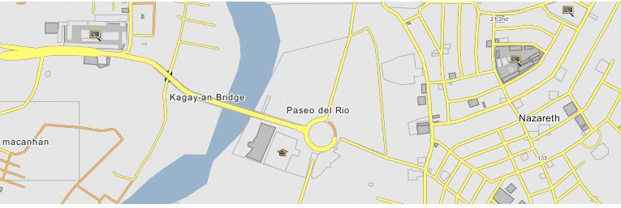
Research Design

This study will employ a quantitative method of research with an emphasis on the descriptive correlational-causal research design. Weighted mean and standard deviation will be used to describe and evaluate the relationships between burnout, psychological safety, perceived organizational support, and job satisfaction among faculty members in healthcare academia. A descriptive correlational design will be appropriate as it will allow the researcher to systematically describe the existing conditions of the participants while also determining the degree of association among the study variables (Saro et al., 2023). This approach will help in identifying patterns and relationships that may contribute to a deeper understanding of the factors influencing job satisfaction.
As defined by Creswell (2014), correlational research is a quantitative approach that investigates the extent to which two or more variables are related, providing insights into trends and interconnections among phenomena. Thus, this design will enable the study to explore not only the prevalence of burnout and its effects but also how psychological safety and organizational support may mitigate its impact on job satisfaction.
Participants and Sampling Procedure

Given the relatively small population (N=96), the preferred approach will be total enumeration sampling procedure—that is, all eligible full-time faculty members will be invited to participate. Total enumeration sampling is a research method where the entire population of interest is included in the study. This approach ensures that every member of the population is represented, eliminating sampling bias and providing comprehensive insights into the group (Steffy, n.d.). Conducting a census will maximize statistical power, avoid sampling error, and ensure representation from programs with small headcounts, such as the allied health programs with only eight to ten full-time faculty members.
The study will involve full-time faculty members teaching healthcare programs at the Paseo del Rio Campus, Macasandig, Cagayan de Oro City. After obtaining permission from the Human Resource Office to access the detailed number of respondents, the accessible population will consist of 96 faculty members distributed as follows: College of Nursing (n=61), College of Rehabilitation Science (n=9), College of Pharmacy (n=8), College of Medical Laboratory Science (n=10) and College of Radiologic Technology (n=8).

Research Instruments

The data for this study will be collected through an adopted descriptive survey questionnaires that has undergone reliability testing by previous authors.
Part 1 will determine the demographic profile of the respondents.
Part 2 will measure the level of burnout among healthcare academic faculty members. This section will consist of 14 items; with 9 items are for the sub-variable emotional exhaustion and 5 items for depersonalization.
Part 3 will measure the level of perceived organizational support (POS) of the respondents. It will also consist of 22 items, including 6 items for the sub-variable organizational transparency and 16 items for organizational climate.
Part 4 will measure the level of psychological safety of the respondents. This section icludes 12 items, with 5 items allotted for interpersonal risk-taking and 7 items for mutual respect.
Part 5 will measure the level of job satisfaction among the respondents. This section consists of 9 items, 5 items for the sub-variable satisfaction with salary and 4 items for satisfaction with benefits.
Scores will then be computed using mean and standard deviation for the second up to
fifth research question of the study. Scale range will use in all variables of the study. “Strongly Agree” will have a score from 4.51 – 5.00, “Agree” with a scale range from 3.51 – 4.50, “Neutral” with a range of 2.51 – 3.50; “Disagree” with a scale range from 1.51 – 2.50 and “Strongly Disagree” with a scale range from of 1.00 – 1.50.
Level of Burnout
Emotional Exhaustion
Scale Range Descriptive Rating Rating level
5 4.51 – 5.00 Strongly Agree Very High

4 3.51 – 4.50 Agree High

3 2.51 – 3.50 Neutral Moderate

2 1.51 – 2.50 Disagree Low

1 1.00 – 1.50 Strongly Disagree Very Low

Depersonalization
Scale Range Descriptive Rating Rating level
5 4.51 – 5.00 Strongly Agree Very High

4 3.51 – 4.50 Agree High

3 2.51 – 3.50 Neutral Moderate

2 1.51 – 2.50 Disagree Low

1 1.00 – 1.50 Strongly Disagree Very Low

Level of Perceived Organizational Support
Organizational Transparency
Scale Range Descriptive Rating Rating level
5 4.51 – 5.00 Strongly Agree Very High

4 3.51 – 4.50 Agree High

3 2.51 – 3.50 Neutral Moderate

2 1.51 – 2.50 Disagree Low

1 1.00 – 1.50 Strongly Disagree Very Low

Organizational Climate
Scale Range Descriptive Rating Rating level
5 4.51 – 5.00 Strongly Agree Very High

4 3.51 – 4.50 Agree High

3 2.51 – 3.50 Neutral Moderate

2 1.51 – 2.50 Disagree Low
.
1 1.00 – 1.50 Strongly Disagree Very Low

Level of Psychological Safety
Mutual Respect
Scale Range Descriptive Rating Rating
5 4.51 – 5.00 Strongly Agree Very High

4 3.51 – 4.50 Agree High

3 2.51 – 3.50 Neutral Moderate

2 1.51 – 2.50 Disagree Low

1 1.00 – 1.50 Strongly Disagree Very Low

Interpersonal risk-taking
Scale Range Descriptive Rating Rating level
5 4.51 – 5.00 Strongly Agree Very high

4 3.51 – 4.50 Agree High

3 2.51 – 3.50 Neutral Moderate

2 1.51 – 2.50 Disagree Low

1 1.00 – 1.50 Strongly Disagree Very Low \

Level of Job Satisfaction
Scale Range Descriptive Rating Rating level
5 4.51 – 5.00 Strongly Agree Highly Satisfied

4 3.51 – 4.50 Agree Satisfied

3 2.51 – 3.50 Neutral Neutral/Moderately satisfied

2 1.51 – 2.50 Disagree Dissatisfied

1 1.00 – 1.50 Strongly Disagree Highly dissatisfied

Validity and Reliability of the Instruments

Reliability in research refers to the degree to which an instrument yields consistent and reproducible results. A study is considered reliable when it can be repeated under similar conditions and produce comparable outcomes (Caroll, 2023). Reliability may be assessed across time or across different samples, ensuring that the measurement tools used are stable and dependable. This study utilized adopted questionnaires developed by four different authors, each with previously established reliability (see appendix C).
The burnout scale employed in this study was adopted from the instrument of Ceballo-Hernandez (2025). To assess its internal consistency, the researcher referred to the Cronbach’s Alpha interpretation criteria cited in Dalyanto (2021), where values ranging from 0.00–0.20 indicate poor reliability, 0.20–0.40 fair reliability, 0.40–0.60 acceptable reliability, 0.60–0.80 good reliability, and 0.80–1.00 very good reliability. Based on these criteria, the Professional Quality of Life scale (ProQOL) tool reported a total reliability coefficient of 0.78, indicating good reliability. Specific subscales of the MBI-ES also demonstrated acceptable to good internal consistency, with emotional exhaustion yielding a reliability coefficient of 0.68 and depersonalization yielding 0.53. These values confirm that the adopted burnout instrument possesses sufficient internal consistency for measuring burnout among faculty members.
For the independent variable, perceived organizational support (POS), the questionnaire items were adopted from the study of Aranas (2016), which evaluates different dimensions of organizational support. Reliability testing was conducted through a pilot test with 30 participants who were not included in the final sample. Analysis using SPSS produced a Cronbach’s alpha of 0.772, indicating acceptable internal consistency of the instrument.
The psychological safety scale, another independent variable, was adopted from the study of Alongge (2024), who utilized the validated Psychological Safety Inventory (PSI) originally developed by Plouffe et al. (2023). While the complete PSI consists of 30 items across five domains, the present study selected 12 items specifically aligned with the subvariables interpersonal risk-taking and mutual respect. Items 1–5 correspond to interpersonal risk-taking, while items 6–12 reflect mutual trust and respect. These items have been previously validated and exhibit established reliability, supporting their suitability for use in this research.
For the dependent variable, job satisfaction, this study adopted items from the instruments reported in the study of Vasquez (2025). The job satisfaction subscale demonstrated a high reliability coefficient of 0.874. Additionally, the subscales adapted from Smerek and Peterson (2007), which include satisfaction with salary and satisfaction with benefits, showed Cronbach’s alpha values of 0.833 and 0.840, respectively. These values indicate very good internal consistency. Since these same subscales are used in the current study, they provide strong evidence that the measures for assessing satisfaction with compensation-related aspects are reliable and appropriate for evaluating job satisfaction among faculty respondents.
Overall, the reliability evidence from the original authors confirms that each adopted instrument demonstrates acceptable to very good levels of internal consistency, validating their use in this study.
Data Gathering Procedure
This study will employ a descriptive, cross-sectional survey design to examine burnout, psychological safety, perceived organizational support, and job satisfaction among healthcare academic faculty members. To ensure strict adherence to the approved research protocol, the administration of the research instruments will be conducted personally by the researcher. Prior to data collection, formal letters of request will be submitted to the Deans of each paramedical program and to the university administration of Liceo de Cagayan University, seeking permission to conduct the study among eligible healthcare faculty members at the institution. Data collection will commence only after approval has been granted by the Research Ethics Board (REB), ensuring that the study complies with established ethical standards and institutional research guidelines. The inclusion criteria for participation are healthcare academic faculty members who are currently employed at this institution, actively engaged in teaching and/or clinical supervision, and willing to provide informed consent. Faculty members who are on extended leave during the data collection period or who do not consent to participate will be excluded from the study. Participation is entirely voluntary, and respondents may withdraw from the study at any time without penalty or effect during on their employment, professional standing, or access to institutional services. If a participant chooses to withdraw, their responses will be excluded from the data analysis.
A cover letter and informed consent form will accompany the survey questionnaire, clearly explaining the purpose of the study, the procedures involved, and the rights of the participants. The informed consent emphasizes transparency by informing participants of the study’s objectives, expected duration, potential risks and benefits, and the intended use of the data. Participants will be given sufficient time to review the consent form and may ask questions before deciding whether to participate. Confidentiality and privacy will be strictly maintained throughout the research process. No identifying information, such as names or employee numbers, will be recorded on the questionnaires. Each completed survey will be assigned a code number solely for data analysis purposes. Only the principal investigator will have access to the raw data. The data protection plan ensures that all collected information will be used exclusively for academic research purposes and will not be shared with employers, administrators, or third parties. Aggregated results will be reported to prevent identification of individual respondents or departments. The survey questionnaires will be distributed in person with clear and concise instructions, allowing respondents to complete them at their convenience. Completion of the questionnaire is expected to take approximately 10–15 minutes. There are no follow-up interviews, focus group discussions, or additional data collection activities required after submission of the questionnaire. This study involves minimal risk to participants. Some questions address work experiences, stress, exhaustion, perceptions of organizational support, and job satisfaction, which may cause mild discomfort or emotional unease. Participants are informed that they may skip any question they find uncomfortable and may discontinue participation at any point without consequence. There are no incentives, payments, or compensation provided for participation, as involvement does not result in any financial expense to the respondents.
The anticipated benefits of the study include contributing to a better understanding of faculty well-being within healthcare academia, which may inform institutional policies, faculty development programs, and organizational support mechanisms. While participants may not receive direct personal benefits, the findings may help improve working conditions, promote psychological safety, and enhance job satisfaction among faculty members. At the community and institutional level, the results may support evidence-based initiatives aligned with quality assurance and ISO accreditation requirements, particularly in assessing job satisfaction among faculty members. Once data collection is complete, the gathered data will be carefully reviewed, encoded, and analyzed using appropriate statistical tools. The results will be disseminated through the researcher’s master’s thesis and may be shared in academic presentations or publications, with all identifying information removed. Participants will be informed that the study findings may contribute to broader academic and professional discussions while maintaining confidentiality and ethical integrity.
Statistical Techniques

Data for this study will be collected through a survey instrument and analyzed using the Statistical Package for the Social Sciences (SPSS). The mean and standard deviation will be used to address Problems 1, 2, 3, and 4. The mean provides a central value but no information about where it came from. According to Livingston (2004), to be meaningful, there must also be a measure of the data sets dispersion. The simplest representation of dispersion is the mean difference, i.e., the sum of differences between each value and the arithmetic mean. Given that the mean represents the true center and that there are an equal number of values higher and lower than the mean, the mean difference is always zero.
For Problem 5, the Pearson Product-Moment Correlation will be employed to determine the significant relationship between job satisfaction and the independent variables: burnout, perceived organizational support, and psychological safety. Pearson’s product moment correlation coefficient (more commonly Pearson’s r) tends to underestimate correlations that exist in the underlying population. The use of Pearson’s r as the classical measure for correlation is widespread in ecology, where manipulative experiments are impractical across the large spatial scales concerned (Humphreys et al., 2019).
For Problem 6, Regression Analysis will be used to identify the predictive power of the independent variables on job satisfaction. The accuracy in responding to the research problems depends on the appropriate statistical treatment of the data. Regression analysis allows for investigating the relationship between variables. Usually, the variables are labelled as dependent or independent. An independent variable is an input, driver or factor that has an impact on a dependent variable (which can also be called an outcome) (Ali & Younas, 2021).

Chapter 4

PRESENTATION, ANALYSIS, AND INTERPRETATION OF DATA

This chapter presents the analysis and interpretation of the data collected from the healthcare academic faculty of Liceo de Cagayan University regarding burnout, perceived organizational support, psychological safety, and job satisfaction. The data were analyzed using descriptive statistics such as mean and standard deviation to determine the level of each variable. Pearson Product–Moment Correlation was used to determine the significant relationship between job satisfaction and the independent variables, while multiple regression analysis was utilized to identify which variables significantly predict job satisfaction.

Problem 1. What is the level of burnout among healthcare academic faculties in terms of:
1.1. Emotional Exhaustion
1.2. Depersonalization
Table 1
Emotional Exhaustion
Indicators | Mean | Standard Deviation | Interpretation | Verbal Interpretational
1. I feel emotionally drained from my work. | 2.750 | 1.056 | Neutral | Moderately exhausted
2. I feel used up at the end of the workday. | 2.688 | 1.089 | Neutral | Moderately exhausted
3.I feel tired when I get up in the morning and have to face another day on the job. | 2.771 | 1.269 | Neutral | Moderately exhausted
4. Working with people all day is really a strain for me. | 2.396 | 1.218 | Disagree | Low level of emotional exhaustion
5. I feel burned out from my work. | 2.563 | 1.141 | Neutral | Moderately exhausted
6. I feel frustrated by my job. | 2.406 | 1.210 | Disagree | Low level of emotional exhaustion
7. I feel I’m working too hard on my job. | 2.406 | 1.210 | Disagree | Low level of emotional exhaustion
8. Working with people directly puts too much stress for me. | 2.375 | 1.207 | Disagree | Low level of emotional exhaustion
9. I feel like I’m at the end of my rope. | 2.208 | 1.239 | Disagree | Low level of emotional exhaustion
Total Mean | 2.531 | 1.055 | Neutral | Moderately exhausted

Legend: Scale Range Descriptive Rating Rating level
5 4.51 – 5.00 Strongly Agree Very High
4 3.51 – 4.50 Agree High
3 2.51 – 3.50 Neutral Moderate
2 1.51 – 2.50 Disagree Low
1 1.00 – 1.50 Strongly Disagree Very Low
Table 1 presents the level of emotional exhaustion among healthcare academic faculties based on the indicators. The overall mean score of 2.531 (SD=1.055) indicates a moderate level of emotional exhaustion among respondents. This suggests that faculty members sometimes experience emotional fatigue related to their work, but it is not consistently severe.
Among the indicators, the statement “I feel tired when I get up in the morning and have to face another day on the job” obtained the highest mean score of 2.771 (SD=1.269). This finding indicates that healthcare academic faculty members moderately experience anticipatory fatigue, reflecting the emotional demands and psychological preparation required to perform their professional responsibilities. This suggests that the daily workload and job expectations may contribute to feelings of tiredness even before the workday begins. Meanwhile, the indicator, “I feel like I’m at the end of my rope” obtained the lowest mean score of 2.208 (SD=1.239), indicating that respondents generally do not frequently experience extreme emotional exhaustion or feelings of being completely overwhelmed. This suggests that although faculty members experience moderate emotional strain, they are still able to maintain emotional resilience and cope with work-related stress.
The moderate level of emotional exhaustion suggests that healthcare academic faculty are experiencing noticeable levels of stress and emotional fatigue. If left unaddressed, emotional exhaustion may lead to decreased teaching effectiveness, reduced motivation, and lower job satisfaction. This highlights the importance of strengthening organizational support systems and promoting psychological safety, as these resources can mitigate burnout and improve faculty well-being.
Emotional exhaustion refers to a condition where individuals feel emotionally overextended and fatigued due to prolonged exposure to work stressors In healthcare academic settings, faculty members carry dual roles involving academic instruction and clinical supervision, which increases emotional strain and vulnerability to burnout. This finding is consistent with Cafasso (2025), who stated that emotional exhaustion is a key component of burnout caused by prolonged stress and excessive job demands. Similarly, Costin et al. (2023) found that emotional exhaustion results from excessive workload and reduced social support, which negatively affects psychological well-being and job performance. Furthermore, Turley (2022) explained that faculty members often experience emotional exhaustion when job demands exceed available coping resources, resulting in decreased motivation and productivity. This aligns with the Job Demands–Resources Model, which states that excessive demands increase burnout when not balanced with adequate resources such as organizational support and psychological safety.

Table 2
Depersonalization
Indicators | Mean | Standard Deviation | Interpretation | Verbal Interpretational
1. I feel I treat some students as if they were impersonal objects. | 2.125 | 1.088 | Disagree | Low level of depersonalization
2. I’ve become more callous toward people since I took this job. | 2.281 | 1.102 | Disagree | Low level of depersonalization
3. I worry that this job is hardening me emotionally. | 2.302 | 1.162 | Disagree | Low level of depersonalization
4. I don’t really care what happens to some students. | 2.000 | 1.016 | Disagree | Low level of depersonalization
5. I feel students blame me for some of their problems. | 2.292 | 1.169 | Disagree | Low level of depersonalization
Total Mean | 2.200 | 0.983 | Disagree | Low level of depersonalization

Legend: Scale Range Descriptive Rating Rating level
5 4.51 – 5.00 Strongly Agree Very High
4 3.51 – 4.50 Agree High
3 2.51 – 3.50 Neutral Moderate
2 1.51 – 2.50 Disagree Low
1 1.00 – 1.50 Strongly Disagree Very Low
Table 2 presents the level of depersonalization among healthcare academic faculties based on the five indicators above. The overall mean score of 2.200 (SD=0.983) indicates a low level of depersonalization among the respondents. This suggests that healthcare academic faculty members generally maintain a positive and professional attitude toward their students and do not frequently detached or impersonal responses in their work. Among the indicators, the statement “I worry that this job is hardening me emotionally” obtained the highest mean score of 2.302 (SD= 1.162). This finding indicates that respondents occasionally experience emotional hardening because of their professional responsibilities. This may reflect the emotional demands of teaching and managing students, which can sometimes lead faculty members to develop emotional distance as a coping mechanism. Meanwhile, the indicator “I don’t really care what happens to some students” obtained the lowest mean score of 2.000 (SD=1.016), indicating that the respondents rarely develop indifferent attitudes toward their students. This suggests that faculty members continue to demonstrate concern and responsibility for student outcomes, reflecting their professional commitment and ethical responsibilities as educators.
The moderate level of depersonalization suggests that faculty members sometimes experience emotional distancing from their work. This may reduce teaching effectiveness, collaboration, and overall job satisfaction. This finding emphasizes the need for institutional interventions that promote psychological safety and organizational support to prevent burnout and improve faculty engagement.
Depersonalization refers to a psychological state where individuals develop emotional detachment and impersonal attitudes toward their work and colleagues. This detachment often occurs as a coping mechanism in response to prolonged occupational stress. This finding supports the study of Fardous and Afzal (2022), who stated that emotionally exhausted teachers tend to withdraw socially and develop detached attitudes toward their work. Similarly, Dinibutun et al. (2020) found that faculty members experiencing burnout often demonstrate reduced emotional connection with their work, which negatively affects job satisfaction and performance. Moreover, Thomson and Jaque (2018) described depersonalization as a coping response to stress, but prolonged detachment can negatively affect professional relationships and job engagement.
Overall, healthcare academic faculty experienced moderate levels of burnout in terms of emotional exhaustion and depersonalization. These findings confirm that healthcare academic faculty are exposed to moderate occupational stress, consistent with literature stating that healthcare educators are highly vulnerable to burnout due to their demanding roles. According to Surguladze (2018), burnout is common among healthcare professionals due to prolonged occupational stress, and if not addressed, it can negatively affect job satisfaction and organizational effectiveness.

PROBLEM 2. What is the level of perceived organizational support among healthcare academic faculties in terms of:

2.1. Organizational Transparency
2.2. Organizational Climate

Table 3
Organizational Transparency
Indicators | Mean | Standard Deviation | Interpretation | Verbal Interpretational
1. Policies and administration are well-defined and properly delegated. | 3.500 | 1.114 | Neutral | Moderate level of perceived transparency
2. Instructions are properly disseminated to employees. | 3.552 | 1.025 | Agree | High level of perceived transparency
3. Implementation of policies is consistent to all employees. | 3.385 | 1.118 | Neutral | Moderate level of perceived transparency
4. Information drive is disseminated well as far as new policies to be implemented. | 3.458 | 0.951 | Neutral | Moderate level of perceived transparency
5. Management applies the policies and procedures objectively to all employees. | 3.406 | 0.969 | Neutral | Moderate level of perceived transparency
6. Policies and administration fall within humane consideration. | 3.635 | 0.985 | Agree | High level of perceived transparency
Total Mean | 3.490 | 0.942 | Neutral | Moderate level of perceived transparency

Legend: Scale Range Descriptive Rating Rating level
5 4.51 – 5.00 Strongly Agree Very High
4 3.51 – 4.50 Agree High
3 2.51 – 3.50 Neutral Moderate
2 1.51 – 2.50 Disagree Low
1 1.00 – 1.50 Strongly Disagree Very Low

Table 3, presents the level of perceived organizational support in terms of organizational transparency among healthcare academic faculty, which obtained an overall mean score of 3.490 and an SD of 0.942, interpreted as moderate. This result indicates that faculty members generally perceive that institutional policies, decisions, and communications are fairly transparent, although there remains room for improvement in strengthening openness and clarity within the organization. Among the indicators mentioned in table 3, the statement “Policies and Administration fall within humane consideration” obtained the highest mean score of 3.65 (SD=0.985). This finding indicates that respondents strongly perceive institutional policies and administrative practice are implemented with fairness, compassion, and consideration for employee welfare. This suggests that the management demonstrates sensitivity toward the needs and well-being of faculty members when implementing policies and procedures. On the other hand, the indicator “Implementation of policies is consistent to all employees” obtained the lowest mean score of 3.385 (SD=1.118). Although this remains within the high level category, it suggests that some respondents may perceive slight inconsistences in policy implementation. However, the relatively high mean score still indicates that respondents generally view policy implementation as fair and consistent.
The moderate level of organizational transparency suggests that while healthcare academic faculty generally perceive openness in institutional communication, there may still be areas where transparency can be further enhanced. Improving transparency through clear communication of policies, consistent dissemination of information, and inclusive decision-making processes may strengthen faculty trust, organizational commitment, and job satisfaction. Strengthening transparency may also help reduce uncertainty, enhance faculty engagement, and reinforce perceived organizational support, ultimately contributing to improved faculty well-being and institutional effectiveness.
Organizational transparency refers to the degree to which an organization openly shares information regarding decisions, policies, and performance, fostering trust and alignment among employees. Transparency allows employees to understand organizational processes, reducing uncertainty and strengthening trust. This finding supports the study of Albu and Flyverbom (2019), who emphasized that transparency involves the openness and quality of information shared within organizations, which significantly influences employee perceptions and attitudes. Similarly, Dehgani-Soltani et al. (2021) found that transparent communication positively affects organizational trust and employee acceptance of institutional decisions, ultimately improving employee engagement and satisfaction. Furthermore, Hofman and Strobel (2020) found that perceived transparency significantly enhances employee satisfaction, as transparency promotes trust, fairness, and confidence in organizational leadership. In higher education institutions, transparent communication helps faculty members feel informed, valued, and aligned with institutional goals. Within the framework of Organizational Support Theory, transparency strengthens employees’ perception that the organization values their contributions and cares about their well-being, thereby enhancing job satisfaction and organizational commitment.

Table 4
Organizational Climate
Indicators | Mean | Standard Deviation | Interpretation | Verbal Interpretational
1. My workplace is pleasant. | 3.833 | 0.970 | Agree | High level of organizational climate.
2. The relationship with my bosses is good. | 3.719 | 0.970 | Agree | High level of organizational climate.
3. Management involves people when decisions are made that affect them. | 3.656 | 0.927 | Agree | High level of organizational climate..
4.Supervisors show an understanding of the people who work for them. | 3.583 | 1.012 | Agree | High level of organizational climate.
5. People are strongly encouraged to develop their skills. | 3.760 | 1.054 | Agree | High level of organizational climate.
6. My suggestions about the job are listened to. | 3.667 | 0.970 | Agree | High level of organizational climate.
7. This company tries to be fair in its actions towards employees. | 3.542 | 1.004 | Agree | High level of organizational climate.
8. Opportunities for training are offered. | 3.729 | 0.946 | Agree | High level of organizational climate.
9. It is considered extremely important here to follow the rules. | 3.646 | 1.086 | Agree | High level of organizational climate.
10. This company is quick to respond when changes need to be made. | 3.510 | 1.005 | Agree | High level of organizational climate.
11. The bosses are approachable. | 3.688 | 0.998 | Agree | High level of organizational climate.
12. People here always want to perform to the best of their ability. | 3.646 | 1.036 | Agree | High level of organizational climate.
13. My efforts receive the recognition they deserve. | 3.510 | 1.056 | Agree | High level of organizational climate.
14. The reasons for the decisions made are usually adequately explained. | 3.604 | 1.010 | Agree | High level of organizational climate.
15. The contribution of new ideas is encouraged. | 3.615 | 1.019 | Agree | High level of organizational climate.
16. It is easy to find help when needed. | 3.646 | 1.056 | Agree | High level of organizational climate.
Total Mean | 3.647 | 0.809 | Agree | High level of organizational climate.

Legend: Scale Range Descriptive Rating Rating level
5 4.51 – 5.00 Strongly Agree Very High
4 3.51 – 4.50 Agree High
3 2.51 – 3.50 Neutral Moderate
2 1.51 – 2.50 Disagree Low
1 1.00 – 1.50 Strongly Disagree Very Low
Table 4 presents the level of perceived organizational support in terms of organizational climate among healthcare academic faculty, which obtained an overall mean score of 3.647 and a standard deviation of 0.809, interpreted as high. This finding indicates that faculty members perceive their work environment as supportive, positive, and conducive to professional growth and well-being. Among the indicators, the statements “My workplace is pleasant” obtained the highest mean score of 3.833 (SD= 0.970). This finding indicates that respondents strongly perceive their work environment as comfortable, positive, conducive to productivity. This suggests that the institution provides a welcoming and supportive atmosphere, which may contribute to employee satisfaction, motivation, and over-all well-being. A pleasant workplace environment plays an important role in enhancing faculty morale and promoting positive professional relationships. Meanwhile, the following statements “This company is quick to respond when changes need to be made” and “My efforts receive the recognition they deserve” both obtained the lowest mean score of 3.510, with standard deviation of 1.005 and 1.056, respectively. Although this scores still fall within high level category, they indicate that respondents may perceive relatively lower responsiveness to organizational changes and slightly less recognition of their efforts compared to other aspects of organizational climate. This suggests that while the overall organizational climate is positive, there may be opportunities for improvement in terms of timely organizational responsiveness and employee recognition.
The high level of organizational climate suggests that healthcare academic faculty perceive their institution as supportive and conducive to their professional well-being. A positive organizational climate contributes to increased faculty engagement, motivation, and job satisfaction, while also helping reduce burnout. Maintaining and strengthening a supportive organizational climate through effective leadership, faculty recognition, and supportive policies is essential for sustaining faculty well-being and improving institutional performance. A strong organizational climate also reinforces perceived organizational support, which is a key factor in enhancing job satisfaction and overall faculty effectiveness.
This finding supports Hall (2025), who stated that organizational climate significantly influences employee attitudes, work behavior, and sense of belonging within the organization. Similarly, Geiger and Pivarova (2018) found that supportive working conditions improve employee retention and job satisfaction. Additionally, Yeh (2015) emphasized that job resources such as supportive workplace relationships and positive work environments significantly enhance job satisfaction more than job demands decrease it. Faculty members who perceive a positive organizational climate are more likely to experience greater motivation, engagement, and job satisfaction. Furthermore, Parker (2022) explained that when employees perceive strong organizational support, they develop a stronger emotional connection with the organization, leading to increased job satisfaction, motivation, and organizational commitment.
PROBLEM 3. What is the level of psychological safety among healthcare academic faculties in terms of:
3.1.Mutual Respect
3.2.Interpersonal Risk-Taking
Table 5
Mutual Respect
Indicators | Mean | Standard Deviation | Interpretation | Verbal Interpretational
1. My team cares about my well-being. | 4.021 | 1.005 | Agree | High mutual respect
2. I trust my team members. | 3.802 | 1.042 | Agree | High mutual respect
3. My team makes me feel included. | 3.979 | 0.973 | Agree | High mutual respect
4. I have a good relationship with my team members. | 4.010 | 0.946 | Agree | High mutual respect
5. I have a good relationship with my team members. | 4.010 | 0.946 | Agree | High mutual respect
6. I feel a sense of belonging on my team. | 4.031 | 0.923 | Agree | High mutual respect
Total Mean | 3.951 | 0.945 | Agree | High mutual respect

Legend: Scale Range Descriptive Rating Rating level
5 4.51 – 5.00 Strongly Agree Very High
4 3.51 – 4.50 Agree High
3 2.51 – 3.50 Neutral Moderate
2 1.51 – 2.50 Disagree Low
1 1.00 – 1.50 Strongly Disagree Very Low
The results showed that healthcare academic faculty experienced a high level of mutual respect, with a mean score of 3.951 and a standard deviation of 0.945. This suggests that faculty members generally perceive strong interpersonal relationships, trust, and a sense of belonging within their team, which contributes to a supportive and collaborative work environment. Mutual respect refers to the presence of trust, dignity, and professional regard among colleagues, which promotes psychological safety in the workplace.
Among the indicators, the statement “I feel a sense of belonging on my team” obtained the highest mean score of 4.031 (SD= 0.923). This finding indicates that respondents strongly perceive themselves as valued and accepted members of their team. This suggests that the workplace fosters inclusivity and emotional support, which strengthens teamwork, cooperation, and psychological well-being among faculty members. On the other hand, the statement “I trust my team members” obtained the lowest mean score of 3.802 (SD= 1.042). Although this score still falls within the high-level category, it suggests that trust among team members, while strong, is slightly lower compared to other aspects of mutual respect. This may indicate that while faculty members maintain generally positive relationships, there may still be minor areas where interpersonal trust can be further strengthened.
The high level of mutual respect suggests that faculty members experience a supportive and respectful work environment. This contributes positively to faculty well-being, engagement, and job satisfaction. Maintaining mutual respect is essential for sustaining psychological safety and organizational effectiveness.
This finding is consistent with LaGree et al. (2023), who found that respectful workplace interactions significantly enhance job satisfaction and employee well-being. Similarly, Lim and Yao (2021) emphasized that mutual respect improves collaboration, motivation, and organizational performance. Edmondson and Lei (2014) also explained that psychological safety enables employees to express themselves freely, contributing to improved learning, engagement, and satisfaction. Overall, the findings indicate that healthcare academic faculty members experience a high level of mutual respect, particularly in terms of their sense of belonging within the team, while slightly lower perceptions were observed in terms of trust among team members. Nonetheless, the high overall mean reflects a positive and respectful team environment that supports effective collaboration and professional relationships.
Table 6
Interpersonal Risk Taking
Indicators | Mean | Standard Deviation | Interpretation | Verbal Interpretational
1. I am not afraid to ask for honest feedback from my team. | 3.875 | 1.049 | Agree | High interpersonal risk-taking
2. I do not worry about repercussions when I seek help from my team. | 3.875 | 0.997 | Agree | High interpersonal risk-taking
3. When I disagree with the team, I feel comfortable voicing my opinion. | 3.740 | 1.145 | Agree | High interpersonal risk-taking
4. I am not afraid to speak up to my team about concerns. | 3.802 | 1.175 | Agree | High interpersonal risk-taking
5. I am not afraid to advocate for others within my team. | 3.865 | 1.193 | Agree | High interpersonal risk-taking
Total Mean | 3.831 | 1.034 | Agree | High interpersonal risk-taking

Legend: Scale Range Descriptive Rating Rating level
5 4.51 – 5.00 Strongly Agree Very High
4 3.51 – 4.50 Agree High
3 2.51 – 3.50 Neutral Moderate
2 1.51 – 2.50 Disagree Low
1 1.00 – 1.50 Strongly Disagree Very Low

Table 6 presents the level of interpersonal risk taking among healthcare academic faculties based on the five indicators mentioned above. The overall mean of 3.831 and standard deviation of 1.034, indicates a high level of interpersonal risk taking, suggesting that respondents generally feel psychologically safe to express themselves, seek feedback, and communicate openly within their team. This reflects a supportive work environment where faculty members feel comfortable engaging in open communication without fear of negative consequences. Among the indicators, the statements “ I am not afraid to ask for honest feedback from my team” and “I do not worry about repercussions when I seek help from my team” both obtained the highest mean score of 3.875, with standard deviations of 1.049 and 0.997, respectively. These findings indicate that respondents strongly feel comfortable seeking feedback and assistance from their colleagues. This suggests that the team environment promotes openness, trust, and supportive collaboration, which are essential components of psychological safety and professional growth. On the other hand, the statement “When I disagree with the team, I feel comfortable voicing my opinion” obtained the lowest mean score of 3.740 (SD = 1.145). Although this score still falls within the high-level category, it suggests that respondents may feel slightly less comfortable expressing disagreement compared to other forms of interpersonal interaction. This may reflect natural hesitation in challenging group opinions, which is common in professional environments, particularly where maintaining harmony and respect is valued.
The high level of interpersonal risk-taking indicates that faculty members feel comfortable expressing themselves in their workplace. This contributes to improved collaboration, teaching effectiveness, and job satisfaction.
This finding aligns with Edmondson et al. (2016), who explained that psychological safety encourages open communication, innovation, and collaboration. Similarly, Saha et al. (2017) found that employees who experience higher psychological safety demonstrate higher job satisfaction. Psychological safety is also essential for promoting organizational learning, innovation, and employee well-being.
Overall, healthcare academic faculty experienced a high level of psychological safety, indicating a supportive and trusting workplace environment. According to Mitterer and Mitterer (2023), psychological safety enhances employee engagement, job satisfaction, and organizational effectiveness by fostering trust and open communication.

PROBLEM 4. What is the level of job satisfaction among healthcare academic faculties in terms of:
4.1. Salary
4.2. Benefits

Table 7
Job Satisfaction with Salary
Indicators | Mean | Standard Deviation | Interpretation | Verbal Interpretational
1. My salary rate is competitive when compared to similar jobs at organization. | 3.198 | 1.219 | Moderate | Moderately satisfied
2. I am fairly paid for the work I do. | 3.302 | 1.198 | Moderate | Moderately satisfied
3. Salary increases are appropriate. | 3.635 | 1.162 | High | Satisfied
4. My salary rate is a significant factor in my decision to stay in my current position. | 3.604 | 1.2773 | High | Satisfied
5. I understand how my base salary is determined. | 3.458 | 1.160 | Moderate | Moderately satisfied
Total Mean | 3.440 | 1.055 | Moderate | Moderately satisfied

Legend: Scale Range Descriptive Rating Rating level
5 4.51 – 5.00 Strongly Agree Very High
4 3.51 – 4.50 Agree High
3 2.51 – 3.50 Neutral Moderate
2 1.51 – 2.50 Disagree Low
1 1.00 – 1.50 Strongly Disagree Very Low
The findings revealed that healthcare academic faculty experienced a moderate level of satisfaction with salary, with a mean score of 3.440 and a standard deviation of 1.055. The respondents are generally satisfied with their compensation and perceive salary as fair and reasonable in relation to their work and professional responsibilities. Salary satisfaction refers to the degree of contentment employees feel regarding their financial compensation. Among the indicators, the statement “Salary increases are appropriate” obtained the highest mean score of 3.635 (SD= 1.162). This finding indicates that respondents perceive salary adjustments as fair and aligned with their performance and professional contributions. This suggests that the institution provides reasonable salary progression, which may contribute to employee motivation, retention, and overall job satisfaction. While the other statement “My salary rate is competitive when compared to similar jobs at organization” obtained the lowest mean score of 3.198 (SD= 1.219). This suggests that respondents may have slightly lower perceptions regarding the competitiveness of their salary compared to similar positions. This may indicate some concerns about external salary comparisons, although overall satisfaction with compensation remains positive.
The moderate level of salary satisfaction suggests that compensation is adequate but may not fully meet faculty expectations. Enhancing salary structures and providing financial incentives may further improve faculty motivation and retention.
This finding supports the study of Loomis (2025), who stated that salary is a significant factor influencing employee motivation, retention, and job satisfaction. Similarly, Alberts (2024) found that salary satisfaction contributes to increased employee commitment and reduced turnover intentions. Additionally, Danish (2010) explained that job satisfaction is influenced by employees’ perception of fairness between their job efforts and the rewards they receive. Salary satisfaction plays a crucial role in determining overall job satisfaction and professional fulfillment. Nonetheless, the moderate overall mean score reflects general satisfaction with compensation, which plays an important role in employee motivation, retention, and professional commitment.

Table 8
Job Satisfaction with Benefits
Indicators | Mean | Standard Deviation | Interpretation | Verbal Interpretational
1. My employer's benefits package (e.g., health insurance, leave credits, retirement plans, tuition discounts) meets my needs. | 3.396 | 1.174 | Moderate | Moderately satisfied
2. The benefits package is a significant factor in my decision to stay in my position. | 3.323 | 1.183 | Moderate | Moderately satisfied
3. My costs associated with the benefits plan are reasonable. | 3.302 | 1.097 | Moderate | Moderate satisfied
4. My employer’s benefits package has been adequately explained to me. | 3.344 | 1.065 | Moderate | Moderately satisfied
Total Mean | 3.341 | 1.055 | Moderate | Moderate satisfied

Legend: Scale Range Descriptive Rating Rating level
5 4.51 – 5.00 Strongly Agree Very High
4 3.51 – 4.50 Agree High
3 2.51 – 3.50 Neutral Moderate
2 1.51 – 2.50 Disagree Low
1 1.00 – 1.50 Strongly Disagree Very Low
Table 8 presents the level of job satisfaction with benefits among healthcare academic faculties based on the four indicators mentioned above. The overall mean score of 3.341 (SD= 1.055) fails within the range of 2.51-3.50, which corresponds to a descriptive rating of neutral, interpreted as moderately satisfied. This indicates that respondents perceive the benefits package as acceptable, but there is still room for improvement in fully meeting their expectations and needs. Among the indicators, the statement “My employer’s benefits package (e.g., health insurance, leave credits, retirement plans, tuition discounts) meets my needs” obtained the highest mean score of 3.396 (SD= 1.174), which is interpreted as Neutral or moderately satisfied. This finding suggests that respondents generally perceive the benefits package as adequate in supporting their needs, although it may not fully exceed their expectations. On the other hand, the statement “My costs associated with the benefits plan are reasonable” obtained the lowest mean score of 3.302 (SD= 1.097), which is also interpreted as Neutral or moderately satisfied. This indicates that respondents may have some reservations regarding the affordability or cost-related aspects of the benefits plan, suggesting an opportunity for the institution to further improve the accessibility and financial suitability of its benefits.
Benefits satisfaction refers to employees’ satisfaction with indirect compensation such as healthcare, leave benefits, and retirement plans. The moderate level of benefits satisfaction indicates that faculty members are generally satisfied but may benefit from enhanced benefits programs to further improve job satisfaction.
This finding supports Radley (2025), who stated that benefits satisfaction enhances employee well-being, job performance, and organizational commitment. Similarly, Jaworski et al. (2018) found that employee benefits significantly influence job satisfaction and retention.
De la Torre-Ruiz et al. (2019) further explained that employees who are satisfied with their benefits develop stronger perceived organizational support, which improves job satisfaction and organizational commitment.
Overall, healthcare academic faculty experienced a moderate level of job satisfaction in terms of salary and benefits, indicating reasonable but improvable compensation satisfaction. According to Danish (2010), job satisfaction reflects employees’ overall evaluation of their job experience, including compensation, working conditions, and organizational support.
PROBLEM 5. Is there a significant relationship between job satisfaction and the following variables:
5.1. Burnout
5.2. Perceived organizational support
5.3. Psychological safety
Table 9
Sub-Variables | Pearson’s r | p-value | Interpretation
Emotional Exhaustion | -0.486 | <0.001 | significant
Depersonalization | -0.249 | 0.014 | significant
Organizational Transparency | 0.629 | <0.001 | significant
Organizational Climate | 0.621 | <0.001 | significant
Mutual Trust | 0.409 | <0.001 | significant
Interpersonal Risk Taking | 0.555 | <0.001 | significant
Legend: P-value
<0.05 - significant
>0.05 - not significant
Table 9 presents the significant relationship between job satisfaction and the six sub-variables: emotional exhaustion, depersonalization, organizational transparency, organizational climate, mutual trust and interpersonal risk taking among healthcare academic faculty. Pearson’s r was used to determine the strength and direction of the relationships, while the p-value was used to test their statistical significance.
The results revealed that emotional exhaustion has a negative correlation with job satisfaction (r= -0.486, p<0.001), which is statistically significant. This indicates that as emotional exhaustion decreases, job satisfaction tends to increase. Faculty members who experience higher emotional fatigue and depletion are less likely to feel satisfied with their job, supporting the notion that burnout undermines professional fulfillment. Similarly, depersonalization shows also weaker negative correlation with job satisfaction (r= -0.249, p=0.014), which is also statistically significant. This suggests that the lower is emotional detachment or impersonal attitudes toward the students and work are associated with higher job satisfaction, although the relation is weaker compared to emotional exhaustion. This also indicates that as burnout increases, job satisfaction decreases. This finding supports Madigan and Kim (2021), who found that burnout significantly reduces job satisfaction and work performance. Similarly, Robinson et al. (2019) reported that burnout negatively affects job satisfaction among educators. These also align with the Job Demands–Resources Model, which explains that excessive job demands increase burnout and reduce job satisfaction. These findings also indicate that burnout components negatively influence job satisfaction among healthcare academic faculty.
The findings show that organizational transparency has a strong positive correlation with job satisfaction (r= 0.629,p<0.001), indicating that greater openness in policies, communication, and decision-making is associated with higher job satisfaction. Faculty members who perceive their institution as transparent are more likely to feel valued, informed, and satisfied with their work environment. Likewise, organizational climate demonstrates a strong positive correlation with job satisfaction (r= 0.621,p<0.001). This suggests that a supportive, fair, and pleasant workplace environment significantly contributes to higher levels of job satisfaction among faculty members. This indicates that faculty members who perceive higher organizational support experience job satisfaction. This finding supports Moon (2025), who stated that perceived organizational support improves employee well-being and job satisfaction. Similarly, Eisenberger et al. (2020) found that organizational support enhances employee motivation and commitment.
Furthermore, psychological safety showed a significant positive relationship with job satisfaction, particularly interpersonal risk-taking (r = 0.555, p < .001) and mutual respect (r = 0.409, p < .001). This indicates that faculty members who feel psychologically safe experience higher job satisfaction. This finding also supports Kim and Kim (2020), who found that psychological safety significantly enhances employee job satisfaction by promoting trust and open communication.
These findings confirm that burnout negatively affects job satisfaction, while perceived organizational support and psychological safety positively influence job satisfaction. Improving organizational support and psychological safety while reducing burnout is essential for enhancing faculty job satisfaction. This means that my study rejects null hypothesis (H_{o}1) stating that there is no significant relationship between job satisfaction and the independent variables. These also support the theoretical framework of the study, particularly the Job Demands–Resources Model, which posits that excessive job demands lead to burnout and reduced satisfaction, while organizational resources and psychological safety enhance employee well-being and job satisfaction

PROBLEM 6. What factors affect job satisfaction among healthcare academic faculties?
The findings revealed that workload and time demands are significant factors affecting job satisfaction among healthcare academic faculties. Few respondents reported experiencing heavy teaching loads due to a large number of enrolled students, coupled with overload teaching assignments and extended working hours beyond the regular schedule. Faculty members expressed that they often work beyond 5:00 pm to complete their responsibilities, including teaching, preparing lessons, and attending to academic requirements. These conditions indicate the presence of emotional exhaustion, as faculty members are continuously exposed to high job demands without sufficient time for recovery. As a result, excessive workload and prolonged working hours contribute to decreased job satisfaction. This findings imply that reducing emotional exhaustion should be a primary strategy for improving job satisfaction among healthcare academic faculty.
Another prominent factor influencing job satisfaction is the limitation in workforce and institutional resources. Few respondents, particularly from programs with increasing student populations, highlighted that the number of faculty members is insufficient to accommodate the growing academic demands. This shortage of personnel leads to increased teaching responsibilities and workload for existing faculty members. Such conditions reflect gaps in perceived organizational support, as the institution may not be providing adequate staffing and resources necessary for effective teaching. Consequently, limited workforce and resource constraints contribute to stress and reduced job satisfaction among faculty.
Compensation emerged as a critical concern among respondents, with some faculty members I interviewed expressing dissatisfaction regarding their salary. Respondents indicated that their compensation does not adequately reflect the volume of work, responsibilities, and academic requirements they handle, including teaching, laboratory preparation, and research tasks. Some respondents also mentioned that despite having advanced qualifications, such as a master’s degree, they do not feel that this is sufficiently recognized in their compensation. This perception suggests a lack of organizational support in terms of financial recognition, which may negatively affect motivation and overall job satisfaction. The findings also revealed that role overload and work-life imbalance significantly affect faculty job satisfaction. Respondents described the challenge of managing multiple responsibilities, including teaching, research, institutional programs, and personal roles such as family obligations. One respondent emphasized the difficulty of handling overlapping deadlines while fulfilling duties both at work and at home. These experiences indicate that faculty members are subjected to competing demands that can lead to stress and burnout. The inability to maintain a balance between professional and personal life may reduce overall well-being and, consequently, job satisfaction.
Technological challenges also emerged as a factor influencing job satisfaction, particularly among faculty members who experience difficulty adapting to modern teaching technologies. One respondent mentioned struggling to keep up with advancements in technology due to age-related factors, which may affect their confidence and teaching effectiveness. The rapid integration of digital tools in education requires continuous learning and adaptation, which can be stressful for some faculty members. This challenge may contribute to feelings of inadequacy and pressure, ultimately affecting their job satisfaction.
Chapter 4 presented the analysis of burnout, perceived organizational support, psychological safety, and job satisfaction among healthcare academic faculty. Results revealed that faculty experienced moderate emotional exhaustion and low depersonalization. Perceived organizational support and psychological safety were generally rated moderate to high. Correlation analysis demonstrated significant relationships between job satisfaction and all independent variables. Overall, the findings support the Job Demands–Resources Model, confirming that job demands decrease satisfaction while job resources enhance it. The study underscores the importance of strengthening institutional support systems and psychological safety mechanisms to improve faculty well-being and satisfaction in healthcare academia.

Chapter 5

SUMMARY, CONCLUSIONS, AND RECOMMENDATIONS

This chapter presents the summary of findings, conclusions, and recommendations of the study on burnout, perceived organizational support, and psychological safety as predictors of job satisfaction among healthcare academic faculty. The summary highlights the major results obtained from the data analysis in relation to the research problems stated in Chapter 1. The conclusions are drawn based on the empirical findings of the study. The purpose of this chapter is to synthesize the key insights generated from the investigation and to provide practical directions for improving faculty well-being, organizational support systems, and overall job satisfaction in healthcare academic settings.
Summary

This study was conducted to examine burnout, perceived organizational support (POS), and psychological safety as predictors of job satisfaction among healthcare academic faculty at Liceo de Cagayan University, Paseo del Rio Campus. The research sought to determine the levels of the independent variables and assess their relationship and predictive power toward job satisfaction. Findings revealed that healthcare academic faculty experienced a moderate level of emotional exhaustion and a low level of depersonalization, indicating that while faculty members encounter emotional strain, they generally maintain professional concern and connection with students. In terms of perceived organizational support, both organizational transparency and organizational climate were rated moderate, suggesting that faculty perceive reasonable levels of fairness, communication, and institutional support, though improvement is still possible. Psychological safety variables, including mutual respect and interpersonal risk-taking, were generally perceived at satisfactory levels, reflecting a relatively supportive academic environment.
Correlation analysis (Problem 5) demonstrated significant relationships between job satisfaction and all independent variables. Emotional exhaustion and depersonalization showed negative relationships with job satisfaction, while organizational transparency, organizational climate, mutual respect, and interpersonal risk-taking demonstrated positive associations. Multiple regression analysis (Problem 6) revealed that, when considered singly and in combination, emotional exhaustion, depersonalization, organizational transparency, organizational climate, and interpersonal risk-taking significantly predicted job satisfaction, while mutual respect did not significantly predict job satisfaction when controlling for other variables. Emotional exhaustion negatively predicted job satisfaction, while organizational transparency, organizational climate, and interpersonal risk-taking positively predicted job satisfaction. A suppression effect was observed between emotional exhaustion and depersonalization, explaining the positive regression coefficient of depersonalization despite its negative correlation with job satisfaction. Overall, the findings support the JD-R Model, emphasizing that job demands (burnout) reduce job satisfaction, while job resources (POS and psychological safety) enhance it.
Conclusions
Based on the findings of the study, the following conclusions are drawn in accordance with the research problems:
Healthcare academic faculty experience moderate emotional exhaustion and low depersonalization, indicating manageable but present levels of occupational stress.
Faculty perceive moderate levels of organizational transparency and organizational climate, suggesting that institutional communication and support systems are functional but may benefit from enhancement.
Psychological safety, particularly interpersonal risk-taking, contributes positively to job satisfaction, indicating the importance of a safe environment for expressing ideas and concerns.
Burnout is significantly related to job satisfaction. Specifically, higher emotional exhaustion is associated with lower job satisfaction, consistent with existing literature on occupational stress and dissatisfaction.
Perceived organizational support and psychological safety are significantly and positively related to job satisfaction, confirming that institutional resources enhance faculty well-being.
Institutions should consider workload management, mental health programs, and faculty development support, consistent with ISO 45003:2021 guidelines on psychological health at work. Enhancing organizational transparency and climate can significantly improve faculty satisfaction. Overall, job satisfaction among healthcare academic faculty is influenced by a dynamic balance between job demands and job resources, consistent with the Job Demands–Resources Model.
Recommendations

Based on the findings of the study and its significance to various stakeholders, the following recommendations are proposed:
Educational institutions, particularly those offering healthcare programs, may implement comprehensive faculty support systems that address workload management, stress reduction, and wellness promotion to mitigate emotional exhaustion and prevent burnout, thereby enhancing job satisfaction and retention.
University administrators may strengthen organizational transparency by improving communication channels, ensuring consistent implementation of policies, and involving faculty members in decision-making processes, as these measures can foster trust, organizational commitment, and overall satisfaction.
Academic leaders and supervisors may sustain and enhance the positive organizational climate by promoting fairness, recognition, professional development opportunities, and supportive leadership practices that contribute to faculty morale and productivity.
Human resource departments may review and enhance compensation structures and benefits packages to ensure that they are competitive, equitable, and responsive to faculty needs, thereby improving motivation, commitment, and long-term retention.
Institutions may continue to cultivate psychological safety by encouraging respectful interactions, open dialogue, feedback mechanisms, and collaborative work environments that enable faculty to express ideas and concerns without fear of negative consequences.
The Commission on Higher Education (CHED) and other policy-making bodies may utilize the findings of this study to develop policies and guidelines that support faculty well-being, professional development, and institutional effectiveness in healthcare education.
Future researchers are encouraged to replicate this study in other academic settings or explore additional variables such as leadership style and work-life balance to further understand the factors influencing job satisfaction among faculty members.

REFERENCES

Afif, A. H. (2018). The relationship between perceived organizational supports with job
satisfaction and organizational commitment at faculty members of universities. Sleep
and Hypnosis (Online), 20(4), 290-293.
Alberts, T. (2024). Organizational Factors and Teachers’ Burnout and Attrition (Order No.
31766849). Available from ProQuest Dissertations & Theses Global. (3164896362).
https://www.proquest.com/dissertations-theses/organizational-factors-teachers-
burnout-attrition/docview/3164896362/se-2
Albu, O. B., & Flyverbom, M. (2019). Organizational transparency: Conceptualizations,
conditions, and consequences. Business & society, 58(2), 268-297.
Ali, P. & Younas, A. (2021). Understanding and interpreting regression analysis. Evidence-
Based Nursing. Research article. https://ebn.bmj.com/content/24/4/116
Alonge, O. O. (2024). Moderating Influence of Immigration on Employees’ Assistance
Programs Usage and Psychological Safety Among Multicultural Workers (Order No.
31770540). Available from ProQuest Dissertations & Theses Global. (3161603380).
PSI INTRUMENTAL TOOL.https://www.proquest.com/dissertations-
theses/moderating-influence-immigration-on-employees/docview/3161603380/se-2
Al Shobaki, M. J., Naser, S. S. A., & Ammar, T. M. (2017). The degree of administrative
transparency in the palestinian higher educational institutions. International Journal
of Engineering and Information Systems (IJEAIS), 1(2), 15-32.
Anant, H. S. (2015). A Study of the Impact of Openness and Trust on the Quality of
Interpersonal Relations within Organizations. International Journal of Recent
Advances in Organizational Behaviour and Decision Sciences (IJRAOB) An Online
International Research Journal (ISSN: 2311-3197), 1(3).
Andriaccio, E. (2025). The impact of leadership style on teacher perception of psychological
safety in secondary grade levels: A qualitative descriptive case study (Order No.
32045449). Available from ProQuest Dissertations & Theses Global. (3213009149).
Retrieved from https://www.proquest.com/dissertations-theses/impact-leadership-
style-on-teacher-perception/docview/3213009149/se-2
Aranas, C.M., (2016). ORGANIZATIONAL SUPPORT AS PREDICTORS OF WORK
ATTITUDES AMONG EMPLOYEES OF THE COMISSION ON AUDIT, REGION
X. Published at Liceo De Cagayan University Library.
Babcock, E. M. (2024). A Basic Qualitative Study on the Impact Salary Has on Job
Satisfaction Among Adjunct Faculty in Higher Education in the United States (Order
No. 31488175). Available from ProQuest Dissertations & Theses Global.
(3112453322). https://www.proquest.com/dissertations-theses/basic-qualitative-
study-on-impact-salary-has-job/docview/3112453322/se-2
Barber, A. E., Dunham, R. B., & Formisano, R. A. (1992). The impact of flexible benefits on
employee satisfaction: A field study. Personnel Psychology, 45(1), 55-74.
https://www.researchgate.net/profile/Randall-
Dunham/publication/229475364_The_impact_of_flexible_benefits_on_employee_sat
isfaction_A_field_study/links/6292f1d76886635d5cabebb8/The-impact-of-flexible-
benefits-on-employee-satisfaction-A-field-study.pdf
Brown, D., & McCormack, B. (2016). Exploring psychological safety as a component of
facilitation within the Promoting Action on Research Implementation in Health
Services framework. Journal of clinical nursing, 25(19-20), 2921-2932.
Borrelli, I., Benevene, P., Fiorilli, C., D’Amelio, F., & Pozzi, G. (2014). Working conditions
and mental health in teachers: a preliminary study. Occupational medicine, 64(7),
530-532.
Bullard, S. E. (2022). Perceptions of Organizational Support and Membership Among
Employees: The Role of Strategic Alignment (Order No. 30310435). Available from
ProQuest Dissertations & Theses Global; Publicly Available Content Database.
(2829363550). https://www.proquest.com/dissertations-theses/perceptions-
organizational-support-membership/docview/2829363550/se-2
Cafasso, J., (2025). What is emotional exhaustion?. Healthline Article.
https://www.healthline.com/health/emotional-exhaustion
Caroll, K., (2023). Validity & Reliability in Research | Definition & Importance. Study.com.
https://study.com/academy/lesson/validity-and-reliability-how-to-assess-the-quality-o
f-a-research-study.html#:~:
Ceballo-Hernandez, H. (2025). Burnout and Quality of Life as Predictors of Compassion
Fatigue in Inner-City Teachers in the United States (Order No. 32121492). Available
from ProQuest Dissertations & Theses Global. (3230034466).
https://www.proquest.com/dissertations-theses/burnout-quality-life-as-predictors-
compassion/docview/3230034466/se-2
Chen, C. Y. (2023). Are professors satisfied with their jobs? The factors that influence
professors’ job satisfaction. Sage Open, 13(3), 21582440231181515.
Chung, P. K. J. (2025). Well-Being in Virtual Team Collaboration: Exploring the Connection
Between Psychological Safety and Basic Psychological Needs (Order No. 32000311).
Available from ProQuest Dissertations & Theses Global. (3224180438).
https://www.proquest.com/dissertations-theses/well-being-virtual-team-collaboration-
exploring/docview/3224180438/se-2
Claudia, M. (2018). The Influence Of Perceived Organizational Support.
Costin, A., Roman, A. F., & Balica, R. S. (2023). Remote work burnout, professional job
stress, and employee emotional exhaustion during the COVID-19 pandemic.
Frontiers in psychology, 14, 1193854.
Creswell, J. W. (2014). Research design: Qualitative, quantitative, and mixed methods
approaches (4th ed.). SAGE Publications.
Danish, R. (2010). Impact of Reward and Recognition on Job Satisfaction and Motivation:
An Empirical study from Pakistan. International Journal of Business and
Management.
Dehghani Soltani, M., Mesbahi, M., & Darvish, M. (2021). The impact of transformational
leadership and transparent communication on employees' openness to change by
explaining the mediating role of organizational trust. Organizational Behaviour
Studies Quarterly, 10(2), 77-104.
de la Torre-Ruiz, J. M., Vidal-Salazar, M. D., & Cordón-Pozo, E. (2019). Employees are
satisfied with their benefits, but so what? The consequences of benefit satisfaction on
employees’ organizational commitment and turnover intentions. The International
Journal of Human Resource Management, 30(13), 2097-2120. https://www.tandfonline.com/doi/full/10.1080/09585192.2017.1314315?scroll=top&needAccess=true
DiCicco‐Bloom, B., & DiCicco‐Bloom, B. (2016). The benefits of respectful interactions:
fluid alliancing and inter‐occupational information sharing in primary care. Sociology
of Health & Illness, 38(6), 965-979.
Dinibutun, S. R., Kuzey, C., & Dinc, M. S. (2020). The effect of organizational climate on
faculty burnout at state and private universities: A comparative analysis. Sage Open,
10(4), 2158244020979175.
Dres, M., Copin, M. C., Cariou, A., Mathonnet, M., Gaillard, R., Shanafelt, T., ... & Azoulay,
E. (2023). Job strain, burnout, and suicidal ideation in tenured university hospital
faculty staff in France in 2021. JAMA Network Open, 6(3), e233652-e233652.
Dwiyanti, R., Amini, M., Sudiro, A., & Irawanto, D. W. (2022). Turnover intentions on
teachers in Indonesia: The role of affective commitment, continuance commitment,
and normative commitment. ResearchGate.
https://www.researchgate.net/publication/366668815
Edmondson, A. C., & Bransby, D. P. (2023). Psychological safety comes of age: Observed
themes in an established literature. Annual Review of Organizational Psychology and
Organizational Behavior, 10(1), 55-78.
Edmondson, A. C., Higgins, M., Singer, S., & Weiner, J. (2016). Understanding
psychological safety in health care and education organizations: a comparative
perspective. Research in Human Development, 13(1), 65-83.
Edmondson, A. C., & Lei, Z. (2014). Psychological safety: The history, renaissance, and
future of an interpersonal construct. Annu. Rev. Organ. Psychol. Organ. Behav., 1(1),
23-43.
Eisenberger, R., Rhoades Shanock, L., & Wen, X. (2020). Perceived organizational support:
Why caring about employees counts. Annual review of organizational psychology
and organizational behavior, 7(1), 101-124.
Espina, E., (2022). TRANSLANGUAGING, SELF-REGULATION, LEARNING
ENVIRONMENT, ONLINE TEACHING-LEARNING METHODS, AND
ENGAGEMENT: UNLEASHING TEACHERS’ SUPERPOWERS. Liceo de Cagayan University.
Fardous, N., & Afzal, M. T. (2022). Contribution of Emotional Exhaustion towards
Depersonalization among College Teachers. Üniversitepark Bülten| Universitepark
Bulletin.
Figner, B. & Weber, E., (2015). Personality and Risk Taking. Elsevier Ltd. All rights
reserved..https://www.researchgate.net/publication/285281067_Personality_and_Risk
_Taking
Fisk, S. R., & Overton, J. (2020). Bold or reckless? The impact of workplace risk-taking on
attributions and expected outcomes. PLoS one, 15(3), e0228672.
Galebovic, M. (2025). Job Burnout Experiences of Essential Employees During the COVID-
19 Pandemic (Order No. 32003451). Available from ProQuest Dissertations &
Theses Global. (3217372501). https://www.proquest.com/dissertations-theses/job-
burnout-experiences-essential-employees/docview/3217372501/se-2
Geiger, T., & Pivovarova, M. (2018). The effects of working conditions on teacher retention.
Teachers and Teaching, 24(6), 604-625.
Gerpott, F. H., Fasbender, U., & Burmeister, A. (2020). Respectful leadership and followers’
knowledge sharing: A social mindfulness lens. Human Relations, 73(6), 789-810.
Hall, D. S. (2025). A Qualitative Case Study on Workplace Organizational Culture and
Organizational Climate and How It Influences Employee Engagement (Order No.
31839888). Available from ProQuest Dissertations & Theses Global. (3244288900).
https://www.proquest.com/dissertations-theses/qualitative-case-study-on-
workplace/docview/3244288900/se-2
Harrison, M., King, R. & Wang, H., (20203). Satisfied Teachers are Good teachers: The
association between teacher job satisfaction and instructional quality. BERJ British
Educational Research Journal. https://doi.org/10.1002/berj.3851
Hewitt, D. B., Ellis, R. J., Hu, Y. Y., Cheung, E. O., Moskowitz, J. T., Agarwal, G., &
Bilimoria, K. Y. (2020). Evaluating the association of multiple burnout definitions
and thresholds with prevalence and outcomes. JAMA surgery, 155(11), 1043-1049.
Hofmann, Y. E., & Strobel, M. (2020). Transparency goes a long way: information
transparency and its effect on job satisfaction and turnover intentions of the
professoriate. Journal of Business Economics, 90(5), 713-732.
Hübner, V., & Pfost, M. (2024). Academic risk taking and teaching quality in higher
education. Learning and instruction, 90, 101877.
Humphreys, R. K., Puth, M. T., Neuhäuser, M., & Ruxton, G. D. (2019). Underestimation of
Pearson’s product moment correlation statistic. Oecologia, 189(1), 1-7.
https://link.springer.com/article/10.1007/s00442-018-4233-0
Jaworski, C., Ravichandran, S., Karpinski, A. C., & Singh, S. (2018). The effects of training
satisfaction, employee benefits, and incentives on part-time employees’
commitment. International Journal of Hospitality Management, 74, 1-12.
https://www.sciencedirect.com/science/article/abs/pii/S0278431917301214
Kim, M. J., & Kim, B. J. (2020). Analysis of the importance of job insecurity, psychological
safety and job satisfaction in the CSR-performance link. Sustainability, 12(9), 3514.
Kinkade, A. (2025). Relationship Between Adjunct Faculty Workplace Inclusion and Burnout
in Online Universities (Order No. 31841113). Available from ProQuest Dissertations
& Theses Global. (3167881993). https://www.proquest.com/dissertations-theses/relationship-between-adjunct-faculty-workplace/docview/3167881993/se-2
Kpagniel, D. (2025). Exploring the Relationship Between Mental Health, Psychological
Safety, and Workplace Injuries: A Quantitative Correlational Study (Order No.
32113418). Available from ProQuest Dissertations & Theses Global. (3224513726).
https://www.proquest.com/dissertations-theses/exploring-relationship-between-
mental-health/docview/3224513726/se-2
Kurtessis, J. N., Eisenberger, R., Ford, M. T., Buffardi, L. C., Stewart, K. A., & Adis, C. S.
(2017). Perceived organizational support: A meta-analytic evaluation of
organizational support theory. Journal of management, 43(6), 1854-1884.
LaGree, D., Houston, B., Duffy, M., & Shin, H. (2023). The effect of respect: Respectful
communication at work drives resiliency, engagement, and job satisfaction among
early career employees. International Journal of Business Communication, 60(3),
844-864.
Leithwood, K., & McAdie, P. (2007). Teacher working conditions that matter. Education
Canada, 47(2), 42-45.
Lim, S., & Yao, J. (2021). The role of leaders in shaping a civil and respectful workplace.
EBSCO Publishing: eBook Collection (EBSCOhost)-printed on 2/8/2023 11: 48 PM
via AN: 2991338; David De Cremer.; On the Emergence and Understanding of Asian
Global Leadership Account: ns335141, 109.
Livingston, E. H. (2004). The mean and standard deviation: what does it all mean?. Journal
of Surgical Research, 119(2), 117-123.
file:///Users/jessamontemar/Downloads/TheMeanandStandardDeviation.pdf

Loomis, R. E. (2025). Job Satisfaction and Retention of Entry-Level Professionals Within the
Baltimore Area Council of the Boy Scouts of America (Order No. 32166027).
Available from ProQuest Dissertations & Theses Global. (3246417205).
https://www.proquest.com/dissertations-theses/job-satisfaction-retention-entry-
level/docview/3246417205/se-2
Maan, A.T., Abid, G., Butt, T.H. et al. (2020). Perceived organizational support and job
satisfaction: a moderated mediation model of proactive personality and psychological
empowerment. Futur Bus J 6, 21. https://doi.org/10.1186/s43093-020-00027-8
Madigan, D. J., & Kim, L. E. (2021). Towards an understanding of teacher attrition: A
meta-analysis of burnout, job satisfaction, and teachers’ intentions to quit. Teaching
and teacher education, 105, 103425.
Mayes, J. (2024). The Relationship Between Selected Faculty Characteristics and Teacher
Burnout: A Cross-Sectional Survey of Faculty Teaching in Grades 9 to 12 at a
Comprehensive Public High School in California (Order No. 30993276). Available
from ProQuest Dissertations &
Theses Global; Publicly Available Content Database. (2934040626).
https://www.proquest.com/dissertations-theses/relationship-between-selected-
faculty/docview/2934040626/se-2
McClure, P. A., Jr. (2025). The Role of Psychological Safety in Teacher Retention at Title 1
Middle Schools (Order No. 31838858). Available from ProQuest Dissertations &
Theses Global. (3159024234). https://www.proquest.com/dissertations-theses/role-
psychological-safety-teacher-retention-at/docview/3159024234/se-2
Merkus, J., (2024). What is Face Validity?| Definition & Example. Quillbot.
https://quillbot.com/blog/research/face-validity/
Mitterer, D. M., & Mitterer, H. E. (2023). The mediating effect of trust on psychological
safety and job satisfaction. Journal of Behavioral and Applied Management, 23(1),
29-41.
Michailidis, E., & Banks, A. P. (2016). The relationship between burnout and risk-taking in
workplace decision-making and decision-making style. Work & Stress, 30(3),
278-292.
Moon, C. M. (2025). Perceived Supervisor Mindsets as a Predictor of Perceived
Organizational Support: A Quantitative Correlational-Predictive Study (Order No.
31931090). Available from ProQuest Dissertations & Theses Global. (3187622625).
https://www.proquest.com/dissertations-theses/perceived-supervisor-mindsets-as-
predictor/docview/3187622625/se-2
Nassar, A. K., Waheed, A., & Tuma, F. (2019). Academic clinicians’ workload challenges
and burnout analysis. Cureus, 11(11).
Newman, A., Donohue, R., & Eva, N. (2017). Psychological safety: A systematic review of
the literature. Human resource management review, 27(3), 521-535.
O’Toole, V. M. (2018). “Running on fumes”: emotional exhaustion and burnout of teachers
following a natural disaster. Social Psychology of Education, 21(5), 1081-1112.
Parker, C. J. (2022). Employee Engagement and Perceptions of Organizational Support and
Turnover Intentions among Teachers (Order No. 29214902). Available from
ProQuest Dissertations & Theses Global. (2681019293).
https://www.proquest.com/dissertations-theses/employee-engagement-perceptions-
organizational/docview/2681019293/se-2
Radley, B. (2025). What are the Benefits of Employee Satisfaction?. WorkdayBlog Article.
https://blog.workday.com/en-us/what-benefits-employee-satisfaction-survey.html
Rink, L. C., Silva, S. G., Adair, K. C., Oyesanya, T. O., Humphreys, J. C., & Sexton, J. B.
(2023). Characterizing burnout and resilience among nurses: A latent profile analysis
of emotional exhaustion, emotional thriving and emotional recovery. Nursing Open,
10(11), 7279-7291.
Robinson, O. P., Bridges, S. A., Rollins, L. H., & Schumacker, R. E. (2019). A study of the
relation between special education burnout and job satisfaction. Journal of Research
in Special Educational Needs, 19(4), 295-303.
Rumschlag, K. E. (2017). Teacher burnout: A quantitative analysis of emotional exhaustion,
personal accomplishment, and depersonalization. International management review,
13(1), 22.
Saha, A. K., Muhammad, N., & Jafrin, T. (2017). Risk taking behavior in relation to
motivation and job satisfaction of professionals. Business Review, 8, 53-76.
Sanders, C. S. (2024). Exploring the Impact of Occupational Prestige on Variables Related
to Turnover in Dirty Work Occupations (Order No. 31639678). Available from
ProQuest Dissertations & Theses Global. (3163366751).
https://www.proquest.com/dissertations-theses/exploring-impact-occupational-
prestige-on/docview/3163366751/se-2
Saro, J. M., Apat, J. Q., & Pareja, M. S. (2023). A descriptive-correlational study of the
teachers’ motivation, competences, and perceptions in writing action research. J Adv
Educ Philos, 7(1), 14-24.
Schweden, T. L., Wolfradt, U., Jahnke, S., & Hoyer, J. (2018). Depersonalization under
academic stress: Frequency, predictors, and consequences. Psychopathology, 51(4),
252-261.
Shaw, D. E. (2025). The predictive nature of perceived organizational support,
organizational attachment, and ego-resiliency in principals (Order No. 31995955).
Available from ProQuest Dissertations & Theses Global. (3200081707). Retrieved
from https://www.proquest.com/dissertations-theses/predictive-nature-perceived-
organizational/docview/3200081707/se-2
Siddique, A. R. (2025). Performance Evaluations, Teacher Salary, and Teacher Retention in
Online Alternative Learning Environments (Order No. 32044572). Available from
ProQuest Dissertations & Theses Global. (3206785119).
https://www.proquest.com/dissertations-theses/performance-evaluations-teacher-
salary-retention/docview/3206785119/se-2
Steffy, C. (n.d.). Total enumeration sampling [PDF]. Scribd.
https://www.scribd.com/document/725742891/Total-Enumeration-Sampling-Total-en
Umeration-sampling-is-a-type-of-purposive-sampling-technique-where-the-researche
r-choose-to-examine-The-entire-popu
Stonefish, T. (2019). One Size Fits All? Exploring the Relationship of Person-environment
Fit and Trust to Feeling Psychologically Safe in the Workplace (Order No.
27541202). Available from ProQuest Dissertations & Theses Global. (2320967043).
https://www.proquest.com/dissertations-theses/one-size-fits-all-exploring-
relationship-person/docview/2320967043/se-2
Surguladze, T. (2018). The Role of Social Support and Demographic Characteristics in
Academic and Clinical Burnout of Mental Health Professionals in Training (Order
No. 10747187). Available from ProQuest Dissertations & Theses Global.
(2051365673). https://www.proquest.com/dissertations-theses/role-social-support- demographic-characteristics/docview/2051365673/se-2
The People Performance People (n.d.). Achieving Psychological Safety at Work. Article.
Performance Psychology.
https://trans2performance.com/blog/achieving-psychological-safety-at-work
Thoennessen, M. (2020). Promoting Inclusive and Respectful Communications. Physical
Review E, 102(5), 050001.
Thomson, P., & Jaque, S. V. (2018). Depersonalization, adversity, emotionality, and coping
with stressful situations. Journal of Trauma & Dissociation, 19(2), 143-161.
Turley, D. (2022). Knowledge Work's Contribution to University Faculty Burnout,
Engagement Rates, and Full-Time Teaching Service: A Quantitative Correlational
Study (Order No. 29061342). Available from ProQuest Dissertations & Theses
Global. (2667602422). https://www.proquest.com/dissertations-theses/knowledge-works-contribution-university- faculty/docview/2667602422/se-2
Vazquez, K. D. (2025). The Relationship Between Race, Ethnicity, and Job Satisfaction
Among American Nurse Anesthetists (Order No. 32046188). Available from ProQuest
Dissertations & Theses Global. (3213737393). https://www.proquest.com/dissertations-theses/relationship-between-race-ethnicity-job/docview/3213737393/se-2
Walden, M. E. A. (2025). An exploration of healthcare leaders’ experience as they endeavor
to cultivate a climate of psychological safety (Order No. 31637341). Available from
ProQuest Dissertations & Theses Global; Publicly Available Content Database. (3130532735). Retrieved from https://www.proquest.com/dissertations-theses/exploration-healthcare-leaders-experience-as-they/docview/3130532735/se-2
Wegert, A. (2025). The Relationship Between Instructional Immediacy Behaviors of Faculty
and Undergraduate Nursing Student Burnout (Order No. 31843134). Available from
ProQuest Dissertations & Theses Global. (3173164214). https://www.proquest.com/dissertations-
theses/relationship-between-instructional-immediacy/docview/3173164214/se-2
Yeh, H. J. (2015). Job demands, job resources, and job satisfaction in East Asia. Social
Indicators Research, 121(1), 47-60.
Ziegler, N. (2025). The First Five Years: A Study of Novice Teacher Retention in High-
Poverty Urban Public Schools (Order No. 31939227). Available from ProQuest
Dissertations & Theses Global. (3206140997).
https://www.proquest.com/dissertations-theses/first-five-years-study-novice-teacher-
retention/docview/3206140997/se-2
Zumrah, A. R., & Boyle, S. (2015). The effects of perceived organizational support and job
satisfaction on transfer of training. Personnel review, 44(2), 236-254

APPENDICES

APPENDIX A

LETTER OF CONSENT

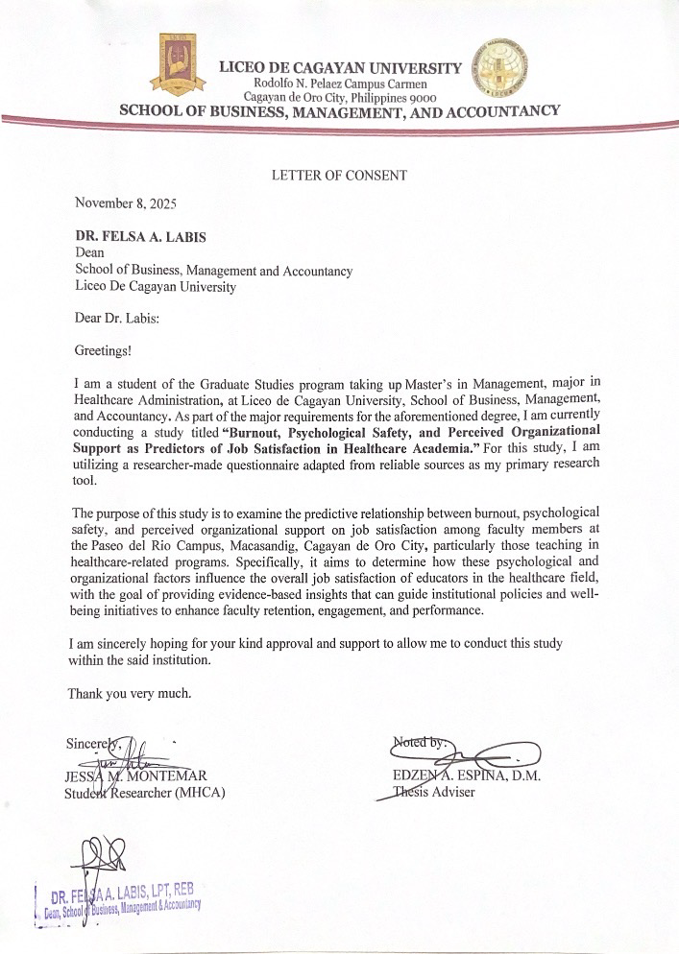

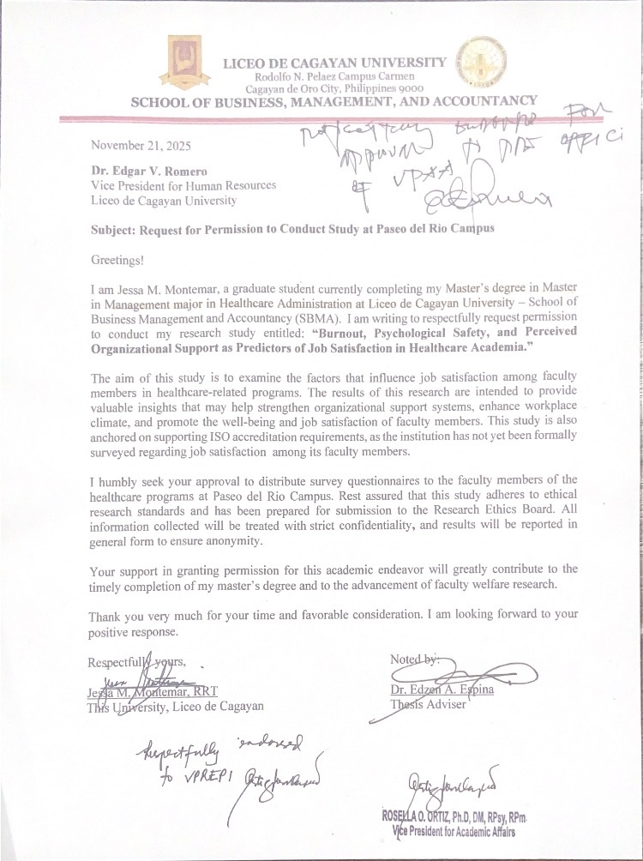

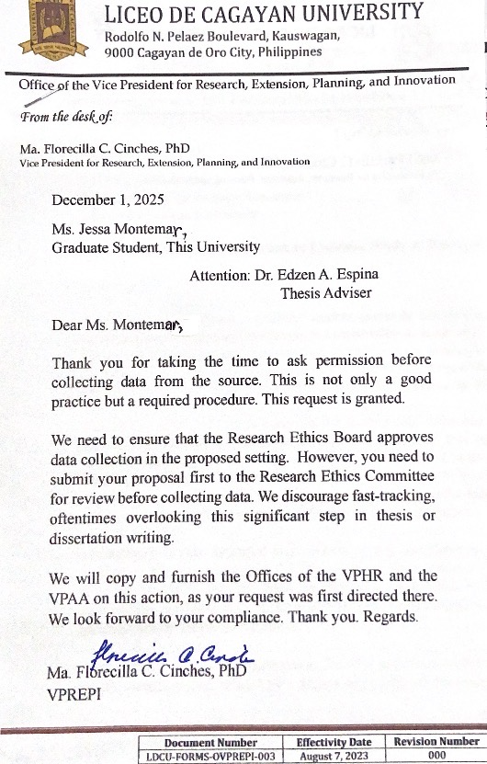

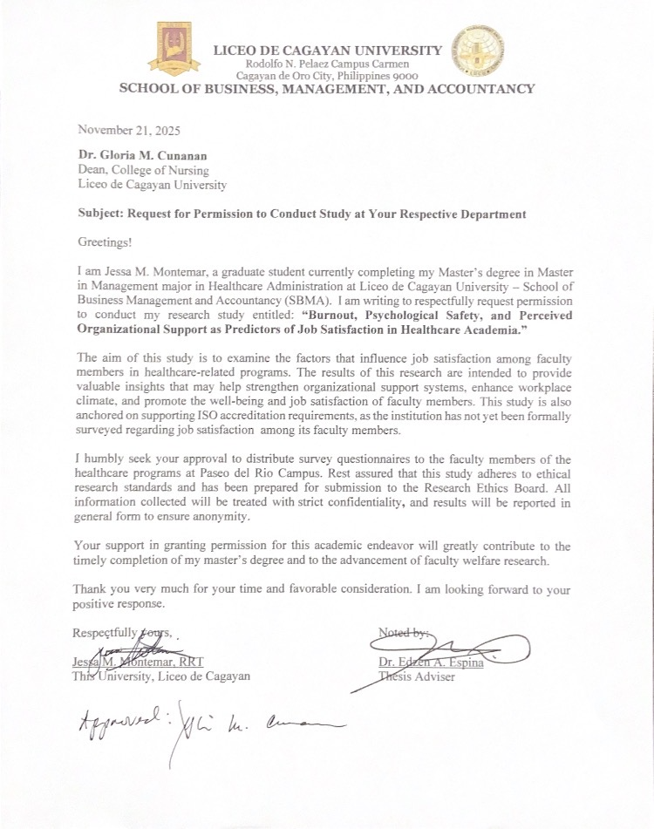

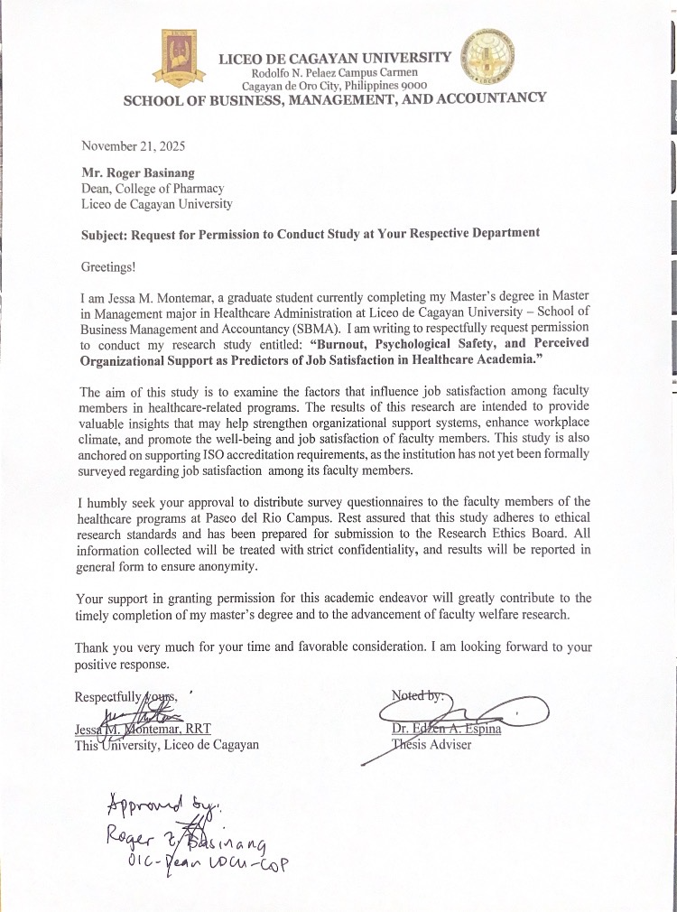

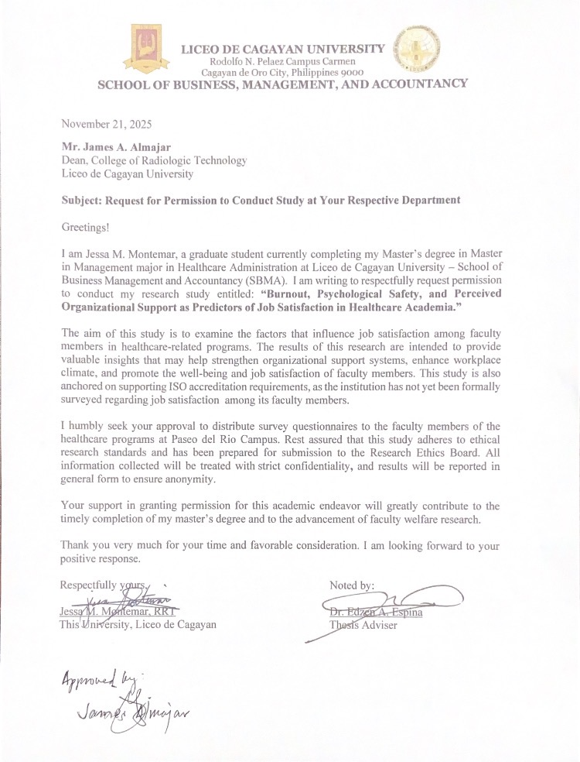

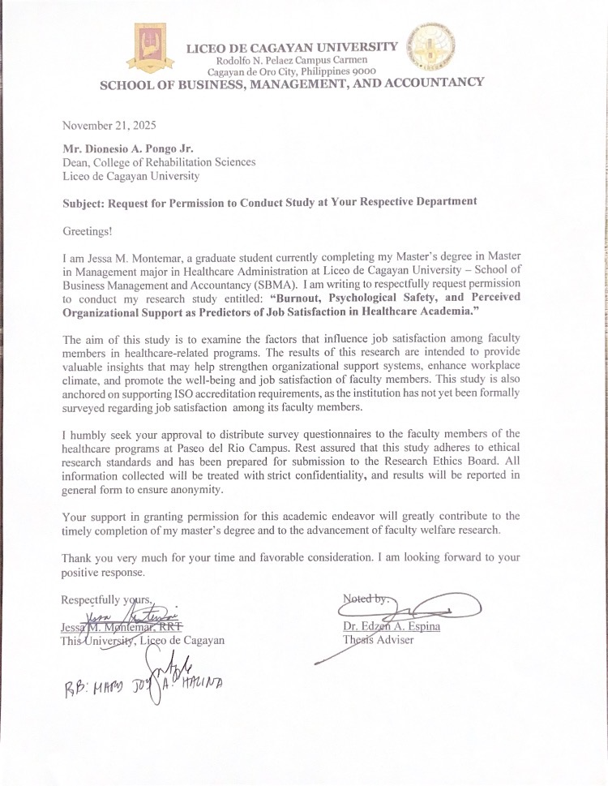

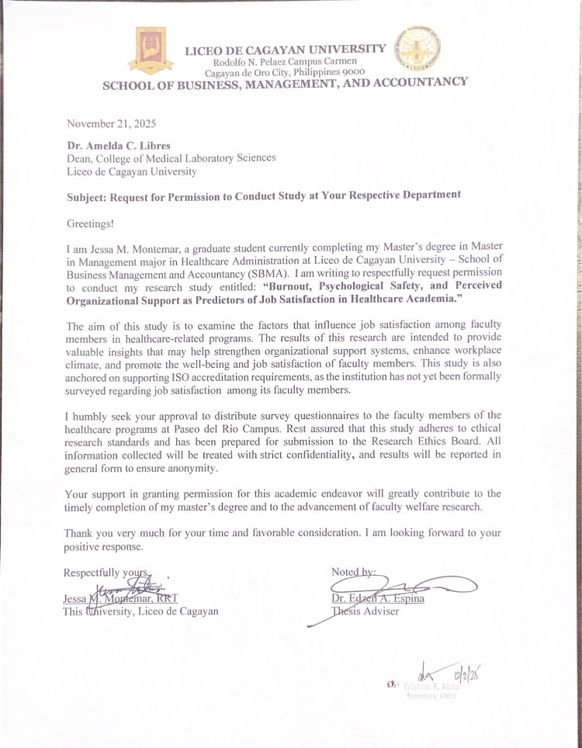

APPENDIX B

LETTER OF APPROVAL

Ever Respected LREB:

Greetings!

I am Jessa M. Montemar, a student of Master’s in Management in Healthcare Administration. I would like to respectfully request for Research Ethics Board Clearance for my study "BURNOUT, PSYCHOLOGICAL SAFETY AND PERCIEVED ORGANIZATIONAL SUPPORT AS PREDICTORS OF JOB SATISFACTION IN HEALTHCARE ACADEMIA”.

The study aims to examine the predictive relationship between burnout, psychological safety, and perceived organizational support on job satisfaction among faculty members in healthcare academia. Specifically, it seeks to determine how these psychological and organizational factors influence the overall job satisfaction of educators in the healthcare field, with the goal of providing evidence-based insights that can inform institutional policies and well-being initiatives to improve faculty retention, engagement, and performance.

May I respectfully ask for the forms that are needed to comply with the requirements in obtaining REB Clearance prior to data gathering procedure.

Thank you very much and more power.

Very respectfully yours,

Jessa M. Montemar, RRT
MHCA Student

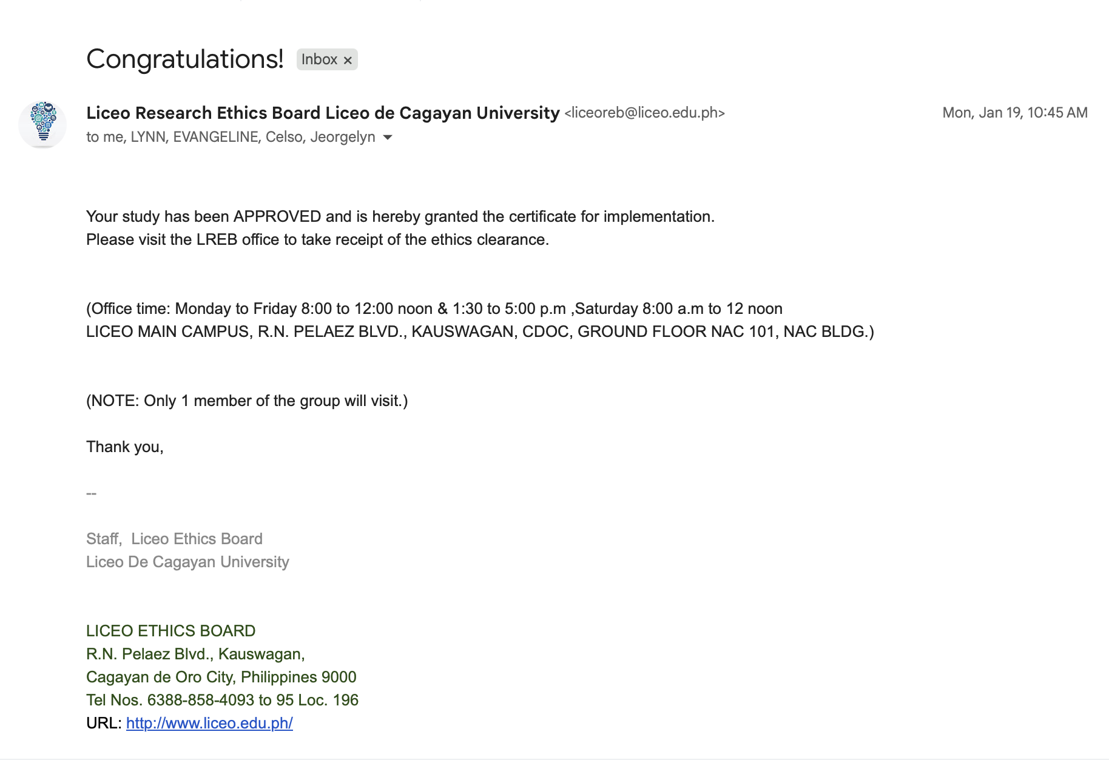

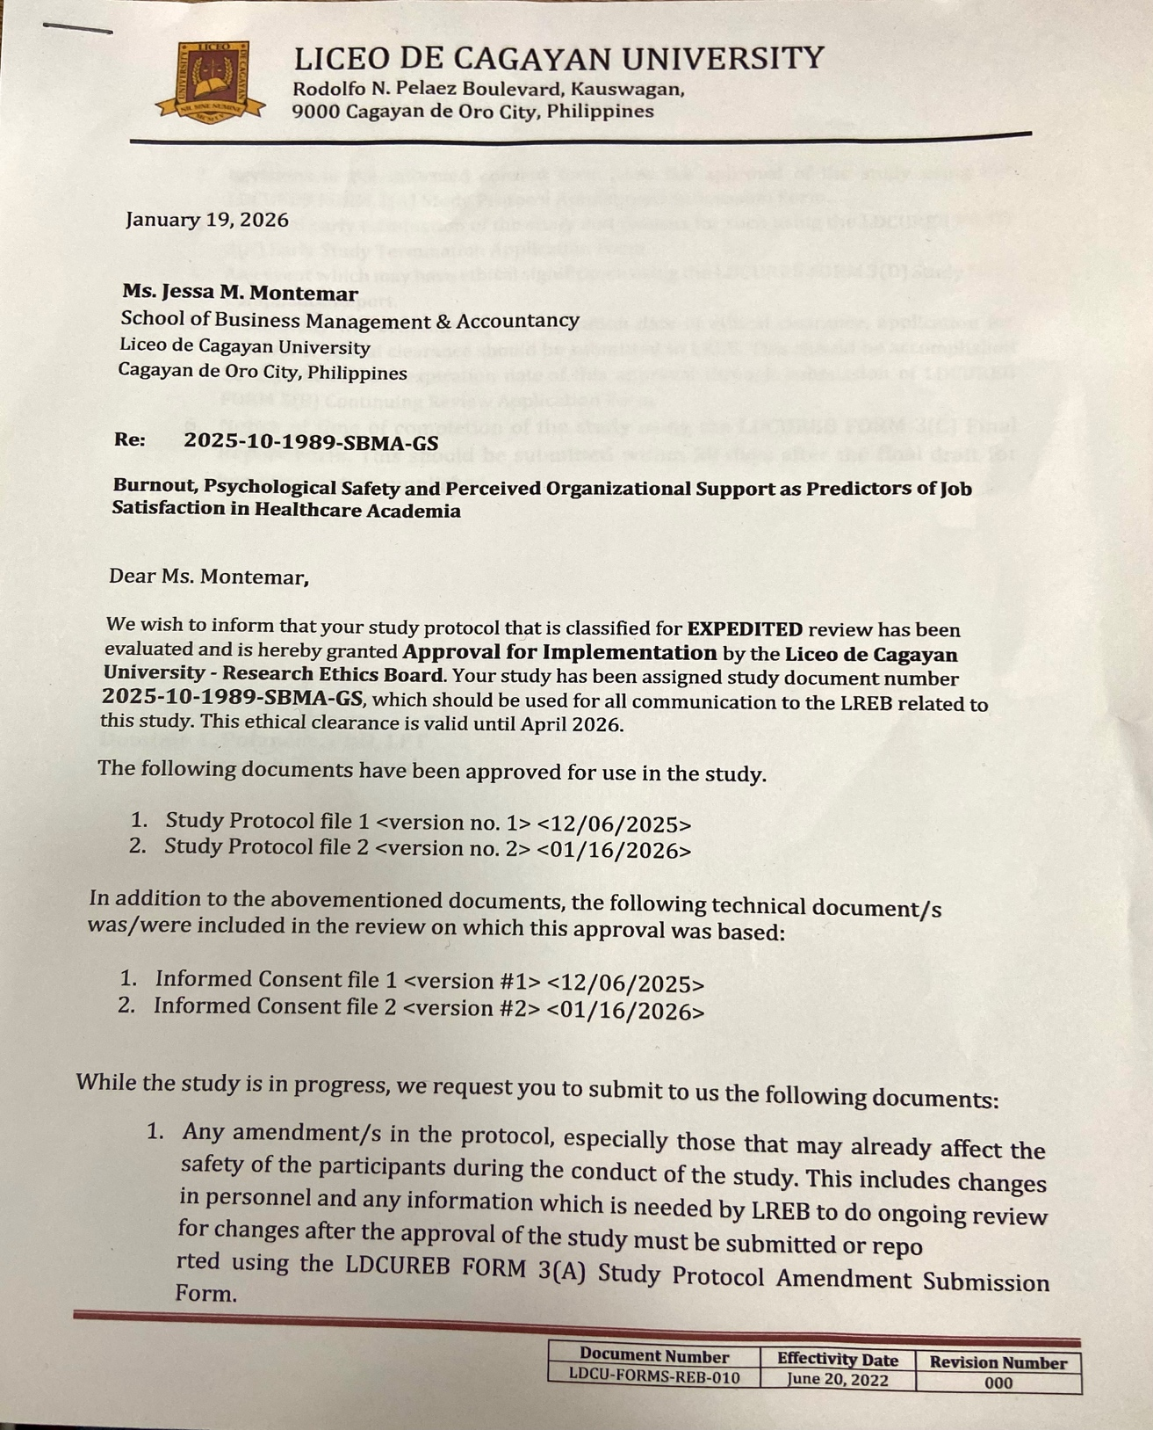

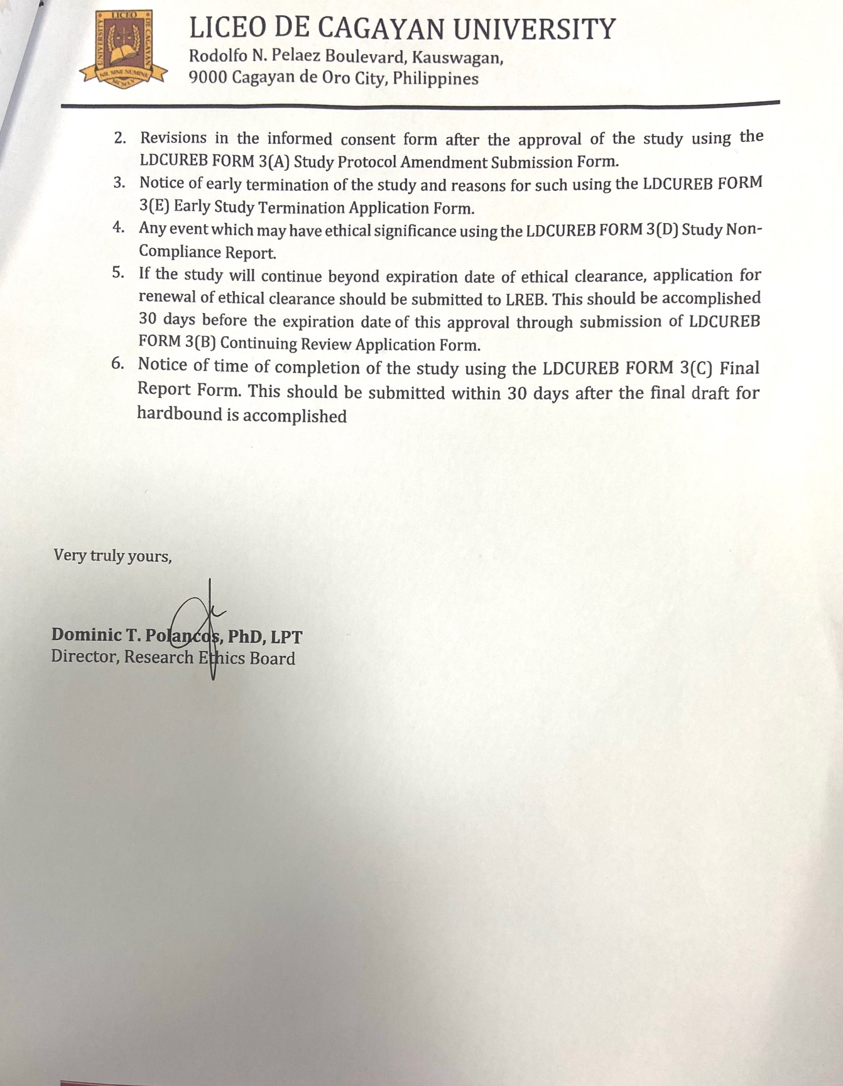

APPENDIX C

SURVEY QUESTIONNAIRES OR LABORATORY RESULTS
OR DIAGNOSTIC RESULTS



LICEO DE CAGAYAN UNIVERSITY
Rodolfo N. Pelaez Campus Carmen
Cagayan de Oro City, Philippines 9000
SCHOOL OF BUSINESS, MANAGEMENT, AND ACCOUNTANCY

Part 1.
Good day! I am conducting a thesis study entitled “Burnout, Psychological Safety, and Perceived Organizational Support as Predictors of Job Satisfaction in Healthcare Academia.” This study aims to examine the experiences of faculty members in healthcare-related programs and how these factors influence their job satisfaction.
Your participation in this survey will be of great help, not only to this study but also to the institution as a whole. Your responses will be kept strictly confidential, and the data collected will be used solely for academic purposes. Kindly answer each item honestly and to the best of your ability. There are no right or wrong answers.
Instructions:
Please put a check mark (✔) in the option that corresponds to your demographic profile.
Demographic Profile
- College/Program Affiliation:
☐ Nursing
☐ Radiologic Technology
☐ Medical Laboratory Science
☐ Pharmacy
☐ Rehabilitation Sciences
- Sex:
☐ Male
☐ Female
☐ Prefer not to say
- Age:
☐ 21–25
☐ 26–30
☐ 31–35
☐ 36–40
☐ 41 and above

Part 2. Burnout

 |  | 1 | 2 | 3 | 4 | 5
 | Emotional Exhaustion
1. | I feel emotionally drained from my work.
2. | I feel used up at the end of the workday.
3. | I feel tired when I get up in the morning and have to face another day on the job.
4. | Working with people all day is really a strain for me.
5. | I feel burned out from my work.
6. | I feel frustrated by my job.
7. | I feel I’m working too hard on my job.
8. | Working with people directly puts too much stress on me.
9. | I feel like I’m at the end of my rope.
 | Depersonalization
1. | I feel I treat some students as if they were impersonal objects.
2. | I’ve become more callous toward people since I took this job.
3. | I worry that this job is hardening me emotionally.
4. | I don’t really care what happens to some students.
5. | I feel students blame me for some of their problems.

This survey questionnaires are adopted by Ceballo-Hernandez, H. (2025)

Part 3. Perceived Organizational Support.
 |  | 1 | 2 | 3 | 4 | 5
 | Organizational Transparency
1. | Policies and administration are well-defined and properly delegated.
2. | Instructions are properly disseminated to employees.
3. | Implementation of policies is consistent to all employees.
4. | Information drive is disseminated well as far as new policies to be implemented.
5. | Management applies the policies and procedures objectively to all employees.
6. | Policies and administration fall within humane consideration.
 | Organizational Climate
7. | My workplace is pleasant.
8. | The relationship with my bosses is good.
9. | Management involves people when decisions are made that affect them.
10. | Supervisors show an understanding of the people who work for them.
11. | People are strongly encouraged to develop their skills.
12. | My suggestions about the job are listened to.
13. | This company tries to be fair in its actions towards employees.
14. | Opportunities for training are offered.
15. | It is considered extremely important here to follow the rules.
16. | This company is quick to respond when changes need to be made.
17. | The bosses are approachable.
18. | People here always want to perform to the best of their ability.
19. | My efforts receive the recognition they deserve.
20. | The reasons for the decisions made are usually adequately explained.
21. | The contribution of new ideas is encouraged.
22. | It is easy to find help when needed.
This survey questionnaires are adopted by Aranas (2016)

Part 4. Psychological Safety

 |  | 1 | 2 | 3 | 4 | 5
 | Mutual Trust/Respect
1. | My team cares about my well-being.
2. | I trust my team members.
3. | My team makes me feel included.
4. | I feel respected by my team.
5. | I have a good relationship with my team members.
6. | I feel a sense of belonging on my team.
7. | I trust my team members.
 | Interpersonal Risk-taking
1. | I am not afraid to ask for honest feedback from my team.
2. | I do not worry about repercussions when I seek help from my team.
3. | When I disagree with the team, I feel comfortable voicing my opinion.
4. | I am not afraid to speak up to my team about concerns.
5. | I am not afraid to advocate for others within my team.
This survey questionnaires are adopted by Alonge, O. (2024)

 |  | 1 | 2 | 3 | 4 | 5
 | Satisfaction with salary
1. | My salary rate is competitive when compared to similar jobs at  other organizations
2. | I am fairly paid for the work I do
3. | Salary increases are appropriate.
4. | My salary rate is a significant factor in my decision to stay in my current position.
5. | I understand how my base salary is determined.
 | Satisfaction with benefits
1. | My employer's benefits package (e.g., health insurance, leave credits, retirement plans, tuition discounts) meets my needs.
2. | The benefits package is a significant factor in my decision to stay in my position.
3. | My costs associated with the benefits plan are reasonable.
4. | My employer’s benefits package has been adequately explained to me.
Part 5. Job Satisfaction
This survey questionnaires are adopted by Vasquez (2025).

-end-
Thank you so much for taking your time.

DIAGNOSTIC RESULTS

1. What is the level of burnout among healthcare academic faculties in terms of;
1.1. Emotional Exhaustion; and
Descriptive Statistics
 |  | Valid |  | Mean |  | Std. Deviation
EE1 |  | 96 |  | 2.750 |  | 1.056
EE2 |  | 96 |  | 2.688 |  | 1.089
EE3 |  | 96 |  | 2.771 |  | 1.269
EE4 |  | 96 |  | 2.396 |  | 1.218
EE5 |  | 96 |  | 2.563 |  | 1.141
EE6 |  | 96 |  | 2.406 |  | 1.210
EE7 |  | 96 |  | 2.625 |  | 1.207
EE8 |  | 96 |  | 2.375 |  | 1.207
EE9 |  | 96 |  | 2.208 |  | 1.239
AvgEE |  | 96 |  | 2.531 |  | 1.055

1.2. Depersonalization?
Descriptive Statistics
 |  | Valid |  | Mean |  | Std. Deviation
D1 |  | 96 |  | 2.125 |  | 1.088
D2 |  | 96 |  | 2.281 |  | 1.102
D3 |  | 96 |  | 2.302 |  | 1.162
D4 |  | 96 |  | 2.000 |  | 1.016
D5 |  | 96 |  | 2.292 |  | 1.169
AvgD |  | 96 |  | 2.200 |  | 0.983

2. What is the level of perceived organizational support among healthcare academic
faculties in terms of the following;
2.1. Organizational Climate; and
Descriptive Statistics
 |  | Valid |  | Mean |  | Std. Deviation
OT1 |  | 96 |  | 3.500 |  | 1.114
OT2 |  | 96 |  | 3.552 |  | 1.025
OT3 |  | 96 |  | 3.385 |  | 1.118
OT4 |  | 96 |  | 3.458 |  | 0.951
OT5 |  | 96 |  | 3.406 |  | 0.969
OT6 |  | 96 |  | 3.635 |  | 0.985
AvgOT |  | 96 |  | 3.490 |  | 0.942

2.2. Organizational Transparency?
Descriptive Statistics
 |  | Valid |  | Mean |  | Std. Deviation
OC1 |  | 96 |  | 3.833 |  | 0.970
OC2 |  | 96 |  | 3.719 |  | 0.970
OC3 |  | 96 |  | 3.656 |  | 0.927
OC4 |  | 96 |  | 3.583 |  | 1.012
OC5 |  | 96 |  | 3.760 |  | 1.054
OC6 |  | 96 |  | 3.667 |  | 0.970
OC7 |  | 96 |  | 3.542 |  | 1.004
OC8 |  | 96 |  | 3.729 |  | 0.946
OC9 |  | 96 |  | 3.646 |  | 1.086
OC10 |  | 96 |  | 3.510 |  | 1.005
OC11 |  | 96 |  | 3.688 |  | 0.998
OC12 |  | 96 |  | 3.646 |  | 1.036
OC13 |  | 96 |  | 3.510 |  | 1.056
OC14 |  | 96 |  | 3.604 |  | 1.010
OC15 |  | 96 |  | 3.615 |  | 1.019
OC16 |  | 96 |  | 3.646 |  | 1.056
AvgOC |  | 96 |  | 3.647 |  | 0.809

3. What is the level of Psychological Safety among healthcare academic faculties
among the following;
3.1. Mutual Respect; and
Descriptive Statistics
 |  | Valid |  | Mean |  | Std. Deviation
MTR1 |  | 96 |  | 4.021 |  | 1.005
MTR2 |  | 96 |  | 3.802 |  | 1.042
MTR3 |  | 96 |  | 3.979 |  | 0.973
MTR4 |  | 96 |  | 4.010 |  | 1.031
MTR5 |  | 96 |  | 4.010 |  | 0.946
MTR6 |  | 96 |  | 4.031 |  | 0.923
MTR7 |  | 96 |  | 3.802 |  | 1.042
AvgMTR |  | 96 |  | 3.951 |  | 0.945

3.2. Interpersonal Risk Taking?
Descriptive Statistics
 |  | Valid |  | Mean |  | Std. Deviation
IRT1 |  | 96 |  | 3.875 |  | 1.049
IRT2 |  | 96 |  | 3.875 |  | 0.997
IRT3 |  | 96 |  | 3.740 |  | 1.145
IRT4 |  | 96 |  | 3.802 |  | 1.175
IRT5 |  | 96 |  | 3.865 |  | 1.193
AvgIRT |  | 96 |  | 3.831 |  | 1.034

4. What is the level of job satisfaction among healthcare academic faculties among the
following;
4.1. Salary; and
Descriptive Statistics
 |  | Valid |  | Mean |  | Std. Deviation
SWS1 |  | 96 |  | 3.198 |  | 1.219
SWS2 |  | 96 |  | 3.302 |  | 1.198
SWS3 |  | 96 |  | 3.635 |  | 1.162
SWS4 |  | 96 |  | 3.604 |  | 1.277
SWS5 |  | 96 |  | 3.458 |  | 1.160
AvgSWS |  | 96 |  | 3.440 |  | 1.055

4.2. Benefits?
Descriptive Statistics
 |  | Valid |  | Mean |  | Std. Deviation
SWB1 |  | 96 |  | 3.396 |  | 1.174
SWB2 |  | 96 |  | 3.323 |  | 1.183
SWB3 |  | 96 |  | 3.302 |  | 1.097
SWB4 |  | 96 |  | 3.344 |  | 1.065
AvgSWB |  | 96 |  | 3.341 |  | 1.055

5. Is there a significant relationship between job satisfaction and;
5.1 Burnout;
Pearson's Correlations
Variable |  |  |  | AvgJS |  | AvgEE |  | AvgD
1. AvgJS |  | Pearson's r |  | —
 |  | p-value |  | —
2. AvgEE |  | Pearson's r |  | -0.486 |  | —
 |  | p-value |  | < .001 |  | —
3. AvgD |  | Pearson's r |  | -0.249 |  | 0.699 |  | —
 |  | p-value |  | .014 |  | < .001 |  | —

5.2. Psychological Safety; and
Pearson's Correlations
Variable |  |  |  | AvgJS |  | AvgOT |  | AvgOC
1. AvgJS |  | Pearson's r |  | —
 |  | p-value |  | —
2. AvgOT |  | Pearson's r |  | 0.629 |  | —
 |  | p-value |  | < .001 |  | —
3. AvgOC |  | Pearson's r |  | 0.621 |  | 0.714 |  | —
 |  | p-value |  | < .001 |  | < .001 |  | —

5.3. Perceived Organizational Support?
Pearson's Correlations
Variable |  |  |  | AvgJS |  | AvgMTR |  | AvgIRT
1. AvgJS |  | Pearson's r |  | —
 |  | p-value |  | —
2. AvgMTR |  | Pearson's r |  | 0.409 |  | —
 |  | p-value |  | < .001 |  | —
3. AvgIRT |  | Pearson's r |  | 0.555 |  | 0.743 |  | —
 |  | p-value |  | < .001 |  | < .001 |  | —

6. Which among the variables, singly or in combination, predicts job satisfaction?

Linear Regression
Model Summary - AvgJS
Model |  | R |  | R² |  | Adjusted R² |  | RMSE
M₀ |  | 0.000 |  | 0.000 |  | 0.000 |  | 0.980
M₁ |  | 0.760 |  | 0.577 |  | 0.548 |  | 0.658
Note. M₁ includes AvgEE, AvgD, AvgOT, AvgOC, AvgMTR, AvgIRT

ANOVA
Model |  |  |  | Sum of Squares |  | df |  | Mean Square |  | F |  | p
M₁ |  | Regression |  | 52.62 |  | 6 |  | 8.770 |  | 20.23 |  | < .001
 |  | Residual |  | 38.58 |  | 89 |  | 0.434
 |  | Total |  | 91.21 |  | 95
Note. M₁ includes AvgEE, AvgD, AvgOT, AvgOC, AvgMTR, AvgIRT
Note. The intercept model is omitted, as no meaningful information can be shown.

Coefficients
Model |  |  |  | Unstandardized |  | Standard Error |  | Standardized |  | t |  | p
M₀ |  | (Intercept) |  | 3.396 |  | 0.100 |  |  |  | 33.957 |  | < .001
M₁ |  | (Intercept) |  | 0.292 |  | 0.592 |  |  |  | 0.493 |  | .623
 |  | AvgEE |  | -0.330 |  | 0.095 |  | -0.355 |  | -3.475 |  | < .001
 |  | AvgD |  | 0.363 |  | 0.104 |  | 0.364 |  | 3.509 |  | < .001
 |  | AvgOT |  | 0.300 |  | 0.111 |  | 0.289 |  | 2.705 |  | .008
 |  | AvgOC |  | 0.345 |  | 0.136 |  | 0.285 |  | 2.527 |  | .013
 |  | AvgMTR |  | -0.044 |  | 0.118 |  | -0.043 |  | -0.375 |  | .709
 |  | AvgIRT |  | 0.264 |  | 0.105 |  | 0.278 |  | 2.519 |  | .014

APPENDIX D

CURRICULUM VITAE


2 x 2
Formal picture with white background

Name: Jessa M. Montemar

Address: Zone 4 Kauswagan, Cagayan de Oro City

Email Address: jmontemar03341@liceo.edu.ph

ORCID Number:

Name of Father: Mamerto V. Montemar

Name of Mother: Dionesia M. Montemar

School Graduated and Honors
Elementary: Talic Elementary School
High School: Cagayan de Oro College-PHINMA
College: Liceo de Cagayan University

Membership: Philippine Association in Radiologic Technologist (PART)

