Costing and Pricing Strategies of Displaced Farmers and Women Entrepreneurs in Polilio and Palagay, Cabanatuan City

INTRODUCTION
In many developing communities, small-scale entrepreneurs and displaced workers play a crucial role in sustaining local economies. Among these are displaced farmers and women entrepreneurs who, despite facing economic uncertainties and limited resources, continue to engage in livelihood activities to support their families. In areas such as Polilio and Palagay in Cabanatuan City, these groups have increasingly turned to small business ventures and informal market participation as alternative sources of income.
Costing and pricing strategies are essential components of business operations, as they directly influence profitability, sustainability, and competitiveness. For displaced farmers and women entrepreneurs, determining the appropriate cost of production and setting prices for goods and services can be particularly challenging due to fluctuating input costs, lack of formal training, and limited access to financial and market information. These challenges may result in underpricing or overpricing, both of which can negatively affect business performance and long-term viability.
Moreover, women entrepreneurs often face additional barriers such as limited access to capital, market networks, and entrepreneurial education, while displaced farmers must adapt to new economic roles outside their traditional agricultural practices. Despite these constraints, both groups demonstrate resilience and innovation in managing their enterprises, making it important to understand the strategies they employ in costing and pricing their products.
This study aims to examine the costing and pricing strategies of displaced farmers and women entrepreneurs in Polilio and Palagay, Cabanatuan City. By analyzing their practices, challenges, and decision-making processes, the research seeks to provide insights that may contribute to improving their business operations, enhancing income generation, and supporting local economic development. Ultimately, the findings of this study may serve as a basis for developing targeted interventions, training programs, and policies that promote sustainable entrepreneurship among marginalized sectors.

OBJECTIVES OF THE STUDY
The primary objective of this study is to examine the costing and pricing strategies of displaced farmers and women entrepreneurs in Polilio and Palagay, Cabanatuan City.
Specifically, this study aims to:
- Identify the common costing practices used by displaced farmers and women entrepreneurs in their business operations.
- Determine the pricing strategies employed by the respondents in selling their products or services.
- Analyze the factors that influence their costing and pricing decisions, such as production costs, market demand, competition, and available resources.
- Assess the challenges encountered by displaced farmers and women entrepreneurs in implementing effective costing and pricing strategies.
- Propose recommendations that may help improve their costing and pricing practices to enhance profitability and sustainability.

STATEMENT OF THE PROBLEM
This study aims to examine the costing and pricing strategies of displaced farmers and women entrepreneurs in Polilio and Palagay, Cabanatuan City.
Specifically, it seeks to answer the following questions:
- What are the costing practices employed by displaced farmers and women entrepreneurs in their business operations?
- What pricing strategies are commonly used by the respondents in selling their products or services?
- What factors influence their costing and pricing decisions in terms of:
3.1 production costs;
3.2 market demand;
3.3 competition; and
3.4 available resources?
- What challenges do displaced farmers and women entrepreneurs encounter in applying effective costing and pricing strategies?
- How do their costing and pricing strategies affect the profitability and sustainability of their businesses?
- What recommendations can be proposed to improve their costing and pricing practices?

METHODOLOGY
This study will utilize a descriptive research design to examine the costing and pricing strategies of displaced farmers and women entrepreneurs in Polilio and Palagay, Cabanatuan City. The descriptive method is appropriate as it allows the researcher to systematically describe the current practices, factors, and challenges experienced by the respondents in their business operations.

Research Design
The study will adopt a descriptive-survey approach to gather relevant data on the costing and pricing practices of the respondents. This design enables the researcher to obtain factual information and analyze relationships among variables without manipulating the study environment.

Respondents of the Study
The respondents of the study will consist of displaced farmers and women entrepreneurs currently engaged in small-scale business activities in Polilio and Palagay. A purposive sampling technique will be used to select participants who have direct experience in managing business costs and pricing their products or services.

Data Gathering Instrument
The primary instrument to be used in this study is a structured questionnaire. The questionnaire will be divided into sections covering respondents’ profile, costing practices, pricing strategies, influencing factors, and challenges encountered. The instrument may also include a few open-ended questions to gather additional insights.

Data Gathering Procedure
The researcher will seek permission from local authorities and respondents prior to data collection. Questionnaires will be personally distributed and explained to the respondents to ensure clarity and accuracy of responses. After completion, the questionnaires will be collected, checked, and prepared for data analysis.

Statistical Treatment of Data
The data gathered will be analyzed using appropriate statistical tools. Frequency and percentage will be used to describe the profile of the respondents. Weighted mean will be utilized to determine the extent of costing and pricing practices. Ranking may also be applied to identify the most common strategies and challenges encountered.

CONCEPTUAL FRAMEWORK
This study is anchored on the idea that the costing and pricing strategies of displaced farmers and women entrepreneurs are influenced by various internal and external factors, which in turn affect their business profitability and sustainability.
The independent variables of the study include the factors influencing costing and pricing decisions such as production costs, market demand, competition, and available resources. These factors shape how respondents compute their costs and set their prices.
The dependent variable is the effectiveness of their costing and pricing strategies, particularly in terms of profitability and sustainability of their businesses.
The respondents of the study are displaced farmers and women entrepreneurs in Polilio and Palagay, Cabanatuan City.

Explanation of the Diagram
The diagram illustrates that different economic and business factors (independent variables) influence how displaced farmers and women entrepreneurs determine their costing and pricing strategies. These strategies then directly impact the outcomes of their businesses, particularly in achieving profitability and long-term sustainability.
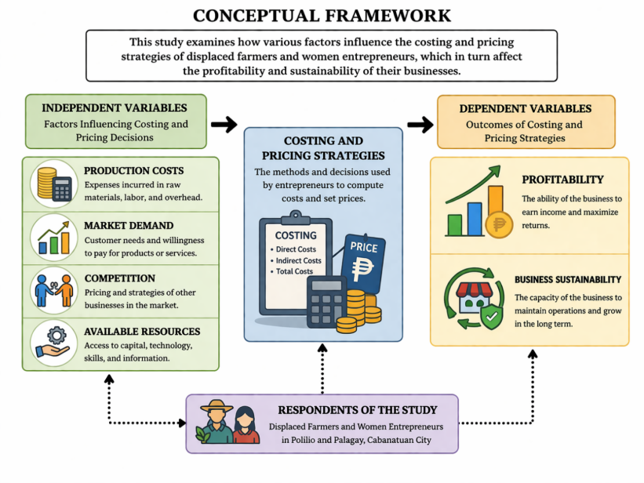

CONCLUSION
This study examined the costing and pricing strategies of displaced farmers and women entrepreneurs in Polilio and Palagay, Cabanatuan City. Based on the findings, it can be concluded that these groups employ a variety of basic and experience-based costing and pricing practices in managing their businesses. Most respondents rely on simple estimation methods rather than formal costing techniques, which may affect the accuracy of their pricing decisions.
The study also revealed that several factors significantly influence their costing and pricing strategies, including production costs, market demand, competition, and the availability of resources. These factors play a crucial role in determining how prices are set and how businesses remain competitive in the local market. However, many respondents face challenges such as limited financial knowledge, lack of access to formal training, and unstable market conditions, which hinder their ability to implement more effective and strategic pricing methods.
Despite these challenges, displaced farmers and women entrepreneurs demonstrate resilience and adaptability in sustaining their livelihoods. Their ability to continuously operate their businesses reflects their important contribution to local economic development. However, there is a clear need for capacity-building programs, financial literacy training, and institutional support to enhance their costing and pricing capabilities.
In conclusion, improving the costing and pricing strategies of these entrepreneurs can lead to better profitability and long-term business sustainability. Providing targeted interventions and support mechanisms will not only strengthen their enterprises but also contribute to the overall economic growth of their communities.

RECOMMENDATIONS
Based on the findings and conclusions of the study conducted among displaced farmers and women entrepreneurs in Polilio and Palagay, Cabanatuan City, the following recommendations are proposed:
- Enhancement of Financial Literacy Programs
Local government units and concerned organizations should conduct training and seminars focused on basic accounting, costing, and pricing strategies. This will help respondents develop more accurate and systematic methods in managing their business finances.
- Provision of Skills Development and Capacity-Building Programs
Government agencies and non-government organizations should offer continuous entrepreneurial training to improve business decision-making, particularly in cost computation and price setting.
- Access to Market Information
Respondents should be provided with updated market data, including prevailing prices, demand trends, and competitor analysis, to enable them to make informed pricing decisions.
- Financial and Technical Support
Institutions may extend financial assistance, microfinancing opportunities, and technical support to help displaced farmers and women entrepreneurs improve their business operations and expand their ventures.
- Encouragement of Record-Keeping Practices
Respondents are encouraged to adopt proper record-keeping of expenses, revenues, and profits to better monitor business performance and support effective costing and pricing strategies.
- Future Research
Future researchers may conduct similar studies in other areas or include additional variables such as digital marketing, access to technology, and customer behavior to further enrich the understanding of entrepreneurial practices.

REFERENCES
Department of Trade and Industry. (2020). Small and medium enterprise development plan 2017–2022.
Food and Agriculture Organization. (2018). Smallholder farmers and family farming.
Kotler, Philip, & Keller, Kevin Lane. (2016). Marketing management (15th ed.). Pearson Education.
Horngren, Charles T., Datar, Srikant M., & Rajan, Madhav V.. (2015). Cost accounting: A managerial emphasis (15th ed.). Pearson Education.
Drury, Colin. (2018). Management and cost accounting (10th ed.). Cengage Learning.
World Bank. (2020). Enhancing opportunities for women entrepreneurs.
International Labour Organization. (2019). Women in business and management: The business case for change.
Scarborough, Norman M.. (2016). Essentials of entrepreneurship and small business management (8th ed.). Pearson Education.
Hisrich, Robert D., Peters, Michael P., & Shepherd, Dean A.. (2017). Entrepreneurship (10th ed.). McGraw-Hill Education.

