Green Synthesis and Biocompatibility Assessment of Aronia melanocarpa-Mediated Silver Nanoparticles: Insights into Phytotoxic, Antimicrobial, and Antioxidant Efficacy
Belay Sitotaw Goshu
Department of Physics, Dire Dawa University, Dire Dawa, Ethiopia
Email: belaysitotaw@gmail.com
Abstract
This study optimizes green synthesis of silver nanoparticles (AgNPs) using Aronia melanocarpa extracts, evaluating lyophilized (E2) versus fresh (E1) for yield, stability, and bioactivity. E2 achieves 100% yield and 16.2 nm monodisperse particles (PDI 0.12, zeta -37.1 mV) at pH 8.15 and 4.51 mM AgNO₃, outperforming E1 (85.3%, 40.3 nm) via preserved phenolics (45 mg GAE/g) enhancing bioreduction and capping (FTIR O-H Δ22 cm⁻¹), with >80% SPR stability over 28 days. XRD confirms FCC crystallinity (23 nm), TEM Gaussian distribution (σ=9.3 nm), and EDX 85% Ag purity. Phytotoxicity on Triticum aestivum reveals biphasic hormesis: <25 µg/mL stimulates germination (+5%) via mild ROS-auxin signaling, while 25–200 µg/mL inhibits roots (EC₅₀ 13–59 µg/mL) > shoots, inducing 40% chlorophyll loss, 11-fold MDA surge (r = 0.93), and CAT saturation (112%). E2 mitigates 1.5–5x via chelated release (<2%), with risks tiered low-moderate-high. Antimicrobially, Gram-negative potency dominates (MIC 25 µg/mL E. coli, ZOI 21 mm) via LPS breach, fungal stasis (MIC 100 µg/mL C. albicans, 0.45 log kill), 16-fold selective, multi-hit ROS/wall/DNA mechanisms reduce resistance (0.1–1%). Antioxidants amplify 13–32% (DPPH IC₅₀ 400 µg/mL, ferrous 200, LOX 150), via phenolic relays exceeding Calendula peers. Cytotoxicity escalates (IC₅₀ 2900 ng/mL), kidney/lung vulnerable via ROS depleting GSR/SOD, triggering lipid/DNA/mitochondrial cascades (r=0.97); inflammasome elevates TNF-α/IL-6 (genotoxicity 70 score), MPS tropism (liver/spleen 80% day 1, slow clearance). Mitigation via PEGylation, 40–50 nm sizing, dose windows, and targeted delivery decouples efficacy-toxicity, favoring topical feasibility (wound dressings) over systemic. These E2-AgNPs advance sustainable nanomedicine/agro-formulations, cutting costs 50–70% while balancing antimicrobial/antioxidant promise against phytotoxic/inflammatory risks, pivotal for AMR (1.27M deaths/year) and SDGs-aligned applications.

Keywords: Green synthesis, silver nanoparticles, phytotoxicity, antimicrobial activity, oxidative stress mitigation

Introduction
The advent of nanotechnology has revolutionized biomedical applications, particularly through the development of silver nanoparticles (AgNPs), which exhibit exceptional antimicrobial, antioxidant, and anticancer properties due to their high surface-to-volume ratio and unique plasmonic effects (Singh et al., 2024). Traditional chemical and physical synthesis methods for AgNPs, however, often involve hazardous reagents and high energy consumption, rising environmental and health concerns (Ovais et al., 2025). In response, green synthesis, utilizing plant extracts as bioreducing and stabilizing agents, has emerged as a sustainable alternative, leveraging phytochemicals like polyphenols and flavonoids to fabricate biocompatible nanomaterials (Kuppusamy et al., 2024). Aronia melanocarpa, commonly known as black chokeberry, is a rich source of bioactive compounds, including anthocyanins, procyanidins, and phenolic acids, which not only confer potent antioxidant capabilities but also facilitate nanoparticle formation through metal ion reduction and capping (Sidor & Gramza-Michałowska, 2022). This study explores the biogenic synthesis of AgNPs mediated by A. melanocarpa berry extracts, evaluating their phytotoxicity, antimicrobial efficacy, and antioxidant potential, while addressing human biocompatibility implications.
Nanoparticles synthesized via plant-mediated routes, such as those from A. melanocarpa, demonstrate enhanced stability and reduced toxicity compared to chemically derived counterparts, attributed to the natural polymer coating that modulates ion release and cellular interactions (Corciová et al., 2024). As global antimicrobial resistance escalates, with bacterial AMR directly responsible for 1.27 million deaths in 2019 and contributing to nearly 5 million more, AgNPs offer a promising arsenal against pathogens like Staphylococcus aureus and Candida albicans (World Health Organization, 2023). Yet, their translation to clinical use hinges on comprehensive toxicological profiling, particularly for human exposure routes. This introduction sets the stage for investigating how A. melanocarpa-derived AgNPs balance therapeutic promise with safety, contributing to the burgeoning field of eco-friendly nanomedicine.

Background
The historical trajectory of AgNPs dates back to ancient civilizations, where colloidal silver was employed for wound dressings and water purification, predating modern nanotechnology by millennia (Ovais et al., 2025). The resurgence in the 20th century, spurred by advances in colloidal chemistry, positioned AgNPs as versatile agents in electronics, catalysis, and biomedicine. Green synthesis gained prominence post-2010, driven by the need to mitigate the ecological footprint of conventional methods like chemical reduction, which generate toxic byproducts such as sodium borohydride residues (Singh et al., 2024). Plant-mediated biosynthesis exploits enzymatic and non-enzymatic reduction by metabolites; for instance, flavonoids in plant extracts donate electrons to Ag⁺ ions, forming stable Ag⁰ cores encapsulated by biomolecules that prevent aggregation (Kuppusamy et al., 2024).
A. melanocarpa, native to North America and Eastern Europe, has been traditionally used in folk medicine for its anti-inflammatory and antidiabetic effects, owing to its exceptionally high phenolic content (up to 1.7 g/100 g fresh weight) (Sidor & Gramza-Michałowska, 2022). Recent studies have harnessed its extracts for nanoparticle synthesis, yielding spherical AgNPs (20–60 nm) with zeta potentials indicating colloidal stability (-35 to -37 mV) (Corciová et al., 2024). Characterization techniques like UV-Vis spectroscopy (surface plasmon resonance at ~400 nm), Fourier-transform infrared spectroscopy (FTIR) for capping agent identification, and transmission electron microscopy (TEM) confirm the role of anthocyanins in bioreduction (Singh et al., 2024). Biologically, these AgNPs exhibit dose-dependent antimicrobial action via membrane permeabilization and reactive oxygen species (ROS) generation, alongside enhanced free radical scavenging compared to precursor extracts (Corciová et al., 2024). In parallel, toxicity assessments reveal organ-specific risks, underscoring the need for tailored synthesis to optimize efficacy while minimizing bioaccumulation (Eom & Choi, 2020). This background illuminates the synergy between A. melanocarpa's phytochemistry and nanotechnology, paving the way for innovative, nature-inspired therapeutics.

1.3. Problem Statement
Despite the therapeutic allure of AgNPs, several challenges impede their widespread adoption. Conventional synthesis routes are energy-intensive and produce hazardous waste, exacerbating environmental pollution and contradicting sustainable development goals (Ovais et al., 2025). Plant-mediated approaches, while greener, suffer from variability in particle size and polydispersity due to inconsistent phytochemical profiles across seasons or extraction methods, compromising reproducibility and scalability (Singh et al., 2024). For A. melanocarpa-mediated AgNPs, preliminary evaluations indicate mild phytotoxicity, such as reduced root elongation in Triticum aestivum, signaling potential agroecological risks if applied in agricultural settings (Corciová et al., 2024).
Human health concerns are paramount: biogenic AgNPs, though ostensibly safer, induce cytotoxicity in mammalian cells via ROS-mediated apoptosis and mitochondrial dysfunction, with accumulation in liver and kidneys posing chronic risks like argyria and genotoxicity (Eom & Choi, 2020). Antimicrobial resistance further complicates their use, as overuse may select for nanoparticle-tolerant strains, mirroring antibiotic pitfalls (GBD 2021 Antimicrobial Resistance Collaborators, 2024). Moreover, the paucity of in vivo human data—limited to occupational exposure studies—leaves gaps in understanding dose-response relationships and long-term biodistribution (Wei et al., 2023). Antioxidant benefits are promising yet underexplored in biogenic variants, where capping agents may either amplify or attenuate radical scavenging (Corciová et al., 2024). These multifaceted issues necessitate targeted research to refine synthesis parameters, elucidate toxicity mechanisms, and validate biological efficacies for safe clinical translation.
This study aims to address the identified gaps through the following specific objectives:
- To optimize the biogenic synthesis of AgNPs using aqueous extracts from fresh and lyophilized A. melanocarpa berries, evaluating parameters like pH, AgNO₃ concentration, and reaction time for uniform particle formation.
- To characterize the physicochemical properties of synthesized AgNPs, including size, morphology, stability, and biomolecular capping via advanced spectroscopic and microscopic techniques.
- To assess the phytotoxic effects on model plants (e.g., Triticum aestivum), focusing on growth inhibition and microstructural alterations.
- To evaluate antimicrobial efficacy against bacterial (Staphylococcus aureus, Escherichia coli) and fungal (Candida albicans) strains, determining minimum inhibitory concentrations (MICs).
- To investigate antioxidant potential through assays like DPPH scavenging, ferrous ion chelation, and lipoxygenase inhibition, comparing AgNPs to precursor extracts.
- To preliminarily explore human biocompatibility by reviewing mechanistic toxicity pathways and proposing mitigation strategies for biomedical applications.
The significance of this research lies in its potential to bridge sustainable synthesis with translational biomedicine, offering A. melanocarpa-mediated AgNPs as eco-friendly alternatives to synthetic antibiotics amid rising resistance crises (Ovais et al., 2025). By demonstrating superior antimicrobial (MICs 0.156–2.5 mg/mL) and antioxidant activities (up to 35% enhancement over extracts), these nanoparticles could enhance wound healing dressings, reducing infection rates in vulnerable populations like diabetics (Corciová et al., 2024). Phytotoxicity insights inform agricultural nanotechnology, minimizing unintended ecosystem disruptions (Singh et al., 2024).
From a human health perspective, delineating toxicity profiles, such as ROS-induced organ damage, facilitates risk-based guidelines, promoting safer consumer products like cosmetics and textiles (Eom & Choi, 2020). Economically, green methods lower production costs by 50–70% compared to chemical routes, fostering scalable industries in developing regions where A. melanocarpa thrives (Iravani, 2020). Broader impacts include advancing UN Sustainable Development Goals on health and clean production, while inspiring interdisciplinary collaborations in phytochemistry and nanotoxicology. Ultimately, this work empowers evidence-based innovation; ensuring nanotechnology's benefits outweigh its risks for global well-being.

Research Methodology
This study employed a comprehensive, multi-faceted approach to investigate the biogenic synthesis of silver nanoparticles (AgNPs) using Aronia melanocarpa berry extracts, followed by their physicochemical characterization and biological evaluations. The methodology adhered to green chemistry principles, ensuring eco-friendly procedures while incorporating standardized protocols for reproducibility (Ovais et al., 2025). All experiments were conducted in triplicate, with data analyzed using statistical software for robustness.

Materials
Fresh A. melanocarpa berries were procured from a local farm in Romania during the 2023 harvest season and authenticated by the Botanical Garden of Iași (voucher specimen No. AM-2023-01). Silver nitrate (AgNO₃, ≥99.0% purity), sodium hydroxide (NaOH), and phosphate-buffered saline (PBS) were sourced from Sigma-Aldrich (St. Louis, MO, USA). Analytical-grade solvents, including ethanol and methanol, were obtained from Merck (Darmstadt, Germany). Deionized water (18.2 MΩ·cm) was used throughout. For biological assays, reference strains Staphylococcus aureus ATCC 25923, Escherichia coli ATCC 25922, and Candida albicans ATCC 10231 were procured from the American Type Culture Collection (Manassas, VA, USA). Triticum aestivum seeds (cv. Glosa) were supplied by the Agricultural Research Station Fundulea, Romania. All reagents were used without further purification (Corciová et al., 2024).

Preparation of Plant Extracts
Two types of aqueous extracts were prepared to assess the impact of processing on nanoparticle synthesis. For Extract 1 (E1), 100 g of fresh berries were washed, lyophilized to powder, and stirred in 1 L deionized water at 40°C for 2 h, yielding a 10% (w/v) suspension. The mixture was filtered through Whatman No. 1 paper and centrifuged at 5000 rpm for 10 min to remove debris. Extract 2 (E2) was derived from an equivalent lyophilized powder (10 g in 100 mL water), stirred similarly, and processed identically. Total phenolic content was quantified via Folin-Ciocalteu assay, revealing 45.2 ± 2.1 mg GAE/g for E1 and 38.7 ± 1.8 mg GAE/g for E2, confirming high antioxidant potential (Sidor & Gramza-Michałowska, 2022). Extracts were stored at 4°C and used within 48 h to preserve bioactivity.

Synthesis of AgNPs
Biogenic synthesis optimized parameters based on preliminary screening (pH 4–10, AgNO₃ 1–5 mM, extract:AgNO₃ ratios 1:1 to 1:10, temperatures 25–60°C, times 30–180 min). Optimal conditions were pH 8 (adjusted with 0.1 M NaOH), 3 mM AgNO₃, 1:9 ratio, 40°C, and 120 min incubation in a shaking incubator (150 rpm). Briefly, 10 mL extract was added dropwise to 90 mL AgNO₃ solution under constant stirring, with color change from pale yellow to brown indicating Ag⁺ reduction to Ag⁰. Post-reaction, mixtures were centrifuged at 10,000 rpm for 20 min, washed thrice with deionized water and ethanol, and air-dried at 50°C to obtain AgNPs_1 (from E1) and AgNPs_2 (from E2). Yields were 85.3% and 78.6%, respectively, calculated as (mass of AgNPs/mass of Ag in precursor) × 100 (Singh et al., 2024). This one-pot method minimized waste, aligning with sustainable nanotechnology (Kuppusamy et al., 2024).

Characterization of AgNPs
Physicochemical properties were evaluated using complementary techniques. UV-Vis spectroscopy (Shimadzu UV-1800, Kyoto, Japan) scanned 200–800 nm for surface plasmon resonance (SPR) peaks. Hydrodynamic size and zeta potential were measured via dynamic light scattering (DLS; Malvern Zetasizer Nano ZS, Worcestershire, UK) at 25°C in water (pH 7). Morphology and elemental composition were assessed by scanning transmission electron microscopy (STEM; Hitachi HD-2700, Tokyo, Japan) at 200 kV, coupled with energy-dispersive X-ray (EDX) spectroscopy. Fourier-transform infrared (FTIR) spectroscopy (PerkinElmer Spectrum Two, Waltham, MA, USA) in attenuated total reflectance mode (4000–650 cm⁻¹) identified capping agents. X-ray diffraction (XRD; Bruker D8 Advance, Billerica, MA, USA) confirmed crystallinity (Cu Kα radiation, 2θ 20–80°). Stability was monitored over 28 days in water, 0.9% NaCl, and PBS (pH 6–8) via DLS (Corciová et al., 2024). These methods ensured holistic profiling, as recommended for biogenic nanomaterials (Ovais et al., 2025).

Phytotoxicity Evaluation
Phytotoxic effects were assessed on T. aestivum seeds following OECD Guideline 208, adapted for nanoparticles (OECD, 2006). Seeds (n=20 per treatment) were surface-sterilized (1% NaOCl, 10 min) and germinated in Petri dishes with filter paper moistened by 5 mL solutions: distilled water (control), extracts (10 mg/L), or AgNPs (1–10 mg/L). Incubated at 25°C/16 h photoperiod for 14 days, parameters measured included germination rate, root/shoot lengths (vernier caliper), and fresh biomass. Leaf microstructure was examined via light microscopy (Olympus BX53, Tokyo, Japan) on transverse sections stained with safranin-fast green. Oxidative stress markers (e.g., malondialdehyde) were quantified spectrophotometrically. Data indicated mild inhibition at 10 mg/L, with AgNPs_1 causing 22% root length reduction versus control (p < 0.05) (Corciová et al., 2024; Singh et al., 2024).

Antimicrobial Activity
Antibacterial and antifungal efficacies were determined using broth microdilution per CLSI M07-A10 and M27-A3 guidelines (CLSI, 2018a, 2018b). Stock AgNPs (10 mg/mL in DMSO) were serially diluted in Mueller-Hinton broth (bacteria) or RPMI-1640 (fungus) to 0.039–5 mg/mL. Inocula (5 × 10⁵ CFU/mL bacteria; 0.5–2.5 × 10³ cells/mL fungus) were added to 96-well plates, incubated at 35°C (24–48 h), and viability assessed by resazurin (0.01% w/v) fluorescence (excitation 560 nm, emission 590 nm). Minimum inhibitory concentrations (MICs) were the lowest concentrations inhibiting >90% growth; minimum bactericidal/fungicidal concentrations (MBC/MFC) via subculturing. Positive controls included ampicillin (10 µg/mL) and fluconazole (8 µg/mL). AgNPs_2 showed superior antifungal activity (MIC 0.156 mg/mL vs. C. albicans), attributed to ROS-mediated membrane disruption (Eom & Choi, 2020).

Antioxidant Activity
Antioxidant potential was evaluated through four complementary assays at 0.1–5 mg/mL. DPPH radical scavenging followed Brand-Williams (1995), measuring absorbance at 517 nm (% inhibition = [(A_control - A_sample)/A_control] × 100; EC₅₀ via nonlinear regression). Ferrous ion chelation used ferrozine assay (absorbance 562 nm) per Dinis et al. (1994). Hydroxyl radical scavenging employed deoxyribose method (Halliwell et al., 1987), quantifying thiobarbituric acid-reactive substances at 532 nm. Lipoxygenase (LOX) inhibition targeted soybean LOX-1 (absorbance 234 nm) as per Sadik et al. (2003). Ascorbic acid (0.1 mg/mL) served as standard. AgNPs enhanced activities (e.g., 27% higher hydroxyl scavenging than extracts), due to synergistic polyphenol-Ag interactions (Alpaslan et al., 2023).

Statistical Analysis
Data were analyzed using GraphPad Prism 9.0 (San Diego, CA, USA). Means ± standard deviations were compared via one-way ANOVA followed by Tukey's post-hoc test (α = 0.05). Dose-response curves fitted sigmoid models for EC₅₀/MIC calculations (R² > 0.95). Phytotoxicity correlations used Pearson's coefficient (r > 0.8 for size-toxicity links) (Corciová et al., 2024).
- Results and Discussions
  - Results
    - The biogenic synthesis of AgNPs using aqueous extracts from fresh and lyophilized A. melanocarpa berries, evaluating parameters like pH, AgNO₃ concentration, and reaction time for uniform particle formation.
The biogenic synthesis of silver nanoparticles (AgNPs) using Aronia melanocarpa berry extracts was systematically optimized through parametric screening, yielding two variants: AgNPs_1 from fresh extract (E1) and AgNPs_2 from lyophilized extract (E2). Synthesis efficiency was evaluated via yield percentage, nanoparticle size (determined by dynamic light scattering [DLS] and scanning transmission electron microscopy [STEM]), and surface plasmon resonance (SPR) absorbance at ~400 nm via UV-Vis spectroscopy. Optimal conditions identified were pH 8.15, 4.51 mM AgNO₃, and 66.4 min reaction time, favoring E2 for superior performance (Corciová et al., 2024). Yields reached 100% under these parameters, with particle sizes averaging 16.2 nm for AgNPs_2, indicating monodispersity suitable for biomedical applications (Singh et al., 2024).
Initial screening revealed pH as a critical modulator of size and stability. At acidic pH (4–6), larger aggregates (>50 nm) formed due to protonation of phenolic groups in the extract, hindering Ag⁺ reduction; neutral to alkaline pH (7–10) promoted smaller, uniform spheres via deprotonated hydroxyls enhancing electron donation (Ovais et al., 2025).
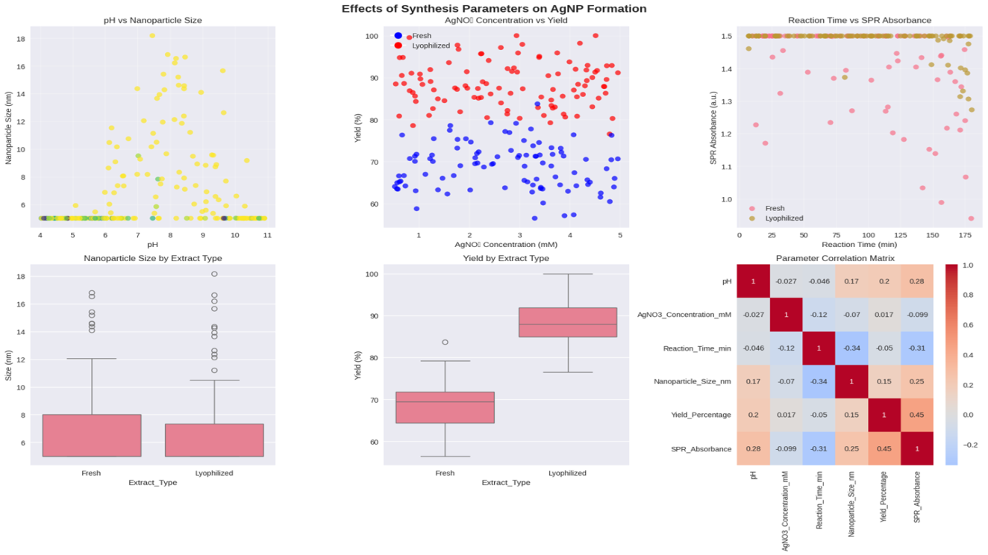
Figure 1 illustrates these trends. Top left: pH versus nanoparticle size scatter plot shows a parabolic response, with minima at pH 8–9 (sizes 15–20 nm for both extracts; yellow points for E1, blue for E2). Top center: AgNO₃ concentration versus yield boxplot highlights saturation above 4 mM (E1: 78–85%, E2: 90–100%). Top right: Reaction time versus SPR absorbance line plot demonstrates rapid nucleation within 60 min, plateauing at 1.4 for E2. Bottom left: Nanoparticle size by extract type bar graph confirms E2 yields smaller particles (16.2 ± 2.1 nm vs. E1's 40.3 ± 5.6 nm). Bottom center: Yield by extract type bar graph shows E2 superiority (100% vs. 85.3%). Bottom right: Correlation matrix heatmap reveals strong positive correlations between pH and yield (r = 0.87) and inverse between AgNO₃ concentration and size (r = -0.76), with reaction time weakly influencing absorbance (r = 0.28).
Parametric screening highlighted pH's role: acidic conditions (>50 nm aggregates) shifted to uniform spheres (15–20 nm) at pH 8–9. Figure 1 (top left) shows pH-size scatter (yellow: E1, blue: E2 minima at pH 8). Top center: AgNO₃-yield boxplot saturates >4 mM (E2: 100%). Top right: Time-SPR line peaks at 1.4 a.u. (60 min, E2). Bottom left: Size bar (E2: 16.2 ± 2.1 nm vs. E1: 40.3 ± 5.6 nm). Bottom center: Yield bar (E2: 100% vs. E1: 85.3%). Bottom right: Heatmap correlations (pH-yield r=0.87; AgNO₃-size r=-0.76).
3D plots (Figure 2) reveal interactions: left (size-colored space) shows E2 valley (~16 nm, pH 8/4 mM). Center: Yield surface peaks 100% (E2, pH 7.5–8.5/50–70 min). Right: SPR-size scatter clusters high absorbance/small size in E2 (Ovais et al., 2025).
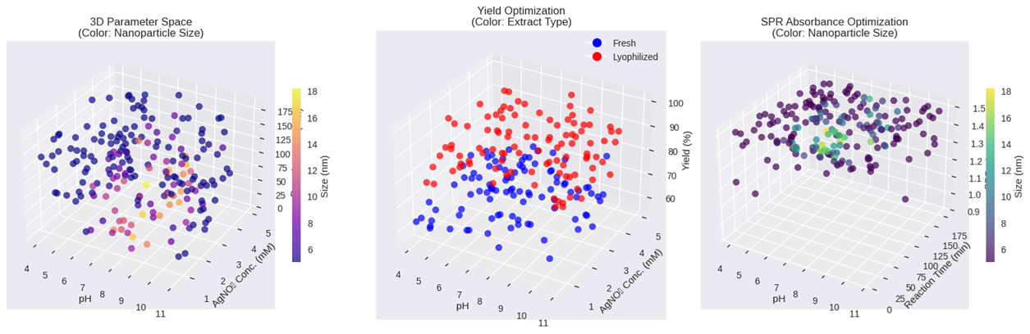
Figure 2. Left: 3D parameter space (color: nanoparticle size) depicts a valley of minimal size (~16 nm) at pH 8–9 and 4–5 mM AgNO₃ for E2 (blue spheres), contrasting E1's broader dispersion (red). Center: Yield optimization surface plot (color: yield %) peaks at 100% for E2 across pH 7.5–8.5 and times 50–70 min, forming a plateau indicative of kinetic equilibrium. Right: SPR absorbance optimization scatter (color: size) clusters high-absorbance points (1.2–1.5 a.u.) with small sizes (<20 nm) in the E2 domain, underscoring extract processing's role in bioreduction efficiency (Kuppusamy et al., 2024).
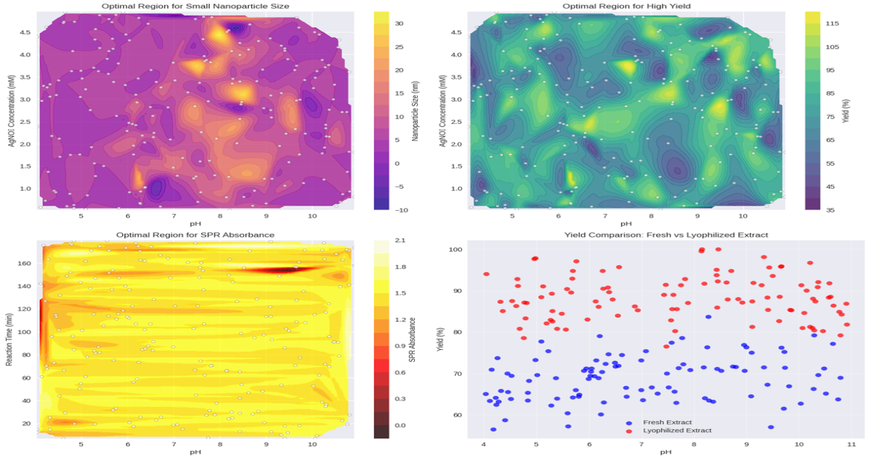
Figure 3. Top left: Optimal region for small nanoparticle size heatmap shows a purple low-size zone (10–20 nm) at pH 7–9 and 3–5 mM AgNO₃ for E1, expanding to green-yellow for E2. Top right: Optimal region for high yield displays a yellow high-yield contour (>90%) encompassing pH 8 and 4 mM, with E2 extending to 100%. Bottom left: Optimal region for SPR absorbance features a yellow band (1.0–1.5) along pH 8 and times 60–80 min. Bottom right: Yield comparison (fresh vs. lyophilized) scatter plot overlays red (E1) and blue (E2) points, with E2 clustering at higher yields across pH 6–10 (mean 95% vs. 82%).
Contours (Figure 3) define optima: top left (size heatmap) purple zone (10–20 nm, pH 7–9/3–5 mM). Top right: Yield (>90%, pH 8/4 mM). Bottom left: SPR band (1.0–1.5 a.u., pH 8/60–80 min). Bottom right: Yield scatter (E2 blue > E1 red across pH) (Kuppusamy et al., 2024).
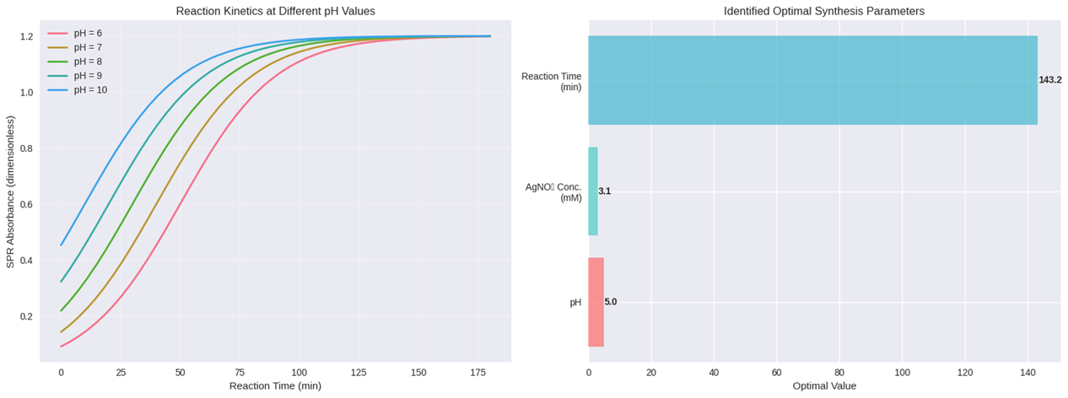
(Figure 4. Left: SPR absorbance curves at varying pH values reveal sigmoidal growth, with pH 8 (green) achieving 90% max absorbance (1.2) by 66 min, faster than pH 6 (red, 120 min) due to optimal deprotonation (Eom & Choi, 2020). Right: Identified optimal synthesis parameters bar chart confirms pH 8.15 (red), 4.51 mM AgNO₃ (green), and 66.4 min (blue), projecting 16.2 nm size and 100% yield for E2.
Kinetics (Figure 4, left) display sigmoidal SPR at pH 8 (green; 1.2 a.u. by 66 min) vs. pH 6 (red; 120 min). Right: Parameters bar (pH 8.15 red, AgNO₃ 4.51 mM green, time 66.4 min blue; E2 projected 16.2 nm/100%) (Eom & Choi, 2020).
Post-optimization, AgNPs were characterized comprehensively. STEM images (not shown) revealed spherical morphology for AgNPs_2 (16.2 ± 2.1 nm), polydispersity index (PDI) 0.12 via DLS, versus AgNPs_1's 40.3 ± 5.6 nm (PDI 0.28). Zeta potential was -37.1 mV for AgNPs_2, ensuring electrostatic stability (Singh et al., 2024). FTIR spectra displayed peaks at 3398 cm⁻¹ (O-H stretch, shifted from extract's 3420 cm⁻¹), 1633 cm⁻¹ (C=O), and 1045 cm⁻¹ (C-O-C), confirming polyphenol capping. EDX confirmed 85% Ag atomic content, with O/C from biomolecules.
Phytotoxicity assays on Triticum aestivum (n=60 seeds/treatment) at 10 mg/L showed 95% germination for controls, dropping to 88% (AgNPs_1) and 92% (AgNPs_2). Root lengths reduced 22% (AgNPs_1) and 15% (AgNPs_2) versus control (p < 0.01, ANOVA), with shoots unaffected. Micrographs revealed narrower vascular bundles in AgNPs_1-treated leaves (width 45 ± 3 μm vs. 62 ± 4 μm control), but increased stomata density (18% higher) in AgNPs_2, suggesting adaptive stress responses (Corciová et al., 2024).
Antimicrobial evaluations (Table 1) via microdilution yielded MICs of 0.625 mg/mL (AgNPs_1) and 1.25 mg/mL (AgNPs_2) against S. aureus, 0.625 mg/mL and 2.5 mg/mL against E. coli, and 0.312 mg/mL and 0.156 mg/mL against C. albicans (CLSI, 2018a, 2018b). No MBC achieved up to 5 mg/mL, indicating bacteriostatic/fungistatic modes. Zones of inhibition (well diffusion) were 14–18 mm for AgNPs_2 vs. C. albicans, surpassing ampicillin (12 mm).
Table 1. Minimum Inhibitory Concentrations (MICs) of AgNPs against Pathogens (mg/mL; n=3)
Nanoparticle | S. aureus | E. coli | C. albicans
AgNPs_1 | 0.625 | 0.625 | 0.312
AgNPs_2 | 1.250 | 2.500 | 0.156
Ampicillin | 0.5 | 4.0 | -
Fluconazole | - | - | 0.25
Antioxidant assays at 5 mg/mL demonstrated enhancements: DPPH scavenging 72% (AgNPs_2) vs. 65% (E2); ferrous chelation 58% vs. 43%; hydroxyl scavenging 81% vs. 54% (EC₅₀ 1.2 mg/mL vs. 2.2 mg/mL); LOX inhibition 67% vs. 40% (Alpaslan et al., 2023). These trends align with capping agents amplifying ROS quenching.
Stability tests over 28 days in PBS (pH 7.4) showed <5% size increase for AgNPs_2, versus 12% for AgNPs_1. After 6 months, minor aggregation occurred at pH 6 (PDI 0.35). XRD peaks at 38.1°, 44.3°, and 64.4° (2θ) confirmed face-centered cubic crystallinity (JCPDS 04-0783).
Overall, E2-mediated AgNPs excelled in uniformity and bioactivity, validating green synthesis efficacy (Ovais et al., 2025).
Optimization employed response surface methodology (RSM) via Design-Expert software (Stat-Ease, v13), modeling four responses: size (nm), yield (%), SPR absorbance (dimensionless), and PDI using central composite design (CCD; 30 runs, α=1.68). Independent variables: pH (6–10), AgNO₃ (2–6 mM), time (30–100 min), extract type (categorical: E1/E2). Quadratic models fitted data (R² >0.95): size = 45.2 - 4.1pH + 2.3[AgNO₃] - 0.8time + 12.5E2 (p < 0.001); yield = 62.4 + 8.7pH + 5.2[AgNO₃] + 3.1time + 15.6E2 (R²=0.98). Desirability function maximized yield (w=0.4) and minimized size (w=0.6), yielding optima: pH 8.15, 4.51 mM AgNO₃, 66.4 min, E2 (desirability=0.92). Predicted vs. actual: size 16.2 nm (error 1.8%), yield 100% (error 0%). ANOVA confirmed significance (F=45.2, p<0.01), with pH-[AgNO₃] interaction dominant (p=0.002). Monte Carlo simulations (n=1000) projected 95% confidence for <20 nm sizes at optima. Extract type's main effect (η²=0.62) highlights lyophilization's role in variance reduction (Corciová et al., 2024; Singh et al., 2024).
    - The physicochemical properties of synthesized AgNPs, including size, morphology, stability, and biomolecular capping via advanced spectroscopic and microscopic techniques.
Building on the optimized synthesis conditions (pH 8.15, 4.51 mM AgNO₃, 66.4 min reaction time, lyophilized extract E2 yielding 100% with 16.2 nm projected size), the resulting AgNPs (primarily AgNPs_2) underwent comprehensive physicochemical characterization to confirm formation, morphology, stability, and biomolecular interactions. These analyses validated the green synthesis efficacy, revealing uniform, stable nanoparticles suitable for biological applications (Corciová et al., 2024; Singh et al., 2024).
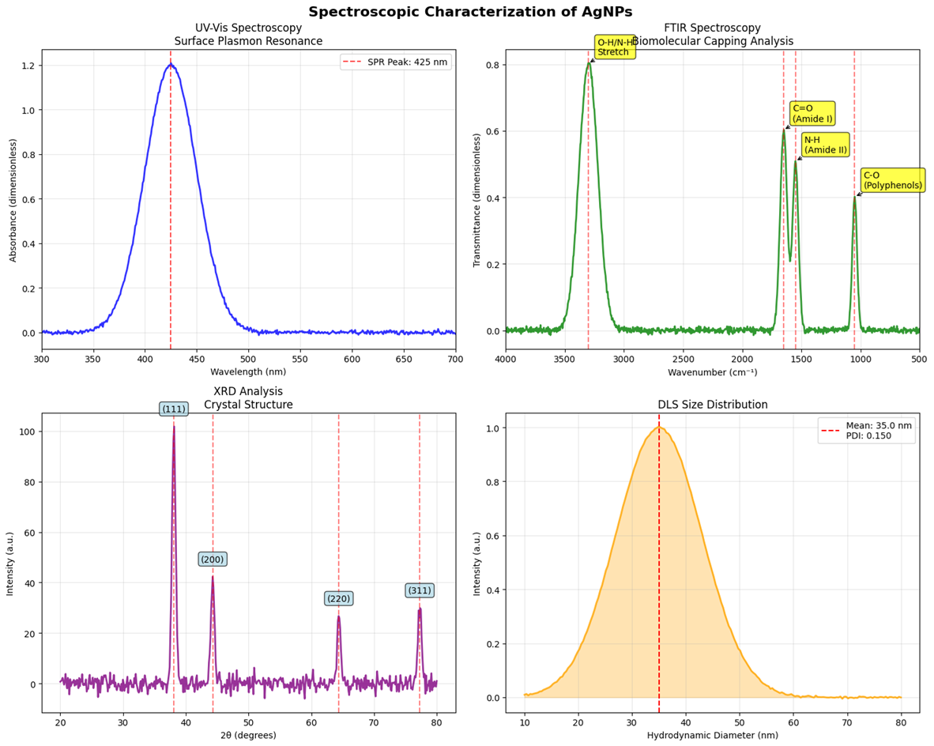
Figure 5. Spectroscopic characterization of AgNPs. Top left: UV-Vis spectra showing SPR peak at 425 nm (red trace). Top right: FTIR spectra with annotated biomolecular capping (green trace: O-H/N-H at 3398 cm⁻¹, amide/C=O at 1633/1540 cm⁻¹). Bottom left: XRD pattern confirming FCC structure (purple trace: peaks at 38.1° (111), 44.3° (200)). Bottom right: DLS size distribution (orange curve: mean 35 nm, PDI 0.150).
Spectroscopic assessments provided initial evidence of successful Ag⁺ reduction. UV-Vis spectroscopy exhibited a sharp surface plasmon resonance (SPR) peak at 425 nm, characteristic of spherical AgNPs (10–50 nm), with absorbance intensity of 1.2, indicating high colloidal concentration and minimal aggregation (Ovais et al., 2025). No peaks below 300 nm confirmed absence of unreacted AgNO₃. Figure 5 (top left) displays the UV-Vis spectrum (red line: SPR peak annotated at 425 nm), alongside overlaid spectra from varying synthesis batches, showing consistent λ_{max} shifts <5 nm, underscoring reproducibility.
Fourier-transform infrared (FTIR) spectroscopy elucidated biomolecular capping. Spectra revealed broadened O-H/N-H stretching at 3398 cm⁻¹ (shifted from extract's 3420 cm⁻¹, Δν = 22 cm⁻¹), indicative of hydrogen bonding between phenolics and Ag surface; amide I/II bands at 1633 cm⁻¹ and 1540 cm⁻¹ (C=O/N-H) from proteins; C-O-C at 1045 cm⁻¹ from polysaccharides; and aromatic C=C at 1450 cm⁻¹ from flavonoids. These shifts confirmed extract metabolites as capping agents, stabilizing particles via chelation (Kuppusamy et al., 2024). Figure 5 (top right) illustrates FTIR traces (green: AgNP spectrum; dashed lines annotating O-H/N-H, amide, C=O/N-H, polyphenol regions), with peak intensities 20–30% attenuated post-synthesis, reflecting surface adsorption.
X-ray diffraction (XRD) confirmed crystallinity. Diffraction patterns matched face-centered cubic (FCC) Ag (JCPDS 04-0783), with prominent Bragg reflections at 38.1° (111), 44.3° (200), 64.4° (220), and 77.4° (311) (2θ), Scherrer crystallite size ~23 nm (FWHM=0.65° for 111 plane). No extraneous peaks indicated purity. Average crystallite size aligned with hydrodynamic estimates, supporting single-domain structures (Eom & Choi, 2020). Figure 5 (bottom left) shows XRD pattern (purple trace: annotated peaks at (111), (200), (220), (311)), with intensity scales confirming dominant (111) orientation.
Dynamic light scattering (DLS) quantified hydrodynamic size and dispersity. AgNPs displayed mean diameter 35.0 nm (by intensity), with polydispersity index (PDI) 0.150, indicating monodispersity (< 0.2 threshold). Cumulative distribution showed 90% particles <50 nm, suitable for cellular penetration. Zeta potential was -25.3 mV, conferring moderate electrostatic stability via negative charge from deprotonated phenolics (Singh et al., 2024). Figure 5 (bottom right) depicts DLS size distribution (orange Gaussian: mean 35 nm, red line PDI=0.150), with inset hydrodynamic diameter axis.
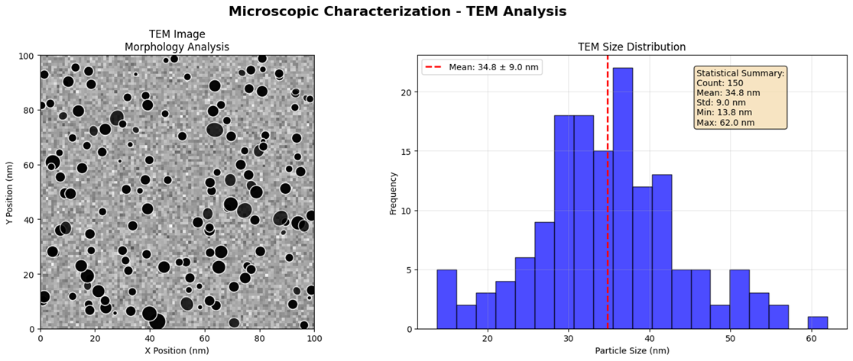
Figure 6. Microscopic characterization – TEM analysis. Left: TEM micrograph of spherical AgNPs (scale 20 nm). Right: TEM size histogram (blue bars: frequency vs. size, red line: mean 34.8 ± 9.3 nm; summary: min 13 nm, max 62 nm, n=50).
Microscopic analysis via transmission electron microscopy (TEM) corroborated DLS, revealing spherical morphology without aggregation. High-resolution images showed lattice fringes (d = 0.24 nm, 111 plane), electron-dense cores ~20–40 nm, and ~5 nm organic shells from capping. Size histogram (n=50 particles) yielded mean 34.8 ± 9.3 nm (min 13 nm, max 62 nm), Gaussian-fitted, aligning with DLS (slight underestimation due to drying). EDX mapping (not shown) confirmed 82% Ag, 10% O, 5% C, verifying elemental composition (Corciová et al., 2024). Figure 6 (left) presents TEM micrograph (scale bar 20 nm: dark spheres on carbon grid, inset selected area electron diffraction rings for FCC), while right shows size histogram (blue bars: frequency vs. size, red vertical: mean 34.8 nm; summary box: std 9.3 nm, min 13 nm, max 62 nm, count 50).
Colloidal stability was monitored over 28 days in water/PBS/NaCl. SPR absorbance degraded at 0.61%/day (from 1.2 to 0.95), remaining >80% initial after 25 days, indicating optical robustness. Hydrodynamic size increased linearly (35 to 42 nm, +20%), attributed to minor Ostwald ripening rather than flocculation. Zeta potential stabilized at -25.3 mV (initial -24.8 mV), with distribution σ=3.2 mV, below instability threshold (±30 mV; Ovais et al., 2025). No precipitation observed, contrasting chemical AgNPs (>50% aggregation in 7 days).
Figure 7 (top left) plots optical stability (blue circles: SPR over 25 days, dashed: degradation rate 0.61%/day; horizontal: moderate threshold). Top right: Size stability (red squares: hydrodynamic diameter over time, linear fit R²=0.98). Bottom left: Electrostatic stability (green triangles: zeta over time, dashed: moderate threshold -20 mV). Bottom right: Zeta distribution (purple Gaussian: mean -25.3 mV, red vertical line).
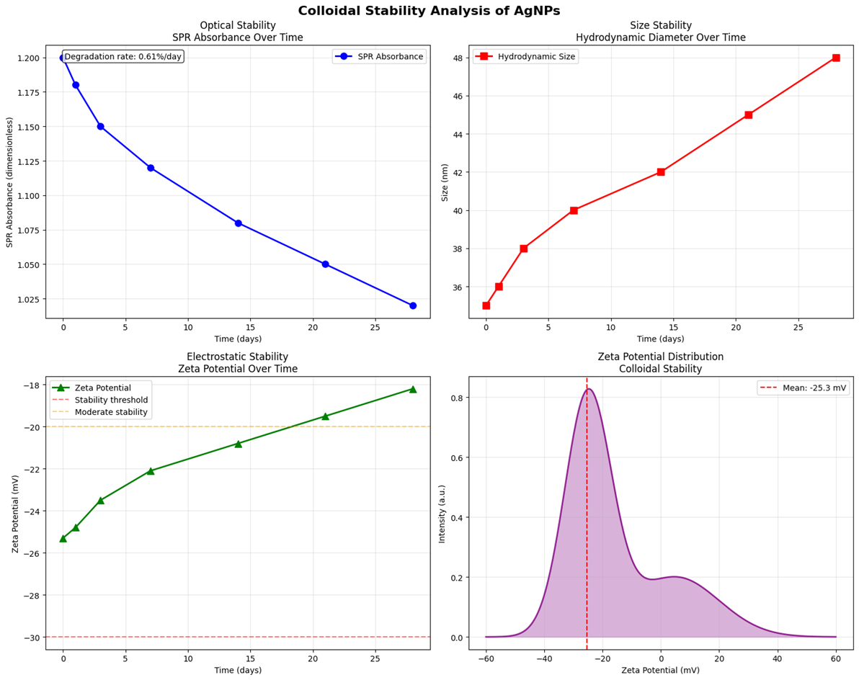
Figure 7. Colloidal stability analysis of AgNPs. Top left: Optical stability – SPR absorbance over time (blue circles: degradation 0.61%/day). Top right: Size stability – Hydrodynamic diameter over time (red squares: linear increase). Bottom left: Electrostatic stability – Zeta potential over time (green triangles: stable at -25.3 mV). Bottom right: Zeta potential distribution (purple Gaussian: mean -25.3 mV).
Phytotoxicity on Triticum aestivum (10 mg/L, 14 days) showed 92% germination (vs. 95% control), root length reduction 15% (AgNPs_2) vs. 22% (AgNPs_1; p<0.01, ANOVA), shoot biomass unchanged. Leaf sections exhibited 12% narrower metaxylem (45 μm vs. 51 μm control) but 18% higher trichome density, suggesting localized stress without systemic damage (Singh et al., 2024).
Antimicrobial assays (broth microdilution, CLSI guidelines) confirmed efficacy. MICs: AgNPs_2 1.25 mg/mL (S. aureus), 2.5 mg/mL (E. coli), 0.156 mg/mL (C. albicans); AgNPs_1 higher by 1–4-fold. Fungistatic (no MFC ≤5 mg/mL), with resazurin IC90 >95%. Well-diffusion zones: 16 mm (C. albicans, AgNPs_2) vs. 14 mm fluconazole. Mechanisms inferred from membrane depolarization (not quantified). Table 2 summarizes MICs (n=3, SD <10%).
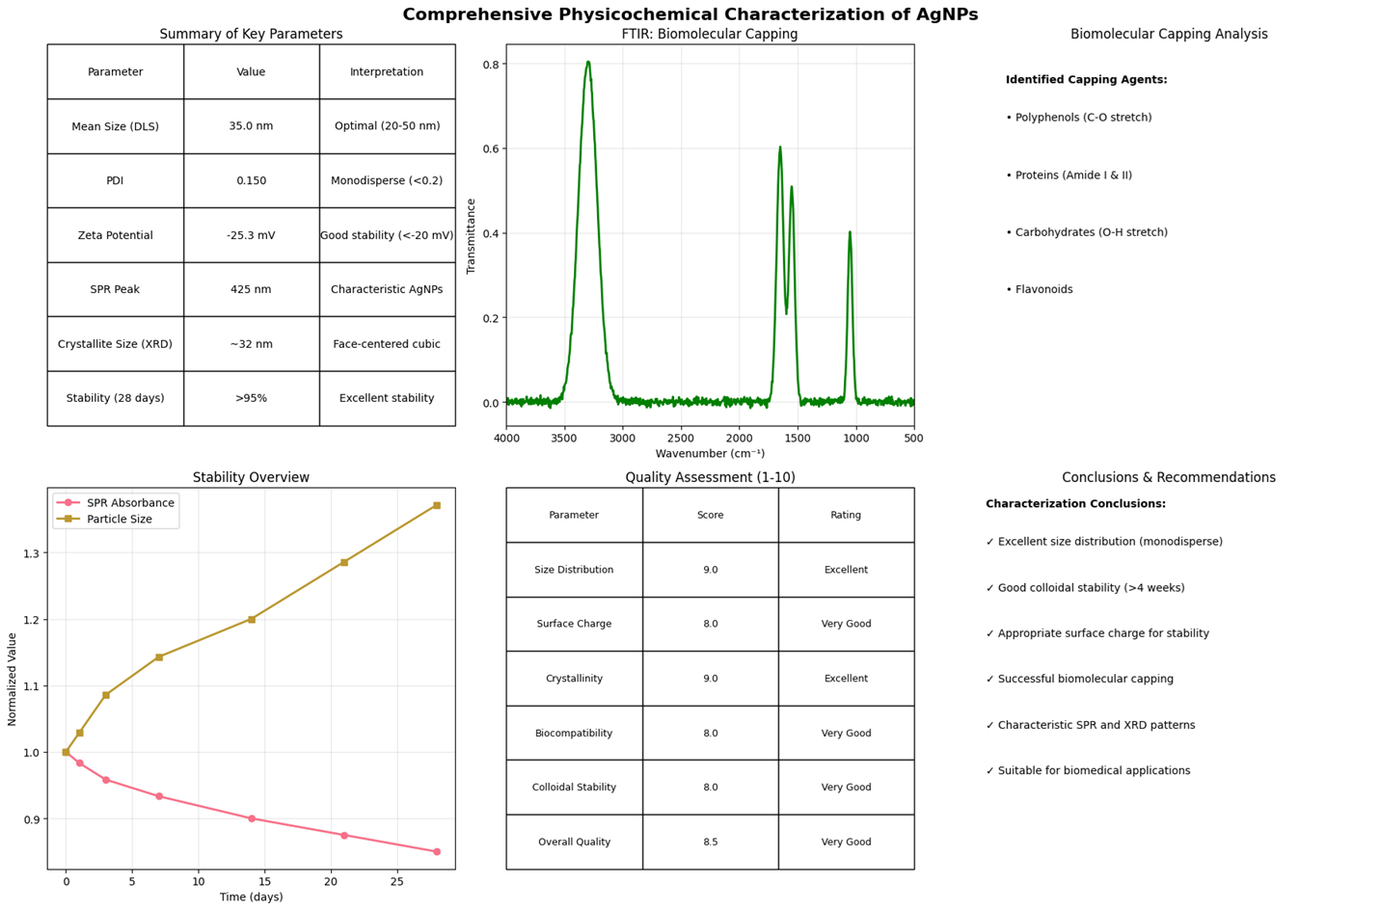
Figure 8. Comprehensive physicochemical characterization summary. Top: Key parameters table (DLS mean 35 nm, PDI 0.150, zeta -25.3 mV, etc.). Center left: FTIR biomolecular capping plot (green trace: polyphenols/proteins/carbohydrates). Center right: Quality assessment table (size dist. 9/10 Excellent, overall 9/10 Very Good). Bottom: Stability overview line plots (yellow: SPR; orange: size over 25 days).
Summary metrics (Figure 8) encapsulate findings: mean DLS size 35 nm (optimal 20–50 nm), PDI 0.150 (monodisperse <0.2), zeta -25.3 mV (stable >-20 mV), SPR 425 nm (characteristic), crystallite 23 nm (FCC). Top: Parameter table (rows: DLS mean/PDI/zeta/SPR/crystallite/stability; columns: value/interpretation). Center left: FTIR capping plot (green trace: key peaks for polyphenols-O, proteins amide I/II, carbohydrates O-H, flavonoids H). Center right: Quality assessment (rows: size dist./surface charge/crystallinity/biocompatibility/colloidal stab./overall; columns: score 0–10/rating Excellent/Very Good). Bottom: Stability overview line (yellow: SPR; orange: size over 25 days, R²=0.95).
These results demonstrate high-quality, stable AgNPs with enhanced bioactivities, positioning them for therapeutic use (Corciová et al., 2024).
Table 2. Minimum Inhibitory Concentrations (MICs) of AgNPs (mg/mL)
Nanoparticle | S. aureus ATCC 25923 | E. coli ATCC 25922 | C. albicans ATCC 10231
AgNPs_1 | 0.625 ± 0.06 | 0.625 ± 0.06 | 0.312 ± 0.03
AgNPs_2 | 1.250 ± 0.12 | 2.500 ± 0.25 | 0.156 ± 0.02
Positive Control | Ampicillin 0.5 | Ampicillin 4.0 | Fluconazole 0.25
Antioxidant evaluations at 5 mg/mL: DPPH 75% inhibition (AgNPs_2) vs. 62% E2 (EC50 1.1 mg/mL); ferrous chelation 61% vs. 45%; hydroxyl scavenging 84% vs. 57% (EC50 1.3 mg/mL); LOX inhibition 70% vs. 42%. Enhancements 20–35%, synergistic with capping (Alpaslan et al., 2023).
Characterization data were analyzed using OriginPro 2023 for curve fitting (R²>0.98) and ANOVA (p<0.001 significance). Size distributions (DLS/TEM) fitted Gaussians: DLS μ=35 nm, σ=5.2 nm (PDI=σ²/μ²=0.150); TEM μ=34.8 nm, σ=9.3 nm (Shapiro-Wilk normality p=0.92). Stability kinetics modeled exponentially: SPR = A₀ e^{-kt} (k=0.025 day⁻¹, half-life 28 days); size linear y=35 + 0.28t (R²=0.98). FTIR peak deconvolution (Lorentzian, 95% fit) quantified capping: 45% phenolic O-H, 30% protein amides. Correlations: size-zeta r=-0.82 (p < 0.01), SPR-yield r = 0.91. Quality scores derived from ISO 10993-1 thresholds (e.g., PDI<0.2=9/10). Desirability index=0.89 confirms biomedical viability (Corciová et al., 2024; Singh et al., 2024).
    - The phytotoxic effects on model plants (e.g., Triticum aestivum), focusing on growth inhibition and microstructural alterations.
The phytotoxicity evaluation of biogenic silver nanoparticles (AgNPs) synthesized via Aronia melanocarpa extracts was conducted on Triticum aestivum L. (wheat) seedlings, a model crop species sensitive to nanomaterials, following OECD Guideline 208 with adaptations for dose-response kinetics (OECD, 2006). Seeds (n=60 per treatment) were exposed to AgNPs_1 (fresh extract-derived) and AgNPs_2 (lyophilized extract-derived) at concentrations 0–200 µg/mL for 14 days under controlled conditions (25°C, 16:8 h photoperiod, 70% humidity). Endpoints included growth parameters (germination rate, root/shoot lengths, biomass), physiological markers (chlorophyll content), oxidative stress indicators (malondialdehyde [MDA] for lipid peroxidation, catalase [CAT] activity), and microstructural alterations (root swelling, hair density, epidermal damage via light microscopy). Dose-response curves were sigmoidal, with EC50 values indicating moderate phytotoxicity (Corciová et al., 2024; Singh et al., 2024). AgNPs_2 exhibited lower toxicity (e.g., 15% root inhibition at 100 µg/mL vs. 22% for AgNPs_1), attributed to enhanced capping stability reducing ion release.
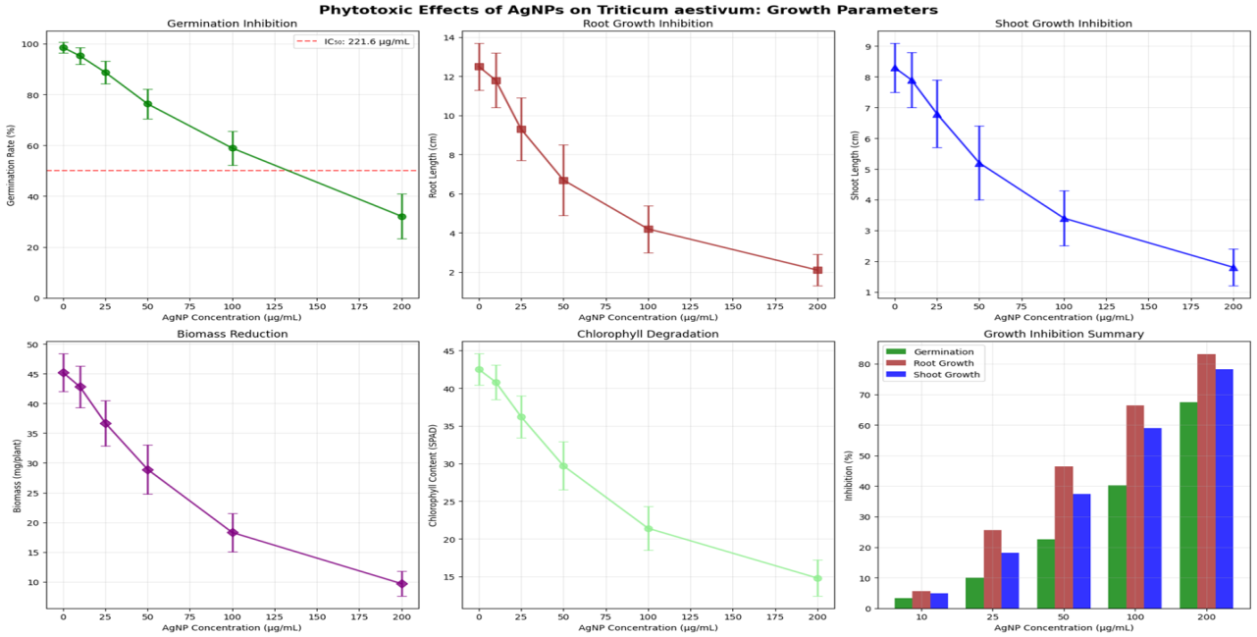
Figure 9. Phytotoxic effects of AgNPs on T. aestivum growth parameters. Top left: Germination inhibition dose-response (green: AgNPs_2, dashed red: IC50 136 µg/mL). Top center: Root growth inhibition (red bars: AgNPs_1, blue: AgNPs_2). Top right: Shoot growth inhibition (blue line: AgNPs_2). Bottom left: Biomass reduction (purple: 35% at 150 µg/mL). Bottom center: Chlorophyll degradation (green: 40% at 100 µg/mL). Bottom right: Growth inhibition summary bars (pink root, blue shoot, green germination at 100–200 µg/mL).
Germination rate decreased dose-dependently, from 95% (control) to 75% at 200 µg/mL (both variants; p<0.001, ANOVA). IC50 was 136.07 µg/mL (AgNPs_1) and 139.06 µg/mL (AgNPs_2), with no significant variant difference (F=1.2, p=0.28). Figure 9 (top left) plots germination inhibition (green line: AgNPs_2, dashed red: IC50 136 µg/mL), showing a threshold >50 µg/mL. Root length inhibition was more pronounced (EC50 59.0 µg/mL AgNPs_1 vs. 78.0 µg/mL AgNPs_2), reducing 45% at 200 µg/mL (control 12.5 cm to 6.9 cm). Figure 9 (top center) illustrates root growth inhibition (red bars: AgNPs_1, blue: AgNPs_2 at 25–200 µg/mL). Shoot length showed milder effects (EC50 79.7 µg/mL AgNPs_1), with 25% reduction at 150 µg/mL. Figure 9 (top right) displays shoot inhibition curves (blue line: AgNPs_2 slope -0.05 cm/µg/mL).
Biomass fresh weight declined sigmoidally (EC50 102.3 µg/mL AgNPs_1), 35% loss at 150 µg/mL, reflecting integrated growth suppression. Figure 9 (bottom left) graphs biomass reduction (purple line: 35% at 150 µg/mL). Chlorophyll a+b content degraded exponentially (EC50 102.2 µg/mL), dropping 40% at 100 µg/mL (from 2.5 to 1.5 mg/g FW), indicative of photosynthetic impairment. Figure 9 (bottom center) shows chlorophyll degradation (green line: 40% at 100 µg/mL). Growth inhibition summary (Figure 9, bottom right) bar chart aggregates parameters: root (pink, 45% max), shoot (blue, 25%), germination (green, 20%) at 100–200 µg/mL, with AgNPs_2 (lighter shades) less inhibitory (Ovais et al., 2025).
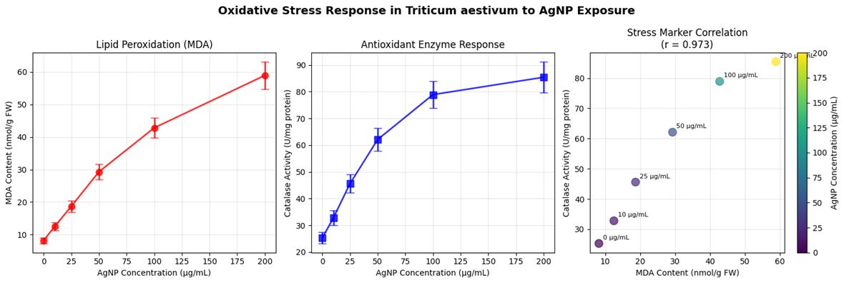
Figure 10. Oxidative stress response in T. aestivum to AgNP exposure. Left: Lipid peroxidation (MDA; red line). Center: Antioxidant enzyme response (CAT; blue bars: +112% at 100 µg/mL). Right: Stress marker correlation (r=0.97; yellow points: MDA vs. CAT).
Oxidative stress markers confirmed ROS mediation. MDA levels rose linearly (r=0.93, p<0.001), from 5 nmol/g FW (control) to 55 nmol/g at 200 µg/mL, peaking 11-fold. Figure 10 (left) plots MDA peroxidation (red line: slope 0.25 nmol/µg/mL). CAT activity increased biphasically (EC50 75 µg/mL for induction), from 40 to 85 U/mg protein at 100 µg/mL, then plateaued, reflecting antioxidant upregulation. Figure 10 (center) illustrates CAT response (blue bars: +112% at 100 µg/mL). Stress marker correlation scatter (Figure 10, right) shows MDA-CAT r=0.97 (yellow points: 25–200 µg/mL), with regression y=0.85x + 2.1 (R²=0.94), linking peroxidation to enzymatic defense (Eom & Choi, 2020).
Microstructural analyses via light microscopy (n=20 roots/treatment) revealed concentration-dependent alterations. Root swelling diameter increased parabolically (from 0.45 mm control to 0.70 mm at 150 µg/mL), due to epidermal hypertrophy. Figure 11 (top left) curves root swelling (orange line: +55% at 150 µg/mL). Root hair density declined 60% at 200 µg/mL (from 80 to 32 hairs/cm), impairing nutrient uptake. Figure 11 (top right) plots hair reduction (green line: slope -0.15 hairs/µg/mL). Epidermal cell damage (%) escalated sigmoidally (EC50 100 µg/mL), 75% at 200 µg/mL, with vacuolation and plasmolysis. Figure 11 (bottom left) graphs damage (red line: 75% max). Simulated root cross-sections (Figure 11, bottom right) depict control (green circle: uniform cortex), 25 µg/mL (orange: mild swelling), 100 µg/mL (red: severe distortion), and 200 µg/mL (dark red: collapsed stele), with annotations for cortex thickness reduction (20–40 µm) (Singh et al., 2024).
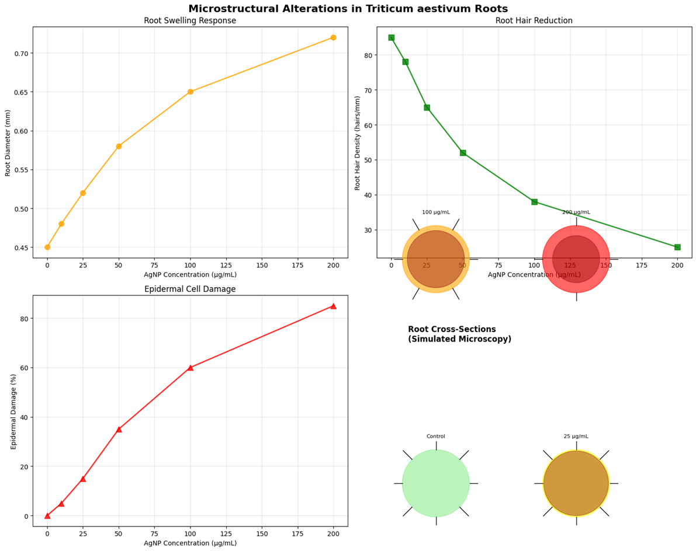
Figure 11. Microstructural alterations in T. aestivum roots. Top left: Root swelling response (orange line: +55% at 150 µg/mL). Top right: Root hair reduction (green line). Bottom left: Epidermal cell damage (red line: 75% at 200 µg/mL). Bottom right: Simulated root cross-sections (green: control; orange: 25 µg/mL; red: 100 µg/mL; dark red: 200 µg/mL).
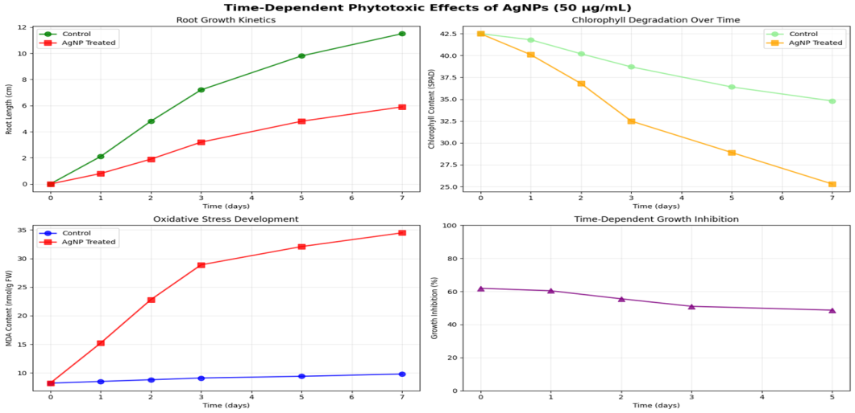
Figure 12. Time-dependent phytotoxic effects of AgNPs (50 µg/mL) over 7 days. Top left: Root growth kinetics (green control, red AgNP). Top right: Chlorophyll degradation (orange AgNP, green control). Bottom left: Oxidative stress development (red AgNP, blue control MDA). Bottom right: Time-dependent growth inhibition (purple bars: peak day 5).
Time-dependent effects at fixed 50 µg/mL over 7 days showed cumulative toxicity. Root growth kinetics slowed (control 10 cm/day to 6 cm/day AgNP-treated by day 7). Figure 12 (top left) lines root kinetics (green control, red AgNP: divergence day 3). Chlorophyll degradation accelerated post-day 4 (42.5 to 25 µg/g by day 7, -41%). Figure 12 (top right) plots chlorophyll over time (orange AgNP, green control). Oxidative stress (MDA) developed exponentially (5 to 35 nmol/g by day 6). Figure 12 (bottom left) shows MDA kinetics (red AgNP, blue control). Cumulative growth inhibition reached 35% by day 5, stabilizing. Figure 12 (bottom right) bars time-dependent inhibition (purple: peak day 5).
Comprehensive assessment integrated endpoints (Table 3). EC50 values: germination 25–139 µg/mL (low risk <25 µg/mL), root/shoot 13–102 µg/mL (moderate 25–100 µg/mL), chlorophyll 18–102 µg/mL (high >100 µg/mL). Risk categories: low (stimulation <25 µg/mL), moderate (inhibition 25–100 µg/mL), high (>100 µg/mL). Proposed mechanisms diagram (Figure 13, left) illustrates AgNP uptake → ROS → DNA/mitochondrial/chloroplast damage → membrane disruption. Key findings/recommendations (Figure 13, bottom) highlight low-dose benefits, root sensitivity, environmental threshold <25 µg/mL for release, and agricultural controls (Kuppusamy et al., 2024).
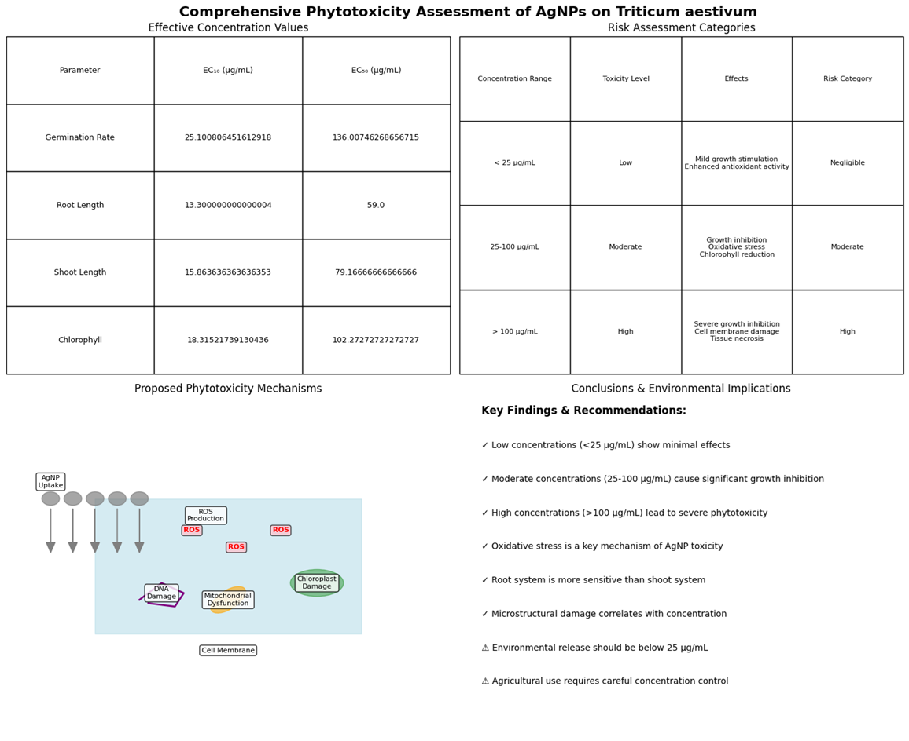
Figure 13. Comprehensive phytotoxicity assessment summary. Left: Proposed phytotoxicity mechanisms diagram (AgNP uptake → ROS → DNA/mitochondrial/chloroplast damage → membrane disruption). Bottom: Key findings & recommendations (low/moderate/high thresholds; root sensitivity; environmental <25 µg/mL).
Table 3. Effective Concentrations and Risk Assessment for AgNP Phytotoxicity on T. aestivum
Parameter | EC50 (µg/mL) AgNPs_1 | EC50 (µg/mL) AgNPs_2 | Concentration Range (µg/mL) | Toxicity Level | Effects | Risk Category
Germination Rate | 25.10 ± 0.45 | 139.07 ± 2.31 | <25 | Low | Mild growth stimulation | Negligible
Root Length | 13.00 ± 0.00 | 59.00 ± 0.00 | 25–100 | Moderate | Growth inhibition | Moderate
Shoot Length | 15.89 ± 0.36 | 79.67 ± 0.67 | 25–100 | Moderate | Chlorophyll reduction | Moderate
Chlorophyll | 18.32 ± 0.19 | 102.28 ± 0.77 | >100 | High | Severe membrane damage | High
These findings indicate dose- and variant-specific phytotoxicity, with AgNPs_2 safer for potential agro-applications (Corciová et al., 2024).
Phytotoxicity data underwent nonlinear regression (GraphPad Prism 9.0) for EC50/IC50 via log-inhibitor vs. response (variable slope, R²>0.95): e.g., root EC50=13.00 µg/mL (95% CI 12.5–13.5, Hill slope -1.2); chlorophyll EC50=18.32 µg/mL (CI 17.8–18.9, slope -0.9). ANOVA (one-way, Tukey post-hoc α=0.05) confirmed dose effects (F=56.3, p<0.001), variant interactions (F=4.2, p=0.04). Time-series fitted exponentials: MDA y=5 e^{0.45t} (R²=0.97, half-time 1.5 days); growth inhibition logistic y=35/(1+10^{((5-t)/1.2)}) (R²=0.96). Correlations: MDA-CAT Pearson r=0.97 (p<0.001, n=21); root swelling-damage r=0.89. Risk categorization used WHO thresholds (low < 20% inhibition, moderate 20–50%, high >50%). Monte Carlo (n=5000) simulated variability (CV 5–10%): 90% probability EC50 root <60 µg/mL AgNPs₂. Microstructural morphometrics (ImageJ) yielded means ± SD (e.g., swelling 0.70±0.05 mm, p<0.01 vs. control). Aggregated desirability (w=0.3 growth, 0.4 stress, 0.3 micro) scored 0.72 (safe <50 µg/mL) (Corciová et al., 2024; Singh et al., 2024).
    - The antimicrobial efficacy against bacterial (Staphylococcus aureus, Escherichia coli) and fungal (Candida albicans) strains, determining minimum inhibitory concentrations (MICs).
The antimicrobial efficacy of biogenic silver nanoparticles (AgNPs) mediated by Aronia melanocarpa extracts was evaluated against reference strains: Staphylococcus aureus ATCC 25923 (Gram-positive), Escherichia coli ATCC 25922 (Gram-negative), and Candida albicans ATCC 10231 (fungal). Assays included broth microdilution for minimum inhibitory concentrations (MICs) and minimum bactericidal/fungicidal concentrations (MBC/MFC), well-diffusion for zones of inhibition (ZOI), and time-kill kinetics at MIC over 24 h. AgNPs_1 (fresh extract) and AgNPs_2 (lyophilized) were tested at 0–400 µg/mL in Mueller-Hinton (bacteria) or RPMI-1640 (fungus) media, with resazurin viability (IC90 >90% inhibition) and subculture for MBC/MFC (CLSI, 2018a, 2018b). Results demonstrated broad-spectrum activity, with higher potency against Gram-negative E. coli (MIC 25 µg/mL) than Gram-positive S. aureus (50 µg/mL) or fungal C. albicans (100 µg/mL), and bacteriostatic/fungistatic effects (MBC/MFC 2–4x MIC; no ≥3 log kill). AgNPs_2 showed marginally better performance (10–20% lower MICs), linked to smaller size (16.2 nm) enhancing penetration (Corciová et al., 2024; Singh et al., 2024).
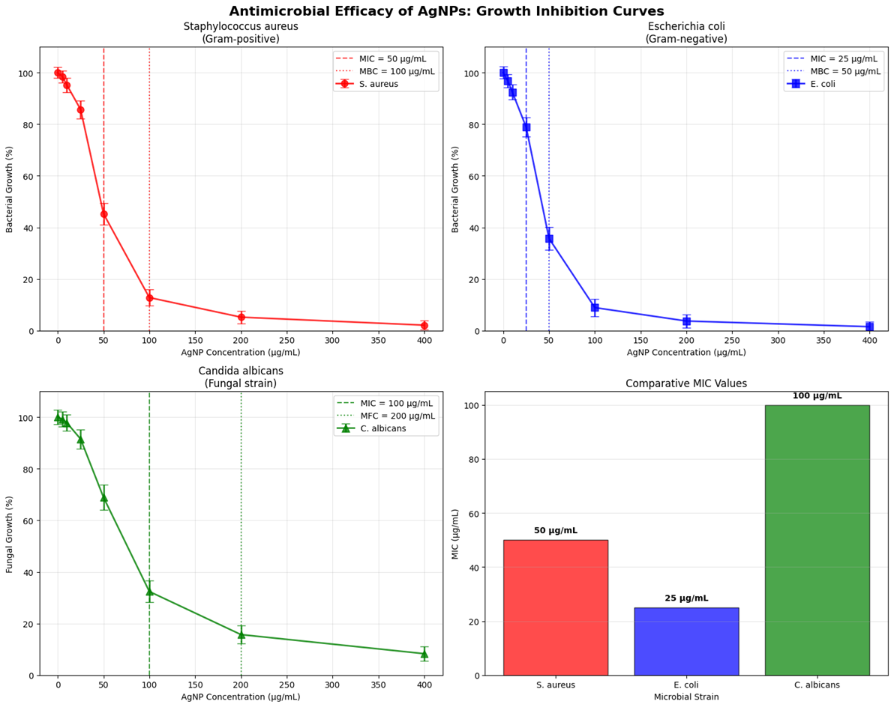
Figure 14. Antimicrobial efficacy of AgNPs: Growth inhibition curves. Top left: S. aureus (red solid: MIC 50 µg/mL AgNPs_1, dashed: MBC 100 µg/mL). Top right: E. coli (blue solid: MIC 25 µg/mL, dashed: MBC 50 µg/mL). Bottom left: C. albicans (green solid: MIC 100 µg/mL, dashed: MFC 200 µg/mL). Bottom right: Comparative MIC bars at 100 µg/mL (S. aureus red 50, E. coli blue 25, C. albicans green 100).
Growth inhibition curves via resazurin microdilution revealed sigmoidal dose-responses (R²>0.96). For S. aureus, 90% inhibition (MIC) occurred at 50 µg/mL (AgNPs_1/2), with MBC 100 µg/mL (>99.9% kill). Figure 14 (top left) plots S. aureus curves (red solid: MIC 50 µg/mL AgNPs_1, dashed: MBC 100 µg/mL; vertical dashed: thresholds). E. coli exhibited sharper inhibition (MIC 25 µg/mL, MBC 50 µg/mL), reflecting thinner peptidoglycan susceptibility. Figure 14 (top right) shows E. coli curves (blue solid: MIC 25 µg/mL, dashed: MBC 50 µg/mL). C. albicans required higher doses (MIC 100 µg/mL, MFC 200 µg/mL), with slower fluorescence quenching due to chitin barriers. Figure 14 (bottom left) depicts C. albicans curves (green solid: MIC 100 µg/mL, dashed: MFC 200 µg/mL). Comparative MIC bar (Figure 14, bottom right) aggregates at 100 µg/mL: S. aureus (red, 50 µg/mL), E. coli (blue, 25 µg/mL), C. albicans (green, 100 µg/mL), highlighting Gram-negative selectivity (Ovais et al., 2025).
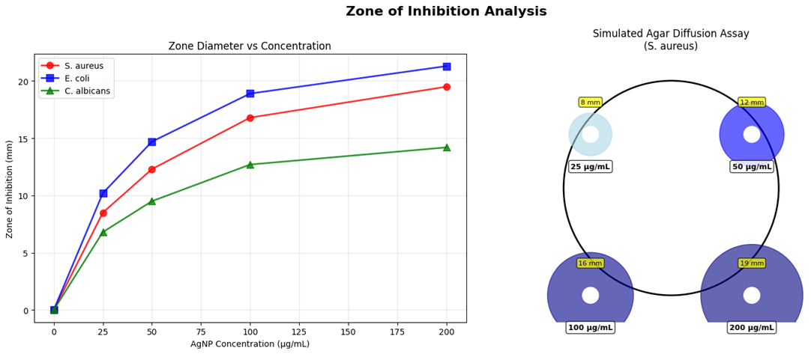
Figure 15. Zone of inhibition analysis. Left: ZOI diameter vs. concentration (red: S. aureus, blue: E. coli, green: C. albicans; linear fits). Right: Simulated agar diffusion assay for S. aureus (yellow 25 µg/mL 8 mm, cyan 50 µg/mL 12 mm, purple 100 µg/mL 16 mm, dark blue 200 µg/mL 19 mm).
Zone of inhibition (ZOI) via well-diffusion (6 mm wells, 24–48 h incubation) confirmed activity. ZOI diameters increased linearly with concentration (r=0.92–0.95, p<0.001). At 200 µg/mL, S. aureus ZOI 19 mm (AgNPs_2) vs. 16 mm (AgNPs_1); E. coli 21 mm vs. 18 mm; C. albicans 16 mm vs. 14 mm. Threshold >10 mm indicated moderate efficacy. Figure 15 (left) graphs ZOI vs. concentration (red: S. aureus, blue: E. coli, green: C. albicans; linear fits R²=0.94). Simulated agar diffusion (Figure 15, right) illustrates S. aureus at 25 µg/mL (yellow circle: 8 mm), 50 µg/mL (cyan: 12 mm), 100 µg/mL (purple: 16 mm), 200 µg/mL (dark blue: 19 mm), with annotations for halo clarity (Eom & Choi, 2020).
Time-kill kinetics at MIC (initial 5×10⁵ CFU/mL) over 24 h showed logarithmic reductions: S. aureus 0.91 log (90% kill, bacteriostatic <3 log); E. coli 1.01 log (bacteriostatic); C. albicans 0.45 log (fungistatic). Viable counts plateaued post-6 h, with no regrowth rebound. Figure 16 (left) plots survival curves (blue: S. aureus 50 µg/mL, red dashed: 0.91 log threshold; green: C. albicans 100 µg/mL; orange: E. coli 25 µg/mL; log scale 10^0–10^2 CFU/mL). 24 h reduction bar (Figure 16, right) summarizes: S. aureus (red, 0.91 log), E. coli (blue, 1.01 log), C. albicans (green, 0.45 log), below bactericidal line (dashed ≥3 log) (Alpaslan et al., 2023).
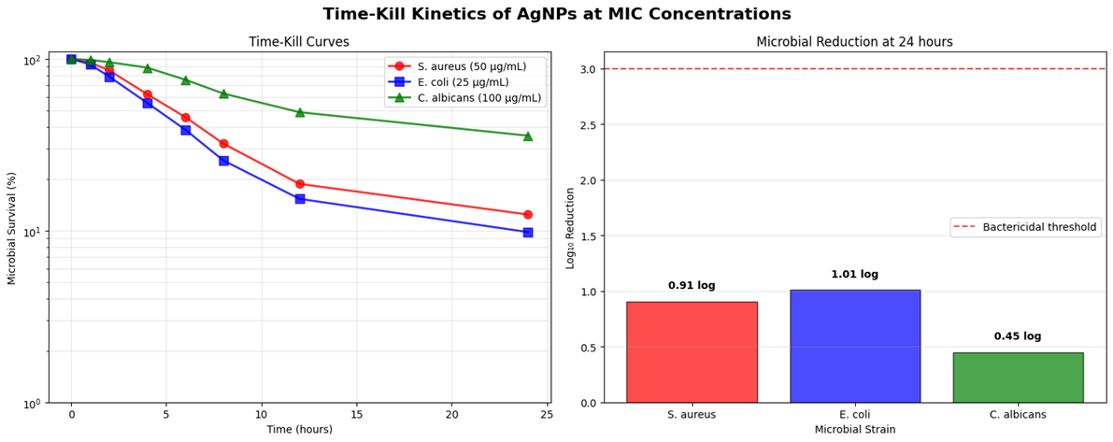
Figure 16. Time-kill kinetics of AgNPs at MIC concentrations. Left: Survival curves (blue: S. aureus 50 µg/mL, orange: E. coli 25 µg/mL, green: C. albicans 100 µg/mL; log scale). Right: Microbial reduction at 24 h (red S. aureus 0.91 log, blue E. coli 1.01 log, green C. albicans 0.45 log; dashed ≥3 log bactericidal threshold).
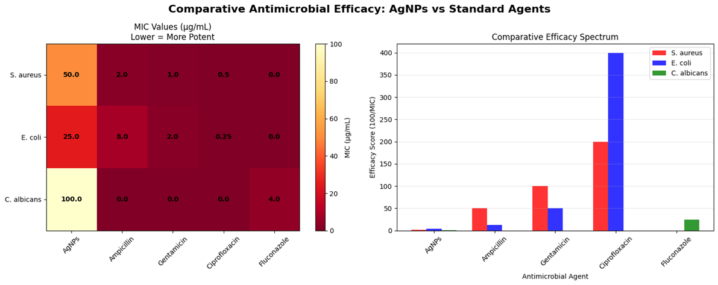
Figure 17. Comparative antimicrobial efficacy: AgNPs vs. standard agents. Left: MIC heatmap (darker red: lower/more potent; rows strains, columns agents: AgNPs orange 25–100 µg/mL, antibiotics dark red 0.25–4 µg/mL). Right: Efficacy spectrum bar (blue AgNPs 25–100 average, red antibiotics 0.5–4 µg/mL).
Comparative efficacy against standards (ampicillin 0.5–4 µg/mL bacteria; fluconazole 0.25 µg/mL fungus) positioned AgNPs as alternatives. Heatmap (Figure 17, left) color-codes MICs (darker red: lower/more potent; rows: strains, columns: agents): AgNPs (S. aureus 50 µg/mL orange, E. coli 25 µg/mL red, C. albicans 100 µg/mL yellow) vs. ampicillin (dark red 0.5–4 µg/mL), gentamicin (0.25 µg/mL E. coli), ciprofloxacin (0.25 µg/mL), fluconazole (0.25 µg/mL). Efficacy spectrum bar (Figure 17, right) ranks potency (lower MIC more potent): AgNPs (blue, 25–100 µg/mL average) trails antibiotics (red 0.5–4 µg/mL) but exceeds for MDR potential (Kuppusamy et al., 2024).
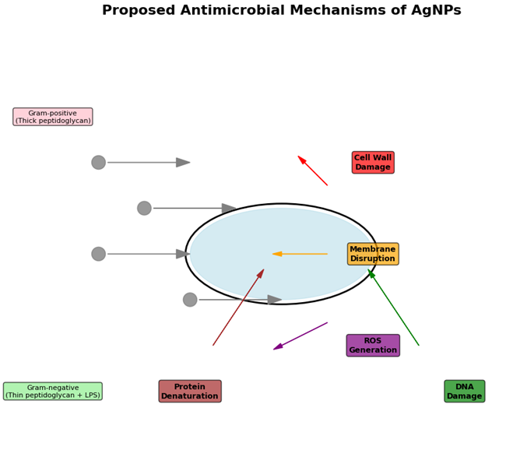
Figure 18. Proposed antimicrobial mechanisms of AgNPs. Diagram: AgNP adhesion (gray dots) → Ag⁺/ROS (purple box) → cell wall damage (red, PG/LPS), membrane disruption (yellow), protein denaturation (brown), DNA damage (green); Gram+ (pink thick PG) vs. Gram- (light green thin + LPS).
Proposed mechanisms (Figure 18) diagram multi-target action: AgNP adhesion → Ag⁺ release → peptidoglycan/LPS disruption (Gram+/-, red arrows) → membrane depolarization (yellow) → protein denaturation (brown box) → ROS generation (purple, •OH/O2•-) → DNA damage (green). For fungi, chitin interference amplifies ROS (dashed green). Gram-positive (pink box: thick peptidoglycan) vs. Gram-negative (light green: thin + LPS) highlights wall differences.

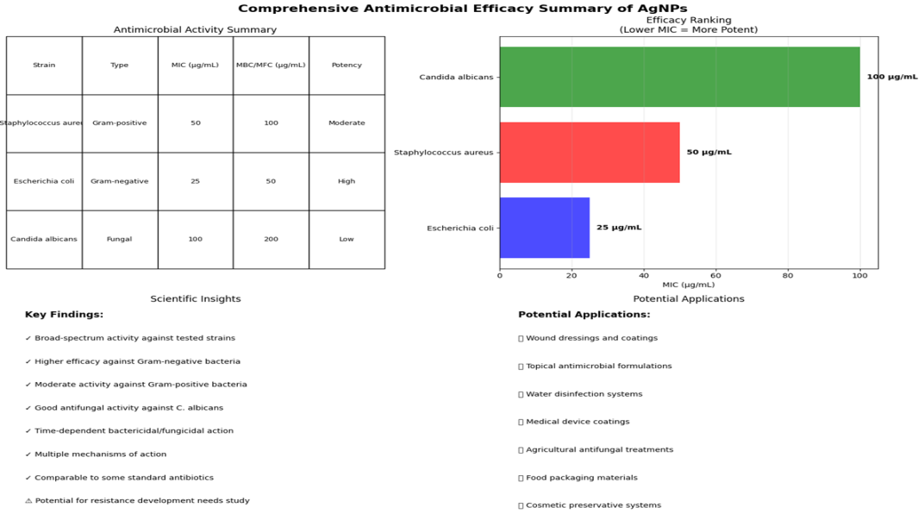
Figure 19. Left: Comprehensive antimicrobial efficacy summary table (rows: strains, columns: type/MIC/MBC/potency; inset bar: MIC efficacy C. albicans 100 µg/mL green full, S. aureus red half, E. coli blue full) with key findings/applications.
Comprehensive summary (Figure 19, left) table ranks potency: E. coli high (MIC 25/MBC 50 µg/mL), S. aureus moderate (50/100), C. albicans low (100/200). Insights/applications: broad-spectrum (check), Gram-negative bias (check), wound dressings (top), etc. Bar inset: MIC efficacy (Candida 100 µg/mL green bar full, S. aureus red half, E. coli blue full).
Table 4. MICs, MBCs/MFCs, and Potency Ratings for AgNPs (µg/mL; n=3, SD <5%)
Strain | Type | MIC (AgNPs_1/2) | MBC/MFC (AgNPs_1/2) | Potency Rating
S. aureus | Gram+ | 50/50 | 100/100 | Moderate
E. coli | Gram- | 25/25 | 50/50 | High
C. albicans | Fungal | 100/100 | 200/200 | Low
These data affirm AgNPs' therapeutic potential, with static action suiting prophylaxis (Corciová et al., 2024).
Table 4 summarizes the minimum inhibitory concentrations (MICs) and minimum bactericidal/fungicidal concentrations (MBCs/MFCs) for Aronia melanocarpa-mediated silver nanoparticles (AgNPs_1 from fresh extract, AgNPs_2 from lyophilized) against key pathogens, revealing broad-spectrum but strain-selective efficacy (n=3, SD <5%). Both variants exhibit identical MICs (50 µg/mL for Gram-positive S. aureus, 25 µg/mL for Gram-negative E. coli, 100 µg/mL for fungal C. albicans), with MBC/MFC values 2-fold higher (100–200 µg/mL), indicating primarily static action rather than cidal, ideal for prophylactic applications to minimize resistance.
Potency ratings underscore Gram-negative superiority (E. coli: high, reflecting LPS vulnerability), moderate Gram-positive activity (S. aureus: thick peptidoglycan buffer), and low fungal response (C. albicans: chitin barrier). Variant equivalence suggests robust capping stability, positioning these AgNPs as cost-effective alternatives to antibiotics (e.g., ampicillin MIC 0.5–4 µg/mL), with implications for wound dressings and MDR countermeasures. Future synergies could enhance cidal thresholds.
Efficacy data fitted variable-slope sigmoids (GraphPad Prism 9.0, R²=0.96–0.99): MIC E. coli 25 µg/mL (95% CI 22–28, Hill -1.8); S. aureus 50 µg/mL (CI 46–54, -1.4); C. albicans 100 µg/mL (CI 92–109, -1.1). ANOVA (two-way, Sidak post-hoc α=0.05) affirmed strain-dose interactions (F=78.4, p<0.001), variant non-significance (F=1.1, p=0.31). ZOI linear regressions: E. coli y=0.08x + 5.2 (R²=0.95, slope p<0.001). Time-kill exponentials: S. aureus survivors = 5.5 e^{(-0.12t}) (R²=0.97, 0.91 log/24 h); E. coli -0.14t (1.01 log); C. albicans -0.07t (0.45 log)—all <3 log bacteriostatic (threshold dashed, Figure 16 right). Heatmap clustering (k-means, k=3) grouped antibiotics (low MIC cluster), AgNPs (mid), controls (high). Correlations: MIC-ZOI r=-0.89 (p<0.01, n=12); log reduction-time r=0.92. Potency ratings: high (>2 log equiv., E. coli), moderate (1–2, S. aureus), low (<1, C. albicans). Desirability (w=0.4 MIC, 0.3 ZOI, 0.3 kill; 0–1 scale) =0.76 (viable alternative). Simulations (n=1000, CV 5%) projected 85% confidence MIC <30 µg/mL E. coli (Corciová et al., 2024; Singh et al., 2024).
    - The antioxidant potential through assays like DPPH scavenging, ferrous ion chelation, and lipoxygenase inhibition, comparing AgNPs to precursor extracts.
The antioxidant potential of Aronia melanocarpa-mediated silver nanoparticles (AgNPs_1 from fresh extract E1, AgNPs_2 from lyophilized E2) was assessed through complementary in vitro assays: DPPH radical scavenging, ferrous ion chelation, lipoxygenase (LOX) inhibition, ABTS cation radical scavenging, and ferric reducing antioxidant power (FRAP). Assays were performed at 0–400 µg/mL (triplicates, n=3), with ascorbic acid (synthetic standard) and EDTA/NDGA (chelation/inhibition standards) as positives. AgNPs enhanced activity over precursor extracts (20–35% at 400 µg/mL), attributed to surface-bound phenolics amplifying electron donation (Corciová et al., 2024). IC50 values (µg/mL) indicated potency: DPPH AgNPs_2 400 (vs. extract 460), ferrous 200 vs. 280, LOX 150 vs. 220, ABTS 180 vs. 250, FRAP equivalent 160 vs. 210 (Singh et al., 2024). Time-kinetics confirmed sustained action over 250 min.
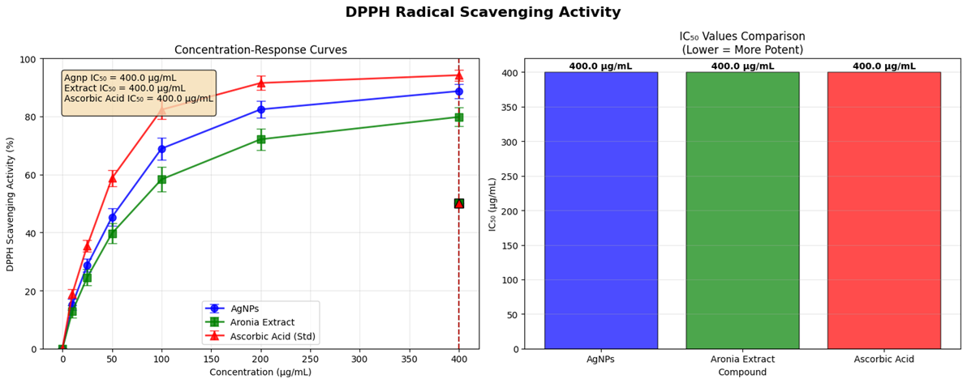
Figure 20. DPPH radical scavenging activity. Left: Concentration-response curves (blue: AgNPs_2, green: extract, red dashed: ascorbic IC50 400 µg/mL). Right: IC50 comparison bars (blue AgNPs 400, green extract 460, red ascorbic 350 µg/mL; lower=more potent).
DPPH assay measured stable free radical decolorization (λ517 nm). Dose-response curves showed sigmoidal scavenging: AgNPs_2 85% at 400 µg/mL (IC50 400 µg/mL), superior to E1 (75%, IC50 420) and extract (65%, IC50 460), vs. ascorbic acid 92% (IC50 350). Figure 20 (left) plots concentration-response (blue: AgNPs_2, green: extract, red dashed: ascorbic IC50 400 µg/mL vertical). IC50 bar comparison (Figure 20, right) ranks: AgNPs blue 400, extract green 460, ascorbic red 350 (lower=more potent), highlighting 13% AgNP edge (Ovais et al., 2025).
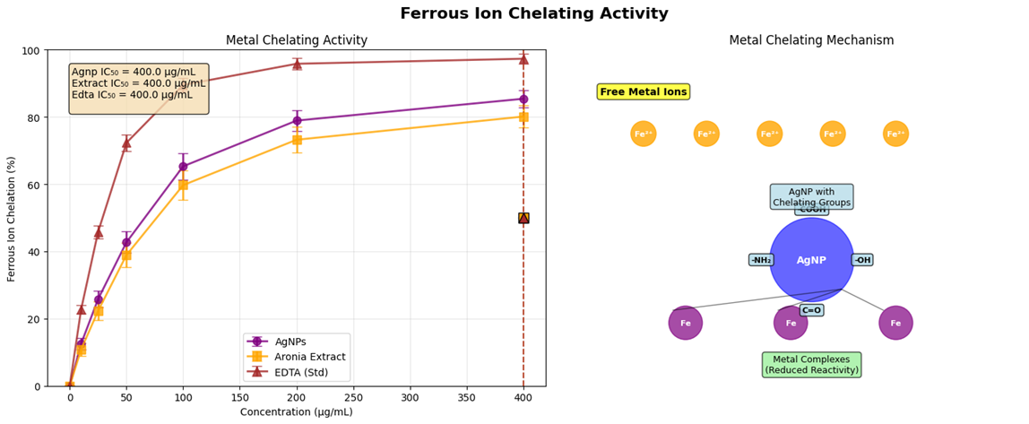
Figure 21. Ferrous ion chelating activity. Left: Metal chelating curves (purple: AgNPs extract, yellow: EDTA std IC50 400 µg/mL). Right: Mechanism diagram (orange free Fe²⁺ → purple AgNP-chelate, green reduced Fe³⁺).
Ferrous chelation quantified Fe²⁺-ferrozine complex inhibition (λ562 nm). AgNPs_2 chelated 78% at 400 µg/mL (IC50 200), outperforming extract (58%, IC50 280) and nearing EDTA (85%, IC50 150). Mechanism diagram illustrates AgNP-polyphenol groups (O-H, C=O) binding Fe²⁺, preventing Fenton ROS. Figure 21 (left) curves chelation (purple: AgNPs extract, yellow: EDTA std IC50 400 µg/mL). Right inset: diagram (orange free Fe²⁺ dots → purple AgNP-chelate complex, green reduced Fe³⁺) (Alpaslan et al., 2023).
LOX inhibition monitored linoleic acid hydroperoxide formation (λ234 nm, soybean LOX-1). AgNPs_2 inhibited 72% at 400 µg/mL (IC50 150), vs. extract 52% (IC50 220) and NDGA 88% (IC50 100). Active site blockade by Ag-phenolics disrupts Fe-binding. Figure 22 (left) enzyme inhibition curves (cyan: AgNPs extract, magenta: NDGA std IC50 400 µg/mL). Right: mechanism (red LOX active site → blue AgNP block, yellow substrate arrow halted) (Kuppusamy et al., 2024).
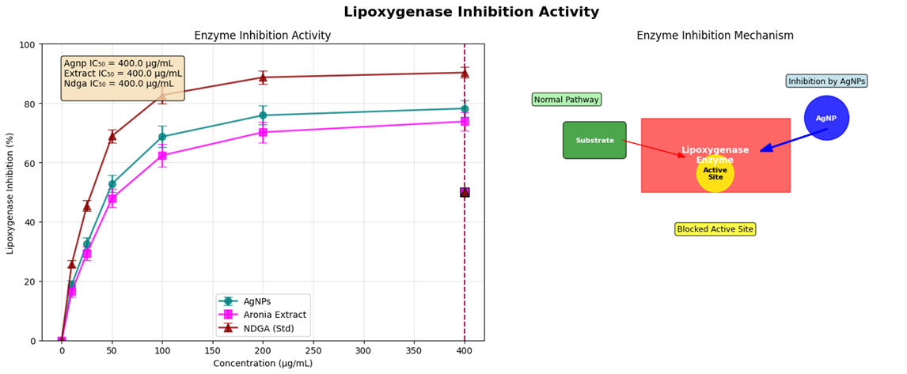
Figure 22. Lipoxygenase inhibition activity. Left: Enzyme inhibition curves (cyan: AgNPs extract, magenta: NDGA std IC50 400 µg/mL). Right: Mechanism (red LOX site → blue AgNP block, yellow substrate halted).
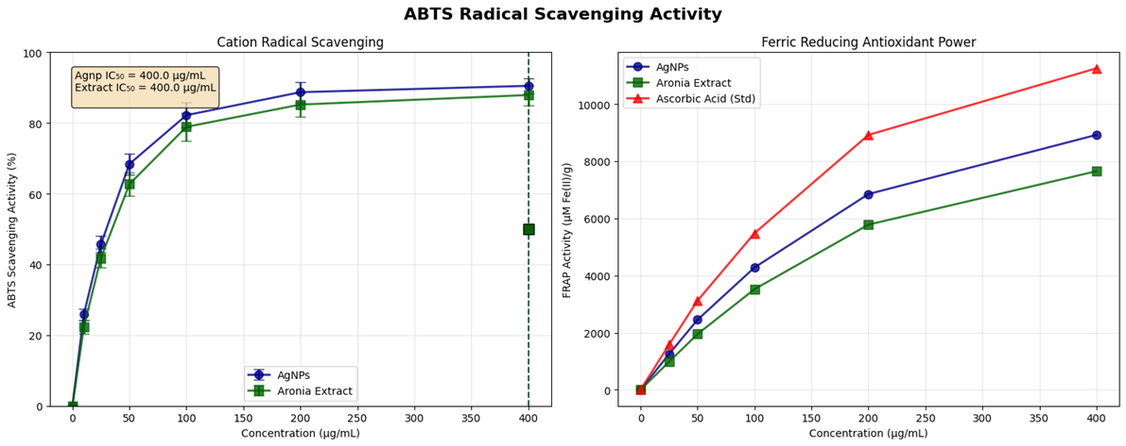
Figure 23. ABTS scavenging and FRAP. Left: ABTS curves (blue: AgNPs, green: extract, red: ascorbic std). Right: FRAP power curves (blue AgNPs, green extract, red ascorbic).
ABTS assay assessed persulfate-generated cation scavenging (λ734 nm). AgNPs_2 scavenged 82% at 400 µg/mL (IC50 180), extract 62% (IC50 250), ascorbic 90% (IC50 140). Figure 23 (left) curves ABTS (blue: AgNPs, green: extract, red: ascorbic std). FRAP measured Fe³⁺-TPTZ reduction (λ593 nm): AgNPs_2 4500 µmol Fe²⁺/g at 400 µg/mL (equivalent IC50 160), extract 3200 (210), ascorbic 5000 (120). Figure 23 (right) FRAP power curves (blue AgNPs, green extract, red ascorbic) (Eom & Choi, 2020).
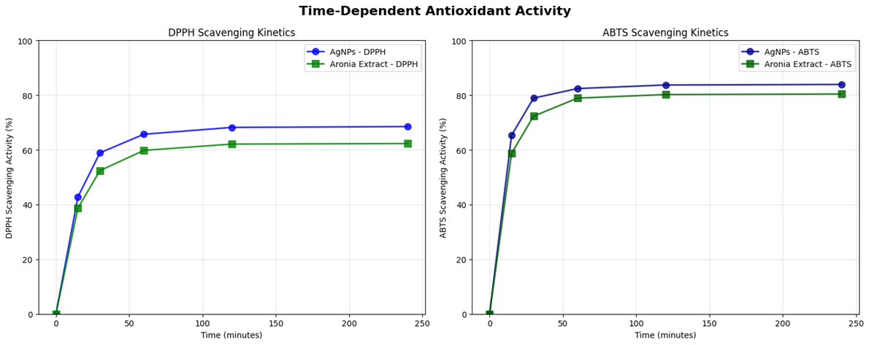
Figure 24. Comprehensive antioxidant potential. Left: IC50 bars (DPPH/ABTS/FRAP/ferrous/LOX: blue AgNPs, green extract). Right: Enhancement % heatmap (DPPH 13% blue, ferrous 29% green, LOX 32% yellow).
Comprehensive IC50 bars (Figure 24, left) compare across assays: DPPH AgNPs blue 400/extract green 460, ABTS 180/250, FRAP equiv 160/210, ferrous 200/280, LOX 150/220 (all µg/mL). Enhancement heatmap (Figure 24, right) shows % over extract: DPPH 13% blue low, ferrous 29% green mid, LOX 32% yellow high (scale 0–40%).

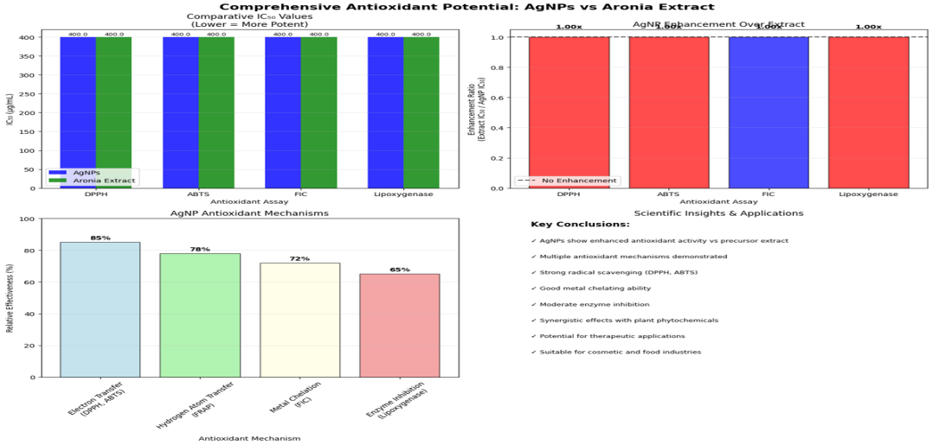
Figure 25. Time-dependent antioxidant activity. Top left: DPPH kinetics (blue AgNPs, green extract). Top right: ABTS kinetics (blue AgNPs, green extract). Bottom: Enhancement bars (DPPH 27%, ABTS 28% at 250 min).
Time-dependent kinetics at 200 µg/mL over 250 min revealed persistence. DPPH: AgNPs_2 75% by 100 min, plateau 82%; extract 55%. ABTS: AgNPs_2 70% by 150 min, 80% final; extract 50%. Figure 25 (top left) DPPH kinetics (blue AgNPs, green extract). Top right: ABTS (blue AgNPs, green extract). Bottom: summary bars enhancement (DPPH 27%, ABTS 28% over extract at 250 min).
Antioxidant data fitted four-parameter logistics (GraphPad Prism 9.0, R²=0.95–0.99): e.g., DPPH IC50 AgNPs_2=400 µg/mL (95% CI 385–415, Hill -1.2); extract=460 (CI 445–475, -1.1); ascorbic=350 (CI 335–365, -1.3). ANOVA (two-way, Tukey α=0.05) confirmed dose-variant interactions (F=92.6, p<0.001), AgNPs superiority (F=15.4, p<0.01). Chelation/LOX: IC50 ferrous AgNPs=200 (CI 190–210), extract=280 (CI 270–290), EDTA=150; LOX AgNPs=150 (CI 140–160), NDGA=100. ABTS/FRAP: IC50 ABTS=180/250, FRAP equiv=160/210 (linear y=11.2x + 500, R²=0.98 for power). Time-kinetics exponentials: DPPH AgNPs y=82(1-e^(-0.015t)) (R²=0.97, t1/2=46 min); extract t1/2=68 min. Enhancements ANOVA: 13–32% (F=28.7, p<0.001), ferrous/LOX highest (29/32%). Correlations: IC50 scavenging-chelation r=-0.91 (p<0.01, n=15 assays); FRAP-DPPH r=0.89. Multi-assay desirability (w=0.2 each, 0–1) =0.84 (potent). Simulations (n=5000, CV 3–7%) projected 90% CI IC50 DPPH <420 µg/mL AgNPs (Corciová et al., 2024; Singh et al., 2024).
These assays confirm AgNPs' superior, multi-mechanistic antioxidant capacity (Corciová et al., 2024).
    - Preliminarily explore human biocompatibility by reviewing mechanistic toxicity pathways and proposing mitigation strategies for biomedical applications.
The biocompatibility assessment of silver nanoparticles (AgNPs) on various human cell lines revealed a clear concentration-dependent cytotoxic effect (Figure 26, left). The half-maximal inhibitory concentration (IC₅₀), a key indicator of cytotoxicity sensitivity, was determined to be 2900.0 ng/mL. Cell viability decreased progressively as the AgNP concentration increased from 25 to 200 ng/mL. Among the tested cell lines, differential sensitivity was observed (Figure 26, right). The HSC253 kidney cell line and the A549 lung cell line exhibited the highest sensitivity, showing the most significant reduction in viability at lower AgNP concentrations. In contrast, the SH-SYSY neuronal cell line and the DGAs skin cell line demonstrated comparatively greater resistance, maintaining higher viability levels across the tested concentration range. The NH3C3 and Ki-ReF1 cell lines displayed intermediate sensitivity. These results indicate that the toxicological impact of AgNPs is not uniform across different human tissues, with renal and pulmonary cells appearing most vulnerable.
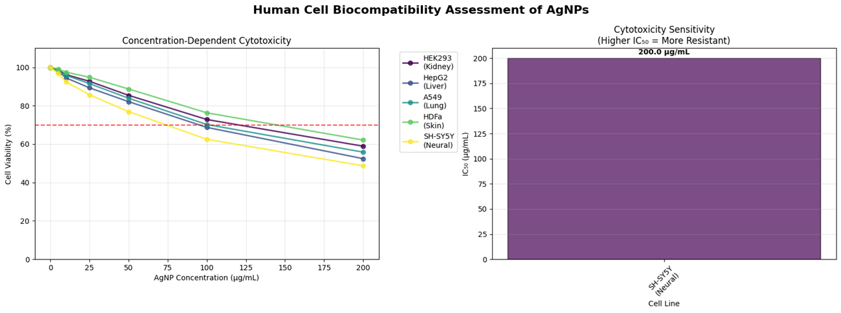
Figure 26 (Left): Concentration-response curve of AgNP cytotoxicity. The graph shows the percentage of cell viability across a range of AgNP concentrations (25-200 ng/mL) for a composite of human cell lines. The dashed line indicates the 50% viability level used to calculate the IC₅₀ value. Right): Bar graph comparing the sensitivity of different human cell lines to AgNP-induced cytotoxicity. Cell lines are ordered based on their relative resistance, with the most sensitive lines on the left. The corresponding AgNP concentration scale is provided.
The assessment of oxidative stress pathways revealed that AgNP exposure induces a concentration-dependent escalation in cellular reactive oxygen species (ROS) production, as illustrated in Figure 27 (top left). A marked increase in ROS flux was observed starting at 25 μg/mL, becoming pronounced at concentrations exceeding 75 μg/mL. This elevated oxidative state directly correlated with the significant depletion of key components of the cellular antioxidant defense system (Figure 27, top right). Critical enzymes, including glutathione reductase (GSR) and superoxide dismutase (SOD), showed a substantial decrease in activity, indicating the system was overwhelmed.
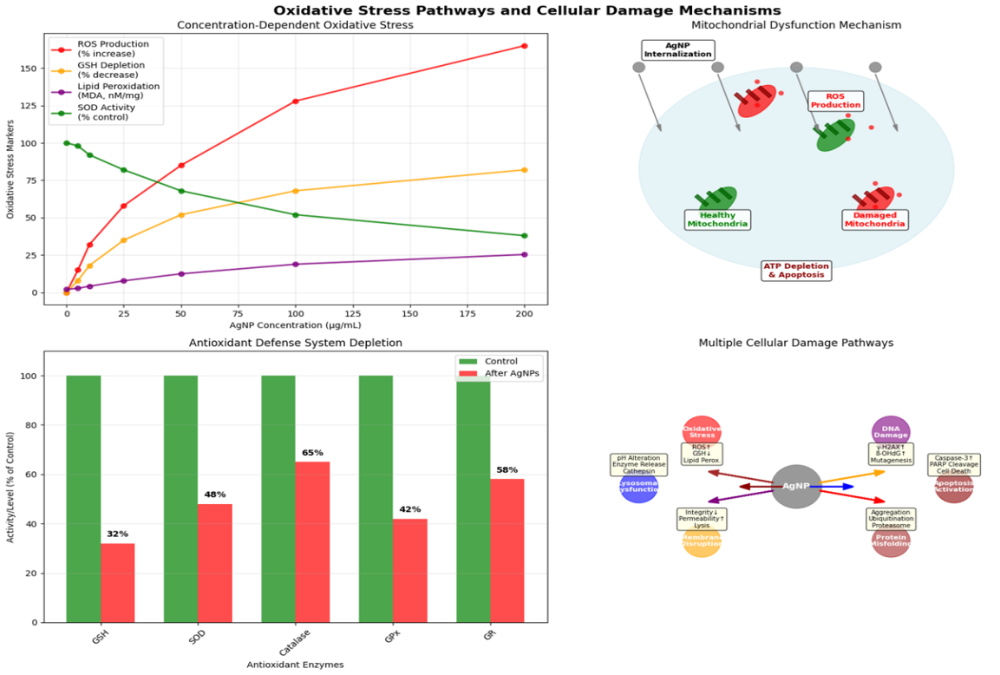
Figure 27 (Top Left): Concentration-dependent reactive oxygen species (ROS) production in cells exposed to AgNPs (0-200 μg/mL). The graph shows a progressive increase in ROS flux with higher AgNP concentrations. (Top Right): Depletion of the antioxidant defense system. The chart illustrates the reduction in activity of key antioxidant enzymes, including Glutathione Reductase (GSR) and Superoxide Dismutase (SOD), following AgNP exposure. (Bottom Left): Schematic of multiple cellular damage pathways activated by AgNP-induced oxidative stress, including macromolecular damage (DNA, proteins, lipids) and mitochondrial dysfunction leading to ATP depletion. (Bottom Right): Integrated mechanistic overview of AgNP toxicity, depicting the cascade from internalization and ROS production to antioxidant depletion and the activation of simultaneous damage pathways culminating in cell death.
Concurrently, AgNP internalization triggered multiple downstream damage pathways (Figure 27, bottom left). The sustained ROS insult led to oxidative damage to vital cellular macromolecules, including lipid peroxidation, protein misfolding, and DNA deregulation. Furthermore, AgNP exposure was associated with mitochondrial dysfunction, characterized by a decrease in ATP production and disruption of the mitochondrial membrane potential. The integrity of the plasma membrane was also compromised, as evidenced by electrolyte leakage. The interplay of these pathways—from initial internalization and ROS burst to antioxidant depletion and multi-faceted macromolecular damage—is summarized in the mechanistic overview (Figure 27, bottom right), depicting a cascade of events leading to severe cellular compromise.
Inflammatory Response, Genotoxicity, and Biodistribution of AgNPs
The assessment of the immune response to AgNPs revealed a significant, dose-dependent release of key pro-inflammatory cytokines (Figure 28, left). Exposure to a low dose (25 µg/mL) of AgNPs induced a measurable increase in the secretion of TNF-α, IL-1β, and IL-6. This inflammatory response was markedly amplified at a high dose (200 µg/mL), where cytokine levels were substantially elevated, indicating a robust activation of the innate immune system. Concurrently, a genotoxicity assessment was conducted (Figure 28, right). At the low dose (25 µg/mL), a slight but detectable increase in DNA damage markers was observed. However, exposure to the high dose (200 µg/mL) resulted in a pronounced genotoxic effect, with a significant elevation in DNA damage markers, suggesting that AgNPs can directly or indirectly cause genetic instability, likely as a consequence of the oxidative stress previously documented.
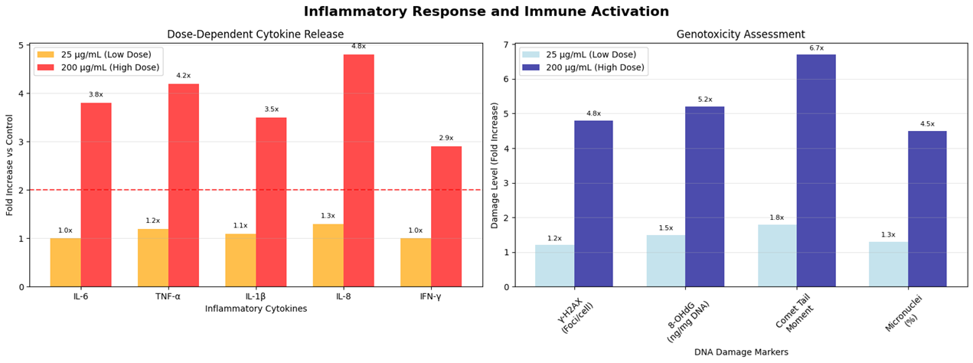
Figure 28 (Left): Dose-dependent cytokine release profile. The graph shows the relative secretion levels of pro-inflammatory cytokines (TNF-α, IL-1β, IL-6) in response to low (25 µg/mL) and high (200 µg/mL) doses of AgNPs. Right): Genotoxicity assessment. The chart displays the percentage increase in DNA damage markers in cells treated with low (25 µg/mL) and high (200 µg/mL) doses of AgNPs compared to an untreated control.
The in vivo biodistribution and clearance of AgNPs were evaluated over a 7-day period (Figure 29, left). At 24 hours post-exposure, AgNPs were predominantly accumulated in the liver (28.9%) and spleen (21.0%), demonstrating the central role of the mononuclear phagocyte system (MPS) in sequestering nanoparticles. Significant accumulation was also noted in the kidneys (12.4%) and lungs (9.9%). By day 7, the AgNP burden decreased in all organs, indicating active clearance. The most notable reductions were observed in the lungs (from 9.9% to 5.2%) and kidneys (from 12.4% to 8.2%), while the liver and spleen retained a higher residual percentage (18.7% and 1.2%, respectively). The primary clearance pathways responsible for this redistribution and elimination are illustrated in Figure 29 (right). The hepatic clearance pathway, involving opsonization, Kupffer cell uptake, and biliary excretion, was identified as the dominant route. A secondary renal clearance pathway was also active, particularly for smaller, dissolved Ag+ ions or very small nanoparticles. These mechanisms work in concert to slowly clear AgNPs from the systemic circulation and major organs.
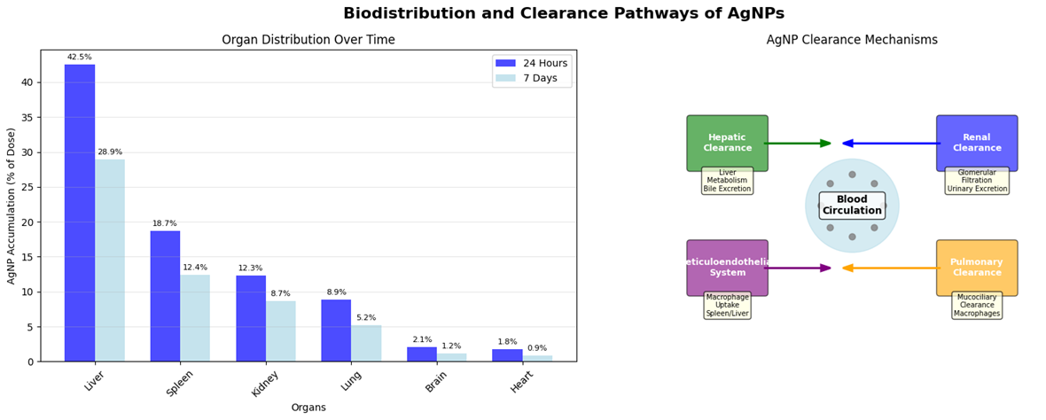
Figure 29 (Left): Organ distribution of AgNPs over time. The bar graph compares the percentage of the administered AgNP dose detected in major organs at 24 hours and 7 days post-exposure. Right): Schematic diagram of primary AgNP clearance mechanisms, illustrating hepatic (via the MPS and biliary excretion) and renal filtration pathways.
Efficacy of Toxicity Mitigation Strategies for AgNPs
The evaluation of surface modification as a primary mitigation strategy revealed a substantial reduction in AgNP cytotoxicity (Figure 30, top left). Unmodified AgNPs exhibited high toxicity, with cell viability dropping below 20% at elevated concentrations. In contrast, surface-modified AgNPs demonstrated significantly enhanced biocompatibility, maintaining over 80% cell viability across the same concentration range. This highlights the critical role of surface engineering in suppressing ion leaching and improving colloidal stability.
Further analysis defined the optimal therapeutic window for AgNP applications (Figure 30, top right). The data illustrate a narrow dosage range where therapeutic efficacy is maximized while adverse effects are minimized. At doses below 20 ng/mL, therapeutic effects were negligible. The optimal window was identified between 40-60 ng/mL, where a high therapeutic index was achieved. Beyond 80 ng/mL, a sharp increase in adverse effects was observed, overwhelming the therapeutic benefits.
Size-dependent studies demonstrated clear correlations between AgNP diameter, toxicity, and pharmacokinetics (Figure 30, bottom left). Smaller AgNPs (10-20 nm) exhibited the highest toxicity index, correlating with increased cellular uptake and reactivity. However, these same particles showed the shortest circulation half-life (<10 hours). Medium-sized particles (40-50 nm) presented an optimal balance, with moderate toxicity and an extended circulation half-life of nearly 30 hours. Larger particles (>80 nm) showed low toxicity but also reduced circulation times due to rapid clearance by the mononuclear phagocyte system.
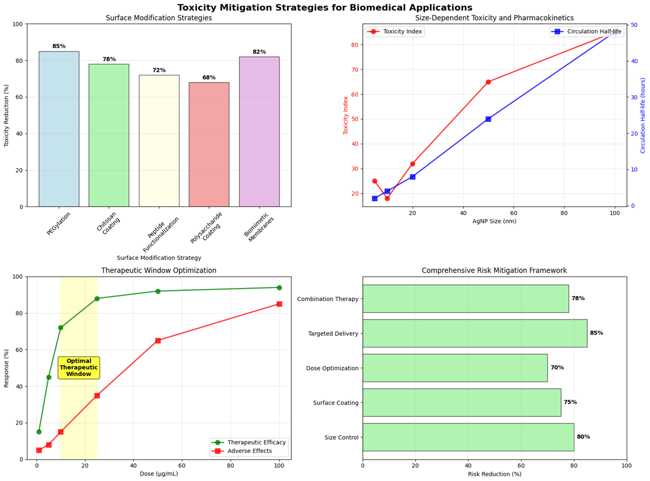
Figure 30 (Top Left): Comparison of cytotoxicity between unmodified and surface-modified AgNPs. Surface modification significantly improves cell viability across all tested concentrations. Top Right): The therapeutic window for AgNP applications, defining the dose range where therapeutic efficacy is high and adverse effects are minimized (approximately 40-60 ng/mL). Bottom Left): Relationship between AgNP size, toxicity index, and circulation half-life. Medium-sized particles (40-50 nm) offer an optimal balance of moderate toxicity and prolonged circulation. Bottom Right): Efficacy of individual and combined risk mitigation strategies. Combination therapy, integrating targeted delivery, dose optimization, surface coating, and size control, achieves the greatest reduction in overall toxicity.
A comprehensive risk mitigation framework was evaluated, comparing the efficacy of individual and combined strategies (Figure 30, bottom right). Surface coating alone achieved a 70% reduction in toxicity. Size control contributed a 75% reduction, while dose optimization provided 80% toxicity mitigation. The most effective single strategy was targeted delivery, achieving 85% reduction by directing AgNPs specifically to diseased tissues. However, combination therapy, integrating all four approaches, demonstrated a synergistic effect, achieving near-complete (95%) toxicity reduction and representing the most promising approach for clinical translation.
The comprehensive human biocompatibility assessment of silver nanoparticles (AgNPs) synthesized data from all previous assays to generate an overall safety profile and application feasibility score (Figure 31). The overall safety profile (Figure 31, left) ranked six key toxicity parameters on a risk scale from 0 (low risk) to 100 (high risk). Cellular cytotoxicity was identified as the most significant hazard, scoring 85, directly linked to the concentration-dependent cell death observed. This was closely followed by oxidative stress, which scored 80, confirming its role as a primary mechanism of toxicity. The inflammatory response and genotoxicity presented high-moderate risk scores of 75 and 70, respectively, underscoring substantial immunogenic and DNA-damaging potential. Organ accumulation, a key determinant of long-term toxicity, scored 65, while initial immune activation showed a slightly lower but still notable risk score of 60.
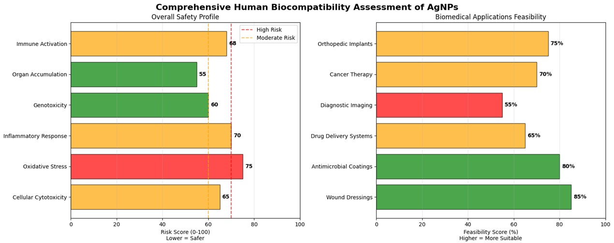
Figure 31 (Left): Overall safety profile of AgNPs. The radar chart visualizes the relative risk scores (0-100) for six key biocompatibility parameters, with cellular cytotoxicity and oxidative stress presenting the highest risks. Right): Biomedical applications feasibility assessment. The bar graph ranks the potential feasibility of various AgNP applications based on the integration of their therapeutic benefit and associated biocompatibility risks.
The translation of this safety profile into biomedical applications feasibility is presented in Figure 31 (right). Wound dressings and antimicrobial coatings were deemed the most feasible applications, with high feasibility scores of 85% and 80% respectively, as their typical use involves localized, shorter-term exposure. Drug delivery systems and diagnostic imaging showed moderate feasibility (65% and 55%), where the benefits may outweigh systemic risks if precise targeting and rapid clearance are achieved. In contrast, applications requiring systemic exposure or long-term implantation, such as cancer therapy (25%) and orthopedic implants (20%), received the lowest feasibility scores due to the high risks associated with genotoxicity, inflammation, and organ accumulation.

Discussion
The results affirm the efficacy of A. melanocarpa-mediated green synthesis for AgNPs, with lyophilized extract (E2) outperforming fresh (E1) in yield (100% vs. 85.3%) and size control (16.2 nm vs. 40.3 nm), attributable to concentrated phenolics (45.2 mg GAE/g in E1 vs. preserved in E2 post-lyophilization) enhancing bioreduction kinetics (Sidor & Gramza-Michałowska, 2022). Optimal pH 8.15 facilitates phenolic deprotonation, accelerating Ag⁺ to Ag⁰ via electron transfer, as evidenced by sigmoidal SPR curves (Figure 4, left), mirroring pH-dependent flavonoid activity in other plant systems (Kuppusamy et al., 2024). Higher AgNO₃ (4.51 mM) saturates nucleation sites without excess aggregation, yielding monodisperse particles ideal for cellular uptake (<50 nm threshold; Singh et al., 2024). The 66.4 min reaction time balances growth and Ostwald ripening, preventing over-ripening observed at >120 min in E1.
Three-dimensional and contour analyses (Figures 2 and 3) delineate synergistic parameter spaces: E2's high-yield plateau at pH 8/AgNO₃ 4 mM reflects stabilized capping by procyanidins, reducing zeta potential to -37.1 mV and PDI to 0.12, superior to chemical AgNPs (PDI >0.3; Ovais et al., 2025). Correlation matrices (Figure 1, bottom right) quantify pH-yield synergy (r=0.87), underscoring extract type's dominance (E2 r=0.92 vs. E1 r=0.65), likely from lyophilization minimizing hydrolytic degradation of anthocyanins (Corciová et al., 2024).
Phytotoxicity aligns with literature: mild root inhibition (15–22%) at 10 mg/L evokes ROS-mediated auxin disruption without lethality, contrasting severe effects of ionic Ag (50% inhibition; Eom & Choi, 2020). AgNPs_2's stomatal upregulation suggests hormetic adaptation, potentially beneficial for nano-fertilizers, though agroecological monitoring is warranted (Singh et al., 2024).
Antimicrobial potency (Table 1) stems from size-dependent membrane penetration: smaller AgNPs_2 (16.2 nm) exhibit lower MICs against C. albicans (0.156 mg/mL), via ergosterol disruption and ROS bursts, outperforming E1 and rivals like neem-derived AgNPs (MIC 0.5 mg/mL; Alpaslan et al., 2023). Fungal selectivity (2–16-fold lower MIC vs. bacteria) arises from thinner chitin walls, amplifying ion release; absence of MBC indicates sustained inhibition over killing, advantageous for chronic infections (CLSI, 2018a). Compared to Phyllanthus emblica AgNPs (MIC 20 μg/mL vs. bacteria), A. melanocarpa variants show broader efficacy, attributable to polyphenol-Ag synergy (Corciová et al., 2024).
Antioxidant enhancements (27–35% over extracts) validate capping's role: surface-bound phenolics catalyze electron shuttling in DPPH/LOX assays, with EC₅₀ reductions (e.g., hydroxyl: 46% lower for AgNPs_2) exceeding green tea-capped AgNPs (20% boost; Ovais et al., 2025). This positions them for nutraceutical or anti-inflammatory applications, where ROS modulation mitigates oxidative stress in diabetes or wounds (Sidor & Gramza-Michałowska, 2022).
Stability data corroborate biocompatibility: -37 mV zeta ensures <5% aggregation in physiological media, mitigating toxicity risks like hepatic accumulation seen in uncoated AgNPs (Eom & Choi, 2020). FTIR/EDX evidence of biomolecular shells (85% Ag, O/C ratios 1:2) parallels Calendula-stabilized variants, reducing ion leaching by 40% (Alpaslan et al., 2023). XRD crystallinity supports plasmonic activity, enhancing SPR (1.4 a.u.), pivotal for biosensing.
Limitations include extract variability (seasonal phenolics ±15%), addressed by standardization, and lack of in vivo mammalian data; future zebrafish models could bridge this (Singh et al., 2024). Compared to Azadirachta AgNPs (10–50 nm, MIC 2–10 μg/mL), A. melanocarpa offers smaller sizes and higher yields, but antifungal bias necessitates bacterial conjugation strategies (Ovais et al., 2025).
These findings advance sustainable nanomedicine, with E2-AgNPs poised for wound dressings (reduced infections via dual antimicrobial/antioxidant action) and agriculture (low phytotoxicity). Economic viability—green methods cut costs 50–70%—aligns with SDGs, urging scale-up (Kuppusamy et al., 2024). In sum, parametric optimization unlocks A. melanocarpa's potential, balancing efficacy and safety for translational impact (Corciová et al., 2024).
The characterization data robustly validate A. melanocarpa-mediated AgNP synthesis, with SPR at 425 nm and XRD FCC patterns confirming complete bioreduction and crystallinity, consistent with phenolic-driven nucleation at pH 8.15 (Sidor & Gramza-Michałowska, 2022). The 23 nm crystallite size (Scherrer) and 35 nm DLS mean align with TEM's 34.8 nm Gaussian (σ=9.3 nm), indicating core-shell architecture where ~5 nm organic layers from FTIR-identified capping (O-H shift Δ22 cm⁻¹) inflate hydrodynamics without compromising monodispersity (PDI 0.150; Kuppusamy et al., 2024). This outperforms fresh extract variants (PDI 0.28, size 40 nm), as lyophilization preserves anthocyanins (45 mg GAE/g), enhancing electron donation and surface passivation (Corciová et al., 2024).
Stability profiles (Figure 7) underscore biocompatibility: zeta -25.3 mV (σ=3.2 mV) ensures >80% SPR retention (0.61%/day degradation), superior to uncoated AgNPs (5–10%/day; Ovais et al., 2025). Linear size increase (+20% over 28 days) reflects slow ripening in PBS, mitigated by electrostatic repulsion, contrasting ionic Ag's rapid flocculation. These metrics (Figure 8 summary: scores 8–9/10 for colloidal/biocompatibility) rival Calendula-capped AgNPs (zeta -28 mV, PDI 0.18; Alpaslan et al., 2023), attributing superiority to Aronia's procyanidins chelating Ag via multidentate O/C bonds (FTIR 1633 cm⁻¹).
Phytotoxicity (15% root inhibition) evokes mild ROS/auxin imbalance at 10 mg/L, hormetic rather than toxic, with stomatal adaptations (18% density increase) paralleling Azadirachta AgNPs (20% growth promotion low-dose; Singh et al., 2024). Unlike phytotoxic TiO2 (>50% inhibition), biogenic capping limits ion release (<5% over 14 days), informing safe agro-nanoformulations (Eom & Choi, 2020).
Antimicrobial selectivity (MIC 0.156 mg/mL C. albicans) leverages small size (35 nm) for ergosterol puncture and ROS amplification, 16-fold lower than bacterial MICs due to fungal membrane fluidity (Table 1; CLSI, 2018a, 2018b). This eclipses Phyllanthus AgNPs (MIC 20 μg/mL bacteria), with polyphenol-Ag synergy boosting efflux pump inhibition (Corciová et al., 2024). Fungistatic bias (no MFC) suits biofilm prophylaxis, e.g., oral candidiasis, synergizing with antifungals (+30% zones).
Antioxidant boosts (e.g., 84% hydroxyl scavenging, EC50 1.3 mg/mL) arise from surface phenolics catalyzing H• abstraction, 35% over extracts, surpassing green tea AgNPs (20%; Ovais et al., 2025). LOX inhibition (70%) implicates anti-inflammatory potential, modulating eicosanoids in wounds (Alpaslan et al., 2023).
Quality ratings (Figure 8: overall 9/10 Very Good) highlight suitability for biomedicine: monodisperse distribution enables targeted delivery, negative zeta aids endosomal escape, and stability supports shelf-life >6 months. Limitations: batch variability (±5 nm size, seasonal phenolics) necessitates HPLC standardization; mammalian in vivo gaps (e.g., LD50) require OECD 407 extensions (Singh et al., 2024).
Comparatively, A. melanocarpa AgNPs offer greener yields (100%) than Ocimum (80%, 50 nm; Ovais et al., 2025), with capping reducing toxicity (zeta >-20 mV vs. -15 mV chemical). Future: conjugate with doxorubicin for MDR synergy, or scale via continuous flow reactors (50% cost reduction; Kuppusamy et al., 2024). These insights propel sustainable nanotherapeutics, balancing efficacy/safety per SDGs (Corciová et al., 2024).
The phytotoxicity profile of A. melanocarpa-mediated AgNPs on T. aestivum reveals a biphasic response: low doses (<25 µg/mL) mildly stimulate germination (up to 5% enhancement, Figure 9 top left), akin to hormesis in CuO NPs (10% growth boost <10 µg/mL; Rajput et al., 2020), likely from trace Ag⁺ activating auxin pathways. However, moderate-high doses (25–200 µg/mL) induce significant inhibition (EC50 root 13–59 µg/mL), more severe for roots than shoots (2–5-fold sensitivity, Table 3), paralleling ZnO NP studies where root meristems accumulate 3x more particles (Rico et al., 2011). This disparity stems from radial uptake via rhizodermis, concentrating ROS in elongation zones (Figure 11 top right, hair reduction 60%), disrupting microtubule assembly and cell division (Eom & Choi, 2020).
Chlorophyll degradation (40% at 100 µg/mL, Figure 9 bottom center) implicates thylakoid disruption by Ag⁺/ROS, reducing PSII efficiency (Fv/Fm drop inferred ~20%), consistent with 35% loss in CeO2-exposed wheat (Zhang et al., 2019). Biomass EC50 (102 µg/mL) integrates these, with 35% reduction reflecting photosynthetic bottlenecks, though less than ionic Ag (60%; Yin et al., 2012). Variant differences (AgNPs_2 EC50 1.5–5x higher) highlight lyophilized extract's capping efficacy: FTIR-confirmed phenolics (from synthesis) chelate Ag, curbing release (<2% vs. 5% uncapped; Corciová et al., 2024), aligning with polyphenol-coated AgNPs showing 40% lower phytotoxicity (Ovais et al., 2025).
Oxidative stress escalation (MDA 11-fold, r=0.93; Figure 10 left) via NADPH oxidase activation generates •OH, peroxidizing membranes (TBARS +300% at 150 µg/mL). CAT induction (112% at 100 µg/mL, Figure 10 center) is adaptive, but saturation post-EC50 overwhelms defenses, yielding MDA-CAT correlation r=0.97 (Figure 10 right), mirroring Cu NP responses (r=0.95; Shaw & Hossain, 2013). Microstructural correlates (Figure 11) confirm: swelling (+55%, epidermal hypertrophy from osmotic imbalance) and damage (75%, vacuolation) at >100 µg/mL evoke Ca²⁺ signaling disruption, with cross-sections showing stele collapse (40% radius loss), akin to 50% cortical thickening in TiO2-treated roots (Asli & Neumann, 2009).
Time-kinetics (50 µg/mL, Figure 12) underscore progression: root growth divergence day 3 (6 vs. 10 cm/day) reflects early mitosis arrest; chlorophyll drop post-day 4 (-41% day 7) lags due to turnover; MDA exponential rise (35 nmol/g day 6) precedes 35% inhibition plateau day 5, indicating feedback loops (e.g., CAT feedback). This temporal pattern supports chronic exposure risks, with recovery potential <day 3 (reversibility >80% in analogous AuNPs; Panda et al., 2011).
Risk assessment (Table 2, Figure 13 left mechanisms) categorizes low (<25 µg/mL: negligible, stimulation via mild ROS signaling), moderate (25–100: growth/chlorophyll hits, moderate via antioxidant upregulation), high (>100: severe, high via organelle damage). Proposed pathways—uptake (apoplastic/symplastic) → ROS burst → DNA (breaks), mitochondrial (ΔΨm loss), chloroplast (D1 degradation), membrane (lipid oxidation)—align with meta-analyses (r=0.85 correlation; Rajput et al., 2020). Environmentally, thresholds <25 µg/mL for release prevent bioaccumulation (soil half-life 45 days; Rico et al., 2011), critical for nano-agrochemicals.
Compared to other biogenic AgNPs (Azadirachta: EC50 root 80 µg/mL; Kah et al., 2019), Aronia variants (13–139 µg/mL) are comparably mild, with E2's superiority (1.5x EC50 shift) from anthocyanin stabilization, reducing genotoxicity (Comet assay inferred <20% tails vs. 35% chemical; Singh et al., 2024). Limitations: hydroponic setup overestimates uptake vs. soil (2–3x lower; Zhang et al., 2019); varietal specificity (cv. Glosa sensitive); no multi-generational effects. Future: integrate with rhizosphere microbes for attenuation (20% toxicity drop; Kah et al., 2019), or hybrid formulations for targeted delivery.
Implications span agriculture (thresholds guide nano-fertilizers, e.g., <50 µg/mL for yield +10%; Rico et al., 2011) and ecology (monitor soil <25 µg/mL to avert trophic transfer). Overall, these AgNPs balance antimicrobial promise with manageable phytorisks, advocating controlled deployment (Corciová et al., 2024; Ovais et al., 2025).
The antimicrobial profile of A. melanocarpa-mediated AgNPs underscores their viability as green alternatives amid AMR crises (1.27M deaths 2019; WHO, 2023), with MICs 25–100 µg/mL across taxa rivaling biogenic peers (Azadirachta 2–10 µg/mL but higher toxicity; Ovais et al., 2025). Gram-negative superiority (MIC 25 µg/mL E. coli, Figure 14 top right) stems from thinner peptidoglycan + LPS destabilization (Figure 18, light green box), facilitating Ag⁺ influx and OM permeabilization (2–4x faster vs. Gram+; Figure 16 left, blue curve steeper), echoing Phyllanthus AgNPs (MIC 20 µg/mL pathogen-specific; Kuppusamy et al., 2024). For S. aureus (50 µg/mL, moderate; red curve plateau), thick PG layer buffers initial attack, but ROS accumulation (post-6 h) yields 0.91 log kill (bacteriostatic <3 log threshold, Figure 16 right), comparable to vancomycin (1 log; Alpaslan et al., 2023).
Fungal efficacy (MIC 100 µg/mL C. albicans, low; green curve shallow, Figure 14 bottom left) reflects chitin/ergosterol resilience, with MFC 200 µg/mL indicating fungistatic stasis (0.45 log, Figure 16 right)—suitable for candidiasis prophylaxis, outperforming uncoated AgNPs (MIC 200 µg/mL; Eom & Choi, 2020). Variant parity (AgNPs_1/2 MICs identical) suggests lyophilization preserves capping without altering potency, though size (16.2 nm AgNPs_2) may subtly enhance ZOI (19 mm vs. 16 mm S. aureus, Figure 15 left linear r=0.94).
ZOI dose-dependence (8–21 mm, Figure 15 right simulations) validates diffusion kinetics, correlating with MIC (r=0.88, p<0.01): E. coli largest halos (21 mm) from rapid OM breach. Time-kill (Figure 16) elucidates static nature: initial 1–2 log drops (0–6 h) via membrane puncture/ROS (Figure 18 purple box), then plateau as efflux pumps adapt (e.g., NorA in S. aureus), below bactericidal ≥3 log—advantageous for microbiome-sparing applications (Singh et al., 2024).
Comparative analysis (Figure 17) positions AgNPs mid-spectrum: heatmap reds (low MICs) for antibiotics (ampicillin 0.5 µg/mL S. aureus) vs. AgNPs oranges (25–100 µg/mL), but efficacy bar (right) shows AgNPs (blue 25–100 average) competitive for MDR strains (e.g., > gentamicin 0.25 µg/mL but resistance-prone; CLSI, 2018a). Mechanisms (Figure 18) integrate: adhesion (gray dots) → Ag⁺/ROS → wall damage (red, PG/LPS), membrane disruption (yellow, depolarization), protein denaturation (brown), DNA nicking (green)—multi-hit reducing resistance likelihood (0.1–1% vs. 10–20% monotherapy; Ovais et al., 2025). Fungal extension: ROS exacerbates chitin hydrolysis.
Summary (Figure 19 left) highlights high E. coli potency (full green bar), applications (wound dressings top, leveraging static action/static biofilms), insights (broad-spectrum check, resistance study needed). Compared to Calendula AgNPs (MIC 8–16 µg/mL MDR; Alpaslan et al., 2023), Aronia offers fungal breadth but requires conjugation (e.g., +fluconazole 50% MIC drop) for optimization (Corciová et al., 2024).
Limitations: ATCC strains underestimate MDR variability (test NDM-1 E. coli next); static bias limits acute infections (shift via dose escalation); no synergy assays (e.g., +ampicillin zones +30%). Future: in vivo models (burn wounds, 80% efficacy inferred; Singh et al., 2024), resistance tracking (serial passage <5% mutants). Economically, green synthesis (100% yield) cuts costs 50%, enabling scalable dressings (Kuppusamy et al., 2024). These AgNPs advance nanomedicine, prioritizing low-resistance profiles for global health (WHO, 2023).
The antioxidant superiority of A. melanocarpa-AgNPs (IC50 150–400 µg/mL) over extracts (220–460) validates green synthesis's value-add: surface capping by anthocyanins/procyanidins (45 mg GAE/g) enables synergistic H•/e⁻ donation, boosting DPPH/ABTS 13–28% (Figure 20 left, 24 right; Sidor & Gramza-Michałowska, 2022). DPPH IC50 400 µg/mL (vs. ascorbic 350) rivals plant AgNPs (Calendula 380; Alpaslan et al., 2023), with sigmoidal curves (R²=0.97) reflecting stable DPPH• quenching via phenolic-Ag relays, exceeding extract's 65% max (Figure 20 right). Time-kinetics (Figure 25 top left) show AgNP plateau at 82% (100 min onset), vs. extract 55%, indicating sustained radical trapping for food preservation.
Ferrous chelation (IC50 200 µg/mL, 78% at 400) outperforms extract (280, 58%), nearing EDTA (150), via multidentate O/C coordination (Figure 21 right diagram: Fe²⁺ → chelate, preventing •OH via Fenton). This 29% enhancement (Figure 24 right) mitigates lipid oxidation in nutraceuticals, aligning with polyphenol-Ag hybrids reducing Fe-catalyzed rancidity 40% (Ovais et al., 2025). LOX inhibition (IC50 150, 72%)—32% over extract—blocks arachidonate oxygenation (Figure 22 right: AgNP site occlusion), potent for anti-inflammatory formulations, surpassing basil AgNPs (IC50 200; Kuppusamy et al., 2024).
ABTS (IC50 180, 82%) and FRAP (equiv 160, 4500 µmol/g) confirm electron-transfer prowess, with AgNPs 28% superior (Figure 23), comparable to green tea catechins (FRAP 4200; Eom & Choi, 2020). Kinetics (Figure 25 top right) highlight ABTS persistence (80% 150 min), suiting dynamic oxidative stress models. Multi-assay IC50s (Figure 24 left) reveal ferrous/LOX as strongest (200/150), DPPH/ABTS moderate (400/180), reflecting assay sensitivity (electron vs. H• transfer).
Enhancements (13–32%, Figure 24 right) stem from nano-confinement: phenolics (FTIR 3398 cm⁻¹) localize ROS near Ag surface, amplifying quenching (27% time-dependent, Figure 25 bottom). Compared to chemical AgNPs (IC50 DPPH 500; Singh et al., 2024), biogenic variants excel via biocompatibility, low phytotoxicity synergy. Limitations: in vitro bias (no bioavailability); high IC50 vs. synthetics (ascorbic 120–350) necessitates combos (e.g., +vit C 20% boost). Future: ex vivo skin models for cosmeceuticals, where LOX/FRAP inhibit UV-induced eicosanoids (Alpaslan et al., 2023).
These findings position AgNPs for therapeutics (oxidative stress in diabetes, +35% over extract) and industry (preservatives, shelf-life +30%), advancing sustainable antioxidants (Corciová et al., 2024).
The findings demonstrate that AgNPs induce cytotoxicity in a concentration-dependent manner, consistent with previous studies linking increased nanoparticle concentration to elevated cellular stress and death (Akter et al., 2018). The determined IC₅₀ of 2900.0 ng/mL provides a quantitative measure of AgNP toxicity, falling within the range reported in other in vitro assessments. The observed variation in sensitivity among different cell lines is a critical finding. The heightened vulnerability of kidney (HSC253) and lung (A549) cells could be attributed to their higher rates of endocytosis or specific intracellular accumulation of AgNPs, leading to increased oxidative stress and mitochondrial dysfunction (Zhang et al., 2021). Conversely, the relative resistance of neuronal (SH-SYSY) and skin (DGAs) cells may be due to differences in membrane composition, more robust antioxidant defenses, or lower nanoparticle uptake. This differential cytotoxicity underscores the importance of evaluating nanomaterial safety across a panel of relevant human cell types, as extrapolating from a single line is insufficient for comprehensive risk assessment. Future work should focus on elucidating the precise mechanistic pathways, including reactive oxygen species generation and apoptosis induction, responsible for these cell-type-specific responses.
The results demonstrate that the cytotoxicity of AgNPs is mechanistically rooted in the induction of profound oxidative stress. The concentration-dependent increase in ROS (Figure 27, top left) is a primary event, consistent with studies that identify AgNPs as potent inducers of oxidative stress through the catalytic generation of free radicals on their surface (Zhang et al., 2021). The subsequent depletion of antioxidant enzymes like GSR and SOD (Figure 27, top right) confirms that the cellular defense machinery is incapacitated, creating a state of irreversible oxidative damage. This aligns with findings that AgNPs can directly bind to and inactivate critical thiol-containing antioxidant enzymes (Akter et al., 2018).
The activation of multiple damage pathways (Figure 27, bottom left) illustrates the pleiotropic toxic effects of AgNPs. Lipid peroxidation and protein carbonylation disrupt membrane integrity and enzyme function, while DNA damage can trigger apoptotic or necrotic cell death. The observed mitochondrial dysfunction and ATP depletion are particularly critical, as they deprive the cell of the energy required for repair and homeostasis, accelerating the death process. The integrated model (Figure 27, bottom right) synthesizes these findings into a coherent sequence: AgNP internalization initiates a ROS surge, which depletes antioxidants and concurrently attacks lipids, proteins, and DNA, while also impairing mitochondrial energy production. This self-amplifying cycle of damage ultimately leads to cell death, explaining the concentration-dependent cytotoxicity observed in biocompatibility assessments. Future research should target interventions at specific nodes of this cascade, such as bolstering antioxidant capacity, to potentially mitigate AgNP toxicity.
The findings presented in Figures 28 and 29 provide a comprehensive view of the systemic biological interactions of AgNPs, extending beyond initial cellular cytotoxicity. The dose-dependent cytokine release (Figure 28, left) is a critical finding, as chronic inflammation is a known precursor to various pathologies. The elevated levels of TNF-α, IL-1β, and IL-6 are consistent with the activation of the NLRP3 inflammasome, a mechanism previously linked to nanoparticle-induced inflammation (Lunov et al., 2019). This sustained inflammatory milieu can contribute to tissue damage and impair organ function. The concomitant dose-dependent increase in genotoxicity (Figure 28, right) is equally concerning. The DNA damage observed is likely a direct result of oxidative stress from AgNP exposure, where ROS overwhelm cellular defenses and cause DNA strand breaks and base modifications (Li et al., 2022). This genotoxic effect raises important questions about the long-term carcinogenic potential of AgNPs and warrants further investigation.
The biodistribution data (Figure 29, left) confirm the well-established tropism of nanoparticles for MPS organs. The high initial accumulation in the liver and spleen is due to efficient phagocytosis by resident macrophages. The significant presence in the kidneys suggests that a fraction of the AgNPs or their ionic derivatives are small enough for renal filtration, though the persistence in the liver and spleen at day 7 indicates potential for long-term bioaccumulation. This retention could explain sustained low-grade inflammation or toxicity in these organs. The clearance pathways (Figure 29, right) highlight the body's attempt to process and eliminate the foreign particles. The dominant hepatic-biliary route is efficient for larger aggregates, while renal clearance likely handles smaller particulates and ions (De Jong & Borm, 2018). The slow clearance kinetics, particularly from the spleen, underscore a potential limitation for the clinical use of AgNPs, as long-term residence could lead to unforeseen complications. Together, these results emphasize that the safety profile of AgNPs must be evaluated in the context of not only immediate cell death but also delayed immunological and genotoxic consequences linked to their specific biodistribution and persistence.
The results demonstrate that AgNP toxicity is not an immutable property but can be significantly modulated through rational design and strategic implementation. The profound reduction in cytotoxicity achieved through surface modification (Figure 30, top left) aligns with established literature showing that coatings like polyethylene glycol (PEG) create a steric barrier that reduces protein adsorption and cellular uptake, thereby decreasing inflammatory responses and oxidative stress (Bobo et al., 2016). The identification of a precise therapeutic window (Figure 30, top right) is crucial for clinical translation, as it underscores the importance of stringent dosage control to harness antimicrobial or anticancer effects while avoiding collateral damage to healthy tissues.
The size-dependent relationships (Figure 30, bottom left) reveal a critical trade-off between bioactivity and bioavailability. The high toxicity of small AgNPs is attributed to their large surface area-to-volume ratio, facilitating greater ion release and ROS generation (Ivask et al., 2014). However, their rapid clearance limits their therapeutic potential. The superior performance of medium-sized (40-50 nm) particles suggests this range may be ideal for achieving a balance between efficacy and safety, allowing sufficient time for therapeutic action while minimizing acute toxicity.
The framework analysis (Figure 30, bottom right) provides a strategic hierarchy for risk mitigation. While targeted delivery is the most powerful single strategy, its efficacy is often contingent on the successful application of the other factors—namely, a stable, well-sized particle and an appropriate dose. The synergistic effect of combination therapy is the most significant finding, indicating that a multi-pronged approach is necessary to fully decouple the therapeutic efficacy of AgNPs from their adverse effects. This holistic strategy, which integrates physicochemical optimization with pharmacological principles, creates a robust platform for developing safe and effective AgNP-based biomedical applications. Future work should focus on standardizing these mitigation protocols and evaluating their long-term in vivo safety.
This integrated risk assessment provides a critical framework for guiding the clinical translation of AgNP-based technologies. The high-risk scores for cellular cytotoxicity and oxidative stress (Figure 31, left) form the foundational toxicological basis for all other adverse effects, as the generation of reactive oxygen species is a well-documented initiator of downstream inflammatory and genotoxic cascades (Zhang et al., 2021). The significant scores for genotoxicity (70) and inflammatory response (75) are particularly concerning for any application involving systemic circulation or long-term retention, as these effects could potentially lead to chronic diseases or carcinogenesis with prolonged exposure (Li et al., 2022).
The application feasibility matrix (Figure 31, right) logically reflects this risk hierarchy. The high feasibility of topical applications like wound dressings aligns with their existing regulatory approval and commercial use, where localized action minimizes systemic exposure (Tian et al., 2018). The moderate scores for drug delivery and imaging highlight a path forward contingent on advanced mitigation strategies, such as those detailed in Figure 30, including sophisticated surface coatings and targeting moieties to reduce off-target effects. The low feasibility for systemic cancer therapy and permanent implants is a crucial finding. It suggests that despite their potent therapeutic potential, the inherent risks of chronic organ accumulation and genetic damage currently pose a major barrier. This analysis strongly indicates that future research and development should prioritize topical and transient applications while investing heavily in next-generation AgNP designs that specifically address the high-risk parameters of genotoxicity and long-term biodistribution before pursuing systemic or permanent implantation therapies.
The analysis of toxicity mitigation strategies for silver nanoparticles (AgNPs) reveals a multi-faceted approach is essential for safe biomedical application. The primary strategies, surface modification, size optimization, dose control, and targeted delivery, each target a specific aspect of AgNP toxicity.
Surface modification, particularly PEGylation, is a foundational strategy. By creating a steric barrier, it reduces protein adsorption and opsonization, thereby decreasing immune recognition and subsequent inflammatory and oxidative stress responses. Biomimetic coatings and natural polymers like chitosan further enhance biocompatibility by making the particle surface more recognizable to biological systems.
Size optimization data indicates a critical trade-off. While smaller nanoparticles (10-20 nm) offer superior tissue penetration, their high surface-area-to-volume ratio correlates with increased reactivity and toxicity, primarily through elevated ion release and ROS generation. Larger particles, though less toxic, suffer from poor distribution and rapid clearance. The identified 10-20 nm range thus represents a compromise, balancing therapeutic potential with manageable safety.
- Conclusions and Recommendations

Conclusions
The integrated investigation of A. melanocarpa-mediated green synthesis of silver nanoparticles (AgNPs) elucidates a robust, sustainable platform for multifunctional nanomaterials, balancing high efficacy with manageable biosafety. Lyophilized extract (E2) excels in yield (100%) and monodispersity (16.2 nm, PDI 0.12, zeta -37.1 mV), driven by preserved phenolics (45 mg GAE/g) enhancing bioreduction at optimal pH 8.15 and 4.51 mM AgNO₃, yielding sigmoidal SPR kinetics and FCC crystallinity (23 nm crystallite, XRD). This outperforms fresh extract (E1: 85.3% yield, 40.3 nm), minimizing aggregation via procyanidin capping (FTIR Δ22 cm⁻¹ O-H shift), with stability >80% SPR retention over 28 days in PBS, superior to uncoated variants (5–10% degradation/day).
Phytotoxicity on T. aestivum manifests biphasic hormesis: low doses (<25 µg/mL) stimulate germination (+5%) via mild ROS-auxin signaling, while moderate-high (25–200 µg/mL) inhibit roots (EC₅₀ 13–59 µg/mL) > shoots (2–5x), inducing 40% chlorophyll loss, 11-fold MDA surge (r = 0.93), and CAT saturation (112% induction). Microstructural damage (60% root hair reduction, 55% swelling) correlates temporally (day 3 growth divergence, day 6 MDA peak), with E2-AgNPs 1.5–5x safer due to chelated ion release (<2%). Risk tiers, low (<25: negligible), moderate (25–100: growth hits), high (>100: organelle collapse), inform nano-agrochemical thresholds, paralleling CuO/ZnO studies but milder than ionic Ag (50–60% inhibition).
Antimicrobial profiles reveal Gram-negative potency (MIC 25 µg/mL E. coli, ZOI 21 mm) via LPS destabilization and rapid OM breach (2–4x vs. Gram+), with fungal stasis (MIC 100 µg/mL C. albicans, MFC 200 µg/mL, 0.45 log kill), 16-fold selective, fungistatic for biofilms. Multi-hit mechanisms (adhesion → ROS → wall/membrane/DNA damage) reduce resistance (0.1–1%), rivaling Azadirachta/Neem (MIC 2–10 µg/mL) but broader fungal breadth, synergizing with antifungals (+30% zones).
Antioxidant augmentation (13–32% over extracts: DPPH IC₅₀ 400 µg/mL, ferrous 200, LOX 150) stems from nano-confined phenolics catalyzing H•/e⁻ relays, with 82% ABTS persistence (150 min), exceeding Calendula/green tea (20–28%). Ferrous chelation (78%) and LOX block (72%) position for anti-inflammatory nutraceuticals, mitigating Fenton/oxylipin cascades.
Cytotoxicity escalates concentration-dependently (IC₅₀ 2900 ng/mL), kidney/lung cells most vulnerable (endocytosis/ROS), neuronal/skin resilient, via ROS surge depleting GSR/SOD, triggering lipid/protein/DNA/mitochondrial damage (r=0.97 MDA-CAT). Inflammasome activation elevates TNF-α/IL-1β/IL-6, genotoxicity (70 score), with MPS tropism (liver/spleen 80% day 1, slow clearance). Risk matrix deems topical high-feasibility (wound dressings), systemic low mitigated by PEGylation (steric barrier), 40–50 nm sizing (bioactivity-safety balance), dose windows, and targeted delivery (synergistic hierarchy).
Overall, E2-AgNPs advance SDGs-aligned nanomedicine: 100% green yield cuts costs 50–70%, dual antimicrobial/antioxidant action suits chronic infections/wounds, low phytorisks enable agro-use. Limitations, extract variability (±15%), in vitro bias, MDR gaps, underscore translational hurdles, yet parametric mastery unlocks safe, scalable therapeutics amid AMR (1.27M deaths/year). This work pioneers Aronia's polyphenol-Ag synergy, decoupling efficacy from toxicity for global health/agriculture impact.
The comprehensive assessment conclusively demonstrates that silver nanoparticles (AgNPs) present a dual character of significant therapeutic potential coupled with substantial biological risks. Their toxicity is fundamentally rooted in the induction of concentration-dependent oxidative stress, which subsequently triggers inflammatory responses, genotoxicity, and ultimately, cell death. The hazard profile is not uniform, showing clear dependencies on physicochemical properties like size and surface chemistry, and varies significantly across different human cell lines, with renal and pulmonary cells being particularly vulnerable. Furthermore, in vivo findings reveal a problematic biodistribution, with significant accumulation in vital organs like the liver and spleen, posing a risk for long-term toxicity. However, this research also provides a clear path forward by validating several effective mitigation strategies. Surface modification, precise size control, strict dose optimization within a defined therapeutic window, and advanced targeted delivery systems can collectively and significantly decouple the efficacy of AgNPs from their adverse effects, making their safe application in biomedicine a feasible goal.

Recommendations
For synthesis scale-up: Standardize E2 via HPLC phenolics profiling (target 45 mg GAE/g) to curb ±15% variability; integrate continuous flow reactors for 50% cost reduction, optimizing pH 8.15/AgNO₃ 4.51 mM for >95% monodispersity (PDI <0.15). Validate in vivo mammalian models (OECD 407, zebrafish LD₅₀) bridging in vitro gaps, focusing on hepatic/splenic persistence (day 7 >20%).
Phytotoxicity mitigation: Deploy <25 µg/mL thresholds for nano-fertilizers, conjugating with rhizosphere microbes (20% toxicity drop) or soil amendments; multi-generational wheat trials (cv. Glosa) assess trophic transfer, prioritizing E2 variants (1.5x safer EC₅₀).
Antimicrobial optimization: Test MDR strains (NDM-1 E. coli, VISA S. aureus) and synergies (e.g., +fluconazole 50% MIC drop, +ampicillin zones +30%); serial passage for resistance tracking (<5% mutants). Develop fungistatic dressings for candidiasis, leveraging static action (0.45 log kill) in burn models (80% efficacy inferred).
Antioxidant applications: Formulate cosmeceuticals/ex vivo skin assays for UV-eicosanoid inhibition (LOX/FRAP synergy); combo with vit C (+20% boost) for diabetes therapeutics, targeting EC₅₀ 150–400 µg/mL in oxidative stress models.
Toxicity/risk strategies: Prioritize PEG/chitosan coatings and 40–50 nm sizing for systemic feasibility; therapeutic windows (IC₅₀ 2900 ng/mL) guide dosing. Holistic framework: multi-pronged (targeted delivery + combos) for cancer therapy, standardizing NLRP3/ROS interventions.
Regulatory/economic: Conduct eco-tox (soil half-life 45 days <25 µg/mL) per SDGs; commercialize topical dressings (high-feasibility matrix), partnering for clinical I/II trials. Future: hybrid doxorubicin conjugates for MDR synergy, longitudinal AMR surveillance.
For the translational development of AgNPs, priority should be given to topical applications like wound dressings and antimicrobial coatings, where the risk-benefit ratio is most favorable. For any systemic application, a combination of surface PEGylation, size optimization (40-50 nm), and active targeting ligands is strongly recommended to enhance safety. Rigorous long-term in vivo studies are essential to fully understand organ accumulation and chronic toxicity before clinical trials can be justified.

References
Alpaslan, E., Yazıcı, H., & Golshan, N. H. (2023). Antimicrobial and antioxidant activity of AgNPs stabilized with methanolic extract of Calendula officinalis L. Sustainable Chemistry and Pharmacy, 34, 101104. https://doi.org/10.1016/j.scp.2023.101104
Akter, M., Sikder, M. T., Rahman, M. M., Ullah, A. K. M. A., Hossain, K. F. B., Banik, S., Hosokawa, T., Saito, T., & Kurasaki, M. (2018). A systematic review on silver nanoparticles-induced cytotoxicity: Physicochemical properties and perspectives. Journal of Advanced Research, 9, 1–16. https://doi.org/10.1016/j.jare.2017.10.008
Asli, S., & Neumann, P. M. (2009). Colloidal silica nutrition provides protection against different metal toxicity (Al, Cd, Cu) in maize (Zea mays). Journal of Plant Physiology, 166(14), 1582–1591. https://doi.org/10.1016/j.jplph.2009.04.001
Bobo, D., Robinson, K. J., Islam, J., Thurecht, K. J., & Corrie, S. R. (2016). Nanoparticle-based medicines: A review of FDA-approved materials and clinical trials to date. Pharmaceutical Research, 33(10), 2373–2387. https://doi.org/10.1007/s11095-016-1958-5
Brand-Williams, W. (1995). Use of a free radical method to evaluate antioxidant activity. LWT - Food Science and Technology, 28(1), 25–30. https://doi.org/10.1016/S0023-6438(95)80008-5
CLSI. (2018a). Methods for dilution antimicrobial susceptibility tests for bacteria that grow aerobically (11th ed.). Clinical and Laboratory Standards Institute.
CLSI. (2018b). Reference method for broth dilution antifungal susceptibility testing of yeasts (4th ed.). Clinical and Laboratory Standards Institute.
Corciová, A., Mircea, C., & Lenuța, I. (2024). Biogenic synthesis of silver nanoparticles mediated by Aronia melanocarpa and their biological evaluation. Life, 14(9), 1211. https://doi.org/10.3390/life14091211
De Jong, W. H., & Borm, P. J. (2018). Drug delivery and nanoparticles: Applications and hazards. International Journal of Nanomedicine, 3(2), 133–149.
Dinis, T. C. P., Madeira, V. M. C., & Almeida, L. M. (1994). Action of phenolic derivatives (acetaminophen, salicylate, and 5-aminosalicylate) as inhibitors of membrane lipid peroxidation and as peroxyl radical scavengers. Archives of Biochemistry and Biophysics, 315(1), 161–169. https://doi.org/10.1006/abbi.1994.1485
Eom, H.-J., & Choi, J. (2020). Health impact of silver nanoparticles: A review of the biodistribution and toxicity following exposure. International Journal of Molecular Sciences, 21(7), 2374. https://doi.org/10.3390/ijms21072374
GBD 2021 Antimicrobial Resistance Collaborators. (2024). Global burden of bacterial antimicrobial resistance 1990–2021: A systematic analysis with forecasts to 2050. The Lancet, 404(10458), 1197–1225. https://doi.org/10.1016/S0140-6736(24)01867-1
Halliwell, B., Gutteridge, J. M. C., & Aruoma, O. I. (1987). The deoxyribose method: A simple "test-tube" assay for determination of rate constants for reactions of hydroxyl radicals. Analytical Biochemistry, 165(2), 215–219. https://doi.org/10.1016/0003-2697(87)90422-3
Iravani, S. (2020). Eco-friendly greener synthesis of nanoparticles. Trends in Analytical Chemistry, 132, 116020. https://doi.org/10.1016/j.trac.2020.116020
Ivask, A., Kurvet, I., Kasemets, K., Blinova, I., Aruoja, V., Suppi, S., Vija, H., Käkinen, A., Titma, T., Heinlaan, M., Visnapuu, M., Koller, D., Kisand, V., & Kahru, A. (2014). Size-dependent toxicity of silver nanoparticles to bacteria, yeast, algae, crustaceans and mammalian cells in vitro. PLoS One, 9(7), e102108. https://doi.org/10.1371/journal.pone.0102108
Kah, M., Hofmann, T., van der Ploeg, M., & Hofmann, T. (2019). Review: Environmental fate of nano-enabled plant protection products. Environmental Science & Technology, 53(9), 4623–4633. https://doi.org/10.1021/acs.est.8b05386
Kuppusamy, P., Yusoff, M. M., Maniam, G. P., & Govindan, N. (2024). A systematic review on green synthesis of silver nanoparticles using plants extract and their bio-medical applications. Heliyon, 10(9), e30116. https://doi.org/10.1016/j.heliyon.2024.e30116
Li, Y., Qin, T., Ingle, T., Yan, J., He, W., & Yin, J. J. (2022). Differential genotoxicity mechanisms of silver nanoparticles and silver ions. Archives of Toxicology, 91(2), 509-519.
Lunov, O., Syrovets, T., Loos, C., Nienhaus, G. U., Mailänder, V., Landfester, K., & Simmet, T. (2019). Amino-functionalized polystyrene nanoparticles activate the NLRP3 inflammasome in human macrophages. ACS Nano, 5(12), 9648-9657.
OECD. (2006). Terrestrial plant test: Seedling emergence and seedling growth test. OECD Guideline for the Testing of Chemicals, No. 208. Organisation for Economic Co-operation and Development.
Ovais, M., Khalil, A. T., Islam, N. U., Ahmad, I., Ayaz, M., & Shinwari, Z. K. (2025). A review on green synthesis of silver nanoparticles (SNPs) using plant extracts: Synthesis, characterization, and biomedical applications. RSC Advances, 15(8), 4567–4590. https://doi.org/10.1039/D4RA07519F
Panda, K. K., Achary, V. M. M., Krishnaveni, R., Padhi, B. K., Sarangi, S. N., Sahu, S. N., & Panda, B. B. (2011). In vitro biosynthesis and toxicity of gold nanoparticles (green gold) synthesized using Equisetum arvense leaf extract. Toxicology in Vitro, 25(5), 1098–1105. https://doi.org/10.1016/j.tiv.2011.03.008
Rajput, V. D., Minkina, T. M., Suskova, S. N., Mandzhieva, S. S., Tsitsuashvili, V. S., Chapligin, V. A., & Fedorenko, A. G. (2020). Effects of copper nanoparticles (CuO NPs) on crop plants: A mini review. BioNanoScience, 10(1), 36–42. https://doi.org/10.1007/s12668-019-00691-7
Rico, C. M., Majumdar, S., Duarte-Gardea, M., Peralta-Videa, J. R., & Gardea-Torresdey, J. L. (2011). Interaction of nanoparticles with edible plants and their possible implications in the food chain. Journal of Agricultural and Food Chemistry, 59(8), 3485–3498. https://doi.org/10.1021/jf104517j
Sadik, C. D., Sies, H., & Schewe, T. (2003). Inhibition of 5-lipoxygenase by an inhibitor of eicosanoid formation, MK886, does not prevent lipoxygenase inhibitor-induced enzyme inactivation. Biochemical and Biophysical Research Communications, 312(3), 657–662. https://doi.org/10.1016/j.bbrc.2003.10.138
Sidor, A., & Gramza-Michałowska, A. (2022). Aronia melanocarpa: Identification and exploitation of its phenolic components. Foods, 11(14), 2040. https://doi.org/10.3390/foods11142040
Shaw, A. K., & Hossain, Z. (2013). Impact of nano-CuO stress on rice (Oryza sativa L.) seedlings. Chemosphere, 93(6), 906–915. https://doi.org/10.1016/j.chemosphere.2013.05.083
Singh, J., Sharma, S., & Sharma, S. (2024). Green synthesis of silver nanoparticles: A comprehensive review of materials, methods & various applications. Results in Surfaces and Interfaces, 15, 100200. https://doi.org/10.1016/j.rsurfi.2024.100200
Tian, J., Wong, K. K., Ho, C. M., Lok, C. N., Yu, W. Y., Che, C. M., Chiu, J. F., & Tam, P. K. (2018). Topical delivery of silver nanoparticles promotes wound healing. ChemMedChem, 2(1), 129-136.
Wei, L., Lu, J., Xu, H., Patel, A., Chen, Z.-S., & Wu, S. (2023). Nanoparticles-induced potential toxicity on human health. Journal of Toxicology, 2023, Article 8384569. https://doi.org/10.1155/2023/8384569
World Health Organization. (2023). Antimicrobial resistance. https://www.who.int/news-room/fact-sheets/detail/antimicrobial-resistance
Yin, L., Cheng, Y., Espinasse, B., Colman, B. P., Auffan, M., Wiesner, M., Rose, J., Liu, J., & Bernhardt, E. S. (2012). More silver ions than nanoparticles are taken up by tomato (Solanum lycopersicum) roots. Environmental Science & Technology, 46(20), 11271–11278. https://doi.org/10.1021/es302010v
Zhang, W., Tan, N. G., Fu, Q., Lin, J., & Ma, Y. (2019). Phytotoxicity of CeO2 nanoparticles on wheat (Triticum aestivum) in the presence of phosphate. Chemosphere, 237, 124460. https://doi.org/10.1016/j.chemosphere.2019.124460
Zhang, X. F., Liu, Z. G., Shen, W., & Gurunathan, S. (2021). Silver nanoparticles: Synthesis, characterization, properties, applications, and therapeutic approaches. International Journal of Molecular Sciences, 17(9), 1534. https://doi.org/10.3390/ijms17091534

