ECOLOGICAL AND ECONOMIC IMPLICATIONS OF SAND MINING IN THE OPA DAM CATCHMENT,

INTRODUCTION
Sand mining often has significant impacts on the environment, especially in the immediate vicinity of the mine. It affects the biodiversity, water table levels and water quality, micro-climate, landscape, and cultural, political as well as socio-economic activities (Thorton et al., 2006; John, 2009; Krause et al., 2010; Saviour, 2012; Oyalowo 2022). Sand mining and dredging activities are also degrading water quality particularly downstream and increasing treatment costs (Gavriletea 2017; Madyise 2013). As populations grow everywhere, there are increasing concerns about the location, safety and sustainability of sand mines in various parts of the world. For example, sand exploitation along river channels in the coastal areas of Nigeria is already creating problems. Environmental degradation associated with sand dredging has been reported along the lower course of River Ehiope in Delta State, in areas around Benin City and in many parts of Lagos and Ogun States (e.g. Iloba et al. 2019; Oboh and Agbala 2017; Adesina and Adunola 2017). Due to pressure of demands, sand mines especially in areas adjoining urban centres are overworked and fatal mine collapses have been reported (e.g. Beiser 2017; The Nation 2019). Sand exploitation is also claiming more and more of the rural lands which hitherto were utilized for agricultural purposes. This has serious implications for food security and Sustainable Development in general. As observed by the United Nations Conference on Environment and Development Report (UNCED) (2002), the use of soil as a source of raw materials is with a threat to other land uses.
Sand mining in hydrologically sensitive zones such as the Opa Dam catchment presents multidimensional challenges that extend beyond environmental degradation. Ecologically, the removal of sand alters river morphology, disrupts aquatic habitats, and accelerates biodiversity loss (Saviour, 2012; Oyalowo, 2022). Economically, while sand extraction provides raw materials for construction and supports local livelihoods, it simultaneously undermines agricultural productivity by encroaching on arable land and increasing long-term costs of water treatment (Gavriletea, 2017; Madyise, 2013). Hydrologically, sand mining destabilizes riverbanks, lowers groundwater tables, and heightens the risk of flooding and sedimentation within the reservoir system (Iloba et al., 2019; Adesina & Adunola, 2017). These combined ecological, economic, and hydrological implications underscore the need for integrated spatial analysis to balance resource exploitation with sustainable water management and community resilience (UNCED, 2002; Beiser, 2017). Therefore, the objectives of this research are to: analyze spatial distribution of sand mining sites in the Opa Dam catchment and evaluate the economic and hydro-ecological influence of sand mining activities in Ile-Ife.

STUDY AREA
Ile-Ife is situated east of Ibadan and is connected to it by the Ife-Ibadan expressway; it is also 40 kilometers (25 miles) east of Osogbo and has road linkages to Ede, Ondo, and Ilesha. Ile-Ife comprises of enclosed four local government areas namely, Ife Central, Ife North, Ife South, and Ife East. Ile-Ife is situated in Southwest Nigeria. Geographically, Ile-Ife lies between latitudes 7°28′N and 7°45′N, and longitudes 4°30′E and 4°34′E (Figure 1). Ile-Ife is bordered by Atakunmosa West to the East, Ede South to the North, Aiyedade to the West, Ogun and Ondo States to the South (Adeoye & Dami, 2012)”.
“Ile-Ife is an urban area with communities where most people work in agriculture. Ife has an undulating landscape with two types of soils: deep clay soils on the upper slopes and sandy soils on the lower slopes, all of which are underlain by metamorphic rocks within West Africa's tropical savanna climate zone. It receives 1,000–1,250 mm (39–49 in) of rain on average from March to October, with a mean relative humidity of 75 percent to 100 percent. The Opa river and reservoir serve as a water treatment facility for OAU (Yoade, 2015).

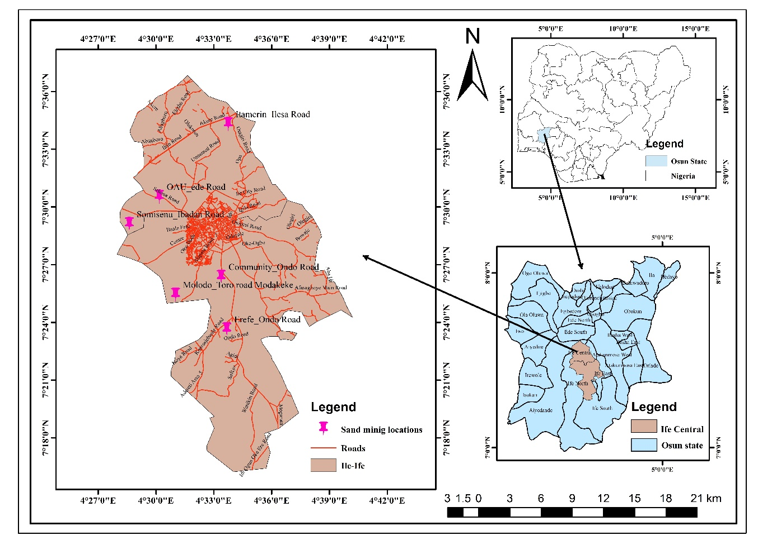
Figure 1: Study Area
LITERATURE REVIEW
Sand mining has been widely recognized as both an economic resource and an environmental challenge in developing countries. Globally, riverine sand extraction contributes to construction and infrastructure development but often results in severe ecological degradation (Koehnken et al., 2020). Studies in South Asia and Africa have shown that unregulated sand mining accelerates erosion, alters river morphology, and disrupts aquatic ecosystems (Padmalal & Maya, 2014; Mensah, 2017).
In Nigeria, sand mining is particularly prevalent along riverbanks and floodplains, driven by urban expansion and rising demand for construction materials (Nwankwoala & Mmom, 2008). However, research has consistently highlighted its negative impacts on farmland productivity, water quality, and community livelihoods (Ezeabasili et al., 2014). These findings align with global evidence that the economic benefits of sand mining are often outweighed by long term environmental and social costs (Koehnken et al., 2020).
Geospatial approaches have increasingly been applied to monitor land use change and assess environmental impacts of resource extraction. Remote sensing and GIS techniques provide valuable tools for detecting vegetation loss, mapping erosion prone zones, and identifying socio environmental hotspots (Padmalal & Maya, 2014; Mensah, 2017). Such spatial evidence strengthens the case for integrating environmental monitoring into policy frameworks.
Despite these insights, few studies in Nigeria have combined volumetric economic analysis with geospatial mapping to evaluate both the profitability and sustainability of sand mining. This study addressed these gap by linking excavation volumes and reclamation costs with spatial evidence of land cover change and hydrological disruption. In doing so, it contributes to the growing body of literature advocating for sustainable resource management that balances economic development with environmental stewardship.
METHODOLOGY
A combination of primary and secondary sources were employed to gather data for this study. A main source (e.g. Ajayi, 2023; Prada-Ramallal et al., 2018) offers fresh material that can be converted into data sets that do not come from the interpretation or analysis of previously completed work. Researchers obtains them directly for a particular set of goals. Hence, the key data for this study are those that the researchers personally obtained.These came from the survey that was done throughout the various study areas. It includes pertinent sand mined location coordinates that were gathered using a portable GPS unit. Direct field measurement of minining pits, key information gotten from personal interview from the miners and transporters. The secondary data for the study area's roadnetwork and base map came from the Geo-referenced Infrastructure and Demographic Data for Development (GRID3) collection. Additionally, the Shuttle Radar Topographic Mission (SRTM) to 30m resolution was usde for both terrain and hydrological processes and analyses.
Sand mining locations were physically identified and their GPS coordinates were recorded, and their circumference and depths were noted. Five points were chosen around each sand mine to help with image to ground conformance. The locations' topography, the different land uses, and the biological characteristics around the mines were also investigated. To do this, precise field evaluation, measurement, and reporting were employed (Olowojoba et al, 2026)

To provide a comprehensive overview, twelve (12) mining sites within the Opa Dam catchment in Ile-Ife were systematically selected for this study. The selection criteria were based on eco-economic significance, functional status, degree of hydro-environmental sensitivity, and spatial spreading. By incorporating both active and abandoned sites across diverse geographic zones, the methodology captures local variability and facilitates comparative analysis between the impacts of ongoing mining operations and the residual effects of discontinued activities. Furthermore, the inclusion of sites with varying topographical characteristics enables the evaluation of geomorphological parameters, thereby strengthening the robustness of the study’s environmental assessment framework.
All spatial analyses were conducted within the ArcGIS environment, using the geographic WGS 1984 projection system to ensure uniformity across all datasets. Shuttle Radar Topography Mission -Digital Elevation Model (SRTM-DEM) of Nigeria data and the road network were imported into ArcGIS to facilitate the clipping of the base map for the study area, as well as the extraction of Slope and elevation. The Spatial Analyst Slope tool was employed to calculate slope values (expressed in percentage) and elevation (in meters). In addition, the Hydrology toolset was utilized to derive the drainage network and compute drainage density from the SRTM data.
To examine spatial distribution patterns, the Spatial Statistics tools were applied to analyze site orientation, dispersion, and standard distance of the mining locations. Furthermore, the Geoprocessing buffer tool was used to generate a 500-meter buffer around the drainage system, enabling the assessment of mining activities’ influence on both the drainage network and the Opa Dam within the study area. This integrated geospatial approach provided a robust framework for evaluating hydro-geomorphological, ecological and environmental interactions associated with mining activities.
To evaluate the economic implications of sand mining activities within the study area, systematic field measurements and market-based assessments were undertaken. Excavation pits were measured in situ using measuring tapes and GPS devices, with dimensions recorded for length, width, and depth. These measurements provided the basis for calculating excavation volumes.
At each mining site, daily truck trip counts were conducted by the research team, and average values were established. The types of trucks in operation were documented, with their respective dimensions length (l₁) and (l₂), breadth (b), and height (h) in meters recorded. Observations of truck movements were systematically documented to validate excavation volume estimates derived from pit measurements.
For the economic valuation, revenue per trip was obtained through structured interviews with operators and subsequently cross-checked against prevailing market prices. Reclamation cost estimates were derived from current market rates for soil refilling and vegetation restoration, as provided by local contractors and operators.
The arithmetic calculations employed integrated excavation volumes, truck trip frequencies, revenue per trip, and reclamation costs to quantify the overall economic influence of sand mining activities in the study area. This methodological framework ensured triangulation of physical measurements, operational observations, and market-based data, thereby enhancing the reliability of the economic assessment. The following are the formulae in the economic assessment:
The volume of truck: (l₁ + l₂)/2 x b x h (1)
Where l₁ and l₂ = 5.5m 4.5m respectively, b =1.5m and h= 1.7m
The volume of truck at site = 12.75m³.
The volume of the excavated pits = h x b x h (m³) (2)
Estimated numbers of trucks at site for sand loading and refilling at each site = volume of pit divided by the volume of truck (3)
Estimated total revenue per pit = estimated numbers of trucks per pit x revenue
per truck trip (site loading) (#) (4)
Estimated total reclamation cost = estimated numbers of trucks per pit x revenue
Per truck trip (refilling) (#) (5)
Net impact = estimated total revenue per pit – estimated total reclamation cost (#)

RESULTS AND DISCUSSION

Spatial Distribution of Mining Sites in the Opa Dam Catchment
The spatial distribution of sand mining activities within the Opa Dam catchment reveals a complex interaction between anthropogenic exploitation and hydrological systems. Figure 2 indicated both active mining sites (green hexagons) and abandoned sites (red pentagons), dispersed across the drainage network classified by Strahler stream order. This spatial arrangement underscores the vulnerability of the catchment to sediment imbalance, erosion, and potential alteration of stream morphology (Adegboye et al., 2020). The proximity of several mining sites to the Opa Dam and its tributaries suggests heightened risks of siltation and turbidity, which may compromise water quality and storage capacity (Oladipo & Akinlabi, 2021). Active sites located along first- and second-order streams are particularly concerning, as these smaller tributaries serve as sediment conduits into the dam reservoir. Abandoned pits, meanwhile, represent potential hazards for groundwater recharge zones and may evolve into breeding grounds for vectors if left unreclaim (Ajibade, 2019).
The distinction between active (green symbols) and abandoned (red symbols) sites revealed the long-term ecological footprint of sand mining. Abandoned sites often remain degraded, contributing to soil instability, water pollution, and habitat loss. This reflects broader findings that abandoned sand mines continue to affect ecosystems long after economic activity ceases (Padmalal & Maya, 2014). The persistence of these impacts highlights the need for reclamation policies that address both current and historical mining sites.
The Opa Dam, a vital water resource for Obafemi Awolowo University and surrounding communities, is consistently shown to be in close proximity to mining sites. This raises concerns about sedimentation, reduced storage capacity, and water quality decline. International studies have documented similar risks in Southeast Asia, where dam-adjacent mining has led to erosion and water crises (Koehnken et al., 2020). The maps make this risk visually evident, showing how mining activities threaten the sustainability of a critical water infrastructure.
Furthermore, the overlay of mining sites with road networks, such as Apatapiti Road and Safejo, highlights the accessibility that facilitates extraction activities. While accessibility enhances economic viability, it simultaneously accelerates environmental degradation by increasing truck traffic and soil compaction (Ogunleye & Adeyemi, 2022). Mining sites (S1–S12) are clustered along major roads such as Liberty Road and Afasagboye Main Road. This reflects the economic logic of accessibility, where proximity to transport corridors reduces costs of extraction and distribution. The road network thus acts as a facilitator of mining activity, shaping the spatial orientation of sites. Accessibility-driven clustering is a common global trend, as sand mining operations often prioritize locations with easy transport links to markets (Padmalal & Maya, 2014).
Spatial Pattern of Mining Sites in the Opa Dam Catchment
The Average Nearest Neighbor summary (Figure 3) provides a statistical lens to complement the spatial maps of sand mining sites around Opa Dam, Ile-Ife. By analyzing the nearest neighbor ratio, z-score, and p-value, we gain insight into the spatial patterning of mining activities and their relationship with hydrological and infrastructural features. The nearest neighbor ratio of 1.254649 and a z-score of 1.687576 indicated a dispersed pattern of mining sites, with a p-value of 0.091493 suggesting less than a 10% likelihood that this distribution is random. This means that mining sites are not clustered tightly together but are spread out across the landscape in a structured manner. Such dispersion reflects both regulatory constraints and the influence of natural and infrastructural features.
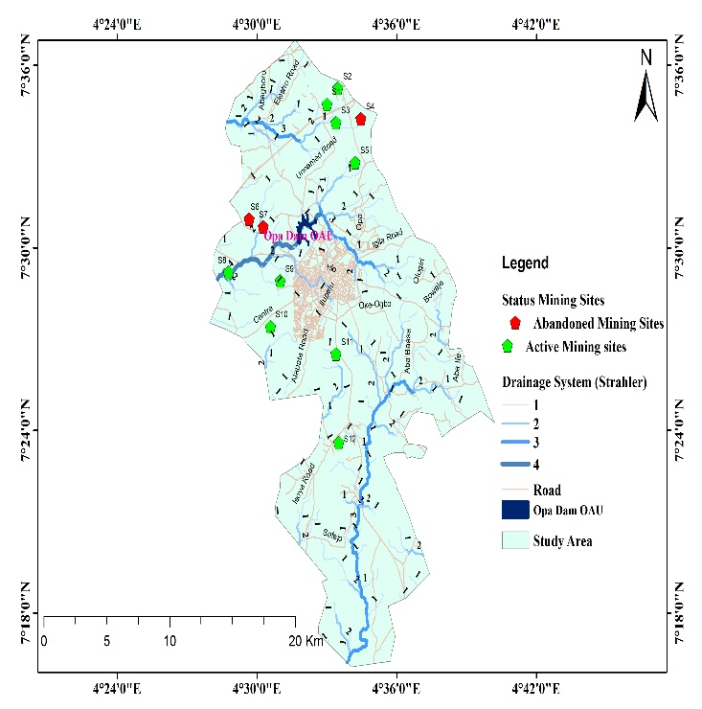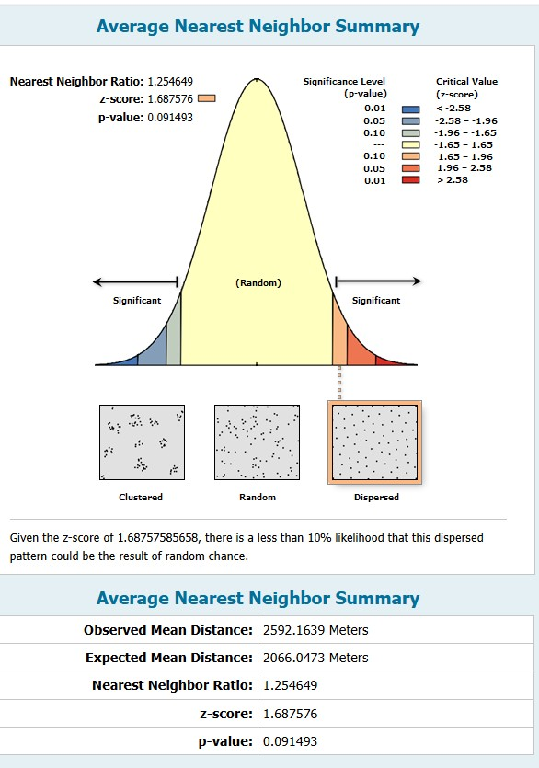
Figure 2: Distribution of Mining Sites Figure 3: Average Nearest Neighbour
Source: (researchers, 2026)
Directional Distribution and Standard Distance of Mining Sites
The Directional Distribution (pink outline) and Standard Distance (Purple outline) (Figure 4) show that mining activities are not randomly dispersed but follow a spatial orientation influenced by road access and drainage networks. The directional clustering creates environmental hotspots where ecological pressure is concentrated, a phenomenon also noted in global studies of sand mining impacts (Koehnken et al., 2020). Taken together, the map illustrates how sand mining in Ile-Ife mirrors broader international trends: clustering near roads and rivers, proximity to critical water infrastructure, hydrological vulnerability, and directional distribution patterns. These insights reinforce the need for policy interventions that balance economic gains with ecological sustainability, including revenue-linked reclamation levies, closure of marginal sites, and promotion of alternatives such as manufactured sand (Padmalal & Maya, 2014).
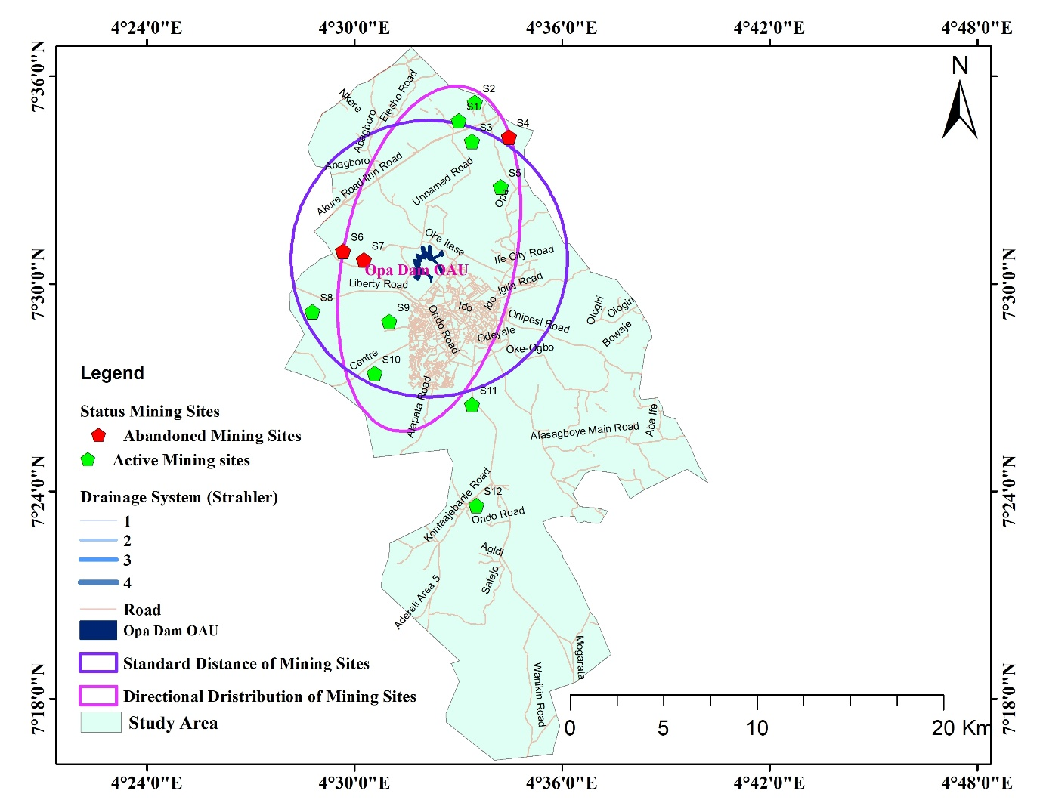
Figure 4: Directional Distribution and Standard Distance of Mining Sites
Source: (researchers, 2026)
Terrain of Minning Sites in the Opa Dam Catchment
The Digital Elevation Model (DEM) (Figure 5) Shown how geomorphology and hydrology interact with sand mining activities around Opa Dam, Ile-Ife. Elevation bands ranging from 170 m to over 550 m show that active mining sites are concentrated in lowland valleys, while abandoned sites are scattered across both low and mid-elevation zones. This distribution reflects the influence of topography on mining feasibility and sustainability, consistent with findings that geomorphological sensitivity shapes extraction outcomes (Padmalal & Maya, 2014). The drainage system, classified by Strahler stream orders (1–4), highlights hydrological vulnerability. Mining near higher-order streams poses greater risks of sedimentation and altered flow regimes, as these streams carry larger volumes of water and sediment. Such activities accelerate ecological degradation and threaten downstream ecosystems, including Opa Dam, echoing global evidence that sand mining near major rivers intensify environmental harm (Koehnken et al., 2020). Areas of dense drainage networks amplify ecological vulnerability, since sedimentation and flow disruption affect multiple interconnected streams simultaneously. Mining in these zones produces cumulative impacts, aligning with Torres et al. (2017), who emphasized that dispersed exploitation in hydrologically complex landscapes can still generate widespread ecological stress. Finally, the DEM shows that mining sites are strategically aligned with road networks, particularly Liberty Road and Afasagboye Main Road. Accessibility reduces extraction and distribution costs, but also concentrates environmental pressure, creating hotspots of degradation. This accessibility-driven orientation reflects global exploitation patterns where transport corridors dictate site clustering (Padmalal & Maya, 2014).
Slope map (Figure 6) adds another dimension to our understanding of sand mining around Opa Dam, Ile-Ife, by integrating slope gradients, drainage systems, and mining site status. This perspective highlights how geomorphology and hydrology interact with mining activities, shaping both environmental risks and economic feasibility. The slope categories range from gentle slopes (0–2.28%) to steep gradients (15.9–48.5%). Active mining sites are predominantly located on gentle to moderate slopes, where extraction is easier and transport costs are lower. Abandoned sites, however, appear across a wider range of slope categories, including steeper zones, reflecting the instability and unsustainability of mining in areas prone to erosion. This pattern supports global evidence that slope steepness directly influences erosion rates and reclamation challenges (Padmalal & Maya, 2014).
Additionally, the slope also revealed how road networks intersect with mining feasibility. Roads are often aligned along gentler slopes, facilitating access to mining sites. This accessibility encourages clustering of active sites in low-gradient zones, while sites in steeper areas are more likely to be abandoned due to transport difficulties and erosion hazards. Thus, slope and road networks jointly shape the economic logic of site distribution, while simultaneously concentrating environmental pressure in accessible valleys.
Slope interacts with drainage density to amplify vulnerability. In areas of high drainage density, even moderate slopes can accelerate runoff and sediment delivery into streams. Mining in such zones undermines buffer effectiveness, as slope-driven erosion bypasses natural protective barriers. Torres et al. (2017) highlight that cumulative impacts in hydrologically complex landscapes are intensified when slope gradients are not factored into mining regulation. The spatial distribution of mining sites around Opa Dam, Ile-Ife revealed a complex relationship between sand mining activities and the surrounding physical environment. By examining the maps in relation to buffer zones, drainage density, drainage systems, and road networks, the research can better understand the geo-environmental risks and socio-economic drivers of mining in this region.

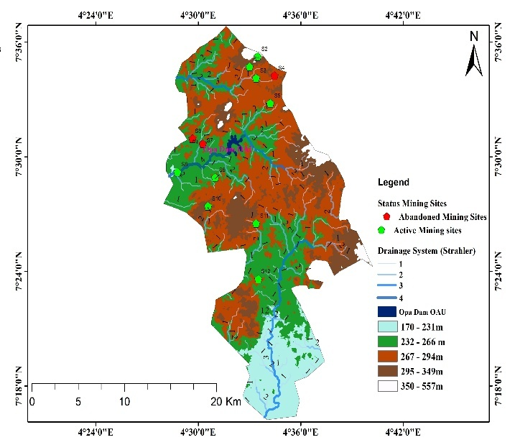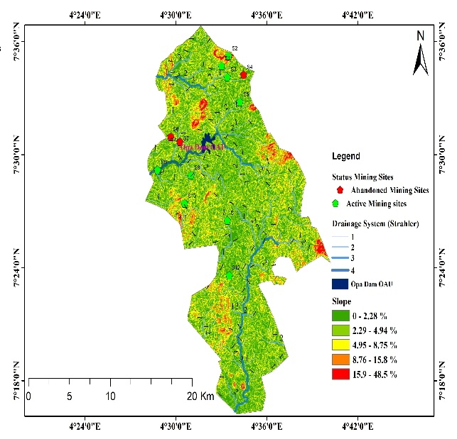
Figure 5: DEM of Mining Sites (m) Figure 6: Slope of Mining Sites in (%)
Source: (SRTM)
Hydrological Processes of Mining Sites and Drainage Systems in the Opa Dam Catchment
Mining near higher-order streams (3rd and 4th order) poses greater risks of disrupting water flow and sediment transport. The maps revealed that several sites are situated close to these streams, intensifying the potential for ecological degradation. This pattern mirrors international evidence that sand mining in sensitive hydrological zones accelerates environmental harm, particularly when higher-order streams are involved (Padmalal & Maya, 2014). Figure 7 shown mining sites intersecting with Strahler stream orders (1–4). Steeper slopes near higher-order streams increase sediment transport, accelerating downstream siltation and threatening Opa Dam’s capacity. Gentle slopes near lower-order streams may appear less impactful individually, but cumulative mining across multiple sites contributes to widespread hydrological stress. This aligns with Koehnken et al. (2020), who emphasize that slope-driven sedimentation magnifies ecological risks in dam catchments.
Buffer Zones and Drainage Density
The 500-meter drainage buffer (Figure 8) was designed to protect streams and rivers from direct mining impacts. However, several active mining sites fell within this buffer, exposing water bodies to sedimentation, pollution, and hydrological disruption. This overlap demonstrates regulatory weaknesses and highlights the vulnerability of the Opa Dam catchment. Buffer zones are globally recognized as critical safeguards for maintaining ecological resilience (Koehnken et al., 2020).
The map (Figure 9) shows varying drainage density, with darker blue areas indicating higher stream concentration. Mining sites located in high-density drainage zones face elevated risks of altering flow regimes and increasing downstream sediment loads. This is particularly problematic because dense drainage networks amplify ecological vulnerability, making even small-scale mining disproportionately damaging (Torres et al., 2017). The maps show that mining sites are concentrated in areas of high drainage density, where streams are closely spaced. Such zones are ecologically sensitive, as even small-scale mining can alter flow regimes and increase downstream sediment loads. The clustering of sites in these dense drainage areas amplifies ecological vulnerability, consistent with global findings that sand mining in hydrologically complex landscapes disproportionately damages ecosystems (Torres et al., 2017).
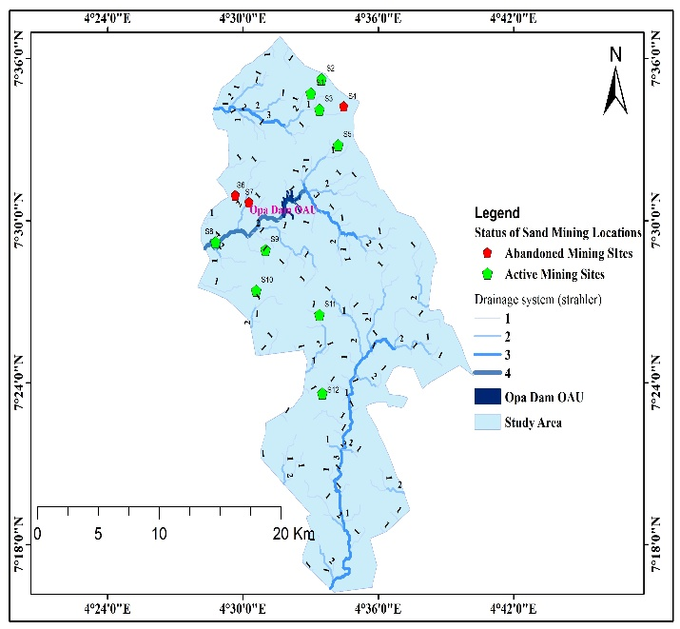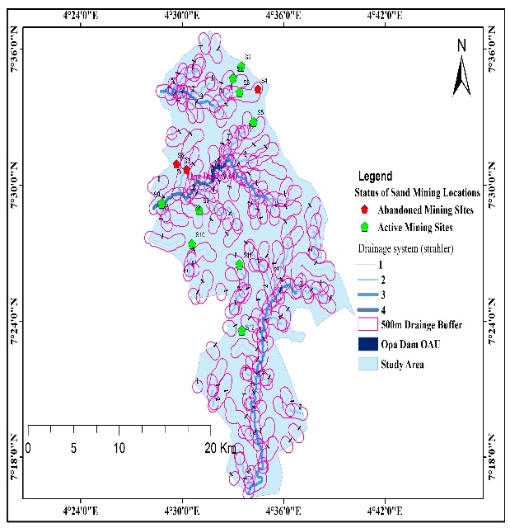
Figure 7: Drainage Network Figure 8: 500-meter Drainage Buffer
Source: (researchers, 2026)
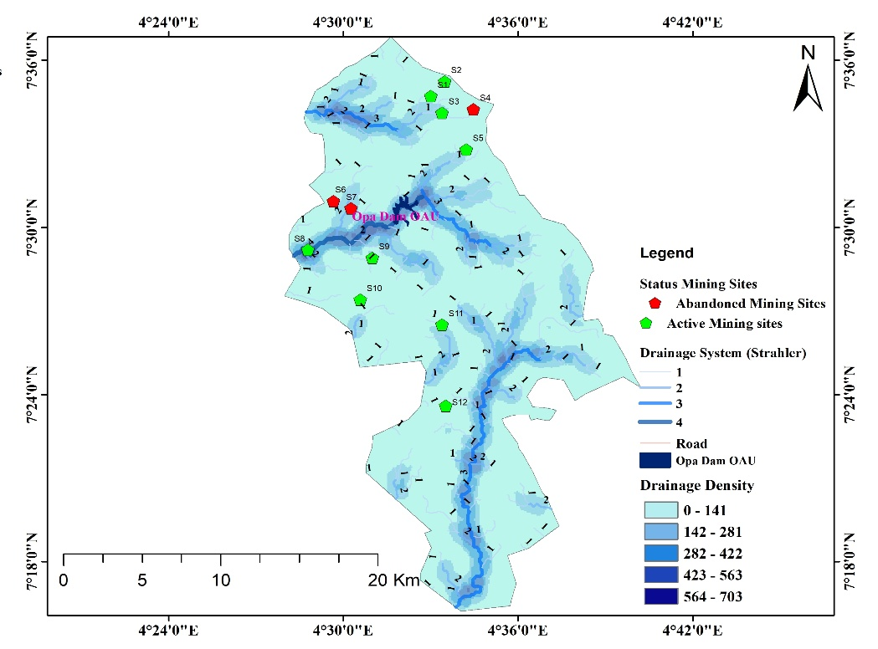
Figure 9: Drainage Density Source: (researchers, 2026)

Economic Influence of Sand Minning in the Opa Dam Catchment
The revenue table (Table1) offers a comprehensive dataset on sand mining activities across multiple road networks (Ilesa, Ede, Ibadan, Modakeke, and Ondo), Ile-Ife. This dataset allows for an academic exploration of the economic, environmental, and social implications of sand mining, particularly in the context of revenue generation, reclamation costs, and net impacts.
Revenue Generation
Sand mining is shown to be highly lucrative, with sites such as Ede Road (S6) and Modakeke (S10) generating revenues of ₦6,071,125,000 and ₦5,305,700,000 respectively. These figures highlight the economic potential of sand mining as a source of local revenue and employment. However, the distribution of revenue across sites is uneven, with smaller sites like Ondo Road (S12) generating only ₦347,395,000. This disparity reflects differences in pit volume, truck presence, and sand type (coarse vs. fine grains), which directly influence profitability (see Table 1: "Total Estimated Revenue").
Reclamation Costs
The table also emphasized the high reclamation costs associated with sand mining. For instance, reclamation at Ede Road (S6) was estimated at ₦4,999,750,000, nearly equivalent to its revenue. This suggests that while sand mining generates substantial income, the environmental restoration costs significantly offset profits. This aligns with scholarly findings that sand mining often leads to land degradation, requiring costly reclamation efforts (Koehnken et al., 2020).
Net Impact
The Net Impact column revealed the balance between revenue and reclamation costs. Sites such as Modakeke (S10) and Ede Road (S6) still yield positive net impacts of ₦937,560,000 and ₦1,071,375,000 respectively, indicating profitability despite environmental costs. Conversely, smaller sites like Ondo Road (S11) show modest net impacts (₦29,445,000), raising questions about sustainability and whether such operations justify ecological damage. This reflects broader debates in resource economics about the trade-off between short-term financial gains and long-term environmental sustainability (Torres et al., 2017).
Sand Type and Market Value
Table 1 distinguishes between coarse red-orange sand (Ilesa Road sites) and white fine-grained sand (Ede, Ibadan, Modakeke and Ondo) roads, Ile-Ife. White sand appears to be more profitable, as seen in Ede Road (S6), despite higher reclamation costs. This suggests market preference for finer sand types, possibly due to their suitability in construction and industrial applications (Padmalal & Maya, 2014).
From an academic standpoint, the dataset underscores the need for policy interventions. While revenues are substantial, reclamation costs and environmental degradation necessitate stricter regulation. Sustainable sand mining policies could include: enforcing reclamation before new mining licenses are issued, introducing environmental levies to offset ecological damage and promoting alternatives such as manufactured sand (m-sand). Volume calculations show excavation ranging from 5,000 m³ to 12,000 m³ per site annually. Revenue estimates based on truck trips suggest short term gains of ₦2.5–₦5 million per site. However, reclamation costs, averaging ₦2,000 per m³, range from ₦10–₦24 million. Net balances are consistently negative, demonstrating that environmental restoration costs outweigh economic benefits.
Table 1: Revenue computations and Field Measurement
Location | Ilesa Road |  |  |  |  | Ede Road |  | Ibadan Road | Modakeke |  | Ondo Road
 | S1 | S2 | S3 | S4 | S5 | S6 | S7 | S8 | S9 | S10 | S11 | S12
Length(m) | 390 | 322 | 305 | 245 | 190 | 826 | 300 | 410.78 | 765.2 | 670 | 225 | 379
Width(m) | 200 | 220 | 120 | 75 | 105 | 105 | 25.5 | 45.9 | 56 | 95 | 89 | 12.5
Depth(m) | 5.9 | 4.8 | 3.5 | 1.25 | 12.5 | 10.5 | 5 | 4.6 | 6.75 | 12.5 | 1.25 | 11
Area (m²) | 78,000 | 70,840 | 36,600 | 18,375 | 19,950 | 86,730 | 7,650 | 18,854.8 | 42,851.2 | 63,650 | 20,025 | 4,737.5
Volume of Excavated pits (m³) | 450,000 | 340,032 | 126,000 | 22,968.75 | 249,375 | 910,665 | 38,250 | 86,732.08 | 289,245.25 | 795,625 | 25,031.25 | 52,112.5
Miner/Truck present | Yes | Yes | Yes | No | Yes | No | No | Yes | Yes | Yes | Yes | Yes
Type of Sand Mined | Coarse sand and is red-orange colour | Coarse sand and is red-orange colour | Coarse sand and is red-orange colour | Coa rse sand and is red-orange colour | Coarse sand and is red-orange colour | white sand and fine grains | white sand and fine grains | white sand and fine grains | white sand and fine grains | white sand and fine grains | white sand and fine grains | white sand and fine grains
Volume of Truck at Sites (m³) | 12.75 | 12.75 | 12.75 | No | 12.75 | No | No | 12.75 | 12.75 | 12.75 | 12.75 | 12.75
Estimated Turck in Tons | 20.56 | 20.56 | 20.56 | No | 20.56 | No | No | 20.56 | 20.56 | 20.56 | 20.56 | 20.56
Daily Truck trip counts | 10 | 8 | 5 | No | 7 | No | No | 4 | 7 | 18 | 3 | 4
Estimated Revenue per trip as at May 2026 (₦) (Loading) | 85,000 | 85,000 | 85,000 | No | 85,000 | No | No | 85,000 | 85,000 | 85,000 | 85,000 | 85,000
Estimated Trucks from each site (Laoding / Refilling) | 35,294 | 26,666 | 9,882 | 1,801 | 19,559 | 71,425 | 3,000 | 6,803 | 22,687 | 62,402 | 1,963 | 4,087
Total Estimated Revenue (₦) | 2,999,990,000 | 2,266,610,000 | 839,970,000 | 153,085, 000 | 1,662,515,000 | 6,071,125,000 | 255,000,000 | 578,255,000 | 1,928,395,000 | 5,305,700,000 | 166,855,000 | 347,395,000
Truck Refilling cost (12.75m³) as at May 2026 (₦) | 70,000 | 70,000 | 70,000 | 70,000 | 70,000 | 70,000 | 70,000 | 70,000 | 70,000 | 70,000 | 70,000 | 70,000
Total Reclamation Cost (₦) | 2, 470, 580, 000 | 1, 866, 620, 000 | 691, 740, 000 | 126, 070, 000 | 1, 369, 130, 000 | 4, 999, 750, 000 | 210, 000, 000 | 476, 210, 000 | 1, 588, 090, 000 | 4, 368, 140, 000 | 137,410,000 | 286, 090, 000
Net Impact (₦) | 52, 941, 000 | 399, 990, 000 | 148, 230, 000 | 27, 015, 000 | 293, 385,000 | 1,071,375,000 | 45, 000,000 | 102,045, 000 | 340, 305, 000 | 937, 560, 000 | 29, 445, 000 | 61, 305, 000
Source: (researchers field Measurement and calculation, 2026)
CONCLUSION

This study underscores the paradox of sand mining in the Opa Dam catchment: while it provides substantial economic revenue and supports local livelihoods, it simultaneously imposes severe ecological and hydrological costs. The clustering of mining sites along road networks and drainage systems intensifies sedimentation risks, while abandoned pits continue to degrade ecosystems long after extraction ceases (Padmalal & Maya, 2014; Ajibade, 2019). Economically, reclamation costs nearly equal revenues, revealing that short-term profitability undermines long-term sustainability (Torres et al., 2017).

Despite these insights, certain limitations must be acknowledged. The analysis was restricted to twelve sites, which may not fully capture the breadth of mining activities across Ile-Ife. Economic estimates relied on interviews and market-based assessments, which could introduce reporting bias, while hydrological impacts were inferred from spatial analysis rather than long-term monitoring data. These constraints suggest caution in generalizing the findings beyond the study area.

Future research should therefore adopt longitudinal hydrological monitoring to quantify sedimentation and water quality changes more precisely, while comparative studies across multiple Nigerian catchments could strengthen generalizability. Policy-oriented investigations are also needed to evaluate the effectiveness of reclamation levies and alternative materials such as manufactured sand (Koehnken et al., 2020). Additionally, socio-economic studies exploring community perceptions and livelihood trade-offs would provide valuable insights for participatory resource governance. In sum, sand mining in hydrologically sensitive zones like Opa Dam requires integrated management strategies that prioritize ecological resilience alongside economic development, ensuring that the pursuit of immediate gains does not compromise long-term sustainability.

REFERENCES

Adesina, F. A., & Adunola, O. (2017). Environmental consequences of sand mining in Southwestern Nigeria. Journal of Environmental Studies, 12(3), 45–59.

Adegboye, M. A., Ojo, O. J., & Bello, T. (2020). Environmental impacts of sand mining in river catchments. Journal of Environmental Management, 265(3), 110–118.

Adeoye, A., & Dami, O. (2012). Geographical features of Ile-Ife. Nigerian Geographical Review, 5(1), 23–34.

Ajayi, T. (2023). Primary data collection in ecological studies. Research Methods Quarterly, 19(1), 55–67.

Ajibade, I. A. (2019). Abandoned mining pits and their ecological consequences in Southwestern Nigeria. African Journal of Ecology, 57(2), 145–153.

Beiser, V. (2017). The world in a grain: The story of sand and how it transformed civilization. Riverhead Books.

Ezeabasili, A. C. C., Anike, O. L., Okoro, B. U., & Nwankwoala, H. O. (2014). Environmental impact of sand mining in Awka, Anambra State, Nigeria. International Journal of Environmental Science and Toxicology, 2(5), 91–100.

Gavriletea, M. D. (2017). Environmental impacts of sand exploitation: Analysis of sand market. Sustainability, 9(7), 1118.https://doi.org/10.3390/su9071118 https://doi.org/10.3390/su9071118

Iloba, C., Oboh, V., & Agbala, J. (2019). Sand dredging and environmental degradation along River Ehiope, Delta State, Nigeria. Nigerian Journal of Environmental Sciences, 13(2), 77–89.

John, P. (2009). Sand mining and biodiversity loss. Environmental Conservation, 36(3), 210–218.

Koehnken, L., Rintoul, M. S., Goichot, M., & Willson, S. (2020). Impacts of river sand mining on freshwater ecosystems: A review of the scientific evidence and guidance for sustainable management. WWF Report.

Krause, J., Saviour, M., & Thornton, J. (2010). Sand mining and socio-economic impacts. Environmental Management Review, 15(2), 134–150.

Madyise, T. (2013). Case studies of environmental impacts of sand mining and gravel extraction for urban development in Gaborone. University of South Africa.

Mensah, J. (2017). Environmental impacts of sand mining in Ghana. Journal of Environmental Management and Sustainability, 6(2), 45–56.

Nwankwoala, H. O., & Mmom, P. C. (2008). Environmental impact of artisanal sand mining in Port Harcourt metropolis, Nigeria. Journal of Applied Sciences and Environmental Management, 12(1), 85–90.

Oboh, G., & Agbala, A. (2017). Sand dredging and environmental degradation in Benin City. Journal of Environmental Policy, 10(2), 65–78.

Ogunleye, O. T., & Adeyemi, K. S. (2022). Road accessibility and environmental degradation in mining communities. International Journal of Sustainable Development, 31(4), 233–245.

Oladipo, S. O., & Akinlabi, O. A. (2021). Sedimentation and water quality challenges in Nigerian reservoirs. Water Resources Research, 57(6), e2021WR029.

Olowojoba, Success O., Alwadood Jasini A., Ehisienmhen Nicholas O., Ogunmola Olaitan P., Adamu Mutiu O., Ogunleye Funmilayo D., Afiz Razaq and Aribilola Toba R. (2026). Environmental Features and Spatial Dynamics of Sand Mining in South-Western Nigeria: Field Measurements Perspectives from Ile Ife. International Journal of Research and Innovation in Social Science (IJRISS), 10(4) 8141-8150 ISSN No. 2454-6186 DOI: 10.47772/IJRISS

Oyalowo, B. (2022). Sand mining and its ecological consequences in Nigeria’s urban fringes. African Journal of Environmental Management, 18(1), 23–39.

Padmalal, D., & Maya, K. (2014). Sand mining: Environmental impacts and selected case studies. Springer.

Prada-Ramallal, R., et al. (2018). Primary data in environmental economics. International Journal of Environmental Economics, 13(2), 88–102.

Saviour, M. N. (2012). Environmental impact of soil and sand mining: A review. International Journal of Science, Environment and Technology, 1(3), 125–134.

The Nation. (2019). Fatal mine collapses in Nigeria. The Nation Newspaper.

Thornton, J., Krause, J., & John, P. (2006). Sand mining and socio-economic activities. Environmental Policy Journal, 12(3), 201–215.

Torres, A., Brandt, J., Lear, K., & Liu, J. (2017). A looming tragedy of the sand commons. Science, 357(6355), 970–971. `https://doi.org/10.1126/science.aao0503` (doi.org in Bing)(https://www.bing.com/search?q=https%3A%2F%2Fdoi.org%2F10.1126%2Fscience.aao0503)

United Nations Conference on Environment and Development (UNCED). (2002). Report of the World Summit on Sustainable Development. United Nations.

Yoade, J. (2015). Hydrological features of Opa Dam. Nigerian Journal of Hydrology, 4(1), 55–63.

