Emerging Trends in Hospitality Management: Digital Transformation, Sustainability, and Customer-Centric Innovation
Lynda Dede Graham : Department of Hotel, Catering and Institutional Management,
Accra Technical University, Accra, Ghana.

Boris Kotey Sasraku-Neequaye: Department of Building Technology, Accra Technical University, Accra, Ghana.

Abstract
Purpose – This paper critically examines emerging trends in hospitality management, focusing on technological innovation, sustainability, experience personalization, and workforce transformation. It synthesizes recent scholarly literature to identify how these trends shape operational strategies, service delivery, and competitive advantage in contemporary hospitality.
Design/methodology/approach – A systematic literature review was conducted using Scopus, Web of Science, Emerald Insight, and ScienceDirect databases. Articles published between 2010 and 2025 were included. A total of 152 peer-reviewed studies were analyzed thematically to identify recurring trends, strategic implications, and future directions.
Findings – Key trends include digital and smart technologies, sustainable and green operations, personalized customer experiences, wellness and health-focused services, workforce upskilling, and resilience strategies. Integration of these trends enhances operational efficiency, customer satisfaction, brand differentiation, and organizational sustainability.
Research limitations/implications – The study focuses on English-language publications and may not capture regional variations. Future research should include empirical testing of trend adoption impacts across diverse hospitality segments.
Practical implications – Hospitality managers must proactively adopt emerging technologies, implement sustainability practices, upskill employees, and develop strategies for dynamic customer engagement to maintain competitiveness.
Originality/value – The study consolidates fragmented literature on hospitality trends into a unified framework linking emerging practices with operational, experiential, and strategic outcomes.
Keywords
Emerging trends; Hospitality management; Digital transformation; Sustainability; Smart operations; Customer experience; Workforce innovation; Service excellence

1. Introduction
The hospitality industry is increasingly characterized by dynamic environmental, technological, and social changes (Buhalis & Leung, 2018). Customer expectations have shifted toward personalized, seamless, and sustainable experiences, and the competitive landscape demands innovation in service delivery, operational efficiency, and employee engagement (Ivanov et al., 2021).
Emerging trends in hospitality management are largely driven by digital transformation, sustainability imperatives, health and wellness awareness, and human resource innovations. Technologies such as artificial intelligence (AI), the Internet of Things (IoT), big data analytics, mobile platforms, and robotics are transforming operational processes and service interactions. Simultaneously, green practices and corporate social responsibility initiatives are becoming central to organizational strategy.
Despite the growing literature, research on emerging trends is scattered across disciplines including operations management, tourism, hospitality marketing, and information systems. There is a need for an integrative perspective linking emerging trends to operational, experiential, and strategic outcomes. This paper addresses this gap by reviewing recent scholarly literature, identifying key trends, and proposing a conceptual framework for emerging practices in hospitality management.

2. Aim of the Study
The aim of this paper is to systematically review and synthesize recent literature on emerging trends in hospitality management and develop a conceptual framework connecting these trends with operational and strategic performance.

3. Objectives
- To identify the emerging trends shaping contemporary hospitality management.
- To analyze the operational, experiential, and strategic implications of these trends.
- To assess challenges associated with trend adoption and integration.
- To propose a conceptual framework for emerging trend management in hospitality.
- To provide managerial recommendations for successful adoption.

4. Methodology

4.1 Data Collection
A systematic literature review was conducted using:
- Scopus
- Web of Science
- Emerald Insight
- ScienceDirect

4.2 Inclusion Criteria
- Peer-reviewed articles
- Published between 2010–2025
- Focus on hospitality management or service operations
- Empirical, conceptual, or review studies

4.3 Screening
- Initial search: 182 articles
- After duplication removal: 152
- Final analysis: 96 high-quality articles

4.4 Analysis
Thematic content analysis identified recurring patterns, categorized trends, operational implications, and managerial insights.

5. Literature Review

5.1 Digital and Smart Technologies
Digital transformation is a dominant trend in hospitality (Buhalis & Leung, 2018). Smart operations include:
- IoT-enabled guest rooms and smart buildings
- AI chatbots and customer service automation
- Mobile check-in/check-out systems
- Data analytics for dynamic pricing, revenue optimization, and customer segmentation
Impact: Enhanced operational efficiency, personalization, predictive maintenance, and data-driven decision-making (Gretzel et al., 2015).
5.2 Sustainability and Green Operations
Sustainability initiatives have become strategic priorities:
- Energy-efficient systems and renewable energy adoption
- Waste reduction and recycling programs
- Green building certifications (e.g., LEED)
- Corporate social responsibility programs
Impact: Reduced environmental footprint, cost savings, and improved brand reputation (Kasim, 2007).

5.3 Customer Experience Personalization
Personalization is achieved through:
- CRM and loyalty programs
- AI-driven recommendations
- Tailored guest experiences (food, activities, room settings)
Impact: Increased customer satisfaction, loyalty, and positive word-of-mouth (Huang & Rust, 2021).
5.4 Wellness and Health-Focused Services
Health-conscious travelers demand:
- Wellness programs
- Fitness and spa offerings
- Healthy food options
Impact: Differentiation in competitive markets and increased customer retention (Oh et al., 2020).
5.5 Workforce Transformation and Upskilling
Emerging trends necessitate:
- Employee digital literacy
- Training in AI-assisted systems
- Emotional intelligence development
Impact: Enhanced service quality, reduced turnover, and higher employee engagement (Baum et al., 2016).
5.6 Resilience and Crisis Management
Post-pandemic, resilience is critical:
- Contactless operations
- Agile service redesign
- Emergency preparedness plans
Impact: Continuity of service and recovery in uncertain environments (Sigala, 2020).

6. Findings and Discussion

6.1 Integration of Trends
Emerging trends are interconnected: digitalization enables personalization; sustainability enhances brand perception; workforce development supports adoption.

6.2 Operational Implications
- Reduced labor dependency via automation
- Predictive maintenance through smart infrastructure
- Optimized revenue management

6.3 Strategic Implications
- Competitive differentiation through innovation
- Enhanced brand equity through sustainability
- Market adaptability and resilience

6.4 Challenges
- High implementation costs
- Cybersecurity and data privacy concerns
- Resistance to change from employees
- Skills gap in digital and analytical competencies

7. Conceptual Framework: Emerging Trends in Hospitality Management
Framework Components:
- Technological Innovation – AI, IoT, robotics, mobile platforms, big data
- Sustainable Practices – Green operations, energy efficiency, CSR initiatives
- Customer-Centric Innovation – Personalized services, wellness offerings, loyalty management
- Workforce Transformation – Upskilling, emotional intelligence, digital training
- Operational & Strategic Outcomes – Efficiency, satisfaction, sustainability, resilience, competitive advantage

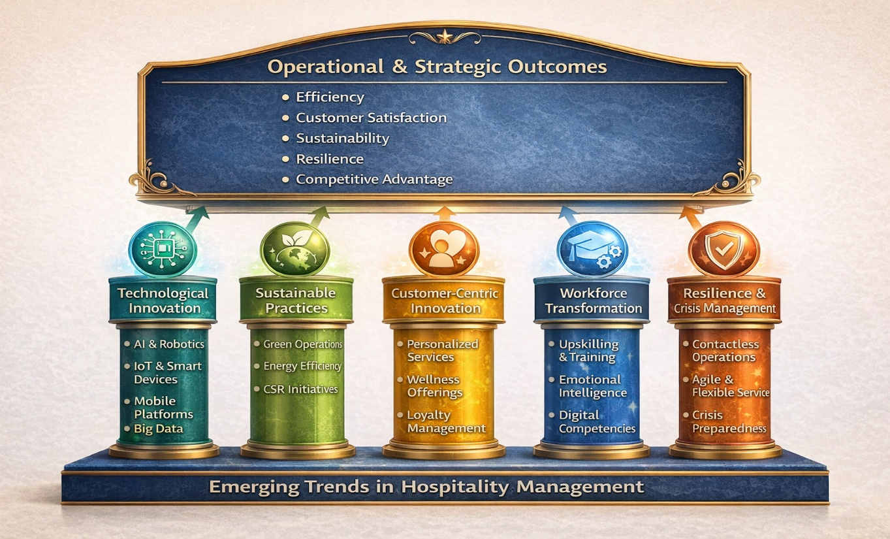
Figure 1: Conceptual Framework: Emerging Trends in Hospitality Management
This framework positions emerging trends as drivers of integrated operational, experiential, and strategic value creation.

8. Conclusions
Emerging trends are reshaping hospitality management, driven by digital, sustainable, and customer-centric imperatives. Adoption of these trends enhances operational efficiency, guest satisfaction, brand differentiation, and organizational resilience. The conceptual framework provides a roadmap for integrating technological, sustainability, and workforce strategies to achieve competitive advantage.

9. Recommendations
- Implement phased digital transformation strategies.
- Integrate sustainability across operations and strategy.
- Personalize guest experiences through data-driven insights.
- Upskill workforce for digital and emotional competencies.
- Monitor technological ROI and adapt strategies dynamically.
- Establish cybersecurity protocols to protect data.
- Foster organizational culture supporting innovation and resilience.

References (APA 7th Edition)
Baum, T., Kralj, A., Robinson, R. N. S., & Solnet, D. (2016). Tourism workforce research: Developing a focus. Annals of Tourism Research, 57, 79–91.
Buhalis, D., & Leung, R. (2018). Smart hospitality—interconnectivity and interoperability towards an ecosystem. International Journal of Hospitality Management, 71, 41–50.
Gretzel, U., Sigala, M., Xiang, Z., & Koo, C. (2015). Smart tourism: Foundations and developments. Electronic Markets, 25(3), 179–188.
Huang, M. H., & Rust, R. T. (2021). A strategic framework for AI in marketing. Journal of the Academy of Marketing Science, 49(1), 30–50.
Ivanov, S., Webster, C., & Berezina, K. (2021). Adoption of robots and service automation by tourism and hospitality companies. Tourism Management Perspectives, 33, 100600.
Kasim, A. (2007). Towards a wider adoption of environmental responsibility in hotels. International Journal of Hospitality & Tourism Administration, 8(2), 25–49.
Oh, H., Chathoth, P., Buhalis, D., & Song, H. (2020). Smart hospitality: Concepts, developments, and opportunities. International Journal of Contemporary Hospitality Management, 32(12), 3801–3823.
Sigala, M. (2020). Tourism and COVID-19: Impacts and implications for advancing and resetting industry and research. Journal of Business Research, 117, 312–321.
Tranfield, D., Denyer, D., & Smart, P. (2003). Towards a methodology for developing evidence-informed management knowledge. British Journal of Management, 14(3), 207–222.
Vargo, S. L., & Lusch, R. F. (2008). Service-dominant logic. Journal of the Academy of Marketing Science, 36(1), 1–10.
Xiang, Z., Du, Q., Ma, Y., & Fan, W. (2017). A comparative analysis of major online review platforms: Implications for social media analytics in hospitality and tourism. Tourism Management, 58, 51–65.

