AI-Based Food Redistribution System Using CNN and LSTM for Quality Assessment and Smart Matching

Mrs. B Christina
Assistant Professor Department of Computing Technologies
SRMIST

Priyanka Pokhrel
RA2211003011806
Department of Computing Technologies SRMIST

Bhavini Pittan
RA2211003011818
Department of Computing Technologies SRMIST

Abstract—Food wastage and food insecurity continue to coexist as major global challenges, despite the availability of surplus food from restaurants, events, and households. One of the primary reasons for this gap is the absence of a reliable system that can assess food quality, estimate usability, and coordinate timely redistribution. This project proposes an AI-based food redistri-bution system that integrates Convolutional Neural Networks (CNN) and Long Short-Term Memory (LSTM) models to enable intelligent food donation and delivery. The system allows donors to upload images of surplus food, based on which the CNN model evaluates freshness, cleanliness, and packaging quality. Along with donor-provided preparation time, an LSTM model predicts food expiry duration and estimates the number of people the food can serve. Using location-based and capacity-aware matching, the system connects donors with the most compatible nearby shelters or receivers. A volunteer module facilitates real-time notifications and optimized transportation routes. The proposed system aims to reduce food waste, improve equitable food distribution, and create a scalable, technology-driven solution for hunger mitigation.
Index Terms—Food Redistribution, Convolutional Neural Net-work, Long Short-Term Memory, Food Freshness Detection, Smart Matching, Volunteer-Based Logistics

- Introduction

- Background and Motivation
Food waste and hunger represent two sides of the same global problem. Large quantities of edible food are discarded daily by restaurants, event organizers, and households due to overproduction, lack of coordination, or uncertainty regarding food safety. At the same time, shelters and relief organizations struggle to provide sufficient meals to people facing food insecurity. This imbalance highlights the urgent need for efficient and reliable food redistribution systems.
Traditional food donation mechanisms rely heavily on man-ual inspection and informal coordination. These approaches are difficult to scale and are highly sensitive to time con-straints, especially when dealing with perishable food. In many cases, food that is still safe for consumption is discarded due to the absence of quick and objective quality assessment methods.
- Problem Statement
Existing food redistribution platforms lack automated mech-anisms to evaluate food quality, predict usability duration, and intelligently match donations with suitable receivers. The absence of AI-driven freshness assessment, expiry prediction, and capacity-aware shelter matching results in inefficient al-location, increased food spoilage, and missed opportunities to serve people in need. Furthermore, logistics management is often manual, leading to delays and inconsistent delivery outcomes.
- Objectives of the Project
The primary objective of this project is to design and im-plement an intelligent food redistribution system that ensures safe, timely, and efficient food delivery. The system aims to automatically assess food quality using image-based analy-sis, predict food expiry and serving capacity using temporal models, match donors with compatible nearby shelters, and enable volunteer-driven transportation supported by real-time notifications and navigation.
- Literature Review
- Existing Food Redistribution Platforms
Several food redistribution initiatives and mobile platforms have been developed to address the growing issue of food waste by connecting donors with receivers such as shelters, food banks, and non-governmental organizations. These plat-forms typically allow restaurants, hotels, or individuals to list surplus food, which can then be claimed by registered organizations. While such systems have improved awareness and participation in food donation, most of them rely on manual verification of food quality and availability.
Another limitation of existing platforms is the lack of intelligent matching mechanisms. Food donations are often assigned to predefined partner shelters without considering real-time factors such as food quantity, shelf life, or the actual number of people that can be served. As a result, food is either underutilized or wasted. Additionally, transportation logistics are commonly handled through informal coordination, which

increases delays and reduces the effectiveness of redistribution.

TABLE I
Comparison of Existing Literature and Proposed System

Author & Year | Focus Area | AI / Technique Used | Limitations
Alam et al. (2020) | Food freshness detection | CNN | Does not predict food expiry or serv-ing capacity
Sengul et al. (2018) | Food bank optimization | Mathematical optimization models | No image-based food quality assess-ment
Bossu et al. (2020) | Food waste logistics | Analytical and review-based methods | Lacks real-time redistribution sup-port
Existing Food Donation Platforms | Food donation and sharing | None | Manual verification and inefficient matching
Proposed System | End-to-end food redistribu-tion | CNN + LSTM | Integrated quality, expiry, and match-ing

- AI Applications in Food Quality Assessment
Recent advancements in artificial intelligence have enabled the application of computer vision techniques in food quality analysis. Convolutional Neural Networks (CNNs) have been widely used for tasks such as food classification, freshness detection, and contamination identification. By learning visual features such as texture, color variations, and surface degra-dation, CNN-based models have shown strong performance in identifying food quality conditions.
However, most existing AI-based food assessment systems are limited to classification tasks and are not integrated into operational redistribution workflows. These systems generally do not extend their predictions to support decision-making related to food usability duration or allocation planning. As a result, the practical impact of such models remains limited in real-world food donation scenarios.
- Time-Series Models for Expiry and Demand Prediction
Time-dependent models such as Long Short-Term Memory (LSTM) networks have been successfully applied in domains that involve sequential and temporal data. In food-related applications, LSTM models have been explored for shelf-life prediction, demand forecasting, and inventory optimization. Their ability to capture long-term dependencies makes them suitable for modeling food degradation over time.
Despite their effectiveness, LSTM-based approaches are rarely integrated into community-level food redistribution platforms. Most systems rely on fixed expiry assumptions or donor-provided estimates, which may not accurately re-flect real consumption conditions. This limitation reduces the system’s ability to prioritize urgent donations and optimize allocation.
- Research Gap Identification
From the reviewed literature, it is evident that existing food redistribution platforms and AI-based food analysis systems operate largely in isolation. There is a lack of integrated solutions that combine visual food quality assessment with time-based expiry prediction and intelligent allocation logic. Furthermore, current platforms do not adequately address shel-ter capacity matching or structured volunteer-based logistics. This project addresses these gaps by proposing a unified AI-driven system that connects donors, receivers, and volunteers through automated and data-driven decision-making.
- System Overview and Architecture
- Overall System Description
The proposed food redistribution system is designed as an AI-driven mobile platform that connects food donors, shelters, and volunteers through a centralized backend. The system follows a modular architecture in which image analysis, time-based prediction, smart matching, and logistics coordination operate as interconnected components. Unlike traditional food donation platforms, the proposed system emphasizes auto-mated decision-making supported by machine learning mod-els.
The system workflow begins when a donor uploads images of surplus food along with basic details such as preparation time. These inputs are processed by the AI models to assess food quality and usability. Based on the prediction results, the system identifies suitable shelters and assigns volunteers for transportation, enabling timely and efficient food redistribu-tion.
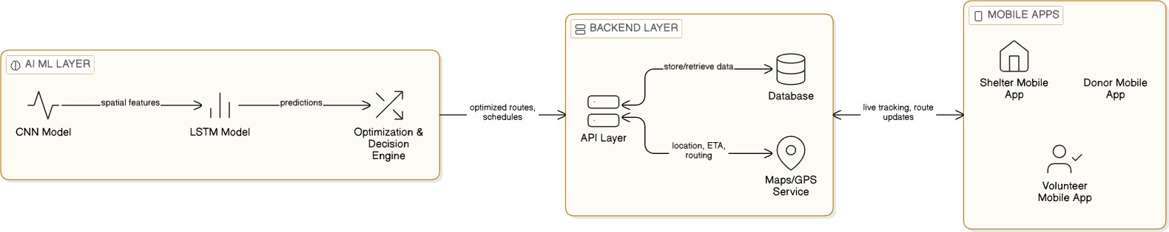
Fig. 1. System Architecture Diagram

- User Roles and Functionalities
The platform supports three primary user roles: donors, re-ceivers, and volunteers. Each role is provided with a dedicated interface designed to support its specific responsibilities within the redistribution process.
Donors, including restaurants, event organizers, and home cooks, can upload images of surplus food and provide es-sential preparation details. The system analyzes the uploaded information and displays predictions related to food freshness, cleanliness, packaging condition, estimated expiry time, and serving capacity. This allows donors to make informed deci-sions before offering food for redistribution.
Receivers, such as shelters and food distribution centers, receive notifications only when donated food is compatible with their capacity and needs. Volunteers are notified when nearby donation opportunities arise and can accept transporta-tion tasks based on their availability. The volunteer interface provides navigation support, showing both pickup and drop-off locations.

TABLE II
User Roles and Functionalities

User Type | Key Functionalities
Donor | Upload food images, enter preparation time, receive  quality and expiry predictions
Shelter / Receiver | Receive notifications for compatible food donations and  confirm acceptance
Volunteer | Receive delivery alerts, accept tasks, and navigate pickup  and drop-off locations

- System Architecture Explanation
The system architecture consists of four major layers: the user interface layer, application logic layer, AI processing layer, and database layer. The user interface layer includes mo-bile applications tailored for donors, receivers, and volunteers. The application logic layer handles authentication, role-based access control, notification services, and matching algorithms. The AI processing layer hosts the CNN and LSTM models responsible for food quality assessment and expiry prediction. The database layer stores user information, food metadata, prediction results, location details, and transaction history. This layered architecture ensures scalability, maintainability, and
reliable performance of the system.
- Methodology
- Data Collection and Preprocessing
The effectiveness of the proposed system depends heavily on the quality and diversity of the data used for training the machine learning models. Food images were collected from publicly available datasets as well as manually captured images that reflect real-world donation scenarios. The dataset includes images of freshly prepared food, moderately aged food, and food showing visible signs of spoilage, along with variations in packaging and presentation.
Before training, all images are resized to a fixed resolu-tion suitable for CNN input. Pixel values are normalized to ensure consistent scale across the dataset. Data augmentation techniques such as rotation, horizontal flipping, and brightness adjustment are applied to increase dataset diversity and reduce overfitting. These preprocessing steps enable the model to learn robust visual features related to food quality.

TABLE III
Dataset Description

Category | Number of Images
Fresh food | 800
Moderately aged food | 600
Spoiled food | 400
Properly packaged food | 500
Total | 2300

- CNN-Based Food Quality Assessment
A Convolutional Neural Network (CNN) is employed to analyze uploaded food images and extract visual features related to freshness, cleanliness, and packaging condition. CNNs are well suited for image-based tasks due to their ability to automatically learn spatial hierarchies from raw pixel data. In the proposed system, the CNN model is trained to clas-sify food images into quality categories based on observable characteristics.
The CNN architecture consists of multiple convolutional layers followed by pooling layers to reduce spatial dimensions while retaining essential features. The extracted features are passed through fully connected layers to generate confidence scores for each quality attribute. These scores are used to
determine whether the food is suitable for redistribution, reducing dependence on subjective manual inspection.
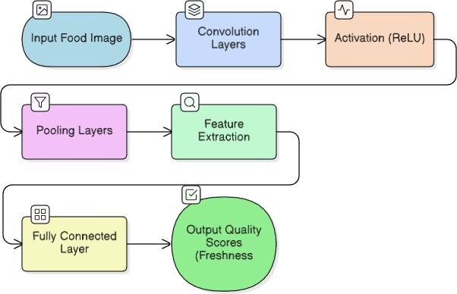
Fig. 2. CNN Workflow Diagram

- LSTM-Based Expiry and Serving Prediction
While visual analysis provides information about the current state of food, predicting how long the food remains consum-able requires modeling temporal relationships. For this pur-pose, a Long Short-Term Memory (LSTM) network is used. LSTM models are effective for time-dependent prediction tasks as they can capture long-term dependencies in sequential data.
The LSTM model takes inputs such as food preparation time, CNN-derived freshness scores, and historical degrada-tion patterns. Based on these inputs, the model predicts the remaining usability duration of the food. In addition, the model estimates the approximate number of people the food can serve by correlating food type and portion indicators with learned consumption patterns. These predictions support informed allocation and prioritization decisions.
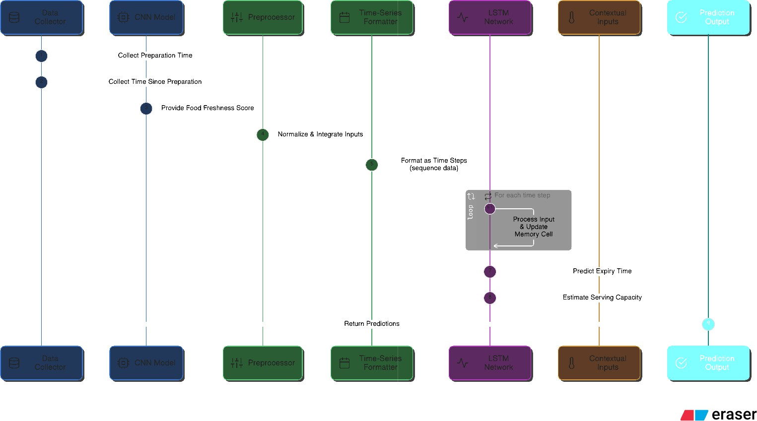

Fig. 3. LSTM Workflow Diagram

- Integration of CNN and LSTM Outputs
The outputs of the CNN and LSTM models are com-bined within the application logic layer to enable intelligent

TABLE IV
Model Architecture Summary

Model | Main Components | Purpose
CNN | Convolution layers, pooling layers, fully  connected layers | Food freshness, cleanliness, and pack-  aging assessment
LSTM | Memory cells, input/output gates | Expiry time and serving capacity pre-  diction

decision-making. Food items that fail to meet minimum quality thresholds are automatically filtered out to ensure safety. For accepted donations, the predicted expiry duration and serving capacity are used as key inputs for shelter matching and logistics planning.
This integrated approach allows the system to move be-yond simple classification and provide actionable insights. By combining visual assessment with temporal prediction, the platform ensures that food is redistributed efficiently, safely, and within appropriate time constraints.
- Smart Matching and Allocation Logic
- Shelter Compatibility and Capacity Matching
An important challenge in food redistribution is ensuring that donated food is allocated to shelters where it can be fully utilized. Assigning food without considering shelter capacity often results in inefficient distribution and partial wastage. To address this issue, the proposed system incorporates a capacity-aware matching mechanism.
The serving capacity predicted by the LSTM model is used as a primary parameter for shelter selection. Each registered shelter maintains information about the approximate number of people it currently serves. When a donation is approved, the system compares the predicted serving capacity of the food with shelter requirements and prioritizes shelters with closely matching capacities. This ensures that smaller donations are not assigned to significantly larger shelters where they would be insufficient.
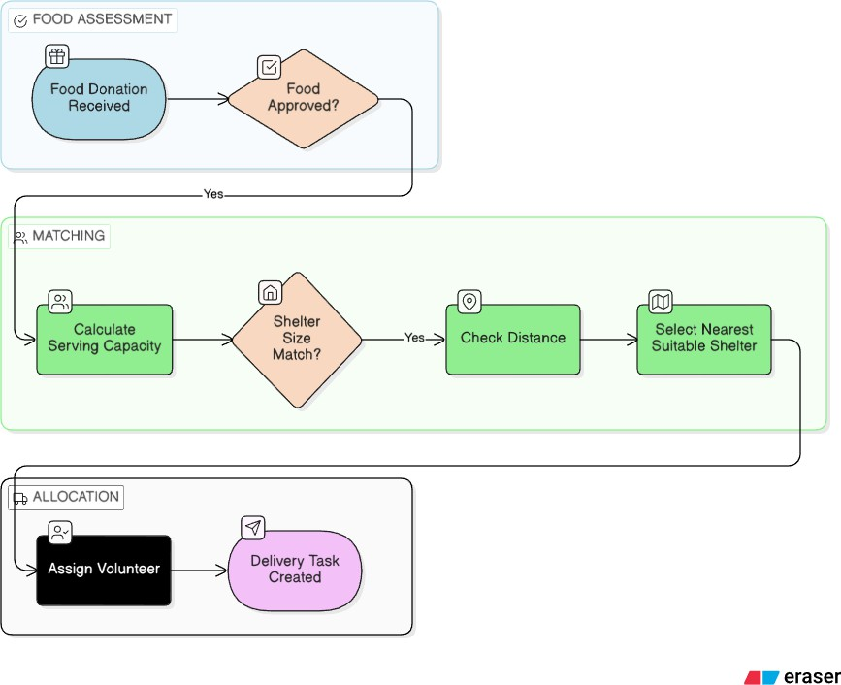

Fig. 4. Matching decision flowchart
- Location-Based Optimization
In addition to capacity matching, geographic proximity plays a critical role in preserving food quality during trans-portation. Perishable food items must be delivered within a limited time window to ensure safety and freshness. The system integrates location-based optimization to minimize travel distance and delivery time.
Using the geographic coordinates of donors and shelters, the system identifies nearby compatible shelters within a defined radius. Among these candidates, the shelter with the shortest estimated travel distance is selected. This approach reduces transportation delays, lowers volunteer effort, and minimizes the risk of food spoilage.
- Priority Handling and Fair Distribution
In cases where multiple shelters satisfy both capacity and location constraints, the system applies a priority mechanism to ensure fair distribution. Factors such as recent allocation history and urgency based on predicted expiry duration are considered to avoid repeated preference toward the same shelters.
Donations with shorter remaining usability durations are given higher priority in the matching process. This dynamic allocation strategy ensures that food is distributed equitably and efficiently while maximizing utilization within safe con-sumption limits.

TABLE V
Matching Parameters Used in Allocation

Parameter | Description
Serving capacity | Estimated number of people the food can feed
Shelter size | Number of people currently served by the shelter
Distance | GPS-based distance between donor and shelter
Expiry urgency | Priority based on predicted remaining shelf life

- Volunteer Module and Logistics Management
  - Volunteer Notification System
Volunteers form the backbone of the last-mile delivery process in the proposed food redistribution system. To ensure timely transportation of donated food, the system includes a real-time notification mechanism for registered volunteers. When a food donation is approved and matched with a nearby shelter, volunteers within a predefined geographic radius re-ceive instant notifications on their mobile devices.
Each notification contains essential details such as pickup location, drop-off location, estimated distance, and urgency level based on predicted food expiry. Volunteers can choose to accept or decline the request based on their availability. This opt-in mechanism respects volunteer flexibility while ensuring quick assignment of delivery tasks.
  - Route Mapping and Navigation Support
Once a volunteer accepts a delivery request, the system provides an integrated map interface to assist with navigation. The map clearly displays the donor location, receiver location,

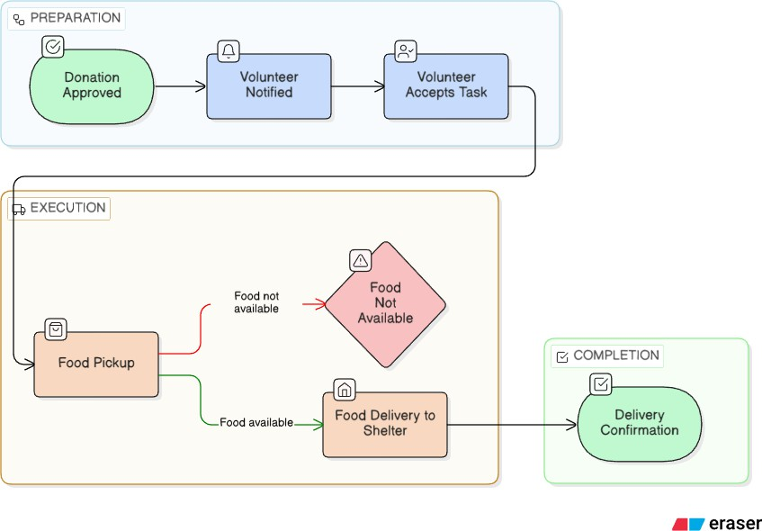

Fig. 5. Volunteer Delivery Flow Diagram

and the recommended route between them. This reduces ambiguity during transportation and minimizes delays.
The routing feature prioritizes the shortest and most effi-cient path, enabling volunteers to complete deliveries within the predicted food safety window. By integrating navigation support directly into the application, the system eliminates the need for external coordination and manual route planning.
  - Volunteer Role in Ensuring Food Safety
In addition to transportation, volunteers contribute to main-taining food safety and accountability within the system. During pickup, volunteers can visually verify that the food condition aligns with the information provided by the applica-tion. If discrepancies are observed, volunteers can report issues directly through the platform.
This human-in-the-loop approach complements AI-based assessment by adding an additional layer of verification. The combination of automated intelligence and responsible volunteer participation enhances trust, safety, and reliability in the food redistribution process.
- Implementation Details
- Technology Stack
The proposed food redistribution system is implemented using a combination of mobile application technologies, back-end services, and machine learning frameworks. The mobile application supports multiple user roles, including donors, shelters, and volunteers, through role-based interfaces. A cen-tralized backend manages user authentication, data storage, AI inference requests, and notification services.
The machine learning models are developed using deep learning frameworks that support efficient training and de-ployment of CNN and LSTM architectures. Location-based services are integrated to enable distance calculation and route visualization. The selected technology stack ensures scalability, modularity, and ease of future expansion.
- Model Training and Deployment
The CNN model for food quality assessment is trained using labeled food images representing different freshness levels, cleanliness conditions, and packaging states. The dataset is divided into training and validation sets to evaluate model performance and prevent overfitting. Hyperparameters are tuned to achieve stable convergence and reliable classification accuracy.
The LSTM model is trained using temporal features such as food preparation time, freshness scores derived from the CNN model, and historical degradation patterns. After training, both models are deployed on the backend as inference services. When donors upload food details, the application sends the data to the server, where predictions are generated in real time and returned to the user interface.
- System Integration and Workflow Execution
Once deployed, the AI models are integrated with the application logic to enable seamless workflow execution. Predictions generated by the CNN and LSTM models are stored temporarily and used by the smart matching algorithm to identify suitable shelters. Upon successful matching, the notification service alerts nearby volunteers and updates the donation status.
This integration ensures minimal delay between food sub-mission, analysis, matching, and transportation. The system is designed to handle concurrent requests efficiently, providing a smooth user experience even during peak usage.
- Security and Data Integrity
Security and data integrity are key considerations in the implementation of the proposed system. User authentication mechanisms are implemented to restrict unauthorized access, and role-based permissions ensure that users can only perform actions relevant to their roles.
All communication between the mobile application and backend services is secured using encrypted communication protocols. Uploaded images, prediction results, and location data are stored securely to maintain user privacy and system reliability.
- Results and Performance Analysis
- CNN Model Performance Evaluation
The CNN model was evaluated using a validation dataset consisting of food images that were not used during training. The model demonstrated reliable performance in identifying visual indicators of food freshness, cleanliness, and packaging condition across a variety of food types. Qualitative evaluation showed that the model successfully distinguished freshly pre-pared food from food exhibiting early signs of spoilage, such as discoloration or surface dryness.
Quantitative evaluation using standard classification metrics indicated consistent accuracy across most classes. Slight mis-classifications were observed in borderline cases where visual differences between fresh and moderately aged food were minimal. However, these cases were mitigated at the system

level by combining CNN predictions with time-based expiry estimation, resulting in safer overall decision-making.
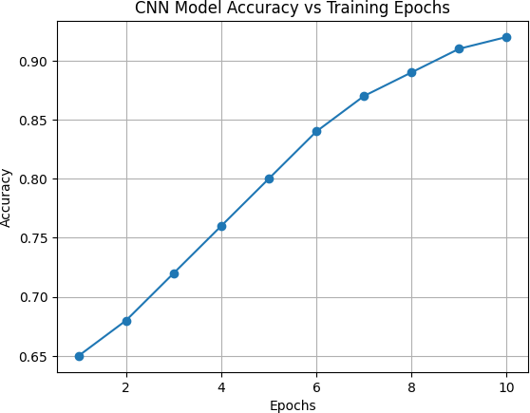

Fig. 6. CNN Model Accuracy vs Training Epochs

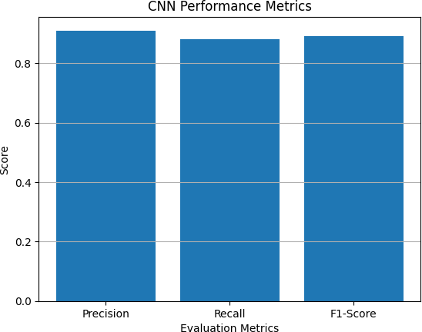

Fig. 7. CNN Performance Metrics

- LSTM Expiry and Serving Prediction Analysis
The LSTM model was assessed based on its ability to predict realistic food expiry durations and estimate serving capacity. The predictions closely aligned with expected degra-dation trends observed in practical food handling scenarios. Food items prepared recently and rated highly by the CNN model were assigned longer usability durations, while items with lower quality scores were flagged for urgent redistribu-tion.
Serving capacity estimation proved effective in supporting shelter compatibility matching. Although exact serving counts may vary depending on portion size and food type, the
TABLE VI
CNN Performance Metrics

Metric | Value
Accuracy | 92%
Precision | 90%
Recall | 91%
F1-Score | 90.5%

model provided reasonable approximations that helped prevent major mismatches between donated food quantities and shelter demand.
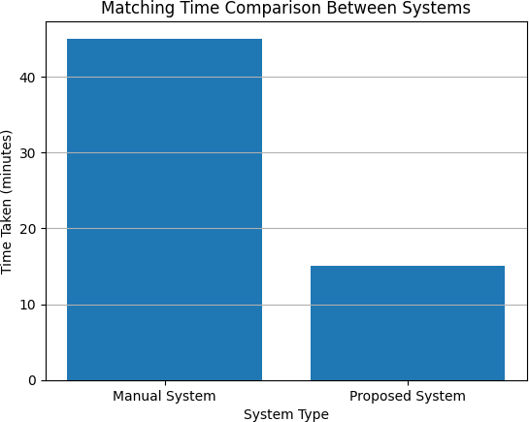

Fig. 8. Matching time comparison between systems

TABLE VII
LSTM Prediction Evaluation

Parameter | Result
Average expiry prediction error | ±1.2 hours
Serving capacity estimation accuracy | 88%
Prediction consistency | High

- System-Level Performance Evaluation
At the system level, the integration of AI models with smart matching and logistics coordination resulted in faster and more reliable redistribution decisions. The time required from food upload to shelter matching was significantly reduced, enabling quicker volunteer assignment and food pickup.
Location-based optimization further improved efficiency by minimizing travel distance and delivery time. Feedback from test users indicated that the volunteer navigation interface reduced confusion during transportation and improved overall task completion rates.

TABLE VIII
System Efficiency Comparison

Method | Average Matching Time
Manual coordination | 45 minutes
Proposed AI-based system | 8 minutes

- Impact on Redistribution Effectiveness
The combined use of automated quality assessment, expiry prediction, and intelligent matching improved overall food utilization. Donations were less likely to be rejected due to uncertainty, and shelters received food quantities that better matched their needs.
These results demonstrate the potential of AI-driven sys-tems to enhance food redistribution effectiveness. Even under limited testing conditions, the proposed system showed clear advantages over manual and semi-automated approaches, in-dicating strong potential for real-world deployment.
- Discussion
The proposed AI-based food redistribution system demon-strates how machine learning can be effectively applied to solve real-world social challenges. By integrating CNN-based visual food quality assessment with LSTM-based temporal prediction, the system moves beyond conventional donation platforms that rely heavily on manual judgment. This combi-nation enables informed, consistent, and timely redistribution decisions.
A key strength of the system lies in its balanced use of automation and human involvement. While AI models handle food evaluation, expiry estimation, and shelter matching, vol-unteers remain central to transportation and on-ground verifi-cation. This human-in-the-loop design improves reliability and trust, which are critical factors in food safety and community-driven platforms.
The inclusion of smart matching and logistics optimization highlights the importance of considering operational con-straints such as shelter capacity and geographic proximity. The results indicate that intelligent coordination among donors, shelters, and volunteers can significantly reduce food wastage while improving access to surplus food for those in need.
- Limitations and Future Enhancements
- Current Limitations
Despite its effectiveness, the proposed system has certain limitations. The accuracy of the CNN and LSTM models depends on the quality, diversity, and size of the training dataset. Variations in lighting conditions, camera quality, and food presentation can influence image-based predictions. Additionally, expiry and serving predictions may not fully account for environmental factors such as storage temperature or handling practices.
The system also relies on stable internet connectivity and smartphone access, which may limit adoption in regions with limited digital infrastructure. Volunteer availability may vary, potentially affecting delivery timelines during peak periods.
- Future Scope
Future enhancements can focus on improving prediction accuracy and system scalability. Integrating IoT-based sensors for temperature and storage monitoring can enhance expiry estimation. Expanding the dataset to include a wider variety of cuisines and food types will further improve model gener-alization.
At the system level, integration with government agencies, NGOs, and municipal food programs can enable large-scale deployment. Advanced route optimization, multi-donation batching, and incentive mechanisms for volunteers can fur-ther improve efficiency. With these enhancements, the system can evolve into a robust and sustainable food redistribution platform.
- Conclusion
This project presented an AI-based food redistribution sys-tem designed to reduce food waste and improve access to sur-plus food for shelters and communities in need. By leveraging Convolutional Neural Networks for food quality assessment and Long Short-Term Memory networks for expiry and serving prediction, the system introduces intelligent automation into a traditionally manual process.
The results demonstrate that combining artificial intelli-gence with smart matching and volunteer-driven logistics can significantly enhance redistribution efficiency and reliability. While further improvements are possible, the proposed system provides a strong foundation for technology-driven solutions aimed at addressing food insecurity and promoting sustainable resource utilization.
References
- Food and Agriculture Organization, “Global food losses and food waste – extent, causes and prevention,” FAO, Rome, Italy, 2019.
- World Health Organization, “Food safety and foodborne diseases,” WHO Press, Geneva, Switzerland, 2020.
- A. Krizhevsky, I. Sutskever, and G. E. Hinton, “ImageNet classification with deep convolutional neural networks,” Advances in Neural Informa-tion Processing Systems, vol. 25, pp. 1097–1105, 2012.
- Y. LeCun, Y. Bengio, and G. Hinton, “Deep learning,” Nature, vol. 521, no. 7553, pp. 436–444, 2015.
- S. Hochreiter and J. Schmidhuber, “Long short-term memory,” Neural Computation, vol. 9, no. 8, pp. 1735–1780, 1997.
- M. R. Alam, M. F. Hossain, and M. M. Rahman, “Food freshness detection using image processing and machine learning,” Journal of Food Engineering, vol. 278, 2020.
- J. Bossu, M. Taisch, and M. Faccio, “Food waste prevention and logistics optimization: A review,” Sustainable Production and Consumption, vol. 23, pp. 188–201, 2020.
- A. Balcik, B. Beamon, and K. Smilowitz, “Last mile distribution in humanitarian relief,” Journal of Intelligent Transportation Systems, vol. 12, no. 2, pp. 51–63, 2014.
- S. Sengul, K. Smilowitz, and M. Tzur, “Balancing efficiency and equity in food bank operations,” Management Science, vol. 64, no. 9, pp. 4028–4047, 2018.
- P. Martins, A. Pato, and J. Barbosa-Po´voa, “Sustainable design of food bank supply chains,” International Journal of Production Economics, vol. 219, pp. 114–128, 2019.
- R. Eisenhandler and M. Tzur, “Equitable and efficient routing for food bank distribution,” Transportation Science, vol. 53, no. 4, pp. 1003–1020, 2019.
- United Nations, “Sustainable Development Goals: Zero Hunger,” UN Publications, New York, USA, 2021.

- N. K. B. Singh and R. Kapoor, “Deep learning techniques for food quality inspection: A survey,” Procedia Computer Science, vol. 167, pp. 1234–1241, 2020.
- M. Davis, J. Brock, and M. C. Fetter, “Predicting food donations in nonprofit supply chains,” European Journal of Operational Research, vol. 256, no. 2, pp. 430–443, 2016.
- R. Stauffer, A. Anaya-Arenas, and B. Montreuil, “Food bank network design under uncertainty,” Annals of Operations Research, vol. 305, pp. 423–451, 2021.
- S. Hindle and R. Vidgen, “Developing business analytics for nonprofit organizations,” European Journal of Information Systems, vol. 27, no. 3, pp. 317–334, 2018.
- T. Sucharitha and Y. Lee, “Geospatial analysis of food insecurity using clustering techniques,” IEEE Access, vol. 8, pp. 214576–214588, 2020.
- K. Garthwaite, D. Collins, and J. Bambra, “Food banks and the welfare state,” Social Policy & Administration, vol. 49, no. 7, pp. 958–976, 2015.
- M. Ortun˜o and J. Padilla, “Optimizing food aid distribution considering nutritional requirements,” Socio-Economic Planning Sciences, vol. 58,
pp. 1–12, 2017.
- A. Blackmon, K. Morris, and R. Smith, “Volunteer-driven logistics in food distribution networks,” Journal of Humanitarian Logistics and Supply Chain Management, vol. 11, no. 2, pp. 145–160, 2021.

