The Evaluation of UTAUT Model for Gamed-LMS, A Prototype of Gamified Learning Management System
Mohd Zahrul Bin Baharin¹*, Johan @ Eddy Luaran², Ani Mazlina Dewi Mohamed³, Hafizz Al-Amirrul Bin Mohd Zanial⁴, Mohd Fitry Bin Yahya⁵ ,Soraya Binti Sharifuddin⁶
University Poly-Tech Malaysia, Malaysia
*Corresponding Author
DOI: https://doi.org/10.47772/IJRISS.2026.10100575
Received: 31 January 2026; Accepted: 05 February 2026; Published: 18 February 2026
ABSTRACT
This study evaluates the acceptance of a gamified Learning Management System (GamedLMS) prototype using the Unified Theory of Acceptance and Use of Technology (UTAUT) model. The prototype integrates gamification elements such as points, badges, leaderboards, and events into a modular LMS designed with C#.NET, aiming to enhance student engagement, motivation, and learning outcomes. A mixed-method approach was employed, involving surveys with 120 students and focus group discussions with four lecturers at University Poly-Tech Malaysia. Findings indicate that both practitioners and students expressed positive agreement toward the system’s design, usability, and gamification features, with high satisfaction reported in areas of motivation, performance measurement, and collaborative learning. Reliability analysis confirmed the robustness of the evaluation instruments. The results highlight the potential of gamified LMS platforms to improve user retention, foster intrinsic and extrinsic motivation, and support language learning, while also validating the applicability of the UTAUT model in assessing technology acceptance in educational contexts. This research contributes to bridging theoretical and practical gaps in gamification studies and offers insights for future development of gamified educational technologies.
Keywords: Gamification, Learning Management System, Online Learning, Prototype, UTAUT Model
Contribution/Originality: This study contributes to assertion of theoretical and practical gaps within the field of gamification and its acceptance in technology in education. This study also contributes to the existing literature on gamified learning management systems and Unified Theory of Acceptance and the Use of Technology (UTAUT).

INTRODUCTION
The prototype of gamified Learning Management System (Gamed-LMS) as introduced in this chapter will provide a platform to test and evaluate how the gamified elements in use may be applied and accepted in an academic setting. This section first provides a summary of the system design and components and then describes the technical implementation; finally, the evaluation of the impact of the system on user engagement, learning outcomes, and overall acceptance. In addition, this chapter will also attempt to investigate the following objectives, thus answering the following research questions:

Research Objectives
- To investigate the agreement of practitioners towards the constructed prototype of Gamed-LMS, based on UTAUT Model.
- To examine the level of acceptance of students towards the developed prototype of Gamed-LMS, based on UTAUT Model.

Research Questions
- What is the level of agreement of the constructed prototype of Gamed-LMS for practitioners use based on UTAUT Model?
- What is the level of acceptance of the developed prototype of Gamed-LMS for students use based on UTAUT Model?

The Development of the Prototype of Gamed-LMS
The prototype Gamed-LMS model is perceived as an incorporation into an existing language learning and gamification learning model with core elements of gamification embedded in the learning management tool to revolutionize the user participation, engagement and motivation. Gamified elements are organized on several system parts and user aspects, such as profiles, courses, subjects, and events. These elements facilitate the recording and analysis of user interactions so that progress is tracked on-the-fly, and learns are issued through scores, rankings, and achievements.
Learning Management System (LMS) that was developed for this study was designed using the C#. NET language in the Microsoft Visual Studio integrated development environment. C#. NET was chosen because it’s a solid ecosystem with powerful, modern, object-oriented architecture that included an enormous database for storing data in SQL Server and included full support in the future for creating desktop and web applications that can scale and stay secure as well as known for its maintainable characteristics. The .NET framework’s rich class libraries and tools facilitated rapid prototyping and efficient deployment of core LMS functionalities such as user authentication, course management, content delivery and assessment modules. The decision to employ C#. NET added that its enterprise-grade solution credentials and history in educational-technology prove its reliability. This technology decision is part of the general goal of the project, to produce a modular, extendable LMS that can enable educational practice to be tested and adapted to change, as well as to administrative expectations and technical architecture.
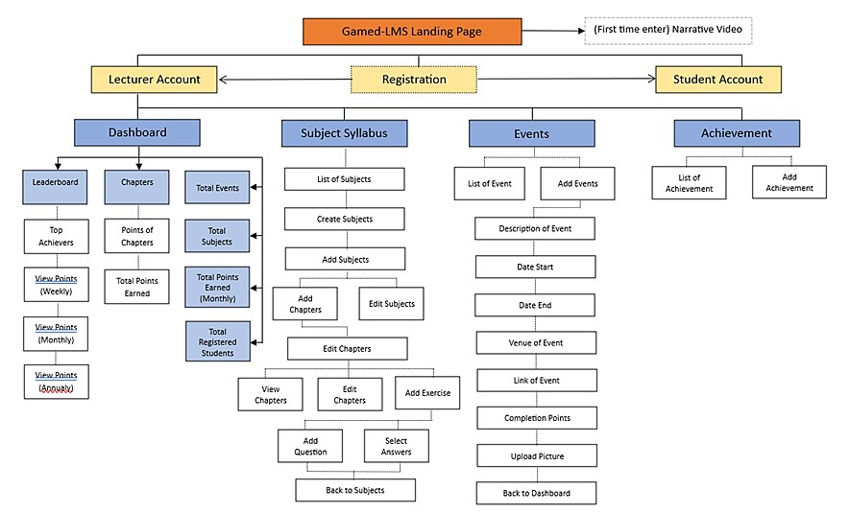

Figure 1: Flow Process of the Prototype of Gamed-LMS
The system architecture comprises of necessary elements like one registration page, user dashboards, leaderboards where the students' performances are viewed. The primary aim that governs the objective of this prototype is to encourage competition and incentivize positive behaviors, such as completing courses and participating within the environment of this gamified learning management system. Rewards & Leaderboards Badges, points, levels, and leaderboards are used to encourage and reward behavior. Moreover, users may also gather points and scores for their interactions, for example from engaging in the exercises or attending an event conducted physically outside of the LMS or online event through provided links.
As the system is designed with educational objectives and gamification principles, the platform offers not only content but also involves students in game type activities. Whereas the playful elements can enhance motivation, the way in which these elements are implemented needs to be checked in relation to educational necessities. The UI and UX of this learning management system are key, because the design of the LMS combine both ease of use and integrating game mechanics into educational content.
In before the development of this prototype, the researcher has developed a Gamification Learning Framework for Language Learning (GLF-LL) to be used as the guidelines for the prototype of Gamed-LMS. Figure 2 illustrates the relationship between gamification elements extracted from the GLF-LL and its implementation process in the prototype of Gamed-LMS. As there are 12 micro gamification elements that have achieved consensus of the experts from both rounds of Fuzzy Delphi analysis, these elements are then implemented into the new prototype, showcasing each of the elements and its function in the LMS.
Figure 2: The Relationship between Gamification Elements from the Gamification Learning Framework for Language Learning (GLF-LL) and the Features in the prototype of Gamed-LMS
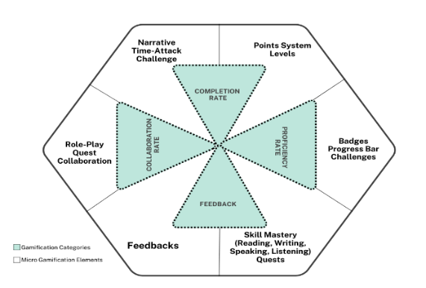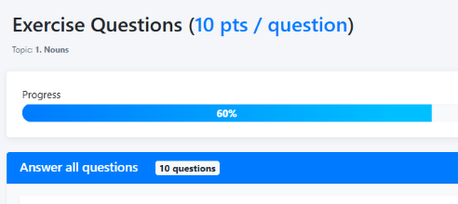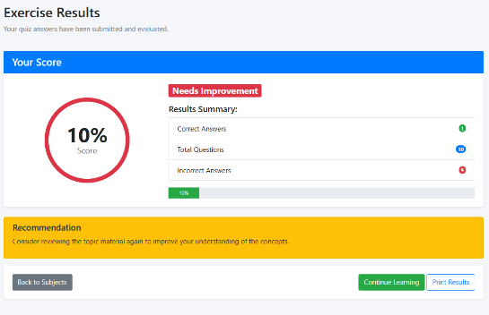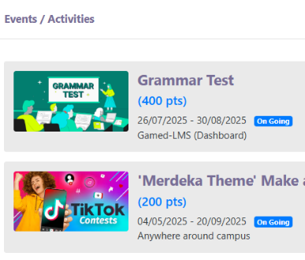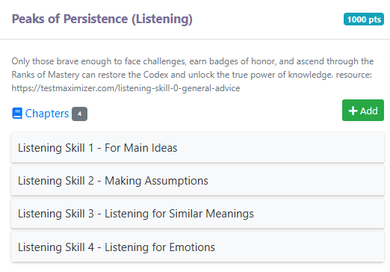
The student’s points and current rank is shown on student’s profile, allowing easier viewing for his / her current progress
Each subject is represented with progress bar, signifying the current progress of student’s while completing the chapter
Sets of challenges are represented by Badges or Achievements, earned throughout the course or by completing exercises and gathering enough points
Language learning syllabus is represented through the mastery of each subject created by the lecturer. In this example, four English learning skills courses were created (Grammar, Listening, Reading and Writing), each represented with its own points of completion
Progress bar / tracker can also be found during answering exercise
The leaderboard element showcasing the current achievement of points of all students in the Gamed-LMS, with specific ranks, name and earned points – sorted by weekly, monthly or semester basis
Narration or story and time-attack challenge is showcased in the Events tab, allowing lecturer to set specific time or duration for the completion of activities – which can also provide points and promote collaborative learning
Quest and Role-Play is provided in the context of the description of the subjects – providing immersive imagination of students while completing the subjects
Feedback is instant – students automatically received grades and scores for the exercise and test that they participate in
Figure 3 illustrates the dashboard of the prototype Learning Management System (LMS) called Gamed-LMS, as they appear for teachers or lecturers. The dashboard groups under one user-friendly interface majority of important information like events, subjects, achievements, and student progress information. The dashboard is separated into a few important sections to help make viewing experience informative and enjoyable and possible.
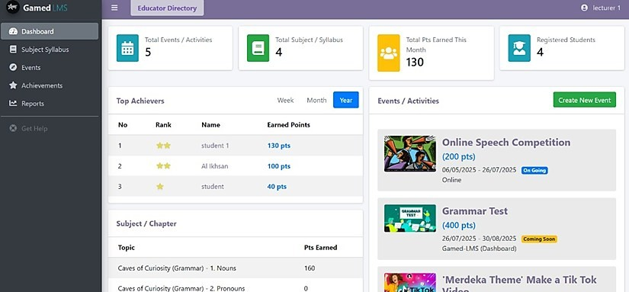
Figure 3: Front Page of the prototype Gamed-LMS
The number of events or activities, subjects or syllabuses, points earned for month, and total registered users are shown on the top right corner of the screen. These figures give the educator a sense of the summary of the system’s activity and engagement. This gives the user rapid feedback regarding overall course performance and event attendance. In the Top Achievers segment there is a table where users can see a list of students according to points scored. This table is grouped by time periods of week, month and annual. The summary of points table is also grouped with the data as well, to monitor the student performance over a period. In this scenario, Student 1 is leading with 130 points, and then Al Ikhsan with 100 points. This mechanism is valuable for the recognition of student effort and introduces a competitive but encouraging factor for students. The Subject/Chapter tab shows the topics with the points gained by the students. This section may not only focus on what students are learning about but also demonstrate how student engagement with course content is monitored and rewarded. The stats in this section make it possible for teachers to see who is doing the most work and studying the most and where students might need more help. Underneath to the right is where the Events/Activities are. There are several events here, and details of each, such as the Event's name, how much users can win points in this event, how long this event will continue, and whether the event is ongoing or in the future. For instance, the Online Speech Contest participation period is now open, and students can obtain 200 points for participation. This section is the resource of upcoming events and deadlines to keep all students and faculty well-informed. Furthermore, the Create New Event option enables educators to create and manage new activities to engage students and promote better learning experience on the platform.
As a result, the dashboard hosts the full picture of what the LMS has to offer and features tools for monitoring student’s successes, managing educational content and facilitating communication between teachers and students. The design of the system is supposed to automate administrative works and offer information on students' progress, to assist the learning process effectively and dynamically.

LITERATURE REVIEW
Micro-game elements such as points, badges, leaderboards, avatars, and progress bars have been shown to boost student motivation by offering visible rewards and tracking progress (Deterding, 2012; Yechkalo et al., 2024; Lutfi, Aftinia, & Permani, 2023). In classroom settings, these elements can be used to scaffold learning tasks, reward participation, and personalize feedback, thereby fostering persistence and autonomy. Smirdele (2020) found that gamification positively influences students’ task awareness and engagement, particularly among introverted learners. As part of technological advancement, the implementation of gamification in online learning setting should be assessed for its effectiveness. One of the ways to assess gamification acceptance is through UTAUT model. According to Venkatesh et, al. (2003), Unified Theory of Acceptance and Use of Technology (UTAUT) examine the acceptance of technology through factors such as performance, effort, social influence and facilitating condition.
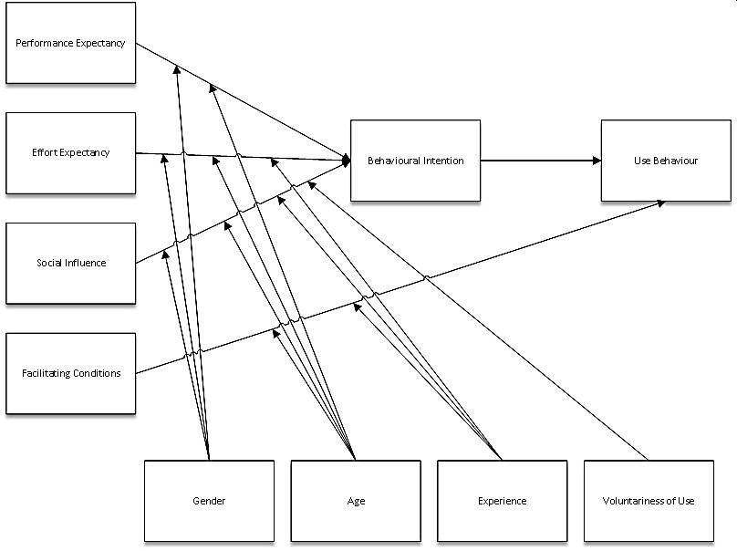

Figure 4: UTAUT Model (Venkatesh et. al. 2003)
As illustrated in Figure 4, the adoption of UTAUT Model aligns with the intention to analyze the behavior of respondents of this study, further confirming on the level of acceptance towards gamification in today’s education. Although gamification integrates playful elements in serious settings such as teaching and learning, researchers found many alignments of its benefits and technology acceptance such as the enhancement of satisfaction, self-esteem, encouraged usage and increase simulation through graphics and mechanics. (DíezPascual & Díaz 2020, Lu & Ho 2020, L. F. Rodrigues, et. al. 2016, Samar & Mazuri 2019, Rahman, Ahmad & Hashim 2018).
Extensive systematic literature reviews were also carried out by many researchers in the past and identified that gamification and UTAUT model influenced user motivation and behavior. As AL-Emran et. al. 2021 and Trocky & Buckley, 2016, argued, the link between gamification and technological acceptance model (TAM) were always underexplored. Thus, this study seeks to assert that connection considering the relevancy of gamification within LMS in the sea of technological features.

RESEARCH METHODS
This research was performed at the University Poly-Tech Malaysia (UPTM), a private university in Malaysia. The study population consists of lecturers and students from various faculties. In overall, there are four academic lecturers and 120 students participated in this study. These experts were chosen because of their background and experience in academics at a tertiary level including education, technology and gamification and have the related knowledge necessary to provide comments during the design review. During the survey, all students who participated were among the users of the prototype of Gamed-LMS, a gamified learning management system. For this study, a random sampling method was employed towards both qualitative and quantitative stage.
Learning Management System (LMS) that was developed for this study was designed using the C#. NET language in the Microsoft Visual Studio integrated development environment. C#. NET was chosen because it’s a solid ecosystem with powerful, modern, object-oriented architecture that included an enormous database for storing data in SQL Server (Krishna, 2025) and included full support in the future for creating desktop and web applications that can scale and stay secure as well as known for its maintainable characteristics (Raju, 2024). The .NET framework’s rich class libraries and tools facilitated rapid prototyping and efficient deployment of core LMS functionalities such as user authentication, course management, content delivery and assessment modules. The decision to employ C#. NET added that its enterprise-grade solution credentials and history in educational-technology prove its reliability. This technology decision is part of the general goal of the project, to produce a modular, extendable LMS that can enable educational practice to be tested and adapted to change, as well as to administrative expectations and technical architecture.
In detail, the system architecture comprises of necessary elements like one registration page, user dashboards, leaderboards where the students' performances are viewed. The primary aim that governs the objective of this prototype is to encourage competition and incentivize positive behaviors, such as completing courses and participating within the environment of this gamified learning management system. Rewards & Leaderboards Badges, points, levels, and leaderboards are used to encourage and reward behavior. Moreover, users may also gather points and scores for their interactions, for example from engaging in the exercises or attending an event conducted physically outside of the LMS or online event through provided links.
As the system is designed with educational objectives and gamification principles, the platform offers not only content but also involves students in game type activities. Whereas the playful elements can enhance motivation, the way in which these elements are implemented needs to be checked in relation to educational necessities. The UI and UX of this learning management system are key, because the design of the LMS combine the elements of appealing graphics, trackability, and serious learning process.

Instrument
The evaluation of the Gamed-LMS prototype is conducted through a mixed-method approach, involving both qualitative and quantitative analyses. The quantitative aspect includes a survey administered to 120 students, complemented by a focus group discussion with 4 lecturers from the private university. These data collection methods aim to measure various aspects of the system, including usability, design, gamification elements, and overall acceptance.

Data Analysis Procedure
The data collection and analysis process in this study is described separately as follows:

Selection of Lecturers & Lecturers’ Profile
The process of selection of lecturers for expert review session was carried out within strict criteria, as depicted in the table below.
Table 1: Lecturers Selection Criteria for Focus Group Discussion
Lecturers’ Selection Criteria
Minimum academic qualification is Masters’
More than 5 years’ experience in the field of teaching and learning at tertiary level
Have academic or industrial experience in dealing with Learning Management System

After confirming the availability and readiness to attend the focus group discussion, four lecturers from various fields were introduced to the prototype of Gamed-LMS. Respondents for this stage of study were informed about the procedure of the focus group discussion and confirmed their consent to collaborate for this study via the design review instrumentation document.
Table 2: Experts’ Profile
Code | Occupation | Faculty | Years of  Experience | Area of Expertise
DR01 | Lecturer | Faculty of Computer and Multimedia | 6 years | Multimedia, Animation
DR02 | Lecturer | Faculty of Social Science,  Education and Humanities | 15 years | TESL, English  Literature
DR03 | Lecturer | Centre of Islamic, General and Language Studies | 11 years | Social Science,  Linguistic, Mandarin
DR04 | Lecturer | Faculty of Computer and Multimedia | 10 years | 3D Animation, Design

The lecturers who participated in this study have varied backgrounds in academia and brought in considerable expertise and experience to the evaluation of the Gamed-LMS prototype. Lecturer DR01 is from the faculty of computer and multimedia with 6 years’ experience in Multimedia and Animation fields. DR02, has been attached in the Faculty of Education, Social Sciences and Humanities for 15 years and his specialization is TESL (Teaching English as Second Language) and English literature. DR03 from the Center of Islamic,
General and Language Studies 11 years specialized in Social Science, Language studies, Mandarin and finally DR04, also with the Faculty of Computer and Multimedia, has a decade of 3D Animation and Design experience and knowledge.

Design Review Evaluation Questions for Qualitative Stage
The evaluation consists of 18 statements, categorized under 5 different sections. Respondents are required to provide ratings for each statement based on 6-point Likert-Scale, respectively known as 1 for Extremely Dissatisfied to 6 for Extremely Satisfied for the agreement scale. As there are two sections of the review, the objective statements of the design review were analyzed using SPSS ver 22.0 for mean score meanwhile the subjective section were coded for thematic analysis. The constructs of the evaluation form are as follows:
Table 3: Relationship of UTAUT Model with the Constructs of the Design Review Evaluation Form
UTAUT  Model | Section | Statement
Social  Influence | Overall Design of the Prototype  Gamed-LMS | The design is attractive to the target group.
Social  Influence | Overall Design of the Prototype  Gamed-LMS | The technology used is relevant for the target group.
Social  Influence | Overall Design of the Prototype  Gamed-LMS | The design helps increase target group confidence.
Social  Influence | Overall Design of the Prototype  Gamed-LMS | The design can provide satisfaction for the target group.
Behavioural Intentions | The Gamification  Elements of the  LMS | The gamification elements of LMS help define clear learning goals & learning objectives of the target group
Behavioural Intentions | The Gamification  Elements of the  LMS | The metrics of gamification elements help measure performance of the target group
Behavioural Intentions | The Gamification  Elements of the  LMS | The gamification content of LMS increases collaborative learning
Behavioural Intentions | The Gamification  Elements of the  LMS | The gamification materials / content of LMS increase user retention
Ease of Use | Technical Aspect | There are identifiable bugs and errors on the LMS
Ease of Use | Technical Aspect | The gamification elements used in the LMS integrate well
Ease of Use | Technical Aspect | The design helps solve navigation and notification challenges
Facilitating Conditions | Motivational Elements | The design helps increase intrinsic motivation
Facilitating Conditions | Motivational Elements | The design helps increase extrinsic motivation
Facilitating Conditions | Motivational Elements | The design helps increase self-determination
Facilitating Conditions | Motivational Elements | The design helps increase self-efficacy
Performance Expectancy | English Language Learning Aspect | The design helps mastery of one or more macro skills in English language learning  (Reading, Writing, Listening & Speaking)  The design helps mastery of general English proficiency
Performance Expectancy | English Language Learning Aspect | The design helps improve communication skills.

Design Review Session
During the meeting, researcher first explained about the prototype of Gamed-LMS and let respondents explore the website on their own accord. In the meantime, researcher attended to any related questions regarding the prototype. After 30 minutes, lecturers were given design review forms for an evaluation of the prototype of Gamed-LMS. Additionally, after the process of rating the website was completed, the respondents were given few questions for focus group discussion. The discussion is recorded and transcribed for statistical and content analysis. The detailed analysis on the data of the review is explained in the following subtopic.
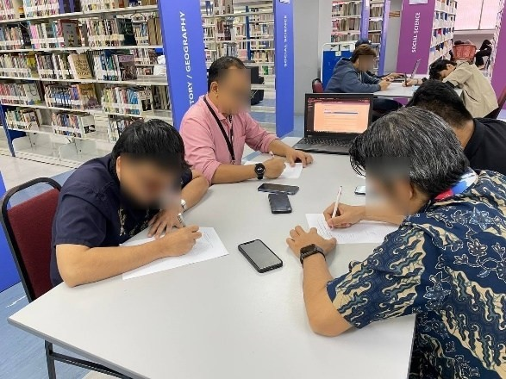
Figure 5: Design Review Process on the prototype of Gamed-LMS

Questionnaire for Qualitative Stage
The questionnaire is constructed by the researcher by combining the elements of acceptance from the UTAUT Model. After the questionnaire is completed, the document is sent for verification for content and language validity by the experts in the field of technology and language. The details of the constructs of the questionnaire are as follows:
Table 4: Relationship of UTAUT Model with the Constructs of the Survey Form
UTAUT Model | Section | Options
 | A –  Demographic | Male
Social  Influence | A –  Demographic | Female
Social  Influence | A –  Demographic | Diploma  Degree
Behavioural Intentions | B –  Gamification  Elements | The gamification features (e.g., points, badges, levels) made learning more enjoyable.
Behavioural Intentions | B –  Gamification  Elements | The gamification elements motivated me to engage more with the LMS.
Behavioural Intentions | B –  Gamification  Elements | I found the gamified tasks to be relevant to the learning content.
Behavioural Intentions | B –  Gamification  Elements | The rewards system encouraged me to complete more activities.  The leaderboard or competition features positively influenced my participation.
Ease of Use | C –  Usability and  Design | The LMS interface is user-friendly and easy to navigate.
Ease of Use | C –  Usability and  Design | I was able to find learning materials without difficulty.
Ease of Use | C –  Usability and  Design | The design of the LMS is visually appealing.  The system responded quickly and reliably during use.
Facilitating Conditions | D –  Learning  Experience | The LMS helped me understand the course content better.
Facilitating Conditions | D –  Learning  Experience | I felt more engaged using this LMS compared to traditional methods.
Facilitating Conditions | D –  Learning  Experience | The LMS supported my learning goals effectively.
 | D –  Learning  Experience | I would recommend this LMS to others.
Performance Expectancy | E –  Overall  Acceptance | I am satisfied with my experience using this LMS.  I would like to continue using this LMS in future courses.  The LMS met my expectations.
Performance Expectancy | E –  Overall  Acceptance | I believe this LMS can improve learning outcomes.

Pilot Test
After the questionnaire is verified for content and face validity, the researcher conducted pilot test and distributed via Google Form to 20 respondents. The questionnaires provided during the survey process are analyzed for reliability analysis. Table 6 depicts Cronbach’s Alpha value of the reliability analysis.
Table 5: Cronbach's Alpha Reliability Analysis
Cronbach's Alpha | N of Items
.864 | 20
Cronbach’s Alpha of 0.864 indicates high reliability of the survey and veracity of the data. Its statistical indication confirms that the feedback from the 20 respondents is reliable, and it constitutes a good basis on which to draw conclusions about the effectiveness of the system. Afterwards, the researcher proceeds with distributing the questionnaire to another 100 respondents. After the process is complete, the researcher analyzes the questionnaire using SPSS version 22.0 for statistical analysis.

RESULTS

Focus Group Discussion
The analysis of the Design Review Form reveals critical insights into the lecturers' perceptions of the prototype's design. The evaluation scale used in the study ranges from 1 (Extremely Dissatisfied) to 6
(Extremely Satisfied), and the results reflect varying degrees of satisfaction across the different design aspects.
Table 6: Section A : Overall Design of the Prototype
 | N | Mean | Std. Deviation
The design is attractive to the target group | 4 | 4.75 | .50
The technology used is relevant to the target group | 4 | 5.00 | .81
The design helps increase target group confidence | 4 | 5.25 | .50
The design is able to provide satisfaction for the target group | 4 | 4.50 | 1.29
Regarding the general appearance of the Gamed-LMS prototype, the attractiveness of the design for the target group was rated high by all respondents, with DR01, DR03, DR04 assigning grade 5 (Very Satisfied) and DR02 assigning grade 4 (Satisfied) leading to a total grade of 22 and satisfaction higher than average (m = 4.75, SD = 0.50). Likewise, the confidence of the target group that the design increases received high point scores from both respondents, with a score of 6 (Extremely Satisfied) from DR01 and DR03, and two scores of 5 (Very Satisfied) from DR02 and DR04, contributing to another total score of 22 out of 24 and a further satisfaction score at very high (m = 5.25, SD = 0.50). But the applicability of the technology for this population received a lower level of satisfaction. DR03 rated its pertinence 6 (Very Satisfied), and DR01 and DR02 rated it as 5 (Very Satisfied) and DR04 gave a rating of 4 (Satisfied). This led to a combined score of 17 and a satisfaction mean at 5.00 (SD = 0.81). The third criterion, the extent manifestations of the design satisfy the target group also received a lower score, whereas DR02 rated this statement a 3 (Dissatisfied), meanwhile DR01, DR03, and DR04 responded with 6, 5, and 4, respectively. This resulted in an overall score of 18 and a satisfaction mean of 4.50 (SD = 1.29).
Table 7: Section B : Gamification Elements of the Prototype
 | N | Mean | Std. Deviation
The gamification elements of LMS help define clear learning goals & learning objectives of the target group | 4 | 5.25 | .500
The metrics of gamification elements help measure performance of the target group | 4 | 5.50 | .577
The gamification content of LMS increase collaborative learning | 4 | 4.50 | 1.000
The gamification materials / content of LMS increase user retention | 4 | 5.00 | .816

According to lecturers the first statement (the extent to which the gamification elements of the LMS assist in describing clear learning objectives for the target group) was scored higher. DR01, DR02 and DR04 rated it a '5' (Very satisfied), while DR03 rated it a '6' (Extremely satisfied)', resulting in an overall score of 21 and a satisfaction mean score of 5.25 (SD = 0.50). This indicates that the gamification elements of the LMS are considered successful in presenting learning objectives to the target audience. As for the acceptance of the gamification elements in assessing the performance of the target group, all the teachers found this LMS to be favorable. DR01, DR02, and DR04 scored 5 (Very Satisfied) while DR03 scored 6 (Extremely Satisfied). The total score of 22 and satisfaction mean score of 5.50 (SD = 0.577) show the perceived effectiveness of the performance measurement tools incorporated in the gamification techniques. Third dimension centers on the potential contribution of gamification content on fostering cooperative learning. It is found that on this statement, there was more divergence of opinion. DR01 and DR03 both rate the statement 4 (Satisfied) and DR02 and DR04 rated it 6 (Very Satisfied) and 4 (Satisfied), respectively. The final score value of 18 and satisfaction mean value at 4.50 (SD = 1.00) demonstrate that the gamification contents can provoke collaborative learning perception from the lecturers and, on the other hand, lead others to think that it still must be improved in this sense. Lastly, the question about whether the LMS’ gamification content makes it possible to keep the user and engage the user better was well reviewed. DR02 rated it 6 (Extremely Satisfied), while DR01 and DR03 each reported ratings of 5 (Very Satisfied), and DR04 rated it 4 (Satisfied). While the feedback is generally positive, with average score of 20 which represents an overall high satisfaction (m = 5.00, SD = 0.816), they suggest that impact of the gamification elements on retention effect differs among the elements.
Table 8: Section C: Technical Aspects of the Prototype
 | N | Mean | Std. Deviation
There are identifiable bugs and errors on the LMS | 4 | 4.00 | .000
The gamification elements used in the LMS integrate well | 4 | 4.75 | .500
The design helps solve navigation and notification challenges | 4 | 5.25 | .957

From Table 8, the first statement checks for known bugs and issues in the LMS prototype. These aspects received scored at 4 by all 4 lecturers, DR01, DR02, DR03 and DR04 providing cumulative value of 16, and a mean score of 4.00 (SD = 0.00). This signifies a neutral position overall, as there are things that work as expected but there are also other things that may have involved technical issues, including bugs and errors. A lower Score Satisfaction from this reflects less identifiable bugs and errors in the prototype. The second area refers to the integration of the gamification elements in the LMS prototype. The responses had a small variation, where DR01, DR03 and DR4 rated 5 (Very Satisfied), and DR02 scored 4 (Satisfied) respectively. The overall score is 19 and the satisfaction mean value is 4.75 (SD = 0.50) which indicates that the integration of gamification components into LMS is generally well received. That said, there’s still plenty of fine tuning needed to make sure that everyone’s technical experience is as seamless as possible.
The third proposition examines capabilities of the LMS in solving navigation and notification problems. This element was rated most highly, with 6 (Extremely Satisfied) by DR02, DR03 and 5 (Very Satisfied) by DR01, and 4 (Satisfied) by DR04. Overall scores of 21 and a mean satisfaction score at 5.25 (SD = 0.95) rate indicate high acceptance of the interventions of the LMS to solve navigation and notification problems, meaning that the intervention to improve usability of navigation and notification is successful.
Table 9: Section D: Motivational Elements of the Prototype
 | N | Mean | Std. Deviation
The design helps increase intrinsic motivation | 4 | 4.75 | .500
The design helps increase extrinsic motivation | 4 | 4.75 | .500
The design helps increase self-determination | 4 | 5.00 | .000
The design helps increase self-efficacy | 4 | 5.50 | .577

The first statement investigates whether the design fosters intrinsic motivation. The scores were bit different with 5 (Very Satisfied) for DR01, DR02, and DR04, and DR03 giving a 4 (Satisfied). The cumulative score of 19 points and a mean score of 4.75 (SD = 0.50) suggest a satisfactory but moderate degree of satisfaction with the effectiveness of the design in encouraging intrinsic behavior. This finding suggests that although the design is motivational, there is potential for stimulating people's intrinsic motivation. The second statement pertains to the design’s impact on facilitating extrinsic motivation. DR01 gave a score of 4 (Satisfied) and DR02, DR03, and DR04 gave it 5 (Very Satisfied). This produced a summed value of 19, and a mean satisfaction value at 4.75 (SD = 0.50), which equaled the satisfaction score for intrinsic motivation. This means that the prototype generally succeeds in stimulating extrinsic motivation. The third proposition tests if the design supports an enhancement of self-determination. The instructors DR01, DR02, DR03, and DR04 gave it a score of 5 (Very Satisfied). This yielded a cumulative score of 20 and a mean of 5.00 satisfaction rate (SD = 0.00). This is indicative of a relatively high perception that LMS supports users in managing their own learning process, leading to either autonomy or freedom of choice. The last assertion explores whether there is evidence that the design contributes to raising self-efficacy, or users' confidence in their ability to be successful. This item received high rates of approval from every lecturer, as DR02 and DR03 evaluated it with 6 points (very satisfied) and DR01 and DR04 with 5 points (quite satisfied). As the total score is 22 and the satisfaction mean value at 5.00 (SD = 0.57) this level has the highest average satisfaction in this category, indicating the effectiveness of the design to extend users’ confidence in success through the LMS.
Table 10: Section E: English Language Learning Aspects of the Prototype
 | N | Mean | Std. Deviation
The design helps mastery of one or more macro skills in English language learning (Reading, Writing, Listening & Speaking) | 4 | 5.25 | .500
The design helps mastery of general English proficiency | 4 | 5.00 | .816
The design helps improve communication skills. | 4 | 4.25 | .500

The first statement examines whether the design assists in the acquisition of one or more macro skills in English learning which are reading, writing, listening and speaking. On this statement, the score was positive in which DR01, DR02 and DR04 rated it 5 (Very Satisfied) and DR03 rated it 6 (Extremely Satisfied). The total score of 21 and satisfaction mean score of 5.25 (SD 0.50) indicate that the prototype is useful in developing language skills for reading, writing, listening, and speaking. The second proposition evaluates whether the design enhances general English language proficiency. The ratings for this specific statement were also high (m = 5.00, SD = 0.81), where DR02 and DR03 rated it 5 (Very Satisfied) and DR01 and DR04 rated it 4 (Satisfied). The range of scores of the total number and percentage ratings of satisfaction demonstrate the conclusion that the respondents generally find the design effective in improving overall English proficiency but there is a possibility to make it even more effective. The third declaration ascertains if the design enhances the communication skill. This dimension had the least rating among others. DR01 and DR04 were satisfied with a rating of 4, and DR02 and DR03 were very satisfied with a rating of 5. The mean total score of 18 and satisfaction mean score of 4.25 (SD = 0.50) indicate moderate satisfaction, translating that the prototype is considered useful for developing communication skills but has some room for improvement.
Table 11: Thematic Analysis of Focus Group Discussion
Theme | Description | Quotes
Gamification and Motivation | Gamification elements, such as points and progress bars, effectively engage students and enhance motivation. | "Gamification can improve knowledge" (DR04).
 | Gamification elements may overly rely on extrinsic motivation, failing to foster deeper, intrinsic engagement. | "It's more on the extrinsic part where the external factors came in" (Focus Group Interview, 09:14).
User Interface and Engagement | The LMS is easy to use, which is beneficial for students' | "Overall is good, clear to the points of helping students’
 | engagement. | engagement, user friendly" (DR03).
 | The user interface needs further development to increase visual appeal and user engagement. | "Design of UI should be more attractive to the target audience" (DR02).
Integration with Other Tools and Learning Support | Integration of points across multiple subjects shows potential to increase motivation and user interaction. | "They get points from all the different subjects" (Focus Group Interview, 04:58).
Suggestions for Improvement | Key areas for improvement, such as enhancing the UI/UX, incorporating intrinsic motivation, providing more teacher support, and offering more interactive gamified elements. | "Progress bar to being able to see your progress so far" (Focus Group Interview, 08:36).

From the lecturers’ perspective, the Gamed- LMS prototype shows good indications at the current stage but there are several areas of improvement that could make this system more effective and more satisfactory to its users. Teachers' feedback constitutes a very valuable roadmap to improving the system and adapting it even more to the motivation and the use of the different types of users.

Survey
The demographic profile of respondents is largely characterized by young, well-educated females focused in their 18 – 20 age group.
Table 12: Demographic Analysis of the Survey Respondents
Question |  | Description | Frequency | Percentage (%)
What is your age? |  | 18 – 20 | 83 | 69.2
What is your age? |  | 21 – 23 | 35 | 29.2
What is your age? |  | 24 – 26 | 2 | 1.7
What is your gender? |  | Male | 44 | 36.7
What is your gender? |  | Female | 76 | 63.3
Current level of education |  | Diploma | 45 | 37.5
Current level of education |  | Degree | 75 | 62.5
Total |  |  | 120 | 100

This demographic composition represents that the data of this study is generally characterized by university students thus providing justification that the implementation of the prototype of Gamed-LMS is sound and compatible for tertiary level of education. Regarding the background education of the respondents, 62.5% of respondents are degree holders, meanwhile 37.5% of the respondents have a diploma.

Table 13: Section A: Gamification Elements of the Prototype
 | N | Mean | Std.  Deviation
The gamification features (e.g., points, badges, levels) made learning more enjoyable. | 120 | 4.55 | .499
The gamification elements motivated me to engage more with the LMS. | 120 | 4.58 | .495
I found the gamified tasks to be relevant to the learning content. | 120 | 4.55 | .498
The rewards system encouraged me to complete more activities. | 120 | 4.21 | .567
The leaderboard or competition features positively influenced my participation. | 120 | 4.26 | .694
Valid N (listwise) | 120

Table 13 provides descriptive statistics of students' opinions regarding the gamification elements such as points, badges and leaderboards. Generally, the high mean score, among others, gamification elements made learning more enjoyable (m = 4.55, sd = 0.499) and general motivation and engagement with LMS (m = 4.58, sd = 0.495) reinforce evidence that gamified elements have had a positive impact on the learning process. Further, the information in these tables on the standard deviations indicates how much or less the respondents agree, so that the results are interpreted in more detail.
The responses in general are positive, but the wide range of features, like the leaderboard, suggest that some students may be less motivated by competition than others (m = 4.26, sd = 0.694).
Table 14: Section C: Usability and Design of the Prototype
 | N | Mean | Std.  Deviation
The LMS interface is user-friendly and easy to navigate. | 120 | 4.35 | .605
I was able to find learning materials without difficulty. | 120 | 4.49 | .502
The design of the LMS is visually appealing. | 120 | 4.43 | .618
The system responded quickly and reliably during use. | 120 | 4.41 | .616
Valid N (listwise) | 120

On usability and design of the prototype Gamed-LMS, overall acceptance of respondents towards gamification is high. Table 14 above depicts the usability and design evaluation score, showing the level of acceptance of the students towards the learning management system interface. Majority of the statements were received well as indicated by the high average scores for ease to use (m = 4.49, sd = 0.502) and visual design aesthetics (m = 4.43, sd = 0.618). These numbers are reinforced by the image featuring the LMS interface itself, providing a visualization of the design elements that students perceived as intuitive and straightforward to use. This picture helps to put the scores in perspective, so the reader can see what parts of the design were favored by the users. Visualizations like this are crucial for making vague ideas such as appear more concrete.

Table 15: Section D: Learning Experience of the Prototype
 | N | Mean | Std.  Deviation
The LMS helped me understand the course content better. | 120 | 4.36 | .607
I felt more engaged using this LMS compared to traditional methods. | 120 | 4.64 | .605
The LMS supported my learning goals effectively. | 120 | 4.71 | .452
I would recommend this LMS to others. | 120 | 4.57 | .496
Valid N (listwise) | 120

Another point of concern in the evaluation was the learning experience. Results revealed that the gamified LMS was able to improve students’ understanding of the course content (m = 4.36, sd = 0.607). More importantly, the platform was found to be much more engaging than face-to-face methods, with an average mean score of 4.64. The results of the study illustrate how gamification can support students’ basic psychological needs through creating enriched learning experiences. The respondents were also very satisfied with the LMS as evidenced by a mean score of 4.57 for overall satisfaction. For the willingness of students to continue to use the system in the future, the rating was again similar and indicated a high level of recommendation for the prototype. Moreover, the gamified LMS was perceived to have a potential to impact on learning, with a mean of 4.57, indicating that students think the platform helps them succeed academically.
Table 16: Section E: Overall Acceptance of the Prototype
 | N | Mean | Std.  Deviation
I am satisfied with my experience using this LMS. | 120 | 4.57 | .496
I would like to continue using this LMS in future courses. | 120 | 4.58 | .629
The LMS met my expectations. | 120 | 4.51 | .501
I believe this LMS can improve learning outcomes. | 120 | 4.57 | .496
Valid N (listwise) | 120

Table 16 illustrates the overall acceptance of the prototype, as reflected from the students' attitudes towards the LMS, was extremely high. The gamification elements were not just accepted but were seen as adding value to study. The overall system acceptance rating of 91.2% implies that the students consider the prototype platform to be much better than the traditional LMS in an important way. This finding seems to support the effectiveness of gamification to promote engagement and learning in higher education. In overall, the respondents of this study have high level of overall acceptance towards the prototype of Gamed-LMS, indicated with high level of satisfaction score (m = 4.57, sd = 0.496) and the ability to improve learning outcomes of respondents (m = 4.57, sd = 0.496).
Positive feedback from the students is encouraging; however, the evaluation also identified directions for improvement. Because the system is to be scalable, it must be reliable, and such technical issues as the system's response time and stability underload become important. Furthermore, more detailed information about the long-term effects of gamification on students’ learning behavior and success would offer a better and more exact assessment of its potential effectiveness.

DISCUSSION
The positive reception of Gamed-LMS aligns with prior studies showing that gamification elements enhance motivation and engagement (Deterding, 2012; Lutfi, Aftinia, & Permani, 2023). This effectively suggests that UTAUT theoretical model aligns well with the anticipated acceptance score from both focus group discussion and survey. The highest ratings were generated by the Learning Experience and Overall Acceptance as well; users found the learning process especially engaging. The Gamification Elements and Usability and Design sections rate lower, though still with positive feedback suggesting that users felt that the interface of the system and the gamification worked for them. Small standard deviations in most sections imply that most users felt comparably positive about the system. However, the small increase in standard deviation in the Learning Experience section suggests a variability in the way users experienced the system that may be due to personal preferences or experience with gamified LMS.
By situating these results within the UTAUT framework (Venkatesh et al., 2003), this study extends recent work such as Kalana and Junaini (2025), confirming that gamification can be systematically assessed through established technology acceptance models and contributes to bridging gaps noted by Al-Emran et al. (2021). These findings suggest that gamified LMS platforms are not only effective in the short term but also hold promise for long-term adoption if technical refinements and broader institutional collaborations are pursued. In the future, additional amendments could be oriented towards those users (with lower rating) concerns about learning experience other than general experience, thus increasing overall satisfaction and acceptance in future versions of the prototype.

CONCLUSION
In summary, the gamification-based LMS prototype proposed by the researcher was successfully implemented and the results from both design review evaluation and survey towards users indicate high level of acceptance, signifies that gamification-integrated learning management systems can be a method for driving more engaging, motivational and fun learning experience using game mechanics. As the theoretical model of UTAUT suggests, the actual use of technology can be seen from the driven behavior of respondents of this study, as analyzed through this study. Gamed-LMS demonstrates that integrating gamification into learning management systems can meaningfully boost student motivation, engagement, and learning outcomes while aligning with established technology acceptance models. However, despite these promising outcomes, the researcher believes that the balance between gamification and learning goals must be carefully considered to prevent unwanted side effects such as giving excessive attention to rewards instead of content understanding and the true objectives of learning, especially English language learning.
Nevertheless, it is recommended that continued system development, as well as focusing on system performance improvement and the optimization of alignment of gamified features with teachers' education needs, should have positive effects on student achievement. All in all, this chapter concludes that the developed and validated Gamification Learning Framework for Language Learning (GLF-LL) by the experts in the previous phase was successfully integrated into a learning management system, despite some of its elements not entirely capable of being transferred.

RECOMMENDATIONS
Future studies should extend the evaluation of Gamed-LMS to larger and more diverse groups of learners and educators across different institutions. Longitudinal research would provide deeper insights into how gamification influences motivation, retention, and learning outcomes over time, as suggested by the foundational work on technology acceptance (Venkatesh, et. al., 2003). It is also important to refine technical aspects such as mobile accessibility and user experience to ensure scalability. Collaboration among universities could further reveal how cultural and contextual factors shape acceptance, supporting recent calls for deeper exploration of gamification within educational technology frameworks (Kalana & Junaini, 2025). These steps will help the prototype of Gamed-LMS evolve into a sustainable educational solution.

Ethics Approval and Consent to Participate
The study was approved by the Research Ethics Committee (REC) of University Teknologi MARA (UiTM), guaranteeing that ethical policies were followed in the conduct of this study. All participants provided written consent, which was obtained via an official letter from Faculty of Education UiTM Shah Alam. This informed consent described the motives for this survey and participants' roles, as well as right to privacy and anonymity.

ACKNOWLEDGEMENT
Part of this article was extracted from a doctoral thesis submitted to University Teknologi MARA, Cawangan Puncak Alam.
Funding
This study received funding from Internal Research Grantt by University Poly-Tech Malaysia (UPTM).

Conflict of Interest
The authors reported no conflicts of interest for this work and declared that there is no potential conflict of interest with respect to the research, authorship, or publication of this article.

REFERENCES
- Al-Emran, M., Mezhuyev, V., & Kamaludin, A. (2021). Is m-learning acceptance influenced by knowledge acquisition and knowledge sharing in developing countries? Education and Information Technologies, 26(3), 2585–2606. https://doi.org/10.1007/s10639-020-10378-y
- Deterding, S. (2012). Gamification: Designing for motivation. Interactions, 19, 14–17.
https://doi.org/10.1145/2212877.2212883
- Díez-Pascual, A. M., & Díaz, M. P. G. (2020). Audience response software as a learning tool in university courses. Education Sciences, 10(12), 1–19. https://doi.org/10.3390/educsci10120350
- Fatah, P. F. A. (2025). The effectiveness of gamification in enhancing English language learning outcomes. Jurnal Pendidikan dan Sastra Inggris, 5(2), 304–320.
https://doi.org/10.55606/jupensi.v5i2.5238
- Kalana, M. H. A., & Junaini, S. N. (2025). Gamification and Technology Acceptance Model: A Systematic Review and Future Research Directions. Journal of Education and Learning (EduLearn), 19(3), 1606–1614. https://doi.org/10.11591/edulearn.v19i3.22154
- Krishna, J. V. (2025). Design pattern usage in large-scale .NET applications. International Journal of Engineering and Architecture, 2, 1–17. https://doi.org/10.58425/ijea.v2i2.420
- Lu, H. P., & Ho, H. C. (2020). Exploring the impact of gamification on users’ engagement for sustainable development: A case study in brand applications. Sustainability, 12(10).
https://doi.org/10.3390/su12104169
- Lutfi, A., Aftinia, F., & Permani, B. E. (2023). Gamification: Game as a medium for learning chemistry to motivate and increase retention of students’ learning outcomes. Journal of Technology and Science Education, 13(1), 193–207. https://doi.org/10.3926/jotse.1842
- Rahman, R. Ab., Ahmad, S., & Hashim, U. R. (2018). The effectiveness of gamification technique for higher education students’ engagement in Polytechnic Muadzam Shah Pahang, Malaysia. International Journal of Educational Technology in Higher Education, 15(41). https://doi.org/10.1186/s41239-0180123-0
- Raju, C. B. (2024). Building scalable web applications: Best practices for backend architecture. International Journal of Science and Research (IJSR), 13, 126–139.
https://doi.org/10.21275/ES24928085711
- Rodrigues, L. F., Oliveira, A., & Costa, C. J. (2016). Playing seriously: How gamification and social cues influence bank customers to use gamified e-business applications. Computers in Human Behavior, 63, 392–407. https://doi.org/10.1016/j.chb.2016.05.063
- Samar, R., & Mazuri, A. G. (2019). Do gamified elements influence users’ intention to adopt internet banking with integration of UTAUT and general self-confidence? International Journal of Business Excellence, 19(3), 394–414. https://doi.org/10.1504/IJBEX.2019.102835
- Smirdele, R., & Rigo, S. M. (2020). The impact of gamification on students’ learning, engagement and behavior based on their personality traits. Smart Learning Environments, 7(3).
https://doi.org/10.1186/s40561-019-0098-x
- Trocky, N. M., & Buckley, K. M. (2016). Evaluating the impact of wikis on student learning outcomes: An integrative review. Journal of Professional Nursing, 32(5), 364–376.
https://doi.org/10.1016/j.profnurs.2016.01.007
- Venkatesh, V., Morris, M. G., Davis, G. B., & Davis, F. D. (2003). User acceptance of information technology: Toward a unified view. MIS Quarterly, 27(3), 425–478. https://doi.org/10.2307/30036540
- Yechkalo, Y. V., Tkachuk, V. V., Shurupova, K. A., Zinchenko, V. M., & Puhach, A. V. (2024). Gamification in higher education: Methodology. CEUR Workshop Proceedings, 96–106. Retrieved from https://ceur-ws.org/Vol-3482/paper000.pdf

