Educational digital game: learning culture through Disney movies

Abstract
This article analyses the World Culture Adventure, a gamified, narrative game designed to teach English language learners about various cultures through Disney movies. The study adopts a qualitative methodology, using unstructured observations and semi unstructured interviews with ESL teachers and students to examine the impact of interactive and emotionally engaging digital environments on students' motivation and cultural comprehension. The game uses famous animated movies as cultural bridges, like Coco for Mexican culture and Madagascar for African diversity. It gives students tasks, challenges and goals in a form of stories supported with pop quizzes to test students’ knowledge. The findings indicate that educational digital games with culture, enhances learner knowledge and create meaningful learning. Using Disney movies was especially helpful for connecting with people on an emotional level and making cultural ideas easier to understand. The study contributes to the gamification research supporting game-based learning in ESL contexts and demonstrates how narrative digital games can facilitate cultural understanding through language educational digital games.

Keywords: Game based pedagogy, gamification, Multicultural context, Digital Educational Games

Introduction
The way we learn is shifting in the digital age, with traditional textbooks, lectures, and strict schedules replaced by more flexible, engaging, and student-centred methods. The core goal of this evolution is to spark greater student interest, connect learning to real-life situations, and foster critical thinking. Game-based learning (GBL) stands out as a driving force in this movement, providing a dynamic and interactive approach that leverages games’ excitement and immersion to boost student motivation, deepen understanding, and make learning matter. World Culture Adventure is a great example. This educational video game draws on the Disney universe to help players from different backgrounds appreciate world cultures. Players learn about languages, clothing, and traditions through the characters, storylines, and settings in a fun and meaningful way. Research shows that gamification creates powerful learning experiences when designed to be meaningful, emotionally engaging, and intellectually stimulating. This is the foundation of Cultural World Adventure. Its feedback systems, character-driven goals, and escalating challenges tap into emotional and intellectual learning. Based on constructivist and experiential theories, the game encourages learning through hands-on experience, collaboration, and reflection. This positions GBL as a vehicle for transforming school into an engaging, impactful experience.
The educational digital games have become more effective than any other method to learn the English Language. According to Jannah et al. (2024), modern schools need to do more than keep up with technological changes. It should be used to teach people how to think critically, work together and use technology. Kids manifest knowledge in what they practice and visually comprehend. In World Culture Adventure, Students play, explore stories, and discuss their learning. Of course, some issues come up when you try to learn through educational games. For example, many teachers do not have enough training, the tech does not work, or they do not know how to use games in the classroom. In their most recent study, Alwaqdani (2025) discuss these problems and stress the need for tools that are easy to use, helpful for teachers, and suitable for teaching. These things were thought about when the World Culture Adventure game was made. It is easy for teachers to use because it is well-designed, has material that fits with the CEFR curriculum, and comes with ready-made lesson plans. Students' tech skills do not need to be learned right away. Bloom's Taxonomy is used to guide the tasks in the game. For example, students will move from basic knowledge to greater analysis and use, all while they have fun and work together.
There are a lot of various items in World Culture Adventure. There are entertaining things like badges and awards to get people involved, as well as more important stuff like cultural simulations, narrative quests, and interactive role-play. Because it is so flexible, it may be used in many different classes and with children of various ages. The game is very important since it lets kids exercise their imaginations while also learning about the real world. Students might have to solve a challenge based on the principles of Scotland ceremonies or gaze at Colombian way of life with a Disney character they know. These exercises are more than just entertaining; they help students retain what they have learned by connecting difficult ideas to real-life cultural practices.
World Culture Adventure is more than simply a game; It is a tool to bring people together. A connection between cultures, between learning and play, and between the past and the future of digital learning. This game gives us a fresh, positive approach to go forward at a time when we need to be more aware of what is going on in the world and things are getting more complicated. It teaches us how to help our kids become more understanding, curious, and empathetic by letting them explore in a fun and meaningful way instead of lecturing them. World Culture Adventure is more than simply a way for teachers to bring the globe into their classrooms; it is a chance to think about what learning can be in a new way.
Culture and Digital gamification
Culture is important for forming an identity, having a point of view, and talking to other people (Eden et al,.2024) Culture has a big impact on schools in many ways, such as what is taught and how teachers and students interact with each other. Teaching about other cultures is more than just sharing facts and traditions. It is a continuing process that helps students think critically, comprehend their ideas in perspective, and become more open-minded about other cultures. Vygotsky's sociocultural theory says that social and cultural factors have a big impact on cognitive development (Zhou,2024). This is why educators are encouraged to see cultural competency as an important educational goal. In multiethnic countries like Malaysia, teachers have a hard job since they must help pupils feel like they belong while also getting them to think critically about challenges from other cultures (Huda& Bakar.,2024). World Culture Adventure and other new ideas are just what the doctor prescribed. This educational game lets kids learn about and interact with diverse cultures in a pleasant and safe way (Yu et al, .2021). It does this by putting cultural knowledge into a game-like atmosphere. Using well-known Disney films as a framework helps students relate what they learn in class to the larger world of culture. These films are based on stories from different cultures, like Mulan (Chinese culture), Coco (Mexican culture) and Encanto (Colombian culture). These films are both instructive and fun ways to learn about other cultures. They also help people start to explore other cultures. Adding storytelling, role-playing and critical thinking to the learning process makes cultural learning more than just an idea; it becomes a main and valuable experience.
Furthermore, the gamification framework makes the game more instructional, which is in line with this plan. Gamification is the process of adding game mechanics like scoring, levelling up, challenges, and prizes to places that are not games, like classrooms. Gamification has the power to change learning completely by making it an active process that focuses on the student instead of a passive one (Handayani et al.,2021). When dealing with a culturally rich and maybe sensitive subject, gamification can be quite helpful in making an environment where discovery is safe, fun and intrinsically motivating. According to Pishchanska et al. (2022), there are three main levels of gamification: light, deep, and combination. Light gamification emphasises more surface-level things like scores and badges, whereas deep gamification goes deeper into story immersion and identity construction. A blend of light and deep gamification tries to merge the two. World Culture Adventure uses a mix of gamification techniques to put students in complex cultural situations that challenge their empathy, critical thinking and ability to make smart choices. At the same time, it rewards them for their actions with visible signs of success, such as points or levels. As cultural ambassadors, students must accomplish missions that require them to know about local customs, be able to address moral problems within cultural frameworks and think about the values that are built into the stories. So, cultural features are an important part of the game's instructional objective, not merely a way to make it seem nice. Every level has a story and gameplay that are skilfully mixed with real cultural facts. This content can be things like languages, ceremonies, celebrations, or stories from the past. Because of this deep absorption, culture is no longer perceived as an abstract academic idea but as a part of everyday life. Gamification also motivates people to get involved and have a strong internal motivation, both of which are important for learning across cultures (Asrifan et al., 2025). Gamified storytelling environments teach students about other cultures in a way that is more interesting, emotionally resonant and helpful for remembering things. This is different from traditional didactic teaching. Gamification can be a great way to teach people from different cultures since it makes them think outside the box and take charge.
In addition, digital games are more than just gamification; they create fully immersive, purpose-built environments that entertain, teach, or train over long periods of user involvement. Gamification adds game elements to learning, but digital games go far further. Video games give students a lot of opportunities to connect abstract cultural notions to real-life situations when they are used in the classroom. Yaman et al. (2024) say that GBL lets students "apply and test what they have learnt" in virtual worlds that are like real life in many ways. This method is especially good for teaching people from other cultures because it gives them a real and artistically free space to exercise cultural interpretation, negotiation, and empathy. Cultural World Adventure uses Disney stories as more than just an inspirational hook; they represent the emotional and structural basis for learning about other cultures. Students may learn about Polynesian stories, traditional navigation methods, and the importance of protecting nature as they explore the environmental themes of Moana. When students interact with Coco, who talks about the ancestral traditions that are part of Día de las Muertos, they learn to respect family bonds and indigenous spiritual worldviews. These digital stories are more like interactive, dynamic experiences than boring, dry texts. Students are not just reading or hearing about various cultures; they are living in them, making choices based on their rules, and dealing with problems that require them to grasp how different cultures work. Students are encouraged to think about their own cultural biases, assumptions, and worldviews through active involvement. This will help them develop a more compassionate and understanding point of view. This kind of engagement is much more powerful than memorising or passively taking in information since it requires active participation, reflection, and change. In short, World Culture Adventure shows how using games in the classroom can engage students, make them feel strong emotions, and get them thinking about cultural education. This game meets the educational demands of different classes by merging digital narrative, gamification, and intercultural competence. It also teaches students the skills and knowledge they need to be global citizens in the 21st century.
Expanding Minds Through Disney Narratives and Global Cultures
In today's world, when people are more connected than ever, ESL teachers need to be culturally competent so that their students can interact well across cultural borders (Hartono et al,. 2021). World culture Adventure takes this notion a step further by using popular Disney stories in a game-based learning setting. These stories are both emotional gateways and structural support for young learners. The game encourages curiosity and respect for many cultures by using stories from Coco, Mulan, Encanto, Brave and Soul. In this manner, Players actively interact with these stories by understanding the target culture deeply overcoming challenges and pop quizzes to achieve certain goal and win prizes and thinking about their own views. So, digital storytelling can be an engaging tool for cross-cultural education when used this way (Kritsotaki et al.,2025; Yehia et al.,2025). In addition, as you follow the story of Mulan, one of the game's most interesting stories, you will get a taste of Chinese culture. As kids follow Mulan's heroic and honourable journey, they learn about real cultural objects and legacy. For instance, they look at Hanfu, an old Chinese clothing that has been passed down through the years, and talk about what it means, what it's made of, and how it works. By letting players make their own digital “Hanfu”, the game encourages cultural pride and a love for beauty. As players explore a digital version of the Great Wall of China, they may also learn about the different dynasties that helped create it. Through interactive stories and riddles, students learn about the principles of Confucianism, the value of family honour, and the legacy of China's dynasties. It helps with vocabulary and reading comprehension, and it builds self-esteem, determination, and pride in one's culture.
After their time in China, the kids will go to Scotland to see the beautiful Highlands shown in the Disney movie Brave. The story is mainly about Princess Merida and her internal battle between wanting to be free and being loyal to her family. Students can learn about Scottish games like caber toss and tug-of-war. These activities show Scotland's long history of being strong, friendly, and enjoying the outdoors. Gamification improves these games by turning them into interactive challenges that test players' timing, knowledge and memories (Wulantari et al 2023) Also, the students explore Scottish music, like Celtic folk songs and the unique sounds of bagpipes. The auditory experience helps students connect ethnic sounds with their prior knowledge, which improves their listening skills and understanding of different cultures. They learn about Scotland's rich history and storytelling traditions in many ways as they walk through the misty moors and old castles. Students also learn Gaelic words by looking into legends and folklore.
Furthermore, the world culture adventure goes on into American culture, this time looking at the African-American experience through the vibrant world of Disney-Pixar's Soul, a jazz-themed movie. The story takes place in modern-day New York City and follows the life of jazz pianist Joe Gardner. Students learn about the history of jazz, an art form that started with African Americans and is known for its roots in community, invention, and struggle. In this music-based game, you can construct simple jazz patterns or identify instruments like the piano, saxophone, or trumpet. In this manner, students learn about how jazz is important to culture and how it can be used to express themselves, all while learning new musical terms. As they journey around a stylized representation of New York City, they learn about city life, multicultural communities, and the variety of people who live in the United States. Playing these minigames on street food, the subway, and ethnic terms is a great opportunity for children to learn about the changing reality of America, especially as an African American. This story encourages young people to embrace the traits of individuality, ambition and strength.
Finally, students are led to Colombia through a vivid world that was inspired by the Disney movie Encanto. The Colombian level does not have a traditional plot; instead, it focuses on cultural geography, biodiversity, and family traditions. One of the most important things to do is to learn about coffee, which is more than just a product; it is a way of life and a source of income for many Colombians. Players take on harvesting obstacles, learn about the coffee-making process from bean to brew, and look at how coffee connects people in their daily lives. Players will also be able to see Colombia's unique natural wonders in the game, such as the Canon Cristales, which shows off its beautiful scenery and wide range of animals. Kids also learn about Colombia's amazing biodiversity, which contains around 20% of the world's butterfly species. This information helps people all over the world learn more about the environment and respect the diversity of life. These immersive activities are meant to extend students' horizons via hands-on discovery that inspires curiosity, empathy and amazement (Zbair et al., 2025).
World Culture Adventure uses Disney's trademark emotional resonance and narrative force to fully engage students in meaningful, story-driven discovery in all cultural settings. Cultural elements help us grasp knowledge better, and characters work as teachers. As students struggle through culturally sensitive dilemmas in the game, such deciding whether to keep traditions alive or embrace modernity, or dealing with moral issues, they improve their critical thinking skills. The reflection questions that are already there have students think critically about what they believe, talk about what they have learned, and talk about how their ideas may have evolved. This teaching style is built on game-based learning, narrative involvement, and cultural immersion, which may turn the ESL classroom into a global playground of learning. Cultural World Adventure is a fun and instructive approach to teach kids about cultures from across the world. It helps them improve their language abilities and teaches them to be empathetic, open-minded, and aware of other cultures, which are all very important in today's multicultural society. Students do not only learn about other cultures; they live them. Instead of just remembering facts, they interact with the subject, make decisions and build relationships. World Culture Adventure is an excellent illustration of how digital games can teach people to be global citizens by combining story, technology, and learning.
Problem statement
Game-based learning is becoming more popular as a modern method to teach, but many new educational games do not follow good ideas for teaching (Adipat et al.,2021). For instance, focusing only on rewards and points rather than on manifesting knowledge. Many digital games meant to help people learn English as a second language (ESL) do not use fun and meaningful stories to enhance the English language (Clark et al., 2023). According to Ebrahimzadeh and Alavi (2017), most gamified English as a Second Language (ESL) resources do not focus enough on narrative context, identity growth, and cultural understanding. Instead, they work on their grammar and words. Games like World Culture Adventure and others like it can help people learn about language and culture through digital stories. Teachers do not use education because few know it or are not well-made. Storytelling is one of the best methods to learn languages and cultures (Gee, 2003; Ebrahimzadeh & Alavi, 2017). You can learn actively and reflectively with the help of digital. The ESL educational games do not live up to these expectations and do not follow a specific pedagogy. Stories in global media (like Disney) are both culturally acceptable and emotionally powerful. These kinds of stories help people think critically and understand other cultures. Cultural content is not usually a part of educational games. When they do, it is usually in the form of a simple picture rather than a real exchange that makes people think. "Story-driven games are a great way to teach people about other cultures and help them understand, but they are not used very often in language classes" (Gee, 2003).
Research Questions
- How do ESL teachers perceive the use of narrative-based digital games in enhancing students’ intercultural competence and language engagement?
- What challenges and opportunities emerge in classroom settings when implementing culturally immersive games like Cultural World Adventure to support ESL learning?
Methodology
This study aimed to determine what ESL teachers think about using the World Culture Game to help their students learn more about language and other cultures. This study is qualitative in nature used unstructured interviews and Unstructured classroom observations to gather information (Chauhan, 2022). The goal is to learn more about the participants' real-life events and thoughts. These methods were chosen because they are flexible and open, which allows complex data to stand independently instead of being closed-ended. Researchers did not have to follow a set way to observe because technology allowed them to record how students interacted with each other, how the classroom worked and how they responded to the game in real time. But It was important to write down how students behaved naturally, how active they were when they showed interest in other cultures and how they used English in everyday situations. We learnt a lot about how story and gaming can help with language skills and understanding other cultures by seeing how the game changed those things. We were able to see new patterns because of the Unstructured observations. For example, students were more interested in other cultures, were more involved, and used the grammar rules they learnt in the game in class talks. Teachers from Indonesia also participated in this interview. Interviewers took the game approach as an opportunity to engage the teachers in more expressive conversations than the formal interviews. They were able to share more of their feelings and experiences. The generality of these questions permitted more extensive answers. For instance, some teachers described the World Culture Adventure game with excitement and fascination, saying it differed from their ordinary game adaptation of teaching language.
Findings and Discussion
In qualitative research, the analysis of field data is crucial for comprehending how participants perceive and react to educational changes. This section delineates the findings from unstructured interviews and unstructured Observation with ESL educators concerning their perspectives of the narrative-based digital game World Culture Adventure. The findings obtained illuminate how these games foster intercultural competence, enhance language engagement, and present both teaching opportunities and operational obstacles. The findings are systematically arranged topically in accordance with the research enquiries.
Narrative inquiry--Implementing an Educational Game for secondary school students
It was a warm and lively morning when I walked into a classroom at one of the high schools taking part in my study. The students and teacher were both looking forward to the new way of teaching. The students were clearly excited about it, and the teacher was also excited because she had agreed to use one of the educational games, I made for her grammar lesson. This observation was critical because it was the first time I saw a tool I had made to make learning a language fun and easy through games being used in the real world. The goal was to discover how a digital game with lots of visuals and cultural elements could help students learn grammar and get more involved in the classroom.
The teacher showed the digital game interface on the smartboard while the students settled into their places. It was a visually stunning platform with characters from different cultures, real-life scenes, and interactive language challenges. I could feel the energy in the room change as soon as the images came on. The eyes of the students got bigger, and there were whispers of interest all over the room. The teacher did not hesitate to start the lesson with a story instead of a grammar rule or a homework question. The story was about a character from a different culture and their everyday life. The images on the screen helped her tell the story, and she mixed grammar questions into the plot without any problems. The students were not just learning about the past tense; they were also helping the character talk about her past, which gave them points and allowed them to fix her grammar.
What impressed me most was how flexible and creative the teacher was. She used every picture and cultural detail as a chance to learn more. She stopped the game when a picture showed a traditional dish from another country and asked the students to share what they knew about the culture. The talk naturally included vocabulary and grammar. It was easy to move from one subject to another. For example, when the game had a scene with a festival, the teacher connected it to the present continuous tense and asked the students to use proper grammatical structures to describe what was happening in the scene. It was clear that the cultural images were not just for looks; they helped students understand and remember grammar ideas by giving them mental and emotional anchors.
The reaction from students was primarily positive. They did not just sit back and take in information; they became participants in their learning. As they played through the game's levels, which required them to use proper grammar to move forward, the classroom was full of laughter, teamwork and helpful corrections. Students got together in small groups to talk about the right grammatical structures. They even had fun arguing about verb forms and sentence structures. They were passionately involved in the learning process. "I did not know grammar could be this fun," one student told her friend as they worked on a project. They clapped loudly when another student's group finished a tough level. This action showed how motivating game-based learning can be.
Also, using technology, especially the visual aspect, became an important way to keep people interested and help them understand. Thanks to the interactive interface, students could get instant feedback, see pictures of right and wrong answers and interact with content that worked for both auditory and visual learners. Some students had trouble with general grammar rules in the regular classroom, but this method seemed to help them a lot. The visual clues helped them understand how the game worked, rewarded them for their hard work, and urged players to keep going. Seeing how quickly the students learned to play the game was interesting. More importantly, they started to understand the grammar rules as forms and ways to communicate in real-life situations.
During the whole lesson, the teacher's job was essential. The technology did not remove her presence; it made it stronger. She helped people get along, told stories and served as a cultural bridge. She was very good at navigating digital material and classroom interactions. She led discussions, cleared up misunderstandings and encouraged students to think about what they were doing. Her willingness to change the material based on how the students responded showed pedagogical growth often needed in classrooms with technology. She encouraged students to ask questions, saw mistakes as chances to learn and often linked the students' answers to their own cultural backgrounds. This made the lesson both open to everyone and important to each student.
From the outside, the whole event looked like a moving tapestry of different ways of learning. The teacher's explanations and student discussions, the images, animations and digital material all worked together to make the experience more real. Differentiated learning was possible because of the mix of forms. For example, a student who had trouble understanding when it was explained verbally might have understood it when shown visually or when talking with other students. The game also lets the teacher see how the students are doing and change the pace and level of difficulty based on what they see.
While I kept watching, I could not help but think deeply about what I was seeing meant. It was not just memorisation or mechanical drills used to teach language in this classroom. It had changed into a trip with a story, culture, interaction and much interest. I realised that using digital games was not just a new thing or a way to get people to work harder; it was a shift in how we teach that put students at the centre of the learning process. Students did not learn grammar to pass a test; instead, they did it to get involved with a story, help a character, solve a problem, or win a challenge. This way, they learnt language in a practical and fun way.
This showed even more how important it is to learn about other cultures through games. In the grammar game, the pictures of how people from different cultures act made the students more interested, open-minded and sensitive. They could talk to people who spoke different languages and cultures because they knew how to use the objective grammar framework to talk about important things to those cultures. These games are great in language class because they teach kids about language and society. Malaysia is an excellent example of a country with a mixed culture.
After some time, this messy study gave me many ideas about how language learning games could change how we do things. It was hard to learn academically and mentally because of the creative teacher, the thoughtful input from the students, the lively class talks and the visuals. Technology, especially digital games with lots of visuals and cultural content, can significantly affect learning and using a language. I thought about the future of language learning: a place where students not only learn grammar but also live it, see it, play with it.
Teachers’ Perceptions of World Culture Adventure
In unstructured interviews, ESL teachers were very interested in World Culture Adventure, a story-based digital game, and how it could be used to teach. The game was a fun way to learn a language that most people felt was different from what they were used to. "Grammar, culture, and stories all at the same time were a lot more fun and helped kids learn a lot more", the teacher said. "This is new to me; I've never seen anything like it before," one teacher from Indonesia said. It is not just a game; you learn as you journey through different worlds. Many teachers felt the same way when they heard about the game for the first time: excited and amazed.
Naturally, the game's story structure helped Students learn about many countries, such as Japan, Mexico and Madagascar. Teachers liked it because it helped kids learn English. Learners were interested in these cultural experiences and encouraged to participate in talks because they were told through immersive stories. One teacher told me that as my students played at the Scottish level, they considered the clothing and why men wear short skirts. Lessons that spark cultural interest are not often taught in school. The game's rich culture has helped people learn languages and understand other cultures. They also liked the story because it gave them a new language teaching method. The game used conversations, stages, and challenges to show how language is used in real life. A teacher said, "I was amazed at how they picked up the past tense without even knowing they were learning grammar. "It can't be helped, like how you have to learn from your mistakes. This kind of learning that happens by accident when people are in appropriate situations is a powerful way to learn a language and fits with the ideas of communicative language training.
The central figure, who leads the players on their journey, was a significant source of ideas. The teachers saw how happy the students were with the activities and the character's lovely words. One teacher said, "One of my students, who often could not sit still, did so today. They stood up straight and paid attention". Making an emotional link with players is a key part of keeping them interested for a long time, and the humanised design of the game did just that. "The kids see the video game character as a real-life role model," said another teacher. The conversations pumped up the students and made them feel like they were part of a group, which kept them interested in class and helped them pay attention. Plus, some teachers have said that the game gave students chances they did not expect to speak English out loud in class. They began talking about the story in English out of the blue. "Have you been to the Mexican village yet?" asked someone. One teacher said, "It is amazing to see that kind of interaction happen by itself." With this new information, we have more proof that the game may help students work together and study independently.
The unstructured interviews showed that ESL teachers thought Cultural World Adventure was a good way to help students learn in a way that was creative, interesting and meaningful most of the time. Teachers who played the game with their students said it helped them learn the language and work with their friends in ways that regular lessons cannot. In this manner, Storytelling, culture immersion, interactive feedback, and teaching grammar simultaneously made for a fun way to learn that might change the way ESL classrooms work.
Recommendations
Even though this study gives us some helpful information, we still do not know much about how World Culture Adventure can help people learn English and understand other cultures. The Unstructured interviews and unstructured observations have provided extensive insights into using games by teachers and students for learning. However, these results also show how new research can build on and improve what is already known.
Including a more extensive participant pool in future studies might be advantageous. This study examined a limited cohort of educators and children, yielding highly detailed yet context-specific findings. We would benefit from including participants from all over Southeast Asia from diverse educational levels, geographical regions, and cultural backgrounds, which would facilitate broader conclusions and deepen our understanding of the operational dynamics of World Culture Adventure across various learning environments. Researchers might also investigate whether students play and learn from the game differently depending on their culture or school. Researchers may examine the effects of gaming on students' feelings and reactions in greater detail in the future. Digital games like World Culture Adventure can teach people more than just how to speak a language. They can also make them more interested in the learning process. By looking at these emotional parts, we can learn more about how learning through games helps with schoolwork and makes students more open-minded and aware of what is happening in the world.
In conclusion, this study has established a robust foundation for understanding the educational potential of World Culture Adventure. More research should examine its potential from various perspectives and over extended durations. Scholars and teachers can work together to make digital learning tools that make teaching English in the 21st century more fun, practical, and accessible to everyone.
Conclusion
The World Culture Adventure shows how powerful storytelling and game-like components can be for helping ESL students learn more about various cultures and enhance their language skills. It was evident from unstructured interviews and observations that the students appreciated the immersive, story-based nature of the game. It maintained their interest and made them think deeply about cultural issues. The game did a great job of linking learning a language with studying diverse cultures and sentiments by using Disney stories in its tasks. Teachers noticed that when playing, children were more interested, motivated, and willing to converse with each other in English. The story-based strategy also lets pupils learn about culture through the story. This study suggests that narrative-based educational games can be helpful for active learning and that gamified teaching is still valuable in ESL classrooms today. World Culture Adventure and other educational games like it help language learning become more interactive, aware of diverse cultures, and focused on the student as technology and education continue to evolve.

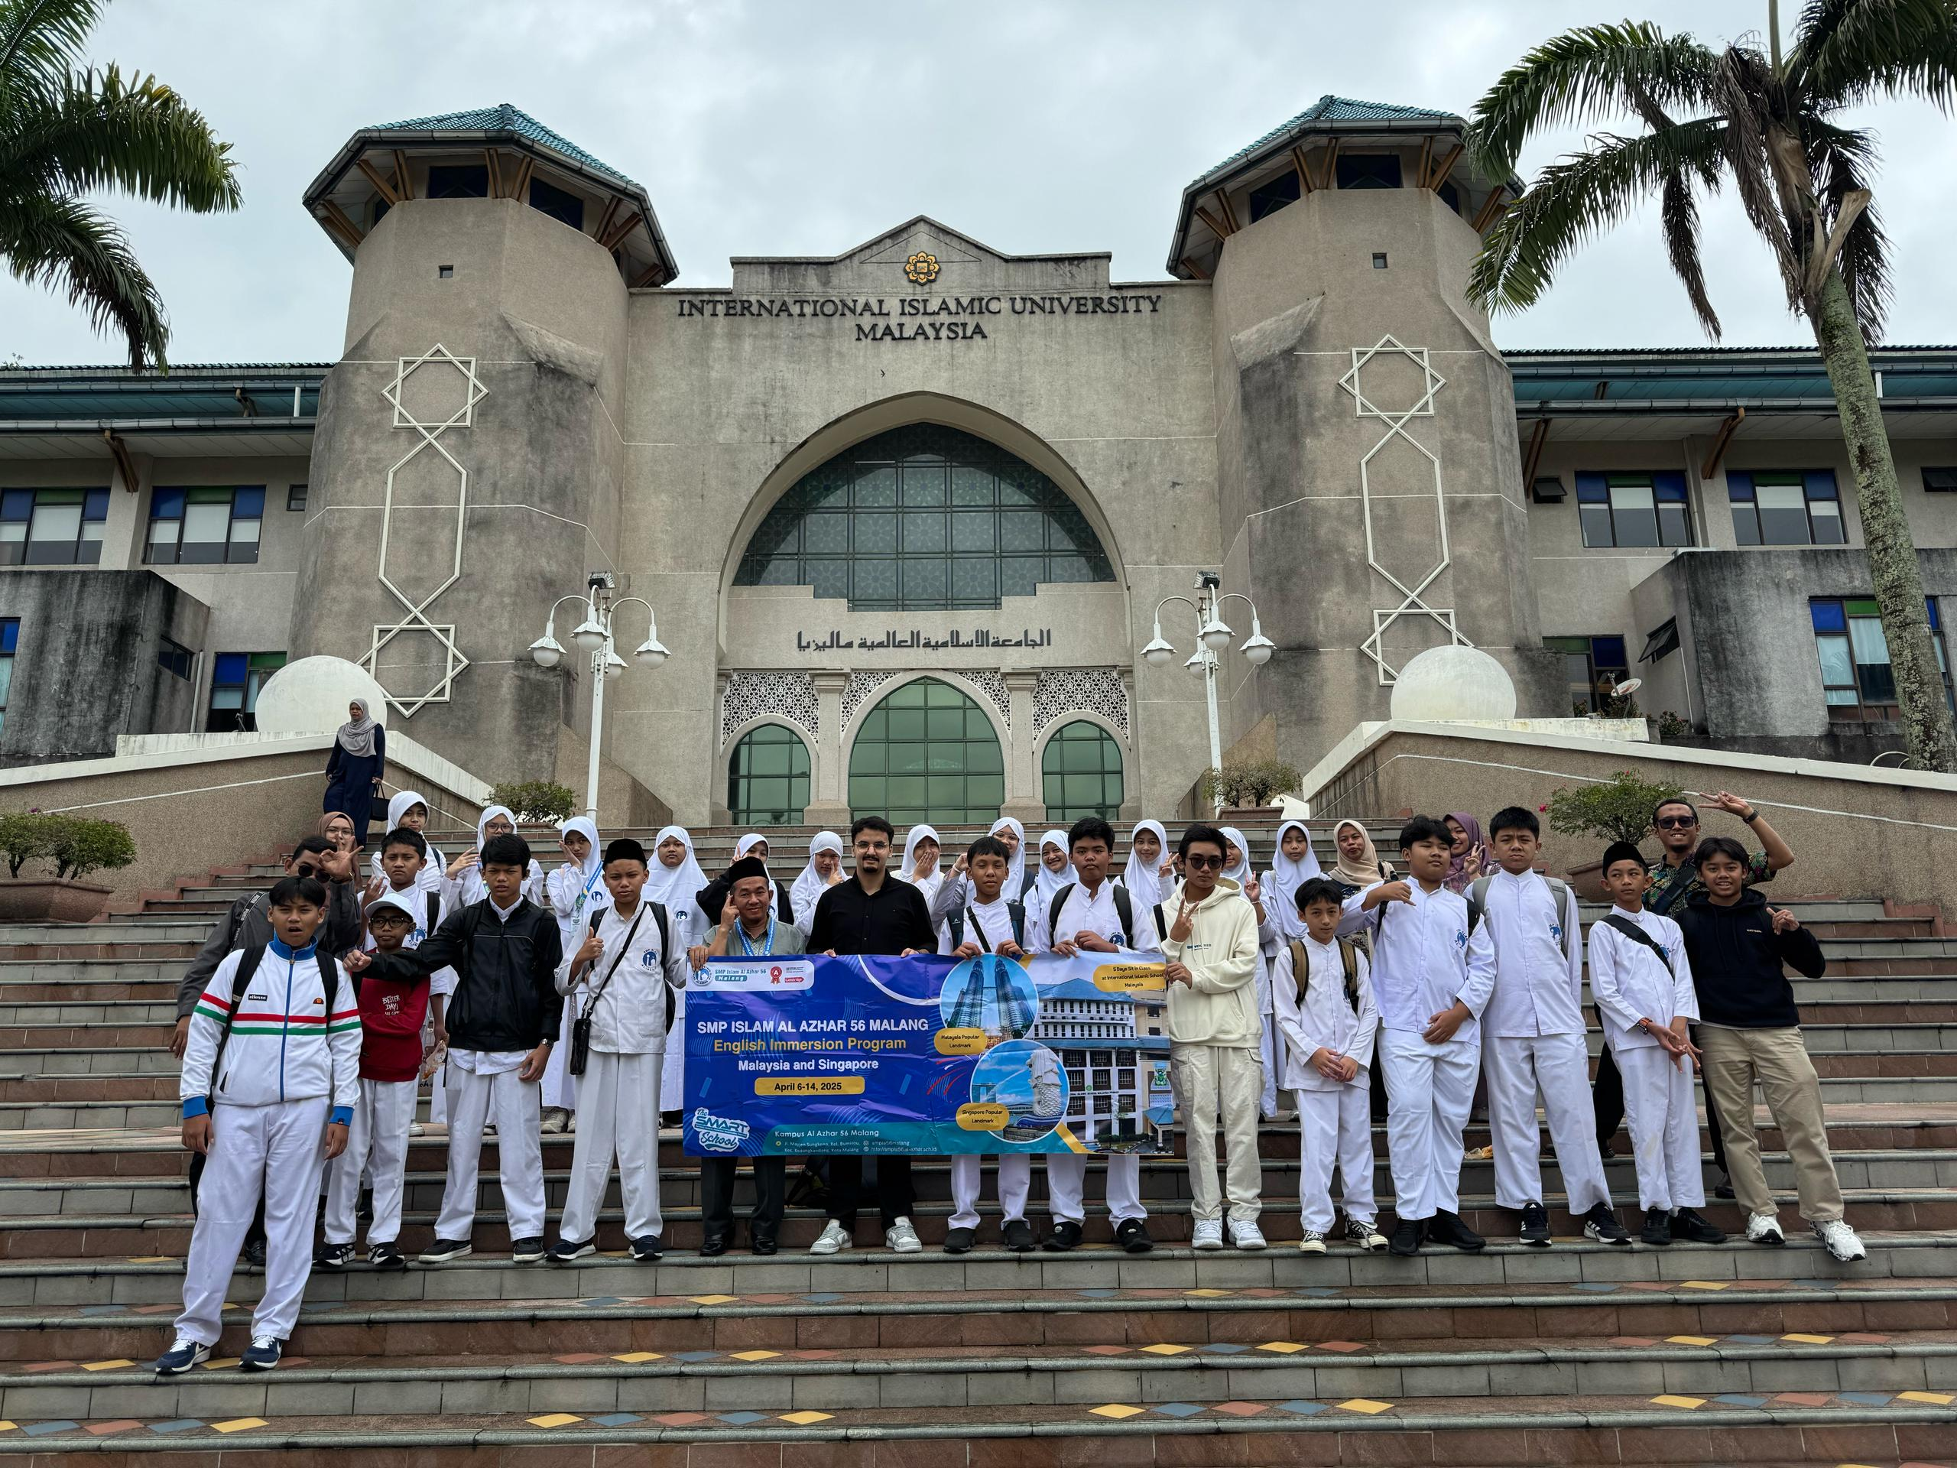
Appendix: AL Azhar 56 Malang---- Indonesian secondary school.

Appendix B—International Awards

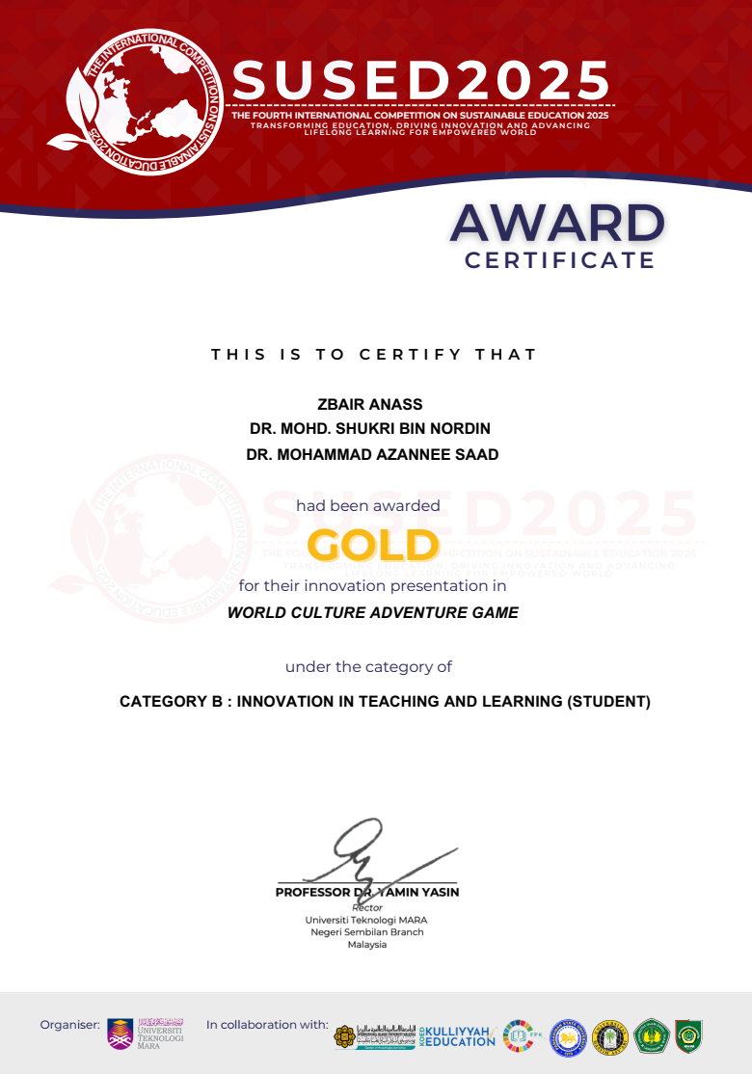
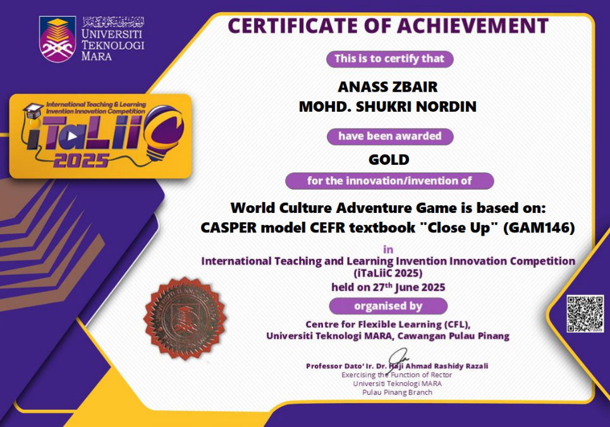

References
Adipat, S., Laksana, K., Busayanon, K., Asawasowan, A., & Adipat, B. (2021). Engaging students in the learning process with game-based learning: The fundamental concepts. International Journal of Technology in Education, 4(3), 542–552.
Alwaqdani, M. (2025). Investigating teachers’ perceptions of artificial intelligence tools in education: potential and difficulties. Education and Information Technologies. 30, 2737–2755.
Asrifan, A., Kaddas, B., Mulyadi, M., Pratiwi, W. R., Supriadi, S., & Jabu, B. (2025). Cross-cultural gamification: Understanding design and user experience in different cultural contexts. In Enhancing Engagement With Gamification: Education, Business, and Healthcare Perspectives (pp. 1–28). IGI Global Scientific Publishing.
Chauhan, R. S. (2022). Unstructured interviews: are they really all that bad? Human Resource Development International, 25(4), 474–487. https://doi.org/10.1080/13678868.2019.1603019
Clark, D. B., Hernández-Zavaleta, J. E., & Becker, S. (2023). Academically meaningful play: Designing digital games for the classroom to support meaningful gameplay, meaningful learning, and meaningful access. Computers & Education, 194(104704), 104704. https://doi.org/10.1016/j.compedu.2022.104704
Ebrahimzadeh, M., & Sepideh, A. (2017). THE EFFECT OF DIGITAL VIDEO GAMES ON EFL STUDENTS’LANGUAGE LEARNING MOTIVATION. Teaching English with Technology, 17(2), 87–112.
Eden, C. A., Chisom, O. N., & Adeniyi, I. S. (2024). Cultural competence in education: strategies for fostering inclusivity and diversity awareness. International Journal of Applied Research in Social Sciences, 6(3), 383–392.
Gee, J. P. (2003). What video games have to teach us about learning and literacy. Computers in Entertainment, 1(1), 20–20. https://doi.org/10.1145/950566.950595
Handayani, P. W., Raharjo, S. R., & Putra, P. H. (2021). Active student learning through gamification in a learning management system. Electronic Journal of E-Learning, 19(6), 601–613. https://doi.org/10.34190/ejel.19.6.2089
Hartono, H., Suparto, S., & Hassan, A. (2021). Language: A ‘Mirror’of the Culture and Its Application English Language Teaching. Linguistics and Culture Review, 5(1), 93–103.
Huda, M., & Bakar, A. (2024). Culturally responsive and communicative teaching for multicultural integration: qualitative analysis from public secondary school. Qualitative Research Journal, 24(4), 434–453. https://doi.org/10.1108/qrj-07-2023-0123
Jannah, R., Khairunnisa, Sholeh, M., & Khaliq, R. (2024). Minimum Competency Assessment in Madrasah Ibtidayah. Al-Hayat: Journal of Islamic Education, 8(3), 923–936. https://doi.org/10.35723/ajie.v8i3.573
Kritsotaki, K., Castro-Kemp, S., & Kamenopoulou, L. (2025). Digital storytelling: An educational approach for enhancing dyslexic children’s writing skills, critical and cultural learning. Journal of Research in Special Educational Needs, 25(2), 289–311.
Pishchanska, V., Altukhova, A., Prusak, Y., Kovmir, N., & Honcharov, A. (2022). Gamification of education: innovative forms of teaching and education in culture and art. Eduweb, 16(2), 119–133. https://doi.org/10.46502/issn.1856-7576/2022.16.02.8
Wulantari, N. P., Rachman, A., Sari, M. N., Uktolseja, L. J., & Rofi’i, A. (2023). The role of gamification in English language teaching: A literature. Journal on Education, 6(01), 2847–2856.
Yehia, E. F., & Ali Amer Alkhashil, M. (2025). The Power of Digital Storytelling in Preserving Saudi Cultural Heritage and Fostering National Identity. Heritage & Society, 1–29.
Yu, Z., Gao, M., & Wang, L. (2020). The effect of educational games on learning outcomes, student motivation, engagement and satisfaction. Journal of Educational Computing Research, 073563312096921. https://doi.org/10.1177/0735633120969214
Zbair, A., Abd Halim, S., & Ahmad, I. B. S. (2025). Janitor Jill Cleaning Quest: A New Approach to Language Learning Through Gamification. International Journal of Research and Innovation in Social Science, 9(4), 5990–6000.

