Design and Development of User-Centered UI/UX for E-Commerce and Restaurant Websites
Samruddhi S. Kotwal
Department of AIDS,ADYPSOE PUNE
Affiliation of SPPU PUNE University
PUNE, INDIA
samruddhi.kotwal@dypic.in Ashwini Shinde
Department of AIDS,ADYPSOE PUNE
Affiliation of SPPU PUNE University
PUNE, INDIA
ashwinis@dypic.in

Abstract—This research paper discusses the work done during an internship that focused on creating User Interface (UI) and User Experience (UX) for restaurant and e-commerce websites. The study underscores the significance of user-centered design principles in enhancing usability, accessibility, and overall customer satisfaction. We used different tools, like Figma and Adobe XD, to make wireframes, prototypes, and final interface designs. The study also looks into usability testing, analyzing how users behave, and making design changes based on what users say. The findings demonstrate that well-structured UI/UX substantially improves user engagement, navigation efficiency, and conversion rates on digital platforms

INTRODUCTION
Websites are very important for business growth in the digital age, especially in the restaurant and e-commerce industries. A website needs more than just a pretty design; it also needs to be easy to use and navigate. Good User Interface (UI) and User Experience (UX) design can help with this.

UI is all about the visual parts, like the layout, colors, and fonts. UX, on the other hand, makes sure that the site is easy to use and that users are happy with it overall. This research paper is based on an internship in which I designed the UI/UX for e-commerce and restaurant websites to make them easier to use and more interactive.

We used tools like Figma and Adobe XD to do requirement analysis, wireframing, prototyping, and usability testing as part of the design process. User-centered design improves engagement, efficiency, and the overall performance of a website.

Literature Survey

UI and UX design issues are now highly significant due to the introduction of various platforms into our daily lives. Some individuals believe that good design matters because it makes the system easier to use, more efficient, and enhances user satisfaction. In particular, e-commerce platforms and even restaurant services are some of the places where effective design makes an enormous difference. [Norman, 2013; Garrett, 2011]

According to several reviews of HCI literature, user-centered design is regarded as one of the best methods for developing an effective interface. This is because the needs, expectations, and behaviors of users must be considered before the actual process of development. There are numerous studies done to assess the effectiveness of certain webpages, and it has been proven that those webpages that are built following the principles of user-centered design tend to outperform their peers.

From various sources, it can be found that user interface plays a key role when it comes to the decision-making process carried out by consumers in online stores. Thus, effective, easily navigable websites, proper product categories, and smooth purchase checkout procedures lead to high conversion rates, while complicated webpages are often neglected by customers. [Gould & Lewis, 1985; Abras et al., 2004].

In one restaurant literature article UI/UX design concepts like beautiful designs influence customers to visit restaurants. Customers are also influenced by high-quality images of food provided on websites easy availability of menu cards and ordering systems. Easy online reservation and quick ordering features along with mobile-responsive websites are expected to be seen by users. [Babich, 2018; Interaction Design Foundation, 2020]..
Responsive website designing is another topic which was discussed in literature. Websites these days should be responsive as per the resolution of different screens as mobile usage is in trend these days. Literature suggests that it increases accessibility and provides a better experience to the user. [Marcotte, 2010; Google UX Research, 2018].
Usability testing is another concept which is defined in one literature article. UI/UX designers give the product for testing to the end-users before delivering it to clients. It helps in understanding where their design lacks usability. Studies show that after several rounds of testing the quality of design improves. [Rubin & Chisnell, 2008; Nielsen, 1994].
Literature research agrees that UI/UX design is necessary for the betterment of product usability. Websites and applications are easier to use when they have a good User Interface and User Experience designed. Previous literature helped me to design better and efficient e-commerce website and restaurant website as I implemented all concepts.

System Architecture
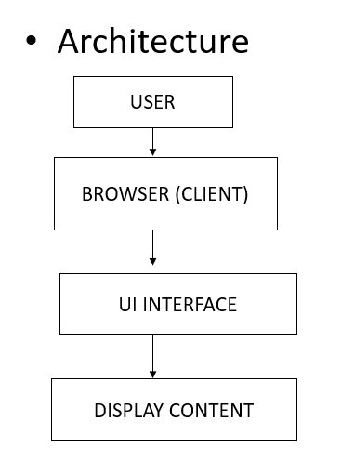

METHODOLOGY
A user-centered and structured approach was used to design the UI/UX for both types of websites, e-commerce and restaurant websites. There are a few stages included in the methodology, all of which are extremely important in designing and arranging the elements of a proper website.

1. Requirement Analysis

During this stage, the requirements for e-commerce and restaurant websites have been analyzed. One of the most important aspects that should not be overlooked at this stage is that there are certain aspects that need to be included in every kind of website and which cannot be forgotten. Among them are such features like shopping cart, filtering, products and product categories, sorting, checkout process, menus, tables reservation and contacts.

2. User Research

User research helps understand the behavior and preferences of users. It helps understand their needs better and analyze the mistakes that other existing websites have and which will help avoid making them during the website development.

3. Wireframing

During wireframing, the placement of contents, the arrangement of pages and general website navigation are considered. The design does not need to be thought about at this point.

4. Prototyping

The interactive prototypes were made with the help of design tools such as Figma and Adobe XD after completing the wireframe design process. The main aim in making the prototypes was to create an imitation of the interaction with the product. Prototypes were used for the navigation and functionality testing of the website.

5. UI Design

In this stage, different visual elements such as color, fonts, graphics, etc., were added to make designs according to the UI design guidelines. Special focus was laid on making designs for appealing interfaces of websites like the one for the e-commerce site and the restaurant site.

6. Usability Testing

To measure the usability of the interface that was designed, usability tests were conducted with the interaction with prototypes and gathering data regarding usability problems.

7. Iterations

In this stage, the necessary changes required to be made in the design were made after conducting usability testing.

8. Responsive Design

In this last stage, the designing was done by taking into account the principles of responsive design.

IV. IMPLEMENTATION

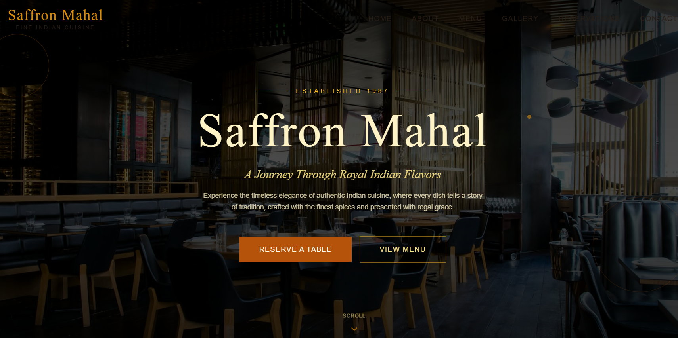

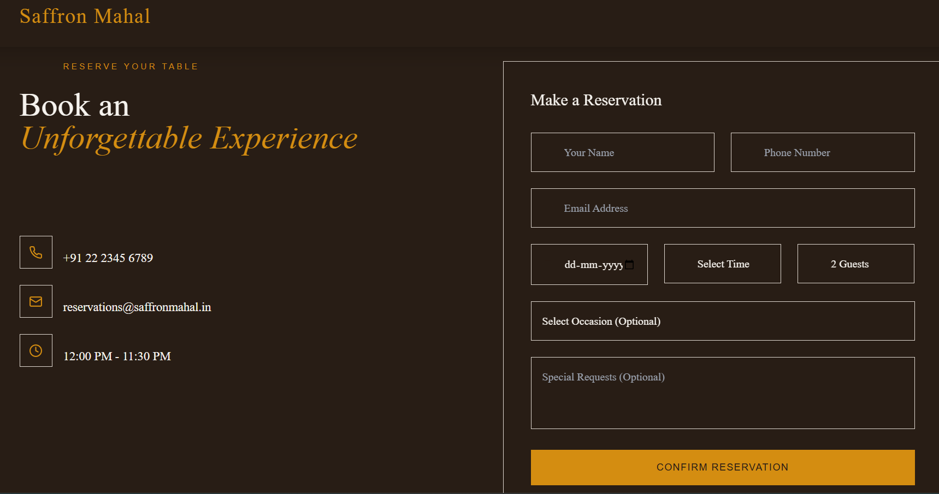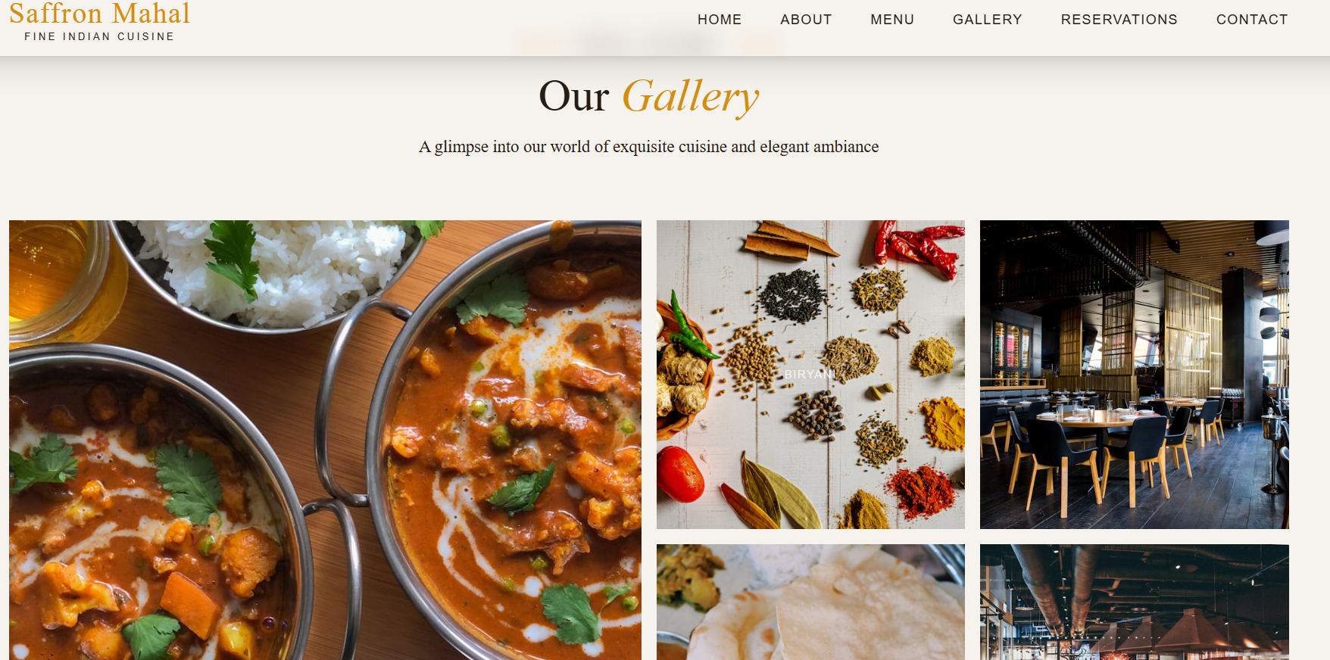

III. CONCLUSION

This research paper presents the internship work on designing UI/UX for e-commerce and restaurant websites, emphasizing a user-centric approach to create visually appealing and easy-to-use platforms. The project followed key stages such as requirement analysis, wireframing, prototyping, and usability testing, using tools like Figma and Adobe XD.

It highlights how effective UI/UX design improves user experience, simplifies navigation, and increases engagement and sales in e-commerce platforms, while ensuring smooth access to menus and ordering systems for restaurant websites. The study also stresses the importance of usability testing and responsive design for better performance across different devices.

IV. FUTURE SCOPE

1.Indeed, the area of UI/UX design has seen substantial progress due to rapid technological advancement and changing requirements of customers. While the research done within the course of the current internship provided an essential base for the continued development in the field, some trends might serve as future scope for work.

2.First, it is worth noting that the employment of such techniques as AI and ML in UI/UX design is anticipated to significantly revolutionize the process of producing goods. By collecting and analyzing customer data, companies will create customized offers that will promote better interaction of people with products of brands. For example, online shopping websites might include recommendations of goods based on user history. As for restaurants, personalized menu cards can be included according to previous consumer choices and preferences.

3.Additionally, a very interesting trend in the field involves employing AI and ML in promoting interaction between websites and consumers through advanced communication channels. By using sophisticated algorithms, chatbots will provide immediate responses to questions raised by users as well as assist them in finding necessary pages on the websites. Moreover, using voice interfaces, consumers will be able to browse websites by giving commands via voice prompt.

4.Another area that can be explored in this case is the use of AR and VR technologies on websites. For example, clothing websites can allow their customers to try different outfits without actually stepping into the store. Likewise, for restaurant websites, there is an option of making the experience of browsing better through the use of AR and VR technologies.

5.There are some future modifications that might take place in relation to the development of websites. Since there are many kinds of devices available through which one can browse websites such as phones, tablets, and laptops, among others, it is essential to create sites that work smoothly on any device.

6.One of the modifications in the future will involve using sophisticated technologies to assess the performance of websites. As such, it will be possible for the designers of the websites to adopt an effective approach towards analyzing data. This will help them to know the user's behavior and take necessary steps.

7.Another field in which improvements may be seen is accessibility. Creating sites that would enable people suffering from disabilities such as visual impairment, auditory troubles, and difficulties in controlling movements, could also become a step forward. Including proper colors contrasts as well as screen readers in addition to other methods such as proper navigation on the keyboard side could be beneficial for these people.

8.However, including payment options into the site for both purchases online and restaurants could also be done much more efficiently and safely. Securing the transactions along with making them easy could ensure safety and simplicity in using these payment options.

9.To sum up, it should be stated that intelligent integration of technology, improved accessibility, immersive experience, and reliance on data-based decision-making could be included in order to upgrade the design. Therefore, the UI/UX development from the internship can only develop further with the help of these tools.

References
[1] S. Kumar, R. Singh – “User-Centered Design Approach for Web Applications” – 2020

[2] A. Bank, K. Cao – “The Impact of UI/UX Design on E-commerce Conversion Rates” – 2021

[3] M. Patel, P. Shah – “Improving User Experience in Restaurant Websites Using UI/UX Principles” – 2021

[4] Interaction Design Foundation – “User Experience (UX) Design Process” – 2022

[5] Adobe Inc. – “Adobe XD User Guide for UI/UX Design” – 2022

[6] Figma Inc. – “Figma Interface Design and Prototyping Guide” – 2023

[7] Google – “Material Design Guidelines for Modern UI Development” – 2021

[8] Statista – “E-commerce User Behavior and UX Trends Report” – 2023

[9] Nielsen Norman Group – “Mobile Usability and UX Best Practices” – 2020

[10] ISO – “Human-Centered Design for Interactive Systems (ISO 9241-210)” – 2019

[11] A. Sharma, P. Verma – “Enhancing User Experience Using Responsive Web Design Techniques” – 2022

[12] R. Mehta, K. Joshi – “Analysis of UI Design Principles in Modern Web Applications” – 2021

