Evaluating Equity in AI-Sourced Visual Content: A Prompt-Aware Analytical Framework
N. Vaishnavi, Dr. B. Kalpana
Department of Computer Science, Avinashilingam Institute for Home Science and Higher Education for Women, Coimbatore-641043, TamilNadu, India.

Abstract
The emergence of AI-generated art has brought forward new issues related to representation and fairness in visual content. The goal of this work is to determine whether generative model’s interpretations of typical cues reinforce demographic bias. The system assesses how well questions match ethnicity, gender, and cultural identity using semantic similarity analysis via CLIP and real-world image retrieval through the Unsplash API. The Fairness Discrepancy Index (FDI), Stereotype Score, Diversity Index, and Representation Rate are among the key measures used to measure bias. Through an interactive Gradio interface, users may visually compare output disparities, receive inclusive options, and input prompts. According to the findings, generic prompts frequently result in unbalanced representations, underscoring the necessity of prompt-aware design and open assessment procedures to advance equity in AI-driven visual creativity
Keywords: Prompt engineering, Bias detection, Generative AI

1 Introduction
By enabling users to produce high-quality images with straightforward text prompts, the development of generative artificial intelligence has revolutionized the production of visual content. AI-generated art has become a crucial component of sectors like digital design, education, advertising, and media due to the extensive use of models like DALL·E, Midjourney, and Stable Diffusion. However, a lot of the large datasets that these systems are based on were scraped from the internet, and many of them have underlying cultural and social biases. Consequently, the images generated by these tools frequently depict marginalized communities and reinforce historical stereotypes, especially concerning gender, race, and cultural identity. Because of this, the images created by these tools frequently depict underrepresented groups and reinforce old stereotypes, especially those related to gender, race, and cultural identity. Given that AI-generated visuals are increasingly influencing public perception and forming narratives at scale, this pattern of biased generation presents a serious challenge. Even though these outputs seem neutral, they have the potential to subtly marginalized communities, skew representation, and prolong exclusion. The problem is made worse by the fact that this kind of bias is frequently ingrained subconsciously, making it challenging for users to identify and correct. Research that critically assesses the fairness of AI-generated imagery, creates techniques to identify representational imbalance, and suggests remedies that advance inclusivity and equity in machine creativity is therefore desperately needed. A larger movement toward responsible and human-centered artificial intelligence is supported by research into this aspect of AI, which also advances ethical technology development.

2 Literature Review
The fairness and bias inherent in generative AI systems have been critically assessed in recent research, with a focus on models such as CLIP and Stable Diffusion. More equitable image retrieval and captioning tasks are now possible thanks to SANER's introduction of a technique that eliminates societal bias in image-text representations without the need for manual annotations [1]. In order to address semantic segmentation bias, ReCLIP++ improved on CLIP, proving that even basic models need to be adjusted to prevent perpetuating demographic disparities [2]. Additionally, researchers looked at how data balancing strategies could enhance multimodal learning fairness, highlighting the important role that curated datasets play in reducing systemic bias [3]. Additionally, to make CLIP's zero-shot predictions more demographically representative, FairerCLIP suggested a technique based on replicating kernel Hilbert spaces (RKHS) to systematically debias them [4].
Another noteworthy contribution suggested prompt-aware fairness adjustments after auditing several text-to-image generators and finding that stereotype amplification still occurs in even the most advanced diffusion-based models [5]. Concerns regarding cultural visibility in automated media were raised by an intersectional analysis of visual AI, which revealed that current image-generation pipelines frequently homogenize or omit minority groups [6]. Additionally, it was discovered that image generators commonly found in commercial tools have a tendency to output outputs for generic prompts such as "beautiful person" that overrepresent Western features, exposing aesthetic bias encoded in training data [7]. Research on racial and gender identity also confirmed that when given professional roles, some models produce disproportionately white or male figures, indicating the need for clear demographic balancing [8][9].
The need for fairness evaluation frameworks in sensitive fields was highlighted by assessments conducted in the medical imaging domain, which showed that bias in representation can affect trust and adoption in healthcare-related visuals [10][11]. The visualization of image clustering around identity markers was made possible by analytical methods employing embedding-based models, like CLIP, which confirmed that minor modifications to prompt wording can have a substantial impact on generated content [12][13]. The persistence of occupational stereotypes was also studied by researchers, who observed that gendered assumptions are frequently reflected in the generated outputs from prompts such as "nurse" or "engineer" [14].
These findings were expanded to the fields of healthcare and education in subsequent research, which highlighted how skewed representations of professionals (such as scientists and doctors) can influence public opinion and lessen diversity in aspirational roles [15]. Concerns regarding the inclusivity of datasets and training objectives have been raised by the discovery that specific prompts consistently produce visually homogeneous results when AI tools are used in social analysis [16]. Further examination of visualizations produced by generative models such as DALL·E and ChatGPT revealed that visual bias may result from both textual and image priors, indicating that both model architecture and prompt interpretation bear some of the blame [17]. Bias-aware architectural designs are required for semantic vision tasks because CLIP-based segmentation frameworks have been demonstrated to inherit the same demographic imbalance problems observed in classification tasks [18].
Research on balancing multimodal datasets has demonstrated that the fairness of model outputs in zero-shot settings is strongly impacted by small changes in representation across training data [19]. Without the need for total model retraining, equitable zero-shot classification techniques such as FairerCLIP present promising avenues to reduce stereotyping in AI-generated content [20]

3 Methodology
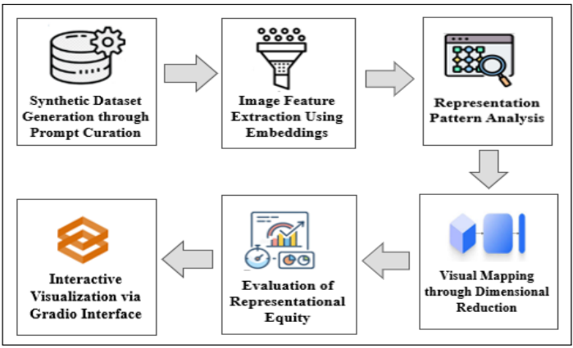Fig 3.1. A Prompt-Aware Analytical Framework

3.1 Synthetic Dataset Generation through Prompt Curation
The initial phase of the work focused on using carefully chosen prompt-based image simulation to create an organized synthetic dataset. This method focused on creating meaningful text prompts that reflect a variety of professions, cultural identities, and gender-based roles rather than using images from external datasets or AI-generated outputs. To add diversity in demographic representation, prompts like "doctor," "female doctor," "Indian teacher," and "African CEO" were purposefully chosen. Deeper investigation of the ways in which linguistic framing can affect perceived identity in subsequent visual tasks was made possible by this variation. Basic placeholder images were created using the Python Imaging Library (PIL) and embedded with the appropriate prompt text in order to simulate the dataset. Despite not being aesthetically accurate representations of actual people, these pictures worked well as placeholders for categorization and clustering. In order to facilitate effective batch processing, each file was methodically kept in directories that corresponded to its demographic group, such as "/doctor/" or "/bride/."
Three main elements were used in this phase: prompt curation for diversity, image creation through code-based simulation, and hierarchical folder organization for semantic grouping. The choice to create synthetic data allowed for complete control over prompt balance, class distribution, and label consistency without having to deal with the technical and moral challenges of using actual human imagery. In addition to ensuring that the data pipeline remained transparent, scalable, and free of external bias, this step served as the basis for later representation analysis

3.2 Image Feature Extraction Using Embeddings
In order to perform subsequent analysis like clustering and fairness evaluation, the second stage of the study concentrated on converting synthetic images into high-dimensional numerical representations. CLIP (Contrastive Language–Image Pretraining), a sophisticated multimodal neural network model created by OpenAI, was used to achieve this transformation. CLIP can comprehend and associate language and images based on their semantic similarity because it is specifically made to align textual and visual inputs in a shared embedding space. Despite being artificially created and having textual labels instead of intricate visual content, the images utilized in this work fulfilled the essential objective of capturing concept-level data obtained from carefully chosen prompts.
Each image was first preprocessed using a standardized transformation pipeline that CLIP's implementation provided with the goal to extract features. In order to guarantee compatibility with the model's input requirements, this involved tensor conversion, normalization, and resizing. Because of its ability to balance representational power and computational efficiency, the pre-trained ViT-B/32 variant of CLIP was used in this research. After processing, each image was fed through the model's visual encoder, which produced a 512-dimensional embedding vector. Based on the initial prompt that labeled the image, these vectors preserved contextual information while numerically encoding each image's semantic identity.
The resultant embeddings were saved and arranged with relevant metadata (e.g., category labels like “doctor,” “nurse,” or “CEO”) for use in metric-based bias evaluation, clustering, and visualization. This phase guaranteed consistency, scalability, and computational efficiency by using pre-trained architecture instead of training a custom image classifier. The CLIP embeddings served as the semantic backbone by successfully bridging the gap between textual prompt design and visual representation. Finally, it is supported in evaluating bias and representation in synthetic datasets driven by curated prompts by enabling sophisticated analytical processes.

3.3 Representation Pattern Analysis
This phase focused on comprehending the distribution of various identity groups across the carefully chosen prompts following the processing of each image and its association with a demographic category using CLIP embeddings. To identify trends in representation, the frequency of related demographic groups was computed for each role-specific prompt (e.g., “doctor,” “nurse,” or “bride”). In order to determine whether the dataset leaned toward stereotypical portrayals or reflected balanced diversity, this step was crucial.
The analysis included comparing the frequency of appearance of various groups in response to similar prompts and aggregating classification results in order to quantify imbalances. For a particular prompt, the Fairness Discrepancy Index (FDI), which shows the difference between the most and least represented groups, is a crucial metric. There may have been bias in the interpretation and visualization of prompts, as a larger FDI suggests a more skewed or unequal distribution.
Bar charts were used to visualize the demographic frequencies for each prompt category in order to improve interpretability. Disparities, such as one gender predominating in professional roles or one cultural background being underrepresented in traditional attire prompts, were evidently depicted in these visualizations. Bar charts provided both qualitative and quantitative insight into representational fairness, making it simpler to identify such trends quickly

3.4 Visual Mapping through Dimensionality Reduction
The subsequent phase in the methodology is to use dimensionality reduction to visualize the semantic relationships between image representations after the representation analysis. To make the data visually explorable and human-interpretable, the dimensionality of the image embeddings produced by CLIP had to be reduced because they were high-dimensional vectors, usually with 512 dimensions. t-Distributed Stochastic Neighbor Embedding (t-SNE), a non-linear dimensionality reduction method that works especially well for projecting intricate high-dimensional data into a two-dimensional space while maintaining local similarities, is used to accomplish this.
The embedding of each image, which has already been semantically encoded, and handled as a point in high-dimensional space in this step. Semantically similar images clustered closer together and dissimilar ones appeared farther apart on a 2D plot created by applying t-SNE to these points. The resulting scatter plot showed how the images became organized according to their content and the underlying structure that CLIP had captured.
Color-coding the visual map according to prompt category or demographic label improved interpretability. Visual comparison between categories could be achieved, for instance, by having points that represented images labeled as "CEO" appear in one color while "nurse" images appeared in another. Strong clusters centered on a single demographic group indicated a potential lack of diversity or bias in representation. On the other hand, scattered and intersecting clusters suggested a higher level of conceptual and visual diversity throughout the dataset.

3.5 Evaluation of Representational Equity
Assessing whether various demographic groups—based on gender, ethnicity, or cultural identity—are fairly and proportionately represented across the different prompt categories is the main goal of this phase. This research examines whether the dataset represents an inclusive and objective representation of people in roles like "doctor," "CEO," or "bride" after grouping the images into semantic and demographic clusters. The goal is to assess how prompt-driven visual content may reflect or reinforce existing social biases rather than determine technical accuracy. This evaluation is necessary because generative image systems are being used more and more in fields like media, advertising, and education, where skewed visual representations have the potential to marginalize particular communities or reinforce negative stereotypes. The project seeks to make sure that content creation is in line with moral and inclusive principles by examining representation through a fairness perspective.
The primary evaluation metrics to measure representation equity:
● Representation Rate: This measure determines the proportion of images in a prompt category that are assigned to each demographic group. It aids in determining whether some identities are underrepresented in the visual space while others predominate.
● Fairness Discrepancy Index (FDI): The difference between the most and least represented demographic groups for a given prompt is measured. A balanced distribution is indicated by a low FDI value, whereas a large disparity is implied by a high value.
● Stereotype Score: This score indicates how well the output patterns fit into prevalent societal stereotypes, such as the idea that doctors are primarily men or that brides are only dressed in white. It is derived using heuristic mapping of known biases and frequency trends.
● Diversity Index (Shannon Entropy): This statistical measure captures the variety of demographic representations in the dataset. A higher entropy value indicates a more diverse and inclusive set of image outputs, while lower values suggest dominance by one or two identity types.
These metrics work together to provide social insight and statistical precision. The assessment determines whether variations in prompt wording (for example, "leader" versus "female leader") result in appreciable variations in demographic inclusion. Additionally, it indicates whether prompt-neutral images exhibit unintentional conformity to prevailing social norms.

3.6 Interactive Visualization via Gradio Interface
The research's final step incorporates an interactive element that, via an intuitive user interface, enables users to interact directly with the findings. In this step, a web-based visualization tool that was developed with Gradio—an open-source Python library that makes it possible to create customizable machine learning interfaces and demos—is deployed. This step turns the project into an exploratory platform that is accessible in real time, instead of restricting the analysis to offline outputs or static graphs.
With this interface, users can enter a text prompt, like "CEO" or "female teacher," and get immediate visual feedback. Using a curated visual dataset or API like Unsplash, the system dynamically retrieves a representative image based on the prompt while also suggesting an alternative inclusive prompt, like "Black woman CEO" or "teacher from India." In addition to demonstrating how wording affects representation, this instructs users on how to write more equitable prompts.
This interface's dual-display feature is what makes it unique; it allows users to see and compare how each phrasing changes the visual result by displaying the results for the original prompt and the revised inclusive prompt side by side. This also helps non-technical audiences understand and relate to the problem of representation bias. In order to maintain transparency and facilitate additional auditing or improvement, the interface additionally records prompts and responses.
This step closes the gap between research and practical application by transforming the findings into an interactive experience. When utilizing generative systems, it promotes consciousness, introspection, and responsible design. Thus, by making the invisible patterns of bias visible, actionable, and correctable, the Gradio-based interface doubles as a demonstration tool and an educational aid, increasing the analysis's impact.

4. RESULTS AND DISCUSSION
Fig 4.1 shows the successful creation and organization of the synthetic dataset under the bias_simulated_dataset/ directory. A particular prompt category reflecting different professional and demographic identities is represented by each subfolder (e.g., doctor/, female_doctor/, ceo/, indian_bride/, female_leader/). Simple placeholder images created with Python's PIL (Python Imaging Library) are contained within these folders. Instead of showing actual people, these pictures are just plain white backgrounds with the appropriate prompt text (like "doctor 1") written on them.
This method maintains the dataset's complete experimental control and ethical soundness. It avoids the noise, privacy issues, and dataset imbalance that frequently plague web-sourced image collections by using text-labeled images rather than actual visuals. Additionally, the uniform formatting guarantees that every category begins with an equal number of samples, providing a fair foundation for subsequent representation analysis and model evaluation. This stage creates a clear, prompt-driven framework for investigating the ways in which language affects AI pipeline representational patterns.
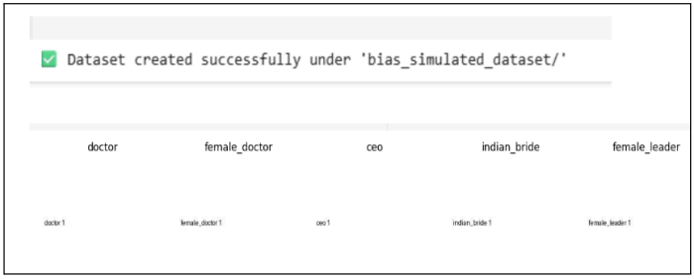
Fig. 4.1 Synthetic Data Generation
Fig 4.2 demonstrates that the CLIP (Contrastive Language–Image Pretraining) model was successful in extracting visual features from 100 images. Despite being artificially created with only text labels, each image has undergone processing to create a distinct numerical vector that encapsulates its semantic and visual content. Each image in a high-dimensional space is represented mathematically by these vectors, also referred to as embeddings. As a result, the dataset is now prepared for a thorough representational analysis, guaranteeing that every image has been successfully encoded.
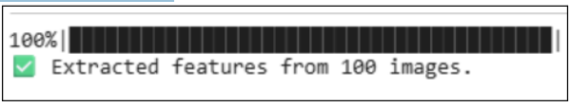
Fig 4.2 Feature extraction
Fig 4.3 shows the demographic classification of the image dataset has been successfully completed using the CLIP model. The demographic labels "white man," "Indian man," "white woman," "Asian man," "Black man," and "Asian woman" have been assigned to each image based on the semantic interpretation of the image content in relation to predefined textual categories.
The bar chart visually presents the count of images assigned to each demographic as shown in Fig 4.4. It is evident from the data that "white man" is the group most commonly represented (37 images), whereas "Asian woman" only appears once. This glaring distributional discrepancy draws attention to an imbalance in the dataset's representation of various groups.
The Fairness Discrepancy Index (FDI), which calculates the difference between the most and least represented groups, is used to quantify this imbalance. The FDI in this instance is 36%, which suggests a sizable representation gap. This result demonstrates that the interpretation produced by the CLIP model has a tendency to favor some demographic groups over others, even in the presence of a controlled and balanced dataset setup. Potential underlying biases in the model's training data or semantic associations are reflected in this skewed representation. These results highlight the significance of critically analyzing the inference of demographic attributes by AI systems, particularly when those systems are employed in delicate applications involving fairness, inclusion, or representation.
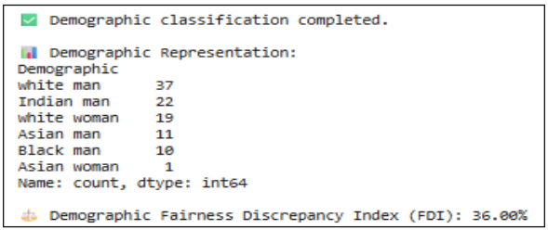
Fig. 4.3. Demographic Representation

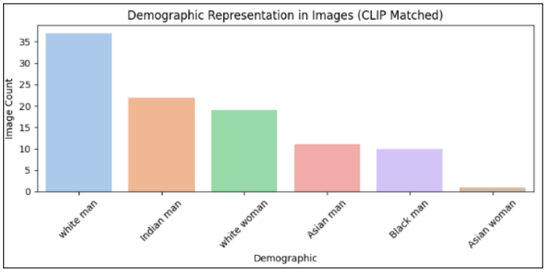
Fig. 4.4 Demographic representation using bar chart
The result of using the t-SNE (t-distributed Stochastic Neighbor Embedding) algorithm on high-dimensional image features obtained from the CLIP model is shown in the Fig. 4.5. By condensing the embeddings into two dimensions, this dimensionality reduction technique makes it simpler to visualize how semantically similar or dissimilar the images are based on the model's understanding. A single image is represented by each point on the plot, and the colors distinguish images according to the prompt categories used when creating the dataset—for example, "doctor," "female_doctor," "black_ceo," "Indian_bride," "leader," and others. The development of discrete clusters suggests that the model assigns these prompts non-overlapping semantic representations and interprets them as meaningfully different. It seems that the model detects internal consistency within each prompt group based on the existence of densely packed clusters. The division of groups, particularly identity-related ones (such as "CEO" versus "female_CEO" or "black_CEO"), may, nevertheless, also indicate that the model is promoting categorical distinctions that might be a reflection of prevailing social stereotypes. The model's learned semantics may be skewed by the underlying training data, which could indicate a potential bias if prompts like "CEO" consistently cluster closer to representations aligned with white males while "female_CEO" or "black_CEO" form distant groups. Instead of reflecting diversity in the real world, these spatial separations may suggest that the AI system handles socially constructed roles in a categorized manner.
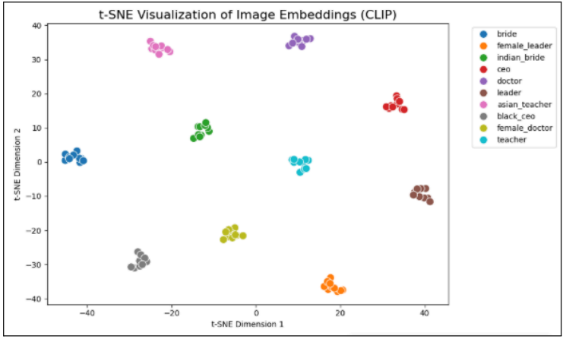
Fig. 4.5. t-SNE Visualization of Image Embeddings
Fig. 4.6. Shows the comprehensive analysis of how fairly different demographic groups are portrayed in response to identical prompts. According to the representation rate, white men make up 37% of the generated images, whereas Asian women only make up 1%, indicating a significant demographic gap. The 36% Fairness Discrepancy Index (FDI) provides a quantitative representation of this imbalance. The system's strong preference for particular identities is indicated by such a high FDI, which could strengthen cultural dominance and exclusion. This concern is further supported by the stereotype score, which shows that the AI model has a tendency to follow societal biases when imagining professional roles. White men scored 0.9, while Asian women scored 0.2. Furthermore, the Shannon Entropy, or Diversity Index, is 1.53, indicating moderate but not ideal diversity. When these metrics are combined, it becomes easier to assess both the existence and severity of representational imbalance. This assessment lays the foundations for interventions that support equity and inclusivity in generative AI outputs and is essential to comprehending how neutral AI systems may reinforce past biases.
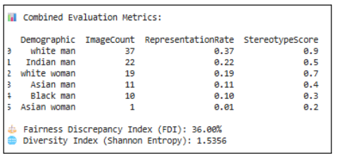
Fig. 4.6. Evaluation of Representational Equity
An unequal distribution of demographic representation is evidently highlighted by the bar chart visualization, which is displayed in Fig. 4.7 and 4.8. The stereotype score and representation rate are highest among white men, suggesting a significant bias in the generative outputs. Asian women and other marginalized groups, on the other hand, are notably underrepresented, which reflects differences in inclusivity and fairness.
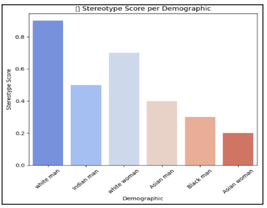
Fig. 4.7. Stereotype score visualization
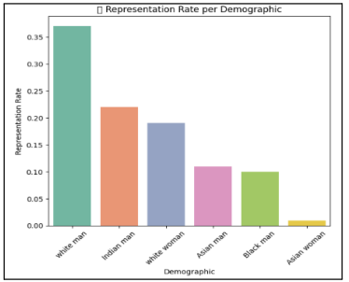
Fig. 4.8. Representation rate visualization
The Bias-Aware Prompt Evaluator web interface was designed to assess the implicit bias in text prompts submitted by the user. As shown in Fig. 4.9, the interface presents a clean input section where the user can enter any descriptive text prompt—for instance, the term “Doctor”. Once the user clicks Submit, the system analyzes the semantic characteristics of the prompt using a pre-trained CLIP model. The analysis section on the right displays the original prompt, the top demographic match (in this case, white man), and a similarity score indicating confidence in that match. A rewritten version of the prompt—for example, “an Indian woman doctor”—is automatically suggested to promote demographic inclusivity in image generation.
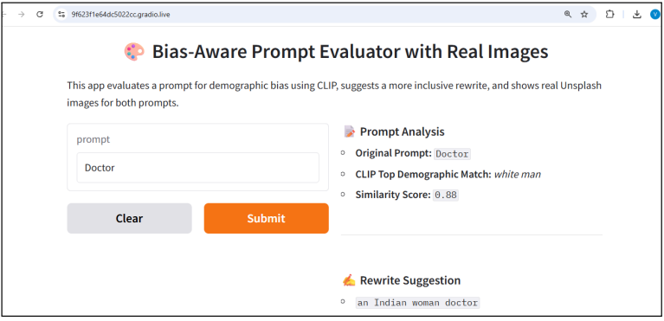
Fig. 4.9. Bias-Aware Prompt Evaluator using Gradio

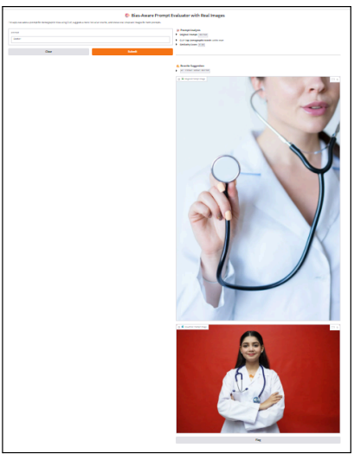
Fig. 4.10. Output Images for Original and Rewritten Prompts Displayed Side by Side
Upon submission, as depicted in Fig. 4.10, the interface proceeds to fetch two real-world images through Unsplash's API. The first image corresponds to the initial prompt (“Doctor”), reflecting the demographic bias predicted by the model. The second image is generated from the suggested inclusive prompt (“an Indian woman doctor”), showing improved demographic balance. By visually comparing these two outputs side by side, users gain a deeper understanding of how word choices affect the representation outcomes in generative AI systems. This not only highlights the existing biases in text-to-image generation but also provides a direct tool to mitigate such issues through informed prompt design.

CONCLUSION AND FUTURE SCOPE
This research critically examines the ways in which prompt phrasing affects the representation of demographics in AI-generated or AI-sourced imagery, exposing glaring differences in how gender, race, and cultural identity are portrayed. The work reveals the existence of underlying stereotypes and unequal representation patterns through a methodical process that includes feature extraction, bias analysis, interactive evaluation, and simulation of synthetic datasets. Including a user-friendly interface that provides inclusive rewriting suggestions and real-time feedback further raises awareness.
This work paves the way for future developments such as adding real-world AI-generated content to the dataset, incorporating multimodal bias detection, and creating adaptive learning mechanisms that continuously improve model behavior in response to fairness constraints. To guarantee more diverse, equitable, and socially conscious generative systems, ethical standards must be established, and fairness-aware design must be integrated into popular generative systems.

REFERENCES
[1] Hirota, Y., Chen, M.-H., Wang, C.-Y., Nakashima, Y., Wang, Y.-C.F., Hachiuma, R.: SANER: Annotation-free societal attribute neutralizer for debiasing CLIP. arXiv preprint arXiv:2408.10202 (2024)
[2] Wang, J., Kang, G.: ReCLIP++: Learn to rectify the bias of CLIP for unsupervised semantic segmentation. arXiv preprint arXiv:2408.06747 (2024)
[3] Alabdulmohsin, I., Wang, X., Steiner, A., Goyal, P., D’Amour, A., Zhai, X.: CLIP the Bias: How useful is balancing data in multimodal learning? arXiv preprint arXiv:2403.04547 (2024)
[4] Dehdashtian, S., Wang, L., Boddeti, V.N.: FairerCLIP: Debiasing CLIP’s zero-shot predictions using functions in RKHSs. arXiv preprint arXiv:2403.15593 (2024)
[5] van Miltenburg, E., et al.: Auditing and instructing text-to-image generation models on fairness. AI and Ethics 5, 2103–2123 (2024)
[6] Veale, M., Binns, R.: Intersectional analysis of visual generative AI: The case of Stable Diffusion. AI & Society (2025). https://doi.org/10.1007/s00146-025-02207-y
[7] Luccioni, A.S., et al.: Easily accessible text-to-image generation amplifies demographic stereotypes at large scale. In: FAccT '23, pp. 2175–2194. ACM (2023)
[8] Fan, A., Rader, E., et al.: Racial bias in AI-generated images. AI & Society (2025). https://doi.org/10.1007/s00146-025-02282-1
[9] Gorska, M., Jemielniak, D.: Gender bias in visual generative artificial intelligence systems and the socialization of AI. AI & Society (2024). https://doi.org/10.1007/s00146-024-02129-1
[10] Hernandez, J., et al.: Gender bias in text-to-image generative artificial intelligence when representing cardiologists. Information 15(10), 594 (2024)
[11] Kaji, M., et al.: Uncertainty in visual generative AI. Algorithms 17(4), 136 (2024)
[12] Qiu, H., Dou, Z., Wang, T., Celikyilmaz, A., Peng, N.: Gender biases in automatic evaluation metrics for image captioning. In: Proc. EMNLP, pp. 8358–8375 (2023)
[13] Steed, C., Gan, J., Shih, W.: Exploring and reducing gender bias in CLIP. AI & Ethics (2024)
[14] Brown, T., et al.: Perpetuation of gender bias in visual representation of professions in the generative AI tools DALL-E and Bing Image Creator. Social Sciences 13(5), 250 (2023)
[15] Gordon, M., et al.: Toward fairness in artificial intelligence for medical image analysis: identification and mitigation of potential biases. Journal of Medical Imaging 10(6), 061104 (2023)
[16] Chickowski, A., et al.: Social biases through the text-to-image generation lens. In: AIES ’23, pp. 1–12. ACM (2023)
[17] McKenzie, G., et al.: Who is to blame for the bias in visualizations, ChatGPT or DALL-E? Information Ethics 6(5), 92 (2024)
[18] Wang, J., Kang, G.: Learn to Rectify the Bias of CLIP for Unsupervised Semantic Segmentation. In: CVPR ’24 (2024)
[19] Alabdulmohsin, I., et al.: Data balancing for multimodal fairness: lessons from CLIP models. arXiv preprint arXiv:2403.04547 (2024)
[20] Dehdashtian, S., Wang, L., Boddeti, V.N.: FairerCLIP: Tools for equitable zero-shot classification. arXiv preprint arXiv:2403.15593 (2024)

