The Impact of Artificial Intelligence on Education: A Survey
Abstract
This study presented the survey results on the attitudes towards the use of artificial intelligence (AI) in education. A convenience sample of 15 participants was drawn to answer a 10-question survey, which was designed using a combination of multiple-choice, drop-down menu, Likert scale, rating scale, and rank questions in Google Forms. In this study, it was found that the use of AI is high, with 53% of participants reporting using it either frequently or regularly. The mean rating of the impact was 4.13 5 (SD = 0.72). While 73% agreed that AI enhanced their learning performance, 87% of the students also implied that they have concerns about the ethics of AI. Using personalized learning was considered the most beneficial feature of AI. The results demonstrated the benefits and issues of incorporating the use of AI in education, and the need for institutional policies regulating the use of AI.
Keywords: Artificial intelligence (AI), education, survey research, academic performance, and ethics.
Introduction
The role of artificial intelligence (AI) in various fields has evolved, and education is no exception. The innovation of embedded intelligent tutoring systems, computer-based testing, and novel AI-powered language tools such as ChatGPT is transforming learning and teaching practices (Kasneci, 2023). As the role of AI increases in the realm of academics, it is important to understand perceptions of students and faculty of AI's potential and risks in order for them to guide policy and student learning.
The advantage of AI is the personalization of the learning process, improving accessibility and relieving teachers of the pressure to deal with all of the students' needs (Crompton & Burke, 2023). But development of academic integrity, discrimination, and excessive dependency are the challenges of deep learning, and are the biggest concerns with the integration of AI apps in education (Baidoo-Anu & Ansah, 2023). The current study provides a quantitative picture of the recent attitudes around the use of AI in education. The survey design was structured because quantitative survey designs are the best for measuring attitudes and behaviors in a specific sample (Zawacki-Richter et al., 2019).
Survey Design
A total of 10 questions were used in the questionnaire, which were grouped into four sections: demographic, frequency of use, impact of computing, and benefits priorities (Easterby-Smith et al., 2021). Five question types were used to meet the requirements of the various question types: multiple-choice, drop-down, Likert scale, rating scale, and ranking (Easterby-Smith et al., 2021). To supplement the quantitative data, a qualitative choice was provided by an optional open-ended question (Q10) (Walliman, 2021).
The demographic items were selected to be multiple-choice type because they are clear categorical data that can be responded to using statistical frequency analysis (Creswell & Creswell, 2018). The selection of the level of education was a drop-down menu, which reduced the decision-making burden of the respondent in the larger listing. The use of five-point Likert scales is pinned down to attitudinal items because this type of scale measures ordinal agreement or frequency with sufficient resolution (Liamputtong, 2020). Question 6 was a numerical rating scale, which enabled computing a mean impact value. Question (Q9) was a rank scale, as it asked the respondents to rank benefits instead of each being rated individually, resulting in more nuanced prioritization information (Saunders et al., 2019). Any issues of ambiguity, bias, and irrelevance, and finalized survey questions for the study were observed.
Methodology
A cross-sectional quantitative survey was used. An online survey was used through Google Forms and was distributed to 15 participants in 7 days with the support of networks through convenience sampling. This type of sampling was convenient for the exploratory nature of the study, as time was limited (Creswell & Creswell, 2018). The participants had to be aged 18 years or above, and must have used a digital device for study purposes for more than one year.
Ethical considerations were incorporated in the study. The researchers presented all respondents with a written statement (Saunders et al., 2023), stating the purpose of the study before responding to the questionnaire, which was considered informed consent. There was no personal information being collected as the demographic question was limited to a wide variety of categories rather than individuals to prevent them from being re-identified. All data was stored in a password-protected device and presented in a grouped form, survey research (Israel & Hay, 2006).
Results and Analysis
Demographic Profile
Most respondents were young and educated. Fig 1 demonstrated that the largest age group was 18–24 years (n = 5, 33%), followed by 25–34 years (n = 4, 27%). The 8 respondents (47%) were males, and six (40%) were females. Concerning the level of education, as presented in Fig. 2, the majority had a Bachelor's (n = 7, 47%), and three of them had a postgraduate degree (20%). The largest group in the occupation group was students (n= 5, 33%), followed by professionals (n= 4, 27%) and teachers (n= 3, 20%). These characteristics match a tech-savvy and well-educated sample that also had to interact with AI tools at school (Cohen et al., 2017).
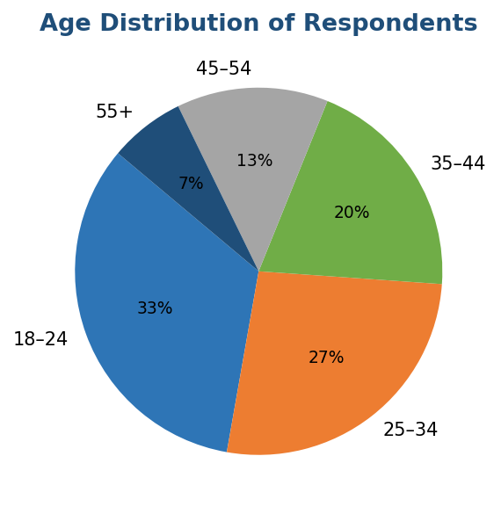
Figure 1. Age distribution of respondents (n = 15).
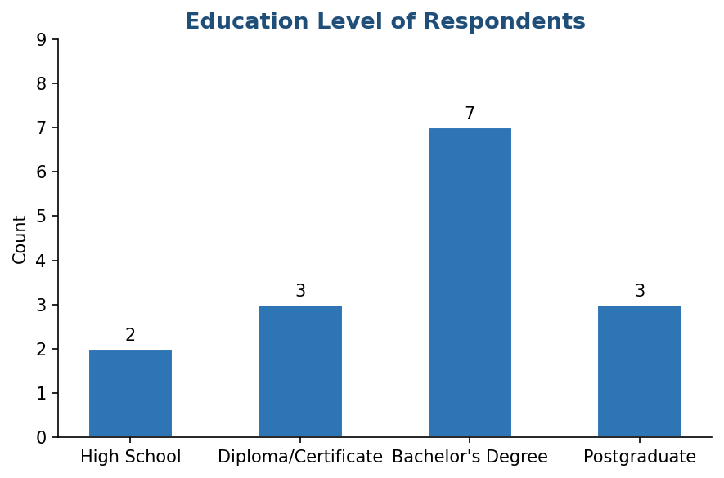
Figure 2. Highest level of education completed by respondents

AI Tool Usage Frequency
In Q5, the respondents were asked to rate the frequency of using AI tools for their learning. The result showed a high rate of adoption in Fig. 3, where 8 (53%) of the respondents said they used AI tools 'Often' or 'Always', and only 3 (20%) reported their use of AI tools as 'Never' or 'Rarely'. This can be compared to Kasneci et al. (2023) (A smaller part of the sample is still in the trial period of adopting such tools since 4 students (27%) said they used AI tools "Sometimes".
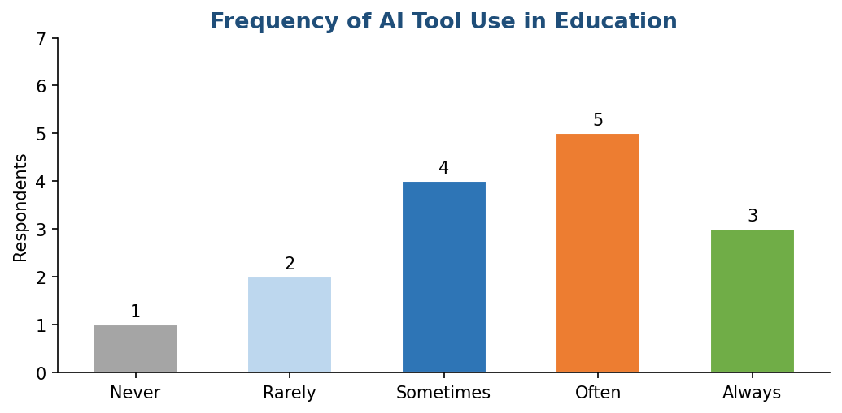
Figure 3. Frequency of AI tool use in educational contexts (Q5).

Perceived Impact on Learning
In Fig 4 and Table 1, the sample has a mean of 4.13 (SD =0.72) on the positive impact of AI in learning on the five-point rating scale (Q6). There were no ratings below 3, and 67% of the respondents gave 4 or 5 on the scale. This is in line with Crompton and Burke (2023), who used a survey to compare learner attitudes towards AI-enhanced learning environments. The standard deviation (SD) was low, which suggests a high level of agreement in the sample (Newhart & Patten, 2023).
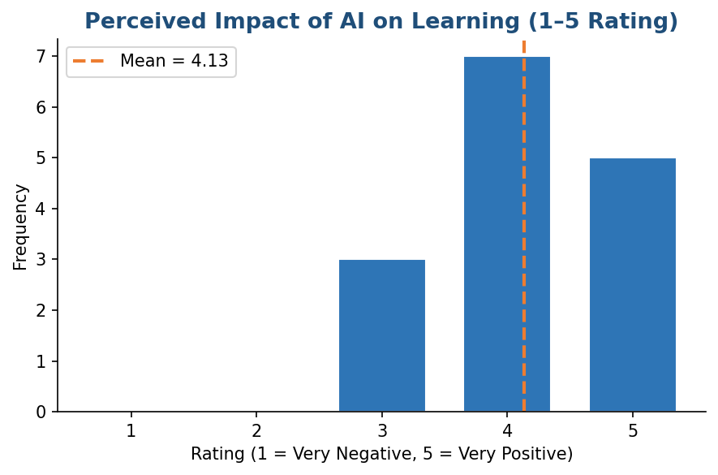
Figure 4. Distribution of perceived impact ratings with mean indicator (Q6)
Table 1. Descriptive Statistics for Perceived Impact Rating (Q6)
Statistic | Value
Mean | 4.13
Standard Deviation | 0.72
Minimum | 3
Maximum | 5
Respondents rating 4 or 5 | 10 (66.7%)

Academic Performance and Ethical Concerns
As demonstrated in Fig. 5, the responses to Q7 (AI tools improve academic performance) were overwhelmingly positive, 73% agreed or strongly agreed, 20% opted for neutral, and 7% for disagree. This finding supports Baidoo-Anu and Ansah (2023), who note that students increasingly see AI as a tool that enhances academic performance. The 20% of those having neutral responses could suggest a lack of understanding of causality, such as whether the AI help is causing improvements or it is one of the other factors.
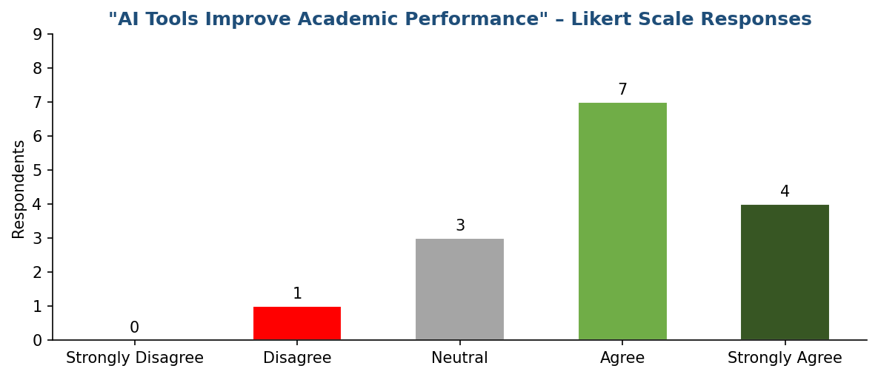
Figure 5. Responses to 'AI tools improve academic performance' (Q7).
In Fig 6, (Q8) was the most significant indicator on the ethical dimension of the survey, which showed 87% of the participants either agreed or strongly agreed that the use of AI in education is a matter of serious ethical concern, and 47% strongly agreed to this. No respondent disagreed. This supports the literature warnings about risks of cheating and plagiarism, invasion of privacy, and inequitable access to AI (Zawacki-Richter et al., 2019). The unanimous high level of agreement shows the importance of professional management (Bell et al., 2019).
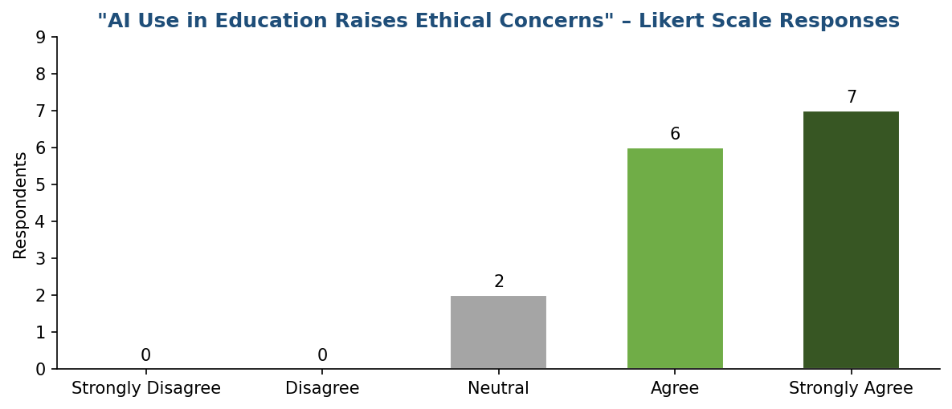
Figure 6. Responses to 'AI use in education raises ethical concerns' (Q8).

Prioritization of AI Benefits
The ranking question (Q9) asked the participants to identify the benefits of AI from most (1) to least (5) important. Fig. 7 indicates that the lower subjective importance was reflected in the lower average rank value. They were: 'Personalized learning' (M = 1.9), followed by 'Time efficiency' (M = 2.3), 'Accessibility' (M = 3.1), 'Instant feedback' (M = 3.4), and 'Resource variety' (M = 4.3). The focus on personalized learning can be considered a reflection of a broader pedagogical consensus that students find personalized teaching based on individual needs and speed valuable (Luckin et al., 2016). The high importance of time efficiency should also be considered, but educators should ensure that students do not trade-off the learning of the content to achieve a higher speed.
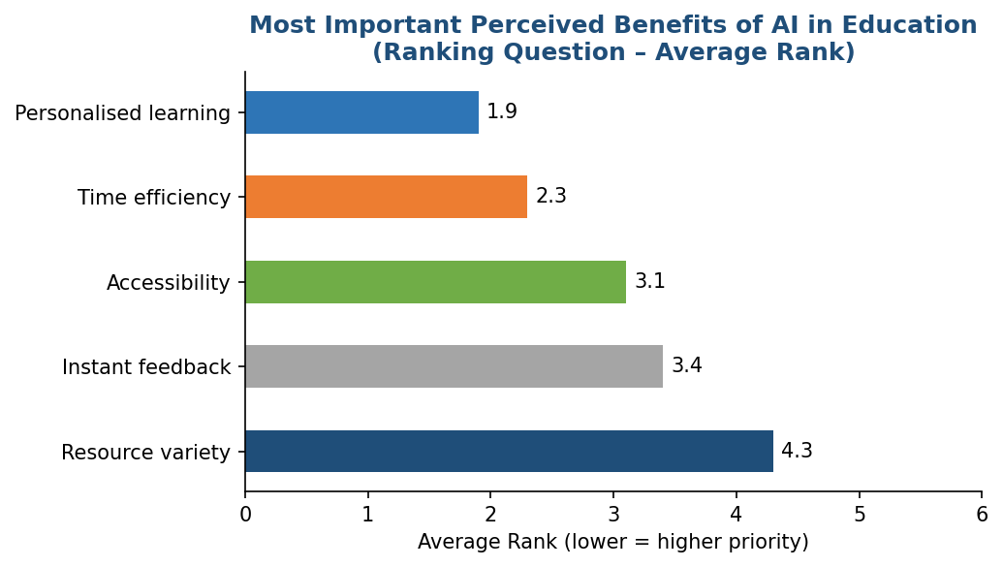
Figure 7. Average ranking of perceived AI benefits (Q9); lower score = higher priority.

Discussion
The combination of very positive ratings and universal ethical interest would indicate what Kasneci et al. (2023) describe as a double awareness: that the benefits of using AI have been discovered, as well as that the risks of free use are both academic and social. This is not a contradiction, but it is, however, evidence of reflexive use.
The positive use of AI is the learning support for individuals, which has practical applications. The most valuable are not those that generate content, but those that are able to consider particular learner needs, traits, and abilities, a notion consistent with that presented by Luckin et al. (2016) that the most educational potential of AI is not as a passive source of information, but as an adaptive and active learning partner.
There are several points of concern with the survey. The sample size (n=15) is also a convenience sample, and it includes younger and higher-educated participants, making it hard to generalize. Social desirability may also impact the responses, particularly to ethical questions. For a more accurate picture of the impacts of evolving attitudes on institutional policy development and adoption in the field of AI technologies, future research should use larger, representative samples and, to stay current, longitudinal studies.
Conclusion
The research adds empirical evidence about the use of AI in education. It demonstrates regular usage and perceived relevance in the usage of AI tools. However, to all respondents, ethics is a must. Schools and governments need to act on this duality by recognizing the pedagogic potential of AI and also devising effective and transparent means to manage issues related to integrity, equity, and privacy.

References
- Baidoo-Anu, D., & Ansah, L. O. (2023). Education in the era of generative artificial intelligence (AI): Understanding the potential benefits of ChatGPT in promoting teaching and learning. Journal of AI, 7(1), 52–62. https://doi.org/10.61969/jai.1337500
- Bell, E., Bryman, A., & Harley, B. (2019). Business research methods (5th ed.). Oxford University Press.
- Cohen, L., Manion, L., & Morrison, K. (2017). Research methods in education (8th ed.). Routledge.
- Creswell, J. W., & Creswell, J. D. (2018). Research design: Qualitative, quantitative, and mixed methods approaches (5th ed.). SAGE Publications.
- Crompton, H., & Burke, D. (2023). Artificial intelligence in higher education: The state of the field. International Journal of Educational Technology in Higher Education, 20(1), 22. https://doi.org/10.1186/s41239-023-00392-8
- Easterby-Smith, M., Jaspersen, L. J., Thorpe, R., & Valizade, D. (2021). Management and business research (6th ed.). SAGE Publications.
- Israel, M., & Hay, I. (2006). Research ethics for social scientists. SAGE Publications.
- Kasneci, E., Sessler, K., Kuechemann, S., Bannert, M., Dementieva, D., Fischer, F., Gasser, U., Groh, G., Gunnemann, S., Hullermeier, E., Krusche, S., Kutyniok, G., Michaeli, T., Nerdel, C., Pfeffer, J., Poquet, O., Sailer, M., Schmidt, A., Seidel, T., ... Kasneci, G. (2023). ChatGPT for good? On opportunities and challenges of large language models for education. Learning and Individual Differences, 103, Article 102274. https://doi.org/10.1016/j.lindif.2023.102274
- Liamputtong, P. (2020). Qualitative research methods (5th ed.). Oxford University Press.
- Luckin, R., Holmes, W., Griffiths, M., & Forcier, L. B. (2016). Intelligence unleashed: An argument for AI in education. Pearson Education.
- Newhart, M., & Patten, M. L. (2023). Understanding research methods: An overview of the essentials. Routledge.
- Saunders, M. N. K., Lewis, P., & Thornhill, A. (2019). Research methods for business students (8th ed.). Pearson Education.
- Saunders, M., Lewis, P., & Thornhill, A. (2023). Research methods for business students (9th ed.). Pearson Education.
- Walliman, N. (2021). Research methods: The basics (3rd ed.). Routledge.
- Zawacki-Richter, O., Marin, V. I., Bond, M., & Gouverneur, F. (2019). Systematic review of research on artificial intelligence applications in higher education -where are the educators? International Journal of Educational Technology in Higher Education, 16(1), 39. https://doi.org/10.1186/s41239-019-0171-0

