YOUTUBE NAVIGATOR: An AI Powered YT

Content Explorer

Mrs. Sruthi Thanugundala
Assistant Professor, Department of CSE (AI & ML) Keshav Memorial Engineering College (KMEC)
Hyderabad, India sruthi.kmec@gmail.com

Kandagatla Yashaswini
Department of CSE (AI & ML)
Keshav Memorial Engineering College (KMEC)
Hyderabad, India kyashaswini2608@gmail.com

N. Ankitha
Department of CSE (AI & ML)
Keshav Memorial Engineering College (KMEC)
Hyderabad, India reddyankitha2710@gmail.com

G. Harsha Vardhan
Department of CSE (AI & ML)
Keshav Memorial Engineering College (KMEC)
Hyderabad, India harshabunny4596@gmail.com

Abstract—In today’s digital environment, YouTube has become a platform that holds a lot of educational and informational content. Unfortunately, locating specific information from long YouTube videos or even whole channels has been difficult due to the limitations of current searching methods which are mostly title-based. This problem poses difficulties not only for students and educators, but for all content creators that need specific insights without watching whole videos. Available systems allow for simple keyword and transcript searches; however, they do not include a semantic layer or any form of interactive searching for the purpose of retrieving exact answers. This project presents YT-Navigator – an AI solution that allows users to search and interact with information on YouTube channels by using natural language queries. The RAG method allows us to retrieve information and answer questions by using the transcription of videos and their metadata. Specifically, we use an agentic AI algorithm to determine what is the most effective method of retrieval.
Index Terms—Agentic RAG, YouTube Content Search, Con-versational AI, Semantic Retrieval

- Introduction
The fast-growing video content in platforms such as YouTube has made it increasingly difficult for users to ef-fectively search for specific information contained in videos. Most of the regular search engines use metadata like titles, descriptions and tags which are often inaccurate reflections of the actual video content. This response mechanism means that users are forced to sift through long videos to extract relevant information manually, which is inefficient and results in a poor user experience.
To address this challenge, the proposed YT Navigator system utilizes a content-level search approach based on video transcripts. The system incorporates natural language processing (NLP) techniques to extract and process transcripts and to understand the semantic meaning of the video content. These transcripts are split into smaller chunks and converted to vector embeddings, allowing for similarity search using an
Identify applicable funding agency here. If none, delete this.
FAISS vector database. This allows the system to find relevant video segments according to the meaning rather than exact keywords.
Along with semantic search, the system uses a hybrid retrieval method that joins keyword matching and embedding similarity to boost retrieval performance. LangGraph also has a chatbot module based on Retrieval-Augmented Generation (RAG), which further enhances the interaction with users by enabling conversational queries. The chatbot fetches the relevant context from the database and generates meaningful responses. Thus the system becomes more intuitive and user friendly.
In summary, YT Navigator provides an effective and scal-able approach to explore large amounts of video content. This system greatly enhances the accuracy and usability of video search by integrating NLP, vector databases and agentic AI, so the user can obtain relevant content directly with minimal effort.

- Contributions

This paper discusses the development of an intelligent system for performing semantic video search and navigation through artificial intelligence methods. The contributions made through this paper can be summarized as below:
- The concept of a semantic search system, based on transcriptions, to achieve content-based retrieval rather than metadata-based retrieval from YouTube videos is introduced.
- The use of vector embedding and FAISS technology for performing searches by similarity among massive video content is included in this approach.
- A method of searching based on semantic search and key words matching technique is adopted to enhance the accuracy of retrieval.

- LangGraph is used in developing a chatbot system utiliz-ing the RAG approach to facilitate conversational inter-action.
- An optimized indexing system is designed to prevent scanning and processing of the previously analyzed videos for better performance and scalability. The design of an interactive web interface is done to facilitate user experience.
- Literature Survey and Related Work
Research conducted recently for the purpose of video under-standing and retrieval has been aimed at enhancing analysis of the content through AI-based methods. In their study, Phukan et al. (2024) proposed a model known as ECIS-VQG that used transformers (T5 and BART) and multimodal embeddings to generate questions on the basis of video content. Despite its effectiveness in generating questions and its suitability for educational purposes, the technique is more geared towards query generation than video segment retrieval.
On the other hand, Li et al. (2025) have proposed the LGRLN model that leverages graph-based representation learning and embeddings to generate summaries of videos as per language queries provided by users. By bridging the gap between language queries and important segments of the video, the LGRLN model facilitates video understanding. However, since it was specifically designed for summarization, it can be less useful for searching.
Yeh et al. (2025) have proposed a novel approach, AVATAAR, that relies on a pipeline-based agent for answer-ing video questions through iterative reasoning techniques. It integrates global and local reasoning along with feedback mechanisms to enhance the quality of answers. Nevertheless, being computationally expensive, it may prove ineffective when dealing with extensive video libraries.
Yang et al. (2025) presented the Exploration–Exploitation Agent (EEA), a system which used semantic-guided tree searches and dynamic query management for better compre-hension of long videos. While the EEA is an improvement over other video understanding systems, it works best on deep video analysis and not for actual retrieval purposes for users. Although there have been advances made with video re-trieval, there is currently no system available that incorporates semantic search using transcripts, vector retrieval, and con-versational interaction for YouTube videos. The proposed YT Navigator can fill the gap because it integrates vector retrieval using Faiss, hybrid retrievals, and RAG chatbots powered by
LangGraph.
- System Architecture
The YT Navigator system is presented as a modular client-server architecture that unifies data extraction from YouTube, transcript processing, semantic search and AI-based query handling into a single platform. The architecture has two major layers, the frontend layer and the backend processing layer.
The frontend offers an interactive user interface to the users to input a YouTube channel url and search video transcripts in
natural language. The backend handles extracting transcripts with AI models and embedding techniques, semantics and search vectors, and response generation.
- Frontend Architecture
The frontend is responsible for interaction and visualization of the search results. Users can provide a YouTube chan-nel link, ask questions about the video content, and obtain timestamp-based answers.
The frontend will call the backend using REST APIs to process the queries and get the results in real-time.

Key responsibilities of the frontend include:
  - Accepting YouTube channel input and validating the URL
  - Displaying video lists and allowing selection for scanning
  - Accepting user search queries and chatbot inputs
  - Presenting search results with timestamps and relevance scores
  - Providing an interactive chatbot interface

Frontend Technologies and Libraries
The frontend implementation uses the following libraries and frameworks:
  - React.js for building the interactive user interface
  - JavaScript and TypeScript for application logic
  - Axios for API communication with the backend
  - Tailwind CSS for styling and layout design
  - WebSocket or streaming APIs for real-time response updates
- Backend Architecture
The backend carries out the main processing operations of the system. It handles extraction of YouTube data, collection of transcripts, generation of embeddings, semantic search and generation of responses using AI.
The backend is written in Python and includes NLP li-braries, vector databases and AI APIs.

Backend Frameworks and Core Libraries
  - FastAPI for backend API services
  - Python 3.x for server-side processing
  - YouTube Data API for fetching channel and video details
  - LangChain for AI workflow orchestration
  - Sentence-Transformers for embedding generation
  - ChromaDB for vector storage and semantic retrieval
  - Groq API / LLM for question answering
  - Pydantic for data validation
- YouTube Channel Extraction Module
The channel extraction module is charged with obtaining data from YouTube channels, including video metadata via the use of the YouTube Data API. After inputting the channel URL by a user, the system will validate the URL and extract information about the channel, including its name, videos, descriptions, and IDs.
The obtained video data is passed to the transcript module for analysis.

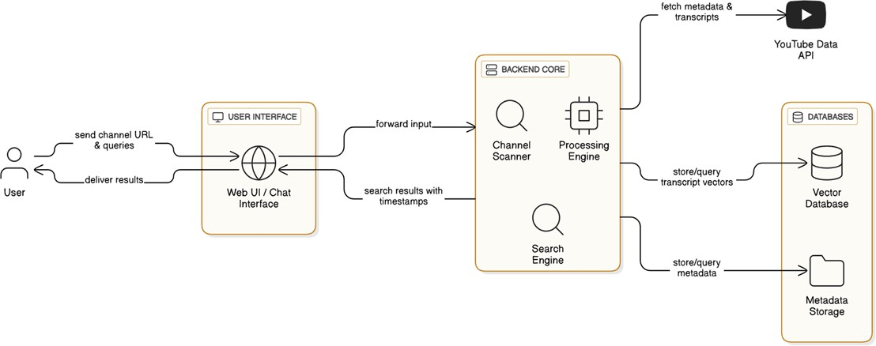

Fig. 1. Youtube Navigator System Architecture

- Transcript Processing Module
The transcript processing module extracts subtitles and transcript data from YouTube videos. The extracted text is cleaned and split into smaller chunks for semantic processing. The processed transcript chunks are converted to embed-dings by sentence-transformer models and stored in a vector
database for fast similarity search.
- Embedding Generation Module
In the embedding generation module, the model is used to generate vectors from the transcript text by leveraging sentence-transformer models. The vectors produced from this process convey semantic information about the content of the transcripts and help increase search accuracy.
The embeddings generated from the sentences are stored in the vector database.
- Vector Database and Storage
The platform employs vector storage for storing video transcript embeddings and associated metadata pertaining to YouTube videos. This layer facilitates quick search of seman-tically similar chunks of transcripts.

Information stored in vector database:
  - Information on channels
  - Video metadata
  - Transcript chunks
  - Timestamps
  - Embeddings
  - Query history of users
- Semantic Search Module
The semantic search module allows users to perform natural language searches on multiple videos in a channel.
When a user enters a query, the system converts the query into embeddings and compares the embeddings against stored
transcript embeddings using vector similarity search. The relevant transcript segments with timestamps retrieved are provided to the user.

- AI Query Response Module
The AI response module uses Large Language Models (LLMs) to produce contextual responses based on the retrieved transcript data.
The language model processes the extracted chunks of the transcript and produces meaningful replies. Users can get the required information quickly without watching the whole videos.

- Timestamp Retrieval Module
The timestamp retrieval module determines the precise po-sition of any relevant data in videos. Once semantic matching is performed, the extracted transcripts can be mapped to their corresponding timestamps.
This facilitates direct access to crucial parts of videos rather than having to search through lengthy content manually.

- Workflow of System
The workflow of YT Navigator starts when a user provides an input YouTube channel URL through the frontend interface. The backend system then fetches the channel data, gets its transcript, and embeds the text.
Once the user inputs their query in natural language, the semantic search component fetches the relevant transcripts stored in the vector database. The AI component is responsible for creating context-based responses and displaying them on the front-end interface.

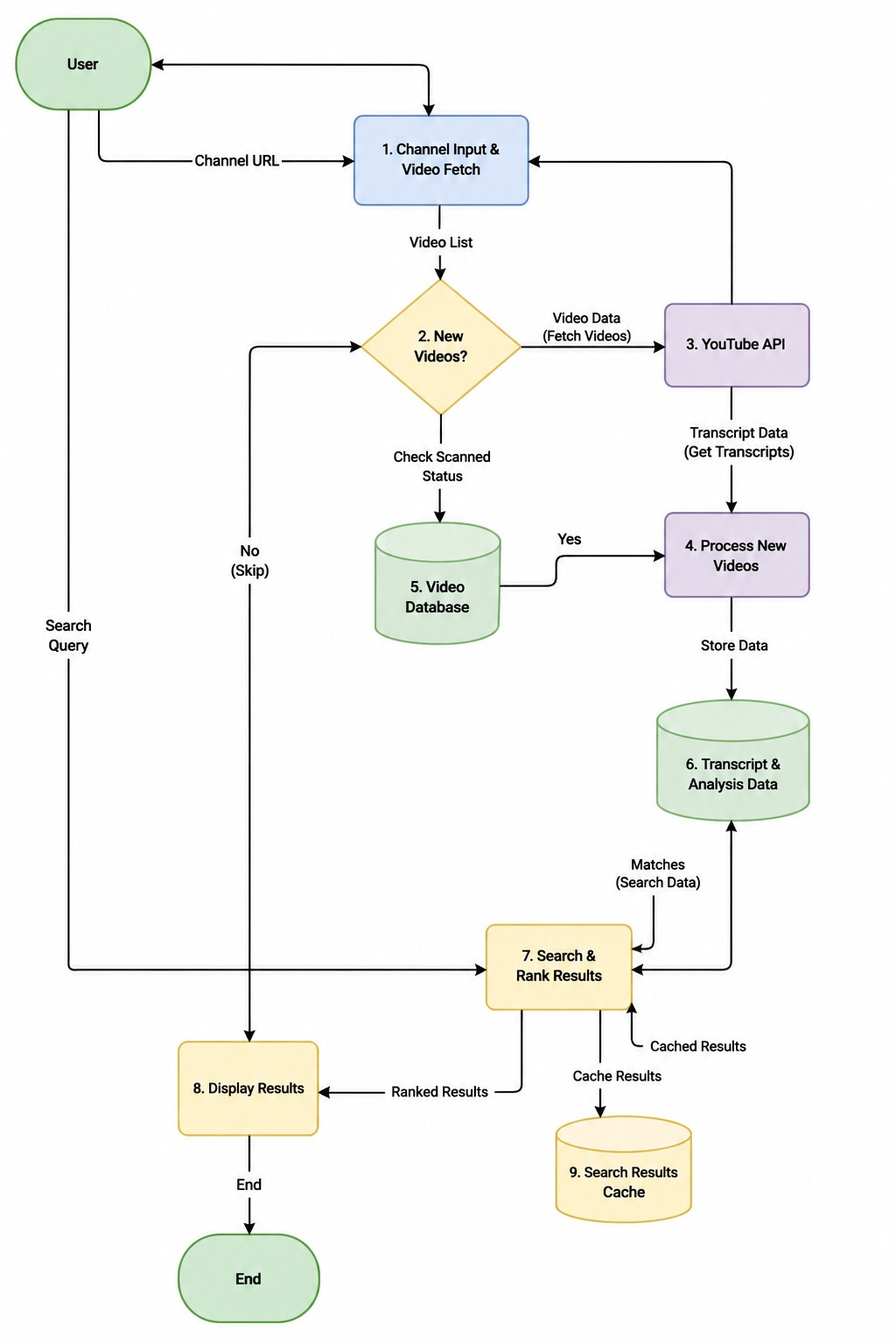

Fig. 2. End-to-End Workflow of YouTube Navigator System

- Methodology

The YT Navigator system uses a clear workflow for extract-ing, processing, analyzing, and retrieving information from
YouTube videos. The methodology combines transcript extrac-tion, semantic embedding generation, vector similarity search, and AI-based response generation to help users explore large amounts of video content efficiently. The process is divided

into several stages, with each stage performing a specific operation in the content retrieval pipeline.
- Channel URL Processing
The workflow starts when the user submits a YouTube channel URL through the frontend interface. The system first checks if the entered URL is valid for a YouTube channel. Once the URL is validated, the backend connects to the YouTube Data API to get channel-related information such as the channel name, a list of videos, video descriptions, and video identifiers. The extracted metadata is temporarily stored for further processing. This stage serves as the entry point of the system and allows automatic collection of channel content without any manual steps.
- Transcript Extraction
After collecting video information, the system extracts available transcript or subtitle data from each video. The transcript extraction module retrieves the spoken content along with timestamp information for each segment. The extracted transcript text is cleaned by removing unnecessary symbols, formatting issues, duplicate spaces, and irrelevant characters. This preprocessing step improves text quality and supports further semantic analysis. The cleaned transcript data serves as the main knowledge source used for semantic search and AI-based question answering.
- Text Chunking and Preprocessing
Because transcript data can be very large for long videos, the system divides the transcript text into smaller chunks for eas-ier processing. Chunking makes embedding generation more efficient and helps ensure accurate retrieval during semantic search. Each chunk includes a limited amount of transcript text, its corresponding timestamp, and video reference. The text is normalized and converted into a machine-readable for-mat before generating embeddings. This stage helps improve retrieval accuracy and lowers computational complexity during similarity comparisons.
- Embedding Generation
The embedding generation module turns transcript chunks into dense vector representations using sentence-transformer models. These embeddings capture the meaning of the tran-script content instead of relying solely on exact keyword matching. The generated embeddings are stored in the vector database and are later used for similarity-based retrieval oper-ations. Semantic embeddings help the system understand con-textual meaning and improve natural language query match-ing. This process allows for efficient semantic search across multiple videos within an entire YouTube channel.
- Semantic Search Processing
When the user enters a natural language query, the system converts the query into embeddings using the same model used for transcript processing. The semantic search module compares the query embeddings with stored transcript em-beddings using vector similarity search techniques. Based on
similarity scores, the system retrieves the most relevant tran-script segments related to the user’s query. Unlike traditional keyword search, semantic search improves retrieval accuracy by identifying contextual similarities between the query and the transcript content.
- AI-Based Response Generation
After retrieving relevant transcript segments, the system sends the content to a Large Language Model (LLM) for contextual response generation. The AI model analyzes the retrieved transcript chunks and generates meaningful answers that summarize or explain the requested information. This allows users to quickly understand video content without having to watch long videos. The AI response generation module improves user interaction and makes educational and informational video content more accessible.
- Timestamp Mapping and Result Display
The final stage of the workflow involves mapping the re-trieved transcript segments to their original timestamps within the videos. The system displays relevant answers along with video titles and timestamp references through the frontend interface. Users can directly navigate to the exact part of the video where the information is located. This greatly reduces the time spent manually searching through lengthy video content. The generated results offer an efficient and user-friendly method for exploring YouTube channel information using natural language queries.
- Implementation
The YT Navigator system is composed of several compo-nents involving web development (html/css/javascript), Natural Language Processing (NLP) approaches, semantic search mod-els, and vector database systems. This system is structured in a way that consists of a web-based user interface, and a back-end Python based server which would be used for transcript parsing and searching as well as generating a response from an AI model based on semantic similarity of the YouTube transcript to the input query.
The back-end of the application uses a modern web frame-work such as Fast API, a lightweight and fast web framework for building RESTful APIs, which handles the channel parsing, transcript extraction, embedding creation, semantic searching, and communicates to other modules such as the backend of semantic searching or any AI models that generate responses from the retrieved context of transcript data from the youtube videos.
The system uses the YouTube Data API in order to grab information about the channel, videos within the channel, and any available transcripts within youtube videos. Extracted transcript data needs to be pre-processed before semantic searching can occur.
Natural language processing and semantic search is made up of sentence-transformer models, as well as LangChain-based work-flows, used in order to convert text from the transcript, and also the input from the user query, into embeddings so

that semantic similarity of both may be taken into account in the search for transcript data within youtube videos.
These embeddings are then put into a vector data base (such as ChromaDB or FAISS), where the semantic similarity is searched in order to extract relevant information from the entire transcript that may be obtained across several videos in a given youtube channel. The relevant parts of the transcript may then be sent to any Large Language Model through AI APIs for context-based responses.
The web application that uses the web development tech-nologies mentioned previously is what the user interacts with. This allows the user to input a Youtube channel URL, enter a natural language query, search, and be provided with an interactive output of results at the specific time stamps in the videos of that youtube channel. All interactions with the backend system are made via REST API calls.
Overall the system architecture is modular and is extensible as far as AI models are concerned. It is possible to add many other different AI models to this project, as well as alternative ways to carry out both natural language processing on the youtube transcript and semantic searching in youtube videos.

- Results and Discussion

We have used several educational and informational YouTube channels to test the YT Navigator system and ana-lyzed its efficiency in transcribing YouTube videos and retriev-ing semantic search and AI question answering functionality. Our experimental results confirm the system’s effectiveness in utilizing NLP techniques to retrieve information from long-duration YouTube videos based on natural language queries.
The system successfully retrieved and stored channel data, video metadata and transcript information from several videos and used it for semantic retrieval functionality. We input few query in the form of educational, programming concepts, and technical concepts to the system and have verified that the se-mantic search module could effectively fetch and rank relevant transcript segments along with timestamps and link to relevant video information. The embedding based retrieval strategy outperformed traditional keyword based search methods by not depending on the exact match of keywords and finding semantically related video segments using vector similarity search. AI question answering model could generate mean-ingful, contextual answers with transcript chunks and help users get an idea about relevant information without the need to watch the whole video. The findings of the system after conducting tests are given below.
- It extracts the videos, channel data and transcripts from YouTube channels efficiently.
- It retrieves the transcript segments relevant to the search query.
- The system provides direct access to the relevant video content using timestamps.
- The retrieval time of the information using the system is faster than manual searching in YouTube.
- The proposed embedding based retrieval mechanism im-proved the contextual query understanding and hence the relevance of the search result over keyword based search.
- The natural language based queries can be easily pro-cessed.
The performance of the vector database greatly enhanced retrieval time as well as facilitated performing similarity search on the extracted transcript collection. The embeddings help overcome the limitation of exact keyword match of text information. The frontend interface provided an easy to use environment for navigating the channels and searching information using queries which presented users with the relevant transcripts in ranked order with timestamps.

- Initial System Output
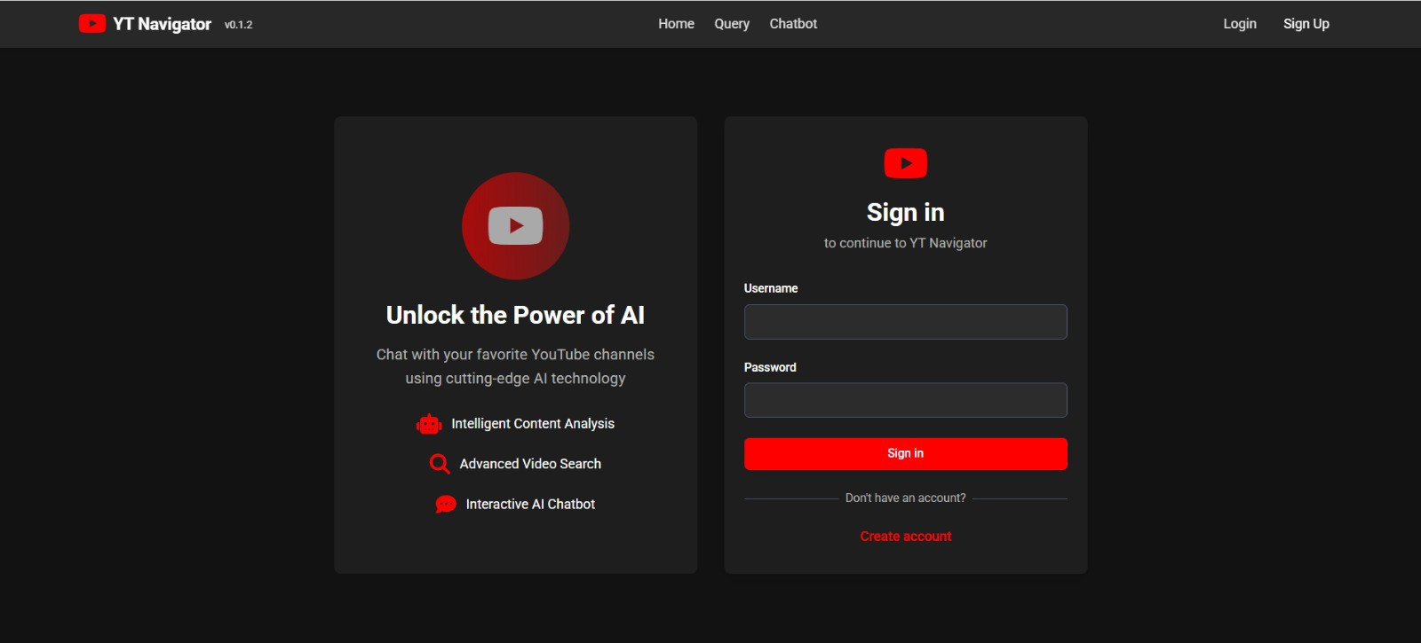
Fig. 3. YT Navigator Interface – Channel Input and Video Selection

The system then prompts the user for the input of a youtube channel url and performs some basic validation on the input. After successful validation the application then fetches the required channel details and displays the available videos for processing. This stage ensures that the correct channel and video details are retrieved before processing on the transcript.

- Video Scanning and Transcript Processing
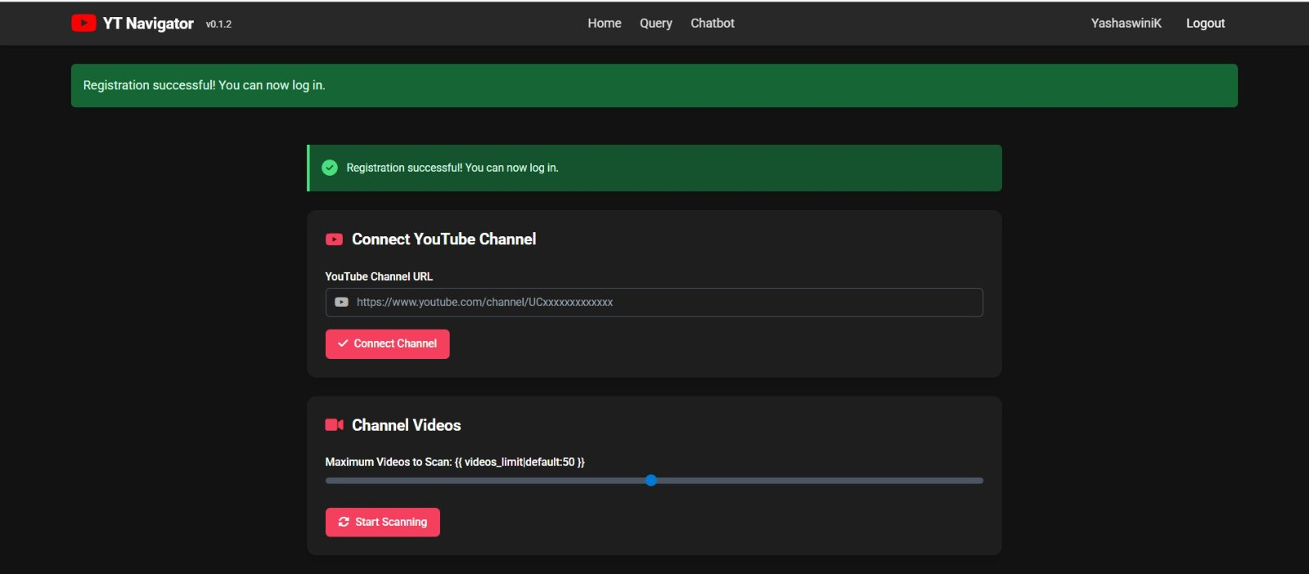
Fig. 4. Video Scanning and Transcript Processing Workflow

Videos within the chosen YouTube channel are accessed by the system and transcript information extracted using transcript retrieval APIs. The transcript is then cleansed, preprocessed and segmented into smaller chunks for use in semantic analysis and embedding creation, overcoming the challenge of handling videos of longer duration.

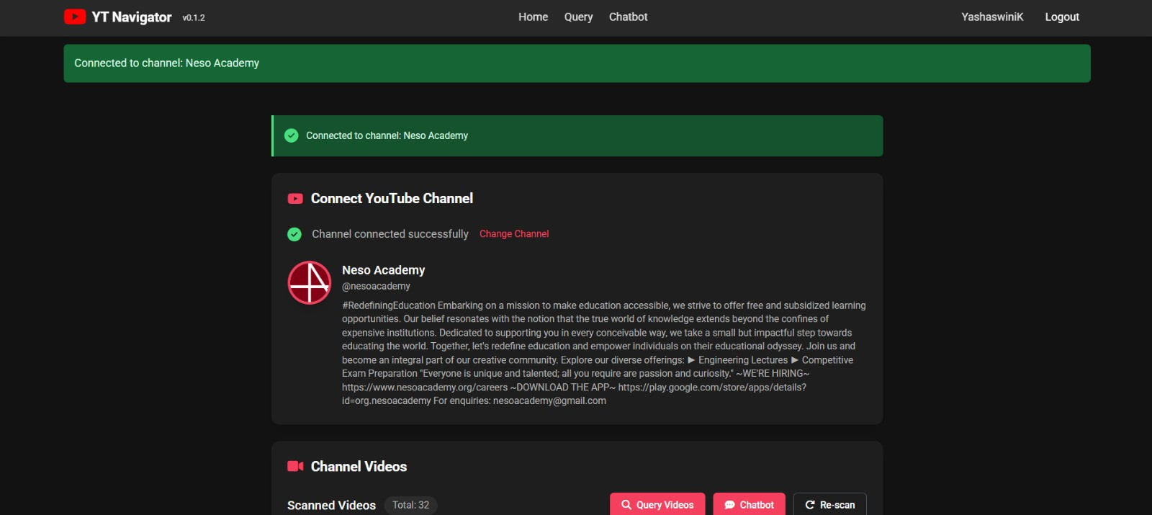

Fig. 5. Semantic Search Results with Relevance Scores

- Semantic Search Results
Converts the user’s query to its embedding and uses it to search the similarity between transcript embeddings and user embedding on vector similarity search. By relevance scores, the most relevant transcript clips of videos will be extracted from multiple videos of channel.

- Retrieved Video Segments with Timestamps
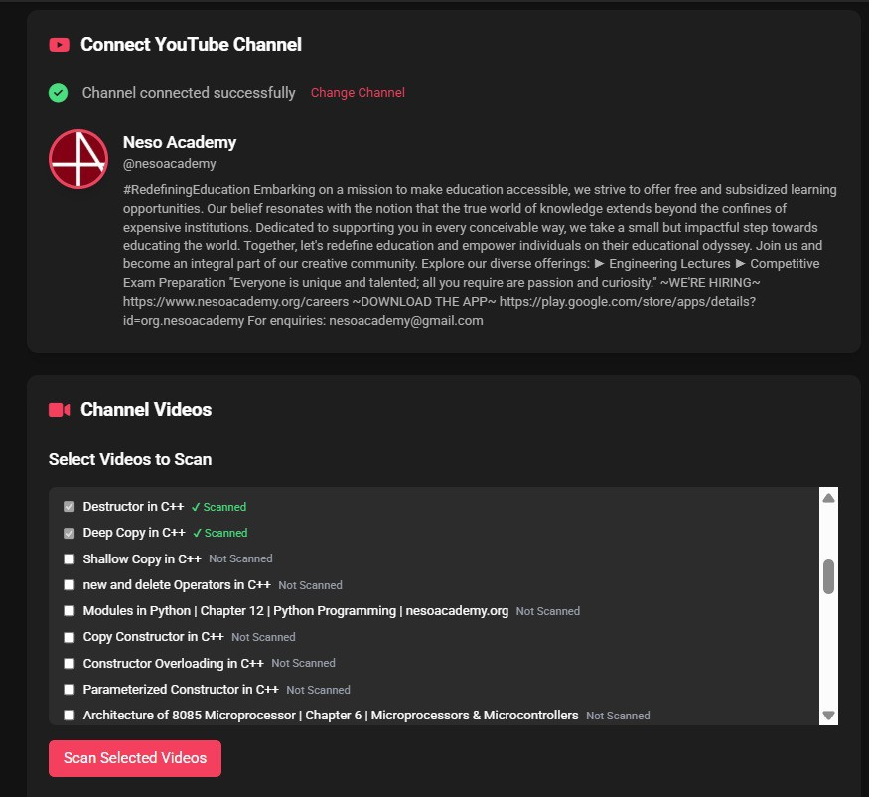

Fig. 6. Retrieved Video Segments with Timestamps

Relevant chunks from the transcripts for a specific query will be extracted and corresponding timestamps within the video for the relevant chunks will be generated. Users would be able to access and navigate directly to the most important segments in the videos, thus saving them the time from sifting through hours of recorded footage.

- Final Output and Response Display
Finally, on the output screen the retrieved answers with video source, timestamp, and ranked search results will appear. The system organized information with context for the video content.

Fig. 7. Final Output with Video Navigation and Response Display
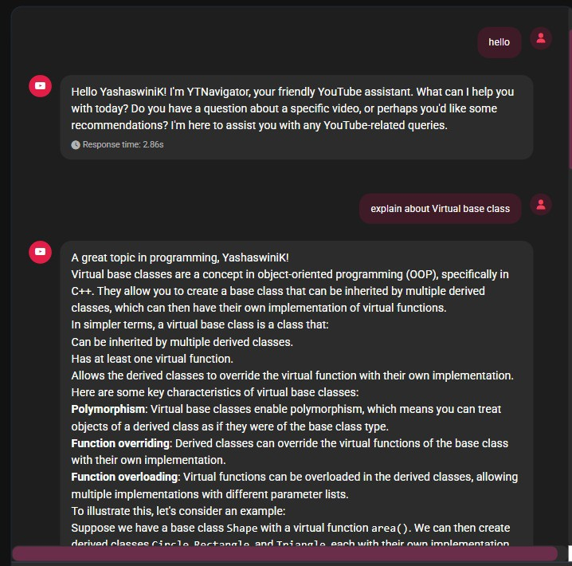

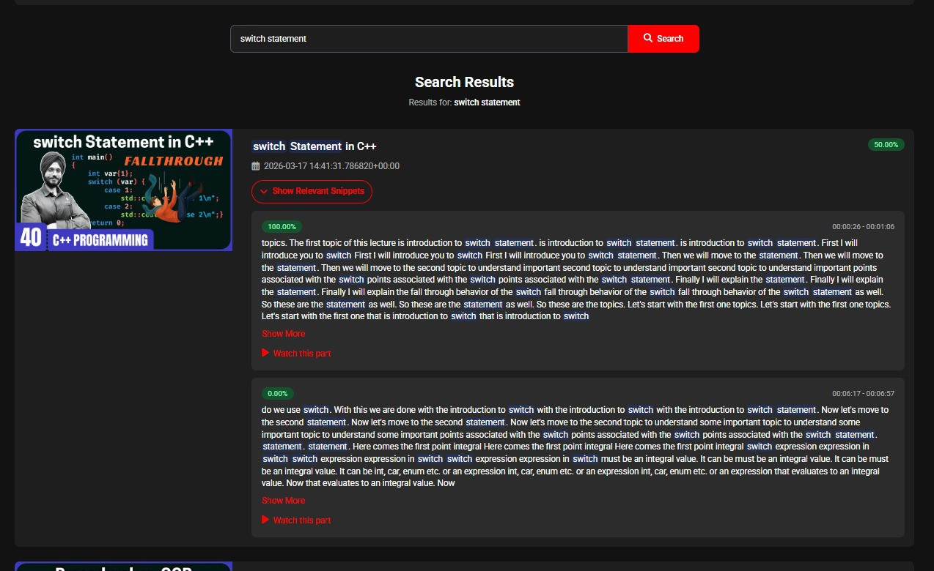
Fig. 8. Chatbot Interaction using Agentic RAG

- Chatbot Interaction using Agentic RAG
The chat-based UI allows the user to interact with the system by asking queries in natural language. Agentic RAG system retrieves necessary information from the transcript and use LLM to answer accordingly. It enhanced the interaction and efficient way of retrieving information from youtube videos.
Results of the experiments showed that YT Navigator can effectively do transcript extraction, semantic searching, timestamp navigation, and AI-generated responses. Using se-mantic searching in conjunction with vector embeddings has resulted in improved contextual understanding between typical keyword searching for video content and through the use of traditional video content searching methods.
The developed system saves significant time and energy when searching for relevant information in long video content on YouTube and provides a scalable solution for searching through intelligent video content.

- Advantages of the Proposed System
The YT Navigator system has a lot of things going for it when compared to the old ways of searching for videos on YouTube.
- Efficient Information Retrieval: The YT Navigator system allows people to find the information they want from videos on YouTube without having to watch the whole thing.
- Semantic Search Capability: The system does not just look for keywords like search systems do it tries to understand what you are really looking for and finds more relevant results.
- Timestamp-Based Navigation: The system gives you the exact time when something is said in a video so you can go straight to that part.
- Natural Language Query Support: Users can interact with the system using simple natural language queries. This makes the platform more user-friendly and accessi-ble.
- Multi-Video Channel Exploration: The system al-lows searching across multiple videos within an entire YouTube channel. This improves large-scale content ex-ploration.
- AI-Assisted Response Generation: The integration of Large Language Models (LLMs) helps generate con-textual and summarized responses based on retrieved transcript content.
- Reduced Time and Effort: The proposed solution sig-nificantly cuts down the time needed to search for specific information from educational and informational videos.
- Scalable and Modular Architecture: The modular ar-chitecture makes it easy to add new AI models, retrieval techniques, and processing modules in future versions of the system.
- Conclusion
This paper introduced YT Navigator, a system that uses AI to make it easier to explore and find information from YouTube channel videos. The system combines transcript extraction, semantic search, vector embeddings, and AI-generated re-sponses to help users discover content efficiently through natural language queries. It allows users to search across multiple videos and go straight to relevant transcript segments with timestamps, which saves time and effort in finding useful information from long videos. The use of semantic similarity search improves understanding of context compared to older keyword-based methods. Overall, YT Navigator offers an effective, scalable, and user-friendly way to explore YouTube content, improving accessibility for learners, researchers, and general users.
use of semantic searching and information retrieval from video clips made in different languages.
- More Advanced AI and Embeddings
The use of more advanced Large Language Models and embeddings will make the AI more advanced, allowing a better contextual understanding and an increased accuracy of the semantic search results.
- Automated Transcript Creation
To enable automatic creation of transcripts for videos that do not have any transcripts attached, speech-to-text modules will be used in YT Navigator.
- Browser Extension
In order to increase usability, the software can also be developed as a browser extension which would provide YT Navigator features to the YouTube site or application.
- Voice-based Searching Capability
Further versions of the YT Navigator can include voice-based searching capability that allows searching for video content and asking queries through spoken phrases rather than typed text.
- Recommendations
A recommendation system may be added to suggest related videos, educational material and other types of content de-pending on the user’s search queries and interests.
- Scalability via Cloud Deployment
Cloud-based deployment, along with efficient vector re-trieval, can be employed for better scalability and large-scale YouTube channel analysis.
XI. References References
- JJ.Devlin et al., “BERT: Pre-training of Deep Bidirectional Transformers for Language Understanding,” NAACL, 2019, https://arxiv.org/abs/1810.04805
- T. Brown et al., “Language Models are Few-Shot Learners,” NeurIPS, 2020, https://arxiv.org/abs/2005.14165
- A. Vaswani et al., “Attention Is All You Need,” NeurIPS, 2017, https://arxiv.org/abs/1706.03762
- N. Reimers and I. Gurevych, “Sentence-BERT: Sentence Embeddings using Siamese BERTNetworks,” EMNLP, 2019, https://arxiv.org/abs/1908.10084
- BAAI, “BGE (BAAI General Embedding) Model Documentation,” 2023, https://huggingface.co/BAAI/bge-small-en-v1.5
- yt-dlp, “yt-dlp: A YouTube Video Downloader,” https://github.com/yt-dlp/yt-dlp
- Scrapetube, “Scrapetube Python Library for YouTube Scraping,” https://github.com/dermasmid/scrapetube
- YouTube, “YouTube Data API Documentation,” https://developers.google.com/youtube/v3

- Future Work
A. Multi-language Transcript Processing
The future version of the YT Navigator will have multi-language transcript processing capability which will allow the

