Measuring and Mapping Child Malnutrition in West Bengal: A Composite Index-Based Spatial Analysis

Abstract
Child malnutrition remains one of the most pressing public health challenges in India, with significant implications for child survival, growth, cognitive development, and future productivity. Despite substantial improvements in health and nutrition programmes, regional disparities in child nutritional outcomes persist across West Bengal. This study examines the spatial distribution and clustering of child malnutrition among under-five children across the districts of West Bengal using data from the National Family Health Survey (NFHS-5), 2019–21. Three key anthropometric indicators—stunting, underweight, and wasting—were used to construct a Composite Child Malnutrition Index through the dimension index approach. Geographic Information System (GIS)-based mapping techniques were employed to visualize district-level variations, while conditional mapping was used to explore the spatial relationships among different forms of malnutrition. Furthermore, Global Moran’s I and Local Indicators of Spatial Association (LISA) were applied to assess spatial autocorrelation and identify malnutrition hotspots.

The findings reveal substantial regional inequalities in child nutritional status across the state. Western districts, particularly Purulia, Paschim Medinipur, Birbhum, and Paschim Bardhaman, exhibit the highest levels of child malnutrition, whereas districts such as Nadia, Hooghly, Howrah, North 24 Parganas, and Purba Medinipur demonstrate relatively favourable outcomes. Stunting emerged as the most prevalent form of malnutrition, indicating the persistence of chronic nutritional deprivation. The conditional maps reveal strong spatial associations among stunting, underweight, and wasting, suggesting overlapping nutritional vulnerabilities. The Global Moran’s I value of 0.423 indicates moderate positive spatial autocorrelation, while LISA analysis identifies significant hotspot and cold-spot clusters, confirming the existence of localized spatial concentration.

The study concludes that child malnutrition in West Bengal is geographically clustered rather than randomly distributed. The findings underscore the need for spatially targeted and integrated policy interventions focusing on nutrition, maternal and child healthcare, food security, and WASH infrastructure to reduce regional disparities and accelerate progress toward achieving Sustainable Development Goal 2 (Zero Hunger).

Keywords: Child Malnutrition; Stunting; Wasting; Underweight; Composite Child Malnutrition Index; Spatial Analysis; GIS; Spatial Autocorrelation; LISA; Moran’s I; NFHS-5; West Bengal.
1. INTRODUCTION
Malnutrition remains one of the most serious public health challenges globally, particularly in South Asia and Sub-Saharan Africa. It results from inadequate, excessive, or imbalanced intake of nutrients and adversely affects children's physical growth, cognitive development, educational achievement, and future productivity. Among children under five years of age, undernutrition is commonly manifested through stunting, wasting, and underweight conditions, collectively referred to as child growth failure.
Globally, approximately 156 million children suffer from stunting, 50 million from wasting, and 93 million from underweight. Although India has made progress in reducing child malnutrition, Evidence from the UNICEF report suggests the burden remains substantial. While the prevalence of stunting declined from 52% in 1992–93 to 38% in 2015–16, wasting increased from 17% to 21% during the same period. India continues to account for nearly 40% of the world's stunted children. Despite substantial progress in public health interventions, undernutrition remains a major concern in India. West Bengal, one of India's most populous states, continues to experience significant levels of child malnutrition, particularly among children under five years of age.
Given the persistence of undernutrition and the Sustainable Development Goal (SDG) target of ending all forms of malnutrition by 2030, there is a need to examine district-level changes in child growth failure indicators. The study therefore aims to assess the prevalence and temporal changes in stunting, wasting, and underweight among under-five children across the districts of West Bengal using NFHS-5 data. Such analysis can help policymakers identify priority districts and formulate targeted interventions to reduce child malnutrition and improve child health outcomes.

2. LITERATURE REVIEW
Child malnutrition is commonly measured through three anthropometric indicators: stunting (low height-for-age), wasting (low weight-for-height), and underweight (low weight-for-age). Malnutrition adversely affects children's cognitive and developmental potential, particularly in socio-economically disadvantaged districts. Nutritional deprivation during early childhood can have long-lasting effects on educational attainment, productivity, and overall human development (De et al.,2019).
The prevalence of stunting increased in seven districts, wasting increased in ten districts, and underweight prevalence increased in nine districts between NFHS-4 and NFHS-5. The findings suggest that nutritional improvements have not been uniform across the state and that some districts have experienced deterioration in child nutritional outcomes (Das et al., 2021).
Nutritional Status Index (NSI) has been calculated using NFHS-5 data and it is identified that Purulia as the most nutritionally deprived district in West Bengal, followed by Bankura and Paschim Medinipur. Their analysis showed that none of the districts could be categorized as having an acceptable nutritional status according to established public health benchmarks (Hoque et al.,2025).
Socio-economic factors play a crucial role in shaping child nutritional outcomes. It is identified that the household socio-economic conditions majorly determine child nutrition. The findings revealed that children from poor households were substantially more likely to be underweight than those from economically better-off families (Ghosh and Arokiasamy, 2010). Beyond anthropometric measurements, several studies have explored the socio-economic determinants of child nutritional outcomes. Using data from the National Family Health Survey (NFHS-2), study reveals socio-economic and demographic characteristics significantly influenced childhood stunting. Factors such as household economic status, parental education, and living conditions were found to be important predictors of nutritional well-being. These findings suggest that child malnutrition is not merely a health issue but is deeply rooted in broader socio-economic inequalities (Som et al., 2007).
Research conducted in Nadia district revealed substantial levels of stunting, underweight, and wasting among preschool children, indicating persistent growth faltering during early childhood. The study further highlighted variations in anthropometric outcomes according to age and sex, suggesting that nutritional vulnerabilities differ across demographic groups (Bose et al., 2007). A considerable proportion of children suffered from multiple forms of anthropometric failure simultaneously, reflecting the multidimensional nature of child malnutrition in the region. Conventional indicators alone may underestimate the true burden of undernutrition among children (Biswas et al., 2010). The majority of the associated factors identified were modifiable, and hence awareness generation in common people may reduce the burden of undernutrition in under-five population (Biswas & Biswas, 2023).
Although girls generally demonstrated higher average stature than boys, the overall growth patterns reflected continuing nutritional deficiencies among school children. Such findings underscore the long-term implications of inadequate nutrition during childhood and adolescence (Manna et al.,2011). Inadequate breastfeeding, delayed complementary feeding, and poor dietary diversity emerged as significant contributors to undernutrition, highlighting the importance of improving nutrition-related knowledge and caregiving practices among mothers and caregivers (Mukhopadhyay et al., 2013).
Alternative anthropometric assessment techniques have also been employed to evaluate child nutritional status in West Bengal. Upper arm anthropometric measurements have been used to assess nutritional deprivation among children aged 5–12 years. A substantial proportion of undernourished children, demonstrating the usefulness of community-based screening methods for monitoring nutritional status and identifying at-risk population (Sen et al.,2011).
Collectively, the existing literature indicates that child undernutrition remains a persistent challenge in West Bengal. The evidence suggests that nutritional deprivation is shaped by a complex interplay of socio-economic conditions, demographic characteristics, feeding practices, and healthcare access. While several studies have documented the prevalence and determinants of undernutrition at local and district levels, substantial disparities continue to exist across different regions of the state. These findings underscore the need for integrated nutrition policies that combine poverty alleviation, maternal education, healthcare services, and improved child feeding practices to address the multifaceted nature of child malnutrition in West Bengal.

3. RESEARCH QUESTION
- What are the spatial patterns and district-level variations in stunting, underweight, and wasting among under-five children in West Bengal?
- Which districts exhibit the highest and lowest levels of child malnutrition according to the Composite Child Malnutrition Index, and what regional disparities exist across the state?
- Does child malnutrition exhibit significant spatial clustering in West Bengal, and where are the major hotspots and cold spots located?

4. OBJECTIVES
- To examine the prevalence and spatial pattern of stunting, wasting, and underweight among under-five children across the districts of West Bengal.
- To identify regional disparities and malnutrition hotspots through the development of a Composite Child Malnutrition Index and spatial mapping techniques.
- To analyse the spatial clustering and geographic patterns of child malnutrition through spatial autocorrelation techniques, including Moran’s I and LISA.

5. DATA
The nationally representative NFHS-5 data collected between 2019 and 2021 served as the basis for this study. The National Family Health Survey (NFHS), a large multi-round survey conducted by the Government of India's Ministry of Health and Family Welfare (MoHFW), gives estimates of a number of variables at the national, state/union territory (UT), and district levels. The International Institute for Population Sciences in Mumbai has been named the nodal agency for several NFHS rounds.

Table 1 Selected dimension and indicators of Child Malnutrition Index
Sub-components | Definition | WHO standard
Stunting Children | A child is considered stunted when their height-for-age is below -2 standard deviations (SD) from the median of the WHO Child Growth Standards. Stunting reflects chronic or long-term undernutrition and repeated infections that hinder normal growth and development. | Height-for-Age Z-score (HAZ) < -2 SD
Underweight Children | A child is considered underweight when their weight-for-age is below -2 standard deviations (SD) from the median of the WHO Child Growth Standards. Underweight reflects a combination of chronic and acute undernutrition. | Weight-for-Age Z-score (WAZ) < -2 SD
Wasting Children | A child is considered wasted when their weight-for-height is below -2 standard deviations (SD) from the median of the WHO Child Growth Standards. Wasting indicates acute undernutrition, often resulting from recent illness, inadequate food intake, or rapid weight loss. | Weight-for-Height Z-score (WHZ) < -2 SD

6. METHODS
Composite Index is calculated after calculating Dimension Index. We used the Dimension Index approach, which is what the UNDP uses to create the human development index, to normalize the indicators in our analysis. The original dataset had values between 0 and 1. Consequently, the following formula is applied to scale equivalency:

$${DI}_{ik}(Dimension Index)= \frac{X_{ik}-Min (X…1_{k})}{Max (X…1_{k})-Min (X…1_{k})}$$
Where:
${DI}_{ik}$ = Dimension Index for the $i^{th}$ unit and $k^{th}$ dimension
$X_{ik}$ = observed value of the $i^{th}$ unit in the $k^{th}$ dimension
$Min (X…1_{k})$ = minimum value of the $k^{th}$ dimension
$Max (X…1_{k})$ = maximum value of the $k^{th}$ dimension

The value of DIik ranges from zero to one, with a number of one indicating that the district in question has the greatest level of authority in relation to the other districts in the state. For a value of 0, the opposite is true.
After calculating DI of each indicator all the indicators wise values have been aggregated for each district to get aggregate score. Later the composite score is divided by the number of indicators (here 10 indicators) to get the index value by using the following formula –
$$C_{i}(Composite Score)= \frac{\sum_{i}^{n}{1 index X_{ik} }}{n}$$
Where:
$C_{i}$ = Composite Score for the $i^{th}$ unit
$X_{ik}$ = index value of the $i^{th}$ unit for the $k^{th}$ indicator
$n$ = total number of indicators
Higher values indicate higher levels of empowerment, while lower values indicate lower levels. The index value goes from 0 to 1.

Ten indicators relating to WASH index were factor analysed using Principal Component Analysis (PCA). Local Moran I and LISA is carried out to analyse spatial autocorrelation.

7. RESULT AND DISCUSSION

Spatial Pattern of Child Malnutrition in West Bengal
The map 1 illustrates the district-wise spatial distribution of child malnutrition in West Bengal, categorized into three levels: Low, Moderate, and High Child Malnutrition Index. The spatial pattern reveals significant geographical disparities in child nutritional outcomes across the state. Districts located in the western part of West Bengal exhibit a higher concentration of child malnutrition, whereas several districts in the eastern and northern regions show relatively lower levels. The districts classified under the high child malnutrition category include Puruliya, Paschim Bardhaman, Birbhum and Paschim Medinipur. Purulia, in particular, has historically been recognized as one of the most socio-economically disadvantaged districts in the state, which may explain its high malnutrition burden. Moderate child malnutrition districts include Darjeeling, Uttar Dinajpur, Dakshin Dinajpur, Maldah, Murshidabad, Bankura, Purba Bardhaman, South 24 Parganas and Kolkata.
Map 1 Spatial Pattern of Child Malnutrition
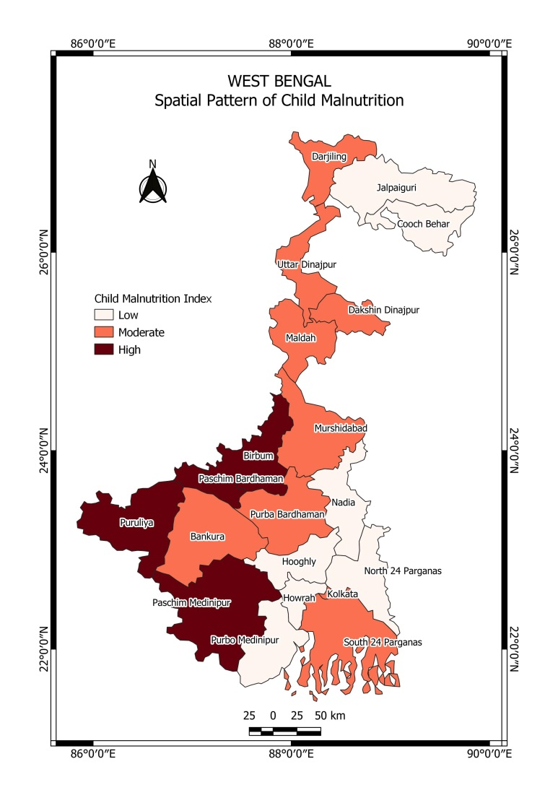
The presence of Kolkata in the moderate category suggests that urbanization alone does not eliminate malnutrition. Urban poverty, slum settlements, and unequal access to nutrition and healthcare services continue to affect child nutritional outcomes even in metropolitan areas. Low child malnutrition districts include Jalpaiguri, Cooch Behar, Nadia, Hooghly, Howrah, North 24 Parganas and Purba Medinipur. This indicates that child malnutrition is not uniformly distributed across the state but is spatially clustered in specific regions. These districts demonstrate comparatively better nutritional conditions. Their relatively lower malnutrition levels may be attributed to better healthcare infrastructure, higher literacy rates, improved maternal and child healthcare services, better transportation and market accessibility and greater economic opportunities
Spatial Variation in Stunting, Underweight and Wasting
The map 2 presents the district-wise distribution of three major indicators of child undernutrition—stunting, underweight, and wasting—among children under five years of age in West Bengal based on NFHS-5 data. The pie charts illustrate the relative contribution of each indicator within individual districts, enabling a comparative assessment of child nutritional deprivation across the state. The map 2 indicates that stunting constitutes the largest share of child malnutrition in most districts, followed by underweight and wasting. This pattern suggests that chronic undernutrition remains a more severe challenge than acute malnutrition in West Bengal. Since stunting reflects long-term nutritional deprivation and repeated exposure to infections, its predominance indicates persistent socio-economic and health-related disadvantages affecting child growth.

Map 2 Spatial Variations of Stunting, Underweight and Wasting Children
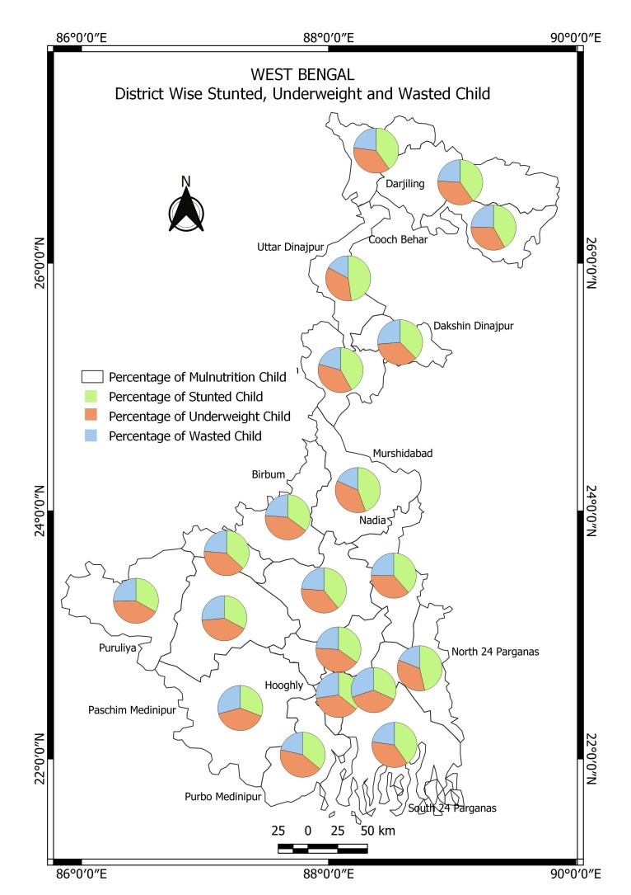
The green segments representing stunting are relatively larger across most districts, particularly in northern and central districts such as Darjeeling, Jalpaiguri, Cooch Behar, Uttar Dinajpur, Murshidabad, and Nadia. This suggests that chronic nutritional deficiencies continue to affect a substantial proportion of children in these regions. High levels of stunting are often associated with poverty, inadequate maternal nutrition, poor sanitation, and limited access to healthcare services.
The orange segments in map 2 representing underweight children are prominent in many districts, especially in western districts such as Purulia, Bankura, Paschim Medinipur, and Birbhum. Underweight reflects both chronic and acute forms of undernutrition and indicates inadequate dietary intake over time. The relatively high proportion of underweight children in these districts points to persistent food insecurity and socio-economic deprivation.
The blue segments in map 2 representing wasting are generally smaller than the other two indicators but remain significant across several districts. Wasting reflects acute undernutrition resulting from recent illness, inadequate food intake, or sudden weight loss. Although wasting levels appear comparatively lower, its presence throughout the state indicates that acute nutritional stress remains a public health concern.
The conditional map 3 displays the spatial relationship between stunting (horizontal axis) and underweight (vertical axis) among children across the districts of West Bengal. Districts are classified into quantiles based on the prevalence of these two nutritional indicators, allowing the identification of areas where both forms of malnutrition coexist. The map reveals a positive relationship between stunting and underweight. Districts with high levels of stunting tend to exhibit high levels of underweight as well, suggesting that chronic nutritional deprivation is often accompanied by inadequate body weight.

Map 3 Spatial relationship between stunting and underweight among children
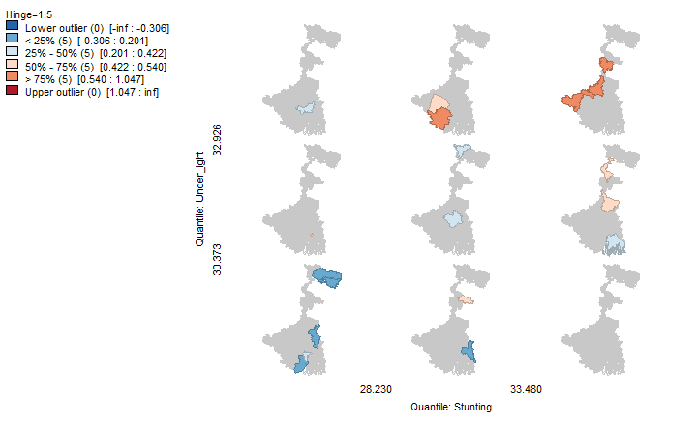
The map 4 suggests a positive spatial relationship between stunting and wasting. Districts with higher stunting levels tend to also exhibit higher wasting levels, indicating overlapping forms of child malnutrition. The conditional map 4 reveals substantial spatial heterogeneity in child malnutrition across West Bengal. Districts characterized by higher levels of stunting generally coincide with higher levels of wasting, indicating a clustering of chronic and acute undernutrition. The concentration of vulnerable districts in the upper quantiles highlights the need for geographically targeted nutrition programmes and improvements in health, sanitation, and food security. Conversely, districts in the lower quantiles exhibit relatively favourable nutritional outcomes, suggesting better socio-economic and healthcare conditions. These findings emphasize the importance of place-based interventions for reducing regional disparities in child malnutrition within the state.
Map 4 Spatial relationship between stunting and wasting among children

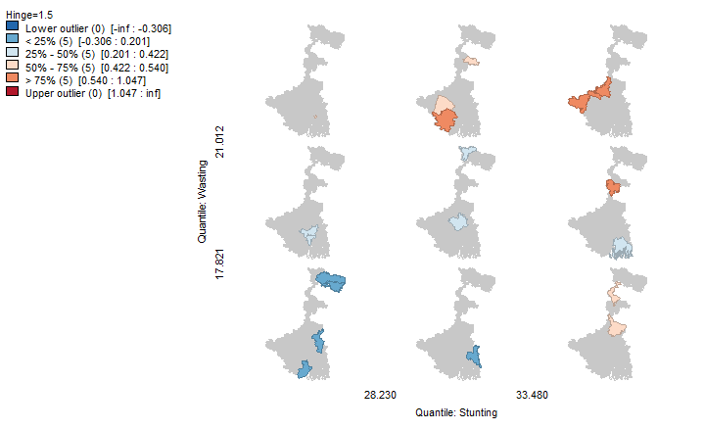
The conditional map 5 highlights the spatial association between underweight and wasting among children across the districts of West Bengal. Districts characterized by high levels of underweight prevalence generally coincide with higher levels of wasting, indicating overlapping forms of nutritional deprivation. The concentration of districts in the upper quantiles suggests that acute and general undernutrition are geographically clustered, reflecting persistent socio-economic and health inequalities. Conversely, districts with low levels of both indicators demonstrate comparatively better child nutritional status. These findings underscore the need for region-specific interventions focusing on nutrition, maternal health, food security, and WASH infrastructure to reduce spatial disparities in child malnutrition across the state.
Map 5 Spatial relationship between underweight and wasting among children

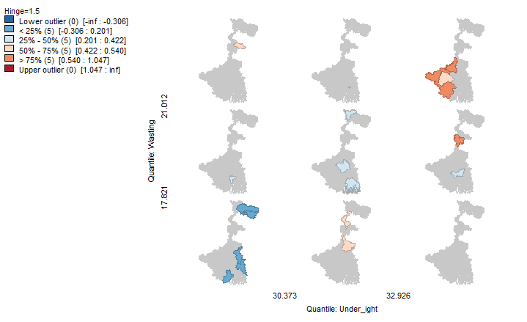
Spatial Autocorrelation Analysis of Child Malnutrition: LISA Interpretation
The LISA cluster map 6 identifies one statistically significant High–High cluster and one Low–Low cluster within West Bengal. The High–High cluster represents a hotspot where a district with a high value is surrounded by neighbouring districts exhibiting similarly high values. Conversely, the Low–Low cluster represents a cold spot characterized by low values concentrated among adjacent districts. The absence of High–Low and Low–High outliers suggests that the spatial pattern is dominated by homogeneous clusters rather than isolated anomalies. These findings indicate localized spatial concentration and highlight the importance of geographically targeted interventions.

Map 6 LISA Cluster Map Map 7 LISA Significance Map

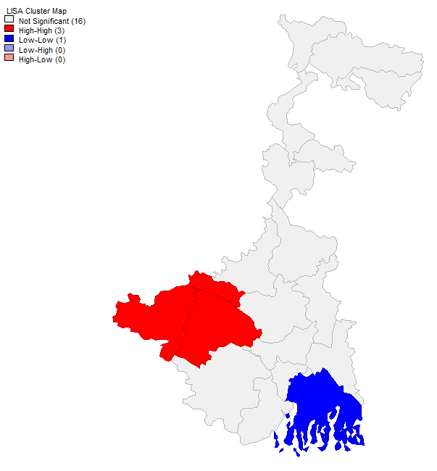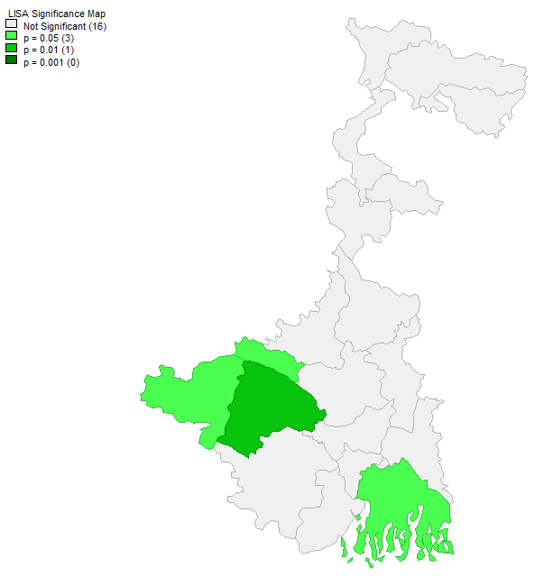

The LISA significance map 7 reveals limited but statistically significant local spatial clustering among the districts of West Bengal. While the majority of districts do not exhibit significant spatial dependence, three districts demonstrate significant local autocorrelation. One district shows stronger clustering at the 1 percent significance level, whereas two districts are significant at the 5 percent level. This indicates that spatial concentration of the studied phenomenon is localized rather than widespread across the state. The results suggest the presence of specific districts where neighbouring effects play a significant role and therefore warrant focused policy attention.

The Moran's scatter plot yields a Global Moran's I value of approximately 0.423, indicating a moderate positive spatial autocorrelation. This suggests that districts with high values tend to be located near other high-value districts, while districts with low values are generally surrounded by low-value districts. The positive slope of the regression line confirms the existence of spatial clustering rather than a random distribution. Therefore, the studied variable exhibits significant geographic dependence across West Bengal, implying that neighbouring districts tend to share similar characteristics. Such spatial dependence should be considered when designing regional development and policy interventions.

8. CONCLUSION

This study examined the spatial distribution of child malnutrition across the districts of West Bengal using NFHS-5 (2019–21) data and a Composite Child Malnutrition Index based on stunting, underweight, and wasting indicators. The findings reveal substantial regional disparities in child nutritional outcomes across the state. Western districts, particularly Purulia, Paschim Medinipur, Birbhum, and Paschim Bardhaman, emerged as the most nutritionally vulnerable regions, whereas districts such as Cooch Behar, Nadia, Hooghly, Howrah, North 24 Parganas, and Purba Medinipur exhibited comparatively better nutritional conditions. The analysis further demonstrated that stunting constitutes the most prevalent form of undernutrition, highlighting the persistence of chronic nutritional deprivation among children under five years of age.

Conditional mapping revealed significant spatial associations among stunting, underweight, and wasting, indicating that different forms of child malnutrition tend to coexist within the same districts. Districts characterized by high levels of one indicator frequently exhibited high levels of the others, reflecting overlapping nutritional disadvantages. Spatial autocorrelation analysis confirmed that child malnutrition is not randomly distributed across the state. The Global Moran’s I value (0.423) indicated moderate positive spatial autocorrelation, while LISA analysis identified significant hotspot and cold-spot clusters. These findings suggest that neighbouring districts often share similar nutritional characteristics and that child malnutrition is influenced by broader regional socio-economic and environmental conditions.

Overall, the study highlights that child malnutrition in West Bengal remains a critical public health challenge and that progress toward achieving Sustainable Development Goal 2 (Zero Hunger) requires geographically targeted and multi-sectoral interventions.

9. POLICY IMPLICATION

Districts identified as malnutrition hotspots, particularly Purulia, Paschim Medinipur, Birbhum, and Paschim Bardhaman, should receive priority in nutrition-related programmes and resource allocation. Expansion and effective monitoring of ICDS centres, Anganwadi services, growth monitoring, and supplementary nutrition programmes are essential for reducing chronic undernutrition among children. Since child nutrition is closely linked to maternal nutritional status, policies should strengthen antenatal care, iron-folic acid supplementation, maternal dietary counselling, and institutional healthcare services. Targeted food security programmes should focus on nutritionally vulnerable households through improved access to diversified diets, micronutrient supplementation, and nutrition-sensitive agriculture. Improved access to safe drinking water, sanitation facilities, and hygiene practices is crucial for reducing recurrent infections that contribute to stunting and wasting. Community-based nutrition education programmes should be implemented to improve breastfeeding practices, complementary feeding, child-care behaviours, and awareness regarding balanced diets.

The presence of significant spatial clustering suggests that district-specific and region-specific interventions will be more effective than uniform state-wide policies.

10. FUTURE RESEARCH

Future studies should examine the socio-economic, demographic, environmental, and healthcare determinants influencing district-level variations in child malnutrition. Further research may investigate the relationship between child malnutrition, WASH conditions, poverty, maternal education, and healthcare accessibility using multivariate spatial models. A comparative analysis using multiple rounds of NFHS data (NFHS-3, NFHS-4, and NFHS-5) could provide deeper insights into trends and changes in child nutritional outcomes over time. Future studies may employ spatial regression models such as Spatial Lag Models (SLM), Spatial Error Models (SEM), and Geographically Weighted Regression (GWR) to better understand spatial determinants of malnutrition. Block-level or village-level analyses would help identify local nutritional inequalities that may remain hidden in district-level studies. Future research could incorporate the Composite Index of Anthropometric Failure (CIAF) to capture the multidimensional nature of child undernutrition more comprehensively. The influence of climate variability, agricultural productivity, drought, flooding, and environmental vulnerability on child nutritional outcomes should be explored to support climate-resilient nutrition policies.

References

Bose, K., Bisai, S., Mukherjee, S., & Khatun, A. (2007). Assessment of nutritional status among preschool children of Nadia District, West Bengal, India.
Biswas, S., Bose, K., & Mukhopadhyay, A. (2010). Assessment of undernutrition by Composite Index of Anthropometric Failure (CIAF) among preschool children in Nadia District, West Bengal, India.
De, K., Dasgupta, A., & Sahoo, S. (2019). Malnutrition and child development: Evidence from a backward district of India.
Manna, P. K., De, D., & Bera, T. K. (2011). Physical growth and nutritional status among school-aged children in North Bengal, India.
Mukhopadhyay, D. K., Biswas, A. B., & Chakraborty, S. (2013). Child feeding practices and nutritional status among under-two children in urban slums of Bankura, West Bengal.
Sen, J., Mondal, N., & Dutta, S. (2011). Nutritional assessment of children using upper arm anthropometry in West Bengal, India.
Som, S., Pal, M., & Bharati, P. (2007). Role of socio-economic and demographic factors in childhood stunting: Evidence from NFHS data in eastern India.
Das, P., Roy, R., Das, T., & Roy, T. B. (2021). Prevalence and change detection of child growth failure phenomena among under-5 children: A comparative scrutiny from NFHS-4 and NFHS-5 in West Bengal, India. Clinical Epidemiology and Global Health, 12, 100857. https://doi.org/10.1016/j.cegh.2021.100857
Ghosh, S., & Arokiasamy, P. (2010). Socio-economic determinants of underweight children in West Bengal, India. Asian Pacific Journal of Tropical Medicine, 3(4), 322–327. https://doi.org/10.1016/S1995-7645(10)60078-8
Hoque, S. A., Anisujjaman, M., & Biswas, S. (2025). The spatial distribution of undernutrition among young children in West Bengal: A report from the National Family Health Survey (NFHS), India. Antrocom: Online Journal of Anthropology, 21(2), 533–542.
International Institute for Population Sciences (IIPS), & ICF. (2021). National Family Health Survey (NFHS-5), 2019–21: West Bengal fact sheet. Mumbai: IIPS.
Biswas, A., & Biswas, B. (2023). Anthropometric assessment of nutritional status among under-five children attending government immunization centres in Bankura Municipality, West Bengal. Indian Journal of Public Health Research & Development, 14(4). https://doi.org/10.37506/ijphrd.v14i4.19758

