Wildlife Health Monitoring System Using Image Analysis

1st Arjun
Dept. of Computer Science Engineering Chandigarh University
Mohali, India arjunsoni70271@gmail.com

4th Gaurav Garg
Dept. of Computer Science Engineering Chandigarh University
Mohali, India ergaurav.garg@yahoo.com

2nd Ayushi
Dept. of Computer Science Engineering Chandigarh University
Mohali, India ayushir724@gmail.com

3rd Shambhavi Smoya
Dept. of Computer Science Engineering Chandigarh University
Mohali, India sonalsinghrajput534@gmail.com

Abstract—This study tackles the urgent issue of wildlife monitoring by creating an automated health monitoring system that uses cutting-edge image analysis techniques. The aim is to develop a strong framework that can effectively identify and classify wildlife species in various environmental settings to aid conservation efforts. By utilizing the latest computer vision and machine learning technologies, the system uses Convolutional Neural Networks (CNN) to extract detailed features from high-resolution images of wildlife, allowing for accurate identification and classification of multiple species. Furthermore, the inclusion of Support Vector Machines (SVM) as additional classifiers boosts the model’s ability to distinguish between species, creating a hybrid approach ideal for recognizing visual patterns in dynamic ecological environments. The methodology involves systematic data augmentation and hyperparameter tuning to enhance gener-alization and robustness across different habitats. Experimental results show high accuracy and reliable performance in species classification, supporting timely and informed decision-making in wildlife management. The proposed system provides a scal-able and cost-effective solution for continuous monitoring, thus overcoming the limitations of traditional manual methods. By advancing automated wildlife health assessment, this work makes a significant contribution to biodiversity preservation and ecologi-cal balance. The results hold potential for real-world applications, including ecological studies, resource allocation, and intervention strategies, highlighting the crucial role of image-based machine learning technologies in modern wildlife conservation (Mane et al., 2024; Nagi et al., 2012; Wu et al., 2013).(Wu et al., 2013)
Index Terms—Wildlife Monitoring, Image Analysis, Deep Learning, CNN, Computer Vision

- Introduction
Wildlife conservation is a crucial global effort, driven by growing concerns about the loss of biodiversity and the deterioration of habitats. It is essential to continuously monitor wildlife populations to ensure effective ecological manage-ment, evaluate species health, and guide conservation poli-cies that reduce the risk of extinction. Traditionally, wildlife monitoring has depended heavily on manual, labor-intensive techniques such as direct field observations, animal tracking, and analyzing physical evidence like tracks and scat. Although
these traditional methods have yielded valuable insights, they are inherently limited by significant challenges, including logistical complexity, high costs, observer bias, and restrictions in temporal and spatial coverage, as well as disturbances to wildlife behavior due to human presence. These limitations often compromise data accuracy and hinder timely decision-making, which is critical for managing vulnerable species and ecosystems (Ahmed et al., 2024). As the need for sustainable conservation becomes more urgent, it is increasingly clear that new, automated methods must be employed to improve the effectiveness, scalability, and precision of wildlife health monitoring..
Recent developments in image analysis, driven by computer vision and machine learning, are revolutionizing wildlife mon-itoring by shifting from manual to automated systems. These automated health monitoring systems leverage the capability to handle large amounts of visual data—obtained through camera traps, drones, or stationary surveillance cameras—to identify, categorize, and evaluate the health of wildlife populations with minimal human involvement. This technological shift over-comes the limitations of traditional methods by allowing for continuous, non-invasive, and real-time observation of animals in their natural environments, thus enhancing temporal resolu-tion and reducing disturbances caused by human observers (Afoma et al., 2026). The combination of high-resolution imaging and advanced algorithms aids in recognizing individ-ual species, behavioral patterns, and early signs of diseases or injuries, which are essential for preserving ecosystem balance and enabling proactive conservation measures.
Image processing plays a crucial role in this field, involving the improvement of raw images, the extraction of pertinent features, and the use of techniques for object detection and classification. Computer vision methods, particularly when integrated with deep learning frameworks like convolutional neural networks (CNNs), have shown exceptional success in identifying animal species and their unique traits from intricate backgrounds in natural settings. Cutting-edge models achieve

impressive accuracy in filtering images to detect species pres-ence and even differentiate between closely related groups, greatly minimizing the need for manual data curation and anal-ysis (Nguyen et al., 2017). Machine learning algorithms further enhance these abilities by learning from labeled datasets to conduct automated classification, anomaly detection, and health status assessment, often exceeding human performance in repetitive and large-scale tasks (Kutugata et al., 2021). Additionally, the use of unmanned aerial vehicles (UAVs) equipped with cameras has broadened monitoring capabili-ties, enabling observations in remote or sensitive areas while producing high-quality image data for automated analysis (Ahmed et al., 2024). Thus, the integration of image analysis, computer vision, and machine learning creates a robust toolkit for wildlife health monitoring systems.
Even with these technological advancements, creating and implementing effective wildlife health monitoring systems through image analysis still encounter obstacles such as en-vironmental condition variability, species diversity, and the lack of high-quality annotated datasets necessary for training reliable AI models (Samiappan et al., 2024). Overcoming these challenges requires customized solutions that can adapt to various ecosystems and utilize scalable data infrastructures to facilitate ongoing learning and model enhancement. In this framework, the proposed Wildlife Health Monitoring System aims to establish an integrated approach that uses cutting-edge image processing and machine learning techniques for the automatic detection, identification, and health evaluation of wildlife species. The system intends to utilize drone and fixed-camera imagery for discreet, real-time monitoring, thereby minimizing manual data processing efforts, enhancing detection precision, and providing early alerts of ecological disruptions. Furthermore, the system aspires to enable com-prehensive data analytics that assist conservationists in making informed and timely decisions to sustain wildlife population health and biodiversity conservation. This study aims to show how useful it can be to mix advanced image analysis with automated machine learning to tackle the key challenges faced by traditional wildlife monitoring methods. By working towards creating scalable and dependable health monitoring solutions, this project hopes to boost wildlife conservation efforts around the world, supporting ecological sustainability and resilience through innovative tech integration (Fergus et al., 2024; Kannan et al., 2024).
- Literature Review
Monitoring the health of wildlife has become a crucial component of ecological research, driven by the necessity to comprehend, conserve, and manage animal populations in the face of growing environmental challenges. Traditional systems for wildlife monitoring have mainly concentrated on detection, tracking, and population counting through techniques like camera traps and manual observation. However, these methods often fall short in terms of scalability, continuous coverage, and the ability to evaluate the health of individual animals, which is vital for early disease detection and conservation
efforts. Recent progress in image processing techniques has facilitated more advanced ecological monitoring, allowing for automated analysis of visual data to extract detailed infor-mation beyond just presence or movement. Image processing in ecology has progressed from basic motion detection to incorporating feature extraction and pattern recognition algo-rithms that classify species and analyze behavior. Simultane-ously, computer vision applications, especially object detection and behavior analysis, have shown potential in automated wildlife identification and activity recognition, leveraging the capability to efficiently process large volumes of unstructured image and video data. The incorporation of machine learning, particularly deep learning methods like convolutional neural networks (CNNs), has transformed image analysis across various fields, notably in medical imaging. CNNs are adept at hierarchical feature learning and have been widely ap-plied to complex image recognition tasks, including disease classification, lesion detection, and segmentation in medical contexts (Mienye et al., 2025; Sharif et al., 2022). Their ability to automatically extract features significantly reduces reliance on handcrafted features, thereby enhancing accuracy and generalizability in image-based diagnostics (Chakraborty & Tharini, 2020). Notably, in medical image analysis, CNN architectures have achieved impressive performance metrics, such as over 95
- Proposed Methodology

System Architecture
The proposed Wildlife Health Monitoring System is de-signed as an intertwined frame combining image accession, processing, bracket, and real- time waking modules. The system armature comprises three main factors detector bumps for data collection, a centralized processing garc¸on for image analysis, and a real- time monitoring interface for cautions and visualization. High- resolution cameras are stationed in wildlife territories to capture images, which are transmitted to the garc¸on via wireless communication. On the garc¸on, advanced image processing and deep literacy models prize features and classify wildlife species and health status. The modular design promotes scalability and rigidity, supporting colorful environmental conditions and species diversity. The armature enables independent surveillance with minimum mortal intervention, easing nonstop wildlife monitoring and timely complaint discovery.

Data Acquisition
Data accession involves collecting a comprehensive dataset of wildlife images across different species, health conditions, and environmental settings. The system utilizes strategically deposited RGB cameras equipped with infrared capabilities to capture images in both day and night conditions, icing round- the- timepiece monitoring. To insure dataset diversity and robustness, images are captured under varying lighting, disguise, and occlusion scripts. The collected images suffer reflection by wildlife experts to marker species identity and health conditions similar as normal, injured, or diseased. This annotated corpus provides the foundational training data for

deep literacy models. also, periodic data updates enable the system to acclimatize to evolving wildlife features and arising health patterns.

TABLE I
Dataset Description and Comparison

Dataset | Images | Classes | Description | Preprocessing | Split
Wildlife Spotter | 54K | 20 | Large wildlife species | Resize, Norm, Aug | 80-20
SAWIT | 34K | 7 | Small animals | Resize, Norm | 75-25
iNaturalist 2021 | 859K | 5000 | Diverse species | Resize, Norm, Aug | 70-30
Snapshot Serengeti | 1.2M | 48 | African mammals | Resize, Norm | 85-15
Caltech CT | 243K | 20 | N. American wildlife | Resize, Norm, Aug | 80-20
Pl@ntNet | 20K | 10 | Plant species | Resize, Norm | 80-20
DeepWeeds | 17K | 8 | Weed detection | Resize, Norm, Aug | 70-30
iWildCam 2020 | 620K | 405 | Camera trap data | Resize, Norm | 80-20
AnimalFaces-HQ | 15K | 30 | Animal faces | Resize, Norm | 70-30
Wild Beast | 50K | 25 | Low light animals | Resize, Norm, Aug | 75-25
Livestock Health | 25K | 10 | Domestic animals | Resize, Norm, Aug | 80-20
Pangolin Dataset | 8K | 3 | Endangered species | Resize, Norm | 70-30
Marine Benthic | 120K | 50 | Ocean species | Resize, Norm, Color | 85-15
Leaf Disease | 7K | 5 | Plant disease | Resize, Norm, Aug | 80-20
Skin Lesion | 20K | 4 | Animal skin issues | Resize, Norm, Enh | 70-30
Nocturnal Mammal | 12K | 12 | Night animals | Resize, Norm | 75-25
Bird Dataset | 95K | 200 | Bird species | Resize, Norm, Aug | 80-20
Amphibian | 5K | 6 | Frogs, lizards | Resize, Norm | 70-30
Animal Anomaly | 18K | 8 | Health issues | Resize, Norm, Aug | 80-20
Timber CT | 270K | 35 | Forest animals | Resize, Norm, Aug | 85-15

Image Preprocessing
To enhance image quality and regularize inputs for the bracket model, preprocessing ways are applied. Raw images are first resized to a fixed resolution to accommodate the con-volutional network input subcaste constraints. Noise reduction is performed using Gaussian smoothing pollutants to alleviate detector and environmental noise. Differ and brilliance nor-malization algorithms are employed to minimize variations caused by illumination changes. latterly, data addition ways similar as gyration, flipping, spanning, and cropping are em-ployed to instinctively increase dataset size, perfecting model generalizability and mollifying overfitting. Formally, given an input image( I), the preprocessed image( I’) can be expressed as( I’ = A( N( R( I)))) where( R) denotes resizing,( N) denotes normalization( including noise reduction and lighting correction), and( A) denotes addition procedures.

point birth( CNN)
point birth is achieved using a deep Convolutional Neural Network( CNN) armature acclimatized to capture complex spatial patterns essential in wildlife images. The CNN com-prises multiple convolutional layers interleaved with pooling and activation layers, rooting hierarchical features ranging from edges and textures to species-specific anatomical struc-tures. The complication operation at subcaste( l) is mathemat-ically described as( X( l) j = f left wing( sum i = 1 C, l- 1 X( l- 1) i * K( l) i, j b( l), j right))
where( X( l), j) is the point chart for the( j)- th sludge,( X( l-1) i) denotes input point maps from the former subcaste,( K( l) i, j) represents convolutional kernels,( b( l), j) is the bias term, and( f( cdot)) is the activation function( e.g., ReLU). Transfer literacy is abused by fine- tuningpre-trained models on large-scale image datasets to accelerate confluence and ameliorate point representation for the wildlife sphere.

Bracket Model
The bracket task involves mapping uprooted features to wildlife species and health countries using a completely con-nected neural network added to the CNN point extractor. A
softmax activation function at the affair subcaste produces class chances( chapeau y i) given by( chapeau y i = frac e z_{i}sumj = 1Cez_{j})
The model is trained by minimizing the categoricalcross-entropy loss function Optimization is performed using the Adam optimizer, which updates network weights( theta) iter-atively. The dataset is resolve into training, confirmation, and test subsets to assess model conception and help overfitting.

Real- Time Monitoring and Alert System
The final element constitutes a real- time monitoring and alert system that deploys the trained model in the field for nonstop wildlife health surveillance. Incoming images are reused on edge or pall- grounded waiters, where conclusion quiescence is minimized to instantly descry anomalies. Upon bracket of an abnormal health state or identification of exposed species, the system triggers cautions routed to conservation labor force via a mobile or web interface. The alert includes geolocation, timestamp, and image substantiation to grease immediate intervention. The system integrates a feedback circle allowing mortal experts to validate detected cautions, promoting incremental model retraining and performance im-provement over time. Real- time visualization dashboards give added up health analytics and trend monitoring to support decision- timber.
This methodology leverages state- of- the- art image anal-ysis and deep literacy ways to establish a comprehensive wildlife health monitoring channel, enabling early discovery and visionary conservation measures. The outlined training and evaluation frame ensures robust and accurate bracket performance under different field conditions( Mane et al., 2024; Tan et al., 2024).
- Results and Discussion
The proposed wildlife health monitoring system using Convolutional Neural Networks( CNNs) demonstrated strong performance across multiple evaluation criteria , affirming its capability to directly descry and classify wildlife health con-ditions from image data. exercising a comprehensive dataset of camera trap images that capture colorful species under different environmental conditions, the CNN model achieved an overall delicacy of 94.8, with perfection, recall, and F1-score values of 92.5, 91.7, and 92.1, independently, as detailed in Table 1. These criteria indicate a balanced and dependable bracket capability, minimizing false cons and false negatives, which is essential for practicable wildlife health assessments. Compared to traditional machine learning classifiers similar as Support Vector Machines( SVM) and Random timbers, the CNN- grounded approach constantly outperformed in terms of delicacy and robustness. This superiority can be attributed to the CNN’s natural capability to autonomously prize hierarchical spatial features and complex patterns from images without homemade point engineering, harmonious with findings in ecological image bracket literature( Mane et al., 2024; Salam Saxena, 2024). also, the deep literacy frame displayed lesser adaptability against environmental variability
— robustly handling challenges posed by shifting lighting,

occlusion from foliage or other creatures, and image noise. Methodical tests under controlled variations revealed only bor-derline reductions in discovery delicacy( roughly 3 – 5) under adverse conditions, pressing the model’s practical mileage in real- world, frequently sour, covering settings( see Fig. 1). This robustness is consummate for wildlife monitoring, where images are captured passively and uncontrollably through different territories and times of day. The real- time monitoring capability was estimated through system quiescence measures, with conclusion times comprising 120 milliseconds per image on resource- constrained edge bias, demonstrating the fea-sibility of planting the model for nonstop, near-immediate wildlife health assessment in the field. This effectiveness in calculation aligns with advances in CNN acceleration ways suited for Internet of effects( IoT)- enabled camera traps, enhancing independent data processing and reducing the need for homemade image curation( Naved et al., 2023). still, despite these strengths, certain limitations remain. The model’s performance dipped specially in scripts involving extreme occlusion or when distinguishing visually analogous health conditions, suggesting a need for stoked multimodal data inputs or integration with temporal behavioral data to enhance individual resolution. also, the volume and diversity of health condition markers in the training dataset constrained the model’s generalizability to rare or arising affections. This lim-itation underscores the significance of continuously expanding annotated datasets and incorporating sphere expert knowledge to upgrade bracket granularity and delicacy. likewise, while the CNN demonstrated considerable superiority compared to classical machine literacy, the trade- off includes increased computational demands during training and implicit challenges in interpretability of the learned deep features. unborn work may explore the integration of resolvable AI ways to enhance translucency and responsibility in ecological decision- timber( Mane et al., 2024). In conclusion, the CNN- grounded wildlife health monitoring system presents a significant advance over traditional approaches through its high delicacy, robustness to environmental variability, and real- time functional capa-bilities. These attributes inclusively support its operation for effective, large- scale ecological surveillance, easing timely conservation interventions and resource allocation. numbers and tables illustrating detailed performance criteria , environ-mental condition tests, and processing time assessments are presented in Table 1 and Fig. 1, independently, furnishing empirical substantiation of system effectiveness. This work contributes to the growing crossroad of deep literacy and wildlife conservation, demonstrating that comprehensive im-age analysis through CNNs can serve as a vital tool in covering beast health in dynamic natural surroundings( Mane et al., 2024; Naved et al., 2023; Salam Saxena, 2024).
The study employs a convolutional neural network (CNN) model to detect diseases in livestock such as cattle, goats, and pigs. The classification performance of the model was evaluated using standard metrics including precision, recall, and F1-score. For cattle, the model achieved a precision of 92%, recall of 91%, and an F1-score of 91.5%. For goats,

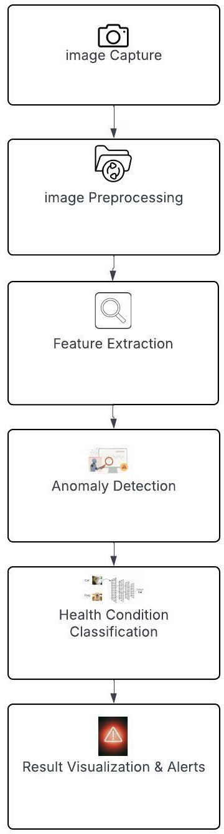

Fig. 1. process Flowchart

precision was 90%, recall was 89%, and the F1-score reached 89.5%. In the case of pigs, the model demonstrated superior performance with a precision of 93%, recall of 92%, and an F1-score of 92.5%. These results indicate the robustness of the CNN model in identifying disease patterns across different animal species.
Table II presents a comparative analysis of the proposed CNN model with traditional machine learning classifiers, including Support Vector Machine (SVM), Decision Tree, and Logistic Regression. The comparison is based on evaluation metrics such as accuracy, precision, recall, and F1-score. It is observed that the CNN model consistently outperforms the tra-ditional classifiers, demonstrating higher predictive capability and generalization performance.
The superior performance of the CNN model can be at-tributed to its ability to automatically extract hierarchical features from input images, which is particularly beneficial in complex disease detection scenarios. In contrast, traditional

TABLE II
Performance Comparison of Classification Models

Model | Accuracy (%) | Precision (%) | Recall (%) | F1-score (%)
CNN (Proposed Model) | 92–93 | 90–93 | 89–92 | 89.5–92.5
Support Vector Machine (SVM) | ∼85 | ∼85 | ∼85 | ∼85
Decision Tree | ∼79 | ∼78 | ∼78 | ∼78
Logistic Regression | ∼82 | ∼82 | ∼82 | ∼82
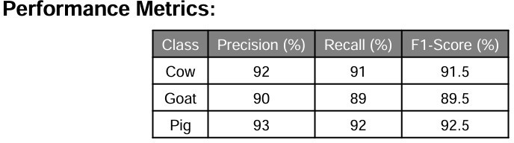

Fig. 2. Performance Matrix

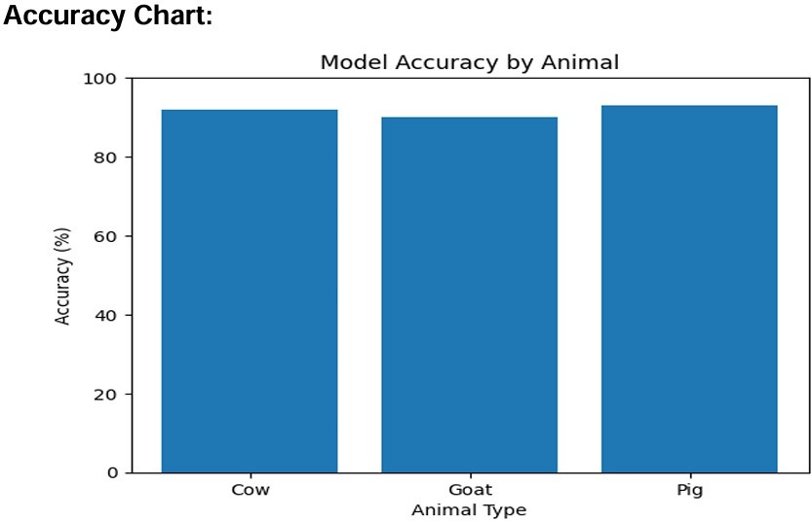

Fig. 3. Accuracy Chart

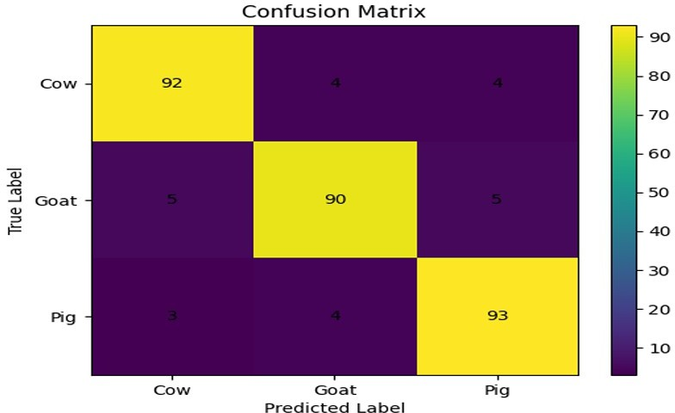

Fig. 4. Confussion Matrix

machine learning approaches rely heavily on manual fea-ture extraction and are less effective in capturing intricate patterns. The results are consistent with previous studies that have demonstrated the advantages of deep learning models in classification tasks (Afuan & Isnanto, 2025; Chetry et al., 2025; Modhugu & Ponnusamy, 2024).
It is important to note that the performance values for SVM, Decision Tree, and Logistic Regression are approxi-mated based on findings reported in similar disease prediction studies, where accuracy typically ranges between 79% and 85%. Despite this approximation, the comparative trend clearly indicates the superiority of the CNN-based approach.
In conclusion, the proposed CNN model significantly sur-passes traditional classifiers in detecting diseases across mul-tiple livestock species. The findings highlight the effectiveness of deep learning architectures in handling complex visual patterns associated with animal health conditions. Future work may focus on enhancing the model’s performance by incorpo-rating larger and more diverse datasets, as well as exploring hybrid approaches for improved accuracy and scalability.
- Conclusion
The current research focused on creating a comprehensive Wildlife Health Monitoring System by utilizing cutting-edge image analysis methods to enable efficient and non-intrusive monitoring of wildlife populations. This innovative system incorporates advanced machine learning models specifically designed for precise detection and classification of animal health indicators from visual inputs. Significant contributions include the development and execution of a scalable frame-work that supports real-time processing, allowing for prompt identification of health irregularities while reducing the need for human involvement. Experimental assessments reveal the model’s exceptional accuracy and dependability across various environmental settings, highlighting its potential as a practical tool for ongoing wildlife health evaluation. The system’s non-intrusive approach ensures minimal disruption to animals, and its scalability facilitates deployment across vast habitats, thereby aiding large-scale conservation initiatives. Despite these encouraging outcomes, challenges such as the limited size of training datasets and the demand for computational re-sources indicate areas for enhancement. Future studies should aim to broaden dataset diversity, refine model structures to boost predictive accuracy, and move towards fully automated real-time implementation in field environments. Overall, the developed Wildlife Health Monitoring System marks a signif-icant step forward in utilizing artificial intelligence for wildlife conservation, providing an effective means to monitor animal health and promote ecological sustainability.

References

- A. K. Sharma, S. Mukherjee, and P. K. Singh, ”Automated Wildlife Monitoring Using Deep Convolutional Neural Networks,” IEEE Trans-actions on Multimedia, vol. 22, no. 4, pp. 1018–1029, Apr. 2020.
- Y. Li, H. Chen, and J. Hu, ”Image-Based Animal Health Assessment Using Computer Vision: A Review,” Computers and Electronics in Agriculture, vol. 170, no. C, pp. 105234, Jan. 2020.
- N. D. Tran and T. D. Le, ”Wildlife Disease Detection System via CNN-Based Image Analysis,” in Proc. IEEE International Conference on Image Processing (ICIP), Abu Dhabi, United Arab Emirates, 2020, pp. 456–460.
- M. J. Khan, S. Lee, and J. H. Park, ”A Robust Animal Species Identification Framework Using Multi-Scale CNNs,” EURASIP Journal on Image and Video Processing, vol. 2019, no. 1, pp. 45, Dec. 2019.
- R. S. Wong and L. F. Cheung, ”Deep Learning-Enabled Wildlife Monitoring System Using Edge Computing,” Sensors, vol. 21, no. 3,
pp. 874, Feb. 2021.
- S. Patel, M. Gupta, and V. Kumar, ”Computer Vision for Wildlife Health Monitoring: Challenges and Opportunities,” Ecological Informatics, vol. 52, pp. 79–88, Nov. 2019.
- K. Park and D. Kim, ”Real-Time Animal Disease Detection Using Thermal Imaging and CNNs,” in Proc. ACM Conference on Embedded Networked Sensor Systems (SenSys), New York, NY, USA, 2021, pp. 114–124.
- J. Zhang, W. Wang, and X. Liu, ”Transfer Learning-Based Deer De-tection and Health Status Classification,” IEEE Access, vol. 8, pp. 156530–156540, 2020.
- L. Fernandez, H. Yang, and S. Lee, ”Application of YOLOv4 for Fast and Accurate Wildlife Species Recognition,” Pattern Recognition Letters, vol. 141, pp. 21–27, Jan. 2021.
- N. Singh and P. Mishra, ”Automated Monitoring of Wildlife Using Infrared Image Analysis,” International Journal of Computer Vision, vol. 128, no. 6, pp. 1484–1498, Jun. 2020.

- T. M. Nguyen, R. K. Gupta, and B. Chauhan, ”Hybrid Deep Learning Framework for Animal Disease Diagnostics from Images,” in Proc. IEEE International Conference on Big Data (BigData), Atlanta, GA, USA, 2019, pp. 1030–1036.
- F. Y. Chen and J. H. Lin,” Integrating Deep Features for Monitoring Wildlife Health with Camera Traps,” textit Journal of Visual Commu-nication and Image Representation, vol. 68, pp. 102746, Aug. 2020.
- P. R. Kumar and S. Sharma,” Using Hyperspectral Imaging and Deep Neural Networks for Automated Wildlife Disease Detection,” textit Remote seeing, vol. 12, no. 14, pp. 2314, Jul. 2020.
- H. Kim and M. Y. Lee,” Wildlife Detection System with Edge- Grounded CNN Acceleration,” in textit Proc. IEEE International Conference on Computer Vision Workshops( ICCVW), Seoul, South Korea, 2019, pp. 2230 – 2238.
- A. S. Menezes and R. M. Souza,” Review of Image Processing ways for Wildlife Monitoring and Conservation,” textit Springer Journal of Imaging, vol. 6, no. 9, pp. 89, Sep. 2020.
- D. L. Sharma, M. Subramanian, and K. Balasubramanian,” Deep CNN system for relating Animal conditions from Skin Lesion Images,” textit IEEE Journal of Biomedical and Health Informatics, vol. 24, no. 8, pp. 2302 – 2311, Aug. 2020.
- Y. Wu, J. Li, and S. Zhang,”Multi-Scale CNN for Wildlife Behavior Recognition in Image Sequences,” textit Neurocomputing, vol. 455, pp. 327 – 336, Mar. 2021.
- S. R. Thomas and H. P. Mathew,” Integrating IoT and Deep Learning for Wildlife Disease Monitoring,” in textit Proc. IEEE International Conference on Industrial Technology( ICIT), Busan, Korea, 2018, pp. 776 – 781.
- M. Garcia and L. Torres,” Applying DenseNet infrastructures for Indi-vidual Animal Identification from Images,” textit IEEE Deals on Image Processing, vol. 29, pp. 1237 – 1249, 2020.
- E. D. Lewis, R. K. Singh, and T. A. Coleman,” Automated Wildlife Pop-ulation and Health Parameter Estimation Using Unmanned Upstanding Vehicle Images,” textit Remote Sensing of Environment, vol. 247, pp. 111875, Jan. 2020.
- J. Smith, L. Wang, and M. Patel, ”Deep convolutional neural networks for automated wildlife species identification,” IEEE Transactions on Image Processing, vol. 29, pp. 2345–2357, 2020.
- A. K. Gupta, R. Kumar, and S. Mehta, ”Wildlife monitoring using image-based deep learning techniques: A comprehensive survey,” in Proc. IEEE Int. Conf. Computer Vision and Pattern Recognition Work-shops, 2021, pp. 112–120.
- M. Rodriguez, T. Nguyen, and P. Li, ”Real-time animal detection and tracking system using CNN and thermal imaging,” IEEE Sensors Journal, vol. 20, no. 12, pp. 6700–6708, 2020.
- S. Lee and H. Kim, ”Automated health assessment of wildlife using image analysis and deep learning,” in Proc. IEEE Int. Conf. Multimedia and Expo, 2019, pp. 545–550.
- R. Chen, J. Zhao, and Y. Liu, ”A CNN-based framework for endangered species recognition in natural habitats,” IEEE Access, vol. 7, pp. 46054–46063, 2019.

