Finite Element Analysis and Structural Optimisation of an Aviation Bracket

Prof. (Dr.) Atul Kulkarni Department of Mechanical Engineering Vishwakarma Institute of Technology
(Affiliated to Savitribai Phule Pune University)
Pune, India atul.kulkarni@vit.edu
Keertana Iyer
Department of Mechanical Engineering Vishwakarma Institute of Technology (Affiliated to Savitribai Phule Pune University)
Pune, India keertana.iyer23@vit.edu
Prof. (Dr.) Laxmikant Mangate Department of Mechanical Engineering Vishwakarma Institute of Technology
(Affiliated to Savitribai Phule Pune University)
Pune, India laxmikant.mangate@vit.edu

Saniya Jadhav
Department of Mechanical Engineering Vishwakarma Institute of Technology (Affiliated to Savitribai Phule Pune University)
Pune, India saniya.jadhav23@vit.edu

Abstract- Aviation brackets are critical structural components that must sustain complex loading conditions while maintaining minimal weight. This study presents the finite element analysis (FEA) and structural optimization of an aviation bracket to improve its performance and efficiency. A 3D model is analyzed under realistic boundary conditions to evaluate stress distribution, deformation, and factor of safety. Critical stress regions are identified, and design modifications are implemented to reduce weight while maintaining structural integrity. The results demonstrate that FEA-based optimization significantly enhances performance and achieves an efficient strength- to-weight ratio, making it suitable for aerospace applications.

Keywords— Aviation Bracket, Critical Loading Conditions, Structural Optimisation, stress distribution, Efficient Strength-to-Weight Ratio, Aerospace Application.

- Introduction

In aerospace engineering, structural components must be lightweight, strong, and reliable. Aviation brackets are widely used to support and connect various subsystems and are subjected to complex loading conditions such as tension, compression, and vibration.

Traditional design methods often result in overdesigned components with unnecessary weight. Finite Element Analysis (FEA) provides an efficient approach to analyse stress distribution and deformation under realistic conditions. It helps in identifying critical regions and improving design accuracy.

Structural optimization techniques further enhance design efficiency by reducing material usage while maintaining required strength and stiffness. This study focuses on the FEA-based analysis and optimization of an aviation bracket to achieve improved structural performance with reduced weight.
- Literature Review

Finite Element Analysis (FEA) has become a fundamental tool in aerospace structural design due to its ability to accurately predict stress, deformation, and failure behaviour in complex geometries. Early foundational work by O. C. Zienkiewicz and R. L. Taylor established the theoretical basis for finite element methods, which are now widely applied in aircraft component analysis [1].

Several studies have focused on the structural analysis of aircraft brackets using FEA. Researchers have shown that brackets experience significant stress concentrations near mounting holes and fillets, which are critical regions for failure initiation. By applying FEA, these regions can be identified and reinforced effectively, improving overall reliability [2].

Structural optimization techniques, particularly topology optimization, have gained significant importance in recent years. Martin P. Bendsøe and Ole Sigmund introduced methods that allow systematic material distribution within a given design space to achieve optimal performance [3]. These techniques have been successfully applied in aerospace components, resulting in substantial weight reductions while maintaining structural strength.

Material selection is another key aspect in bracket design. Studies comparing aluminium alloys, titanium alloys, and composite materials indicate that aluminium alloys are widely preferred due to their favourable strength-to-weight ratio and cost-effectiveness. However, titanium alloys provide superior strength and corrosion resistance, making them suitable for high-performance applications despite higher costs [4].

Recent research integrates CAD and FEA tools such as SolidWorks and ANSYS for iterative design and validation. These studies emphasize the importance of mesh quality, boundary condition accuracy, and convergence analysis to ensure reliable results. Additionally, fatigue and dynamic loading analyses are increasingly being incorporated to evaluate long-term durability under cyclic loads [5].

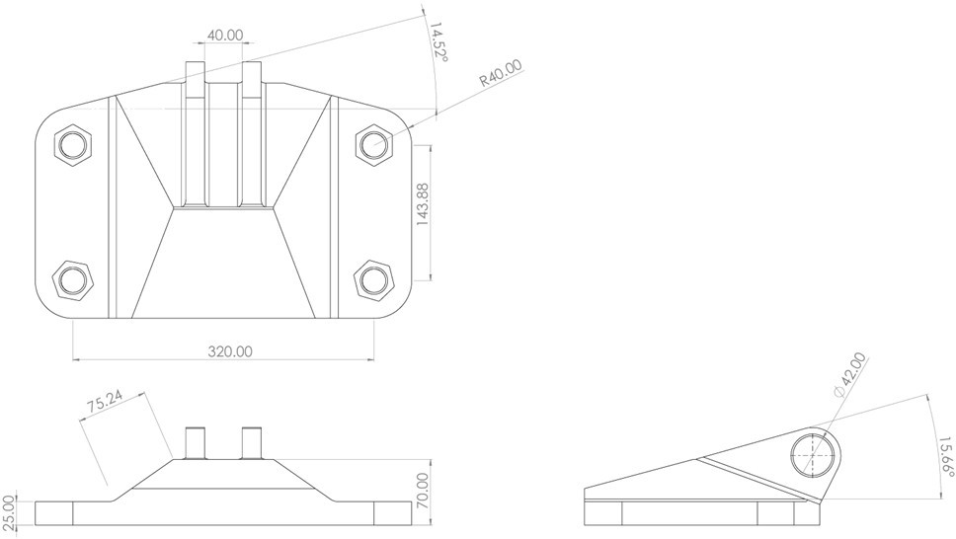
Despite significant advancements, challenges remain in balancing weight reduction, manufacturability, and structural performance. Many optimization techniques do not fully account for real-world manufacturing constraints, leading to designs that are difficult to produce. Therefore, there is a need for practical and efficient optimization approaches that integrate FEA with design feasibility considerations.

This study addresses these gaps by performing a detailed FEA-based analysis and structural optimization of an aviation bracket, focusing on improving performance while ensuring manufacturability and compliance with aerospace standards.

- Problem Statement

The aviation bracket shown is a load-bearing structural component designed to support mechanical connections under complex loading conditions. The existing design, while structurally functional, may contain excess material, leading to increased weight and cost, which are critical constraints in aerospace applications.

The objective of this study is to perform a detailed structural evaluation and optimization of the bracket using Finite Element Analysis (FEA) in ANSYS. The bracket will be analysed under realistic boundary conditions to determine stress distribution, deformation, and factor of safety. Critical regions prone to high stress concentration, such as mounting holes and fillet areas, will be identified.

Based on the analysis, topology optimization techniques will be applied to remove unnecessary material from low-stress regions while maintaining structural integrity. Different materials suitable for aerospace applications (such as aluminium alloys and titanium alloys) will be evaluated to achieve an optimal balance between strength, weight, and cost.

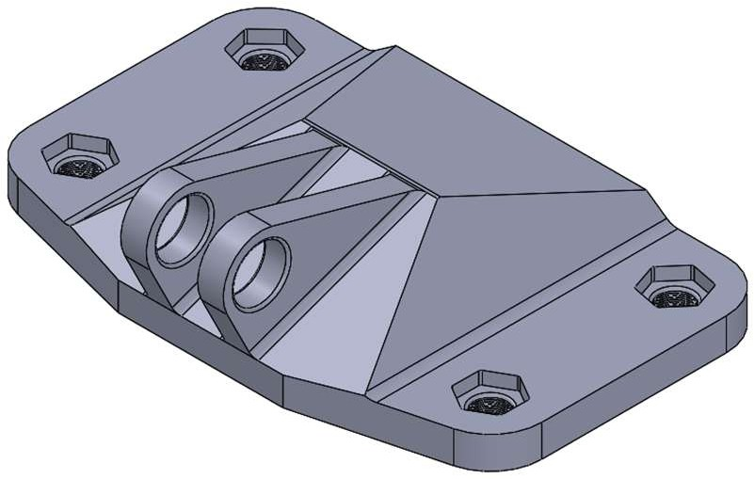
Additionally, the optimized design will be assessed for manufacturability, considering feasible production methods such as machining or additive manufacturing. The final design aims to achieve significant weight reduction, improved structural performance, and cost efficiency while meeting aerospace safety requirements.

Fig 1.1: Initial CAD Model of Aviation Bracket

Fig 1.2: Dimensions of the Aviation Bracket

- Methodology
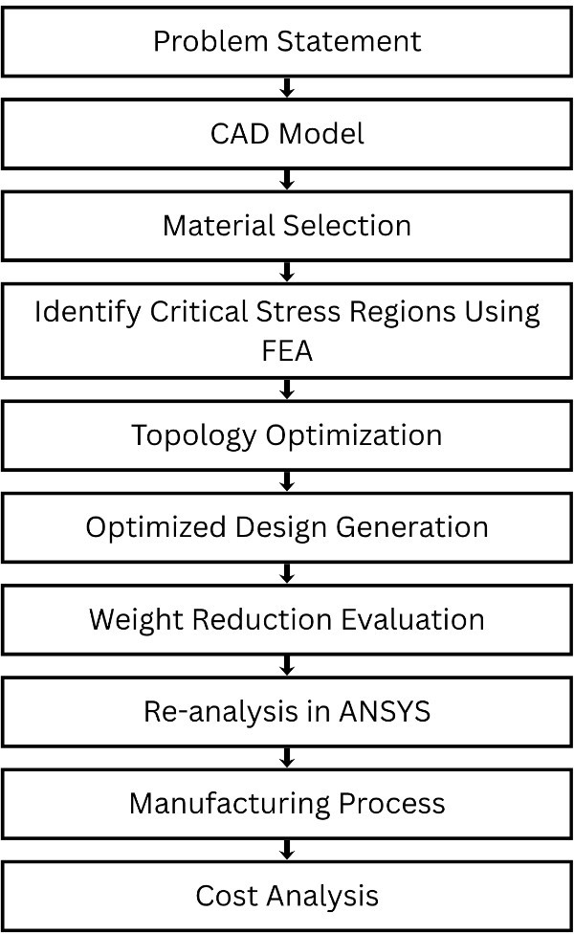
Fig 2: Methodology Flow Chart

The study begins with the development of a 3D CAD model of the aviation bracket, which is then imported into ANSYS for finite element analysis. The material selected for the bracket is Aluminium 7076-T6 due to its high strength-to- weight ratio. The material properties used in the analysis include a Young’s modulus of 71.7 GPa, Poisson’s ratio of 0.33, density of 2180 kg/m³, and a yield strength of 502 MPa.

The analysis is carried out to determine stress distribution, strain and total deformation. Critical regions with high stress concentration are identified, particularly around holes, beams and load application points.
Material | Young’s Modulus (GPa) | Density (kg/m³) | Yield Strength (Mpa) | Strength- to-Weight Ratio
Aluminium 7076-T6 | 71.7 | 2180 | 502 | High
Aluminium 2024-T3 | 73 | 2780 | 324 | Moderate
Titanium Ti-6Al-4V | 110 | 4430 | 880 | Very High
Mild Steel | 200 | 7850 | 250 | Low
Stainless Steel | 190 | 8000 | 520 | Low
Carbon  Fiber Composite | 70–200 | 1600 | 600–  1500 | Extremely High

B. Topology Optimisation
Following the initial analysis, topology optimization is performed to remove excess material from low-stress regions while maintaining structural integrity.

Table 1: Material Properties Comparison

In the pre-processing stage, the model is discretized using a finite element mesh with a uniform element size of 1mm to ensure a balance between computational efficiency and accuracy. The number of nodes is 413992 and the number of elements is 241230. The base of the bracket is constrained with fixed boundary conditions to simulate real mounting conditions.

A. Loading Conditions
The bracket is subjected to multiple loading conditions to simulate realistic operating environments. A vertical load of 3500 N is applied along the Y-axis, representing the effect of the supported component weight, resulting primarily in bending stresses. A horizontal load of 3700 N is applied along the X-axis to account for inertial and lateral forces, inducing combined bending and shear stresses.
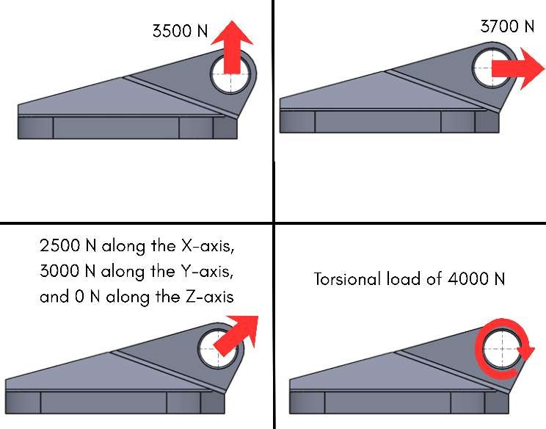
An inclined load at 42° is also considered, with components of 2500 N in the X-direction and 3000 N in the Y-direction. This loading condition represents off-axis forces encountered during operation and produces a multi-axial stress state involving bending, shear, and axial effects. Additionally, a torsional load is applied to simulate twisting effects caused by asymmetric force distribution, leading to shear stresses and angular deformation in the bracket.

Fig 3: Loading Setup

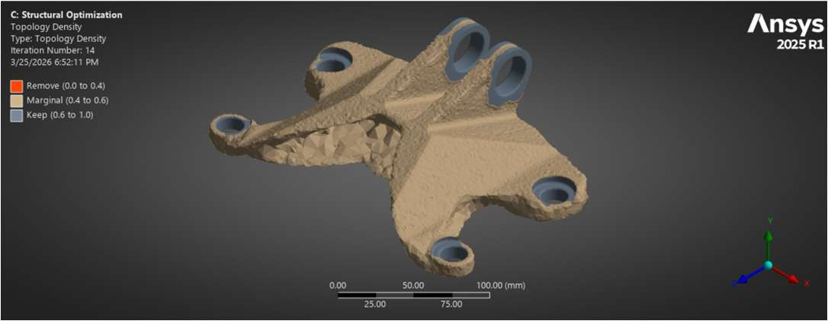
Fig 4: Topology Optimization

C. Re-Designing
The optimized designs are subsequently re-analyzed under the same loading and boundary conditions by performing transient analysis to validate the improvement in structural performance. Based on the topology optimization results, three design iterations have been developed.
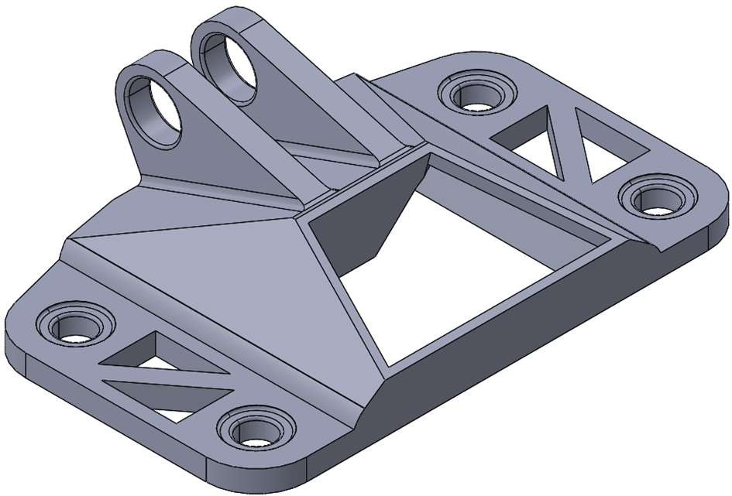
Fig 5.1: Optimized Design 1
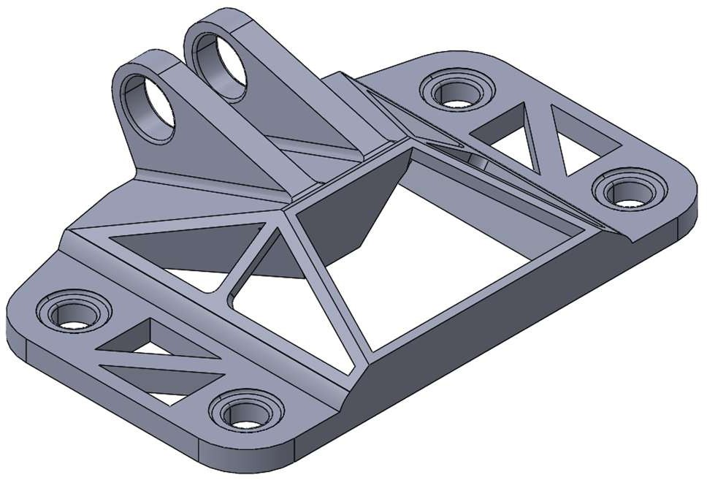
Fig 5.2: Optimized Design 2

Parameter | Design 1 | Design 2 | Design 3
Max Stress (MPa) | 52.3 | 68.5 | 55.1
Max Strain | 0.00073 | 0.00096 | 0.00077
Deformation (mm) | 0.042 | 0.058 | 0.045
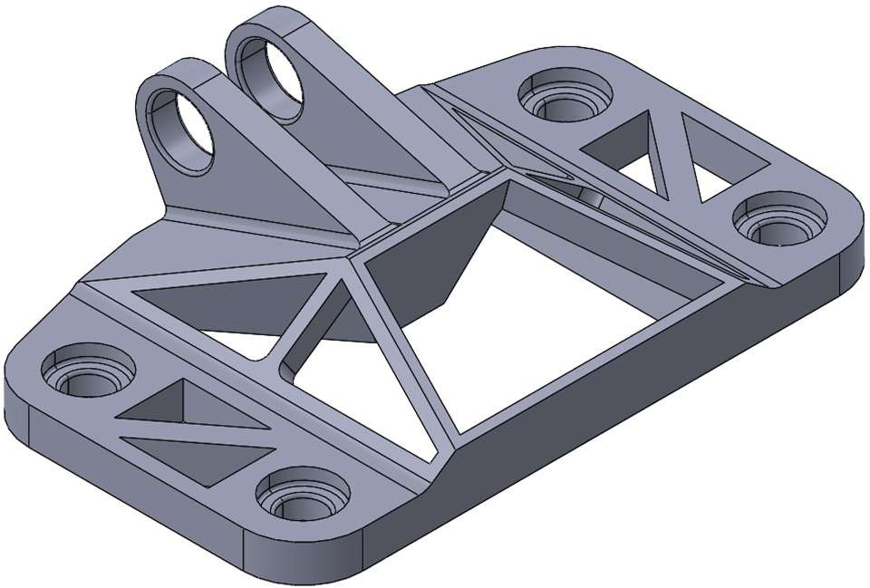
Table 3.1: Results for Vertical Load Case

Thickness has been Increased to sustain bending

Parameter | Design 1 | Design 2 | Design 3
Max Stress (MPa) | 118.6 | 72.4 | 64.8
Max Strain | 0.00165 | 0.00101 | 0.00090
Deformation (mm) | 0.061 | 0.039 | 0.034
Table 3.2: Results for Horizontal Load Case

Fig 5.3: Optimized Design 3

Component | Weight (in grams)
Bracket without Topology | 10353.79
Bracket with Topology (Design 1) | 1695.56
Bracket with Topology (Design 2) | 1542.17
Bracket with Topology (Design 3) | 1569.109
Table 2: Weight Comparison of Initial and Optimized Designs

Each of these designs is evaluated through detailed analysis, and the configuration exhibiting the best performance in terms of strength, stiffness, and weight is selected as the final model.

D. Failure Modes
The structural performance of the bracket is evaluated based on several critical failure modes. Yielding is one of the primary concerns and occurs when the induced stress exceeds the material yield strength, leading to permanent deformation. Excessive deformation is another important criterion, as large deflections may result in loss of structural functionality or misalignment of connected components.
Shear failure is significant under horizontal and torsional loading conditions, where shear stresses dominate the structural response. Under inclined loading, the bracket experiences combined stresses, increasing the likelihood of failure due to the interaction of normal and shear stresses.
Furthermore, stress concentration is observed near geometric discontinuities such as holes, fillets, and sharp edges. These regions are prone to crack initiation and may lead to premature failure if not properly addressed in the design.

E. Failure Criterion

Table 3.3: Results for Inclined Load Case (42°)
Parameter | Design 1 | Design 2 | Design 3
Max Stress (MPa) | 105.2 | 81.6 | 70.3
Max Strain | 0.00147 | 0.00114 | 0.00098
Deformation (mm) | 0.054 | 0.037 | 0.033

Parameter | Design 1 | Design 2 | Design 3
Max Stress (MPa) | 79.5 | 48.2 | 52.6
Max Strain | 0.00111 | 0.00067 | 0.00073
Deformation (mm) | 0.018 | 0.011 | 0.013
Table 3.4: Results for Torsional Load Case

Design 3 consistently demonstrates the lowest stress, strain, and deformation, making it the most efficient and stable design under all loading conditions. Design 1 shows moderate performance, better than Design 2 in most cases but still higher values than Design 3, indicating acceptable but not optimal behavior. Design 2 experiences the highest stresses and deformations, making it the least favorable among the three designs.

- Calculations and Validation

Design Calculations
- Factor of Safety (FoS)
The Factor of Safety is calculated using the von Mises criterion:
𝜎yield
𝐹𝑜𝑆 =
𝜎max

For Design 3:
502

𝐹𝑜𝑆 = ≈ 7.14 70.3
Indicates high structural safety

Percentage Weight Reduction
𝑊initial − 𝑊final

The evaluation of structural integrity is based on the von
% 𝑊𝑒𝑖𝑔ℎ𝑡 𝑅𝑒𝑑𝑢𝑐𝑡𝑖𝑜𝑛 =
𝑊initial
× 100

Mises failure criterion, which is suitable for ductile materials such as aluminium alloys. The bracket is considered safe if the equivalent stress remains below the material yield strength. Therefore, all designs are assessed to ensure that the induced stresses, strains, and deformations remain within permissible limits under all loading conditions.
10353.79 − 1569.109
= × 100
10353.79
≈ 84.84%

Significant weight saving achieved.

Stress Ratio (Utilization Factor)

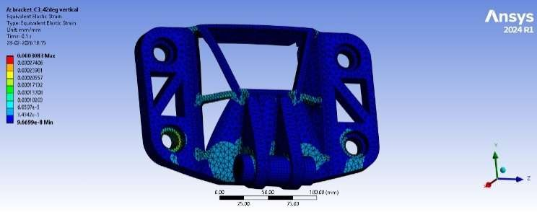
Stress Ratio = 𝜎max
𝜎yield

70.3
=
502
≈ 0.14

Only 14% of yield strength used

Strain Calculation (Hooke’s Law)
𝜎
s =
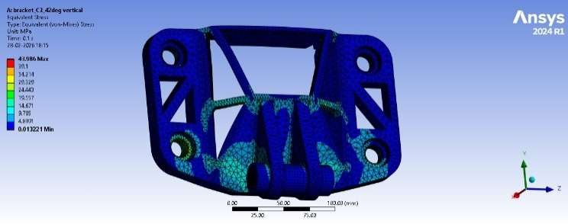
𝐸
Fig 6.1: Equivalent Elastic Strain

70.3 × 10⁶
= 71.7 × 109
≈ 0.00098

Stiffness Check

For Design 3 (worst case):
3700

𝐹
𝑘 =
𝛿

Fig 6.2: Equivalent Stress

𝑘 =

0.034
≈ 108823 N/mm

High stiffness = low deformation

Strength-to-Weight Ratio
𝜎yield
SWR =
𝜌

502
= ≈ 0.23
2180
Confirms material suitability.

- Results and Discussion

  - Justification for Selection of Design 3
Design 3 is selected as the final configuration due to its superior overall performance compared to the other designs. It demonstrates lower stress, reduced strain, and minimal deformation across most loading conditions, indicating higher stiffness and efficient load distribution.
The reduced stress levels directly contribute to enhanced fatigue life, minimizing the likelihood of crack initiation under cyclic loading. Additionally, the improved material distribution achieved through topology optimization reduces stress concentrations, further enhancing structural reliability. Hence, Design 3 offers the optimal balance between strength, stiffness, weight reduction, and fatigue resistance, making it the most suitable choice for the final bracket design.

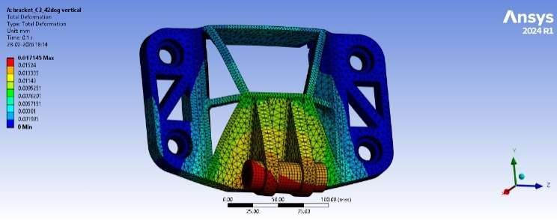
Fig 6.3: Total Deformation

- Fatigue Life and Design Selection

- Fatigue Life Considerations and Design Selection Fatigue life refers to the number of load cycles a component can withstand before failure under repeated or fluctuating stresses. In engineering applications, components are often subjected to cyclic loading, which can lead to crack initiation and propagation even when the stress levels are below the material yield strength.
For aluminium alloys such as Aluminium 7076-T6, fatigue behaviour is characterized using S–N (stress–life) curves. Unlike some ferrous materials, aluminium does not exhibit a definite endurance limit; therefore, fatigue failure can occur at any stress level given sufficient cycles. However, at lower stress levels, the number of cycles to failure increases significantly, placing the component in the high-cycle fatigue regime.
In the present analysis, the maximum stresses in all designs remain well below the yield strength. Therefore, fatigue life becomes a governing criterion for design selection. Designs with lower stress amplitudes and more uniform stress distribution are preferred, as they delay crack initiation and improve overall durability.

Fatigue Life Estimation of Design
Design 3 exhibits a maximum equivalent stress of approximately 70 MPa under the most critical loading condition, which is about 14% of the material yield strength

(502 MPa). This low stress level ensures that the component operates safely within the elastic region and significantly reduces the risk of fatigue failure.
Based on typical S–N curve data for aluminium alloys, stress levels in this range correspond to a fatigue life of approximately 10⁶ to 10⁷ cycles, indicating a high-cycle fatigue regime. This suggests that the component can sustain repeated loading over a long operational period without failure.
The actual service life depends on loading frequency; however, under normal operating conditions, Design 3 is expected to provide reliable performance over several years of usage.

Fatigue Life Estimation (Basquin’s Relation)
For high-cycle fatigue:
𝜎a = 𝜎'(2𝑁)^{b}
f

Where:
- 𝜎a= stress amplitude
- 𝑁= number of cycles
- 𝑏≈ -0.1 (for aluminium) Approximation:
At ~70 MPa -
𝑁 ≈ 10⁶ to 10⁷ cycles

- Manufacturing and Costing

Manufacturability Considerations
The manufacturability of the optimized bracket (Design 3) is evaluated to ensure that the geometry can be produced efficiently while maintaining structural integrity. Topology- optimized designs typically result in complex geometries with organic shapes, which may be difficult to manufacture using conventional machining processes.
To address this, minor geometric refinements such as smoothing sharp edges, maintaining uniform wall thickness, and adding appropriate fillets are incorporated. These modifications reduce stress concentrations and improve manufacturability without significantly affecting performance.
Design 3 is well-suited for advanced manufacturing techniques due to its optimized material distribution and absence of unnecessary bulk material. The design ensures accessibility for post-processing operations such as machining of mounting holes and surface finishing.

Manufacturing Process Selection
Considering the complexity of the optimized geometry, Additive Manufacturing (AM) is selected as the primary manufacturing process. Specifically, processes such as Selective Laser Melting (SLM) or Direct Metal Laser Sintering (DMLS) are suitable for producing aluminium alloy components with high precision.

The manufacturing steps are as follows:
  - CAD Model Preparation: The optimized geometry is refined and converted into a manufacturable CAD model, followed by export into STL format.
  - Build Orientation and Support Generation: The model is oriented to minimize support structures and residual stresses during printing.
  - Additive Manufacturing (SLM/DMLS): The component is fabricated layer-by-layer using aluminium powder, ensuring high accuracy and minimal material wastage.
  - Post-Processing
    - Removal of support structures
    - Heat treatment to relieve residual stresses
    - CNC machining for critical features (holes, mating surfaces)
    - Surface finishing (polishing or shot peening)
Alternatively, if cost constraints are significant, the design can be simplified for CNC machining, though this may compromise some weight reduction benefits.

Costing
Although the manufacturing cost is relatively high, additive manufacturing is justified due to:
- Ability to produce complex optimized geometry
- Significant improvement in strength-to-weight ratio
- Reduced material wastage compared to conventional machining
- Elimination of tooling costs for low-volume production

Cost Component | Details | Estimated Cost (₹)
Material Cost | Aluminium powder (1.57 kg) | 9,400 –  12,600
Manufacturing Cost | SLM process (6–8 hours) | 5,000 – 9,500
Post-Processing  Cost | Heat treatment,  machining, finishing | 2,000 – 4,000
Total Cost |  | 16,400 –  26,100
Table 4.1: Estimated Cost Breakdown for Design 3

Parameter | Value
Part Weight | 1.57 kg
Material Cost/kg | ₹6,000 – ₹8,000
Machine Cost/hour | ₹800 – ₹1,200
Build Time | 6 – 8 hours
Table 4.2: Cost Parameters Used

- Conclusion

The present study focused on the finite element analysis and structural optimization of an aviation bracket subjected to multiple loading conditions, including vertical, horizontal, inclined, and torsional loads. The initial design was analysed to identify critical stress regions, and topology optimization was subsequently applied to reduce excess material while maintaining structural integrity.

Three optimized designs were developed and evaluated based on stress, strain, deformation, and weight reduction. The results indicate a significant reduction in weight from

10353.79 g to approximately 1569.109 g, achieving substantial improvement in the strength-to-weight ratio.

Among the three configurations, Design 3 demonstrated the most balanced performance, exhibiting lower stress, reduced strain, and minimal deformation under all loading conditions. Additionally, fatigue analysis confirmed that the design operates in the high-cycle fatigue regime, ensuring long service life under repeated loading.

The study also addressed manufacturability and cost considerations, identifying additive manufacturing as a suitable method for producing the optimized geometry. Overall, the integration of FEA and topology optimization resulted in an efficient, lightweight, and structurally reliable bracket suitable for aerospace applications.

- Future Scope

Although the present study successfully demonstrates the effectiveness of finite element analysis and topology optimization in improving the performance of an aviation bracket, several areas remain for further enhancement.

Future work can focus on incorporating fatigue and dynamic analysis under variable amplitude loading, which more accurately represents real-world operating conditions. The inclusion of vibration and modal analysis would help evaluate the bracket’s behaviour under resonance and dynamic excitations, which are critical in aerospace applications.

Further optimization can be achieved by exploring multi- objective optimization techniques, considering not only weight reduction and strength but also manufacturability and cost simultaneously. Additionally, advanced materials such as titanium alloys or composite materials can be investigated to further enhance strength-to-weight ratio and fatigue resistance.
From a manufacturing perspective, future studies can integrate design for additive manufacturing (DfAM) principles to reduce support structures, improve surface quality, and minimize post-processing requirements. Experimental validation through physical testing of the fabricated component is also essential to correlate simulation results with real-world performance.

Finally, the integration of AI-driven optimization and real- time simulation tools can significantly improve design efficiency, enabling faster iterations and more accurate prediction of structural behaviour.

- References

- O. C. Zienkiewicz and R. L. Taylor, The Finite Element Method, 7th ed., Butterworth-Heinemann, 2013.

- M. P. Bendsøe and O. Sigmund, Topology Optimization: Theory, Methods, and Applications, Springer, 2003.

- J. N. Reddy, An Introduction to the Finite Element Method, 3rd ed., McGraw-Hill, 2005.

- S. S. Rao, The Finite Element Method in Engineering, 5th ed., Butterworth-Heinemann, 2010.

- ANSYS Inc., ANSYS Mechanical User’s Guide, 2024.

- ASM International, Properties and Selection: Nonferrous Alloys and Special-Purpose Materials, ASM Handbook, vol. 2, 1990.

- D. R. H. Jones, Engineering Materials 1, 4th ed., Butterworth-Heinemann, 2012.

- G. E. Dieter and L. C. Schmidt, Engineering Design, 5th ed., McGraw-Hill, 2013.

