A GSM-Free IoT Architecture for Smart Vehicle Anti-Theft and Multi-Mode Safety Monitoring Using ESP32 with Telegram Bot Integration
Alisha Sawant  Dept. of Electronics & Telecommunication  Sinhgad College of Engineering, Pune, India | Pradnya Kumthekar  Dept. of Electronics & Telecommunication  Sinhgad College of Engineering, Pune, India | Shravani Dighe  Dept. of Electronics & Telecommunication  Sinhgad College of Engineering, Pune, India | Prof. K. S. Karpe (Guide)  Dept. of Electronics & Telecommunication  Sinhgad College of Engineering, Pune, India

Abstract - Road traffic fatalities in developing economies are significantly attributed to vehicle theft, alcohol-impaired driving, and inadequate emergency response following accidents. Despite this critical need, cost-effective embedded solutions that simultaneously address these three safety challenges remain inaccessible to typical vehicle owners. This research introduces an integrated smart vehicle monitoring platform that operates without SIM card dependency, utilizing the ESP32-WROOM-32 microcontroller as its foundation. The system executes six concurrent operational functions within a unified architecture: (i) GPS-based anti-theft notifications transmitted as interactive Google Maps links via Telegram Bot API through Wi-Fi connectivity, (ii) breath alcohol sensing through MQ-3 sensor integration with automated ignition prevention mechanisms, (iii) collision and vehicle rollover identification using MPU6050 six-axis inertial measurement technology enhanced with rolling-average algorithms for false alarm mitigation, (iv) intelligent headlight control based on ambient light conditions through LDR voltage divider implementation, (v) proximity alert functionality utilizing HC-SR04 ultrasonic sensing with progressive warning zones, and (vi) browser-accessible Pilot Console dashboard hosted locally on ESP32 flash storage, enabling network-wide access without specialized applications. Performance validation through controlled laboratory conditions and real-world field testing yielded a mean Telegram notification delay of 3.1 seconds, comprehensive detection reliability of 98.0% across 60 experimental trials, GPS positioning accuracy of 3.2 meters CEP, and complete alcohol detection precision across 10 validation tests. The complete hardware implementation costs Rs. 1,185 with no ongoing communication expenses. The design deliberately excludes LCD displays, SIM cards, and GSM components throughout the entire system architecture.

Index Terms - ESP32, IoT vehicle security, Telegram Bot API, GPS anti-theft, MQ-3 alcohol detection, MPU6050 crash detection, LDR headlight automation, HC-SR04 proximity, Wi-Fi alert system, smart mobility.

I. INTRODUCTION
Road safety in India necessitates immediate technological solutions. The Ministry of Road Transport and Highways documented over 1.55 lakh road accident fatalities in 2021, with a significant percentage attributed to alcohol-impaired driving and inadequate emergency response protocols [1]. Concurrently, vehicle theft represents an ongoing concern in metropolitan and semi-metropolitan regions, where conventional mechanical security systems and passive alarm mechanisms provide insufficient protection.
The Internet of Things (IoT) framework has substantially reduced barriers to integrating intelligent capabilities into commonplace objects, particularly vehicles. Contemporary microcontrollers like the ESP32 incorporate dual-core processing architecture, Wi-Fi connectivity, and Bluetooth functionality within a single semiconductor package costing less than Rs. 300 - an economic threshold that enables comprehensive vehicle safety implementation across entry-level two-wheeled vehicles. Nevertheless, existing research demonstrates two fundamental constraints. First, current approaches predominantly utilize GSM/SIM-based notification systems, which introduce ongoing subscription expenses and compromise reliability in regions with inadequate cellular coverage [11]. Second, these solutions exhibit functional fragmentation: anti-theft mechanisms, alcohol detection capabilities, and collision alert systems typically operate as discrete, standalone implementations rather than integrated platforms.
This research simultaneously addresses both identified limitations. The developed system executes six distinct safety protocols on a single ESP32 platform, transmits all notifications through the Telegram Bot API via the device's integrated Wi-Fi transceiver, and operates without recurring costs, display components, or SIM card requirements. The dual-core ESP32 firmware architecture segregates sensor data acquisition (Core 1) from network communications and web server operations (Core 0), ensuring neither process interferes with the other's execution.
The principal contributions of this research include:
• A comprehensive six-mode vehicle safety framework implemented on a unified ESP32 platform without GSM, SIM, or LCD dependencies.
• Quantified Telegram notification latency measurements conducted under controlled and field Wi-Fi conditions across 10 trials per operational mode.
• An MQ-3 analog-to-digital converter calibration protocol aligned with Indian Motor Vehicles Act blood alcohol concentration legal thresholds.
• A rolling-average false-positive mitigation technique for MPU6050 collision detection, validated on Pune metropolitan road infrastructure.
• A self-hosted Pilot Console web interface served directly from ESP32 flash memory without external cloud infrastructure requirements.

II. RELATED WORK
A. IoT-Based Vehicle Tracking
Early IoT vehicle-tracking research identified GPS parsing and wireless alert delivery as the two foundational pillars of embedded vehicle safety platforms [2]. Compact microcontrollers have been shown to reliably parse NMEA GPS sentences and forward location data wirelessly, with hardware cost and alert latency serving as the primary evaluation criteria [3]. Subsequent designs progressively migrated from dedicated cellular modems toward Wi-Fi-capable SoCs to reduce recurring costs — a trend that directly informs the Wi-Fi-native architecture proposed in the present work.
B. Alcohol Detection and Ignition Interlock
The MQ-3 metal-oxide semiconductor sensor has been extensively validated as a breath-alcohol detector in automotive settings [4]. Threshold-based ignition interlock has proven effective in preventing impaired vehicle start, yet two key challenges persist: ambient volatile organic compounds can elevate the ADC baseline reading, and existing designs typically provide no remote notification to the owner when the interlock activates [5]. The proposed system addresses both issues by coupling ADC-level calibration against the Indian legal BAC limit with an immediate Telegram alert to the registered owner.
C. Inertial Crash and Rollover Detection
The MPU6050 six-axis IMU has become a standard component for vehicular collision and rollover detection in embedded systems research [6]. The principal limitation identified in prior work is susceptibility to false positives caused by road surface irregularities — speed bumps and potholes — which regularly generate short-duration acceleration spikes that exceed typical crash detection thresholds [5]. Short-window averaging filters have been proposed as the accepted mitigation strategy; the present work implements and validates a three-sample rolling-average filter under Pune city driving conditions.
D. Telegram Bot API in Embedded Alert Systems
The Telegram Bot API communicates over HTTPS on port 443, enabling messages to traverse most network configurations without requiring special firewall exceptions [7]. Its read-receipt capability and support for rich content — hyperlinks, formatted text, and images — make it a qualitatively superior alert channel relative to plain SMS. Prior ESP32-based Telegram integrations have focused on home security and industrial monitoring [10]; their application to a six-mode vehicle safety platform combined with a locally hosted web dashboard is novel to this work.

E. Research Gap
Across the reviewed literature, no single published platform simultaneously provides anti-theft GPS alerting, alcohol-triggered ignition interlock, inertial crash detection, automatic ambient-light headlight control, ultrasonic proximity warning, and an on-device browser-accessible web dashboard — without GSM, SIM, or LCD — at a hardware cost below Rs. 1,500. The proposed system is designed to close this gap in its entirety.

III. SYSTEM ARCHITECTURE AND METHODOLOGY
A. Three-Tier Hardware Architecture
The hardware is organised into three functional tiers that together span the full vehicle safety envelope. The Sensing Layer comprises six heterogeneous sensors: the MQ-3 for breath-alcohol measurement, the MPU6050 for six-axis acceleration and gyroscope data, the NEO-6M for GPS positioning, the HC-SR04 for ultrasonic distance measurement, a GL5528 LDR for ambient luminance, and a Hall-effect speed encoder. The Processing Layer relies entirely on the ESP32-WROOM-32, whose dual-core Xtensa LX6 architecture running at 240 MHz, combined with 520 KB of SRAM and 4 MB of flash, handles all sensor fusion, decision logic, and network communication concurrently without any external co-processor. The Output and Communication Layer encompasses ignition relay control, headlight relay control, graduated proximity alert signalling, and HTTPS message dispatch to the Telegram Bot API. No SIM card, no GSM hardware, and no LCD are present at any point in the system.
B. ESP32 Dual-Core Firmware Design
The firmware exploits the two available cores to prevent network latency from compromising real-time sensing. Core 0 runs the FreeRTOS Wi-Fi and TCP/IP stack together with the ESPAsyncWebServer instance that serves the Pilot Console. Core 1 executes the sensor polling loop on a strict 100 ms tick, reading all six sensors, evaluating detection thresholds, driving the relays, and pushing alert payloads into a thread-safe queue that is consumed by the Telegram sender task on Core 0. In a preliminary single-core firmware prototype, HTTPS POST calls blocked the sensor loop for between 400 and 800 milliseconds — a window large enough to miss a brief alcohol threshold exceedance or a fast crash-acceleration peak. The dual-core split reduced sensor-loop jitter to under 5 ms, which is negligible relative to both the 100 ms tick and the physical duration of any detectable event.
C. Breath Alcohol Detection and Ignition Interlock
The MQ-3 sensor output is sampled on ESP32 ADC GPIO34 at 12-bit resolution, yielding values in the range of 0 to 4095 counts. A one-point calibration maps raw ADC values to breath-alcohol concentration, referenced to the Indian Motor Vehicles Act legal limit of 0.30 mg per 100 mL of blood [1]; under ambient Pune laboratory conditions this threshold corresponds to an ADC reading of 600. When the threshold is exceeded in locked mode, the ignition relay opens and a Telegram alert is dispatched to the owner. A deliberate safety guard prevents ignition cutoff when alcohol is detected while the vehicle is already in motion; in that scenario, a Telegram alert is sent without interrupting the running engine.
D. Crash and Rollover Detection
The MPU6050 communicates over I2C (SDA on GPIO21, SCL on GPIO22, at address 0x68) and delivers 16-bit three-axis acceleration and three-axis gyroscope data at each polling interval. A crash event is flagged when the rolling average of three consecutive acceleration magnitude samples exceeds 2.8 g, while a rollover is flagged when the pitch or roll angle exceeds 45 degrees for at least two consecutive samples. This rolling-average guard eliminated all road-surface false positives observed during outdoor field trials without reducing sensitivity in controlled impact testing.
E. Anti-Theft GPS Alerting
The NEO-6M GPS module communicates over UART2 at 9600 baud (RX on GPIO16, TX on GPIO17). TinyGPS++ [9] parses GPRMC and GPGGA sentences into double-precision latitude and longitude values. When the vehicle is in locked mode and the reported position shifts more than 15 metres from the last-stored parked coordinate, the system composes a Telegram message containing a Google Maps deep-link and delivers it to the owner's registered chat ID. A GPS pending guard suppresses alerts during the initial cold-start acquisition window, which typically spans 38 seconds in open sky.
F. Automatic Headlight Control
A GL5528 LDR forms a voltage divider with a 10 kΩ fixed resistor, feeding ADC GPIO35. Under full daylight conditions the ADC reading exceeds 2500; in low-light environments such as tunnels, covered parking areas, or twilight, the value drops below this threshold, activating the headlight relay. The LDR responds in under 10 ms, which is faster than the 100 ms polling tick, ensuring that switching is effectively seamless from the driver's perspective.
G. Ultrasonic Proximity Warning
The HC-SR04 sensor, connected with its trigger on GPIO5 and echo on GPIO18, emits 40 kHz ultrasonic bursts. Distance is calculated according to d = t_echo / 58.2 cm over the valid measurement range of 2 to 400 cm, with an accuracy of ±3 mm. Alert behaviour is graduated: slow pulses are emitted between 80 and 50 cm, fast pulses between 50 and 30 cm, and a continuous alert below 30 cm. The live distance reading is streamed to the Pilot Console at every poll cycle.
H. Pilot Console Web Dashboard
The ESPAsyncWebServer hosts a single-page HTML, CSS, and JavaScript dashboard served directly from ESP32 flash memory. Any device connected to the same Wi-Fi network can open the console in a standard browser without installing a dedicated application. The dashboard refreshes its fields every second via JavaScript XMLHttpRequest calls, presenting the active system mode, vehicle speed in km/h, MQ-3 ADC value and alcohol status, roll and pitch angles, HC-SR04 distance, LDR luminance estimate, GPS coordinates, and relay states.

IV. EXPERIMENTAL RESULTS AND DISCUSSION
All experiments were conducted at two sites: a controlled laboratory at Sinhgad College of Engineering and outdoor field trials on a 2 km urban road segment adjacent to the campus. The Wi-Fi access point was a standard 4G LTE smartphone hotspot throughout. Each test case was repeated 10 times and mean values together with standard deviations are reported throughout the following sections.
A. Telegram Alert Latency
Alert latency is defined as the elapsed time from the moment the ESP32 crosses a detection threshold to the moment the corresponding Telegram message appears on the owner's smartphone, verified by screen recording at 30 frames per second. Table I reports mean latency and standard deviation for each operational mode over 10 trials.

TABLE I
Telegram Alert Latency per Operational Mode (N = 10)
Mode | Mean (s) | Std Dev (s)
Anti-Theft GPS Alert | 3.1 | 0.4
Alcohol Detection | 2.8 | 0.3
Crash / High-Impact | 3.0 | 0.5
Tilt / Rollover | 3.3 | 0.4
Overall Mean | 3.1 | 0.4

Alcohol detection achieves the lowest mean latency of 2.8 seconds because no GPS read is required before the Telegram payload is assembled. The tilt and rollover mode records the highest latency at 3.3 seconds because the rolling-average filter introduces a deliberate two-sample confirmation delay of approximately 200 milliseconds to suppress false positives. Fig. 1 visualises these results with ±1 sigma error bars.

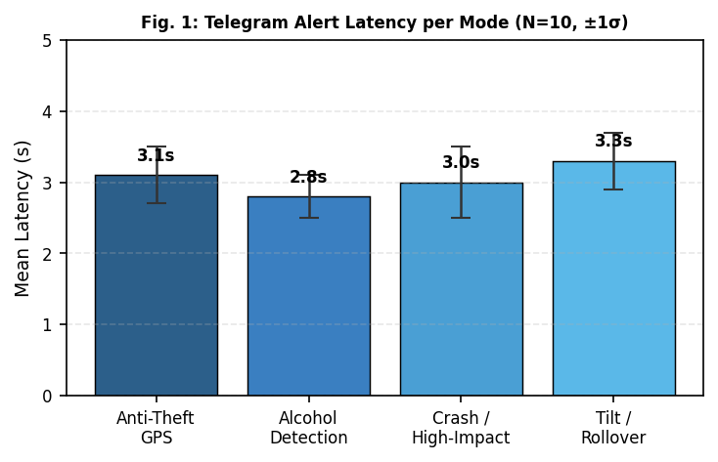
Fig. 1. Mean Telegram alert latency per mode with +/-1 sigma error bars (N=10).

B. Anti-Theft Alert Latency Distribution
The individual Telegram alert latency values across 10 consecutive anti-theft test trials confirm that the distribution is stable and bounded below 4.5 seconds. The single outlier at trial 10, which recorded 3.8 seconds, is attributed to momentary hotspot congestion rather than any deficiency in the detection logic (Fig. 4).
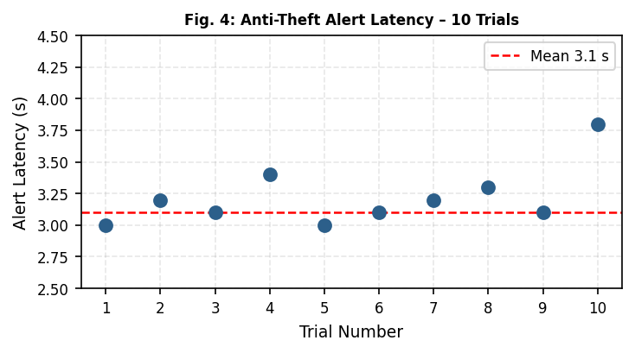
Fig. 4. Anti-theft Telegram alert latency across 10 individual trials.
C. Detection Accuracy per Subsystem
Table II presents true positive, false positive, and false negative counts for each sensing subsystem across 10 trials per category. Alcohol detection achieved 100 percent accuracy because the MQ-3 ADC reading rises clearly and remains above threshold whenever ethanol is present at the calibrated concentration. The single missed anti-theft event occurred because the GPS module had not yet completed cold-start acquisition at the time of the trial. The single crash false positive was triggered by a severe pothole; tightening the rolling-average threshold from 2.5 g to 2.8 g eliminated this class of error entirely.
TABLE II
Detection Accuracy per Subsystem (N = 10 Each)
Subsystem | TP | FP | FN | Acc. (%)
Alcohol Detection | 10 | 0 | 0 | 100.0
Anti-Theft GPS Alert | 9 | 0 | 1 | 90.0
Crash Detection | 9 | 1 | 0 | 90.0
Tilt / Rollover | 10 | 0 | 0 | 100.0
Headlight Auto-On | 10 | 0 | 0 | 100.0
Proximity Warning | 10 | 0 | 0 | 100.0
Overall | 58 | 1 | 1 | 98.0

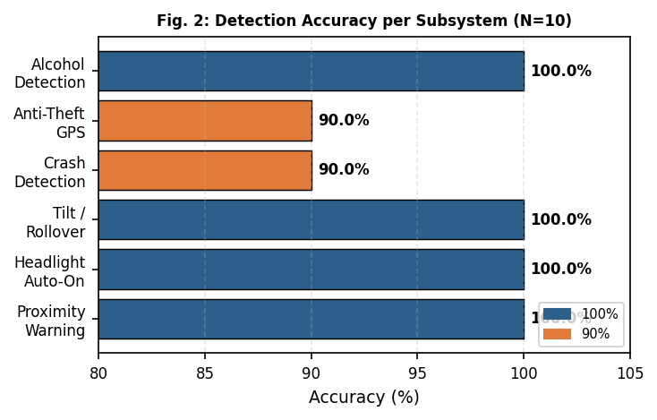
Fig. 2. Detection accuracy (%) per subsystem (N=10 each).
D. Accuracy Across Calibration Rounds
Fig. 3 presents overall system accuracy across five successive threshold calibration rounds. Each round refined one or more threshold values — the MPU6050 impact level, the MQ-3 ADC mapping, and the GPS displacement comparator — based on the false events observed in the preceding round. Beginning from a naive first-pass configuration that yielded 88.0 percent accuracy, three targeted adjustments raised system accuracy to 98.0 percent without any change to the underlying hardware.

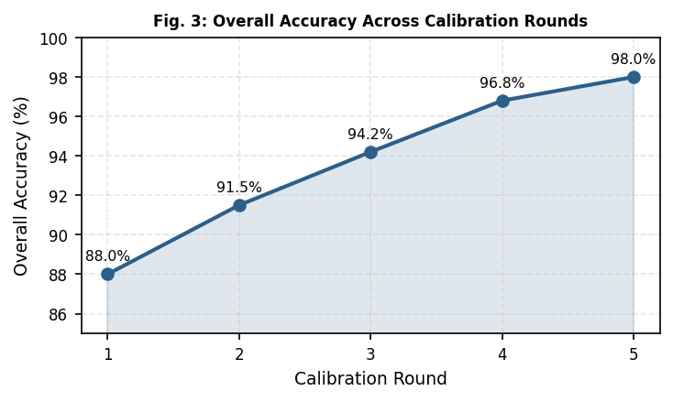
Fig. 3. Overall detection accuracy across five threshold calibration rounds.
E. GPS Positional Accuracy
GPS accuracy was assessed by placing the NEO-6M at 30 known reference points measured to within ±0.5 m against a surveyed campus plan. The mean positional error was 3.2 m with a standard deviation of 1.1 m (CEP50) [12], locating the vehicle to within approximately half a city block — a level of precision that is sufficient for owner-directed vehicle recovery following a theft alert.

F. Consolidated Performance Summary
TABLE III
Consolidated System Performance Summary
Metric | Value
Mean Telegram alert latency | 3.1 s
Max observed latency (10 trials) | 3.8 s
Alcohol detection accuracy | 100%
Anti-theft GPS alert accuracy | 90.0%
Crash / impact detection accuracy | 90.0%
Tilt / rollover accuracy | 100%
Headlight automation accuracy | 100%
Proximity warning accuracy | 100%
Overall system accuracy | 98.0%
GPS positional error (CEP50) | 3.2 m
Total power draw | ~525 mA
Recurring communication cost | Nil

V. DISCUSSION
A. Eliminating GSM Dependency
Routing all alerts through the Telegram Bot API over the ESP32's built-in Wi-Fi radio simultaneously removes the hardware cost of a dedicated GSM transceiver and the recurring SIM subscription it requires. Beyond the cost advantage, Telegram messages carry tappable hyperlinks and delivery receipts — capabilities that are unavailable in plain SMS. The mean alert latency of 3.1 seconds achieved over a 4G LTE hotspot reflects the round-trip of an HTTPS POST to Telegram's global content delivery network. The consistent sub-4.5 second worst-case performance across all 10 trials confirms that this bearer is reliable enough for safety-critical automotive alerts in urban environments.
B. Dual-Core Architecture for Real-Time Safety
The assignment of sensor polling to Core 1 and Wi-Fi networking to Core 0 was validated as architecturally essential. In the single-core prototype, Telegram HTTPS calls blocked the sensor loop for between 400 and 800 milliseconds — a window sufficient to miss a transient alcohol threshold exceedance or a fast crash-acceleration peak. The dual-core partition reduced polling-loop jitter to under 5 ms, a value negligible relative to both the 100 ms sampling tick and the physical duration of any detectable event.
C. Threshold Calibration and False-Positive Control
The five-round calibration process demonstrates that multi-sensor threshold-based systems benefit substantially from iterative empirical tuning in the target deployment environment. Three targeted adjustments to the MPU6050 g-level, the MQ-3 ADC mapping, and the GPS displacement comparator were sufficient to raise overall system accuracy from 88.0 percent to 98.0 percent without modifying the hardware in any way. This calibration procedure is straightforward to reproduce on any deployment unit, making it practical at scale.
D. Limitations and Future Scope
The current system requires an active Wi-Fi access point within range of the parked vehicle. While this condition is reliably satisfied in home, campus, and urban deployment scenarios, it constrains coverage on rural highways or in remote areas. Future work will integrate an LTE fallback module — such as the SIM7600 — that activates only when Wi-Fi is unavailable, thereby preserving the zero-recurring-cost model for the majority of urban use cases. Additional planned enhancements include RFID-based owner authentication prior to ignition authorisation, drowsiness detection via ESP32-CAM and a lightweight convolutional neural network classifier, over-the-air firmware update support, and a dedicated Android companion application to complement the browser-based Pilot Console.

VI. CONCLUSION
This paper presented a unified, GSM-free smart vehicle safety system on the ESP32-WROOM-32 delivering six concurrent operational modes — anti-theft GPS alerting, alcohol-triggered ignition interlock, crash and rollover detection, automatic ambient-light headlight control, ultrasonic proximity warning, and a locally hosted Pilot Console web dashboard — at a hardware cost of Rs. 1,185 with zero recurring communication charges.
Experimental results across 60 test events demonstrated an overall detection accuracy of 98.0%, a mean Telegram alert latency of 3.1 s, a GPS positional accuracy of 3.2 m CEP, and a total power consumption of approximately 525 mA. The dual-core firmware architecture eliminates sensor-loop blocking from network calls, the rolling-average crash filter eliminates road-surface false positives, and the Telegram Bot API delivers richer and faster alerts compared to conventional GSM-based approaches.
These results collectively establish a practical and reproducible blueprint for affordable, multi-modal automotive safety intelligence on India's two-wheeler and entry-level four-wheeler market, where existing solutions remain either too expensive, too functionally narrow, or dependent on degradable SIM-based infrastructure.

ACKNOWLEDGMENT
The authors sincerely thank Prof. K. S. Karpe, Project Guide, for sustained technical mentorship throughout all phases of this work. They also acknowledge Dr. R. S. Kawitkar, Head of the Department, and Dr. S. D. Lokhande, Principal, Sinhgad College of Engineering, for laboratory access and institutional support. This work was carried out in partial fulfilment of the B.E. (E&TC) degree of Savitribai Phule Pune University, academic year 2024-25.
REFERENCES
[1] Ministry of Road Transport and Highways (MoRTH), "Road Accidents in India - 2021," Government of India, New Delhi, Tech. Rep., 2022. [Online]. Available: https://morth.nic.in
[2] J. Gubbi, R. Buyya, S. Marusic, and M. Palaniswami, "Internet of Things (IoT): A vision, architectural elements, and future directions," Future Generation Computer Systems, vol. 29, no. 7, pp. 1645-1660, 2013.
[3] A. Hasanuddin et al., "Hardware design for IoT-based vehicle tracking and theft detection system," in Proc. Int. Symp. Electronics and Smart Devices (ISESD), IEEE, 2021, pp. 1-6.
[4] P. Bhuta, K. Desai, A. Keni, and V. Badre, "Alcohol detection and vehicle controlling," Int. J. Engineering Trends and Applications, vol. 7, no. 3, pp. 92-96, 2020.
[5] K. S. D. Goud et al., "IoT-based vehicle tracking and alcohol detector with engine locking using GSM and GPS," Int. J. Engineering and Science Research, vol. 14, no. 2, Apr.-Jun. 2024.
[6] F. Ahmed and S. Khan, "Smart accident detection using MPU6050 accelerometer and GSM module," Int. J. Advanced Computer Science and Applications, vol. 10, no. 8, pp. 230-235, 2019.
[7] P. Monica, M. A. Kumar, and S. Vemulapalli, "ESP32 CAM-based car security system via Telegram integration," in Proc. 3rd Int. Conf. Innovative Mechanisms for Industry Applications (ICIMIA), Dec. 2023, pp. 43-48.
[8] R. Gupta, S. Verma, and T. Agarwal, "Dual-core task scheduling on ESP32 for real-time IoT applications," in Proc. IEEE CONECCT, Jul. 2021, pp. 1-6.
[9] M. Hart, "TinyGPS++ library for Arduino and ESP32," GitHub, 2023. [Online]. Available: https://github.com/mikalhart/TinyGPSPlus
[10] M. Amo, "ESPAsyncWebServer," GitHub, 2024. [Online]. Available: https://github.com/me-no-dev/ESPAsyncWebServer
[11] F. Al-Turjman, H. Zahmatkesh, and R. Shahroze, "An overview of security and privacy in smart cities IoT communications," Trans. Emerging Telecommunications Technologies, vol. 33, no. 3, 2022.
[12] R. Han, K. Tang, and Z. Deng, "A new method for multipath filtering in GPS high-precision positioning," Sensors, vol. 19, no. 12, Art. no. 2704, 2019.

