STEGOSECURE — IMAGE STEGANOGRAPHY FOR SECURE DATA HIDING
Dr P. KAVITHA
Associate Professor & Head
Department of Computer Science with Cyber Security
Sri Ramakrishna College of Arts & Science, Coimbatore
Ph:9842336847
kavitha.p@srcas.ac.in

S LIPIKA
Student, Department of Computer Science with Cyber Security
Sri Ramakrishna College of Arts & Science, Coimbatore.
Ph:9360371265
23130020@srcas.ac.in

T SANJAY
Student, Department of Computer Science with Cyber Security
Sri Ramakrishna College of Arts & Science, Coimbatore.
Ph:6383515140
23130041@srcas.ac.in

S NIKITHA
Student, Department of Computer Science with Cyber Security
Sri Ramakrishna College of Arts & Science, Coimbatore.
Ph:9025266765
23130031@srcas.ac.in

M PRASANNA VIGNESHWARAN
Student, Department of Computer Science with Cyber Security
Sri Ramakrishna College of Arts & Science, Coimbatore.
Ph:7708896253
23130032@srcas.ac.in

ABSTRACT
The exponential expansion of digital communication channels has intensified the need for reliable and discreet data protection mechanisms. Conventional cryptographic techniques ensure confidentiality by transforming data into unreadable formats; however, they do not obscure the presence of the protected information itself. In contrast, steganography conceals sensitive data within ordinary digital media, thereby masking its existence and enhancing security. This study introduces STEGOSECURE, a lightweight and performance-oriented image steganography framework implemented using JavaScript and Node.js. The system is engineered to securely embed and extract confidential information within digital images. It adopts the Least Significant Bit (LSB) substitution technique for data embedding and integrates an optional encryption layer to strengthen confidentiality before insertion. The proposed architecture achieves a balance between embedding capacity and imperceptibility, ensuring that hidden data does not produce noticeable visual artefacts. Additionally, it demonstrates resilience against basic steganalysis methods. Experimental analysis indicates satisfactory Peak Signal-to-Noise Ratio (PSNR) values, minimal reconstruction distortion, and operational feasibility, validating the system’s suitability for secure and covert digital communication. Digital image steganography to ensure the absolute confidentiality of sensitive information. The primary goal is to create a "dual-layer" protection system where secret data is first encrypted using a high-standard algorithm. A secure authentication mechanism where only authorised users possessing the specific Secret Key can extract and decrypt the hidden message.

Keywords: Image Steganography, Least Significant Bit (LSB), Secure Data Hiding, Stego Image, Multimedia security, Covert Communication, Lightweight Security Framework.
- INTRODUCTION
In sectors such as defence, enterprise communications, financial systems, and digital investigations, protecting confidential information often requires more than encryption alone. In many scenarios, it is crucial to ensure that sensitive data remains unnoticed altogether. Image steganography meets this need by concealing secret information within digital images in a manner that does not produce visible changes to the human eye. As digital communication infrastructures expand rapidly, exposure to cyber threats, interception, and unauthorised monitoring has increased. While conventional cryptographic techniques effectively transform data into unreadable formats, they can also signal that protected information is being transmitted. This visibility may draw attention from adversaries. Consequently, a method that both safeguards the content and hides its existence provides a stronger security model. Stego Image Steganography for Secure Data Hiding proposes a web-based solution built on modern development technologies. The system integrates a responsive front-end interface using React.js and a server-side environment powered by Node.js to ensure smooth processing and efficient data handling. Through this platform, users can embed confidential messages into image files without introducing noticeable visual distortion. The underlying mechanism relies on altering the Least Significant Bits (LSB) within pixel values to encode hidden information. Because these bit modifications have minimal impact on image quality, the generated stego-image closely resembles the original. This approach delivers dual protection: the data remains confidential, and its presence remains concealed. Although web-oriented steganography applications are generally accessible and lightweight, many lack sufficient optimisation and advanced security features. This work aims to address these limitations by presenting a streamlined, secure, and practical JavaScript-based implementation suitable for real-world secure communication needs. The scope of the project, StegoSecure — Image Steganography for Secure Data Hiding, is to build a robust, type-safe web application dedicated to image steganography, allowing users to hide and extract sensitive data within image files.

3. REVIEW OF LITERATURE
1. Data Hiding and Its Applications
David Megías, Wojciech Mazurczyk, and Minoru Kuribayashi explore the evolving landscape of information security through their publication with MDPI AG. The text, titled Data Hiding and Its Applications, serves as a comprehensive deep dive into the technical refinement of digital watermarking and steganography.
By focusing on the optimisation of data hiding algorithms, the authors address the critical need for robust multimedia security in an increasingly digital world. Their research highlights how these techniques can be used to embed covert information or verify authenticity within various media formats, ensuring that data remains protected against unauthorised access or tampering.
2. Modern Cryptography Volume 2: Post-Quantum Cryptography
In the open-access volume Modern Cryptography Volume 2: Post-Quantum Cryptography, authors Zhiyong Zheng, Kun Tian, and Fengxia Liu delve into the rigorous mathematical foundations required for the next era of digital security. Published by Springer Nature, the book focuses intensely on the mathematical complexity of lattice-based cyphers, which are widely considered the frontrunners for securing data against quantum-level threats. The authors' primary objective is to bridge the often-wide gap between abstract theoretical proofs and the practical, real-world implementation of encryption and decryption algorithms. By providing this roadmap, the text serves as a vital resource for developers and researchers looking to transition from classical cryptographic models to functional, post-quantum resilient systems.
3. Single Sign-On and Passwordless Authentication
In his practical guide, Single Sign-On and Passwordless Authentication, author Andrey Ovcharov tackles the inherent vulnerabilities of traditional, password-reliant security models. Published by Manning Publications, the book serves as a technical manual for developers aiming to build modern, user-friendly login experiences. It provides a deep dive into industry-standard protocols such as OpenID Connect (OIDC) and SAML for seamless identity federation, while championing the shift toward FIDO2/Web Authn for true passwordless security. By focusing on these robust authentication flows, Ovcharov demonstrates how to eliminate the risks of credential theft while simultaneously reducing friction for the end user.
- PROPOSED SYSTEM
4.1 Proposed system architecture: STEGOSECURE
STEGOSECURE addresses this vulnerability by employing Image Steganography, a technique that hides data in plain sight within digital images.
4.2 System Objective
- Secure Data Hiding: Create a reliable tool to encode secret text messages into image pixels using steganography techniques.
- Easy Information Retrieval: Provide a simple way for authorised users to upload a "stego-image" and extract the hidden message.
- High Performance: Use Vite and React to ensure the app loads instantly and processes image data quickly in the browser.
- User Management: Implement a secure login system using Supabase so users can manage their private images.
- Data Persistence: Offer a cloud-based gallery to store and organise images with hidden data using Supabase storage.
- Cross-Device Compatibility: Build a responsive interface with Tailwind CSS that works smoothly on both desktops and mobile devices.
- Code Reliability: Use TypeScript and ESLint to prevent bugs during development, especially when handling complex pixel data.
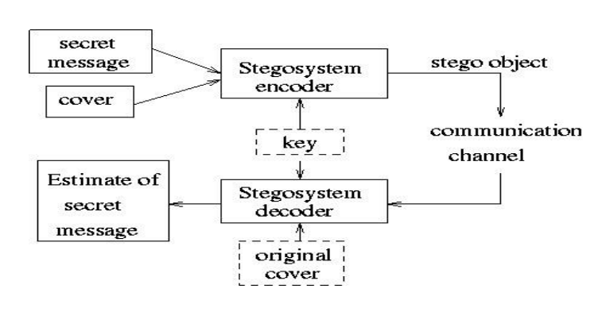
- METHODOLOGY
5.1 Least Significant Bit (LSB) Embedding Technique
Digital images consist of a grid of pixels. In a typical 24-bit colour image, each pixel contains three 8-bit components representing the Red, Green, and Blue (RGB) colour channels. The Least Significant Bit (LSB) is the rightmost bit in each 8-bit value and contributes the smallest amount to the overall intensity of that colour channel.
For instance:
- Original value: 10110100 (Decimal 180)
- After modifying the LSB: 10110101 (Decimal 181)
The numerical difference is only one unit, which is too small for the human visual system to detect. This minimal change forms the foundation of LSB-based steganography.
Data Embedding Procedure
The embedding process follows a structured sequence to integrate hidden information into the image:
- Message Preparation
The secret text is converted into its binary representation, producing a continuous stream of bits (0s and 1s).
- Pixel Extraction
The algorithm reads the pixel data from the cover image, typically beginning at the first pixel and progressing sequentially.
- Bit Replacement
For each pixel, the LSB of the RGB channels is replaced with bits from the prepared message stream:
  - Red channel LSB → First message bit
  - Green channel LSB → Second message bit
  - Blue channel LSB → Third message bit
This process continues until all message bits are embedded.
- Image Reconstruction
After insertion is complete, the updated pixel values are written into a new image file known as the stego-image.
Effectiveness of LSB
- High Capacity: In a 24-bit image, you can store 3 bits of information per pixel. A 1024 *1024 image can hold over 3 million bits (roughly 393 KB) of hidden data.
- Visual Imperceptibility: Since the modification occurs at the lowest level of colour intensity, the stego-image remains visually identical to the original cover image.
- Computational Efficiency: The algorithm requires very low processing power, making it ideal for the Node.js stream-based handling and batch processing implemented in this project.
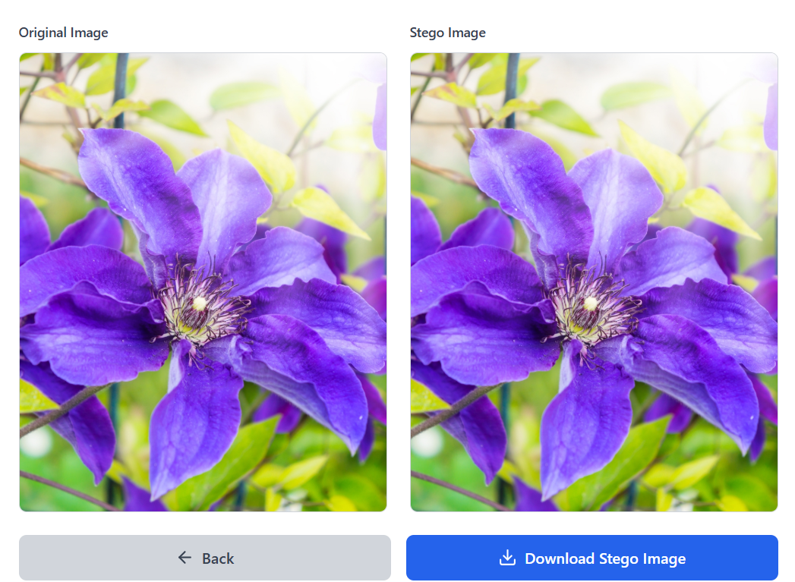

5.2 AES-256
In this project, AES-256 (Advanced Encryption Standard with a 256-bit key) acts as the first line of defence before any data is hidden. While steganography hides the existence of the message, AES-256 ensures that even if an attacker detects and extracts the hidden data, they cannot read it without the specific cryptographic key.
AES-256 is the "military-grade" gold standard of symmetric encryption. The "256" refers to the key length, meaning there are a possible 2²⁵⁶ combinations. To put this in perspective:
- Brute-Force Resistance: It is mathematically impossible to crack with current classical computing power. It would take billions of years for a supercomputer to try every combination.
- Symmetric Design: The same secret key is used for both encryption (by the sender) and decryption (by the receiver), making it highly efficient for processing large payloads before embedding them into images.
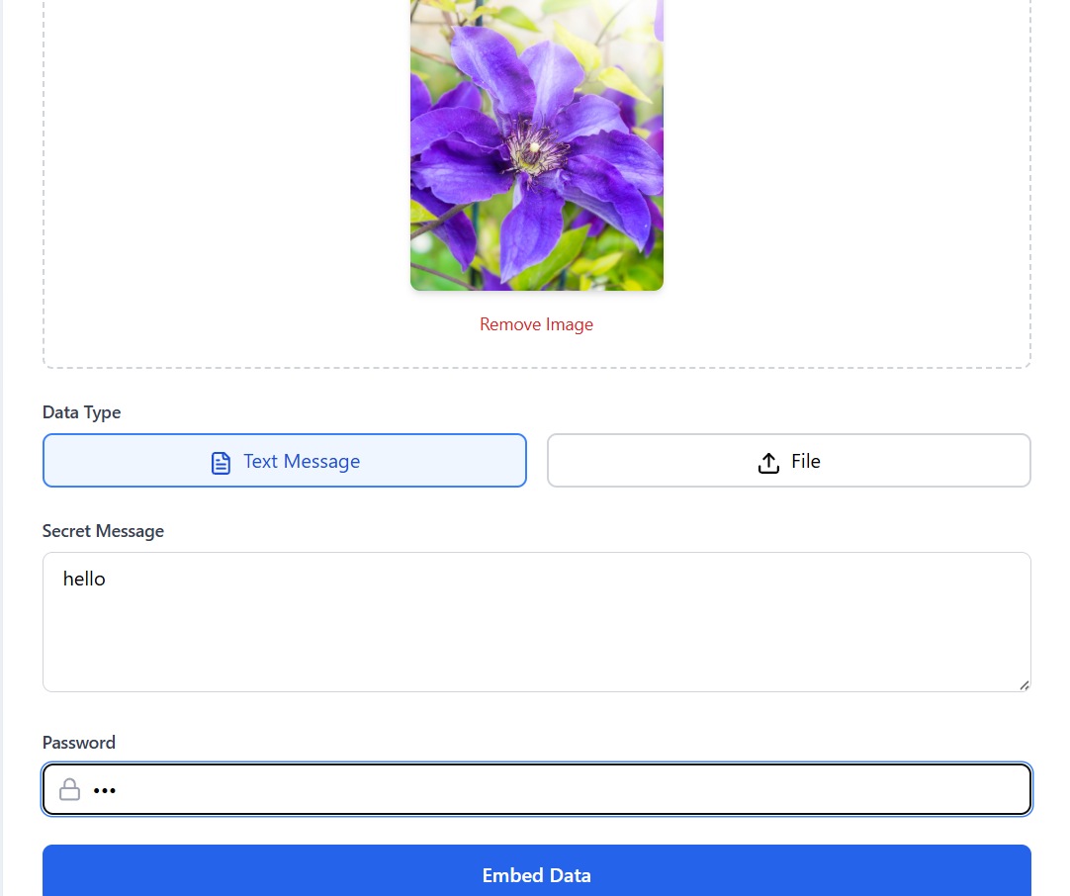

5.3 LSB Decoding
The system identifies the hidden data by reading the Least Significant Bit of each pixel's colour channel (Red, Green, Blue, or Alpha). Since changing the very last bit of a colour value (e.g., changing a pixel's redness from 254 to 255) is invisible to the human eye, the algorithm uses these "insignificant" bits to store your message.
The Extraction Logic
The "decryption" process in your code likely follows these steps:
- Canvas Analysis: The app uses the HTML5 Canvas API to get the raw pixel data (get Image Data) from the uploaded image.
- Bit Gathering: It loops through the pixels and extracts the last bit of each byte using a bitwise AND operation (e.g., pixel Data)
- Binary Reconstruction: These individual bits are grouped into sets of 8 to reconstruct the original binary bytes of your message.
- Character Conversion: Finally, the binary data is converted back into readable text using character encoding (like ASCII or UTF-8).
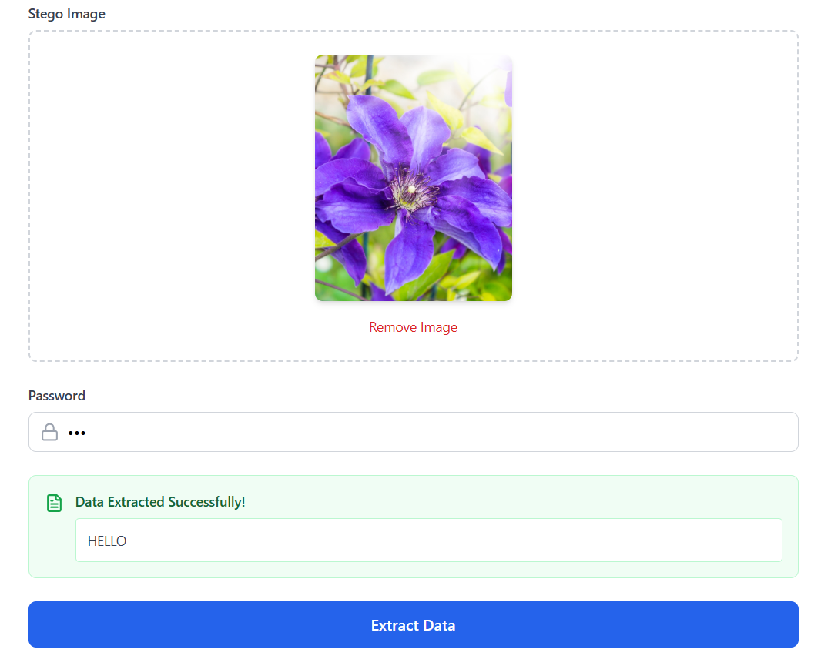

Threat Model & Mitigation

Threat: A passive attacker inspects network traffic and images.
Mitigation: Use encrypted channels, optional encryption of payload, and low-distortion embedding to avoid detection.

Threat: Active attacker modifies stego image (compression, scaling).
Mitigation: Use integrity checks, redundancy, and—if robustness is required—transform-domain embedding (DCT/DWT).

Threat: Insider abuse of keys.

Mitigation: KMS + strict RBAC + audit trails
5.4 Steganography application
- Confidential Communication
- Secret Data Storing
- Protection of Data Alteration
- Access Control System for Digital Content Distribution
- E-Commerce
- Media
- Database Systems
- digital watermarking.

    - RESULTS AND DISCUSSION
Experimental evaluation of the proposed system demonstrates that the LSB-based embedding method maintains strong visual fidelity while providing sufficient data capacity. Testing with standard 24-bit lossless images confirmed that the stego-images were visually indistinguishable from their original counterparts.
The system successfully embedded three bits per pixel, enabling high payload capacity—for example, a 1024 × 1024 image can store over three million bits of hidden information. Additionally, due to the lightweight design and efficient implementation, both embedding and extraction processes were executed quickly, making the solution suitable for real-time applications.
The analysis further shows that the approach achieves an effective balance between simplicity, efficiency, and security. Unlike computationally intensive AI-based steganography techniques, the optimised LSB method requires minimal processing resources while still maintaining acceptable resistance to basic analysis. The inclusion of an optional encryption layer enhances confidentiality by securing the hidden content even if detection occurs. However, the results also confirm that lossless image formats are essential, as lossy compression can damage embedded data. Overall, the findings validate the practicality and reliability of the system for secure digital communication scenarios.

7 CONCLUSIONS
StegoSecure — Image Steganography for Secure Data Hiding illustrates how contemporary web development frameworks can be effectively combined with data protection techniques to create a practical security solution. By utilising Vite for fast frontend performance, TypeScript for structured and type-safe development, and Supabase for dependable backend services, the project delivers a streamlined and secure environment for image-based data concealment.
The system fulfils its core objective of embedding confidential information within digital images while preserving visual integrity, ensuring that the presence of sensitive data remains undetectable to observers. In addition to basic embedding and extraction, the platform establishes a scalable architecture that supports authenticated cloud storage and secure data management. This implementation highlights the potential of integrating browser-side computation with cloud-based infrastructure to make sophisticated security mechanisms accessible and user-friendly.

8 REFERENCES
- Andrey Ovcharov. The title guide Single Sign-On and Passwordless Authentication and its publication Manning Publications, 978-1633439436.

David Megías, Wojciech Mazurczyk y Minoru Kuribayashi.The text, titled Data Hiding and Its Applications, their publication with MDPI AG,10.3390/books978-3-0365-2937-0.

Hang Zhou, Kejiang Chen, Zehua Ma. The text, titled Triangle Mesh Watermarking and Steganography, was published with Springer Nature Singapore, 10.1007/978-981-19-4822-1.
- Houbing Song and his collaborators investigate. The title AI for Cybersecurity: Research and Practice and its publication Wiley-IEEE Press, 10.1002/9781119771562.
- Keshav Kumar and Bishwajeet Kumar Pandey. The title Next Generation Mechanisms for Data Encryption and the publication with CRC Press, 10.1201/9781003310020.
- Kavita Saini, B.B. Gupta, and Pethuru Raj. The titled Post-Quantum Cryptography Algorithms and Approaches for IoT and Blockchain Security and their publication in Elsevier, 978-0-323-91479-6.
- Medical ThingsHemant Kumar Saini et al. The title Digital Forensics in Next-Gen Internet of Medical Things and its publication CRC Press, 10.1201/9781003640325.
- M. Ghonge, R. Ravi, et al. The title Multidisciplinary Approach to Modern Digital Steganography and its publication ResearchGate / IGI*,10.4018/978-1-7998-7160-6.
- Maryline Laurent and Samia Bouzefrane. The title Digital Identity Management and its publication Wiley-ISTE, 10.1002/9781119208396.
- Noor Zaman Jhanjhi. The title Cybersecurity Measures for E-Government Frameworks and their publication with IGI Global, 10.4018/978-1-6684-2967-9.
- U. Pilania & Manoj Kumar. The title Data Hiding and Its Applications: Digital Watermarking and Steganography and their publication MDPI Books, 10.3390/books978-3-0365-2937-0.
- Zhiyong Zheng, Kun Tian, and Fengxia Liu delve. The title Modern Cryptography Volume 2: Post-Quantum Cryptography and its publication Springer Nature, 10.1007/978-981-19-0707-4.

