Beyond Questionnaires: Innovative Data Collection Strategies in Mixed Methods Research

Abstract
Introduction: Mixed methods research combines quantitative and qualitative approaches to provide a comprehensive understanding of complex research problems. While questionnaires remain widely used for data collection, emerging technologies and participatory approaches have expanded the range of innovative methods available to researchers. These strategies enhance data richness, participant engagement, and contextual understanding. Aim and Objectives: This review aims to explore innovative data collection strategies used in mixed methods research beyond traditional questionnaires. The objectives were to identify emerging data collection techniques, evaluate their applications across disciplines, and assess their advantages and limitations in enhancing research outcomes. Methodology: A systematic review was conducted using electronic databases including Google Scholar, PubMed, Research Gate, Scopus, and Science Direct. Relevant articles published in English between 2020 and 2025 were searched using keywords such as “mixed methods research,” “innovative data collection,” “digital data collection,” “participatory methods,” and “research technologies.” Studies focusing on non-questionnaire-based data collection methods in mixed methods designs were included and critically reviewed. Results and Discussion: The review identified several innovative strategies, including mobile applications, wearable devices, digital diaries, social media analytics, virtual interviews, geospatial mapping, and participatory visual methods such as photo voice. These approaches enabled real-time data capture, improved participant involvement, and provided deeper contextual insights. However, challenges related to data privacy, technological accessibility, ethical considerations, and data integration were also noted. Combining these methods with traditional approaches strengthened the validity and comprehensiveness of research findings. Conclusion: Innovative data collection strategies have transformed mixed methods research by offering diverse and dynamic ways to gather information beyond questionnaires. Their integration enhances data quality and depth, although careful consideration of ethical and practical issues remains essential. Future research should focus on developing standardized frameworks for effectively incorporating these emerging methods into mixed methods studies.
Keywords: Mixed methods research - innovative data collection - digital technologies -participatory methods - systematic review.

INTRODUCTION

Mixed methods research (MMR) is a research methodology that integrates both quantitative and qualitative approaches within a single study to provide a more comprehensive understanding of complex research problems. Quantitative research focuses on numerical data, statistical analysis, and measurement of variables, whereas qualitative research emphasizes understanding human experiences, perceptions, behaviours, and social contexts. By combining these two approaches, mixed methods research allows researchers to obtain both breadth and depth of information, thereby improving the validity and richness of research findings.

Traditionally, questionnaires have been one of the most widely used data collection tools in mixed methods research. Questionnaires are valued for their simplicity, cost-effectiveness, and ability to collect data from large populations within a relatively short period. They are particularly useful for measuring attitudes, knowledge, practices, and demographic characteristics. Despite these advantages, questionnaires have several limitations. They often rely on participants' memory and honesty, making them susceptible to recall bias and social desirability bias. Furthermore, questionnaires may not capture the complexity of human experiences, emotions, and contextual factors influencing behaviors and decisions.

The rapid advancement of digital technologies over the past decade has transformed the landscape of research data collection. Researchers now have access to innovative tools that can capture real-time, objective, and context-rich information. Mobile applications, wearable devices, digital diaries, social media platforms, geospatial technologies, and participatory visual methods have emerged as powerful alternatives and complements to traditional questionnaires. These approaches enable continuous monitoring, immediate recording of experiences, and collection of naturally occurring data in real-world settings.

The COVID-19 pandemic further accelerated the adoption of technology-based data collection methods. Physical distancing requirements encouraged researchers to conduct virtual interviews, online focus groups, and digital ethnographic studies. As a result, innovative data collection techniques have become increasingly integrated into mixed methods research across healthcare, nutrition, education, psychology, environmental sciences, and social sciences.

These emerging strategies offer several benefits. They improve participant engagement, reduce recall errors, facilitate access to hard-to-reach populations, and generate multidimensional datasets that provide deeper insights into research questions. However, they also present challenges related to data privacy, ethical considerations, technological accessibility, digital literacy, and data management complexities.

Given the growing importance of these innovative methods, a comprehensive examination of their applications, benefits, and limitations is necessary. This review explores contemporary data collection strategies beyond questionnaires and evaluates their contribution to enhancing mixed methods research.

AIM AND OBJECTIVES

Aim:

To explore innovative data collection strategies beyond traditional questionnaires and assess their role in enhancing mixed methods research.

Objectives:
- To identify emerging data collection methods used in mixed methods research.
- To examine the applications of innovative data collection strategies across different disciplines.
- To evaluate the advantages of these methods in improving data quality, participant engagement, and contextual understanding.
- To assess the challenges and limitations associated with implementing innovative data collection approaches.

REVIEW OF LITERATURE:
Mobile Applications for Data Collection
Mobile applications have become increasingly popular tools for collecting real-time research data. Smartphones are widely available across different populations, making mobile applications a practical and accessible method for researchers.
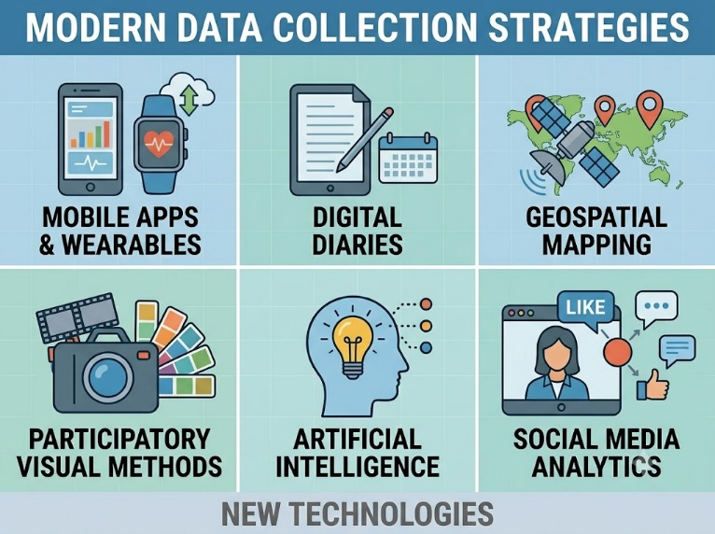
Smith et al. (2021) reported that mobile-based data collection enables ecological momentary assessment (EMA), where participants record information as experiences occur. This approach minimizes recall bias and improves data accuracy. Participants can receive automated reminders and notifications, increasing response rates and reducing missing data.
Mobile applications have been widely used in health and nutrition research to track dietary intake, physical activity, medication adherence, mental health symptoms, and lifestyle behaviors. Researchers can collect quantitative data through structured forms and qualitative data through open-ended responses, photographs, voice recordings, and location tracking.
Advantages include real-time data collection, improved participant compliance, cost-effectiveness, and enhanced data management. However, limitations include dependence on internet connectivity, smartphone ownership, technical issues, and concerns regarding data security and privacy.
Wearable Devices and Sensor Technologies
Wearable technologies represent a major advancement in objective data collection. Devices such as smartwatches, fitness trackers, heart rate monitors, glucose sensors, and sleep monitors continuously collect physiological and behavioral information.
Johnson and Brown (2022) found that wearable devices provide highly accurate measurements of physical activity, energy expenditure, sleep quality, heart rate variability, and stress indicators. Unlike questionnaires, wearable devices reduce participant burden and eliminate errors associated with self-reporting.
In mixed methods studies, wearable data can be combined with interviews and observations to better understand health behaviors and environmental influences. For example, researchers studying obesity may combine physical activity data from fitness trackers with participant interviews about exercise barriers and motivations.
Despite their benefits, wearable devices may be expensive, require technical expertise, and raise ethical concerns regarding surveillance and informed consent.
Digital Diaries and Experience Sampling Methods
Digital diaries allow participants to record experiences, emotions, thoughts, and activities over time using smartphones, tablets, or computers. Experience Sampling Methods (ESM) involve collecting data multiple times per day through prompts or notifications.
Lee et al. (2023) demonstrated that digital diaries provide detailed insights into participants' daily lives and capture temporal variations in behaviour. These methods are particularly useful in psychology, nutrition, chronic disease management, and behavioural sciences.
Participants can document experiences through text, audio recordings, videos, photographs, or combinations of these formats. Researchers can subsequently analyze both quantitative trends and qualitative narratives.
The major advantage of digital diaries is their ability to capture data in natural settings, thereby improving ecological validity. However, participant fatigue, inconsistent recording, and technological barriers may affect data quality.
Social Media Analytics
Williams et al. (2021) found that social media analytics provide valuable insights into public health communication, consumer behavior, political discourse, and social movements. Researchers can examine posts, comments, hashtags, engagement metrics, and interaction patterns.
Social media data offer several advantages including large sample sizes, real-time monitoring, and access to authentic public opinions. During the COVID-19 pandemic, social media analytics were widely used to study public perceptions, misinformation, and vaccine acceptance.
However, ethical concerns regarding consent, privacy, anonymity, and data ownership remain significant challenges. Researchers must ensure compliance with ethical guidelines and platform policies.
Virtual Interviews and Online Focus Groups
Virtual interviews and online focus groups gained prominence during the COVID-19 pandemic and continue to be widely used. These methods utilize video conferencing platforms such as Zoom, Microsoft Teams, and Google Meet to facilitate communication between researchers and participants.
Patel and Kumar (2022) reported that virtual interviews improve accessibility by enabling participation from geographically distant locations. Researchers can recruit participants from different regions without travel expenses.
Online focus groups allow interactive discussions among participants while maintaining flexibility and convenience. Sessions can be recorded, transcribed automatically, and analyzed efficiently.
Advantages include reduced costs, broader participant reach, and scheduling flexibility. Challenges include internet connectivity issues, reduced observation of non-verbal cues, technical difficulties, and concerns about confidentiality.
Geospatial Mapping and Geographic Information Systems (GIS)
Geospatial technologies enable researchers to analyze spatial relationships and environmental influences on human behavior and health outcomes.
Thompson et al. (2023) demonstrated that GIS can be integrated into mixed methods studies to investigate environmental determinants of health, food accessibility, disease distribution, and urban planning issues.
For example, researchers studying food insecurity may map supermarket locations, transportation networks, and participant residences to understand barriers to healthy food access. These spatial data can be complemented with interviews and surveys to provide a comprehensive understanding of community experiences.
GIS enhances contextual analysis and supports evidence-based decision-making. Nevertheless, data collection may require specialized software, technical expertise, and careful management of location-based privacy concerns.
Participatory Visual Methods: Photovoice and Digital Storytelling
Participatory visual methods emphasize active participant involvement in the research process. Photovoice is a widely used technique in which participants take photographs representing their experiences, challenges, or perspectives.
Hernandez et al. (2020) found that photovoice empowers participants by allowing them to communicate issues that may be difficult to express verbally. The photographs serve as discussion prompts during interviews and group discussions.
Digital storytelling combines images, audio narration, videos, and personal narratives to document lived experiences. These methods are particularly valuable in community-based research, public health studies, and social justice initiatives.
Participatory visual approaches generate rich qualitative data, increase participant engagement, and promote community empowerment. However, ethical considerations related to image ownership, confidentiality, and informed consent must be carefully addressed.
Artificial Intelligence and Big Data Analytics
Recent studies have highlighted the role of artificial intelligence (AI) and machine learning in modern data collection and analysis. AI-powered systems can process large datasets from multiple sources, including social media, wearable devices, electronic health records, and digital platforms.
Researchers use AI to identify patterns, predict outcomes, automate coding of qualitative data, and enhance data integration processes. In mixed methods research, AI can assist in synthesizing quantitative and qualitative findings more efficiently.
Although AI offers significant potential, concerns regarding algorithmic bias, transparency, accountability, and ethical use remain important considerations.
METHODOLOGY:
This study is based on a systematic review of published scientific literature related to innovative data collection strategies in mixed methods research.
- Collection of research articles from Google Scholar, PubMed, Research Gate, Scopus, and Science Direct.
- Screening articles published between 2020 and 2025.
- Selection of studies focusing on non-questionnaire-based data collection methods.
- Analysis of applications, benefits, limitations, and ethical considerations.
- Synthesis of findings to identify emerging trends and best practices.

RESULTS AND DISCUSSION:

The results revealed that innovative data collection strategies in mixed methods research. The findings reveal a substantial transformation in data collection practices driven by technological advancements and increasing emphasis on participant-centered research.

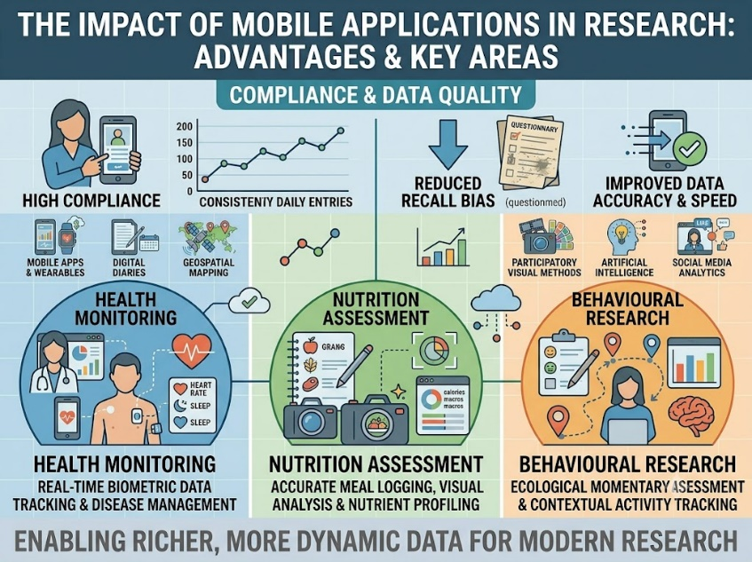
Mobile applications emerged as one of the most frequently used methods due to their accessibility, flexibility, and capacity for real-time data capture. Studies consistently reported improved participant compliance and reduced recall bias compared with traditional questionnaires. Mobile applications were particularly effective in health monitoring, nutrition assessment, and behavioural research.

Wearable devices contributed objective physiological and behavioural measurements, enhancing data reliability and validity. The integration of wearable sensor data with qualitative interviews enabled researchers to better understand the factors influencing observed behaviours. Digital diaries and experience sampling methods provided detailed longitudinal information regarding participants' daily experiences. These methods captured fluctuations in emotions, behaviours, and environmental exposures that would likely be missed by retrospective questionnaires.

Social media analytics offered researchers unprecedented access to naturally occurring public data. Analysis of social media content revealed emerging trends, attitudes, and behavioral patterns across large populations. However, ethical concerns related to privacy and informed consent were frequently discussed. Virtual interviews and online focus groups significantly increased participation rates and expanded geographical reach. Many studies reported cost savings and improved flexibility. Nonetheless, researchers noted difficulties in observing non-verbal communication and maintaining participant engagement during extended virtual sessions.Geospatial technologies enriched mixed methods studies by incorporating environmental and spatial dimensions into data analysis. GIS mapping facilitated a deeper understanding of contextual factors affecting health, nutrition, and social outcomes. Participatory visual methods demonstrated considerable value in community-based research. Photovoice and digital storytelling enabled participants to actively contribute to knowledge generation and provided rich contextual data. These methods were particularly effective among vulnerable and marginalized populations.
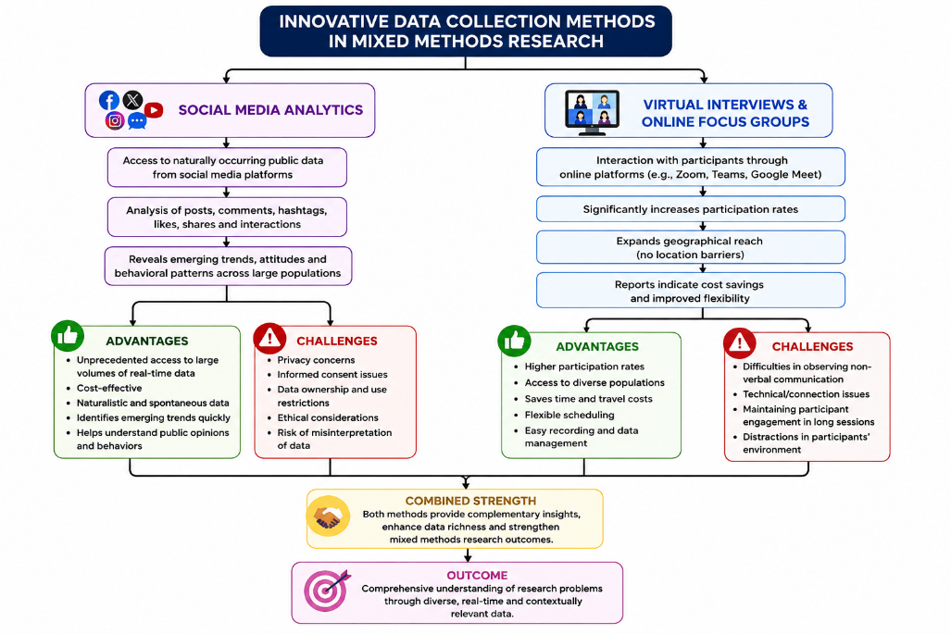

Despite the numerous benefits, several common challenges emerged across studies. Data privacy and cybersecurity concerns were frequently reported. Technological inequalities created barriers for participants with limited internet access or digital literacy. Researchers also encountered difficulties integrating large volumes of heterogeneous data from multiple sources. Overall, the evidence suggests that innovative data collection strategies substantially enhance the depth, quality, and contextual richness of mixed methods research. When combined with traditional questionnaires and interviews, these approaches strengthen triangulation and improve the comprehensiveness of research findings.

CONCLUSION:

The findings of this review demonstrate that innovative data collection strategies have significantly expanded the methodological possibilities of mixed methods research. While questionnaires continue to play an important role in data collection, emerging technologies and participatory approaches provide opportunities to capture richer, more accurate, and contextually relevant information.

Mobile applications, wearable devices, digital diaries, social media analytics, virtual interviews, geospatial mapping technologies, participatory visual methods, and artificial intelligence have transformed the way researchers collect and interpret data. These approaches facilitate real-time monitoring, enhance participant engagement, reduce recall bias, and generate multidimensional datasets capable of addressing complex research questions.

The integration of innovative methods with traditional quantitative and qualitative approaches strengthens methodological triangulation, improves validity, and provides a more comprehensive understanding of human experiences and behaviors. Such integration is particularly valuable in healthcare, nutrition, education, environmental studies, and social sciences, where complex interactions between individuals and their environments must be understood.

However, successful implementation requires careful attention to ethical principles, including informed consent, privacy protection, data security, and equitable access to technology. Researchers must also address challenges related to digital literacy, technological infrastructure, and the management of large and diverse datasets.

Future research should focus on developing standardized methodological frameworks, ethical guidelines, and best-practice recommendations for integrating innovative data collection strategies into mixed methods research. Continued technological advancement is expected to further expand opportunities for collecting high-quality, participant-centered data and advancing evidence-based knowledge across disciplines.

REFERENCES:
- Creswell JW, Plano Clark VL. Designing and Conducting Mixed Methods Research. 4th ed. Thousand Oaks, CA: Sage Publications; 2023.
- Creswell JW, Creswell JD. Research Design: Qualitative, Quantitative, and Mixed Methods Approaches. 6th ed. Thousand Oaks, CA: Sage Publications; 2023.
- Fetters MD, Curry LA, Creswell JW. Achieving integration in mixed methods designs: Principles and practices. Health Serv Res. 2013;48(6 Pt 2):2134–56.
- Johnson RB, Onwuegbuzie AJ. Mixed methods research: A research paradigm whose time has come. Educ Res. 2004;33(7):14–26.
- Braun V, Clarke V. Successful qualitative research: A practical guide for beginners. London: Sage Publications; 2022.
- Palinkas LA, Mendon SJ, Hamilton AB. Innovations in mixed methods evaluations. Annu Rev Public Health. 2019;40:423–42.
- Bolger N, Laurenceau JP. Intensive Longitudinal Methods: An Introduction to Diary and Experience Sampling Research. New York: Guilford Press; 2019.
- Lupton D. Digital Health: Critical and Cross-Disciplinary Perspectives. London: Routledge; 2021.
- Nevedal AL, Reardon CM, Opra Widerquist MA, Jackson GL, Cutrona SL, White BS, et al. Rapid versus traditional qualitative analysis using matrix templates and team-based coding. BMJ Open. 2021;11:e046241.
- Wang C, Burris MA. Photovoice: Concept, methodology, and use for participatory needs assessment. Health Educ Behav. 1997;24(3):369–87.
- Evans WD, Thomas CN, Favatas D, Smyser J, Briggs J. Digital and social media interventions for health behavior change. Health Educ Behav. 2020;47(5):741–50.
- Ranjan Y, Rashid Z, Stewart C, Conde P, Begale M, Verbeeck D, et al. RADAR-base: Open source mobile health platform for collecting real-world data using smartphones and wearables. JMIR Mhealth Uhealth. 2019;7(8):e11734.
- Kamel Boulos MN, Peng G, VoPham T. An overview of GeoAI applications in health and healthcare. Int J Health Geogr. 2019;18(1):7.
- Archibald MM, Ambagtsheer RC, Casey MG, Lawless M. Using Zoom videoconferencing for qualitative data collection. Int J Qual Methods. 2019;18:1–8.
- Denzin NK. The Research Act: A Theoretical Introduction to Sociological Methods. 4th ed. New York: Routledge; 2022.
- Teti M, Schatz E, Liebenberg L. Methods in the time of COVID-19: The vital role of qualitative inquiries. Int J Qual Methods. 2020;19:1–5.
- Patton MQ. Qualitative Research & Evaluation Methods. 5th ed. Thousand Oaks, CA: Sage Publications; 2023.
- World Health Organization. Ethics and Governance of Artificial Intelligence for Health. Geneva: WHO; 2021.
- United Nations Educational, Scientific and Cultural Organization (UNESCO). Recommendation on the Ethics of Artificial Intelligence. Paris: UNESCO; 2021.
- Greenhalgh T, Wherton J, Shaw S, Morrison C. Video consultations for COVID-19 and beyond: A rapid review. BMJ. 2020;368:m998.

