See Before You Stay: An Immersive Hotel Booking System with a 360° Virtual Tour for The First Islatel
Jerico H. Odato ¹*, Elaine M. Corpuz²*, Karl N. Trenquitio³*, Marck Ian C. Culaniban⁴*, Marino B. Bartolome Jr.⁵*
Bachelor of Science in Information Technology, Pangasinan State University

*Corresponding Authors: , jericoodato25@gmail.com, corpuzlin6@gmail.com, trenquitiokarl74@gmail.com, culanibanmarckian@gmail.com,
ABSTRACT
The Immersive Hotel Booking System with a 360° Virtual Tour is a web-based platform developed for The First Islatel in Alaminos City, Pangasinan, to address challenges associated with traditional hotel reservation processes. Existing booking methods, such as call-in, walk-in, and basic online reservations, provide limited opportunities for potential guests to explore hotel facilities before making a booking decision. This lack of visual interaction often results in booking uncertainty, unmet guest expectations, manual data-entry errors, and inefficiencies in reservation management. To address these concerns, the study aimed to design and develop an interactive and user-centered hotel booking system that enhances customer engagement and streamlines hotel operations. The system was developed using the Rapid Application Development (RAD) model to enable iterative design, user feedback integration, and accelerated system deployment. It is built on a Three-Tier Architecture consisting of presentation, application, and database layers to ensure scalability, maintainability, and security. Key features of the system include an immersive 360° virtual tour viewer, a self-service digital Customer Information Sheet (CIS), a secure online booking and payment module, and an administrative control panel for reservation and customer management. The system was evaluated by 34 respondents composed of hotel management personnel, staff, guests, and information technology experts. Evaluation results produced an overall weighted mean of 4.13, interpreted as Very Good. Among the quality attributes assessed, Usability obtained the highest rating of 4.71, interpreted as Excellent, followed by Reliability with 4.11 and Functionality with 4.06. Findings indicate that the system is functional, reliable, user-friendly, and ready for deployment. Furthermore, it offers a practical and replicable digital solution for hospitality establishments seeking to modernize reservation processes, improve guest experiences, and support digital transformation initiatives.
Keywords: Hotel Booking System, 360° Virtual Tour, Rapid Application Development, Immersive Technology, The First Islatel, ISO 9126
I. INTRODUCTION
The hospitality industry has undergone significant transformation in recent years due to rapid advancements in digital technology and evolving consumer expectations. Digital transformation has become a core strategic priority within the hospitality sector, with businesses increasingly adopting smart systems, automation, and immersive technologies to enhance service efficiency and customer experience [1]. Modern travelers are now more digitally empowered than ever before the widespread use of mobile devices, online booking platforms, and social media has reshaped how customers search for information, compare options, and make purchasing decisions. Guests no longer rely solely on brochures or static images when selecting accommodations; instead, they expect dynamic, interactive, and transparent digital experiences.
Among emerging technologies, Virtual Reality (VR) has gained considerable attention in tourism and hospitality research. Studies confirm that immersive VR experiences positively influence destination image and significantly increase travel intention [2]. A systematic review of 274 peer-reviewed articles on virtual technology in hospitality and tourism further confirms the growing adoption of 360° virtual tours in hotel marketing and destination previewing [7]. When potential guests engage with immersive digital environments, they develop stronger perceptions of quality, reliability, and trust, which directly contribute to booking decisions [3]. Unlike traditional photographs, 360-degree virtual tours allow users to explore spaces interactively, view facilities from multiple angles, and simulate physical presence reducing uncertainty, enhancing transparency, and bridging the gap between expectation and reality [9].
Tourism continues to play a vital role in the Philippine economy. According to the Philippine Statistics Authority (2025), tourism contributed 8.9 percent to the national economy in 2024, with the Tourism Direct Gross Value Added reaching PHP 2.35 trillion [4]. The World Travel & Tourism Council (2025) further projects that the Philippine travel and tourism sector will inject a record PHP 5.9 trillion into the economy in 2025, representing 21 percent of national GDP [5]. Within this national context, Alaminos City in Pangasinan is internationally recognized for the Hundred Islands National Park, creating consistent demand for lodging and event services.
The First Islatel, founded in 2022 under Islatel Realty and Development Corporation, accommodates approximately 600 guests per month and offers five room types catering to couples, families, and corporate guests. Despite these offerings, the hotel's existing reservation procedures rely on paper-based Customer Information Sheets (CIS), basic online forms with static images, and manual verification contributing to booking hesitation, transcription errors, and an 'expectation vs. reality' gap experienced by guests upon arrival.
To bridge this gap, the proponents developed the Immersive Hotel Booking System with a 360° Virtual Tour for The First Islatel a modern, user-centered platform integrating online booking with immersive 360-degree virtual tours. The system enables potential guests to visually explore hotel facilities before confirming reservations, aiming to enhance customer confidence, reduce booking hesitation, minimize manual errors, and improve overall operational efficiency.
II. METHODOLOGY
Research Design and Development Approach
The proponents adopted the Rapid Application Development (RAD) model as the software development lifecycle for this project [6]. RAD emphasizes quick, iterative cycles to deliver a functional system within a short timeline, enabling continuous refinement based on user feedback [11]. The development process was divided into four main phases: Requirements Planning, User Design, Construction, and Cutover.
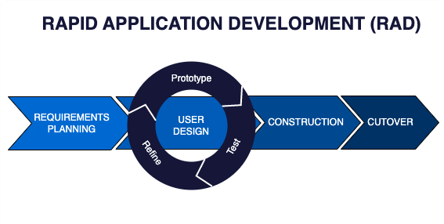
Figure 1. Rapid Application Development Model
Source: https://www.agilelonestar.com/knowledge-base/rapid application-development
In the Requirements Planning phase, structured interviews were conducted with the General Manager, Mr. Dane Lavarias, and hotel staff, supplemented by on-site observations of the existing booking workflow. These activities identified recurring operational issues, including the absence of visual room previews, reliance on manual CIS forms, and payment processing limitations. In the User Design phase, wireframes and flowcharts were developed using Figma, and early prototypes were presented to hotel stakeholders for iterative feedback. The Construction phase involved actual coding and implementation using HTML, Tailwind CSS, JavaScript, and PHP, with MySQL as the database management system, all within a XAMPP local development environment. The Cutover phase focused on final testing, user training, pilot runs, and system validation.
System Architecture
The system was designed using a Three-Tier Architecture separating the platform into three layers. The Presentation Layer serves as the user-facing interface accessible via web browsers and mobile devices, supporting both guest and administrator views. The Application Layer handles core business logic including booking validation, 360° virtual tour rendering, availability checking, and booking confirmations. The Data Layer is built on a structured MySQL schema that stores hotel information, user accounts, reservation records, and tour images, ensuring data integrity, security, and accessibility.
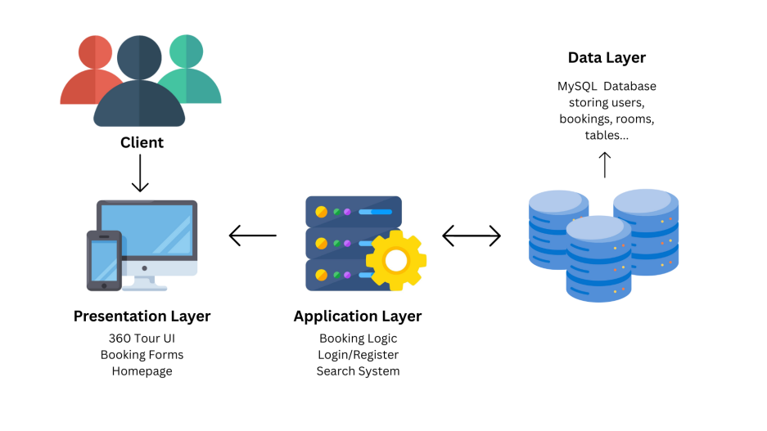
Figure 2. The Three-Tier Architecture
System Development Tools
The following technologies were employed: Visual Studio Code as the primary development environment; HTML, Tailwind CSS, and JavaScript for the front-end interface; PHP as the server-side scripting language; MySQL for database management via XAMPP; Photo Sphere Viewer (a JavaScript library) for rendering 360° panoramic images; the 360 Photo Cam Application on an iPhone 15 for capturing panoramic images; PayMongo as the online payment gateway supporting Visa card transaction; and Bravo.com for email verification and booking notification delivery.
Population and Sampling
Purposive sampling was used to select 34 respondents with direct engagement in the hotel's booking process or relevant technical expertise. The respondent distribution is presented in Table 1.

Table 1. Respondents of the Study
Respondents | Number of Respondents
Hotel Staff | 6
Hotel Manager | 1
Customers / Guests | 25
IT Experts | 2
Total Respondents | 34
Data Collection and Instrumentation
Data was gathered through structured interviews with hotel management, on-site observations of hotel operations, and a survey questionnaire distributed to all respondents. The survey assessed the developed system across six software quality characteristics aligned with ISO 9126 standards: Functionality, Reliability, Usability, Efficiency, Maintainability, and Portability. Responses were measured using a five-point Likert scale, and the weighted mean formula was applied to interpret results. The scale and corresponding interpretations are defined in Table 2.

Table 2. Scale of Measurement
Scale | Statistical Limits | Rating | Descriptive Interpretation
1 | 1.00 – 1.80 | Poor | Truly Not Accepted
2 | 1.81 – 2.60 | Fair | Not Accepted
3 | 2.61 – 3.40 | Good | Fairly Accepted
4 | 3.41 – 4.20 | Very Good | Accepted
5 | 4.21 – 5.00 | Excellent | Very Accepted

III. RESULTS AND DISCUSSIONS
Existing Booking Process of The First Islatel
Evaluation of the current booking processes revealed three primary reservation methods: call-in, walk-in, and online booking. In call-in reservations, front desk uses a computer to record guest information on a paper CIS form and verifies room availability, with a 50% down payment required to finalize bookings. Walk-in bookings follow the same procedure but allow guests to physically inspect rooms, along with a ₱2,000 refundable security deposit collected at check-in. The existing online booking process uses the hotel's official website integrated with a Property Management System (PMS), requiring guests to input personal and booking details before settling a 50% down payment. However, the absence of interactive visual features results in guests booking based on static images, creating an 'expectation vs. reality' problem upon arrival. Research confirms that perceived benefits, system quality, and service quality are the primary predictors of a guest's intention to use online hotel booking platforms [8].
Difficulties in the Existing Booking System
Through interviews, observations, and Fishbone diagram analysis, four major categories of difficulties were identified. First, inefficient and error-prone booking procedures were caused by manual CIS data entry, leading to frequent errors in guest names, dates, and contact information, resulting in booking confusion and delayed reservations. Second, staff-related service and accuracy issues stemmed from manual entry causing overbooking and idle rooms, as well as inconsistent rate application due to the absence of an automated pricing engine. Third, outdated and limited system functionality was evident in the payment portal's failure to process foreign credit cards, deterring international guests, and the legacy PMS requiring manual verification of payments and availability. Fourth, insufficient system data manifested as inaccurate room descriptions causing guest disappointment and complaints upon check-in.
System Features
The Immersive Hotel Booking System with a 360° Virtual Tour was developed to directly address the identified limitations through four core features.
Self-Service Digital CIS System. This feature shifts information input from staff to guests on a digital form, preventing transcription errors and eliminating the persistent root cause of booking confusion. Staff are freed from manual data entry, speeding up the check-in process and improving data accuracy.
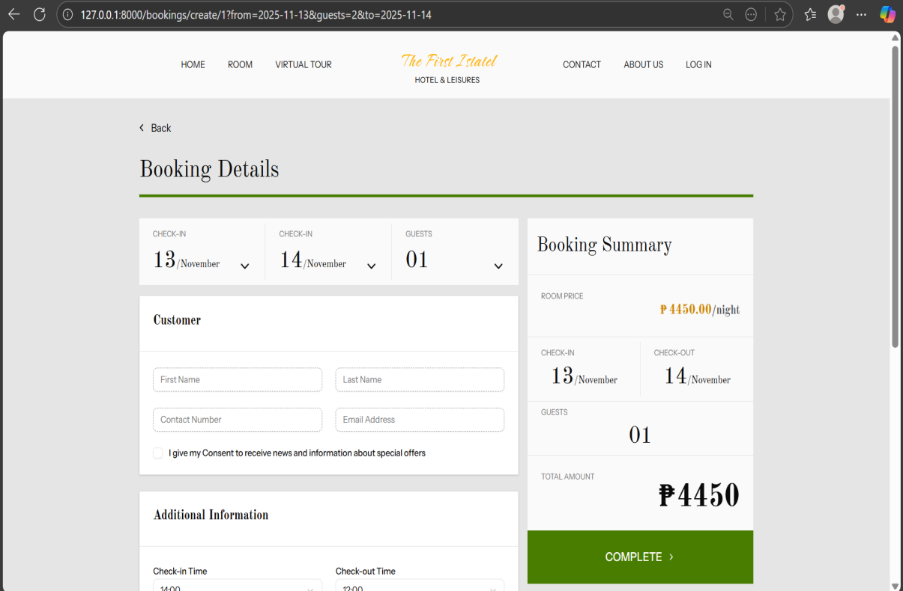
Figure 3. Self-Service Digital CIS System
360° Virtual Tour. Using the Photo Sphere Viewer JavaScript library and images captured with the 360 Photo Cam application, guests can explore hotel rooms, amenities, and function areas in full 360-degree detail before booking. This directly resolves the 'booking blindly' problem by providing visual transparency, managing expectations, and reducing complaints upon arrival.
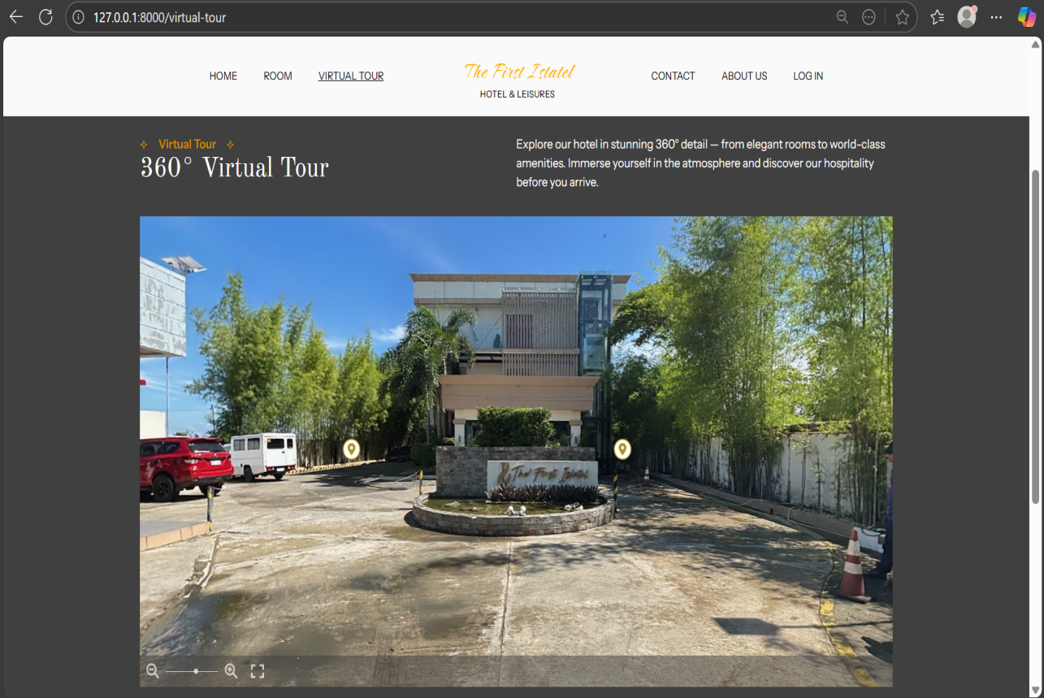
Figure 4. 360° Virtual Tour
360° Virtual Tour Viewer Content Editor. Hotel staff and administrators can update virtual tour content in real time, ensuring guests always receive accurate visual information. Super Admin oversight maintains consistency and prevents misleading room images from being displayed.
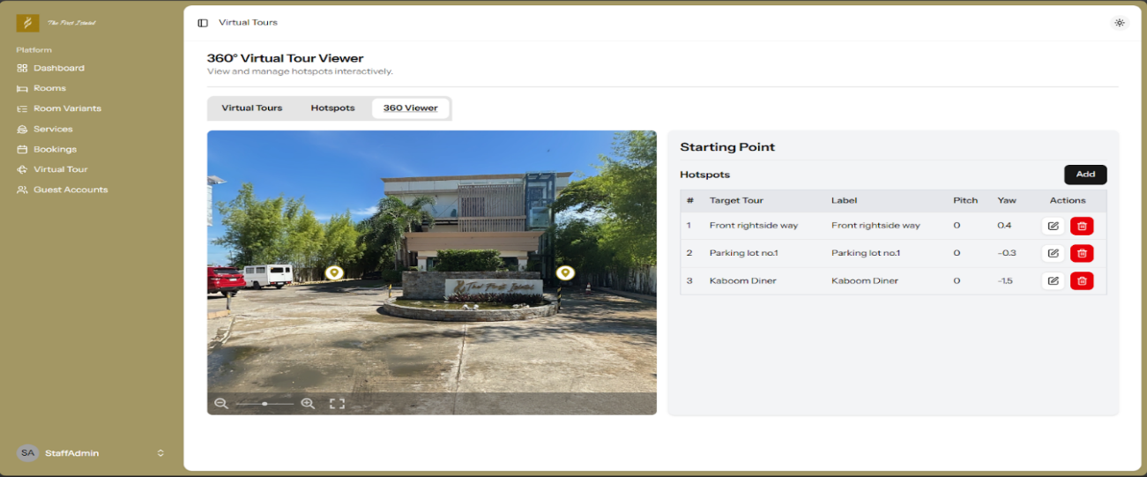
Figure 5. 360° Virtual Tour Viewer Content Editor
Operational Control Panel. The admin dashboard provides instant access to key metrics including Total Bookings, Active Guests, Revenue, Upcoming Check-Ins, and Top Room Types. This eliminates manual reporting and supports real-time data-driven decision-making, replacing the inefficiencies of the legacy PMS.
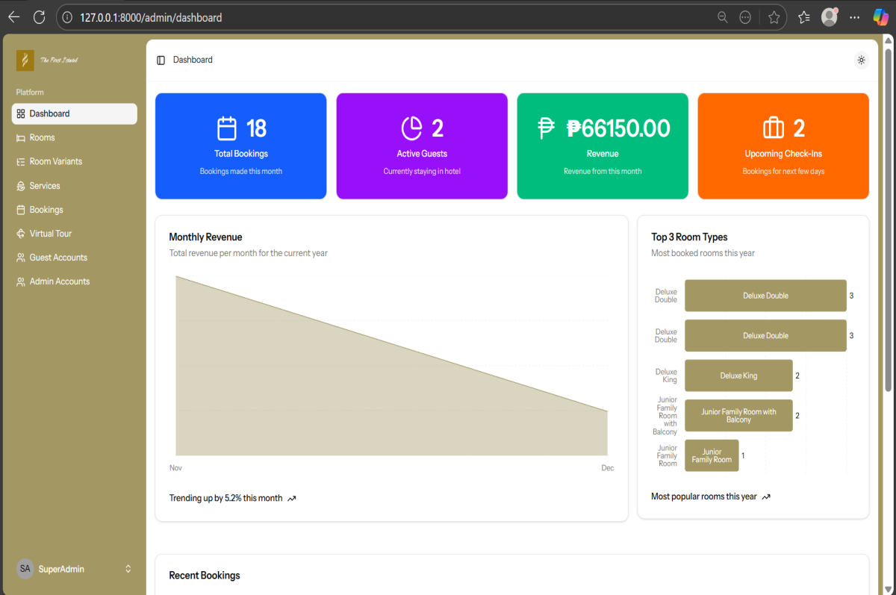
Figure 6. Operational Control Panel
System Evaluation
A structured evaluation was conducted with 34 respondents using a survey questionnaire aligned with ISO 9126 software quality standards. The system was assessed across six quality characteristics. The evaluation results are presented in Table 3.

Table 3. Overall System Evaluation Results
Characteristics | Mean | Descriptive Interpretation
Functionality | 4.06 | Very Good
Reliability | 4.11 | Very Good
Usability | 4.71 | Excellent
Efficiency | 4.04 | Very Good
Maintainability | 3.81 | Very Good
Portability | 4.02 | Very Good
Overall Weighted Mean = | 4.13 | Very Good

The system achieved an overall weighted mean of 4.13, interpreted as Very Good, indicating general acceptability and positive reception by all respondent groups.
Usability scored highest at 4.71, interpreted as Excellent, confirming that the platform is highly intuitive and easy to navigate for all types of users. This is consistent with findings that system availability and ease of use are critical determinants of online hotel booking behavioral intention [10]. Reliability scored 4.11, interpreted as Very Good, demonstrating that the system performs consistently and handles errors smoothly. Functionality scored 4.06, interpreted as Very Good, confirming that the system effectively meets the hotel's operational requirements. Efficiency scored 4.04, interpreted as Very Good, reflecting responsive loading for virtual tours and booking processes. Portability scored 4.02, interpreted as Very Good, confirming that the system performs well across different devices and platforms. Maintainability scored 3.81, interpreted as Very Good, indicating that system updates and bug fixes can be applied without significant disruption to operations.
IV. CONCLUSION
This study successfully designed and assessed an Immersive Hotel Booking System with a 360° Virtual Tour for The First Islatel in Alaminos City using the Rapid Application Development model and a Three-Tier Architecture. The system addressed critical gaps in the hotel's existing manual booking procedures by integrating a self-service digital CIS, an immersive 360° virtual tour, a real-time operational control panel, and a secure online booking module with payment integration.
The system directly resolved the core problems identified in the study. The 360° Virtual Tour eliminated the 'booking blindly' problem by providing guests with transparent, interactive visual previews, significantly reducing the expectation-reality gap and associated complaints. The Self-Service Digital CIS removed manual data-entry errors that previously caused operational failures and booking confusion. The Operational Control Panel replaced the inefficiencies of the legacy PMS with real-time reporting and metric monitoring.
Evaluation with 34 respondents yielded an overall weighted mean of 4.13 (Very Good). Usability scored highest at 4.71 (Excellent), confirming a highly intuitive and accessible platform. Reliability (4.11), Functionality (4.06), Efficiency (4.04), Portability (4.02), and Maintainability (3.81) all demonstrated Very Good performance, confirming that the system satisfies user expectations and technical requirements.
The system has several limitations. It is scoped exclusively to The First Islatel and relies on pre-recorded 360° images without live or real-time video feeds. The evaluation involved a relatively small pool of 34 respondents, and the system does not currently include an automated chatbot or a cancellation and rebooking module. Future studies may expand the respondent pool, integrate AI-based room recommendations and chatbot assistance, automate cancellation workflows, synchronize with third-party booking channels such as Agoda, and incorporate expanded PMS-like features for guest history tracking and automated notifications. This system serves as a replicable model for other hospitality establishments seeking to modernize their reservation processes through immersive digital platforms.
ETHICAL CONSIDERATIONS
A total of 34 respondents participated in the study and evaluated the system using ISO 9126 quality standard criteria. The informed consent of all respondents was obtained prior to data collection. Their responses remained confidential, as no personal identifying data was collected or retained.
CONFLICT OF INTEREST
No conflict of interest exists regarding the development or evaluation of this research project. This research is a fulfillment of academic obligations without any external sponsorship or commercial incentive.
DATA AVAILABILITY
Table 3 summarizes the overall system acceptability evaluation results. Raw data can be provided by the corresponding authors upon request.
REFERENCES
[1] Peng, X., Zhu, J., Lee, S., Zhou, D., Song, W., & Ying, T. (2024). Digital transformation in the hospitality industry: A bibliometric review from 2000 to 2023. International Journal of Hospitality Management, 120, 103761. https://www.sciencedirect.com/science/article/abs/pii/S0278431924000732
[2] Kieanwatana, K., & Vongvit, R. (2024). Virtual reality in tourism: The impact of virtual experiences and destination image on the travel intention. Results in Engineering, 24, 103650. https://www.sciencedirect.com/science/article/pii/S2590123024018930
[3] Anaya-Sánchez, R., Rejón-Guardia, F., & Molinillo, S. (2024). Impact of virtual reality experiences on destination image and visit intentions: the moderating effects of immersion, destination familiarity and sickness. International Journal of Contemporary Hospitality Management, 36(11), 3607–3627. https://www.emerald.com/insight/content/doi/10.1108/IJCHM-09-2023-1488
[4] Philippine Statistics Authority. (2025). Philippine Tourism Satellite Account: 2024 results. Tourism Direct Gross Value Added estimated at 8.9 percent of GDP. https://psa.gov.ph/statistics/tourism
[5] World Travel & Tourism Council. (2025). Philippines' Travel & Tourism Sector Set to Inject a Record PHP 5.9TN to the Economy in 2025. https://wttc.org/news/philippines-travel-tourism-sector-set-to-inject-a-record-php-5-point-9tn-to-the-economy-2025
[6] GeeksforGeeks. (2022). Rapid Application Development Model (RAD) – Software Engineering. https://www.geeksforgeeks.org/software-engineering-rapid-application-development-model-rad/
[7] Chen, J., Wu, X., & Lai, I. K. W. (2023). A systematic literature review of virtual technology in hospitality and tourism (2013–2022). SAGE Open, 13(3). https://doi.org/10.1177/21582440231193297
[8] Salameh, A. A., Al Mamun, A., Hayat, N., & Ali, M. H. (2022). Modelling the significance of website quality and online reviews to predict the intention and usage of online hotel booking platforms. Heliyon, 8(9), e10735. https://doi.org/10.1016/j.heliyon.2022.e10735
[9] Lim, W. M., Gupta, S., Aggarwal, A., Paul, J., & Sadhna, P. (2024). How do digital natives perceive and use augmented reality? Implications for immersive commercial experiences via AR. International Journal of Hospitality Management, 116, 103631. https://doi.org/10.1016/j.ijhm.2023.103631
[10] Chen, L., Goh, C. F., Low, Y. M., Tan, O. K., & Lim, K. Y. (2025). From service to intention: A Technology Acceptance Model perspective on e-service quality in online hotel booking. SAGE Open. https://doi.org/10.1177/21582440251397834
[11] Riadi, I., Sunardi, & Yudhana, A. (2024). Analysis impact of Rapid Application Development method on development cycle and user satisfaction: A case study on web-based registration service. Scientific Journal of Informatics, 11(1). https://doi.org/10.15294/sji.v11i1.49590

