ASSESSMENT OF ELECTRICAL ANISOTROPY OF BASEMENT ROCKS IN PARTS OF AGO-IWOYE, SOUTHWESTERN NIGERIA USING RADIAL VERTICAL ELECTRICAL SOUNDING

Abstract
Radial Vertical Electrical Sounding (RVES) survey was conducted along Ishara Road in Southwestern Nigeria to evaluate the structural trends and anisotropic characteristics of crystalline basement rocks, specifically granite-gneiss, gneiss, and migmatite. Surface geological mapping was initially carried out to establish the structural baseline by measuring the strike and dip profiles of local outcrops. RVES datasets were subsequently acquired across twelve distinct stations along four key azimuthal orientations (0°, 45°, 90°, and 135°), utilizing a maximum current electrode spacing (AB/2) of 50 m. From the calculated mean apparent resistivity data, secondary geoelectric parameters, including the reflection coefficient and the coefficient of apparent anisotropy (λ_{a}), were derived to model subsurface heterogeneity. Polar plots generated via ORIGIN software tracked resistivity variations against azimuths at discrete depth horizons of 5 m, 10 m, 15 m, and 50 m. Computed λ_{a} values across the study area ranged between 1.21 and 2.10, with stations 3, 6, 11, and 12 exhibiting the most pronounced structural anisotropy. The resulting anisotropy polygon geometries reveal a multi-directional fracture network, dominated primarily by an E–W trend, alongside secondary NE–SW and NW–SE systems. This structural distribution correlates strongly with surface outcrop rosette diagrams. Furthermore, Cartesian azimuthal curves highlight intense fracturing at stations 3, 6, 11, and 12, characterized by sharp crest-and-trough amplitudes across all depth horizons. Collectively, these parameters demonstrate that the basement complex is highly anisotropic, with subsurface fracturing trending perpendicular to the regional lithological strike. Ultimately, zones exhibiting an elevated coefficient of anisotropy coupled with low reflection coefficients mark optimal targets for productive borehole development, whereas low-anisotropy, high-reflection zones present the highly stable bedrock conditions required for civil engineering foundations.
Keywords: Radial Vertical Electrical Sounding; Structural Anisotropy; Basement Complex; Fracture Characterization; Hydrogeophysical Exploration.
- INTRODUCTION
Taylor and Flemming (1988) described a rock as electrically anisotropic if the value of a vector measurement of its resistivity varies with direction. Examination of the structural trend in rocks is difficult in areas with little or no outcrops, therefore assessment of electrical anisotropy in rocks has become very vital in improving the precision of geological and geophysical mapping utilizing electrical resistivity survey methods (Okpoli & Igwe, 2013).
Anisotropy is one of the greatest problems experienced when acquiring accurate rock resistivity measures, it is also a universal physical property in common materials or media. However, there is a big difference in anisotropy among crystals, materials used in daily life, and other earth materials. It is also noteworthy that the International geophysical community is aware of the importance and usefulness of anisotropy among physical properties (He et al., 2022). The type of anisotropy to be studied is the Electrical Anisotropy, which is also known as Inhomogeneity, It is the variation in resistivity with respect to direction and it is constantly assigned to structural features such as faults, joints, foliation and bedding, and weathering (Bayewu et al., 2016), these discontinuities are responsible for the mechanical and hydraulic nature of underlying rocks (Moreira et al., 2019). Electrical anisotropy in rocks can also be due to the presence of aligned vertical features and vertical to subvertical thin beds (Okpoli & Igwe, 2013).
It should be noted that fractures on the surface and subsurface are extremely important structures, as fractures on the rock surface allow infiltration of meteoric water, while subsurface fractures and their orientation aid the movement of groundwater in multiple directions (Olawuyi et al., 2022). Furthermore, fractures could be dangerous and can cause failure of any civil engineering structures if ignored. Therefore, the study of fracture systems in subsurface rocks is consequential to many geophysical and geological studies (Misra et al., 2022). The degree of homogeneity of a medium is expressed in terms of the coefficient of apparent anisotropy, denoted by the symbol λa. This coefficient can be determined by calculating the geoelectric parameters or by deducing it from the ratio of the length of the major axis to the length of the minor axis of a polar plot (Akinlabi & Onifade, 2018).
The geophysical survey method used is called Radial Vertical Electrical Sounding (RVES) which is also known as Azimuthal Resistivity Sounding (ARS) and it can be done using different kinds of array methods and the method used will determine the parameters calculated. Carpenter et al. (1997) employed a standard Wenner array to study electrical anisotropy. Adabanija et al. (2021), Ejepu et al. (2017), Ramadas et al. (2020), Akinlabi and Onifade (2018), Oladunjoye (2018) and Massoud et al. (2009) all used Schlumberger array while Asare et al. (2015) used both Wenner and Schlumberger arrays. However, the cross-square array method is specially designed for anisotropic studies (Habberjam, 1975). Bayewu et al., (2016); Yeboah-Forson & Whitman, (2013) used the cross-square array method.
The aim of this study is to assess the anisotropic properties of subsurface rocks in relation to their structural trend and give them the respective interpretations that can be useful in engineering and hydrogeological solutions. This led to the study area being located around the Ishara Road axis, Ago-Iwoye with latitudes; 6.9408°N – 6.9552°N, and longitudes; 3.8844°E – 3.9024°E (Fig. 1). This area is known for its closeness to a transition zone, which has given geologists a tough time comprehending its geology. A quick geological mapping of the area was done to observe the structures. Even with the little outcrops, rosette diagrams (Fig. 2 & 3) were made from strike and deep measurement as seen in Fig. 4, showing the E-W direction of structures in those rocks. This study plans to solve the problem of insufficient anisotropic data about the area and understand the area better in the light of apparent anisotropy.

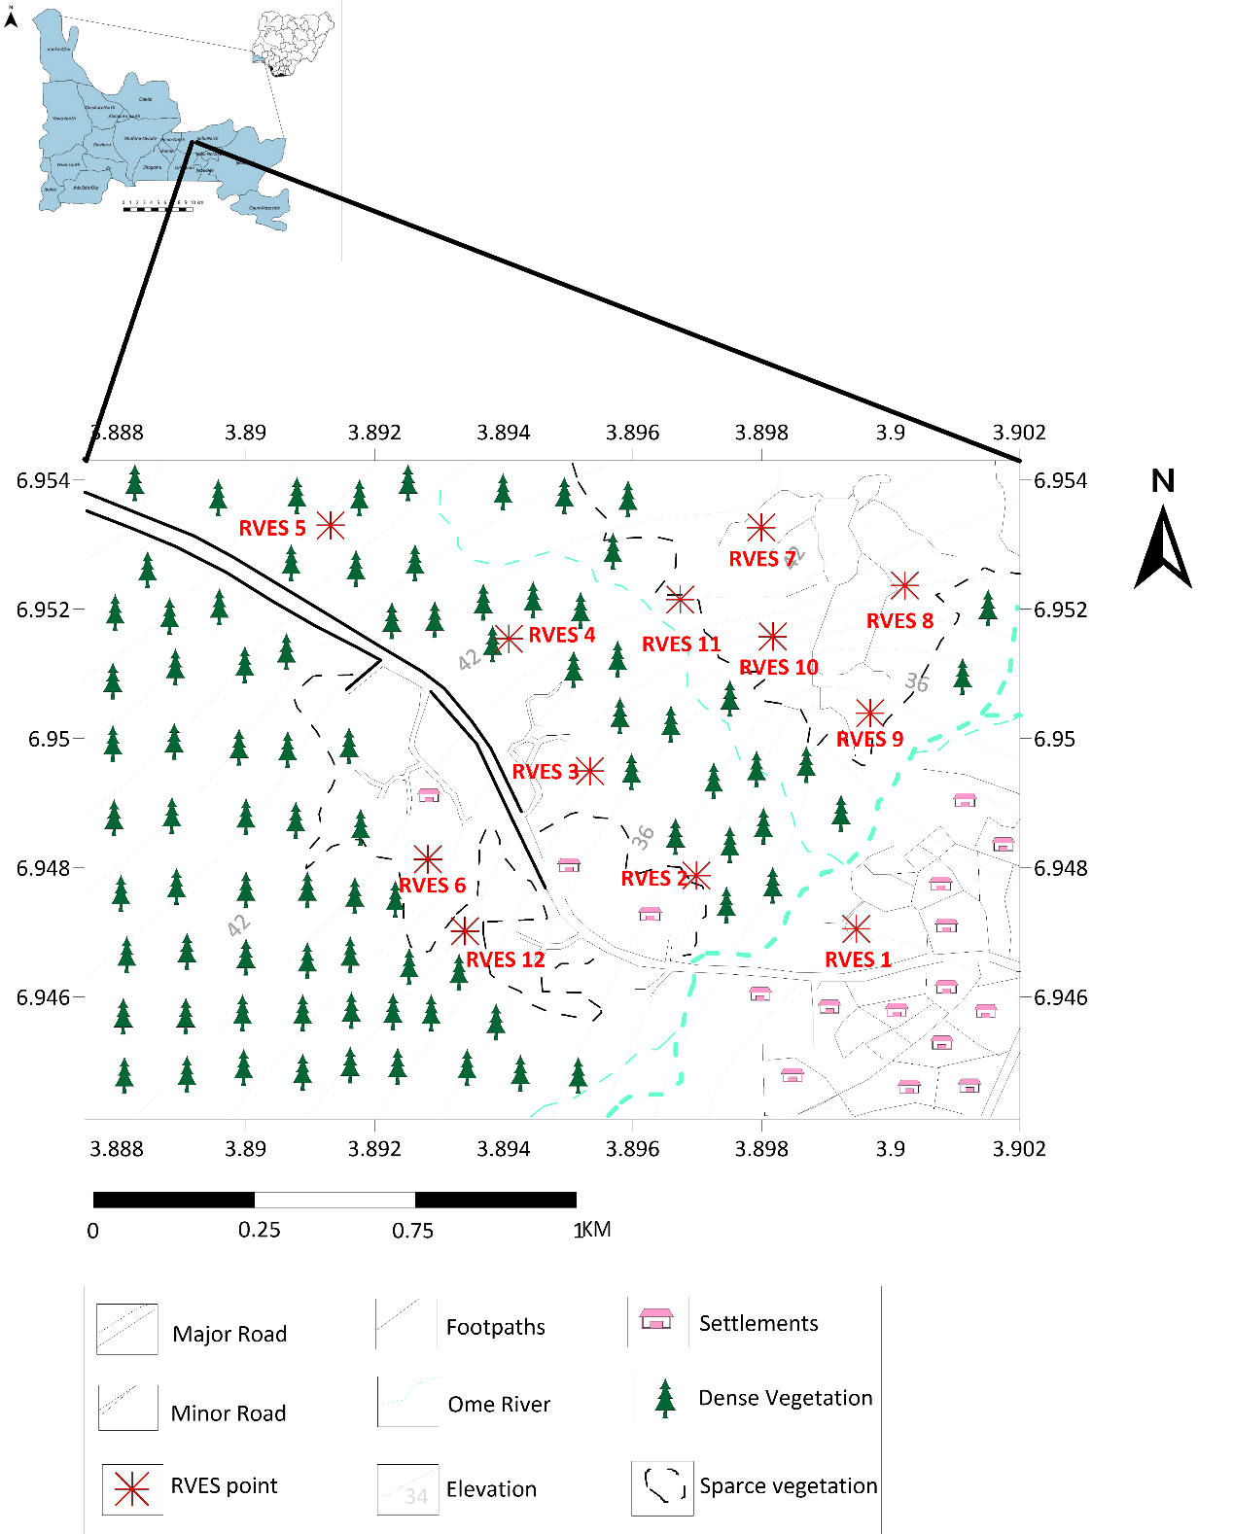
Figure 1: Topographical map of the study area

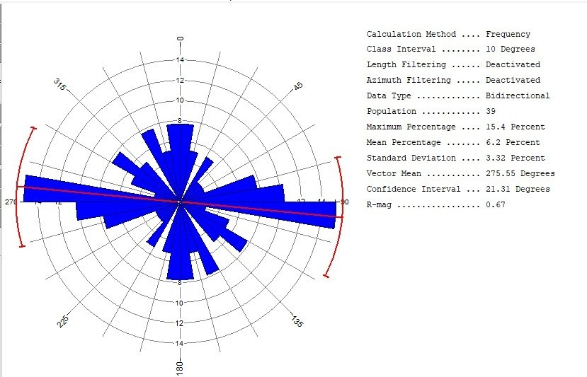

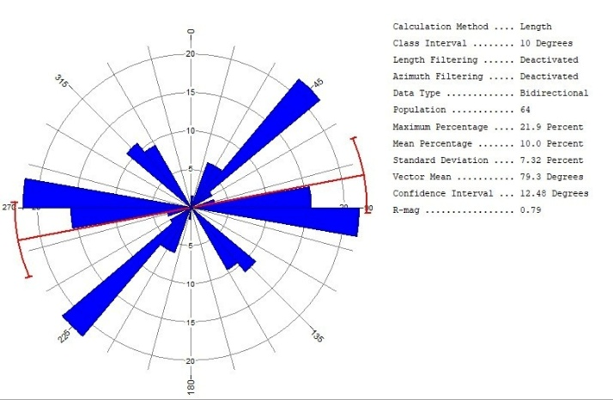
Figure 2: Picture showing the rosette diagram of the joints in the area.
Figure 3: Picture showing the rosette diagram of the veins in the area.
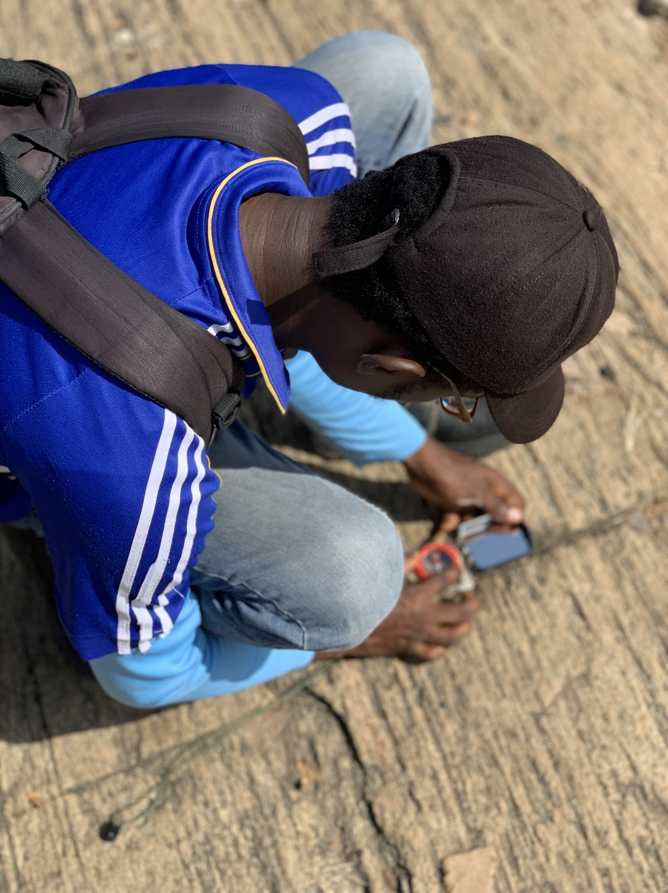
Interpreting RVES data can be difficult and ambiguous, as changes in apparent resistivity across different angles may be as a result of dipping strata and other lateral variations in resistivity of subsurface formations (Watson & Barker, 1999). Nonetheless, the advantages of this research are significant; evaluating anisotropy will aid in assessing aquifers for groundwater exploration, conducting structural analysis for construction projects, and enhancing the geological understanding of the region. The RVES is a cost-effective approach to characterizing the electrical anisotropy of fractured rock and determining its orientation (Okpoli & Igwe, 2013). This study will correlate the structural trends identified through geological field mapping with the RVES results, similar to the work conducted by Ejepu et al., 2014.
Figure 4: Picture showing the collection of strike and dip measurements.

- METHODOLOGY
To ensure a detailed study of anisotropic properties of bedrock this research was carried out in four stages: reconnaissance survey, data collection, noise removal and software interpretation. The initial stage aimed at familiarizing the team with the study area, secure necessary permissions, and locating areas suitable for the required electrode spread. A brief geological survey was done in the area to further give insights to the inhomogeneity of basement rocks in the area.
The data collection involved geophysical investigation, in which the RVES method was adopted. Utilizing the Omega Terameter, compass-clinometers, wires, electrodes and other complimentary accessories, RVES was conducted at 12 different locations in the area (Fig. 1) along multiple azimuths: 0° (North-South), 45° (Northeast-Southwest), 90° (East-West), and 135° (Northwest-Southeast). This rotation, through 180° or 360° allows for the measurement of apparent resistivity variation with orientation (Fig. 5), which is key to defining anisotropy (Habberjam, 1975). The array method employed was the Schlumberger array (Fig. 6) based on the works of Okpoli & Igwe (2013). The maximum current electrode spacing (AB/2) was set at 50m. Before setting up, a spread of at least 100m by 100m with no obstruction along 0°, 45°, 90°, and 135° is sought for, as seen in Fig. 7. The noise removal stage was done using Microsoft Excel by plotting the resistivity to get a line of best fit. The refined data sets were processed and interpreted using computer software packages, which includes; WINRESIST, ORIGIN 8.0 and Surfer 13.
As stated earlier the initial method of interpretation utilized computer-aided iteration. However, for a more advanced understanding and the specific delineation of anisotropy, several key variables were calculated from the field values and parameters: Apparent Resistivity, Mean Apparent Resistivity, Coefficient of apparent anisotropy and Reflection coefficient. For better understanding, various plots and graphs were made and they include; polar plots, cartesian azimuthal graphs, coefficient of anisotropy map. The most important variable is the apparent resistivity which is the foundation of further calculations in this study. It is calculated as the product of the geometric factor and ratio of the voltage to the current (Lane et., 1995).
ρ_{a} = (V/I) x G(f)----------------------(i)
Mean Apparent Resistivity was obtained by calculating the arithmetic mean of resistivity values at point but in different azimuths, all this was done in a bid to further understand anisotropy with respect to orientation and direction; the formula can be found below
ρ = ρ0 + ρ45 +4 ρ90 + ρ135-----------(ii)
When RVES is carried out using the Schlumberger, the coefficient of apparent anisotropy is measured by the ratio of the major axes of the plot to the minor axis of the plot (Ramadass 2020). using the relationship. This calculation could further be explained as the ratio of the maximum resistivity to the minimum resistivity (Oladunjoye et al., 2018) represented as;
λ_{a} =$\frac{ { ρ}_{max}}{{ ρ}_{min}}$ ---------------(iv)

For hydrogeological interpretations in lieu with anisotropy Reflection coefficient was calculated and this was done using this formula
r = $\frac{ρ_{n}-ρ_{n-1}}{ρ_{n}+ρ_{n-1}}$ (Loke, 1999) ---------------(v)
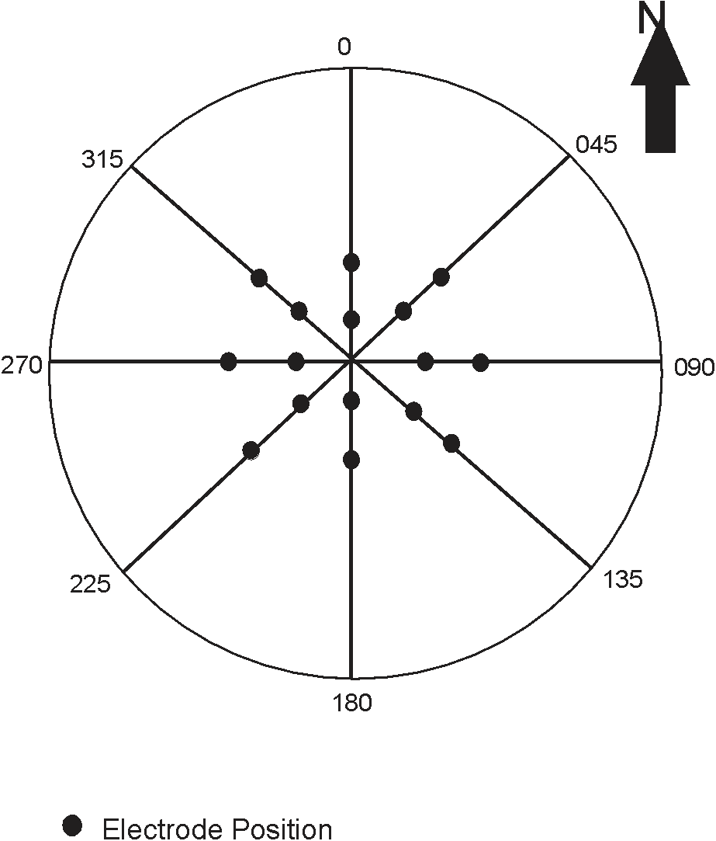
λ_{a} = a/b —-------------(iii)
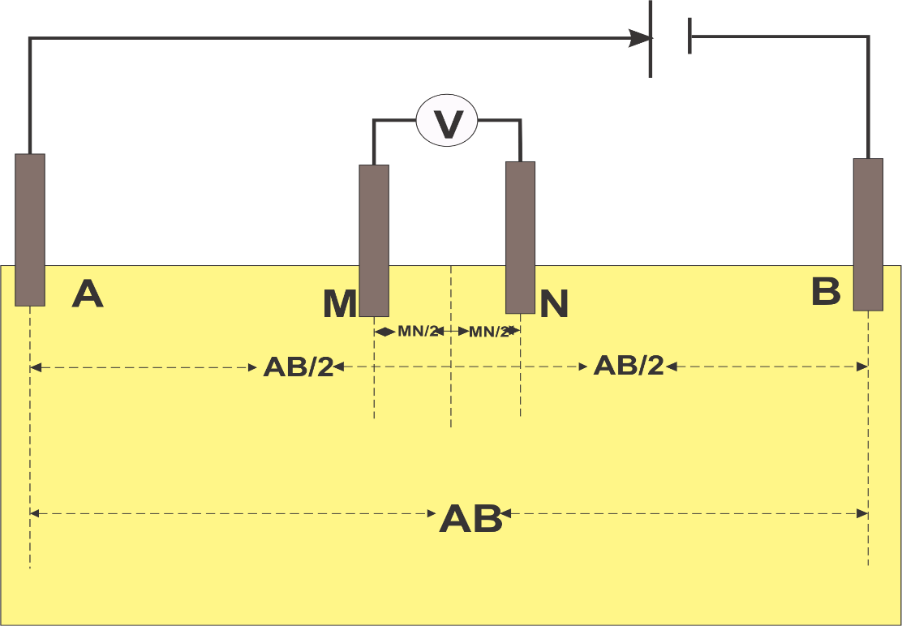
Figure 5: Diagram showing the field setup for RVES using Schlumberger array.

Figure 6: Diagram showing the setup for Schlumberger array as carried out in the study.

This calculation could further be explained as the ratio of the maximum resistivity to the minimum resistivity (Oladunjoye et al., 2018) represented as;
λ_{a} =$\frac{ { ρ}_{max}}{{ ρ}_{min}}$ ---------------(iv)
For hydrogeological interpretations in lieu with anisotropy Reflection coefficient was calculated and this was done using this formula
r = $\frac{ρ_{n}-ρ_{n-1}}{ρ_{n}+ρ_{n-1}}$ (Loke, 1999) ---------------(v)
Where the ρ𝑛 is the resistivity of the last layer and ρ𝑛−1 is the resistivity of the layer beforeThe reflection coefficient was calculated for the 0° azimuth of each location.
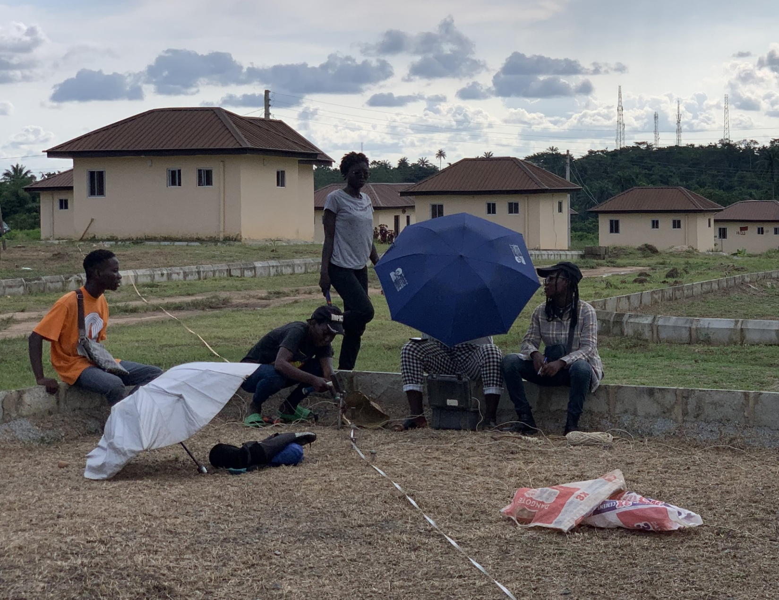
Figure 7: Picture showing the setup for RVES on the field
Some other analytical methods were used, which include polar plots, Cartesian Azimuthal Graph, Apparent anisotropy Graph, Iteration Curves and Coefficient of anisotropy map. All this done in line with previous works from Bayewu et al. (2016), Ejepu et al. (2014), Olasehinde & Bayewu (2011) and so many more researchers.
Polar plots were made using the Origin 8.0 app, plotting the apparent resistivity against their corresponding azimuths. This was done for specific depths; 5m, 10m, 15m, and 50m. The Apparent Anisotropy Graph was gotten by plotting Apparent anisotropy against depth in an inverse graph pattern and it was done for all locations. The Cartesian Azimuthal Graph was plotted for 4 different depths, 5m, 10m, 15m and 50m, the resistivity values were converted to percentage resistivity and plotted against the azimuths.
One of the greatest difficulties encountered was in getting enough space to carry out the survey, with thick vegetation being a stumbling block in most areas, the block was overcome by clearing pathways manually for each azimuth. Nevertheless, areas with thick vegetation are preferred to areas with a tangible amount of housing units which is impossible to navigate as one wouldn’t start demolishing houses in search of spread.
- RESULTS
3.1 Mean Apparent resistivity
Values for apparent resistivity were numerous due to the fact that 1-D electrical sounding was done in four different azimuths. However, to get a better and concise understanding of the apparent resistivity, the mean apparent resistivity was calculated from the results of each apparent resistivity in the four azimuths for each location. Values for the mean apparent resistivity ranged from 24.15Ωm to 1256.72Ωm across all locations. Locations 3, 4, and 5 were noted for having the smallest range in the data set. Location 3 mean resistivity values ranged from 49.34Ωm to 211.79Ωm, Location 4 mean resistivity values ranged from 24.15Ωm -179.61Ωm, location 5 mean resistivity values ranged from 125.1Ωm - 311.48Ωm. It was observed that most locations recorded a high value of mean apparent resistivity at depths of 50m, excluding location 3 and 5.
3.2 Cartesian azimuthal plots
Cartesian graphs display the best form of visual interpretation for anisotropic studies, by showing the manner in which the rock isn’t entirely homogeneous in a wave-like pattern. These plots were made for each location, protruding peaks were observed in location 1, 3, 6, 11 and 12. Locations 2, 4, 5, 7, 8, 9, 10 had little to no protruding peaks. From the locations with protruding peaks, it was observed that 15m depth had the most protruding peaks (Fig. 8 - 11).
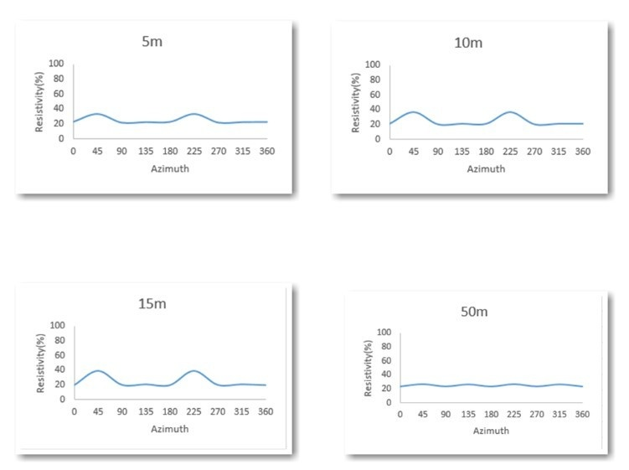
Figure 8: Picture showing cartesian azimuthal plots for locations 3 at various depths.

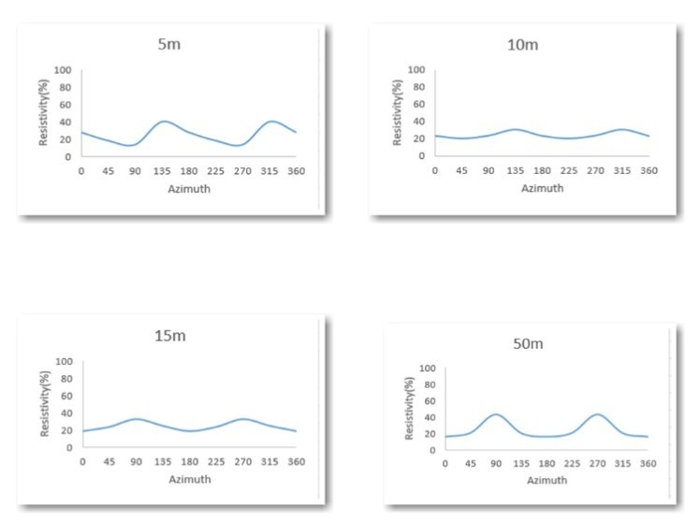
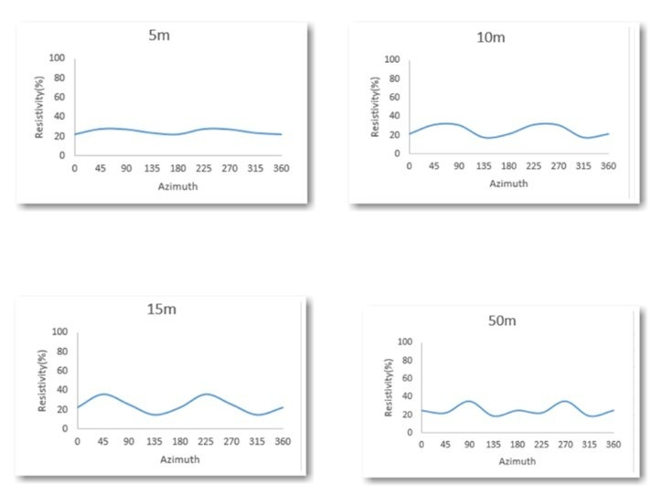
Figure 9: Picture showing cartesian azimuthal plots for locations 6 at various depths.
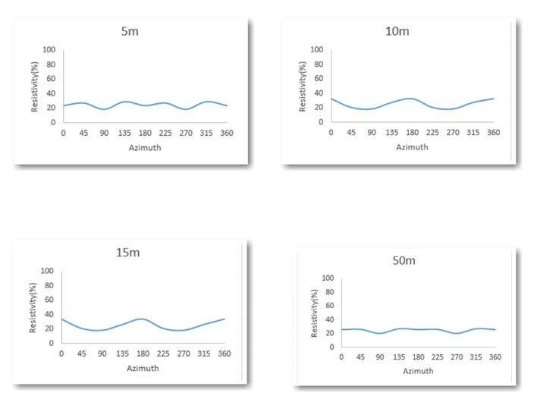
Figure 10: Picture showing cartesian azimuthal plots for locations 11 at various depths.
Figure 11: Picture showing cartesian azimuthal plots for locations 12 at various depths.

3.3 Coefficient of apparent anisotropy.
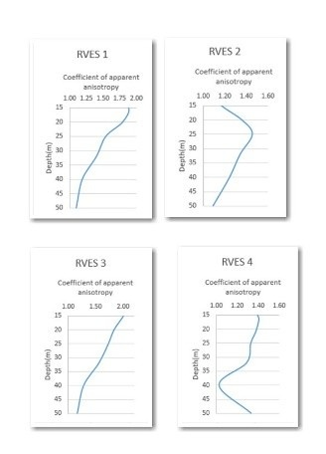
Coefficient of apparent anisotropy (λ_{a}) was calculated for each location and the results showed a general range of 1.02 - 3.25 across all locations. The mean apparent anisotropy was calculated for each location to get a succinct picture of the inhomogeneous nature of the study area. Location 1 had a value of 1.33, 2 had a value of 1.21, 3 had a value of 1.53, 4 had a value of 1.26, 5 had a value of 1.46, 6 had a value of 2.10, 7 had a value of 1.30, 8 had a value of 1.31, 9 had a value of 1.45, 10 had a value of 1.38, 11 had a value of 1.75, 12 had a value of 1.69. Apparent anisotropy plots were also made as seen in Fig. 12 - 14. These plots showed two basic trends, trending inwards
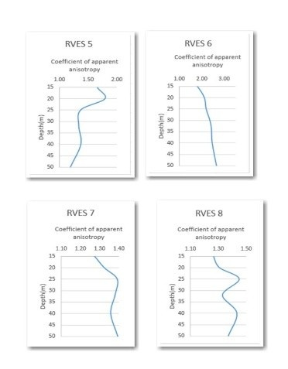
Figure 12: : Picture showing the apparent anisotropy plots for location 1 - 4
Figure 13: Picture showing the apparent anisotropy plots for location 5 - 8
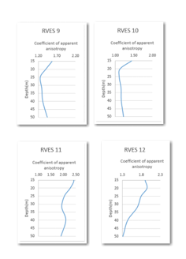
Figure 14: Picture showing the apparent anisotropy plots for location 9 - 12
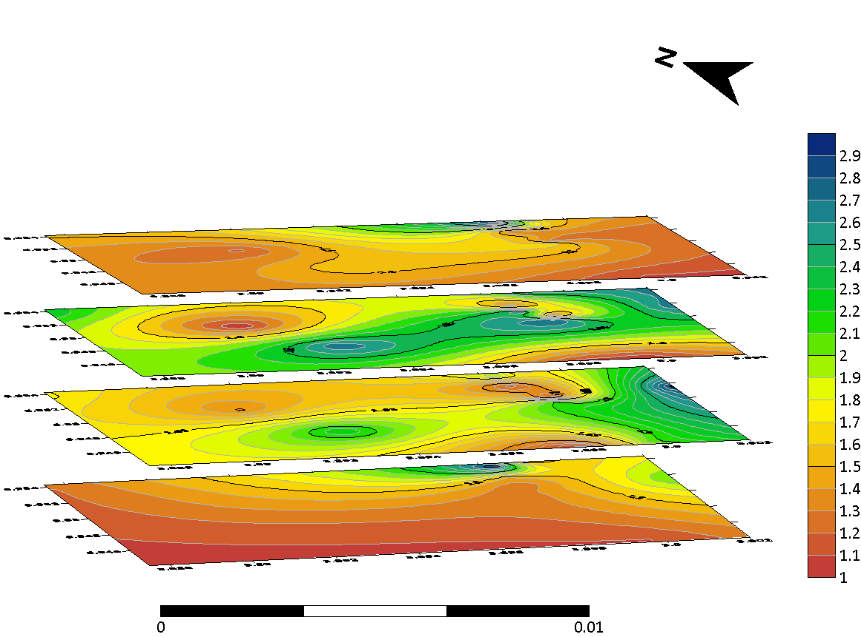
or outwards. Stacked Anisotropy Topo maps were also made from 5m, 10m, 15m to 50m depths to explain the lithology of the area (Fig. 15)
Figure 15: Picture showing Stacked Anisotropy Topo maps were also made from 5m, 10m, 15m to
50m depths
3.4 Polar plots
The fracture direction is essential to understanding anisotropy, all the more reasons polar plots were made (Fig. 16 - 19). Three major fracture directions were noted in the plots; Primary, Secondary and Tertiary directions. The primary direction was represented with a blue arrow; the secondary direction was represented with a green arrow while the tertiary direction was denoted with a red arrow. Most of the plots showed the three different types of fracture direction, except location 3 and 9. The trends observed were in N-S, NE-SW, NW - SE and E - W directions. The results showed that E-W was the most common primary direction, it also showed that NW-SE was predominant in the secondary direction and NE-SW in the tertiary direction as seen in Table. From the results of the polar plots, a Fracture topo-map at 50m was created to make the research easy to understand by others (Fig. 20).
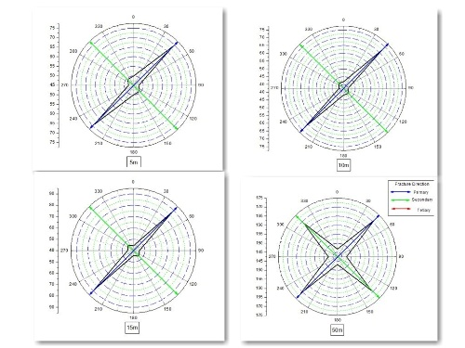
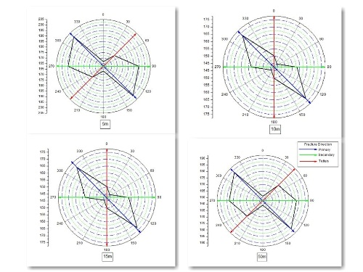
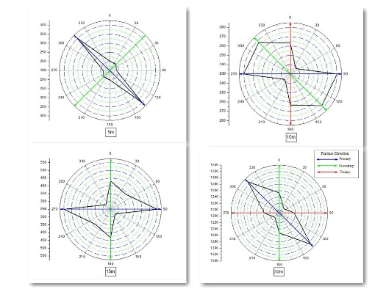
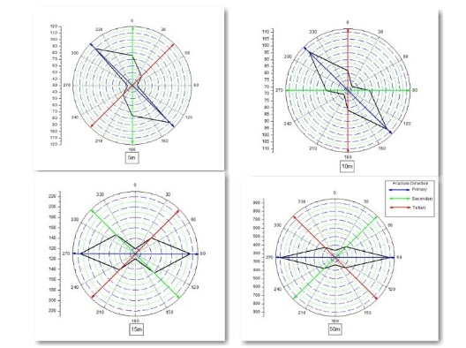
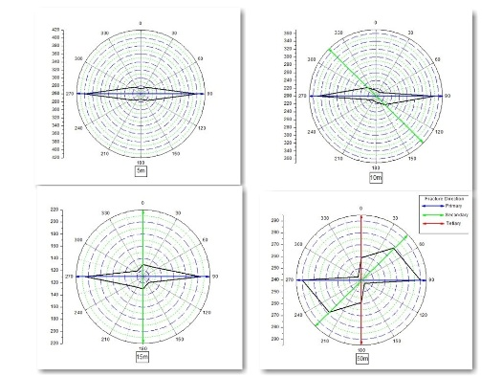
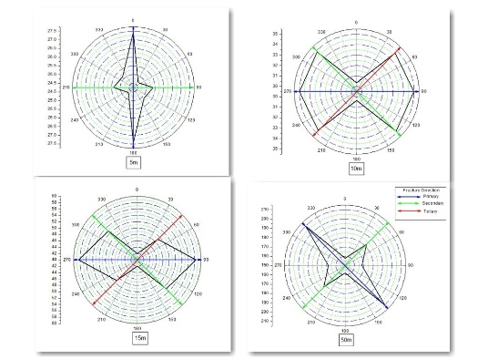
Figure 16: Picture showing polar plots for location 1 – 3.
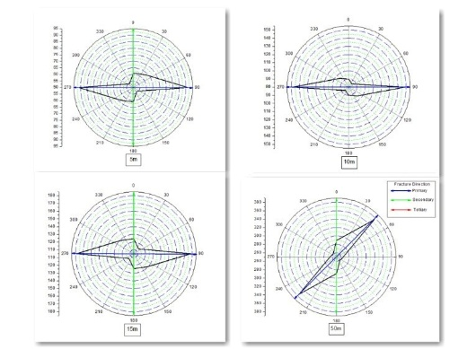
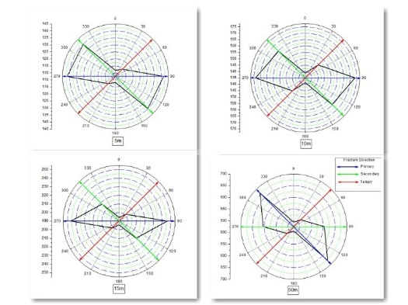
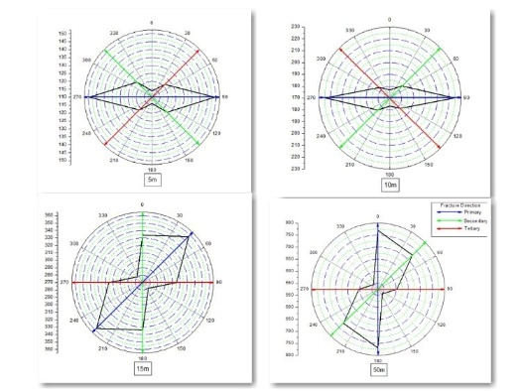
Figure 17: Picture showing polar plots for location 4 - 6.
Figure 18: Picture showing polar plots for location 7 – 9.
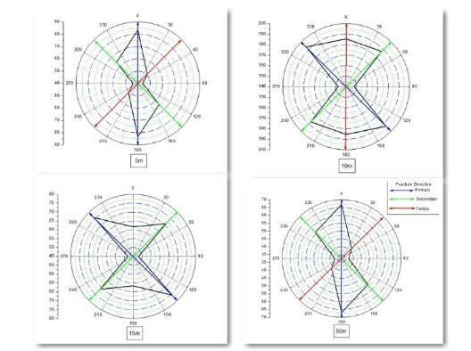
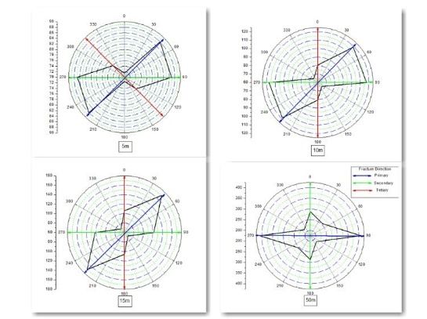
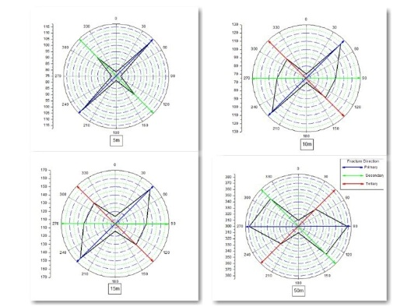
Figure 19: Picture showing polar plots for location 8- 12.
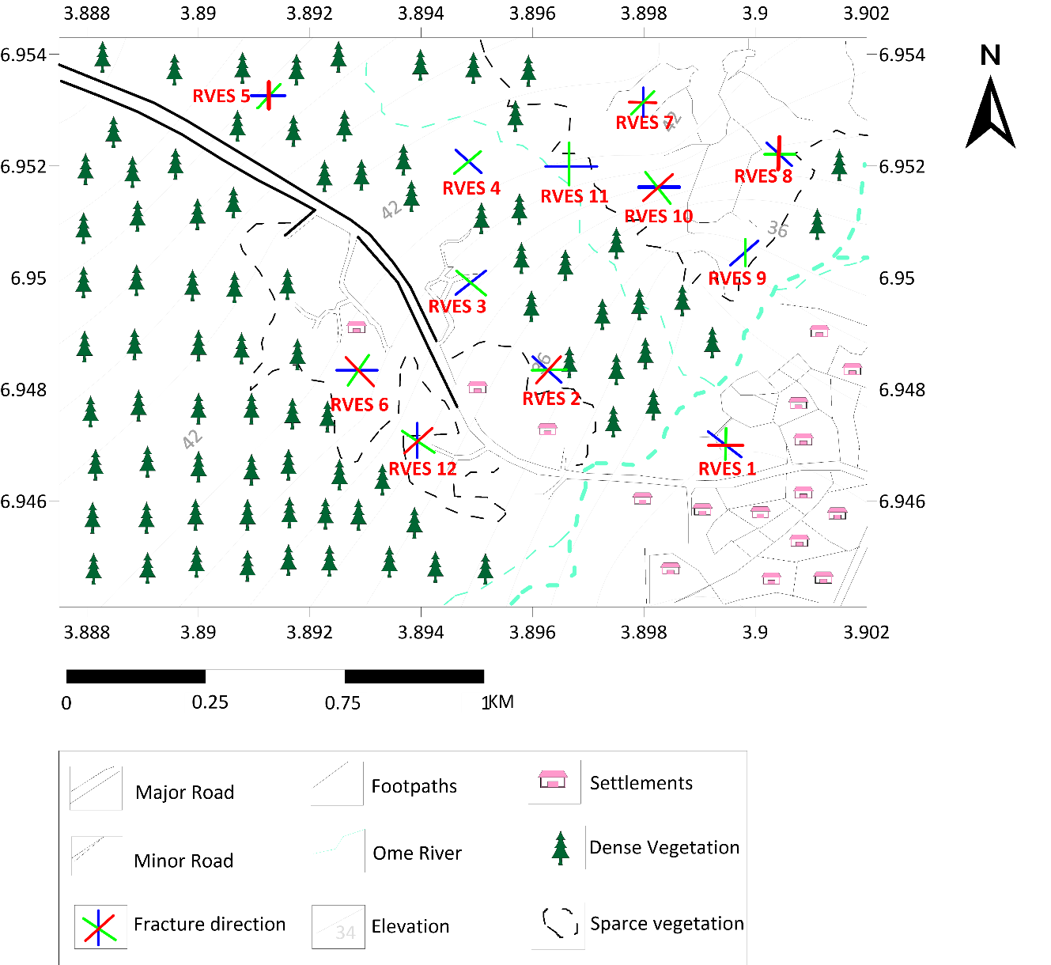
Figure 20: Picture showing the Topo map of the area with fracture direction of each location at
50 m indicated on it.

- DISCUSSIONS
This research was aimed to assess anisotropy in rocks in a step by step approach, also linking it with structural trends to give a proper understanding on interpretation of anisotropic behavior in rocks.
4.1 Mean Apparent resistivity
The results of the mean apparent resistivity suggests that resistivity values increase with depth because the lowest values of resistivity in this study were observed at depths of 4m and 9m, and the highest values were noticed to be at the 50m depth most times. This bears similarity to the thesis by Loke (1999). The results have engineering and hydrogeological implications. The low values of mean apparent resistivity at location 3, 4, 5 indicates that they are good for hydrogeological activity but less suitable for engineering purposes.

4.2 Cartesian azimuthal plots
The analysis of the Cartesian azimuthal graph provides deeper insights to the concept of anisotropy in rocks. The graphs with smooth or close to smooth lines with no prominent peak and trough suggest less fractures, whereas the graphs with prominent peak and trough indicate more fracture (Bayewu et al. 2014). The graphs for locations 3, 6, 11 and 12 suggested the presence of fracture and the troughs were all prominent at depth of 15m, therefore indicating the likelihood of fracture at that depth.
4.3 Coefficient of apparent anisotropy
The greater the value of the coefficient of anisotropy the greater the fracturing in such media (Busby). From the mean coefficient of apparent anisotropy, it suggests that location 3(λ_{a} = 1.53) 6(λ_{a} = 2.10), 11(λ_{a} = 1.75) and 12(λa = 1.69) have the greatest chance of high occurrence of fractures. Thereby agreeing with the results from the Cartesian Azimuthal graph that suggested these same locations to have fractures. The apparent anisotropy graph was interpreted in two ways according to the trend of the graph line and the value range of the coefficient of apparent anisotropy. According to Bayewu et al. Trending inwards implies good support for engineering operations while trending outwards suggests a good support for hydrogeological operations. For better interpretation, the range of the coefficient of apparent anisotropy was put in consideration. This led to the discovery that Location 2, 4, 5, 7, 9 and 10 shows an indication of support engineering activities because of their small range of coefficients of apparent anisotropy and graph line trending inwards. Location 1, 3, 6, 11, 12 shows a likelihood of supporting hydrogeological operations because of the large range of coefficients of apparent anisotropy and graph line trending outwards. It should be noted that this approach is still open to further studies.
4.4 Polar plots
The major or longest axis of the ellipse observed in anisotropy polygons, gives the fracture direction and areas with the presence of two or more interconnected fracture direction and high co-efficient of anisotropy indicates intense Inhomogeneity (Bayewu et al., 2013; Olawuyi, 2022). From the Table The major primary fracture direction was E-W having twenty appearances as a primary fracture direction which was perpendicular to the strike direction of the region, NNW-SSE. This implies that fracture direction is against the direction of the rock’s orientation (Habberjam & Watkins, 1967.).

4.5 Implications for Groundwater Development and Engineering in Southwestern Nigeria
The findings of this study carry significant implications for groundwater resource development in Southwestern Nigeria, a region where crystalline basement rocks constitute the primary lithological unit and where access to potable water remains a persistent developmental challenge. Approximately 60 million Nigerians currently lack access to safe drinking water (WHO/UNICEF, 2023), and basement complex states such as Ogun, Osun, Oyo, Ekiti, Kwara, and Kogi are disproportionately affected due to the low primary porosity of their underlying rocks. In such terrains, groundwater occurrence is almost entirely fracture-controlled, making the identification of productive fracture zones a prerequisite for successful borehole siting. The results of this study demonstrate that RVES is a reliable, non-invasive, and cost-effective tool for detecting such zones prior to drilling. The coefficient of apparent anisotropy (λ_{a}) values obtained for locations 3, 6, 11, and 12 — ranging from 1.53 to 2.10 — indicate significant fracturing at these sites, and the corroborating evidence from the Cartesian azimuthal plots and mean apparent resistivity data strengthens confidence in their hydrogeological potential. Applied at a broader scale, this methodology could substantially reduce the high failure rates of boreholes drilled without prior geophysical investigation, a recurring problem reported across rural communities in Nigeria (Fashae et al., 2014).
Beyond borehole siting, the dominant E-W fracture orientation identified across the study area has direct implications for understanding groundwater flow and recharge dynamics in the region. Surface fractures aligned in this direction facilitate the infiltration of meteoric water, while their subsurface continuity governs the lateral movement of groundwater toward potential discharge zones. This is particularly relevant in the context of Nigeria's changing rainfall patterns; as climate variability increasingly disrupts the reliability of surface water sources, groundwater recharge through fractured basement rock becomes a more critical component of water security. Understanding the geometry of fracture networks — as enabled by RVES — can inform the placement not only of extraction boreholes but also of managed aquifer recharge interventions, which are gaining traction as a climate adaptation strategy in sub-Saharan Africa (Taylor et al., 2013). The finding that fractures trend perpendicular to the NNW-SSE strike direction of the rocks also provides a structural geological insight that could guide regional-scale hydrogeological mapping efforts in the broader Ijebu-Remo transition zone.
- CONCLUSION AND RECOMMENDATIONS
Having discussed the results and its inferred interpretations, a succinct summary of the key findings in relation to the research aim as well as the value and contribution is in order. The limitations of the study and recommendations won’t be left out as they are among the core motives of research. Radial Vertical Electrical Sounding is a distinct method for characterizing fractured rock since it provides information with which parameters can be measured which cannot be obtained from the conventional vertical electrical sounding. Parameters such as the coefficient of apparent resistivity. Using the Schlumberger array for this method is easier compared to the conventional cross-square array. However, this limits the number of the parameters that can be calculated.
From the Results, It was observed that rocks are not entirely homogeneous as each location had a degree of anisotropy only that they differed in their magnitude. It was also observed that resistivity values varied with depth and the lowest values were seen at depth ranging from 6m to 12m while the highest values were noticed at depth of 50m. It was observed that results from the Cartesian azimuth plot and the apparent anisotropy graph seemed to complement and match each other. Cause they both suggested Location 3, 6, 11 and 12 to be good for hydrogeological operations. Indications from the Cartesian azimuthal plot on Location 2, 5, 7, 8, 9, and 10 showed a prospect of the locations supporting engineering activities. However, this is still subject to further geotechnical survey as it is not an absolute discovery. The major fracture directions observed were E-W, NW-SE, NE-SW which shows the fracture line deviating from the N-S orientation of granitic rocks. The E-W direction was the major primary fracture direction which suggests that fractures occur perpendicular to the orientation of the rock. The mean coefficient of anisotropy for each location also supported the correlated indications from the Cartesian azimuthal plots and apparent anisotropy graph with location 3 having a value of 1.53, location 6 having a value of 2.10, location 11 having a value of 1.75 and location 12 having a value of 1.69. These values indicate a relationship between anisotropy and hydrogeological capabilities, the higher the coefficient of anisotropy the better the hydrogeological prospect. Nevertheless, this is not absolute and needs further studies to be proven. To crown it all, the results from the fracture direction somehow suggest that the rosette diagram from the geological field mapping done prior to the research to be correct, with both of them indicating the E-W prominent direction of structures.
This study emphasizes the vital role that Rotating Vertical Electrical Sounding (RVES) plays as a successful, non-invasive geophysical technique for locating productive fracture zones in Southwestern Nigeria's crystalline basement terrain. The use of RVES gives crucial information, such as the coefficient of apparent anisotropy (λ_{a}) and azimuthal orientation, which greatly enhances drill siting success and lowers failure rates because groundwater occurrence in this area is strictly fracture-controlled. Additionally, identifying a prominent E-W fracture trend offers crucial information about structural geology, recharge dynamics, and local groundwater flow. In light of the growing need for managed aquifer recharge treatments to lessen the effects of climate variability on rural water availability in Nigeria, our findings provide a scalable paradigm for improving water security. Additionally, identifying a prominent E-W fracture trend offers crucial information about structural geology, recharge dynamics, and local groundwater flow. In light of the growing need for managed aquifer recharge treatments to lessen the effects of climate variability on rural water availability in Nigeria, our findings provide a scalable paradigm for improving water security.

APPENDIX
Table 1: Table showing the values of mean apparent resistivity rounded to whole numbers for locations 1 - 12.
Location |  | 1 | 2 | 3 | 4 | 5 | 6
AB/2 |  | Mean λ_{a} | Mean λ_{a} | Mean λ_{a} | Mean λ_{a} | Mean λ_{a} | Mean λ_{a}
 | 1 | 252 | 528 | 212 | 102 | 149 | 393
 | 2 | 253 | 323 | 146 | 51 | 228 | 186
 | 3 | 228 | 241 | 77 | 30 | 284 | 104
 | 4 | 195 | 201 | 61 | 24 | 308 | 73
 | 6 | 198 | 168 | 49 | 27 | 311 | 63
 | 9 | 265 | 157 | 49 | 34 | 252 | 86
 | 12 | 346 | 162 | 52 | 41 | 192 | 121
 | 15 | 415 | 177 | 56 | 51 | 148 | 163
 | 20 | 512 | 220 | 62 | 68 | 125 | 219
 | 25 | 606 | 285 | 75 | 83 | 134 | 274
 | 32 | 742 | 368 | 90 | 109 | 185 | 336
 | 40 | 937 | 457 | 117 | 150 | 207 | 410
 | 50 | 1257 | 548 | 159 | 180 | 268 | 521
Location |  | 7 | 8 | 9 | 10 | 11 | 12
AB/2 |  | Mean λ_{a} | Mean λ_{a} | Mean λ_{a} | Mean λ_{a} | Mean λ_{a} | Mean λ_{a}
 | 1 | 122 | 216 | 76 | 96 | 52 | 222
 | 2 | 89 | 146 | 56 | 118 | 59 | 147
 | 3 | 97 | 127 | 51 | 107 | 68 | 98
 | 4 | 111 | 121 | 58 | 96 | 76 | 73
 | 6 | 143 | 133 | 77 | 88 | 85 | 56
 | 9 | 192 | 157 | 105 | 98 | 96 | 50
 | 12 | 255 | 184 | 124 | 120 | 107 | 54
 | 15 | 322 | 215 | 136 | 140 | 117 | 61
 | 20 | 396 | 258 | 158 | 179 | 133 | 73
 | 25 | 472 | 316 | 179 | 231 | 155 | 85
 | 32 | 550 | 385 | 215 | 268 | 199 | 103
 | 40 | 608 | 457 | 247 | 313 | 249 | 130
 | 50 | 662 | 573 | 298 | 348 | 292 | 178
Table 2: Table showing the fracture direction for locations 1 - 8.
 |  | Location 1 |  |  |  | Location 2
 | 5m | 10m | 15m | 50m | 5m | 10m | 15m | 50m
Primary | NW-SE | E-W | E-W | NW-SE | NW-SE | NW-SE | NW-SE | NW-SE
Secondary | NE-SW | NW-SE | N-S | N-S | E-W | E-W | E-W | E-W
Tertiary | - | N-S | - | E-W | NE-SW | N-S | N-S | NE-SW
 |  | Location 3 |  |  |  | Location 4
 | 5m | 10m | 15m | 50m | 5m | 10m | 15m | 50m
Primary | NE-SW | NE-SW | NE-SW | NE-SW | N-S | E-W | E-W | NW-SE
Secondary | NW-SE | NW-SE | NW-SE | NW-SE | E-W | NW-SE | NW-SE | NE-SW
Tertiary | - | - | - | - | - | NE-SW | NE-SW | -
 |  | Location 5 |  |  |  | Location 6
 | 5m | 10m | 15m | 50m | 5m | 10m | 15m | 50m
Primary | E-W | E-W | E-W | E-W | NW-SE | NW-SE | E-W | E-W
Secondary | - | NW-SE | N-S | NE-SW | N-S | E-W | NW-SE | NE-SW
Tertiary | - | - | - | N-S | NE-SW | N-S | NE-SW | NW-SE
 |  | Location 7 |  |  |  | Location 8
 | 5m | 10m | 15m | 50m | 5m | 10m | 15m | 50m
Primary | E-W | N-S | NW-SE | W-E | E-W | E-W | E-W | NW-SE
Secondary | NW-SE | NE-SW | N-S | NE-SW | NW-SE | NE-SW | NW-SE | E-W
Tertiary | NE-SW | NW-SE | E-W | NW-SE | NE-SW | NE-SW | NE-SW | NE-SW

REFERENCES
Akinlabi, I. A., & Onifade, A. A. (2018). Evaluation of Electrical Anisotropy within Ladoke Akintola University of Technology campus Ogbomoso, southwestern Nigeria. Journal of Science Research, 17(1), 7-16.
Bayewu, O. O., Mosuro, G. O., & Oloruntola, M. O. (2013, August). The evaluation of anisotropic properties of parts of Ijebu-Igbo, southwestern, Nigeria, using azimuthal resistivity survey (ARS) method. In Global Meeting Abstracts (pp. 589-593). Society of Exploration Geophysicists
Bayewu, O., Moroof, O. O., Ganiyu, M. O., Folorunso, I. O., & Kolawole, A. U. (2014). Evaluation of resistivity anisotropy of parts of Ijebu Igbo, southwestern, Nigeria using azimuthal resistivity survey (ARS) method. Journal of Geography and Geology; 6(4) ISSN 1916-9779 E-ISSN 1916-9787 Published by Canadian Center of Science and Education. doi:10.5539/jgg.v6n4p140
Bayewu, O. O., Oloruntola, M. O., Mosuro, G. O., Laniyan, T. A., Fatoba, J. O., Folorunso, I. O., Folorunso, I. O., Kolawole, and A.U. Bada, B. T. (2016). Application of cross-square array and resistivity anisotropy for fracture detection in crystalline bedrock. Arabian Journal of Geosciences, 9(4). doi:10.1007/s12517-016-2305-1
Carpenter, P. J. (1997). Use of resistivity and EM techniques to map subsidence fractures in glacial drift. Environmental & Engineering Geoscience, 3(4), 523-536.
Ejepu, J. S., Adebowale, T. A., Abdullahi, D. S., Yusuf, A., & Ochimana, K. (2014). Subsurface Structural Mapping for Groundwater Resource Development of a Part of Tudun-Fulani North-Central Nigeria Using Radial Vertical Electrical Sounding Technique.
Fashae, O. A., Tijani, M. N., Talabi, A. O., & Adedeji, O. I. (2014). Delineation of groundwater potential zones in the crystalline basement terrain of SW-Nigeria: an integrated GIS and remote sensing approach. Applied Water Science, 4(1), 19-38.
Habberjam, G. M., & Watkins, G. E. (1967). The use of a square configuration in resistivity prospecting. Geophysical prospecting, 15(3), 445-467.
Habberjam, G. M. (1975). Apparent resistivity, anisotropy and strike measurements. Geophysical prospecting, 23(2), 211-247.
He, Jiahuan, Tangyan Liu, Long Wen, Tingting He, Min Li, Jin Li, Li Wang, and Xin Yao. 2022. "Numerical Simulation Analysis of Difference from a Radial Resistivity Testing Method for Cylindrical Cores and a Conventional Testing Method" Mathematics 10(16) pp. 2885. doi.org/10.3390/math10162885
Lane Jr, J. W., Haeni, F. P., & Watson, W. M. (1995). Use of a square‐array direct‐current resistivity method to detect fractures in crystalline bedrock in New Hampshire. Groundwater, 33(3), 476-485.
Loke M. H. (1999). Electrical imaging surveys for environmental and engineering studies. A practical guide to 2-D and 3-D surveys. Terraplus Inf., p. 67
Massoud, M. A., Tarhini, A., & Nasr, J. A. (2009). Decentralized approaches to wastewater treatment and management: applicability in developing countries. Journal of environmental management, 90(1), 652-659.
Misra, S., Goswami, D., & Roy, S. (2022). Mineralogy and structures below Deccan Traps: Evidences from scientific drilling in the Koyna seismogenic zone, India. Journal of Earth System Science, 131(3), 149.
Moreira, S. S., Bacellar, L. A. P., & Aranha, P. R. A. (2019). A comparative evaluation of vertical fractures using different azimuthal electrical resistivity survey arrays. Near Surface Geophysics, 17, pp. 345–357. doi:10.1002/nsg.12047
Okpoli, C. C., & Igwe, O. (2013). Electrical Resistivity Anisotropy in Fracture Delineation and Characterization: A Case Study of Iwaro-Ayepe Area, Southwestern Nigeria. The Pacific Journal of Science and Technology, 14(2), 488-497.
Oladunjoye, M. A., Adefehinti, A., & Ganiyu, K. A. O. (2018). Geophysical appraisal of groundwater potential in the crystalline rock of Kishi area, Southwestern Nigeria. Journal of African Earth Sciences. doi:10.1016/j.jafrearsci.2018.11.017
Olasehinde, P. I., & Bayewu, O. O. (2011). Evaluation of electrical resistivity anisotropy in geological mapping: A case study of Odo Ara, West Central Nigeria. African Journal of Environmental Science and Technology, 5(7), 553-566.
Olawuyi, A. K., Fatoye, O. V., Adeyanju, M. A., Oyanameh, O. E., & Arowosafe, K. O. (2022). Fracture Delineation and Characterization for Groundwater Study Using Azimuthal Resistivity Survey: Case Study of Part of University Of Ilorin, Southwestern, Nigeria. Nigerian Journal of Scientific Research, 21(2), 436-445.
Ramadass, G., Alekhya, K. and Udayalaxmi, G. (2020) Detection of subsurface fracture system by Vertical Electrical Soundings (VES) and Radial Vertical Electrical Soundings (RVES) in hard rock terrain- A Case study of Jagtial district, Telangana, India. Earth Science India, v. 13 (I), pp. 1-7. doi.org/10.31870/ESI.13.1.2020.1
Taylor, R. W., & Fleming, A. H. (1988). Characterizing jointed systems by azimuthal resistivity surveys. Groundwater, 26(4), 464-474.
Watson, K. A., & Barker, R. D. (1999). Differentiating anisotropy and lateral effects using azimuthal resistivity offset Wenner soundings. Geophysics, 64(3), 739-745.
Yeboah‐Forson, A., & Whitman, D. (2014). Electrical resistivity characterization of anisotropy in the Biscayne Aquifer. Groundwater, 52(5), 728-736.

