Quantifying Corporate Contributions to National Decarbonisation: The Case of SSE’s Renewable Energy Portfolio and Carbon Emissions Reduction in the United Kingdom (2020 2024)

Abstract
This study investigates the measurable contribution of SSE plc, a major UK renewable energy company, to national carbon emission reduction efforts. Recognising the critical role of private sector actors in achieving the UK’s net zero targets, the research quantifies SSE’s renewable electricity output, estimates the corresponding avoided carbon emissions, and evaluates the company’s alignment with national decarbonisation goals. A quantitative, single case study design was used, drawing on secondary data from company reports and official government sources. Carbon emissions displacement was calculated using the UK Government’s carbon intensity conversion factors.
Between 2020 and 2024, SSE generated approximately 51.8 TWh of renewable electricity contributing 7 8.4% of the UK’s annual renewable generation and helped avoid over 12 million tonnes of CO₂ emissions. This impact stems largely from its offshore wind portfolio, including Dogger Bank and Seagreen, supported by onshore wind and hydroelectric assets. While the findings highlight SSE’s significant role in decarbonisation, limitations include reliance on secondary data and the single company focus, which constrain broader generalisability and analytical depth.
The study recommends future research adopt real time marginal emissions modelling and expand to include comparative multi firm analysis. It also calls for continued government support for private sector renewable investment through stable policy and financial mechanisms.

1. Introduction

The urgency of climate change mitigation has placed unprecedented pressure on national governments, regulators, and private utilities to decarbonise electricity generation. The Intergovernmental Panel on Climate Change (IPCC) warns that global greenhouse gas (GHG) emissions must peak by 2025 and fall by 43% by 2030 to limit warming to 1.5 °C (IPCC, 2022). The power sector, responsible for roughly 40% of global CO₂ emissions, is widely recognised as the linchpin of this transition (IEA, 2023). Rapid technological advances and falling costs for wind and solar energy have created new opportunities for large scale renewable deployment, yet the pace of change must accelerate to meet international climate targets.
The United Kingdom represents a leading case of national energy transformation. Under the legally binding Climate Change Act, the UK has committed to achieving net zero emissions by 2050, supported by interim goals of at least 95% low carbon electricity by 2030 and a fully decarbonised power system by 2035 (Department for Energy Security and Net Zero [DESNZ], 2024). Progress to date has been significant: in 2024, low carbon sources supplied 58% of UK electricity, while the average generation carbon intensity declined to 124 gCO₂/kWh, marking a 70% reduction since 2014 (Carbon Brief, 2025). These achievements reflect a combination of supportive policy mechanisms such as the Contracts for Difference (CfD) scheme and sustained private investment in offshore wind, solar, and emerging clean technologies.
Private sector utilities such as SSE plc are critical to meeting these ambitious targets, yet their specific contributions to national emissions reductions remain under documented. Once renewable electricity enters the grid, electrons cannot be traced to individual generators, complicating firm level attribution of avoided emissions (Greenhouse Gas Management Institute, 2022). Most existing research aggregates emissions and generation data at the national level (Niță et al., 2025), which obscures the measurable role of individual firms in driving decarbonisation. This creates a significant knowledge gap, particularly as corporate actors increasingly disclose climate related metrics under frameworks such as the Task Force on Climate Related Financial Disclosures (TCFD) and the EU Corporate Sustainability Reporting Directive (CSRD).
This study addresses that gap by quantifying SSE’s renewable electricity output and estimating the associated avoided emissions over the period 2020 2024, while situating these results within the UK’s broader renewable energy growth and decarbonisation trajectory. By combining firm level generation data with government conversion factors, the research provides a clearer empirical basis for understanding how private utilities contribute to national climate objectives and offers insights relevant to both policymakers and corporate sustainability strategists.

Literature Review and Theoretical Framework

Historical Context: UK Energy Transition
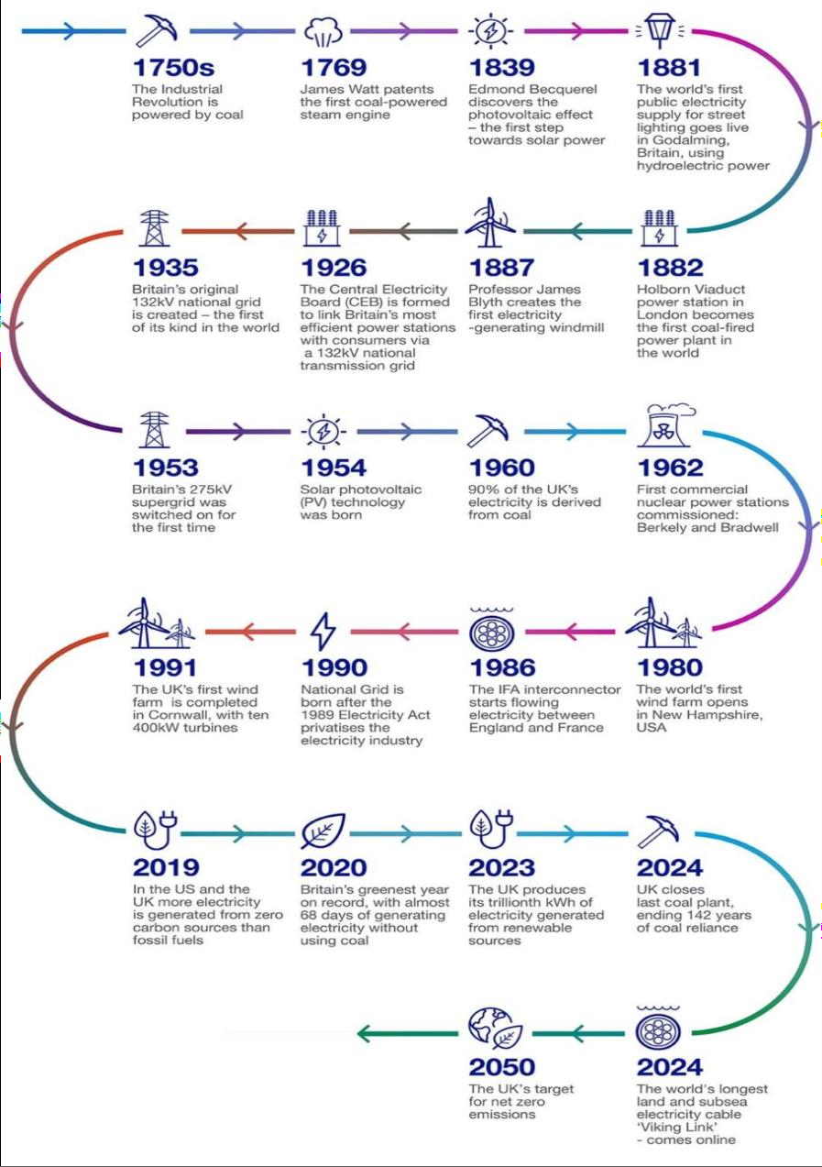
Fig 1: History and evolution of energy in the UK. Source: National Grid, (2024).

Coal once supplied over 90% of UK electricity (National Grid ESO, 2023). The 2008 Climate Change Act and successive carbon budgets initiated a rapid shift: coal generation fell from 142 TWh in 2012 to just 2 TWh in 2023, culminating in the closure of Ratcliffe on Soar, the UK’s last coal plant, in September 2024 (BBC, 2024). Over the same period, renewables expanded from 7% of generation in 2010 to 51% in 2024 (RenewableUK, 2025). The Contracts for Difference (CfD) scheme, grid modernization programs, and the Clean Power 2030 plan underpin the UK’s ambition for a carbon free grid within the decade.

Energy Privatization and Private Sector Contributions to UK Net Zero
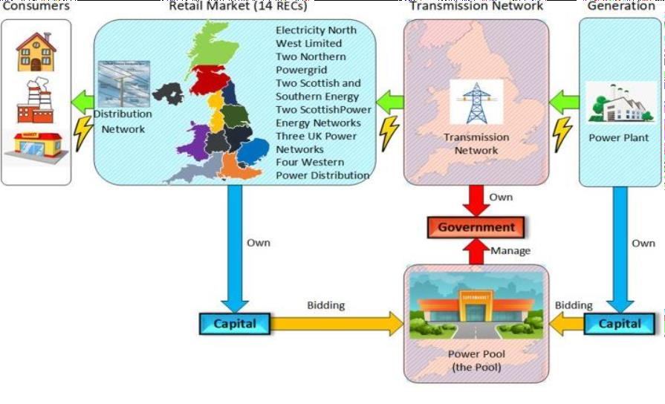
Fig. 2. Structure of the UK electricity industry and electricity trading. Adopted from Liu, et.al., (2022).
The privatization of the UK electricity sector fundamentally reshaped the energy landscape, creating the market architecture that now underpins the country’s decarbonisation efforts. Beginning in the 1980s with the sale of British Gas (1986) and the Central Electricity Generating Board (1990), reforms introduced competitive trading through the Pooling and Settlement Agreement (PSA), which required most large generators to sell electricity through a central market (Grubb & Newbery, 2018; Lin et al., 2017). This shift dismantled the former state monopoly, allowing private capital to enter both generation and distribution while the government retained oversight of the transmission network. Over time, privatization and market liberalisation encouraged private ownership of generation assets and created clear bidding and settlement rules, enabling firms to respond to price signals and invest in low carbon technologies. Although scholars debate whether liberalisation alone guarantees sufficient investment some noting that cheap renewable generation can struggle to yield stable returns without policy support (Siccion, 2024) the policy framework, notably the Contracts for Difference (CfD) mechanism, has helped to stabilise revenues and attract large scale private investment in renewables (Bolton et al., 2016; Spring et al., 2024).
Today, private capital drives the majority of the UK’s low carbon expansion. Since 2010, nearly £200 billion in combined public private funding has flowed into clean energy, with private investors providing the lion’s share (Environmental Audit Committee, 2024). Major utilities including SSE (£12.5 billion), RWE (£15 billion by 2030), Iberdrola (£6 billion in East

Anglia plus £24 billion in new pledges), Ørsted (£12 billion), and EDF (£50 billion by 2035) have announced multibillion pound commitments to UK offshore wind, grid upgrades, and storage infrastructure (Fitch Solutions, 2021; The Guardian, 2024). Innovative players such as Greencoat UK Wind, which now manages 49 wind farms with nearly 2 GW of capacity displacing 2.2 million tonnes of CO₂ annually, and Highview Power, which secured £300 million to build the UK’s first commercial scale liquid air storage plant, further illustrate the breadth of private sector engagement. Beyond carbon reduction, these investments deliver significant socio-economic benefits: between 2023 and 2024, the net zero economy grew by 10.1%, generating £83.1 billion in GVA, supporting 951,000 full time jobs, and creating a wider economic multiplier of £1.89 for every £1 of net zero output (BBC News, 2024). In sum, privatization provided the enabling framework, while private capital, expertise, and innovation now supply the engine of the UK’s drive toward a fully decarbonised power system by 2030 and beyond.

Theoretical Underpinning

The United Kingdom’s renewable energy transition has been driven by a unique combination of market liberalisation, ambitious climate policy, and the growing financial and technical capacity of private sector utilities. Understanding how firms such as SSE plc position themselves within this landscape requires both a strategic and an institutional lens. This section reviews the key theoretical and empirical literature underpinning the analysis, drawing on the Resource Based View (RBV), Public Choice Theory, and the historical evolution of UK energy policy. Together, these perspectives illuminate the interplay between firm level capabilities and the policy environment that shapes investment in low carbon infrastructure.
The Resource Based View (RBV) argues that firms achieve sustained competitive advantage by developing resources that are Valuable, Rare, Inimitable, and Non substitutable (VRIN) (Barney, 1991). Applied to SSE, this framework highlights the company’s ability to mobilise distinctive internal assets in pursuit of the UK’s net zero targets.
    - Valuable: SSE’s engineering expertise and financial scale enable the delivery of capital-intensive projects such as the Dogger Bank (3.6 GW) and Seagreen (1.1 GW) offshore wind farms.
    - Rare: Few UK based competitors combine deep offshore construction experience with the balance sheet strength required to secure multi-billion pound Contracts for Difference (CfD).
    - Inimitable: Decades of grid integration know how, regulatory relationships, and project management capability create barriers that are difficult for new entrants to replicate.
    - Non substitutable: No alternative combination of resources can substitute for SSE’s blend of capital, credibility, and technical expertise in large scale offshore wind deployment.

While RBV provides a compelling explanation for SSE’s ability to expand renewable capacity under uncertain market conditions, critics note that it tends to underplay the role of external policy dependencies (Priem & Butler, 2001). In highly regulated sectors like energy, even firms with VRIN resources depend on supportive policies such as the CfD mechanism and the UK’s Net Zero Strategy to translate internal strengths into realised competitive advantage.
On the other hand, Public Choice Theory (Buchanan & Tullock, 1962; Mueller, 2003) complements RBV by shifting attention from firm resources to the incentives created by policy and regulation. The theory posits that self-interested actors, whether governments or firms, respond rationally to economic incentives, and that privatisation can improve efficiency and innovation when regulation provides clear investment signals. SSE’s strategic decision to divest its retail supply arm and concentrate on renewable generation illustrates this logic: the company has aligned its capital allocation with the UK’s liberalised electricity market and the price stability offered by CfD contracts for low carbon output.
However, Public Choice Theory also attracts criticism for overlooking broader public goods. Scholars such as Stiglitz (1989) caution that market led models may fail to address grid resilience, social equity, or the distributive impacts of large infrastructure projects. These concerns are pertinent to SSE’s current strategy, which prioritises large scale offshore wind over smaller community based renewable schemes. By integrating RBV’s focus on internal capabilities with Public Choice Theory’s emphasis on market incentives, this study captures both the firm level and systemic drivers of SSE’s role in the UK’s energy transition.

3.1 Methodology

This study adopts a quantitative single case research design to examine SSE plc as a leading private developer of renewable energy in the United Kingdom. Guided by a positivist paradigm, the approach emphasises objective, replicable measurement to evaluate the company’s contribution to national decarbonisation efforts. Focusing on a single firm allows for a detailed, context rich analysis of its renewable output and associated avoided emissions while maintaining methodological rigour.
The analysis draws exclusively on secondary data sourced from publicly available and independently verifiable documents. Key datasets include SSE Annual Reports and Sustainability Statements (2020 2024), which provide annual generation figures and project level details; UK government statistics from the Department for Energy Security and Net Zero (DESNZ) and its predecessor BEIS, covering national greenhouse gas emissions, renewable generation, and official GHG conversion factors; and industry reports from organisations such as Ember, Carbon Brief, and PwC, which offer additional context on electricity sector trends and economic impacts. These sources together ensure a comprehensive and reliable evidence base.
Data analysis involved a two step process to quantify SSE’s avoided carbon emissions and market contribution. First, annual renewable electricity output (in GWh) was multiplied by the

UK Government’s combined electricity emission factor (kg CO₂e/kWh) for each corresponding year, using the formula:
Avoided Emissions (tCO₂e)=Renewable Output (kWh)×Emission Factor

Emission factors ranged from 0.22499 kg CO₂e/kWh for 2020 2023 to 0.22535 kg CO₂e/kWh in 2024, reflecting the declining carbon intensity of the UK grid. Second, SSE’s share of national renewable generation was calculated by dividing its annual output by total UK renewable generation. This allowed the company’s performance to be contextualised within the broader national decarbonisation trajectory, linking firm level actions to UK wide progress toward net zero.

Results

  - SSE Renewable Output and Capacity Growth

Table 1 shows SSE renewable ouput and installed capacity

Fiscal Year | Renewable Output  (GWh) | % Change | Installed Capacity (GW)*
2020 | 11,442 |  | 3.8
2021 | 10,242 | ↓ 10.5% | 4.1
2022 | 9,496 | ↓ 7.3% | 4.4
2023 | 10,227 | ↑ 7.7% | 4.8
2024 | 11,158 | ↑ 9.1% | 5.2
*approximate, based on SSE reports.
Output dipped in 2021 2022 due to weak wind conditions but recovered in 2023 2024 as new offshore wind projects, including the 1.1 GW Seagreen farm, entered operation.

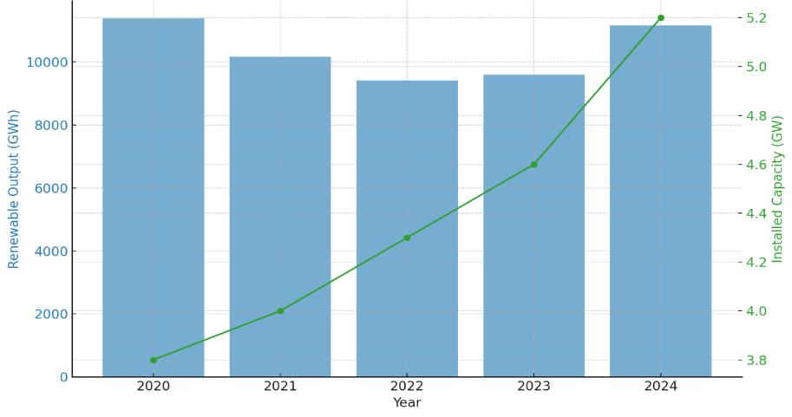

figure 3: SSE renewable output vs installed capacity (2020 2024). Source: SSE, (2024)

Avoided Carbon Emissions

Table 2 shows SSE avoided carbon emissions

Year | SSE Output  (GWh) | Emission Factor (kg  CO₂e/kWh) | Avoided Emissions  (MtCO₂e)
2020 | 11,442 | 0.22499 | 2.57
2021 | 10,242 | 0.22499 | 2.30
2022 | 9,496 | 0.22499 | 2.14
2023 | 10,227 | 0.22499 | 2.30
2024 | 11,158 | 0.22535 | 2.51
Cumulatively, SSE avoided ≈11.8 MtCO₂e from 2020 2024 equivalent to roughly 0.5 0.6% of the UK’s annual territorial emissions (~405 MtCO₂e in 2022).

Contribution to National Renewable Generation

Table 3 shows SSE % share of UK’s national renewable generation

Year | UK Renewable Output  (TWh) | SSE Output (TWh) | SSE Share (%)
2020 | 135.0 | 11.44 | 8.44
2021 | 137.5 | 10.24 | 7.42
2022 | 139.8 | 9.50 | 6.72
2023 | 144.0 | 10.23 | 6.67

2024 | 150.8 | 11.16 | 7.43
SSE consistently contributed 6.7 8.4% of UK renewable electricity, effectively supplying one in every thirteen units of clean power.
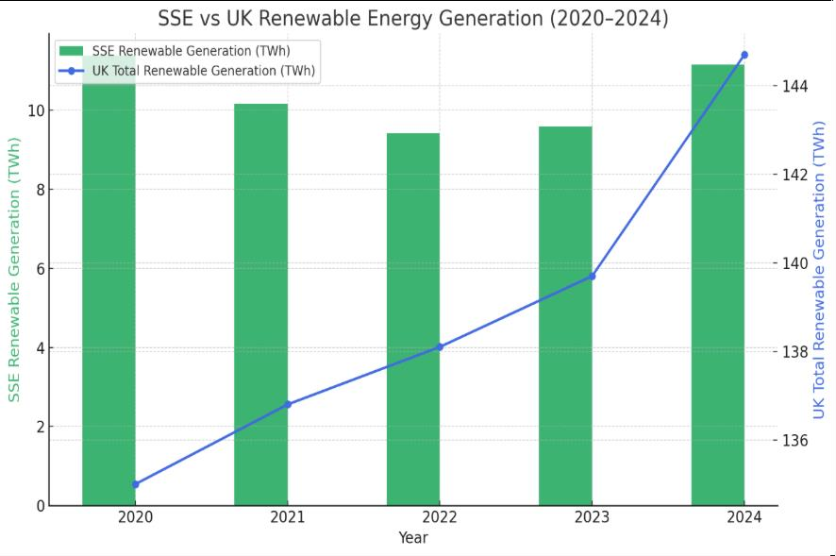
Figure 4: Bar line graph of SSE vs UK Renewable Energy Generation (2020-2025)

Source: Researcher

Between 2020 and 2024, SSE's renewable electricity generation remained steady while the UK's total renewables output gradually increased, with a sharp rise in 2024. SSE’s renewables helped avoid 2.1 to 2.5 MtCO₂e annually, about 0.6% of UK emissions, underscoring its role in national decarbonisation. The company’s projects align with UK policies like the CfD and Capacity Market, supporting clean energy and grid stability. In 2024, SSE generated 11.2 TWh around 1 in every 13 units of UK renewable electricity highlighting its significant sectoral impact.

Discussion

SSE’s renewable electricity output and capacity expanded steadily between 2020 and 2024, supported by both favourable policy frameworks and significant private investment. Installed capacity rose from approximately 3.8 GW in 2020 to 5.2 GW by 2024, a 37% increase in just four years, consistent with SSE’s reported £12.5 billion low carbon investment programme (SSE Annual Report, 2024). Generation volumes fluctuated more modestly, falling from

11,442 GWh in 2020 to 9,496 GWh in 2022 before recovering to 11,158 GWh in 2024. The temporary decline in 2021 2022 was driven largely by unusually weak wind conditions, mirroring national trends: UK onshore and offshore wind generation fell by 15% in 2021 despite capacity growth, due to the lowest average wind speeds in a decade (Carbon Brief, 2022; National Grid ESO, 2023). Recovery in 2023 2024 coincided with the commissioning of the 1.1 GW Seagreen offshore wind farm and upgrades at sites such as Beatrice and Viking, which helped offset weather related variability and set the stage for sustained output growth.
The carbon implications of this generation are substantial. Using UK Government greenhouse gas conversion factors for electricity, SSE’s operations are estimated to have avoided 11.8 million tonnes of CO₂ equivalent (MtCO₂e) over the five year period. Annual avoided emissions ranged from a low of 2.14 MtCO₂e in 2022 to a high of 2.57 MtCO₂e in 2020, reflecting the relationship between generation volume and emissions displacement. For context, the UK’s territorial greenhouse gas emissions stood at 405 MtCO₂e in 2022 (DESNZ, 2023), meaning SSE’s output alone accounted for roughly 0.5 0.6% of the country’s annual emissions reductions. These findings align with national decarbonisation data showing that UK grid carbon intensity fell to 124 gCO₂/kWh in 2024, down 70% from 2014 levels (Carbon Brief, 2025).
SSE also maintained a significant share of the national renewable electricity mix, supplying between 6.7% and 8.4% of UK renewable output during the study period. In 2024, SSE contributed 11.16 TWh of renewable generation against a UK total of 150.8 TWh, equivalent to powering roughly three million homes (DESNZ, 2024). Although SSE’s market share dipped slightly in 2022 as overall UK renewable generation expanded to a record 139.8 TWh (Ember, 2023), it rebounded to 7.43% in 2024, reflecting successful project delivery and capacity expansion.
These results underscore the pivotal role of private utilities in achieving the UK’s legally binding climate targets. SSE’s £24 billion clean energy investment plan through 2030 supports the government’s ambitions of 50 GW offshore wind and 70 GW solar by 2035 (DESNZ, 2024). Empirical evidence from the UK’s Contracts for Difference (CfD) Allocation Round 6 awarding 4.5 GW of low carbon capacity in 2024 with a £1.55 billion budget (UK Government, 2024) confirms that supportive market mechanisms are sustaining large scale private investment. SSE’s performance, therefore, reflects the combined influence of firm specific capabilities and robust policy incentives, demonstrating how private capital and technological expertise can materially advance national decarbonisation while delivering measurable reductions in greenhouse gas emissions.

Conclusion

This study provides one of the first quantitative assessments of a single UK utility’s contribution to national decarbonisation targets. SSE’s renewable generation between 2020 and 2024 displaced an estimated 11.8 MtCO₂e, representing a significant, measurable share of the UK’s power sector emissions reductions. While methodological limitations prevent perfect attribution, the findings demonstrate that private utilities are indispensable actors in achieving the UK’s legally binding net zero goal. Future research should develop marginal emission models and cross firm comparisons to refine corporate carbon avoidance accounting.

References
Barney, J. B. (1991). Firm resources and sustained competitive advantage. Journal of Management, 17(1), 99 120. https://doi.org/10.1177/014920639101700108
BBC News. (2024). UK’s first commercial liquid air storage plant backed by infrastructure bank. Retrieved August 2, 2025, from https://www.bbc.co.uk/news
BBC News. (2024). UK to close last coal power station after 142 years. BBC News. Retrieved August 14, 2025, from https://www.bbc.co.uk/news/articles/c5y35qz73n8o
Bolton, P., Froggatt, A., & Wilsdon, J. (2016). The UK’s Contracts for Difference scheme: Policy overview and assessment. Chatham House.
Carbon Brief. (2024). UK electricity emissions drop by 70% since 2014. https://www.carbonbrief.org
Carbon Brief. (2025). UK electricity carbon intensity falls to historic low in 2024. https://www.carbonbrief.org
Department for Energy Security and Net Zero. (2024). Clean Power 2030 Action Plan [PDF].
GOV.UK. https://www.gov.uk/government/publications/clean power 2030 action plan
Department for Energy Security and Net Zero. (2024). UK Government GHG conversion factors for company reporting: Methodology paper for emission factors 2024. GOV.UK. https://www.gov.uk/government/publications/greenhouse gas reporting conversion factors 2024
DESNZ. (2024). Emissions data to 2023. GOV.UK. https://www.gov.uk
Ember. (2023). European Electricity Review 2023. https://ember climate.org/insights/research/european electricity review 2023
Environmental Audit Committee. (2024). Review of low carbon investment in the UK. UK Parliament. https://www.parliament.uk
Fitch Solutions. (2021). United Kingdom Power Report Q3 2021. Fitch Solutions Group.

Greenhouse Gas Management Institute. (2022). You are not buying green (or really any) electrons. https://ghginstitute.org/2022/07/07/you are not buying green or really any electrons/
Grubb, M., & Newbery, D. (2018). UK Electricity Market Reform and the Energy Transition: Emerging Lessons. The Energy Journal, 39(6), 1 26.
https://doi.org/10.5547/01956574.39.6.mgru
Intergovernmental Panel on Climate Change (IPCC). (2022). Press release: Urgent global emissions reductions required to limit warming to 1.5 °C. IPCC. https://www.ipcc.ch/report/ar6/wg3/
International Energy Agency (IEA). (2023). Electricity market report 2023. IEA.
Lin, J., & Magnago, F. H. (2017). Electricity markets: Theories and applications. John Wiley & Sons.
Liu, J., Wang, J., & Cardinal, J. (2022). Evolution and reform of UK electricity market.
Renewable and Sustainable Energy Reviews, 161, 112317. https://doi.org/10.1016/j.rser.2022.112317
Mueller, D. C. (2003). Public choice III (3rd ed.). Cambridge University Press.
National Grid. (2024). The history of energy in the UK. National Grid. https://www.nationalgrid.com/stories/energy explained/history of energy UK
Niță, A., Muntean, M., & Aardenne, J. (2025). EDGAR v7.0: Fossil CO₂ emissions of all world countries, 2024 report. European Commission, Joint Research Centre.
Priem, R. L., & Butler, J. E. (2001). Is the resource based “view” a useful perspective for strategic management research? Academy of Management Review, 26(1), 22 40.
https://doi.org/10.5465/amr.2001.4011928
RenewableUK. (2025). UK offshore wind capacity and sector statistics. https://www.renewableuk.com
Siccion, T., & Gupta, S. (2024). Private equity flows to UK renewables surpass investment in US. S&P Global Market Intelligence Report.
Spring, M., Preston, J., & Buckingham, W. (2024). Assessing the CfD model: A comparative study of renewable auction schemes. Journal of Energy Policy Studies, 12(2), 135 152.
SSE plc. (2024). Sustainability report 2024: Renewable capacity and economic impacts. SSE plc.
UK Government. (2024). Contracts for Difference Allocation Round 6: Final results. GOV.UK. https://www.gov.uk

