Consumer Preference in Multivendor E-Commerce Marketplaces: An Exploratory Perspective

Rajitha Panthange Dr. Sabina Rachel Harold
Research Scholar Associate Professor
Department of Business Management Department of Business Management
Mahatma Gandhi University, Nalgonda Mahatma Gandhi University, Nalgonda

Email: katarayp@gmail.com Email: venu.sabina@gmail.com

Abstract

E-Commerce Multivendor Marketplaces offer a variety of products to the consumer all sold on a single digital platform; while multivendor e-commerce marketplaces enhance accessibility, variety, and convenience, they also introduce significant complexity into the consumer decision-making process. The consumers often undergo heightened awareness, the benefits offered, many a times become a bane to completing the purchase. Consumers face issues such as information overload, quality validation, trust and most importantly the decision regarding vendor selection from among the many. For the sellers unless they understand and address these issues, acquiring and retention of customers looks grim. This paper brings to the fore an exploratory context regarding consumer preference in vendor selection when buying on e-commerce multivendor marketplaces.

Keywords: Consumer Behaviour Process, E-Commerce, Multivendor Marketplace, Consumer Preference, Consumer Behaviour Determinants

- Introduction

  - Scaling Heights: The E-Commerce Sector

The internet heralded the ecommerce shopping movement, since the first online purchase in 1984 ecommerce has grown astronomically, the present growth rate since can be pegged at 400% in the timespan of 40 years. Figure 1 illustrates the growth of the e-commerce market; presently valued at $6.8 trillion, it is estimated to grow to $8 trillion by the year 2027 [1]. In comparison to some of the larger sectors such as oil and gas, and the manufacturing sector, e-commerce can be said to be an infant sector that has been on an accelerated growth trajectory [2]. The global economy is undergoing a transformation. Through the use of online technologies, all businesses are being transformed into information-based operations. The Internet has broadened the scope of businesses. E-commerce represents a paradigm shift that affects both marketers and customers [3]
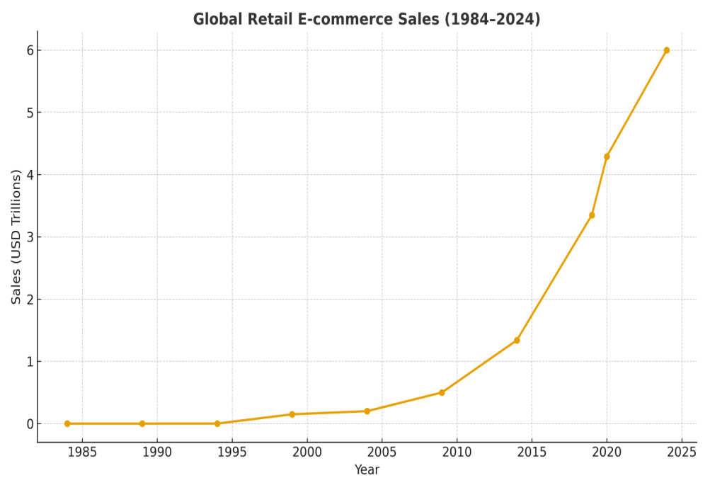

As an industry that contributes significantly to the global GDP growth, ecommerce is a sector to reckon with. The consumers are the driving force in this sector and their behaviour dictates all decisions; right from the website design to the products sold on the website. Every plan made, very strategy implemented are all customer centric. E-commerce represents a rapidly growing share of consumer spending [4]. Therefore, it is not surprising that all the stakeholders in the e-commerce sector are committed to understanding the consumer behaviour process to serve them better [5].

  - Consumer Decision Making in Digital Environment

The consumer decision-making process consists of several stages that individuals experience when acquiring a product or service [6]. The steps are no different from the traditional consumer decision making process. The stages are briefly described below:
- It starts with problem/need recognition – the consumer in this stage is faced with a problem or need that arose, which can be solved through the purchase of a particular product or service [7]
- The next stage is the consideration/information search – this is the stage where the consumers start their quest on search engines, they become information resources. The initial search is regarding availability products (what kind of products will satiate their needs), the consumers then at this stage become aware of brands that can satisfy their need [8].
- The following stage is the alternatives evaluation – this is the stage where comparative analysis takes place, which market places offer better choice in terms of product quality, price and services et al. All the alternatives are evaluated and usually the consumer zeroes in on a few items that have passed the evaluation criteria [9].
- The next stage is a crucial stage where they decide on the purchase – which brand to buy, when to buy, and from whom to buy. This is the stage where many external factors play a role in validating the consumers’ final choice. The external factors that influence the consumers’ decision are many and a few are listed: trust on the e-merchant, e-word of mouth (e-wom), online reviews, influencer ratings etc., [10,11].
- The next two stages are post purchase behaviour, the consumer having bought the product next evaluates the purchases’ worth– is it’s a purchase that adds value then the customer is satisfied as the product meets the customers’ expectations, dissatisfaction results when the product purchased does not meet the customer expectations i.e., the product does not perform as expected [12,13].

  - Rise of Multivendor Marketplaces

A digital platform business can be defined as a two-sided market, which is an environment with supplier and consumer groups that engage in exchanges and transactions [14]. A multivendor marketplace can be thought of as a digital shopping mall, a single digital storefront that offers a plethora of products. It is can be described as an online platform where sellers can register, list and sell their products to consumers all from a single website. Consumers prefer shopping on multivendor websites, this preference can be attributed to the variety that these marketplaces offer along with the convenience of shopping that they offer. Inevitably all consumers tend to compare products in the competitive set, digital marketplaces have altogether eliminated this tedious task of visiting several stores before confirming a purchase. The ease of buying/ convenience is deemed an important reason for the rapid growth of multivendor digital marketplaces.

Multivendor marketplaces are categorised into types based on:
- Product Offerings – product based, services based or hybrid marketplaces
- Target Audience – B2B, B2C, C2C marketplaces
- Business Model – Horizontal marketplaces that offer a variety of products across different categories and Vertical marketplaces that sell products connected to a niche area.
The e-commerce marketplaces offer a win-win advantage to all the stakeholders; the consumers stand to gain benefits in terms of variety and convenience; the vendors gain access to larger customer base and less operational overheads cost meanwhile the platform administrators have the advantage of low inventory risk and scalability. Rather than competing with fixed assets and capabilities, such as a network of stores, the power of multi-sided marketplaces comes from their ability to tap into a large group of end-customers and providers [15].

- Challenges in Multivendor Marketplaces

Multivendor marketplaces present a dual-edged ecosystem wherein consumers benefit from variety and competitive pricing, while simultaneously facing risks related to trust and quality inconsistency, and sellers encounter challenges such as intense competition, platform dependency, and constrained brand differentiation [16].

  - Seller Challenges:
The accessibility to multiple sellers, combined with the convenience of online shopping, represents one of the most significant advantages of multivendor marketplaces. However, this very characteristic—where numerous vendors offer similar or diverse product varieties—intensifies competition among sellers [17]. The online buying process is often marked by increased consumer awareness, with buyers comparing multiple vendors and even identifying alternative products to satisfy their needs.
At the same time, sellers become highly dependent on the platform, as algorithms and policies largely determine product visibility and reach. This dependency makes it difficult for sellers to build a distinct brand identity, especially since marketplaces tend to promote the platform rather than individual brands. Additionally, the requirement to pay commissions and invest in advertising further reduces profit margins. Operational challenges such as logistics and inventory management add to the complexity of selling in such environments.

Reviews, which serve as a critical trust-building cue for consumers, also present challenges, as their authenticity and impact can significantly influence seller performance. Unless these issues are effectively addressed, they may hinder both seller success and the overall buying process within multivendor marketplaces.

  - Consumer Challenges:
While multivendor marketplaces offer convenience and variety, they also present challenges that can hinder the completion of the buying process. While online shopping offers convenience, it removes the opportunity for tangible product evaluation, thereby shifting consumer reliance to seller cues for trust formation and variety may increase the likelihood of finding products that meet consumer needs, excessive options can lead to information overload and make decision-making more difficult. The absence of physical inspection in online marketplaces makes it difficult for consumers to accurately assess product quality, thereby acting as a significant constraint in the buying process. A commonly cited reason for product returns is the mismatch between the received product and its online representation, as descriptions and images may sometimes be misleading. This challenge is further intensified in multivendor environments where multiple sellers offer similar products, making quality validation even more complex. Although return policies partially mitigate this issue, they are not always consumer-friendly and may vary across sellers [18].

In addition, consumers must possess adequate digital literacy to effectively navigate the marketplace. They often experience choice overload due to the abundance of options, as well as the fear of missing out on better alternatives. For products requiring post-purchase services, the terms and conditions are often unclear or not readily accessible, adding to consumer uncertainty. Under such circumstances, selecting a reliable vendor becomes a significant dilemma, complicating the overall purchase decision.

- Purpose and Focus of the Paper
This paper seeks to highlight the complexity of consumer decision-making in multivendor e-commerce marketplaces, where multiple sellers offer identical or closely comparable products. While such platforms enhance convenience, accessibility, and choice, they simultaneously create an environment characterized by information overload, uncertainty, and difficulty in differentiating between vendors. In this context, the traditional product-centric basis of decision-making is significantly altered.

The paper emphasizes that, in the absence of physical product evaluation and clear differentiation, consumers increasingly rely on a range of marketplace cues—such as seller ratings, reviews, pricing signals, product representation, and platform-mediated indicators—to make purchase decisions. It proposes that these cues act as substitutes for direct validation and play a critical role in shaping consumer preference.

Further, the paper aims to draw attention to the dynamic interplay between consumer behavior and seller strategies within such marketplaces. It highlights how consumers actively engage in comparison and search for alternatives, while sellers attempt to signal credibility and build trust in a highly competitive and algorithm-driven environment.

Overall, the paper proposes to underscore the need to identify and understand the key determinants that influence consumer choice of vendors in multivendor settings. By bringing these factors into focus, the study contributes to a better understanding of how purchase decisions are formed in digital marketplaces and how both sellers and platforms can respond to reduce consumer uncertainty and improve decision outcomes.

- Towards Understanding Consumer Preference in Multivendor Marketplaces
The preceding discussion highlights that while multivendor e-commerce marketplaces enhance accessibility, variety, and convenience, they also introduce significant complexity into the consumer decision-making process. Unlike traditional retail environments, where product evaluation is often tangible and seller differentiation is clearer, online marketplaces present consumers with multiple vendors offering identical or highly similar products. This intensifies the challenge of vendor selection and shifts the basis of decision-making from product attributes to the cues available within the digital environment.

In such contexts, consumers are required to navigate through an abundance of information, evaluate competing seller signals, and often engage in continuous comparison and search for alternatives within the platform. The absence of physical validation, coupled with variability in seller credibility, delivery performance, and post-purchase services, further complicates the process. As a result, decision-making becomes increasingly dependent on indirect indicators such as ratings, reviews, pricing, and platform-mediated signals.

At the same time, sellers operate in a highly competitive environment where differentiation is difficult, and visibility is largely governed by platform algorithms and policies. This creates a situation where both consumers and sellers rely heavily on digital cues, yet the effectiveness and interpretation of these cues remain uncertain.

Given these dynamics, a critical issue emerges: what determines consumer preference when selecting a vendor among many offering similar products in a multivendor marketplace? Understanding these determinants is essential, as it not only influences purchase decisions but also affects consumer trust, satisfaction, and overall marketplace efficiency. This underscores the need for focused inquiry into the factors that shape consumer choice in such environments, particularly in the presence of multiple alternatives and competing seller signals.

References
- Global ecommerce Sales Growth (2022–2028) [Updated Oct 2024]. (n.d.). Oberlo. https://www.oberlo.com/statistics/global-ecommerce-sales-growth
- E-commerce Market Size and Share | Industry Report, 2033. (n.d.). https://www.grandviewresearch.com/industry-analysis/e-commerce-market#:~:text=E%2Dcommerce%20Market%20Summary,of%20the%20e%2Dcommerce%20industry.
- Vyas, S. K., Vyas, L., Singh, S., & Joshi, M. (2023). Future of E-Commerce: A Robust Review. Lecture Notes in Networks and Systems, 697–710. https://doi.org/10.1007/978-981-19-7663-6_66
- Dolfen, P., Einav, L., Klenow, P. J., Klopack, B., Levin, J. D., Levin, L., & Best, W. (2022). Assessing the Gains from E-Commerce. American Economic Journal Macroeconomics, 15(1), 342–370. https://doi.org/10.1257/mac.20210049
- Vo, T. H. G., Cho, J., Le, K. H., & Luong, D. B. (2022). Establishing customer behavior through E-Commerce websites in newly emerging market. Marketing and Management of Innovations, 13(4), 85–93. https://doi.org/10.21272/mmi.2022.4-09
- Giang, J. (2024, October 22). The importance of Consumer Decision-Making Process for businesses. Trustify Review. https://trustifyreview.app/consumer-decision-making-process/
- Mihajlovic, M., Savic, A., & Sarcevic, V. (2025). Stages in the Consumer Buying Decision-Making Process. MEST Journal, 13(2), 166–176. https://doi.org/10.12709/mest.13.13.02.14
- Goodman, M. (2024, September 12). Consumer Decision-Making Process: The 5 key stages. Okendo. https://okendo.io/resources/blog/consumer-decision-making-process/#:~:text=This%20guide%20will%20dive%20into,%2C%20and%20post%2Dpurchase%20decision.
- Oly Mishra. (2018). Criteria For Evaluation of Alternatives in Online Consumer Decision Making Process. ELK Asia Pacific Journal of Marketing and Retail Management, 9(4). https://doi.org/10.31511/eapjmrm.2018v09i04005
- Chevalier, J. A., & Mayzlin, D. (2006). The Effect of Word of Mouth on Sales: Online book reviews. Journal of Marketing Research, 43(3), 345–354. https://doi.org/10.1509/jmkr.43.3.345
- Loop | the operations platform built for retention. (n.d.). Loop. https://www.loopreturns.com/blog/post-purchase-evaluation-in-buyers-journey/
- Graff, J., Sophonthummapharn, K., & Parida, V. (2012). Post-purchase cognitive dissonance evidence from the mobile phone market. International Journal of Technology Marketing, 7(1), 32. https://doi.org/10.1504/ijtmkt.2012.046433
- Li, Z. (2022). Research on the post-purchase behaviour tendency of the product quality to customers in fast-selling marketing. Applied Mathematics and Nonlinear Sciences, 8(1), 2639–2652. https://doi.org/10.2478/amns.2021.2.00244
- Kim, J. (2018b). Market entry strategy for a digital platform provider. Baltic Journal of Management, 13(3), 390–406. https://doi.org/10.1108/bjm-07-2017-0228.
- Gawer, A., & Cusumano, M. A. (2013). Industry platforms and ecosystem innovation. Journal of Product Innovation Management, 31(3), 417–433. https://doi.org/10.1111/jpim.12105
- Gupta, S., Kushwaha, P., Badhera, U., Chatterjee, P., & Gonzalez, E. D. S. (2023). Identification of benefits, challenges, and pathways in E-commerce industries: An integrated two-phase decision-making model. Sustainable Operations and Computers, 4, 200–218. https://doi.org/10.1016/j.susoc.2023.08.005
- Cui, S. (2025). Increased (Platform) competition reduces (Seller) competition. Journal of Industrial Economics, 73(2), 285–315. https://doi.org/10.1111/joie.12409
- Waqas, M., Rafiq, S., & Wu, J. (2023). Online Shopping: A Systematic review of customers’ perceived benefits and challenges during COVID-19 Pandemic. Global Knowledge Memory and Communication, 74(7–8), 2655–2679. https://doi.org/10.1108/gkmc-04-2023-0129

