Mathematical modeling of Unsteady MHD convective flow through a porous medium with chemical reactions

Abstract :The unsteady magnetohydrodynamic (MHD) free convective oscillating ﬂow of an optically thin incompressible viscous ﬂuid embedded in two parallel porous walls under the inﬂuence of an externally applied transverse magnetic ﬁeld with a chemical reaction. Rotating disks involving chemical reactions find extensive applications in the medical field, particularly in optimizing chemical processes for controlled drug delivery systems, thereby improving precision in therapeutic treatments. In this study, we elucidate the behavior of fluid flow over a rotating disk with Casson ternary hybrid nanofluid with incorporation of chemical reactions. Subsequently, the bvp4c solver in MATLAB is utilized to numerically solve the set of non-linear ordinary differential equations describing the boundary value problem. Overall, these results offer valuable insights into optimizing heat and mass transfer in engineering systems involving non-Newtonian nanofluids under chemical reaction environments.
Key words : MHD, Porous medium, Chemical reaction, Heat transfer, Mass transfer
1.Introduction.
The MHD free convective ﬂows occurred recurrently in natural world. The functions of MHD incompressible viscous ﬂows in sciences and engineering connecting heat transport under the inﬂuence of chemical reacting are of enormous signiﬁcance to lot of regions of science and engineering streams. These commonly occurred in the petro-chemical industries, power and cooling system, chemical vapor deposition on surfaces, freezing of nuclear reactor, temperature exchangers designing, forest ﬁring mechanics, geophysical and MHD power generations system. The systematic solutions for the unsteady free central heating ﬂow through porous medium and had been examined by Magyari et al.[1] Hossain et al.[2] explored the effects on MHD mixed heat and mass transport on natural central heating commence porous surface ﬁxed into a ﬂuid saturate porous medium. Mazumdar and Deka[3] discussed the MHD ﬂow past the impulsively enchanting consign of an inﬁn- itely vertical plate in the occurrences of thermal radiation. Sharma et al.[4] and Mahapatra et al.[5] examined the con- sequences of chemical reacting for free convection ﬂow past a porous medium enclosed over the perpendicular surface. Rajesekhar et al.,[6] Kishan and Srinivas,[7] Anjalidevi and David[8] explored the consequences of an assortment of variables on ﬂuid ﬂow quantity.
Rotational fluid dynamics in industrial applications is a vast field that encompasses various studies and practical implications. The importance of these dynamics extends to medical applications, such as blood flow within spinning devices like artificial hearts or centrifugation operations in diagnostic laboratories [9]. Moreover, the application of CFD in studying the effects of Casson fluid, a non-Newtonian fluid model often used to represent blood, has been a subject of research, particularly in the context of chemical reactions and oscillating flow effects [10]. Casson fluid is particularly valuable for modeling non-Newtonian fluidssuch as blood due to its precision in representing blood’s rheological properties essential for comprehensive studies on blood flow in diverse conditions and diseases [11,12,13]. In the medical field, understanding homogeneous and heterogeneous reactions in Casson fluid is crucial for modeling biological processes where reactions are distributed uniformly, such as chemical reactions within the bloodstream or cellular activities. Thus, the present study explicates transport phenomena over a rotating disk using a novel non-Newtonian fluid called Casson fluid paired with homogeneous and heterogeneous reactions.
Sahoo and Nand-keolyar [14], Ragupathi et al. [15], Ahmed et al. [16], Ramzan et al. [17] have shed light on key outcomes that focus on Casson fluid flow with chemical processes. The study’s conclusion highlights pronounced effectiveness of homogeneous and heterogeneous chemical reaction parameters in diminishing concentration distribution and alter the fluid’s properties, such as viscosity and thermal conductivity affect-ing the velocity and temperature profiles. These papers collectively demonstrate that the behavior of Casson nanofluids in rotating disk systems is highly sensitive to autocatalytic, thermal, and rotational effects. These insights are essential for advanced thermal management and bioengineering applications Evidently, homogeneous and heteroge-neous reactions occurring in the fluid flow over rotating disks have the potential to enhance system entropy optimization, thereby contributing to increased efficiency and lowered energy consumption in diverse industrial processes.
In addition to being involved in a number of issues, there are a lot of signiﬁcant proﬁts. Many materials are utilized for machinery, hydro-energy, medicine equip- ments, and states of the arts facility because of those capabilities. The physical applications of atmospheric substances and engineering promote the study of changes in the oceanographically science. As well as, its applications have been grown into the food industries, chemical engineering, ﬁltrations system, and machinery science. In the situation at speed and velocities speciﬁc to the earth which will rotate in relation to each axis. Knowledge of the land scope and the latter have been become an essential part since of those interests and com- mitments to those surrounding. As a further study of astronomy is concerning, the study of physical science has became progressively more imperative as it caught be studied in ﬂuids and the solar material, intermolecular and intra-molecular solar beams, etc. These detect bias MHD generators and electrical motors for input and outputs. Here, they have some signiﬁcant engineering and geological features of the canal from the planets, water study and waterways, and to study usual gases, oils and water situations by oils ﬁeld and oils technology. The practice of diving in the last dungeon is exciting to both science and technology to ﬁnd out that reveals the correct kinds of situations are a most important and difﬁ- cult for resolving fragmentary water problems. Despite the revelations expressed by most, here is the immense deal of evidences that is not tolerates depending on those subjects matter and the other critical issues. Through everyone on the top of study, the united conse- quence of radiation and chemical reaction on the MHD convective heat transfer ﬂow had not been considered as at the similar time. A moment ago, Krishna and Chamkha,[18] Krishna et al.,[19] and Krishna and Chamkha[20] explored the MHD ﬂow through porous medium in planar ducts/channels. The inﬂuence of thermal radiating, Hall and ions slip consequences on an unsteady MHD free convection revolving ﬂow of Jeffrey liquids over the unbounded perpendicular porous plate by the ramped wall temperature have been explored by Krishna.[21] Krishna[22] discussed the radiating absorp- tion, chemically reacting consequences on MHD com- bined convection ﬂows past the partially unbounded moving porous surfaces.
2.Mathematical formulation of the problem
We considered the unsteady MHD free convective oscillating flow of an optically thin incompressible viscous fluid embedded in two parallel porous walls under the influence of an external applied transverse magnetic field with chemical reaction, radiative heat flux, and heat absorption. The physical modeling of the investigation is displayed in Figure I. This is assumed that the fluid has tiny electrical conductivity and the electromagnetic forces created and is too small, so that it is neglected the induced magnetic field.
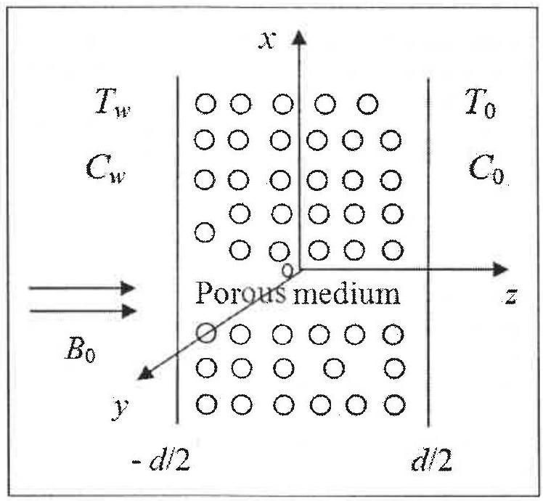
Figure I. Physical configuration of the problem.
$\frac{∂w}{∂z}=0, \frac{∂u}{∂t}+w\frac{∂u}{∂z}=-\frac{1}{ρ}\frac{∂p}{∂x}+ν\frac{∂^{2}u}{∂z^{2}}-\frac{σB_{0}^{2}u}{ρ}-\frac{ν}{k}u +gβ\left(T-T_{0}\right)+gβ^{*}\left(C-C_{0}\right) \frac{∂v}{∂t}+w\frac{∂v}{∂z}=ν\frac{∂^{2}v}{∂z^{2}}-\frac{σB_{0}^{2}}{ρ}v-\frac{ν}{k}v \frac{∂T}{∂t}+w\frac{∂T}{∂z}=\frac{k_{1}}{ρC_{p}}\frac{∂^{2}T}{∂z^{2}}+\frac{Q_{0}T}{ρC_{p}}-\frac{1}{ρC_{p}}\frac{∂q_{r}}{∂z} \frac{∂C}{∂t}+w\frac{∂C}{∂y}=D\frac{∂^{2}C}{∂z^{2}}-KrC$ (1-5)
The initial and boundary conditions are
$u=0,v=0,T=0,C=0 for all z and t≤0 u=0,v=0,T=0,C=0 at z=-\frac{d}{2} u=0,v=0,T=T_{0}+\left(T_{w}-T_{0}\right)cos⁡ωt,C =C_{0}+\left(C_{w}-C_{0}\right)cos⁡ωt at z=\frac{d}{2}$ (6-8)
Combining the equations (2) - (3), let $q=u+iv$, it is achieved as,
$\frac{∂q}{∂t}+w\frac{∂q}{∂z}=-\frac{1}{ρ}\frac{∂p}{∂x}+ν\frac{∂^{2}q}{∂z^{2}}-\left(\frac{σB_{0}^{2}}{ρ}+\frac{ν}{k}\right)q+gβ \left(T-T_{0}\right)+gβ^{*}\left(C-C_{0}\right)$ (9)
Consequently, this is contained that, the fluid is optically thick by comparatively minute density. The radiative heat flux is given by
$\frac{∂q_{r}}{∂z}=4x^{2}\left(T-T_{0}\right)$ (10)
Where $α$ is the radiating absorption coefficient.
The periodical pressure gradient as,
$-\frac{1∂p}{ρ∂x}=Pcos⁡ωt$ (11)
Integrating the equation of continuity (1), it is obtained as,
$w^{'}=w_{0}$ (12)
We are introducing the non-dimensional variables as
$x^{*} =\frac{x}{d},z^{*}=\frac{z}{d},ξ^{*}=\frac{ξ}{d},q^{*}=\frac{q}{w_{0}},θ=\frac{T-T_{0}}{T_{w}-T_{0}},ϕ =\frac{C-C_{0}}{C_{w}-C_{0}},t^{*}=ωt,ω^{*}=\frac{ωd^{2}}{ν},p^{*}=\frac{p}{ρw_{0}^{2}}.$
Substituting the non-dimensional variables in the equations (4), (5), and (9), we get
$ω\frac{∂q}{∂t}+λ\frac{∂q}{∂z}=-λ\frac{∂p}{∂x}+\frac{∂^{2}q}{∂z^{2}}-\left(M^{2}+\frac{1}{K}\right)q +Gr⁡θ+Gm⁡ϕ ω\frac{∂θ}{∂t}+λ\frac{∂θ}{∂z}=\frac{1}{Pr}\frac{∂^{2}θ}{∂z^{2}}-\frac{1}{Pr}\left(N^{2}-Q\right)θ ω\frac{∂ϕ}{∂t}+λ\frac{∂ϕ}{∂z}=\frac{1}{Sc}\frac{∂^{2}ϕ}{∂z^{2}}-Kc⁡ϕ$ (13-15)
The initial and boundary conditions are,
$u=0,v=0,θ=0,ϕ=0 for all z and t≤0$ (16)
$u=0,v=0,θ=0,ϕ=0, for t>0, at z=-\frac{1}{2} u=0,v=0,θ=cos⁡t,ϕ=cos⁡t, for t>0 at z=\frac{1}{2}$ (17-18)
"Where, $M^{2}=\frac{σB_{0}^{2}d^{2}}{μ}$ Hartmann number, $K=\frac{k}{d^{2}}$ permeability parameter, $λ=\frac{w_{0}d}{ν}$ suction parameter, $Gr=\frac{gβd^{2}\left(T-T_{0}\right)}{νw_{0}}$ thermal Grashofs number, $Gm=\frac{gβ^{*}d^{2}\left(C-C_{0}\right)}{νw_{0}}$ mass Grashofs number, $Kc=\frac{d^{2}Kr}{ν}$ chemical reaction parameter, $Sc=\frac{ν}{D}$ Schmidt number, $Q=\frac{Q_{0}d^{2}}{k_{1}}$ heat absorption parameter, $Pr=\frac{μc_{p}}{k_{1}}$ Prandtl number, $N=\frac{2αd}{\sqrt{k_{1}}}$ radiation parameter." The system of Eqns. (13) to (15) together with initially along with frontier conditions (16)-(18) are resolved by utilizing Laplace Transform technique. The transformed solutions are
$q‾=a_{25}e^{m_{5}z}+a_{24}e^{m_{6}z}+a_{13}+a_{14}e^{m_{3}z} +a_{15}e^{m_{4}z}+a_{16}e^{m_{1}z}+a_{17}e^{m_{1}z} θ‾=a_{9}\left(\frac{s}{s^{2}+1}\right)e^{m_{3}z}+a_{10}\left(\frac{s}{s^{2}+1}\right)e^{m_{4}z} ϕ‾=a_{11}\left(\frac{s}{s^{2}+1}\right)e^{m_{1}z}+a_{12}\left(\frac{s}{s^{2}+1}\right)e^{m_{1}z}$ (19-21)
"Implement the inverse Laplace transformations for the equations (19), (20) and (21), happens to unwieldy as of the existence of both the multiple poles and branch points. These integrals are willing to the solutions by means of asymptotic approximations. It is obtained the velocity, temperature and concentration distributions respectively. For engineering interest, it is obtained that the skinfriction, Nusselts number and Sherwood number near the left side plate as well as right side plate as,"
$τ=\left(\frac{∂q}{∂z}\right),Nu=\left(\frac{∂θ}{∂z}\right), and Sh=\left(\frac{∂ϕ}{∂z}\right)$ (22)
3.Results and discussion
The heat generating and/or absorption as well as thermo-diffusion on the unsteady free convection MHD gyrating flow of radiation and chemical reactive second order fluid past an unbounded perpendicular plate during absorbent medium have been discussed. The analytical solutions for the governing equations are found by utilization of Laplace transformation methodology. The velocity, temperature and concentration profiles are analyzed with some graphical profiles. It is represented the , temperature and concentration distributions for quite a few quantities of permeability parameter K, magnetic field parameter M, chemical reaction parameter Kr, are described in Figs. 1–7. For computational purpose we are fixing M = 0.5, K = 0.5, Pr = 0.71, R = 2, Gr = 10,Gm =5, Sr = 0.1, H = 2, α = 0.5, t = 0.5 and drawn the profiles being each parameter varied over the range. From Figs. 1–7, it is depicted that, concentration, temperature and velocity profiles are lessen in case of ramped wall temperature with ramped surface concentration than that of isothermal temperature with ramped surface concentration.Figs. 1 and 2 has been shown that, the intensity of the magnetic field has reducing effects on velocity profiles for together heated circumstances. It is anticipated to the information that, the representing ofmagnetic domain parameter produces electrical field in the liquid flow.
This implied that, the magnetic field has reducing effect for together ramped wall temperature with ramped surface concentration as well as isothermal temperature with ramped surface concentration. It is expected to the information that, the application of the magnetic field to
fluid give augment to the resistive model forces (Lorentz forces) on the fluid in the boundary layers, this slow down the movement of the fluid. From Figs. 3 and 4, it is depicted that the variation of the velocity component with respected to the permeability parameter K. Mutually the velocity components u and v are enhancing by an escalating into the permeability parameters K. Therefore, an augmentation in the permeability of porous medium lead to mounts throughout the fluid flow region. Inferior the permeability lower the fluid velocity is displayed in entire liquid expanse. These results are also used in petroleum extraction process from crude oil in petroleum engineering. The thicknesses of the boundary layers increase when the permeability parameter increases throughout the fluid region.together thermal case as displayed into Fig. 5 as well as 6. It has been shown that, the destructive reactions Kr > 0 led to falls in the velocity field this in turn deteriorates the buoyancy impacts owing into the concentration gradient. Subsequently, the flow field is retarding. These incidences have the higher conformity by the physical reality.The chemical reactions have a reducing influences on liquid flow velocity and concentration profiles for together thermal case as displayed into Fig. 7. This has been shown that, the destructive reactions Kr > 0 led to falls into the concentration field this in turn deteriorates the buoyant forces impacts owing to concentration gradient. Subsequently, the flows domain is reduced. These occurrences have a superior conformity with
the physically realities.
The variations of the shear stress, Nusselt numbers and Sherwood numbers are determined in Tables 1–3 for different quantities of the governing parameters. This is scrutinized from Table 1 that, it is notified that, for together ramped wall temperature and isothermal plate, the stress components τx as well as τy enhances by an increasing in second graded fluid parameter α, chemical reacting parameter Kr, temperature generations and/or absorptions H and thermal radiation parameter R, as well as it reduces by an increasing in the permeability parameter K,thermal-diffusion (Soret) parameters Sr, thermal Grashof numbers Gr and mass Grashof quantity Gm. This is also found that by an increasing in the intensity of the magnetic fields then the stress components τx retards and the component τy boosting up for together ramped wall and isothermal plate. Table 2 illustrated the consequences of Pr, temperature generating and/or absorbing parameter H and radiating parameter R on Nusselt number. The Nusselt number Nu augment with an enhancing in Prandtl number Pr and temperature generating and/or absorbing parameter H and it retards with an increasing in radiating parameter R for together ramped wall temperature in addition to isothermal plate. Nusselt number is enhancing for ramped wall temperature in addition to it trim downs for an isothermal plate with an increasing in time. Finally, the Sherwood number Sh is reduced with an increasing in the Soret number Sr as well as Schmidt number, and it is increasing with an increasing in chemically reacting parameter Kr and certain instant of time for together ramped wall temperature and an isothermal plate(Table 3).
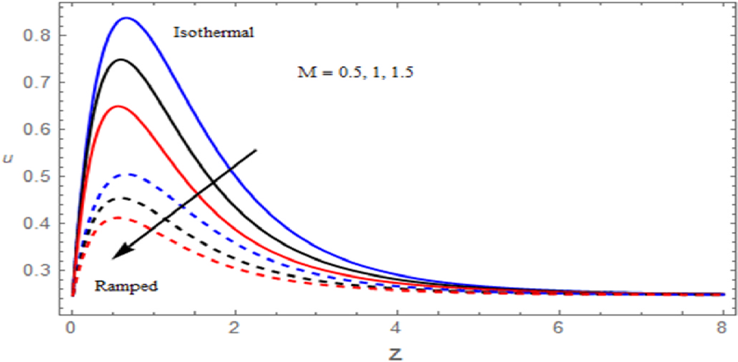
Fig.1. The Velocity profile for u against M
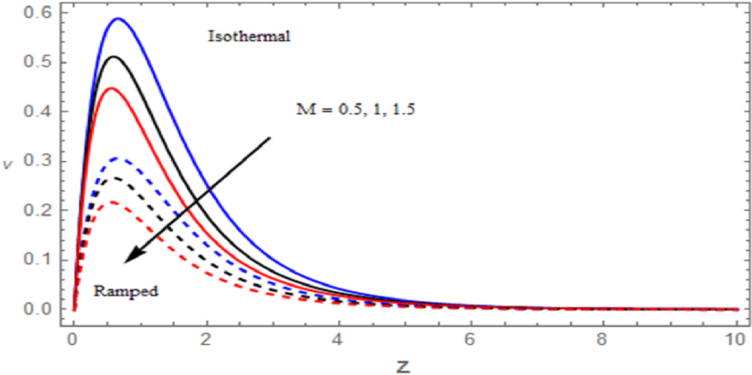
Fig.2. The Velocity profile for v against M

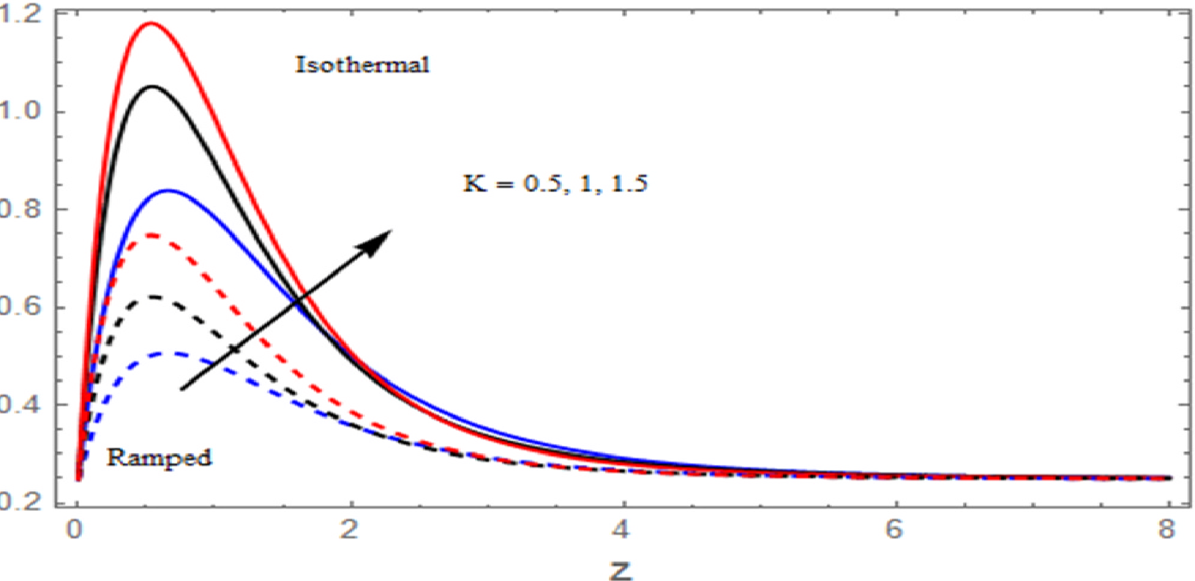
Fig.3. The Velocity profile for u against K
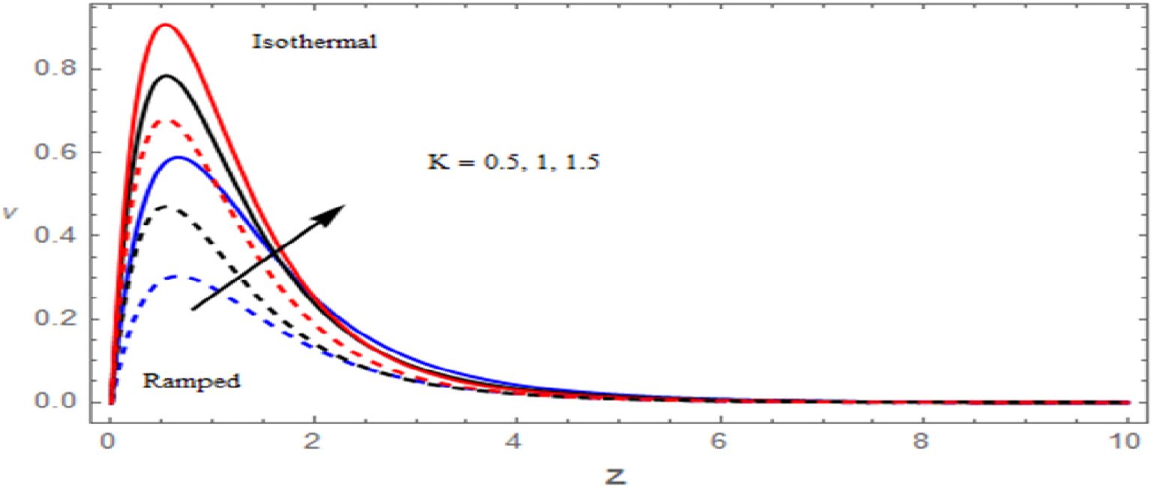
Fig.4. The Velocity profile for v against K
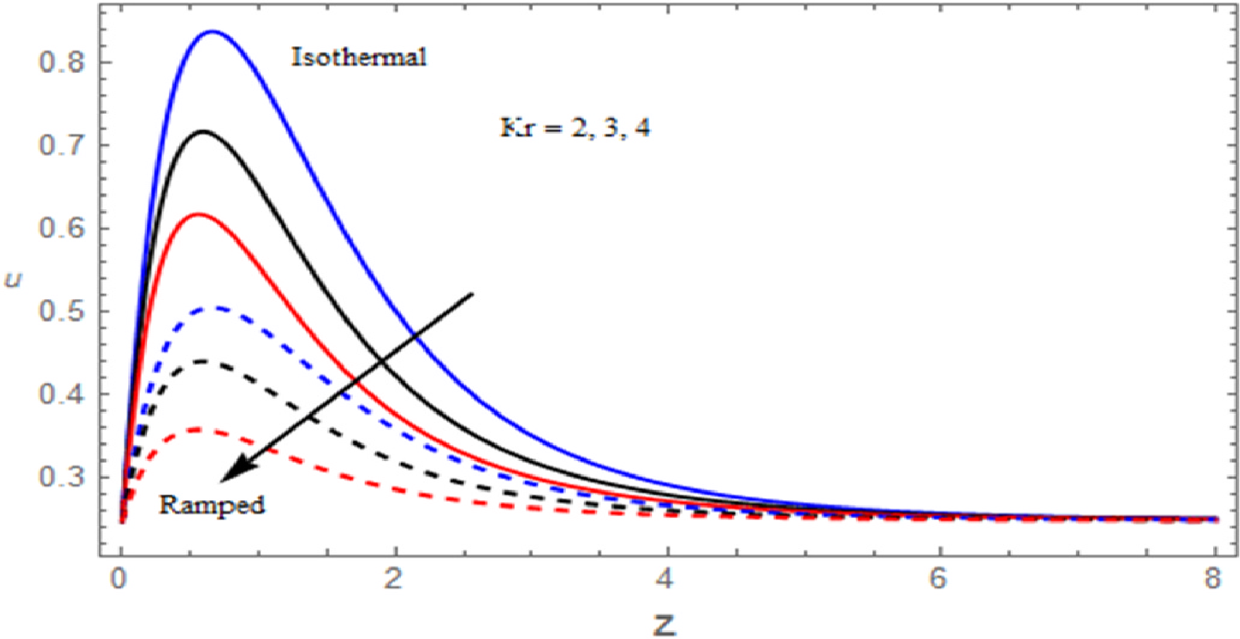
Fig.5. The Velocity profile for u against Kr
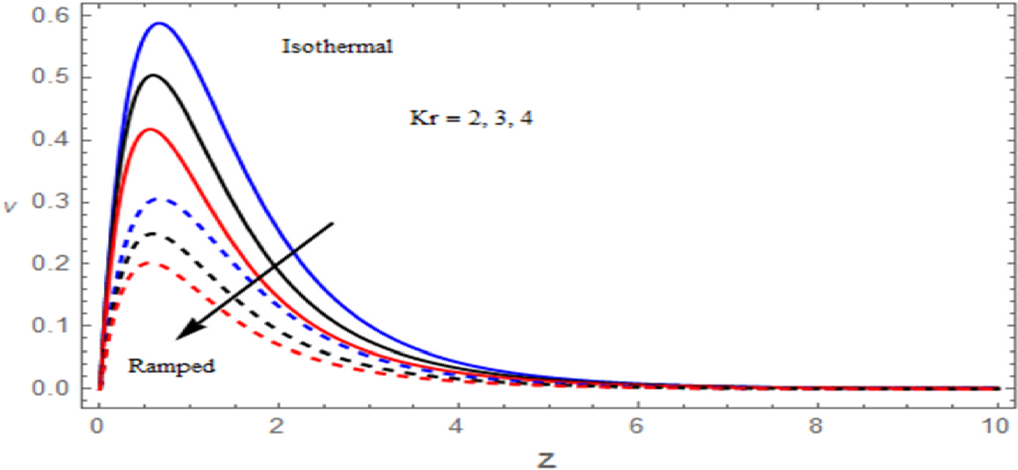
Fig.6. The Velocity profile for u against Kr
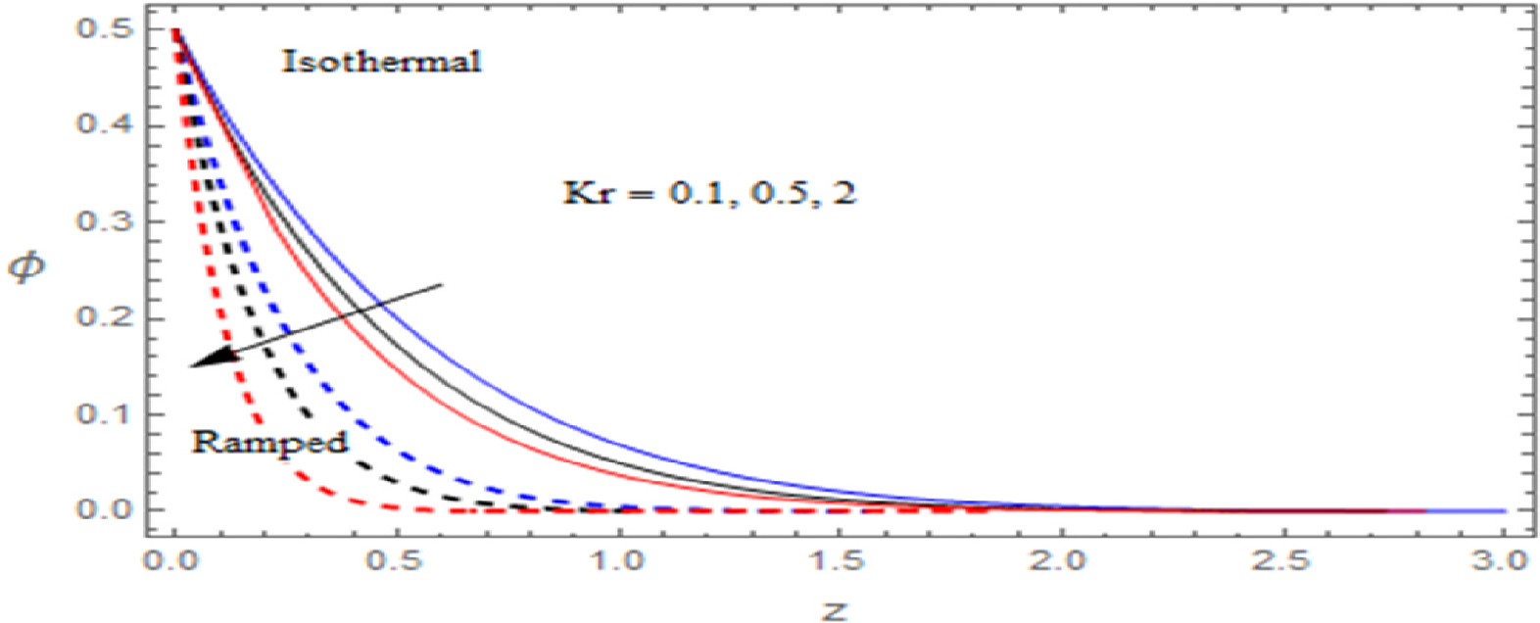
Fig.7. The Concentration profile for against Kr

Table.1. Shear stress
M | K | α | Kr | Sr | Gr | Gm | H | R | Ramped Temperature |  | Isothermal plate
 |  |  |  |  |  |  |  |  | τ_{x} | τ_{y} | τ_{x} | τ_{y}
0.5 | 0.5 | 0.1 | 2 | 0.1 | 5 | 2 | 2 | 2 | 1.238914 | 0.074655 | 1.676789 | 0.90178
0.8 |  |  |  |  |  |  |  |  | 0.819758 | 0.085768 | 1.387469 | 0.931437
1 |  |  |  |  |  |  |  |  | 0.476292 | 0.092448 | 1.157014 | 1.035444
 | 1 |  |  |  |  |  |  |  | 1.141496 | 0.052348 | 1.501635 | 0.835859
 | 1.5 |  |  |  |  |  |  |  | 0.912178 | 0.041372 | 1.356789 | 0.724449
 |  | 1 |  |  |  |  |  |  | 1.809166 | 0.085765 | 1.790966 | 1.034638
 |  | 1.5 |  |  |  |  |  |  | 2.942596 | 0.112417 | 1.932254 | 1.212479
 |  |  | 3 |  |  |  |  |  | 1.542595 | 0.082744 | 2.030801 | 1.101368
 |  |  | 4 |  |  |  |  |  | 2.175447 | 0.114618 | 3.017479 | 1.500931
 |  |  |  | 0.5 |  |  |  |  | 1.146445 | 0.048281 | 1.127884 | 0.582842
 |  |  |  | 1 |  |  |  |  | 0.956685 | 0.040985 | 0.382856 | 0.342548
 |  |  |  |  | 8 |  |  |  | 1.138812 | 0.051911 | 1.654147 | 0.870477
 |  |  |  |  | 10 |  |  |  | 0.910222 | 0.045744 | 1.632145 | 0.844737
 |  |  |  |  |  | 5 |  |  | 1.183247 | 0.063176 | 1.664265 | 0.893785
 |  |  |  |  |  | 8 |  |  | 1.076654 | 0.048317 | 1.653458 | 0.869904
 |  |  |  |  |  |  | -5 |  | 1.146365 | 0.059126 | 1.617595 | 0.804638
 |  |  |  |  |  |  | 5 |  | 1.542356 | 0.085744 | 1.801854 | 1.004739
 |  |  |  |  |  |  |  | 5 | 1.312152 | 0.082159 | 1.790859 | 1.101844
 |  |  |  |  |  |  |  | 8 | 1.541178 | 0.093459 | 1.876855 | 1.501359

Table.2.Nusselt number
Pr | R | H | t | Ramped Temperature | Isothermal temperature
0.71 | 2 | 2 | 0.2 | 0.928195 | 1.019297
3 |  |  |  | 1.042736 | 1.317133
7 |  |  |  | 1.443152 | 1.619286
 | 5 |  |  | 0.890154 | 0.750059
 | 8 |  |  | 0.853935 | 0.467056
 |  | -2 |  | 0.843835 | 0.753217
 |  | 5 |  | 1.042718 | 1.190074
 |  |  | 0.5 | 1.070486 | 0.709297
 |  |  | 0.8 | 1.068975 | 0.85697
Table.3.Sherwood number
Sr | Kr | Sc | t | Ramped Temperature | Isothermal temperature
0.1 | 2 | 2 | 0.2 | 0.351368 | 0.261569
0.5 |  |  |  | 0.268144 | 0.232263
1 |  |  |  | 0.644744 | 0.160236
 | 3 |  |  | 0.413675 | 0.421249
 | 4 |  |  | 0.491589 | 0.490095
 |  | 0.3 |  | 0.324755 | 0.232212
 |  | 0.6 |  | 0.291786 | 0.202319
 |  |  | 0.5 | 0.421759 | 0.502222
 |  |  | 0.8 | 0.532885 | 0.724107
4.References
[1] Magyari E, Pop I and Keller B. Analytical solutions for unsteady free convection ﬂow through a porous media. J Eng Math 2004; 48: 93–104.
[2] Chamaka AJ. Hydro magnetic combined heat and mass transfer by natural convection from a permeable surface embedded in a ﬂuid saturated porous medium. Int J Num Methods for Heat and Fluid Flow 2000; 10: 455–476.
[3] Mzumdar MK and Deka RK. MHD Flow past an impul-sively started inﬁnite vertical plate in presence of thermal radiation. Rom Journ Phys 2007; 52: 565–573.
[4] Sharma PR, Kumar N and Sharma P. Inﬂuence of chemical reaction and radiation on unsteady MHD free convection ﬂow and mass transfer through viscous incompressible ﬂuid past a heated vertical plate immersed in porous medium in the presence of heat source. Appl Math Sciences 2011; 5:2249–2260.
[5] Mahapatra M, Dash GC, Panda S, et al. Effects of chemical reaction on free convection ﬂow through a porous medium bounded by a vertical surface. J Eng Phys Thermophys 2010; 83: 130–140.
[6] Rajasekhar K, Reddy GVR and Prasad BDCN. Chemically reacting on MHD oscillatory slip ﬂow in a planer channel with varying temperature and concentration. Adv Appl Sci Res 2012; 3: 2652–2659.
[7] Kishan N and Srinivas M. Thermophoresis and viscous dissipation effects on Darcy–Forchheimer MHD mixed con- vection in a ﬂuid saturated porous media. Adv Appl Sci Res 2012; 3: 60–74.
[8] Anjalidevi SP and David AMG. Effects of variable viscosity and nonlinear radiation on MHD ﬂow with heat transfer over a surface stretching with a power-law velocity. Adv Appl Sci Res 2012; 3: 319–334.
[9] K.H. Fraser, M.E. Taskin, B.P. Griffith, Z.J. Wu, The use of computational fluid dynamics in the development of ventricular assist devices, Med. Eng. Phys. 33 (3) (2011) 263–280.
[10] A.K. Armstrong, J.D. Zampi, L.M. Itu, L.N. Benson, Use of 3D rotational angiography to perform computational fluid dynamics and virtual interventions in aortic coarctation, Catheter. Cardiovasc. Interv. 95 (2) (2020) 294–299.
[11] E.W. Errill, Rheology of blood, Physiol. Rev. 49 (4) (1969) 863–888.
[12] P. Chaturani, V. Palanisamy, Casson fluid model for pulsatile flow of blood under periodic body acceleration, Biorheology 27 (5) (1990) 619–630.
[13] N. Willenbacher, K. Georgieva, Rheology of disperse systems, in: Product Design and Engineering: Formulation of Gels and Pastes, 2013, pp. 7–49.
[14] A. Sahoo, R. Nandkeolyar, Radiative heat transport of cattaneo–christov double diffusive casson nanofluid flow between two rotating disks with hall current and activation energy, Z. Angew. Math. Mech. (2023) e202200419.
[15] E. Ragupathi, D. Prakash, M. Muthtamilselvan, K. Ahn, Entropy analysis of casson nanofluid flow across a rotating porous disc with nonlinear thermal radiation and magnetic dipole, Internat. J. Modern Phys. B 37 (26) (2023) 2350308.
[16] J. Ahmed, F. Nazir, B.M. Fadhl, B.M. Makhdoum, Z. Mahmoud, A. Mohamed, I. Khan, Magneto-bioconvection flow of casson nanofluid configured by a rotating disk in the presence of gyrotactic microorganisms and joule heating, Heliyon 9 (8) (2023) e18028.
[17] M. Ramzan, S. Riasat, J.D. Chung, Y.M. Chu, M. Sheikholeslami, S. Kadry, F. Howari, Upshot of heterogeneous catalysis in a nanofluid flow over a rotating disk with slip effects and entropy optimization analysis, Sci. Rep. 11 (1) (2021) 120.
[18] Krishna MV and Chamkha AJ. Hall and ion slip effects on MHD rotating boundary layer ﬂow of nanoﬂuid past an inﬁnite vertical plate embedded in a porous medium. Results Phys 2019; 15: 102652.
[19] Krishna MV, Reddy GS and Chamkha AJ. Hall effects on unsteady MHD oscillatory free convective ﬂow of second grade ﬂuid through porous medium between two vertical plates. Phys Fluids 2018; 30: 023106.
[20] Krishna MV and Chamkha AJ. Hall effects on unsteady MHD ﬂow of second grade ﬂuid through porous medium with ramped wall temperature and ramped surface concen- tration. Phys Fluids 2018; 30: 053101.
[21] Krishna MV. Hall and ion slip impacts on unsteady MHD free convective rotating ﬂow of Jeffreys ﬂuid with ramped wall temperature. Int Commun Heat Mass Transf 2020; 119: 104927.
[22] Krishna MV. Radiation-absorption, chemical reaction, Hall and ion slip impacts on magnetohydrodynamic free con- vective ﬂow over semi-inﬁnite moving absorbent surface. Chinese J Chem Eng 2021; 34: 40–52.

