Smart Mailbox Notification and Security System Using NodeMCU ESP8266 and Blynk Application

INTRODUCTION
The rapid advancement of the Internet of Things (IoT) has transformed modern communication, automation, and security systems by enabling physical devices to collect, process, and exchange data through internet connectivity. IoT technology allows users to monitor and control devices remotely using smartphones, cloud platforms, and wireless networks, making smart systems more efficient, convenient, and responsive. In smart home environments, IoT has been widely applied for automation, surveillance, energy management, appliance control, and security monitoring [1]–[5]. The availability of low-cost microcontrollers, wireless sensors, mobile applications, and cloud-based platforms has further accelerated the development of affordable smart home solutions [6]–[8].
Smart mailbox systems are one of the practical applications of IoT in residential security and automation. Conventional mailbox systems require users to manually inspect the mailbox to determine whether letters or parcels have arrived. This approach is inefficient, especially for users who frequently receive deliveries or are away from home for long periods. Delayed collection may increase the risk of parcel theft, loss, or damage caused by weather conditions. Recent studies show that IoT-based monitoring systems can improve home security and user convenience by providing real-time alerts, remote access, and automated control functions [1], [2], [8], [9]. Therefore, integrating mailbox systems with IoT technology can help users receive immediate notifications when mail is delivered while also improving mailbox security.
Previous research has shown that IoT-based smart home systems commonly use sensors, microcontrollers, relays, mobile applications, and cloud platforms to support remote monitoring and control [6], [7], [10]. The NodeMCU ESP8266 is suitable for this type of application because it provides built-in Wi-Fi connectivity, low cost, compact size, and compatibility with Arduino IDE. These features make it useful for smart home automation, notification systems, and wireless security applications [6], [11]. In addition, infrared sensors are commonly used for object detection because they are simple, affordable, and easy to interface with microcontrollers. For mailbox applications, an infrared sensor can detect the presence of letters or parcels inside the mailbox and send the detection signal to the controller for further processing.
The Blynk IoT platform is also useful for smart mailbox development because it provides a smartphone-based interface for real-time monitoring and control. Through Blynk, users can receive notifications, check system status, and remotely control electronic devices through internet connectivity. Previous IoT security and home automation studies have shown that mobile application control improves accessibility and user convenience, especially for systems that require real-time response [6], [8], [12]. However, IoT systems must also consider security and reliability because smart home devices are vulnerable to unauthorized access, data privacy issues, and communication failures [1]–[5], [10], [13].
Although existing smart mailbox systems provide notification features, many designs focus mainly on mail detection and do not fully integrate secure remote access control. Some systems also depend on manual locks, limited notification methods, or separate security mechanisms. Recent IoT security studies emphasize that smart home systems should combine detection, notification, authentication, and access control to improve protection against unauthorized access [1], [2], [4], [10]. Therefore, a smart mailbox system should not only notify users when mail is delivered but also provide an electronic locking mechanism to improve parcel security.
This study proposes a Smart Mailbox Notification and Security System using NodeMCU ESP8266, an infrared obstacle sensor, the Blynk mobile application, a relay module, and a solenoid lock mechanism. The proposed system detects the presence of letters or parcels inside the mailbox and sends real-time notifications to the user’s smartphone. In addition, the solenoid lock allows users to remotely unlock the mailbox through the Blynk application, improving both convenience and security. The main objective of this project is to design and develop a low-cost IoT-based smart mailbox prototype that can provide mail detection, smartphone notification, and electronic access control. The system is intended for residential and small-scale commercial use, where affordability, simplicity, and reliability are important design considerations.

METHODOLOGY
A. System Overview
The proposed smart mailbox system consists of hardware and software components integrated through IoT communication. The main hardware components used in the proposed system are NodeMCU ESP8266, infrared obstacle sensors, solenoid locks, relay modules, power supply units, and smartphones for remote monitoring and control, see Figure 1.
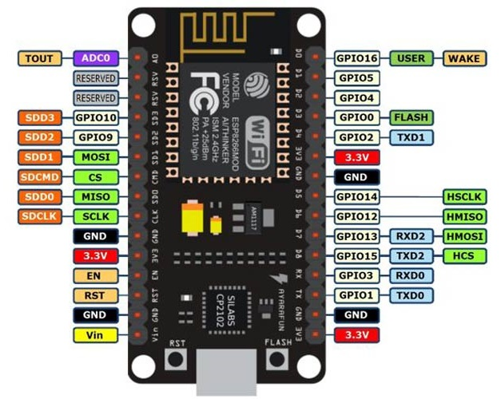
Figure 1: NodeMCU ESP8266.
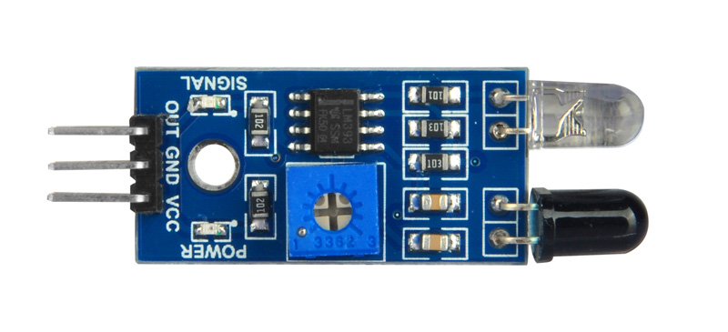
Figure 2: IR Sensor.

The software components involved in the system include Arduino IDE for programming development, the Blynk mobile application for remote communication, and Wi-Fi networks for internet connectivity. The operational process of the system begins when the infrared sensor continuously monitors the mailbox compartment for object detection as shown in Figure 2. Once a parcel or letter enters the mailbox, the infrared sensor detects the object and sends a signal to the NodeMCU microcontroller. The NodeMCU then transmits notification data through the Wi-Fi network to the Blynk cloud server, allowing the Blynk application to display a notification alert on the user’s smartphone. Users may subsequently unlock the mailbox remotely using the Blynk application, causing the NodeMCU to activate the relay module and solenoid locking mechanism.

B. Hardware Design
Referring to Figure 3, the hardware design of the proposed smart mailbox system consists of several electronic components integrated to provide notification and security functions. The NodeMCU ESP8266 acts as the central controller responsible for processing sensor inputs, managing internet communication, and controlling the overall system operation. The built-in Wi-Fi capability of NodeMCU allows the system to communicate directly with the Blynk cloud platform without requiring additional wireless communication modules.
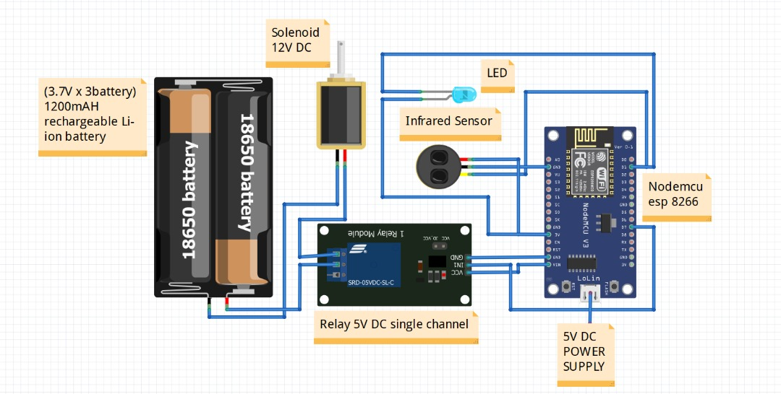
Figure3: Schematic diagram.

An infrared obstacle sensor is installed inside the mailbox compartment to detect the presence of letters or parcels. The sensor continuously emits infrared signals and detects reflected signals when an object is inserted into the mailbox. Once detection occurs, the sensor sends a signal to the NodeMCU microcontroller for processing. The relay module is used as an electrical switching device that controls the power supplied to the solenoid lock. Since the output current from NodeMCU is insufficient to directly operate the solenoid lock, the relay module functions as an interface between the microcontroller and locking mechanism. Figure 4 shows the schematic diagram of the system.

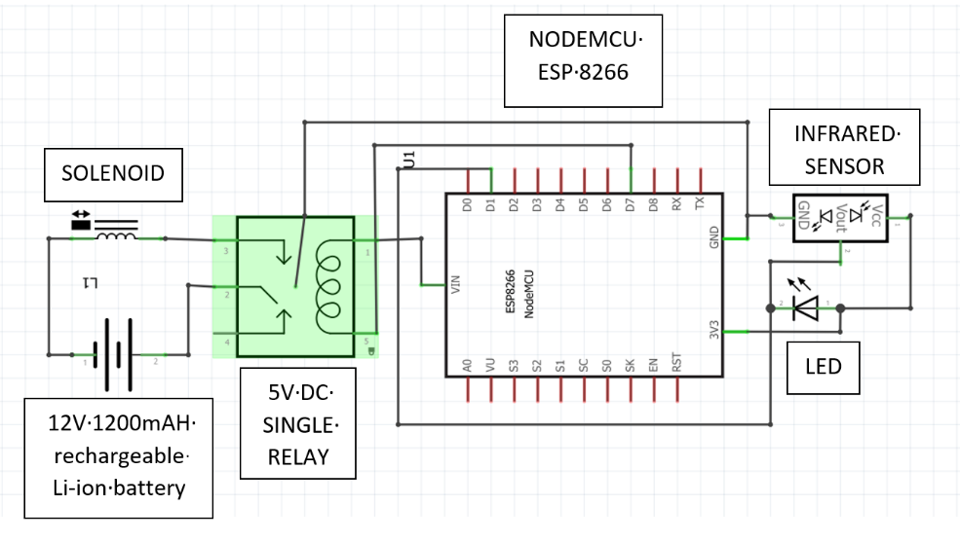
Figure 4: Schematic diagram

The solenoid lock serves as the primary security mechanism of the mailbox system. When activated, the lock mechanism retracts and allows users to open the mailbox door remotely through the Blynk application. A regulated power supply is used to provide stable electrical energy to all system components, ensuring reliable and continuous system operation.

C. Software Development
The software development process of the proposed system was carried out using Arduino IDE and the Blynk mobile application platform. Arduino IDE was used to develop, compile, and upload the program code into the NodeMCU ESP8266 microcontroller. The program was designed to manage sensor data reading, Wi-Fi communication, notification transmission, relay activation, and solenoid lock control. Appropriate libraries related to ESP8266 and Blynk communication were included to establish stable wireless communication between the hardware system and the cloud server as illustrate in Figure 5.

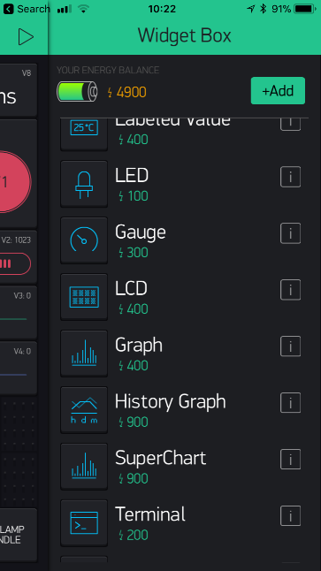 | 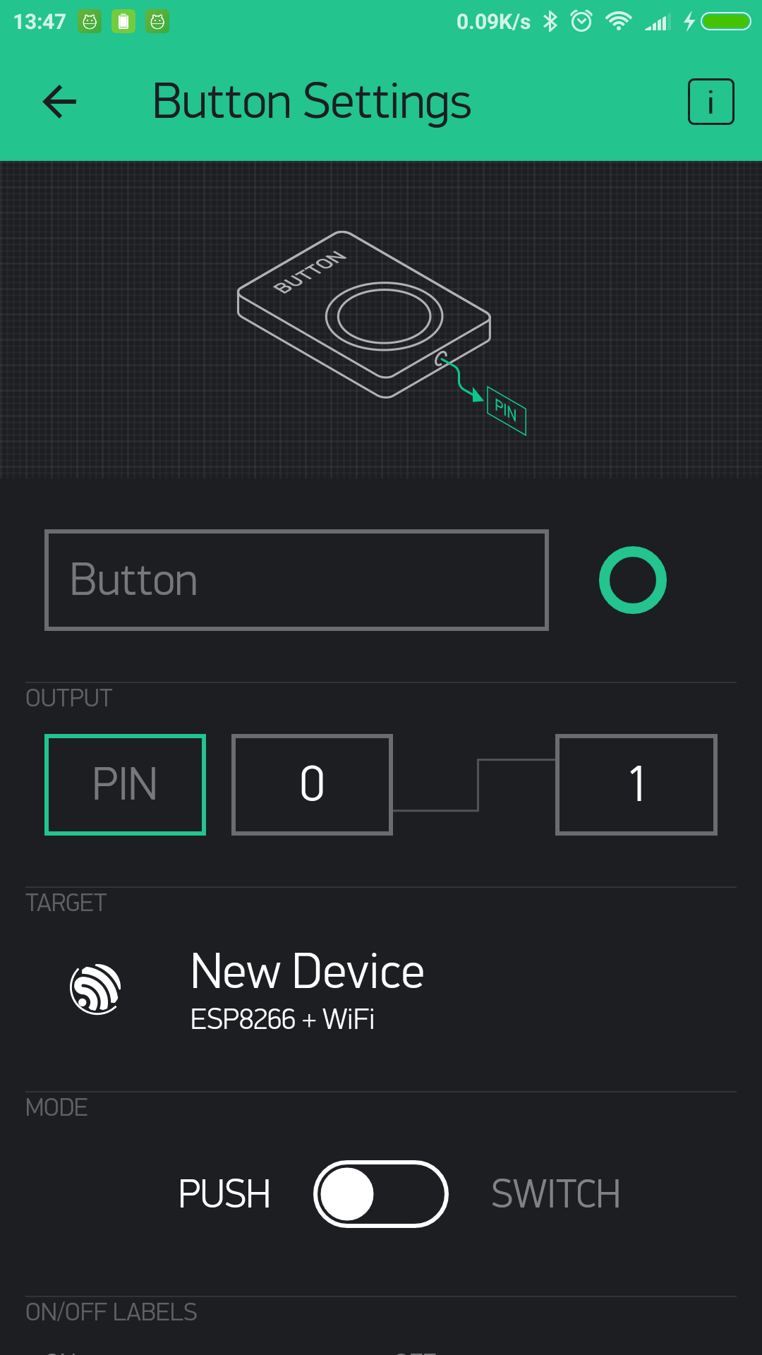
(a) | (b)
Figure 5: Interface of (a) Blynk apps Widget Box, and (b) Blynk widget settings.

The Blynk application was used to provide a user-friendly interface for smartphone-based monitoring and control. Through the application, users are able to receive real-time notifications when letters or parcels are detected inside the mailbox. The application also allows users to remotely unlock the mailbox through internet connectivity. The integration between NodeMCU ESP8266 and Blynk platform enables efficient communication and improves the convenience of remote mailbox monitoring.

D. System Flowchart
The flowchart in Figure 6 illustrates the operational process of the proposed Smart Mailbox Notification and Security System. The process begins with system initialization, where the NodeMCU ESP8266 activates and enters the sensor scanning mode. During this stage, the infrared sensor continuously monitors the mailbox compartment to detect the presence of a letter or parcel. If no item is detected, the system repeatedly returns to the scanning process, ensuring continuous real-time monitoring. Once an item is detected, the system proceeds to send a notification to the user through the Blynk mobile application, informing the user that a new delivery has arrived in the mailbox.
Figure 6: Flow chart of the system

After receiving the notification, the user can access the Blynk application and remotely request access to the mailbox through the unlock function. The unlock command is transmitted through the internet to the NodeMCU, which controls the relay module and solenoid lock mechanism. Before granting access, the system verifies whether the user is a registered and authorized user. If the authentication process fails, the system returns to the unlock request stage and waits for a valid authorization attempt. This security mechanism prevents unauthorized individuals from accessing the mailbox contents and enhances overall system protection.
Once the user is successfully authenticated, the system activates the solenoid lock and opens the mailbox door, allowing the user to retrieve the delivered letters or parcels. After the retrieval process is completed, the operation cycle reaches the end stage and the system automatically returns to monitoring mode for future deliveries. Through the integration of object detection, real-time notification, user authentication, and remote access control, the proposed smart mailbox system provides a convenient, secure, and efficient solution for modern mail and parcel management applications.

E. Prototype Development
The prototype development process involved the integration of both hardware and software components into a functional smart mailbox system. Acrylic materials were used to construct the physical structure of the mailbox prototype because they provide durability, lightweight characteristics, and ease of fabrication, see Figure 7. The prototype was designed to accommodate letters and small parcels while simultaneously protecting the internal electronic components from physical damage.
During the assembly process, careful consideration was given to the placement of sensors, wiring connections, and electronic modules to ensure stable operation and improve overall system reliability. The infrared sensor was positioned strategically inside the mailbox compartment to maximize detection accuracy, while the NodeMCU, relay module, and power supply were installed securely within protective housing. Proper cable management techniques were implemented to improve the appearance and safety of the prototype. After the assembly process was completed, the entire system underwent several stages of testing and debugging to verify correct functionality before final evaluation.

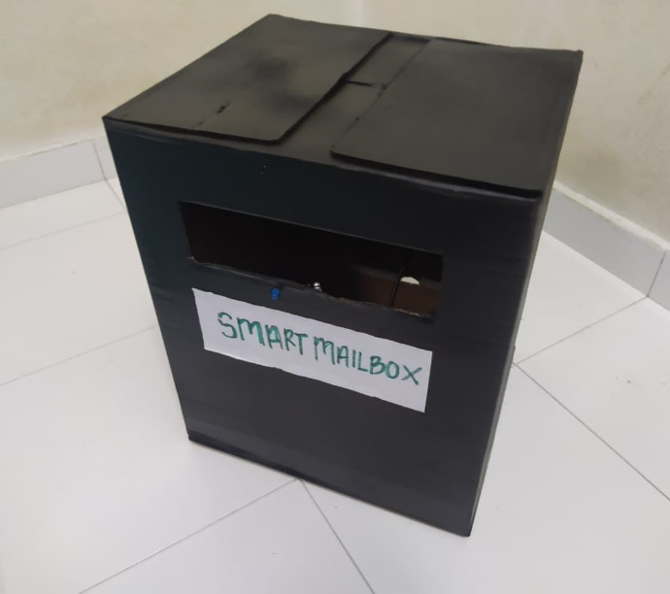 | 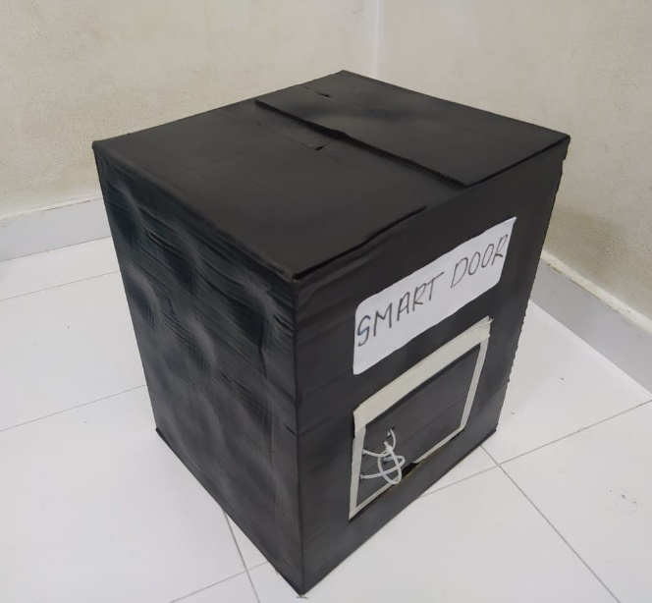
(a) | (b)
Figure 7: Protype of Smart Mailbox (a) front view, and (b) back view

RESULT
A. System Testing
The developed Smart Mailbox Notification and Security System was evaluated through a series of experimental tests to determine its functionality, reliability, and overall performance. The testing process in Figure 8 focused on verifying the operation of the infrared obstacle sensor, notification delivery through the Blynk application, Wi-Fi communication stability, and the effectiveness of the remote locking mechanism. Each component was tested individually before conducting an integrated system evaluation to ensure that all hardware and software modules operated correctly under normal conditions. The experimental results demonstrated that the system was able to perform all intended functions successfully, indicating that the design objectives were achieved.

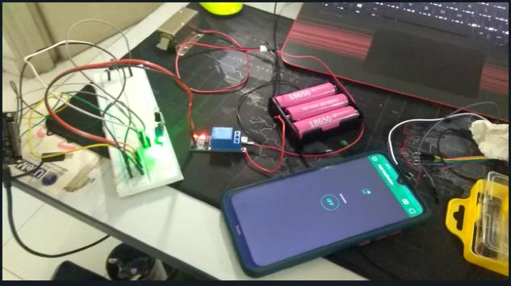
Figure 8: System testing

B. Sensor Detection Performance
The infrared obstacle sensor played a critical role in detecting the presence of letters and parcels inside the mailbox. During testing, various objects with different sizes and shapes were inserted into the mailbox compartment to evaluate the sensor's detection capability. The results showed that the sensor consistently detected the presence of delivered items within its operating range and transmitted the detection signal to the NodeMCU ESP8266 without significant delay. The detection accuracy was influenced by factors such as sensor alignment, object positioning, and ambient lighting conditions. Nevertheless, the sensor maintained stable performance throughout the testing period and proved suitable for mailbox monitoring applications as shown in Figure 9.

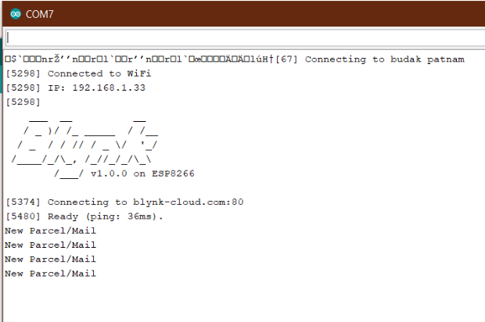
Figure 9: Sensor detection

C. Notification Response Performance
The notification subsystem in Figure 10 was evaluated by measuring the ability of the NodeMCU ESP8266 to transmit delivery information to the Blynk cloud server and subsequently to the user’s smartphone. Once an item was detected by the infrared sensor, a notification was generated and delivered to the smartphone application through the Wi-Fi network. The results indicated that notification alerts were received within a few seconds after object detection. The response time varied slightly depending on internet connection quality and network traffic conditions. However, the delay remained within an acceptable range for real-time monitoring applications. The Blynk platform provided stable communication throughout the testing process, ensuring reliable delivery of notification messages.

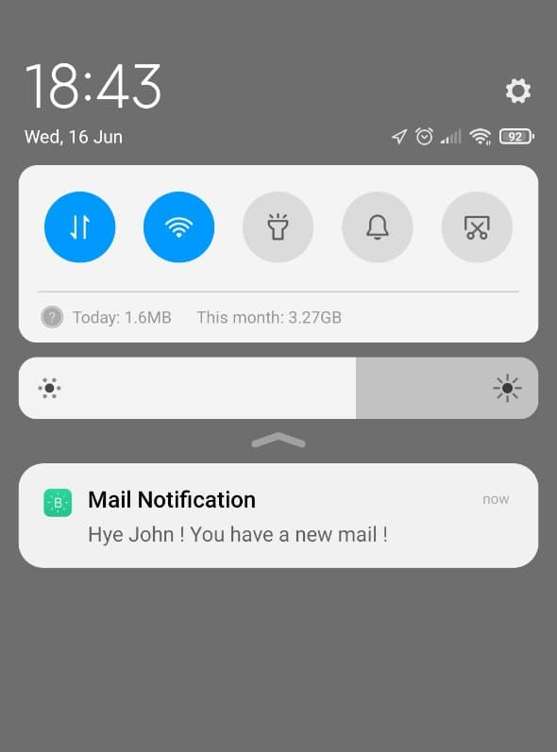 | 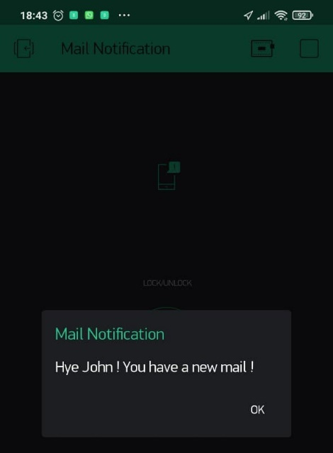
(a) | (b)
Figure 10: Blynk notification on (a) phone, and (b) smart mailbox system interface

D. Solenoid Lock Performance
Referring to Figure 11, the performance of the electronic locking mechanism was evaluated by testing the remote unlocking function through the Blynk mobile application. When the unlock command was transmitted from the smartphone, the NodeMCU activated the relay module, which subsequently energized the solenoid lock. Experimental observations showed that the locking mechanism responded accurately to user commands and allowed the mailbox door to be opened without difficulty. The relay module operated reliably and provided sufficient isolation between the low-voltage control circuit and the higher-power locking mechanism. The successful operation of the solenoid lock demonstrated the effectiveness of the proposed security system in providing controlled access to mailbox contents.

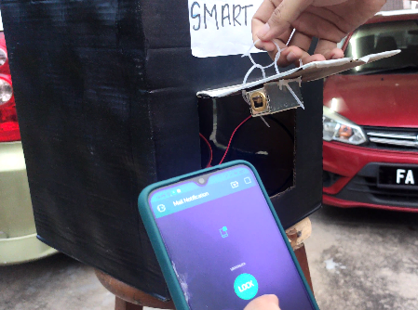 | 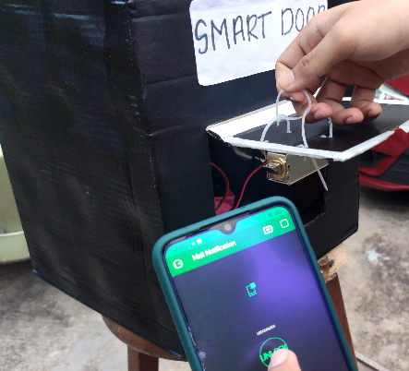
(a) | (b)
Figure 11: Smart Mailbox (a) Locked, and (b) Unlocked mode

E. Overall System Performance Analysis
The overall system evaluation demonstrated that the proposed Smart Mailbox Notification and Security System successfully achieved its intended objectives by integrating parcel detection, real-time notification, and remote access control within a single IoT-based platform. Throughout the testing process, all hardware and software components operated together effectively, enabling seamless communication between the infrared sensor, NodeMCU ESP8266 microcontroller, Blynk cloud server, and smartphone application. The system was capable of accurately detecting the presence of letters and parcels inside the mailbox and subsequently transmitting notification alerts to users in real time. This functionality allowed users to receive immediate updates regarding mail deliveries regardless of their physical location, thereby eliminating the need for frequent manual mailbox inspections. The integration of smartphone-based monitoring significantly improved user convenience, particularly for individuals who receive regular parcel deliveries or are frequently away from home.
In addition to the notification functionality, the implementation of the solenoid lock and relay control mechanism enhanced mailbox security by providing remote access control through the Blynk mobile application. Users were able to unlock the mailbox electronically using authorized smartphone commands, reducing dependence on conventional lock-and-key systems. This feature not only improved accessibility but also minimized potential issues associated with lost keys, unauthorized duplication, and manual access limitations. Furthermore, the use of low-cost components such as the NodeMCU ESP8266 and infrared obstacle sensor contributed to the affordability of the overall system, making it suitable for residential and small-scale commercial applications. The successful integration of sensing, communication, and security functions demonstrates the practicality of IoT technology in developing efficient smart home solutions.
Despite the positive performance results, several limitations were identified during system testing. The proposed system relies heavily on a stable Wi-Fi connection and internet availability to support real-time notification delivery and remote unlocking operations. Any interruption in network connectivity may affect communication between the mailbox and the smartphone application, potentially delaying notifications or preventing remote access. Additionally, the infrared obstacle sensor possesses a limited detection range and may be influenced by environmental conditions such as object positioning, sensor alignment, and ambient lighting. Periodic maintenance and calibration may therefore be required to ensure consistent performance over long-term operation. Future improvements could include the integration of camera-based monitoring systems for visual parcel verification, cloud database storage for delivery history management, GSM communication backup for improved reliability during internet outages, and artificial intelligence-based parcel recognition technologies. These enhancements would further improve the functionality, scalability, and reliability of the smart mailbox system, making it more suitable for widespread deployment in modern residential and commercial environments.

CONCLUSIONS
This paper presented the design and development of a Smart Mailbox Notification and Security System using NodeMCU ESP8266 and Blynk application. The proposed system successfully detects letters and parcels using an infrared obstacle sensor and sends real-time notifications to users through smartphone applications. In addition, the system enhances mailbox security through remote-controlled solenoid locking mechanisms. Experimental testing demonstrated reliable system performance, stable communication, and effective notification delivery. The implementation cost remains affordable, making the system suitable for residential smart home applications. Overall, the project contributes toward IoT-based smart security systems and demonstrates the practical application of low-cost wireless automation technologies.

ACKNOWLEDGEMENT
I would like to express my sincere gratitude to Centre for Research and Innovation Management (CRIM) and Universiti Teknikal Malaysia Melaka (UTeM) for their invaluable support throughout this project. Their resources, guidance, and encouragement played a crucial role in the successful development and implementation of this Smart Mailbox system.

REFERENCE
[1] G. Vardakis, G. Hatzivasilis, E. Koutsaki, and N. Papadakis, “Review of smart-home security using the Internet of Things,” Electronics, vol. 13, no. 16, Art. no. 3343, 2024, doi: 10.3390/electronics13163343.
[2] T. Magara, H. Zhou, and M. Li, “Internet of Things (IoT) of smart homes: Privacy and security,” Security and Communication Networks, vol. 2024, Art. no. 7716956, 2024, doi: 10.1155/2024/7716956.
[3] P. Williams, I. Dutta, H. Daoud, and M. Bayoumi, “A survey on security in Internet of Things with a focus on the impact of emerging technologies,” Internet of Things, vol. 19, Art. no. 100564, 2022, doi: 10.1016/j.iot.2022.100564.
[4] B. Yuan, W. Li, D. Liu, J. Liu, and W. Wang, “On the security of smart home systems: A survey,” Journal of Computer Science and Technology, vol. 38, no. 2, pp. 338–364, 2023, doi: 10.1007/s11390-023-2488-3.
[5] I. Cvitić, D. Peraković, M. Periša, and M. Botica, “An overview of smart home IoT trends and related security challenges,” Mobile Networks and Applications, vol. 28, pp. 1333–1345, 2023, doi: 10.1007/s11036-022-02055-w.
[6] M. A. Khan et al., “Smart Android based home automation system using Internet of Things (IoT),” Sustainability, vol. 14, no. 17, Art. no. 10717, 2022, doi: 10.3390/su141710717.
[7] Z. Sharif, L. T. Jung, M. Ayaz, M. Yahya, and D. Khan, “Smart home automation by Internet-of-Things edge computing platform,” International Journal of Advanced Computer Science and Applications, vol. 13, no. 4, 2022, doi: 10.14569/IJACSA.2022.0130455.
[8] P. Netinant, T. Utsanok, M. Rukhiran, and S. Klongdee, “Development and assessment of Internet of Things-driven smart home security and automation with voice commands,” IoT, vol. 5, no. 1, Art. no. 5, 2024, doi: 10.3390/iot5010005.
[9] M. A. M. Sidek, N. Samsudin, and M. F. M. Yusof, “Smart mailbox notification system with solar battery charging based on IoT,” Journal of Electrical and Electronic Systems Research, vol. 24, no. 1, pp. 89–96, 2024, doi: 10.24191/jeesr.v24i1.014.
[10] K. Murat, F. Skopik, and M. Wurzenberger, “Security analysis of low-budget IoT smart home devices,” Electronics, vol. 13, no. 12, Art. no. 2371, 2024, doi: 10.3390/electronics13122371.
[11] O. Alshamsi, A. Alketbi, and A. Alshamsi, “Towards securing smart homes: A systematic literature review,” Information, vol. 15, no. 10, Art. no. 631, 2024, doi: 10.3390/info15100631.
[12] A. A. Laghari, K. Li, R. A. Laghari, and S. Karim, “Internet of Things applications security trends and solutions,” Discover Internet of Things, vol. 4, Art. no. 24, 2024, doi: 10.1007/s43926-024-00090-5.
[13] O. Taiwo and A. E. Ezugwu, “Internet of Things-based intelligent smart home control system,” Security and Communication Networks, vol. 2021, Art. no. 9928254, 2021, doi: 10.1155/2021/9928254.
[14] W. A. Jabbar et al., “Design and fabrication of smart home with Internet of Things enabled automation system,” IEEE Access, vol. 7, pp. 144059–144074, 2019, doi: 10.1109/ACCESS.2019.2942846.
[15] A. Al-Fuqaha, M. Guizani, M. Mohammadi, M. Aledhari, and M. Ayyash, “Internet of Things: A survey on enabling technologies, protocols, and applications,” IEEE Communications Surveys & Tutorials, vol. 17, no. 4, pp. 2347–2376, 2015, doi: 10.1109/COMST.2015.2444095.

