Survey Paper On: Leveraging Artificial

Intelligence (AI) and Blockchain to Enhance Supply Chain Management for a Ganapati Idol Selling Platform

Yadav Ashish Suryaprakash  Department of Information Technology, Pillai College of Engineering, New Panvel,  yashish22it@student.mes.ac.in |  | Patil Sahil Dinanath  Department of Information Technology, Pillai College of Engineering, New Panvel,  psahil22it@student.mes.ac.in
Prof. Vrushali Bahurupi
Department of Information Technology, Pillai College of Engineering, New Panvel,
vrushalibahurupi@mes.ac.in

Patil Yash Nilesh  Department of Information Technology, Pillai College of Engineering, New Panvel,  pnyash23it@student.mes.ac.in |  | Dabake Soham  Department of Information Technology, Pillai College of Engineering, New Panvel,  dsoham23it@student.mes.ac.in

Abstract: This study introduces a new digital platform that is focused on enhancing customer engagement in the retailing of the Ganesh idol. It integrates artificial intelligence, machine learning, and blockchain into a single online platform. The website would provide an engaging shopping experience for customers. For instance, buyers can interact with AR-based 3D models that can help preview, customize, and evaluate idol designs in detail prior to purchase. The aim is to go beyond mere conventional e-commerce models and create a more personalized and interactive marketplace driven by modern digital technologies.
To implement this, we use computer vision, deep learning models, and generative models like Semantic Segmentation. These methods provide clear visualizations and tailored customizations. In contrast, traditional methods may be restricted when processing images or using predictive models such as LSTM, ARIMA, and GRU. These techniques have difficulty with dynamic user edits/changes or detailed artistic features. Semantic Segmentation combined with AR tools can facilitate real-time customization and realistic design previews, while blockchain-based smart contracts preserve the integrity of every transaction in a secure, open, and tamper-proof environment, furthering trust and accountability at every point in the supply chain.
Moreover, the study shows that by integrating deep learning methods with AR-enabled 3D visualization, customers can participate in design-related activities. They can personalize features based on their preferences. Utilizing blockchain for safe and traceable exchanges, the system establishes a sound, adaptable, and transparent structure. This renovates not only the supply chain but also upgrades the overall e-commerce
Keywords—Artificial Intelligence, Machine Learning, Supply Chain Management.

I.INTRODUCTION:
The rapid growth in the digital economy is making the traditional supply chain practices increasingly difficult. Certain issues such as inefficiencies, lack of transparency, and security are common problems. The present study has proposed a new platform for the retail industry of the Ganapati idol, which is integrated with Artificial Intelligence and blockchain.
◢ AI predicts the demand for products, inventories, and provides personalized experiences to customers through immersive 3D idol customization using AR. Simultaneously, blockchain builds trust and accountability through the secure recording of transactions in a transparent, tamper-proof way using smart contracts. In sum, technology integration is expected to enhance operations, stakeholder trust, and material sustainability verification.
In all, the proposed solution enhances supply chain efficiency while providing real-time insights to artisans and suppliers, interactive customization options to customers, and verified eco-friendly choices.
Objectives:
The aim of this project is to reimagine supply chain management within the retail sector of the Ganapati idol. We seek to create a single platform driven by AI and blockchain technology.
The platform will:
● Improve efficiency through AI-driven demand forecasting and smart resource allocation.
● Provide security and transparency through smart contracts enabled by blockchain and permanent, tamper-proof logs of all transactions.
● Increase customer engagement by offering real-time AR-based 3D customizations of idols along with AI-enabled personalized recommendations.
● Assist in eco-sustainability by verifying that
raw materials are genuinely environmentally safe.
Allow complete traceability by tracking every stage in the supply chain, right from material procurement to final delivery.
Scope:
The project encompasses the entire design, development, and deployment of a supply chain management system for the retailing of the Ganapati idol.
The system's objectives are to address the following key challenges:
● Poor inventory monitoring and control
● Lack of transparency in transactions and material flows
● Few chances for customer-driven customization
● The urgent need for sustainable and eco-friendly practices
Blockchain-based smart contracts would automate agreements among artisans, suppliers, and customers. This will ensure reliability, accountability, and security within every stage of the supply chain. Simultaneously, the platform promotes environmental sustainability by confirming through blockchain verification the authenticity of eco-friendly raw materials.
Conceived to bring in more efficiency and reduce the risk of fraud, it also hopes to reshape some of the conventional supply chain practices of the idol-making industry. The project blends transparency and sustainability with customer-focused innovation, striving to create a modern digital marketplace that supports artisans, builds trust with customers, and influences the cultural and environmental aspects of the Ganapati idol celebrations positively.
Literature Survey
A literature survey highlights existing research in that area in an organised way. This research covers the present-day research in the integration of AI and blockchain into the field of supply chain management. For clarity, the survey is divided into three major parts: the role of AI in supply chain management, blockchain for ensuring transparency and traceability, and the combined effect of those two technologies.
1. Integration of Artificial Intelligence and Blockchain Technology (2023). This 2023 study explains how traditional supply chains can be improved by using AI and blockchain. AI methods like CNN, GAN, and AR can help companies predict customer demand more accurately, manage inventory better, and even allow customers to customize products in an interactive 3D way. Blockchain adds an extra layer of security and transparency by keeping records that cannot be changed, which improves traceability and data integrity. It also uses smart contracts to automate supply chain tasks and reduce manual effort. Although the study does not include real implementations or case studies, it gives a strong theoretical base for building smarter, decentralized, and environmentally friendly supply chain systems.
2. AI in Supply Chain Management (2021) talks about how AI technologies like machine learning, natural language processing, and computer vision transform operations across various stages-demand forecast, procurement, logistics, and customer service, among others. This research points out how AI can help improve overall efficiency by making real-time decisions, reducing costs of operations, and improving the accuracy of planning with data-driven algorithms that spot patterns and optimize resources in distributed networks. The study also gives real-world examples, such as using predictive analytics to manage inventory, AI chatbots to improve customer interaction, and autonomous technologies like self-driving vehicles, drones, and smart land logistics to speed up delivery and operations. At the same time, it highlights major challenges, including poor data quality, difficulty in integrating AI with existing systems, lack of skilled workforce, and ethical issues that require AI decisions to be explainable. In the end, the authors conclude that AI is not only a supporting tool, but a key driver for building an intelligent, flexible, and resilient supply chain that enables a fully digital logistics ecosystem.
3. Artificial Intelligence Applications for Information, 2024
This paper reviews how Artificial Intelligence is used to manage and process information, focusing on how it improves efficiency, speed, and accuracy when handling large amounts of data. It explains key AI methods such as natural language processing, machine learning, and semantic analysis, and shows how they are used for tasks like searching information, classifying data, generating recommendations, and creating summaries. The paper also says that AI systems can learn from user behavior, provide more personalized content, and find useful insights from unstructured data. At the same time, it highlights challenges like data privacy, lack of transparency in how algorithms work, and ethical issues, but concludes that AI will remain an important part of future intelligent information systems.
4. Blockchain Technology in Supply Chain Management 2020
This study explains how blockchain can improve supply hookup supply chain management by bringing more transparency, traceability, and security at every step. Because blockchain is decentralized and records cannot be changed, it can permanently store and verify all transactions—from buying raw materials to delivering the final product—which helps reduce fraud, counterfeiting, human errors, and other risks. The study also highlights that smart contracts make the system even stronger by automatically handling transactions, increasing trust between stakeholders, and improving logistics and inventory processes. Real examples from industries like food, pharmaceuticals, and manufacturing show that blockchain can be useful in many areas. However, the study also points out challenges such as scalability, difficulty integrating with old systems, and meeting regulations. Overall, it concludes that blockchain can become a key technology for building supply chains that are more efficient, secure, transparent, and accountable.
5. This 2023 study explains that companies need to combine artificial intelligence with supply chain management and logistics to gain a strong competitive advantage. It says modern businesses increasingly rely on intelligent systems to coordinate operations, optimize logistics, and quickly respond to changing market conditions. AI tools such as predictive analytics, IoT, and automated decision-making help improve visibility, speed, and efficiency across the entire value chain. The study also highlights that proper data sharing and smooth system integration between suppliers, manufacturers, and distributors are important because they reduce costs and improve customer satisfaction. Overall, the study concludes that future supply chains will be transformed by the combined use of intelligent technologies that enable real-time coordination and end-to-end visibility.
6. Artificial Intelligence Use in Indian Agriculture (2020)
This study investigates the potential and practical applications of AI in Indian agriculture, with specific reference to how this technology can help resolve deep-rooted challenges such as low productivity.
This includes inefficient resource utilization and dependence on conventional farming practices. The use of AI-powered tools in conjunction with remote sensing, weather forecasting, crop monitoring, and irrigation automation provides the farmer with important information for decision-making, thereby reducing costs and increasing yields. Particular emphasis has been given to the adoption of machine learning models and mobile-based advisory platforms developed for small and marginal farmers. Though there are considerable benefits accruing from its adoption, the study identifies a few key barriers, such as limited awareness, inadequate digital infrastructure, and the need for stronger policy support. The study thus concludes that with appropriate integration strategies, AI holds immense potential to modernize Indian agriculture and contribute toward sustainable rural development.
7. Digital Supply Chain Management Using Artificial Intelligence (AI), Machine Learning (ML), and Blockchain (2022)
This paper explains how AI, machine learning, and blockchain are transforming digital supply chain management by making it smarter, more transparent, and more flexible. It discusses how AI and ML are used for predictive analytics, demand forecasting, risk assessment, and automating supply chain processes. Blockchain strengthens the system by ensuring data integrity, end-to-end traceability, and secure transactions through decentralized records and smart contracts. When these technologies are combined, they improve supply chain visibility, reduce delays, and increase coordination between suppliers and partners. The paper also includes case studies from manufacturing and retail, showing clear improvements in efficiency and customer satisfaction. Overall, it concludes that using AI, ML, and blockchain together is essential for building resilient, future-ready supply chains that can quickly adapt to changing market conditions.
Proposed Methodology
A. Existing System Introduction:
The existing Ganapati Idol Supply Chain Management system follows the traditional linear structure, and there are four major stakeholders involved in the supply chain-suppliers, manufacturers, painters, and customers. Suppliers supply raw materials such as clay, paints, and decoration items. However, because of a lack of digital tools,That prevents effective inventory tracking and quality assurance. The idols are manufactured by the manufacturers themselves.Manually, by molding and sculpting, without AI-powered monitoring and optimization of the process. Painters add finishing touches using traditional colouring and ornamentation techniques; no digital preview or opportunities for customer customization are offered. Finally, customers buy idols only from physical stores or exhibitions without personalization, order tracking, or information about the origin of the product. The result of such a manual, disjointed process consists of a number of disadvantages-the absence of full transparency, delays in inefficient tracking, less customer interaction, and no security measures such as blockchain that authenticate the product to avoid counterfeiting. prevents effective inventory tracking and assurance of quality. The idols then go into production by manufacturers,
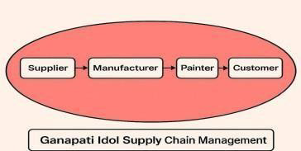

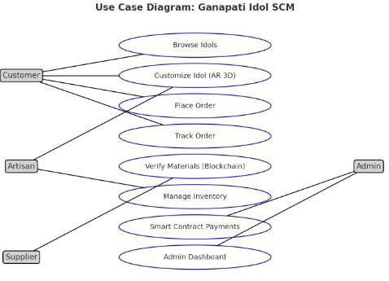
Implementation:
The approach involved in the implementation plan for this survey paper is to first design and develop the core architecture by integrating AI with blockchain technology in a phased manner. First, data collection and preprocessing will be carried out to trainMachine learning models will be developed to forecast demand and suggest personalized products, while blockchain-based smart contracts will ensure secure, transparent, and tamper-proof tracking of transactions and materials. A web-based interface with interactive features shall be developed. This shall also include augmented reality-enabled 3D visualization for the real-time customization of Ganapati models. The system shall thereafter be subjected to integration testing, ensuring that AI modules, blockchain ledgers, and the front-end application can communicate well. After verification, it shall be deployed in a pilot phase among selected artisans, suppliers, and customers for feedback and refinement. The further work shall involve continuous monitoring and iterative enhancement towards scalability, high user satisfaction, and long-term sustainability objectives.

B. Propose System Introduction:
The system architecture proposed in this paper is a comprehensive multilayer framework that ensures a supply chain management solution which will be secure, intelligent, and transparent for the Ganapati idol retail sector. This is designed in six interdependent tiers. The Frontend Layer provides an intuitive interface built with modern frameworks such as ReactJS or Angular, thereby enabling the stakeholders-suppliers, manufacturers, and customers-to interact smoothly. The API Layer acts as a secure intermediary by authenticating the requests and transferring data efficiently between the frontend and the backend. The Business Logic Layer enforces the business rules and integrates both blockchain and database systems for the function of production tracking, order management, and control over workflow. At the very heart of trust and accountability, the Blockchain and Smart Contracts Layer ensures immutable records of each transaction and automates-perhaps through decentralized verification-certain processes such as payments and inventory updates. The Database Layer manages a variety of both static and dynamic datasets-from user information to inventory records, to AI-generated output used in analytics and forecasting. Finally, the Dashboard Visualization Layer offers real-time, role-based insight into key indicators, such as stock levels, shipment status, and production activities that have taken place, thus facilitating effective decision-making with the help of supply chain management.
Use Case Diagram:
This use case diagram depicts the interaction of various stakeholders of the supply chain management platform for the Ganapati idol with the main features of the system. The customers can view the idols, customize them in 3D using AR, place the order, and track the delivery status. Through the system, the artisans can manage their inventory of idols and customize them according to the customer's requirements. The suppliers will verify the quality and authenticity of the eco-friendly raw materials through blockchain-based validation.
In contrast, the admin controls the entire system through the dashboard, ensuring smooth and secure transactions via blockchain-enabled smart contracts. The ellipses are representations of use cases, or tasks/functionalities, while the lines that connect them show the relationships the actors have with those tasks. Or better to say, this diagram defines both who the users of the system are and what type of actions they will be enabled to perform by making the platform transparent, secure, and customer-friendly.
Survey Analysis:
A survey conducted to gauge the acceptance of digital platforms amongst artisans on the question: “Would you be interested in selling your idols online?” revealed an unequivocal interest, with 100% strongly showing a willingness to do so. The overwhelming response indicates that the artisans are ‘ready for adoption’ of digital solutioning, besides underscoring the pragmatic relevance of the proposed system, especially since the platform addresses industry needs; it therefore validates the project's objectives of modernization, efficiency, and sustainability.
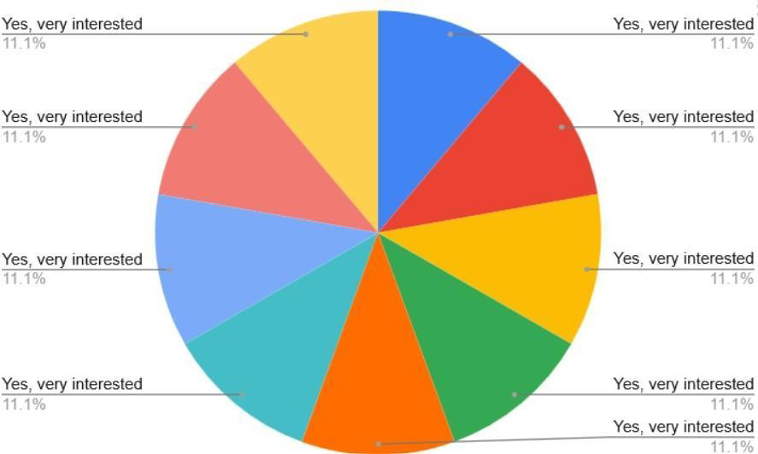
Implementation Workflow: -
Sample of Inputs, Outputs, and GUI Screenshots
a colourful banner. It displays a selection of handcrafted Ganpati idols. This makes it simple for people to explore and discover unique products. The design creates a festive vibe and invites users to begin browsing immediately.

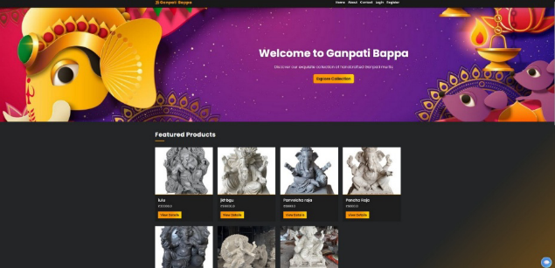
Home Page
The Login and Registration Pages: they allow users to create accounts and sign in securely. Users can choose their roles as either a customer or a murtikar. After that, they can access their own dashboards and features.

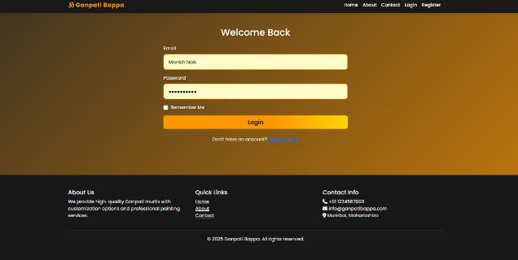
Login Page

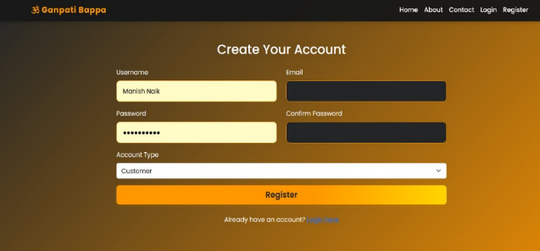
Registration Page

Pheta Page

About Page:The About Page explains the origin and vision of Ganpati Bappa. It shares the brand’s commitment to merging tradition with artistic skill. It also outlines the values that guide the website, which helps build trust and authenticity with visitors.

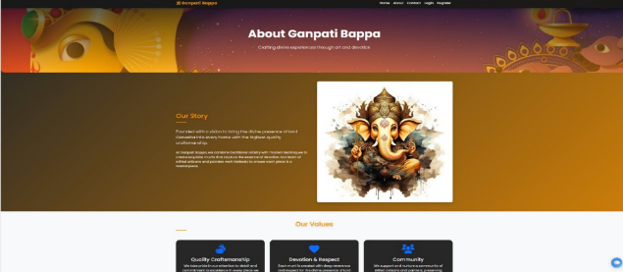

About Page

Contact Page: The Contact Page features an easy message form and full contact details. This allows users to reach out for questions, support, or collaboration opportunities.

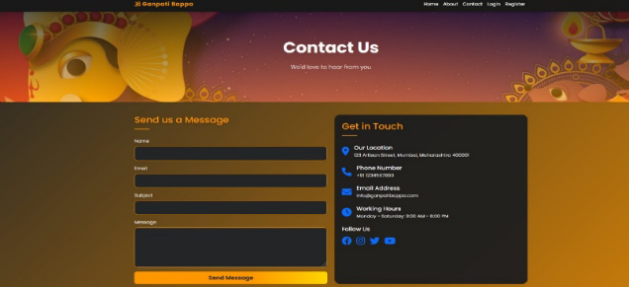

Contact Page
Pheta Page and Colouring Page: The images show an e-commerce web application for customizing and ordering Ganapati murti designs. Users can select photo references, personalize painting instructions, and specify jewellery details. They can also place orders on a checkout page. The dashboard helps painters manage orders easily and view their assigned tasks.
Murtikar Upload Page: On the Murtikar Portfolio Page, idol makers, or murtikars, can upload, display, edit, and manage their collection of Ganpati murtis. They can organize their portfolio to draw in customers and keep track of their creations.

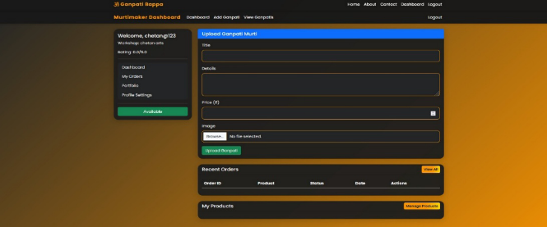
Murtikar Upload Page
Murtikar Portfolio Page: On the Murtikar Portfolio Page, idol makers, called murtikars, can upload, display, edit, and manage their collection of Ganpati murtis. They can organize their portfolio to attract customers and keep track of their creations.

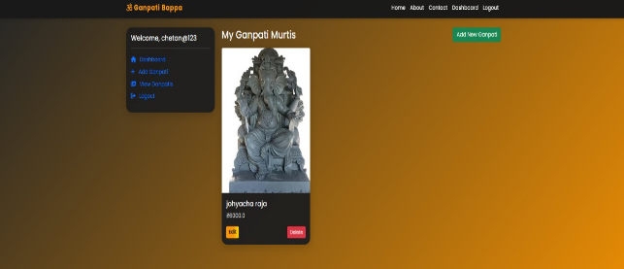
Murtikar Portfolio Page
Customer Page: The Customer Page shows personalized greetings, featured idols, order summaries, and easy access to carts and orders. This setup makes every customer feel valued and helps them understand what they are doing.

Customer Page

Shopping Cart Page and My Orders (Customer) Page: The Shopping Cart Page displays selected items. It helps customers manage their purchases before checkout. This leads to a smooth shopping experience.
The My Orders Page shows all the orders a customer has placed. It simplifies tracking orders and viewing order history.

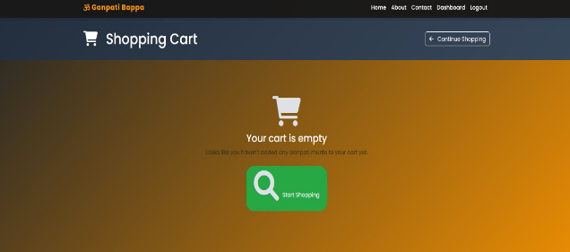
Shopping Cart Page
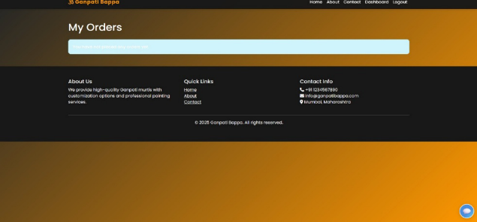
My Orders (Customer) Page
Painter Dashboard and Painter Portfolio Page: The Painter Dashboard and Portfolio Pages allow painters to track their assigned orders, showcase their work portfolio, and manage their availability for new commissions. This promotes a smooth workflow and improves visibility.

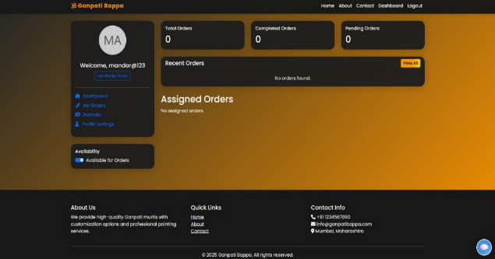
Painter Dashboard
Painter Portfolio Page: Here, you can find the painter's information. His work, performance, orders, and other details show his availability for new commissions. This helps keep the workflow steady and ensures visibility.


Painter Portfolio Page

Summary:
This project demonstrates how integrating Artificial Intelligence and blockchain can transform the conventional Ganapati idol supply chain into a more transparent, efficient, and customer-centric ecosystem. Using blockchain's immutable ledger, the system reduces paperwork, human error, and third-party overhead, thereby lowering operational costs and accelerating dispute resolution.
Smart contracts further automate payments and track provenance, making sure that, for example, raw materials like biodegradable clay and plant-based pigments are verifiably certified on-chain to further build trust between artisans, suppliers, and customers. AI-driven analytics amplify operational efficiency via demand forecasting and personalized recommendations. Time-series models like LSTM accurately forecast seasonal Ganapati demand, enabling better planning and reducing inventory costs through dynamic segmentation. Similarly, AI-driven logistics optimization improves distribution efficiency. Such a reduction of operational waste and inefficiency was demonstrated in platforms like Uber Freight, where machine learning reduced empty miles. On the customer side, the AR-enabled 3D customization tool enhances engagement and conversion, with retailers seeing increased sales and attaining higher average order values as shoppers can interact with products virtually before buying. Lastly, implementing hybrid Layer-2 blockchain solutions increases transaction throughput while reducing gas fees; integrating Large Language Models enables advanced query handling and conversational interfaces. Recent studies indicate that integration of LLMs and IoT, and blockchain data can enhance decision-making and operational insights, which would be a valuable way to extend system capabilities.

In conclusion, the proposed
The AI-blockchain-enabled Ganapati idol platform strikes a balance between efficiency and trust, hence presenting a sustainable, transparent, immersive e-commerce model. Beyond religious artistry, it creates a scalable blueprint for modernizing the artisanal markets and fostering eco-conscious digital marketplaces.
Future Scope:
In the future, the platform can be expanded by developing a dedicated mobile
applications cater to both artisans and customers, with multi-language support to ensure wider access. AI-powered marketing tools can even help artisans showcase their idols to a wider customer base by recommending intelligent suggestions and personalized promotions. Integrations can be further made for trusted logistics partners and secure payment gateways that help in smooth order fulfilment and delivery operations. It will require continuous improvements in order to maintain scalability, user adoption, and sustainability over the long term. These will modernize not only the traditional Ganapati idol supply chain but also create an inclusive, efficient, and eco-friendly digital marketplace.
References:
[1] O. Kuznetsov, P. Sernani, L. Romeo, E. Frontoni, and A. Mancini, "On the Integration of Artificial Intelligence and Blockchain Technology: A Perspective About Security," in IEEE Access, vol. 12,
pp. 3881-3897, 2024, doi: 10.1109/ACCESS.2023.3349019.
[2] P. Dudczyk, J. K. Dunston, and G. V. Crosby, "Blockchain Technology for Global Supply Chain Management: A Survey of Applications, Challenges, Opportunities and Implications," in IEEE Access, vol. 12, pp.
70065-70088, 2024, doi:10.1109/ACCESS.2024.3399759.
[3] G. Culot, M. Podrecca, and G. Nassimbeni, “Artificial intelligence in supply chain management: A systematic literature review of empirical studies and research directions,” International Journal of Production Economics, vol. 250, pp. 108–123, 2024, doi:
10.1016/j.ijpe.2024.108123.
[4] R. Toorajipour, V. Sohrabpour, A. Nazarpour, P. Oghazi, and M. Fischl, “Artificial intelligence in supply chain management: A systematic literature review,” J. Bus. Res., vol. 122, pp. 502–517, 2021,
doi:10.1016/j.jbusres.2020.09.009.
[5] A. Yadav, R. K. Garg, and A. Sachdeva, “Artificial intelligence applications for information management in sustainable supply chain management: A systematic review and future research agenda,” Int. J. Inf. Manag. Data Insights, vol. 4, no. 2, p. 100292, 2024,
doi:10.1016/j.jjimei.2024.100292.
[6] L. Witt, A. T. Fortes, K. Toyoda, W. Samek, and D. Li, “Blockchain and Artificial Intelligence: Synergies and Conflicts,” arXiv preprint arXiv:2405.13462, 2024. [Online].
Available: https://arxiv.org/abs/2405.13462
[7] J. D. Harris and B. Waggoner, “Decentralized and Collaborative AI on Blockchain,” in Proc. 2019 IEEE International Conference on Blockchain (Blockchain), Jul.2019,.368–375,
doi:10.1109/Blockchain 2019.00057.
[8] D. Bhumichai, C. Smiliotopoulos, R. Benton, G. Kambourakis, and D. Damopoulos, “The Convergence of Artificial Intelligence and Blockchain: The State of Play and the Road Ahead,” Information, vol. 15, no. 5, art. 268, 2024, doi:10.3390/info15050268.
[9] A. Gupta, G. Awatade, S. Padole, and Y. Choudhari, “Digital Supply Chain Management Using AI, ML and Blockchain,” 2022,
doi:10.1007/978-981-19-0240-6_1.
[10] A.-A. A. Sharabati and E. R. Jreisat, “Blockchain Technology Implementation in Supply Chain Management: A Literature Review,” Sustainability, vol. 16, no. 7, art. 2823, 2024, doi:10.3390/su16072823.
[11] V. Charles, A. Emrouznejad, and T. Gherman, “A critical analysis of the integration of blockchain and artificial intelligence for supply chain,” Annals of Operations Research, vol. 327, no. 1, pp. 7–47, Aug. 2023, doi:10.1007/s10479-023-05169-w.
[12] K. Wannenwetsch, I. Ostermann, R. Priel, F. Gerschner, and A. Theissler, “Blockchain for Supply Chain
Management: A Literature Review and Open Challenges,” Procedia Computer Science, vol. 225, pp. 1312–1321, 2023, doi:10.1016/j.procs.2023.10.119.
[13] E. Hirata, M. Lambrou, and D. Watanabe, “Blockchain technology in supply chain management: insights from machine learning algorithms,” Maritime Business Review, vol. 6, no. 2, pp. 114–128, May 21, 2021, doi:10.1108/MABR-07-2020-0043.
[14] P. K. Singh, “Digital Transformation in Supply Chain Management: Artificial Intelligence (AI) and Machine Learning (ML) as Catalysts for Value Creation,” International Journal of Supply Chain Management, vol. 12, no. 6, pp. 57–63,
2023, doi:10.59160/ijscm.v12i6.6216.
[15] N. Tsolakis, R. Schumacher, M. Dora, and M. Kumar, “Artificial intelligence and blockchain implementation in supply chains: a pathway to sustainability and data monetisation?” Annals of Operations Research, vol. 327, no. 1, pp. 157–210, Aug.
2023, doi:10.1007/s10479-022-04785-2.
[16] M. Islam, M. Monjur, and T. Akon, “Supply Chain Management and Logistics: How Important Interconnection Is for Business Success,” Open Journal of Business and Management, vol. 11, pp. 2505–2524, 2023,
doi:10.4236/ojbm.2023.115139.

