16
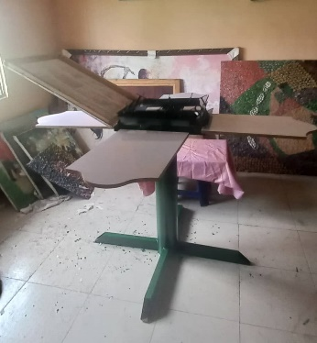
Picture of the Researchers with screen printing machine produced.
17
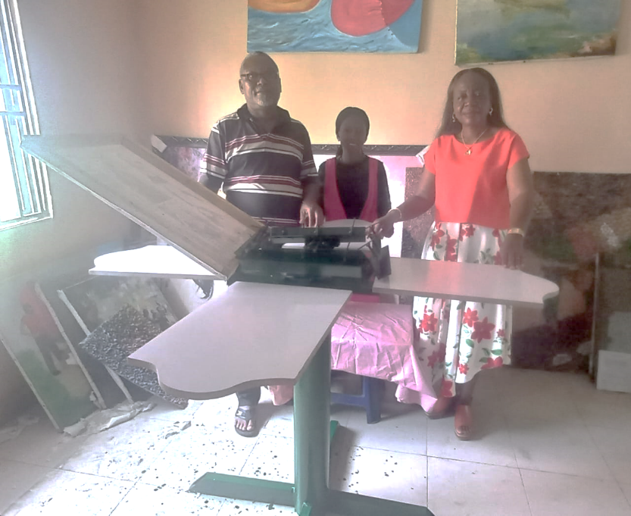
Researchers posed with the Finished and Functional Screen Printing

18
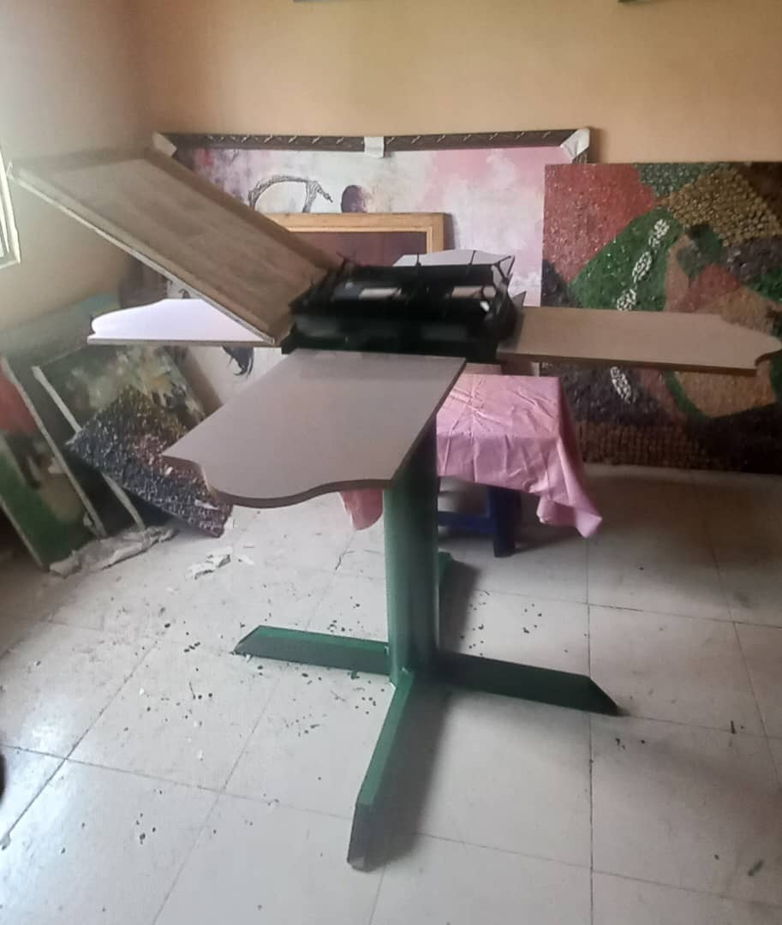
Functional Screen Printing Machine
Finishing
This is the final assemble of the Manual Screening Printing Machine in functional state with a four printing base printing at the same time with four colours and a printer. This process enables the printer to attend to a four coloured work at the same time without calling for assistant. Conclusions
We are aware there are auto mechanical screen Printing Machine available across the continent but some artisan still fine this very useful as it help to quicken the production of their printing work as they find it very difficult to gather the resources needed to pay for a brand new auto base screen printing machine following the state of our countries economy. The introduction of this machine to the Fine and Apply arts Department of the Federal College of Education (Technical) Asaba will bring a great relief to both Staff and Students of the department.

Recommendations
The following recommendations are hereby made:
- Government should increase participation in practical research equipment and machine development in the department of Fine and Applied arts, Federal College of Education (Technical) Asaba and other institutions across the country.
- Staff and students of institutions of higher learning should be encouraged to go into creating tools that will enhance the easy achievement of their creative ideals in this era of AI Technology.
- Tetfund should not relent in sponsoring more Academic research in relevant areas in Vocational and Technical sub sector in the tertiary institutions in Nigeria by making fund available.

References
Adeyeye, O. (2020). “Evaluation of Developments in Offset Lithography Printing Industry in
South West Nigeria”. (Ph.D. Seminar)
Baines, J. (2019). “A History of Screen Printing: Tracing Our Industry’s Roots”. Oxford: Oxford
University Press.
Catherine, S. (2011), “History of screen printing” Curator JTPM
Daniel, O. O., Haruna, A. A. and Atanu, B. U. (2009). “Lithographic Plate and Serigraphic Mes
Making Machine”. p. 10, 12, 27

Ifeanyi O. D, Ogunode N. J. and Ajape T. S. (2021). Shortage of funds in the Nigerian Public
Universities: causes effects and ways forward. Innovative Technologica Methodical
Research Journal, Vol. 2 issue 7
Lastimosa, M. (2018). "Introduction to Screen-printing" (2018). Curricula. 30.
https://scholarworks.lib.csusb.edu/cap-curr/30
Kipphan, H. (ED). (2001). Handbook of print media technologies and production methods
(1st ed.).Berlin: Springer.

Komi, S. (2015) Sakurai-Future screenprinting applications.
http://www.natgraph.co.ukpdfs/Sakurai

Luke, G. (2022). “Research and Market Challenges for the Printing Industry”. Global Industry
Analysis Inc, Guinness Centre Taylors Lane, Dublin 8, Ireland

Ukazu, I., 2022 “Why fine art education is struggling and needs an overhaul” Institute of
Management and Technology (IMT), Enugu State

