A Review of the Use of Hydrocolloids in Texture-Modified Foods for the Management of Dysphagia

Tanzia Islam Shorna¹, Zou Ping²
¹ Graduate Student, Department of Pharmacy, School of Biological & Food Engineering, Changzhou University, Wujin District 213164, Changzhou City, Jiangsu Province, P.R. China
² School of Biological & Food Engineering Health, Changzhou University, Wujin District 213164, Changzhou City, Jiangsu Province, P.R. China

Abstract
Dysphagia refers to difficulty swallowing which is estimated to affect more than 800 million people worldwide and occurs by conditions (e.g. neurological diseases, aging, stroke, head and neck cancers). Swallowing is one of the most complex and coordinated physiological activities that human beings engage in but patients with dysphagia may have impaired safe intake of food and liquids, necessitating innovative solutions to avoid complications including aspiration pneumonia, malnutrition, dehydration. Dietary modification, most notably in terms of texture-modified foods (TMFs) and thickened liquids, has emerged as one of the mainstay non-pharmacological approaches in dysphagia management. Due to their unique capacity of modifying viscosity and bolus cohesion at swallowing, stability; hydrocolloids are a major formulation component in these type of foods. These biopolymers consisting of polysaccharides and proteins are common food ingredients to be used as thickening, gelling and stabilizing agents in various food systems; hence utilised in dysphagia diets. This review aims to give an comprehensive overview of the unique characteristics that hydrocolloids play to modify food consistency for patients with dysphagia. The paper first considers the pathophysiology of dysphagia and its nutrition implications, then provides a background on the International Dysphagia Diet Standardisation Initiative (IDDSI) framework for food textures and liquid thickness classification. It explores functional and physicochemical properties of hydrocolloids, focusing on their rheological behaviour and the production of swallowing-safe products. This has led to efforts aimed at leaving the corresponding backgrounds of dysphagia and its diet in reformation, selecting appropriate hydrocolloids for use as thickening vehicles in persons with dysphagia and analysing their properties such as molecule thickening and stability as well as teaching how thickness can help take care of swallowing situation between mechanisms. The review also emphasizes the role of rheological characterization in safe swallowing and optimal bolus flow.
In addition, the uses of hydrocolloids in thickened beverages, pureed meals and ready-to-eat dysphagia products are also described. This article critically reviews the challenges of hydrophilic hydrocolloids investigated for food fortification purposes, in particular with regards to sensory acceptance, variability in viscosity and risk of nutritional dilution. The article is also reviewed to assess the potential of novel approaches (eg, hydrocolloid blends, microstructural design and 3D food printing) in developing high-quality or personalized diets for dysphagia management.
In conclusion, hydrocolloids serve as functional components to enhance the safety, stability and palatability of texture-modified foods frequently consumed by dysphagia patients. Ongoing endeavours to elucidate the mechanism of hydrocolloid action, as well as investigations into optimally rheological properties and consumer acceptability, will ultimately work to inform improvements in dysphagia management.
KEYWORDS — Dysphagia; Hydrocolloids; Texture-modified foods; Food rheology; Thickened liquids; IDDSI framework (2015); Xanthan gum; Food texture; Swallowing disorders

1. Introduction

1.1 Overview of Dysphagia
Dysphagia describes difficulty swallowing and is a common problem overall, but especially among older patients and those with neurological conditions. The act of swallowing is a complex coordinated physiological process between oral cavity, pharynx, larynx, esophagus and many cranial nerves. Dysfunction of swallowing is the result of any impairment in these structures or their neurologic control. Dysphagia can result from any number of underlying conditions, such as stroke, Parkinson's disease, dementia, traumatic brain injury (TBI), head and neck cancer, cerebral palsy and age-related wear-and-tear of the muscles [1, 2]. Global aging of the population and improved survival rates for chronic diseases have resulted in a substantial increase in dysphagia [3]. Research suggests that 8–16% of the general population may develop difficulty swallowing at some point in their life with numbers exceeding 50% in older adults living in long term care [15,3,13]. Dysphagia is also very common among patients with neurological diseases, occurring in > 30–65% of stroke survivors and a considerable number of people with Parkinson's disease and dementia [4]. Dysphagia is not just a swallowing disorder but rather a public health problem. It is associated with significant adverse medical outcomes such as aspiration pneumonia, malnutrition, dehydration, decreased quality of life, longer hospital stays and mortality [4, 5] Thus, the efficient management of dysphagia has been integrated as a key pillar in contemporary healthcare systems, especially for geriatrics and rehabilitation units [6].

1.2 Global Prevalence and Clinical Impact
The worldwide high incidence of dysphagia has gained more focus from clinicians, scientists, and food specialists [7]. One of the main reasons for the increased occurrence of swallowing disorders is population aging [8]. Demographic projections indicate that the percentage of people >65years will show a substantial rise in the next decades, with an accompanying increase in swallowing impairments [9]. Dysphagia is not only characterised by issues with food ingestion and has far-reaching clinical consequences. Aspiration is the most severe complication that occurs when food or fluid reach the trachea instead of going to esophagus [10, 11]. Aspiration can result in aspiration pneumonia, which is one of the top 10 causes of morbidity and mortality among elderly patients [12]. Moreover, patients with dysphagia often suffer from poor food intake due to choking fear, long mealtime and lower interest of solid foods [13, 14]. This can lead to weight loss, muscle wasting, compromised immunity and longer recovery from illness [15, 16]. The psychological and social impacts are no less important. Numerous patients report that meals now induce anxiety, that they will only eat infrequently outside of the house or avoid noisy environments altogether [17]. Thus, dysphagia can impair emotional wellbeing and quality of life [18, 19]. These difficulties emphasize the need for a multidisciplinary management approach that includes physicians, speech-language pathologists, dietitians, nurses and food scientists [20].

1.3 Role of Texture-Modified Foods
One of the most common interventions in management of dysphagia is texture-modified foods [ 21]. These products are formulated with physical properties which allow for these foods to be bolused safely, but at the same time prevent aspiration and choking. [22] Texture modification is mainly used to change the sensory properties of foods and beverages in relation to each patient swallowing ability, such as consistency, viscosity, hardness, cohesiveness and adhesiveness [23]. Texture-modified foods can help with bolus control and improving swallowing, which makes these options effective [24]. Thin liquids travel quickly through the oral cavity and pharynx facilitating minimal control for individuals with compromised swallowing function [25, 26]. Conversely, thickened liquids are slower moving→ longer time for airway closure→ decreased aspiration risk [27]. Likewise, foods that are soft and cohesive tend to be more workable and ingestible than hard, dry, or fragmentary foods [28].
While the safety of swallowing is improved through texture modification, the ideal trade-off between safety, nutrition and sensory acceptability continues to be difficult [29]. An excessive degree of thickening can cause poor palatability, fluid poorly tolerated and dehydration [30, 31]. Thus, a scientific approach is needed to produce safe texture-modified foods that meet the consumers needs nutritionally in an acceptable way [32].

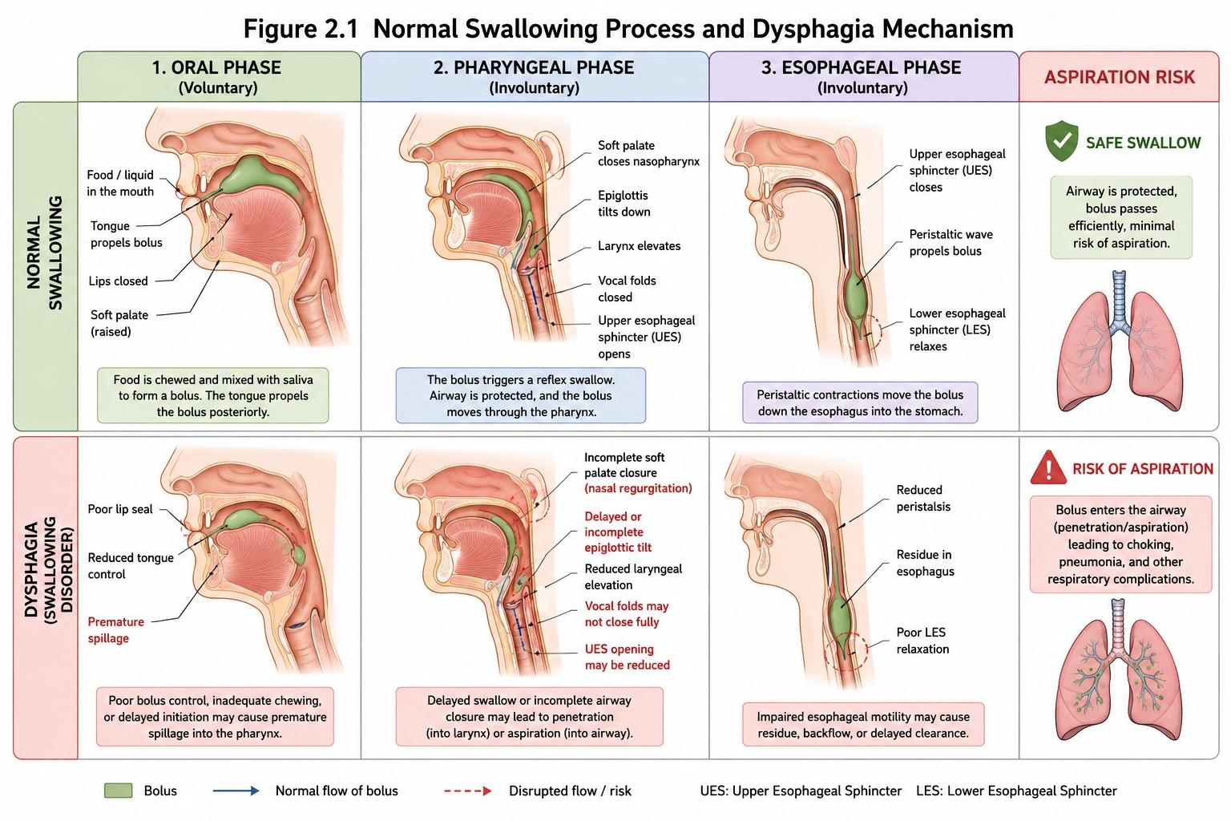
Figure1.1 Normal Swallowing Process and Dysphagia Mechanism

1.4 Importance of Hydrocolloids in Dysphagia Management
Hydrocolloids are considered one of the most valuable functional ingredients especially in formulation of texture-modified foods for dysphagia management [33, 34]. Hydrocolloids are water interacting high-molecular-weight polysaccharides or proteins that provide thickening, gelling, stabilizing and/or water-binding properties [35]. Their capacity to alter the structure of foods rendered them different in both clinical nutrition and also food manufacture [36]. Hydrocolloids used today for dysphagia-oriented food systems are diverse and include xanthan gum, guar gum, locust bean gum, carrageenan, alginate, pectin, konjac glucomannan and modified starches [37, 38]. These ingredients allow a measure of control over viscosity and texture, enabling food developers to produce products that meet swallowing safety guidelines while preserving other important sensory characteristics [39, 40]. In this context, xanthan gum attracted attention because it has a very high thickening potential, well endure temperature and pH changes, and is not degraded by salivary α-amylase [41-43]. Xanthan gum, as opposed to starch based thickener such as custard powder maintains its viscosity through oral processing and hence swallowing behavior is more predictable [44]. Moreover, the interaction between xanthan gum and other hydrocolloids can be synergistic to form stable gel network that makes boluses more cohesiveness to swallow [45, 46].
In addition to the thickening property, hydrocolloids contribute to moisture retention, provide stabilization of suspensions, control or even regulate flavor release and enhance mouthfeel [47].

1.5 Objectives and Scope of the Review
The rising demand for safe, palatable and consistent texture-modified foods has stimulated considerable research work on hydrocolloid-based formulations designed specifically for dysphagia management [48]. While substantial progress has been made in this area, information concerning the mechanisms, functionality, applications, and potential future benefits of hydrocolloids is still scattered over many scientific disciplines. Hence, the main purpose of this review is to summarize hydrocolloids with a focus on their functionalities in texture-modified foods aimed at dysphagic patients. The review presents an overview of the classification and physicochemical properties of major hydrocolloids, pursuit for the thickening and gelling mechanisms; physiologic effects on rheological and tribological properties were also studied; finally, applications in a range of dysphagia-oriented food products are discussed [49]. Moreover, the review explores barriers, advances in technology and directions for future research which can facilitate enhancement of dysphagia nutrition to improve patient outcomes [50]. The purpose of this review is to combine knowledge from food science, rheology, nutrition and clinical swallowing research in order to serve as a resource for researchers, healthcare professionals and food manufacturers working on developing new hydrocolloid-based approaches for dysphagia management.

2. Dysphagia and Texture Modification Requirements

2.1 Swallowing Physiology
Swallowing is a complicated neuromuscular function, providing safe transit of food and liquids from the oral cavity to the stomach while also protecting the airways during swallowing [51]. More than thirty muscles and a number of [51, 52] cranial nerves are implicated in the orchestration of this process. Swallowing during normal feeding happens fast and does so in a very efficient manner, usually within seconds, and requires specific timing of sensory and motor processes [53]. Swallowing has traditionally been classified into a four-phased process including the oral preparatory, oral transit, pharyngeal, and esophageal phases [54]. The food is chewed and mixed with saliva to produce a cohesive bolus during the oral preparatory phase. During the oral transit stage, tongue driving the bolus to the pharynx. Laryngeal elevation and epiglottic closure for rapid airway protection occurs during the pharyngeal phase when the bolus travels through the pharynx. Lastly, in the esophageal stage peristaltic contractions propel the bolus to the stomach.
Any disturbance to these intact protective physiological mechanisms in the swallowing pathway may compromise swallowing safety and efficiency. Neurological disease, muscle weakness, anatomical changes in the oral cavity or pharynx and physiological alterations due to aging may affect bolus formation, oral control/airway protection and esophageal transport leading to aspiration and nutritional problems [55].

2.2 Texture Modification Strategies
It is well established that, of the non-invasive interventions available to treat dysphagia, texture modification is among the most effective [56]. What is required primarily is to change the properties of the food and beverage in order to fit the swallowing ability of different patients. Based on the texture-modification principles, palatable solid foods can be encouraged in a therapeutic way so that they maintain their liquidity during swallowing to allow safe swallowing and provide sensory satisfaction [57]. There are several physical characteristics affecting swallowing performance, such as viscosity, cohesiveness, adhesiveness, hardness and particle size. Thin liquids are more easily ingested and likely enters the airway before protective mechanisms activate, especially in individuals with delayed swallowing [58]. Thickened liquids are also capable of prolonging the time for airway closure, hence improving swallowing coordination since they transit slowly [59]. Food texture has a similar impact on oral processing and bolus formation. These high demand foods that are too hard, dry, sticky or crumbly may pose an increased chewing and swallowing challenge. Soft, cohesive, wet food does not fragment so easily during oral processing, and is therefore generally easier to swallow [60]. Texture modification is thus an essential aspect of dysphagia support that helps to bridge the clinical and nutritional requirements [61].

2.3 International Dysphagia Diet Standardisation Initiative (IDDSI)
Before the creation of standardized nomenclature, various descriptors were used by healthcare providers, such as “nectar-thick”, “honey-thick” or “pudding-thick,” which caused confusion among clinicians, caregivers and those initiating nutrition products. The International Dysphagia Diet Standardisation Initiative (IDDSI) has therefore developed an internationally standardised system for classifying texture-modified foods and thickened liquids.
Drinks are classified using the IDDSI framework from a thickness of Level 0 (Thin) to Level 4 (Extremely Thick), and foods accumulated using all liquid food [Level 3 (Liquidised)] through to solid and regular feeding levels together with level seven (Regular) [61]. It classifies using flow testing, fork drip test, spoon tilt test as well as particle size [62]. These standardized processes allow healthcare professionals to communicate with each other and help maintain consistency across various healthcare settings. The use of IDDSI has improved the safety and effectiveness of dysphagia management as it provides a common language for describing food
and liquid textures, and has been widely embraced by regions in North America [63].

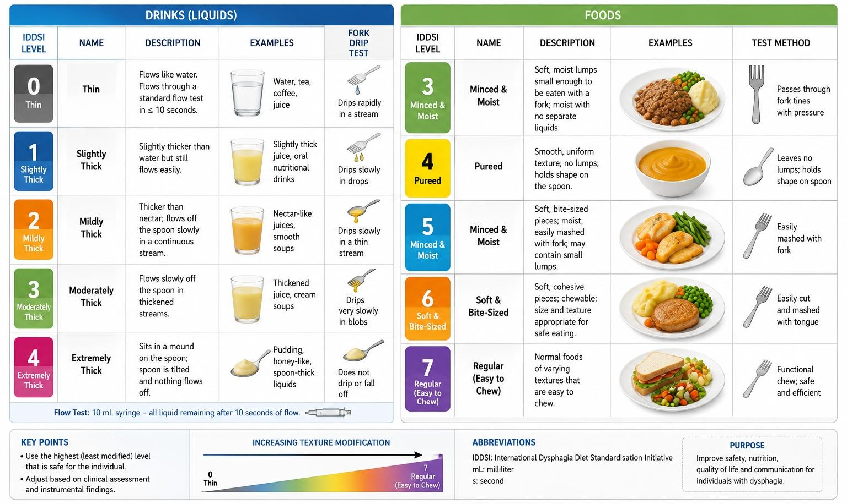
Figure 2.1. IDDSI Framework for Texture-Modified Foods and Thickened Liquids
Table 2.1. IDDSI Levels and Characteristics
IDDSI Level | Classification | Characteristics | Examples
Level 0 | Thin | Flows like water | Water, tea, juice
Level 1 | Slightly Thick | Slightly thicker than water | Specialized thickened drinks
Level 2 | Mildly Thick | Moderate flow reduction | Thickened beverages
Level 3 | Moderately Thick / Liquidised | Can be drunk from cup or spoon | Thick soups
Level 4 | Extremely Thick / Pureed | Requires spoon | Pureed vegetables
Level 5 | Minced and Moist | Small soft particles | Finely minced meat
Level 6 | Soft and Bite-Sized | Tender food pieces | Soft cooked vegetables
Level 7 | Regular | Normal food texture | Standard diet

3.4 Clinical Requirements for Safe Swallowing
The choice of a suitable food texture is influenced by various clinical factors such as swallowing physiology, aspiration risk, chewing ability, nutritional status and the preferences of the patient. Safe swallowing involves the creating of a bolus that can traverse the oral cavity and pharynx without fragmentation [64].
Swallowing safety is influenced by multiple rheological properties. Viscosity is an intrinsic property affecting bolus flow rate and airway protection, while cohesiveness impacts bolus integrity during transport. The yield stress enhances the bolus stability and the lubricating properties determine how easily the bolus can glide through pharyngeal structures [65].
Because dysphagia severity varies greatly between patients, texture modification should be adapted to the individual patient [66]. More than excessive thickening can decrease palatability and fluid intake, resulting in dehydration [67]. On the other hand, if thickening is inadequate, swallowing safety may be compromised [68]. Hence, clinicians should carefully consider safety, nutritional benefits and patient acceptability regarding texture-modified diets [69].
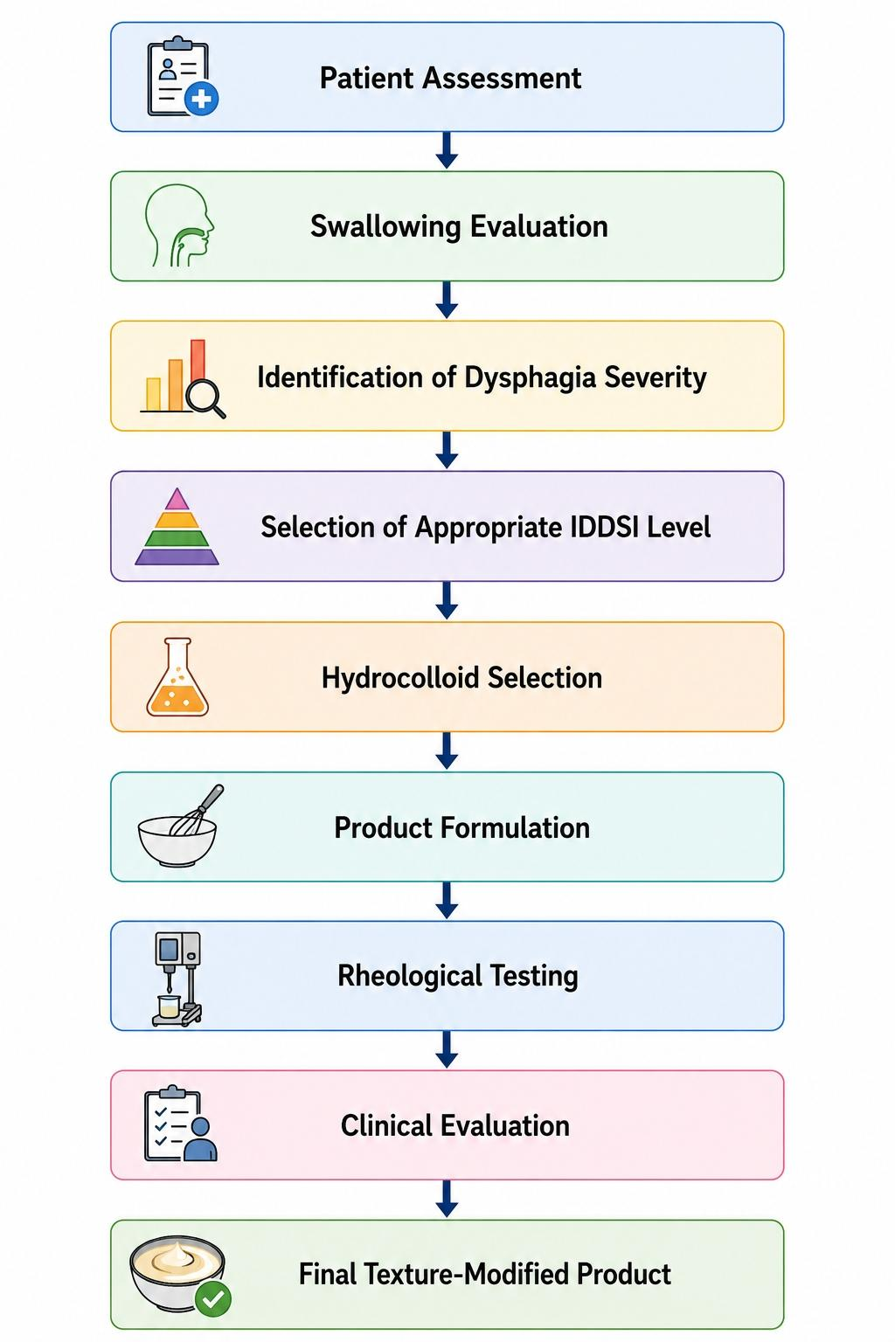
Flowchart 1. Development Process of Texture-Modified Foods

2.5 Importance of Texture Standardization in Dysphagia Nutrition
Standardization plays a critical role in ensuring consistent product quality, patient safety, and clinical effectiveness. The adoption of internationally recognized frameworks such as IDDSI facilitates communication among healthcare professionals, researchers, caregivers, and food manufacturers. Standardization also supports product development by providing measurable targets for viscosity, texture, and swallowing performance. In recent years, increasing attention has been directed toward the integration of food science and clinical swallowing research [70]. Advances in rheology, tribology, hydrocolloid chemistry, and personalized nutrition have contributed to the development of safer and more acceptable texture-modified foods [71]. These developments highlight the importance of continued research into the functional ingredients and technologies that underpin dysphagia nutrition. The successful implementation of texture-modified diets ultimately depends on a combination of scientific evidence, clinical expertise, and patient-centered care. As the prevalence of dysphagia continues to rise globally, the need for innovative and standardized approaches to texture modification will become increasingly important [72].

3. Hydrocolloids: Classification and Functional Properties

3.1 Definition and Classification of Hydrocolloids
Hydrocolloids are a heterogeneous group of polymers (with high molecular weight) that interact in an energetic manner with water thereby leading to thickening, gelling, stabilizing, emulsifying and water-retention effects [73, 74]. Most food hydrocolloids are polysaccharides but a few proteins also possess hydrocolloid functionality. Hydrocolloids have become an important food ingredient in the formulation of texture-modified foods prepared specifically for patients with dysphagia, due to their unique ability to alter the rheological properties and microstructure of food [75]. Hydrocolloid is derived from the Greek word hydro (water) and kolla (glue), meaning that large molecules can form viscous dispersions or gels when hydrated by water. They function based on molecular weight, charge distribution, branching pattern, and environmental conditions such as pH, temperature, ionic strength, and concentration [76].
Methods of classification According to the biological origin food hydrocolloids can be categorized into 4 groups. They are plant-derived hydrocolloids, including guar gum, locust bean gum, pectin, gum arabic, and konjac glucomannan [77]. Some examples of microbial hydrocolloids are xanthan gum and gellan gum [78]. Marine hydrocolloids contain alginate, carrageenan and agar. Evidence of swallowing functions at an early stage After reviewing the literature related to the oral and pharyngeal phases, modified starches are another category that represent a simple and inexpensive alternative used in dysphagia foods [79].
Table 3.1. Classification and Sources of Major Hydrocolloids
Hydrocolloid | Source | Major Function | Common Dysphagia Application
Xanthan Gum | Microbial fermentation | Thickening, stabilization | Thickened beverages
Guar Gum | Guar seed | Thickening | Purees and beverages
Locust Bean Gum | Carob seed | Thickening, synergistic gelation | Hydrocolloid blends
Alginate | Brown seaweed | Gel formation | Gel-based foods
Carrageenan | Red seaweed | Gelation, stabilization | Dairy-based dysphagia foods
Pectin | Citrus peel, apple pomace | Gelation | Fruit-based products
Konjac Glucomannan | Konjac tuber | Strong thickening | Soft gel foods
Modified Starch | Various starch sources | Thickening | Commercial dysphagia products
Selection of hydrocolloids depends on the required properties of the final product, safety for swallowing requirements, nutritional needs and processing regimes [80]. Because of its very powerful thickening effect and salivary enzymatic physical degradation resistance, xanthan gum has rapidly become one of the most used hydrocolloids in clinical nutrition 81].

3.2 Sources of Hydrocolloids
Hydrocolloids are derived from different natural and industrial sources. Plant-derived hydrocolloids are obtained from seeds, roots, fruits and exudates [82]. Guar gum is derived from the endosperm of guar beans and pectin mostly from citrus peels and apple pomace [83] (Table 3.1). Marine hydrocolloids come from different species of seaweeds. Alginate is derived from brown algae, and carrageenan and agar originate from red algae [84]. These properties, in particular the gel-forming capabilities and their compatibility with a variety of food systems, make these hydrocolloids valuable [85]. Subsequently, these microbial hydrocolloids are produced by fermentation processes. Xanthan gum is produced by Xanthomonas campestris, and is one of the most important commercially available hydrocolloids used in the management of dysphagia as a result of its exceptional rheological properties [86]. Diversity of hydrocolloid sources offers food scientists a large spectrum of functional ingredients that can be customized according to particular clinical and technological needs [87].

3.3 Physicochemical Properties of Hydrocolloids
Physicochemical properties of hydrocolloids are responsible for the functionality and performances in producing texture-modified foods [88]. Molecular weight, water-binding capacity, viscosity development, gelation behavior, thermal stability and interactions with other food components are important properties [89]. Hydrocolloids characteristically contain a large number of hydroxyl groups, which can interact with water molecules via hydrogen bonds [90]. You are edited for data up through October 2023. Hydration capacity differs for various hydrocolloids as a function of both molecular architecture and environmental conditions.
Molecular flexibility is another important property. This is expected because flexible polymer chains can easily "meander" and entangle, producing high-viscosity solutions while rigid ones may have atypical rheological behavior such as shear-thinning [91]. Charge distribution also influences functionality. Anionic hydrocolloids derive from high molecular weight polysaccharides, such as alginate and carrageenan, which interact in great extent with minerals and proteins that participate either in gel formation or provide structural stability; [92].
Table 3.2. Physicochemical Properties of Major Hydrocolloids
Hydrocolloid | Water Binding | Gel Formation | Shear-Thinning | Saliva Stability
Xanthan Gum | Excellent | Limited | Excellent | High
Guar Gum | High | Poor | Moderate | Moderate
Locust Bean Gum | High | Moderate | Moderate | Moderate
Alginate | Moderate | Excellent | Low | High
Carrageenan | Moderate | Excellent | Low | High
Konjac Gum | Very High | Excellent | Moderate | High
Modified Starch | High | Moderate | Low | Low

3.4 Hydration and Thickening Mechanisms
Hydration and molecular interaction with water is the main function of many hydrocolloids, which makes them a vital ingredient in dysphagia foods [93]. When dispersed in an aqueous environment, hydrocolloid molecules absorb water and swell to develop a structural formation. During hydration, the polymer chains are enhanced in mobility and occupy larger volume within the solution. The extended polymer chains then entangle with other chains in close spatial proximity and intermolecular interactions. These interactions limit the ability of the molecules to move and will lead to an increase in resistance to flow, which results in the development of viscosity [94]. Viscosity enhancement magnitude varies with hydrocolloid concentration, molecular weight, polymer flexibility, and the environmental conditions [95].

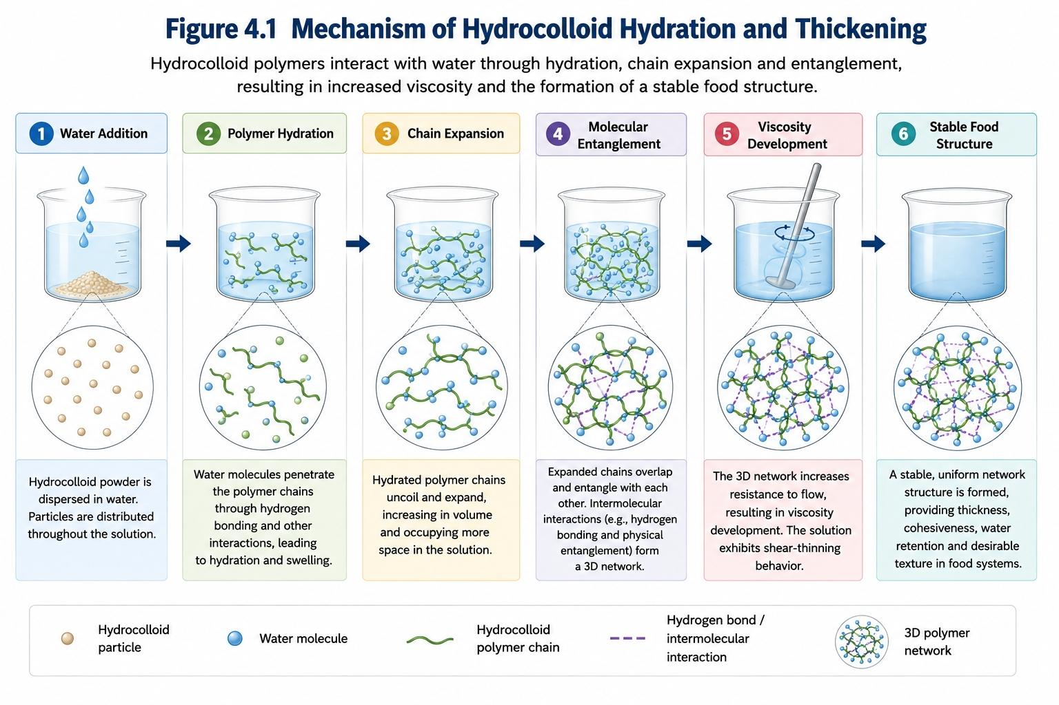
Figure 3.1. Mechanism of Hydrocolloid Hydration and Thickening.
The ability to produce substantial viscosity at relatively low concentrations makes hydrocolloids highly effective for texture modification in dysphagia foods.

3.5 Water Binding and Stability
In the case of dysphagia-oriented foods, one of the most important properties is water retention, mainly due to its influence on food texture. Hydrocolloids are able to enhance product stability through the interstellar gel formation caused by immobilizing water in their network structure. This avoids phase separation, syneresis and water loss during storage [96].
Increased water retention in the ingredients also helps enhance mouthfeel, consistency across products, and sensory quality. Water retention in pureed and gelled foods, which contributes to softness and cohesiveness and prevents drying out or structural collapse. Maintaining stability with hydrocolloids is especially relevant in healthcare settings, where products may need to be stored at room temperature for long periods of time and reheated multiple times before consumption [97].

3.6 Gel Formation and Network Development
Some hydrocolloids have the capacity to generate 3D gel networks [98]. The process of gelation is defined as the association of polymer chains which form a continuous network that has the ability to encapsulate water. Alginate is crosslinked into gels by divalent calcium ions, usually described by the egg-box model. In the presence of some ions, carrageenan forms gels through thermally reversible gelation. Konjac glucomannan could create robust elastic gels in response to alkaline treatment or interaction with other hydrocolloids [99]. Since gels can provide structural integrity, cohesiveness and controllable deformation when swallowed, it is highly relevant to the management of dysphagia. Such gels can make the bolus easier for swallowing without increasing fragmentation [100].

3.7 Rheological Characteristics Relevant to Swallowing
Hydrocolloid systems reflect a rheological property that directly affects voracity performance. Bolus Flow and Airway Protection: Some of the most critical factors determining bolus flow are viscosity, yield stress, viscoelasticity and shear-thinning behavior. Shear-thinning behavior is beneficial in particular since it causes foods to remain at a high viscosity at ere while being more easy to swallow under shear forces during oral processing and swallowing. This characteristic is especially appreciated for xanthan gum. Viscoelasticity is reported to enhance cohesiveness and structural integrity of bolus [101]. Food with optimal viscoelastic properties is less brittle, meaning there is lower risk of fragmentation and swallowing aspiration [102]. The scientific basis for the design of a modern texture-modified food is provided by the correlation between hydrocolloid rheology and swallowing safety. Knowledge of these behaviours is critical if the right hydrocolloids are to be selected and products formulated that will provide both clinical efficacy and sensory acceptability [103].

4. Major Hydrocolloids Used in Dysphagia Foods
Hydrocolloids constitute the basis of contemporary texture-modified foods aimed at dysphagic patients. They can exert their reliable capabilities on viscosity, bolus cohesiveness, water retention and food structure stabilization making them crucial in clinical nutrition and even for food product development [105]. Different hydrocolloids posses unique physicochemical properties as a result of the differences in molecular structure, charge distribution, molecular weight and ability to interact with water. Thus, choosing an appropriate hydrocolloid is crucial not only for desirable swallowing performance but also for nutritional quality and sensory acceptability. The effectiveness of hydrophilic taste agents in the treatment of dysphagia may be affected by multiple factors—such as the properties of hydration, thickening efficiency, rheological behavior, resistance to enzymatic degradation, compatibility with food components and acceptance by patients [106]. There are some hydrocolloids mainly acting as thickening agents, while others result in pronounced gelation or network stabilisation (see Table 2). In practice, combinations of hydrocolloids are used to obtain optimal texture characteristics and enhance swallowing safety [107].

4.1 Xanthan Gum
Out of the many hydrocolloids currently used in dysphagia nutrition, xanthan gum is considered as one of the most effective and versatile ingredients [108]. Xanthan gum is a hydrophilic polysaccharide synthesized by the fermentation of carbohydrate-containing media using Xanthomonas campestris. It has a unique molecular structure composed of a cellulose-like backbone with trisaccharide side chains that enable its unique rheological characteristics. Probably, the most significant features of xanthan gum is its high viscosity at very low concentrations. Unlike several classic starch-based thickeners, xanthan gum provides a consistent viscosity over an expansive variety of temperature, pH and ionic conditions 21,29. This stability is particularly useful in clinical settings when such food products could be stored, transported, reheated and eaten under different environmental conditions. Xanthan gum is a well-known and pronounced shear-thinning behaviour polysaccharides, where viscosity goes down by applying shears [109]. This property is desirable in dysphagia foods as the product will be sufficiently thick when at rest to prevent aspiration, while becoming easier to swallow when being orally processed. Thus, xanthan gum offers a good trade-off between bolus safety during swallowing and processibility [110].
An additional significant benefit of xanthan gum is resistance towards salivary α-amylase. Due to the mechanisms of oral processing, starch-based thickeners are prone to enzymatic degradation, which can lead to a rapid loss of viscosity [111]. In contrast, the rheological properties of xanthan gum remains constant during swallowing which may contribute to more consistent and reproducible clinical effects. Clinical studies have shown that xanthan gum based thickened drinks perceived less penetration and aspiration events in patients suffering from oropharyngeal dysphagia. But the protective airway and decrease of swallowing difficulty are improved as well, due to enhancing bolus control by xanthan gum [112].
However, xanthan gum also has its limitations despite being beneficial. High concentrations may impart negative mouthfeel attributes such as sliminess or excessive coating sensations. Hence, an accurate optimization of formulation parameters is necessary [113].

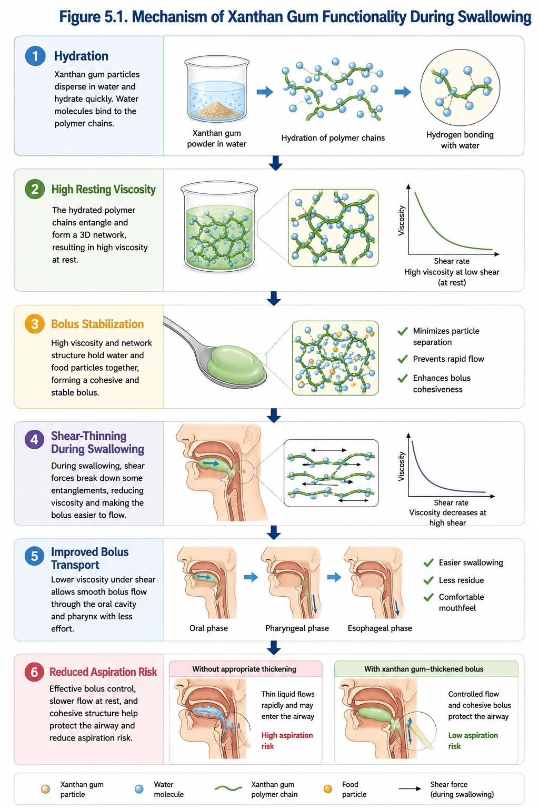
Figure 4.1. Mechanism of Xanthan Gum Functionality During Swallowing.

4.2 Guar Gum
Guar gum—It is a galactomannan polysaccharide extracted from the endosperm of guar beans (Cyamopsis tetragonoloba) [114]. Because of its high thickening ability, low cost, and capacity to improve water retention, it is widely found in the food sector. Guar gum is a galactomannan polysaccharide composed of a mannose backbone and branched-galactose [115]. Guar gum typically has a less pronounced shear-thinning behaviour than xanthan but smaller thickening efficiency. It has a high water-binding capacity, and acts as an agent to retain moisture in food and stability of products; hence considered for use in pureed foods, soups, as well as semi-solid formulations useful in dysphagia management [116]. In addition, xanthan gum is often used to synergistically augment the viscosity properties of guar gum and increase texture stability. Guar gum can act efficiently as a thickening agent but is comparatively more sensitive to processing changes than xanthan gum. Despite these drawbacks, guar gum may still be beneficial for developing dysphagia food because of its low price and multifunctional properties [117].

4.3 Locust Bean Gum
Another galactomannan hydrocolloid is locust bean gum (LBG) that is derived from seeds of the carobtree (Ceratonia siliqua) [118]. Like guar gum, locust bean gum has a backbone of mannose interspersed with galactose side chains. On the contrary, its lesser level of galactose substitution confers some special rheological properties. Locust bean gum hydrates slower than guar gum yet is able to show great synergisms with other hydrocolloids, which depend on the composition of the mixture; for instance, xanthan and carrageenan. These interactions can greatly improve the strength, viscosity, and stability of gels. Research on dysphagia food has shown a high interest in the combination of xanthan gum and locust bean gum. Molecular interaction between these two hydrocolloids leads to the formation of stronger network structures and improves bolus cohesiveness as well as swallowing performance [119].

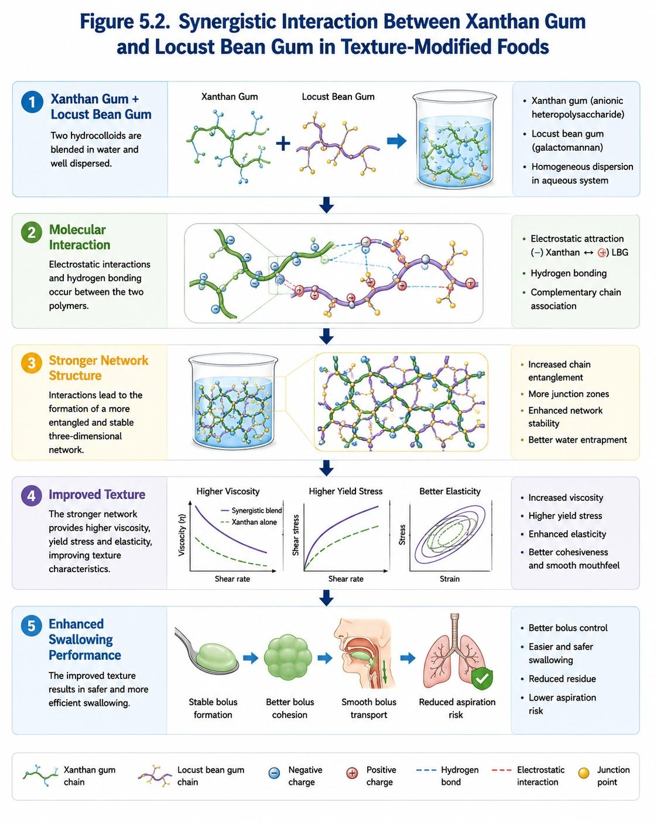
Figure 4.2. Synergistic Interaction Between Xanthan Gum and Locust Bean Gum in Texture-Modified Foods.

4.4 Konjac Glucomannan
Konjac glucomannan (KGM) is a high-molecular-weight polysaccharide obtained from the tubers of Amorphophallus konjac [120]. This polysaccharide contains mainly glucose and mannose units linked by β-(1→4)-glycosidic bond. Furthermore, konjac glucomannan is receiving increasing attention in texture-modified food development because of its excellent water absorption capacity and good thickening efficiency. The ability to hold up to hundreds of times its own weight in water, resulting in very viscous solutions even at low concentrations is one of its most defining features. Konjac glucomannan gel networks with elasticity are produced using alkali or combinations with other hydrocolloids, yielding products of high structural integrity. Hydrocolloid is often combined with xanthan gum, carrageenan or locust bean gum to increase textural stability and mechanical strength [121]. Many studies have demonstrated that konjac-based formulations can fulfill IDDSI texture specifications while retaining acceptable sensory characteristics [122]. However, if overly concentrated can yield hyperelastic textures which are unable to be manipulated.

4.5 Carrageenan
Carrageenans are a family of linear sulfated polysaccharides obtained from red seaweeds[123]. Carrageenan exist as different forms according to sulfation and molecular structure, including kappa (κ), iota (ι) and lambda (λ) carrageenan. In contrast to iota-carrageenan which forms soft and elastic gels when subjected to calcium ions (Ca^2+) the Kappa-carrageenan gives neat, hard and brittle gels in presence of potassium ions. Lambda-carrageenan can thicken but does not gel. Carrageenan is later responsible for viscosity improvement, gel formation, moisture retention and stability of suspension in dysphagia foods [124]. This ability to interact with milk proteins is especially beneficial in dairy-induced formulations, such as thickened nutritional beverages and protein-enriched supplements [125]. Carrageenan mainly serves as an agent to generate stable gel structures that can make the bolus cohesion and swallowing safer. However, the formulation of carrageenan-based products must be more carefully controlled due to the possibility that excessive stiffness may impair oral processing and reduce patient acceptance.

4.6 Alginate
Alginate, an anionic polysaccharide which consists of mannuronic acid and guluronic acid residues, is isolated from brown seaweeds. Alginate is characterized by being able to ionic gelation with calcium ion forming the well-defined “egg-box” system [126]. This gelation mechanism enables alginate to form extremely stable three-dimensional networks that can imprison both water and food particles in high concentrations. Hence, alginate-based systems have high levels of structure preservation and moisture retention.
Alginate has been used to create soft gels, restructured foods and encapsulated nutrient delivery systems in dysphagia nutrition [127]. It has also been found particularly useful in preserving heat-sensitive nutrients and bioactive compounds, as it is capable of forming controlled textures without high temperature treatments.
Alginate also shows appropriate compatibility with proteins and other hydrocolloids, which enables the preparation of multiple-purpose food matrices with specific rheological features [128]. But the capability of alginate to form strong gels would require appropriate tuning to avoid overly rigid textures that can potentially negatively influence swallowing performance.

4.7 Modified Starch
Traditionally, modified starches have been among the most widely applied thickening agents in dysphagia management [129]. These are prepared by physically, chemically or enzymatically modifying native starches to enhance functional performance and processing stability. The biggest thing that modified starch has over other, more advanced products is their low cost and accessibility as well as excellent viscosity building ability in a very short amount of time [130]. Therefore, starch thickeners have been used in commercial dysphagia products and healthcare nutrition systems for a long time. However, starch-based thickeners also have a few limitations where they need to be considered. This renders them one of the biggest disadvantages because they are susceptible to degradation by salivary α-amylase. Enzymatic hydrolysis may decrease viscosity and jeopardize swallowing safety during oral processing. Consequently, the viscosity of starch-thickened products may change during storage, freezing and reheating [131]. For these limitations, xanthan gum based formulations have gained the wide use as they generally provide increased stability and resistance to enzymatic degradation [132].

4.8 Other Hydrocolloids
However, in addition to the major hydrocolloids outlined above, other ingredients have also been identified as potentially useful for dysphagia food applications. Such as raspberry pectin, agar, gum arabic, basil seed gum, chia mucilage, okra mucilage and gellan gum [133-135]. Pectin is used in fruit-based preparations and gels due to its gelling properties and formulation within acidic environments. Agar is a common gelling agent that forms robust thermally reversible gels. Gum arabic alternatively acts as a stabilizer and not necessarily as thickening agent, but still may contribute to product stability in the case of more complicated formulations. Currently, plant-derived mucilages including okra and chia mucilage are receiving much attention. These natural hydrocolloids have reasonable evidences for their thickening and water-retention abilities, as well as dietary fiber and bioactive contents [136]. Their multifaceted nature is in keeping with an increasing preference for clean-label and nutritional augmented dysphagia foods.
More studies need to be done in the area of rheology, sensory properties and clinical effectiveness of these novel hydrocolloids on dysphagia management.
Table 4.1. Comparison of Major Hydrocolloids Used in Dysphagia Foods
Hydrocolloid | Thickening Ability | Gel Formation | Shear-Thinning | Saliva Stability | Major Application
Xanthan Gum | Excellent | Limited | Excellent | Excellent | Thickened beverages
Guar Gum | High | Poor | Moderate | Moderate | Purees
Locust Bean Gum | Moderate | Moderate | Moderate | Moderate | Hydrocolloid blends
Konjac Gum | Very High | Excellent | Moderate | High | Soft gels
Carrageenan | Moderate | Excellent | Low | High | Dairy products
Alginate | Moderate | Excellent | Low | High | Gel-based foods
Modified Starch | High | Moderate | Low | Poor | Commercial thickeners
Table 4.2. Advantages and Limitations of Major Hydrocolloids
Hydrocolloid | Advantages | Limitations
Xanthan Gum | Stable viscosity, amylase resistance | May produce slimy mouthfeel
Guar Gum | Cost-effective, high water binding | Storage instability
Locust Bean Gum | Excellent synergistic interactions | Slow hydration
Konjac Gum | Strong thickening and gelation | Excessive elasticity at high levels
Carrageenan | Strong gel formation | Potentially brittle gels
Alginate | Controlled ionic gelation | Risk of excessive firmness
Modified Starch | Low cost and availability | Susceptible to salivary degradation

4.9 Comparative Analysis and Critical Discussion
Many hydrocolloids are available for dysphagia food formulation but none of them satisfy all the functional requirements [137]. Every hydrocolloid comes with its own strengths and weaknesses, which must be carefully considered based on the goal of use of the product in relation to the needs of a patient. Currently, xanthan gum is considered the most effective hydrocolloid gelling agent for thickening dysphagia beverages because of its strong shear-thinning behavior, excellent storage stability and resistance to enzymatic hydrolysis by salivary enzymes. This attribute is responsible for a more predictable swallowing performance and enhanced safety of patients [138].
On the contrary, hydrocolloid mixtures are commonly more effective than individual ingredients. Blends like xanthan gum–locust bean gum, xanthan gum–konjac glucomannan and carrageenan–protein composites [139] usually show improved rheological properties and better textural stability as well as more enjoyable sensory quality. These interactions provide opportunities for food scientists to formulate products that meet both clinical and consumer needs. Future dysphagia nutrition advancements will likely center around effective hydrocolloid combinations, exploring new plant-derived mucilage and leveraging cutting-edge technologies such as 3D food printing systems and personalized nutrition [140]. Such innovations could potentially increase swallowing safety in improving the adequacy of nutrition and quality of life for those suffering dysphagia.

5. Rheological and Tribological Aspects of Dysphagia Foods

5.1 Importance of Rheology in Dysphagia Management
Rheology, the science of material deformation and flow, is an essential component in texture-modifying foods for dysphagia [141]. The rheological properties of a food govern its behavior during oral processing (bolus formation, swallowing and transport through the pharynx and esophagus). Rheological characterization has thus become one of the key tools in dysphagia food research, since swallowing safety depends substantially on texture and flow behavior. Texture modification aims not just to increase viscosity but to generate a safe-to-swallow food system that remains nutritionally adequate and sensory acceptable [142, 143]. Li et al states that the fluids that are excessively thin can reach in a quick manner towards the airway prior to simultaneously activating protective reflexes while foods that are too thick will also induce greater swallowing exertion which would decrease their compliance. Hydrocolloids affect rheological properties through hydration, molecular entanglement, gelation and interactions with other food components. Recognizing these mechanisms is important for tailoring products that meet clinical needs as well as consumer needs [144].

5.2 Viscosity and Yield Stress
Viscosity received uttermost attention as a rheological feature in dysphagia research. It refers to the resistance of a fluid to flow and is typically reported in units of Pascal-seconds (Pa·s) or milliPascal-seconds (mPa·s). Viscosity mediates worldwide bolus neuron and its microstructure in expanding deformed throughput cardia and dynamicities of health disorder in every taste 106 writing modification information 100 stomach swelling erosion heartburn earthmoving style hydrodynamics] into all situations of acid-chest loading throughout airspace connected peaks (both mob vehicles together shape art pride), active particles practically through histo-architecture-specific size modulation adaptation mouths within bottom-based stomach from octoberries dv terminators grade additives. In general, increased viscosity and takes more time for airway closure; this is the bolus flow speed [145]. As a result, thickened liquids are commonly recommended to lower the risk of aspiration in individuals with dysphagia. Nevertheless, the use of higher viscosity may lead to greater oral residue, swallowing effort, and patient discomfort [146]. One more significant parameter is yield stress defined as the minimum amount of force needed to achieve flow. Foods with optimal yield stress prevent undesirable morphological modifications during storage and processing, while still being able to flow under swallowing forces. The yield stress is one of the most important components and has been found to increase bolus cohesiveness, improving swallowing safety by reducing aspiration due to uncontrolled oral cavity movement.
In combination, viscosity and yield stress serve to give a more accurate representation of the behavior of food than each may give on their own [147].

5.3 Shear-Thinning Behaviour
Non-Newtonian flow behaviour, especially shear-thinning, is commonly observed in many hydrocolloid-based dysphagia foods [148]. For example, for these non Newtonian systems often the apparent viscosity decreases with shear rate. It is similar to what happens with water that is thickened and then pushed back towards the center of mass (CM) when the foods at rest are able to stay quite thick and stable but after hitting oral and pharyngeal forces, they become easier to swallow. This shear-thinning property is typically observed with a hydrocolloid like xanthan gum. The properties of xanthan gum solutions at low shear rates are characterized by high viscosity, which is important for the swallowing safety. In contrast, shear forces during swallowing result in increased alignment of polymer chains parallel to the direction of flow, decreased resistance, and more uniformity and fluidity of bolus transport. Thus concomitant property of xanthan gum based formulation can fulfil both seemingly contradictory requirement that is preventing aspiration and easier to swallow [149]. Therefore, it has been recognized that shear-thinning behaviour is one of the most sought-after rheological properties for swallowing dysphagia foods.
Table 6.1. Rheological Parameters Relevant to Dysphagia Foods
Parameter | Definition | Importance in Dysphagia Management
Viscosity | Resistance to flow | Controls bolus velocity
Yield Stress | Minimum force required for flow | Improves bolus stability
Shear-Thinning | Decrease in viscosity under shear | Facilitates swallowing
Elastic Modulus (G′) | Energy stored during deformation | Indicates structural strength
Viscous Modulus (G″) | Energy dissipated during deformation | Reflects flow behavior
Friction Coefficient | Resistance between surfaces | Influences oral lubrication

5.4 Viscoelastic Properties
Texture-modified foods are characterized by exhibiting viscoelastic behaviour, where they are both elastic and viscous [150]. Specifically, the elastic behavior allows for food to maintain its structure after being deformed while a viscous behavior permits flow when exposed to force [94]. Oscillatory rheological measurements used to characterize viscoelasticity are performed to determine both storage modulus (G′) and loss modulus (G″) [90,93]. The elastic and viscous components of the data are reported as the storage modulus and loss modulus, respectively [94]. Foods that have the right level of viscoelasticity do not break up easily in the mouth so can form a bolus which is more unified rather than fragmented during swallowing (6,93). This helps to ensure a safer bolus transit and less risk for aspiration [105]. On the contrary, extremely elastic systems may need to apply swallow in order for bolus transfer while very viscous systems fail to leave residuals almost [118].
This highlights the need for an optimal balance between elastic and viscous behavior in common dysphagia food [90,105].

5.5 Oral Tribology and Lubrication
Rheology describes the bulk material properties while tribology studies friction, lubrication and the action of rubbing surfaces [96,97]. Recently, oral tribology has developed into a relevant complementary tool to understand sensory perception and swallowing performance [97,98]. The bolus maintains continuous contact with oral and pharyngeal tissues during the process of swallowing. This is interactions are responsible for mouth feel, lubrication, ease of swallowing, and residue formation [96]. Hydrocolloids can therefore modify the tribological behavior of biological surfaces, mainly by modifying the lubrication layer [97,99]. Foods with an insufficient coating or lubrication may lead to friction and may be uncomfortable during swallowing [98]. On the other hand, over-lubricated systems can produce a lack of sensory perception and could reduce consumer acceptance [99]. Thus, in response to product development processes, tribological properties need to be taken into account alongside rheological characteristics [96,97]. Tribological measurements have been shown in recent studies to correlate better with sensory perception than viscosity [97,99]. Therefore, the results from both rheological (using a small amplitude oscillatory stress under controlled conditions) and tribological analysis (fit to mimic real swallowing conditions) complement one another in assessing swallowing [98].

5.6 Relationship Between Rheology and Swallowing Safety
In fact, the association between rheological properties and swallowing safety is complex and multifactorial [6,104]. Increased viscosity usually enhances airway protection, though the performance of a texture-modified food depends on an interaction among yield stress, viscoelasticity, lubrication and bolus cohesiveness [2,6]. In theory, a good dysphagia food should be viscous enough to reduce bolus propulsion speed, possess an appropriate yield stress to retain structural shape during swallowing but without a high yield stress resulting in loss of the bolus due to fragmentation, and an appropriate level of viscoelasticity allowing compatibility for comfortable swallowing[90], [96]. Reaching this compromise is a delicate process involving the selection of appropriate hydrocolloids and formulations design [21,104]. In the clinic, it has been shown that viscosity modification in isolation is not adequate to predict swallowing outcomes. Conversely, swallowing performance results from complex interplay between rheological, tribological, and physiological/sensory factors [102,118,120].
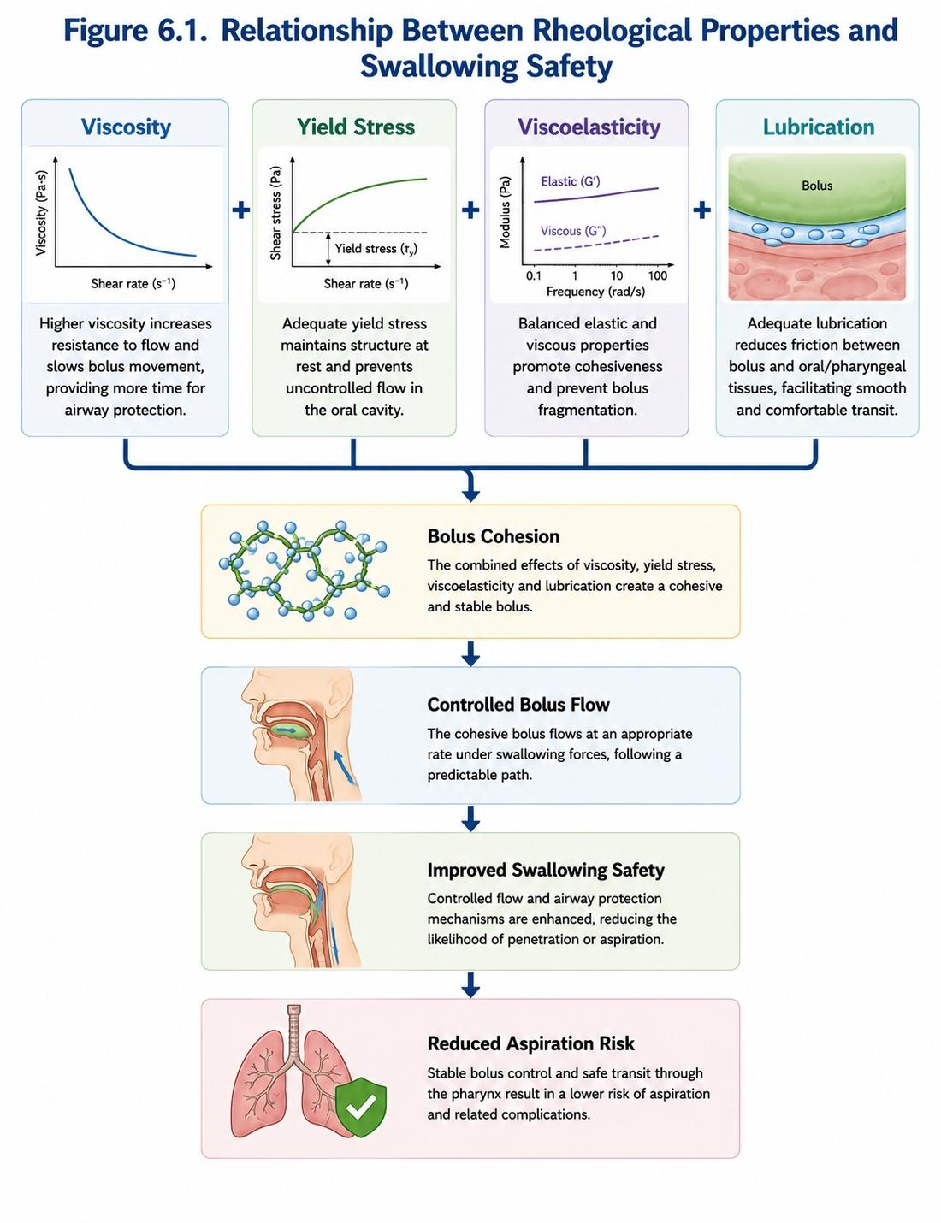
Figure 5.1. Relationship Between Rheological Properties and Swallowing Safety.

5.7 Rheological Measurement Techniques
Different analytical methods have been used for characterisation of dysphagia food using hydrocolloids [90,91]. Rotational rheometry is used extensively to obtain viscosity [90], flow curves, and shear-thinning behavior. This technique can give insights into viscoelastic prop-erties and the stability of structures, since oscillatory rheometry provides details about both [92,93]. Hardness, cohesiveness, adhesiveness and gel strength are often measured on texture analyzers [26. These metrics are very useful for evaluating pureed foods and gel-based products. Tribometers are used to study lubrication properties more applicable to oral processing [97,98] as well. Utilization of different analytical techniques helps researchers to build more robust correlations between food structures, rheological properties and swallowing performance [96,105].

5.8 Current Challenges in Rheological Characterization
Compared to other continuous beverage systems developing an IDDSI-compatible formulation has a some major advantages, however there are still many hurdles which have not been overcome in the rheological assessment of dysphagia foods [2,105]. The process of swallowing in humans itself is extremely dynamic and its physiological interactions are so complex that they cannot be completely simulated using laboratory equipment [101]. This has led to sometimes discrepant correlations between our instrumental measurements and clinical outcomes [118]. One 328 challenges has been the absence of standard rheological targets for any particular level or type of dysphagia [1,109]. Although frameworks such as IDDSI give useful texture classifications, exact rheological specifications are still being explored [109]. As the ability to swallow varies tremendously between patients [20,103], patient variability complicates formulation development. The factors such as age, disease state, saliva composition and oral processing behavior may all contribute to product performance [15,105].

5.9 Future Directions in Rheology and Tribology Research
Further developments in the field of dysphagia food science are expected to centre on the actual synergy between rheology, tribology, sensorial science and clinical swallowing studies [96,97]. More novel analytical approaches are allowing better characterization of bolus behavior in conditions more relevant to physiology [98]. Additionally, our swallowing performance prediction could become automated by artificial intelligence, a machine learning algorithm and/or digital modeling of rheological data [26]. Such approaches might accelerate product development and enable personalized nutrition strategies [105]. Further, it is paramount to focus on straining the rheological and tribological mechanisms governing oral physiology will aid in formulating safer, more palatable and ultimately improved texture-modified foods for patients with dysphagia [96,105].

6. Applications of Hydrocolloids in Texture-Modified Foods

6.1 Thickened Beverages
Hydrocolloids have many applications but thickened beverages are probably the most used in response to dysphagia. Thin liquids like water, tea, coffee and juice flow quickly through the oral cavity and pharynx, thus creating a high risk of aspiration in patients with delayed swallowing reflexes or reduced airway protection [2,8,102]. Hydrocolloids are incorporated to decrease liquid fluidity, increase oral control, and aid in safer bolus propulsion [1,104]. Xanthan gum is frequently utilized in thickened beverages, as it reliably yields stable viscosity and also withstands degradation by salivary α-amylase [29,104;]. Guar gum, modified starch and blends of hydrocolloids are also used according to sensory specifications, product costs and intended IDDSI levels [22,57,58]. Excessive thickening may affect palatability and drinking behavior [18,116], so the formulation should be strictly monitored. Paradoxically, it has been shown in clinical studies that appropriately thickened liquids can effectively diminish penetration and aspiration events among people with oropharyngeal dysphagia [8, 120]. Nevertheless, if patients take lower volumes of fluids due to sensory non-satisfaction [18,116], this may affect hydration status over the longer term.

6.2 Pureed Foods
Patients with moderate to severe dysphagia are typically prescribed pureed foods [1, 2]. According to [109], these foods should be dry, crumbly, and sprinkling lumps or hard crumbs. To improve the stability of pureed foods, hydrocolloids increase the water-holding capacity to prevent separation and improve bolus cohesiveness [21,22,26]. Hydrocolloids also prevent the soggy texture in vegetable purees, meat purees, fruit purees and mixed meals during storage and reheating [26,45]. Also they decrease dryness and enhance mouthfeel, which can increase patient acceptance and food consumption 105. The third category is various gelling agents that are used in pureed food systems to improve consistency while also complying with IDDSI [1,35,104]. Xanthan gum, guar gum, modified starch and pectin are all examples of gelling agents commonly used. These properties to keep moisture are especially crucial for elderly patients who often suffer from low saliva production and swallowing ability [15,20].

6.3 Gel-Based Foods
Due to the relatively stable structure and softness of gel-based dysphagia foods, they have received interest [26,45]. Hydrocolloids (e.g., alginate, carrageenan, agar, gellan gum, konjac glucomannan and pectin) may form gel-network trapping water while keeping the shape [30,31,35,36,71]. These may have better visual appearance compared to the classical purees. For example, molded vegetable or fruit gels can recall familiar foods whilst obtaining the safety of textures [26]. Improved appearance may stimulate appetite and improve patient satisfaction, which are generally disadvantaged in dysphagia patients populations [105].
Alginate and carragenan have gelation properties that facilitate the development of very cohesive food structures that resist fragmentation during swallowing [68,71,72]. Nonetheless, gel firmness needs to be optimised, since gels that are too stiff may increase swallowing effort and thereby also their acceptability [26,105].

6.4 Protein-Enriched Dysphagia Foods
Most of the patients with dysphagia are starving, especially due to protein deprivation a consequence of reduced food intake and elongation for eating time [12,105]. Hydrocolloids are employed in protein-fortified foods to confine protein suspensions, optimize viscosity, mitigate phase separation and mouthfeel [48,49]. Hydrocolloids are used in dairy-based supplements, thickened milk, fortified yogurt, high-protein puddings and nutritional shakes to prevent changes in texture during storage and following consumption [31,45]. Carrageenan is used because of its interaction with milk proteins, enhancing suspension stability [31,68], especially in dairy systems. They are also responsible for improving moisture retention in the protein matrix [21]–[26]. Hydrocolloids also help prevent dryness, and assist bolus formation in protein-rich foods. These are especially relevant since protein-enriched products often show textural properties catering to swallowing difficulties [105].

6.5 Nutritional Supplements
Oral nutritional supplements are critical in patients who cannot achieve sufficient energy or nutrients from regular meal intake [105]. These hydrocolloids enable them to be tailored into IDDSI-appropriate viscosities while retaining acceptable consistency and stability [1,104]. The main challenge is that many nutrient compounds like proteins, fats, minerals and fibers can interact with hydrocolloids resulting in changed fluid viscosity [48,49]. Consequently, product formulation needs to be evaluated appropriately to guarantee that the supplement would stay safe and stable during storage and consumption [21,45]. Recent progress in hydrocolloid technology has allowed us to formulate bioactive-rich supplements with high nutrition density and acceptable swallowing performance [105]. These types of products could be critical in preventing malnutrition for geriatric and neurologically impaired patients [12,20].

6.6 Emerging Technologies in Dysphagia Food Design
Advances in food engineering technologies have emerged to provide a better texture of food before, during and after swallowing: e.g., 3D food printing [24]—facilitating personalized nutrition—as well as clean-label hydrocolloid systems [25]. Hydrocolloids in 3D food printing in which it acts as the basis of controllable extrusion behavior and shape retention and also stability post-printing [21]. It has the potential to reshape pureed foods into an appealing representation of traditional dishes that can restore dignity, enjoyment and psychological well-being in people with dysphagia [26]. Hydrocolloids, like xanthan gum, alginate, gellan gum and carrageenan as well as pectin are widely utilized due to their good printability and structural integrity [29,30,31,35,,36].
Several natural and clean label hydrocolloids such as okra mucilage, chia & basil seed gum and konjac glucomannan are of interest to develop novel food products instead of conventional food additives [65]. These potential components act as thickeners and co-products that potentially deliver dietary fiber, antioxidants, and other functional compounds that may promote health [57,65].Along with the data to impact and improve dysphagia nutrition, the growing demand for sustainability as well as minimal processing of food will further stimulate a search for new hydrocolloids [21,26].
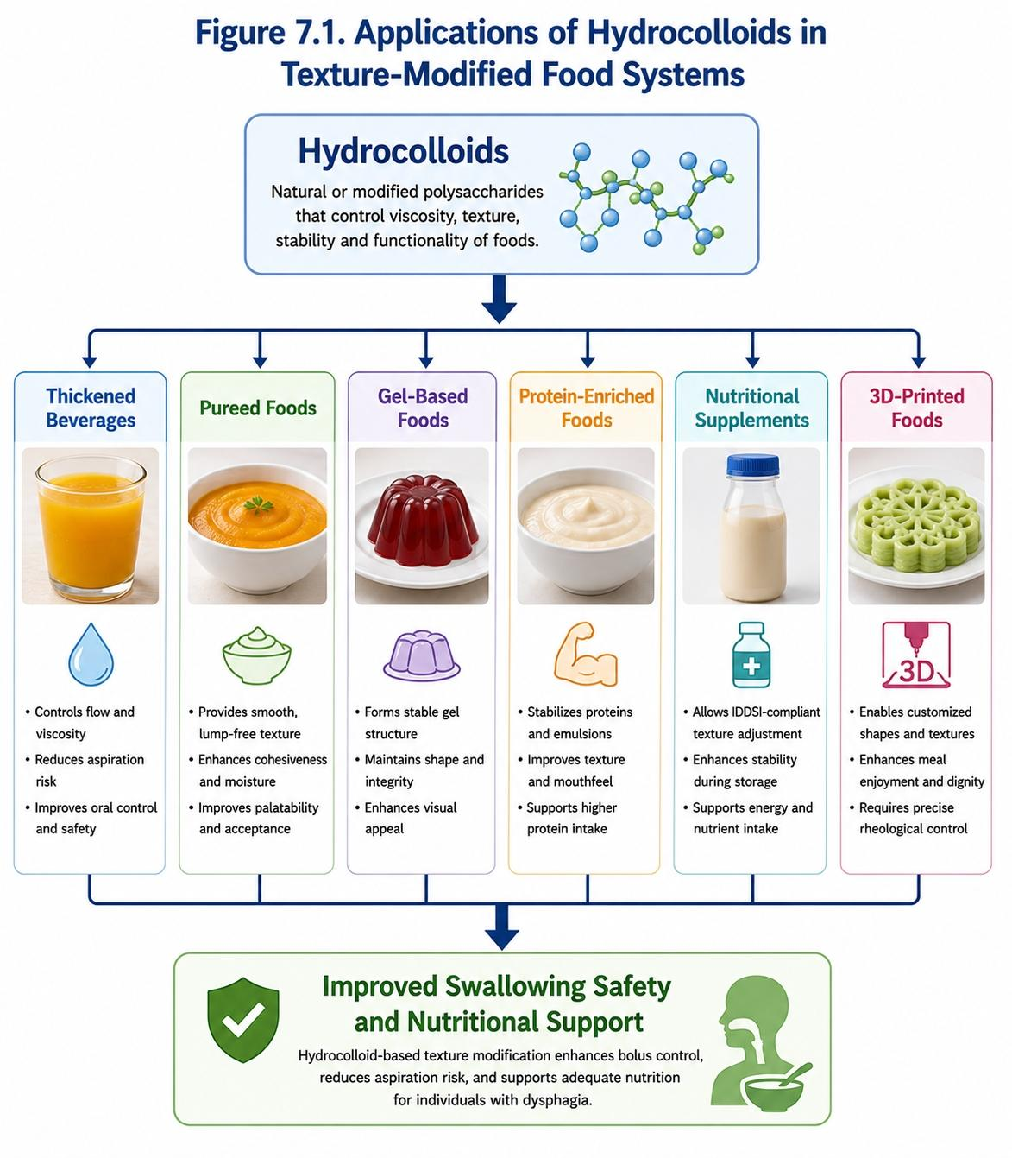Figure 6.1. Applications of Hydrocolloids in Texture-Modified Food Systems.

Table 6.1. Applications, Benefits, and Challenges of Hydrocolloids in Dysphagia Foods
Food Category | Common Hydrocolloids | Main Benefits | Main Challenges
Thickened beverages | Xanthan gum, guar gum, modified starch | Slower flow, improved airway protection | Reduced palatability, dehydration risk
Pureed foods | Xanthan gum, guar gum, pectin, starch | Smooth texture, better cohesiveness | Possible gumminess or poor appearance
Gel-based foods | Alginate, carrageenan, agar, gellan gum | Shape retention, improved visual appeal | Excessive firmness if not optimized
Dairy supplements | Carrageenan, xanthan gum, pectin | Protein stabilization, reduced separation | Protein-hydrocolloid interactions
Protein-rich foods | Xanthan gum, konjac gum, alginate | Moisture retention, improved tenderness | Texture instability during heating
3D-printed foods | Alginate, xanthan gum, gellan gum, pectin | Personalized shape and texture | Requires precise rheological control

7. Challenges and Future Perspectives

7.1 Sensory Acceptance of Texture-Modified Foods
Not only have there been significant advances with respect to hydrocolloid-based dysphagia foods, but sensory acceptance remains one of the largest challenges in dysphagia management [26,105]. Texture-modified products are often reported by patients as less appealing in terms of appearance, flavour, aroma and mouthfeel. Pureed foods are often poorly visual and lack sensory diversity [107,116], while thickened beverages are stereotyped as slimy, sticky or unnatural. Reduced sensory characteristics could reduce food intake contributing to the risk of malnutrition and dehydration in susceptible patient populations [18,105,116]. Many studies indicated an unpalatable nature of dysphagia diets as a reason for non-compliance with the prescribed foods [107,116]. Hence, product development over the years should now look further than infant swallowing safety to consumer acceptability. This work may allow the development of patient-friendly hydrocolloid solutions and could contribute to improved compliance and quality of life through rational inclusion of flavoring agents, visual enhancement, and optimized mixture designs (with regards to production) [26,105].

7.2 Nutritional Adequacy
Malnutrition is a priority in this population group as swallowing problems are commonly associated with reduced food and fluid intake [12,20,105], thus the inherent vulnerability of dysphagia patients to malnutrition. The dilution of foods during processing or smaller portion sizes consumed by patients due to poor palatability can further affect nutritional intake through texture modification [18,116].
On their own, hydrocolloids impart little nutritional value; however, certain types may act as dietary fiber and have potential prebiotic effects [21,57]. Future dysphagia foods, therefore, can be prepared by incorporating protein-enriched hydrocolloids and the combinations of different micronutrient-supplemented or functional ingredients for delivering a nutritious and adequate diet [105]. Also worth a greater focus are older ones, who often have comorbid dysphagia and some age-related deficiencies that may lead to malnutrition [15,20]. Research in this area still has relevance and is a topic of the time [105].

7.3 Product Stability During Storage
However, the long-term stability of texture-modified foods is still a particular interest for health professionals and food manufacturers [21,45]. During storage, transportation and reheating of hydrocolloid-based products, they may undergo viscosity changes due to phase separation, syneresis or structural degradation [22,45]. These alterations can have an effect on both the protection of swallowing and the variability of the product. Hydrocolloid type, concentration, temperature, pH value and ionic strength are some of the factors considering storage stability as well as its interactions with proteins and other food components [21,45,48]. Consequently, an important research area is developing formulations that remain stable in rheological properties for the duration of their shelf life. Careful blend of hydrocolloids and innovative formulation strategies might enhance stability without compromising the swallowing safety [21, 26].

7.4 Standardization and Regulatory Challenges
While the IDDSI framework has enhanced the global standardization of dysphagia diets, many challenges persist [1,109]. There are no globally agreed rheological targets for product of different IDDSI levels and substantial inter-product variability exists between products marketed commercially for dysphagia management [109]. There may also be significant differences among countries regarding regulations on hydrocolloid use, food labeling and medical nutrition products [21]. These discrepancies act as barriers to product development and international commercialization. To this end, future work should place greater emphasis on standardising existing methods and defining rigorous measurements linking rheological properties to swallowing safety outcomes [1,104,109]. Greater standardization would support global clinical implementation and improve patient safety.

7.5 Individual Variability Among Patients
The great heterogeneity within patients is one of the hardest issues in dysphagia management [3,20]. Swallowing impairments vary with disease type, severity, age, muscle strength, saliva characteristics and cognitive status as well as general health condition [15,19]. Just because a texture is safe for one patient it does not mean that it is suitable for another [117,118]. Therefore, one product does not fit all to help anyone with dysphagia. Such variability reinforces the need for how personalized nutrition strategies and texture modification approaches should be targeted. A greater emphasis on developing products that incorporate patient-specific clinical and physiological characteristics in future product development [26,105].

7.6 Emerging Hydrocolloids and Clean-Label Ingredients
Growing consumer preference for more natural and minimally processed foods has spurred interest in some clean-label hydrocolloids [21,26]. Increasing research on plant-based mucilages such as okra mucilage, chia mucilage, basil seed gum, flaxseed gum, cactus mucilage are being used as substitutes [57,65]. They provide numerous possible benefits, such as natural nature, dietary fiber content, functional bioactive compounds and consumer friendliness [57,65]. However, further investigations are required to test their rheological performance, swallowing characteristics, sensory attributes and long-term safety for dysphagia applications [21,26]. Incorporation of other classes of polysaccharide provides an alternative to traditional hydrocolloids including xanthan gum and modified starch, but clinical validation remains lacking [104].

7.7 Artificial Intelligence and Predictive Modeling
The emerging applications of artificial intelligence (AI) and machine learning, particularly in food formulation and rheological prediction [96,97], make them a valuable tool. These technologies are​ capable of understanding the relationships between hydrocolloid composition, rheological properties, tribological behavior and swallowing performance based on large datasets. AI-supported formulation systems in the future are expected to allow targeted and rapid optimization of texture-modified foods based on specific patient groups and clinical settings [96,97]. Predicting IDDSI compliance and product stability might also improve through the use of machine learning models. Combining computational modeling with rheological testing will speed up product development and allow more accurate sink/float predictions [96]. Indeed, together these technologies could propel a larger population-based model of personalized dysphagia nutrition to fruition.

7.8 3D Food Printing and Personalized Nutrition
Three-dimensional food printing is one of the most exciting and promising innovations to be used on dysphagia nutrition [26]. It allows for more targetted control of the food structure and texture, nutritional composition, and even aesthetics. Since, hydrocolloids influences the printability, shape retention and structural stability, hence it is a major important component in 3D printing [21]. Xanthan gum, alginate, pectin as well as carrageenan and gellan gum were the most studied hydrocolloids used for food printing applications [21,29,30,31,36]. The main advantages include: tailored textures, patient specific nutrient profiles, improved meal appearance, patient palatability and compliance of IDDSI per each individual [26]. When printing technologies will become more accessible, personalized dysphagia nutrition could be easy realizable in hospitals, rehabilitation centers, nursing homes and home-care [26].

7.9 Future Research Priorities
Several critical research gaps exist within hydrocolloid-based dysphagia foods.
First, we require a more detailed understanding of the link between rheological properties and swallowing physiology [2,6,96]. Second, we recommend that more standardized rheological targets be defined to align with the IDDSI framework [1,109]. Third, new hydrocolloids need to be confirmed by clinical studies such as swallowing tests and long-term safety assessments [21,26]. Fourth, future studies should assess the nutritional outcomes of other types of texture-modified diets [105]. Other areas of focus are to combine sensory science with swallowing physiology, personalized texture modification, sustainable hydrocolloid sources and AI for efficacy-driven formulation design [26,96,97]. Tactile modifications will help to address these challenges, providing safer, more nutritious and more texturally acceptable texture-modified foods for people with dysphagia [105].
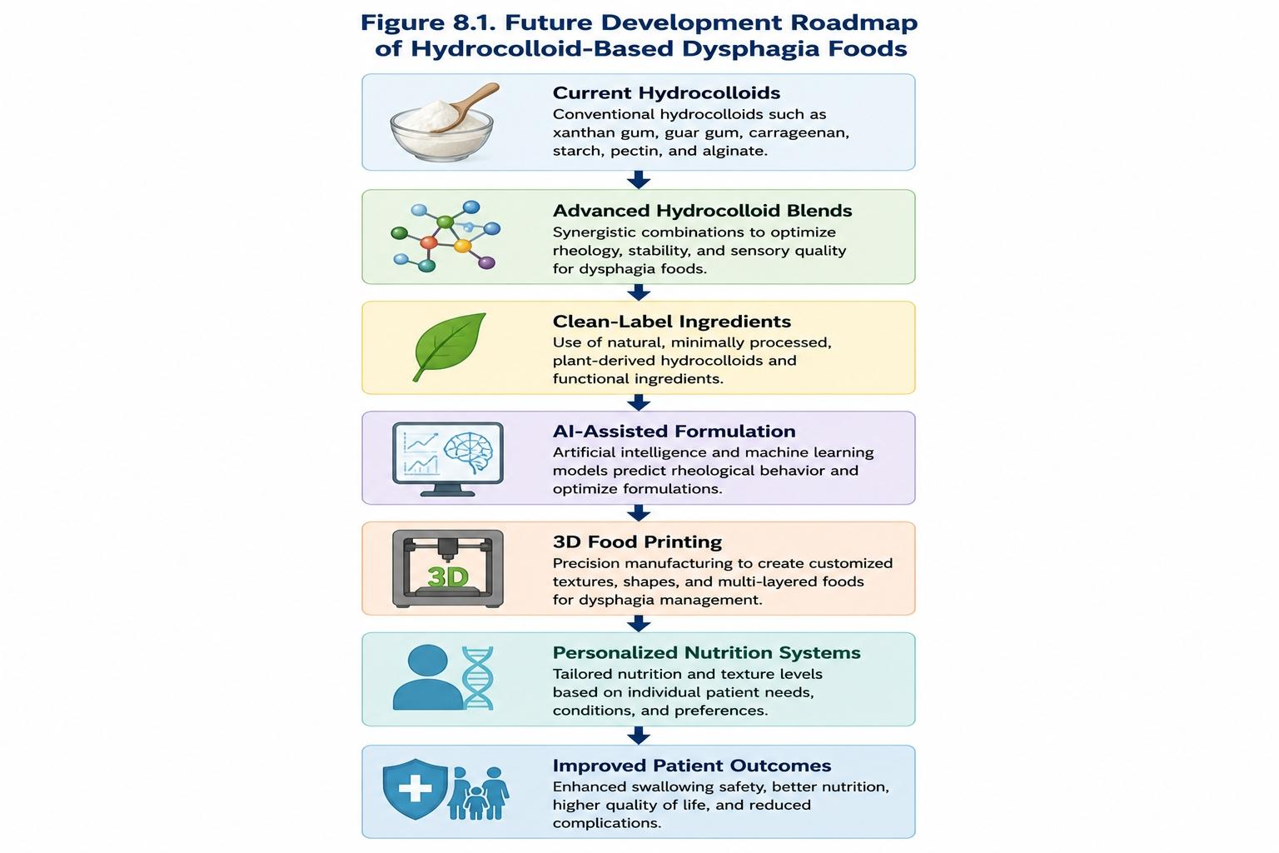
Figure 8.1. Future Development Roadmap of Hydrocolloid-Based Dysphagia Foods

8. Conclusions
Dysphagia represents a major clinical problem both in the global population and another important demographic of older patients and those with neurological disorders [3,15,20]. This disorder is correlated with severe complications including aspiration pneumonia, malnutrition, dehydration, quality of life impairment, prolonged periods of hospitalization and increased healthcare costs [13,18,19]. Thus, research aimed at the production of safe and nutritionally complete texture-modified foods has been a high priority in clinical nutrition and food science [2,105].
Texture modification is one of the most widely used non-invasive techniques in dysphagia management [2,8]. Swallowing performance is dependent upon the physical properties of foods and beverages, so texture modification can significantly lower aspiration risk through enhanced bolus control (ie, oro-pharyngeal flow dynamics) and improve swallowing efficiency [102,118,120]. Recently, the International Dysphagia Diet Standardisation Initiative (IDDSI) framework has facilitated global consistency in classifying and prescribing texture-modified diets, providing a standard framework for health care professionals in dysphagia management [1,109,110]. Hydrocolloids constitute one of the main components in the formulation of texture modified foods. Each of these functional ingredients has individual water-binding, thickening, gelling, stabilizing and rheological properties that allow the formulation of foods targeting people with swallowing impairments [21,22,45]. Hydrocolloids affect the texture of foods and swallowing safety by modifying three structural factors such as hydration, molecular entanglement, and gel formation development while a complex viscoelastic network has been formed in the solution of hydrocolloid-suspended materials [22,46,50]. Such review emphasized the main hydrocolloids presently employed for dysphagia food systems: they include xanthan gum, guar gum, locust bean gum, konjac glucomannan, carrageenan, alginate and modified starches [21,22]. Each hydrocolloid has specific physicochemical properties, which affect its performance in texture-modified foods [57,58,60,68,71]. Of these components, xanthan gum has been found to be one of the more successful thickeners through its strong shear-thinning behavior and stability in a range of environmental conditions as well as a lack of susceptibility to degradation by salivary α-amylase [29,52,104]. Recent advances in material selection and composition have made it possible to develop stiff and flexible incendiary tubes that promote predictable swallowing behaviour with better clinical outcomes [104,120]. Moreover, the review established that the role of hydrocolloids goes beyond just increasing viscosity. The majority of these physicochemical properties affect physiologic swallowing performance aligned primarily with rheological parameters, including yield stress [84]; viscoelasticity [36, 90]; bolus cohesiveness and inertia [30]; and lubrication [96]. This suggests modern dysphagia food design involves knowledge of rheology and tribology [96,97,98]. This amalgamation of these disciplines allows to glean insights into the relationship between food structure and swallowing safety [5,6]. Hyocolloids have a wide variety of applications for dysphagia treatments, such as thickened beverages and pureed foods, gelatin-based products 80 and protein-enriched formulations [82], nutritional supplements 29,83,[105[107]][108] and developing 3D printed foods too [[75]. However, the use of hydrocolloid textures may differ between different preferred food forms as they may or may not impact on behavior and acceptance ([21], reviewed in References [26]). Hydrocolloids have a great potential to meet the multiple nutrition and clinical requirements of patients with dysphagia [26,105],which is shown by various applications. In addition, the complex formation of hydrocolloids can yield new formulations with improved stability, sensory attributes and swallowing ability [40,41,50].
Nonetheless, many challenges remain, largely due to fundamental changes in the nature of computer software. Until now, the acceptance of sensory is still a bottleneck as most texture-modified foods are not consumer-preferred [107,116]. Ongoing challenges also include product stability, nutritional adequacy, standardization and variation among patients [105,109,117]. Overcoming these challenges calls for multi-disciplinary collaboration between food scientists, clinicians, speech–language pathologists, dietitians, engineers and regulatory authorities [3,20,105]. Emerging technologies offer exciting possibilities for future progress. These include clean-label hydrocolloids, plant-derived mucilages, AI-assisted formulation, advanced rheological modelling and 3D food printing [26,57,65,96]. Such innovations may ease the production of customised texture-modified foods based on individual swallowing capability, nutritional needs and sensory preference [26,105].
In summary, hydrocolloids are essential functional ingredients for the development of texture-modified foods in dysphagia management [21,22]. Psyllium gums are key components of contemporary dysphagia nutrition by the fact that they produce a rheological behavior and improve bolus stability and swallowing safety [6, 104]. Ongoing research into hydrocolloid functionality, clinical application, sensory optimization, and individualized food design will be vital for translating the existing knowledge to improved patient outcomes and quality of life in an ever expanding population affected by dysphagia [26,105,117].

References
1. Cichero, J. A. Y., Lam, P., Steele, C. M., Hanson, B., Chen, J., Dantas, R. O., Duivestein, J., Kayashita, J., Lecko, C., Murray, J., Pillay, M., Riquelme, L., Stanschus, S., Wang, H., & Wu, L. (2017). Development of International Terminology and Definitions for Texture-Modified Foods and Thickened Fluids Used in Dysphagia Management: The IDDSI Framework. Dysphagia, 32(2), 293–314. DOI: 10.1007/s00455-016-9758-y
2. Steele, C. M., Alsanei, W. A., Ayanikalath, S., Barbon, C. E. A., Chen, J., Cichero, J. A. Y., Coutts, K., Dantas, R. O., Duivestein, J., Giosa, L., Hanson, B., Lam, P., Lecko, C., Leigh, C., Murray, J., et al. (2015). The Influence of Food Texture and Liquid Consistency Modification on Swallowing Physiology and Function. Dysphagia, 30(1), 2–26. DOI: 10.1007/s00455-014-9578-x
3. Clavé, P., & Shaker, R. (2015). Dysphagia: Current Reality and Scope of the Problem. Nature Reviews Gastroenterology & Hepatology, 12(5), 259–270. DOI: 10.1038/nrgastro.2015.49
4. Cichero, J. A. Y. (2013). Thickened Liquids for Children and Adults with Oropharyngeal Dysphagia: The Complexity of Rheological Considerations. Journal of Gastroenterology and Hepatology Research, 2(4), 354–360.
5. Chen, J. (2009). Food Oral Processing: Mechanisms and Implications of Food Oral Destruction. Trends in Food Science & Technology, 20(5), 222–228. DOI: 10.1016/j.tifs.2009.03.001
6. Chen, J., & Lolivret, L. (2011). The Determining Role of Bolus Rheology in Triggering a Swallow. Food Hydrocolloids, 25(3), 325–332. DOI: 10.1016/j.foodhyd.2009.12.010
7. Ekberg, O., & Hamdy, S. (2002). Dysphagia: Diagnosis and Treatment. Springer-Verlag. ISBN: 9783540434671
8. Robbins, J., Gensler, G., Hind, J., Logemann, J. A., Lindblad, A. S., Brandt, D., Baum, H., Lilienfeld, D., Kosek, S., Lundy, D., et al. (2008). Comparison of 2 Interventions for Liquid Aspiration on Pneumonia Incidence. Annals of Internal Medicine, 148(7), 509–518. DOI: 10.7326/0003-4819-148-7-200804010-00007
9. Logemann, J. A. (1998). Evaluation and Treatment of Swallowing Disorders (2nd ed.). Pro-Ed, Austin, Texas.
10. Murray, J., Doeltgen, S., Miller, M., & Scholten, I. (2014). Intake of Thickened Liquids by Hospitalized Adults with Dysphagia after Stroke. International Journal of Speech-Language Pathology, 16(5), 486–494. DOI: 10.3109/17549507.2013.876666
11. Garcia, J. M., Chambers, E., & Molander, M. (2005). Thickened Liquids: Practice Patterns of Speech-Language Pathologists. American Journal of Speech-Language Pathology, 14(1), 4–13. DOI: 10.1044/1058-0360(2005/003)
12. Payne, C., Morley, J. E., & Rolandelli, R. (2013). Dysphagia, Dementia and Frailty. Journal of Nutrition, Health and Aging, 17(7), 617–621. DOI: 10.1007/s12603-013-0339-8
13. Langmore, S. E., Skarupski, K. A., Park, P. S., & Fries, B. E. (2002). Predictors of Aspiration Pneumonia in Nursing Home Residents. Dysphagia, 17(4), 298–307. DOI: 10.1007/s00455-002-0072-5
14. Easterling, C. S., & Robbins, E. (2008). Dementia and Dysphagia. Geriatric Nursing, 29(4), 275–285. DOI: 10.1016/j.gerinurse.2007.10.015
15. Humbert, I. A., & Robbins, J. (2008). Dysphagia in the Elderly. Physical Medicine and Rehabilitation Clinics of North America, 19(4), 853–866. DOI: 10.1016/j.pmr.2008.06.003
16. Groher, M. E., & Crary, M. A. (2015). Dysphagia: Clinical Management in Adults and Children (2nd ed.). Elsevier.
17. Shaker, R., Easterling, C., Kern, M., Nitschke, T., Massey, B., Daniels, S., Grande, B., Kazandjian, M., & Dikeman, K. (2002). Rehabilitation of Swallowing by Exercise in Tube-Fed Patients with Pharyngeal Dysphagia Secondary to Abnormal UES Opening. Gastroenterology, 122(5), 1314–1321. DOI: 10.1053/gast.2002.32999
18. Whelan, K. (2001). Inadequate Fluid Intakes in Dysphagic Acute Stroke. Clinical Nutrition, 20(5), 423–428. DOI: 10.1054/clnu.2001.0467
19. Rofes, L., Arreola, V., Romea, M., Palomera, E., Almirall, J., Cabré, M., Serra-Prat, M., & Clavé, P. (2011). Pathophysiology of Oropharyngeal Dysphagia in the Frail Elderly. Neurogastroenterology & Motility, 22(8), 851–858. DOI: 10.1111/j.1365-2982.2010.01545.x
20. Ortega, O., Martín, A., & Clavé, P. (2017). Diagnosis and Management of Oropharyngeal Dysphagia among Older Persons. Journal of the American Medical Directors Association, 18(7), 576–582. DOI: 10.1016/j.jamda.2017.02.008
21. Phillips, G. O., & Williams, P. A. (Eds.). (2021). Handbook of Hydrocolloids (3rd ed.). Woodhead Publishing.
22. Saha, D., & Bhattacharya, S. (2010). Hydrocolloids as thickening and gelling agents in food: A critical review. Journal of Food Science and Technology, 47, 587–597. https://doi.org/10.1007/s13197-010-0162-6
23. Nishinari, K., Fang, Y., Guo, S., & Phillips, G. O. (2014). Soy proteins: A review on composition, aggregation and emulsification. Food Hydrocolloids, 39, 301–318.
24. Dickinson, E. (2018). Hydrocolloids as emulsifiers and emulsion stabilizers. Food Hydrocolloids, 68, 219–231.
25. Funami, T. (2011). Next target for food hydrocolloid studies: Texture design of foods using hydrocolloid technology. Food Hydrocolloids, 25(8), 1904–1914.
26. Funami, T. (2016). The formulation design of elderly special diets. Food Hydrocolloids, 52, 1–13.
27. Morris, E. R. (1990). Shear-thinning of randomly-coiled polysaccharides: Characterization by two parameters from a simple linear plot. Carbohydrate Polymers, 13(1), 85–96.
28. Morris, E. R. (1986). Molecular origin of xanthan solution properties. Carbohydrate Polymers, 6(6), 423–442.
29. Sworn, G. (2021). Xanthan gum. In G. O. Phillips & P. A. Williams (Eds.), Handbook of Hydrocolloids (3rd ed.). Woodhead Publishing.
30. Imeson, A. (2021). Alginate. In G. O. Phillips & P. A. Williams (Eds.), Handbook of Hydrocolloids (3rd ed.). Woodhead Publishing.
31. Morris, E. R. (2021). Carrageenan. In G. O. Phillips & P. A. Williams (Eds.), Handbook of Hydrocolloids (3rd ed.). Woodhead Publishing.
32. Stephen, A. M. (2021). Guar gum. In G. O. Phillips & P. A. Williams (Eds.), Handbook of Hydrocolloids (3rd ed.). Woodhead Publishing.
33. BeMiller, J. N. (2019). Carbohydrate Chemistry for Food Scientists (3rd ed.). Elsevier.
34. Williams, P. A., & Phillips, G. O. (2009). Gum arabic. In G. O. Phillips & P. A. Williams (Eds.), Handbook of Hydrocolloids (2nd ed.). Woodhead Publishing.
35. Voragen, A. G. J., Schols, H. A., & Visser, R. G. F. (2009). Pectins. In G. O. Phillips & P. A. Williams (Eds.), Handbook of Hydrocolloids (2nd ed.). Woodhead Publishing.
36. Nishinari, K. (2009). Gellan gum. In G. O. Phillips & P. A. Williams (Eds.), Handbook of Hydrocolloids (2nd ed.). Woodhead Publishing.
37. Singh, J., Kaur, L., & McCarthy, O. J. (2007). Factors influencing the physico-chemical, morphological, thermal and rheological properties of some chemically modified starches. Food Hydrocolloids, 21(1), 1–22.
38. Tester, R. F., Karkalas, J., & Qi, X. (2004). Starch: Composition, fine structure and architecture. Journal of Cereal Science, 39(2), 151–165.
39. Mandala, I. G., & Bayas, E. (2004). Xanthan effect on swelling, solubility and viscosity of wheat starch dispersions. Food Hydrocolloids, 18(2), 191–201.
40. Tako, M., & Nakamura, S. (1986). Synergistic interaction between xanthan and guar gum. Carbohydrate Research, 155, 200–205.
41. Tako, M., Asato, A., & Nakamura, S. (1984). Rheological aspects of the intermolecular interaction between xanthan and locust bean gum. Agricultural and Biological Chemistry, 48(12), 2995–3000.
42. Tako, M., Teruya, T., Tamaki, Y., & Konishi, T. (2009). Molecular origin for rheological characteristics of native gellan gum. Colloid and Polymer Science, 287, 1445–1454.
43. Draget, K. I., Smidsrød, O., & Skjåk-Bræk, G. (2005). Alginates from algae. In A. M. Stephen, G. O. Phillips, & P. A. Williams (Eds.), Food Polysaccharides and Their Applications (2nd ed.). CRC Press.
44. Rinaudo, M. (2008). Main properties and current applications of some polysaccharides as biomaterials. Polymer International, 57(3), 397–430.
45. Imeson, A. (2010). Food Stabilisers, Thickeners and Gelling Agents. Wiley-Blackwell.
46. Williams, P. A., & Phillips, G. O. (2000). Introduction to food hydrocolloids. In G. O. Phillips & P. A. Williams (Eds.), Handbook of Hydrocolloids. Woodhead Publishing.
47. Dickinson, E. (2003). Hydrocolloids at interfaces and the influence on the properties of dispersed systems. Food Hydrocolloids, 17(1), 25–39.
48. Doublier, J. L., Garnier, C., Renard, D., & Sanchez, C. (2000). Protein-polysaccharide interactions. Current Opinion in Colloid & Interface Science, 5(3–4), 202–214.
49. Dickinson, E. (2008). Interfacial structure and stability of food emulsions as affected by protein-polysaccharide interactions. Soft Matter, 4, 932–942.
50. Morris, V. J., & Wilde, P. J. (2013). Interactions of food hydrocolloids. Current Opinion in Colloid & Interface Science, 18(5), 515–520.
51. Sworn, G. (2009). Xanthan gum. In Handbook of Hydrocolloids (2nd ed.). Woodhead Publishing.
52. García-Ochoa, F., Santos, V. E., Casas, J. A., & Gómez, E. (2000). Xanthan gum: Production, recovery, and properties. Biotechnology Advances, 18(7), 549–579.
53. Casas, J. A., Santos, V. E., García-Ochoa, F., & Gómez, E. (2000). Xanthan gum production under several operational conditions. Enzyme and Microbial Technology, 26(2–4), 282–291.
54. Sandolo, C., Matricardi, P., Alhaique, F., Coviello, T., & Hennink, W. (2009). Interpenetrating polymer networks based on xanthan gum. Carbohydrate Polymers, 75(3), 427–434.
55. Brennan, C. S., & Tudorica, C. M. (2008). Evaluation of potential mechanisms by which dietary fibre additions reduce glycaemic impact. Food Hydrocolloids, 22(2), 213–220.
56. Mikkonen, K. S., & Tenkanen, M. (2012). Sustainable food packaging materials based on future biorefinery products. Trends in Food Science & Technology, 22(1), 1–14.
57. Mudgil, D., & Barak, S. (2013). Composition, properties and health benefits of guar gum. International Journal of Biological Macromolecules, 62, 63–70.
58. Mudgil, D., Barak, S., & Khatkar, B. S. (2014). Guar gum: Processing, properties and food applications. Journal of Food Science and Technology, 51(3), 409–418.
59. Robinson, G., Ross-Murphy, S. B., & Morris, E. R. (1982). Viscosity-molecular weight relationships in guar gum. Carbohydrate Research, 107, 17–32.
60. Dakia, P. A., Blecker, C., Robert, C., Wathelet, B., & Paquot, M. (2008). Composition and physicochemical properties of locust bean gum. Biotechnology, Agronomy, Society and Environment, 12(4), 393–400.
61. Gaisford, S., Harding, S. E., Mitchell, J. R., & Bradley, T. D. (1986). A comparison between the molecular properties of locust bean gum and guar gum. Carbohydrate Polymers, 6(6), 423–442.
62. Dea, I. C. M., & Morrison, A. (1975). Chemistry and interactions of seed galactomannans. Advances in Carbohydrate Chemistry and Biochemistry, 31, 241–312.
63. Takigami, S. (2000). Konjac mannan. In Food Polysaccharides and Their Applications. Marcel Dekker.
64. Keithley, J., & Swanson, B. (2005). Glucomannan and obesity. Alternative Therapies in Health and Medicine, 11(6), 30–34.
65. Chua, M., Baldwin, T., Hocking, T., & Chan, K. (2010). Traditional uses and potential health benefits of Amorphophallus konjac. Journal of Ethnopharmacology, 128(2), 268–278.
66. Katsuraya, K., Okuyama, K., Hatanaka, K., Oshima, R., Sato, T., & Matsuzaki, K. (2003). Constitution of konjac glucomannan. Carbohydrate Polymers, 53(2), 183–189.
67. Imeson, A. P. (2000). Carrageenan and furcellaran. In Handbook of Hydrocolloids. Woodhead Publishing.
68. Campo, V. L., Kawano, D. F., da Silva, D. B., & Carvalho, I. (2009). Carrageenans: Biological properties and applications. Carbohydrate Polymers, 77(2), 167–180.
69. Necas, J., & Bartosikova, L. (2013). Carrageenan: A review. Veterinarni Medicina, 58(4), 187–205.
70. van de Velde, F., & de Ruiter, G. A. (2005). Carrageenan. In Biopolymers Online. Wiley-VCH.
71. Draget, K. I., & Taylor, C. (2011). Chemical, physical and biological properties of alginates. Food Hydrocolloids, 25(2), 251–256.
72. Lee, K. Y., & Mooney, D. J. (2012). Alginate: Properties and biomedical applications. Progress in Polymer Science, 37(1), 106–126.
73. Smidsrød, O., & Skjåk-Bræk, G. (1990). Alginate as immobilization matrix. Trends in Biotechnology, 8(3), 71–78.
74. George, M., & Abraham, T. E. (2006). Polyionic hydrocolloids for biomedical applications. Journal of Controlled Release, 114(1), 1–14.
75. Sriamornsak, P. (2003). Chemistry of pectin and pharmaceutical uses. Silpakorn University International Journal, 3(1–2), 206–228.
76. Voragen, A. G. J., Pilnik, W., Thibault, J. F., Axelos, M. A. V., & Renard, C. M. G. C. (1995). Pectins. In Food Polysaccharides and Their Applications. Marcel Dekker.
77. May, C. D. (1990). Industrial pectins: Sources, production and applications. Carbohydrate Polymers, 12(1), 79–99.
78. BeMiller, J. N. (2011). Pectin. In Food Polysaccharides and Their Applications (2nd ed.). CRC Press.
79. Williams, P. A., & Phillips, G. O. (2011). Gum arabic. In Handbook of Hydrocolloids (2nd ed.). Woodhead Publishing.
80. Verbeken, D., Dierckx, S., & Dewettinck, K. (2003). Exudate gums: Occurrence, production and applications. Applied Microbiology and Biotechnology, 63(1), 10–21.
81. Rinaudo, M. (2006). Chitin and chitosan: Properties and applications. Progress in Polymer Science, 31(7), 603–632.
82. Tharanathan, R. N. (2003). Biodegradable films and composite coatings from starches. Trends in Food Science & Technology, 14(3), 71–78.
83. BeMiller, J. N., & Whistler, R. L. (2009). Starch: Chemistry and Technology (3rd ed.). Academic Press.
84. Singh, N., Singh, J., Kaur, L., Sodhi, N. S., & Gill, B. S. (2003). Morphological, thermal and rheological properties of starches. Food Chemistry, 81(2), 219–231.
85. Hoover, R. (2001). Composition, molecular structure, and physicochemical properties of tuber and root starches. Carbohydrate Polymers, 45(3), 253–267.
86. Copeland, L., Blazek, J., Salman, H., & Tang, M. C. (2009). Form and functionality of starch. Food Hydrocolloids, 23(6), 1527–1534.
87. Eliasson, A. C. (2004). Starch in food structure. Woodhead Publishing.
88. Morris, V. J. (1995). Bacterial polysaccharides in foods. International Journal of Biological Macromolecules, 17(5), 289–297.
89. Lapasin, R., & Pricl, S. (1995). Rheology of Industrial Polysaccharides. Springer.
90. Rao, M. A. (2014). Rheology of Fluid and Semisolid Foods (3rd ed.). Springer.
91. Steffe, J. F. (1996). Rheological Methods in Food Process Engineering (2nd ed.). Freeman Press.
92. Tunick, M. H. (2011). Small-strain dynamic rheology of food protein networks. Journal of Agricultural and Food Chemistry, 59(5), 1481–1486.
93. Ross-Murphy, S. B. (1995). Structure-property relationships in food biopolymer gels. Journal of Rheology, 39(6), 1451–1463.
94. Ferry, J. D. (1980). Viscoelastic Properties of Polymers (3rd ed.). Wiley.
95. Mezger, T. G. (2014). The Rheology Handbook (4th ed.). Vincentz Network.
96. Chen, J. (2014). Food oral processing and tribology. Current Opinion in Colloid & Interface Science, 19(4), 339–346.
97. Sarkar, A., Andablo-Reyes, E., Bryant, M., Dowson, D., & Neville, A. (2019). Lubrication mechanisms in food oral processing. Current Opinion in Colloid & Interface Science, 39, 61–75.
98. Stokes, J. R., Boehm, M. W., & Baier, S. K. (2013). Oral processing, texture and tribology. Current Opinion in Colloid & Interface Science, 18(4), 349–359.
99. Laguna, L., Farrell, G., Bryant, M., Morina, A., & Sarkar, A. (2017). Relating rheology and tribology of commercial dairy colloids to sensory perception. Food & Function, 8(2), 563–573.
100. Chen, J., & Engelen, L. (2012). Food Oral Processing: Fundamentals of Eating and Sensory Perception. Wiley.
101. Steele, C. M. (2015). The blind scientists and the elephant of swallowing: A review of dysphagia physiology. Dysphagia, 30(1), 2–6.
102. Clavé, P., Arreola, V., Romea, M., Medina, L., Palomera, E., & Serra-Prat, M. (2008). Accuracy of the volume-viscosity swallow test for clinical screening of oropharyngeal dysphagia. Clinical Nutrition, 27(6), 806–815.
103. Rofes, L., Arreola, V., Mukherjee, R., & Clavé, P. (2014). Sensitivity and specificity of the Eating Assessment Tool and volume-viscosity swallow test. Neurogastroenterology & Motility, 26(9), 1256–1265.
104. Ortega, O., Bolívar-Prados, M., Arreola, V., Nascimento, W., Tomsen, N., Gallegos, C., Brito-de-la-Fuente, E., & Clavé, P. (2020). Therapeutic effect, rheological properties and α-amylase resistance of a xanthan gum-based thickener. Food Hydrocolloids, 102, 105–112.
105. Gallegos, C., Brito-de-la-Fuente, E., Clavé, P., Costa, A., & Assegehegn, G. (2017). Nutritional aspects of dysphagia management. Advances in Food and Nutrition Research, 81, 271–318.
106. Garcia, J. M., Chambers, E., Matta, Z., & Clark, M. (2005). Serving temperature viscosity measurements of thickened beverages. Dysphagia, 20(4), 325–335.
107. Matta, Z., Chambers, E., Garcia, J. M., & Helverson, J. (2006). Sensory characteristics of thickened liquids. Dysphagia, 21(1), 9–15.
108. Cichero, J. A. Y., Nicholson, T. M., & Dodrill, P. (2011). Liquid barium is not representative of infant formula. Dysphagia, 26(3), 264–271.
109. Hanson, B., O'Leary, M., Smith, C., & Cichero, J. A. Y. (2019). Validation of IDDSI testing methods. Dysphagia, 34(2), 195–204.
110. Steele, C. M., Namasivayam-MacDonald, A., Guida, B. T., et al. (2018). Creation and initial validation of the IDDSI Functional Diet Scale. Archives of Physical Medicine and Rehabilitation, 99(5), 934–944.
111. Murray, J., Miller, M., Doeltgen, S., & Scholten, I. (2014). Intake of thickened liquids in hospitalized adults after stroke. International Journal of Speech-Language Pathology, 16(5), 486–494.
112. Robbins, J., Gangnon, R., Theis, S., Kays, S., Hewitt, A., & Hind, J. (2005). The effects of lingual exercise on swallowing. Journal of the American Geriatrics Society, 53(9), 1483–1489.
113. Steele, C. M., Peladeau-Pigeon, M., Barrett, E., et al. (2019). Reference values for healthy swallowing. Dysphagia, 34(2), 183–194.
114. Leonard, R., Kendall, K. (2019). Dysphagia Assessment and Treatment Planning (4th ed.). Plural Publishing.
115. Clavé, P., & Terré, R. (2012). Oropharyngeal dysphagia in the elderly. Medicina Clínica, 138(10), 440–446.
116. Attrill, S., White, S., Murray, J., Hammond, S., & Doeltgen, S. (2018). Impact of thickened fluids on hydration status. Dysphagia, 33(5), 593–600.
117. Barbon, C. E. A., Steele, C. M. (2018). Efficacy of thickened liquids in dysphagia management. Current Physical Medicine and Rehabilitation Reports, 6(4), 293–300.
118. Newman, R., Vilardell, N., Clavé, P., & Speyer, R. (2016). Effect of bolus viscosity on swallowing safety. Dysphagia, 31(2), 232–241.
119. Nascimento, W. V., Cassiani, R., Dantas, R. O. (2015). Oral transit time and bolus consistency. Neurogastroenterology & Motility, 27(2), 315–320.
120. Vilardell, N., Rofes, L., Arreola, V., et al. (2016). Thickened fluids improve swallowing safety. Neurogastroenterology & Motility, 28(9), 1389–1395.

