Fuzzy logic enabled motor fault detection and automatic backup system with integrated load shedding in sewage treatment plants

Introduction
Motor fault detection systems are essential for ensuring reliable operation in sewage treatment plants, where motors continuously drive pumps and aerators. Conventional motor protection systems rely on fixed threshold values of voltage, current, and temperature. However, these methods often suffer from inaccurate fault detection under varying operating conditions and load fluctuations. To address this issue, fuzzy logic-based fault detection is introduced. By analyzing multiple motor parameters simultaneously, the system can identify fault conditions more accurately and reliably. In addition, automatic backup motor activation and load shedding are incorporated to maintain uninterrupted operation and efficient power management. In this work, a fuzzy logic-enabled motor fault detection and automatic backup system with integrated load shedding is designed and validated using MATLAB simulation and hardware implementation for sewage treatment plant applications.

Related Work
Motor fault detection systems commonly use parameters such as voltage, current, and temperature to assess motor health. Traditional protection methods rely on fixed threshold values to identify abnormal operating conditions. These methods are simple to implement but often fail to detect faults accurately under varying load and environmental conditions. Researchers have explored fuzzy logic and intelligent monitoring techniques to improve fault diagnosis and system reliability. IoT-based monitoring has also been introduced for real-time supervision of motor performance. However, many existing systems focus only on fault detection without providing automatic backup operation or load management. The proposed work integrates fuzzy logic, automatic backup activation, and load shedding to enhance operational reliability.
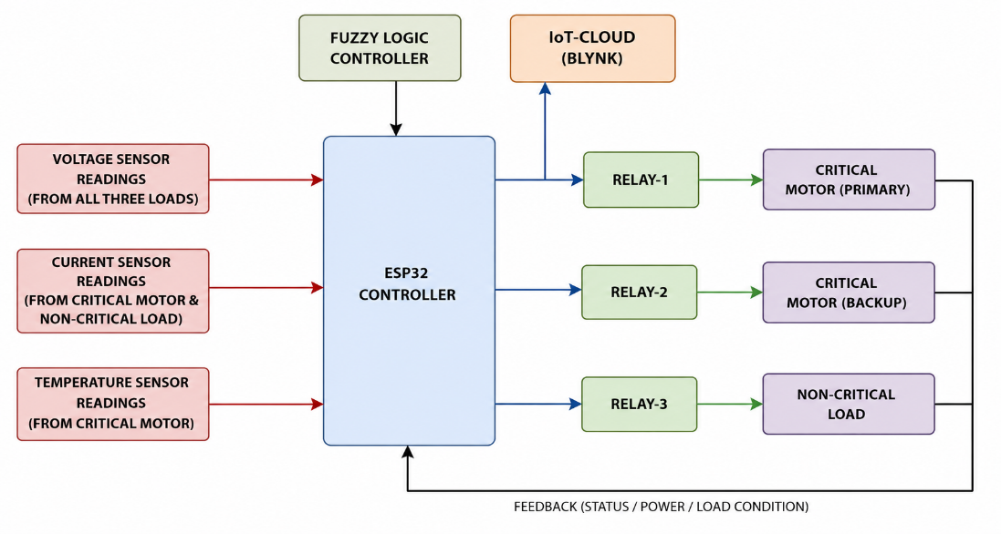

System Design
The proposed fuzzy logic-enabled motor fault detection system consists of three main sections: the sensing unit, control unit, and load control unit. The sensing unit includes voltage, current, and temperature sensors that continuously monitor the operating condition of the motor. The control unit consists of an ESP32 microcontroller integrated with a fuzzy logic controller and IoT cloud platform. The load control unit comprises the primary motor, backup motor, non-critical load, and relay modules. The sensor readings are continuously transmitted to the ESP32, where they are processed using fuzzy logic rules to determine the motor status. The voltage sensor monitors the supply voltage, the current sensor measures the load current, and the temperature sensor detects motor overheating. Based on these inputs, the fuzzy logic controller evaluates the operating condition of the motor and generates an appropriate control action. Under normal conditions, the primary motor operates continuously while the backup motor remains inactive. When a fault condition is detected, the faulty motor is isolated and the backup motor is automatically activated through relay switching. During undervoltage conditions, the non-critical load is disconnected to implement load shedding and ensure uninterrupted operation of critical processes.The fuzzy logic controller evaluates motor condition using voltage, current, and temperature as input parameters. For a fault condition, the measured values are:

Voltage = 260 V
Current = 4.2 A
Temperature = 120°C
The membership values are obtained from the predefined fuzzy sets using trapezoidal membership functions. Since the voltage exceeds the normal operating range, it belongs to the High voltage region with a membership value of 0.65. Similarly, the current corresponds to the High current region with a membership value of 0.85, while the temperature completely belongs to the High temperature region with a membership value of 1.
Voltage membership value = 0.65
Current membership value = 0.85
Temperature membership value = 1
Rule output value = 1
The final defuzzified output is calculated using:
Z = (0.65 + 0.85 + 1 + 1)/4
Z = 0.887
Since the calculated status value is greater than the predefined fault threshold, the motor condition is classified as a critical fault state. The system therefore identifies the motor as faulty and initiates the required protective action, including backup motor activation and load management.

Simulation and Design Specification
The simulation of the proposed system is carried out using the MATLAB/Simulink environment. The simulation model includes voltage, current, and temperature sensing units, a fuzzy logic controller, relay switching circuits, a primary motor, a backup motor, and a non-critical load. The sensor blocks continuously monitor motor operating parameters and provide inputs to the fuzzy logic controller. The fuzzy controller is designed using membership functions for voltage, current, and temperature, along with predefined IF–THEN rules for fault evaluation. The controller output determines the motor status and corresponding control action. Relay blocks are used to simulate motor isolation, backup motor activation, and load shedding operations. Scope blocks are connected to observe motor parameters and fault status. The simulation is performed under normal, overvoltage, undervoltage, and overtemperature conditions. It is observed that the fuzzy logic controller accurately identifies fault conditions and initiates appropriate protective actions. The simulation validates the effectiveness of the proposed motor fault detection and control system.
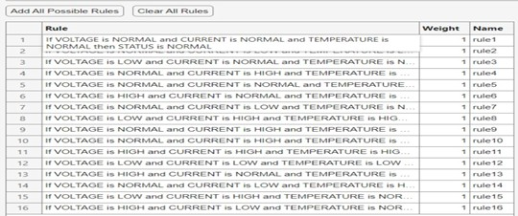
The figure shows the fuzzy rule base used for motor fault detection. It consists of a set of IF–THEN rules that evaluate the motor condition based on voltage, current, and temperature inputs. Each rule maps different combinations of input parameters to an output status, enabling the fuzzy logic controller to distinguish between normal and fault conditions. This rule-based approach improves decision-making under varying operating conditions.
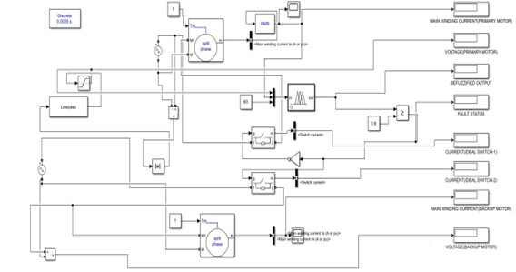
The figure illustrates the MATLAB/Simulink model developed for the fuzzy logic-based motor fault detection and protection system. The model incorporates voltage, current, and temperature monitoring, along with a fuzzy logic controller for fault evaluation. Based on the controller output, relay switching is performed to isolate the faulty primary motor and activate the backup motor when required. The simulation also includes load shedding functionality and displays key parameters such as motor voltage, current, fault status, and controller output for performance analysis. When abnormal conditions such as overvoltage, undervoltage, overcurrent, or excessive temperature are detected, the controller isolates the faulty motor and activates the backup motor through relay switching. The simulation results verify the effectiveness of the proposed system in achieving accurate fault detection, reliable backup activation, and efficient power management in sewage treatment plant applications.

Hardware Implementation
- The system is designed based on fuzzy logic-enabled motor fault detection with automatic backup motor activation and load shedding for sewage treatment plant applications.

- An ESP32 microcontroller is used as the central controller to acquire sensor data, execute fuzzy logic rules, and perform control actions.

- Voltage, current, and temperature sensors continuously monitor the operating condition of the motor and provide real-time inputs to the controller.

- The sensor readings are processed using an embedded fuzzy logic algorithm to identify abnormal conditions such as overvoltage, undervoltage, overcurrent, and overheating.

- Relay modules are used to isolate the faulty primary motor and automatically activate the backup motor, ensuring uninterrupted operation of critical processes and during power-stressed conditions, the controller implements load shedding by disconnecting non-critical loads while maintaining supply to essential loads.

- The ESP32 communicates with the Blynk IoT platform, enabling real-time monitoring of motor parameters, fault status, and system operation through a cloud-based interface.
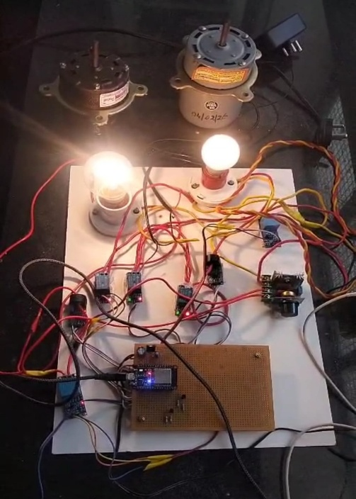
Advantages of proposed system
The proposed fuzzy logic-enabled motor fault detection system offers several advantages. It provides accurate fault detection by simultaneously analyzing voltage, current, and temperature parameters. The system improves reliability by automatically isolating the faulty motor and activating a backup motor, thereby ensuring uninterrupted operation. The integrated load shedding mechanism enhances power management by disconnecting non-critical loads during abnormal conditions. IoT-based monitoring enables real-time supervision and remote access to system parameters. The design is cost-effective, easy to implement, and suitable for sewage treatment plant applications. The system also reduces downtime, maintenance requirements, and the risk of process interruptions.

Results and discussions
The simulation results show that the fuzzy logic controller accurately identifies normal and fault conditions based on voltage, current, and temperature inputs. The hardware results also exhibit similar behavior. Under normal operating conditions, the motor operates at approximately 228 V, 4.8 A, and 36°C. During overvoltage and undervoltage conditions, the system successfully detects faults and initiates the required protective actions. Automatic backup motor activation ensures uninterrupted operation, while load shedding effectively disconnects non-critical loads during power-stressed conditions. The proposed system demonstrates reliable fault detection, improved operational continuity, and efficient power management for sewage treatment plant applications.

- CONCLUSIONS
A fuzzy logic-enabled motor fault detection system with automatic backup activation and integrated load shedding has been designed and implemented. The system uses voltage, current, and temperature monitoring to accurately identify motor fault conditions. MATLAB simulation validates the effectiveness of the fuzzy logic controller under various operating conditions. The hardware prototype demonstrates reliable fault detection, backup motor activation, and load shedding during abnormal conditions. The proposed system is suitable for sewage treatment plant applications, ensuring uninterrupted operation, improved reliability, and efficient power management.

References
- A. H. Sabry and U. A. Amirulddin, “A review on fault detection and diagnosis of industrial machines and robots,” Results in Engineering, vol. 19, Art. no. 102397, 2024.
- K. Venkatesh and N. M., “Fault analysis and predictive maintenance of induction motor using machine learning,” IEEE Access, vol. 12, pp. 1–10, 2024.
- M. H. Jopri, N. A. Ahmad, and M. Manap, “Fuzzy logic based fault detection of motor using current analysis,” International Journal of Electrical and Computer Engineering, vol. 8, no. 3, pp. 1459–1467, 2018.
- R. A. Patil and D. R. Kumbhar, “Smart load shedding using fuzzy logic,” Renewable Energy Reviews, vol. 120, Art. no. 1096, 2020.
- R. B. Fairuz, “Non-invasive fault detection of stator windings of induction motors,” IEEE Sensors Journal, vol. 22, no. 5, pp. 4560–4568, 2021.
- S. K. Sharma and R. Gupta, “Real-time condition monitoring of induction motors using IoT and fuzzy inference systems,” IEEE Internet of Things Journal, vol. 8, no. 15, pp. 12345–12354, 2021.

