Multi-Modal Multi-Agentic AI Shopping Assistant

Dr. Shanthi Therese  Asst Prof, Information Technology Thadomal Shahani Engineering College Mumbai, India @thadomal.org | Om Pawaskar  Student, Information Technology Thadomal Shahani Engineering College Mumbai, India ompawaskar7@gmail.com | Darshan Soni  Student, Information Technology Thadomal Shahani Engineering College Mumbai,India soni.darshan0209@gmail.com
Yuvraj Upadhyay Student, Information Technology Thadomal Shahani Engineering  College Mumbai, India  upadhyayyuvraj23@gmail.com | Atharva Yadav  Student, Information Technology Thadomal Shahani Engineering College Mumbai, India  atharvayadav11@gmail.com

Abstract - The "Multimodal Multi-Agentic AI Shopping Assistant" is driven by the demand for a system that can move beyond isolated recommendation engines and basic multimodal retrieval. By addressing the clear research gap where platforms fail to synthesize data into intelligent, context-aware interactions, this project utilizes advanced technologies like multimodal fusion and collaborative multi-agent frameworks. This system seeks to offer a holistic, real-time, and explainable understanding of the entire shopping journey. The main objective of the "Multimodal Multi-Agentic AI Shopping Assistant" is to deliver a comprehensive intelligence layer that creates a "personalized shopping index" for predictive and adaptive insights. Built with a modern tech stack including PyTorch, LangChain, and React, the system integrates four specialized AI agents: Search, Recommendation, Negotiation, and Transaction. This design enables detailed interaction analysis and transparent explainability at every stage of the shopping process. Key features of the platform include its synergistic use of multimodal data by fusing product images, text descriptions, behavioral logs, and numerical patterns with an explainable multi-agent architecture. This structure provides a "panoramic view" of user preferences and shopping intent. Through its ability to drill down from a single holistic index into specific agent insights, the assistant aims to empower users and businesses by transforming "black box" recommendations into clear, actionable, and transparent outcomes for proactive decision-making. In conclusion, the "Multimodal Multi-Agentic AI Shopping Assistant" provides a transformative solution to the limitations of
traditional e-commerce systems. By creating an "intelligent synthesis of multiple advanced AI paradigms", this project aims to modernize the online shopping experience, enhance personalization through a "true 360- degree view" of user behavior, and foster an intelligence- driven approach to retail optimization, making a significant impact on engagement, satisfaction, and long- term business growth.

- INTRODUCTION

With the explosive growth of e-commerce, buyers today are presented with an overwhelming array of choices across countless platforms, often resulting in decision paralysis and inefficient shopping experiences. While traditional recommendation engines have provided some level of personalization, these systems typically rely on siloed data sources or single-modal interactions, such as basic text-based search or rigid filtering options. Furthermore, users must frequently switch between multiple apps or websites to compare products, check reviews for authenticity, and search for competitive prices. This fragmented process underscores the limitations of current digital shopping tools in providing a cohesive, intelligent, and user-centric experience. The Multimodal Multi-Agentic Shopping Companion introduces a paradigm shift by creating an integrated AI-powered framework capable of synthesizing information from text, images, and voice inputs. At its core, this project leverages a distributed agent-based approach—where each agent is specialized in handling product discovery, recommendation, price comparison, and review verification—allowing the system to mimic the nuanced evaluation strategies of a savvy

human shopper. By orchestrating the combined strengths of advanced NLP, computer vision, and explainable multi-agent collaboration, this assistant offers a truly holistic solution that not only generates recommendations but also provides reasoned, transparent explanations for every suggestion.

- LITERATURE REVIEW

The current e-commerce environment has witnessed major advancements in artificial intelligence, especially in areas such as personalized recommendations and multimodal product search. Despite these improvements, most systems remain limited to specific functions, often focusing only on search optimization or transaction automation without integrating both. For example, frameworks like UniECS emphasize unified multimodal search by combining visual and textual information through deep learning models. This enables flexible product retrieval using both image and text data. However, these systems usually stop at retrieval and lack deeper reasoning abilities, negotiation mechanisms, or comprehensive end-to-end shopping assistance. In contrast, multi-agent shopping systems treat the online shopping process as a collaborative interaction among autonomous agents such as buyers, sellers, mediators, and recommenders. Each agent performs a specialized role, handling tasks like product discovery, price negotiation, and personalized suggestions. These systems use communication protocols and security layers, often incorporating blockchain to ensure trust and transparency. While effective in managing transactions and decision-making, they generally operate only with structured or textual data and lack the capacity to process or interpret multimodal inputs such as product images or combined descriptive queries. As a result, current e-commerce AI systems remain fragmented, with one group excelling at multimodal understanding and another at agent- based reasoning. The absence of a unified system that can both understand multimodal inputs and perform intelligent agentic operations has led to limited personalization, poor explainability, and a lack of proactive engagement during the shopping experience.

A clear research gap exists in integrating multimodal deep learning with multi-agent intelligence into a single adaptive framework. Existing multimodal models such as UniECS are primarily designed for retrieval tasks and do not include active collaboration or negotiation mechanisms. On the other hand, multi-agent systems offer intelligent communication and decision-making but are restricted to text-based or structured data interactions. This disconnect prevents e- commerce platforms from delivering a complete, context- aware experience. Most existing systems are limited in their ability to combine text and image inputs within a single query. They also lack transparency in decision-making, as users cannot see or understand why a particular product was recommended or selected. In addition, current approaches
tend to react to user input rather than anticipating needs or preferences, which restricts their usefulness in dynamic shopping environments. Data flow between components such as recommendation, search, and transaction modules is often fragmented, reducing overall efficiency. Bridging this gap requires an integrated system that can understand, reason, and act on diverse forms of data while maintaining transparency and adaptability throughout the shopping process.

- Data Collection
The data collection phase involved sourcing and integrating multiple datasets to build a robust intelligent system capable of supporting multimodal product search, personalized recommendations, and explainable agent-based decision making. Two main categories of data were gathered:
- product and user interaction data for recommendation and search, and
- review and pricing data for trust analysis and comparison across platforms.

E-Commerce Product Dataset

Primary product data was collected from major e-commerce platforms such as Amazon and Flipkart using web scraping techniques and publicly available APIs. This dataset contains detailed product information across multiple categories including electronics, fashion, and household goods. Over thousands of product records were collected, representing diverse brands and price ranges. Key attributes include:

  - Product name and category

  - Brand and seller information

  - Price and discount details

  - Product specifications and descriptions

  - Product images and multimedia content

User Interaction and Behavioral Data

User interaction data was gathered through simulated user sessions and application logs generated during system testing. This dataset captures behavioral patterns such as search queries, clicked products, time spent per product, and user preferences. These records are used to personalize recommendations and improve the adaptive learning capability of the system. Key features include:

  - Search queries (text, voice, and image-based)

  - Click-through history

  - Purchase intent indicators

  - Preference tags (budget range, favorite brands, categories)

Review and Sentiment Dataset Integration

Customer review data was collected from e-commerce platforms and public review repositories. This dataset includes large volumes of textual feedback provided by users on different products. Natural Language Processing (NLP) techniques are applied to analyze sentiment, detect fake or manipulated reviews, and compute trust scores. Key fields include:

  - Review text and rating

  - Sentiment polarity score

  - Authenticity and trust indicators

  - Review frequency and reviewer behavior patterns

Multimodal Data Integration

Product images were collected alongside textual descriptions and review data to support multimodal search functionality. Image features are extracted using computer vision models and combined with textual embeddings to enable unified semantic retrieval. This integration allows users to search using product photos, voice commands, or text queries.

Database Storage and Management

All datasets are stored in a MongoDB database to support efficient indexing, filtering, and real-time retrieval during inference. The flexible document-based schema enables the system to manage heterogeneous data types such as text, images, numerical values, and agent analysis outputs.

This integrated data collection framework ensures that the Multimodal Multi-Agentic AI Shopping Assistant can perform accurate product discovery, personalized recommendation, review authenticity analysis, and cross- platform price comparison while maintaining transparency and scalability.

- DATA PREPROCESSING

Once the data was collected, it underwent several stages of transformation to prepare it for multimodal understanding, agent-based reasoning, and intelligent recommendation generation.

Cleaning and Validation

Duplicate and incomplete product records were removed from the dataset.
Invalid or missing entries (such as null prices, broken image links, or incomplete product descriptions) were filtered out. Category-specific anomalies (for example, unrealistic price values or inconsistent specifications across sellers) were handled using rule-based validation and outlier detection techniques.

Review data was also validated by removing spam-like or extremely short reviews and filtering entries with missing ratings or timestamps.

Feature Engineering

To enhance model performance and contextual understanding, several derived features were generated from the raw data:

  - Historical user interaction features (previous searches, clicked products, and browsing history)

  - Average product rating and sentiment score from customer reviews

  - Price trends and discount percentages across platforms

  - Trust and authenticity scores computed from review analysis

  - Multimodal embeddings extracted from:

    - Product text descriptions (NLP-based embeddings)

    - Product images (computer vision feature vectors)

      - Voice or speech queries (speech-to-text representations)

These engineered features helped capture user intent, product relevance, and quality indicators more effectively for personalized recommendation.

Normalization and Transformation

All continuous variables such as price, discount percentage, rating values, and sentiment scores were normalized using min-max scaling or z-score normalization to ensure uniform contribution during model training.

Categorical variables such as product category, brand, and platform were transformed using one-hot encoding or embedding representations to reduce sparsity and improve learning efficiency.

Textual data (reviews and descriptions) was cleaned by removing stop words, punctuation, and special characters, followed by tokenization and vectorization using transformer- based language models.

Model Input Preparation

The final dataset prepared for training the intelligent recommendation and decision-making models consisted of:

Input Features:

  - Product attributes (price, category, brand, specifications)

  - User interaction history and preference vectors

  - Review sentiment and trust scores

  - Multimodal embeddings (text, image, and voice)

Target Variables:

  - Product relevance score

  - Recommendation ranking score

  - User satisfaction or engagement likelihood
This structured dataset was used to train machine learning and deep learning models responsible for search ranking, recommendation generation, and explainable agent decisions.

Agent Matching and Recommendation Pipeline

A custom backend pipeline processed user queries and preferences in real time. Each user request was distributed among specialized agents (Search Agent, Recommendation Agent, Price Agent, and Review Agent). The processed inputs were cross-referenced with the MongoDB-stored product and review datasets to:

  - Estimate product relevance and quality scores

  - Generate cross-platform price comparisons

  - Identify trustworthy and high-rated products

  - Suggest alternative products with better value or higher user relevance

This pipeline ensures that the system delivers transparent, personalized, and context-aware recommendations based on multimodal inputs and agent collaboration.

- PROPOSED METHODOLOGY

System Overview:

The system is designed as a full-stack web application aimed at enabling intelligent product discovery, multimodal search, personalized recommendations, and explainable agent-based decision support. It integrates machine learning, multimodal data processing (text, image, and voice), and collaborative AI agents to enhance the online shopping experience.

Frontend (React, Tailwind CSS, and ShadCn/ui)

A responsive and user-centric interface built using React and styled with Tailwind CSS and shadcn/ui components.

Accepts user inputs including:

  - Text-based product queries

  - Voice commands for product search

  - Uploaded product images

  - User preferences (budget range, category, brand, and ratings

Displays:

  - Ranked product recommendations

  - Cross-platform price comparison

  - Review trust and sentiment analysis

  - Agent-wise explanations (Search Agent, Price Agent, Review Agent, Recommendation Agent)

  - NLP-based personalized shopping insights and suggestions

Backend Logic (Node.js, Express, and Python Microservices)

Handles user requests and parses multimodal inputs. Key operations:
  - Interfaces with MongoDB to store user profiles, search history, and processed product data

  - Executes Python-based microservices responsible for image recognition, NLP processing, and recommendation inference

  - Scrapes and aggregates product data from e- commerce platforms (such as Amazon and Flipkart) to obtain key attributes (price, specifications, ratings, and reviews)

  - Coordinates multiple specialized agents for product analysis and decision making

Each agent performs focused tasks such as:

  - Product search and filtering

  - Price comparison and deal detection

  - Review authenticity and sentiment analysis

  - Personalized recommendation scoring
The backend aggregates results from all agents and presents a unified response to the user.

Machine Learning and AI Models

Pre-trained machine learning and deep learning models are used to support multimodal understanding and recommendation generation.

Input features include:

  - Product attributes (price, category, brand, specifications)

  - User interaction history and preference vectors

  - Review sentiment and trust scores

  - Multimodal embeddings from text, images, and voice queries

Output:

  - Product relevance and recommendation scores

  - Trust and quality indicators

  - Explainable agent-based decision outputs

These models enable adaptive and context-aware shopping recommendations.

API Integration

  - Speech-to-Text API: Converts voice queries into textual form for semantic processing

  - Computer Vision API: Extracts features from uploaded product images for visual search

  - Natural Language Processing Module: Generates human-readable explanations and personalized shopping suggestions based on user intent and agent analysis

  - E-commerce APIs / Web Scraping Services: Retrieve real-time product prices, availability, and review data

Trust and Explainability Module

The system computes trust and transparency indicators using review analysis and agent reasoning:

  - Review authenticity score derived from NLP-based fake review detection

  - Sentiment polarity score for customer feedback

  - Agent-wise contribution scores explaining why a product is recommended

This module ensures that every recommendation is interpretable and user-centric.

Recommendation and Decision Pipeline

A custom backend pipeline processes user queries and preferences in real time. Each request is distributed among multiple specialized agents. The results are combined to:

  - Rank products based on relevance, price, and trustworthiness

  - Suggest alternative products with better value or higher user preference match

  - Provide cross-platform comparisons and transparent reasoning

This pipeline ensures that the system delivers personalized, multimodal, and explainable shopping assistance.

- RESULTS AND DISCUSSIONS

Multimodal Intelligent Product Search.

Breakdown of recommended products based on agent-wise analysis (Search Agent, Price Agent, Review Agent, and Recommendation Agent).

Trust and Review Authenticity Analysis.

NLP-Based Personalized Shopping Insights and Recommendations.

Comparison of Personalized Recommendations vs. Default Search Results.

The system demonstrates the following core behaviors:

Multimodal Query Understanding:
The system accepts user input in the form of text queries, voice commands, or uploaded product images and interprets them using NLP and computer vision models to identify user intent and relevant product categories.

Agent-Wise Product Evaluation:
Each specialized agent independently evaluates products:
  - Search Agent identifies relevant products across platforms

  - Price Agent performs price comparison and deal detection
  - Review Agent analyzes sentiment and authenticity of customer reviews

  - Recommendation Agent computes personalized relevance scores

Explainable Recommendations:
The system provides transparent explanations for each recommendation, showing why a product is suggested based on price advantage, quality, trust score, and user preferences.

- Personalization and Adaptation: Recommendations dynamically adapt based on user interaction history, preferred brands, budget range, and feedback, enabling a more tailored shopping experience.

- Comparison of Agent-Driven vs. Default Results: The system compares intelligent agent-based recommendations with standard keyword-based search results, demonstrating improved relevance, trustworthiness, and user satisfaction.

Key Screenshots

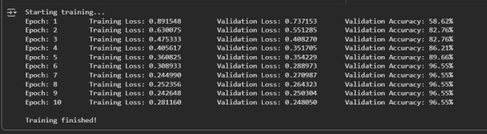

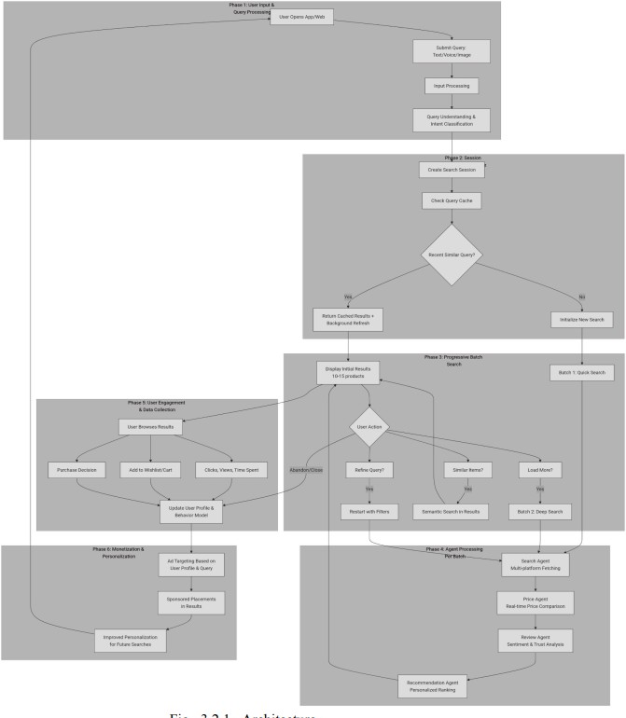
Fig 5.1 Architecture

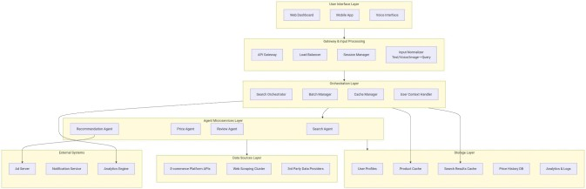

Fig 5.2 System Diagram

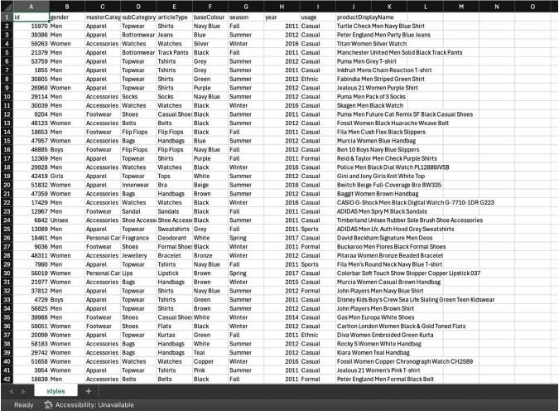
Fig 5.3 Dataset Structure
Fig 5.4 Model Training

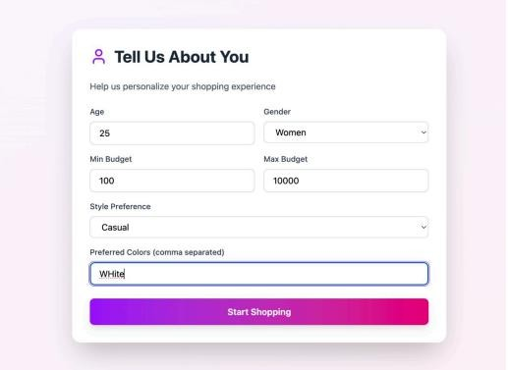
Fig 5.5 User Preference
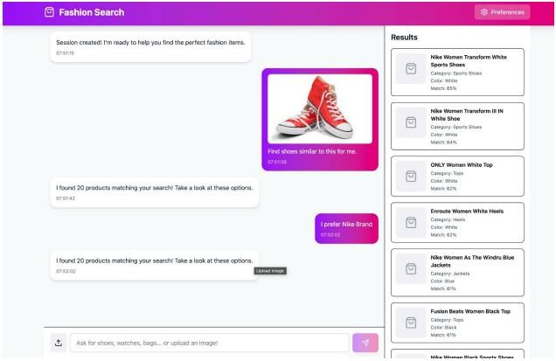
Fig 5.6 Agentic Chatbot

- CONCLUSION

The Multimodal Multi-Agentic Shopping Companion project successfully addresses the major pain points faced by e- commerce users: fragmented product information, lack of trust in reviews, and limited real-time personalization. By integrating multimodal input handling (text, image, and voice) with a scalable agent-based architecture, the platform enables holistic product discovery, cross-platform comparison, and explainable recommendations tailored to each user’s needs.

The modular agent design—incorporating search, price aggregation, review analysis, and personalized recommendation agents—ensures a seamless and adaptive shopping journey that elevates both trust and user control.

This work advances beyond the capabilities of existing systems by offering real-time, explainable insights; robust review filtering; dynamic user modeling; and extensibility for new modalities and shopping platforms. The project’s technical innovations lie in its synergistic use of advanced NLP, computer vision, and specialized agent orchestration— fusing data from multiple modalities for a unified, transparent, and dynamic shopping experience. As shopping behavior and e-commerce technology continue to evolve, the system provides a solid foundation for expanding intelligent shopping assistants with additional specialized agents, broader marketplace integration, and further user-centric enhancements

REFERENCES

[1]D. Liu and E. Lopez Ramos, “Multimodal semantic retrieval for product search,” arXiv:2501.07365 [cs.IR], 2025. [Online]. Available: https://arxiv.org/abs/2501.07365
- B. Kantamneni et al., “Survey of multi-agent systems for microgrid control,” Renewable and Sustainable Energy Reviews, 2015.

- “A multi agent based e-shopping system,” Research & Reviews: Journal of Computer Science, 2014.

- N. R. Jennings, “On agent-based software engineering,” Artificial Intelligence, 2000.

- Wang et al., “Damage detection in packaging using multimodal deep learning for e-commerce logistics,” 2023.

- “Multi-agent system architecture for collaborative e- commerce,” in Proc. IEEE Int. Conf. on E-Commerce Technology, 2006.

- Afsar et al., “Recent advances in multimodal sentiment analysis: A survey,” Information Fusion, 2024.

- Lin et al., “Research on multimodal prediction of e- commerce customer satisfaction driven by big data,” Future Generation Computer Systems, 2024.

- F. Chen and W. Ren, “On the control of multi-agent
systems: A survey,” Foundations and Trends in Systems and Control, vol. 6, no. 4, pp. 339–499, 2019.

- P. Stone and M. Veloso, “Multiagent systems: A survey from a machine learning perspective,” Artificial Intelligence, 1997.

- A. Dorri, S. S. Kanhere, and R. Jurdak, “Multi-agent systems: A survey,” IEEE Access, 2018.

- C. R. Jaimez-González and W. A. Luna-Ramírez, “Towards a multi-agent system architecture for supply chain management,” arXiv:2110.08125, 2021. [Online]. Available: https://arxiv.org/abs/2110.08125

- D. Maldonado and R. Zito, “Multi-agent systems: A survey about its components, communication, and applications,” IEEE Access, 2024.

