Climate-Resilient Rural Water Supply Systems in India: Integration of Sustainability, Smart Infrastructure, and Water Security under Jal Jeevan Mission
Abstract
With the launch of Jal Jeevan Mission (JJM), there is a major shift in the approach of rural water supply schemes in India, from infrastructure to integrated climate-resilient water security solutions. The focus of the traditional water supply projects in rural areas has been on simple infrastructure like hand pumps, bore wells, pipelines and limited distribution networks. But the escalating demands of groundwater, climate variability, water quality degradation and increasing demand for water use in rural areas have led to the development of sustainable, technology-based and environmentally friendly water management systems. This paper critically examines the developing framework of the rural water supply infrastructure in India by incorporating the concepts of engineering systems, recharge of water resources, planning climate resilience, smart water management technologies, development principles based on ESG and circular water economy concepts. The study uses qualitative analytical review, which is based on government documents, technical manuals, policy documents and published literature on Jal Jeevan Mission, Integrated Water Resource Management (IWRM), and sustainable rural infrastructure development. The review emphasizes the need of sustainability of the sources, decentralized governance, smart monitoring systems and recharge structures of the groundwater to guarantee long-term rural water security. The case studies from Gujarat, Telangana, Rajasthan and Maharashtra prove that the use of integrated water infrastructure models is successful in enhancing service reliability and resilience to climate change. The paper also explores implementation issues like over-exploitation of groundwater, lack of operation and maintenance, financial sustainability problems and institutional fragmentation. The study identified key factors that future-ready water systems in rural areas need to incorporate to achieve equitable, resilient rural water security and meet the Sustainable Development Goals (SDGs): engineering infrastructure, environmental sustainability, digital monitoring, climate adaptation, and community participation.
Keywords: Rural water supply, Jal Jeevan Mission, climate resilience, groundwater recharge, water security, ESG infrastructure, smart water systems, Integrated Water Resource Management, circular water economy, sustainable rural infrastructure.
1. Introduction
Safe drinking water is an essential for sustainable development, public health protection and social well-being. Worldwide there are still almost 2 billion people without safely managed drinking water services, especially in rural areas, and in climate vulnerable areas. The demand for water in developing countries is growing as a result of the rapid population growth, urbanization, industrialization, depletion of ground water and climate change.
With huge amount of rainfall received in a year, India is one of the most water-stressed countries in the world. Seasonal water scarcity, falling groundwater levels, lack of adequate infrastructure, lack of operation and maintenance, as well as contamination of water by fluoride, arsenic, iron and bacteriological contamination continues to be a major issue in rural areas. Indian estimates by NITI Aayog show that nearly 600 million people in India suffer from high or severe water stress and about 85% of the rural drinking water is provided from groundwater.
The work of rural water supply systems in India has mainly been through infrastructure development, either through the creation of bore wells, hand pumps or isolated piped water supply systems. However, these often proved unsuccessful as a result of weak sustainability planning for the sources, inadequate governance, limited maintenance systems and variability in water availability to sources due to climate change.
The Jal Jeevan Mission (JJM) was launched in 2019 with the catchcry “Har Ghar Jal” to step away from the framework of India's rural water supply and usher in a new paradigm. Key aspects of the mission are Functional Household Tap Connections (FHTCs), source sustainability, community participation, water quality surveillance, greywater management, and decentralized operation and maintenance systems.
Modern rural water supply systems combine:
- Source sustainability
- Groundwater recharge
- Water treatment
- Smart monitoring
- Community participation
- Environmental protection
- Climate resilience
- Zero discharge and reuse concepts
- Climate-resilient infrastructure planning
- Integrated Water Resource Management (IWRM)
- ESG-based infrastructure development
- Smart monitoring systems
- Circular water economy concepts
- Sustainable groundwater management
These systems directly contribute to rural development, public health, women empowerment, sanitation, and long-term environmental sustainability.
Despite significant progress, several challenges remain concerning climate adaptation, institutional coordination, energy efficiency, long-term sustainability, groundwater depletion, and operational resilience.
This paper critically reviews the emerging framework of rural water supply systems in India and examines the integration of sustainability, smart infrastructure, climate resilience, ESG principles, and water security concepts under Jal Jeevan Mission.
Under the vision of “Har Ghar Jal” through the Jal Jeevan Mission, India is transforming rural water infrastructure from isolated water supply systems into comprehensive water security and public health programmes.
A. Concept of Rural Water Supply
A rural water supply scheme is a complete chain that starts from the water source and ends at the household tap connection.
The system includes:
- Water source development
- Source sustainability measures
- Water abstraction systems
- Treatment and storage infrastructure
- Transmission and distribution networks
- Household tap connections
- Monitoring and automation systems
- Operation & maintenance frameworks
- Wastewater management and recharge systems
Thus, rural water supply is fundamentally a water security management system, not only a civil engineering project.
B. Jal Jeevan Mission and “Har Ghar Jal”
The Government of India launched the Jal Jeevan Mission to provide:
- Functional Household Tap Connections (FHTC)
- Safe drinking water to every rural household
- Sustainable and equitable water supply
- Community-managed water infrastructure
C. Complete Components of a Rural Water Supply Scheme
C.1 Water Source Identification and Sustainability
The first and most critical component is the identification of a sustainable water source.
Possible sources include:
- Surface water reservoirs
- Rivers and canals
- Groundwater aquifers
- Springs in hilly regions
- Rainwater harvesting structures
Key activities include:
- Hydrogeological investigation
- Aquifer mapping
- Yield assessment
- Water quality analysis
- Seasonal reliability studies
Source sustainability measures include:
- Watershed development
- Catchment protection
- Recharge pits
- Percolation tanks
- Check dams
- Recharge shafts
- Rainwater harvesting
These measures help maintain long-term groundwater availability and reduce over-extraction.
C2. Groundwater Recharge and Water Conservation Systems
Groundwater recharge is essential for sustainable rural water supply.
Major Recharge Structures
Recharge Pits
Used to infiltrate rooftop and storm water runoff into shallow aquifers.
Recharge Shafts
Deep recharge structures used where top strata are impermeable.
Check Dams
Small barriers constructed across streams to increase infiltration and groundwater recharge.
Percolation Tanks
Store runoff water and promote slow infiltration into groundwater zones.
Farm Ponds and Recharge Trenches
Improve local water retention and aquifer recharge.
These systems:
- Improve groundwater levels
- Increase drought resilience
- Reduce dependency on deep borewells
- Enhance source sustainability
C3. Water Abstraction and Intake Infrastructure
Depending on the source type, the scheme includes:
Intake Structures
- River intake wells
- Jack wells
- Infiltration galleries
Pumping Systems
- Raw water pumping stations
- Submersible pumps
- Vertical turbine pumps
- Solar-powered pumping systems
Modern systems increasingly use:
- Energy-efficient pumps
- Variable frequency drives (VFDs)
- Solar photovoltaic systems
- Smart energy management
C4. Water Treatment Infrastructure
Water treatment is critical for public health protection.
Typical Water Treatment Plant (WTP) Components
Preliminary Treatment
- Screening
- Grit removal
- Aeration
Primary Treatment
- Coagulation
- Flocculation
- Sedimentation
Filtration
- Rapid sand filters
- Pressure filters
- Multimedia filtration
Disinfection
- Chlorination
- UV treatment
- Ozonation (limited cases)
Water treatment plants ensure:
- Removal of turbidity
- Bacterial control
- Fluoride and iron removal
- Arsenic mitigation
- Safe potable water standards
C5. Storage and Distribution Infrastructure
Storage Structures
Clear Water Reservoirs (CWR)
Elevated Storage Reservoirs (ESR)
Ground Service Reservoirs (GSR)
Distribution Network
The distribution system includes:
- Rising mains
- Transmission pipelines
- Distribution pipelines
- Valve chambers
- Air valves and scour valves
- Pressure reducing valves
- Bulk meters
- Household service connections
Proper hydraulic design ensures:
- Adequate residual pressure
- Uniform distribution
- Reduced leakage
Minimum non-revenue water losses
This paper critically analyses the new paradigm of rural water supply systems in India and looks into the assimilation of sustainability, smart buildings, climate resilience, ESG principles and water security in the Jal Jeevan Mission.
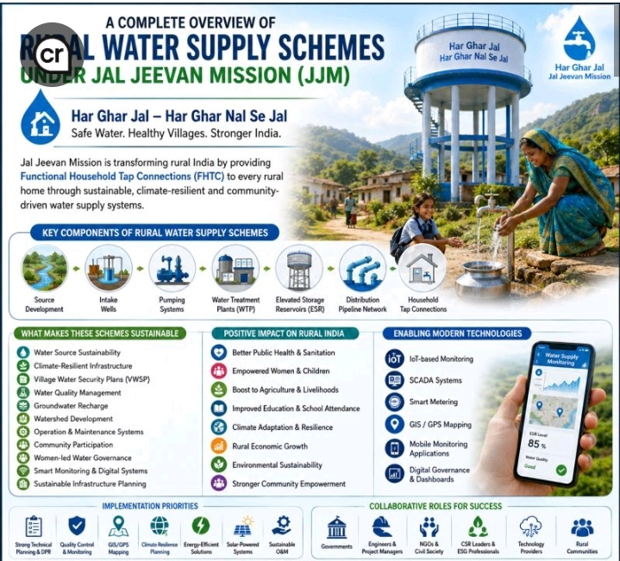
2. Literature Review
2.1 Global problems related to rural water supply.
Other studies in the international scene show that increasing sustainable rural water supply is still a key challenge in developing countries, caused by a lack of infrastructure financing, the vulnerability of water to climatic variations, groundwater depletion, and institutional fragmentation. The reports of the WHO and the UNICEF Joint Monitoring Programme (JMP) highlight the importance of sustainability of services, not just in terms of building them but also by ensuring their operation, security of sources and in good governance.
Many of the countries in Africa and Asia still have high rates of failure of rural water systems for various reasons, such as inadequate community ownership, energy shortages and poor maintenance practices.
2.2 Water supply in rural areas in India
Groundwater-based rural water supplies are part of the Indian history and studies have pointed out the pitfalls of infrastructure-oriented solutions. In many older schemes in rural areas the following issues were experienced:
- Source failure
- Seasonal unreliability
- Groundwater depletion
- Poor water quality
- Inadequate O&M systems
- Limited institutional accountability
The following points from recent literature have been stressed:
- Multi-source water systems
- Groundwater recharge
- Smart monitoring technologies
- Decentralized governance
- Community participation
- Water quality surveillance
2.3 Climate Resilience and Water Infrastructure
Hydrological cycles, groundwater recharge, rainfall regimes and the frequency of droughts are becoming more impacted by climate change. The study shows the future rural water systems should be based on the following:
- Climate-adaptive infrastructure
- Recharge-based sustainability
- Multi-source integration
- Flood-resilient infrastructure
- Energy-efficient pumping systems
In addition, research has focused on the increasing importance of solar-powered pumping systems, smart SCADA monitoring, and water management technologies based on IoT to enhance resilience of systems.
2.4 Research Gap
The available studies are mainly dedicated to either infrastructure development or groundwater management or governance systems alone. Currently there is limited research that incorporates all of the following:
- Engineering infrastructure
- Climate resilience
- ESG principles
- Smart monitoring systems
- Circular water economy
- IWRM frameworks
In the context of a harmonised rural water security framework in India.
This paper aims to fill this gap by examining sustainable rural water infrastructure systems with an integrated analysis approach.
3. Research Methodology
This study used qualitative analytical review methodology, which used secondary data, technical reports, policy documents and published literature data.
3.1 Data Sources
The analysis is carried out based on:
- Jal Jeevan Mission reports:
- This includes publications by the Ministry of Jal Shakti.
- NITI Aayog reports
- The data from Central Ground Water Board are used.
- Reports from WHO and UNICEF
- The IPCC climate assessment reports which are being produced
- Peer-reviewed journal articles
- Rural infrastructure technical manuals
3.2 Analytical Framework
The study compares the rural water supply systems in terms of the following dimensions:
- Engineering infrastructure
- Source sustainability
- Climate resilience
- Water governance
- Smart technologies
- ESG-based infrastructure development
- Information on the concepts of the circular water economy
3.3 Scope of the Study
In this study, the research will concentrate on:
- Water supply systems in rural areas with piped supplies.
- Groundwater recharge infrastructure
- Use of water treatment and storage systems.
- Smart monitoring technologies
- Climate-resilient planning approaches
- Decentralized governance systems

4. Quantitative Data and Statistics
4.1 Rural Water Supply Coverage in India
Parameter | Estimated Value
Rural households with tap water access in 2019 | ~17%
Rural households with tap water access in 2026 | >75%
Groundwater contribution to rural drinking water | ~85%
Population facing water stress in India | ~600 million
Districts affected by groundwater depletion | >250
Average NRW losses in rural systems | 20–40%

4.2 Climate Vulnerability Indicators
Climate Risk | Impact on Rural Water Systems
Erratic monsoon | Reduced recharge
Heat waves | Increased demand
Drought | Source failure
Flash floods | Infrastructure damage
Groundwater depletion | Reduced sustainability

5. Case Studies
5.1 Gujarat Rural Water Grid
It was decided to design an integrated rural water grid system which was to include surface reservoirs, transmission pipelines, pumping system, and a network of distribution pipelines at the village level in Gujarat. The project had a significant impact in terms of successfully reducing the groundwater dependency of water-scarce parts of the world and increasing drought resilience.
5.2 Telangana Mission Bhagiratha
Mission Bhagiratha rolled out a large scale rural drinking water infrastructure network, comprising of centralized drinking water treatment plants, bulk transmission systems, ESRs and household tap connections. The programme has enhanced water access and reliability in the rural areas.
5.3 Rajasthan Groundwater Recharge Initiatives
Recharge structure in drought-prone districts such as check dams, percolation tanks, recharge wells etc. were introduced in Rajasthan. These interventions enhanced the groundwater status and resulted in more water being available in the long-term.
5.4 Hiware Bazar Watershed Model, Maharashtra
Integrated watershed management, groundwater recharge, water budgeting and community participation were adopted in Hiware bazar village, making it a sustainable water management village, which was once a drought prone village.
6. Figures and Tables
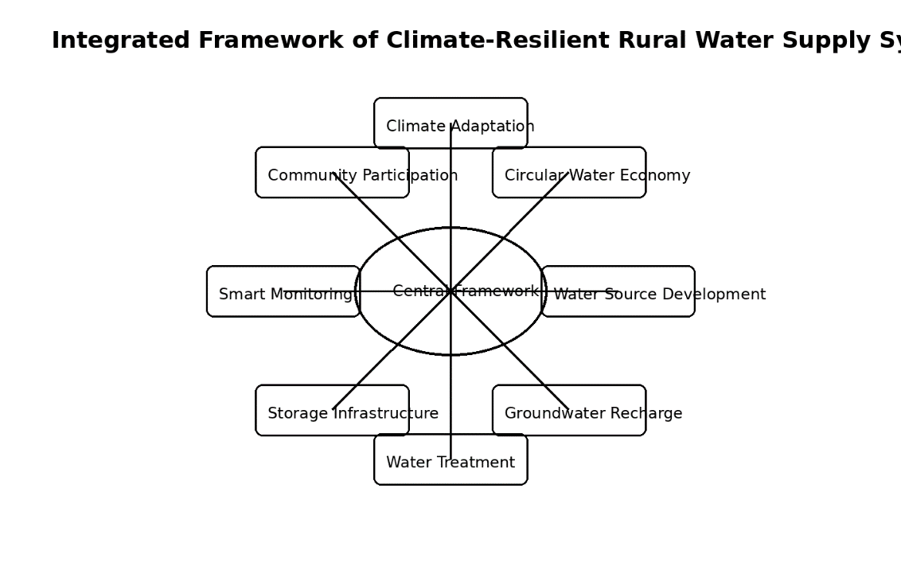
Figure 1
Integrated Framework of Climate-Resilient Rural Water Supply Systems
Figure Description
It should be a figure with a circular integrated structure and the components should be connected.
Central Core:
Research for the "Climate-Resilient Rural Water Security".
Connected Components:
- Water Source Development
- Groundwater Recharge
- Water Treatment Systems
- Storage Infrastructure
- Smart Monitoring
- Community Participation
- ESG Governance
- Climate Adaptation
- Wastewater Reuse
- Circular Water Economy
Outer Layer:
- SDGs
- Sustainability
- Public Health
- Environmental Protection
- Rural Development

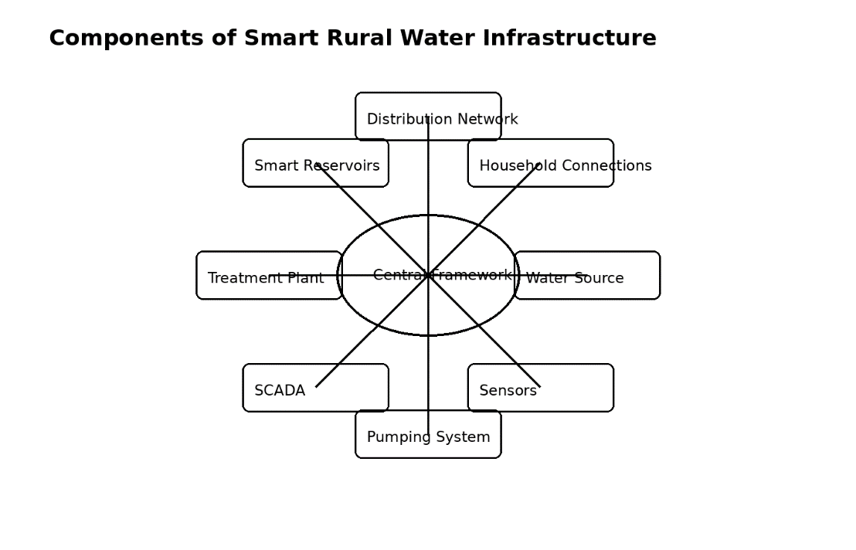
FIGURE 2
Components of Smart Rural Water Infrastructure
Figure Description
Produce a technical schematic that is based on flow and contains:
Water Source, Sensors, Pumping System, SCADA Control, Treatment Plant, Smart Reservoirs, Distribution Network, Household connections.
Supporting Smart Components:
- IoT Sensors
- GIS Mapping
- Digital Dashboard
- Remote Monitoring
- Leak Detection
- Smart Metering

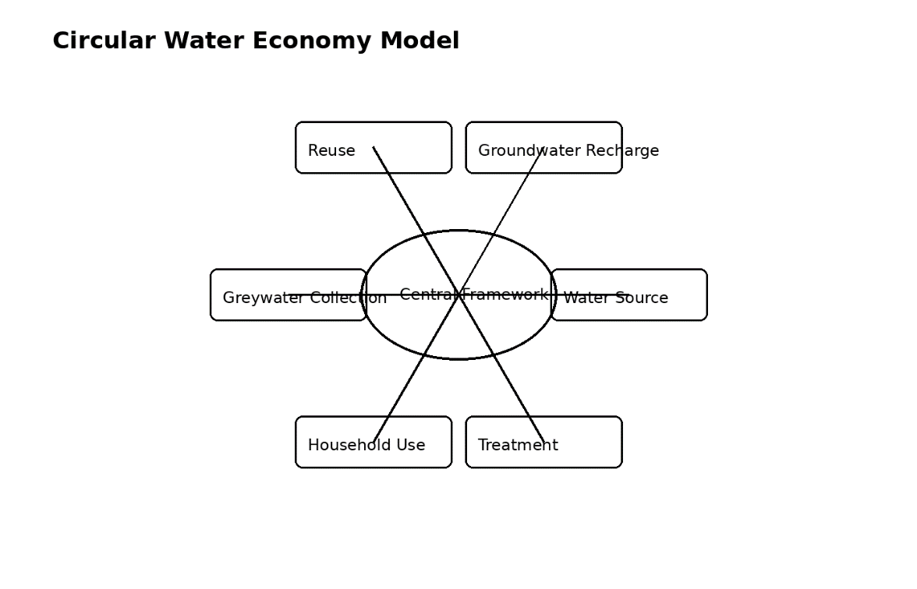
FIGURE 3
Circular Water Economy Model for Rural Areas
Figure Description
This should be a circle diagram with:
Water Source →
Water Treatment →
Household Use →
Greywater Collection →
Decentralized Treatment →
Reuse for Irrigation/Gardening →
Groundwater Recharge →
Back to Source Sustainability
Draw sustainability arrows to indicate:
- Reduced Pollution
- Reduced Freshwater Demand
- Aquifer Recharge
- Water Reuse

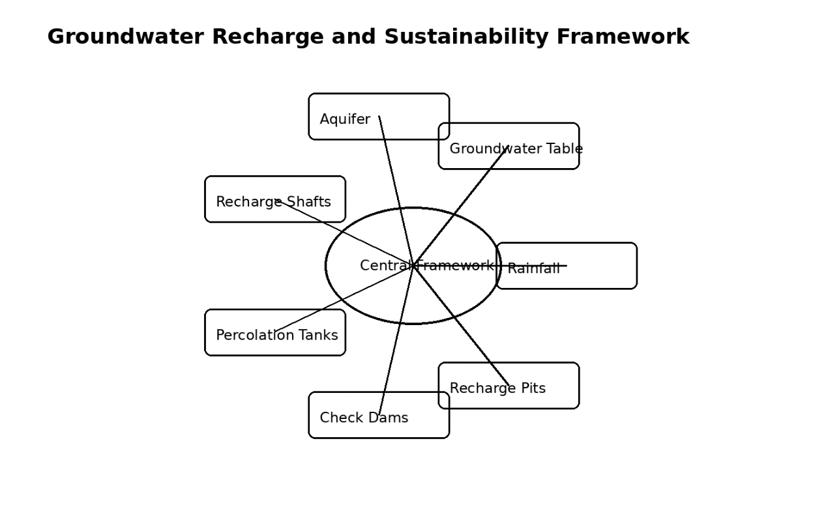 FIGURE 4
Groundwater Recharge and Sustainability Framework
.
Figure Description
Cross sectional hydrogeological schematic with:
- Rainfall
- Surface runoff
- Recharge pits
- Check dams
- Percolation tanks
- Recharge shafts
- Aquifer layers
- Groundwater table
- Bore wells
Draw arrows to represent ground water recharge and infiltration.
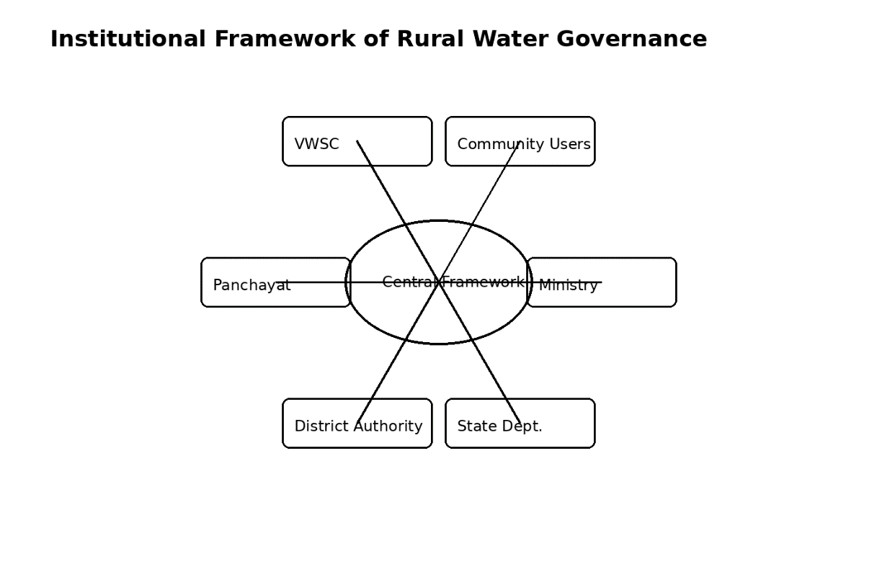
FIGURE 5
Institutional Framework of Rural Water Governance
Figure Description
Hierarchy governance model with:
Ministry of Jal Shakti
- State Water Departments
- District Water Authorities
- Panchayats
- Village Water and Sanitation Committees (VWSCs)
- Community Users
Display arrows of interaction for:
- Monitoring
- Funding
- O&M
- Governance
- Water Quality Surveillance

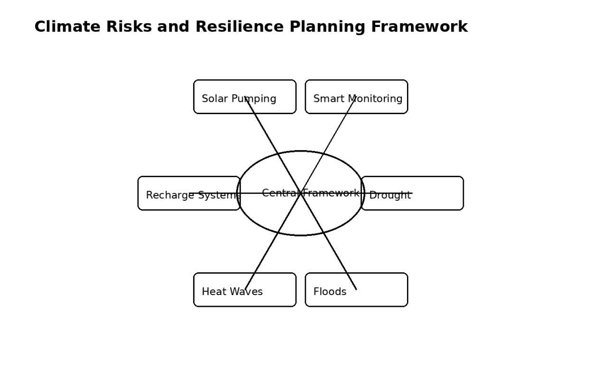
FIGURE 6
Climate Risk and Resilience Planning framework
Figure Description
Left Side:
Climate Risks
- Drought
- Floods
- Heat Waves
- Groundwater Depletion
- Erratic Rainfall
Right Side:
Adaptation Measures
- Multi-source systems
- Recharge infrastructure
- Flood-resilient design
- Solar pumping
- Smart monitoring
- Demand management
Centre:
“Climate-Resilient Water Infrastructure”
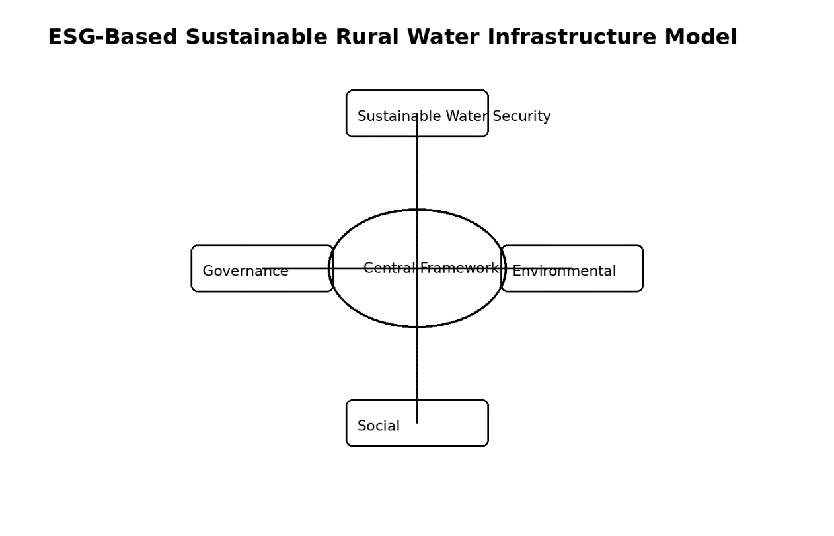
FIGURE 7
ESG-Based Sustainable Rural Water Infrastructure Model

Figure Description
Three intersecting circles:
- Environmental
- Social
- Governance
Inside intersections:
- Sustainable extraction
- Public health
- Transparency
- Women participation
- Renewable energy
- Smart governance
- Community ownership
Centre:
The project is called “Sustainable Rural Water Security”.

TABLES AND FIGURES FOR SCOPUS JOURNAL MANUSCRIPT
TABLE 1
Comparison Between Conventional and Modern Rural Water Supply Systems
Parameter | Conventional Rural Water Systems | Modern Climate-Resilient Rural Water Systems
Primary Objective | Basic water access | Sustainable water security
Water Source | Single groundwater source | Multi-source integrated systems
Infrastructure Focus | Pipelines and pumps | Integrated socio-technical systems
Source Sustainability | Limited consideration | Recharge-based sustainability
Water Treatment | Minimal treatment | Advanced multi-stage treatment
Monitoring | Manual inspection | IoT and SCADA-based monitoring
Energy Systems | Grid-dependent pumps | Solar and energy-efficient systems
Governance | Department-centric | Community-managed governance
Climate Resilience | Limited | Climate-adaptive infrastructure
Wastewater Management | Neglected | Circular water economy and reuse
Asset Management | Reactive maintenance | Predictive digital maintenance
Water Quality Surveillance | Periodic testing | Real-time monitoring systems
Sustainability Approach | Infrastructure-oriented | ESG and SDG aligned systems

TABLE 2
Major Groundwater Recharge Structures and Their Functions:
Recharge Structure | Primary Function | Technical Application | Key Benefits
Recharge Pits | Storm water infiltration | Rooftop runoff recharge | Improves shallow aquifer recharge
Recharge Shafts | Deep aquifer recharge | Impermeable top strata areas | Enhances deep groundwater levels
Check Dams | Flow retardation and infiltration | Seasonal streams | Reduces runoff and increases recharge
Percolation Tanks | Surface storage and infiltration | Rural catchment areas | Sustains groundwater availability
Farm Ponds | Local water retention | Agricultural regions | Enhances drought resilience
Recharge Trenches | Linear infiltration | Roadside and open areas | Improves recharge efficiency
Rainwater Harvesting Systems | Rainwater conservation | Rooftops and community buildings | Reduces dependency on groundwater
Watershed Structures | Catchment treatment | Hilly and drought-prone regions | Improves ecosystem sustainability

TABLE 3
Climate Risks and Adaptation Strategies in Rural Water Infrastructure
Climate Risk | Impact on Water Systems | Adaptation Strategy
Erratic Rainfall | Reduced recharge and unreliable supply | Multi-source water systems
Drought Conditions | Groundwater depletion | Recharge-based sustainability planning
Flash Floods | Damage to pipelines and pump houses | Elevated and flood-protected infrastructure
Heat Waves | Increased water demand | Demand-side management and storage optimization
River Flow Variability | Unstable surface water supply | Integrated reservoir management
Groundwater Decline | Reduced borewell yield | Aquifer recharge and watershed development
Energy Disruptions | Pumping interruptions | Solar-powered pumping systems
Water Quality Deterioration | Public health risks | Advanced treatment and surveillance systems

TABLE 4
ESG Indicators in Rural Water Infrastructure Development
ESG Component | Indicators | Infrastructure Implications
Environmental | Groundwater recharge | Sustainable source management
Environmental | Renewable energy use | Reduced carbon footprint
Environmental | Wastewater reuse | Circular water economy
Environmental | Leakage reduction | Lower non-revenue water losses
Social | Household tap connections | Improved public health
Social | Women participation | Gender-inclusive governance
Social | Community ownership | Improved sustainability
Social | Water quality surveillance | Reduced disease burden
Governance | SCADA monitoring | Transparency and accountability
Governance | Digital dashboards | Performance monitoring
Governance | GIS asset mapping | Efficient infrastructure management
Governance | Community auditing | Improved institutional governance

TABLE 5
Major Components of Rural Water Supply Systems
System Component | Key Infrastructure Elements | Functional Role
Source Development | Reservoirs, aquifers, springs | Water availability
Recharge Infrastructure | Check dams, recharge pits | Source sustainability
Intake Systems | Jack wells, intake wells | Raw water abstraction
Pumping Systems | Pumps, VFDs, solar systems | Water conveyance
Water Treatment Plants | Filters, chlorination units | Water purification
Storage Systems | CWR, ESR, GSR | Supply balancing
Distribution Networks | Pipelines, valves, meters | Water delivery
Smart Monitoring | IoT sensors, SCADA | Real-time management
Water Quality Systems | Testing labs, sensors | Public health protection
O&M Systems | Maintenance frameworks | Long-term sustainability
Wastewater Systems | Reed beds, soak pits | Greywater reuse
TABLE 6
Smart Technologies Used in Modern Rural Water Supply Systems
Technology | Function | Benefits
IoT Sensors | Flow and pressure monitoring | Real-time performance tracking
SCADA Systems | Remote monitoring and automation | Improved operational efficiency
GIS Mapping | Asset and network mapping | Better maintenance planning
GPS Surveying | Infrastructure positioning | Accurate asset management
Smart Meters | Consumption measurement | Demand management
Digital Dashboards | Data visualization | Governance transparency
AI-Based Analytics | Predictive maintenance | Reduced system failures
Solar Pumping Systems | Renewable energy integration | Lower operational cost

7. Critical Discussion
While there were significant improvements under Jal Jeevan Mission, there is a need to address some of the challenges.
7.1 Groundwater Overexploitation
Even in rural schemes, the use of groundwater for most of the time is very high and poses a threat to sustainability.
The challenges encountered with the operation and maintenance of the system are 7.2.
In rural systems, often there are the following problems:
- Pump failures
- Leakage losses
- Poor maintenance
- Energy inefficiency
- Limited technical manpower
7.3 Financial Sustainability
High energy costs, lack of tariff revenue and reliance on government funding impact sustainability.
7.4 Institutional Fragmentation
Since implementation and maintenance activities are often tied up in coordination issues, both within departments, between local governments and agencies, and across the agencies themselves, delays are common.
7.5 Climate Risks
Climate variability is adding uncertainties to:
- Water availability
- Groundwater recharge
- Reservoir reliability
- Infrastructure performance
8. Research and policy directions for the future
Water systems in rural areas should be developed to move forward on the following points:
- AI-enabled predictive monitoring
- Smart metering systems
- Digital twins for water infrastructure
- Renewable-energy-powered pumping
- Decentralized wastewater reuse
- Climate-resilient infrastructure design
- Integrated aquifer management
- Community-led governance models
9. Conclusion
In India, the conventional water supply schemes with an infrastructure focus are shifting towards a much more comprehensive, climate-resilient water security framework in the rural communities. The Jal Jeevan Mission has thus kick-started such a transformation by incorporating source sustainability, recharge of groundwater, digital monitoring, local governance, and ESG infrastructure planning. The study highlights the need to develop a future-ready rural water systems, which should integrate engineering infrastructure, adaptation measures to climate change, groundwater sustainability, smart technologies, community involvement, and circular water economy ideas to achieve long-term water security.
A sustainable rural water infrastructure must not only provide water to rural people, it must also intelligently manage water resources in a sustainable way and be equitable, efficient and resilient in the face of increasing climate uncertainty.
There must be a focus on the future policy and infrastructure planning:
- Recharge-based sustainability
- Climate resilience
- Smart governance
- Integrated Water Resource Management (IRWM)
- Community participation
- Renewable energy integration
- Long-term operational sustainability
The need of the hour for sustainable development goals (SDGs) and resilient rural development in India is such integrated approaches.

References:
- Ministry of Jal Shakti. Jal Jeevan Mission Annual Report.
- NITI Aayog. Composite Water Management Index.
- WHO/UNICEF Joint Monitoring Programme for Water Supply.
- Central Ground Water Board Reports.
- IPCC Climate Change Assessment Reports.
- Biswas AK. Integrated Water Resources Management.
- Gleick PH. Water sustainability and climate resilience.
- Government of India Rural Water Supply Guidelines.
- Sustainable Water Resources Management Journal papers.
- Journal of Cleaner Production publications on water sustainability.

Author : Prof Gautam Bondyopadhyay

