RETRACING APOCALYPTICISM IN FRANK DARABONT’S THE MIST (2007) MOVIE



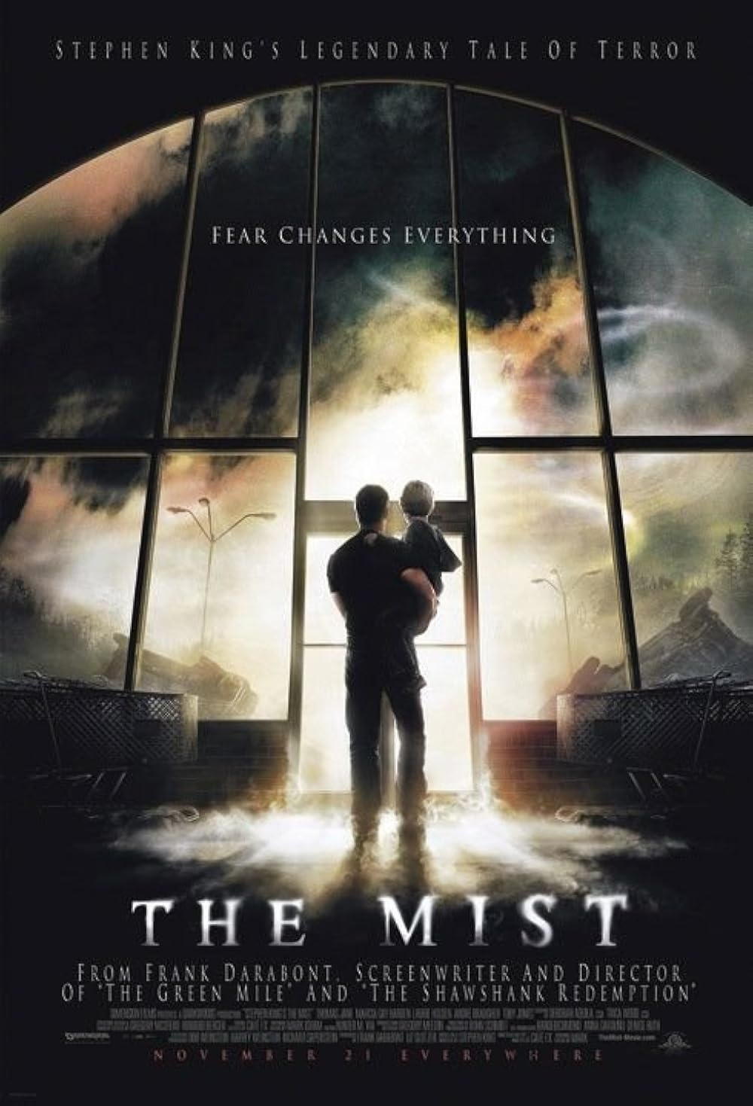

INTRODUCTION

1.1. Background of the Study
For a very long time, apocalypticism has been ingrained in mythical traditions as a metaphor for the breakdown of order and the arrival of chaos in human society. The traits of apocalypticism often expose the limits that are shattered by forces beyond rational, the arranged ones that come through the top, and the known from the unknown. In this way, the literature branch itself is a moment when catastrophic events unveil the latent pieces of reality rather than just the final seconds to live (Ballentine, 2022; Koch, 1972).

In many mythical systems, the world is seen as a delicate framework upheld by imperceptible boundaries that separate chaos from order. Every boundary that crosses reality we used to experience can lead to chaos that appears as certain symbols, such as monsters, strange spots, or enigmatic surroundings. Carl Jung, one of the experts on the theory in question, describes these recurrent patterns as archetypal structures in the collective unconscious, especially those stuck to the unknown and the shadow (Ballentine, 2022; Kim et al., 2024).

On the other hand, Joseph Campbell’s concept of the monomyth, which defines a recurrent sequence of departure, initiation, and return, allows for a structural analysis of mythical narratives. Apocalyptic storylines, however, frequently upset this framework, leading to a failed or unfinished journey where repair is difficult, according to studies in myth and movies (Koch, 1972). Typical disruption like this one is a metaphor for a situation in a nightmare that comes to life, where order is overtaken by chaos, and the boundaries between worlds cannot be restored.

As a complement, Mircea Eliade’s work highlights that myth is essentially concerned with the division between the sacred and the profane, where it is linked to disintegration and instability, and the holy stands for order, origin, and significance. She argues that myth makes people perceive and reconnect everything around them with inevitable reality, but when this bond is disrupted, it results in a feeling of confusion and broken minds(Eliade, 1959).

The Mist (2007) movie, made by Frank Darabont and based on a Stephen King novella, is a credible instance of apocalypticism. It all started when a little town called Maine was covered by a mist that was supposed to be a chemical explosion from the factory at first, because some of the scenes show the moment when an emergency siren was heard. The movie tells of a group of people who were trapped inside a supermarket for many days after their small Maine town was surrounded by thick white mist full of deformed creatures from another dimension. An ancient legendary rupture, a much earlier and more frightening catastrophe, developed from the initial struggle for survival. As a long-forgotten boundary between the human world and a realm of primeval, otherworldly beings was finally crossed, this rupture ultimately led to the liberation of creatures that mankind had never planned to see (Darabont, 2007). The mist can be interpreted as a metaphorical barrier dividing the human world from a chaotic realm within a mythological framework. Some appearance of hideous beings upon the collapse of this border also represents the return of primordial forces that threaten the stability of human society.

Scholarly engagement with apocalypticism in cinema, especially with regard to most movies that deal with man-made tragedies, has created several important theoretical frameworks that are still coherent to the understanding of The Mist (2007). According to a comprehensive research of American apocalyptic cinema, 59 apocalyptic films were released in the first ten years of the 2000s alone, demonstrating the growing popularity of these kinds of movies in the twenty-first century (Hamonic, 2017).

Despite these mythical components being rooted, most prior research had put its aim on the movie's structural, psychological, or thematic features, paying little attention to its underlying mythological framework. Specifically, there is still a study gap that more emphasizes how the movie creates apocalypticism through boundary violations, archetypal patterns, and the rupture of the monomyth framework. To close this gap, the paper, originally from the author, is likely compiled to examine The Mist (2007) from a mythological perspective, concentrating on how apocalypticism is created by the dissolution of boundaries, the appearance of chaos, and the failure of mythic restoration.

1.2. Research Question
To shape our critical perception of the main problem, there is certainly a single sentence that can be questioned from this movie at any time, as follows:
How does The Mist (2007) portray apocalypticism?

1.3. Research Objective
The author put together this essay to outline the apocalyptic elements that Frank Darabont’s The Mist (2007) calls forth, with a focus on how the movie uses prohibited thresholds and ancient mythological traditions of disaster to show how human society collapses when faced with a reality for which it was unprepared.

1.4. Uses of the Study
1.4.1. Theoretical Use
The main study of this paper contributes to the ongoing scholarly effort to understand how mythological frameworks of catastrophe resurface in contemporary cinema, tracing the way a single, incomprehensible disruption of the known world sets off what might be called a “domino of fears”, where the collapse of one certainty pulls every other certainty down with it, as depicted in Frank Darabont's The Mist (2007). The movie itself particularly looks at how the fog that comes over the town isn't just a physical threat, but also a mythic force that removes the thin layer of social order that people think is permanent and leaves behind something much more honest about the human condition.

Besides that, the paper also gives a vague picture of how the sudden appearance of an incomprehensible otherness, something from a totally different realm of existence, can push normal people to their utmost extremes: the giving up of reason, the desperate embrace of false confidence, and the readiness to hurt each other before any creature outside the walls has a chance.

1.4.2. Practical Use
Practically speaking, this study provides a number of observable advantages for various reader groups that interact with its conclusions. With insights that can be immediately applied to comprehend other films that address similar themes of institutional failure and government secrecy, this research offers educators and students in film studies or literature programs a tangible framework for examining how a dreadful watch functions as social commentary rather than just entertainment.

Apart from being a main reflection of science ethics, many Sci-Fi enthusiasts and general audiences can consider the study of this paper as a tool to enhance the viewing experience by exposing deeper levels of significance that could otherwise go missed, turning an apparently simple monster film into an insightful analysis of modern concerns that give later viewings more depth.

1.5. Scope of the Study
Primary investigation of apocalypticism in The Mist (2007) from a mythological standpoint is the main topic of this work. Carl Jung and Joseph Campbell’s ideas serve as the foundation for this analysis, which focuses on character dynamics, narrative structures, and symbolic aspects that represent boundary violations, archetypal patterns, and the breakdown of the monomyth. The whole of the study uses Jung’s notion of archetypes to identify recurrent symbolic patterns that appear when the equilibrium of the human world is upset, such as chaos, the shadow, and the unknown. In the meantime, the narrative's deviation from the conventional structure of initiation, return, and departure is examined using Campbell’s monomyth framework, which leads to an unsuccessful or incomplete voyage. The political, ideological, and institutional elements of the movie are not examined in this study. As a determined step to preserve analytical focus and guarantee coherence with the study aims, it instead focuses on the mythological aspect of the story.

CHAPTER TWO
THEORETICAL FRAMEWORK

2.1. Previous Studies

Writer | Objective | Method | Approach and Theories | Findings
Kusuma et al. (2019) | To analyze fear and hope in The Mist | Qualitative textual analysis | Structuralism; binary opposition | Reveals that fear leads to moral collapse while hope preserves humanity under crisis
Muwaffaq et al. (2020) | To examine apocalyptic narrative schemas in dystopian films | Narrative analysis | Narrative theory; cognitive semiotics | Identifies pre-, apocalyptic, and post-apocalyptic structures; emphasizes human adaptability
Wu (2021) | To analyze apocalyptic archetypes in contemporary disaster films | Qualitative analysis | Carl Jung (archetypal theory) | Finds that apocalyptic archetypes reflect collective unconscious responses and symbolize destruction and renewal
Greg Garrett (2020) | To explore apocalyptic narratives as modern myth in film and culture | Qualitative cultural-textual analysis | Mythological approach; Jungian archetypes | Shows that apocalyptic narratives function as modern myth structures reflecting archetypal fears and chaos
Şahin (2023) | To analyze mythological patterns and the hero journey in film narratives | Qualitative content analysis | Joseph Campbell (monomyth); myth theory | Demonstrates that films reproduce mythic structures and often adapt or disrupt the hero’s journey in apocalyptic contexts
Lacroix (2020) | To examine post-apocalyptic narratives as emerging myth | Qualitative analysis | Myth theory; post-apocalyptic studies; monomyth critique | Finds that post-apocalyptic narratives challenge the traditional monomyth by presenting unresolved collapse and failed restoration

Writer | Title | Method, Approach, and Theories | Findings
Hamonic (2017) | Global Catastrophe in Motion Pictures as Meaning and Message: The Functions of Apocalyptic Cinema in American Film | Theoretical and critical film analysis approaches examining apocalyptic cinema through multiple frameworks | Identified seven key functions of apocalyptic cinema: helping viewers make sense of the world, offering crisis management strategies, documenting collective hopes and fears, critiquing social orders, warning of imminent dangers, refuting apocalyptic hysteria, and promoting spiritual renewal
Wu (2021) | The Appearance and Resonance of Apocalyptic Archetypes in Contemporary Disaster Films | Jungian analytical psychology applied to post-9/11 and pre-COVID-19 disaster films | Discovered that apocalyptic archetypes in contemporary disaster films carry dual connotations of destruction and rebirth, reflecting collective unconscious responses to disaster psychology
Kusuma et al. (2019) | Hope and Fear in Stephen King’s “The Mist” | Structuralism theory using binary opposition analysis | Found that fear strips away humanity while hope preserves it even under catastrophic conditions; religious fundamentalism transforms from blessing life to cursing life; moral degeneration occurs when survival becomes paramount
Muwaffaq et al. (2020) | Apocalyptic Narrative Schemas in Dystopian Films | Narrative analysis using a cognitive semiotics approach, identifying narrated events and protagonist actions | Identified three distinct apocalyptic schemas (pre-apocalyptic, apocalyptic, and post-apocalyptic) with different storyline models; dystopian films portray hopefulness wherein humanity prevails over catastrophe; collective fear is a typical representation; humanity is portrayed as adaptive to catastrophic situations
Aston & Walliss (2013) | Small Screen Revelations: Apocalypse in Contemporary Television | Cultural studies and genre analysis of apocalyptic narratives across media | Documented unprecedented growth of apocalyptic cinema in the 21st century, reflecting heightened cultural fascination with end-times narratives following post-9/11 trauma

This study aims to fill in several fascinating gaps found in the constellation of academic studies on apocalyptic movies. Although Hamonic’s masterful taxonomy of the septemfold functions of apocalyptic cinema offers a crucial theoretical framework for comprehending how these movies function within American culture, his comprehensive survey inevitably forgoes in-depth examination of the specific ideological interventions of individual works (Hamonic, 2017).

Similarly, Wu’s application of Jungian archetypes uncovers compelling patterns in the way collective trauma is metabolized through disaster narratives. Though this psychoanalytic framework is genuinely illuminating about unconscious structures, it tends to flatten what might be better understood as anxieties shaped by specific cultural and historical moments rather than universal psychological constants (Wu, 2021). The Mist (2007) operates at both registers simultaneously — speaking to timeless mythological fears about what lies beyond the boundary of the known world while also giving those fears a distinctly contemporary texture rooted in the particular social fractures of its time.

Meanwhile, Kusuma and colleagues’ structuralist reading sheds genuine light on the binary tensions at the heart of King’s story, particularly the opposition between dread and hope as competing psychological anchors under conditions of acute crisis (Kusuma et al., 2019). Yet the hope-versus-fear dichotomy, persuasive as it is, may leave a deeper layer of the text untouched, specifically, the movie’s sustained interest in how communities fracture not from the outside in but from the inside out, as the social bonds that once made collective survival possible quietly become the first casualties of an incomprehensible catastrophe.

Differentiating between pre-apocalyptic, apocalyptic, and post-apocalyptic narrative structures in dystopian movies, Muwaffaq and colleagues’ study on apocalyptic narrative schemas offers important taxonomic clarity (Muwaffaq et al., 2020). Through the identification of recurring themes of optimism and human adaptation, their cognitive semiotic technique effectively illustrates how dystopian novels generally depict humanity as ultimately resilient in the face of calamity.

Reading across these earlier studies, it becomes clear that while scholars have made genuine progress in mapping the formal, psychological, structural, and generic dimensions of apocalyptic cinema, the conversation has yet to fully engage with how certain films root their catastrophe narratives in the much older soil of mythological tradition — using ancient archetypes of transgressed boundaries and primordial chaos not as decoration but as the actual architecture of their meaning. It is precisely this dimension of The Mist (2007) that the present study takes as its primary concern.

2.2 Mythological Approach
The mythological approach has been prioritized by the author as his framework to explore this literary theory. It is also necessary to note that the focus of mythological criticism is on repeated story structures, archetypes, and symbolic patterns that can be found in many cultures and times.

2.3 Archetypal Theory
Archetypal theory, which was introduced by Carl Jung, explains that repeated symbols are usually summoned from the collective unconscious. Archetypes such as the shadow, mobs, and the strange things come to life when the stability of the human world is disturbed.

According to Jungian theory, the threshold is the line separating the familiar world of ego-consciousness from the vast, unexplored realm of the unconscious, where the threshold is a barrier that demands a change in everybody who crosses it; it is never just a separating line but rather a charged zone (Jung, 1990). The passing of this threshold has historically been the point in mythological traditions where a character’s understanding of the world is shown to have been partial, provisional, and encircled by something much older and stronger than anything they had mapped or labeled on all sides.

2.4 Monomyth Theory
Joseph Campbell, in his term called “monomyth,” refers to a well-known arrangement of a story with three of its main stages: departure, initiation, and return (Campbell, 1949). The structure in this term means that the main protagonist has gone from the world we live in now, has a hardship somewhere unfamiliar, and then becomes anomalous or restored balance.

However, such a pattern is often broken or just walked in place within apocalyptic stories. The story may lead to failure, loss, or unsolved transformation rather than healing. The intended situation in The Mist (2007) might be interpreted as the monomyth’s failure, in which order cannot be restored, and the return phase is either nonexistent or ineffectual. According to Lacroix (2020), some disturbances in certain scenes point to a move away from conventional mythic conclusions and toward stories that highlight instability and collapse.

On another occasion, recent research on myth and movie indicates that modern tales often modify or disrupt the monomyth framework, especially in post-apocalyptic settings where the mob side rules and the hero's path is unresolved (Şahin, 2023). The argument that apocalyptic narratives function beyond traditional mythic closure is reinforced by its aberration, which shows a mythological condition in which the line between order and chaos remains permanently ruptured.

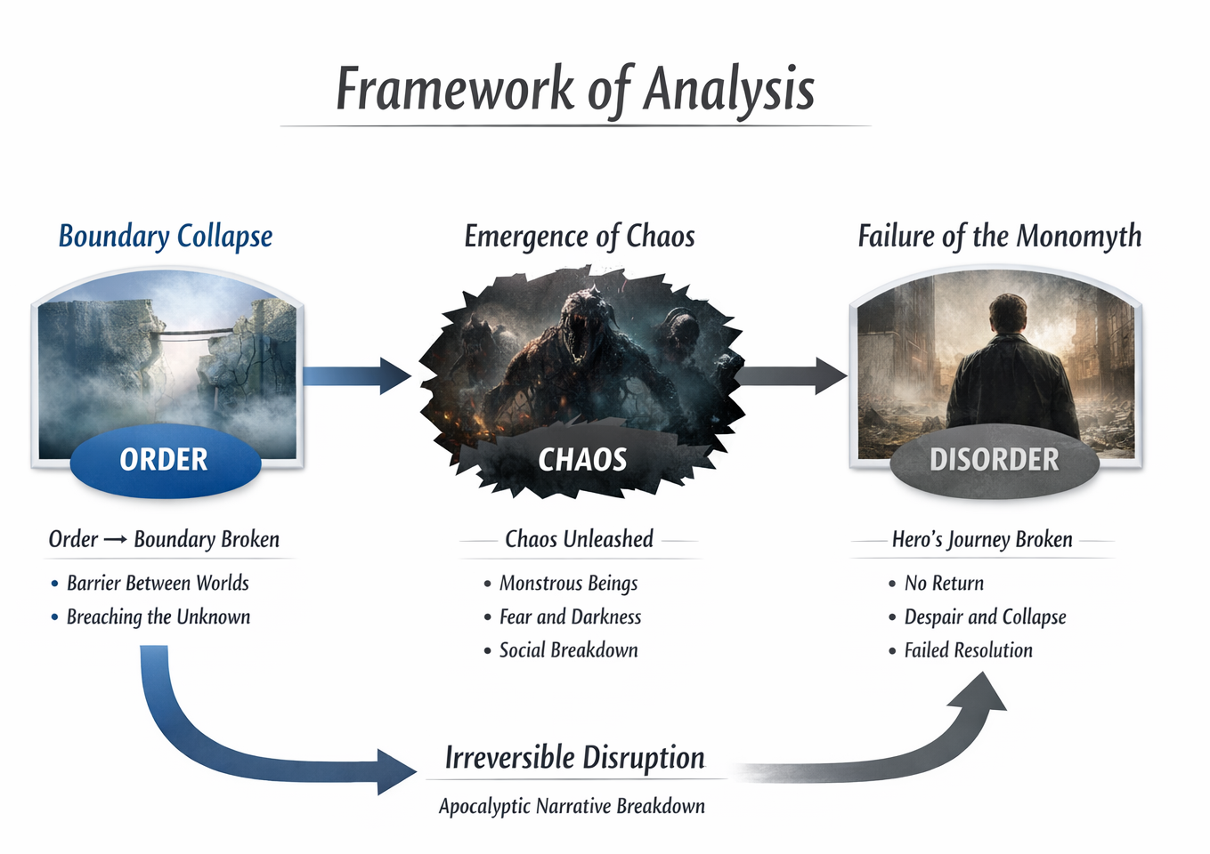
Figure 2.1. Framework of Analysis: Mythological Construction of Apocalypticism
Source: Adapted from Carl Jung (1969) and Joseph Campbell (1949).

- Boundary Collapse
This part looks at the disruption of the division between the human world (order) and the unknown (chaos). Boundaries serve as stable, protective confines in mythology. Unidentified and unpredictable forces start to penetrate the human world if these boundaries crumble.
The mist as a symbolic boundary
Transition from the normal world to the unknown space

- Emergence of Chaos
This is the section that examines how chaos develops when the border is crossed. Based on Jungian archetypes, chaos manifests as monsters, darkness, and terror, which stand for the unknown and the shadow.
Creatures as archetypal chaos
Human psychological breakdown
Social disintegration

- Failure of the Monomyth
Lastly, this is the best effort to examine how the story departs from Campbell’s conventional savior’s journey. The protagonist fails rather than being restored, which leaves the story cycle unfinished or broken.
Disrupted hero journey
Absence of resolution
Collapse of restoration

CHAPTER THREE
METHODOLOGY

3.1. Research Design
In order to investigate apocalypticism as it appears in a quite appalling mythology in Frank Darabont’s The Mist (2007), the current study of this paper uses a qualitative description as its research design. A flexible, naturalistic method of investigation, qualitative description aims to offer thorough accounts of events without imposing preconceived theoretical frameworks or explanatory models (Sandelowski, 2000). A qualitative description for the research, like this, seeks to provide clear answers to basic questions, such as what happens, where it happens, when it manifests, and how it unfolds, in contrast to phenomenological studies that require in-depth interpretation of lived experiences or grounded theory research that aims toward theory development (Lambert, 2012).

When examining apocalyptic depiction in cinematic texts, the qualitative description is somehow appropriate to be chosen regarding this matter. According to Flick (2014), movies serve as cultural artifacts that encode societal fears, ideological tensions, and collective imagination about apocalyptic futures. Besides that, it fits in perfectly with the research objectives stated in earlier chapters.

3.2. Data and Data Source
Frank Darabont’s The Mist (2007), a narrative work with apocalyptic themes based on further views of myths, serves as a primary data source for this kind of study. It is a movie version of Stephen King’s 1980 book in 90 pages with the same title (McKee, 2003). The data are pictures, narration, and dialogue from The Mist (2007).

3.3. Data Collecting Techniques
Data collection from The Mist (2007) required methodical interaction with cinematic text over several viewing sessions, each of which was calibrated to capture different aspects of apocalyptic portrayal. Here are five of the following techniques that have been used to organize the collection process:

- Initial Comprehensive Viewing
To gain a fundamental understanding of the movie’s narrative arc, emotional register, and thematic movement, the research started with a continuous viewing of the whole movie (Rose, 2016). This initial screening is necessary to reduce note-taking if the author is ready to let patterns develop naturally rather than forcing them into predetermined categories.

- Focused Analytical Viewings
A more focused strategy was used in later screenings, isolating particular aspects of the movie for in-depth analysis during at least five complete viewings (Jewitt, 2012). In one session, conversations that explicitly addressed mythological or apocalyptic themes were monitored; pertinent conversations were verbatim recorded and timestamped. Another examined the spatial dynamics between the foggy outdoors and the supermarket’s interior, viewing each as a mythological zone with its own set of rules and symbolic logic. They also looked at the movement and design of the creatures as manifestations of an old, inhuman order of existence that functions completely beyond the moral and physical lexicon that the human characters bring to their experience of the catastrophe.

- Screenplay and Paratextual Consultation
Screenplay materials and production documentation were studied following a thorough engagement with the film itself in order to confirm dialogue authenticity and highlight narrative decisions made throughout the translation from paper to screen (Batty & McAulay, 2016). Additional background regarding the creative choices made for the film's tone, tempo, and the particular methods Darabont opted to depict the mythical aspects of King’s source novella in cinematic terms was supplied via the director's commentary that accompanied home video releases.

3.4. Data Analyzing Techniques
Data drawn from The Mist (2007) was analyzed through a combination of narrative analysis and structuralist interpretation, applied in a methodical sequence with the aim of surfacing the mythological and apocalyptic patterns woven through the film’s formal and thematic construction. The analytical process moved through at least five stages, outlined as follows:

- Classifying Event Sequencing
The first analytical step was to dissect the movie’s plot into distinct acts, events, and moments of revelation, making a clear distinction between the sjužet, where the order and manner in which those events are revealed to the audience, and also a piece of fabula, which is the chronological sequence of what actually happens (Cutting, 2016). From the first disorienting appearance of the fog featuring the gradual view of the creatures to the devastating revelations of The Mist (2007) final scene and what they imply about the true nature of the world the characters had believed themselves to inhabit, special attention was paid to how knowledge develops throughout the narrative timeline.

- Interpreting Mythological Symbol
How to analyze the symbolic and metaphorical lexicon in which the movie uses to convey its apocalyptic vision is that this stage had to go beyond narrative structure (Rose, 2016). As a multifaceted mythological image, The Mist (2007) itself attracted persistent attention: besides being a physical occurrence, it also serves as a barrier between two incompatible systems of reality and a visual depiction of the kind of ignorance that ancient disaster tales frequently link to times when the world as we know it collapses. The spatial contrast between the enclosed supermarket and the open, fog-drowned exterior, as well as how specific characters represent more general mythological archetypes, such as the unwilling hero, the false prophet, and the community that splits apart in the dark, were all subjects of further symbolic analysis.

Sample of Analysis: “You’ve seen what’s out there. You know what’s in that mist. This is God’s punishment. We have to make a sacrifice, a blood sacrifice, or none of us are getting out of here alive.” – Mrs. Carmody (Marcia Gay Harden), The Mist (2007)

REFERENCES

Cook, J. (2017). ‘How Much Do I Want the Apocalypse to Happen and Just Wipe this All Clean?’: The Use of Apocalyptic Narratives by Non-religious Youth. Journal of the Australian Society of Religious Studies, 5(2), 45–62.
Ford, J. (2023). Otherworlding: Othering places and spaces through mythologization. Journal of Folklore and Mythology Studies, 15(2), 112–130.
Johnson, E. (2021). A scientific method to the madness of Unit 731’s human experimentation and biological warfare program. Journal of the History of Medicine and Allied Sciences, 76(4), 377–403.
Korn, J., & Körs, C. (2020). Covid-19 and the Apocalypse: Religious and Secular Perspectives. Implicit Religion, 23(2–3), 1–20.
Lacroix, C. (2020). An emerging new American mythos: Post-apocalyptic narratives. New Horizons in English Studies.
McSweeney, T. (2018). “Daddy, I’m scared. Can we go home?” Fear and allegory in The Mist. In The cinema of Frank Darabont: Hollywood’s forefather of hope (pp. 1–15). Edinburgh University Press. https://edinburgh.universitypressscholarship.com/view/10.3366/edinburgh/9781474413817.001.0001/upso-9781474413817-chapter-012
Muwaffaq, T., et al. (2020). Apocalyptic narrative schemas in dystopian films. International Journal of Humanity Studies, 3(2), 211–227. https://eprints.uai.ac.id/1822/2/ILS0041-22_Isi-Artikel.pdf
O’Leary, S. D. (n.d.). (2020) The Ecological Crisis, Apocalypticism, and the Internalization of Unfreedom. World Review of Political Economy, 11(1), 115–132. https://www.jstor.org/stable/10.13169/worlrevipoliecon.11.1.0115
Reynolds, B. E., & DiTommaso, L. (2025). Apocalypses and apocalyptic: A response to Benjamin E. Reynolds. Journal for the Study of the Pseudepigrapha, 34(3), 1–25.
Şahin, M. (2023). The water myth in cinema: The hero’s journey in films. Galactica Media: Journal of Media Studies, 5(2), 83–101. https://doi.org/10.46539/gmd.v5i2.365
Sharma, A., & Rana, M. (2024). The reflection of self in postmodern labyrinth: An inquisitive study in Stephen King’s The Mist and Misery. South Eastern European Journal of Public Health, 16, 829–832.
Snyder, P. J. (2017). Dreadful reality: Fear and madness in the fiction of H. P. Lovecraft. USM Honors Theses, 12, 1–45.
Syarip, R., et al. (2019). Hope and fear in Stephen King’s The Mist. Rainbow: Journal of Literature, Linguistics and Culture Studies, 8(2), 1–14. https://www.researchgate.net/publication/338030639_Hope_and_Fear_in_Stephen_King's_The_Mist
Ulstein, G. (2019). ‘Age of Lovecraft’?—Anthropocene monsters in (new) weird narrative. Nordlit, 42, 47–66.
van Niekerk, R. J. (2025). Revelation as an apocalypse: Critical considerations on the literary genre apocalypse. Verbum et Ecclesia, 46(1), a3553.
Yu, C. (2021). The appearance and resonance of apocalyptic archetypes in contemporary disaster films. Multidisciplinary Digital Public Institute, 11(2), 913.

