Development and Evaluation of a Digital Pet Recovery and Adoption Management System for Alaminos City
Erricca C. Morales*¹, Jayson P. Eusebio*², Vazille R. Ringor*³, Jeferson B. Caalim*⁴, Mark Leslie D. Melendez*⁵
Bachelor of Science in Information Technology, Pangasinan State University
*Corresponding Authors: erricca.17@gmail.com, jaysoneusebio135@gmail.com, ringorvazille@gmail.com, jefersoncaalim08@gmail.com, mlmelendez.alaminos@psu.edu.ph
ABSTRACT
The Pet Recovery and Adoption System is a digital platform designed to address the persistent challenges of stray animal management in Alaminos City. Traditional methods such as printed posters, social media posts, and paper-based verification have led to inefficiencies, resulting in lost pets never reuniting with their owners, road accidents, and the spread of rabies. The system was developed using the Rapid Application Development model and utilizes a three-tier architecture to enhance data security and operational efficiency. Key features include search filters, lost and found posters, pet registration, impounded pets gallery, adoptable pets gallery with pet cards for request submission, pet request management for request tracking, admin dashboard, report generation, event announcements, claimed and adopted pets tracking, and real-time email notifications. The system directly addresses the 72-hour impound window and 7-day reclamation limit set by local policy. Evaluation was conducted with 32 respondents including City Veterinary Office staff, pet owners, community users, and Information Technology experts following ISO/IEC 25010 standards across eight quality characteristics. Results showed an overall weighted mean of 4.11 interpreted as Agree, with Functional Suitability scoring highest at 4.21 interpreted as Strongly Agree, closely followed by Performance Efficiency at 4.20 and Usability at 4.18. The system is acceptable, functional, and ready for deployment, serving as a highly replicable model for other local government units in the Philippines to streamline animal control operations and promote public safety. With an overall rating of Agree, this digital transformation reduces manual delays and helps prevent euthanasia due to shelter overcrowding. By digitalizing these processes, the system helps accelerate pet reunification, increases adoption rates to prevent shelter overcrowding, reduces stray-related accidents, and mitigates the transmission of rabies within the community.
Keywords: Pet Recovery, Pet Adoption, Stray Animals, Alaminos City, ISO/IEC 25010
I. INTRODUCTION
The growing presence of free-roaming animals has become a concern worldwide, especially in developing countries, where they pose a threat to public safety and community health. Rescue programs, sterilization, and culling are designed to keep numbers down, but the issue remains problematic. Sustainable measures, such as local population control and better policies, address the issue at its source, rather than simply moving it elsewhere [9]. In the Philippines, stray animals continue to be a major problem, especially in urban and semi-urban areas. Senator Grace Poe recently highlighted this crisis, noting that there are approximately 13.11 million stray cats and dogs in the country, contributing to its 6th-place ranking in global rabies cases [8]. In 2023 alone, numerous fatalities occurred due to contact with infected animals, of which 57% were unvaccinated [10].
Research indicates that the shift from manual efforts like posters and word-of-mouth to technology-driven solutions, such as centralized pet adoption websites, significantly improves efficiency and accessibility [11]. However, a significant "accessibility gap" exists in the Philippines; for instance, a survey revealed that 72% of participants were unaware of local pet adoption programs, demonstrating the need for more integrated digital services [6]. While organizations like PAWS and CARA use social media to facilitate adoption, most reports are still handled manually, lacking a centralized system for logging applications and lost pet records [1]. This reliance on traditional methods, such as leaflets and unorganized social media posts, increases the risk of fraud and inefficiencies, often resulting in pets facing euthanasia due to shelter overcrowding [4].
Alaminos City, a growing urban area in Pangasinan, faces these specific challenges. The Alaminos City Veterinary Office (CVO) manages a city pound that captures two to five animals daily. Currently, strays are held for 3 days in the impound section. If unclaimed, they are moved to the adoptable section for another 4 days. If still unclaimed after a total of 7 days, they face euthanasia to prevent overcrowding. This gives pet owners a total of 7 days to reclaim their pets before euthanasia is considered. Owners wishing to reclaim pets must undergo a manual verification process, involving interviews and physical proof of ownership. This manual approach often leads to delays, meaning lost pets may not be reunited with their owners within the 72-hour impound phase, reducing their chances of reclaim before the 7-day period expires.
To bridge this gap, modern animal welfare management requires digital platforms that offer real-time search filters, status updates, and coordination tools to improve the adoption experience [5]. A mandatory pet registration feature addresses this need by creating an official ownership database that can verify claims and prevent fraudulent adoptions. When a lost pet is found, owners or staff can use search filters to manually locate the animal in the impounded pets gallery and verify ownership through registered pet records. Ensuring high software quality is essential, as platforms following international standards like ISO/IEC 25010 are more functional, reliable, and user-friendly for the community [3]. By integrating digital tracking and lost-and-found reporting, shelters can effectively manage records and improve adoption success rates [7].
The Pet Recovery and Adoption System for Alaminos City includes the following features designed to address key challenges in manual pet management, such as the lack of a centralized platform for lost and found reporting, delays from manual verification within the 7-day reclamation window, inefficient tracking of impounded and adoptable pets, and the absence of automated notifications.
II. METHODOLOGY
The proponents used the Rapid Application Development model as the software development life cycle. This methodology emphasizes quick, iterative cycles to deliver a functional system within a short timeline [2]. As illustrated in Figure 1, the development process was divided into four main phases. The first phase, Requirements Planning, established the project scope and identified user needs through consultations with stakeholders. This was followed by the User Design phase, where the architectural system and visual prototypes were developed. The Construction phase involved the actual coding and logic implementation using the Laravel framework, while the Cutover phase focused on final testing, validation, and ensuring all features were fully operational.
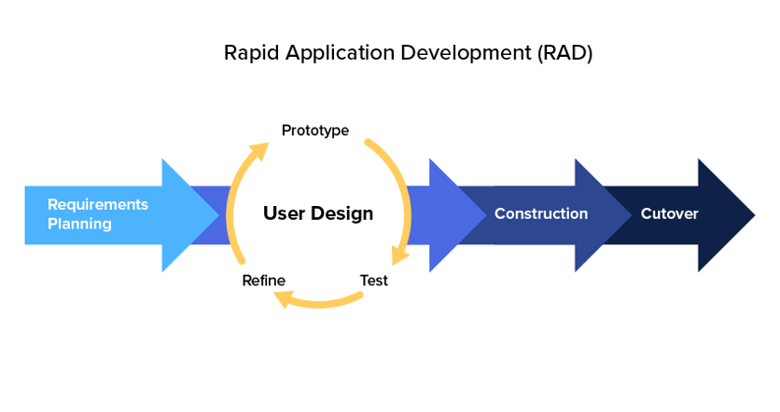
Figure 1. Rapid Application Development Model
Source:https://codeit.us/wpcontent/uploads/2019/04/software-development-methodologies-4.webp
To obtain feedback from future users, purposive sampling was used to select 32 respondents from Alaminos City. As shown in Table 1, the participants included 10 City Veterinary Office staff, 20 Pet Owners and Community Users, and 2 Information Technology (IT) experts. These community members were selected due to their direct engagement in pet management or technical expertise, ensuring the data collected were essential in determining the effectiveness and reliability of the system.
Table 1. Respondents of the Study
Respondents | Number of Respondents
City Veterinary Office Staff | 10
Pet Owners and Community Users | 20
IT Experts | 2
Total Respondents | 32
To establish the level of acceptability of the platform, the study employed a survey questionnaire anchored on the ISO/IEC 25010 software quality standards. The questionnaire was designed to assess the eight quality characteristics defined by ISO/IEC 25010 standards [3]. The data were measured using an ordinal scale to categorize information collected via a five-point Likert scale. The weighted mean was used to establish the boundaries of the categories, which are presented with their statistical interpretations in Table 2.
Table 2. Scale of Measurement
Scale | Statistical Limits | Rating | Descriptive Interpretation
1 | 1.00 – 1.80 | Strongly Disagree | The system is hard to use and needs major improvements.
2 | 1.81 – 2.60 | Disagree | The system works but has several areas for improvement.
3 | 2.61 – 3.40 | Fair | The system is easy to use with only a few minor issues.
4 | 3.41 – 4.20 | Agree | The system is smooth and user-friendly with minimal issues.
5 | 4.21 – 5.00 | Strongly Agree | The system is intuitive, efficient, and seamless to use.
III. RESULTS AND DISCUSSIONS
The architectural design of the system serves as the structural foundation for a digital platform intended to enhance animal welfare operations in Alaminos City. The proponents utilized a Three-Tier Architecture model as the main structural system. This architecture breaks down into three primary tiers namely, the Presentation Tier, Application Tier, and Data Tier to ensure efficient logical separation of concerns. This facilitated the modular development approach by allowing different aspects of the system to be designed concurrently.
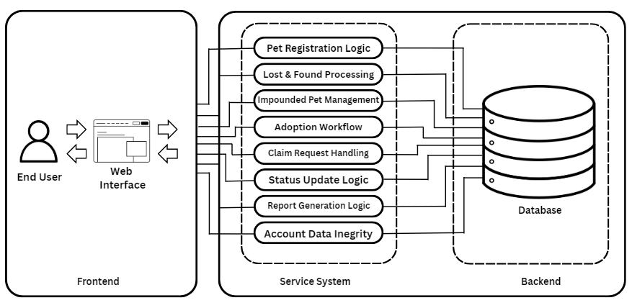
Figure 2. The Three-Tier Architecture
The system is structured with these three tiers to ensure scalability and maintainability. The Presentation Tier represents the intended user interface, responsible for presenting information through a well-structured design. This tier offers customized views for both community users and City Veterinary Office employees to cater to their specific operational needs. Through this interface, community users are able to access pet registration features for proactive identification and view galleries for impounded and adoptable pets, as well as access lost and found reporting for user-to-user coordination.
In support of this interface is the Application Tier, which serves as the central part of the system by processing all data and logic based on the administrative rules of the City Veterinary Office. The staff, acting as administrators, oversee the records of impounded pets captured by the office as they roam the streets. To streamline the workflow and reduce manual delays, the Application Tier manages the transition of an animal's status. Impounded pets are held for a mandatory 72-hour stay; if unclaimed, they become eligible for transfer to the adoptable section. Additionally, while users can manage their own lost and found reports, the Application Tier grants administrators the authority to view and delete these accounts for moderation purposes while preventing unauthorized edits to ensure data integrity.
The Data Tier implements a structured MySQL schema to serve as the technical foundation, ensuring the secure storage of sensitive pet records and user information. By separating storage from the application logic and user interface, the design ensures that digital records, such as ownership history and recovery logs, remain consistent, easily searchable, and protected from unauthorized access. This organized approach to data management keeps all information accessible within the database to support the overall functionality of the platform.
This three-tier architecture directly addresses the identified challenges by separating the user interface for community access, the application logic for processing pet recovery and adoption workflows, and the data storage for secure records.
System Features
The Pet Recovery and Adoption System for Alaminos City includes the following features designed to address the identified challenges in manual pet management. Each feature directly targets a specific gap: lost and found posters replace fragmented social media posts, pet registration enables ownership verification to prevent fraudulent claims, automated request management eliminates manual verification delays, and email notifications provide real-time status updates.
Search Filters. Users can efficiently discover specific pets through search and filtering capabilities tailored to each section. For lost and found posters, users can filter by post type (lost or found), status, location, and date range. For impounded and adoptable pets, users can filter by species, breed, gender, and color markings.
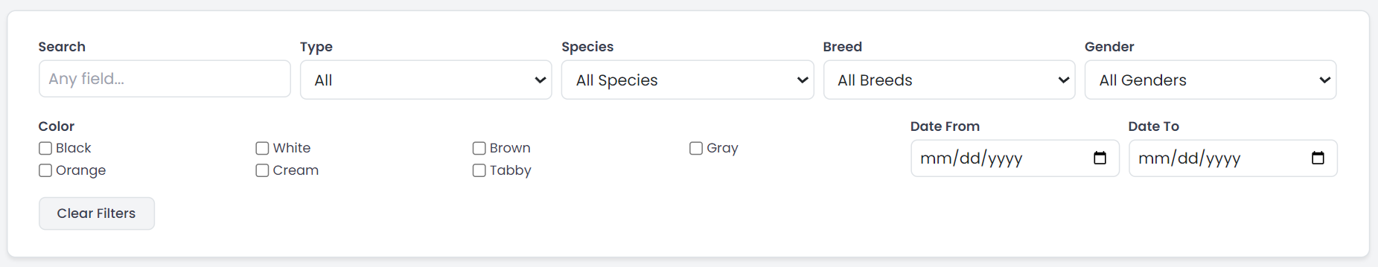
Figure 3. Search Filters
Lost and Found Posters Page. Residents can post and browse announcements about their lost or found pets through this page, creating detailed posts with pet descriptions, photos, location details, and contact information. Users can mark posts as resolved when reunited, facilitating efficient pet recovery through community cooperation.
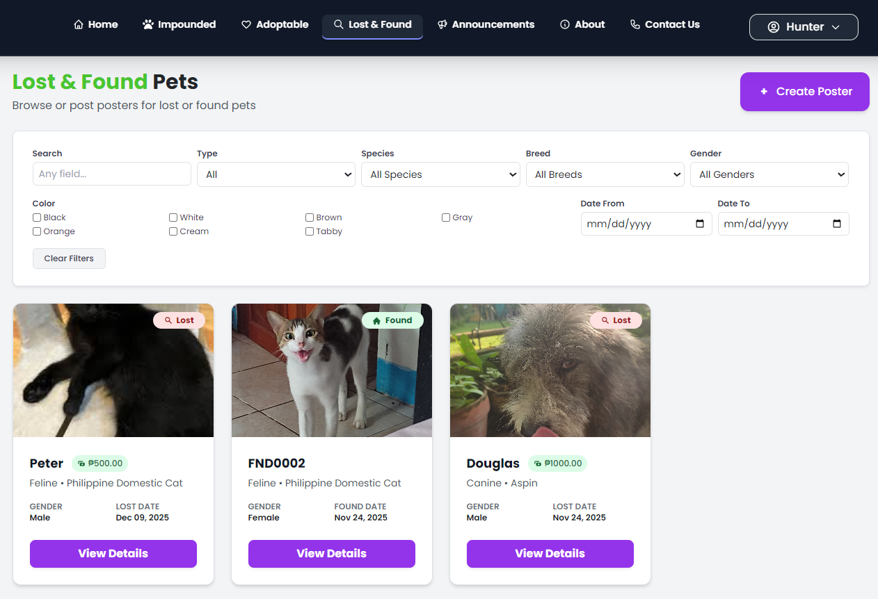
Figure 4. Lost and Found Posters Page
Pet Registration Page. Pet owners can formally register their pets with the City Veterinary Office through this feature, submitting detailed pet information including name, species, breed, birthday, color markings, and photos to create an official database of domesticated animals. Admins review registrations for completeness and authenticity, approving them into the official registry or denying with feedback, while users can track the approval status of each registration.
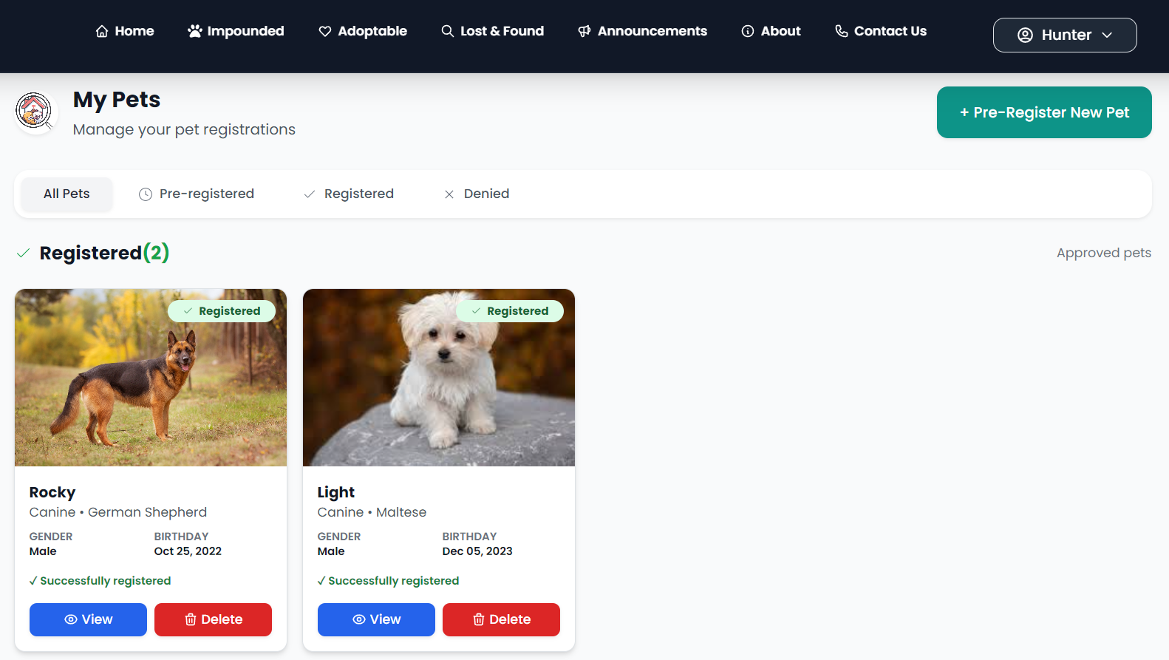
Figure 5. Pet Registration Status Page
Impounded Pets Page. A real-time registry of stray and impounded animals currently held by the City Veterinary Office with detailed information for each animal including species, breed, estimated age, gender, color markings, description, and caught location. Pet owners can browse the list to identify their lost pets and reclaim them directly from this page.
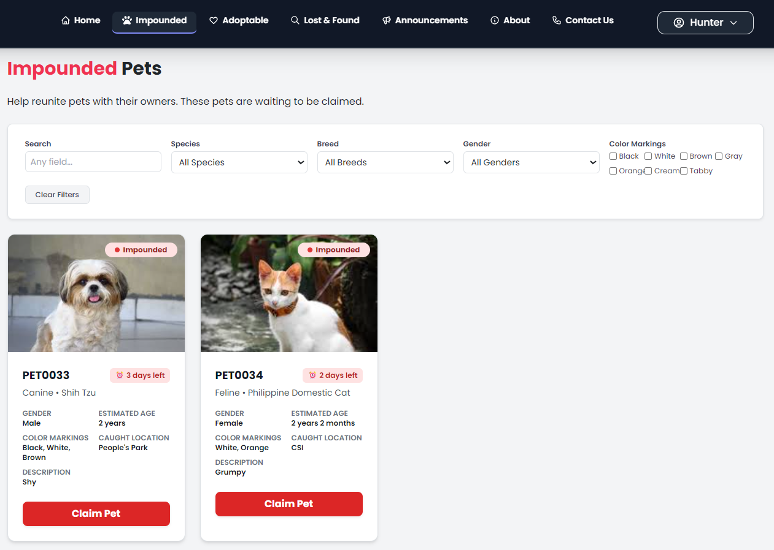
Figure 6. Impounded Pets Page
Adoptable Pets Page. Pets available for adoption are showcased in this catalog, where an "Adopt" button lets users begin the adoption process for their chosen pet. Additionally, pet owners can reclaim their own pet if it appears here, using the "Claim" button shown for each pet.
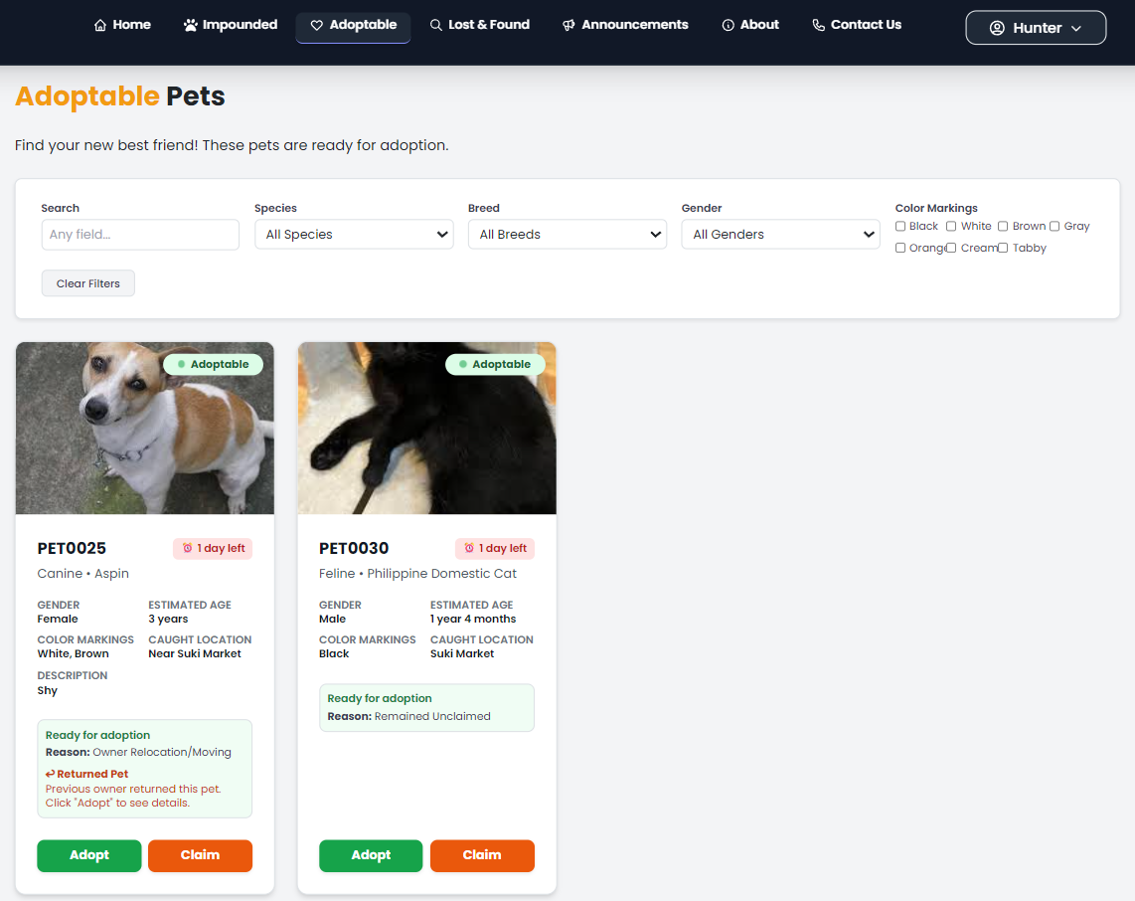
Figure 7. Adoptable Pets Page
Pet Request Management Page. All adoption and claim requests are centralized into a single interface where users can submit requests and track their status via a personalized dashboard. Admins can review, approve, or deny requests from a pending requests dashboard, replacing the manual verification process that previously required interviews and paper documents.
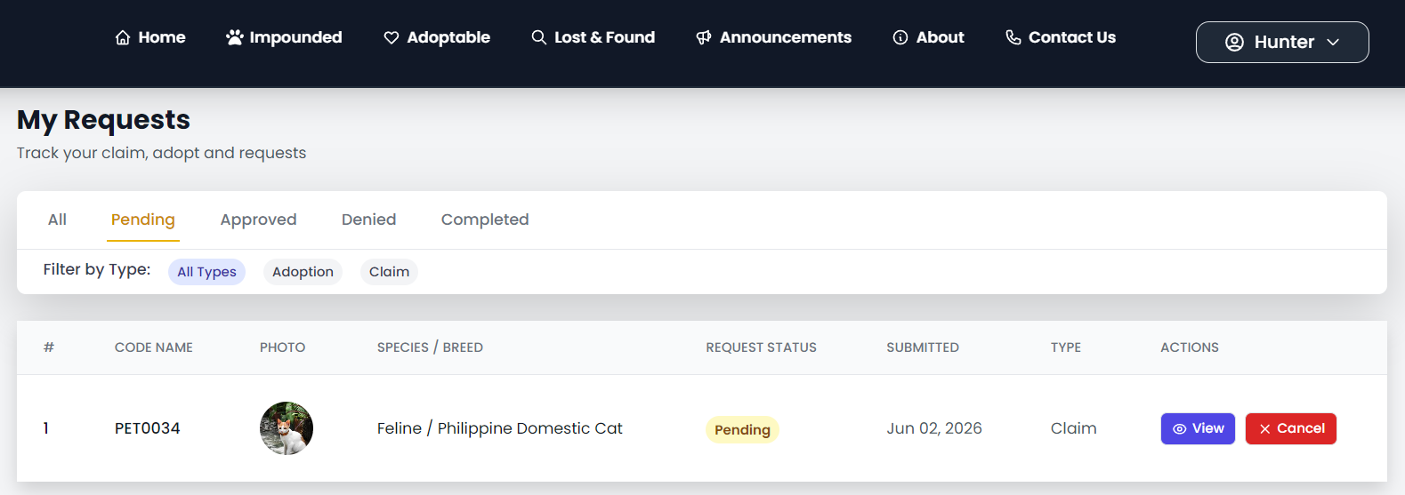
Figure 8a. User My Requests Page
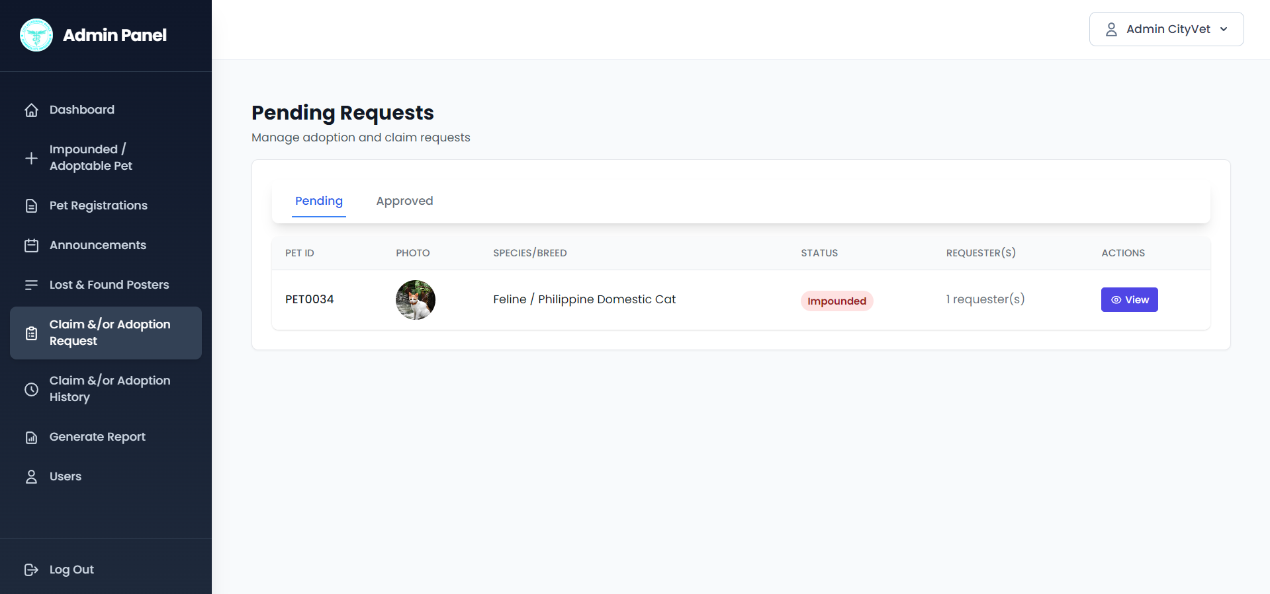
Figure 8b. Admin Pending Requests Dashboard
Admin Management Dashboard. City Veterinary Office administrators have system-wide management and monitoring capabilities through this dashboard, which displays key metrics such as total users, active pets, pending requests, and lost and found reports. Admins can manage pet registrations, lost and found posts, claim and adoption requests, and user accounts, with quick action buttons to approve or deny pending requests directly from the dashboard.
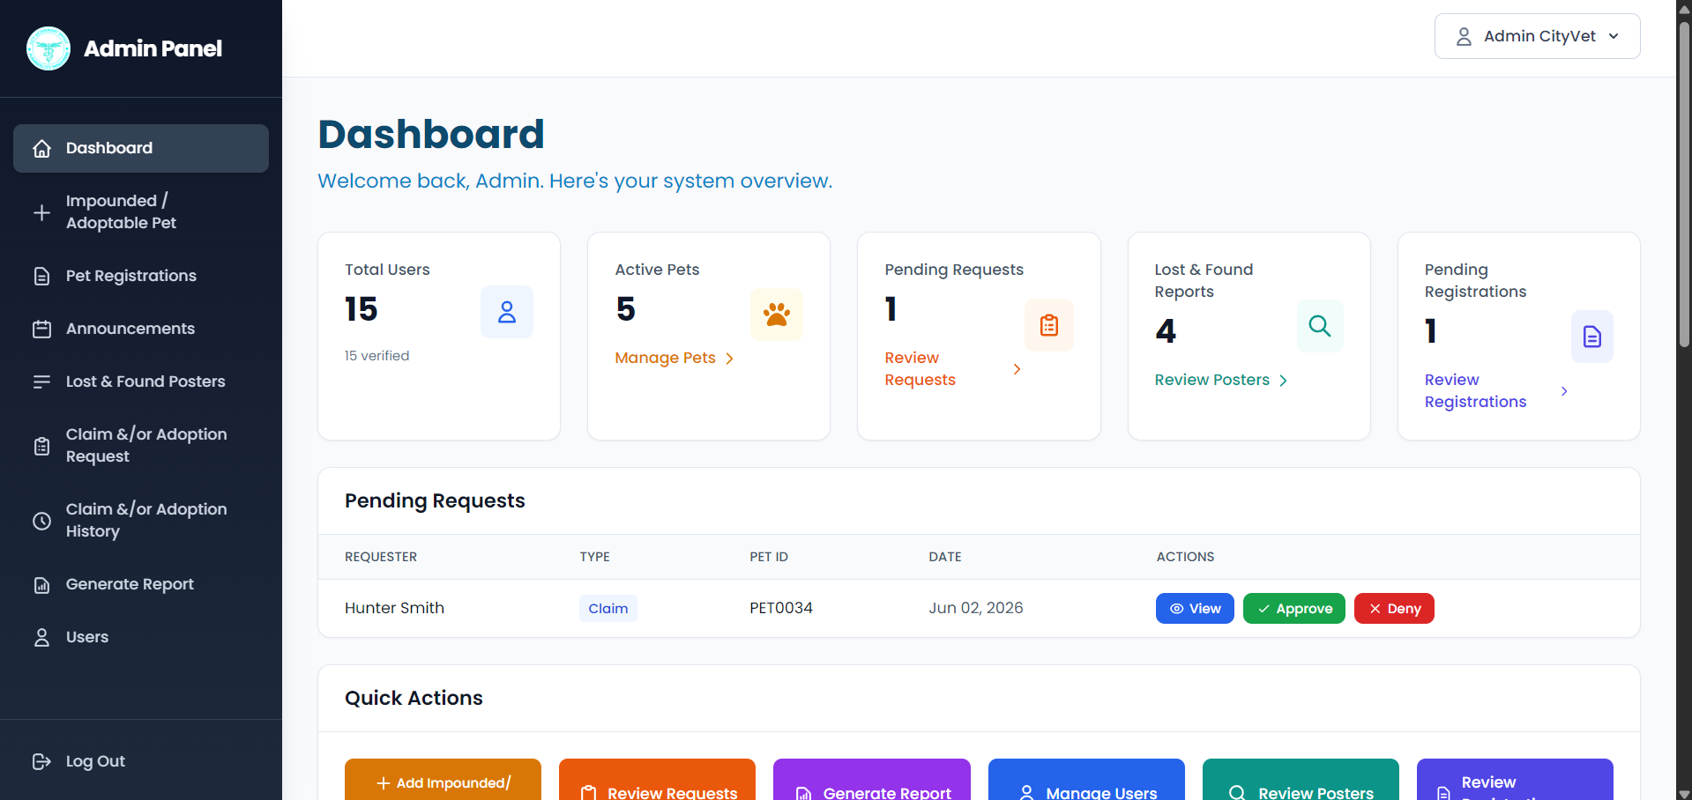
Figure 9. Admin Management Dashboard Page
Report Generation Page. Administrators can generate monthly reports for impounded, adoptable, adopted, and claimed pets by selecting the month, year, and report type scope. The feature supports data export to PDF or CSV format, enabling evidence-based decision-making for the veterinary office and helping track adoption and claim outcomes.

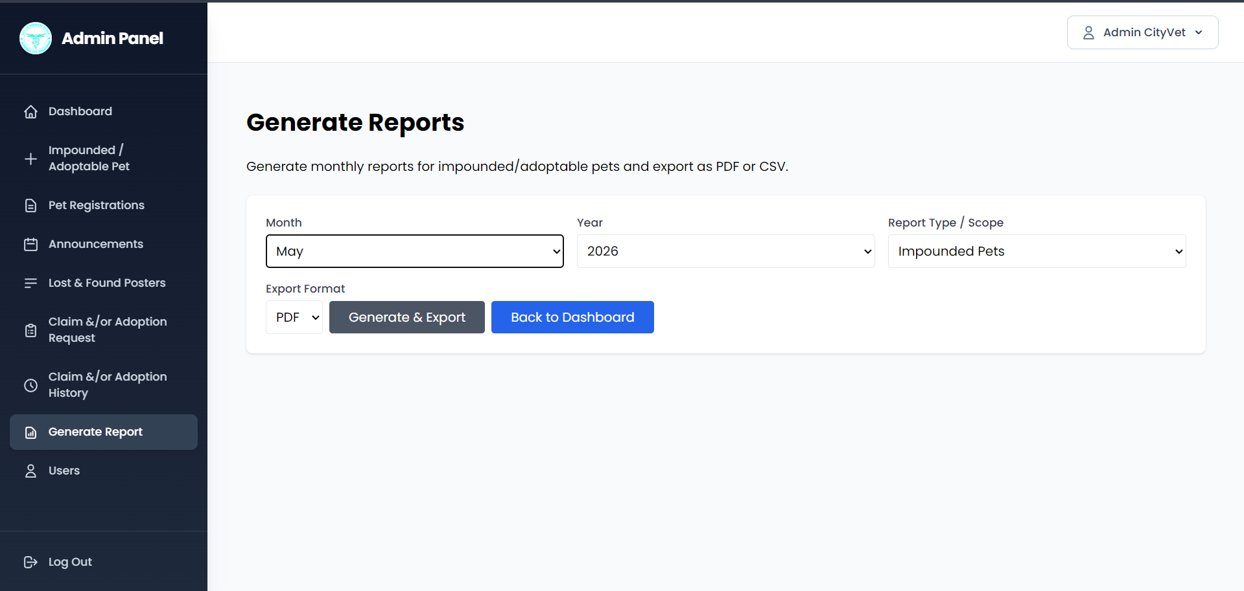
Figure 10. Report Generation and Analytics Page
Event Announcements. This feature serves as a digital bulletin board for the City Veterinary Office to broadcast public advisories and upcoming events like vaccination drives, registration caravans, adoptions, and health seminars. Admins create announcements with key details, while the public views them chronologically.
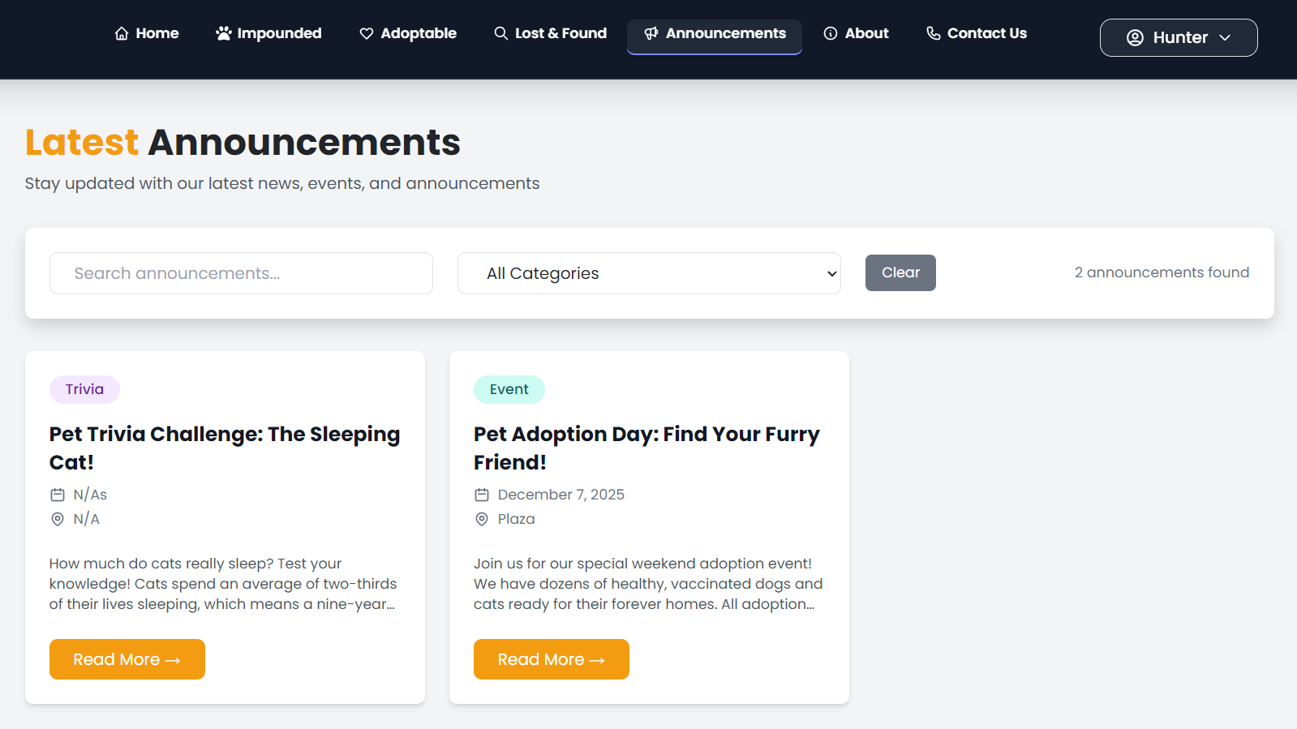
Figure 11. Event Announcement Page
Claimed & Adopted Pets. This feature provides users with a personalized record-keeping system that maintains a history of all successfully claimed or adopted pets. Users can view pet status timelines, manage their pet records, and access all documentation in one place.
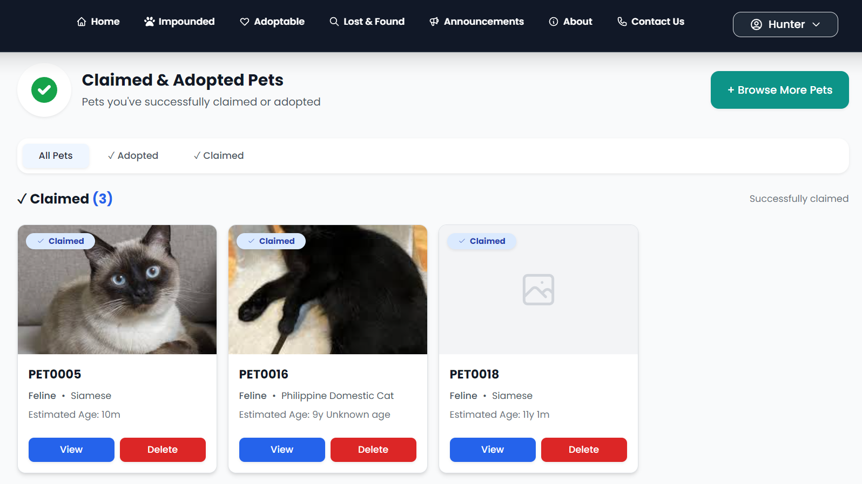
Figure 12. Claimed and Adopted Pets Page
Email Notifications. This feature sends instant status updates to a user's registered Gmail account regarding approval or denial of impound or adoption requests. The system generates emails containing pet identification codes, approval or denial outcomes, and rejection feedback.

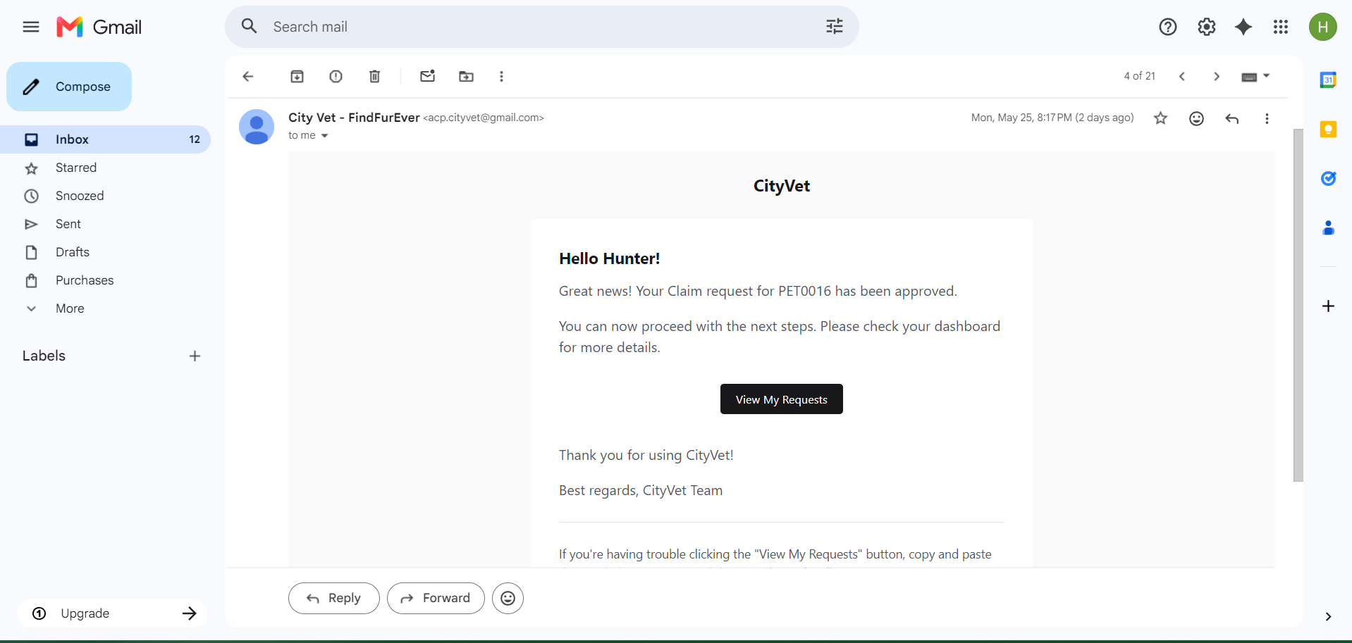
Figure 13. Automated Email Notification System
System Evaluation
To assess how well the system met user expectations, an evaluation was conducted involving 32 respondents. The system was assessed based on eight software quality characteristics anchored on the ISO/IEC 25010 standards namely, Functional Suitability, Performance Efficiency, Compatibility, Usability, Reliability, Security, Maintainability, and Portability. The resulting mean scores and their corresponding descriptive interpretations are detailed in Table 3.
Table 3. Overall System Evaluation Results
Characteristics | Mean | Descriptive Interpretation
Functional Suitability | 4.21 | Strongly Agree
Performance Efficiency | 4.20 | Agree
Compatibility | 3.91 | Agree
Usability | 4.18 | Agree
Reliability | 4.07 | Agree
Security | 4.17 | Agree
Maintainability | 4.06 | Agree
Portability | 4.13 | Agree
Weighted Mean = | 4.11 | Agree
As shown in Table 3, the system achieved an overall weighted mean of 4.11, interpreted as Agree, indicating that the Pet Recovery and Adoption System is generally perceived as acceptable, well structured, and valuable by its respondents.
Functional Suitability scored highest at 4.21 interpreted as Strongly Agree, confirming comprehensive support for pet recovery and adoption tasks. Performance Efficiency scored 4.20 interpreted as Agree, reflecting responsive loading of pet lists and search filters. Usability scored 4.18 interpreted as Agree, indicating the platform is user-friendly with strong recognizability and accessibility. Security scored 4.17 interpreted as Agree, demonstrating adequate protection of personal information and pet records. Portability scored 4.13 interpreted as Agree, confirming cross-browser compatibility. Reliability scored 4.07 interpreted as Agree, highlighting consistent performance with data recovery capability. Maintainability scored 4.06 interpreted as Agree, confirming the system can be updated reasonably. Compatibility scored 3.91 interpreted as Agree, showing adequate integration with existing office systems.
IV. CONCLUSION
This study successfully developed and evaluated a Digital Pet Recovery and Adoption Management System for Alaminos City using the Rapid Application Development model and a three-tier architecture. The system addressed critical gaps in manual pet management through a centralized digital platform featuring search filters, lost and found posters, pet registration, impounded and adoptable pet galleries, pet request management, admin dashboard, report generation, event announcements, claimed and adopted pets tracking, and email notifications.
The lost and found posters page replaced fragmented social media posts with a centralized platform. The pet registration feature created an official ownership database to prevent fraudulent claims. The automated request management eliminated manual verification delays that previously caused pets to miss the reclamation window. Evaluation with 32 respondents following ISO/IEC 25010 standards yielded an overall weighted mean of 4.11 interpreted as Agree. Functional Suitability scored highest at 4.21 interpreted as Strongly Agree, confirming effective support for pet recovery and adoption tasks. Performance Efficiency (4.20), Usability (4.18), Security (4.17), and Portability (4.13) all demonstrated acceptable system quality. Reliability (4.07), Maintainability (4.06), and Compatibility (3.91) also showed positive results.
The system successfully reduced manual delays in pet recovery and adoption workflows, improving compliance with the mandatory holding period and minimizing the risk of euthanasia due to shelter overcrowding. This study has several limitations. The system is scoped exclusively to Alaminos City and covers only dogs and cats, which may limit its direct applicability to other local government units with different animal management procedures. The evaluation was conducted with only 32 respondents, which may not fully represent the diversity of potential users. Additionally, the system does not handle pet medical histories or payment transactions for reclaim fines, and ownership verification still requires in-person assessment at the City Veterinary Office. Future studies may expand the system to other LGUs, broaden the respondent pool, and integrate payment processing and medical record management to further improve operational efficiency.
This system serves as a replicable model for other local government units in the Philippines facing similar stray animal management challenges.
ETHICAL CONSIDERATIONS
A total of 32 respondents participated in the study and rated the system using the ISO/IEC 25010 standard. The informed consent of all respondents was obtained. Their answers remained confidential as no personal data was collected.
CONFLICT OF INTEREST
No conflict of interest exists regarding the development or evaluation of this research project by the authors. This research project is a fulfillment of academic obligations without any external sponsorship.
DATA AVAILABILITY
Table 3 summarizes the results of the ISO/IEC 25010 evaluation. Any other raw data can be provided by the corresponding author on request.
REFERENCES
- Financial Assistance PH. (n.d.). List of Animal Shelters That You Can Support in the Philippines. https://financialassistance.ph/animal-shelters-philippines/
- GeeksforGeeks. (2022). Rapid Application Development Model (RAD) – Software Engineering. https://www.geeksforgeeks.org/software-engineering-rapid-application-development-model-rad/
- ISO/IEC 25010:2023(en). (2023). ISO/IEC 25010:2023(en) Systems and software engineering — Systems and software Quality Requirements and Evaluation (SQuaRE) — Product quality model. https://www.iso.org/obp/ui/en/#iso:std:iso-iec:25010:ed-2:v1:en
- Kajbaje, S., Sawant, R., Loke, R., & Patil, V. (2022). AI-Based Pet Adoption System. International Research Journal of Engineering and Technology (IRJET), 9(4), 2565-2568. https://www.irjet.net/archives/V9/i4/IRJET-V9I4298.pdf
- Kova, S., Prehanto, A., & Guntara, R. G. (2024). Usability analysis of web-based animal adoption system to increase user experience. JURTEKSI (Jurnal Teknologi dan Sistem Informasi), 10(3), 419-426. https://doi.org/10.33330/jurteksi.v10i3.3173
- Landicho, V., Mandalupe, A., Monleon, H., & Banzil, J. (2025). BOOP: A multifunctional mobile application providing pet-care services and adoption platform to stray animals. iCONNECT Multidisciplinary Research Journal, 2(1), 70-79. https://ejournals.ph/article.php?id=25414
- Liu, J., & Wu, Y. (2023). Research on the Strategy of Digital Services in the Adoption Scene of Pet Shelters. https://link.springer.com/chapter/10.1007/978-3-031-35696-4_14
- Senate of the Philippines. (2024). Overpopulated homeless animals. https://legacy.senate.gov.ph/photo_release/2024/0515_02.asp
- Strand, P. (2021). The Use of Dogs in Animal-Based Research: The Rest of the Story. https://www.naiaonline.org/articles/article/the-global-stray-dog-population-crisis
- Tan, D. M. (n.d.). Key Facts About Rabies in the Philippines. https://global.lockton.com/ph/en/news-insights/key-facts-about-rabies-in-the-philippines
- Villalonga-Vivoni, C. (2024). How a volunteer network helps Connecticut families reunite with their lost dogs. https://www.ctinsider.com/connecticut/article/lost-dog-recovery-ct-network-19968695.php

