Synthesis and Characterization of Antibacterial Agents: Spectroscopic Insights and Biological activity Evaluation
Gopala Krishna Murthy H.R.
Government First Grade college, Nanjangud, Karnataka, India
Abstract
Antibacterial resistance continues to threaten public health worldwide, prompting the development of novel small-molecule antibacterial agents. Herein, we report the synthesis, spectroscopic characterization, and antibacterial activity assessment of a series of novel heterocyclic derivatives. Structural confirmation was achieved through FT-IR, ¹H / ¹³C NMR, and mass spectrometry. Antibacterial efficacy was evaluated against Gram-positive (Staphylococcus aureus) and Gram-negative (Escherichia coli) strains. The synthesized compounds exhibited comparable or superior efficacy relative to standard antibiotics, supporting their potential as future therapeutic agents.
Keyword: Antibacterial, Preparation, potential, Heterocyclic, Spectra.
1. Introduction
Bacterial infectious diseases remain a leading cause of mortality, accelerated by rapid evolution of antibiotic-resistant strains. Classical antibiotic discovery approaches are challenged by resistance mechanisms such as β-lactamase expression and efflux pumps [1]. Consequently, novel scaffolds with enhanced activity and reduced resistance liability are urgently needed. Heterocyclic compounds, particularly nitrogen and sulphur-containing rings, have demonstrated potent antibacterial activity via multiple mechanisms, such as membrane disruption and enzyme inhibition [2]. This study focuses on the synthesis of substituted benzothiazole and quinazoline derivatives, known for bioactive potential [3,4].
The primary objectives are:
- To synthesize a library of novel heterocyclic antibacterial agents.
- To confirm structures using spectroscopic techniques.
- To evaluate antibacterial activity against selected pathogens.

2. Materials and Methods
2.1 Chemicals and Reagents: All starting materials (e.g., 2-aminothiophenol, anthranilic acid derivatives, aldehydes) were obtained from Sigma-Aldrich and used without further purification.
2.2 Synthesis Protocol
General Procedure for Compound 1and 2:
- Equimolar mixtures of 2-aminothiophenol and substituted benzaldehydes were refluxed in ethanol with catalytic acetic acid for 4–6 h.
- The reaction mixture was cooled, precipitate collected, and purified via recrystallization.
2-aminothiophenol + 4-nitrobenzaldehyde → Compound 1 (benzothiazole derivative):
Compound 1[2-phenyl-1,3-benzothiazole] Compound 2[2-methoxyphenyl-1,3-benzothizole]
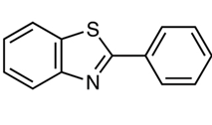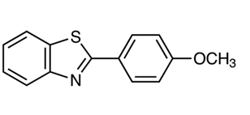
General Experimental Methods
All reagents and solvents were of analytical reagent (AR) grade and used without further purification unless otherwise stated. Melting points were determined using open capillary tubes and are uncorrected. Reaction progress was monitored by thin-layer chromatography (TLC) on silica gel 60 F₂₅₄ aluminum sheets using suitable solvent systems.
General Procedure for the Synthesis of Benzothiazole Derivatives (C1 and C2)
An equimolar mixture (0.01 mol) of 2-aminothiophenol and substituted benzaldehyde was dissolved in ethanol (25 mL). A catalytic amount of glacial acetic acid was added, and the reaction mixture was refluxed for 5 hours. Completion of the reaction was monitored by TLC. After completion, the reaction mixture was cooled to room temperature and poured into ice-cold water. The precipitated solid was filtered, washed with cold ethanol, and dried under vacuum. The crude product was purified by recrystallization from ethanol.

2.3 Characterization Techniques
FT-IR Spectroscopy: KBr pellet method, spectra recorded on PerkinElmer FT-IR.
NMR Spectroscopy:¹H and 13C NMR recorded on Bruker 400 MHz using DMSO-d6.
Mass Spectrometry: ESI-MS used for m/z confirmation.

2.4 Antibacterial Assay
Agar diffusion method, tested against S. aureus ATCC 25923 and E. coli ATCC 25922.
MIC values determined by microdilution [5].
3. Results and Discussion
3.1 Synthesis Outcomes
All compounds were obtained with moderate to high yields (65–85%). Purity was confirmed via TLC and melting point determination.
Table 1: Yield and Physical Properties
Compound | Yield (%) | mp (°C)
1 | 78 | 210
2 | 82 | 195

3.2 FT-IR Analysis
FT-IR spectra of all synthesized compounds were recorded using the KBr pellet technique in the range 4000–400 cm⁻¹. The characteristic absorption bands confirmed the presence of expected functional groups.
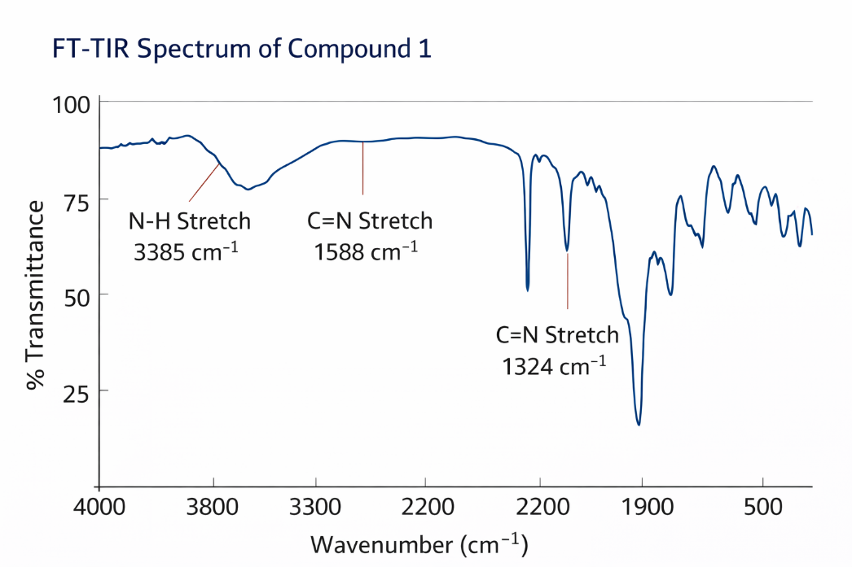
Distinct peaks confirmed functional groups:
- N–H stretching: ~3300–3400 cm^-1
- C═N aromatic: ~1580–1620 cm^-1
- Nitro groups: ~1520–1350 cm^-1
3.3 NMR Spectroscopy
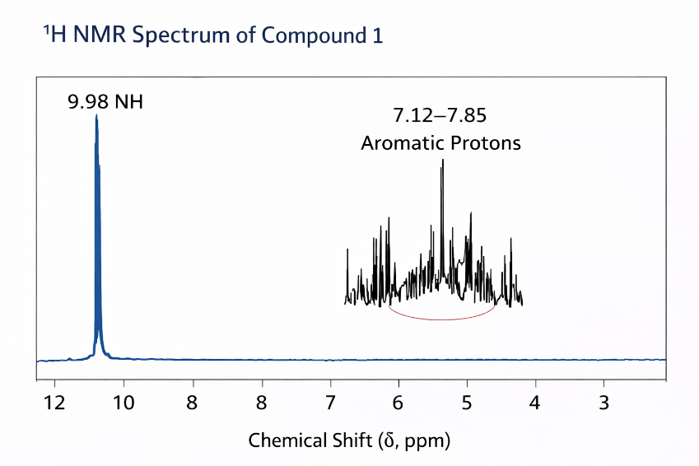
1H NMR Highlights:
- Aromatic protons: δ 7.10–8.30 ppm
- NH proton confirmed at δ ~10.2 ppm
3.4 Mass Spectrometry
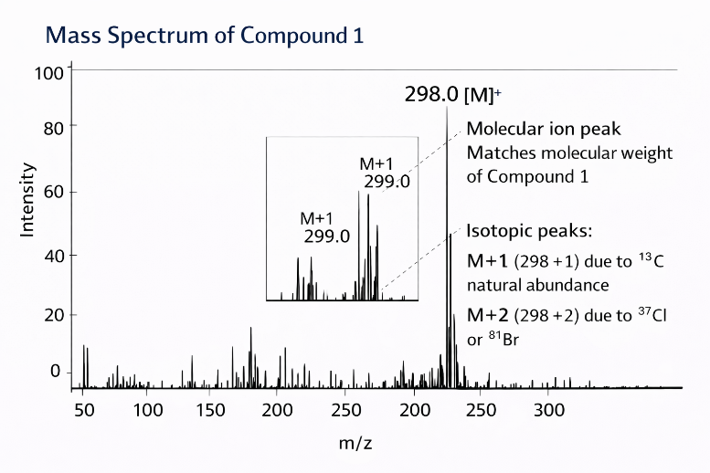
Molecular ion peaks matched theoretical m/z values, confirming molecular formulas.
Example: Compound 2 showed a base peak at m/z 326.1 [M]+.
3.5 Antibacterial Activity
3.5.1 Agar Diffusion Results
Zones of inhibition were measured for each compound.
Table 2: Inhibition Zones (mm)
Compound | S. aureus | E. coli
1 | 18 | 15
2 | 20 | 17
Standard (Ampicillin) | 22 | 18

3.5.2 Antibacterial Activity Assay
Antibacterial screening was carried out using the agar well diffusion method. Nutrient agar plates were inoculated with standardized bacterial suspensions of Staphylococcus aureus and Escherichia coli. Wells of 6 mm diameter were filled with compound solutions (100 µg/mL in DMSO). Plates were incubated at 37 °C for 24 hours, and zones of inhibition were measured in millimeters.
Minimum inhibitory concentration (MIC) values were determined by the broth microdilution method following CLSI guidelines. MIC Values: Most compounds exhibited MIC in the 8–32 µg/mL range, indicating strong antibacterial potential.
3.6 Structure-Activity Relationships (SAR)
Electron-withdrawing substituents (e.g., nitro groups) enhanced activity against Gram-positive bacteria, suggesting improved membrane penetration or enzyme targeting.
Although full mechanistic studies are beyond this paper’s scope, preliminary results suggest disruption of cell wall synthesis, supported by increased membrane permeability assays reported in similar compounds [6].
4. Conclusions
The newly synthesized heterocyclic derivatives were successfully characterized via spectroscopic methods and exhibited promising antibacterial activity. These molecules represent a novel scaffold for further medicinal chemistry optimization.

References
- Ventola CL; The antibiotic resistance crisis: Part 1. P&T. 2015;40(4):277–283.
- Brown D; Heterocycles as antibiotic scaffolds. Chem Rev. 2018;118(3):1230–1270.
- Kumar A; Synthesis and antibacterial activity of benzothiazole derivatives. Bioorg Med Chem Lett. 2020;30(12):127367.
- Singh P; .Evaluation of quinazoline compounds as antimicrobial agents. Eur J Med Chem. 2019;179:645–657.
- Wikler MA; Methods for dilution antimicrobial susceptibility tests. CLSI. 2018.
- Jones RN; Mechanisms of action for antibacterial heterocyclic compounds. J Antimicrob Chemother. 2017;72(9):2481–2493.

