Impact Assessment Study of Urban Flooding on Stray Animals to understand their Vulnerability to Changing Climate

ABSTRACT:
The past three decades have seen an unprecedent rise in urban growth in developing countries of Global South that has led to consequent degradation of the overall physical environment and quality of life. The adverse effects of changing climatic patterns are visible in the form of urban flooding that can cause major disruptions in cities, and lead to significant impacts on people, economy, ecology and environment. In landscape architecture discipline, the impact of climate-generated issues on human health in cities are widely studied, but their impact on urban fauna specifically stray animals (dogs & cattle) have still remained unexplored. These animals have become an integral part of human life and urban ecosystem yet disproportionately vulnerable during flooding. Various countries have begun taking initiatives for achieving inclusive planning by integrating animal welfare into their disaster management plan thus, considering animals as an integral part of urban ecosystem. These current disaster management guidelines are currently human, infrastructure and economy focused and not recognizing animals as a part of shared environment. To understand the ground situation of stray dogs during a flood situation, this study was conducted in three different locations of Delhi during Monsson 2025. The research focuses on analysing the ecological behaviour of urban stray animals and their possible survival mechanisms during urban flooding in Indian cities. It proposes a framework that works in favour of animals and essential to be implemented to have a holistic approach in landscape planning and design.

Keywords: climate change, disaster management, ecology, urban fauna, urban flooding

INTRODUCTION
Urban flooding induced by climate change is a growing concern in major cities of India primarily due to changes in land use and land cover. There are various reasons responsible for urban flooding and the most common are intense precipitation events, river inundation and fluvial floods, among others. To mitigate flash flooding, it is very important to have flood resilient strategies involving city planners, environment planners, and urban planners that corelate with the disaster situations and provide suitable planning solutions as per the existing condition. Urban fauna is an essential factor contributing to social and cultural aspects of the shared ecosystem. Among these, stray dogs have become an integral part of the urban ecosystem, inhabiting residential areas, commercial areas and streets. Flooding has an adverse impact on stray dogs, not only affecting their survival but also their waste-based food source, displacement, behavioural trauma, aggression and mortality. In recent years, several countries have started integrating animal welfare into disaster management, however, India still hasn’t integrated the protection and welfare of stray animals into disaster management because of a human centric approach to policies. Due to these reasons, the risk faced by stray animals aggravates. The research focuses on the impact of urban flooding on stray dogs while evaluating the roles of governmental agencies, disaster management, and NGOs on preparedness planning. By examining the relationship between various factors like animal-welfare, ecological vulnerability, and urban flooding, this research seeks to contribute towards sustainable design aspects to ensure resilient urban planning practice and design approach by integrating inclusive design principles for urban ecosystems.

LITERATURE REVIEW

Urban Flooding
Flooding usually occurs when water extends over a location that used to be a dry land caused by an overflow of water beyond the regular normal limits of a watercourse. It may happen because of water release from a reservoir, canal or dam, particularly if flows in rivers, and creeks are already having high water levels. Floods can be described in terms of their heights, depth and extent. A flood peak is the highest high and is generally observed during a flood event at a specific site (Government, 2024). Fluvial floods are caused when the soil’s capacity of absorbing water is surpassed, resulting into water logging.

Flooding is one of the main events that can cause major disruptions in cities, and also majorly impacts the human, environment and the economy. These events of flooding may be exacerbated because of climate change and socio-economic changes (Manandhar, Cui, Wang, &Shrestha, 2023). Waterlogging occurs in densely populated places where excessive rainfall-induced water is trapped due to poor drainage. There is a change seen in this pattern when it comes to rural areas and coastal regions, due to availability of more permeable land surface, instead of impermeable surfaces, roads, pathways, and developed structures, that prevent water from getting percolated into the soil. Thus, in urban areas, spaces that are low lying can be designed to hold water to alleviate storm surges, thereby contributing to stormwater management (Todini, 2025).

There are three common types of flood events that have been identified: Flash floods those are caused by rapid and extensive rainfall usually tend to rise in water-level quickly in an area; the second type is the river floods caused when heavy rainfall and snowmelts forces a river to exceed capacity; and the third type is, coastal floods that are caused by storm surges associated with tropical cyclones and tsunami (International, 2025). Integrating more green spaces and protecting ecological systems can thus contribute to mitigating flood events. Disaster preparedness professionals need to understand and integrate flood impacts to build flood resilient cities. Designing detention ponds, retention ponds, or water catchment areas can support mitigating floods as it has capacity to hold water and can survive storm surges. Locations for implementing strategies can also be identified based on the topography and past events of flooding to integrate preparedness for flooding events (Agonafir, et al., 2023).

Reason responsible for Urban Flooding
Unplanned development and organic growth without considering the various factors leading to rapid urban densification, and inadequate urban drainage design result in loss of natural drainage, pluvial sewer flooding and impacting ecological services. It also degrades the water quality because of surface-level pollutants, eventually impacting the quality of groundwater, and also leads to soil pollution (Miller & Hutchins, 2017). Change in land use, degrading wetlands, and open spaces with compacted surface, reduce the permeability of soil, thus the natural seepage of rainwater does not take place, leading to issues such as water logging in cities. In various continents, climate change has severely affected monsoons and tropical cyclones which are the two major causes of urban flooding. Due to this, extreme events are becoming unpredictable. As per IPCC report, it is more likely to observe an increase in the risk of urban flooding in areas or regions with excessive precipitation due to high levels of global warming. Meanwhile, in Central India, it is observed that the events of extreme rainfall have increased by 75%. However, these events are becoming more intense over time, and the flood events along the river basins have increased in recent years. Besides intense rainfall, during the summers, when the temperature rises, it results in the melting of glacier, an increase in flows of the Himalayan rivers, resulting in flash floods (Manandhar, Cui, Wang, & Shrestha, 2023).

In metropolitan cities of India like Delhi, Mumbai, Chennai, etc, urbanization has encroached upon major open areas that disturb the original surface water movement which used to be drained in the watersheds like lakes, river and drainage channels. This unplanned growth eventually obstructs the drainage, but also increases the chances of getting these areas flooded during heavy rains causing backlash in terms of water flow resulting in urban flooding. Unplanned drainage system is also one of the major reasons for floods, as outdated and undersized drainage elements designed for a lesser population cannot suffice the capacity required during heavy rainfalls and are insufficient to cope up with today’s needs, along with future preparations and growth. This drastically affects and causes a negative impact on infrastructure, leading to major economic losses affecting the lifestyle of the public.

Urban Fauna
Fauna, an important factor in human society is valued in many ways. The relationship between humans, animals and the environment can influence health and well-being outcomes for animals and humans both. Animals can be someone’s companion, can contribute to well-being of a society, can provide a service, is essential for someone’s livelihood, also have spiritual and cultural significance which can be critical to the functioning of ecosystems (Australian Institute for Disaster Resilience & The Australian Government National Emergency Manae, 2024). For maintaining the urban fauna, urban green spaces (UGS) are vital in densely populated and developed cities. In India, urban densification has resulted in reduction of natural habitats, making the preservation crucial for biodiversity (Hooda, 2025). In various developed countries, stray animals are sent to the animal shelter or pounds to be cared for. Meanwhile, in India it is observed that livestock owners often abandon livestock that no longer offer to their benefit or are no longer productive. This makes the cattle wander into the streets or are taken into the shelters or gaushala to care for them (Sharma, Sharma, Aulakh, & Singh, 2023).

In this paper, we specifically focus on stray dogs as urban fauna and their concerns. Stray dogs are dogs that roam freely on the streets, not necessarily owned by the humans. They are most independent, uncontrolled causing overcrowding and lead to global challenge of public health and environmental safety. In India, we can see world’s largest population of stray animals (dogs). We consider stray animals as companion and helper to human lives since ancient times. These stray animals are also considered to be the integral part of urban ecosystems, but also pose serious public safety concerns and animal welfare challenges. As they are unowned free roaming animals, homeless, abandoned, street or sheltered animals, are also affected by various zoonotic pathogens and skin diseases. As they are unowned, there is proper process to get all the stray animals vaccinated because unvaccinated animals can result in spread of rabies and various other diseases. For this reason, the term dog population management (DPM) has emerged that practices ‘ABD’ module, which includes sterilization, vaccination, public awareness, and educational programs etc (Pang, 2025).

Stray dogs are considered to be one of the most adaptive species in a city as they thrive to survive in any condition, they consume waste making their residence or shelter dependent on the residential areas majorly near the dump. But the presence of stray dogs is now is a controversial topic, while they also contribute in rodent population, they are often linked to various public health related issues such as rabies transmission as stated in the report by WHO, 2018. During disaster, their reliance on waste food source becomes a liability as there is no other source during that point in time because garbage dumps, markets, and feeding points are submerged in water.

Impact of flood on Urban Fauna
Extreme floods do affect the biodiversity and terrestrial animal adversely. The degree of impact on animals depends on various factors such as animal characteristics, natural surroundings, and type of flood etc. There were various evaluation methods suggested previously to study impact of floods on animals, but they do not provide suitable measures for their welfare. In India, major cities have reported a series of devastating urban floods in the recent decade. Incidents like Mumbai flood 2005 has experienced intense urban flooding. Regional factors prone to flooding coupled with climatic variability are noted to aggravate flood risks and impact on surrounding environments including urban fauna. Initially urban flooding was a concern of municipal and environmental governance, but now in current time it has attained the status of ‘disaster’ which largely opens the scope for research and draws the attention of environmental scientists and disaster management professionals (Gupta & Nair, 2010).

Flooding leads to various changes on urban fauna, and one of the significant changes is behavioural changes that intensifies human animal interaction. As these stressful situations traumatises animals which might result in aggressive behaviour of animals and thus can also harm human life and lead to altered breeding habits. For stray dogs, they may survive in a group to search waste or dumped food for their survival. Even during post floods these animals remain in vulnerable situation and in state of shock and gets affected to waterborne and vector borne diseases. Organised veterinary interventions are required to help these stray animals for their mortality. Flood like situations also result in population shift of stray animals for their survival which also disturbs the ecological balance of a region. Thus, lack of intervention and planning for stray animals during flood like situations not only endangers animal welfare but also affects public health issues. By integrating ‘One Welfare’ principles into disaster risk reduction and emergency management, animal-related disaster risks can be reduced in a systemic way, leading to improved outcomes for animals, humans and the environment (Australian Institute for Disaster Resilience & The Australian Government National Emergency Manae, 2024).

Disaster Management
Flooding is one of the most destructive hazards, that impacts nation’s economy and development. In present times, the intensity of flooding events has immensely increased due to rapid urbanisation, leading to reduction in permeability of the land surface and changing climate (Manandhar, Cui, Wang, & Shrestha, 2023). There are various approaches practiced to manage flood, or designing strategies for flood resilient structures but there is very less study on the role of urban form, its nature and complexities in flooding (Balaian, Sanders, & Abdolhosseini Qomi, 2024). Hazards that may show lower average annual losses can still have significant impact on various factors such as local communities, built and natural environment. It is very important to note that risk assessment in disaster management does not consider only shorter terms and seasonal risk for natural hazards. As per Government (2024) report, to have impact full disaster management it is very important to summarize information for each hazard including:
- Its potential impact
- Areas where the current hazard is concentrated
- Maps on the risk profile considering built and natural environment.
- A summary of how each hazard and risk profile is expected to change in the future

A hazard becomes a disaster when ecosystems, human life, economy, infrastructure all gets affected and when its scale, type and intensity go beyond the capacity to manage. This makes it very essential to understand the drivers of these hazards and have a risk assessment done, where the risk has to be measured across four dimensions of natural, social, built and economic environment. With this type of assessment, it provides a scope for preventing future natural calamities (Government, 2024). In disaster and emergency management, a holistic approach is required which recognises the interrelationship between animal welfare along with the human well-being, social and physical environment. To have proper disaster management for animals it is very necessary to break down the barriers and to collaborate with different organisations and communities (Australian Institute for Disaster Resilience & The Australian Government National Emergency Manae, 2024). Disaster risk reduction is a policy objective to reduce the risk rather than ignoring and letting it grow beyond manageable capacity (Basher, 2016).

For assessment of urban flood hazards, it requires various data of natural systems and site conditions in terms of relief, land cover, soil, hydrology, channel flow pattern, meteorological parameters, etc. To obtain these data digital technology such as RS and GIS, multi-criteria analysis and social surveys have been used to document areas prone to flooding. In recent period, this urban flood susceptibility mapping has successfully utilised a variety of statistical techniques, including advanced soft computing technologies (Manandhar, Cui, Wang, & Shrestha, 2023). Flood disaster management consists of the policies, frameworks and interventions designed to prevent, mitigate, respond to and recover from flood impacted areas. These Disaster management has been evolved globally, to have a proactive risk reduction module and paradigm from a reactive response, these emphasizes on preparedness and resilience. The progress has been noted for flood risk management, but still remains human, infrastructure and economy oriented, and thus neglecting the animal welfare such as stray dogs and cattle, which is the integral part of urban ecosystem.

Companion animals or stray animals generally get abandoned during these situations. States like Kerala and Karnataka in India, faced major deaths of livestock as well stray animals due to various diseases and flooding. The literature also reveals that there has been an initiative to achieve a holistic approach by inclusive planning in disaster resilience encompassing human, environmental and animal dimensions. Neglecting animals will also led to increase in zoonotic pathogens and various skin related diseases causing ecological concerns that may pose serious threats to human lives and human-animal conflict in post flood situations. Thus, there is a need to have inclusive flood disaster management framework to transform animal welfare into recovery, relief and preparedness frameworks.

Components of Flood Disaster Management
Mitigation and Preparedness
Mitigating floods and flood risks involves long terms measures that majorly would focus on mitigating and reducing vulnerability to floods. Measures such as designed stormwater drainage systems, embankments and flood zoning regulations can be adopted. Disaster preparedness also includes awareness, early warning systems, and plans for phase-wise evacuation. Studies do highlight that plan of preparedness for humans have improved in many regions especially urban contexts, but neglects stray animals and thus no provision and preparedness for stray animals from government authorities have been given.

- Emergency Response
The emergency response is focused on the rescue operations, relief and immediate survival needs. The city-level government authorities like Municipal Corporation often prioritize restoring essential needs and services like water, electricity and healthcare. In India, flood response is largely government driven along with the NGO support, but for stray animals, NGOs are only involved for the rescue and relief operations. Thus, the rescue of urban fauna majorly depends on the volunteers of these organizations, highlighting major institutional gaps.

- Recovery and Rehabilitation
Recovery post flood situation refers to rebuilding infrastructure affected because of the floods and restore normalcy. This rebuilding infrastructure prioritises residential recovery by reconstruction, and disease prevention. Animal related recovery such as provision of veterinary services, camps, shelter and food remains neglected and also results in mortality because of negligence.

Disaster management strategies in various countries for animal welfare
Case 1 - Australia
In Australia natural hazards usually occur because of weather e.g., hydrometeorological hazards such as floods, bush fires, cyclones, thunderstorms and heatwaves and also driven by geological factors such as earthquakes and tsunamis. Natural hazards as the name suggests, are naturally occurring processes important for both regeneration and rejuvenation of the natural environment. In Australia, we will be focusing specially on South Australia were floods, bush fires, storms, cyclones and coastal hazards are the major natural calamities. Riverine flood hazard in NSW is greatest around coastal river systems including the Northern Rivers region of northern NSW and LGAs in the Hawkesbury-Nepean Valley to the west and northwest of Sydney (Government, 2024).
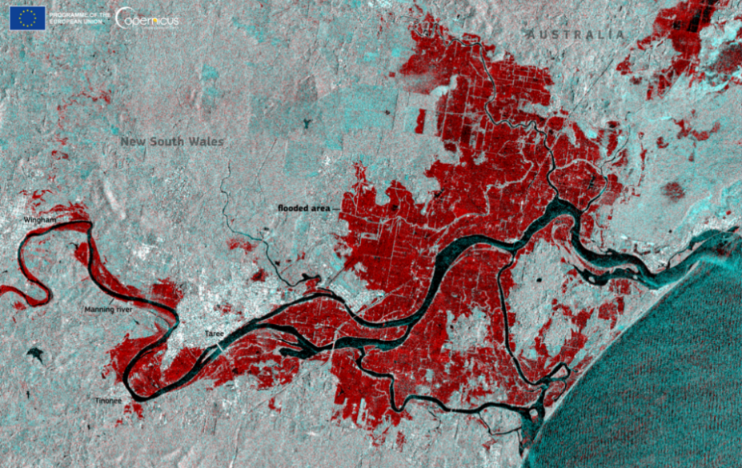
Figure 1. Map of flood prone land in NSW.
Source: Wikimedia Commons

As per Government (2024) report, between 1900 and 2022 there have been 950 flood events in NSW resulting in 736 lives lost, 5066 injuries and 3,596 homes where lost (collapsed) and is also followed by huge economical losses.
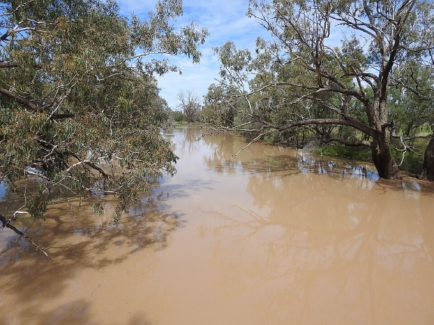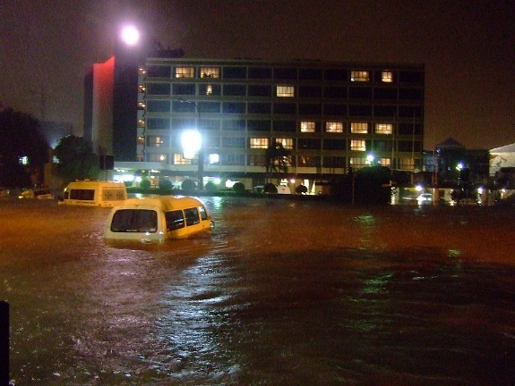
Figure 2. Australian countryside affected by severe flooding Figure 3. Australian city affected by severe flooding
Source: Wikimedia Commons Source: Wikimedia Commons

In 2022, Australian household companion animal (pet) ownership was estimated as 69 percent. This is an increase from estimated ownership levels of 63 percent in previous years. These numbers indicate: Australia is one of the most animal friendly country and has a high level of household companion animal ownership. Almost every household is likely to have animals (Australian Institute for Disaster Resilience & The Australian Government National Emergency Manae, 2024). In Australia, Animal emergency management (AEM) is an emerging area of research and authorities are working towards providing a framework for different organisations to use to prepare for, respond to and recover from natural calamities and flood like situations. AEM in Australia encompass all activities that are related to prevention, preparedness, response and recovery involving animals and the people who have responsibility for them in natural hazard like situations or in case of any emergency. The nation has considered and recognised the importance of animals and the environment and the need to protect and maintain a balance with this ecosystem (Australian Institute for Disaster Resilience & The Australian Government National Emergency Manae, 2024). In Australia various professionals in veterinary medicine generally use and follow ‘Five Domain Model of Animal Welfare’, that act as a guide while assessing welfare and animals in distress.
Physical and Functional Domains

- Nutrition
2. Environment
3. Health
4. Behaviour

Mental State

Welfare State

Figure 4. Five domains model of animal welfare
Source: Author
This approach considers welfare from the perspectives of the animals and also addresses their physical and emotional well-being. It recognises that an animal's experience across the four physical domains (nutrition, environment, health and behaviour) ranges from positive to negative and contribute to positive and negative experiences in the fifth domain (mental state). The model emphasises a positive mental state as being critical to welfare, rather than purely an absence of negative experiences (Australian Institute for Disaster Resilience & The Australian Government National Emergency Manae, 2024). In AEM, Biosecurity is a fundamental term related to animal health. Incorporating biosecurity measures in AEM planning, means infectious diseases threats to animals and people those are emerged and caused because of disaster are anticipated and prevented where possible, rapidly detected when they arise and are taken care of by treating them once detected (Australian Institute for Disaster Resilience & The Australian Government National Emergency Manae, 2024).

All principles and management arrangements in South Australia follows the laws and official plans that guide emergency management and the welfare of animals in South Australia. Beyond the Emergency Management Act 2004, the framework is consistent with the (Government of South Australia, 2018):
- Animal Welfare Act 1985
- Dog and Cat Management Act 1995
- Impounding Act 1920 (which describes how stray livestock may be managed)
- National Parks and Wildlife Act 1972 (conservation and protection of native animals)
- Natural Resources Management Act 2004 (e.g., control of pest animals).

Case 2 - New Zealand
Floods, earthquakes, landslides, drought and storms, etc. and various other disasters are frequent hazards in New Zealand. Volcanic risks exist within Auckland and central North Island cities and towns. Over past years, these disasters have been occurred multiple times and scale and frequency of these disasters have also been increased (Mitchell, 2024). Coastal settlements are usually prone to tsunami and the effects of sea water-level rise. Climate change also acts as one of the major reasons for the cause of these disasters. In New Zealand, disaster risk is clearly a matter of huge importance and requires considerable policy framework (Basher, 2016).

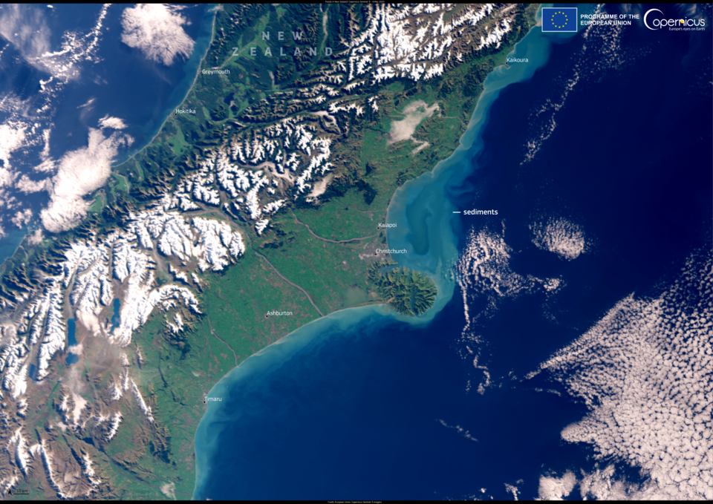
Figure 5. Flood map of New Zealand
Source: Wikimedia Commons
New Zealand is surrounded by ocean, has mountain ranges reaching altitudes over 2,400 m in the North Island and 3,700 m in the South Island. Most of the population in New Zealand resides in coastal regions and also many communities are situated on active floodplain. Reasons such as low-lying areas and hydrological cycles cause flooding events. Also, warmer air can carry more moisture than cooler air and can potentially give rise to larger floods. It is also noticed that more flooding has been happening within the northern region, which is where majority of population resides. This has also led to more built up within the flood prone areas, thus many of the communities are founded on the active floodplain. This combination of circumstances has resulted in flooding being New Zealand’s most costly hazard. Local government authorities have started taking actions by proposing proper planning rules and flood control works in an attempt to protect the population from these events. Data regarding the floods have been computed to identify hazard in several regions and to reduce them, this will require upgrading of river control schemes and restricted construction within the active floodplains (Smart & Mckerchar, 2010).
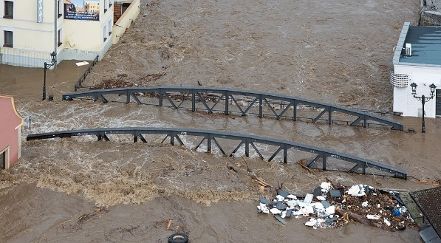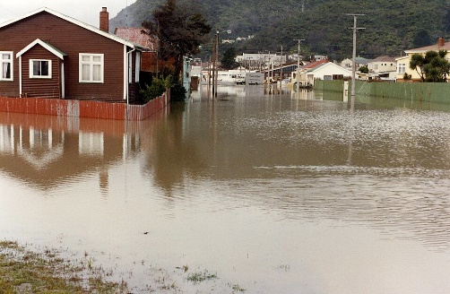
Figure 6. Image showing floods in New Zealand Figure 7. Image showing floods in New Zealand
Source: Wikimedia Commons Source: Wikimedia Commons
One of the catastrophic incidents once took place in April 2017, when the largest companion animal rescue in New Zealand’s history took place to save hundreds and thousands of animals which were left behind inside the flooded township of Edgecumbe. As the stopbank, Matahina Dam was in close proximity to residential areas, there was a rapid inundation of homes caused by flooding with high intensity, which made them to evacuate their homes within very short time period along with their companions and belongings. It was noted that the flood water reached upto 2m of height in some areas causing huge economical and property losses. A rescue operation was conducted for over 1000’s of animals, many animals unfortunately were left behind as there were complexities and unpreparedness to handle various animals including wild animals, production animals & pet animals. Post rescue challenges also included animal identification and behavioural changes because of the trauma, tracking, decontamination, management of deceased animals, which had a long-term impact on animals as well as humans. This incident clearly demonstrated lack of preparedness for this kind of disaster management, which caused to have an animal inclusive approach and which should not be compromised as those are also a part of our environment (Glassey, Liebergreen, Ferrere, & King, 2024).

Later the National Advisory Committee for Animals in Emergencies have developed the National Planning Principles for Animals in Disaster in countries Australia and New Zealand for Animals in Disaster, which was designed to improve disaster management planning by ensuring that animals do get preference in inclusive planning. These National Planning Principles for Animals in Disaster have been endorsed by the Australian-New Zealand Emergency Management committee which states that the Planning Process should include:

- Integrating animal welfare into disaster management plans to improve animal welfare outcomes.
- Clear goals, coordination, responsibilities having structured network among all the involved agencies such as stakeholder, local government, NGOs and animal welfare organisations.
- It is necessary to appoint professional consultants, trainers, to achieve effective implementation of disaster plans.
- Proper awareness and education to be given to the animal owners regarding their responsibilities for their animal’s welfare during disaster.

Below are the broader areas of their Disaster Plan that incorporates animal welfare in Disasters:
- An approach of all-hazard for all animals and various disaster of all stage should be considered while preparing disaster plans with relevant legal and regulatory framework.
- The plan should ensure addressing maintaining biosecurity requirements, disaster risks, resource availability during disaster emergency, etc.
- A formal partnership or coordination should be established between inter-agency and animals’ welfare organisations in ways convenient to the public.
- It must include clear objectives, response measures, regular testing and review processes to support animal welfare along with human wellbeing, and economic resilience during disasters.
(Australian Institute for Disaster Resilience & The Australian Government National Emergency Manae, 2024).

Animal welfare in these countries considers animals as non-negotiable part of environment during the times of disaster and emergencies but no focus has been given to or considerations made for stray animals. Animals with no companions and as they are also an important part of this shared urban ecosystem, they should be considered equally important. No animal welfare has specifically has mentioned about stray animals (dogs and cattle), as these animals do suffer and are prone to various diseases during these situations focused attention is also required in this area.

Disaster management strategies in India for animal welfare:
National level of information on livestock population is collected every 5 years. The last livestock census was conducted in 2024. As per census 2019, total population of stray animals and stray cattle in the country was 203.31 lakhs. As per the Eleventh Schedule of Constitution of India, the state may endow Panchayat to establish and run the Cattle Pounds (Kanji House)/Gaushala Shelters. Many states have started establishing numerous Gaushala Shelter houses for Stray Cattle. However, the Animal Welfare Board of India (AWBI) provides financial assistance to the recognised Gaushalas/AWOs/NGOs/SPCAs and Local Authorities under a scheme of Shelter House for establishment of new animal shelter house and under the Regular Grant Scheme. This is given for maintenance of animal shelters, animal medicines, purchase of medical equipment, conducting of veterinary camps and rescued cattle maintenance grant for maintenance of the animals rescued from illegal transportation/slaughter houses. In addition, it provides financial assistance under the scheme of Provision of Ambulance Services for animals in distress for purchase of suitable vehicles for transportation, rescue and also for providing emergency services to animals in distress.

The National Policy on Disaster Management 2009:
It sets the foundational tone for disaster management in India. It includes a critical clause that recognises the importance of saving animals during disasters, outlining basic responsibilities such as providing shelter, feed, and post-disaster care. This was a milestone as it marked the formal inclusion of animals in a national level disaster framework for the first time in history. However, the policy is more like a vision document and lacks operational clarity. There is no structure for budget, framework, legal enforcement or technical guidance.

The National Disaster Management Plan 2019:
This plan aligned more closely with Sendai Framework and introduces a broader lens of disaster risk reduction. Importantly, it contains dedicated section that mentioned about significance of protecting livestock animals in building community resilience. However, the plan remains limited to livestock. Companion animals, stray, service animals, and even wildlife was been neglected despite of their ecological importance in the environment.

The 2005 Disaster Management Act and its 2024 amendment:
It does not address animals or animal welfare, also there is no considered component for safety and welfare of animals from disaster risk.

Despite of these available plans and policies in India, the on-ground implementation still remains negligible.

METHODOLOGY
To check the exact ground situation of stray animals stranded in floods, a study was conducted in Delhi on three selected sites in real-time when these sites were affected due to floods during August-September 2025. Surveys were conducted local residents of the area and interviews were conducted with NGOs in the city. Since the study was exploratory in nature, open-ended questions were asked to respondents to understand how rescue operations happen during disasters in different locations and what are the limitations of agencies involved in rescue operations.

Primary Study
In the study, at least of total 5 groups per site were surveyed to understand the exact situation that happens during the floods and to understand their responses. Participants were usually shopkeepers and residents in these areas. This was the initial survey conducted in terms of direct site-to-site condition. This survey was conducted to initially understand the exact condition of stray animals and to come on a conclusion that whether we need to integrate preparedness for stray animals in disaster management guidelines. Further, an interview-based survey was also conducted with different NGOs in which 3 are based in Delhi and 2 in Maharashtra and rescue volunteers to have a strong justification for having an inclusive planning for stray animals. These are not according to the sites selected for the survey but to understand the overall process of rescue that happens during floods and how does it impact stray animals. The questions were framed to understand their opinion as in what interventions can be proposed to have preparedness framework for better urban ecosystems.

Commencing each public interview, the conversation was initiated with a broad opening, inviting participants to share their personal experiences regarding floods and how these situations impacted stray animals. As the conversation unfolded, they explained about various scenarios where stray animals get stuck because of floods and suffer physically as well as mentally. Conversations with NGOs revealed how difficult it is to spot a stray animal when the water level is around 2m and it is also difficult to locate themselves and the stray animals.

Site Study 01: Majnu ka Tilla, Delhi
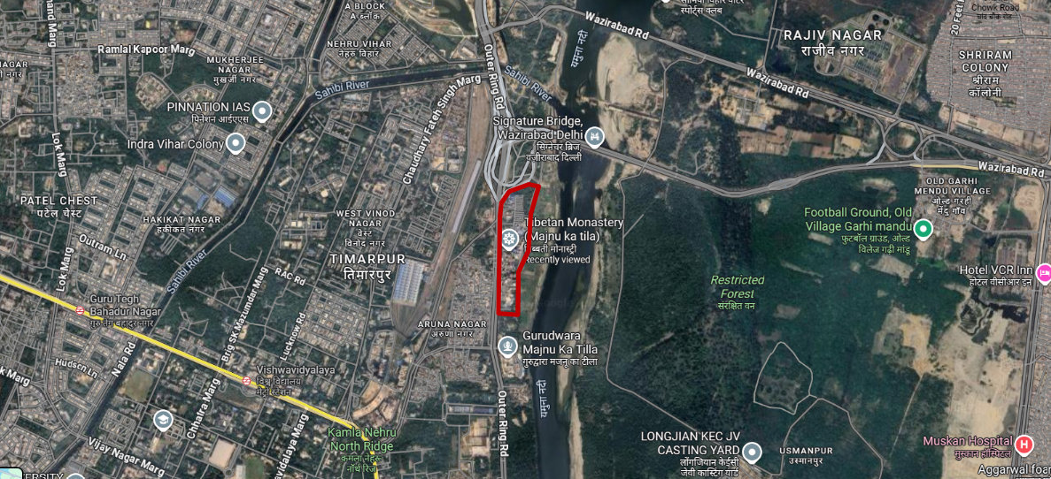
Figure 8. Context map showing location of Majnu ka Tilla
Source: Author (Google Earth)

Current Situation 2025
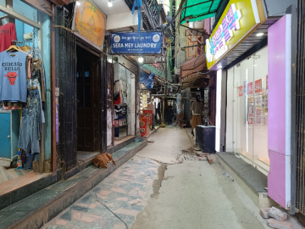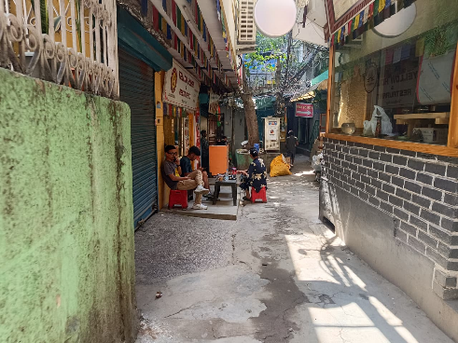
Figure. 9. Current situation in MKT 2025 Figure 10. Current situation in MKT 2025
Source: Author

Site Study 02: Monastery Market, Civil Lines, Delhi
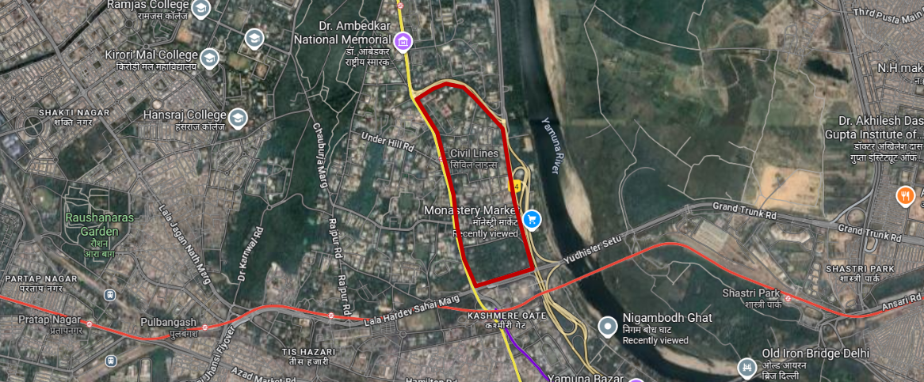
Fig. 11. Context map showing location of Monastery Market, Civil Lines, Delhi
Source: Author (Google Earth)
Current Situation 2025
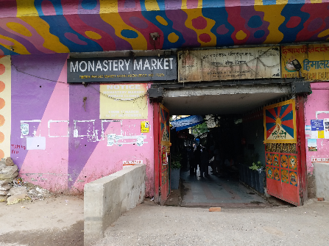
Fig. 12. Current situation in Civil lines 2025
Source: Author

Site Study 03: Nigambodh Ghat- Old Iron Bridge, Delhi
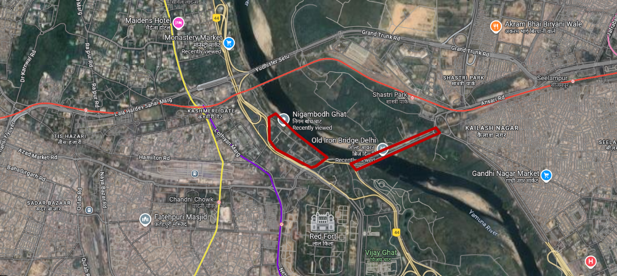
Figure 13. Context map showing location of Nigambodh Ghat- Old Iron Bridge, Delhi
Source: Author (Google Earth)

Current Situation 2025
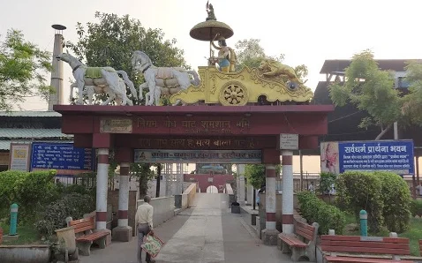
Figure 14. Current situation in Nigambodh 2025
Source: Author (Google Earth)

SURVEY

Public Interviews:
A public survey was conducted in three areas of Delhi: Majnu Ka Tila, Monastery Market, and Nigambodh Ghat, as these areas are situated near the Yamuna Floodplain and are highly prone to urban flooding. The response from the public clearly stated that the situation during rescuing stray dogs gets very complicated, due to lack of awareness and absence of any prior warnings regarding the floods. As a result, all shops and commercial establishments in these areas are often forced to shut down during such events. Limited resources are made available for rescuing stray dogs which leads to the increase in their mortality rate and also results in displacement and shift in their population.

The research has also revealed that there are very few actions undertaken by the department of disaster management or the government agencies. In most of the cases the authorities only provide boats, while volunteers and various NGOs take the responsibility for the rescue operation. During these panic situations, stray dogs are observed to experience trauma, behavioural changes, aggression and vulnerability to various diseases.
Public opinion on preparedness for stray animals strongly supports to integrate an inclusive approach of disaster management. Residents of these areas often share an emotional and companion like bonding with dogs and strongly believe that effective actions must be implemented to prevent these situations to achieve welfare of animals during disasters.

NGOs Interviews:
A series of interviews were conducted with various NGOs actively working for animal welfare: Yamuna Khimstang Foundation, My Neighbourhood and Animal Rahat. Their responses were recorded and opinions on inclusive disaster management were noted.

Mr. Sonam, founder of Yamuna Khimstang Foundation based in Delhi specifically focuses on the Majnu Ka Tilla area and they have rescued 130-150 dogs during recent flood events. According to him, the stray dogs get traumatised by these events and shift in their population is observed. He further stated that there has been no contribution made from Government on this matter and they voluntarily take the responsibility to conduct rescue operations. Lack of Social awareness in the people and preparedness for disaster management involving animals needs to be discussed. In his opinion, a proper evacuation plan can be prepared and early warnings to show preparedness and relocate dogs in a safer area to save lives and avoid spreading of disease.

Ms. Ayesha Christina Benn, founder of My Neighbourhood organization based in Delhi has been actively working for animal welfare from years and has a record of rescuing approximately around 150-200 stray dogs. During this process they came across traumatised, deceased and infected stray dogs due to floods. In their opinion, implementing early warnings regarding floods can help in phase wise evacuation. Also, implementing disaster preparedness plan is essential for animal welfare. According to them, having an overall data on stray animals can help tracing stray dogs during emergency. Design approach such as identifying flood prone areas and designing elevated evacuation areas for animals’ safety can be practiced by also considering food and water provisions.

Dr. Naresh Upreti, founder of Animal Rahat organisation based in Maharashtra has also shared his opinion on the stressful situation of urban floods and their impact on stray dogs. According to him, there has been no action taken from the government for stray dogs during flooding events. He has stated, there should be a proper system developed to generate data on stray dogs in flood affected areas and to have sufficient shelters for accommodating all the stray dog population along with the provision of food and water. Proper education and awareness to the public and the disaster management people along with the training to handle rescue and stressful situation during these events should be given. Guidelines need to be proposed to integrate animal inclusive disaster management.

Findings:
The data analysis from the public survey and interview-based survey revealed that Disaster Management Guidelines in India currently lack provisions for stray animal protection, though over 90% of respondents (both public and NGOs) believe it should be included. NGOs emphasized the absence of population data on stray animals, which hinders planning for shelters, evacuation, and food supply. Also, My Neighbourhood NGO is the first NGO who have started geotagging stray dogs to have an accurate data on dog population and have maintained the data for North Delhi till now wherein they also have reports and data on vaccinated and non-vaccinated dogs using an app MCD-311, which is a smart city app and can be accessed by anyone. This makes it easy to rescue stray animals during flood events as their locations are available through geotags.

Public interviews revealed that local communities are not informed or prepared for animal rescue. Awareness campaigns and training were repeatedly recommended. Also, empathy is an important factor of our life. By spreading social awareness we educate people that stray animals are part of our daily lifestyle and urban environment and their existence is important for functioning of ecosystem.

Analysis:
Across all sites, respondents unanimously confirmed the presence of stray animals specially dogs who suffer from flood events. The water level during these events typically ranged from 1-1.5m, severely disrupting both human and animal survival conditions. According to the respondents majorly dogs exhibited stress, trauma, and various diseases including paralysis as they continuously tried to swim to survive during and after floods. This also aligns with the case of flood in Queensland, Australia, that reported high rates of displacement, disorientation, and mortality among urban stray and companion animals. The behavioural changes were being noted as stress, anxiety, aggression, and disorientation that indicate post-traumatic stress in animals, similar to patterns seen in Costa Rica’s 2018 flood response studies. In the surveyed areas, 60–70% of respondents observed shifts in stray populations post-flooding, which increased or decreased depending on access to food and shelter. Mortality rates were reported to increase significantly, particularly where water stagnation led to disease outbreaks (leptospirosis, mange, and infections). NGO representatives corroborated this, stating that stray animals suffer high mortality and morbidity due to infection, starvation, and drowning.

Government intervention was found to be minimal or inconsistent. While a few respondents noted limited assistance (boats for evacuation), most described their role as “nothing” or “maybe.” NGOs such as Friendicoes, PETA, SGACC, and Animal Warriors Conservation Society were instead the main responders, handling rescue and care independently. This indicates a gap between human-centric disaster management and the inclusion of urban fauna, particularly strays. International frameworks (e.g., the Australian Animal Welfare Emergency Response Plan) demonstrate stronger integration of animals into official emergency response systems - an aspect missing in India.

There is an absence of designated elevated zones or animal-safe shelters in flood-prone urban landscapes, a planning gap that contributes directly to mortality.

Comparative Analysis
- Australia & New Zealand: Integrate animal rescue into state emergency frameworks with animal census, safe shelters, and trained responders.
- Costa Rica: Uses community-based evacuation plans for domestic and stray animals, emphasizing early warning.
- South Africa: Focuses on temporary shelter networks and coordinated NGO-government responses.
These case studies highlight the need for structured animal-inclusive disaster policy in India.

Projected Outcome
Developing and integrating a stray animal adaptation and rescue framework within India’s disaster management system can yield the following outcomes:
- Reduction in mortality and disease spread among stray animal populations during flood events.
- Improved coexistence and reduced human-animal conflict in post-disaster urban recovery.
- Data-driven disaster preparedness, facilitated by a national or municipal stray animal census.
- Enhanced efficiency and coordination between NDMA (National Disaster Management Authority), local bodies, and NGOs.
- Urban resilience through landscape design, integrating elevated zones, water-tolerant refuges, and access pathways for rescue.

Proposed Framework for India: “Integrated Stray Animal Disaster Management Framework (ISADMF)”

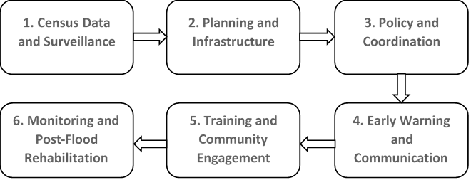
Figure 15. Proposed framework for India for Integrated Stray Animal Management
Source: Author

- Census Data and Surveillance
- Keeping a record of the National Census of Stray Animals: city-wise and zone-wise.
- Use of GIS mapping to identify flood prone areas with a high density of stray dogs.
- Maintaining real-time data through municipal and NGO collaboration.

- Planning and Infrastructure
- Proposing elevated evacuation zones and temporary animal shelters within urban design/plans.
- Incorporating the provision of food and water stations in evacuation zones.

- Policy and Coordination
- Integrating animal rescue into the National Disaster Management Plan (NDMP) for inclusive planning.
- Proposing Animal Disaster Response Units (ADRUs) under NDMA and State Disaster Management Authorities.
- Developing Standard Operating Procedures (SOPs) for animal rescue along with proper training and education.

- Early Warning and Communication
- Preparedness for disaster management by implementing an early warning system that includes alerts for animal welfare NGOs.
- Launching campaigns for public awareness and educating citizens on how to assist stray animals during disasters.

- Training and Community Engagement
- Training campaigns to local volunteers, rescue teams and veterinary staff in animal handling during disaster or panic emergencies.
- Partner with schools and RWA communities for social awareness drives on animal care during disaster emergencies.

- Monitoring and Post-Flood Rehabilitation
- Establishing a Stray Animal Recovery Index (SARI) to track various factors such as health, mortality, and population.
- Providing vaccination drives and veterinary care immediately after floods.

Schematic Integration into Urban Land Use Planning
Sr. no. | Planning Elements | Proposed Animal Inclusion Measure
1 | Flood-prone Zones | Elevated animal refuge points
2 | Urban Green Spaces | Multi-level shelters with food and water
3 | Riverbanks | Emergency access corridors
4 | Public Awareness Zones | Community outreach centres
5 | Disaster Training Facilities | ADRU training hubs

CONCLUSION
A thorough comprehension of urban flood risk is crucial for the creation of secure, sustainable, and resilient cities. This study reveals that there are various adverse effects of urban flooding on stray animals. To cater these issues and mitigate disaster like situations, there should be preparedness plans catering to rescue of animals during such events. These plans should redevelop modules and strategies which majorly focus on humans and infrastructure for climate-generated risks. The study reveals that animals remain completely neglected in these proposal and plans. Stray animals specially dogs have been considered to possess social value in India, still remains neglected during emergencies. This study highlights that urban stray dogs, are among the most vulnerable groups during flood disasters, yet remain excluded from existing disaster management frameworks and opens doors for future research in this domain to develop an understanding of disaster preparedness in varying contexts. Primary data from Delhi and insights from international examples emphasize that animal welfare must be embedded within disaster preparedness policies for both ethical and ecological reasons. Hence, India urgently needs a comprehensive national framework integrating stray animal management into its disaster planning and urban resilience strategy.

REFERENCES

- Agonafir, C., Lakhankar, T., Khanbilvardi, R., Krakauer, N., Radell, D., & Devineni, N. (2023). A review of recent advances in urban flood research. Water Security, 100141. doi:10.1016/j.wasec.2023.100141

- Australian Institute for Disaster Resilience, & The Australian Government National Emergency Manae. (2024). Australian Disaster Resilience Handbook Collection | 2024 Planning for Animals. Australian Institute for Disaster Resilience. Australia: Australian Disaster Resilience Knowledge Hub. Retrieved from https://knowledge.aidr.org.au/resources/handbook-animals-in-disaster/

- Balaian, S., Sanders, B., & Abdolhosseini Qomi, M. (2024). How urban form impacts flooding. Nature Communications, 1-10. doi:10.1038/s41467-024-50347-4

- Basher, R. (2016). High Stakes – Disaster Risk in New Zealand. View of High stakes - Disaster Risk in New Zealand, 25-29. Retrieved from https://ojs.victoria.ac.nz/pq/article/view/4615/4102

- Chang, L.-F., & Huang, S.-L. (2015). Assessing urban flooding vulnerability with an emergy approach. Graduate Institute of Urban Planning, National Taipei University. Landscape and Urban Planning. doi:10.1016/j.landurbplan.2015.06.004

- Director of the Ministry of Civil Defence & Emerge. (2015). Section 14-Animal welfare. Ministry of Civil Defence & Emergency Management. Retrieved from https://www.civildefence.govt.nz/assets/Uploads/documents/publications/guidelines/directors-guidelines/11/15-welfare-services/dgl/Welfare-Services-DGL-11-15-Part-II-Section-14.pdf

- Glassey, S., Liebergreen, N., Ferrere, M., & King, M. (2024). It was one of the worst days of my life: Companion animal owners’ experiences of the Edgecumbe 2017 flood in Aotearoa New Zealand. International Journal of Disaster Risk Reduction, 1-19. Retrieved from https://www.sciencedirect.com/science/article/pii/S221242092300403X

- Glassey, S., Liebergreen, N., Ferrere, M., & King, M. (2024). 1000 Animals Left Behind: Responder Experiences of the 2017 Edgecumbe Flood in New Zealand. Animals, 1-25. Retrieved from https://www.researchgate.net/publication/382331077_1000_Animals_Left_Behind_Responder_Experiences_of_the_2017_Edgecumbe_Flood_in_New_Zealand

- Government of South Australia. (2018). Managing Animals in Emergencies A FRAMEWORK FOR SOUTH AUSTRALIA. Dpeartment of the Premier and Cabinet. Retrieved from https://www.dpc.sa.gov.au/__data/assets/pdf_file/0006/38355/Managing-Animals-in-Emergencie....pdf

- Government, N. (2024). State Disaster Mitigation Plan 2024-2026. Retrieved from Department of the Premier and Cabinet: https://www.dpc.sa.gov.au/responsibilities/security-emergency-and-recovery-management/state-emergency-management-plan

- Gupta, A., & Nair, S. (2010). Urban floods in Bangalore and Chennai: risk management challenges and lessons for sustainable urban ecology. India: Research Gate. Retrieved from https://www.jstor.org/stable/24077767

- Hooda, S. (2025). Urban Green Spaces and Their Impact on Local Flora and Fauna in India. International Research Journal, 12(5), 588-594. Retrieved from https://tijer.org/tijer/papers/TIJER2505078.pdf

- International, F. P. (2025). Flooding and Animals. Vienna: FOUR PAWS ORGANIZATION.

- Manandhar, B., Cui, S., Wang, L., & Shrestha, S. (2023, 3 6). Urban Flood Hazard Assessment and Management Practices in South Asia: A Review. Land, 12(3), 627. doi:10.3390/land12030627

- Miller, J., & Hutchins, M. (2017). The impacts of urbanisation and climate change on urban flooding and urban water quality: A review of the evidence concerning the United Kingdom. Journal of Hydrology: Regional Studies, 345-362. doi:10.1016/j.ejrh.2017.06.006

- Mitchell, H. (2024). Strengthening disaster resilience and emergency management Government response to the Report of the Government Inquiry into the Response to the North Island Severe Weather Events. Department of the Prime Minister and Cabinet. New Zealand: New Zealand Government. Retrieved from https://www.dpmc.govt.nz/sites/default/files/2024-10/Strengthening-disaster-resilience-and-emergency-management.pdf

- Pang, H. (2025). SDGS AND THE DEVELOPMENT OF A STRAY DOG MANAGEMENT MANUAL BASED ON BUDDHISM AND DOG POPULATION MANAGEMENT. International Buddhist Studies College, 1-26. Retrieved from https://www.researchgate.net/publication/391273652_SDGS_AND_THE_DEVELOPMENT_OF_A_STRAY_DOG_MANAGEMENT_MANUAL_BASED_ON_BUDDHISM_AND_DOG_POPULATION_MANAGEMENT

- Sharma, V., Sharma, R., Aulakh, R., & Singh, B. (2023). Prevalence of Brucella species in stray cattle, dogs and cats: A systematic review. Preventive Veterinary Medicine, 219, 106017-106017. doi:10.1016/j.prevetmed.2023.106017

- Smart, G., & Mckerchar, A. (2010). More flood disasters in New Zealand. Journal of Hydrology (NZ), 69-78. Retrieved from https://www.researchgate.net/publication/267564384_More_flood_disasters_in_New_Zealand

- Todini, E. (2025). Understanding and Mitigating Urban Flood Risk. Hydrology, 12(6), 146 _1-12. doi:10.3390/hydrology12060146

- Zhang, Y., Li, Z., Ge, W., Chen, X., Xu, H., & Guan, H. (2021). Evaluation of the impact of extreme floods on the biodiversity of terrestrial animals. Science of The Total Environment, 790, 148227. doi:10.1016/j.scitotenv.2021.148227

